Comparative Study on Substrate Optimization, Nutritional and Bioactive Screening of P. sajor-caju – Embedded in gummies production

ABSTRACT
Mushrooms are highly valued for their nutritional, medicinal and ecological benefits, with Pleurotus sajor-caju recognized for its ability to grow on diverse lignocellulosic substrates. This study evaluated the yield performance, nutritional quality, phytochemical profile and value-added potential of P. sajor-caju cultivated on paddy straw, maize straw and banana leaves, supplemented with rice bran and cotton seed. Cultivation trials assessed weekly mycelial growth, colonization, primordial initiation, fruiting body formation, harvesting time, yield and biological efficiency. Dried fruiting bodies were analysed for organoleptic characteristics, reactions with various chemical reagents, fluorescence behaviour, proximate composition, amino acid content, heavy metal levels and phytochemical profile. Among all treatments, substrates supplemented with nutrient-rich additives produced the highest yield and improved nutritional quality and were subsequently used for the formulation of value-added mushroom-based gummies, which underwent sensory evaluation. The results confirmed that supplementation significantly enhanced biological efficiency compared to control substrates. Specifically, paddy straw with rice bran supported the fastest mycelial growth, the earliest colonization and primordial initiation, the highest number of fruiting bodies, the shortest harvesting time and the greatest yield and biological efficiency, followed by maize straw with rice bran. Nutritional analyses also revealed high protein and carbohydrate content, balanced amino acid composition, beneficial phytochemicals and safe levels of heavy metals in paddy straw supplemented with rice bran. Mushroom-based gummies formulated from these optimized substrates were well accepted by consumers and demonstrated significant potential for functional food applications, particularly in extending the shelf life of mushrooms. Overall, the findings highlight the potential of P. sajor-caju for sustainable agro-waste management, enhanced nutrition and the development of value-added products.
KEYWORDS: Pleurotus sajor-caju, biological efficiency, nutritional composition, phytochemical profiling, gummies, value-added products, fruiting bodies
INTRODUCTION
Fungi are heterotrophic organisms that lack chlorophyll and depend on external sources of nutrition. Of the approximately 110,000 described fungal species, around 16,000 are classified as mushrooms, with roughly 700 considered safe, nutritious and medicinally valuable (Rathore et al., 2019). Although over 3,000 species are edible, only about 200 have been experimentally cultivated and fewer than 100 are produced commercially (Wasser, 1999, 2002). Mushrooms are highly valued for their rich content of protein, fibre, vitamins, minerals and bioactive compounds, while being low in fat and cholesterol. Their nutritional quality is often compared to that of eggs, milk and meat. In addition, mushrooms exhibit various therapeutic properties, including anti-cancer, antibiotic, antiviral, immunomodulatory and blood lipid–lowering effects (Barros, 2008; Shu, 2007). Traditionally collected from the wild, edible mushrooms such as Agaricus bisporus (button), Pleurotus spp. (oyster), Calocybe indica (milky) and Volvariella spp. (paddy straw) are now widely cultivated in India, with Pleurotus species ranking second among commercially produced mushrooms (Satish et al., 2017). The global mushroom market, valued at USD 38 billion in 2018, continues to grow due to population expansion, urbanization and the increasing demand for sustainable protein sources (Elaine and Tan, 2009; Livi-Bacci, 2012). In India, where cereal-based vegetarian diets are often protein-deficient, mushrooms offer a solution to malnutrition, while also generating rural employment and promoting efficient agro-waste recycling (Gupta et al., 2016).
Pleurotus spp., commonly known as oyster mushrooms, are commercially significant edible fungi. Their global production has increased substantially due to their ability to grow on a wide range of agro-based residues (Kurt and Buyukalaca, 2010). Pleurotus sajor-caju is a fast-growing, lignocellulose-degrading species capable of utilizing diverse agricultural residues (Zhang et al., 2002). Agricultural residues serve as the primary lignocellulosic resource and the main substrate for the solid-state fermentation of edible fungi like P. sajor-caju. While rice straw remains the predominant substrate in India, exploring low-cost alternatives and suitable supplements is essential to maximize yield and enhance nutritional quality (Chandra et al., 2013). P. sajor-caju is recognized as an important food item due to its significant roles in human health, nutrition and disease prevention, reflecting the common saying that “medicines and foods have a common origin” (Chang, 1996; Kaul, 2001). It is highly valued for its nutritional and medicinal properties, including the ability to inhibit hypertensive effects through active compounds that modulate the renin-angiotensin system (Chang, 1996). In addition, it contains a rich source of bioactive compounds such as polysaccharides, β-glucans, proteins, vitamins and minerals. Although fresh or dried mushrooms offer numerous health benefits, their consumption is limited by perishability, taste and consumer acceptability. To address these challenges, recent advances in functional food technology have enabled the development of mushroom-based gummies.
Gummies are widely consumed by both children and adults, particularly those under 17 years, due to their natural and chewy texture (Moloughney, 2020). In response to the growing demand for gummies with enhanced nutritional value while retaining their traditional texture, our research team developed several alternative formulations using Oyster mushrooms. Such value-added mushroom-based products not only improve consumer acceptability but also help reduce post-harvest losses. Building on this, the present study aims to identify suitable agricultural residues for Oyster mushroom cultivation and evaluate the effect of various supplements on mushroom growth, yield and quality. The study also focuses on assessing the nutritional content, amino acid profile, bioactive compounds and heavy metal levels in the dried fruiting bodies, while exploring the production of nutritionally enriched mushroom-based gummies as a novel value-added product.

MATERIALS AND METHODS
Source and Maintenance of Fungal Culture
The pure master culture of P. sajor-caju was obtained from Win Labs Agro Tech, Coimbatore, India and used for the preparation of both master and commercial spawns. Throughout the study, the culture was maintained on 2% malt extract agar (MEA) slants at 4 ºC, with fresh slants sub-cultured every 15 days and complete sub-culturing performed at 2-month intervals.

Spawn Preparation
For spawn preparation, whole sorghum grains were boiled in a 1:1 ratio (grain: water) for 10–15 minutes. After draining, the grains were mixed with 4% (w/w) CaCO₃ and 2% (w/w) CaSO₄. Approximately 250 g of the treated grains were packed into polythene bags (200 × 300 mm) and sterilized in an autoclave at 121 ºC for 30 minutes. After sterilization, the bags were inoculated with actively growing mycelium from the malt extract agar slants and incubated at 27 ± 2 ºC in the dark for 10–15 days, until the mycelium fully colonized the grains (Bano and Srivastava, 1962).
Substrates and Supplements
Locally available paddy straw, maize straw and banana leaves were used as substrates. Rice bran and cotton seed were incorporated as supplements at 50% (w/w), following the methods suggested by Bhatti et al. (1987) and Gupta et al. (2018). A total of nine treatments were designed, comprising each substrate alone as the control and each substrate supplemented separately with rice bran or cotton seed. Thus, three treatments were prepared for each substrate.
Cultivation of mushrooms
Mushroom cultivation was carried out in a partially ventilated room with diffused light at 25 ± 2 °C and >85% relative humidity, ensuring adequate air circulation. Substrates were chopped into 2–4 cm pieces, soaked overnight, sterilized at 121 °C for 20 min, and adjusted to 60% moisture (Chang and Miles, 1982). Approximately 1.5 kg of each substrate was packed into polypropylene bags, inoculated with 2% (w/w) spawn and incubated at 25 ± 2 °C with 80–90% relative humidity until complete colonization. Fruiting was induced under diffused light and high humidity (Rangad et al., 2014). Growth parameters, including mycelial growth, colonization period, primordial initiation and harvesting time were recorded for each treatment.
Yield and Biological Efficiency
Fruiting bodies were harvested in three flushes over 35 days and yield was expressed as total fresh weight. Biological efficiency (BE) was calculated for each treatment using the formula described by Chang et al. (1981).
BE (%) = (Fresh weight of mushrooms / Dry weight of substrate) × 100
Pharmacognostical studies
Freshly harvested mushroom fruiting bodies were cleaned, oven-dried at 37 °C for three days and stored in airtight containers. The dried material was ground and sieved through a Willey mill to obtain a 60-mesh powder, which was stored at room temperature for further studies (Harborne, 1973).
Physico-chemical studies
Organoleptic characteristics of P. sajor-caju mushroom powder, including colour, texture, odour and taste, were evaluated according to Trease and Evans (1983). The behaviour of mushroom powder with various chemical reagents, along with fluorescence analysis, was performed following the standard method described by Kokoshi et al. (1958).
Nutritional analysis
Proximate composition (moisture, protein, carbohydrate, crude fibre and ash) was determined following AOAC (2005) methods. Protein and carbohydrate contents were estimated using the Lowry (1951) and Anthrone (Hedge and Hofreiter, 1962) methods, respectively, while amino acid profiling was performed using HPLC as described by Moore et al. (1958).
Heavy metal analysis
Heavy metal concentrations (Pb, Cd, Cr, Ni, Zn, and Cu) were determined using ICP-OES according to APHA (1995) guidelines.
Soxhlet Extraction
Air-dried mushroom fruiting bodies (10 g) were sequentially extracted using petroleum ether, ethanol and water in a Soxhlet apparatus for 5 h each. Between solvents, samples were oven-dried at 40 °C and stored at 4 °C. Water extracts were obtained by maceration for 16 h. All extracts were filtered, concentrated, vacuum-dried and weighed, with yields expressed relative to the air-dried sample. Extracts were stored over anhydrous sodium sulphate at 5–8 °C (Anonymous, 1985).
Phytochemical Screening
Phytochemical screening for alkaloids, flavonoids, tannins, terpenoids, saponins and glycosides was performed following Harborne (1973).

Mushroom Gummies
Shade-dried P. sajor-caju powder was used to prepare a mushroom extract by boiling in water for 30 min and filtering. The extract was mixed with bloomed gelatin, palm sugar and citric acid, stirred until homogeneous, poured into lightly oiled Molds and refrigerated for 6–24 h to set (Pizzoni et al., 2015).
Sensory analysis
A non-trained panel of 20 members evaluated the mushroom gummies using a 5-point Likert scale (1 = least, 5 = most) for appearance, colour, taste, aroma and texture (softness, juiciness, elasticity) (Romo-Zamarrón et al., 2019).
Statistical analysis
All results are expressed as mean ± SD. Growth, yield, nutritional composition, amino acid profile, heavy metal content and gummy parameters were subjected to one-way ANOVA, and significant differences were determined using Duncan’s multiple range test at p < 0.05 and p < 0.01. Sensory evaluation was analyzed as mean ± SD using a 5-point Hedonic scale. All statistical analyses were conducted with SPSS v16.0.
RESULTS
Cultivation of Pleurotus sajor-caju mushroom
Weekly mycelial growth
Weekly mycelial growth of P. sajor-caju differed significantly among substrates and supplements (Table 1). The fastest growth was observed on paddy straw with rice bran (18.03 cm), followed by maize straw with rice bran (17.00 cm), while banana leaves recorded the lowest growth (11.61–12.97 cm). Overall, rice bran supplementation consistently promoted greater mycelial growth compared to control and cottonseed treatments (p < 0.01) (Fig. 1; Plates 1 and 2).
Table 1. Comparison of weekly mycelial growth of P. sajor-caju on different substrates
Substrates | Supplements | First week  (cm) | Second week  (cm) | Third week  (cm) | Total numbers  (cm)
Paddy straw | Control | 03.73 ± 0.25^{c} | 05.80 ± 0.20^{b} | 06.93 ± 0.40ª | 16.46 ± 0.85
Paddy straw | Rice bran | 04.03 ± 0.55^{c} | 06.17 ± 0.15^{b} | 07.83 ± 0.15ª | 18.03 ± 0.85
Paddy straw | Cotton seed | 03.17 ± 0.15^{c} | 05.17 ± 0.15^{b} | 06.17 ± 0.40ª | 14.51 ± 0.70
Maize straw | Control | 03.27 ± 0.31^{b} | 05.50 ± 0.30ª | 06.87 ± 0.45ª | 15.64 ± 1.05
Maize straw | Rice bran | 03.77 ± 0.31^{c} | 06.00 ± 0.20^{b} | 07.23 ± 0.25ª | 17.00 ± 0.75
Maize straw | Cotton seed | 03.00 ± 0.20^{b} | 05.07 ± 0.25ª | 05.83 ± 0.21ª | 13.90 ± 0.66
Banana leaves | Control | 02.20 ± 0.20^{c} | 05.00 ± 0.20^{b} | 05.27 ± 0.15ª | 12.47 ± 0.55
Banana leaves | Rice bran | 02.23 ± 0.25^{c} | 04.27 ± 0.25^{b} | 06.47 ± 0.15ª | 12.97 ± 0.65
Banana leaves | Cotton seed | 02.03 ± 0.15^{c} | 04.05 ± 0.20^{b} | 05.53 ± 0.25ª | 11.61 ± 0.60

Source | Factor with Significance
Paddy straw (Control) _{(2,8)} | 86.887**
Paddy straw + Rice bran _{(2,8)} | 93.295***
Paddy straw + Cotton seed _{(2,8)} | 100.14**
Maize straw (Control) _{(2,8)} | 62.698**
Maize straw + Rice bran _{(2,8)} | 144.220***
Maize straw + Cotton seed _{(2,8)} | 42.516**
Banana leaves (Control) _{(2,8)} | 333.323**
Banana leaves + Rice bran _{(2,8)} | 332.289**
Banana leaves + Cotton seed _{(2,8)} | 229.763**
Note: Means ± S.D., n =3. Different letters on the same column indicate significant differences (p<0.01) according to Duncan's Multiple Range Test; *, **, *** indicates significance at a 0.01 % level

Fig. 1. Weekly mycelial growth of P. sajor-caju on different substrates

Plate 1. Spawn run initiation on different substrates with supplements

Paddy straw | Paddy straw + Rice bran | Paddy straw + Cotton seed
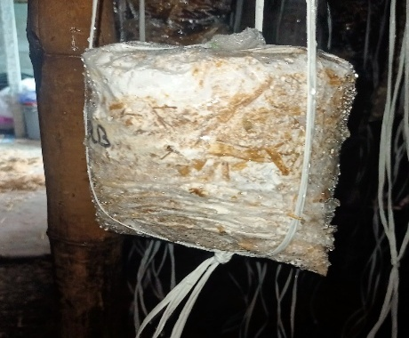 | 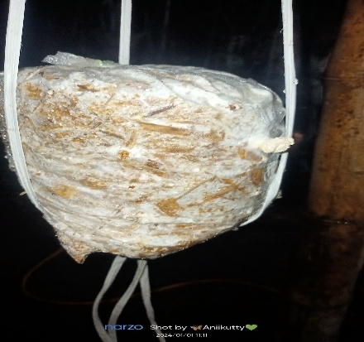 | 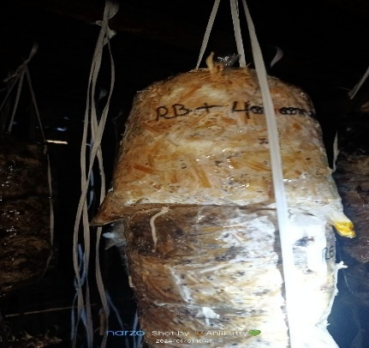
Maize straw | Maize straw + Rice bran | Maize straw + Cotton seed
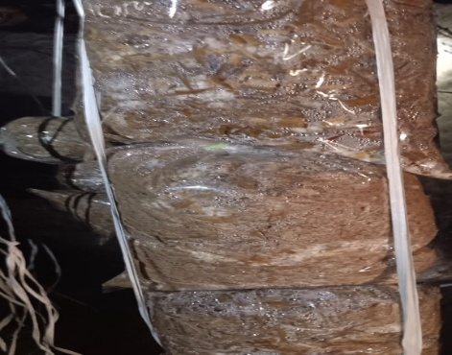 | 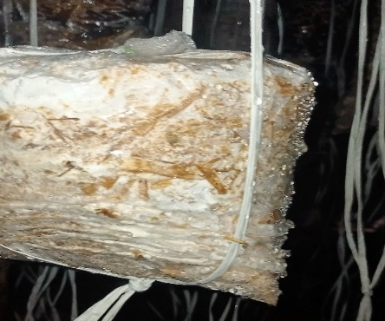 | 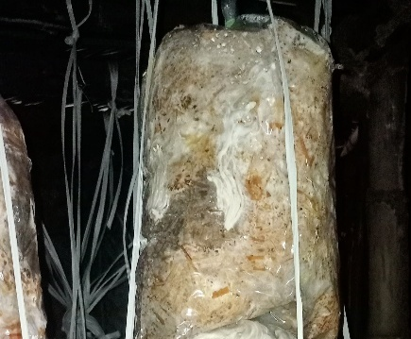
Banana leaves | Banana leaves + Rice bran | Banana leaves + Cotton seed
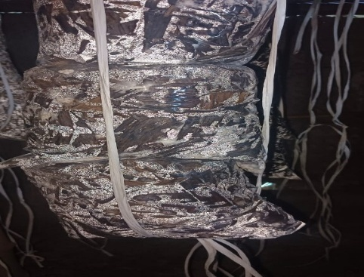 | 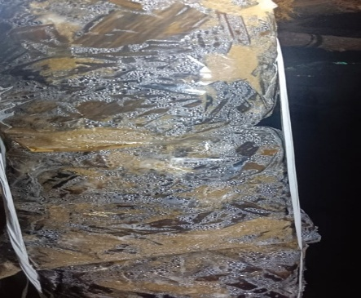 | 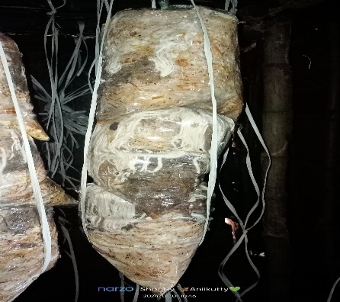

Plate 2. Pinhead initiation on different substrates with supplements and spawn inoculation

Paddy straw | Paddy straw + Rice bran | Paddy straw + Cotton seed
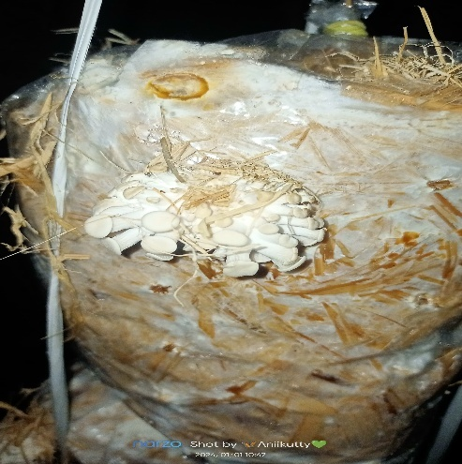 | 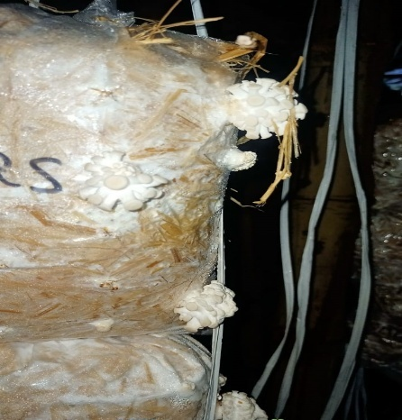 | 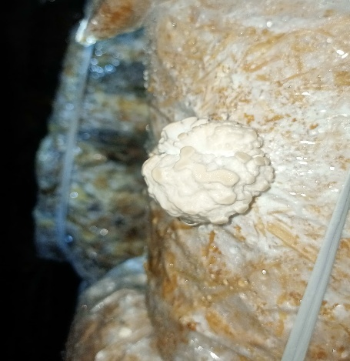
Maize straw | Maize straw + Rice bran | Maize straw + Cotton seed
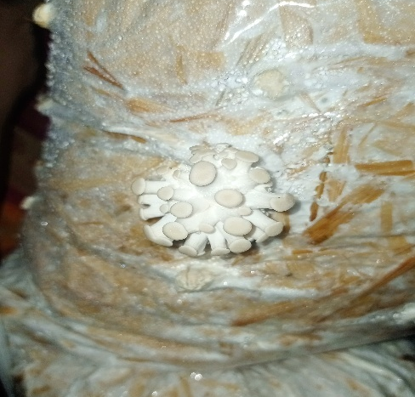 | 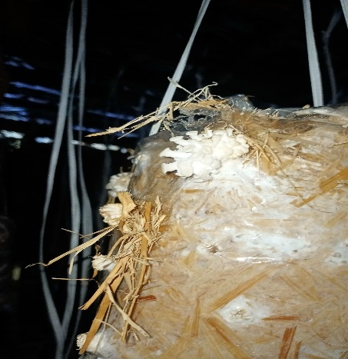 | 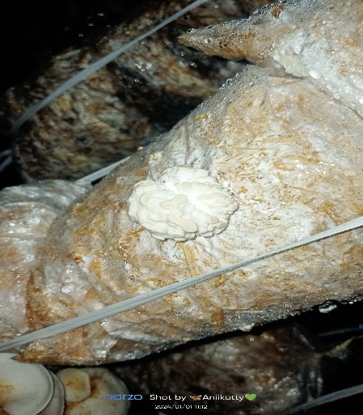
Banana leaves | Banana leaves + Rice bran | Banana leaves + Cotton seed
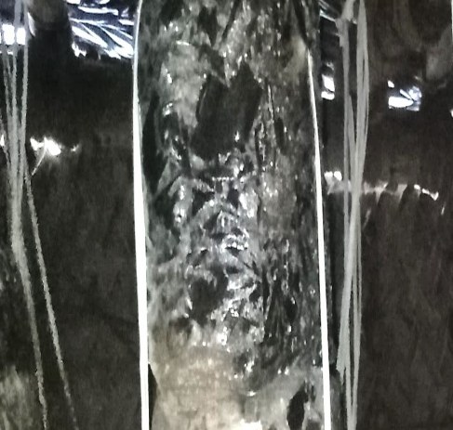 | 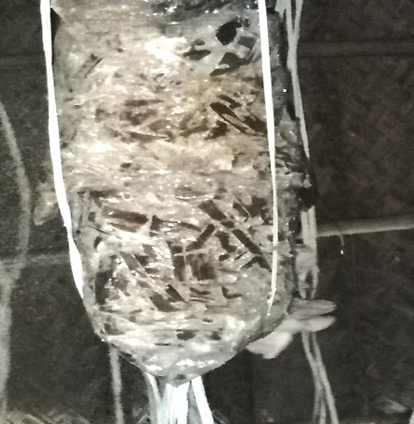 | 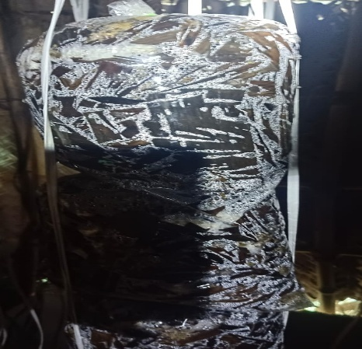
Colonization, Primordial formation, Fruiting and First harvest days
Substrates and supplements significantly affected the developmental stages of P. sajor-caju (Table 2). Paddy straw with rice bran showed the shortest colonization (5.00 days), earliest primordia (7.67 days), shortest first harvest (9.00 days) and the highest number of fruiting bodies (8), while banana leaves had delayed colonization (11–12 days) and the lowest fruiting body count (0.33–1.67). Rice bran supplementation consistently accelerated development compared to other treatments (p < 0.01) (Fig. 2; Plate 3).

Table 2. Comparison of colonization, primordial formation, fruiting and first harvest of P. sajor-caju on different substrates

Substrates | Supplements | Colonization (days) | Primordial formation (days) | No. of fruiting bodies | First harvest (days)
Paddy straw | Control | 06.30 ± 2.00^{b} | 13.33 ± 1.53ª | 05.33 ± 2.08^{b} | 14.33 ± 1.53ª
Paddy straw | Rice bran | 05.00 ± 1.00^{b} | 07.67 ± 1.53ª | 08.00 ± 1.00^{c} | 09.00 ± 2.00ª
Paddy straw | Cotton seed | 07.67 ± 2.53ª | 14.67 ± 2.08ª | 02.67 ± 1.00ª | 16.00 ± 2.52ª
Maize straw | Control | 06.67 ± 2.52^{b} | 13.60 ± 3.51ª | 04.33 ± 1.53^{b} | 15.67 ± 2.08ª
Maize straw | Rice bran | 05.67 ± 1.53^{b} | 09.00 ± 1.00ª | 07.33 ± 1.53^{b} | 10.33 ± 1.53ª
Maize straw | Cotton seed | 10.67 ± 3.06^{c} | 15.00 ± 1.00^{b} | 02.00 ± 2.08^{d} | 16.33 ± 1.00ª
Banana leaves | Control | 11.56 ± 2.08^{b} | 15.67 ± 2.00ª | 01.00 ± 1.53^{c} | 16.67 ± 2.52ª
Banana leaves | Rice bran | 11.00 ± 1.73^{b} | 15.04 ± 1.53ª | 01.67 ± 1.00^{c} | 16.43 ± 1.53ª
Banana leaves | Cotton seed | 12.00 ± 3.00^{c} | 16.33 ± 1.53^{b} | 00.33 ± 0.58^{d} | 18.33 ± 0.58ª

Source | Factor with Significance
Paddy straw (Control) _{(3,10)} | 26.250***
Paddy straw + Rice bran _{(3,10)} | 52.448***
Paddy straw + Cotton seed _{(3,10)} | 0.892*
Maize straw (Control) _{(3,10)} | 54.821***
Maize straw + Rice bran _{(3,10)} | 40.667***
Maize straw + Cotton seed _{(3,10)} | 149.976*
Banana leaves (Control) _{(3,10)} | 43.529**
Banana leaves + Rice bran _{(3,10)} | 188.400**
Banana leaves + Cotton seed _{(3,10)} | 308.792*
Note: Means ± S.D., n =3. Different letters on the same column indicate significant differences (p<0.01) according to Duncan's Multiple Range Test; *, **, *** indicates significance at a 0.01 % level

Fig. 2. Comparison of colonization, primordial formation, fruiting and first harvest of P. sajor-caju on different substrates
Ccolonization period of P. sajor-caju on different substrates with supplements
Primordial formation of P. sajor-caju on different substrates with supplements
Number of fruiting bodies of P. sajor-caju on different substrates with supplements

Plate 3. Fruiting bodies of P. sajor-caju at different harvesting stages

Paddy straw | Paddy straw + Rice bran | Paddy straw + Cotton seed
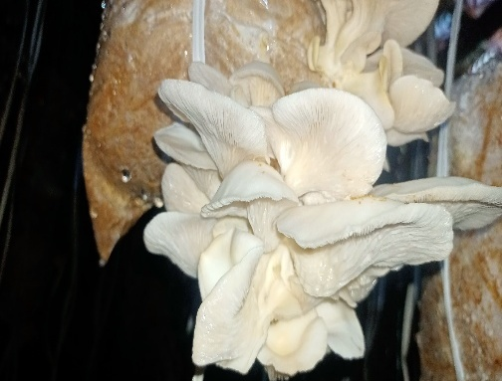 | 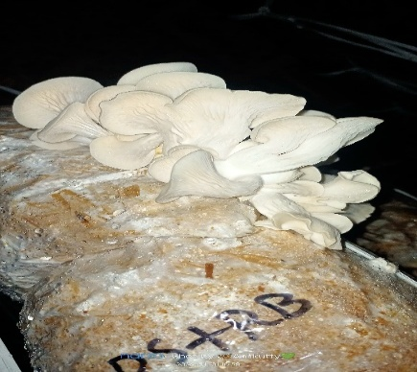 | 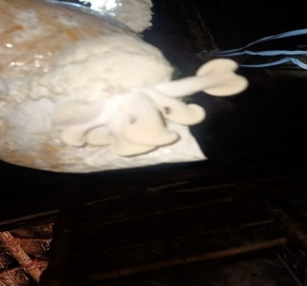
Maize straw | Maize straw + Rice bran | Maize straw + Cotton seed
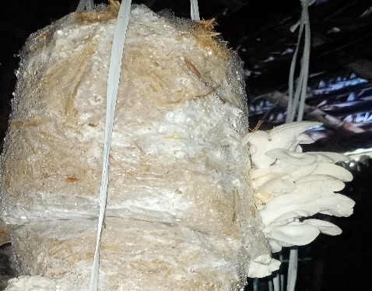 | 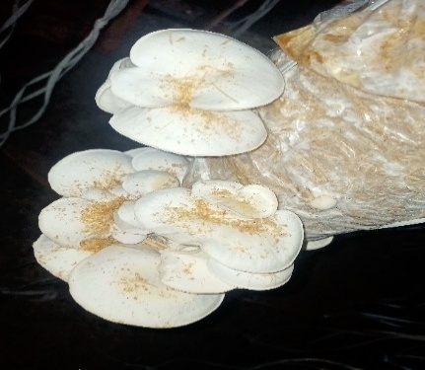 | 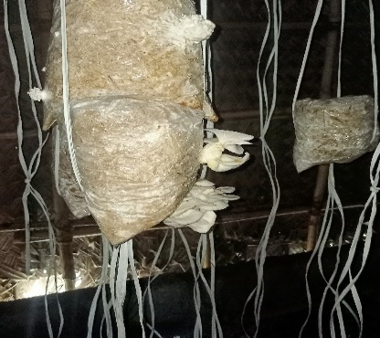
Banana leaves | Banana leaves + Rice bran | Banana leaves + Cotton seed
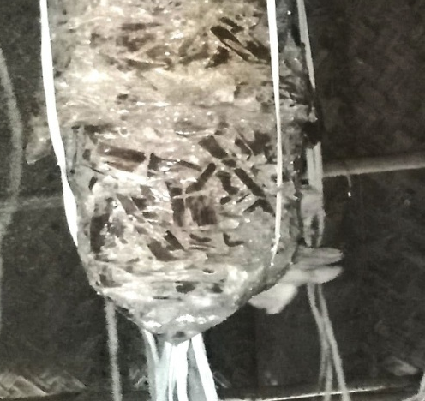 | 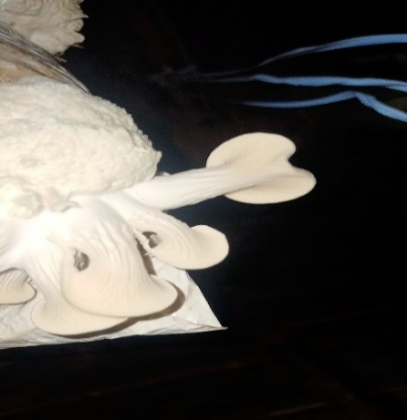 | 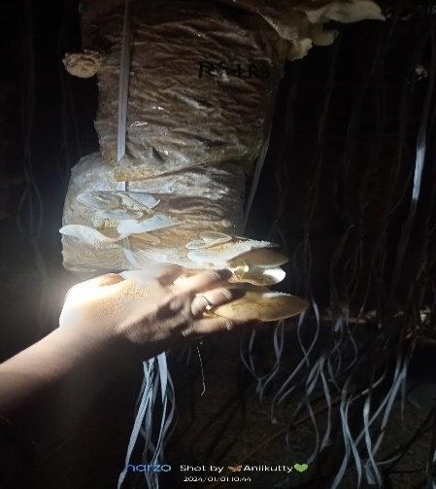

Yield and Biological Efficiency
Yields differed markedly among treatments (Table 3). Paddy straw + rice bran produced the highest yield (790.33 g/kg dry substrate) and biological efficiency (65.86%), followed by maize straw + rice bran (619 g/kg; 51.58%). Banana leaves + cotton seed gave the lowest yield (104.1 g/kg; 8.66%). Mushroom size was also greatest on paddy straw + rice bran (7.2 cm).
Table 3. Effect of substrate supplementation on the yield and biological efficiency of P.sajor-caju
Substrates | Supplements | Yield (gm) / Kg dry straw |  |  | Total | Size of mushroom (cm) | Biological efficiency (%)
Substrates | Supplements | 1st Picking (g) | 2nd Picking (g) | 3rd Picking (g) | Total | Size of mushroom (cm) | Biological efficiency (%)
P | Control | 120.6 ± 4.04ª | 101.33 ± 4.16^{b} | 91.33 ± 6.11^{b} | 313.26 ± 14.29 | 6.5 ± 0.02 | 26.10 ± 0.41
P | Rice bran | 394 ± 3.61ª | 226 ± 2.65^{b} | 170.33 ± 3.51^{c} | 790.33 ± 9.05 | 7.2 ± 0.02 | 65.86 ± 0.63
P | Cotton seed | 99.67 ± 2.52ª | 81 ± 3.61^{b} | 49.67 ± 3.51^{c} | 230.34 ± 9.05 | 5.9 ± 0.17 | 19.19 ± 0.63
M | Control | 100.67 ± 3.06ª | 98.33 ± 3.51ª | 58.67 ± 3.06^{b} | 257.67 ± 9.61 | 6.2 ± 0.04 | 21.47 ± 0.64
M | Rice bran | 271 ± 3.61ª | 197.67 ± 2.08^{b} | 150.33 ± 2.52^{c} | 619 ± 8.19 | 7.0 ± 0.02 | 51.58 ± 0.55
M | Cotton seed | 99.02 ± 2.00ª | 75.02 ± 1.53^{b} | 45.33 ± 2.00^{c} | 219.37 ± 5.51 | 5.8 ± 0.02 | 18.28 ± 0.37
B | Control | 79.5 ± 2.00ª | 55.67 ± 2.52^{b} | 35.33 ± 2.52^{c} | 170.17 ± 6.11 | 3.7± 0.25 | 14.18 ± 0.47
B | Rice bran | 82.67 ± 2.08ª | 57.33 ± 2.52^{b} | 37.67 ± 1.53^{c} | 177.67 ± 7.00 | 4.7 ± 0.25 | 14.80 ± 0.95
B | Cotton seed | 47.5 ± 0.05ª | 35.3 ± 0.61^{b} | 20.01 ± 1.00^{c} | 104.1 ± 2.07 | 3.3 ± 0.25 | 8.66 ± 0.14

Source | Factor with Significance
Paddy straw (Control) _{(2,8)} | 28.713***
Paddy straw + Rice bran _{(2,8)} | 3.803***
Paddy straw + Cotton seed _{(2,8)} | 185.321**
Maize straw (Control) _{(2,8)} | 157.896***
Maize straw + Rice bran _{(2,8)} | 1.245***
Maize straw + Cotton seed _{(2,8)} | 284.672**
Banana leaves (Control) _{(2,8)} | 160.396**
Banana leaves + Rice bran _{(2,8)} | 142.548*
Banana leaves + Cotton seed _{(2,8)} | 3.867**
Note: P: Paddy straw; M: Maize straw; B: Banana Leaves
Means ± S.D., n =3. Different letters on the same column indicate significant differences (p<0.01) according to Duncan's Multiple Range Test; *, **, *** indicates significance at a 0.01 % level
Pharmacognostical Studies
Organoleptic Characters
Organoleptic evaluation indicated substrate-dependent differences, with paddy straw + rice bran powder exhibiting a sweet aroma and mild taste (Table 4).
Table 4. Organoleptic characteristics of dried P. sajor-caju mushroom powder
Substrates | Supplements | Characters
Substrates | Supplements | Colour | Texture | Taste | Odour
Paddy straw | Rice bran | Light yellow | Coarse powder | Mild | Sweet odour
Maize straw | Rice bran | Light brownish yellow | Coarse powder | Mild | Milky odour
Paddy straw | Control | Light yellow | Coarse powder | Salty | Sweet odour

Chemical Reagent Reactions and Fluorescence analysis
Colour changes in P. sajor-caju powder upon treatment with various reagents are presented in Table 5. The fluorescence behaviour of powdered P. sajor-caju mushroom treated with various chemical reagents was examined in daylight and under UV light at 254 and 365 nm (Table 6).
Table 5. Reactions of dried P. sajor-caju mushroom powder with different chemical reagents
Powder + Reagents used | Colour of the liquid
Powder as such | Yellowish white
Powder + Concentrated HCl | Light brown
Powder + Concentrated H₂SO₄ | Dark reddish brown
Powder + Ethanol | Yellowish white
Powder + Methanol | Yellowish white
Powder + Acetone | Light brown
Powder + Petroleum ether | Yellowish white
Powder + Benzene | Reddish brown
Powder +Aqueous solution | Light yellow

Table 6. Fluorescence analysis of dried P. sajor-caju mushroom powder
Reagent | Visible | UV
Reagent | Visible | Long (365 nm) | Short (254 nm)
Powder as such | Brown | Light yellow brown | yellow brown
Hager`s | Light brown | Greenish brown | Yellowish brown
Mayer’s | Pale yellow | Brown | Brownish yellow
Iodine solution | Brownish red | Dark chocolate brown | Dark greenish brown
FeCl₃ | Brown | Blackish brown | Light green
Methanol | Yellowish orange | Black | Greenish brown

Proximate Composition and Amino acid Profile
Proximate analysis of mature P. sajor-caju fruiting bodies revealed the highest protein (1.63 mg/100 g) and crude fibre (76.19 mg/100 g) content in samples grown on paddy straw with rice bran (Table 7). Similarly, amino acid profiling showed elevated levels of lysine, phenylalanine and tryptophan in the same treatment (Table 8).
Table 7. Effect of substrates and supplements on the nutritional composition of P. sajor-caju after the second flush
Substrate used singly /  Comb. with supplements (1:1) | Moisture (%) | Protein (mg/100g) | Carbohydrate (mg/100g) | Crude fibre (mg/100g) | Ash  (%)
Paddy straw + Rice bran | 89.08 ± 2.28ª | 1.63 ± 0.78ª | 0.84 ± 0.24ª | 76.19 ± 3.40ª | 0.54 ± 0.30ª
Maize straw + Rice bran | 90.57 ±1.58ª | 1.19 ± 0.59ª | 0.73 ± 0.06ª | 71.68 ±1.73ª | 0.51 ± 0.16^{b}
Paddy straw (Control) | 87.9 ± 1.27ª | 0.88 ± 0.46ª | 0.80 ± 0.16ª | 71.61± 2.48ª | 1.11 ± 0.05^{b}
F= df (2,8) | 1.967** | 0.485* | 0.336* | 2.853** | 8.572**
Note: Mean ± S.D., n =3. Different letters on the same column indicate significant differences (p<0.05) according to Duncan's Multiple Range Test; *, ** indicates significance at a 0.05 % level

Table 8. Amino acid profile of initial substrates and post-harvest residues after the second flush of P. sajor-caju
Amino acids | Substrates and supplements (mg/100g dry wt)
Amino acids | Paddy straw + Rice bran | Maize straw + Rice bran | Paddy straw  (Control)
Tryptophane | 0.26 ± 0.02ª | 0.22 ± 0.03^{ab} | 0.02 ± 0.01^{b}
Histidine | 0.35 ± 0.02ª | 0.37 ± 0.02ª | 0.17 ± 0.06^{b}
Leucine | 1.00 ± 0.05ª | 0.09 ± 0.01^{b} | 1.05 ± 0.02^{c}
Lysine | 0.72 ± 0.03ª | 0.65 ± 0.04^{b} | 0.03 ± 0.01^{c}
Phenylalanine | 0.70 ± 0.05ª | 0.53 ± 0.02^{b} | 0.26 ± 0.04^{c}
Valine | 0.58 ± 0.02ª | 0.79 ± 0.03^{b} | 0.33 ± 0.02^{c}
Methionine | 0.27 ± 0.03ª | 0.15 ± 0.02^{b} | 0.25 ± 0.01^{c}

Source | Factor with Significance
Tryptophane | 20.067**
Histidine | 162.000***
Leucine | 1.138***
Lysine | 817.824***
Phenylalanine | 582.259***
Valine | 551.808**
Methionine | 140.773**
Note: Means ± S.D., n =3. Different letters on the same column indicate significant differences (p<0.01) according to Duncan's Multiple Range Test; *, **, *** indicate significance at a 0.01 % level
Estimation of heavy metals and Microelements
Heavy metal contents remained within safe limits (Pb: 0.25 ppm; Cd: 0.08 ppm), while Zn (13.02 mg/100 g) and Cu (4.10 mg/100 g) were the dominant micronutrients (Table 9).

Table 9. Heavy metal and mineral content analysis of dried P. sajor-caju mushroom powder
Heavy Metals | Values (ppm/100g)
Pb | 0.25 ± 0.05
Cd | 0.08 ± 0.02
Cr | 0.95 ± 0.92
Ni | 4.07 ± 1.95
Microelements (mg/100g dry wt)
Zn | 13.02 ± 1.82
Cu | 4.10 ± 0.86
Note: Values are means of triplicate determinations ± Standard Deviation

Successive solvent extraction
Percentage yield
The highest percentage yield was observed in the ethanol extract (8.40 ± 0.30 %).
Qualitative phytochemical analysis
Phytochemical screening revealed the presence of proteins, amino acids, alkaloids and saponins, with the ethanol extract exhibiting the greatest diversity (+++) (Table 10). All extracts tested negative for fixed oils.
Table 10. Qualitative phytochemical screening of P. sajor-caju mushroom powder extracts

Tests |  | P. sajor-caju extract
 |  | Petroleum ether | Ethanol | Aqueous
Proteins | Biuret Test | + + + | + + + | + + +
Carbohydrates | Barfoed’s Test | + - + | + + - | + + +
Amino acids | Ninhydrin Test | + + + | + + + | + + -
Alkaloids | Wagner’s Test | + + + | + + + | + - -
Flavonoids | Alkaline reagent Test | + + - | + + - | + + -
Tannins | Braymer’s test | - - - | - - - | - - -
Phenols | Lead acetate Test | + - - | + + - | - + +
Glycoside | Borntrager’s Test | - - - | + - - | + - -
Terpenoids | Liebermann test | + + - | - - - | - - -
Saponin | Frothing test | - - - | + + + | + + +
Coumarin | NaOH test | - - - | + - - | - - -
Quinone | Sulphuric acid test | - + - | + + - | - - -
Anthraquinone | Borntrager's test | - - + | - - + | - - -
Fixed oils | Stain test | - - - | - - - | - - -
Gums and mucilage | Absolute alcohol test | - - - | - + + | + - -

Note: +++’ indicates the high presence of compounds; ‘++’ indicates the moderate presence of compounds; ‘+’ indicates the presence of compounds; ‘---’ indicates the absence of compounds
Mushroom Gummies
Powdered paddy straw + rice bran was used to prepare mushroom gummies at 5% and 10% incorporation levels. The moisture content of the gummies (18.2 – 20.15%) remained below the critical threshold of 24% (Table 11). Both formulations received higher sensory scores than the controls, demonstrating good consumer acceptability (Tables 12 and 13; Plate 4).
Table 11. Descriptive characteristics and moisture content of mushroom gummies
Mushroom Gummies | Descriptive profile of Gummies | Moisture Content of Gummies
5 % MG | Golden brown, attractive, pleasant baked aroma and flavour, smooth in mouth feel | 18.2 ± 0.07
10 % MG | Comparatively less brown, evenly baked, baked aroma and flavour, smooth coarse mouth feel | 20.15 ± 0.77
Note: MG: Mushroom Gummies; Values are means of triplicate determinations ± Standard Deviation

Table 12. Formulation of mushroom gummies
Ingredients (g) | Control | 5 % Mushroom Gummies | 10 % Mushroom Gummies
Ingredients (g) | Control | Grams | Grams
Mushroom powder | - | 0.5 | 1.0
Water | 1.75 | 175 | 175
Sucrose | 25 | 25 | 25
Citric Acid | 2 | 2 | 2.0
Neutral gelatine | 10 | 9.5 | 9.0
Total | 38.75 | 212 | 212

Table 13. Mean sensory scores of mushroom gummies
Criteria | 5 % MG | 10 % MG | Control Gummies
Appearance | 4.28 ± 0.82 | 4.26 ± 0.80 | 4.17 ± 0.74
Colour | 4.24 ± 0.70 | 4.17 ± 0.64 | 4.15 ± 0.62
Taste | 3.60 ± 1.13 | 3.40 ± 1.10 | 3.10 ± 1.08
Aroma | 4.24 ± 0.58 | 4.16 ± 0.57 | 4.14 ± 0.53
Texture | 4.21 ± 0.65 | 4.17 ± 0.63 | 4.15 ± 0.57
Acceptability | 4.18 ± 0.74 | 4.14 ± 0.71 | 4.07 ± 0.63

Note: MG: Mushroom Gummies; Mean and S.D values are based on 5-point Hedonic scale
5-Like extremely; 4-Like slightly; 3-Neither like nor dislike; 2-Dislike slightly; 1-Dislike extremely

Plate 4. Preparation of mushroom gummies using P. sajor-caju powder

Harvesting of fruiting bodies | Packing of fruiting bodies | Shade drying of fruiting bodies
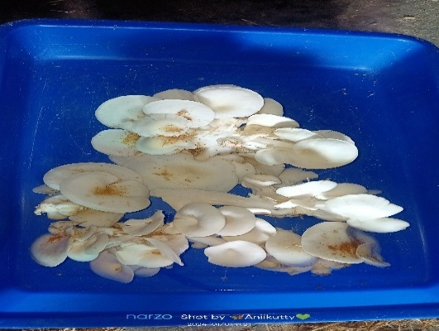 | 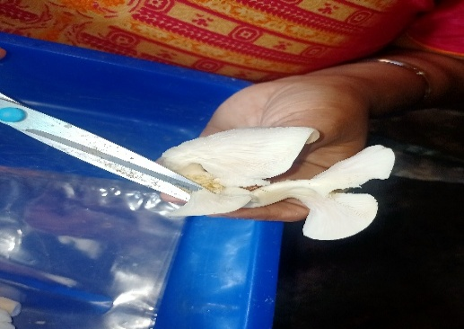 | 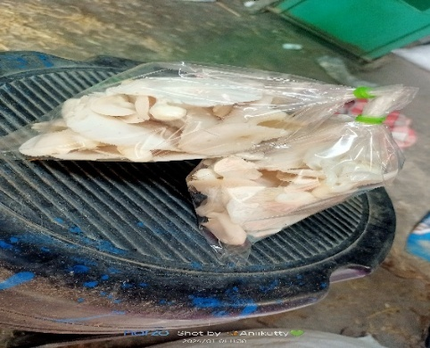
Powdering of fruiting bodies | Powder mixed with sugar and gelatin | Mixture boiled with water
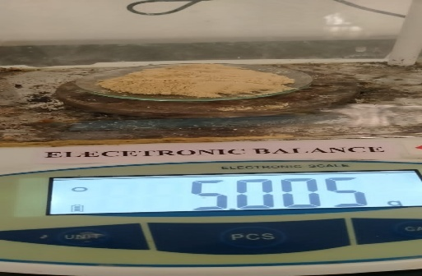 | 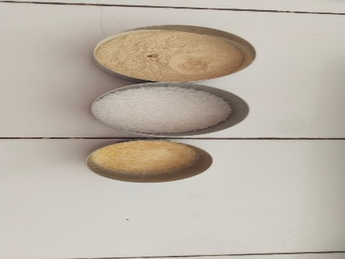 | 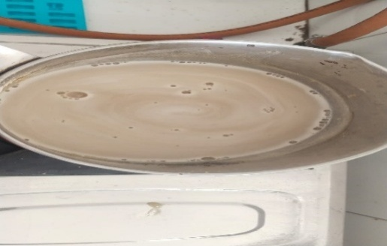
Boiled mushroom extracts | Poured the mixture to molds
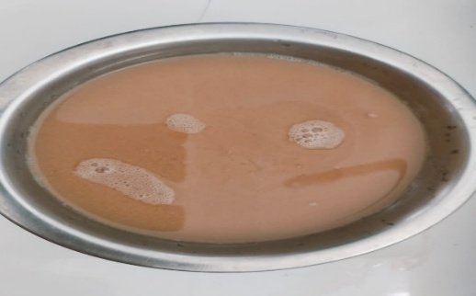 | 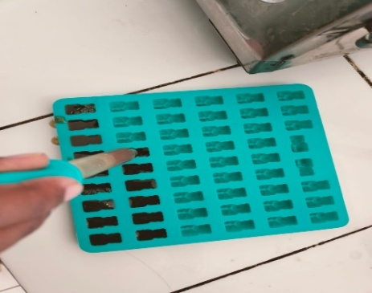
Mushroom Gummies
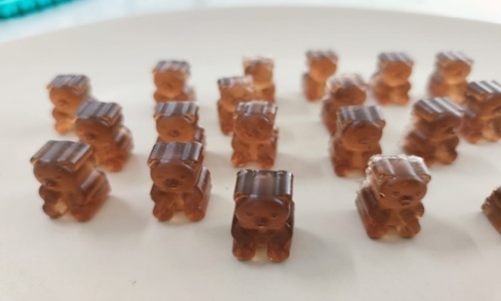 | 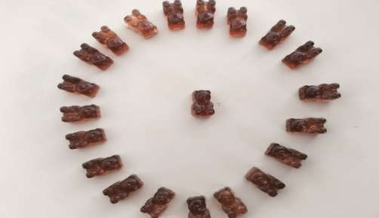

DISCUSSION
The study demonstrates that substrate type and supplementation significantly affect the growth and yield of Pleurotus sajor-caju. Paddy straw supplemented with rice bran produced the fastest mycelial growth, shortest colonization and primordia initiation periods, and the highest yield and biological efficiency, consistent with reports highlighting the role of rice bran as a nitrogen- and carbohydrate-rich supplement (Pokhrel et al., 2013). Banana leaves resulted in poor performance, likely due to limited cellulose availability and lower lignin degradability (Mondal et al., 2010). Weekly observations confirmed rapid mycelial colonization on rice bran–bran-supplemented paddy straw, in agreement with earlier findings on rice straw substrates (Ahmed, 1986; Onuoha et al., 2009). Maize straw with rice bran showed comparable performance, whereas cottonseed supplementation was less effective, contrary to some earlier reports (Sardar et al., 2020).
Organoleptic evaluation is a simple and cost-effective tool for the standardization and identification of crude natural products (Rakholiya and Chanda, 2012). In this study, untreated P. sajor-caju powder appeared yellowish white, with minor colour variations observed after treatment with different chemical reagents, aiding preliminary identification and quality assessment. The mushroom powder showed brownish colour in visible light and yellowish-brown fluorescence under UV light (254 and 365 nm). Such fluorescence variations indicate the presence of diverse bioactive constituents, consistent with earlier reports (Schulz and Baranska, 2007). Nutritional analysis revealed that P. sajor-caju cultivated on paddy straw supplemented with rice bran exhibited the highest protein, carbohydrate and crude fibre contents, with overall nutrient and amino acid profiles comparable to earlier reports on Pleurotus spp. (Wani et al., 2010). The presence of essential amino acids such as lysine, leucine and methionine highlights its value as a high-quality protein source for vegetarian diets. Moreover, heavy metal concentrations were within WHO-permissible limits, confirming the safety of mushrooms produced on these agro-residues. Phytochemical screening revealed the presence of bioactive constituents, including alkaloids, flavonoids, phenolics, glycosides, terpenoids, saponins and anthraquinone, corroborating earlier reports on the therapeutic potential of Pleurotus spp. (Renuga Devi and Krishnakumari, 2015).
The successful formulation of mushroom gummies highlights the scope for developing innovative functional foods. Similar incorporation of mushroom powder into confectionery and bakery products has been previously reported (Arumuganathan et al., 2005). Such value-added products not only minimize post-harvest losses but also offer consumers nutritious, protein-rich and low-fat functional foods.

CONCLUSION
The study demonstrates that substrate type and supplementation significantly influence the cultivation performance of Pleurotus sajor-caju. Paddy straw and maize straw were the most suitable substrates, with rice bran supplementation yielding the highest biological efficiency. Nutritional analysis confirmed that P. sajor-caju is rich in protein, carbohydrates, essential amino acids and bioactive phytochemicals, while heavy metal levels remained within permissible limits, ensuring food safety. The successful development and sensory acceptance of mushroom-based gummies further highlight their potential as innovative value-added products capable of reducing post-harvest losses and expanding consumer choices. Overall, the findings emphasize the dual benefits of oyster mushroom cultivation: efficient agro-residue utilization and the production of safe, protein-rich functional foods.
Data availability: The data that support the findings of this study are available within the article.
Declarations: Conflict of interest. The authors declare no competing interests

REFERENCES

- Ahmed, S. 1986. Cultivation of oyster mushroom (Pleurotus spp.) in Bangladesh. Bangladesh Agricultural Research Council Report. Dhaka.
- American Public Health Association (APHA). 1995. Standard Methods for the Examination of Water and Wastewater (19th ed.). Washington, DC: APHA.
- Anonymous. 1985. Indian Pharmacopoeia, Government of India (3rd Edition). Controller of Publication, New Delhi.
- AOAC. 2005. Official Methods of Analysis. 18th ed. Washington, DC: Association of Official Analytical Chemists.
- Arumuganathan, T., Rai, R.D. and Hemkar, A.K. 2005. Studies on the development of value-added products from fresh button mushroom Agaricus bisporus. Mushroom Res, 14(2): 84-87.
- Bano, Z. and Srivastava HC. 1962. Studies on cultivation of Pleurotus species on paddy straw. Food Science. 12: 363–365.
- Barros, L., Cruz, T., Baptista, P., Estevinho, L.M. and Ferreira, I.C. 2008. Wild and commercial mushrooms are a source of nutrients and nutraceuticals. Food and Chemical Toxicology, 46(8): 2742-2747.
- Bhatti, MA., Mir, FA. and Nawaz, R. 1987. Studies on oyster mushroom cultivation. Pakistan Journal of Agricultural Research. 8: 205–210.
- Chandra Pokhrel., Neelam Kalyan., Usha Budathoki. and Ram Kailash Yadav. 2013. Cultivation of Pleurotus sajor-caju using different agricultural residues. Inter., J., of Agricul., Policy and Res., 1(2), 019-023.
- Chang, ST. and Hayes, WA. 1981. Yield and efficiency in mushroom cultivation. Mycologia. 73(6):130–135.
- Chang, ST and Miles, PG. 1982. Edible Mushrooms and Their Cultivation. Boca Raton: CRC Press.
- Chang, R. 1996. Functional properties of mushrooms. Nutrition Reviews. 54: 91-93.
- Elaine, M. and Tan, N. 2009. Makes Money by Growing Mushrooms, in, FAO. Food and Agricultural Organization.
- Gupta, S., Sharma, V. and Sharma, S. 2016. Potential of oyster mushroom cultivation for sustainable livelihood in rural areas of India. Inter., J., of Current Microbiol., and Applied Sci., 5(4):157–164.
- Gupta, S., Summuna, B., Gupta, M. and Annepu, S.K. 2018. Edible mushrooms: cultivation, bioactive molecules, and health benefits. Bioactive molecules in food, 1, 1-33.
- Harborne, JB. 1973. Phytochemical Methods: A Guide to Modern Techniques of Plant Analysis. London: Chapman and Hall.
- Harborne, J.B. 1973. Phytochemical methods, Chapman and Hall, London (1st ed.). 33-35.
- Hedge, JE. and Hofreiter, BT. 1962. Estimation of carbohydrate by anthrone method. In: Whistler RL, Wolfrom ML, editors. Methods in Carbohydrate Chemistry. 17. New York: Academic Press. 420–424.
- Kaul, T.N. 2001. Biology and Conservation of Mushrooms. Oxford & IBH Publishing Co. Pvt. Ltd. New Delhi. India. 117-145.
- Kokoshi, C.J., Kokoshi, R.J. and Sharma, P.J. 1958. Fluorescence of powdered vegetable drugs under UV radiation. Jou., American Pharm. Asso., 47: 715-717.
- Kurt, S. and Buyukalaca, S. 2010. Yield Performances changes in enzyme activities of Pleurotus spp. (P. ostreatus and P. sajor-caju) cultivated on different agricultural wastes. Biores. Technol., 101:3164-3169.
- Livi-Bacci, M.A. 2012. A concise history of world population, 5th ed. Malden (MA): Wiley-Blackwell.
- Moloughney, S. 2011. Functional confectionery: finding the sweet spot. Nutraceuticals World. https://www.nutraceuticalsworld.com/issues/2011-03/view_features/ functional-confectionery-finding-the-sweet-spot/.
- Mondal, SR., Rehana M. and Pervin F. 2010. Comparative study on the cultivation of oyster mushroom (Pleurotus ostreatus) on different substrates. Bangladesh Research Publications Journal. 4(1):45–52.
- Moore, S., Spackman, DH. and Stein WH. 1958. Chromatography of amino acids on sulfonated polystyrene resins. Analytical Chemistry. 30(7):1185–1190.
- Onuoha, CI., Akueshi, CO. and Gyar, SD. 2009. Cultivation of Pleurotus species on agricultural wastes. African Journal of Biotech., 8(20):5091–5095.
- Pizzoni, D., Compagnone, D., Di Natale, C., Alessandro, N. and Pittia, P. 2015. Evaluation of aroma release of gummy candies added with strawberry flavours by gas-chromatography/mass-spectrometry and gas sensors arrays. Jou. Food Eng., 167: 77–86.
- Pokhrel, CP., Ohga, S. and Adhikari, MK. 2013. Growth and yield performance of oyster mushroom (Pleurotus ostreatus) on different substrates. Journal of Eco biotechnology. 5(1):15–20.
- Rakholiya, K., Kaneria, M. and Chanda, S. 2012. Physicochemical and phytochemical analysis of different parts of Indian Kesar mango – a unique variety from Saurashtra region of Gujarat. Pharmacog., Jou., 8(5), 502–506.
- Rangad, G., Girmay, Z. and Moges A. 2014. Cultivation and yield performance of Pleurotus species. Jour., Applied Biology and Biotech., 2(1):1–6.
- Rathore, H., Prasad, S. and Sharma S. 2019. Mushroom nutraceuticals for improved nutrition and better human health: A review. Pharma Nutrition. 7:100–120.
- Renuga Devi, K. and Krishnakumari, S. 2015. Phytochemical screening and antioxidant activity of oyster mushroom. Inter., Jou., Pharmaceutical Sci., Review and Res., 31(1):23–27.
- Romo-Zamarron, K.F., Pérez-Cabrera, L.E. and Tecante, A. 2019. Physicochemical and sensory properties of gummy candies enriched with pineapple and papaya peel powders. Food and Nutri., Sci., 10(11), 1300–1312.
- Sardar, H., Naseer, A. and Bashir, M. 2020. Effect of different substrates on growth and yield of oyster mushrooms (Pleurotus spp.). Pakistan Jou., Phytopathology. 32(2):195–202.
- Satish, K., Sharma, V.P., Shirur, M. and Kamal, S. 2017. Status of milky mushroom (Calocybe indica) in India – a review. Mushroom Res. 26(1): 21–39.
- Schulz, H. and Baranska, M. 2007. Identification and quantification of valuable plant substances by IR and Raman spectroscopy. Vibrational Spectroscopy, 43(1), 13–25.
- Shu, Y.T., Tsai, P.W., Shih, J.H. and Jeng, L.M. 2007. Agaricus bisporus is harvested at different stages of maturity. Food Chem., 103: 1457-1464.
- Wani, B.A., Bodha, R.H. and Wani, A.H. 2010. Nutritional and medicinal importance of mushrooms. Jour., Medicinal plants res., 4(24), 2598-2604.
- Wasser, S.P. and Weis, A.L. 1999. Medicinal properties of substances occurring in higher Basidiomycetes mushrooms: current perspectives. Int Jou., Med Mushrooms. 1: 31–62.
- Wasser, S.P. 2002. Review of medicinal mushroom advances: Good news from old allies. Herbal Gram. 56: 28–33.
- Zhang, R., Xiujin, L. and Fadel, JG. 2002. Oyster mushroom cultivation with rice and wheat straw. Biores. Technol., 82:277-284.

