PREDICTING OF MOISTURE RATIO FOR BITTER LEAF (VERNONIA AMYGDALINA) USING ARTIFICIAL NUERAL NETWORK

ABSTRACT
This was developed artificial neural network model for predicting the moisture ratio of bitter leaf (Vernonia amygdalina) utilizing drying time, drying rate and temperature as input parameters. Bitter leaf was dried in an oven dryer at four different temperatures (40 ºC, 50 ºC, 60 ºC and 70ºC) and the experimental data gotten was used to train the network using different configurations which consisted of different number of neurons and transfer functions. The best performing model was adjudged using the mean square Error value and was selected to predict the moisture ratio of bitter leaf. It consisted of four hidden neurons and used the tangent sigmond transfer function. The model gave a mean square error value of 0.00011205 and an R-value of 0.999. The regression coefficient (R²) value for the correlation between the predicted and experimental outputs for the model was 0.998. These results proved that the model developed showed good generalization. ANN helps in predicting fast, accurate, efficient and a reliable tool. It is recommended that other drying techniques be used for drying the product (bitter leaf).

Keywords: Bitter leaf, Drying, Moisture ratio, Prediction, Artificial Neural Network

1.0 INTRODUCTION:
Bitter leaf (Vernonia amygdalina) is a shrub or small tree of 2-5m with petiolate leaf of about 6mm diameter and elliptic shape. The East African country of Tanzania is traditionally linked to this plant and it can be found growing wild along the edges of agricultural field (Ogbonda and Kabari, 2013). It is grown domestically, bitter leaf grows under a range of ecological zones in Africa and produces large mass of forage and is drought resistant (Bonsi et al., 1995). It is called bitter leaf in English because of its bitter taste. In Nigeria, it is known variously as ewuro in Yoruba, Onugbu in Igbo, oriwo in Bini, ityuna in Tiv, chusardoki in hausa while it is known as etidot in Ibibio and efik (Farombi and Owoeye, 2011).

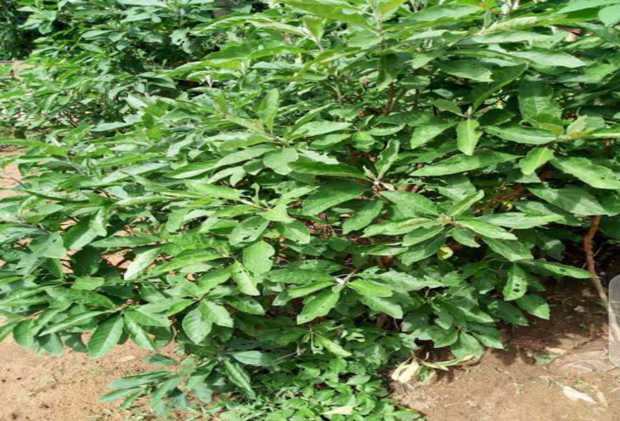
Figure 1: Bitter leaf plant
Table 1: Scientific Classification of Bitter Leaf
Kingdom | Plantae
Division | Angiosperms
Order | Asterales
Family | Asteraceae
Genus | Vernonia
Species | v.amygdalina
Source: Sani et al., 2012
Bitter leaf has a grey color or green coloured bark which has a rough texture. As it name suggests, bitter leaf has a bitter taste with a characteristic odour. Propagation by seed is possible but most farmers use stems cuttings. Cuttings are selected on the basis of attribute such as degree of bitterness, leaf size and growth characteristic. The bitter taste of Vernonia amygdalina is as a result of its anti-nutritional components such as alkaloids, saponins, glycocides (Bonsi et al., 1995).
The importance and benefits of bitter leaf are numerous but not limited to: soups, are a staple food here in Africa and green leafy vegetables are very much useful in soup preparations. Bitter leaf in spite of its bitter taste is usually washed and used to prepare various kinds of soups. The washing is usually done to get rid of the bitter taste which for most people is undesirable. Bitter leaf is known to have several health benefits such as in treatment of fever (Ogbonda and Kabari, 2013). Chimpanzees ingest the bitter pith of Vernonia amygdalina for the control of intestinal nematode infections. It is also used in place of hops to make beer in Nigeria. Bitter leaf is also found in homes in Nigeria as fence post and pot herb. It has also been fed to broilers, where it was able to replace 300g kg-¹ of maize-based diet without affecting feed intake, body weight gain and feed efficiency (Teguia et al., 1993). Bitter leaf plant is found in abundance here in Nigeria where it is used both as food and as medicine. It is highly sought after due to the following health benefits: Bitter leaf is rich in vitamin C, a great antioxidant mineral which plays a vital role in the body, it maintains bones and teeth, vitamin E serves as an antioxidant fighting against free radicals that have harmful effects on the body, bitter leaf contains flavonoids which has powerful antioxidant effects and helps in the treatment of various diseases such as fever, it aids in the area of body weight by increasing the metabolic rate which in turn leads to increased fat loss, vitamin B1 is responsible for this benefit, its antifungal and antibacterial properties treats skin infections such as ringworms, eczema, etc. (Ogbonda and Kabari, 2013).
In a study conducted by Gideon et al. (2019) on dried bitter leaf. It was discovered that the leaves of Vernonia amygdalina (bitter leaf) are enriched with highly nutritional components. These are summarized in Table 2.

Table 2: Proximate compositions of Vernonia amygdalina
PARAMETER | MEAN VALUES (%)
Protein | 42.52±0.25
Moisture | 2.4±0.5
Ash | 4.26±0.2
Fat | 6.5±0.29
Crude fiber | 3.83±0.02
Carbohydrate | 40.47±0.07
Dry matter | 97.6±0.05

Moisture is an integral part of all leafy vegetables. This moisture content is responsible for its highly perishable nature as well as its freshness. Regardless of this flaw, vegetables which are major sources of vitamins, minerals, fiber and other plant bioactive compounds like antioxidants important for human health and well-being (James and Athanasia, 2016) are being sought after.
For the purpose of preservations, it is necessary to reduce if not completely eliminate the moisture content of these vegetables. Moisture removal from agro-industrial plants by thermal drying is an integral part of food processing. While it is often an essential step, drying can be energy intensive and destructive of a product’s appearance and nutritional value. Stabilization at minimal cost is an ongoing research and development focus, and considerable progress is being made (James and Athanasia, 2016).
Leafy vegetables are known to be seasonal. They do not grow all year round. They mostly thrive during rainy seasons and in dry season become scarce. There therefore exists a need to apply the most suitable preservation technique while also retaining its nutritional value. However, the preservation technique may lead to the loss of some of the characteristics which initially made them consumer delight (Oladele and Aborisade, 2009).
Drying is defined as the process of moisture removal due to simultaneous heat and mass transfer. In simpler terms drying refers to the process of moisture removal from a material by exposing it to a heat source. Drying vegetables result in both nutrient and culinary losses. These losses however vary with the drying technique employed (Oladele and Aborisade, 2009; Inyang et al., 2017). There are many drying techniques but the cheapest and most commonly used in Nigeria is sun-drying (Oladele and Aborisade, 2009). This involves, in the case of leafy vegetables spreading the leaves in the open sun. Improved drying methods include oven, solar, osmotic and freezer drying. Regardless of the drying technique used, a unique theoretical setting of drying has to be determined through the balance of the heat flow, temperature changes and moisture flow (James and Athanasia 2016). There are several drying methods such as sun, oven, osmotic, freeze, drum, solar, microwave, infra-red, spray, vacuum, foam mat, impingement, acoustic, explosion puffing, hybrid, etc (Inyang et al., 2017)
Drying of wet materials is a complex, dynamic, unsteady, highly non-linear, strongly interactive, successfully interconnected and multi-variable processes whose underlying mechanisms are not yet perfectly understood (Aghbashlo, et al., 2018).
Therefore, it is necessary to predict the moisture ratio of the product (bitter leaf) for preservation to avoid deterioration or spoilage of the product, thus, it will help preserve, elongate the shelf-life, provide easy transportation for handling, and this will enhance the accuracy and efficiency of predicting and optimizing the shelf life of the bitter leaf. However, this gives useful insight into the drying mechanisms, easy control of drying process, and optimum product output. Hence, this work seeks to predict and develop an ANN model for the drying of bitter leaf.

1.1 Overview of artificial neural network (ANN)
Artificial neural networks (ANNs), usually referred to as neural networks (NNs), are computing systems vaguely inspired by the biological neural networks that constitute human brains. An ANN is an interlinked set of simulated neurons (nodes, inspired by a simplification of neurons in a brain) which are made up of several input signals with synaptic weights. In an ANN model structure, each circular node represents an artificial neuron and an arrow depicts a connection from the output of one artificial neuron to the input of another. An ANN model simply sums the products of inputs and their corresponding connection weights (w) and then it passes it through a transfer or activation function to get the output of that layer and feed it as an input to the next layer. A bias term is often added to the summation function in order to raise or lower the input which is received by the activation function. The activation function does the nonlinear transformation to the input making it capable to learn and perform more complex tasks (Inyang et al., 2021) 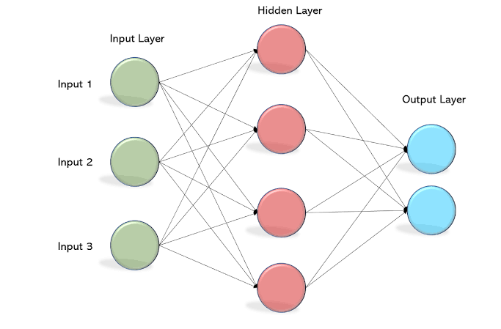
Figure 2: A Typical Multilayer perceptron network structure

1.2 APPLICATIONS OF ANN IN DRYING TECHNOLOGY
Application of the ANN paradigm in drying technology up to 2015 has been comprehensively reviewed by Aghbashlo et al., (2018). In situations where the relationship between various variables describing the drying problem is complex and ill-defined, the widely used ANN can provide a platform where these problems can be solve with reasonable accuracies and computation times (Kalogirou, 2001).
ANN models are widely accepted since it solves the problem of complexity associated with mathematical models. Generally, ANN has been used in drying technology for modeling, predicting and optimization of heat and mass transfer thermodynamic performance parameters and quality indicators as well as physiochemical properties of dried products (Aghbashlo et al., 2018). Important researches has been carried out on the applications of ANN technology for modelling, monitoring and controlling different drying processes as cited by Aghbashlo et al., (2018). Cubillos and Reyes (2003) satisfactorily predicted the moisture of carrot cubes in a fluidized based dryer using a structural modular ANN model with two sublayers of linear and sigmoidal nodes in the hidden layer. Movagharnejad and Nikzad (2007) predicted the moisture ratio of tomato during the drying process in a pilot plant tray drier using a one hidden layer MLP ANN model. Hosseinpour et al., (2011) successfully predicted hot air and superheated steam drying kinetics and geometrical properties of shrimp batch using two MLP ANN models developed based on image texture features. Saraceno et al., (2012) successfully predicted the moisture ratio of cylindrically and slab shaped potato and carrot samples during a hot air drying using a hybrid ANN model obtained by integrating one hidden layer MLP ANN model and Newton thin layer drying model. Drâgoi et al., (2013) developed a soft sensor for freeze-drying process using a recurrent BP-trained ANN optimized by differential evolution algorithm based on the database obtained from a one-dimensional phenomenological model. The interpolation and extrapolation accuracy of the developed sensor was then experimentally confirmed to monitor temperature and thickness of sucrose aqueous solution in an inline manner. Khawas et al., (2014) found that an MLP ANN model was more accurate compared with RSM model for predicting the quality attributes of culinary bananas during vacuum drying. Perazzini et al., (2014) precisely predicted the residence time distribution of citrus waste particles in a semi- pilot scale rotary drier using a one hidden layer MLP ANN model. Prakash and Kumar (2014) successfully predicted jaggery fruit drying process parameters that is drying rate, product temperature and greenhouse air temperature using three exclusive ANFIS models. Kurtulmus et al., (2014) successfully discriminated tarhana drying methods, that is sun-drying, oven drying and microwave drying using K- nearest neighbors and ANN classifiers developed on the basis of SDA-based selected image texture features. Tarafdar et al., (2017) successfully predicted water activity of button mushrooms during freeze-drying using a one hidden layer MLP ANN model. They claimed that the developed model can reduce energy consumption of freeze-drying process. Bai et al., (2018) successfully predicted the drying kinetics and color changes of Ginkgo biloba seeds during drying process in a microwave drier using the BP neural network model. Inyang and Bassey (2021) carried out prediction of the moisture of atama (Heinsia Crinita) leaves using ANN with oven drying. Inyang et al., (2021) predicted the drying parameters of cocoyam with ANN using oven drying. Adum and Inyang (2024) used ANN and RSM for the optimization of drying parameters for hot leaves (piper guineense) using oven drying. Inyang and Samuel (2025) predicted the shelf life of onions using ANN with oven drying.
According to the findings from the aforementioned surveys, ANN technology can be a useful modeling and controlling tool with a wide variety of application for various drying systems (Aghbashlo et al, 2018; Inyang and Obunikut, 2022). In this work ANN modelling will be used to predict the drying parameters of bitter leaf.

2.0 MATERIALS AND METHODS:

2.1 Raw Materials Collection
Fresh bitter leaf (Vernonia amygdalina) bunch was used in this work. The bitter leaf was sourced locally from a compound in Use offot, Uyo Local Government Area, Akwa Ibom State. The sample was then taken to the chemical Engineering laboratory, University of Uyo for the drying experiment. The equipment used in this work were knife, chopping board, weighing balance, tray for drying, oven dryer and plastic container for storage.

2.2. Sample preparation
The fresh bitter leaf was plucked and washed to get rid of dust and other contaminants after which they were chopped into shreds using a knife and chopping board. The leaves were then evenly spread in the tray to ensure effective drying in consonance with the thin layer model which describes the drying phenomenon in a unified manner regardless of the control mechanism in the drying of agricultural products (Yaldyz and Ertekin, 2001).

2.3 Methods/Procedure
The drying experiments were conducted using four drying temperatures (40°C, 50°C, 60°C and 70°C). The laboratory dry oven (model DHG-9101) was preheated to the desired temperature before loading the samples. 50±0.01g sample of shredded bitter leaf was weighed using a digital weighing balance (Adam Equipment accurate balance, PGW 2502E, readability 0.01g). To determine the initial moisture content of the sample, 5g of the sample was dried to constant weight at 105°C for 3 hours. The initial moisture content was then calculated using the AOAC methods (AOAC, 1990).
${ M}_{0}=\frac{W_{1}-W_{2}}{W_{1}}×100$ Equation 1

Where W₁ equals initial weight of sample and W₂ equals weight after drying

The oven drying process was kick-started by spreading the sample on an aluminum tray and then placing it inside the oven under selected temperature. The oven door was opened at 10 minutes time interval and the weight loss of the sample was recorded. Drying continued till constant weight of sample was attained.

2.4 Selection of Best Input and Target Parameters
Artificial neural networks require sufficient data. This is a necessity and for optimal performance of the network, choosing the best parameter to use is equally as important as more input parameters than required will result in a large network size and reduction in the learning speed and efficiency. The input parameters for this work are drying time, temperature and drying rate, while the target output was moisture ratio (MR). The parameters are defined below:

2.4.1 Moisture Content
This is simply how much water is in a product. It influences the physical properties of a substance including weight, density, viscosity, conductivity and others. It is generally determined by weight loss upon drying (Adum and Inyang, 2024). The wet basis moisture content can be calculated as:
$MC=\frac{W_{i}-W_{f}}{W_{i}}×100$ Equation 2
Where W_{i} equals weight of sample moisture plus dry matter, and W_{f} is weight after drying.

2.4.2 Moisture ratio
Moisture ratio is the ratio of the moisture content at any time to the initial moisture content of the sample. (Inyang and Bassey, 2021). It is a dimensionless quantity expressed as
$MR=\frac{Mt}{M_{o}}$ Equation 3
Where M_{t} is the moisture content at any time, t and
M_{o} is the initial moisture content

2.4.3 Drying rate
This is the rate at which internal moisture evaporates to the surroundings. It is dependent on the rate at which heat is applied to the product and the rate at which moist air is removed from the surroundings (Inyang and Samuel, 2025). It is expressed as
$DR=\frac{W_{t}-W_{t+dt}}{t}$ Equation 4
Where W_{t} equals to moisture content at any time, t and W_{t+dt} equals moisture content at time t+dt.

2.4.4 Drying temperature
Lower relative humidity promotes faster evaporation and subsequently faster drying. As the temperature of the air is increased, it can absorb more liquid and therefore the relative humidity is decreased. The temperatures range used were for drying of leaves (Inyang and Bassey, 2021).

2.4.5 Drying time
This is the time it takes to remove moisture from a product. The drying time is dependent on the moisture content and drying temperature.

3.0 RESULTS AND DISCUSSION
The drying experiment of bitter leaf at air temperatures of 40ºC, 50ºC, 60ºC and 70ºC continued until the moisture content of the samples reached 0.41(w.b). As is seen, increase in the air temperature from 40ºC to 70ºC results in a decrease in the final drying time of the product. The drying times for bitter leaf were 850, 420, 330 and 170mins at 40⁰C, 50⁰C, 60⁰C and 70ºC respectively. This implies that with the increase of air temperature makes the amount of moisture removed from the bitter leaf sample to be decreased (Adum and Inyang, 2024).

Table 3: Statistical properties of best selected input parameters
PARAMETER | MINIMUM | MAXIMUM | AVERAGE | STANDARD DEVIATION
Drying Time (mins) | 0 | 850 | 291.2707 | 229.3421478
Temperature (ºC) | 40 | 70 | 49.11602 | 10.28984492
Drying rate (ºC/mins) | 0 | 0.473 | 0.097066 | 0.104601

3.1 Artificial Neural Network (ANN) Model
Using a partition ratio of 70:15:15, the number of data points for training, validation and testing were selected as 127, 27 and 27 respectively. The selected neural network consisted of a single hidden layer with 4 neurons and an output layer. This configuration was arrived at after testing different configurations (ANN[3-3-1], ANN[3-4-1], ANN[3-5-1] and ANN[3-10-1]) to effectively and efficiently predict the moisture ratio of bitter leaf. Testing different configurations ensures that the most reliable ANN structure is chosen to recognize patterns, learn and predict the desired output with minimal errors. The configuration that performs best as adjudged by the MSE value and R² can then be used to predict the output it was trained for. The performances in training, validation and testing of the selected model configuration are shown in Figure 6 for the single-layer (ANN[3-4-1]) model.

3.2 Design of Network Architecture
ANN models typically consist of input, hidden and output layers. The number of neurons in the input and output layers are determine by the number of input and output parameters. The first layer is the input layer; the second is the hidden layer where computation takes place. The output layer represents the outputs of the problem, and consists of certain number of neurons based on the number of output parameters. A single hidden layer was chosen consisting of 4 neurons to train the network (Inyang and Obunikut, 2022).
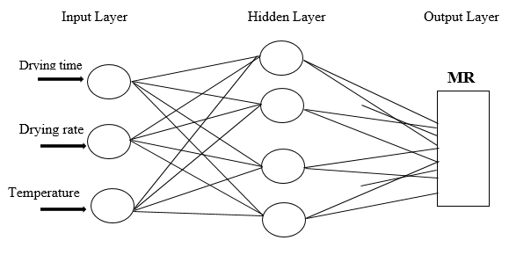
Figure 3: Network topology

3.3 Artificial Neural Network (ANN) Training
To train the ANN model, MATLAB software which has ANN as one of its features was used. This was accomplished with the command window using the nntool command. Training the network dropped error towards zero. Lower error does always mean a better network. To train the network the Levenberg-Marquardt training algorithm was used in training the input and target datasets. Training the dataset adjusts the weights on the neural network. Figures 4 and 5 show the ANN training user interface. (Inyang and Bassey, 2021).

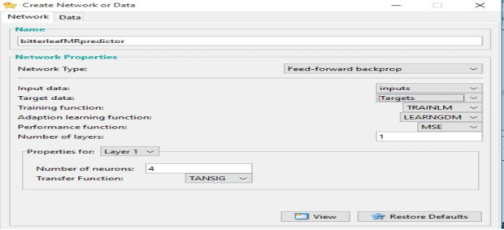
Figure 4: ANN Interface for selection of data and training specifications

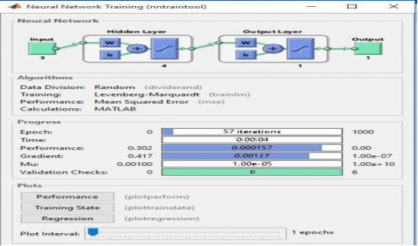
Figure 5: ANN training interface

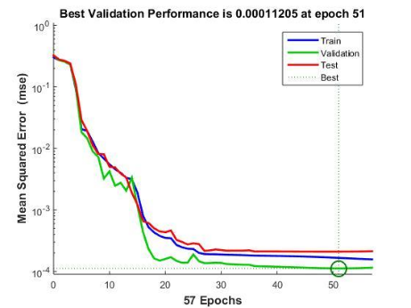
Figure 6: Performances in training, validation and testing

Figure 6 shows how the mean squared error (MSE) decreases, during training, validation and testing, as the number of epoch increases. The optimal performance of the neural network was observed to occur at the 51st epoch with an approximate MSE value of 0.00011205. This signified that the neural network learned better as the number of epochs increased. The neural network was trained using the Levenberg-Marquardt training algorithm. The Levenberg-Marquardt training algorithm was used particularly because it takes a less amount of time compared to others. The ‘3’ in the notation refers to the total number of variables in the input layer (i.e drying time, temperature, and drying rate), while ‘4’ refers to the 4 neurons in the single hidden layer while the last ‘1’ denotes the number of output parameter (Moisture ratio). The regression plots for training, testing, validation and the overall plot are shown in Figure 7. (Adum and Inyang, 2024; Inyang and Samuel, 2025).
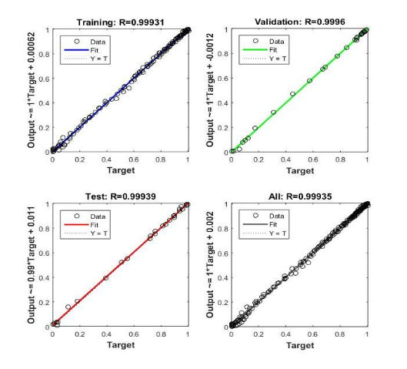
Figure 7: Regression analysis plots for training, validation, and testing all datasets
The Regression Analysis Plots show that the linear regression fit to the data points and match the predicted output to the actual target. The correlation coefficients for training, validation and testing were 0.99931, 0.9996 and 0.99939 respectively as well an overall coefficient of 0.99935. With these values of R, It can be concluded that the ANN model has performed perfectly well (Inyang and Bassey, 2021; Inyang et al., 2021)

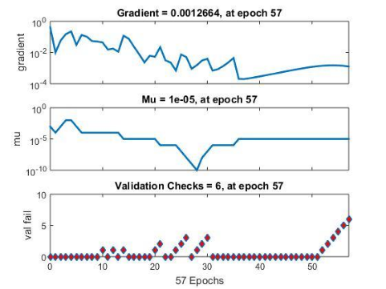
Figure 8: Network gradient plot, Mu plot and validation checks

Figure 8 shows the gradient descent, Mu and validation checks plots. The gradient descent is an optimization algorithm that minimizes some functions by iteratively moving in the direction of steepest descent as defined by the negative of the gradient. The gradient descent is used to update the parameters of the model. At the 57th epoch, the gradient is 0.0012664. Mu, which means momentum update, is the approximate training gain. Mu is the control parameter for the algorithm used to train the neural network. Validation protects the ability to generalize to non-training data. It equally stops training when the non-training validation subset error rate increases continuously for more than 6 (default) epochs. The validation subset error rate is therefore slightly biased (Inyang and Samuel, 2025).

Table 4: Summary of results
Input parameters | Time, Temperature, Drying rate
Output parameter | Moisture Ratio
Partition ratio | 70-15-15
Network topology | 3-4-1
Training algorithm | Levenberg Marquardt
Network type | Feed forward back propagation
Transfer function | TANSIG
R | 0.9996
MSE | 0.00011205

Table 4 shows the parameters, the training algorithm employed, performance summary expressed by the R and MSE values.

3.4 Artificial Neural Network Based Equation
The assignments of weights and biases to the variables were performed. The letters ‘W’ and ‘b’ denote weights (W) and biases (b). The values for weights and biases were automatically generated by the network. The crucial relationship between the weights, bias and is linearly developed using Equation 5 carefully outlined below:
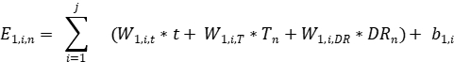 Equation 5
Where W_{1,i,t}, W_{1,i,T}, W_{1,i,DR} refer to the weights assigned respectively to the drying time (t), temperature (T), and drying rate (DR); ‘b_{l,i}’ is the bias at the particular hidden layer (l) assigned to the neuron (i). ‘E_{l,i,n}’ refers to the nth sum of the weighted variables, based on the weight assignment in association with the ith neuron at the hidden layer (l); j is the last count of neuron in the network.

Table 5: Summary of weights and bias
Hidden layer 1 | W_{1,I,t} | W_{1,I,th} | W_{1,I,T} | Bias | bias_{O}
1 | -7.6758 | 1.1211 | -0.57953 | -7.0048 | 0.83073
2 | 2.8033 | -8.212 | -0.0219 | -9.6647 | 0.83073
3 | -2.5223 | -1.1064 | -0.02353 | 0.29254 | 0.83073
4 | 0.8773 | 0.91994 | -0.27278 | 1.1856 | 0.83073

The weights and biases shown in Table 5 were by default generated by the network. The ‘E_{1,i,n}’ value can be readily determined by multiplying the appropriate weights (in Table 5) with independent variables in Equation 5 . The transfer function used is mathematically expressed below as:
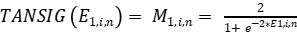 Equation 6
It is pertinent to state that the description is limited to the single-hidden layer model used. The final output is given here:
Equation 7
Where W_{o,i} and b_{o} are the weights and bias at the output layer (o) respectively;
b_{o} = 0.83073
(Adum and Inyang, 2024; Inyang and Samuel, 2025).

3.5 Predicting of moisture ratio using ANN
ANN can predict the moisture ratio as a function of time, temperature and drying rate accurately as proven by this work. Onwude et al. (2016) predicted the moisture ratio for pumpkin using final drying time, microwave power and moisture content as input parameters. The Levenberg-marquardt training algorithm was used in training the network while TANSIG was selected as the transfer function. The model had a R² value of 0.990 and RMSE value of 0.036. Kumar et al. (2016) successfully predicted the moisture ratio for green chickpea using time and hydrating temperature as input parameters and TANSIG as transfer function. Again, the Levenberg-Marquardt algorithm was used to train the network. The developed model had an R value of 0.9 and MSE of 0.02. For this work, the experimental data was fed to the network and trained with the Levenberg-Marquardt training algorithm while TANSIG was selected as transfer function. With a learning rate of 0.001 and 4 nodes in the hidden layer, the model predicted the moisture ratio quite well in the entire range of data with an MSE value of 0.00011205 and R² value of 0.9996. In addition, the regression analysis from MS Excel returned an R² value of 0.9989 as shown in Figure 9 (Inyang and Bassey, 2021, Adum and Inyang, 2024; Inyang and Samuel, 2025).
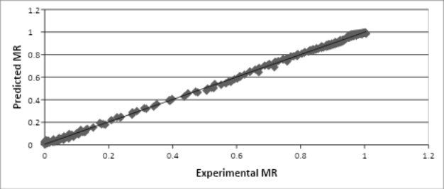
Figure 9: Predicted MR versus Experimental MR

4.0 CONCLUSION
Moisture which is very high in vegetables is often removed for the purpose of Preservation. This research work gives solution to the problem of optimization as it relates to drying of agricultural products such as bitter leaf under optimum conditions with the aim of yielding a high quality product, with it's nutritive value retained. Thus, fast and accurate modeling of drying systems is required to control drying process, to discount operating and energy costs, to enhance product quality, to increase manufacturing rate and to retrofit available drying systems. Hence, the ANN procedure is sensitive, reliable, fast, simple and low cost method for monitoring the authenticity of the product (bitter leaf) which provide customers with a safer food supply.
Drying experiments for bitter leaf were conducted at four different temperatures of 40°C, 50°C, 60°C and 70°C with the aim of generating drying data. The experimentally generated data (drying rate, drying time, temperature) was then used to train the ANN using the Levenberg-marquardt training algorithm. A feed forward back propagation neural network model with a 3-4-1 topology was developed. TANSIG was chosen as the transfer function for the model. The model performed excellently well with an MSE value of 0.00011205 and R value of 0.9996 which was a demonstration that ANNs are an accurate and effective tool for modeling drying systems. Also, the predicted moisture ratio from the ANN model demonstrated a good match with experimental data which confirms the reliability and accuracy of the ANN in data prediction. The model will eliminate the problem of complexity and time wastage usually encountered when using mathematical models in cases involving a wide range of parameters. The work will solve the common problems associated with preservation of bitter leaf.
It is recommended that Adaptive Neural Fuzzy Interface System (ANFIS) should be explored and other drying methods such as freeze drying and osmotic drying could be used.

REFERENCES
A.O.A.C. (1990) Official Methods of Analysis. 15th Edition, Association of Official Analytical Chemist, Washington DC. DOI: 10.1093/9780197610145.001.0001

Adum, U. U. and Inyang, U .E. (2024) Optimization of Drying Parameters of Hot Leaves (Piper Guineense) using Artificial Neural Network and Response Surface Methodology, Journal of Systematic and Modern Science Research, 4(9):28 – 44 . https://berkeleypublications.com/bjsmsr/article/view/164
Aghbashlo M., Soleiman H. and Mujumdar, A. (2018) Artificial Neural Network-Based Modeling and Controlling of Drying Systems, Intelligent Control in Drying 36(5): 155 - 172.
DOI: 10.1201/9780429443183-9

Bai, J. W., Xiao, H., Hai-Le Ma, H. and Zhou, C. (2018) Artificial Neural Network Modeling of Drying Kinetics and Color Changes of Ginkgo Biloba Seeds during Microwave Drying Process, Journal of Food Quality,8:1 – 8 https://doi.org/10.1155/2018/3278595
Bonsi, M. L., Osuji, P. O., Tuah, A. K. and Umunna, N. N. (1995). Vernonia amygdalina as a supplement to teff straw (Eragrosis tef.) fed to Ethiopian Menz sheep, Agrofor Systems, 31(3): 229 – 241 https://doi.org/10.1007/bf00712076

Cubillos, F. and Reyes, A (2003) Drying of Carrots in a Fluidized Bed. II. Design of a Model Based on a Modular Neural Network Approach January. Drying Technology 7(7):1185-1196 https://doi.org/10.1081/DRT-120023175
Dragoi, E. N., Curteanu, S. and Fissore, D. (2013) On the Use of Artificial Neural Networks to Monitor a Pharmaceutical Freeze-Drying Process, Drying Technology, 31(1):72-81
DOI: 10.1080/07373937.2012.718308

Farombi, O. and Owoeye, O. (2011) Antioxidative and Chemopreventive Properties of Vernonia amygdalina and Garcinia biflavonoid, International Journal of Environmental Research and Public Health 8(6):2533 - 55 DOI: 10.3390/ijerph8062533

Hosseinpour, S., Rafiee, S., Mohtasebi, S. S. (2011) Application of image processing to analyze shrinkage and shape changes of shrimp batch during drying. Drying Technology, 29(12):1416 – 1438.
DOI: 10.1080/07373937.2011.587620

James A. and Athanasia M. (2016) Solar-drying of vegetables for micronutrients retention and product diversification. American Journal of Research Communication, 4(8):1 - 13

http://dspace.nm-aist.ac.tz/handle/123456789/204

Inyang, U., Oboh, I. and Etuk, B (2017) Drying and the different Techniques, International Journal of Food Nutrition and Safety, 8(1):45 – 72 https://www.researchgate.net/publication/356187901_International_Journal_of_Food_Nutrition_a nd_Safety_2017_81_4572_International_Journal_of_Food_Nutrition_and_Safety_Drying_and_th e_Different_Techniques

Inyang, U. E., Jock, A. A. and Nkwocha, P. C. (2021) Prediction of Cocoyam Drying Parameters Using Artificial Neural Network, International Journal of Novel Research in Engineering and Science, 8(1):4 – 13 https://www.noveltyjournals.com/upload/paper/PREDICTION%20OF%20COCOYAM%20DRY ING.pdf
Inyang, U. E. and Bassey, V. J. (2021) Prediction of the moisture ratio of Atama (Heinsia Crinita) leaves using artificial neural network (ANN), International Journal of Engineering and Technology, 10 (2):232 – 240 DOI:10.14419/ijet.v10i2.31809

Inyang, U. E. and Obunikut, M. E. (2022) Artificial Neural Network and Their Applications in Food Materials: A Review, Engineering and Technology Journal, 07(04):1235 – 1248
DOI: 10.47191/etj/v7i4.06

Inyang, U. E. and Samuel, H. C. (2025) An Artificial Neural Network (ANN) Model to Forecast Onion Shelf Life, Current Journal of Applied Science and Technology, 44(8):1 – 10 DOI: 10.9734/cjast/2025/v44i84585

Kalgoriou, S. A. (2001). Artificial Neural Network in Renewable Energy Systems Application: A Review, Renewable and Sustainable Energy Review, 5: 373-401
DOI:10.1016/S1364-0321(01)00006-5

Kurtulmus¸ F., Gürbüz, O. and Degirmencioglu, N. (2014) Discriminating Drying Method of Tarhana Using Computer Vision, Journal of food process Engineering, 37(4):1-13
DOI: 10.1111/jfpe.12092

Khawas P., Arup D., Kumar K. D. and Sankar C. D., (2014). Thin-layer drying characteristics of Kachkal banana peel (Musa ABB) of Assam, India. International Food Research Journal, 21(3):975 – 982 https://www.researchgate.net/publication/262483950_Thin layer_drying_characteristics_of_Kachkal_banana_peel_Musa_ABB_of_Assam_India
Kumar, C., Joardder, M. U. H., Farrell, T. W., Millar, G. J. and Karim, M.A. (2016). Mathematical model for intermittent microwave convective drying of food materials. Drying Technology, 34(8): 962–973 DOI: 10.1080/07373937.2015.1087408
Movagharnejad, K. and Nikzad, M. (2007) Modeling of tomato drying using artificial network, Computers and Electronics in Agriculture, 59(1-2):78 – 85 DOI: 10.1016/j.compag.2007.05.003
Ogbonda G. E. and Kabari L. G. (2013). Heavy Metal Content in Bitter Leaf (Vernonia amygdalina) Grown along Heavy Traffic Routes in Port Harcourt, Journal of Food Science Technology, 51(9): 1654 – 1673 DOI: 10.5772/55604
Oladele, A. and Aborisade A. E. (2009) Influence of Different Drying Methods and Storage on the Quality of Indian Spinach (Basella rubra L.) American Journal of Food Technology 4(2):66-70. DOI: 10.3923/ajft.2009.66.70
Onwude D., Hashim N., Janius R., Nawi, N., and A. khalina (2016). Modeling the Thin-Layer Drying of Fruits and Vegetables: A Review. Comprehensive Reviews in Food Science and Food Safety 15(3):599-618. DOI: 10.1111/1541-4337.12196/pdf

Perazzini, H., Freire, F.B., Freire, J.T. (2014). Prediction of Residence Time Distribution of Solid Wastes in a Rotary Dryer, Drying Technology, 32: 428–436 DOI: 10.1080/07373937.2013.835317.

Prakash, O. and Kumar, A. (2014) ANFIS modelling of a natural convection greenhouse drying system for jaggery: An experimental validation, International Journal of Sustainable Energy, 33(2):316-335 DOI: 10.1080/14786451.2012.724070

Saraceno, A., Aversa, M. and Curcio, S. (2010) Advanced Modeling of Food Convective Drying: A Comparison Between Artificial Neural Networks and Hybrid Approaches, Food and Bioprocess Technology 5(5):1-12 DOI: 10.1007/s11947-010-0477-3

Sani, A. A., Alemika, E. T., Abdulraheem, R. O., Abdulkareem, S. S., Abdulraheem, R. B and Ilyas, M. (2012). A study review of documented phytochemistry of Vernonia amygdalina (Family Asteraceae) as the basis for pharmacologic activity of plant extract. Journal of Natural Sciences Research, 2(7):1- 7 https://www.academia.edu/82819165/A_Study_Review_of_Documented_Phytochemistry_of_Vernonia_amygdalina_Family_Asteraceae_as_the_Basis_for_Pharmacologic_Activity_of_Plant_Extract
Tarafdar, A., Shahi, N. C., Singh, A. and Sirohi, R.(2017) Artificial Neural Network Modeling of Water Activity: a Low Energy Approach to Freeze Drying, Food and Bioprocess Technology, 11(1):164-171 DOI: 10.1007/s11947-017-2002-4
Teguia, A., Tchoumboue, J., Mayaka, B. T. and Tankou C. M. (1993). The growth of broiler chickens as affected by the replacement of graded levels of maize by sweet potato leaves (Ipomea batatas) or Ndole (Vernonia spp.) in the finisher diet. Animal Feed Science Technology, 40 (2-3):181 – 196 https://doi.org/10.1016/0377-8401(93)90159-H

