Separating the Temporal Dynamics and Wealth Inequalities in Early Childbearing: Multilevel Statistical Analysis.

Abstract
Early childbearing remains a persistent global public health challenge, yet existing evidence is largely derived from cross-sectional or pooled analyses that ignore hierarchical data structures and within-country dependence. This study aims to quantify the temporal dynamics and socio-economic inequalities in national proportions of child, sexual, and early childbearing (CSEC) while addressing key statistical limitations in prior research. Analysis of the results indicates no statistically significant trend over time after accounting for the hierarchical relationship (β = 0.017, p = 0.254), suggesting irregular progress. Significantly positive relationships were found in both rural (β = 2.238, CI: 1.529-2.947) and urban (β = 2.069, CI: 1.462-2.677) settings. Wealth effects were non-linear, with the largest coefficients in the middle (β = 2.941) and fourth (β = 2.340) quintiles, challenging conventional poor-rich dichotomies. A substantial proportion of variance was attributable to between-country differences, confirming the inadequacy of pooled models. The novelty of this research lies in its equity-aware longitudinal multilevel framework, which overcomes independence and aggregation biases in earlier studies. Actionable recommendations include adopting hierarchical monitoring for SDG reporting, strengthening adolescent reproductive health services in both rural and urban settings, and targeting socio-economically transitional populations often overlooked in policy design.

Keywords: Global Maternal and Adolescent Health, Socio-Economic, Rural and Urban Health Disparities, Linear Mixed-Effects Models, Cross-Country Comparative Analysis.

Introduction
Early childbearing and associated sexual and reproductive health services continue to be a thorny issue of public health and development in both the low- and middle-income nations. The indicators encompassing child, sexual, and early childbearing experiences, also known as CSEC, involve complex interactions among socio-economic conditions, geographic environments, health services, education, and structural inequalities (Amponsah et al., 2024; Mohammed et al., 2025; Bourne & Foster, 2025). Although the world is on track to promote the Sustainable Development Goals, especially SDG 3 on health, SDG 5 on gender equality, and SDG 10 on reduced inequalities, there are significant differences in the results of CSEC across countries, regions, and subgroups of the population (O’Brien et al., 2024; Bourne, 2025).
International organisations such as the United Nations Children's Fund (UNICEF) have begun to emphasise the need for disaggregated and longitudinal surveillance of maternal and adolescent health indicators (World Health Organisation, 2024; World Health Organisation, 2025). Empirical data always indicate that early childbearing and other associated sexual health outcomes have a strong correlation with poverty, lower education levels, living in rural areas, and restricted access to reproductive health services (Singh et al., 2024; Ekholuenetale et al., 2025; Jena, 2024; Zegeye et al., 2024; Adewuyi et al., 2024). Demographic and Health Surveys (DHS), and Multiple Indicator Cluster Surveys (MICS) data have revealed greater prevalence of teenage pregnancy and early childbearing in the poorest fifth of the wealth distribution and in rural areas, with significant regional variation throughout the sub-Saharan African and South Asian areas (Jejaw et al., 2025; Hailu & Beyene, 2025; Rahman et al., 2025; Grbic et al., 2024). These trends indicate that structural deprivation and gender inequality are important factors that determine reproductive paths.
Comparative studies across various regions also suggest that the level of the national income is an important macro-determinant of the maternal and adolescent health outcomes. There is a stronger and more sustained frequency of early childbearing in low-income countries, which is indicative of systemic education systems, health infrastructure, and social protection system constraints (Lee & Barclay, 2025; Castro et al., 2025; Ku et al., 2025; Wulandari et al., 2025; Kulu et al., 2025). Nevertheless, there is also evidence of substantial variability across income levels, indicating that country income is not a full determinant of CSEC variability.
Logistic regression and simple trend analysis are the most common forms of analysis in the CSEC literature (Rezey & DiMeglio, 2024; Amponsah et al., 2024; Prakash, 2024; Wulandari et al., 2025; Dunnigan & Fusco, 2025). These approaches help provide functional associations; however, they tend to assume independence of observations in pooled datasets and linearity. This is seldom true in global health surveillance data, where repeated measurements over time and country-region clustering are inherent characteristics of the data-generating process.
An emerging methodological literature supports the multilevel and longitudinal modelling framework in order to overcome these drawbacks. Other mixed-effects models and hierarchical linear models have been implemented in maternal and child health studies to include between-country variations, within-country patterns, and contextual impacts of region and income group (Mouteyica & Ngepah, 2025; Derso et al., 2025; Mussa et al., 2024; Mulaw et al., 2024; Mare et al., 2024). These models can incorporate random effects and slopes, thus allowing for unobserved heterogeneity and processes that occur over time that might not be captured in traditional models. Although these improvements have been made, little has been done in applying multilevel models to CSEC-specific indicators. The numerous studies are still based on single-level models or treat survey years as categorical effects that are not explicitly modelled as longitudinal change (Ayiah-Mensah et al., 2025; Wagner et al., 2025; Dlamini et al., 2025; Rahman et al., 2024). Also, there is a dearth of literature that combines wealth quintiles with rural-urban residence and changes in time into a single hierarchical structure, primarily based on a globally harmonised dataset of UNICEF variables.
Equity-oriented studies have become dominant in maternal and adolescent health research, where it is important to estimate disparities across socio-economic groups rather than rely on national averages. Both geographic and wealth-based disparities in CSEC results have been reported. However, most studies reported these differences, yet did not incorporate them into inferential frameworks capable of estimating uncertainty and comparing results across countries (Ayiah-Mensah et al., 2025; Dunnigan & Fusco, 2024; Mitchell et al., 2025; Birur et al., 2025).
The method of analysis used for policy research to identify both the average treatment effect and the variability (Suh & Natarajan, 2024; Carvelli et al., 2024) was done in a manner that would involve the application of linear multilevel models to identify broader trends not only for each country but also for broader geographical and income group trends. These tend to assist interventions targeting specific geographic areas where progress has accelerated or decelerated.
Though much of the literature predominantly highlights the extent to which early childbearing, along with its sexual health indicators, prevails, important imperatives remain to be addressed (Stevenson et al., 2024; Cardoso et al., 2024; Lebrun-Harris et al., 2024; Omoyemiju & Asa, 2025). To begin with, not much is done through longitudinal multilevel analysis of CSEC indicators based on harmonised global datasets. Secondly, published literature tends not to model a single coherent framework of temporal trends, socio-economic gradients and country-level heterogeneity simultaneously. Third, quantitative measures of equity differences often lack a robust variance decomposition that separates within-country reform from between-country variation.
This study fills these gaps by drawing on experience with a hierarchical linear model applied to multi-year UNICEF CSEC data on maternal statistics. The model clearly accounts for repeated observations across countries, temporal patterns, and wealth, residence, and group income disaggregation. Through this, the study will determine the mean trends and discrepancies in CSEC results, besides estimating statistically meaningful between-country and within-country differences. The evidence that will result is intended to fortify policies based on equity and to provide the world literature on maternal and adolescent health with methodological novelty.
Materials and Methods
Data source and study design
This study used a quantitative, longitudinal research design with secondary, country-level data from the UNICEF global maternal and adolescent health data repository. The dataset comprises harmonised estimates of child, sexual, and early childbearing (CSEC) based on national representative surveys, including Demographic and Health Surveys (DHS), Multiple Indicator Cluster Surveys (MICS), and other nationally validated health surveys. These polls are conducted using standard sampling frameworks that ensure cross-country comparability and temporal continuity.
The analytic dataset comprises 555 observations of countries and survey years 2000-2023. The States submit repeated observations over time, forming a hierarchical data structure in which the survey years are nested within countries. The structure encourages an application of multilevel longitudinal modelling methods. The information can be accessed publicly using the SDMX API and the UNICEF data warehouse. This repository is available at: https://sdmx.data.unicef.org

Model specification
Let $Y_{ij}$ denote the national CSEC proportion for country $j$ at time $i$. The linear mixed-effects model is specified as:
$$Y_{ij}=β_{0}+β_{1}{\text{Year}}_{ij}+β_{2}{\text{Rural}}_{ij}+β_{3}{\text{Urban}}_{ij}+β_{4}{\text{Poorest}}_{ij}+β_{5}{\text{Second}}_{ij}+β_{6}{\text{Middle}}_{ij}+β_{7}{\text{Fourth}}_{ij}+β_{8}{\text{Richest}}_{ij}+u_{0j}+u_{1j}{\text{Year}}_{ij}+ε_{ij}$$
where:
- $β_{0}$ is the fixed intercept representing the expected national CSEC proportion at the centred year and average covariate levels.
- $β_{1},…,β_{8}$ are fixed-effect coefficients associated with standardised predictors.
- $u_{0j}∼N\left(0,σ_{u0}^{2}\right)$ is the country-specific random intercept capturing baseline heterogeneity.
- $u_{1j}∼N\left(0,σ_{u1}^{2}\right)$ is the country-specific random slope for time, allowing countries to have distinct temporal trends.
- $ε_{ij}∼N\left(0,σ^{2}\right)$ is the residual error term.
The random intercept and random slope are allowed to be correlated, reflecting potential dependence between baseline CSEC levels and rates of change over time.
Results and Discussion
Table 1: Fixed Effects of the Linear Mixed-Effects Model Predicting National CSEC Proportion
Variable | Estimate | SE | df | t | p | CI_low | CI_high
Intercept | 13.833 | 0.069 | 95.8 | 200.72 | < .001 | 13.698 | 13.968
Year (centred) | 0.017 | 0.015 | 80.2 | 1.15 | 0.254 | -0.012 | 0.047
Rural (z-score) | 2.238 | 0.362 | 152.8 | 6.19 | < .001 | 1.529 | 2.947
Urban (z-score) | 2.069 | 0.310 | 271.8 | 6.68 | < .001 | 1.462 | 2.677
Poorest quintile (z-score) | 1.100 | 0.271 | 296.5 | 4.07 | < .001 | 0.570 | 1.631
Second quintile (z-score) | 1.331 | 0.314 | 287.4 | 4.24 | < .001 | 0.716 | 1.947
Middle quintile (z-score) | 2.941 | 0.305 | 284.2 | 9.64 | < .001 | 2.343 | 3.539
Fourth quintile (z-score) | 2.340 | 0.263 | 265.9 | 8.91 | < .001 | 1.826 | 2.855
Richest quintile (z-score) | 1.138 | 0.216 | 302.7 | 5.28 | < .001 | 0.716 | 1.561

Table 1 presents the fixed-effects estimates from the linear mixed-effects model and serves as the focus of the inferences in the present study. The statistically significant intercept shows that national CSEC proportions are also substantively high at the centred year and at average socio-economic conditions, highlighting the presence of early childbearing and other vulnerabilities across nations despite the structural covariates. Thus, a baseline outcome like this supports other countries’ findings that reveal the deeply embedded nature of risks associated with reproduction among adolescents and mothers (World Health Organisation, 2024; World Health Organisation, 2025), even after commitment to the SDG 3 and SDG 5 goals.
The results of this finding are those of a model with an insignificant coefficient on the centered year variable, and this implies that, even when accounting for country-level heterogeneity as well as socio-economic stratification, there are no common globally variation patterns of CSEC proportions with respect to time, which contrasts with trend studies indicating a certain improvement based on cross-sectional averages, even when improvements are possibly non-uniform and context-dependent. The outcome supports the literature indicating the need to exercise caution when using aggregate time trends to interpret health indicators among mothers and adolescents without accounting for hierarchical data structures and equity dimensions (Castro et al., 2025; Singh et al., 2024).
The positive correlation between the rural and urban residence variables is a critical and novel observation. Although most of the existing literature focuses on rural disadvantage, the importance of the urban coefficient itself shows that threats of CSEC are certainly not confined to rural settings. This twin task is indicative of increasing evidence of urban poverty, informal settlements, and disparities in access to services that place urban adolescents and young women at similar or greater risk, especially in the context of rapidly urbanising low- and middle-income nations. The present finding builds on previous rural-urban comparisons by quantifying their independent contributions within a multilevel longitudinal framework, with direct implications for SDG 11 on sustainable cities, in addition to SDG 3.
Wealth quintile effects are strongly graded, with the middle and fourth quintiles having the highest coefficients, followed by the poor, the second, and the wealthiest quintiles. This non-linear trend invalidates the traditional hypothesis of a monotonic wealth gradient and suggests that transitional socio-economic groups may be more exposed to the risks of early childbearing. There is usually aspirational pressure, unfinished transition into education and access to reproductive health services is unequal. It is subtle and has hardly been found in previous CSEC research, which generally takes a polarised poor-versus-rich approach and reflects a methodological and substantive improvement in line with equity-oriented measurement in line with SDG 10.
In general, Table 1 illustrates the value of the hierarchical model in disaggregating the socio-economic, spatial, and temporal implications and in capturing unobserved heterogeneity at the country level. The findings ensure the study's uniqueness by providing strong evidence of inequities, which is crucial for policy-making.
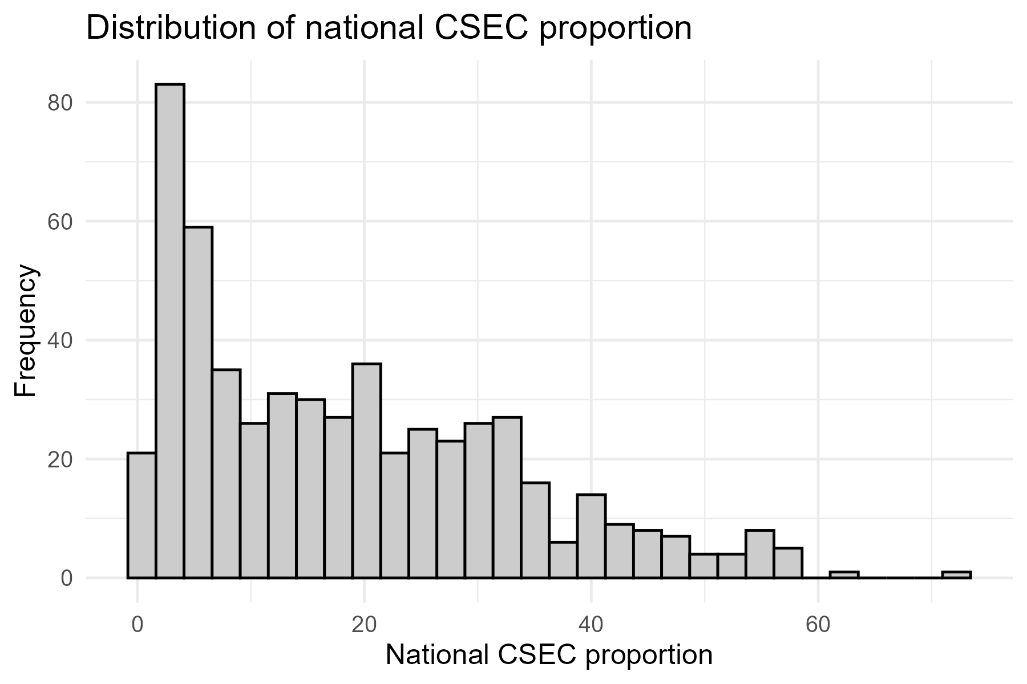
Figure 1: Distribution of National CSEC Proportion
Figure 1 shows the empirical distribution of national CSEC proportions across all years of observation in a country, which is strongly right-skewed. Lower numbers are super-concentrated, and there is a long tail on top-the bulk has attained relatively low CSEC proportion figures, but most are still incredibly high. This heterogeneity further underscores the unsuitability of global averages as indicators of progress and strengthens arguments in the literature that improvements in maternal and adolescent health are unequally distributed across the globe (Jejaw et al., 2025; Hailu & Beyene, 2025).
The existence of extreme points also helps validate a procedure involving mixed-effects modelling and precludes traditional least-squares and pooled regression analyses. This kind of skewness signifies structural inequalities, conflict environments, weak health structures and deeply rooted gender norms that continue to exist in particular situations. Figure 1 provides the descriptive information for the inferential data presented in Table 1, highlighting the existence of the goals SDG 3.1 and SDG 5.6. These goals relate to reducing preventable health risks for mothers and adolescents in a given geographic area that currently needs improvement.
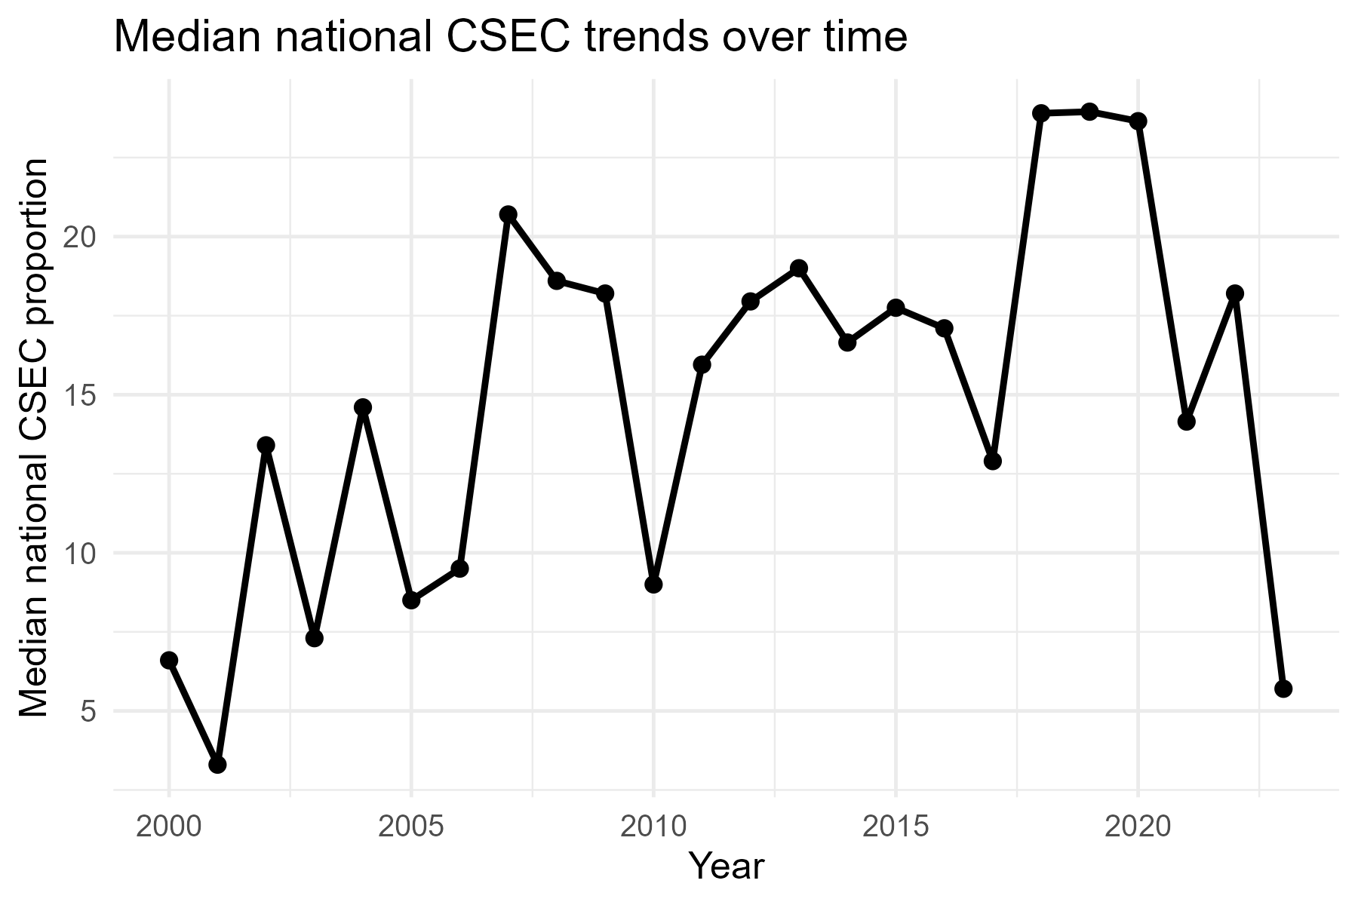
Figure 2: Median National CSEC Trends Over Time
Figure 2 shows the median national proportions for CSEC and the fluctuations that have occurred, rather than a constant decrease. Though there is a decrease in some years, it is followed by improvement. This trend supports the observations in Table 1, which show a non-significant effect of time, but emphasises that the positive changes in CSEC results are not linear and are not always assured.
This temporal uncertainty is consistent with new findings that developmental gains in adolescent and maternal health are extremely shock-prone to economic and policy transformations, conflict and epidemic health. The figure thus mocks the optimistic views of linear and continuous improvement as well as the need for long-term therapies. Policymaking-wise, the observed volatility highlights the need for robust health systems and sustained investment in adolescent reproductive health services, in line with SDG 3 and SDG 16.
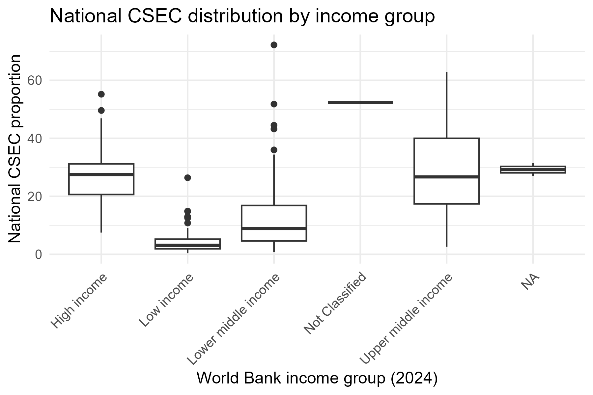
Figure 3: National CSEC distribution by World Bank Income Group
Figure 3 illustrates how the distribution of national CSECs overlaps across World Bank income classifications. There still remain differences in medians. As low-income nations tend to have lower median values, their distributions are broader, and many lower-middle-income and upper-middle-income countries exhibit high outliers. This observation strengthens the argument that national income classification accounts for too little to explain CSEC disparities.
The intersection of the income groups justifies that the variables of wealth quintiles and residence should be included in the multilevel model and that the analysis design of the study (that is, analytic) is justified. It also aligns with previous studies indicating that within-country disparities can be as high as, or even higher than, between-country disparities in maternal and adolescent health outcomes. This fact is invaluable in the case of SDG 10, where the issue of inequalities across income groups should be considered rather than assuming even growth in higher income levels.
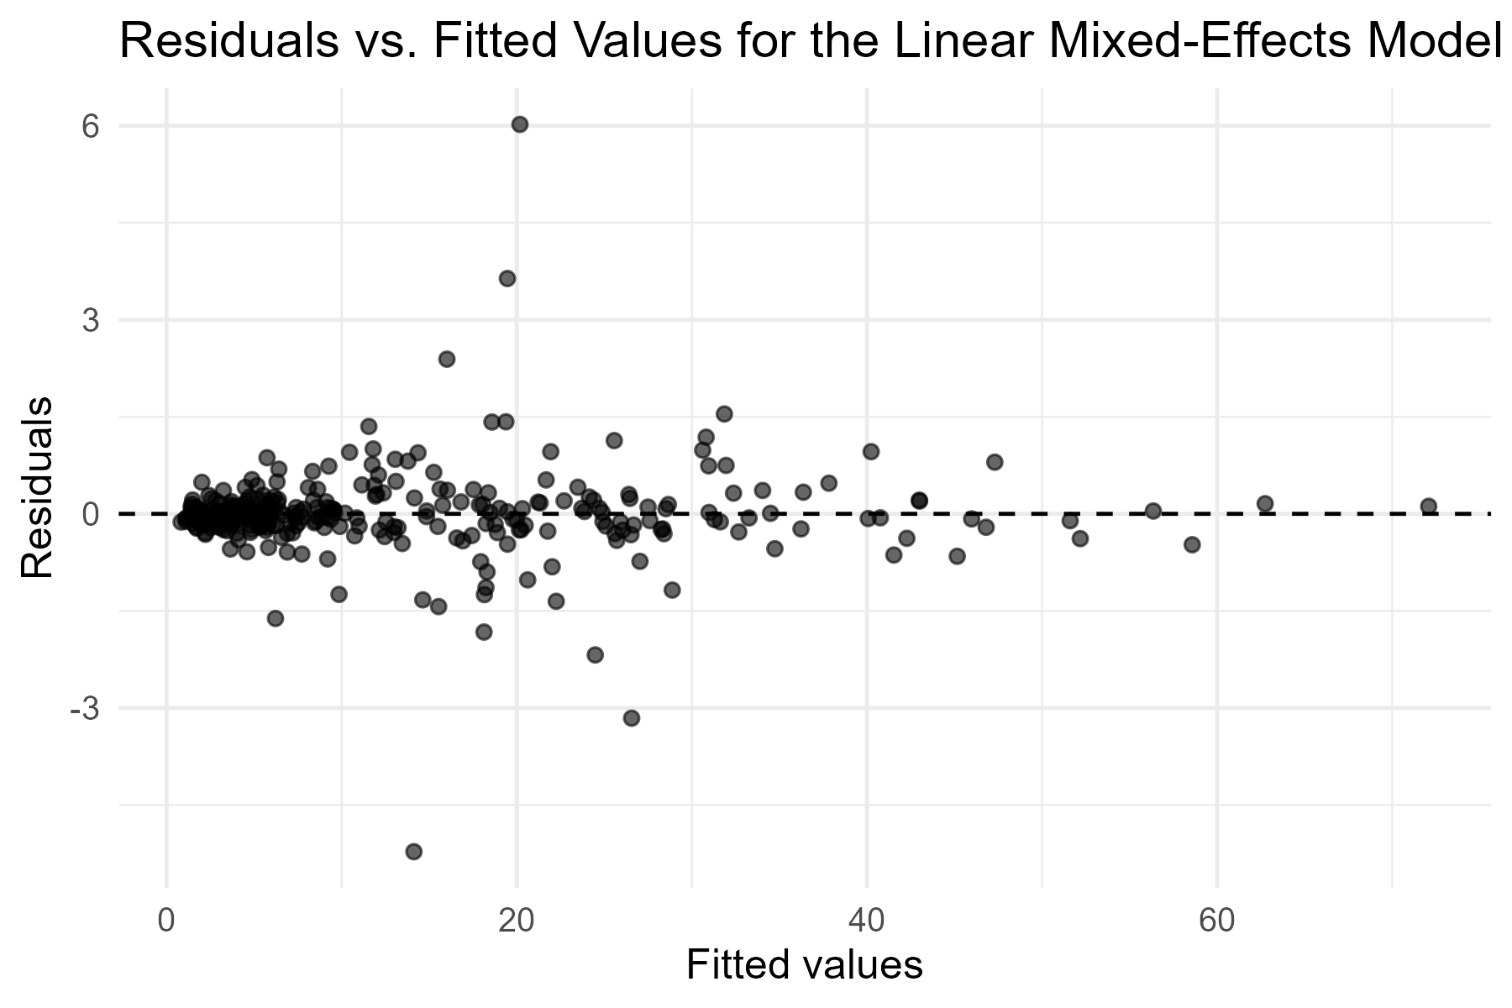
Figure 4: Residuals versus Fitted Values of the Linear Mixed-Effects Model
Figure 4, model results show its adequacy: non-existence of a systematic pattern and funnel spread suggests sufficient linearity and homoscedasticity, which implies that the fixed-effect results of Table 1 are reliable, hence a linear mixed effect model is suitable for modelling CSEC data. It also has substantial methodological value, as it demonstrates the power of modelling techniques and thereby justifies this research over previous ones that relied on less demanding diagnostics. The validity of models should be examined to translate statistical results into plausible policy implications, especially in the context of global monitoring systems linked to SDG indicators.
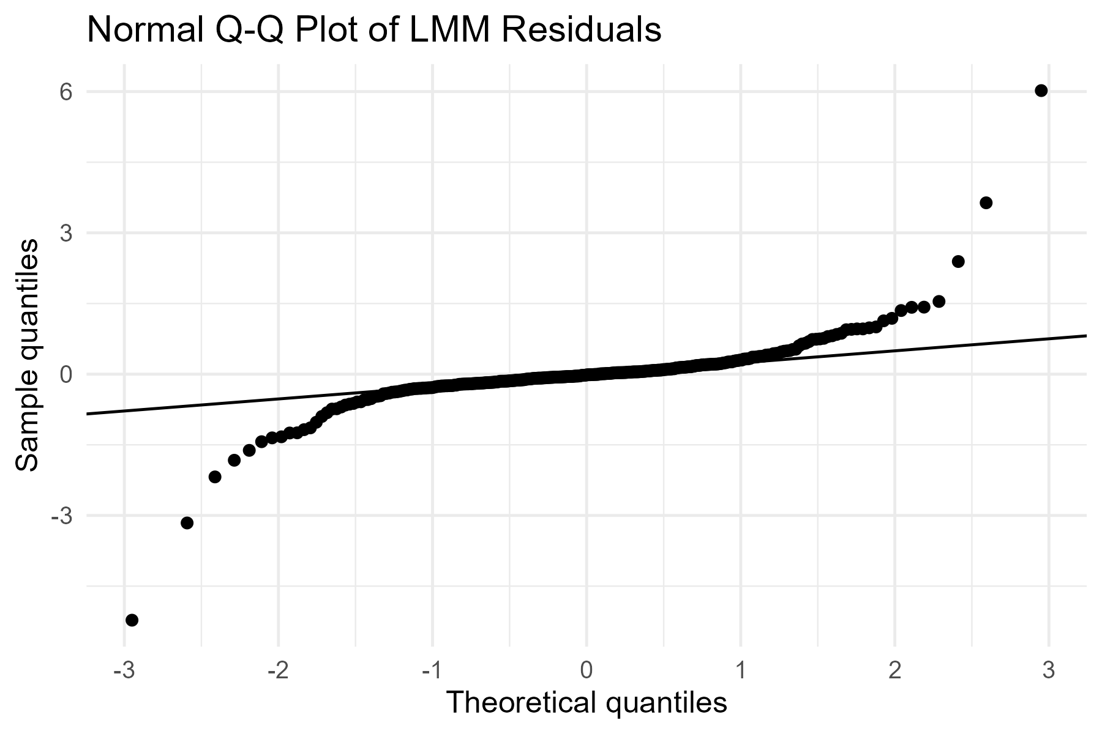
Figure 5: Normal Q-Q plot of LMM Residuals
Figure 5 illustrates the standard Q-Q plot of model residuals and suggests approximate normality, with slight deviations at the tails. Large, heterogeneous international datasets should be expected to exhibit such deviations and should not have a material impact on inference. General compliance with the assumptions of normality also justifies the application of Gaussian mixed-effects modelling.
More to the point, it must be emphasised that this diagnostic substantiates the study's claim to the methodology's novelty, as it focuses on model assumptions, which are sadly lacking in massive CSEC analyses. The study meets these assumptions, making it statistically defensible as a contribution to the methodological literature on maternal and adolescent health measurement.
Combined, the tables and figures indicate that the national outcomes of CSEC are conditioned by complex, intersecting socio-economic and spatial factors that develop unevenly over time. The results refute simplistic ideas about global development and demonstrate that multilevel and longitudinal methods are needed to monitor SDG-related health targets. This study quantifies average effects and structural inequities, which can inform evidence-based interventions to mitigate the risk of early childbearing, enhance reproductive health systems, and promote gender equity across different national settings.
It provides strong empirical evidence for structural and time-related predictors of the proportions of child, sexual, and early childbearing (CSEC) across countries, using a longitudinal multilevel model applied to harmonised UNICEF data. The analysis shows that, even after accounting for country-specific heterogeneity and socio-economic stratification, national CSEC rates remain consistently high, indicating that early childbearing risks still pose a significant challenge globally.
Among the key outcomes, the global time trend in the CSEC proportions is not statistically significant when the hierarchical structure and covariates are included. Although the descriptive analyses showed variability across countries over time, the multilevel model reveals that this variability is not stable at the country level. In effect, the improvement made in one is paired with stagnation or deterioration in the other, adopting a delicate country-dependent approach rather than global developments.
Residency differentials are efficient and valid predictors of the corresponding level of CSEC in a country. There is a positive relationship between country CSEC percentages and rural and urban standardised coefficients, as shown by equal effects. This study goes against traditional wisdom that rural regions are associated with early motherhood and highlights vulnerability in urban and urbanising settings. The dual nature of rural and urban effects underscores the complexities of spatial inequalities, which can be addressed through targeted interventions.
There is a nonlinear relationship between national CSEC examination results and socio-economic stratification by wealth quintile. The highest effect sizes are observed in the middle and fourth wealth quintiles, followed by the poor and the rich. This trend demonstrates that the socio-economic groups under transition can be exposed to increased risks related to early childbearing, which could be explained by the lack of complete transition to education and the labour market, exposures to precarity, and unequal access to reproductive health services. These non-monotonic wealth effects are a new empirical input that goes beyond the poor-rich dichotomies that prevail in the literature.
The linear mixed-effects specification is sufficient as indicated by model diagnostics. Residual tests suggest a fair degree of normality and homoscedasticity, and the estimates of intra-class correlations indicate that a significant proportion of the variance in CSEC performance can be explained by differences between countries. These results confirm the methodology and underscore the importance of accounting for unobserved contextual heterogeneity in global health studies.

Conclusion
This research contributes to the understanding of childbearing, sexual, and early childbearing by applying longitudinal analysis, disaggregating socio-economic status recovery, and a hierarchical model within a single statistical analysis. The study transcends the boundaries of descriptive and cross-sectional analyses by offering statistically rigorous evidence on the dynamics underlying CSEC results across countries using the harmonised UNICEF dataset. The results indicate that improvements in reducing the risks of early childbearing are disproportionate and relative, and that there is no uniform decline worldwide when structural disparities are taken into account. There are strong independent effects of spatial and socio-economic variables, especially the rural-urban setting and wealth inequality, on national CSEC proportions. The discovery of increased risks among middle and transitional-wealth groups disrupts existing beliefs and highlights the ignored groups in policy debates.
Policymaking-wise, the findings highlight the importance of equity-oriented interventions in line with SDG 3, SDG 5, and SDG 10. Interventions that only target the poorest or rural population would not lead to long-term low-risk of early childbearing unless similar concerns are considered to target urban populations and socio-economically transitional populations. Enhancing reproductive health services for adolescents, ensuring the continuity of education, and addressing structural determinants of inequality are significant elements of an effective response.
In this study, the significance of linear mixed-effects models for global health surveillance and evaluation cannot be overestimated. The explicit within-country change and across-country heterogeneity modelling approach offers a strong alternative to traditional pooled studies and provides a base for further research using Bayesian extensions, spatial correlation, or policy intervention effects.
To sum up, this study enhances the literature of maternal and adolescent health both substantively and methodologically. It provides policymakers with practical evidence and demonstrates that sophisticated statistical models are essential to achieving fair and sustainable development towards international health targets.

Data availability
The information can be accessed publicly using the SDMX API and the UNICEF data warehouse. This repository is available at:https://sdmx.data.unicef.org
Ethical Considerations
The research was based solely on publicly available, anonymised data, which did not require ethical consent.
Declaration of competing interest
The authors declare that they have no known competing financial interests or personal relationships that could have influenced the work reported in this paper.

References
Adewuyi, E. O., Akosile, W., Olutuase, V., Philip, A. A., Olaleru, R., Adewuyi, M. I., ... & Khanal, V. (2024). Caesarean section and associated factors in Nigeria: assessing inequalities between rural and urban areas insights from the Nigeria Demographic and Health Survey 2018. BMC Pregnancy and Childbirth, 24(1), 538.
Amponsah, E. B., Abdullah, A., Eltigani, B., & Cluver, L. D. (2024). Risk and protective factors of commercial sexual exploitation of children and adolescents in sub-Saharan Africa: A systematic review. Trauma, Violence, & Abuse, 25(4), 3177-3190.
Ayiah-Mensah, F., Bosson-Amedenu, S., Anderson, F. N., & Kokuro, A. (2025). Nonlinear Cox Survival Modeling of Prostate Cancer with SHAP-Based Explainability. Journal of Advances in Mathematics and Computer Science, 40(12), 28-47.
Ayiah-Mensah, F., Baah, E. M., Harris, E., & Okai, S. K. (2025). Machine-Learning Implications on Global Antenatal Care Improvement and Equity Disparities: The Wealth Effect, Regional Dynamics and Model-Based. Asian Journal of Pregnancy and Childbirth, 8(1), 527-542.
Birur, E. A., McClanahan, R., & Fraley, H. (2025). Commercial Sexual Exploitation of Children: A Descriptive Study with California School Nurses. The Journal of School Nursing, 10598405251387155.
Bourne, P. A. (2025). The failure of the education system in Jamaica: Using CSEC performance in English Language (English A) and Mathematics. International Journal of Transformation in English & Education, 10(2), 1-13.
Bourne, P. A., & Foster, C. (2025). Trends and Determinants of Secondary School Achievement in Jamaica: A Time-Series Analysis of CSEC Five-Subject Passes in Mathematics and English Language (2010-2021).
Cardoso, M. A., Lourenço, B. H., Matijasevich, A., Castro, M. C., & Ferreira, M. U. (2024). Prevalence and correlates of childhood anemia in the MINA-Brazil birth cohort study. Revista de Saúde Pública, 57, 6s.
Carvelli, M., Ward, C., Venetis, P., Turkheimer, D., Schulhofer, S., Jacobs, L. L., ... & Raghu, M. (2024). Lashing Back: Ending the" Undeclared War" against Women Seeking Justice. Women's Rts. L. Rep., 46, 223.
Castro, M. C., Turra, C. M., & Ponmattam, J. (2025). Trends and Decomposition of Changes in Mortality in Low‐and Middle‐Income Countries, 1950–2019. Population and Development Review, 51(1), 295-321.
Derso, E. A., Gelaye, K. A., Campolo, M. G., Woldemariam, A. T., & Alibrandi, A. (2025). Neighborhood-level heterogeneity in childhood morbidity through generalized linear mixed models. Frontiers in Public Health, 13, 1456068.
Dlamini, W. J., Melesse, S. F., & Mwambi, H. G. (2025). An Explicit Research Methodology Suitable for Studying Factors Influencing Under-Five Child Mortality in Four East African Nations. The Open Public Health Journal, 18(1).
Dunnigan, A. E., & Fusco, R. A. (2024). The relationship between commercial sexual exploitation and foster care placement in the US: A scoping review. Child Abuse & Neglect, 155, 106950.
Ekholuenetale, M., Nzoputam, C. I., Barrow, A., & Arora, A. (2025). Individual, household, and community-level factors associated with high-risk fertility behaviour among Nigerian women: secondary analysis of the 2018 demographic and health survey data. Reproductive Health, 22(1), 17.
Grbic, D., Supic, Z. T., Todorovic, J., Nesic, D., Karic, S., Jurisic, A., ... & Jankovic, S. (2024). Factors associated with low birth weight in low-income populations in the Western Balkans: insights from the Multiple Indicator Cluster Survey. Frontiers in Public Health, 12, 1394060.
Hailu, B. A., & Beyene, J. (2025). Adolescent marriage, maternity, and limited access to education in 106 countries: Bayesian analysis of prevalence, trend, and prediction. Scientific Reports, 15(1), 9584.
Jejaw, M., Demissie, K. A., Tafere, T. Z., Tiruneh, M. G., Hagos, A., & Teshale, G. (2025). Prevalence and Determinants of Early Adolescent Childbearing in High Maternal Mortality Sub-Saharan Africa: A Multilevel Analysis of DHS Data. Journal of Epidemiology and Global Health, 15(1), 63.
Jena, S. K., Dolui, M., Ghoshal, S., & Sarkar, S. (2024). Demographic and socio-economic correlates of knowledge of the ovulatory cycle among tribal women in India: Evidence from the nationally representative survey (NFHS-5). BMC Public Health, 24(1), 766.
Ku, S., Werchan, D. M., Feng, X., & Blair, C. (2025). Trajectories of maternal depressive symptoms from infancy through early childhood: The roles of perceived financial strain, social support, and intimate partner violence. Development and psychopathology, 37(1), 515-528.
Kulu, Hill, Julia Mikolai, Isaure Delaporte, Chia Liu, and Gunnar Andersson. "Family trajectories among immigrants and their descendants in three European countries: A multistate approach in comparative research." Population studies 79, no. 2 (2025): 203-223.
Lebrun-Harris, L. A., Sandel, M., Sheward, R., Poblacion, A., & de Cuba, S. E. (2024). Prevalence and correlates of unstable housing among US children. JAMA pediatrics, 178(7), 707-717.
Lee, D. S., & Barclay, K. J. (2025). More twins expected in low-income countries with later maternal ages at birth and population growth. Human Reproduction, 40(2), 372-381.
Mare, K. U., Aychiluhm, S. B., Mulaw, G. F., Sabo, K. G., Ebrahim, O. A., Tebeje, T. M., & Seifu, B. L. (2024). Non-adherence to antenatal iron supplementation and its determinants among pregnant women in 35 sub-saharan African countries: a generalized linear mixed-effects modeling with robust Poisson regression analysis. BMC Pregnancy and Childbirth, 24(1), 872.
Mitchell, K. J., Jones, L. M., O'Brien, J. E., & Puchlopek-Adams, A. (2025). An updated typology of commercial sexual exploitation of children and youth cases coming to law enforcement attention in 2021: Implications for identification and investigations. Child Abuse & Neglect, 169, 107619.
Mohammed, A. R., Musah, B. I., Mahmoud, B., Issah, A. D., & Doke, E. (2025). Family, individual and socio-economic risk factors for the trafficking and commercial sexual exploitation of Nigerian girls in Northern Ghana. Journal of Sexual Aggression, 1-16.
Mouteyica, A. E. N., & Ngepah, N. (2025). Exploring health outcome disparities in African regional economics communities: a multilevel linear mixed-effect analysis. BMC Public Health, 25(1), 175.
Mulaw, G. F., Mohammed, O. A., & Mare, K. U. (2024). Level of dietary diversity score and its predictors among children aged 6–23 months: a linear mixed model analysis of the 2019 Ethiopian Mini Demographic Health Survey. BMJ Public Health, 2(1).
Mussa, I., Gamachu, M., Regassa, L. D., Birhanu, A., Mohammed, F., Weyessa, A. D., ... & Zakaria, H. F. (2024). Maternal socio-economic status determines animal source food consumption of children aged 6–23 months in East African countries: a multilevel mixed-effects generalized linear model. Frontiers in Nutrition, 11, 1336568.
O’Brien, J. E., McKinney, K., Martin, L., & Jones, L. M. (2024). Help-seeking among children impacted by commercial sexual exploitation: a scoping review. Trauma, Violence, & Abuse, 25(5), 3571-3584.
Omoyemiju, M. A., & Asa, S. S. (2025). Prevalence of early childbearing practice among young women in Nigeria: Evidence from 2021 multiple indicators cluster survey. African Journal of Reproductive Health, 29(3), 103-114.
Prakash, J., Goel, R., Mu, Y., Rosner, B., & Stoklosa, H. (2024). Risk prediction model for child sex trafficking among female child welfare-involved youth: Welfare-involved female sexual exploitation risk assessment tool. Journal of Women's Health, 33(12), 1708-1719.
Rahman, F., Rashid, M., Khan Chowdhury, M. R., & Kader, M. (2025). Association between adolescent pregnancy and infant mortality: a population-based study. Frontiers in Pediatrics, 13, 1459594.
Rahman, M., Jahan, F., Hanif, S., Yeamin, A., Shoab, A. K., Andrews, J. R., ... & Benjamin-Chung, J. (2025). Effects of household concrete floors on maternal and child health: the CRADLE trial–a randomised controlled trial protocol. BMJ open, 15(3), e090703.
Rezey, M. L., & DiMeglio, M. (2024). What is known about the magnitude, trend, and risk for child sexual abuse and the commercial sexual exploitation of children in the United States?. Journal of child sexual abuse, 33(6), 691-713.
Singh, M., Shekhar, C., & Gupta, J. (2024). Distribution and determinants of early marriage and motherhood: a multilevel and geospatial analysis of 707 districts in India. BMC public health, 24(1), 2844.
Stevenson, M., Guillén, J., Ortíz, J., Correa, J. F. R., Page, K. R., Talero, M. Á. B., ... & Wirtz, A. L. (2024). Syphilis prevalence and correlates of infection among Venezuelan refugees and migrants in Colombia: findings of a cross-sectional biobehavioral survey. The Lancet Regional Health–Americas, 30.
Suh, B., & Natarajan, M. (2024). Hot spots of commercial sex activities in New York City neighborhoods: Lessons learned. Crime & Delinquency, 70(11), 2932-2957.
Wagner, G. J., Ghosh-Dastidar, B., Gwokyalya, V., Faherty, L. J., Beyeza-Kashesya, J., Nakku, J., ... & Wanyenze, R. K. (2025). Effects of M-DEPTH model of depression care on maternal depression, functioning, and HIV care adherence, and infant developmental over eighteen months post-partum: results from a cluster randomized controlled trial. BMC Pregnancy and Childbirth, 25(1), 400.
World Health Organization. (2024). The adolescent health indicators recommended by the Global Action for Measurement of Adolescent Health: Guidance for monitoring adolescent health at country, regional and global levels. World Health Organization.
World Health Organization. (2025). Trends in maternal mortality 2000 to 2023: estimates by WHO, UNICEF, UNFPA, World Bank Group and UNDESA/Population Division.
Wulandari, R. D., Laksono, A. D., Astuti, Y., Matahari, R., Rohmah, N., Prihatin, R. B., & Elda, F. (2025). Stunting Among Low-Income Families in Indonesia: Is Mother’s Employment a Risk Factor?. Journal of research in health sciences, 25(3), e00654.
Zegeye, A. F., Tamir, T. T., Mekonen, E. G., Workneh, B. S., Negash, W. D., & Mekonnen, C. K. (2024). Individual and community-level determinants of knowledge about fertile periods among adolescent girls and young women (10–24 years) in Sub-Saharan Africa: a multilevel mixed effect analysis of a recent demographic and health survey. Heliyon, 10(5).

