Original Research Article

Human Exposure to Micro (Nano) Plastics and their Potential Health Impact: A Scientometric Analysis

ABSTRACT:
Plastic pollution has emerged as an urgent global challenge, with various studies indicating that exposure to these minute plastic particles, such as microplastics (diameter less than 5 mm in size) and nanoplastics (smaller than 1 μm), can potentially lead to various adverse impacts on human health. There is a shred of growing evidence indicating that the chemicals found in plastic are connected to several grave health problems, including cancer, gastrointestinal disorders, obesity, endocrine disruption, infertility, etc. This study aims to provide a systematic and in-depth analysis of the exposure to microplastics and nanoplastics on human health. The exploration of bibliometric studies on the effects of human exposure to micro- and nanoplastics on health is still limited, and this forms the basis of the present investigation. Extensive data, including the scientific output of researchers, country/region contributions, affiliations, author references, and thematic trends, were carefully examined using the VOSviewer program (version 1.6.15). The finding in this study shows a progressive increase in the number of related published works from 2014 to 2024, with 2994 documents retrieved from the Web of Science Core Collection database. The fact that Chinese researchers are frequently listed as top-affiliated authors indicates the significant influence these scientists have had on research on the health impacts of microplastic and nanoplastic exposure. This study contributes to the existing knowledge of the potential impact of micro(nano)plastic exposure on human health and the urgent need for concerted efforts to address the challenges posed by plastic particles.

Aims: To investigate human exposure to microplastics and nanoplastics and their potential health impacts using bibliometric mapping and analysis.

Study design: Bibliometric mapping and analysis.

Place and Duration of Study: Manipur, India. Study was done between August and November 2025.

Methodology: We retrieved information related to the search topic encompassing title, abstract, keyword plus, and author keywords from the Web of Science (WoS) core collection database for the period of publications from 2014 to 2024. A total of 2994 documents was retrieved from various publication types, such as articles, review articles, meeting abstracts, editorial material, proceeding papers, letters, and book chapters. Mapping and analysis of data were performed using VOSviewer version 1.6.20 software programme.

Results: With a total publication of 2994, the micro(nano)plastics (MNPs) and human exposure axis have garnered the attention of researchers worldwide as seen by the steady increase in research publications in the last decade. This rise in research output unequivocally demonstrates how MNPs affect human life. Environmental Sciences Ecology is the most popular research area contributing 64.8% of total research publications, with Science of the Total Environment as the top leading journal in the field of MNPs and their associated human health risks. With a total of 7624 citations, the Chinese Academy of Sciences tops the list with the highest publication count. Globally, the People’s Republic of China top the nations contributing significantly about 38.2% of the total publication. Co-occurrence network analysis reveals majority of research conducted were concentrated on oxidative stress and toxicity pathways caused by exposure to MNPs as primary threats to gut microbiota and metabolism in aquatic animals and human health.

Conclusion: Increased exposure to environmental pollutants, such as MNPs, may contribute to an increase in cancer, immune disorders, metabolic and other neurological problems as evidenced from many literature studies. There is a great deal of uncertainty about the impact of environmental exposure to MNPs on human health. Given the expected increase in the presence of these synthetic plastic materials in our environment, extensive research is needed to fully understand the danger that microplastics and nanoplastics bring to human health.

Keywords: microplastics, nanoplastics, toxicity, exposure, human health, bibliometric.

1. INTRODUCTION
Plastics have become indispensable in many aspects of modern life, including packaging, construction, transportation, clothing, storage, and a wide range of consumer goods. Large quantities of plastic leak into rivers, oceans, and other water bodies worldwide due to inappropriate practices of disposal and waste management (Jambeck et al., 2015). Because of its durability, plastic pollution poses a significant threat to the marine ecosystem and human health (Thushari and Senevirathna, 2020). The most common types of plastic used widely in our daily life are constituted of materials such as polyvinyl chloride (PVC), polystyrene (PS), polypropylene (PP), polyethylene (PE), and polyethylene terephthalate (PET) (Rodrigues et al., 2019). The term “microplastic” was first coined in a study conducted by Richard C. Thomson’s group at the University of Plymouth, U.K., in the year 2004 (Thompson et al., 2004). Microplastic (MP) is generally defined as a plastic particle typically less than five millimetres in size and is commonly classified as primary or secondary microplastic. Primary microplastics are produced in a micro size range and released directly into the environment, while secondary microplastics are derived from abiotic and biotic fragmentation of larger plastic materials (Cole et al., 2011; Duis and Coors, 2016; Eubeler et al., 2010; Koelmans et al., 2014; Lucas et al., 2008; Rodrigues et al., 2019). According to a 2017 report by the International Union for Conservation of Nature, primary microplastics are major sources of plastics in the oceans globally, with an estimate of 1.5 million tonnes per year (Boucher and Friot, 2017). The Organisation for Economic Co-operation and Development (OECD) estimates that approximately 2.7 million tonnes of microplastics entered the environment in the year 2020, and this figure is expected to reach 4.1 million tonnes by the year 2040 (OECD, 2024). Furthermore, MPs can continue to degrade into even smaller particles termed nanoplastics (NPs) with a size less than 1 μm (Dawson et al., 2018; Winiarska et al., 2024).
The distribution of micro(nano)plastics (MNPs) shows their alarming potential for worldwide dispersion, encompassing both isolated high-altitude plateaus and the deepest oceanic areas (Yang et al., 2023). Their prevalence draws attention globally, as several pieces of evidence suggest that MNPs' toxicity and bioactivity are substantially governed by their physicochemical properties (Amelia et al., 2021; Gallo et al., 2018; Teuten et al., 2009; Wang et al., 2018; Yang et al., 2023). Due to the fact that they are found in almost every ecosystem, MPs have been regarded as a serious environmental threat (Shahul Hamid et al., 2018). MNPs pollution poses a tremendous threat to the environment and human health (Boctor et al., 2025; Marcharla et al., 2024). Because of their tiny size, they are easily disseminated in the environment and have become widespread enough to be swallowed by both aquatic and terrestrial organisms (Larue et al., 2021). Microplastics have already been detected in seafood species such as fish, shrimp, and bivalves (Devriese et al., 2015; Li et al., 2015; Neves et al., 2015), as well as tap water and other food items such as honey, beer, salt, and sugar (Kosuth et al., 2018; Liebezeit and Liebezeit, 2014, 2013; Yang et al., 2015).
Ingestion of microplastics can lead to the incorporation of organic and inorganic contaminants into organs or tissues, threatening organisms’ survival and reproduction (Guzzetti et al., 2018; Rahman et al., 2021). Three main pathways exist for MNPs to enter the human body: ingestion (through the digestive tract), inhalation (via the lungs), and dermal contact (Prata et al., 2020; Winiarska et al., 2024; Zarus et al., 2021). The principal route of human exposure is the consumption of food and water contaminated with MNPs (Galloway, 2015). In a 2019 study in the United States, the annual total exposure (ingestion and inhalation) of MPs for male children, male adults, female children, and female adults in the United States is estimated to be around 81000, 113000, 74000, and 94000, respectively (Cox et al., 2020, 2019). MNPs have the potential to affect human health through oxidative stress, cytotoxicity, inflammatory changes, metabolism alteration, translocation to distant organs, neurotoxicity, toxicity to the reproductive system, carcinogenesis, and indirect effects by serving as chemical and microorganism vectors (Rahman et al., 2021). These detrimental impacts were also observed in experimental models such as cells, organoids, and animals (Li et al., 2023).
Human health may also be impacted by the transfer or leaching of chemical compounds from the plastic substance itself. Monomeric units such as Bisphenol A (BPA), which is used to make polycarbonate and epoxy resins, can induce detrimental consequences due to its estrogenic effect, including a variety of metabolic disorders as well as reproductive and developmental issues in humans (Ehrlich et al., 2012; Hengstler et al., 2011; Lang et al., 2008; Miao et al., 2011). The same considerations apply to the plasticizers, pigments, and stabilizers, which are added throughout the plastic production process to give the end product the required attributes, such as flexibility, colour, and stability, which can cause endocrine disruption or acute toxicity when exposed to the organisms (Lithner et al., 2011). The global meta-analysis exploring the association of MPs and various cancer risks has indicated a stronger correlation between MPs exposure and lung cancer when compared to other cancer types (Liu et al., 2025). It has been shown that human bronchial epithelial cells (BEAS-2B) exposed to MNPs (<1 μm to 10 μm) activate NF-κB, which regulates the expression of inflammatory genes without raising cellular ROS levels (Gosselink et al., 2025). Because of their small size, MNPs can pass through biological membranes such as lung epithelial barriers, thereby triggering a TNF-α-associated apoptosis pathway in the human alveolar epithelial A549 cell line, affecting viability and cell cycle (Xu et al., 2019).
As MNPs have the potential to be harmful to human health in many physiological systems, we have conducted a thorough assessment of human exposure to MNPs and their impact on human health through published literature for the period 2014-2024 using bibliometric mapping and analysis as reported in this study.

2. material and methods
2.1 Data collection
The Web of Science (WoS) core collection database was used in retrieving the information related to the search topic encompassing title, abstract, keyword plus, and author keywords for the period of publications from 2014 to 2024. Compared to Google Scholar, ScienceDirect, and Scopus, WoS is one of the most extensive search engines, citation indexing services, and scientific databases (Wong et al., 2022). For retrieving information from the WoS core collection database, the query performed considered the following keywords: {microplastic* OR nanoplastic*} AND {human} AND {skin OR dermal OR gastrointestinal OR blood OR kidney OR renal OR brain OR eye* OR heart OR liver OR thyroid OR cardiovascular OR lung OR cancer* OR metaboli* OR allerg* OR disease* OR respirat* OR immun* OR neoplasm* OR neuro* OR reproducti* OR fertility OR genotoxic* OR diabet* OR pregnancy OR infection* OR endocrine OR hormone OR inflammation OR oxidative OR DNA OR neurotoxic* OR cytotoxic* OR faeces OR digesti* OR carcinogen* OR obesity OR nervous OR toxic* OR asthma}. Data for our investigation was retrieved on 6 September 2025, with English as the language of the reported publication. We obtained a total of 2994 documents from various publication types, such as articles, review articles, meeting abstracts, editorial material, proceeding papers, letters, and book chapters.
2.2 Bibliometric mapping and analysis
Mapping and analysis of data were performed using VOSviewer version 1.6.20 software programme (Centre for Science and Technology Studies, Leiden University, The Netherlands) after retrieval of the database from the WoS. VOSviewer is used to visualize bibliographic coupling and other social networks, like citation networks, co-authorship networks, and co-occurrence, using one of three representations: network, overlay, or density visualization (Arruda et al., 2022). It also generates maps that are more coherent and well-structured than those made with other popular bibliometric methods (van Eck and Waltman, 2010). Using VOSviewer version 1.6.20, the following parameters of the bibliometric data were analysed: publication and citation sources, authors, affiliations, countries, keywords, and future trends.

3. results and discussion
3.1 Data source and temporal trend of publications
Important insights into publication trends in the last decade (2014 to 2024) were obtained by bibliometric analysis on the Web of Science Core Collection database. The micro(nano)plastics (MNPs) and human exposure axis have garnered the attention of researchers worldwide in the last decade, as seen by the steady increase in research publications from 2014 (3 publications) to 2024 (894 publications), with a total publication of 2994 as of September 6, 2025 (Figure 1). This rise in research output unequivocally demonstrates how MNPs affect human life. The total number of citations for the overall publications is reported to be 179871, with an average of 60.08 citations per item and an h-index of 193. The popular research areas for human exposure to MNPs and their associated health risks are shown in Figure 2.

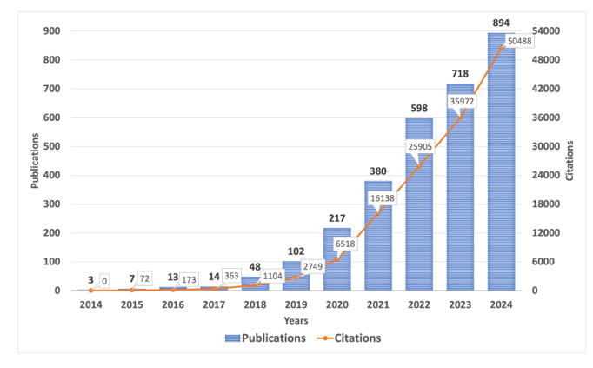

Figure 1: Temporal trend of publication for human exposure to MNPs and their associated health risk. Publication records along with citations count from the year 2014 to 2024.

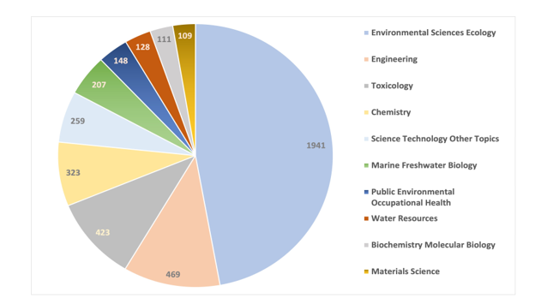
Figure 2: Top ten research areas related to publications on human exposure to MNPs.

With 2994 of the total publications, Environmental Sciences Ecology is the most popular research area, with 1941 record counts contributing 64.8% of total research publications. Engineering (469), Toxicology (423), and Chemistry (323) were the next three significant research areas. This illustrates the fact that the environmental sciences, engineering, toxicology, and chemical sciences are the primary areas of study for human exposure to MNPs and their potential impacts on human health. Science & Technology, Marine Freshwater Biology, Public Environmental Occupational Health, and Water Resources are comparatively understudied fields of study that could become hot spots for research in the near future. The list of leading journals in the field of MNPs and their associated human health research is presented in Figure 3. The Science of the Total Environment (389), Journal of Hazardous Materials (210), Environment Pollution (177), Ecotoxicology and Environmental Safety (99), Marine Pollution Bulletin (99), and Chemosphere (90) are the top journals with the highest number of research publications, according to the results obtained from the WoS core collection database. The top publishers with the largest record count of publications linked to the search query are shown in Figure 4. Prominent publishers, including Elsevier, MDPI, and Springer Nature, made significant contributions to the popular research fields of human exposure to MNPs and their associated health risks. The most cited literature reveals the challenges that researchers are concerned about and lays the framework for future research.
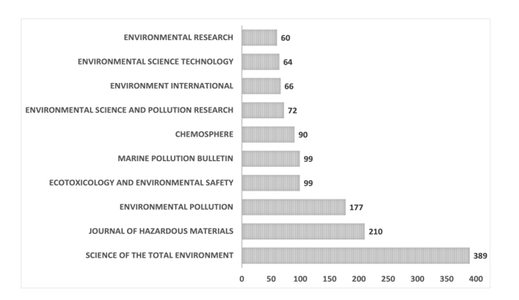

Figure 3: The top ten leading journals with the highest number of research publications in the field of MNPs and their associated human health research obtained from the WoS core collection database.

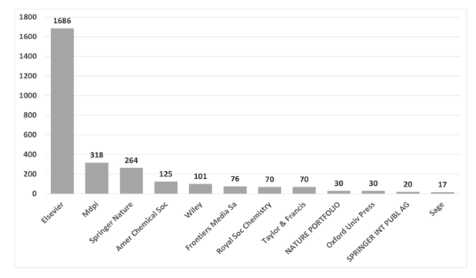

Figure 4: The top publishers with the largest record count of research publications linked to the search query.

3.2 Authors, Affiliations, and Countries
Co-citations indicate the areas of the field that researchers have previously examined. From 2014 to 2024, approximately 14,825 authors conducted studies on MNPs and health issues based on the information obtained through the Web of Science database. Figure 5 depicts a network visualization map for co-authorship using the VOS viewer program. The overall strength of co-citation relationships with other authors was calculated for each of the 14,825 authors with at least 5 documents. A total of 219 authors with at least 100 citation counts were selected and grouped into 10 clusters based on their overall relationship strength.
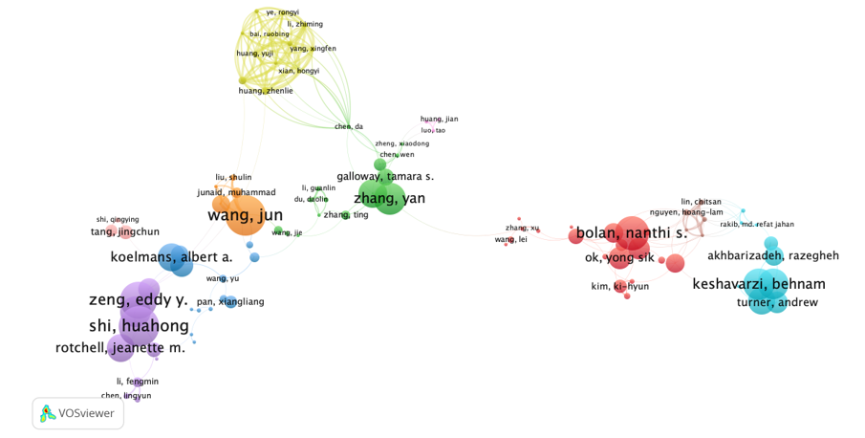
Figure 5: Network visualization map for co-authorship using the VOS viewer program. The overall strength of co-citation relationships with other authors was calculated for each of the 14,825 authors with at least 5 documents and a minimum citation of 100.

In the Web of Science database, Lucia Guilhermino of the University of Porto had the most cumulative global citations, with 3,791 across 17 publication records related to the search query. His 2018 study, “Marine microplastic debris: An emerging issue for food security, food safety and human health,” published in Marine Pollution Bulletin, has been cited 1022 times in total on the Web of Science databases as of September 2025. Jun Wang of the South China Agricultural University tops the list of highest publication counts (30) with a total of 2250 citations, followed by Richard Marcos and Alba Hernandez of the Autonomous University of Barcelona with publication counts of 24 (1383 citations) and 23 (1261 citations), respectively. The top leading authors with the highest publication record—at least 10 publications—who worked on the study topic associated with the search query are shown in Figure 6, along with their corresponding citations.

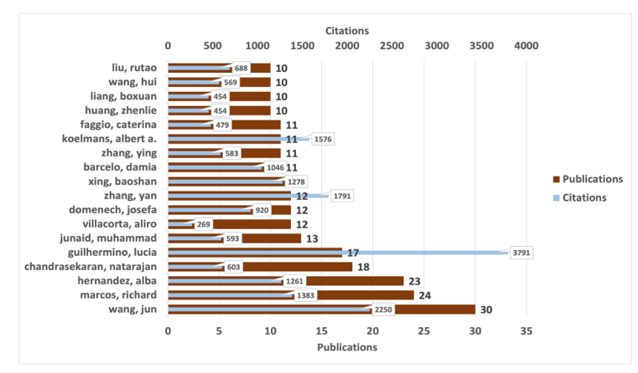

Figure 6: The top leading authors with the highest publication record—at least 10 publications—who worked on the study topic associated with the search query, along with their corresponding citations

The most cited research publications on MNPs and health-related topics are displayed in Table 1, which is a list of highly influential research articles. Figure 7 shows the publication records associated with the topic of interest for the top institutions retrieved from the WoS database. The Chinese Academy of Sciences tops the list with the highest publication count of 137, with a total of 7624 citations. The University of Chinese Academy of Sciences ranks second with 63 publications and 4148 citations, ahead of Shandong University (40 publications and 2614 citations). The network visualization map of research affiliations for co-citation, as analysed by VOS viewer, is depicted in Figure 8. The total strength of co-citation relationships between each of the 3673 organisations was computed. Based on the overall relationship strength of the co-authorship relationships with at least 5 publications and 100 citation records, 320 linked organisations were represented on the map. The Chinese Academy of Sciences holds the record for the most citations (7624), with the University of Porto (4380), the University of Chinese Academy of Sciences (4148), and the University of Newcastle (4127) following closely behind.

Table 1: A list of highly influential research articles (top ten most cited research publications) related to human exposure to MNPs and their potential health impacts.

Sl. NO. | TITLE  WITH DOI | AUTHORS | SOURCE TITLE | PUBLICATION YEAR | TOTAL CITATIONS | ANNUAL CITATIONS
1. | Emerging threats and persistent conservation challenges for freshwater biodiversity  10.1111/brv.12480 | Reid et al. | BIOLOGICAL REVIEWS | 2019 | 2233 | 319
2. | Discovery and quantification of plastic particle pollution in human blood  10.1016/j.envint.2022.107199 | Leslie et al. | ENVIRONMENT INTERNATIONAL | 2022 | 2055 | 513.75
3. | Plastic and Human Health: A Micro Issue?  10.1021/acs.est.7b00423 | Wright & Kelly | ENVIRONMENTAL SCIENCE & TECHNOLOGY | 2017 | 2023 | 224.78
4. | Microplastics in freshwater systems: A review of the emerging threats, identification of knowledge gaps and prioritisation of research needs  10.1016/j.watres.2015.02.012 | Eerkes-Medrano et al. | WATER RESEARCH | 2015 | 1867 | 169.73
5. | Plasticenta: First evidence of microplastics in human placenta  10.1016/j.envint.2020.106274 | Ragusa et al. | ENVIRONMENT INTERNATIONAL | 2021 | 1854 | 370.8
6. | Environmental exposure to microplastics: An overview on possible human health effects  10.1016/j.scitotenv.2019.134455 | Prata et al. | SCIENCE OF THE TOTAL ENVIRONMENT | 2020 | 1511 | 251.83
7. | Microplastics in freshwater systems: A review on occurrence, environmental effects, and methods for microplastics detection  10.1016/j.watres.2017.12.056 | Li et al. | WATER RESEARCH | 2018 | 1471 | 183.88
8. | Microplastics in bivalves cultured for human consumption  10.1016/j.envpol.2014.06.010 | Van Cauwenberghe & Janssen | ENVIRONMENTAL POLLUTION | 2014 | 1435 | 119.58
9. | Detection of Various Microplastics in Human Stool A Prospective Case Series  10.7326/M19-0618 | Schwabl et al. | ANNALS OF INTERNAL MEDICINE | 2019 | 1207 | 172.43
10. | Microplastics in Seafood and the Implications for Human Health  10.1007/s40572-018-0206-z | Smith et al. | CURRENT ENVIRONMENTAL HEALTH REPORTS | 2018 | 1091 | 136.38

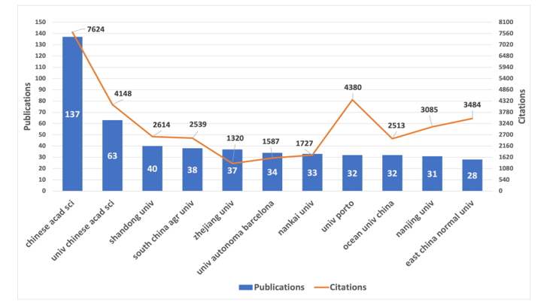
Figure 7: The publication records for the top ten institutions along with their corresponding citations retrieved from the WoS database.

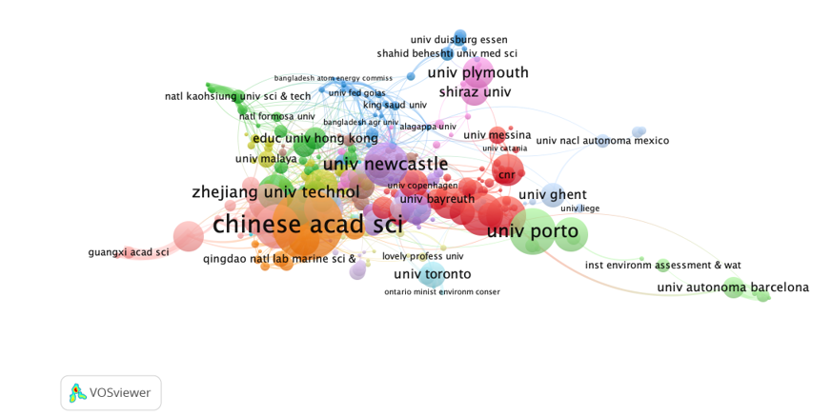
Figure 8: The network visualization map of research affiliations for co-citation, as analysed by VOS viewer. The total strength of co-citation relationships between each of the 3673 organisations was computed. Based on the overall relationship strength of the co-authorship relationships with at least 5 publications and 100 citation records, 320 linked organisations were represented on the map.
The top 10 nations that have contributed the most scientifically to this field are displayed in Figure 9. 1145 (or around 38.2%) of the 2,994 publications that were examined came from the People's Republic of China, indicating that one of the most influential and populous nations in the world is very concerned about this issue. The USA and India came next with 333 publications (about 11.1%) and 258 (around 8.6%), respectively. Italy is the leader in the European Union with 221 published articles (about 7.3%), ahead of South Korea with 187 and Germany with 172. With 159 publications, Spain is one of the study's main contributors, followed by England (130), Australia (116), and Canada (105). With a total of 61105 citations, the P. R. of China is the country with the most citations, followed by the USA (24429), England (14981), Germany (14977), Italy (14290), Australia (12814), India (12054), the Netherlands (10732), South Korea (9309), Canada (8744), Portugal (8452), and Spain (7909). A network map visualisation of several countries made with bibliographic coupling is shown in Figure 10. 43 out of 109 countries satisfied the requirement during the study, which required a minimum of 5 documents with at least 1000 citations for a country. Four groupings of nations were shown as working on this topic in the network map. There were four clusters that connected all the countries: clusters 1, 2, 3, and 4 had 14, 11, 10, and 8 countries, respectively. The thickness of the line corresponds to the frequency of citations.
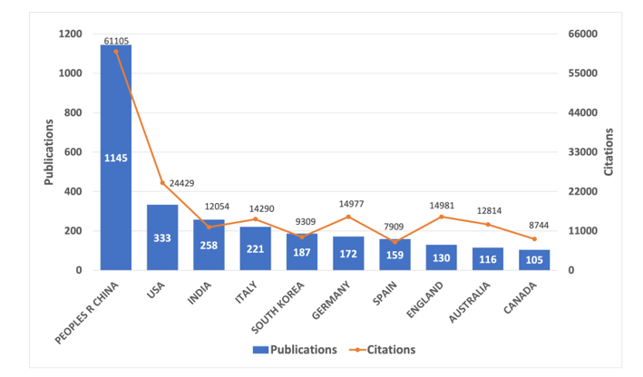
Figure 9: The top 10 nations that have contributed the most scientifically to this field with the highest publication counts.
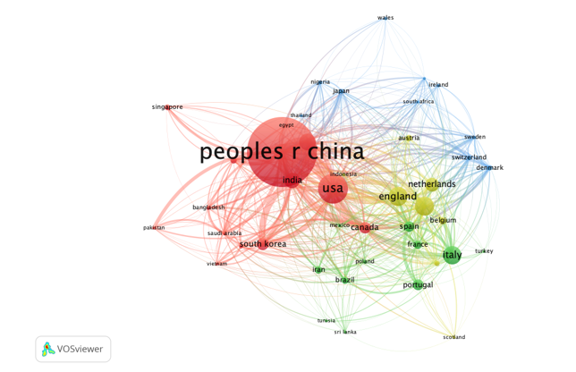
Figure 10: A network map visualisation of several countries made with bibliographic coupling.

3.3 Current trends and Co-occurrence network analysis
Co-occurrence networks make it possible to examine and visualise the connections between various terms or ideas within a certain field of study. This facilitates the discovery of patterns, trends, and linkages between concepts by researchers, leading to a more thorough comprehension of the body of current knowledge. It is feasible to find terms or ideas that are closely associated with one another but might not be mentioned directly in the scientific literature by doing a co-occurrence network analysis. By giving a visual representation of the correlations between the searched phrases, this can lead to the discovery of new associations or information, which can lead to the production of new research hypotheses that aid in the evaluation of the scientific literature. The most crucial component of the literature search is the keywords. Co-occurrence keyword analysis can help uncover new trends and the most researched areas within a certain field of study (Radhakrishnan et al., 2017). By examining the keywords used by the original authors, this helps to determine how the topic has evolved and predicts future trends (Narong and Hallinger, 2023; Ozek et al., 2023).
For our analysis, the keyword visualisation map was obtained by using the VOS viewer software. The size of the node shows how frequently a keyword appears. The higher the node’s size, the more frequently the keyword occurs. It displays the most important search terms from the study on the health impact of exposure to MNPs. The pool of the 72 most common words with a minimum number of occurrences of 50 keywords is shown in Figure 11 and includes terms like “microplastics,” “pollution,” “marine environment,” “particles,” “exposure,” “toxicity,” “ingestion,” “nanoparticles,” “nanoplastics,” “oxidative stress,” etc. The literature search was classified into three clusters by the network map, each represented by a distinct hue. Keywords with higher frequency in Cluster 1 consist of the maximum number of keywords (25 items), such as microplastics, nanoplastics, nanoparticles, exposure, particles, toxicity, oxidative stress, microbiota, inflammation, mechanisms, stress, apoptosis, etc.

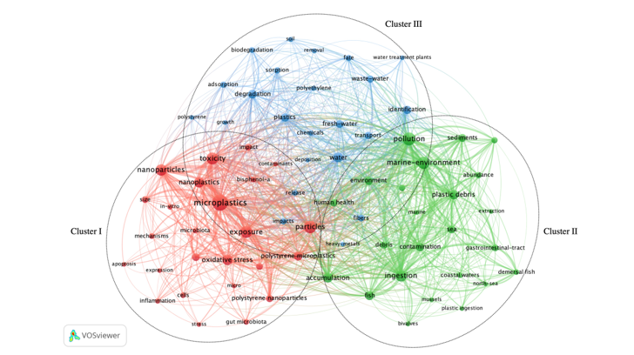
Figure 11: The keyword visualisation map as obtained by the VOS viewer software with the pool of the 72 most common words with a minimum number of occurrences of 50 keywords.

The majority of the research conducted in Cluster I concentrated on the oxidative stress and toxicity pathways caused by exposure to microplastics, nanoplastics, and other plastic particles, as these factors may be the primary threats to gut microbiota and metabolism. The research on pollution in marine environments, ingestion, accumulation, and gastrointestinal tracts in aquatic animals and how that affects human health is grouped in Cluster II. This demonstrates the presence of plastic debris and microplastic contamination as a primary cause of water pollution in aquatic ecosystems. Cluster III investigates the breakdown of polymers, biodegradation, and various plastic types in relation to their presence in soil and their fate in aquatic bodies. This cluster examines many types of plastics, heavy metal depositions, and environmental monitoring of pollutants and fibers in relation to their identification and transportation.

3.4 Influential research publications on human exposure to microplastics
The 2019 study “Emerging threats and persistent conservation challenges for freshwater biodiversity” by Reid et al. highlighted the significance of freshwater ecosystems for human life support and identified microplastic pollution as one of the twelve emerging threats to freshwater biodiversity (Reid et al., 2019). The study has over 2233 citations in the WoS database, with an average of 319 citations annually. The most cited papers on human exposure to microplastics are shown in Table 1.

A groundbreaking study on the identification and quantification of plastic particles in the human bloodstream for the first time was conducted by the Lamoree group at the Vrije Universiteit Amsterdam, the Netherlands. It has received 2055 citations in total since it was published in the journal Environmental International in the year 2022, with an average of 513 citations annually in the WoS database. Four different types of polymers, such as polyethylene terephthalate, polyethylene, polymers of styrene, and poly(methyl methacrylate), were identified and quantified in human blood using the double-shot pyrolysis-gas chromatography/mass spectrometry technique. This study offers detailed studies of the presence of plastic particles ≥700 nm in the blood of 22 healthy individuals with an average mean of 1.6 μg/ml in human blood (Leslie et al., 2022).

Surprisingly, a study by Ragusa et al. (2021) has shown the first piece of evidence of microplastics in the human placenta and coined the term “Plasticenta.” The study uses Raman Microspectroscopy to assess the existence of pigmented microplastics with irregular, spherical forms that range in size from 5 to 10 μm in human placentas (Ragusa et al., 2021). Interestingly, research on eight healthy individuals between the ages of 33 and 65 revealed that human excrement contained microplastics of nine different types, with polypropylene and polyethylene terephthalate being the most prevalent (Schwabl et al., 2019). With evidence of various exposure pathways through diet and inhalation, Wright and Kelly’s 2017 review article, “Plastic and Human Health: A Micro Issue?” has garnered 2023 citations in the WoS database and elucidated significant aspects of microplastic uptake and translocation inside the human body that may be harmful to human health (Wright and Kelly, 2017). Prata et al. (2020) provided further information on the modes of exposure, such as ingestion, inhalation, and skin contact, and emphasised how the environment affects human exposure to microplastics. The review also covered the threat that microplastic toxicity poses to human health, including oxidative stress and inflammation that can cause neurotoxicity, neoplasia, and disruption in immune function (Prata et al., 2020).

Andrady (2017) evaluated the significance of specific plastic properties that make up microplastics in relation to their function as a pollutant that may have detrimental effects on the environment. The study also highlighted how fragmentation can result in secondary microplastics, highlighting the possibility of a surface-ablation mechanism that can favourably create microplastics with a lower size (Andrady, 2017). The 2015 study “Microplastics in freshwater systems: A review of the emerging threats, identification of knowledge gaps and prioritization of research needs” by Eerkes-Medrano et al., with over 1867 citations in the WoS database, emphasized the growing threat posed by microplastics in freshwater systems as well as their potential effects on human populations (Eerkes-Medrano et al., 2015). In order to handle the increasing concerns related to microplastic pollution, the research also calls for the creation of effective management strategies and regulations. Furthermore, Li et al. (2018) discussed the presence and effects of microplastics in freshwater systems using a variety of detection and quantification techniques to improve environmental risk assessment (Li et al., 2018). To understand the potential exposure of microplastics and evaluate the harm to human health, Koelmans et al. (2019) offered a thorough investigation and perceptive evaluation of microplastic contamination in freshwater sources and drinking water (Koelmans et al., 2019). There is a glaring need for improvement in the quality assurance of microplastic sampling and analysis in water samples, as only four of fifty prior investigations satisfied all the quality requirements set by Koelmans & Co.

Van Cauwenberghe & Janssen investigated the presence of microplastics on two species of commercially cultivated bivalves, namely Mytilus edulis and Crassostrea gigas. At the time of human consumption, it was observed that M. edulis and C. gigas had an average plastic load of 0.36 ± 0.07 particles per gram of soft tissue (wet weight) and 0.47 ± 0.16 particles per gram of soft tissue, respectively. As a result, eating shellfish can expose European consumers to as many as 11,000 microplastics every year (Van Cauwenberghe and Janssen, 2014). The first study on the natural trophic transfer of microplastics from mussels to crabs and its translocation to the haemolymph and tissues of crabs was conducted by Farrell and Nelson of the University of Portsmouth, U.K., in the year 2013 (Farrell and Nelson, 2013). Rochman et al. (2015) discovered anthropogenic debris, such as plastic and fibers, recovered from fish and shellfish gathered from markets in Indonesia and the United States that were sold for human consumption (Rochman et al., 2015). This has implications for human health, marine life, and the larger food chain. Smith et al. (2018) reported evidence for human exposure to microplastics through seafood and discussed potential health consequences (Smith et al., 2018). The presence of marine microplastics in seafood raises concerns about its safety. Furthermore, the 2019 study by Cox et al. titled “Human consumption of Microplastics” emphasized that the numbers for daily microplastic consumption in the USA by male children, male adults, female children, and female adults are estimated to be 113, 142, 106, and 126, respectively (Cox et al., 2019).

4. Conclusion

Human exposure to microplastics and nanoplastics is increasing as a result of increased plastic use and material durability. Micro(nano)plastics can interact with tissues on their surface, causing inflammatory lesions in instances when concentrations or individual susceptibilities are high. Increased exposure to environmental pollutants, such as microplastics or nanoplastics, may also contribute to an increase in cancer, immune disorders, and neurological problems. Even when the precautionary approach is applied, there is a great deal of uncertainty about the impact of environmental exposure to micro(nano)plastics on human health. It is expected that the amount of microplastics and nanoplastics contaminating animal habitats will increase as the human population grows and humans use more synthetic materials. Given the expected increase in the presence of these synthetic materials in our environment, more research is needed to fully understand the danger that microplastics and nanoplastics bring to humans.

CONSENT
Not applicable

Ethical approval
Not applicable

References

Amelia TSM, Khalik WMAWM, Ong MC, Shao YT, Pan H-J, Bhubalan K. 2021. Marine microplastics as vectors of major ocean pollutants and its hazards to the marine ecosystem and humans. Prog earth Planet Sci 8:12. https://doi.org/10.1186/s40645-020-00405-4
Andrady AL. 2017. The plastic in microplastics: A review. Mar Pollut Bull 119:12–22. doi:https://doi.org/10.1016/j.marpolbul.2017.01.082 https://doi.org/10.1016/j.marpolbul.2017.01.082
Arruda H, Silva ER, Lessa M, Proença DJ, Bartholo R. 2022. VOSviewer and Bibliometrix. J Med Libr Assoc 110:392–395. doi:10.5195/jmla.2022.1434 https://doi.org/10.5195/jmla.2022.1434
Boctor J, Hoyle FC, Farag MA, Ebaid M, Walsh T, Whiteley AS, Murphy D V. 2025. Microplastics and nanoplastics: fate, transport, and governance from agricultural soil to food webs and humans. Environ Sci Eur 37:68. https://doi.org/10.1186/s12302-025-01104-x
Boucher J, Friot D. 2017. Primary Microplastics in the Oceans: A Global Evaluation of Sources, Gland, Switzerland: IUCN. 43pp. https://doi.org/10.2305/IUCN.CH.2017.01.en
Cole M, Lindeque P, Halsband C, Galloway TS. 2011. Microplastics as contaminants in the marine environment: A review. Mar Pollut Bull 62:2588–2597. doi:https://doi.org/10.1016/j.marpolbul.2011.09.025
Cox KD, Covernton GA, Davies HL, Dower JF, Juanes F, Dudas SE. 2020. Correction to Human Consumption of Microplastics. Environ Sci Technol 54:10974. https://doi.org/10.1021/acs.est.0c04032
Cox KD, Covernton GA, Davies HL, Dower JF, Juanes F, Dudas SE. 2019. Human Consumption of Microplastics. Environ Sci Technol 53:7068–7074. https://doi.org/10.1021/acs.est.9b01517
Dawson AL, Kawaguchi S, King CK, Townsend KA, King R, Huston WM, Bengtson Nash SM. 2018. Turning microplastics into nanoplastics through digestive fragmentation by Antarctic krill. Nat Commun 9:1001. https://doi.org/10.1038/s41467-018-03465-9
Devriese LI, van der Meulen MD, Maes T, Bekaert K, Paul-Pont I, Frère L, Robbens J, Vethaak AD. 2015. Microplastic contamination in brown shrimp (Crangon crangon, Linnaeus 1758) from coastal waters of the Southern North Sea and Channel area. Mar Pollut Bull 98:179–187. doi:https://doi.org/10.1016/j.marpolbul.2015.06.051
Duis K, Coors A. 2016. Microplastics in the aquatic and terrestrial environment: sources (with a specific focus on personal care products), fate and effects. Environ Sci Eur 28:2. https://doi.org/10.1186/s12302-015-0069-y
Eerkes-Medrano D, Thompson RC, Aldridge DC. 2015. Microplastics in freshwater systems: A review of the emerging threats, identification of knowledge gaps and prioritisation of research needs. Water Res 75:63–82. doi:https://doi.org/10.1016/j.watres.2015.02.012
Ehrlich S, Williams PL, Missmer SA, Flaws JA, Ye X, Calafat AM, Petrozza JC, Wright D, Hauser R. 2012. Urinary bisphenol A concentrations and early reproductive health outcomes among women undergoing IVF. Hum Reprod 27:3583–3592. https://doi.org/10.1093/humrep/des328
Eubeler JP, Bernhard M, Knepper TP. 2010. Environmental biodegradation of synthetic polymers II. Biodegradation of different polymer groups. TrAC Trends Anal Chem 29:84–100. doi:https://doi.org/10.1016/j.trac.2009.09.005
Farrell P, Nelson K. 2013. Trophic level transfer of microplastic: Mytilus edulis (L.) to Carcinus maenas (L.). Environ Pollut 177:1–3. doi:https://doi.org/10.1016/j.envpol.2013.01.046
Gallo F, Fossi C, Weber R, Santillo D, Sousa J, Ingram I, Nadal A, Romano D. 2018. Marine litter plastics and microplastics and their toxic chemicals components: the need for urgent preventive measures. Environ Sci Eur 30:13. https://doi.org/10.1186/s12302-018-0139-
Galloway TS. 2015. Micro- and Nano-plastics and Human Health BT - Marine Anthropogenic Litter In: Bergmann M, Gutow L, Klages M, editors. Cham: Springer International Publishing. pp. 343–366. https://doi.org/10.1007/978-3-319-16510-3_13
Gosselink IF, Leonhardt P, Höppener EM, Smelt R, Drittij MJ, Davigo M, van den Akker GGH, Kooter IM, Welting TJM, van Schooten FJ, Remels AH V. 2025. Size- and polymer-dependent toxicity of amorphous environmentally relevant micro- and nanoplastics in human bronchial epithelial cells. Microplastics and Nanoplastics 5:19. https://doi.org/10.1186/s43591-025-00126-9
Guzzetti E, Sureda A, Tejada S, Faggio C. 2018. Microplastic in marine organism: Environmental and toxicological effects. Environ Toxicol Pharmacol 64:164–171. https://doi.org/10.1016/j.etap.2018.10.009
Hengstler JG, Foth H, Gebel T, Kramer P-J, Lilienblum W, Schweinfurth H, Völkel W, Wollin K-M, Gundert-Remy U. 2011. Critical evaluation of key evidence on the human health hazards of exposure to bisphenol A. Crit Rev Toxicol 41:263–291. https://doi.org/10.3109/10408444.2011.558487
Jambeck JR, Geyer R, Wilcox C, Siegler TR, Perryman M, Andrady A, Narayan R, Law KL. 2015. Plastic waste inputs from land into the ocean. Science (80- ) 347:768–771. https://doi.org/10.1126/science.1260352
Koelmans AA, Gouin T, Thompson R, Wallace N, Arthur C. 2014. Plastics in the marine environment. Environ Toxicol Chem 33:5–10. https://doi.org/10.1002/etc.2426
Koelmans AA, Mohamed Nor NH, Hermsen E, Kooi M, Mintenig SM, De France J. 2019. Microplastics in freshwaters and drinking water: Critical review and assessment of data quality. Water Res 155:410–422. doi:https://doi.org/10.1016/j.watres.2019.02.054
Kosuth M, Mason SA, Wattenberg E V. 2018. Anthropogenic contamination of tap water, beer, and sea salt. PLoS One 13:e0194970. https://doi.org/10.1371/journal.pone.0194970
Lang IA, Galloway TS, Scarlett A, Henley WE, Depledge M, Wallace RB, Melzer D. 2008. Association of Urinary Bisphenol A Concentration With Medical Disorders and Laboratory Abnormalities in Adults. JAMA 300:1303–1310. https://doi.org/10.1001/jama.300.11.1303
Larue C, Sarret G, Castillo‐Michel H, Pradas del Real AE. 2021. A critical review on the impacts of nanoplastics and microplastics on aquatic and terrestrial photosynthetic organisms. Small 17:2005834. https://doi.org/10.1002/smll.202005834
Leslie HA, van Velzen MJM, Brandsma SH, Vethaak AD, Garcia-Vallejo JJ, Lamoree MH. 2022. Discovery and quantification of plastic particle pollution in human blood. Environ Int 163:107199. https://doi.org/10.1016/j.envint.2022.107199
Li J, Liu H, Paul Chen J. 2018. Microplastics in freshwater systems: A review on occurrence, environmental effects, and methods for microplastics detection. Water Res 137:362–374. https://doi.org/10.1016/j.watres.2017.12.056
Li J, Yang D, Li L, Jabeen K, Shi H. 2015. Microplastics in commercial bivalves from China. Environ Pollut 207:190–195. https://doi.org/10.1016/j.envpol.2015.09.018
Li Y, Tao L, Wang Q, Wang F, Li G, Song M. 2023. Potential Health Impact of Microplastics: A Review of Environmental Distribution, Human Exposure, and Toxic Effects. Environ Heal 1:249–257. https://doi.org/10.1021/envhealth.3c00052
Liebezeit G, Liebezeit E. 2014. Synthetic particles as contaminants in German beers. Food Addit Contam Part A 31:1574–1578. https://doi.org/10.1080/19440049.2014.945099
Liebezeit G, Liebezeit E. 2013. Non-pollen particulates in honey and sugar. Food Addit Contam Part A 30:2136–2140. https://doi.org/10.1080/19440049.2013.843025
Lithner D, Larsson Å, Dave G. 2011. Environmental and health hazard ranking and assessment of plastic polymers based on chemical composition. Sci Total Environ 409:3309–3324. https://doi.org/10.1016/j.scitotenv.2011.04.038
Liu Xurui, Wang L, Liu Xiaoyu, Yu P, Diao Y, Chen T, Sheng Y, Zhang D, Peng D, Guo Y, Li S, Xu R. 2025. Microplastics, plastics, and their products exposures and cancer: a pooled analysis. Int J Surg 111. https://doi.org/10.1097/JS9.0000000000002631
Lucas N, Bienaime C, Belloy C, Queneudec M, Silvestre F, Nava-Saucedo J-E. 2008. Polymer biodegradation: Mechanisms and estimation techniques – A review. Chemosphere 73:429–442. :https://doi.org/10.1016/j.chemosphere.2008.06.064
Marcharla E, Vinayagam S, Gnanasekaran L, Soto-Moscoso M, Chen W-H, Thanigaivel S, Ganesan S. 2024. Microplastics in marine ecosystems: A comprehensive review of biological and ecological implications and its mitigation approach using nanotechnology for the sustainable environment. Environ Res 256:119181. https://doi.org/10.1016/j.envres.2024.119181
Miao M, Yuan W, Zhu G, He X, Li D-K. 2011. In utero exposure to bisphenol-A and its effect on birth weight of offspring. Reprod Toxicol 32:64–68. https://doi.org/10.1016/j.reprotox.2011.03.002
Narong DK, Hallinger P. 2023. A Keyword Co-Occurrence Analysis of Research on Service Learning: Conceptual Foci and Emerging Research Trends. Educ Sci. https://doi.org/10.3390/educsci13040339
Neves D, Sobral P, Ferreira JL, Pereira T. 2015. Ingestion of microplastics by commercial fish off the Portuguese coast. Mar Pollut Bull 101:119–126. https://doi.org/10.1016/j.marpolbul.2015.11.008
OECD. 2024. Policy Scenarios for Eliminating Plastic Pollution by 2040, Policy Scenarios for Eliminating Plastic Pollution by 2040. https://doi.org/10.1787/76400890-en
Ozek B, Lu Z, Pouromran F, Radhakrishnan S, Kamarthi S. 2023. Analysis of pain research literature through keyword Co-occurrence networks. PLOS Digit Heal 2:e0000331. https://doi.org/10.1371/journal.pdig.0000331
Prata JC, da Costa JP, Lopes I, Duarte AC, Rocha-Santos T. 2020. Environmental exposure to microplastics: An overview on possible human health effects. Sci Total Environ 702:134455. https://doi.org/10.1016/j.scitotenv.2019.134455
Radhakrishnan S, Erbis S, Isaacs JA, Kamarthi S. 2017. Novel keyword co-occurrence network-based methods to foster systematic reviews of scientific literature. PLoS One 12:e0172778. https://doi.org/10.1371/journal.pone.0172778
Ragusa A, Svelato A, Santacroce C, Catalano P, Notarstefano V, Carnevali O, Papa F, Rongioletti MCA, Baiocco F, Draghi S, D’Amore E, Rinaldo D, Matta M, Giorgini E. 2021. Plasticenta: First evidence of microplastics in human placenta. Environ Int 146:106274. https://doi.org/10.1016/j.envint.2020.106274
Rahman A, Sarkar A, Yadav OP, Achari G, Slobodnik J. 2021. Potential human health risks due to environmental exposure to nano- and microplastics and knowledge gaps: A scoping review. Sci Total Environ 757:143872. https://doi.org/10.1016/j.scitotenv.2020.143872
Reid AJ, Carlson AK, Creed IF, Eliason EJ, Gell PA, Johnson PTJ, Kidd KA, MacCormack TJ, Olden JD, Ormerod SJ, Smol JP, Taylor WW, Tockner K, Vermaire JC, Dudgeon D, Cooke SJ. 2019. Emerging threats and persistent conservation challenges for freshwater biodiversity. Biol Rev 94:849–873. https://doi.org/10.1111/brv.12480
Rochman CM, Tahir A, Williams SL, Baxa D V, Lam R, Miller JT, Teh F-C, Werorilangi S, Teh SJ. 2015. Anthropogenic debris in seafood: Plastic debris and fibers from textiles in fish and bivalves sold for human consumption. Sci Rep 5:14340. https://doi.org/10.1038/srep14340
Rodrigues MO, Abrantes N, Gonçalves FJM, Nogueira H, Marques JC, Gonçalves AMM. 2019. Impacts of plastic products used in daily life on the environment and human health: What is known? Environ Toxicol Pharmacol 72:103239. https://doi.org/10.1016/j.etap.2019.103239
Schwabl P, Köppel S, Königshofer P, Bucsics T, Trauner M, Reiberger T, Liebmann B. 2019. Detection of Various Microplastics in Human Stool. Ann Intern Med 171:453–457. https://doi.org/10.7326/M19-0618
Shahul Hamid Fauziah, Bhatti Mehran Sanam, Anuar Norkhairiyah, Anuar Norkhairah, Mohan Priya, Periathamby Agamuthu. 2018. Worldwide distribution and abundance of microplastic: How dire is the situation? Waste Manag Res 36:873–897. https://doi.org/10.1177/0734242X18785730
Smith M, Love DC, Rochman CM, Neff RA. 2018. Microplastics in Seafood and the Implications for Human Health. Curr Environ Heal Reports 5:375–386. https://doi.org/10.1007/s40572-018-0206-z
Teuten EL, Saquing JM, Knappe DRU, Barlaz MA, Jonsson S, Björn A, Rowland SJ, Thompson RC, Galloway TS, Yamashita R, Ochi D, Watanuki Y, Moore C, Viet PH, Tana TS, Prudente M, Boonyatumanond R, Zakaria MP, Akkhavong K, Ogata Y, Hirai H, Iwasa S, Mizukawa K, Hagino Y, Imamura A, Saha M, Takada H. 2009. Transport and release of chemicals from plastics to the environment and to wildlife. Philos Trans R Soc B Biol Sci 364:2027–2045. https://doi.org/10.1098/rstb.2008.0284
Thompson RC, Olsen Y, Mitchell RP, Davis A, Rowland SJ, John AWG, McGonigle D, Russell AE. 2004. Lost at Sea: Where Is All the Plastic? Science (80- ) 304:838. https://doi.org/10.1126/science.1094559
Thushari GGN, Senevirathna JDM. 2020. Plastic pollution in the marine environment. Heliyon 6:e04709. https://doi.org/10.1016/j.heliyon.2020.e04709
Van Cauwenberghe L, Janssen CR. 2014. Microplastics in bivalves cultured for human consumption. Environ Pollut 193:65–70. https://doi.org/10.1016/j.envpol.2014.06.010
van Eck NJ, Waltman L. 2010. Software survey: VOSviewer, a computer program for bibliometric mapping. Scientometrics 84:523–538. https://doi.org/10.1007/s11192-009-0146-3
Wang Fen, Wong CS, Chen D, Lu X, Wang Fei, Zeng EY. 2018. Interaction of toxic chemicals with microplastics: A critical review. Water Res 139:208–219. https://doi.org/10.1016/j.watres.2018.04.003
Winiarska E, Jutel M, Zemelka-Wiacek M. 2024. The potential impact of nano- and microplastics on human health: Understanding human health risks. Environ Res 251:118535. https://doi.org/10.1016/j.envres.2024.118535
Wong SL, Mong GR, Nyakuma BB, Ngadi N, Wong KY, Hernández MM, Armenise S, Chong CT. 2022. Upcycling of plastic waste to carbon nanomaterials: a bibliometric analysis (2000–2019). Clean Technol Environ Policy 24:739–759. https://doi.org/10.1007/s10098-021-02267-w
Wright SL, Kelly FJ. 2017. Plastic and Human Health: A Micro Issue? Environ Sci Technol 51:6634–6647. https://doi.org/10.1021/acs.est.7b00423
Xu M, Halimu G, Zhang Q, Song Y, Fu X, Li Yongqiang, Li Yansheng, Zhang H. 2019. Internalization and toxicity: A preliminary study of effects of nanoplastic particles on human lung epithelial cell. Sci Total Environ 694:133794. https://doi.org/10.1016/j.scitotenv.2019.133794
Yang D, Shi H, Li L, Li J, Jabeen K, Kolandhasamy P. 2015. Microplastic Pollution in Table Salts from China. Environ Sci Technol 49:13622–13627. https://doi.org/10.1021/acs.est.5b03163
Yang Z, DeLoid GM, Zarbl H, Baw J, Demokritou P. 2023. Micro- and nanoplastics (MNPs) and their potential toxicological outcomes: State of science, knowledge gaps and research needs. NanoImpact 32:100481. https://doi.org/10.1016/j.impact.2023.100481
Zarus GM, Muianga C, Hunter CM, Pappas RS. 2021. A review of data for quantifying human exposures to micro and nanoplastics and potential health risks. Sci Total Environ 756:144010. https://doi.org/10.1016/j.scitotenv.2020.144010

