Original Research Article

Analysis of the Influence of Blast-Induced Free Surface on Rock Fragmentation Characteristics in Deep-Hole Blasting

Abstract:
To thoroughly investigate the influence of blast-induced free surfaces on rock fragmentation characteristics, a three-dimensional blasting model was established using ANSYS/LS-DYNA software. The ALE fluid-structure coupling algorithm and the RHT rock constitutive model were employed to simulate the blasting process under different blast-induced free surface conditions. The study analyzed the impact of free surfaces generated from previous blast holes on subsequent blast hole rock failure. Simulation results demonstrate that: 1) With the increase in the number of blast-induced free surfaces, the damage range of the rock mass progressively increases; 2) The damage proportion reaches 15.1% with a single free surface, 20.3% with two free surfaces, and 32% with three free surfaces. The data clearly indicate that as the number of free surfaces increases, the rock damage range expands, and the fragmentation effect becomes more pronounced. This research on rock damage range under varying free surface conditions provides a theoretical basis for optimizing blast design and controlling rock fracture propagation.
Keywords: Blasting;Blast-induced free surface; Rock fragmentation characteristics; Damage range; Numerical simulation

INTRODUCTION
In deep-hole blasting, the free surface plays a crucial role in the rational release of explosive energy, improvement of rock fragmentation, enhancement of blasting effects, promotion of better rock fragmentation, and increase of broken rock volume. (Liu et al., 2025). Research has shown that during the rock-breaking process of blasting, only a small portion of the energy released by explosives is utilized for rock fragmentation, while the majority dissipates in the form of adverse effects such as blast vibration and flying rocks. (Leng et al., 2023). Different free surfaces lead to varying degrees of rock fragmentation, with multiple free surfaces making the rock mass more prone to fragmentation. (Yang et al., 2022). Therefore, how to rationally utilize the generated free surface has always been an important aspect of blasting design and a research focus in fine-controlled blasting technology.
During the blasting process, rock blasting follows damage patterns where there exists a linear relationship between depth and blasting rock fragmentation effectiveness - the greater the depth, the more pronounced the fragmentation effect. (Zhao et al., 2020). Min Peng et al. combined tunnel blasting to propose a blasting parameter prediction formula considering free surfaces. (Min et al., 2023). Li Yongzhen et al. through computational analysis concluded that the rock damage between the blast hole and the initial free surface is more severe, with an increased damaged zone near the free surface, enhancing the surrounding rock fragmentation. (Li et al., 2025). Wu Congshi et al. through field measurements of blast vibration found that the number of free surfaces affects vibration energy distribution - the more free surfaces, the less total energy in the blast vibration signal. (Wu et al., 2017). Hong Zhixian et al. studied the influence of the ratio between the major and minor axes on the rock damaged zone.(Hong et al., 2019). Leng Zhendong et al. through field blasting experiments analyzed that explosive energy is primarily used for rock fragmentation, while the generated free surface affects the peak vibration induced by blasting, thereby influencing rock fragmentation. (Leng et al., 2016). Existing research has fully revealed the impact of free surfaces on blasting rock fragmentation and damage, providing a theoretical basis for optimizing blasting design.
However, most existing research has focused on the impact of free surfaces on peak particle velocity (PPV), with relatively fewer studies on the generated free surfaces and rock fragmentation. In millisecond-delay blasting, the initially detonated blast holes create a temporary free surface for subsequent detonations, known as the generated free surface. He Li et al. through field experimental schemes and blast monitoring data demonstrated that the generated free surface has a significant impact on rock damage. (He et al., 2020). Lu Wenbo et al. further verified the impact of the generated free surface on blast vibration peak using SPH numerical simulation methods. (Lu et al., 2018). Lu Wenbo et al. through numerical simulation methods revealed the rock fragmentation mechanism and proposed a predictive model for blasting rock fragmentation. (Lu et al., 2024). Ma Li et al. through analysis of open-pit rock throw blasting mechanics concluded that blast gases promote crack propagation and form fragmentation sizes. (Ma et al., 2017). Sun Boyong et al. using the Favreau model considered the effects of tensile waves and blast gases at various free surfaces, ultimately using rock fragmentation as the criterion for judgment. (Ma et al., 2006). Liu Xiangyu et al. based on electronic detonator technology studied the formation time of the second free surface in tunnel blasting and conducted blasting parameter design. (Ma et al., 2021).
This confirms the irreplaceability of inter-row initiation technology under specific conditions, highlights the unique advantages of the collaborative energy-release mechanism between rows during inter-row initiation, and also verifies the inherent drawbacks of the rock-breaking mechanism in single-hole sequential initiation, where explosive energy tends to be preferentially released toward lateral free surfaces. (Chen et al., 2025).Using ANSYS/LS-DYNA for numerical simulation, the implementation of hole-by-hole initiation can increase blast-induced free surfaces, resulting in more extensive rock fragmentation and effective blasting outcomes. Furthermore, optimizing the timing of hole-by-hole initiation can effectively reduce blasting vibrations. (Zhang., 2025) Deep-hole blasting with hole-by-hole initiation technology can effectively reduce blasting hazards, improve blasting outcomes, lower the surface boulder rate, significantly enhance excavation and loading efficiency, and contribute to the protection of slope safety. (Zou., 2025) Current research on the generated free surfaces from sequential-hole initiation in deep-hole blasting remains relatively insufficient. Therefore, it is necessary to conduct research on the rock fragmentation and damage caused by sequential-hole initiation in deep-hole blasting.
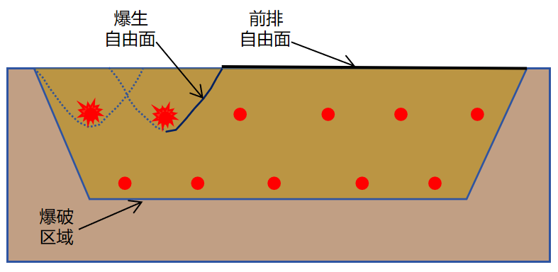
Fig.1 Blast-induced free surface

Numerical Simulation of Deep Hole Blasting
2.1 Blasting Model Parameters
A deep-hole blasting model was established using the finite element software ANSYS/LSDYNA, as shown in Figure 2. The model dimensions are 6 m × 3 m × 18 m (length × width × height), with a charge length of 12 m and a stemming length of 4 m in the borehole.Six blast holes were arranged in the model. The rock material in the model was simulated using the RHT material model, which is widely employed to characterize the dynamic response of brittle materials, such as rock, under explosive and impact loading. The fluid-structure interaction (ALE) algorithm of LS-DYNA was utilized to simulate the dynamic shock effects of the explosive, coupled with the JWL equation of state to describe the pressure-volume relationship during the explosive detonation process. The expression is given by Equation (1):
（1）
In the equation,P is the pressure determined by the JWL equation of state,V is the relative volume,E₀ is the initial specific internal energy,A, B, R₁, R₂, and ω are independent constants defining the JWL equation,with the values of each parameter listed in Table 1.
Table.1 Explosive Numerical Simulation Parameters
Density  /(kg·m-3) | A  /(GPa) | B  /(GPa) | R₁  /(m) | R₂  /(m) | ω  /(rad·s⁻¹)
1000 | 220 | 0.2 | 5.2 | 2.1 | 0.5
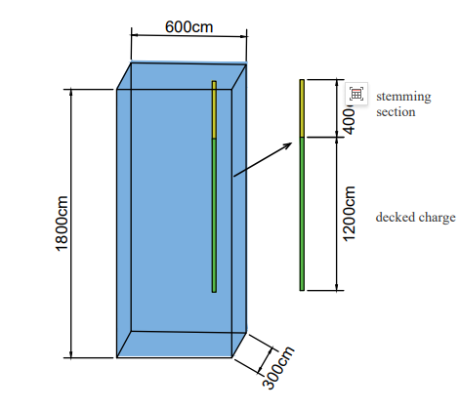
Fig.2 Blasting model

2.2 RHT Rock Constitutive Model
The rock material in this model adopts the RHT material model. The RHT rock constitutive model is widely used to simulate the dynamic response of rock under blasting, with its key features encompassing multi-mechanism failure and the evolution of damage. The constitutive equations of the RHT model consist of three stages: the elastic stage, strain hardening stage, and damage softening stage. The RHT model requires the definition of five equations, namely the elastic limit surface equation, linear hardening stage equation, failure surface equation, damage softening stage equation, and residual strength surface equation.Equation of state is as follows:
The application advantages of the RHT material model lie in:Accurately reflecting the propagation of blast stress waves.Predicting fracture zones and crack propagation by visualizing the extent of rock fragmentation through damage variables.Analyzing free surface effects, enabling the simulation of radial cracks at free surfaces.
elastic limit surface equation:
The linear hardening stage equation:
failure surface equation
damage softening stage equation
residual strength surface equation

Numerical Simulation Results and Analysis
3.1 Blasting Numerical Simulation Scheme
A two-row blast hole model was established using ANSYS-LSDYNA. The rock mass was modeled with the RHT material, and the ALE fluid-structure interaction algorithm was employed. And extract the calculation result model diagrams using Lsprepost. In the model, Part1 represents the rock, Part2 the air, Part3 the explosive, and Part4 the stemming. Non-reflective boundaries were applied to the surrounding and bottom surfaces of the rock mass to simulate an infinite rock medium, while the top surface was set as a free boundary. The charging parameters and rock parameters remained consistent across all models to comparatively analyze the effects of different blast-generated free surface conditions on rock fragmentation.
To further investigate the influence mechanism of blast-generated free surfaces on rock fragmentation and damage during blasting, after the detonation of I-1, I-2 is initiated. The rock mass of I-1 is excavated to dimensions of 200 cm × 150 cm × 1600 cm, with the free surfaces indicated in yellow and the blast-induced free surfaces shown in green. This process is repeated accordingly. Both the first and second rows of blast holes are detonated from the middle.The detonation sequence is illustrated in Fig 3.

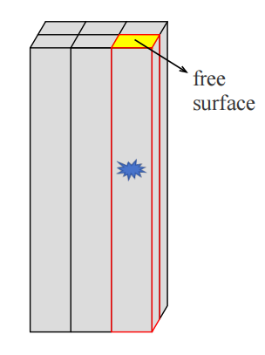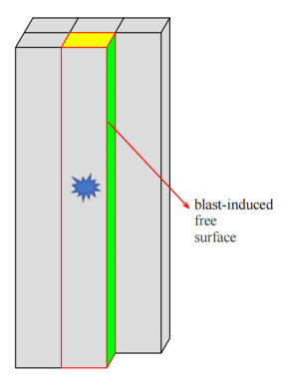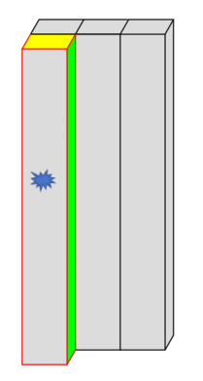
I-1 I-2 I-3

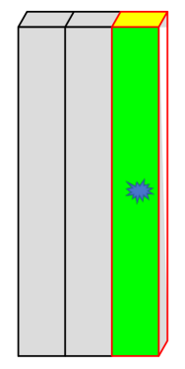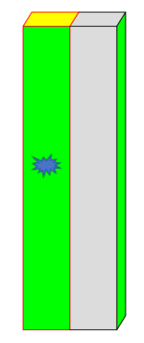
II-1 II-2 II-3
Fig 3 Schematic diagram of hole-by-hole detonation and free surface conditions
3.2 Analysis of Numerical Simulation Results
Figure 4 shows the blasting damage diagrams of blast holes I-1, I-2, I-3, II-1, II-2, and II-3. During the blasting process, the explosive energy propagates through the surrounding rock mass in the form of blast stress waves. When these waves encounter a free surface, they are reflected and form tensile waves, which promote tensile fracture in the rock mass near the free surface. In the case of I-1, where there is only one free surface at the top, the blast stress waves propagate infinitely around the borehole and rapidly attenuate, resulting in a relatively small blasting damage range. In this scenario, the explosive energy is primarily transmitted in the form of seismic waves, generating blasting vibrations. After the detonation of I-1, a blast-induced free surfaces is created on the face in contact with I-2, meaning that previously detonated blast holes exert a certain influence on subsequent ones. As the number of blast-induced free surfaces increases, the damage range in the direction of the free surfaces significantly expands. The range of stress wave reflection from the free surfaces further increases, leading to a corresponding expansion of the blasting damage range. Additionally, the number of cracks around the blast holes also increases further. A schematic diagram of numerical models under different free surface conditions is shown in Fig 4 below.

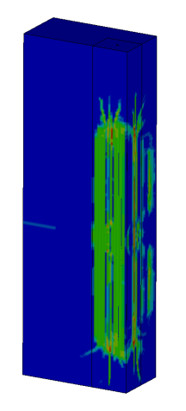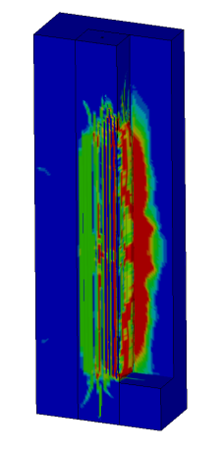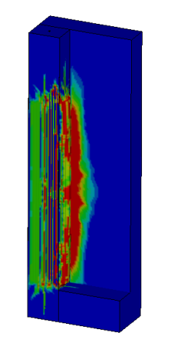
I-1 I-2 I-3
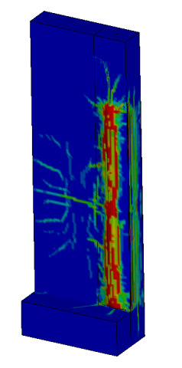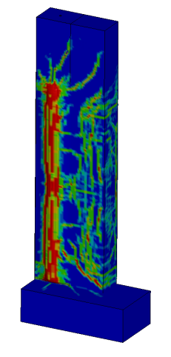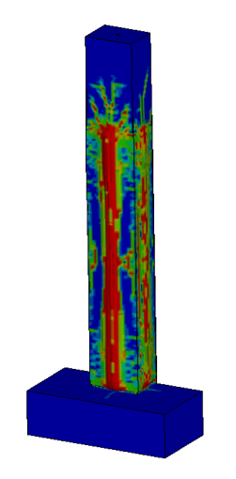
II-1 II-2 II-3

Fig 4 Schematic diagram of numerical models under different free surface conditions.
By comparing the percentage of the fragmented area (red zone) on the interface, the rock fragmentation under varying numbers of free surfaces can be assessed. When blast hole I-1 detonates, the top surface serves as the free surface while the other surfaces are non-reflective boundaries. Under these conditions, the red zone occupies a relatively small area, and the extent of rock fragmentation is limited. When blast hole I-2 detonates, the blast-generated free surface created by I-1 leads to an increase in the red zone area around I-2. Cracks gradually propagate and extend outward in all directions. Upon detonation of I-4, the blast-induced free surface produced by I-1 causes cracks to progressively spread toward the vicinity of the free surface. When II-2 detonates with two blast-induced free surfaces, crack propagation becomes more pronounced, and rock fragmentation damage is greater compared to the scenario with only one free surface. During the detonation of II-3, which has blast-induced free surfaces on three sides, the rock mass extrudes outward, and the internal damage zone expands further.
When I-1 is detonated, due to the presence of non-reflective boundaries, the explosive stress waves can only propagate infinitely along the borehole direction and rapidly attenuate. Under these conditions, the damage range of I-1 is relatively small, and crack propagation is limited. Since the explosive is initiated in the middle of the model, the blast pressure waves from I-2 and I-3 quickly spread outward in all directions. The red damage zone expands into the surrounding rock mass, resulting in rock fragmentation. When the number of blast-induced free surface increases for II-2, and the explosive is initiated in the middle of the model, cracks rapidly propagate outward in all directions, covering a larger area and showing a higher density compared to II-1. In the case of II-3, which has three blast-induced free surface, cracks quickly extend toward the surrounding free surfaces, leading to a more extensive damage range within the rock mass.

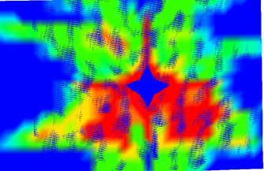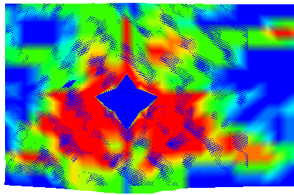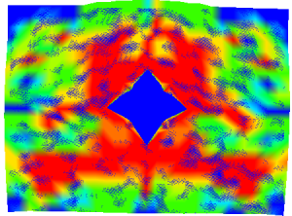
II-1 II-2 II-3
Fig 5 Cross section of the second row blast hole model
To better observe the influence of different blast-induced free surfaces on the damage range of rock mass, an analysis was conducted on the damage range of the second-row borehole models. As shown in Fig 5, when borehole II-1 has one blast-induced free surface, the damage range accounts for 15.1%; when borehole II-2 has two blast-induced free surfaces, the damage range is 20.3 %; and when borehole II-3 has three blast-induced free surfaces, the damage range is 32 %.The Damage Scope Proportion Map is shown in Fig 6‌. The data clearly indicate that as the number of blast-induced free surfaces increases, the damage range of the rock mass also continuously expands, and the fragmentation effect of the rock mass becomes more pronounced. Numerical simulation analysis conducted using ANSYS/LS-DYNA demonstrates that the application of hole-by-hole initiation technology can effectively increase the number of free surfaces during the blasting process, thereby significantly optimizing the distribution of explosive energy and the propagation paths of stress waves.Therefore, the number of blast-induced free surfaces is one of the significant factors affecting rock mass fragmentation.
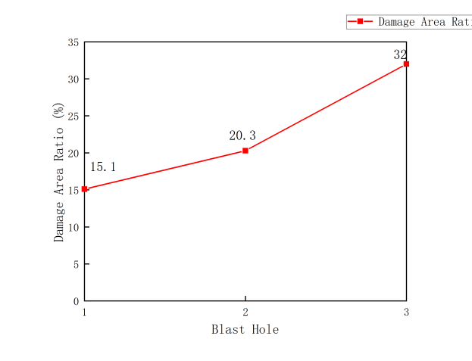
Fig 6 ‌Damage Coverage Percentage Chart‌

Conclusion
1.Blast-induced free surfaces significantly influence the extent of blasting damage: Simulation results demonstrate that as the number of blast-induced free surfaces increases, the reflection of blast stress waves at the free surfaces intensifies, leading to a notable expansion in the range of tensile failure. When the number of free surfaces increases from one to three, both the blasting damage area and the degree of rock fragmentation show a progressive upward trend.
2.Free surface orientation controls crack propagation patterns: Under conditions of a single free surface (Blast Holes I-1), explosive energy primarily propagates along the axial direction of the borehole and attenuates rapidly, resulting in a limited damage range. However, with the formation of lateral blast-induced free surfaces (Blast Holes II-2 and II-3), cracks significantly extend toward the free surfaces, exhibiting multidirectional propagation characteristics, along with increased crack density and connectivity.
3.Multiple free surfaces promote rock fragmentation and damage: A comparison of the damage percentages under varying numbers of free surfaces reveals that a greater number of free surfaces corresponds to a larger proportion of the fragmented interface area (red zone). This indicates that blasting energy is more effectively converted into rock fragmentation work rather than being dissipated solely as vibrations. Particularly under conditions with three free surfaces, the rock mass exhibits noticeable outward extrusion, and the internal damage range expands further.
4.Engineering implications: In practical blasting engineering, the blast-induced free surfaces can be actively created and utilized through rational design of initiation sequences and blast hole layouts. This approach can enhance rock fragmentation efficiency, reduce blasting vibrations, and optimize blasting outcomes. The simulation results provide theoretical reference for parameter design in engineering applications such as bench blasting and smooth blasting in tunnels.

Reference
Chen, Y. C., Liu, W. H., Li, P. F., et al. (2025). Applicable Conditions and Limitations of Hole-by-Hole Initiation Using Industrial Electronic Detonators . Blasting, 1-10.

Hong, Z. X., Guo, C., Xiong, H. W., et al. (2019). Numerical simulation study on the influence of lateral pressure coefficient on decoupled charge blasting. Blasting, 2019, 36(03), 65-75+89.

He, L., Zhong, D. W., Li, P., Song, K., & Si, J. F. (2020). Vibration prediction and energy analysis of slope under blasting load in underpass tunnel. Explosion And Shock Waves. https://doi.org/10.11883/bzycj-2019-0255

Li, Y., Lu, W., Wang, Y., Chen, M., & Yan, P. (2025). Research of rock blasting seismic energy radiation and its dependence on blasting source and free surfaces. Chinese Journal of Rock Mechanics and Engineering, 44(06), 1585-1595. https://doi.org/10.3724/1000-6915.jrme.2024.0862

Liu, L., Wu, L., Zhang, A., et al.(2025) Influence of free surface number on fragmentation and muck pile morphology in underwater rock blasting. Engineering Blasting, 31(05), 34-42.

Liu, X. Y., Gong, M., Wu, H. J., et al. (2021). Determination method for tunnel electronic detonator blasting parameters under free surface variation conditions. Explosion and Shock Waves, 41(10), 153–165.

Leng, Z. D., Lu, W. B., Hu, H. R., et al. (2016). Influence of generated free surfaces on peak vibration induced by slope millisecond-delay blasting. Chinese Journal of Rock Mechanics and Engineering, 35(09), 1815-1822.

Leng, Z. D., Gao, Q. D., Lu, W. B., et al.(2023). Research advances in energy regulation theory and application technology for rock drilling blasting. Metal Mine, (5), 64–76.

Lu, W., Leng, Z., Hu, H., Chen, M., & Wang, G. (2018). Experimental and numerical investigation of the effect of blast-generated free surfaces on blasting vibration. European Journal of Environmental and Civil Engineering, 22(11), 1374-1398. https://doi.org/10.1080/19648189.2016.1262285.

Lu, W. B., Meng, T., Hu, Y. G., (2024). Research status and prospects of rock blasting fragmentation simulation and fragmentation prediction. Engineering Blasting, 30(05), 20-28.

Min, P., Xie, J., Shen, Y. S., Chang, M. Y., Dong, J., & Chen, K. F. (2023). Optimization of prediction formula for blasting vibration velocity of subway tunnels considering effects of free surface parameters. Journal of Vibration and Shock, 42(21), 245-253. https://doi.org/10.13465/j.cnki.jvs.2023.21.029

Ma, L., Ding, X. H., Sun, J. D., et al. (2017). Mechanism of rock fragmentation and throwing in deep-hole bench throwing blasting. China Sciencepaper, 12(21), 2445-2448.

Sun, B. Y., Duan, W. d, Zheng, F., et al. (2006). Research and development trend of rock fragmentation theoretical models under blasting action. Metal Mine, (9), 5-7.

Wu, C. S., Xu, R. W., & Zhang, Q. B. (2017). Influence of free surface on energy distribution characteristics of blast vibration. Explosion and Shock Waves, 37(06), 907-914. https://doi.org/10.11883/1001-1455(2017)06-0907-08.

Yang, C. L., Xiong, Y. F., Li, X.,(2022). Finite element study on the influence of varying free surface numbers on rock blasting. Mining Technology, 22(05), 175-181.

Zhao, J. P., Cheng, B. B., Lu, W., et al.(2020). Damage law of rock double-hole blasting under high in-situ stress. Engineering Blasting, 26(05), 14-20+41.

Zhang, Q., (2025). Numerical Simulation of Hole-by-Hole Initiation and Its Vibration Control Research. Science and Technology Innovation and Application,15(32), 64-67.

Zou, H, C., (2022). Application Example of Hole-by-Hole Initiation Using Conventional Millisecond Detonating Cord Detonators in an Open-Pit Deep-Hole Bench Blasting. Yunnan Metallurgy, 51(01), 26-30.

