Prevalence of Anaemia and Pattern of Hematological Indices among Antenatal Women at Booking in a New Tertiary Health Care Facility in Southwest, Nigeria: A Retrospective Study

Abstract
Background: Pregnancy induces significant haematological changes. Anaemia in pregnancy remains a major public health concern. Understanding the local prevalence and patterns of haematological indices is essential to guide targeted interventions.
Objectives: To determine the prevalence of anaemia and describe the pattern of haematological indices among pregnant women at booking in a new tertiary health facility.
Materials and Methods: A retrospective study which reviewed the electronic medical records of pregnant women at the Redeemer’s Health Village Hospital, Ogun State, between 15 June 2024 and 14 June 2025. Socio-demographic characteristics including gestational age, parity, trimester at booking and haematological parameters were extracted. Anaemia was classified by severity (World Health Organisation criteria) and morphology. Descriptive statistics were used to summarise the data. Data were analyzed using SPSS version 23, with statistical significance set at a value of p < 0.05.
Results: A total of 77 women were included; majority (68.8%) aged 25–34 years. Nulliparous women accounted for 45.5% and 46.8% booked during the first trimester. The overall prevalence of anaemia was 36.4%. Normocytic normochromic anaemia was the most common morphological type (24.7%), followed by microcytic hypochromic (10.4%) and macrocytic normochromic (1.3%). Majority had normal white blood cell (90.9%) and platelet counts (92.2%). No significant associations were found between severity of anaemia and maternal age, parity, or trimester at booking.
Conclusion: Normocytic normochromic anaemia remains common at antenatal booking in our environment. Short inter-pregnancy interval and other underlying factors may contribute to the observed burden. Strengthening preconception care and promoting adequate birth spacing may help reduce anaemia at conception and at booking.
Keywords: Anaemia, Antenatal booking, Haematological indices, Pregnancy, Retrospective study

Introduction
Pregnancy is accompanied by profound physiological adjustments that affect nearly every organ system, including the haematopoietic system. These changes progress throughout gestation and become more pronounced in the second and third trimesters [1], largely due to haemodilution. During this period, plasma volume expands more rapidly than red cell mass [2], producing a relative reduction in haemoglobin concentration. Although this response is a normal adaptation to pregnancy, it can reveal or worsen underlying haematological disorders such as anaemia, which may negatively impact fetomaternal wellbeing. [3] Other blood components also undergo alterations in pregnancy, with white blood cell (WBC) counts typically rising [4], platelet counts tending to fall [5], and coagulation factors increasing to create a physiologically hypercoagulable state [6] that facilitates haemostasis in preparation for childbirth.
Anaemia in pregnancy remains a major global health challenge. According to the World Health Organization (WHO), anaemia is defined as a haemoglobin level below 11 g/dL in the first and third trimesters and below 10.5 g/dL in the second trimester. [7] Recent WHO estimates indicate that approximately 37% of pregnant women worldwide are anaemic. [8] Studies conducted across Nigeria and the broader sub-Saharan African region show considerable variability in anaemia prevalence at antenatal booking. For instance, research from The Gambia, Akure (Nigeria), and Port Harcourt (Nigeria) documented prevalence rates of 21.6% [9], 40.0% [10], and 60.2% [11], respectively. Such differences likely reflect variations in nutritional status, malaria endemicity and transmission, socioeconomic conditions, and access to quality healthcare.
Optimal pregnancy outcomes are more likely when conception occurs during a period of good maternal health and when antenatal care is initiated early. However, many women in resource-constrained settings present late for antenatal booking, often due to ignorance, poverty, unplanned pregnancies [12] or limited access to healthcare services. Late initiation of antenatal care reduces opportunities for early identification and management of anaemia and other haematological abnormalities. Consequently, affected women face increased risks of complications such as fatigue, anaemic heart failure, intrauterine growth restriction (IUGR), preterm delivery, low birth weight (LBW), and intrauterine fetal demise (IUFD). [13]
Given the significant maternal and perinatal sequelae associated with anaemia and abnormal haematological parameters in pregnancy, it is important to generate context-specific data that can guide preventive and therapeutic interventions. This study therefore sought to determine the prevalence of anaemia and describe the pattern of haematological indices among pregnant women booking for antenatal care at a newly established tertiary health facility in Southwest Nigeria.
Materials and Methods
Study Design and Setting
This hospital-based retrospective study was conducted at Redeemer’s Health Village Hospital (RHVH), a newly established tertiary healthcare facility in Southwest Nigeria. The RHVH is located within the grounds of the Redemption City, which covers over 2500 hectares of land along the Mowe axis of the Lagos-Ibadan Expressway, Obafemi-Owode Local Government Area, Ogun State, Nigeria. The study covered a one-year period from 15th June 2024 to 14th June 2025.
Study Population
The study population comprised pregnant women who presented for antenatal booking at the RHVH during the study period.
Inclusion Criteria
- Pregnant women who attended antenatal booking within the study period and had complete haematological records
Exclusion Criteria
- Women with vaginal bleeding within four weeks prior to booking
- Patients with known haemoglobinopathies or bleeding disorders
- Women who had received blood transfusions within the preceding four weeks of antenatal booking
- Patients treated for infections within four weeks prior to booking or presenting with clinical features of infection
- Women positive for blood borne viruses (HIV, HBV, HCV)
- Women with incomplete medical records
Data Collection
Relevant clinical and laboratory information was extracted from the hospital’s electronic medical records (EMR). Data collected included maternal age, gestational age at booking, parity, inter-pregnancy interval, and haematological parameters such as haemoglobin concentration (Hb), haematocrit (HCT), mean corpuscular volume (MCV), mean corpuscular haemoglobin (MCH), mean corpuscular haemoglobin concentration (MCHC), total white blood cell count (WBC), and platelet count.
Sample Collection and Laboratory Analysis (Routine procedure)
At the booking visit, 5 mL of venous blood was routinely collected aseptically from each participant into K₂-EDTA tubes. Phlebotomy followed standard procedures, including minimal tourniquet time, use of the antecubital vein, and gentle inversion of tubes 8–10 times immediately after collection. Samples were appropriately labeled with patient identification and collection time, and transported to the laboratory at ambient temperature within 20 minutes of collection.
Haematological analyses were performed using automated haematology analyzers. Parameters measured included haemoglobin, haematocrit, red cell indices (MCV, MCH, MCHC), total white blood cell count, and platelet count. All analyses were conducted according to the hospital’s standard laboratory operating procedures.
Data Analysis
Data were analyzed using the Statistical Package for the Social Sciences (SPSS), version 23. Continuous variables were summarized as means ± standard deviations (SD), while categorical variables were presented as frequencies and percentages. Associations between categorical variables were assessed using the Chi-square test, with statistical significance set at p < 0.05.
Classification of Anaemia
List 1 : By Severity (WHO Criteria)
Normal | Mild anaemia | Moderate anaemia | Severe anaemia
Hb ≥ 11.0 g/dL | Hb 10.0–10.9 g/dL | Hb 7.0–9.9 g/dL | Hb < 7.0 g/dL

List 2 : By Morphology
 | MCV | MCH | MCHC
Normocyticnormochromic anaemia | Normal | Normal | Normal
Microcytic hypochromic anaemia | Reduced | Reduced | Reduced
Macrocytic normochromic anaemia | Elevated | Normal | Normal

Normal reference values
MCV = 80 – 100 ft
MCH = 27 – 32 pg
MCHC = 32 – 36 g/dl
Ethical Consideration
Ethical approval for the study was waived by the hospital’s Research and Ethics Committee because of the retrospective nature of the study with the caveat that all data be de-identified without any form of traceability to the patients used for the study.
Results
Seventy-seven women met the inclusion criteria. The mean maternal age of the booked women was 31.04 ± 4.95 years with an age range of 18 - 42 years. The mean parity was 0.94 ± 1.03 with a parity of 0 – 4. Majority (45.5%, 35/77) of the women were nullipara. Of the 42 women with previous parous experience, 88% (37/42) had short inter-pregnancy interval. Most of the women (46.8%) booked in the first trimester. The mean gestational age at booking, however was 18.45 ± 11.16 weeks (Table 1).
The mean haemoglobin (Hb) was 11.08g/dL ± 3.52 with a range of 8.5 to 13.7g/dL (Table 4). Twenty-eight women (36.4%) were anaemic (Figure 1). Majority (20.8%) of the pregnant women at booking had mild anaemia while 15.6% had moderate anaemia (Figure 2). No case of severe anaemia was detected. Nineteen women (24.7%) had normocytic normochromic anaemia, while 8 (10.4%) and 1 (1.3%) women had microcytic hypochromic and macrocytic normochromic anaemia respectively (Table 2).
Majority (90.9%) of the women had normal leucocytes count with a mean leucocytes count of 7.68 ± 2.97 x 10⁹/µL. The mean platelets count was 230.81 ± 66.38 x 10⁹/µL with 92.2% having normal platelets count. Only 2.6%, 6.5% and 7.8% of women had leucocytopenia, leucocytosis, and thrombocytopenia respectively (Table 3).
There were no statistically significant associations between anaemia severity and maternal age, parity, or trimester at booking (p = 0.652, 0.445, and 0.400, respectively) (Tables 5, 6 and 7).
Table 1: Socio-demographic and Obstetric characteristics of women at booking
Socio-demographic characteristic | Value (frequency)  n (%)
Maternal Age (years)
< 25 | 6 (7.8)
25-34 | 53 (68.8)
35-44  Total  Mean ± SD age (min 18, max 42) | 18 (23.4)  77 (100.0)  31.04 ± 4.95
Parity
0 | 35 (45.5)
1 | 19 (24.6)
2-4 | 23 (29.9)
Total  Mean ± SD parity (min 0, max 4) | 77 (100.0)  0.94 ± 1.03
Trimester at booking
1 | 36 (46.8)
2 | 17 (22.1)
3  Total  Mean GA (weeks)  Interpregnancy interval for P1 – 4 women  Adequate (≥ 2 years)  Short (< 2 years)  Total  Figure1  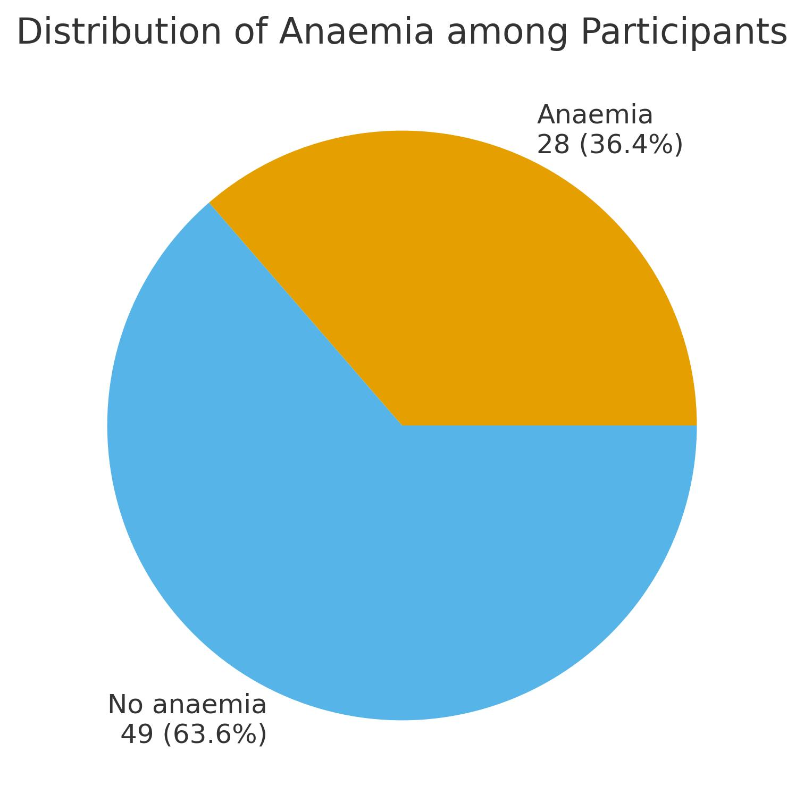  Figure 2  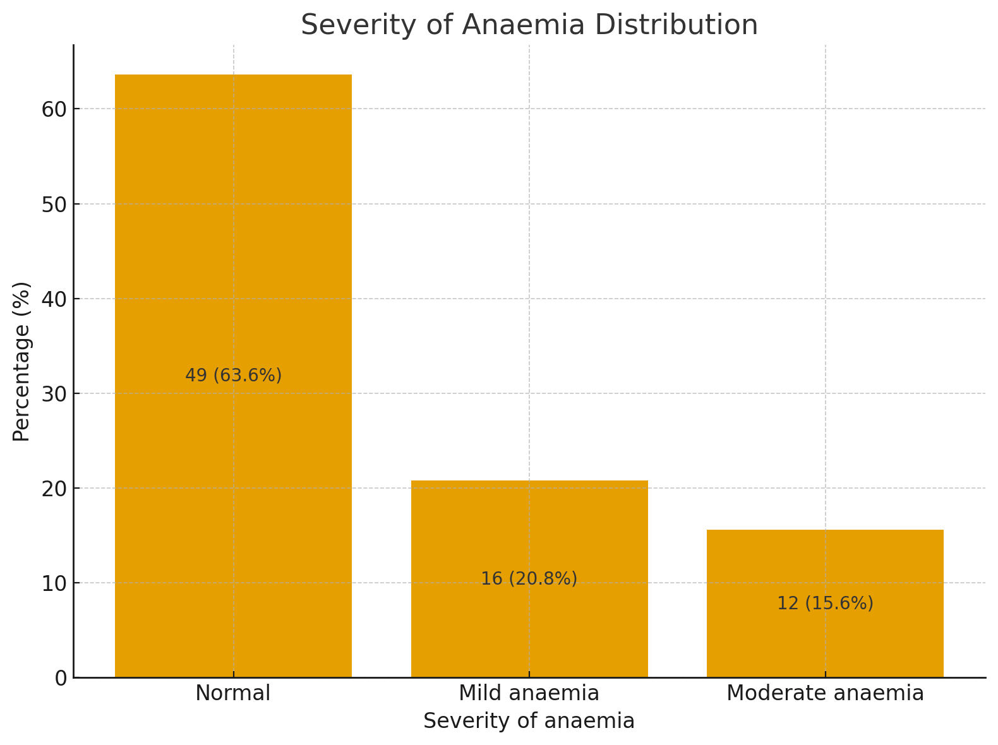  Table 2: Morphology of anaemia at booking | 24 (31.1)  77 (100.0)  18.45 ± 11.16  05 (12.0)  37 (88.0)  42 (100.0)
  Morphology | Value (frequency)  n (%)
  No anaemia  Normocytic normochromic  Microcytic hypochromic  Macrocytic normochromic  Total | 49 (63.6)  19 (24.7)  8 (10.4)  1 (1.3)  77 (100.0)
Table 3: Leucocytes and Thrombocytes counts at booking
Value (frequency)
n (%)
Leucocytes
< 4000 | 2 (2.6)
4000 – 11000 | 70 (90.9)
>11000  Total  Thrombocytes ( x 10⁹/L)  < 150  150 - 450  Total | 5 (6.5)  77 (100.0)  6 (7.8)  71 (92.2)  77 (100.0)
Table 4: Mean hematological indices
Hematological indices | Statistics  N | Minimum | Maximum | Mean | SEM | SD
Hb (g/dl) | 77 | 8.5 | 13.7 | 11.08 | 0.14 | 1.20
PCV (%) | 77 | 25.4 | 40.6 | 33.14 | 0.40 | 3.52
MCV (ft)  MCHC (g/dl)  MCH (pg)  WBC ( x 10⁹/L)  Platelets ( x 10⁹/L) | 77  77  77  77  77 | 28.3  28.0  20.4  3.24  95.0 | 105.0  337.0  35.0  24.0  440 | 83.33  37.73  29.07  7.68  230.81 | 1.07  3.94  0.34  0.34  7.57 | 9.35  34.57  2.98  2.97  66.38
Table 5: Association between severity of anaemia and trimesters at booking

Level of anaemia | 1st trimester | 2nd trimester | 3rd trimester | Total
Normal | 23 | 13 | 13 | 49
Mild | 9 | 1 | 6 | 16
Moderate  Total | 4  36 | 3  17 | 5  24 | 12  77
Chi square = 4.041, DF=4 P-value = 0.400

Table 6: Association between severity of anaemia and parity

Level of anaemia | Nullipara  (P0) | Primipara  (P1) | Multipara (P2-4) | Total
Normal | 21 | 12 | 16 | 49
Mild | 9 | 2 | 5 | 16
Moderate  Total | 5  35 | 5  19 | 2  23 | 12  77
Chi square = 3.724, DF=4 P-value = 0.445

Table 7: Association between severity of anaemia and maternal age

Level of anaemia | < 35 years | ≥ 35 years | Total
Normal | 41 | 8 | 49
Mild | 12 | 4 | 16
Moderate  Total | 9  62 | 3  15 | 12  77
Chi square = 0.855, DF = 2, P-value = 0.652
Discussion
In our study, about 70% of women booking for antenatal care were aged 25 - 34 years, consistent with findings from Olatubosun [14] and Olayinka [15] et al., who reported a predominant age range of 25 - 29 years at booking. This is expected, as women within this age group are generally at their peak reproductive years. Most participants (45.5%) were nulliparous, similar to the findings of Okagua et al. [16], which may reflect maternal anxiety or heightened vigilance during the first pregnancy. In contrast, Nonye-Enyidah et al. [17] reported multigravidae (39.8%) as the largest group at booking, possibly due to previous pregnancy complications prompting antenatal visits.
Nearly half of the women in this study (46.8%) booked during the first trimester, comparable to earlier reports [18] indicating high first-trimester booking rates (66.0%). Early booking in these populations may be influenced by higher educational levels and increased awareness of the importance of early antenatal care. Conversely, other studies in West Africa [19] and East Africa [20] have reported lower first-trimester booking rates of 29.0% and 40.6%, respectively, highlighting variations in access to care and healthcare-seeking behavior across these regions.
The overall prevalence of anaemia at booking in this study was 36.4%, with mild and moderate anaemia accounting for 20.8% and 15.6%, respectively. This aligns with WHO global estimates (37%) [8] and other studies in Nigeria [10, 21, 22] reporting 40 - 76.3% prevalence. Multiple factors may contribute to this high prevalence, including socioeconomic challenges, endemic malaria, nutritional deficiencies, limited participation in preconceptional care, and short inter-pregnancy intervals. In this study, 88% of women with previous parous experience had inter-pregnancy intervals of less than two years, which may further contribute to the high anaemia prevalence.
Regarding severity, mild anaemia was the most common, followed by moderate anaemia, mirroring findings from Bayarkhuu et al. [23], with no cases of severe anaemia detected. In contrast, Abidemi and colleagues [22] reported moderate anaemia as predominant and a 9.1% prevalence of severe anaemia, suggesting geographical differences may influence anaemia patterns. Some studies [24] have reported much lower prevalence rates (e.g., 16.6%) [24], reflecting variations in population health, nutrition, and study methodology.
Morphologically, normocytic normochromic anaemia was most prevalent (24.7%), followed by microcytic hypochromic (10.4%) and macrocytic normochromic (1.3%). This pattern is similar to reports from Melku et al. in Ethiopia [24] and Bayarkhuu et al. [23] in Mongolia, likely reflecting physiological dilutional anaemia in pregnancy compounded by iron deficiency which has been reported to be common in Nigeria. [25]
Most participants had normal leukocyte counts (90.9%), with mean WBC of 7.68 ± 2.97 × 10⁹/µL, while leucopenia and leucocytosis were observed in very negligible number of the women studied. These findings are consistent with Yusuf et al. [26], who also reported predominantly normal leukocyte counts. The leucocytosis observed in our study is likely physiological, as pregnancy is associated with mild elevations in white blood cells.⁴ Similarly, 92.2% of women had normal platelet counts (mean 230.81 ± 66.38 × 10⁹/µL). Thrombocytopenia was identified in less than a tenth of participants, consistent with reported ranges of 6 - 15% in other studies, [27, 28] likely reflecting gestational thrombocytopenia [29] or other underlying medical conditions.
No statistically significant associations were observed between anaemia severity and maternal age, parity, or trimester at booking (p = 0.652, 0.445, and 0.400, respectively). These findings contrast with Yusuf et al, [26] who reported significant associations between anaemia severity, parity, and gestational age, highlighting potential population or methodological differences.
Conclusion
Anaemia remains highly prevalent among women at antenatal booking, predominantly mild in severity and normocytic normochromic in morphology. Leukopenia, leukocytosis, and thrombocytopenia were observed in a small proportion of women. Encouragingly, a high proportion of women booked for antenatal care during the first trimester. This gives hope of the likelihood of preconception care being strengthened and promotion of adequate birth spacing in subsequent pregnancies for the enlightened women.
Recommendations
Despite nearly half of the women booking in the first trimester, anaemia prevalence remained high in our study, suggesting many women may have been anaemic prior to conception. Therefore:
1. Preconception care should be emphasized to optimize maternal health.
2. Education on contraception and adequate inter-pregnancy intervals should be promoted to allow maternal recovery and restoration of haematological indices before subsequent pregnancies.
3. Nutritional counselling and interventions to prevent and manage anaemia should be intensified, especially among women of reproductive age.
References
- Stephansson, O., Dickman, P. W., Johansson, A., & Cnattingius, S. (2000). Maternal hemoglobin concentration during pregnancy and risk of stillbirth. JAMA, 284(20), 2611-2617. https://doi.org/10.1001/jama.284.20.2611

- Chandra, S., Tripathi, A. K., Mishra, S., Amzarul, M., & Vaish, A. K. (2012). Physiological changes in hematological parameters during pregnancy. Indian Journal of Hematology and Blood Transfusion, 28(3), 144-146. https://doi.org/10.1007/s12288-012-0175-6

- Obeagu GU, Obeagu EI. Complications of anaemia in pregnancy: An updated overview for healthcare professionals. Medicine. 2025;104(35):e44246. Doi:10.1097/MD.0000000000044246.

- Dockree, S., Shine, B., Pavord, S., Impey, L., & Vatish, M. (2021). White blood cells in pregnancy: Reference intervals for before and after delivery. EBioMedicine, 74, 103715. https://doi.org/10.1016/j.ebiom.2021.103715

- Reese, J. A., Peck, J. D., Deschamps, D. R., McIntosh, J. J., Knudtson, E. J., Terrell, D. R., Vesely, S. K., & George, J. N. (2018). Platelet counts during pregnancy. New England Journal of Medicine, 379(1), 32-43. https://doi.org/10.1056/NEJMoa1802897

- Bagot, C. N., Leishman, E., Onyiaodike, C. C., Jordan, F., & Freeman, D. J. (2017). Normal pregnancy is associated with an increase in thrombin generation from the very early stages of the first trimester. Thrombosis Research, 157, 49-54. https://doi.org/10.1016/j.thromres.2017.06.027

- World Health Organization. (2025). Anaemia in women and children. https://www.who.int/data/gho/data/themes/topics/anaemia_in_women_and_children

- World Health Organization. (2023). *Anaemia*. https://www.who.int/news-room/fact-sheets/detail/anaemia

- Mbowe, F., Darboe, K. S., Sanyang, A. M., & Barrow, A. (2025). Prevalence and determinants of anaemia among pregnant women attending maternal and child health clinics at Sukuta Health Center, The Gambia: An institutional-based cross-sectional study. *Womens Health (Lond), 21*, 17455057251338380. https://doi.org/10.1177/17455057251338380

- Irinyenikan, T. A., Folarin, B. J., Alabi, B. Y., Bade-Adefioye, A. M., & Sani, I. (2023). Prevalence of anaemia among antenatal clinic attendees at a tertiary hospital in Southwest, Nigeria. *European Journal of Clinical Medicine*, *4*(4), 7-12. https://doi.org/10.24018/clinicmed.2023.4.4.274

- Awoyesuku, P. A., Ohaka, C., & Ngeri, B. (2020). Prevalence of Anemia in Pregnant Women under Antenatal Care at the Rivers State University Teaching Hospital, Port-Harcourt, Nigeria and Association to Knowledge and Attitude on Anemia and Its Prevention. International Journal of Tropical Disease & Health, 41(20), 20-33. https://doi.org/10.9734/ijtdh/2020/v41i2030390

- Gelaw, K. A., Atalay, Y. A., & Gebeyehu, N. A. (2023). Unintended pregnancy and contraceptive use among women in low- and middle-income countries: systematic review and meta-analysis. Contraception and Reproductive Medicine, 8(1), 55. https://doi.org/10.1186/s40834-023-00255-7

- Izuka, E. O., Obiora-Izuka, C. E., Asimadu, E. E., Enebe, J. T., Onyeabochukwu, A. D., & Nwagha, U. I. (2023). Effect of late antenatal booking on maternal anemia and fetus birth weight on parturients in Enugu, Nigeria: An analytical cross-sectional study. Nigerian Journal of Clinical Practice, 26(5), 558-565. https://doi.org/10.4103/njcp.njcp_117_22

- Olatunbosun, O. A., Abasiattai, A. M., Bassey, E. A., James, R. S., Ibanga, G., & Morgan, A. (2014). Prevalence of anaemia among pregnant women at booking in the University of Uyo Teaching Hospital, Uyo, Nigeria. BioMed Research International, 2014, 849080. https://doi.org/10.1155/2014/849080

- Olayinka, T. O., Bello, I. S., Olajubu, T. O., Oyegbade, O. O., Olajubu, A. O., & Ezeoma, I. T. (2022). Factors influencing the booking gestational age among antenatal clinic attendees at primary health centers in South West, Nigeria: A cross-sectional study. *SAGE Open Nursing*, *8*, 1-7. https://doi.org/10.1177/23779608221139078

- Okagua, K. C., Ogbondah, B., Jaja, I., & Okagua, J. (2022). Demographic correlates of gestational age at booking among antenatal clinic attendees in secondary healthcare facilities in semi-urban/rural areas of Rivers state, Southern Nigeria. The Nigerian Health Journal, 22(3), 305-310. https://doi.org/10.60787/tnhj.v22i3.607

- Nonye-Enyidah, E. I., Altraide, B. O. A., & Jumbo, A. I. (2021). Prevalence of anaemia in pregnancy at antenatal care booking in a teaching hospital in Southern Nigeria. International Journal of Reproduction, Contraception, Obstetrics and Gynecology, 10(9), 3287-3294. https://doi.org/10.18203/2320-1770.ijrcog20213441

- Abuosi, A. A., Anaba, E. A., Daniels, A. A., Baku, A. A. A., & Akazili, J. (2024). Determinants of early antenatal care visits among women of reproductive age in Ghana: evidence from the recent Maternal Health Survey. BMC Pregnancy and Childbirth, 24(1), 309. https://doi.org/10.1186/s12884-024-06490-3

- Abdo, R., Demelash, M., Seid, A. M., & Mussema, A. (2023). First trimester antenatal care contact in Africa: a systematic review and meta-analysis of prevalence and contributing factors. BMC Pregnancy and Childbirth, 23(1), 742. https://doi.org/10.1186/s12884-023-06034-1

- Kolola, T., Morka, W., & Abdissa, B. (2020). Antenatal care booking within the first trimester of pregnancy and its associated factors among pregnant women residing in an urban area: a cross-sectional study in Debre Berhan town, Ethiopia. BMJ Open, 10(6), e032960. https://doi.org/10.1136/bmjopen-2019-032960

- Alabrah, P. W., Solomon, A. E., Oweisi, P. W., Eguvbe, A. O., & Kehinde, O. (2022). Anaemia at booking and related factors in pregnant women attending antenatal clinic in a rural health facility in South-South Nigeria. Asian Hematology Research Journal, 5(1), 34-42. https://journalahrj.com/index.php/AHRJ/article/view/109

- Abidemi, O., & Bello, M. A. (2024). Prevalence of anaemia at booking in Northwestern Nigeria tertiary hospital. Clinics of Surgery, 10(10), 1-6. https://clinicofsurgery.org

- Bayarkhuu O, Tsogbadrakh O. Prevalence, type and risk factors associated with anaemia in pregnancy at the Chingeltei district health center in Ulaanbaatar, Mongolia. Ultrasound in Obstetrics and gynaecology. 2022; 60(s1):99.doi:10.1002/uog.25260.

- Melku, M., Addis, Z., Alem, M., & Enawgaw, B. (2014). Prevalence and predictors of maternal anemia during pregnancy in Gondar, Northwest Ethiopia: An institutional based cross-sectional study. Anemia. https://doi.org/10.1155/2014/108593

- Ugwu, N. I., & Uneke, C. J. (2020). Iron deficiency anemia in pregnancy in Nigeria-A systematic review. *Niger J Clin Pract*, *23*(7), 889-896. https://doi.org/10.4103/njcp.njcp_197_19

- Yusuf, M., & Darma, B. A. (2022). Pattern of Haematological Indices Among Pregnant Women at Booking in Murtala Muhammad Specialist Hospital, Kano. Ibom Medical Journal, 15(1), 47-53. https://doi.org/10.61386/imj.v15i1.232

- McCrae, K. R. (2010). Thrombocytopenia in pregnancy. Hematology Am Soc Hematol Educ Program, 2010, 397-402. https://doi.org/10.1182/asheducation-2010.1.397

- Omunakwe, H. E., Wekere, F. C. C., & Ela, G. M. (2021). Thrombocytopenia in women initiating antenatal care in Port Harcourt. Journal of Hematology and Blood Disorders, 7(1), 102. https://www.annexpublishers.com/journal-of-hematology-and-blood-disorders-archive.php?volume=7&issue=1

- Fogerty, A. E. (2018). Thrombocytopenia in Pregnancy: Mechanisms and Management. Transfusion Medicine Reviews, 32(4), 225-229. https://doi.org/10.1016/j.tmrv.2018.08.004

