Case report

Placentrex medication in the management of corneal opacity associated with Bovine trypanosomosis: A case report

Abstract
A six years old female cross bred Jersey cow was presented to the veterinary clinical complex, BVC,BASU, Patna, Bihar with the history of inappetance, bilateral ocular changes and lacrimal discharges, apparent blindness and drop in milk production. Clinical examination revealed body temperature of 103.2 ⁰ F, pale conjunctival mucus membranes, bilateral corneal opacity with hyphema and lacrimation, stamping of feet and salivation. Based on the clinical history, the animal was suspected for haemoprotzoal infection. The blood was collected for blood smear examination and haemato-biochemical estimations. Microscopic examination (oil immersion objective) of Giemsa stained blood smear revealed characteristic haemoflagellates, the Trypanosoma spp. The haematological examination showed low level of haemoglobin (8.4 gm/dl) and TEC (4.78X10⁶/µl), while the biochemical estimation revealed normal level of total serum protein, albumin and blood glucose, but the high values of total serum bilirubin (0.92 mg/dl) was observed. Based on clinical and blood smear examination, the case was diagnosed for corneal opacity associated with trypanosomosis.
Treatment was started with Inj. Triquin (Quinopyramine sulphate and chloride) @ 5 mg /kg, SC (single dose) after infusion of 2.0 litre of Dextrose saline solution. Day after initial therapy, Inj Placentrex (Human placental extract) 1ml was administered sub-conjunctively as a single dose in both eyes. Further, eye drop Prednisolone acetate four drops TID was prescribed as follow-up treatment. Clinical recovery with complete resolution of corneal opacity was observed after 3 week treatment, and the post therapeutic blood sample was also found negative for any haemoparasites.
Keywords: Cattle; Corneal opacity; Placentrex; Trypanosomosis.
1. INTRODUCTION
Bovine trypanosomosis is a wasting disease of livestock, caused by Salivarian groups of trypanosomes (T. vivax, T. congolense and T. brucei spp.), and transmitted through the bite of blood sucking insects (Giordani et al., 2016). Clinically the acute disease in bovine is characterized by high fever, emaciation, lacrymation, reduced milk yield, nervous signs and death may occur within 24 hours of onset of clinical signs (Rani et al., 2015). Chronic can lead to loss of body condition with impaired reproductive performance (Radostits et al., 2007). Sometimes, ocular lesions associated with Trypanosoma spp. infection have been described in man and many animal species. The present communication reports on use of Placentrax in successful management of corneal opacity associated with trypanosomosis in a cross bred cow.
2. PRESENTATION OF CASE
A six years old female cross bred Jersey cow was presented to the veterinary clinical complex, BVC,BASU, Patna, Bihar with the history of inappetance, bilateral ocular changes and lacrimal discharges, apparent blindness and drop in milk production. Clinical examination revealed body temperature of 103.2 ⁰ F, pale conjunctival mucus membranes, salivation, bilateral corneal opacity with hyphema, lacrimation (Fig. 1) and stamping of feet. Based on the clinical history, the animal was suspected for haemoprotzoal infection. The blood was collected for blood smear examination and haemato-biochemical estimations. Microscopic examination (oil immersion objective) of Giemsa stained blood smear revealed characteristic haemo flagellates, the Trypanosoma spp. (Fig.2). The haematological examination showed low level of haemoglobin and total erythrocyte count, while the biochemical estimation revealed normal level of total serum protein, albumin and blood glucose, but the high values of total serum bilirubin was observed (Table 1). Based on clinical and blood smear examination, the case was diagnosed for corneal opacity associated with Bovine trypanosomosis.
3. DISCUSSION
After diagnosis, a single dose of Inj. Triquin (Quinopyramine sulphate and chloride) @ 5 mg /kg, SC was given after infusion of 2.0 litre of Intalyte solution. Day after initial therapy, Inj Placentrex (Human placental extract) 1ml was administered sub-conjunctively as a single dose in both eyes, and eye drop Prednisolone four drops three times in a day was advised as follow-up treatment. Clinical recovery with complete reversion of corneal opacity was observed after 3 week post treatment (Fig. 3), and the post therapeutic blood sample was found negative for hemoparasites. The infected cattle revealed anaemia which could be attributed due to erythrophagocytosis by mononuclear phagocytic system of the hosts (Sivajothi et al., 2014), and or enhanced erythrocytic oxidation (Mishra et al., 2017). Increase in bilirubin indicated increased destruction of erythrocytes which is commonly reported due to hemolytic crisis during the period of infection and was also supported by decrease in haemoglobin (Kumar et al., 2012). During the disease process, organisms descend from the brain along with the optic artery, causing immune complexes to develop in the aqueous humour, and this leads to cloudiness of cornea by accumulation of the granular deposits within the aqueous humour (Sudhakara & Sivajothi, 2017). It is well documented that placentrex has good effect on ocular therapy in human patients due to its anti-inflammatory, immunotropic and antioxidant properties (Ali et al., 2020). It is too widely used in healing process of corneal ulcers, corneal opacity and iris prolapse in animals. The healing property might be owing to tissue regeneration power through unique process of protein synthesis (Arunachalam et al., 2001). The use of corticosteroids prevent corneal opacification by inhibiting fibroplasia, decreasing vascularization, and reducing melanosis (Preena & Arvind, 2017).
Table 1: Hemato-biochemical parameters of cattle infected with trypanosomosis
Parameters | Day 0 | Reference*
Hemoglobin (g/dl) | 8.4 | 8.0-15.0
TEC (X10 ⁶/μl) | 4.78 | 5.0-10.0
Total Protein (gm/dL) | 7.46 | 5.7-8.1
Albumin (gm/dL) | 3.32 | 2.1-3.6
Blood Glucose (mg/dL) | 63.32 | 45-75
Serum Bilirubin (mg/dL) | 0.92 | 0. 01-0.5
*Source: Radostits et al., 2007
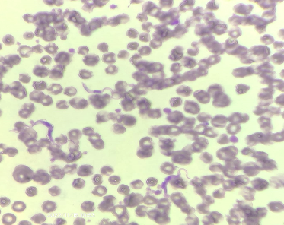

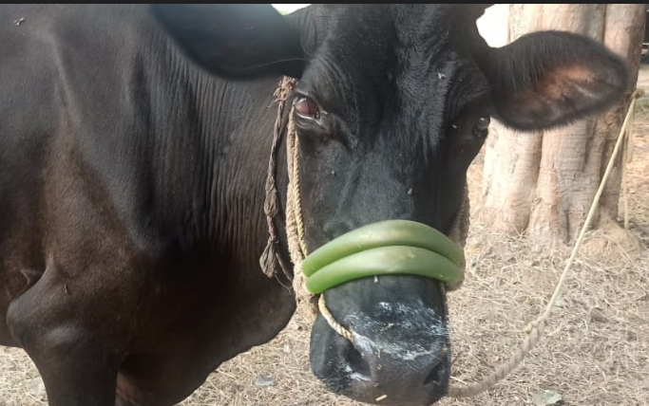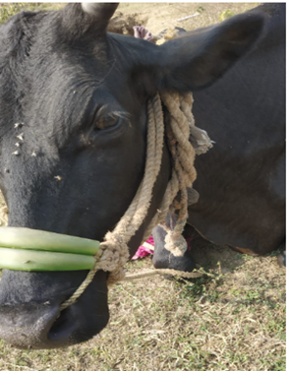
Fig. 1. Showing corneal opacity
Fig. 3. Showing complete reversion of corneal opacity
Fig. 2. Arrow showing the extracellular Trypanosoma spp. in blood smear

Conclusion:
The present case demonstrates that Placentrex, when used as an adjunct therapeutic agent along with trypanocidal drugs and Steroid therapy can be beneficial in the treatment of corneal opacity caused by bovine trypanosomosis. Veterinary practitioners should consider Bovine trypanosomosis in the differential diagnosis when assessing the ocular lesions in cattle in field condition.

COMPETING INTERESTS DISCLAIMER:
Authors have declared that they have no known competing financial interests OR non-financial interests OR personal relationships that could have appeared to influence the work reported in this paper.

REFERENCES
Ali, Samshul., Choudhury, B., Basumatary, P. & Ashraf, N.V.K. (2020). Chemical restraint and clinical management of corneal opacity in a free ranging wild water buffalo (bubalus arnee) in Assam, north-eastern India. Veterinary Practitioner, 21 (1), 120-122.

Arunachalam, K., Karunanithi, K., Thiruvenkadan, A.K. & Karunakaran, P. (2001). Efficacy of placentrex drug against corneal defects in Mecheri Sheep. Indian Journal of Small Ruminants, 7(2), 88-88.
Giordani, F., Morrison, L.J., Rowan, T.G., de Koning, H.P., & Barrett, M.P. (2016). The animal trypanosomiases and their chemotherapy: a review. Parasitology, 143, 1862–1889. https://doi.org/10.1017/S0031182016001268

Kumar, H., Mohinder, P.G., Pritam, K.S., Mahajan, V., Mandeep, S.B., Kaur, K., Verma, S., & Singla, L.D. (2012). An outbreak of acute Trypanosoma evansi infection in crossbred cattle in Punjab, India. Journal of Applied Animal Research, 40(3), 256-259. https://doi.org/10.1080/09712119.2012.9707179

Mishra, Rashmi R., Senapati, S.K., Sahoo, Sudam, C., Das, M. R., Sahoo, G., & Patra, R.C. (2017). Trypanosomiasis induced oxidative stress and hemato-biochemical alteration in cattle. Journal of Entomology and Zoology Studies, 5(6), 721-727.

Preena, P., & Aravind, B. (2017). Case report on the medical management of corneal opacity in a captive elephant tusker. Adv. Anim. Vet. Sci., 5(8), 342-345. https://doi.org/10.17582/journal.aavs/2017/5.8.342.345

Radostits, O. M., Gay, C. C., Hinchcliff, K. W., & Constable, P. D. (2007). *Veterinary Medicine: A Textbook of the Diseases of Cattle, Sheep, Pigs, Goats, and Horses* (10th ed.). Saunders Elsevier. https://www.elsevier.com/books/veterinary-medicine-e-book/radostits/978-0-7020-2777-2

Rani, N. L., Suresh, K., & Rajesh, K. (2015). A retrospective study on clinico-epidemiological aspects of trypanosomiasis in buffaloes. International Journal of Veterinary Science. https://www.ijvets.com/

Sivajothi, S., Reddy, B. S., Kumari, K. N., & Rayulu, V. C. (2014). Haematological changes in Trypanosoma evansi infected cattle. International Journal of Scientific World, 2(1), 27-30. https://doi.org/10.14419/ijsw.v2i1.2275

Sudhakara, R. B., & Sivajothi, S. (2017). Corneal opacity due to trypanosomosis in buffaloes-need of topical medication. Open Access J Sci., 1(6), 155–156. https://doi.org/10.15406/oajs.2017.01.00031

