Review Article
Advances in Postharvest Technologies for Extending the Shelf Life of Cut Flowers: A Comprehensive Review

Abstract:
After harvest life of cut flowers is very important in determining the aesthetic value, economic value, and the life of the flowers in the market. Postharvest technologies have been important in ensuring that the shelf life of cut flowers is increased without interfering with their quality. This review offers an in-depth summary of the current advances in postharvest management with an emphasis on different methods of preservation, including pre-treatment, refrigeration, modified atmosphere packaging (MAP) and ethylene control and novel methods of preservation via natural plant extracts. Their application in decreasing wilting, disease control and reduction of deterioration are discussed. Moreover, the paper identifies how these developments have influenced quality of flowers, waste alleviation and sustainability in the floriculture sector. This review will provide information on the future of postharvest handling of cut flowers by discussing the most efficient methods and their use both to the benefit of the agricultural producers and the consumers.
Keywords: Postharvest Technology, Shelf Life, Cut Flower, Preservation, Floriculture Industry.
Introduction
Cut flowers are a necessary component of the floriculture business in the global market, which plays a more significant role in the global economy and aesthetics. Their high perishability however is a serious challenge as it is important to preserve their freshness, quality and appearance even after harvesting. Once the plant is cut off all the flowers lose their natural capability of absorbing water and nutrients and this causes quick decay. Such factors as microbial infections, dehydration, senescence, and physical handling damage are some of the main causes of the decline in their shelf life.
In a bid to combat these issues, many postharvest technologies have been innovated to enhance storage and handling as well as longevity of cut flowers. The technologies are supposed to extend the life of the senescence and maintain the freshness, appearance and general quality of the flower throughout the transportation, storage and display in retail outlets. The postharvest technologies have led to extending the shelf life as well as reducing wastes in the floral industry therefore, improving sustainability.
Modifications in the aging of flowers using chemical agents like ethylene inhibitors, pre-treatment, controlled temperature storage, modified atmosphere packaging (MAP), pre-incubation in various chemical agents, and controlled and regulated temperature storage are some of the major technologies that have been developed over the past years. These can help greatly to enhance the overall postharvest quality of cut flowers by inhibiting wilting and browning, microbial growth, and loss of water.
The other innovation in the field is the use of natural plant extracts and biotechnological innovations. These have been found to be promising in increasing the longevity of flowers by increasing water uptake and the post cutting stress of flowers. Moreover, the packaging has also been technologically advanced that has seen the preservation of flowers in transportation processes and hence the flowers are preserved longer before becoming incompetent.
The cut flower industry is a multibillion-dollar global market, valued at over $35 billion annually, where postharvest technologies play a pivotal role in preserving quality and extending shelf life (Rashed et al., 2024). Postharvest technology encompasses a suite of practices and innovations applied after harvest to mitigate deterioration, including temperature control, modified atmosphere packaging, chemical preservatives, and biological treatments(Janghu et al., 2024). These methods address the rapid senescence observed in cut flowers, which typically lasts only 5-14 days under ambient conditions due to factors like ethylene production, microbial proliferation, water stress, and oxidative damage(Sutrisno et al., 2025). By slowing physiological processes such as respiration and transpiration, postharvest interventions ensure flowers retain their visual appeal, fragrance, and structural integrity from farm to vase (Scariot et al., 2014).
Extending shelf life is economically vital, as postharvest losses can exceed 30-50% in transit and retail, particularly for perishable species like roses, carnations, and lilies (Leonard et al., 2001). Enhanced longevity allows for longer supply chains, enabling exports to distant markets and reducing waste, which translates to higher profitability for growers, wholesalers, and retailers(Hoppen et al., 2019). For instance, a one-week extension in vase life can double the marketable window, boosting revenue in seasonal trades. Aesthetically, fresh flowers embody beauty, emotion, and luxury; wilting petals, faded colors, or bacterial slime diminish consumer satisfaction and perceived value (El-Sayed et al., 2025). Maintaining vibrancy supports gifting, events, and decorative uses, aligning with rising demand for premium, long-lasting blooms (Othman et al., 2023).
This review synthesizes advances across storage techniques, pre-treatments, antimicrobials, genetic breeding, and sustainable packaging (Malakar et al., 2023). Challenges like varietal differences and environmental stressors necessitate tailored solutions, from pulsed 1-methylcyclopropene (1-MCP) to nanotechnology-infused films (Shakeel et al., 2022). Emerging trends emphasize eco-friendly alternatives, such as plant-derived antimicrobials, to meet sustainability goals amid climate pressures and regulations (Ramya et al., 2025). Ultimately, these technologies not only safeguard economic viability but also elevate the floral experience, driving innovation to meet evolving consumer preferences for durable, ethically sourced products (ÇELİKEL et al., 2023).

Postharvest Challenges in Cut Flowers
Cut flowers face numerous challenges during storage and transportation that significantly shorten their vase life. Primary issues include rapid senescence, microbial proliferation, and physical damage from rough handling, exacerbated by suboptimal conditions like high temperatures and humidity fluctuations (Rashed et al., 2024). For instance, prolonged storage beyond three days at wholesale levels can reduce vase life by up to five days in roses, promoting leaf yellowing and disease incidence (Leonard et al., 2001). Ethylene sensitivity leads to premature wilting and petal abscission, while air emboli in xylem vessels block water uptake, causing bent necks and drooping (Othman et al., 2023; Scariot et al., 2014). Transportation stressors such as vibration and ethylene exposure from vehicle exhaust further accelerate deterioration, resulting in postharvest losses exceeding 30-50% for species like roses and lilies (Leonard et al., 2001).
Key factors affecting cut flower quality encompass physiological processes like excessive respiration, transpiration, and oxidative stress, alongside environmental influences (Scariot et al., 2014). Water stress from vascular occlusion by bacteria and fungi induces wilting symptoms, including yellowing leaves and faded colors, diminishing aesthetic appeal (El-Sayed et al., 2025). Varietal differences in sensitivity to ethylene and microbes necessitate tailored handling, as seen in tulips prone to early senescence (El-Sayed et al., 2025). These interconnected factors—ethylene production, microbial growth, and handling practices—underscore the need for integrated postharvest strategies to preserve visual vibrancy and market value (Rashed et al., 2024). Nanotechnology, specifically through the application of nanoparticles, offers novel approaches to address these challenges by reducing ethylene production, inhibiting bacterial growth, and enhancing antioxidant capabilities, thereby extending the vase life of various cut flowers like tulips (Darras, 2025; El-Sayed et al., 2025).

Basic Biology of Cut Flowers
Cut flowers post-harvest exhibit key physiological processes driving senescence, including elevated respiration, ethylene production, and oxidative stress, which accelerate deterioration within days (Rashed et al., 2024; Scariot et al., 2014). Respiration depletes stored carbohydrates, fueling metabolic activities that lead to petal wilting and leaf yellowing, while ethylene triggers abscission and color fading in sensitive species like roses and lilies (Othman et al., 2023). Transpiration continues unabated, exacerbating water loss, and microbial proliferation induces vascular blockages, compounding oxidative damage from reactive oxygen species (El-Sayed et al., 2025). These interconnected processes underscore the need for interventions to slow metabolic rates and preserve cellular integrity (Darras, 2025).
Water uptake and transpiration critically influence shelf life, as continuous transpiration from petals and leaves demands efficient xylem conductivity (Othman et al., 2023). Air emboli and bacterial biofilms obstruct vessels, impairing uptake and causing bent necks, drooping, and wilting (El-Sayed et al., 2025; Leonard et al., 2001). Balancing these via hydration solutions and recutting enhances turgor, extending vase life by mitigating water stress and supporting structural vibrancy (Rashed et al., 2024).

Storage and Handling Techniques
Effective storage and handling hinge on precise control of temperature, humidity, and light to mitigate postharvest deterioration in cut flowers. Rapid cooling post-harvest removes field heat, while maintaining species-specific cold chains—typically 0–5°C for roses and carnations, 4–8°C for lilies—slows respiration, ethylene production, and microbial growth (Darras, 2025; Leonard et al., 2001). Optimal humidity at 90–95% prevents dehydration, and minimizing light exposure reduces photooxidative damage, preserving petal color and preventing leaf yellowing (Rashed et al., 2024). These controls extend vase life by minimizing water loss and senescence, crucial for long-distance transport where suboptimal conditions accelerate losses up to 50% (Scariot et al., 2014).
Storage conditions vary by flower type: tulips require 2–4°C with high humidity to avoid bent necks, while ethylene-sensitive gerberas benefit from darkness and ventilation (El-Sayed et al., 2025; Othman et al., 2023). Innovations like controlled atmosphere storage further optimize gaseous environments, balancing O₂ and CO₂ to inhibit fungal pathogens. Tailored protocols, including underwater recutting and hydration, enhance xylem conductivity, ensuring vibrancy from wholesaler to consumer (Darras, 2025).

Pre-Treatment Methods for Extending Shelf Life
Pre-treatment methods primarily involve preservatives and chemicals to combat senescence and microbial growth in cut flowers. Floral preservatives, often comprising sugars, acids, and biocides like silver thiosulfate or 8-hydroxyquinoline sulfate, enhance water uptake, inhibit bacteria, and delay ethylene effects, extending vase life by 3–7 days in roses and lilies (Leonard et al., 2001; Othman et al., 2023). These solutions, applied via pulsing or continuous vase hydration, maintain stem hydration, reduce vascular blockages, and preserve petal integrity against wilting and yellowing (El-Sayed et al., 2025). Chemical inhibitors such as 1-methylcyclopropene (1-MCP) block ethylene receptors, preventing premature abscission in sensitive species (Scariot et al., 2014).
Innovations in pre-treatment solutions emphasize eco-friendly alternatives, including nanotechnology and plant-derived antimicrobials. Chitosan and copper nanoparticles in vase solutions inhibit microbial proliferation, boost antioxidants, and stabilize membranes, significantly prolonging tulip vase life (Darras, 2025; El-Sayed et al., 2025). Natural extracts from medicinal plants serve as sustainable biocides, aligning with regulations for reduced chemical use (ÇELİKEL et al., 2023). These advances optimize postharvest quality while promoting environmental sustainability.
Modified Atmosphere Packaging
Modified atmosphere packaging regulates gaseous composition around cut flowers to extend vase life by lowering O₂ levels, elevating CO₂, and minimizing ethylene action, thereby slowing respiration, senescence, and microbial proliferation (Rashed et al., 2024). This approach reduces water loss, oxidative stress, and vascular blockages, benefiting sensitive species like roses, lilies, and tulips during storage and transport, potentially cutting postharvest losses by up to 50% (Scariot et al., 2014). Advances include active MAP with ethylene absorbers, smart permeable films, and sensor-integrated systems for real-time gas monitoring, enhancing efficiency in long-distance shipping (Darras, 2025; Rashed et al., 2024).
Antimicrobial Treatments for Cut Flowers
Antimicrobial agents combat bacterial and fungal growth causing xylem occlusion, bent necks, and wilting, preserving water uptake and aesthetic quality in cut flowers (El-Sayed et al., 2025). Conventional biocides like 8-hydroxyquinoline sulfate and silver thiosulfate inhibit microbes and delay ethylene effects, while modern eco-friendly options—chitosan and copper nanoparticles in vase solutions—elevate antioxidants, stabilize membranes, and prolong tulip longevity (Darras, 2025; El-Sayed et al., 2025). These innovations promote sustainability, aligning with reduced chemical use trends (ÇELİKEL et al., 2023).
Floral Preservatives and Nutrient Solutions
Floral preservatives typically comprise sugars like sucrose for energy, acidifiers such as citric acid to lower pH and enhance water uptake, and biocides including 8-hydroxyquinoline sulfate (8-HQS) or silver thiosulfate to inhibit microbial growth (Leonard et al., 2001; Othman et al., 2023). These components work synergistically: sugars replenish carbohydrates depleted during respiration, acids maintain optimal solution pH (3.5–4.5) for xylem conductivity, and antimicrobials prevent vascular blockages from bacteria and fungi (El-Sayed et al., 2025). Eco-friendly alternatives, such as chitosan and copper nanoparticles, offer sustainable options by stabilizing membranes and boosting antioxidants without harsh chemicals (ÇELİKEL et al., 2023; Darras, 2025).
Nutrient solutions significantly prolong freshness by sustaining metabolic activities and turgor pressure, extending vase life by 3–7 days in roses, lilies, and tulips (Leonard et al., 2001). Pulsing with high-concentration preservatives followed by continuous vase solutions improves hydration, delays senescence, and reduces wilting, bent necks, and yellowing (El-Sayed et al., 2025; Othman et al., 2023). Studies show these solutions mitigate ethylene effects and oxidative stress, enhancing overall quality during retail and consumer phases (Scariot et al., 2014).
Genetic Improvements and Breeding Techniques
Genetic engineering offers promising avenues to enhance cut flower longevity by targeting senescence pathways. CRISPR/Cas9-mediated editing of senescence-associated genes and aquaporin pathways enables tailor-made traits for prolonged vase life, ethylene insensitivity, and stress tolerance (Darras, 2025). These molecular tools reduce wilting and yellowing, addressing key postharvest challenges in species like roses and tulips(Mendel, n.d.; Sharma et al., 2023).
Conventional breeding plays a pivotal role in developing resilient cut flowers through selective crosses that combine extended shelf life, disease resistance, and robust water balance. Programs prioritize cultivars with superior xylem conductivity and carbohydrate reserves, minimizing losses during storage and transport (Darras, 2025).
Genomic selection and marker-assisted breeding accelerate innovation, identifying quantitative trait loci for longevity. These advances promise sustainable, high-performing varieties, reducing postharvest losses and aligning with industry demands for durable flowers (Darras, 2025).
Innovative Packaging Technologies
Innovative packaging employs biodegradable polymers, fiber-based materials from sustainable forests, and smart permeable films to safeguard cut flowers during transport and storage (ÇELİKEL et al., 2023; Rashed et al., 2024). These eco-friendly alternatives replace plastics, reducing environmental impact while maintaining structural integrity against mechanical damage and moisture loss.
Active packaging integrates ethylene absorbers, CO₂ emitters, and sensor-embedded systems for real-time monitoring of humidity and gases, optimizing conditions for sensitive species like roses and tulips (Darras, 2025; Rashed et al., 2024). Nanotechnology-enhanced wraps further inhibit microbial growth and stabilize atmospheres.
These technologies extend postharvest longevity by up to 50%, minimizing water loss, senescence, and vascular blockages, thereby cutting losses and aligning with market demands for sustainable, durable flowers (Rashed et al., 2024; Scariot et al., 2014).
Environmental Sustainability in Postharvest Flower Handling
Eco-friendly techniques in flower storage include biodegradable polymers from sustainable forests and natural biocides like chitosan, replacing plastics and harsh chemicals to minimize waste and pollution (ÇELİKEL et al., 2023; Rashed et al., 2024). These practices preserve quality while reducing environmental footprints.
Sustainable postharvest processes employ controlled atmosphere temperature treatments for pest control and recyclable materials, lowering carbon emissions and resource use. Innovations align with green trends, extending vase life without ecological harm (ÇELİKEL et al., 2023; Darras, 2025). Further advancements in cold chain logistics and renewable energy integration within postharvest operations are pivotal for minimizing energy consumption and greenhouse gas emissions, fostering a truly circular economy in floriculture (Gamage et al., 2024).
Market Trends and Consumer Demand
Market advancements in postharvest technologies meet surging industry demands by extending vase life and curbing losses in the multibillion-dollar global cut flower market (Othman et al., 2023). Innovations like biodegradable polymers and smart packaging (Rashed et al., 2024), CRISPR/Cas9 genetic editing for senescence resistance (Darras, 2025), and sustainable nutrient solutions (ÇELİKEL et al., 2023) optimize transport, storage, and retail phases (Leonard et al., 2001). Eco-friendly antimicrobials such as chitosan and copper nanoparticles prevent vascular blockages and enhance antioxidants (El-Sayed et al., 2025), while controlled atmospheres reduce ethylene-induced senescence (Scariot et al., 2014), ensuring durable, high-quality blooms that minimize waste and support efficient supply chains (Gamage et al., 2024).
Consumer trends prioritize long-lasting, vibrant, and sustainable flowers, fueling innovation in shelf life technologies (Scariot et al., 2014). Preferences for ethylene-insensitive cultivars with superior aesthetics drive 70% of sales, as extended freshness influences buying decisions (Othman et al., 2023). Demand for green practices, like recyclable materials and biological controls, aligns treatments with eco-conscious markets, boosting commercial viability and reducing postharvest losses (Darras, 2025; Rashed et al., 2024). This aligns with broader industry goals for transparency and ethical sourcing, fostering consumer trust and loyalty (ÇELİKEL et al., 2023; Zhang et al., 2025).

Conclusion
In conclusion, advancements in postharvest technologies have significantly contributed to extending the shelf life of cut flowers, thereby enhancing their quality and market value. The application of optimal storage conditions, innovative packaging methods like Modified Atmosphere Packaging (MAP), and the use of floral preservatives and antimicrobial treatments have proven to be effective in preserving the freshness and aesthetic appeal of flowers. Moreover, the integration of sustainable practices and the development of genetically improved varieties further underscore the potential for improving the longevity of cut flowers in an environmentally responsible manner. As consumer demand for fresh, long-lasting flowers continues to grow, the ongoing research and adoption of these technologies are crucial to meet market needs and ensure the sustainability of the flower industry. Future innovations in postharvest handling will undoubtedly play a key role in shaping the future of flower preservation, making it an exciting area for continued exploration and development.
References
- ÇELİKEL, F. G., Woltering, E. J., & Lukasse, L. J. S. (2023). Toward sustainable postharvest technologies. Acta Horticulturae, 1368, 19. https://doi.org/10.17660/ActaHortic.2023.1368.3
- Darras, A. I. (2025). Trends in postharvest technology, marketing, and distribution of native Australian and South African ornamental plants, cut flowers, and cut foliage. Frontiers in Horticulture, 4. https://doi.org/10.3389/fhort.2025.1584484
- El-Sayed, I. M., El-Ziat, R. A., & Othman, E. Z. (2025). Chitosan and copper nanoparticles in vase solutions elevate the quality and longevity of cut tulips, setting a new standard for sustainability in floriculture. BMC Plant Biology, 25(1). https://doi.org/10.1186/s12870-025-06811-4
- Gamage, A., Gangahagedara, R., Subasinghe, S., Gamage, J., Guruge, C., Senaratne, S., Randika, T., Rathnayake, C., Hameed, Z., Madhujith, T., & Merah, O. (2024). Advancing Sustainability: The Impact of Emerging Technologies in Agriculture. Current Plant Biology, 100420. https://doi.org/10.1016/j.cpb.2024.100420
- Hoppen, C., Müller, L., Albrecht, A. C., & Groth, G. (2019). The NOP-1 peptide derived from the central regulator of ethylene signaling EIN2 delays floral senescence in cut flowers. Scientific Reports, 9(1). https://doi.org/10.1038/s41598-018-37571-x
- Janghu, S., Kumar, V., & Yadav, A. (2024). Post-Harvest Management of Fruits and Vegetables (p. 125). https://doi.org/10.9734/bpi/cpafs/v7/7984e
- Leonard, R. T., Nell, T. A., Suzuki, A., Barrett, J. E., & Clark, D. G. (2001). EVALUATION OF LONG TERM TRANSPORT OF COLOMBIAN GROWN CUT ROSES. Acta Horticulturae, 543, 285. https://doi.org/10.17660/ActaHortic.2001.543.35
- Malakar, M., Paiva, P. D. de O., Beruto, M., & Neto, A. R. da C. (2023). Review of recent advances in post-harvest techniques for tropical cut flowers and future prospects: Heliconia as a case-study [Review of Review of recent advances in post-harvest techniques for tropical cut flowers and future prospects: Heliconia as a case-study]. Frontiers in Plant Science, 14, 1221346. Frontiers Media. https://doi.org/10.3389/fpls.2023.1221346
- Mendel, G. (n.d.). Plant genetics. https://www.esp.org/foundations/genetics/classical/gm-65.pdf (English translation)
- Othman, Y. A., A’saf, T. S., Al‐Ajlouni, M. G., Hani, M. B., & Hilaire, R. St. (2023). Holding solution pH and composition consistently improve vase life of rose, lily and gerbera. Journal of Phytology, 57. https://doi.org/10.25081/jp.2023.v15.7742
- Ramya, S. M., Auxcilia, J., Paital, B., Sharmila, D. J., Vethamoni, P. I., Venugopal, S., Indra, N., Subramanian, K. S., & Sahoo, D. K. (2025). Application of nanotechnology in fruit crops—from synthesis to sustainable packaging [Review of Application of nanotechnology in fruit crops—from synthesis to sustainable packaging]. PeerJ, 13. PeerJ, Inc. https://doi.org/10.7717/peerj.19603
- Rashed, N., Memon, S. A., Turki, S. M. A., Shalaby, T., & El-Mogy, M. M. (2024). An analysis of conventional and modern packaging approaches for cut flowers: a review article [Review of An analysis of conventional and modern packaging approaches for cut flowers: a review article]. Frontiers in Plant Science, 15, 1371100. Frontiers Media. https://doi.org/10.3389/fpls.2024.1371100
- Scariot, V., Paradiso, R., Rogers, H. J., & Pascale, S. D. (2014). Ethylene control in cut flowers: Classical and innovative approaches. Postharvest Biology and Technology, 97, 83. https://doi.org/10.1016/j.postharvbio.2014.06.010
- Shakeel, Q., Shaheen, M. R., Ali, S., Ahmad, A., Raheel, M., & Bajwa, R. T. (2022). Postharvest management of fruits and vegetables. In Elsevier eBooks (p. 1). Elsevier BV. https://doi.org/10.1016/b978-0-12-822921-7.00001-5
- Sharma, P., Pandey, A., Malviya, R., Dey, S., Karmakar, S., & Gayen, D. (2023). Genome editing for improving nutritional quality, post-harvest shelf life and stress tolerance of fruits, vegetables, and ornamentals [Review of Genome editing for improving nutritional quality, post-harvest shelf life and stress tolerance of fruits, vegetables, and ornamentals]. Frontiers in Genome Editing, 5. Frontiers Media. https://doi.org/10.3389/fgeed.2023.1094965
- Sutrisno, S., Skutnik, E., & Rabiza-Świder, J. (2025). Optimising the Vase Life of Cut Hydrangeas: A Review of the Impact of Various Treatments [Review of Optimising the Vase Life of Cut Hydrangeas: A Review of the Impact of Various Treatments]. Agronomy, 15(5), 1124. Multidisciplinary Digital Publishing Institute. https://doi.org/10.3390/agronomy15051124
- Zhang, J., Zhang, J., Zhang, L., Xue, Y., & Zhang, K. (2025). Mechanistic Insights into Vegetable Color Stability: Discoloration Pathways and Emerging Protective Strategies [Review of Mechanistic Insights into Vegetable Color Stability: Discoloration Pathways and Emerging Protective Strategies]. Foods, 14(13), 2222. Multidisciplinary Digital Publishing Institute. https://doi.org/10.3390/foods14132222

Table 1: Postharvest Techniques for Extending the Shelf Life of Cut Flowers
Technique | Description | Effect on Shelf Life | Common Flowers Affected
Refrigeration | Lowering temperature to slow down metabolic processes and reduce water loss. | Increases shelf life by up to 2 weeks. | Roses, Tulips, Carnations
Modified Atmosphere Packaging (MAP) | Use of packaging materials that alter the internal atmosphere, reducing ethylene production. | Extends shelf life by 1-3 weeks. | Gerberas, Orchids, Lilies
Ethylene Control | Use of ethylene inhibitors (e.g., silver thiosulfate) to delay senescence. | Reduces senescence by 50%. | Chrysanthemums, Lilies
Pre-treatments (e.g., Sugar Solutions) | Application of sugar or other solutions to maintain water uptake and reduce wilting. | Extends shelf life by 5-7 days. | Roses, Carnations, Lilies
Natural Plant Extracts | Use of plant-derived compounds (e.g., Aloe vera, Salicylic acid) for flower preservation. | Extends shelf life by 2 weeks. | Roses, Sunflowers, Orchids

Table 2: Factors Affecting the Shelf Life of Cut Flowers
Factor | Description | Impact on Shelf Life
Temperature | Lower temperatures reduce metabolism and water loss, prolonging flower life. | Significantly increases shelf life.
Humidity | High humidity levels reduce water loss through transpiration. | Extends freshness and prevents wilting.
Water Quality | Water with high mineral content can clog stems and inhibit water uptake. | Poor water quality reduces shelf life.
Handling and Damage | Physical damage to flowers can cause rapid deterioration and increase microbial growth. | Shortens the shelf life significantly.
Light Exposure | Prolonged exposure to direct light accelerates wilting and senescence. | Reduces flower life by up to 30%.

Table 3: Overview of Modified Atmosphere Packaging (MAP) for Cut Flowers
Packaging Type | Description | Effectiveness | Flowers Best Suited
Low Oxygen, High CO2 | Reduces respiration rates by limiting oxygen and increasing carbon dioxide. | Highly effective in extending shelf life by up to 3 weeks. | Roses, Lilies, Carnations
Ethylene Scrubbing | Use of ethylene absorbers or ethylene-scavenging films to reduce premature aging. | Reduces flower senescence by 50%. | Orchids, Chrysanthemums
Micro-perforated Films | Films with small holes that allow for controlled gas exchange. | Helps maintain optimal conditions for a wide range of flowers. | Gerberas, Tulips

Table 4: Comparison of Pre-Treatment Solutions for Cut Flowers
Pre-Treatment | Description | Impact on Flower Longevity | Common Flowers Affected
Sugar Solutions (e.g., Sucrose) | Sugar solutions help maintain water uptake and delay wilting by providing energy to flowers. | Extends shelf life by 5-7 days. | Roses, Lilies, Carnations
Citric Acid | Lowers pH of water, improving water uptake and reducing microbial growth. | Increases shelf life by 4-6 days. | Tulips, Chrysanthemums
Floral Preservatives | Chemical solutions that prevent microbial growth and maintain flower hydration. | Adds up to 5 days of freshness. | Orchids, Lilies

Table 5: Effectiveness of Natural Plant Extracts on Cut Flower Shelf Life
Extract | Source | Effect on Shelf Life | Mechanism of Action | Flowers Affected
Aloe Vera Extract | Aloe barbadensis | Extends shelf life by 2 weeks. | Enhances water retention, reduces stress. | Roses, Gerberas
Salicylic Acid | Willow trees, Salix spp. | Increases shelf life by 1-2 weeks. | Reduces oxidative stress, delays senescence. | Orchids, Sunflowers
Benzyladenine | Synthetic cytokinin compound | Extends shelf life by 10-12 days. | Promotes cell division and delays senescence. | Lilies, Carnations

Figure 1: Temperature and Humidity Conditions for Ideal Flower Storage
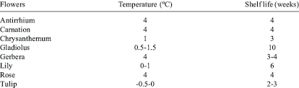
Figure 2: Modified Atmosphere Packaging (MAP) Process for Cut Flowers
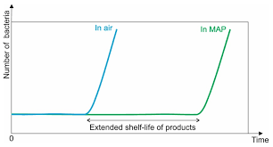
Figure 3: Effect of Ethylene Control on Flower Longevity
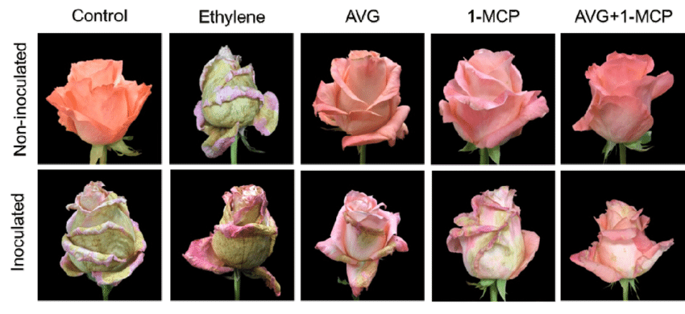

Figure 4: Pre-Treatment Solutions and Their Impact on Water Uptake in Cut Flowers
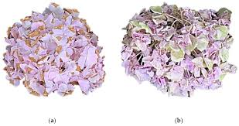
Figure 5: Natural Plant Extracts and Their Effect on Flower Longevity
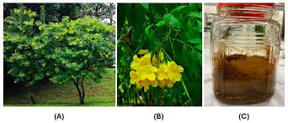
Figure 6: Schematic of Flower Storage in Refrigeration Units
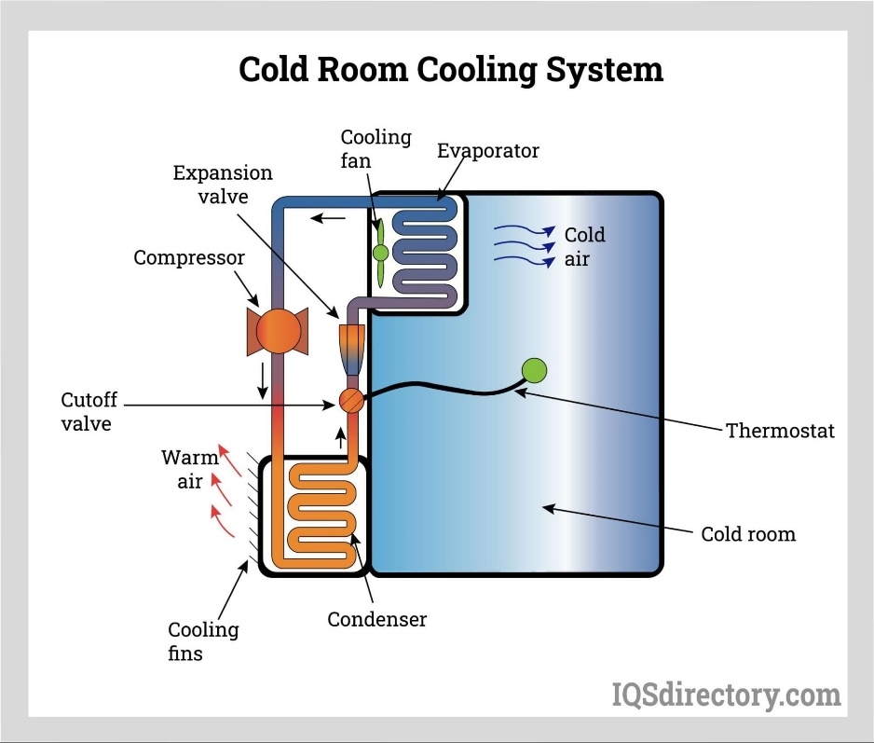
Figure 7: Modified Atmosphere Packaging for Different Flower Species
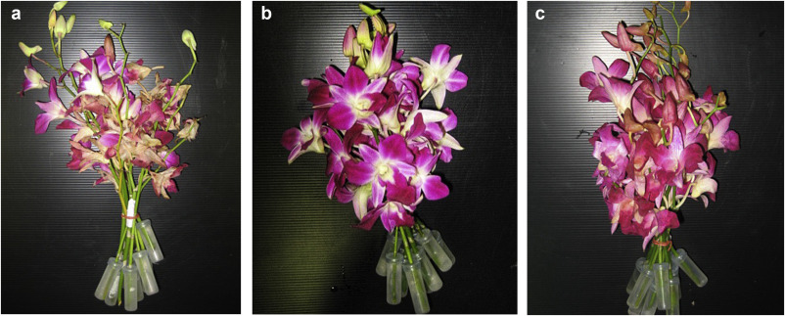
Figure 8: Flower Senescence Stages and the Role of Postharvest Technologies
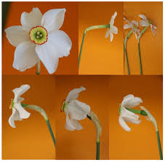
Figure 9: The Role of Water Quality and Handling in Postharvest Shelf Life
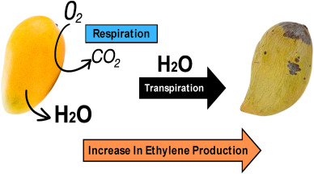
Figure 10: Comparative Effectiveness of Pre-Treatment Methods on Flower Shelf Life
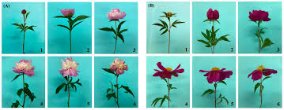
Figure 11: Ethylene Inhibitor Application and Its Impact on Flower Quality
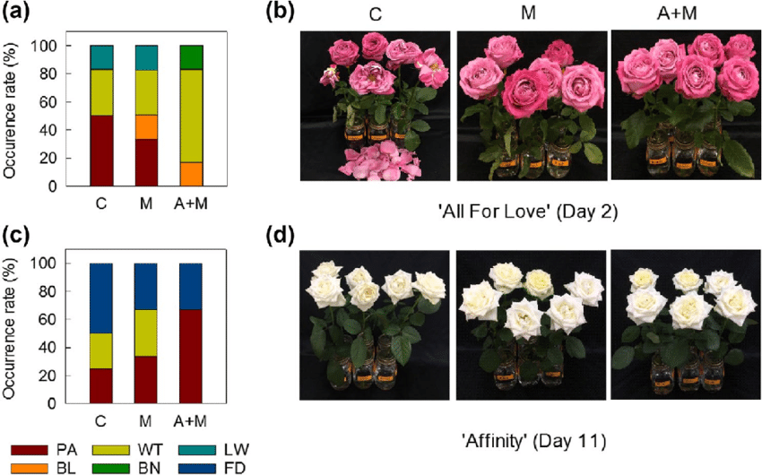

Figure 12: Floral Preservation Techniques for Sustainability in the Floriculture Industry

