Original Research Article

HISTOMORPHOMETRIC ASSESSMENT OF HUMAN SKELETAL REMAINS: COMPARATIVE ANALYSIS OF LONG AND SHORT BONES

ABSTRACT
Aims: Quantitative assessment of bone microstructural elements is relevant in the present forensic field following incessant cases of culprits’ penchant to hide evidence at all cost. The aim of this study therefore is to analyze the histomorphometric properties of skeletal remains and examine for variability between long and short bones.
Study design: A descriptive cross-sectional design was adopted for this study which enabled the systematic collection and quantitative analysis of histomorphometric parameters from human long bones (tibia) and short bones (tarsals).
Place of study: Skeletal remains were obtained from the Department of Human Anatomy of the Faculty of Basic Medical Sciences, Rivers State University.
Methodology: The modified Frost manual method of bone preparation was adopted and 10 cadaveric specimens were obtained each for each bone type from adult Nigerians. Images were analyzed using calibrated ImageJ software. The parameters measured are: Haversian canal diameter (µm), Osteon diameter (µm), Primary osteon count, Secondary osteon count, and Osteon fragment count.
Results: The tibia exhibited significantly greater counts of secondary and primary osteons compared with the talus (P≤0.05). Other histomorphometric properties were not statistically significant except for subtle variations.
Conclusion: These differences carry meaningful implications for biomechanical interpretation and forensic application, but need confirmation especially since this study did not consider age and sex differences.
Keywords: Forensics, Nigerians, Osteon count, Secondary osteons, Talus, Tibia
1.0 INTRODUCTION
Bone is a dynamic, load-bearing tissue whose microscopic architecture reflects both genetic programming and lifelong adaptation to mechanical and metabolic demands (Cowan et al., 2024). At the cortical level, the compact bone of diaphyseal shafts is organized into secondary osteons, primary osteons, Haversian canals and interstitial fragments; these histomorphometric features encode information about remodelling rates, biomechanical loading and age-related change (Cowan et al., 2024; Rosa et al., 2022). Quantitative assessment of these microstructural elements therefore provides objective metrics that are useful in diverse fields such as forensic anthropology, bioarchaeology, orthopaedics and bone biology (Dillon et al., 2016; Orupabo et al., 2021).
Long bones (e.g., tibia) and short bones (e.g., talus) differ fundamentally in function and loading environment, and these differences are reflected in their microstructure. Long-bone cortices are subject to substantial bending and torsional stresses and typically show higher osteon density and distinct remodelling patterns compared with short, predominantly trabecular-rich bones that transmit compressive loads across complex joint surfaces (Rosa et al., 2022; Zedda et al., 2024). Comparative histomorphometric studies have demonstrated that osteon size, Haversian canal diameter and osteon fragmentation vary by bone type, reflecting both systemic factors (like age, and body metabolism) and the local mechanical environment (Zedda et al., 2024). Such microstructural contrasts can be exploited in forensic contexts (e.g., fragment identification, age estimation) and in reconstructing activity patterns in past populations (Orupabo et al., 2021; Orupabo & Chijioke, 2024).
Histological and histomorphometric analysis of human bone has become an increasingly important tool in forensic anthropology and osteo-biological research. Microscopic evaluation of bone microstructure, including osteon count, osteon diameter, Haversian canal dimensions, and other cortical features provides data that can assist in species identification, sex estimation, age-at-death determination, and assessment of post-mortem changes (for example, taphonomic alteration). Recent advances in microscopic and image-analysis techniques have enhanced the precision and reliability of such analyses, enabling researchers to derive quantifiable and reproducible data even from fragmented or degraded remains (Sluis et al., 2025).
The forensic and anthropological utility of cortical histomorphometry has been emphasized in several recent studies from Africa and elsewhere. In Nigeria, emerging studies have begun generating baseline histomorphometric datasets tailored to local populations, a critical development because population-specific reference values significantly enhance the precision of forensic interpretations (Orupabo et al., 2021; Orupabo & Chijioke, 2024). This growing body of Nigerian evidence consistently demonstrates that histomorphometry can yield reliable forensic insights where traditional macroscopic or osteometric methods fall short. For example, midshaft femoral histomorphometry applied to cadaveric samples produced discriminant-function models capable of sex estimation with high accuracy (82% for males and 81.5% for females), underscoring its practical utility (Orupabo & Oghenemavwe, 2024). Likewise, comparative analyses of long-bone segments including femur, tibia, and humerus, have assessed features such as primary and secondary osteon counts, Haversian canal diameters, and osteon fragments, thereby establishing inter-segmental patterns valuable for strengthening forensic identification frameworks within Nigerian contexts (Orupabo & Chijioke, 2024). Collectively, these studies confirm that histomorphometric techniques serve as an essential tool, particularly in cases involving fragmented, commingled, or poorly preserved remains where standard morphological assessments are limited (Cummaudo et al., 2018).
However, despite these advances, there remains a relative paucity of histomorphometric data comparing long bones and short bones within the same population in Nigeria. Most published research focuses on long bones (e.g., femur, tibia) due to their abundance, ease of sampling, and traditional forensic value. There is limited comparative analysis involving short bones (such as tarsals) despite their potential relevance: in forensic contexts, small bones may survive when larger elements are destroyed or lost. This represents a significant gap, because short bones may exhibit different histological remodeling patterns, densities, or microstructural characteristics owing to differences in function, bone loading, vascularization, and mechanical stress compared to long bones.
Understanding histomorphometric variation between long and short bones is important not only for species or sex identification but also for providing reference baselines for African populations. Given that most existing bone-microstructure databases are derived from non-African populations, there is a risk of misinterpretation when applying them to Nigerian or other African skeletal remains. Studies such as those from Southwestern Nigeria, which produced detailed cranial and mandibular morphometric data highlight the need for region- and population-specific data to improve the accuracy and relevance of forensic, clinical, and anthropological applications (Femi-Akinlosotu et al., 2024).
Accordingly, this study aims to fill the identified gap by conducting a descriptive cross-sectional a histomorphometric comparison of a representative set of tibial (long bone) and talar (short bone) cortical samples drawn from the osteological collection of the Department of Human Anatomy, Rivers State University. Using standardized ground-section preparation (modified Frost method), calibrated image capture and ImageJ-based measurement, the research quantifies secondary osteons, primary osteons, osteon fragments, Haversian canal diameter and maximum osteon diameter. The objectives are to (a) describe the microstructural profile of the sampled tibiae and tali, (b) test for statistically significant differences in key histomorphometric parameters between long and short bone categories, and (c) provide population-relevant baseline data that can inform forensic, archaeological and orthopaedic applications in Nigerian contexts.

2.0. MATERIALS AND METHODS
Study Design
A descriptive cross-sectional design was adopted for this study. This design enabled the systematic collection and quantitative analysis of histomorphometric parameters from human long bones (tibia) and short bones (tarsals). The study was descriptive in that it documented and quantified microscopic skeletal features using objective measurements, and comparative because it statistically evaluated differences between the two bone types.
Study Population
The study population consisted of available adult human skeletal remains housed in the osteological collection of the Department of Human Anatomy, RSU. These cadaveric remains were originally obtained from the Nigeria Police and preserved for teaching purposes. No antemortem demographic information (e.g., age or sex) was available.
Bone Types Examined
- Long bone: Tibia (characterized by a compact diaphysis and spongy epiphyses)
- Short bone: Talus (a tarsal bone composed mainly of spongy bone with a compact cortical covering)
Inclusion Criteria
- Well-preserved tibia and tarsal (talus) bones
- Bones without visible fractures, degradation, or taphonomic distortion
Exclusion Criteria
- Poorly preserved, fragmented, or structurally compromised bones
- Bones with post-processing damage that would compromise histological evaluation

Materials
The instruments and materials used for bone preparation and histomorphometric analysis were:
- Skeletal specimens: tibia and talus bones from the Department of Human Anatomy, Rivers State University osteological collection
- Electric band saw for bone sectioning
- Abrasive papers (waterproof sandpapers) and polishing equipment
- Photomicroscope (Leica) equipped with 4×, 10×, 20×, and 40× objectives
- Laboratory consumables (slides, cover slips, alcohol, xylene, distilled water, forceps, mounting media, DPX)
- Image analysis software (Fiji ImageJ)
- Calibrated micrometer slide for software calibration and measurement accuracy

Bone preparation
The modified Frost manual method of bone preparation was adopted (Frost 1958, Maat et al., 2001). Cadaveric selection was done from adult skeletal collections. A cross section of skeletal remains were done and ground to very thin sections. A glass board measuring 30cm by 10cm was covered with a P16 sandpaper after coating with Vaseline ointment to prevent trapping of moisture. A smoother P220 sandpaper was used when thinner sections have been obtained to prevent breakage of the sections. Grinding was done with the aid of the pulp of the finger and subsequent use of the Frost holder to obtain very thin sections. This is done until specimen appears translucent and bendable, less than 20 microns in thickness as adjudged by two forensic investigators.

Specimen mounting and microscopy
Specimens obtained are thoroughly and gently washed in soapy water and rinsed thereafter in distil water, and allowed to air-dry. They are then mounted on a glass slide, cover slipped and placed on a glass board having a black polythene underneath, which helps the introduction of contrast into the specimen. The slides are placed here for 2 to 3hrs before and then for more 12 hours to allow for proper drying before loading onto glass trays.
The Leica 50E photomicroscope aided with the LAS-EZ software, Leica biosystems, Wetzlar, Germany was utilized to study the specimen and images captured for more detailed analysis. Images were taken at four fronts: superiorly, inferiorly, medially and laterally especially at fields with a greater population of osteons, and under x 10 magnification. The total count of osteons for each slide was done by adding the four fields of capture, and likewise the mean haversian canal diameter (HCD) was measured by obtaining the average HCD of the various fields of capture.

Histomorphometric Measurements
Images were analyzed using calibrated ImageJ software. The parameters measured are: Haversian canal diameter (µm), Osteon diameter (µm), Primary osteon count, Secondary osteon count, and Osteon fragment count.
Data Analysis
Data obtained from the histomorphometric assessments were analyzed using the Statistical Package for the Social Sciences (SPSS), Version 26. Descriptive statistics were first computed for all measured parameters within each bone type (tibia and talus). These included the mean (µ), minimum and maximum values, standard error of the mean (SEM), and the sample size (N). This descriptive summary provided an overview of the central tendencies and distribution patterns of the histomorphometric variables across the two bone categories.
Inferential statistical analyses were then conducted to compare the histomorphometric properties of long and short bones. Independent samples t-tests were employed to evaluate differences in mean values between tibia and talus in instances where parametric assumptions such as normality and homogeneity of variance were satisfied. All statistical tests were interpreted using a predetermined level of significance, with p values less than 0.05 considered statistically significant.

3.0 RESULTS
Descriptive Statistics for Tibia Bones
Table 1 presents the descriptive statistics for the histomorphometric parameters of the tibia. The tibia samples (N = 10) showed a relatively high number of secondary osteons (M = 11.30, SEM = 1.34) and osteon fragments (M = 10.80, SEM = 1.10). The mean number of primary osteons was low (M = 3.10, SEM = 0.75). The mean Haversian canal diameter was 13.90 µm (SEM = 0.59), while the maximum osteon diameter had the highest value among measured variables (M = 46.56 µm, SEM = 1.62). Overall, low SEM values indicate consistency in remodeling patterns across individuals.
Table 1: Descriptive Statistics of Histomorphometric Parameters of Tibia Bones
Parameter | N | M (µm) | SEM | Min | Max
Secondary osteons (OS) | 10 | 11.30 | 1.34 | 5.00 | 17.00
Primary osteons (OP) | 10 | 3.10 | 0.75 | 0.00 | 6.00
Osteon fragments (OF) | 10 | 10.80 | 1.10 | 3.00 | 16.00
Haversian canal diameter (HCD) | 10 | 13.90 | 0.59 | 11.70 | 17.23
Maximum osteon diameter (Max OD) | 10 | 46.56 | 1.62 | 37.72 | 54.78
Note. N=Number, M=Mean, SEM=Standard Error of Mean, OS = secondary osteons; OP = primary osteons; OF = osteon fragments; HCD = Haversian canal diameter.

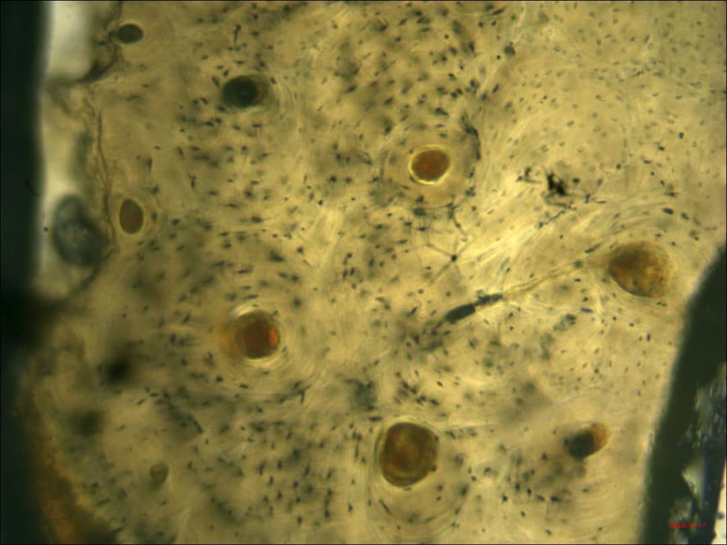
OF
OS
Figure 1: TIBIA x 10. Photomicrograph Section of Tibia Tissue. Section showed osteon fragments (OF), haversian canal (HC), primary osteons (OP), secondary osteons (OS), lamellae. No dye staining

Descriptive Statistics for Talus Bones
Table 2 summarizes the histomorphometric measurements of the talus (N = 10). Compared with the tibia, the talus demonstrated lower counts of both secondary osteons (M = 0.70, SEM = 0.33) and primary osteons (M = 0.50, SEM = 0.50). Osteon fragments showed moderate presence (M = 11.20, SEM = 1.97). The talus exhibited the largest Haversian canal diameter (M = 14.75 µm, SEM = 0.91) among both bone types. Maximum osteon diameter was smaller than in the tibia (M = 41.64 µm, SEM = 6.06).

Table 2: Descriptive Statistics of Histomorphometric Parameters of Talus Bones
Parameter | N | M (µm) | SEM | Min | Max
Secondary osteons (OS) | 10 | 0.70 | 0.33 | 0.00 | 3.00
Primary osteons (OP) | 10 | 0.50 | 0.50 | 0.00 | 5.00
Osteon fragments (OF) | 10 | 11.20 | 1.97 | 5.00 | 26.00
Haversian canal diameter (HCD) | 10 | 14.75 | 0.91 | 11.13 | 20.05
Maximum osteon diameter (Max OD) | 10 | 41.64 | 6.06 | 33.51 | 59.46
Note. N=Number, M=Mean, SEM=Standard Error of Mean, OS = secondary osteons; OP = primary osteons; OF = osteon fragments; HCD = Haversian canal diameter.

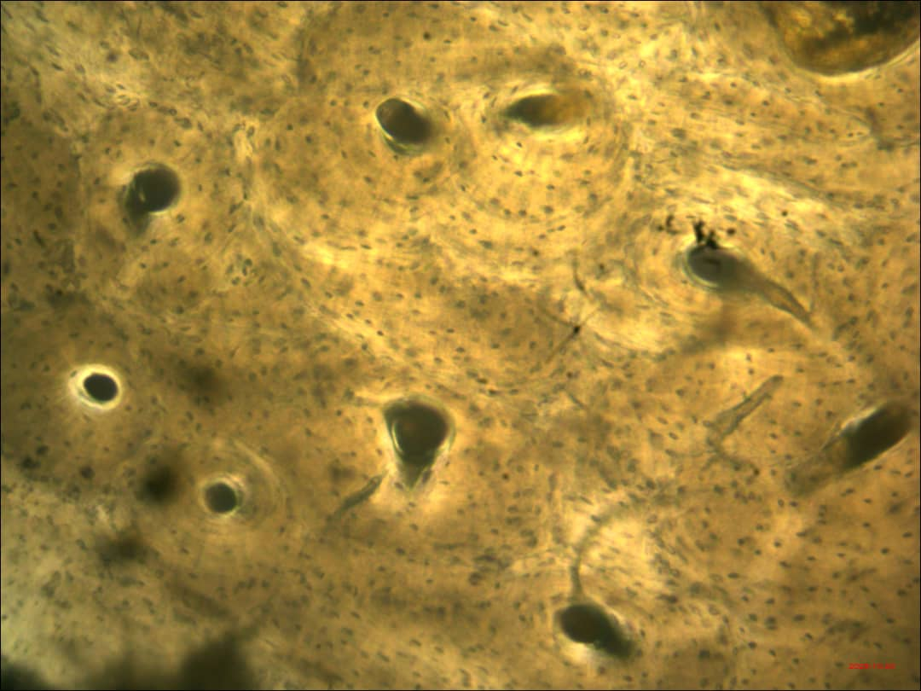
HC
VC
OF
OP
Figure 2: TALUS x 10. Photomicrograph Section of Talus Tissue. Section showed osteon fragments (OF), lamellae, haversian canal (HC), primary osteons (OP), secondary osteons (OS), volkmann's canals (VC). No dye staining

Comparative Analysis of Long and Short Bones
Student’s t-tests were used to compare the histomorphometric features of long bones (tibia) and short bones (talus). Significant differences emerged across several parameters (Table 3). The tibia exhibited significantly higher counts of secondary osteons (t = 7.66, p < .001) and primary osteons (t = 2.87, p < .001). No significant differences were observed for osteon fragments (p = .43), Haversian canal diameter (p = .21), or maximum osteon diameter (p = .23). These findings indicate distinct remodeling patterns between long and short bones, particularly in osteon density.

Table 3: Comparative Analysis of Histomorphometric Properties of Long and Short Bones Using Student’s t-Test
Bone Comparison | Parameter | t Statistic | t Critical | P
Tibia vs. Talus | Secondary osteons | 7.66 | 1.81 | .00*
Tibia vs. Talus | Primary osteons | 2.87 | 1.74 | .00*
Tibia vs. Talus | Osteon fragments | −0.17 | 1.76 | .43
Tibia vs. Talus | Haversian canal diameter | −0.82 | 1.75 | .21
Tibia vs. Talus | Maximum osteon diameter | 0.82 | 2.35 | .23
Note. p ≤ .05 indicates statistical significance.
Table 3 shows the t-test comparison between tibia (long bone) and talus (short bone). The tibia had significantly higher secondary and primary osteon counts (p < .05) than the talus. No significant differences were observed in osteon fragments, Haversian canal diameter, or maximum osteon diameter between the bone types

DISCUSSION
The present histomorphometric comparison of tibial (long) and talar (short) bones demonstrates anatomically and functionally consistent differences in cortical microarchitecture that align with established principles of bone remodeling and biomechanical adaptation. The tibia exhibited significantly greater counts of secondary and primary osteons compared with the talus (see Table 1), indicating a higher degree of Haversian remodeling in the long bone. This finding is consistent with prior morphometric work showing dense osteonal architecture in diaphyseal cortical bone that reflects sustained mechanical loading and life-long remodeling activity (Pazzaglia et al., 2013). By contrast, the talus, representative of tarsal short bones, showed a lower osteon density but larger mean Haversian canal diameter (HCD) and substantial osteon fragment counts (Table 2). Such a pattern plausibly reflects differences in loading regimes and vascular/repair dynamics between weight-bearing tubular long bones and the complex articular environment of tarsal bones; short bones often experience concentrated, multi-directional forces and may remodel with different spatial strategies, producing fewer intact osteons but larger vascular spaces when remodeling events are extensive (Chang & Liu, 2022).
The significant between-bone differences in primary and secondary osteon counts (p ≤ .05) observed in this study support the interpretation that long bones like the tibia undergo more frequent remodeling cycles resulting in higher osteon population densities. This is biologically plausible because diaphyseal cortical bone transmits repetitive bending and torsional stresses during locomotion, stimulating repeated cutting-cone remodeling and increasing counts of intact secondary osteons (Pazzaglia et al., 2013). Larger Haversian canals in the talus may indicate relatively larger vascular channels or different stages of refilling during the remodeling sequence; previous reviews note that Haversian canal size and osteon morphology vary with remodeling rate, vascular supply, and the mechanical environment (Chang & Liu, 2022; Crowder et al., 2022). That the differences in HCD and maximum osteon diameter (Max OD) were not statistically significant in this dataset (Table 3) suggests that while trends are present, the sample variance and modest sample size used here limit confidence in small-magnitude differences for these parameters.
Osteon fragments (OF) did not differ significantly between tibia and talus (p = .43), a result that merits careful interpretation. Fragmentary osteons are sensitive to methodological definitions and observer classification (intact vs. fragmentary), and inter-observer variability can inflate measurement noise (Crowder et al., 2022). The absence of a between-bone difference in OF in the present work may therefore reflect either true biological similarity in fragment prevalence or limitations in classification resolution, especially when fragmentary osteons are common and cement lines are difficult to discern. Adopting the clearer osteon definitions and collection protocols recommended by recent methodological studies would likely reduce classification error in future work (Crowder et al., 2022).
The pattern of relatively higher osteon counts in tibia and larger Haversian features in talus has practical implications for both basic bone biology and forensic anthropology. From a biomechanical perspective, these microstructural differences corroborate models of site-specific adaptation: cortical bone microstructure encodes the history of mechanical usage and repair, so site-level comparisons (long versus short bones) can illuminate differential loading and remodeling histories (Pazzaglia et al., 2013; Chang & Liu, 2022). For forensic and archaeological applications, histomorphometric markers such as osteon density, HCD, and osteon size are commonly used for species identification, age-at-death estimation, and fragmentation analysis; however, discriminant accuracy depends on both the skeletal element sampled and population-specific baselines (Stan et al., 2024; Orupabo et al., 2021). In particular, the present results reinforce the necessity of element-specific reference data: the markedly higher secondary osteon counts in tibia versus talus suggest that applying a tibia-derived age or density model to talar material would be inappropriate without correction for skeletal element.
This study’s findings also echo recent calls in the literature to establish population-specific histomorphometric baselines for forensic practice in Nigeria and other under-represented regions. Several Nigerian investigations have demonstrated the feasibility and value of histomorphometric measures for age estimation and identification, while also emphasizing interpopulation variation (Orupabo et al., 2021). The current comparative data between long and short bones therefore contribute preliminary baseline information that may be useful for regional forensic protocols, but they should be interpreted cautiously given the sample and methodological constraints.
Methodological limitations of the present study must be acknowledged. The sample sizes per bone (N = 10 for tibia and N = 10 for talus) are modest and restrict statistical power for detecting small-to-moderate differences in parameters such as HCD and Max OD; consequently, non-significant results for those variables should not be taken as conclusive evidence of equivalence. Observer bias and classification ambiguity, particularly regarding fragmentary osteons, are additional concerns. Again, recent work has shown that stricter, validated osteon definitions reduce interobserver error and strengthen analytical reproducibility (Crowder et al., 2022). The document also lacks demographic metadata (age, sex, health status, or precise provenance) for the bone samples, which prevents stratified analyses and limits inferential scope. Age, sex, and pathology each influence remodeling rates and osteon morphology (Chang & Liu, 2022; Pazzaglia et al., 2013), so future studies should pair histomorphometry with robust sample metadata to permit multivariable modelling and covariate control.
Practical steps to strengthen future research emerge from these limitations. First, increasing sample size and including well-documented demographic and clinical metadata (age, sex, known medical history) would permit age-adjusted and sex-stratified analyses, enhancing both biological interpretation and forensic utility. Second, employing standardized definitions for intact and fragmentary osteons (Crowder et al., 2022) and blinded multi-observer scoring will reduce classification bias. Third, combining histomorphometry with complementary imaging (e.g., microradiography, back-scattered SEM) and quantitative stereology can improve precision in osteon delineation and Haversian canal measurement (Pazzaglia et al., 2013). Finally, generating element- and population-specific reference datasets for Nigerian and West African skeletal collections should be prioritized to improve regional forensic and anthropological practice (Orupabo et al., 2021; Stan et al., 2024).

Conclusion
In conclusion, the comparative histomorphometric results showing higher primary and secondary osteon counts in the tibia and larger Haversian features with lower osteon density in the talus in this study are consistent with established concepts of site-specific remodelling driven by mechanical environment and vascular dynamics. These differences carry meaningful implications for biomechanical interpretation and forensic application, but need confirmation and refinement. Adoption of uniform osteon definitions and expansion of Nigerian reference data will substantially enhance the interpretative power of cortical bone histomorphometry in both research and applied settings.

Disclaimer (Artificial intelligence)
Authors hereby declare use of some aid in the preparation of the manuscript from ChatGPT for the text and not for text-to-image generation.
Consent
Consent was obtained from the Dean of Faculty and Head of Department of Human Anatomy to use the cadaveric specimen for the research.
Ethical Approval
This study adhered strictly to ethical principles governing the use of human skeletal materials in research and approval was obtained from the Research and Ethics Review Board of the Faculty of Basic Medical Sciences of the Rivers State University (RSU/FBMS//REC/25/311). All skeletal elements were handled respectfully and with full acknowledgment of their human origin, ensuring dignity was maintained throughout the research process. The remains were entirely anonymous, and no attempt was made to identify the individuals from whom the bones originated. To safeguard confidentiality, all data derived from the skeletal samples were securely stored and used exclusively for the purposes of this study. Furthermore, the research methodology, analytical procedures, and limitations were reported transparently to maintain scientific integrity and uphold ethical standards. These measures collectively ensured that the study complied with institutional and professional guidelines for ethical research involving human remains.
Competing interest
There is no conflict of interest

REFERENCES
Cowan, P. T., Launico, M. V., & Kahai, P. (2024). Anatomy, bones. StatPearls. https://www.ncbi.nlm.nih.gov/books/NBK537199/
Rosa, S. B., Peña, M. F., Izquierdo, M. D., & Grant, A. (2022). We should not accept inappropriate radiologic views. Radiography, 28(2), 574–575. https://doi.org/10.1016/j.radi.2022.02.009
Dillon, S., Cunningham, C., & Felts, P. (2016). Quantification of Osteon Morphology Using Geometric Histomorphometrics. Journal of Forensic Sciences, 61(2), 402–408. https://doi.org/10.1111/1556-4029.12966
Orupabo, C. D., Oghenemavwe, L. E., & Diamond, T. E. (2021). Histomorphometric estimation of age from bone samples of Nigerians. International Journal of Medicine and Medical Research, 6(2), 67–76. https://doi.org/10.11603/ijmmr.2413-6077.2020.2.11414
Zedda, M., Babosova, R., Gadau, S., Lepore, G., Succu, S., & Farina, V. (2024). Does a relation between bone histomorphometry and fractures exist? The case of the equine radius and tibia. Veterinární Medicína, 69(9), 307–313. https://doi.org/10.17221/18/2024-VETMED
Orupabo, C. D., & Chijioke, J. O. (2024). A comparative analysis on the histomorphometric pattern of various segments of adult male long bones: Forensic implication. Journal of Forensic Science and Medicine, 10(3), 171–175. https://doi.org/10.4103/jfsm.jfsm_98_23
Sluis, I., Duijst, W., & Krap, T. (2025). Bone histology for forensic anthropology: a technical review on the advances in microstructural analysis of taphonomically altered buried or subaerially exposed bone. International Journal of Legal Medicine, 139(6), 2921–2938. https://doi.org/10.1007/s00414-025-03536-9
Orupabo, C. D., & Oghenemavwe, L. E. (2024). Sex Determination by Discriminant Function Analysis from Femoral Histomorphometry of a Nigerian Population. Archives of Current Research International, 24(12), 155–164. https://doi.org/10.9734/acri/2024/v24i121005
Cummaudo, M., Cappella, A., Biraghi, M., Raffone, C., Màrquez-Grant, N., & Cattaneo, C. (2018). Histomorphological analysis of the variability of the human skeleton: forensic implications. International Journal of Legal Medicine https://doi.org/10.1007/s00414-018-1781-0
Femi-Akinlosotu, O. M., Igado, O. O., & Adeniji, K. O. (2024). Morphometrics of human skulls and mandibles obtained from Southwestern Nigeria: implications in clinical manoeuvres. The Journal of Basic and Applied Zoology, 85(1) https://doi.org/10.1186/s41936-024-00411-8
Frost, H. M. (1958). Preparation of thin undecalcified bone sections by rapid manual method. Stain Technology, 33(6), 273–277. https://doi.org/10.3109/10520295809111862
Maat, G. J., Van Den Bos, R. P., & Aarents, M. (2001). Manual preparation of ground sections for the microscopy of natural bone tissue: update and modification of Frost’s ‘rapid manual method.’ International Journal of Osteoarchaeology, 11(5), 366–374. https://doi.org/10.1002/oa.578
Pazzaglia, U. E., Congiu, T., Pienazza, A., Zakaria, M., Gnecchi, M., & Dell’Orbo, C. (2013). Morphometric analysis of osteonal architecture in bones from healthy young human male subjects using scanning electron microscopy. Journal of Anatomy https://doi.org/10.1111/joa.12079
Chang, B., & Liu, X. (2022). Osteon: Structure, Turnover, and Regeneration. Tissue Engineering Part B Reviews. https://doi.org/10.1089/ten.teb.2020.0322
Crowder, C., Dominguez, V. M., Heinrich, J., Pinto, D., & Mavroudas, S. (2022). Analysis of histomorphometric variables: Proposal and validation of osteon definitions. Journal of Forensic Sciences, 67(1), 80–91. https://doi.org/10.1111/1556-4029.14949
Stan, E., Muresan, C., Daescu, E., Dumache, R., Ciocan, V., Ungureanu, S., Costachescu, D., & Enache, A. (2024). A Review of Histological Techniques for Differentiating Human Bone from Animal Bone. Methods and Protocols, 7(4), 51 https://doi.org/10.3390/mps7040051

