Effects of coffee on the growth of bacteria, fungi and plants

ABSTRACT
Coffee has been used several times in soil amendment to increase the soil organic matter contents, which has led to improvement in crop yield and quality. However, limited information exists on the effect of coffee on soil bacteria and fungi. This study aimed to assess the effect of coffee on the soil bacteria and fungi. Soil samples were amended with concentrations of coffee (0%, 0.5%, 1% and 2%) in triplicates with the plant. Bacteria and fungi were isolated from each microcosm at seven-day intervals for four weeks. The abundance of bacterial genes (16S rRNA) and fungal genes (28S rRNA) from the soil as well as the pH of the soil and plants parameters were determined. The data collected were analysed statistically using R programme. The population of bacteria in soil microcosms decreased from 7.0 x 10⁷ to 2.0 x 10⁶ cfug⁻¹ while the population of fungi increased from 5.0 x 10⁶ to 8.0 x 10⁸ cfug⁻¹ with an increase in the concentration of coffee. Additionally, the bacteria 16S rRNA genes decreased from 4.0 x10⁷ to 5.0 x10⁶ geneg⁻¹ while the fungi 28S rRNA genes increased from 2.0 x10⁶ to 5.0 x10⁷ geneg⁻¹ of soil with an increase in the concentration of coffee. The pH of the soil decreased from 7.6 at day 0 to 7.3 after 28 days. The increase in concentration of coffee reduces the measured plant (Phaseolus vulgaris) parameters, while the highest concentration of coffee (2.0%) tested completely inhibited the plant growth. The amendment of soil with coffee inhibits the growth of the soil bacteria but stimulates the growth of soil fungi. The addition of a low concentration of coffee to the soil reduces the soil pH.
Keywords: Inhibition, growth, stimulate, soil, bacteria, fungi, coffee.
INTRODUCTION
Soil ecosystems are complex, important networks that sustain plant life, decompose organic matter, and recycle nutrients. Among these are organisms, such as the soil bacteria and fungi, which play important roles in nutrient cycling, maintenance of soil structure and decomposition of organic matter (Iswanto et al., 2019). Soil bacteria and fungi are important for ecosystem functioning. Soil Bacteria, which are involved in nutrient cycling, organic matter decomposition, and soil-borne diseases. Some soil bacteria can also fix atmospheric nitrogen, decompose organic matter, and convert nutrients into products available to plants (Basu et al., 2021). Fungi, on the other hand, are the primary degraders or decomposers of complex materials such as lignin and cellulose. They form symbiotic relationships with plant roots (mycorrhizae), increase water and nutrient uptake, and contribute to soil formation by stabilizing soil aggregates (Dellagi et al., 2020). Several factors affect the diversity of soil fauna and also the development of soil microbial communities, including soil type, organic matter, pH, presence of moisture, pollutants or amendments (like coffee) (Naz et al., 2022). The effect of coffee, as a potential contaminant or soil amendment, on soil microorganisms is important to assess the environmental impact (Yang et al., 2021). Coffee plantations are more susceptible to climate changes, such as extreme temperature (low or high temperature), variable precipitation patterns (drought and waterlogging), and elevated atmospheric carbon dioxide (CO₂) concentrations (Beugre et al., 2023). The plants are also sensitive to other environmental conditions such as alteration of soil pH and pollutants. These conditions have direct effects on coffee productivity, and also indirect effects by increasing disease severity, and lowering the nutritional quality of coffee. Overall, climatic changes alone could contribute up to 70% of the coffee yield reduction (Asad et al., 2023).
The soil microbiome encompasses a diverse array of microorganisms, including bacteria, fungi, archaea, protozoa, and viruses. Recent advancements in high-throughput sequencing techniques have revolutionized our understanding of soil microbial diversity, revealing complex interactions within this dynamic ecosystem (Shen et al., 2022). Studies have identified numerous factors influencing microbial community composition, such as soil pH, moisture, temperature, land use, and plant diversity (Qingxia et al., 2024). Moreover, emerging research has highlighted the importance of rare microbial taxa in maintaining ecosystem stability and resilience to environmental disturbances (Dinca et al., 2022).
Soil microbes play an important role in nutrient cycling, mediating organic matter decomposition and recycling essential elements such as carbon, nitrogen, and phosphorus. Through enzymatic activities of microorganisms, complex organic materials are broken down, making it easier for plants to absorb nutrients from the soil. In addition, association between the microorganisms and plant roots, such as mycorrhizal increases nutrient availability and contribute to soil fertility (Shah et al., 2021). In microbial nitrogen metabolism, nitrification along with denitrification enhances soil nitrogen availability and essential system performance and greenhouse gas emission (Basu et al., 2021).
The loss of soil microbial diversity can have profound implications for ecosystem services such as nutrient cycling and disease resistance, which are essential for crop growth and health. Soil microbial diversity needs to be managed to enhance crop performance. Microbial species and diversity play an important role in the ecological balance of soil ecosystems. The relationship between microbial diversity and ecosystem function is complex. Increased microbial richness and diversity are often associated with enhanced ecosystem function. The impact of microbial diversity on the ecosystem varies, based on environmental factors (Yang et al., 2021).
Coffee is the most consumed beverage worldwide, with billions of tons of beverages produced and discarded each year. Its ubiquity has generated considerable interest in its environmental effects, especially in agricultural waste management practices. Coffee contains a variety of bioactive compounds such as caffeine, chlorogenic acids and diterpenes, which can have significant effects on ecosystems. These compounds are known for their antimicrobial properties, but their effects on soil microbial communities, especially in their mutagenicity was less investigated (Chilosi et al., 2020). Intensive coffee production is accompanied by several environmental issues, including soil degradation, biodiversity loss, and pollution due to the wide use of agrochemical inputs and wastes generated by processing. In addition, climate change is expected to decrease the suitability of cultivated areas while potentially increasing the distribution and impact of pests and diseases (Duong et al., 2020).
Coffee is a complex chemical; it has mutagenic properties that can affect microorganisms. The main metabolic compounds in coffee include caffeine, chlorogenic acids, and various polyphenols (Mazzafera, 2022). Caffeine, a nerve stimulant, is the most popular ingredient in coffee. It can disrupt DNA replication and repair mechanisms, causing mutations. Mutations cause changes in the genetic makeup of organisms. These changes can be beneficial, neutral, or deleterious, depending on the context and the specific genetic changes involved. The chlorogenic acids, which is one of the major phenolic components of coffee, have been shown to generate reactive oxygen species (ROS) during the processing of coffee. These ROS can cause oxidative damage to DNA, proteins, and lipids, leading to tissue damage and cellular dysfunction. Although polyphenols are generally considered antioxidants, they may exhibit pro-oxidant activity under certain conditions, contributing to mutagenic effects of coffee (Hoseini et al., 2021).
The complex interaction between soil microbes and plant health is the subject of considerable research, with implications for agricultural and ecosystem management. Beneficial soil microorganisms, such as rhizobacteria and mycorrhizal fungi, associate with plants and have synergistic effects, including increased nutrient utilization, pathogen inhibition and drought tolerance (Das et al., 2022). Conversely, soil-borne pathogens can adversely affect plant health, leading to reduced yields and economic losses. Understanding the dynamics of soil microbial communities and their effects on plant- microbial interactions is essential for achieving sustainable agricultural practices and reducing disease outbreaks (Harman et al., 2021).
Several studies have investigated the effects of coffee and its components on various microorganisms. For example, caffeine has been shown to inhibit the growth of some bacteria and fungi, while chlorogenic acids exhibit antibacterial properties (Rojas-Gonzalez et al., 2022). But most of these results were focused on specific bacteria or fungi modeled under controlled laboratory conditions. However, the effects of coffee on soil bacterial and fungi complexity in the natural environment have not yet been widely researched. Hence, the need to examine the effect of low concentrations of coffee on soil heterotrophic bacteria and fungi. Coffee has been used severally as a mutagen of plants. This usage has led to increased crop yield and improvement in the nutritional qualities of the crops (Yang et al., 2021). Yet, limited information exists on the effect of coffee on soil heterotrophic bacteria and fungi. Hence, this present study aimed to assess the effects (stimulatory or inhibitory) of different concentrations of coffee on the soil heterotrophic bacteria and fungi.
MATERIALS AND METHODS
Samples collections, sterilization of equipment and workbench
The study was conducted in a controlled environment at Adekunle Ajasin University (AAUA), located in Akungba-Akoko, Ondo State, Nigeria (7.479234^{O}N, 5.748411^{O}E). The neutral pH soil used for the experiment was sourced within the University campus garden. A top garden soil samples (0-5cm depth) were collected within the AAUA campus, sieved and transferred carefully to Microbiology Department laboratory Adekunle Ajasin University, Akungba Akoko, Microbiology laboratory using a new zip lock bags. All glassware used was thoroughly washed with detergent, rinsed with clean water, air dried and sterilized for 2 hours in hot air oven at 160°C allowed to cool before use. The inoculating loops were sterilized in Bunsen burner flame until red hot and allowed to cool before use. The workbench was also disinfected by swabbing each time with cotton wool soaked in 70% ethanol.
Preparation of Soil-coffee mixture microcosms and planting of beans
The soil used was prepared with different concentrations of coffee: 0% (control), 0.5%, 1%, and 2%. For the control group, 300 grams of soil was weighted using a weighing balance without coffee. The 0.5% coffee mixture consisted of 298.5 grams of soil with the addition of 1.5 grams of coffee. The 1% coffee mixture comprised 297grams of soil with 3 grams of coffee. While the 2% coffee mixture consisted 294 grams of soil mixed with 6 grams of coffee. Each mixture was thoroughly homogenized to ensure an even distribution of coffee throughout the soil. Different microcosms of soil and coffee were prepared in triplicate and placed into sterile one liter bottle for further examination according to Bello et al, (2019) and Martins Filho et al, (2020). The moisture contents of the soil were maintained at 30% (the normal soil field moisture contents for optimum microbial activities) with the periodic addition of sterile distilled water according to Bello et al, (2019). Each pot was planted with three (3) bean seeds (Phaseolus vulgaris) to ensure a sufficient sample size.
pH measurement
The pH measurement of the soil samples was measured using a pH meter. For each sample, 5.0 grams of soil was weighed and mixed with 10 ml of sterile distilled water. The mixture was thoroughly stirred and allowed to stand for 30 minutes. The pH of the soil suspension was measured by immersing the calibrated pH meter electrode into the solution. The reading was recorded accordingly in triplicates.
Soil sampling for bacterial, fungal and plant analysis
The microcosms were monitored daily over a period of 28 days. Ten grams of soil were sampled and taken weekly to the laboratory for bacteria and fungi culture analysis and DNA analysis. All culture media used, (Nutrient agar and Potato dextrose agar Oxoid, UK) were prepared according to Bello, (2021; 2022), while bacterial and fungal counts were done according to Bello, (2023). The growth of the bean plants was monitored daily over a period of 28 days. The parameters measured included: the height of the plant, the number of leaves and the width of the leaves with ruler (cm). Plant height and leaf width were measured using a ruler, while the number of leaves was counted on each sampling days. Plant height measurements were taken from the soil surface to the tip of the tallest leaf.
Molecular analysis of soil samples at different concentrations of coffee
The samples from each treatment microcosms were aseptically transported to the Institute of Genomics and Global Health (IGH), Redeemer’s University Ede, Osun State, Nigeria, via a sterile labelled zip-lock bag. The nucleic acids were extracted from 0.5 gram of soil samples using bead beating methods with CTAB buffer, liquefied phenol and chloroform: isoamyl alcohol (24:1). The precipitation and washing of the nucleic acids were done using polyethylene glycol solution (PEG-6000) and 70 % ice-cold ethanol, respectively. The centrifugations were done at 4ºC for 10 minutes. The quantity and quality of DNA extracted were measured using a NanoDrop spectrophotometer (Thermo Fisher Scientific). The abundance of bacterial and fungal (16S rRNA and 28S rRNA genes, respectively) was estimated by quantitative PCR (qPCR) of the DNA extracts (diluted to 2–10 ng μl⁻¹) using the primer pairs 27F/1492R (5’-AGAGTTTGATGGCTCAG-3’ and 5’-GGTTACCTTGTTACGACTT-3’) for bacteria and (5’-GTAAAAGTCGTAACAAGGTTTC-3’ and 5’-GTGAATCATCGARTCTTTGAAC-3’) for fungi, respectively (Hink et al., 2018; Bello et al., 2019).
The abundance of bacterial and fungal genes were estimated in 20-μl reaction mixes consisting of 10 μl of SYBR® Green Supermix, 0.4 μg BSA, and 0.5 μM each of the bacteria and fungi primers (both forward and reverse primers). The qPCR conditions were optimized as: 95ºC for 5 min, 35 cycles of 95ºC for 30sec, 58ºC for 30 sec, 72ºC for 1 min followed by measurement of fluorescence. To cover the degeneracy of the primers as much as possible, and a dilution series containing 10¹-10⁸ genes per assay was used for quantification of all genes (Hink et al., 2018; Bello et al., 2019). The efficiencies of the bacteria 16S rRNA gene and fungi 28S rRNA gene qPCR assays were 0.95 and 0.97, respectively, with R² values > 0.98. The melting curve analysis and standard agarose gel electrophoresis were used to assess amplification specificity. The abundance of the bacterial and fungal genes, respectively quantified and plotted per gram of soil.
Statistical analysis of the data
The statistical analyses were performed with R-programme using two-way ANOVA to assess the effect of different concentration of coffee and time of sampling on bacterial, fungal count, pH, plant parameters, bacterial and fungal gene abundance for 28 days. Tukey HSD multiple post-hoc tests was used to assess the significance of the differences among the means.
RESULTS
The bacterial and fungal counts from the soil microcosms
The bacterial population increased significantly (p < 0.05) from 6.0x10⁶ cfug⁻¹ at day 0 to 8.0x10⁶ cfug⁻¹ after 28 days of sampling in the control treatment (0.0% coffee concentration). The bacterial population decreased significantly (p < 0.05) from 6.0x10⁶ cfug⁻¹ at day 0 to 4.0x10⁶ cfug⁻¹ after 28 days in the treatment with 0.5% coffee concentration and 1.0% coffee concentration, respectively. But there was no significant difference (p > 0.05) between the 0.5% and 1.0% treatment after 28 days of treatment. However, at 2.0% coffee concentration, the bacterial population decreased significantly (p < 0.05) from 6.0x10⁶ cfug⁻¹ at day 0 to 2.0x10⁶ cfug⁻¹ after 28 days (Figure 1). Generally, the highest bacterial population of 8.0x10⁶ cfug⁻¹ was obtained in the soil sample without coffee (control) while treatments with concentrations 2% coffee had the least bacterial population (2.0x10⁶ cfug⁻¹) after 28 days of sampling. Hence, the bacterial population decreased with an increase in the concentration of coffee.
The fungal count significantly increased with an increase in the sampling time (from 0 day to 28 day) (from 5.0 x10⁶ to 6.3 x10⁶ cfu/g of soil) and concentration of the coffee (p < 0.05) (Figure 1). The microcosm that was treated with the highest concentration of coffee (2.0%) had the highest fungal population (8.3x10⁶ cfu/g of soil) and it was significantly (p < 0.05) higher than the remaining treatments at sample time day 28 (6.3x10⁶, 7.3 x10⁶ and 7.1 x10⁶ cfu/g of soil). While there was no significant difference in the fungi count between the microcosms treated with 0.5% and 1.0% at the final day of sampling (day 28) even though the fungal count obtained at 0.5% and 1.0% were both significantly different from the fungi count obtained at day 28 in the control microcosm with 0% concentration of coffee (p < 0.05).
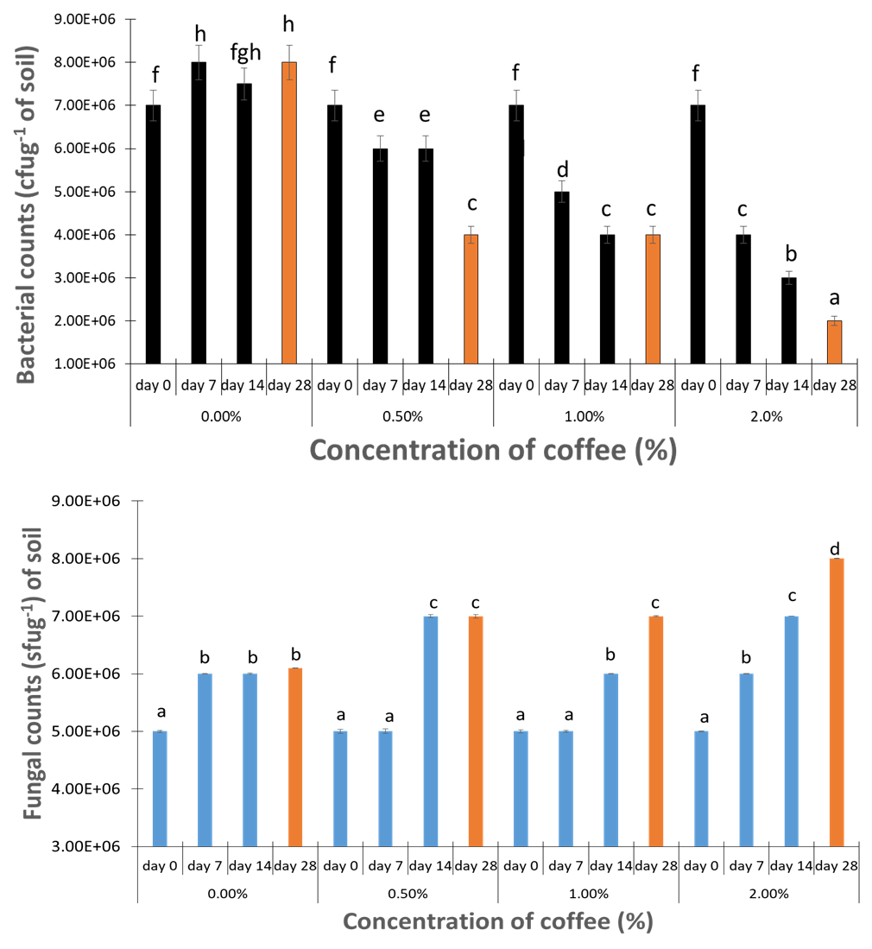
Figure 1: Total bacterial and fungal counts in colony and spore forming unit per gram of soil (cfug⁻¹) respectively obtained from soil treated with different concentrations (percentages) of coffee.
Data represents the mean of the triplicate samples while error bars are the standard error of the mean. Different letters indicate a significant difference at p < 0.05.
Bacterial and fungal gene abundance
The bacterial 16S rRNA gene in the soil without coffee amendment significantly (p < 0.05) increased from 4.0 x 10⁷ at day 0 to 7.3x10⁷ gene per gram of soil at day 28. The highest bacterial 16S rRNA gene 7.3x10⁷ geneg⁻¹ was obtained in the soil sample without coffee (control) on the final day of sampling (day 28) while the treatments with concentrations of 0.5%. 1.0% and 2% coffee contained 3.5x10⁷, 3.0x10⁷ and 5.0 x10⁶ respectively (Figure 2). However, the bacterial gene decreased significantly (p < 0.05) in day 28 as the concentration of coffee increased (from 0.5 % to 2.0%), with the lowest gene abundance obtained at day 28 in 2% coffee concentration (p < 0.05) (5.0 x 10⁶ geneg⁻¹ of soil). Although there was no significant difference (p < 0.05) in the number of bacteria genes obtained in the microcosms treated with 0.5% and 1.0% at the final day of sampling.
The fungal 28S rRNA genes obtained significantly (p < 0.05) increased from 2.0 x 10⁶ geneg⁻¹ of soil at day 0 to 2.0 x 10⁷ geneg⁻¹ of soil at day 28 in the control treatment. After 28 days of sampling, fungal 28S rRNA genes significantly increased (p < 0.05) with an increase in the concentration of the coffee (2.0 x10⁷ to 5.1 x10⁷ geneg⁻¹ of soil). The microcosm that was treated with the highest concentration of coffee (2.0%) had the most abundant 28S rRNA fungal genes (5.1 x10⁷ gene per gram of soil) and it was significantly higher than the remaining treatments at sample time day 28 (p < 0.05). Although there was no significant difference in the number of fungal genes obtained in the microcosms treated with 0.5% and 1.0% at the final day of sampling (2.9 x10⁷ and 3.0 x10⁷ gene per gram of soil) (day 28) (Figure 2).
Soil pH
The pH of the soil decreased as the coffee concentration increased significantly throughout the sampling days (p < 0.05). The microcosm without coffee treatment (0% concentration) had the highest pH (7.6), which is almost stable throughout the sampling days (day 0 to day 28) (Figure 3).

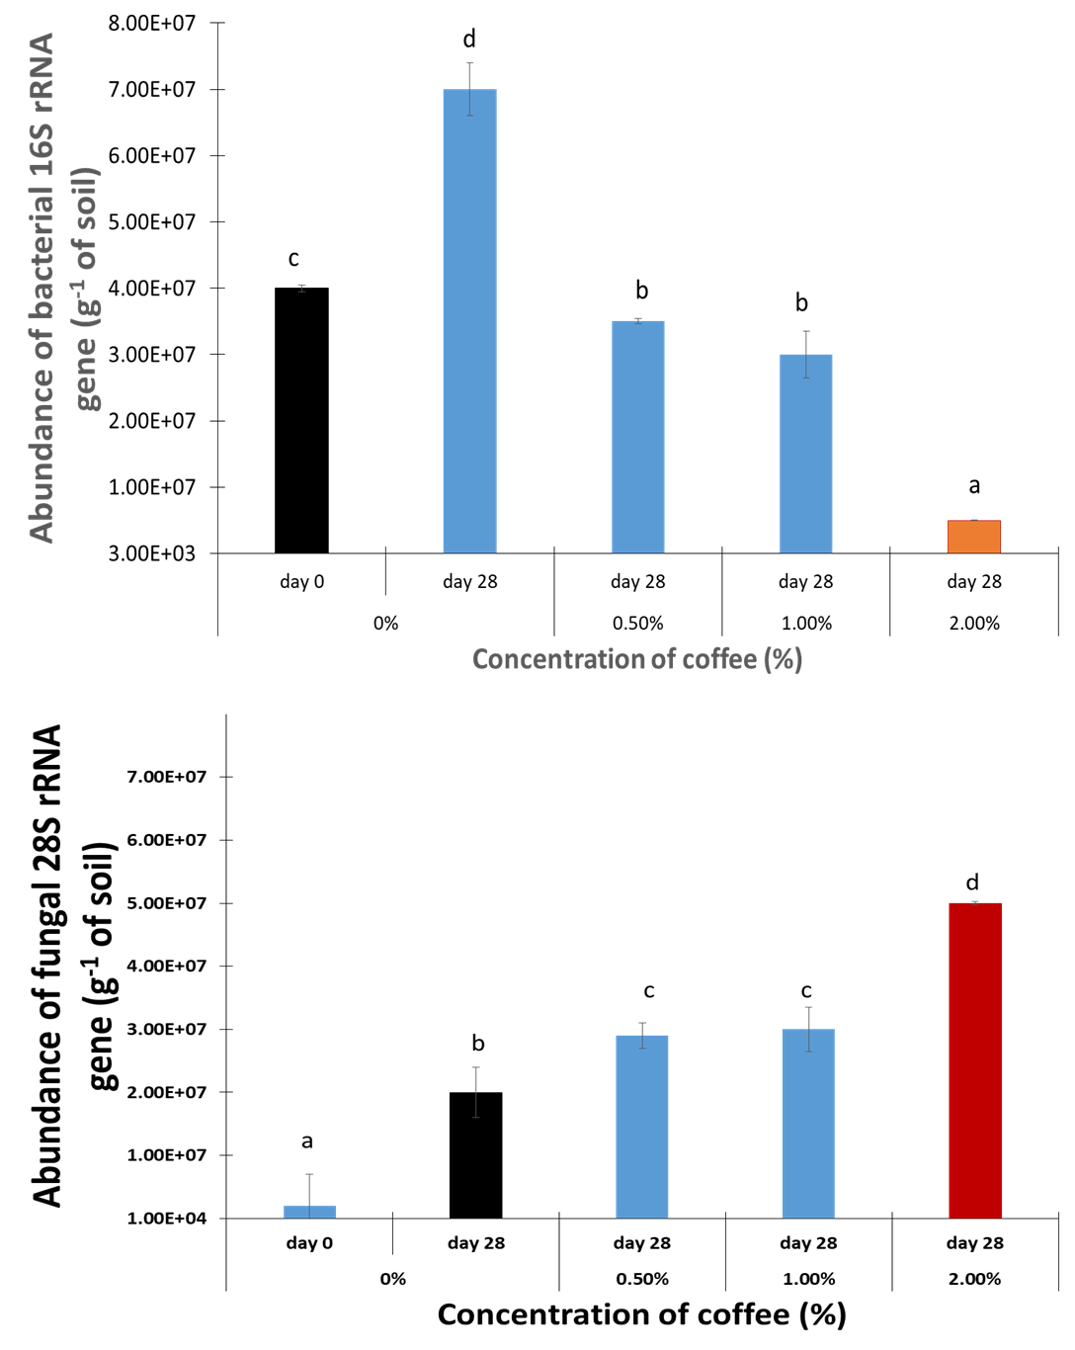
Figure 2: Abundance of bacterial 16S rRNA and fungal 28S rRNA geneg⁻¹ of soil obtained from soil treated with different concentrations (percentages) of coffee.
Data represents the mean of the triplicate samples while error bars are the standard error of the mean. Different alphabets indicates significant difference at p < 0.05.

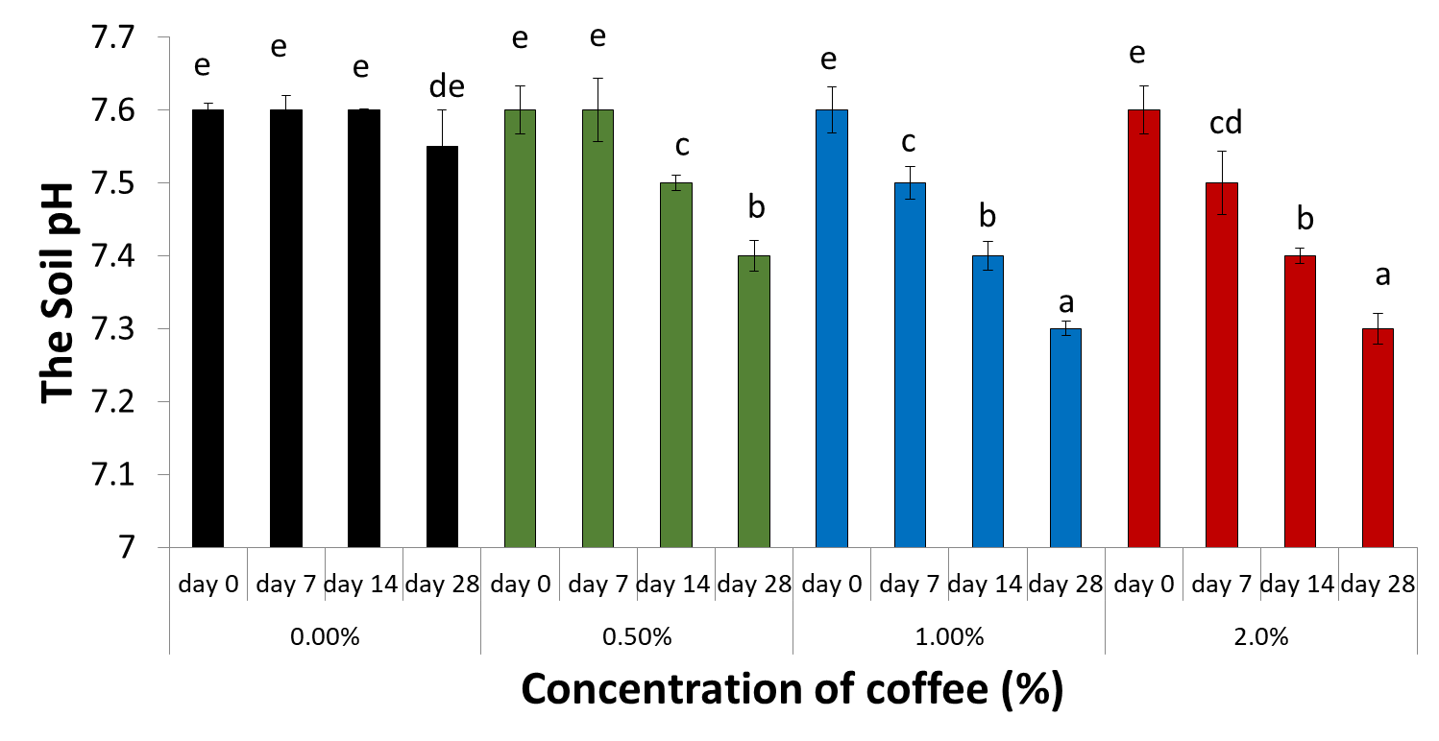

Figure 3: The pH of the Soil treated with different concentrations (percentages) of coffee.
Data represents the mean of the triplicate samples while error bars are the standard error of the mean. Different alphabets indicates significant difference at p < 0.05.

Plant growth parameters
The plant growth decreased with an increase in coffee concentration of the coffee. The highest height of the plant (in centimeter) was obtained in the soil sample without coffee (0% coffee concentration = control) (15.0 centimeter) compared to the treatments with different concentrations of coffee. The plant height increased significantly (p < 0.05) with sampling time (from 7 day to 28 days) from 0 to 14.0 cm. The plant height also increased with time (day 7 to day 28) in the microcosm treated with 1% concentration (from 0 to 5cm). The least height was recorded on day 7 and 14 at 0.5% and 1% coffee concentration, respectively. Plant growth was totally inhibited at 2% (Figure 4). The number of plant leaves counted showed a significant increase with time (sampling days) from 0 to 8, with the highest obtained in the soil sample without coffee (0% coffee concentration = control) and the least at 1% on day 7. The number of leaves increases significantly (p < 0.05) with time (from 7 day to 28 days) in the microcosms with 0% concentration of coffee (from 0 to 8). The microcosm treated with 0.5% concentration also showed a significant increase in the number of plant leaves with time (from 0 to 9) (p < 0.05). The microcosm treated with 1% produced leaves on the last day of sampling (day 28) (5 leaves). However, plant growth was totally inhibited at 2% (Figure 4). The width of plant leaves measured significantly increased (p < 0.05) with time from 5cm to 7 cm from day 7 to day 28 in the control (0% coffee). The width of plant leaves significantly increased (p < 0.05) with time from 1cm to 5 cm from day 7 to day 28 in the 0.5% coffee treatment while plant growth with average leaf width of 2 was observed and measured at day 28 in the 1.0% coffee treatment. However, there was no observable plant growth in 2.0% coffee treatment (Figure 4). Generally, the width of plant leaves decreased significantly with an increase in the concentration of coffee (p < 0.05).
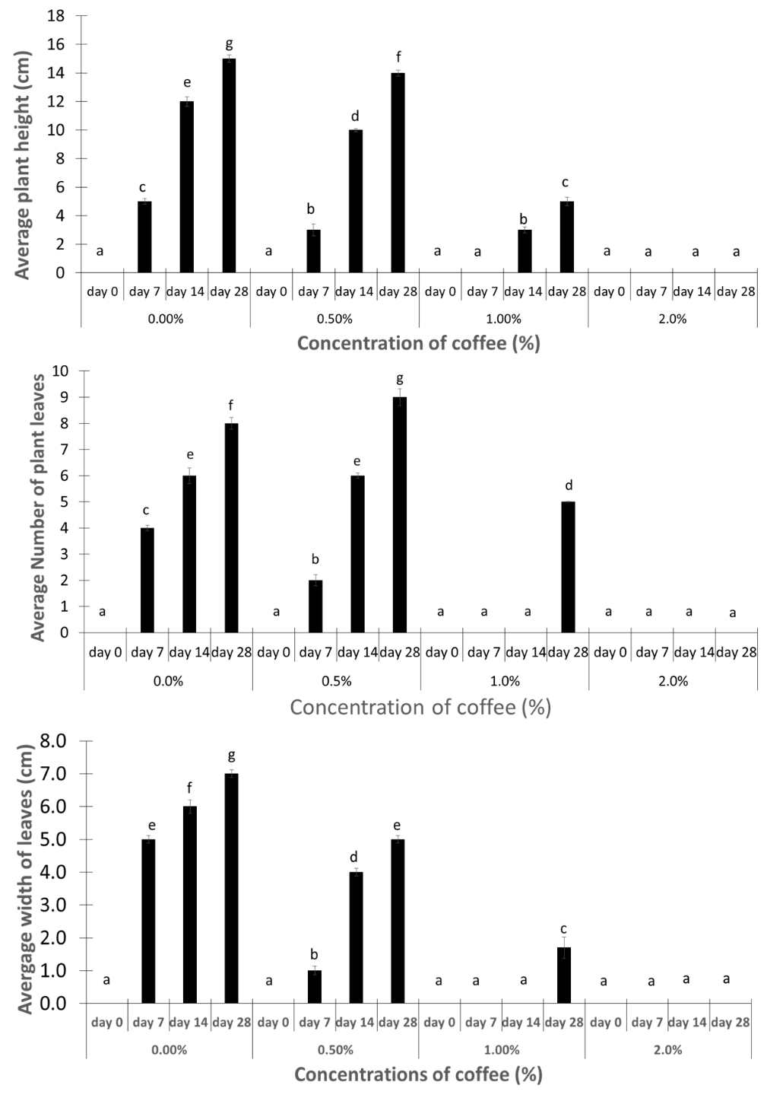
Figure 4: The plant height (Centimeter), number of leaves and width of leaves (Centimeter) in the Soil treated with different concentrations (percentages) of coffee.
Data represents the mean of the triplicate samples, while error bars are the standard error of the mean. Different alphabets indicates significant difference at p < 0.05.
DISCUSSION
The Bacterial and fungal counts of the soil microcosms
The use of organic amendments, such as grounded coffee or its waste has gained attention for their potential impact on improving soil organic matter contents and increasing plant growth and productivity, prompting investigations on how such material can influence the soil microbial population and the soil pH. The decrease in the bacterial population with an increase in the concentration of coffee in soil indicates that coffee or its constituents inhibit the growth of soil bacteria. The observed results in the present study agree with the previous study by Canci et al. (2022) that coffee inhibits bacterial growth. The increases in fungal populations with increases in the concentrations of coffee in soil indicate that low concentrations of coffee in soil stimulate the growth of soil fungi. The results obtained from the present study aligns with the previous studies by Ma et al. (2023), who reported that low levels of organic amendment enhance fungal population due to increased nutrient availability. The results also agree with the findings of Hartmann et al. (2015) which observed that moderate organic inputs in soil enhance fungal diversity and abundance.
Bacterial and fungal gene abundance of the soil microcosms
The result obtained from the gene abundance corroborates the results of the bacterial and fungal count, which indicates that coffee inhibits the growth of bacteria but stimulates the growth of fungi. This result is in agreement with findings in the previous studies by Chaves-Ulate et al. (2023) which discovered that some low molecular weight phenolic compounds (constituents of coffee) can penetrate the cell membrane, causing the acidification of the cytoplasm, which consequently leads to bacterial death.
There was an increase in the number of fungal genes in the soil as the concentration increased. This observation highlights the stimulatory effects of coffee on fungal diversity, aligning with research by Shu et al. (2022), who found that organic inputs could enhance microbial diversity and structure.
The soil pH of the soil microcosms and measured plant parameters
Soil pH is an important determinant of microbial community structure, with various bacterial and fungal species exhibiting preferences over a specific pH of soil. The decrease in soil pH as the concentration of coffee increases could be attributed to organic acid production from the breakdown of coffee into several acidic constituents like caffeic acid by soil microorganisms which increases the soil acidity. This observation corroborates a previous study by Goulding (2016), who reported that low organic matter concentration leads to soil acidification.
The significant reduction in plant (Phaseolus vulgaris) growth, plant height, number of leaves and the width of plant leaves demonstrates a clear negative effect of Phaseolus vulgaris growth in the response to increasing coffee concentration. The results obtained from the present study indicate that low organic amendment like coffee, inhibits the plant growth. The present results corroborates previous studies by Valiño et al. (2023), who observed that certain organic amendments can inhibit plant growth at low or moderate levels due to allelopathic effects. The lack of plant growth observed at 2% indicate that coffee inhibits the plant (Phaseolus vulgaris) growth. This could be attributed to the fact that the presence of coffee reduces the soil moisture contents hence reducing the water availability to the plants. The present results align with previous studies by Mukhtar et al. (2020), who observed that excessive organic amendments could lead to phyto-toxicity, negatively impacting root development and nutrient uptake.
CONCLUSION
In conclusion, the research study underscores the complex interactions between coffee concentration, soil pH and microbial population. Based on this result, the addition of coffee reduces the number of soil bacteria as the concentration increases. However, the addition of coffee stimulates the growth of fungi activities and diversity in soil. Coffee acts as a mutant and inhibitor to soil bacteria. The present research highlights the broader ecological consequences of the amendment of soil with coffee. Therefore, a minimal amount of coffee could be used as a soil amendment considering the effect of coffee on bacterial diversity, soil pH and plant growth.
Disclaimer (Artificial intelligence)
Option 1:
Author(s) hereby declare that NO generative AI technologies such as Large Language Models (ChatGPT, COPILOT, etc.) and text-to-image generators have been used during the writing or editing of this manuscript.
Option 2:
Author(s) hereby declare that generative AI technologies such as Large Language Models, etc. have been used during the writing or editing of manuscripts. This explanation will include the name, version, model, and source of the generative AI technology and as well as all input prompts provided to the generative AI technology
Details of the AI usage are given below:
1.
2.
3.

REFERENCES
Basu, S., Kumar, G., Chhabra, S., & Prasad, R. (2021). Role of soil microbes in biogeochemical cycle for enhancing soil fertility. In: New and Future Developments in Microbial Biotechnology and Bioengineering. https://doi.org/10.1016/B978-0-444-64325-4.00013-4
Bello, M. O., Thion, C. E., Gubry-Rangin, C., & Prosser, J. I. (2019). Differential sensitivity of ammonia oxidising archaea and bacteria to matric and osmotic potential. Soil Biology and Biochemistry, 129, 184-190. https://doi.org/10.1016/j.soilbio.2018.11.017
Bello, M. O. (2021). Prolonged Usage of Herbicides Reduces Heterotrophic Aerobic Bacteria and Fungi Population and Alters Soil Physicochemical Parameters. Journal of Advances in Microbiology, 21(4), 63-75. https://doi.org/10.9734/jamb/2021/v21i430342
Bello, M. O. (2022). Prolonged use of herbicides increased the resistance of soil aerobic heterotrophic bacteria and fungi to antibiotics. International Journal of Current Microbiology and Applied Sciences, 11(06), 281-291. https://doi.org/10.20546/ijcmas.2022.1106.031
Bello, M. O. (2023). Differential toxicity effects of herbicides on the growth of soil bacteria and fungi. International Journal of Science and Research, 12(10), 1050-1054. https://www.ijsr.net/archive/v12i10/SR231010105054.pdf
Canci, L. A., de Toledo Benassi, M., Canan, C., Kalschne, D. L., & Colla, E. (2022). Antimicrobial potential of aqueous coffee extracts against pathogens and Lactobacillus species: A food matrix application. Food Bioscience, 47, 101756. https://doi.org/10.1016/j.fbio.2022.101756
Chaves-Ulate, C., Rodríguez-Sánchez, C., Arias-Echandi, M. L., & Esquivel, P. (2023). Antimicrobial activities of phenolic extracts of coffee mucilage. NFS Journal. https://doi.org/10.1016/j.nfs.2023.03.005
Chilosi, G., Aleandri, M. P., Luccioli, E., Stazi, S. R., Marabottini, R., Morales-Rodríguez, C., Vettraino, A. M., & Vannini, A. (2020). Suppression of soil-borne plant pathogens in growing media amended with espresso spent coffee grounds as a carrier of Trichoderma spp. Scientia Horticulturae, 259, 108666. https://doi.org/10.1016/j.scienta.2020.108666
Das, P. P., Singh, K. R., Nagpure, G., Mansoori, A., Singh, R. P., Ghazi, I. A., Kumar, A., & Singh, J. (2022). Plant-soil-microbes: A tripartite interaction for nutrient acquisition and better plant growth for sustainable agricultural practices. Environmental Research, 214(Pt 1), 113821. https://doi.org/10.1016/j.envres.2022.113821
Dellagi, A., Quillere, I., & Hirel, B. (2020). Beneficial soil-borne bacteria and fungi: a promising way to improve plant nitrogen acquisition. Journal of Experimental Botany, 71(15), 4469-4479. https://doi.org/10.1093/jxb/eraa112
Dincă, L. C., Grenni, P., Onet, C., & Onet, A. (2022). Fertilization and soil microbial community: A review. Applied Sciences, 12(3), 1198. https://doi.org/10.3390/app12031198
Gatica-Arias, A., & Vargas-Segura, C. (2023). Chemical Mutagenesis of Coffee Seeds (Coffea arabica L. var. Catuaí) Using NaN3. In Mutation Breeding in Coffee with Special Reference to Leaf Rust: Protocols (pp. 179-187). Springer Berlin Heidelberg. https://doi.org/10.1007/978-3-662-67273-0_13
Goulding, K. W. T. (2016). Soil acidification and the importance of liming agricultural soils with particular reference to the United Kingdom. Soil Use and Management, 32(3), 390-399. https://doi.org/10.1111/sum.12270
Hartmann, M., Frey, B., Mayer, J., Mäder, P., & Widmer, F. (2015). Distinct soil microbial diversity under long-term organic and conventional farming. The ISME Journal, 9(5), 1177–1194. https://doi.org/10.1038/ismej.2014.210
Hink, L., Gubry-Rangin, C., Nicol, G. W., & Prosser, J. I. (2018). The consequences of niche and physiological differentiation of archaeal and bacterial ammonia oxidisers for nitrous oxide emissions. The ISME Journal, 12, 1084–1093. https://doi.org/10.1038/s41396-017-0025-5
Hoseini, M., Cocco, S., Casucci, C., Cardelli, V., & Corti, G. (2021). Coffee by-products derived resources. A review. Biomass and Bioenergy, 148, 106009. https://doi.org/10.1016/j.biombioe.2021.106009
Iswanto, T., Shovitri, M., Altway, A., Widjaja, T., Kusumawati, D. I., & Lisdiyanti, P. (2019). Isolation and identification of caffeine-degrading bacteria from soil, coffee pulp waste and excreted coffee bean in Luwak feces. Biodiversitas Journal of Biological Diversity, 20(6), 1580-1587. https://doi.org/10.13057/biodiv/d200614
Li, J., Yang, C., Zhou, H., & Shao, X. (2020). Responses of plant diversity and soil microorganism diversity to water and nitrogen additions in the Qinghai-Tibetan Plateau. Global Ecology and Conservation, 22, e01003. https://doi.org/10.1016/j.gecco.2020.e01003
Ma, N., Yin, D., Liu, Y., Gao, Z., Cao, Y., Chen, T., Huang, Z., Jia, Q., & Wang, D. (2023). Succession of endophytic fungi and rhizosphere soil fungi and their correlation with secondary metabolites in Fagopyrum dibotrys. Frontiers in Microbiology. https://doi.org/10.3389/fmicb.2023.1220431
Martins Filho, A. P., de Medeiros, E. V., de Sousa Lima, J. R., Duda, G. P., de Moraes Silva, W., Antonino, A. C. D., Araújo da Silva, J. S., de Oliveira, J. B., & Hammecker, C. (2020). Impact of coffee biochar on soil carbon, microbial biomass and enzymatic activities in Semiarid Entisol cultivated with maize. Revista Brasileira de Geografia Física, 13(3), 903-914. https://doi.org/10.26848/rbgf.v13.3.p903-914
Mazzafera, P. (2022). Degradation of caffeine by microorganisms and potential use of decaffeinated coffee husk and pulp in animal feeding. Scientia Agricola, 59: 815-821.
Mukhtar, A., Manzoor, M., Gul, I., Zafar, R., Jamil, H. I., Niazi, A. K., Ali, M. A., Park, T. J., & Arshad, M. (2020). Phytotoxicity of different antibiotics to rice and stress alleviation upon application of organic amendments. Chemosphere, 258, 127353. https://doi.org/10.1016/j.chemosphere.2020.127353
Naz, M., Dai, Z., Hussain, S., Tariq, M., Danish, S., Khan, I. U., Qi, S., & Du, D. (2022). The soil pH and heavy metals revealed their impact on soil microbial community. Journal of Environmental Management, 321, 115770. https://doi.org/10.1016/j.jenvman.2022.115770
Chen, Q., Song, Y., An, Y., Lu, Y., & Zhong, G. (2024). Soil Microorganisms: Their Role in Enhancing Crop Nutrition and Health. Diversity, 16(12), 734-760. https://doi.org/10.3390/d16120734
Shah, K. K., Tripathi, S., Tiwari, I., Shrestha, J., Modi, B., Paudel, N., & Das, B. D. (2021). Role of soil microbes in sustainable crop production and soil health: A review. Agricultural Science and Technology, 13(2), 109-118. https://doi.org/10.15547/ast.2021.02.019
Shu, X., He, J., Zhou, Z., Xia, L., Hu, Y., Zhang, Y., Zhang, Y., Luo, Y., Chu, H., Liu, W., Yuan, S., Gao, X., & Wang, C. (2022). Organic amendments enhance soil microbial diversity, microbial functionality and crop yields: A meta-analysis. Science of The Total Environment, 829, 154627. https://doi.org/10.1016/j.scitotenv.2022.154627
Valiño, A., Pardo-Muras, M., Puig, C. G., López-Periago, J. E., & Pedrol, N. (2023). Biomass from allelopathic agroforestry and invasive plant species as soil amendments for weed control—A review. Agronomy, 13(12), 2880. https://doi.org/10.3390/agronomy13122880
Yang, X., Zhu, K., Loik, M. E., & Sun, W. (2021). Differential responses of soil bacteria and fungi to altered precipitation in a meadow steppe. Geoderma, 384, 114812. https://doi.org/10.1016/j.geoderma.2020.114812
Duong, B., Marraccini, P., Maeght, J. L., Vaast, P., Lebrun, M., & Duponnois, R. (2020). Coffee microbiota and its potential use in sustainable crop management. A review. Frontiers in Sustainable Food Systems, 4, 607935. https://doi.org/10.3389/fsufs.2020.607935
Asad, S., Priyashantha, A. K. H., Tibpromma, S., Luo, Y., Zhang, J., Fan, Z., Zhao, L., Shen, K., Niu, C., Lu, L., Promputtha, I., & Karunarathna, S. C. (2023). Coffee-Associated Endophytes: Plant Growth Promotion and Crop Protection. Biology, 12(7), 911. https://doi.org/10.3390/biology12070911
Guézéré Corinne Beugre, Adobi Christian Kadjo, Konan Mathurin Yao, Koumba Maï Kone, Isabelle Piro-Metayer, Charlie Poss, Noël Durand, Angélique Fontana, and Tagro Simplice Guehi. (2023). Sensory Quality of Coffee Beverrage Produced Thereof Linked to the Inhibition of Molds Growth and Ochratoxin a Removal from Coffee Cherries Using Lactobacillus plantarum Strains. Current Journal of Applied Science and Technology 42 (13),10–20. https://doi.org/10.9734/cjast/2023/v42i134112.

