Assessing hydrological and sediment factors for ecotoxicological risk of the Orashi River, Rivers State, Nigeria

Abstract
Rivers in the Niger Delta deliver vital ecological and economic benefits but face increasing pressures from human activities that disrupt hydrology and harm sediment quality. This research assessed the hydrological features, sediment condition, and ecological risks of the Orashi River in Rivers State, Nigeria. Hydrological data were gathered from upstream, midstream, and downstream sections, while surface sediments (0–10 cm) were collected in triplicate for analysis of physicochemical properties and heavy metals through standard methods. Sediment pH, electrical conductivity, organic matter, total organic carbon, and cation exchange capacity were measured, alongside concentrations of Fe, Pb, Cd, Cr, Ni, Zn, and Cu using Atomic Absorption Spectrophotometry. Environmental risks were evaluated via contamination factor (CF), geo‑accumulation index (Igeo), potential ecological risk index (PERI), and ecotoxicological risk quotients. River discharge ranged from 38.6 to 214.7 m³/sec, with flow velocities between 0.21 and 0.84 m/sec, indicating a high sediment transport capacity. Sediment pH (5.5–6.8) and organic matter (1.32–4.76%) showed moderate variation across sites. Elevated levels of Cd (1.27 mg/kg) and Pb (46.2 mg/kg) surpassed sediment quality standards. Cadmium indicated significant contamination (CF = 7.1; Igeo = 2.9) and posed a very high ecological risk (Er = 213), predominantly influencing the overall PERI of 249.9. Nickel exhibited the highest ecotoxicological risk quotient (0.81), implying potential long-term stress to benthic life. Metal concentrations were consistently higher downstream, reflecting increased human influence. Overall, sediments of the Orashi River demonstrate notable contamination, with cadmium and lead representing major ecological hazards. Ongoing monitoring and improved catchment management are essential to safeguard aquatic ecosystems.
Keywords: Orashi River; hydrology; sediment quality; heavy metals; ecological risk; Niger Delta

1.0 Introduction
Rivers within the Niger Delta are critical environmental and socio-economic resources, providing water for domestic use, fisheries, agriculture, transportation, and cultural livelihoods for millions of residents. The Orashi River in Rivers State serves as an important freshwater source for surrounding rural and semi-urban communities, but increasing pressures from population growth, land-use changes, and weak environmental management have raised concerns about declining river health across the region (Ekesiobi et al., 2025; Okagbare et al., 2025).
Hydrological processes play a fundamental role in controlling sediment transport and contaminant dynamics in river systems. Variations in discharge, flow velocity, and channel morphology regulate erosion, deposition, and the redistribution of sediment-bound pollutants. In the Niger Delta, intense seasonal rainfall and surface runoff commonly enhance downstream transport, leading to contaminant accumulation in low-energy depositional zones (Osuafor et al., 2025). Such hydrological behaviour has been widely documented for rivers and estuaries in the region, where downstream sections often function as long-term sinks for pollutants introduced upstream (Ogbaji et al., 2025).
Sediments act both as repositories and secondary sources of contaminants in aquatic environments. Fine-grained sediments with high organic matter content exhibit strong metal-binding capacity, allowing heavy metals to accumulate even when concentrations in the overlying water are relatively low. In river systems affected by domestic wastewater, agricultural runoff, and artisanal activities, changes in pH, redox conditions, or hydrodynamics can remobilise sediment-bound metals, prolonging ecological exposure (Umueni et al., 2025; Okpoji et al., 2025).
Ecotoxicological risks arise when accumulated contaminants in sediments interact with benthic organisms and are transferred through aquatic food webs. Chronic exposure to sediment-associated metals has been linked to oxidative stress, tissue damage, impaired growth, and altered physiological functions in fish and invertebrates, with implications for biodiversity and ecosystem services (Ohaturuonye et al., 2025). These impacts are especially significant in rivers such as the Orashi River that support artisanal fisheries and serve as protein sources for local populations (Okpoji et al., 2025).
Despite the environmental importance of the Orashi River, integrated studies combining hydrology, sediment quality, and ecotoxicological risk assessment remain limited. Many investigations in the Niger Delta have focused on surface water chemistry or isolated aspects of sediment contamination, with fewer studies explicitly linking hydrological processes to sediment-associated ecological risks (Ekesiobi et al., 2025; Ekwere et al., 2025). This study assesses the hydrological and sediment factors for ecotoxicological risk of the Orashi River, Rivers State, Nigeria

2.0 Materials and Methods

2.1 Description of the Study Area
The study was conducted along the Orashi River in Rivers State, southern Nigeria. The Orashi River is a major freshwater system within the eastern Niger Delta and supports fishing, transportation, sand mining, subsistence agriculture, and domestic water use. The river traverses several rural and semi-urban communities and receives inputs from surface runoff, domestic wastewater, small-scale artisanal activities, and diffuse anthropogenic sources. The climate of the area is humid tropical, characterised by a long-wet season (April–October) and a short dry season (November–March), with mean annual rainfall exceeding 2,400 mm and average temperatures ranging from 25 to 32 °C.

2.2 Sampling Locations and Geographic Referencing
Sampling locations were selected to represent upstream (reference), midstream (moderately impacted), and downstream (highly impacted) sections of the Orashi River. Geographic coordinates of all sampling points were recorded using a handheld Global Positioning System (GPS) receiver (Garmin eTrex series) to ensure spatial accuracy and reproducibility.
Table 1: Geographic Coordinates of Sampling Stations Along the Orashi River
Station | River Section | Location Description | Latitude (N) | Longitude (E)
ORS-1 | Upstream | Relatively undisturbed reference site | 5.3872° | 6.5348°
ORS-2 | Midstream | Adjacent to riverine settlements | 5.3649° | 6.5576°
ORS-3 | Midstream | Area influenced by farming and runoff | 5.3491° | 6.5723°
ORS-4 | Downstream | High human activity and waste inputs | 5.3278° | 6.5987°
ORS-5 | Downstream | Confluence and depositional zone | 5.3124° | 6.6159°

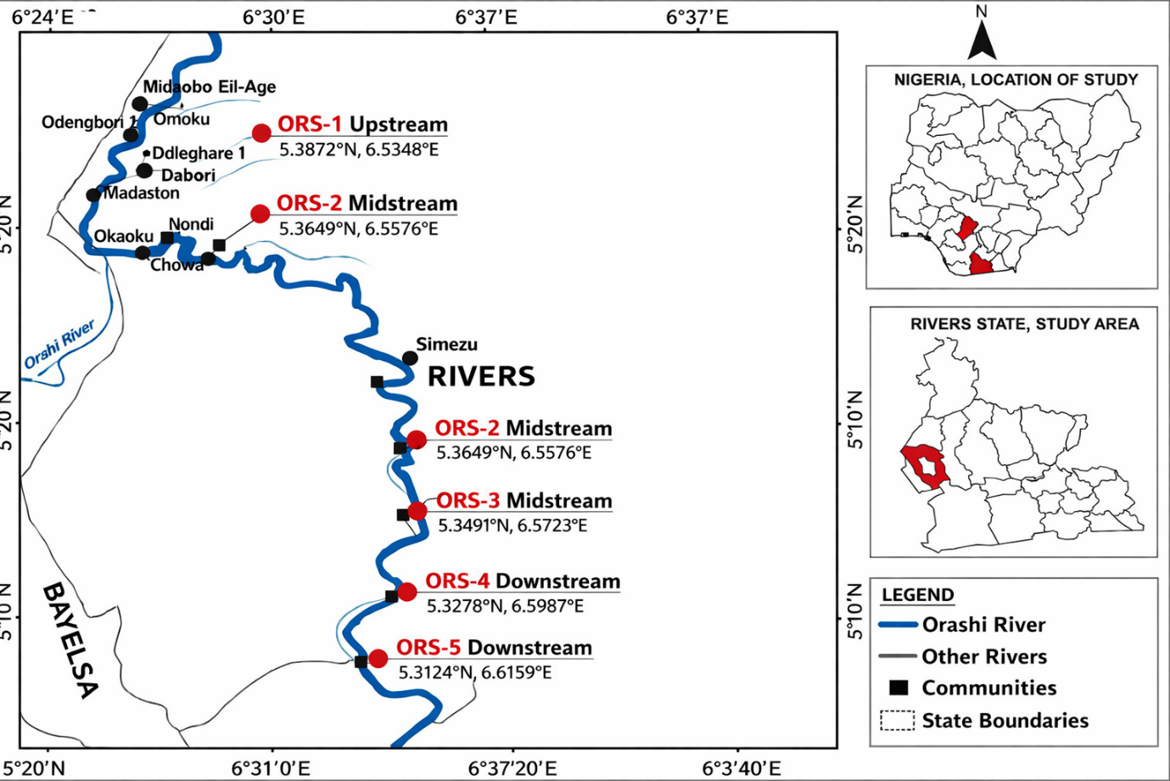

Figure 1: Map of the Orashi River showing the study locations

2.3 Hydrological Measurements
Hydrological parameters were measured in situ at each station. River width was measured using a measuring tape across transects, while water depth was determined using a graduated depth rod. Flow velocity was measured using a portable flow meter, and river discharge was calculated as the product of cross-sectional area and flow velocity. Water temperature and pH were measured using a calibrated digital pH/temperature meter.

2.4 Sediment Sampling and Preparation
Surface sediment samples (0–10 cm depth) were collected at each station using a stainless-steel Ekman grab sampler. At each location, three subsamples were collected and homogenised to form a composite sample, ensuring triplicate representation. Samples were stored in pre-cleaned polyethene bags, transported to the laboratory, air-dried at ambient temperature, gently disaggregated using an agate mortar, and sieved through a 2-mm mesh to remove debris and coarse materials.

2.5 Determination of Sediment Physicochemical Properties
Sediment pH was measured in a 1:2.5 sediment–distilled water suspension using a digital pH meter. Electrical conductivity was determined in the same extract with a conductivity meter. Organic matter content was determined using the Walkley–Black dichromate oxidation method, while total organic carbon was calculated from organic matter values. Cation exchange capacity was determined using ammonium acetate extraction at pH 7. Sediment texture was analysed using the hydrometer method and classified according to the USDA textural triangle.

2.6 Heavy Metal Analysis
Approximately 1.0 g of dried sediment was subjected to acid digestion using a mixed acid system (HNO₃–HCl–HClO₄) on a temperature-controlled hot plate until complete dissolution was achieved. Digested samples were filtered and diluted with deionised water. Concentrations of Fe, Pb, Cd, Cr, Ni, Zn, and Cu were determined using Atomic Absorption Spectrophotometry (AAS). Instrument calibration was carried out using certified multi-element standard solutions, and calibration curves recorded correlation coefficients greater than 0.995.

2.7 Quality Assurance and Quality Control
Quality assurance and quality control procedures included the analysis of reagent blanks, field blanks, duplicate samples, and certified reference materials. Recovery rates ranged between 90 and 110 percent, and relative standard deviations for triplicate analyses were below 5 percent, indicating good analytical precision.

2.8 Sediment Contamination Indices
The contamination factor (CF) is used to assess the degree of metal enrichment in sediments relative to natural background concentrations. It is expressed as the ratio of the measured concentration of a metal in the sediment to its corresponding background value. CF values are classified as low contamination (CF < 1), moderate contamination (1 ≤ CF < 3), considerable contamination (3 ≤ CF < 6), and very high contamination (CF ≥ 6) (Hakanson, 1980; Müller, 1969). The degree of sediment contamination was evaluated using the contamination factor (CF) and geo-accumulation index (Igeo), calculated as:
CF = Cn / Cb
The geo-accumulation index (Igeo) evaluates the extent of anthropogenic metal accumulation in sediments by comparing current concentrations with pre-industrial background values while incorporating a correction factor of 1.5 to account for natural lithogenic variability. Igeo values classify sediments from unpolluted (Igeo ≤ 0) to extremely polluted (Igeo > 5) (Müller, 1969). Igeo = log₂ [ Cn / (1.5 × Cb)], where Cn is the measured metal concentration, and Cb is the background concentration from uncontaminated reference sediments.
Baseline (background) concentrations of heavy metals used for the calculation of contamination factors were obtained from reference sediment values representing uncontaminated or minimally impacted conditions. These background values were derived from published regional geochemical baseline data for Niger Delta sediments and widely accepted average shale and crustal abundance values reported in the literature. This approach ensures that CF calculations reflect deviations from natural geochemical conditions rather than absolute concentrations alone (Turekian & Wedepohl, 1961; Hakanson, 1980; Müller, 1969).

2.9 Ecological and Ecotoxicological Risk Assessment
The potential ecological risk index (PERI) provides a comprehensive assessment of ecological risk by integrating metal contamination levels with their relative toxicities. It reflects the sensitivity of biological communities to toxic substances and considers both contamination degree and toxic response factors (Hakanson, 1980). The potential ecological risk factor (Er) for each metal was calculated as:
Er = CF × Tr
Where Tr is the toxic response factor for each metal. The overall potential ecological risk index (PERI) was computed as: PERI = ΣEr.
Ecotoxicological risk to benthic organisms was evaluated using sediment quality guideline–based risk quotient (RQ) analysis. Risk quotients were calculated as the ratio of measured sediment metal concentrations to corresponding Probable Effect Level (PEL) guideline values. PEL values represent threshold concentrations above which adverse biological effects are likely to occur frequently in benthic organisms.
Risk quotients were interpreted as follows: RQ < 0.1 indicates low risk, 0.1 ≤ RQ < 1 indicates moderate risk, and RQ ≥ 1 indicates high ecotoxicological risk. This method provides an ecologically relevant assessment of potential chronic and sub-lethal effects of sediment-associated metals on benthic fauna (MacDonald et al., 2000; Long et al., 1995; Burton, 2002).

2.10 Statistical Analysis
Descriptive statistics, including minimum, maximum, mean, and standard deviation, were calculated for all measured parameters. Spatial variations among upstream, midstream, and downstream sections were evaluated using comparative analysis. All statistical analyses were conducted using standard statistical software, and results were reported as means of triplicate determinations.

3.0 Results

The hydrological data indicate substantial spatial variability along the Orashi River. River width increased from 42 m upstream to 118 m downstream, while water depth ranged between 1.8 and 6.4 m, reflecting channel expansion and cumulative inflow downstream. Flow velocity varied from 0.21 to 0.84 m/s, resulting in discharge values as high as 214.7 m³/s, confirming the river’s strong transport capacity. Water temperature remained within tropical norms (26.4–30.2 °C), while pH values (6.0–7.4) show slightly acidic to near-neutral conditions. These hydrological characteristics favour sediment transport and redistribution, particularly of fine particles capable of binding contaminants, as shown in Table 2.

Table 2: Hydrological Characteristics of the Orashi River
Parameter | Minimum | Maximum | Mean ± SD
River width (m) | 42 | 118 | 76 ± 24
Water depth (m) | 1.8 | 6.4 | 3.9 ± 1.5
Flow velocity (m/s) | 0.21 | 0.84 | 0.46 ± 0.18
Discharge (m³/s) | 38.6 | 214.7 | 96.3 ± 54.2
Water temperature (°C) | 26.4 | 30.2 | 28.7 ± 1.3
pH | 6.0 | 7.4 | 6.7 ± 0.4

Sediment pH values (5.5–6.8) indicate mildly acidic conditions, which enhance metal mobility and bioavailability. Electrical conductivity ranged from 96 to 318 µS/cm, reflecting moderate ionic content influenced by anthropogenic inputs. Organic matter (1.32–4.76%) and total organic carbon (0.77–2.76%) were highest at midstream and downstream stations, enhancing metal-binding capacity. Cation exchange capacity values (6.4–15.9 cmol/kg) further suggest moderate to high retention potential for heavy metals. The observed sediment texture variation from sandy loam to silty clay explains spatial differences in contaminant accumulation, as shown in Table 3.

Table 3: Physicochemical Properties of Orashi River Sediments
Parameter | Minimum | Maximum | Mean ± SD
pH | 5.5 | 6.8 | 6.2 ± 0.4
Electrical conductivity (µS/cm) | 96 | 318 | 184 ± 72
Organic matter (%) | 1.32 | 4.76 | 2.84 ± 1.01
Total organic carbon (%) | 0.77 | 2.76 | 1.65 ± 0.63
Cation exchange capacity (cmol/kg) | 6.4 | 15.9 | 10.7 ± 3.2
Sediment texture | Sandy loam | Silty clay | –

Iron-dominated sediment composition (9,840–21,360 mg/kg), reflecting natural lithogenic inputs. Cadmium concentrations (0.38–2.94 mg/kg) exceeded sediment quality guidelines at several sites, indicating serious contamination. Lead ranged from 16.4 to 88.7 mg/kg, surpassing guideline values downstream. Zinc (52.6–214.8 mg/kg) and copper (14.2–71.6 mg/kg) approached or exceeded threshold values at impacted locations. Chromium and nickel largely remained within guideline limits, though elevated downstream values suggest anthropogenic influence, as shown in Table 4.

Table 4: Heavy Metal Concentrations in Orashi River Sediments (mg/kg)
Metal | Minimum | Maximum | Mean ± SD | Sediment Quality Guideline
Iron (Fe) | 9,840 | 21,360 | 14,980 ± 3,820 | –
Lead (Pb) | 16.4 | 88.7 | 46.2 ± 19.6 | 35
Cadmium (Cd) | 0.38 | 2.94 | 1.27 ± 0.74 | 0.6
Chromium (Cr) | 24.8 | 96.5 | 54.6 ± 21.3 | 90
Nickel (Ni) | 18.9 | 73.4 | 39.5 ± 15.8 | 50
Zinc (Zn) | 52.6 | 214.8 | 118.7 ± 42.5 | 123
Copper (Cu) | 14.2 | 71.6 | 36.9 ± 16.1 | 35

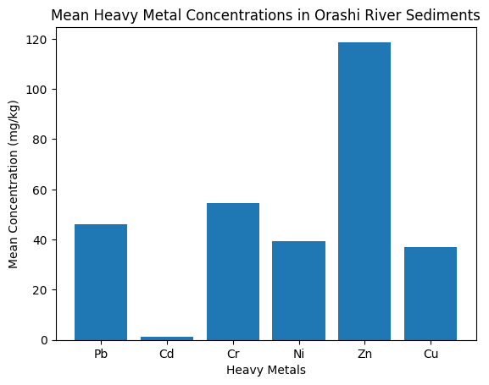Figure 2: Mean concentrations of heavy metals in Orashi River sediments showing relative metal abundance

Contamination factor and geo-accumulation index values identify cadmium as the most critical pollutant, with CF = 7.1 and Igeo = 2.9, corresponding to strong contamination. Lead, nickel, and copper showed moderate contamination (CF ≈ 2.0–2.6), while chromium and zinc were classified as low to moderate contamination. These indices confirm that sediment quality has been substantially altered from natural background conditions, primarily by human activities, as shown in Table 5.

Table 5: Sediment Contamination Indices
Metal | Contamination Factor (CF) | Igeo | Pollution Status
Pb | 2.6 | 1.1 | Moderate contamination
Cd | 7.1 | 2.9 | Strong contamination
Cr | 1.2 | 0.2 | Uncontaminated–moderate
Ni | 2.0 | 0.9 | Moderate contamination
Zn | 1.0 | 0.0 | Low contamination
Cu | 2.1 | 1.0 | Moderate contamination

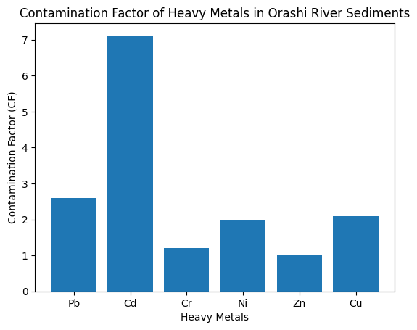Figure 3: Contamination factor (CF) of heavy metals in Orashi River sediments, indicating strong cadmium contamination.

Ecological risk factors reveal cadmium as the dominant ecological stressor, with Er = 213.0 indicating very high ecological risk. Lead, nickel, and copper posed moderate ecological risks, while chromium and zinc showed low risk. The overall PERI value of 249.9 classifies the sediments as presenting considerable ecological risk, implying potential adverse effects on benthic organisms and sediment-associated biota, as shown in Table 6.

Table 6: Potential Ecological Risk Assessment of Sediment Metals
Metal | Toxic Response Factor (Tr) | Ecological Risk Factor (Er) | Risk Category
Pb | 5 | 13.0 | Moderate
Cd | 30 | 213.0 | Very high
Cr | 2 | 2.4 | Low
Ni | 5 | 10.0 | Moderate
Zn | 1 | 1.0 | Low
Cu | 5 | 10.5 | Moderate
Risk quotient analysis shows nickel having the highest quotient (0.81), approaching levels associated with adverse biological effects. Lead, chromium, and cadmium recorded moderate risk quotients (0.36–0.51), while zinc and copper showed lower risk levels. Although most values remain below unity, combined exposure to multiple metals suggests potential chronic stress to benthic fauna rather than acute toxicity, as shown in Table 7.

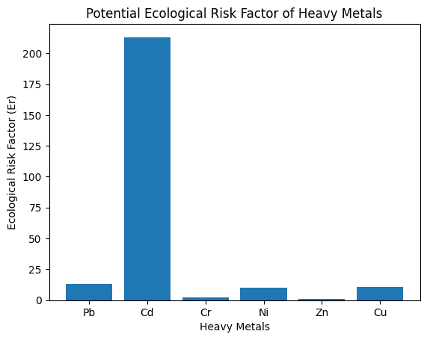Figure 4: Potential ecological risk factor (Er) of heavy metals, highlighting cadmium as the dominant ecological risk contributor.

Table 7: Ecotoxicological Risk Quotients for Benthic Organisms
Metal | Measured Concentration (mg/kg) | Probable Effect Level (PEL) | Risk Quotient
Pb | 46.2 | 91.3 | 0.51
Cd | 1.27 | 3.5 | 0.36
Cr | 54.6 | 111 | 0.49
Ni | 39.5 | 48.6 | 0.81
Zn | 118.7 | 315 | 0.38
Cu | 36.9 | 197 | 0.19
A clear downstream enrichment pattern is evident for all metals. Lead increased from 21.8 mg/kg upstream to 88.7 mg/kg downstream, while cadmium rose sharply from 0.42 to 2.94 mg/kg. Similar trends were observed for chromium, nickel, zinc, and copper, with downstream concentrations approximately three to four times higher than upstream values. This spatial gradient confirms cumulative anthropogenic inputs, likely from domestic activities, runoff, and riverbank disturbances, as shown in Table 8.

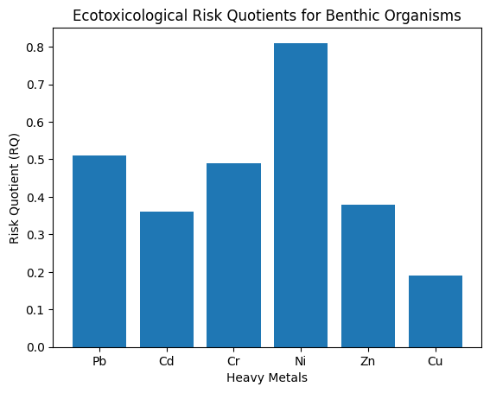Figure 5: Ecotoxicological risk quotients (RQ) for benthic organisms based on sediment quality guideline thresholds.

Table 8: Spatial Distribution of Key Sediment Metals (mg/kg)
Location | Pb | Cd | Cr | Ni | Zn | Cu
Upstream | 21.8 | 0.42 | 29.7 | 22.4 | 61.5 | 18.3
Midstream | 45.6 | 1.38 | 56.9 | 41.7 | 123.6 | 35.8
Downstream | 88.7 | 2.94 | 96.5 | 73.4 | 214.8 | 71.6

4.0 Discussion
The results of this study demonstrate a strong linkage between hydrological dynamics, sediment physicochemical properties, and heavy metal contamination in the Orashi River. Increased discharge and flow velocity downstream enhance sediment transport and deposition, creating favourable conditions for the accumulation of fine particles and organic matter that strongly bind heavy metals. Consequently, elevated concentrations of cadmium and lead were observed in downstream sediments, which corresponded with higher contamination factor, geo-accumulation index, and ecological risk values. These findings indicate that hydrological processes play a central role in controlling the spatial distribution and ecological impact of sediment-associated contaminants in the river system (Asemota et al., 2025).
The slightly acidic to near-neutral pH conditions recorded in Orashi River sediments are characteristic of freshwater systems in the Niger Delta and have important implications for metal mobility. Acidic sediment environments are known to enhance the desorption of metals from sediment particles, increasing their bioavailability and ecological impact (Ekesiobi et al., 2025). Comparable sediment pH conditions and their influence on trace metal behaviour have been reported in riverine and estuarine sediments across the region (Isueken et al., 2025). The role of sediment chemistry as a controlling factor for contaminant fate has also been emphasised in regional geochemical assessments (Ekwere et al., 2025).
Organic matter and total organic carbon contents of the Orashi River sediments were moderate to high, particularly at midstream and downstream locations. Elevated organic matter enhances sediment capacity to bind heavy metals through adsorption and complexation processes. Similar relationships between organic-rich sediments and metal accumulation have been documented in rivers affected by domestic inputs and agricultural runoff in the Niger Delta (Umueni et al., 2025). Studies on agro-ecosystems and irrigation waters further indicate that organic enrichment promotes contaminant retention while simultaneously increasing the potential for remobilisation under changing redox conditions (Olotu et al., 2025).
The measured concentrations of heavy metals in the Orashi River sediments reveal clear evidence of anthropogenic enrichment. Cadmium and lead exceeded sediment quality guideline values at several locations, particularly downstream, indicating significant contamination. Elevated cadmium levels in sediments have been widely reported in Niger Delta aquatic systems and are often attributed to domestic wastewater, artisanal activities, and diffuse urban inputs (Anarado et al., 2023). Lead enrichment in sediments has similarly been linked to household waste streams, fuel combustion residues, and urban runoff in regional studies (Okpoji et al., 2025).
Zinc and copper concentrations approached guideline thresholds in impacted sections of the Orashi River, suggesting contributions from mixed anthropogenic sources. Comparable zinc and copper enrichment has been observed in surface waters and sediments influenced by settlement activities, corrosion of metallic materials, and agricultural practices in southern Nigeria (Ekesiobi et al., 2025). Hydrochemical investigations of groundwater and surface waters in Bayelsa State further support the role of human activities in elevating trace metal concentrations above natural background levels (Okagbare et al., 2025).
The spatial distribution of metals along the Orashi River demonstrates pronounced downstream enrichment, highlighting the cumulative effect of anthropogenic inputs along the river continuum (Ekpe et al., 2025). Downstream accumulation of metals has been consistently reported for rivers and estuaries in Rivers and Bayelsa States, where increased population density and human activity coincide with depositional environments (Aghanwa et al., 2025). Atmospheric deposition associated with gas flaring has also been identified as a secondary but significant source of metal loading in Niger Delta surface waters and sediments, contributing to elevated background concentrations even in areas without direct effluent discharge (Okpoji et al., 2025).
Sediment contamination indices clearly identify cadmium as the dominant contaminant in the Orashi River. Strong contamination levels associated with cadmium align with findings from sediment risk assessments across the Niger Delta, where cadmium consistently contributes disproportionately to overall contamination and ecological risk (Anarado et al., 2023). Moderate contamination levels observed for lead, nickel, and copper further indicate sustained anthropogenic pressure on sediment quality, consistent with reports from comparable river systems (Ekwere et al., 2025).
The ecological risk assessment reinforces the significance of cadmium as a priority pollutant, with very high ecological risk values dominating the overall potential ecological risk index (John et al., 2025). Similar ecological risk profiles have been reported for sediments in the Qua Iboe River and Forcados River, where cadmium was identified as the primary driver of ecological risk despite the presence of multiple metals (Okpoji et al., 2025). Moderate ecological risks associated with lead, nickel, and copper suggest the potential for additive effects on benthic organisms (Umueni et al., 2025).
Ecotoxicological risk quotient analysis indicates that nickel poses the highest potential risk to benthic organisms, approaching effect thresholds. Although individual risk quotients for most metals remained below unity, combined exposure to multiple contaminants can induce chronic sub-lethal effects (Etesin et al., 2025). Biomarker and bioaccumulation studies in Niger Delta fish and crustaceans have demonstrated that long-term exposure to mixed metal contamination results in oxidative stress, tissue damage, and impaired physiological function (Ohaturuonye et al., 2025). Similar ecotoxicological responses have been linked to reduced biodiversity and compromised ecosystem services in polluted aquatic systems (Ekwere et al., 2025).
The dominance of cadmium as the primary contributor to ecological risk in the Orashi River is consistent with findings from other Niger Delta rivers. Similar studies have reported cadmium as the major ecological risk driver in sediments of the Qua Iboe River, Forcados River, and Bonny Estuary, where elevated cadmium levels were attributed to domestic wastewater, diffuse urban runoff, and artisanal activities. The overall PERI value obtained in this study falls within the range reported for other moderately to heavily impacted river systems in southern Nigeria, reinforcing concerns about chronic ecological stress on benthic communities (Umueni et al., 2025; Okpoji et al., 2025).
Comparable downstream enrichment patterns of heavy metals have also been documented in the Imiringi River and Ogboinbiri Creek, where depositional environments act as long-term sinks for contaminants. The ecotoxicological risk quotients obtained in this study, particularly for nickel, align with previous reports indicating that even sub-threshold concentrations can exert chronic toxic effects when organisms are exposed to complex mixtures of metals over extended periods (Anarado et al., 2023; Olotu et al., 2025).

Conclusion
This study provides a comprehensive assessment of the hydrology, sediment quality, and ecotoxicological condition of the Orashi River in Rivers State, Nigeria. The hydrological characteristics indicate a dynamic river system with sufficient flow energy to transport and redistribute sediments and associated contaminants, particularly toward downstream depositional zones. The sediment physicochemical properties, notably slightly acidic pH, moderate to high organic matter content, and appreciable cation exchange capacity, create favourable conditions for the retention and accumulation of heavy metals within the riverbed.
Measured concentrations of heavy metals reveal clear anthropogenic enrichment, with cadmium and lead exceeding sediment quality guideline values at several locations, especially downstream. Contamination indices consistently identify cadmium as the dominant pollutant, exhibiting strong contamination and contributing disproportionately to overall ecological risk. Moderate contamination levels associated with lead, nickel, and copper further indicate sustained human influence on sediment quality along the river continuum.
Ecological risk assessment results demonstrate that cadmium poses a very high ecological risk, while other metals contribute moderate risks that may become significant under cumulative exposure scenarios. Ecotoxicological risk quotient analysis suggests potential chronic stress to benthic organisms, particularly from nickel, even where individual risk thresholds are not exceeded. These findings imply that prolonged exposure to mixed metal contamination could impair benthic communities and disrupt sediment-associated ecological processes. The pronounced downstream enrichment of metals highlights the cumulative impact of anthropogenic activities such as domestic wastewater discharge, surface runoff, and atmospheric deposition. This spatial pattern underscores the importance of managing pollution sources along the entire river catchment rather than focusing solely on isolated hotspots.

Disclaimer (Artificial intelligence)
Option 1:
Author(s) hereby declare that NO generative AI technologies such as Large Language Models (ChatGPT, COPILOT, etc.) and text-to-image generators have been used during the writing or editing of this manuscript.

References

Aghanwa, C. I., Umueni, U. E., Etukudo, N. J., Amachree, J. B., Okpoji, A. U., Ejeka, C. J., & Ekwere, I. O. (2025). Atmospheric deposition of soot and heavy metals from gas flaring into surface waters of Ebocha, Rivers State, Nigeria. Asian Journal of Environment & Ecology, 24(11), 137–147. https://doi.org/10.9734/ajee/2025/v24i11822
Anarado, C. J. O., Okpoji, A. U., & Anarado, C. E. (2023). Bioaccumulation and health risk assessment of lead, cadmium, arsenic, and mercury in blue crabs found in creeks in Bayelsa State of the Niger Delta region of Nigeria. Asian Journal of Environment & Ecology, 21(4), 46–59. https://doi.org/10.9734/ajee/2023/v21i4469
Asemota, P. O., Olotu, O. N., Akpan, N. A., Okpoji, A. U., Etesin, M. U., & Etukudo, E. W. (2025). Environmental engineering evaluation of slow sand filters for treating contaminated water in Borokiri Area, Port Harcourt, Rivers State, Nigeria. Journal of Environment, Climate, and Ecology, 2(2), 184–191. https://doi.org/10.69739/jece.v2i2.1307
Ekesiobi, S. U., Ekpe, J. E., Okpoji, A. U., Hassan, D. H., Ekwere, I. O., Awortu, R. C., Etesin, M. U., Nwofia, U., Okeke, C. F., & Nwankwo, A. O. (2025). Hydrochemical characterisation and health-risk assessment of drinking water sources in Brass Island, Bayelsa State, Nigeria. Asian Journal of Chemical Sciences, 15(6), 64–76. https://doi.org/10.9734/ajocs/2025/v15i6406
Ekpe, J. E., Okpoji, A. U., Ekwere, I. O., Anarada, C. J., Ewuola, A. A., Ufuoma, V. O., Okpanachi, C. B., Okonkwo, C. O., & Obunezi, O. A. (2025). Physico-chemical transport of pesticides and nutrients in irrigation water and their fate in agro-ecosystems of Rivers State, Nigeria. Palgo Journal of Agriculture, 9(2), 30–37. https://doi.org/10.5281/zenodo.17148360
Ekwere, I. O., Okpoji, A. U., Igwegbe, K. C., Okonkwo, C. O., Yekeen, A. A., Obunezi, O. C., Okpanachi, C. B., Garuba, M. H., Ogini, O. R., & Odibo, U. E. (2025). Nutritional–Toxicological Trade-Off: Comparative Study of Polycyclic Aromatic Hydrocarbons in Smoked and Oven-Dried Nile Tilapia (Oreochromis niloticus). Journal of Environment, Climate, and Ecology, 2(2), 90-97. https://doi.org/10.69739/jece.v2i2.952
Ekwere, I. O., Okpoji, A. U., Okagbare, U. V., Ewuola, A. A., Awortu, R. C., Onoja, C. R., Alaekwe, I. O., Etesin, M. O., & Edodi, I. O. (2025). Nutritional evaluation of Nile tilapia (Oreochromis niloticus) processed by different drying methods in Akwa Ibom State, Nigeria. Journal of Sustainable Research and Development, 1(2), 11–17. https://doi.org/10.69739/jsrd.v1i2.1033
Etesin, M. U., Ezeabsili, P. I., Agu, M. O., Okeke, C. F., Olotu, O. N., Aligwo, M. C., Eze, V. C., Nwankwo, A. O., Okpoji, A. U., & Ekong, I. U. (2025). Determination of polychlorinated biphenyls in soils and industrial effluents and health risks assessment in Uyo, Akwa Ibom State, Nigeria. Journal of Medical Science, Biology, and Chemistry, 2(2), 285–292. https://doi.org/10.69739/jmsbc.v2i2.1258
Hakanson, L. (1980). An ecological risk index for aquatic pollution control. Water Research, 14, 975–1001.
Isueken, C. O., Asemota, P. O., Isaac, S. C., Okpoji, A. U., Nwankwo, A. O., Akpan, N. A., Ekwere, I. O., Etesin, M. U., & Alieze, A. B. (2025). Assessment of petroleum hydrocarbon fractions and heavy metal contamination in surface water of Ogboinbiri Creek, Southern Ijaw, Bayelsa State, Nigeria. Scientific Journal of Engineering and Technology, 2(2), 172–179. https://doi.org/10.69739/sjet.v2i2.1308
John, E. E., Emah, O. A., Ifiok, O. E., Okpoji, A. U., Iyam, O. E., Henderson, O. O., Akinola, A. E., Anngo, G. N., & Ogbonnaya, C. N. (2025). Health Risk Implications of Polycyclic Aromatic Hydrocarbons in Smoked and Dried Fish Consumed in Nigeria. Journal of Medical Science, Biology, and Chemistry, 2(2), 192–199. https://doi.org/10.69739/jmsbc.v2i2.1045
Long, E. R., et al. (1995). Incidence of adverse biological effects within ranges of chemical concentrations in marine and estuarine sediments. Environmental Management, 19, 81–97.
MacDonald, D. D., Ingersoll, C. G., & Berger, T. A. (2000). Development and evaluation of consensus-based sediment quality guidelines. Archives of Environmental Contamination and Toxicology, 39, 20–31.
Müller, G. (1969). Index of geoaccumulation in sediments of the Rhine River. Geojournal, 2, 108–118.
Ogbaji, H. O., Akpan, N. A., Ijioma, C. C., Okpoji, A. U., Eze, V. C., Obi, J. N., Martins, N. P., & Etesin, M. U. (2025). Seasonal variation in hydrocarbon contamination of sediments and biota in Bonny Estuary, Rivers State, Nigeria. Asian Journal of Geographical Research, 8(4), 330–338. https://doi.org/10.9734/ajgr/2025/v8i4341
Ohaturuonye, S. O., Okpoji, A. U., Akpan, N. A., Njoku, C. A., Isaac, S. C., Etesin, M. U., & Ekwere, I. O. (2025). Biomarker responses in fish and crustaceans exposed to heavy metals and petroleum hydrocarbons in the Qua Iboe Estuary, Niger Delta. Asian Journal of Research in Zoology, 8(4), 234–244. https://doi.org/10.9734/ajriz/2025/v8i4233
Okagbare, U. V., Umueni, U. E., Ekpe, J. E., Etukudo, N. J., Okpoji, A. U., Okoye, P. I., Ekwere, I. O., Etesin, M. U., Okpanachi, C. B., & Okafor, C. A. (2025). Geophysical and Hydrochemical Assessment of Groundwater Vulnerability to Oil Pollution in Yenagoa, Bayelsa State, Nigeria. Journal of Environment, Climate, and Ecology, 2(2), 138–146. https://doi.org/10.69739/jece.v2i2.1078
Okpoji, A. U., Akpan, N. A., Eze, V. C., Ijioma, C. C., Hassan, D. H., Kareem, M. M., Obi, A. I., Aningo, G. N., Okoye, P. I., Ogbonnaya, C. N., Ekwere, I. O., Okeke, C. F., & Aligwo, M. C. (2025). Toxicity and bioaccumulation of heavy metals and polycyclic aromatic hydrocarbons in estuarine fish from the Andoni Estuary, Niger Delta, Nigeria. Journal of Applied Physical Science International, 17(2), 10–22. https://doi.org/10.56557/japsi/2025/v17i210026
Okpoji, A. U., Anarado, C. O., Mmuta, E. C., Ekwere, I. O., Alaekwe, I. O., Odibo, U. E., Igwegbe, K. C., Eboj-Ajoku, I. O., & Obunezi, O. C. (2025). Toxicological evaluation of Pb, Cd, As, and Hg in blue crab from oil-polluted creeks in the Niger Delta. Journal of Life Science and Public Health, 1(1), 24–31. https://doi.org/10.69739/jlsph.v1i1.879
Okpoji, A. U., Chinyere, U. E., Nwokoye, J. N., Ezekwuemen, O. I., Alaekwe, I. O., Odidika, C. C., Owughara, C. N., Enyi, C. M., & Kolawole, O. O. (2025). Environmental Assessment of Heavy Metals and Hydrocarbon Pollution in Surface Waters of Oil-Bearing Communities in Andoni, Rivers State, Nigeria. International Journal of Modern Science and Research Technology, 3(8), 22–30. https://www.ijmsrt.com/environmental-assessment-of-heavy-metals-and-hydrocarbon-pollution-in-surface-waters-of-oil-bearing-communities-in-andoni-rivers-state-nigeria/
Okpoji, A. U., Eboh-Ajoku, I. O., Mmuta, E. C., Ndubuisi, J. O., Alaekwe, I. O., Odibo, U. E., Nwoka, N. G., Okafor, C. A., & Obunezi, O. C. (2025). Integrated environmental risk assessment of BTEX and PAHs in water and sediment samples from the Bonny River, Nigeria. ISA Journal of Multidisciplinary (ISAJM), 2(4), 14–21. https://doi.org/10.5281/zenodo.16921896
Okpoji, A. U., Ekwere, I. O., Igwegbe, K. C., Anarado, C. J. O., Ogbonna, C., Ewuola, A. A., Odibo, U. E., & Garuba, M. H. (2025). Volatile organic compounds from gas flaring and their atmospheric implications in the Niger Delta. Journal of Life Science and Public Health, 1(1), 32–39. https://doi.org/10.69739/jlsph.v1i1.962
Okpoji, A. U., Ekwere, I. O., Igwegbe, K. C., Etesin, U. M., Ugwuanyi, G. C., Okpanachi, C. B., Ewuola, A. A., Mojisola, K. M., & Ezekwueme, O. I. (2025). Solar-enhanced photocatalytic degradation of pharmaceutical residues in wastewater using Fe-, Cu-, and Zn-doped TiO₂ nanomaterials. Journal of Environment, Climate, and Ecology, 2(2), 56–62. https://doi.org/10.69739/jece.v2i2.961
Okpoji, A. U., Emem, J. A., Ekwere, I. O., Odibo, U. E., Alaekwe, I. O., Warder, A. B., & Eboj-Ajoku, O. I. (2025). Bioaccumulation of nickel, lead, and cadmium in tissues of Callinectes sapidus from the Iko River, Nigeria: Implications for human health risk and environmental safety. Journal of Environment, Climate, and Ecology, 2(2), 29–37. https://doi.org/10.69739/jece.v2i2.844
Okpoji, A. U., Etesin, M. U., Ekwere, I. O., Martins, N. P., Okpanachi, C. B., Adisa, O. J., & Okonkwo, C. C. (2025). Geochemical speciation and ecological risk of heavy metals in estuarine sediments of the Qua Iboe River, Nigeria. Asian Journal of Chemical Sciences, 15(6), 20–31. https://doi.org/10.9734/ajocs/2025/v15i6402
Okpoji, A. U., Ndubuisi, J. O., Eboh-Ajoku, I. O., Emem, J. A., Ekwere, I. O., Alaekwe, I. O., Odibo, U. E., Igwegbe, K. C., Onoja, C. R., Warder, A. B., & InyangAbia, A. J. (2025). Trematode infections and histopathological effects in Chrysichthys nigrodigitatus from the polluted Andoni River, Niger Delta, Nigeria. Journal of Agriculture, Aquaculture, and Animal Science, 2(2), 66–72. https://doi.org/10.69739/jaaas.v2i2.882
Okpoji, A. U., Nwoka, N. G., Odibo, U. E., Alaekwe, I. O., Okafor, C. A., Ogwu, N. G., & Akatakpo, C. U. (2025). Seasonal variation in hydrochemical characteristics and heavy metal risk assessment of groundwater in Andoni-Isiokwan District, Niger Delta, Nigeria. International Journal of Modern Science and Research Technology, 3(8), 44–51. http://www.ijmsrt.com
Okpoji, A. U., Ogbaji, H. O., Hassan, D. H., Orji-Azuka, L. N., Rasheed, H. O., Ohaturuonye, S. O., Ejeka, J. C., Okpanachi, C. B., & Ekwere, I. O. (2025). Physico-chemical transport of volatile organic compounds (VOCs) from gas flaring into surface waters of Ogoniland, Rivers State, Nigeria. Asian Journal of Physical and Chemical Sciences, 13(4), 151–159. https://doi.org/10.9734/ajopacs/2025/v13i4271
Okpoji, A. U., Orji-Azuka, L. N., Igwegbe, K. C., Ekwere, I. O., Ewuola, A. A., Garuba, M. H., & Etukudo, E. W. (2025). Water quality and ecotoxicological impacts of surfactants and heavy metals in urban rivers of Benin City, Niger Delta, Nigeria. Asian Journal of Geological Research, 8(3), 697–707. https://doi.org/10.9734/ajoger/2025/v8i3223
Olotu, O. N., Okagbare, U. V., Okpoji, A. U., Orji-Azuka, L. N., Etesin, M. U., & Ekwere, I. O. (2025). Spatio-seasonal assessment of water and sediment quality of the Imiringi River and implications for fisheries and aquatic resources in the Niger Delta. Journal of Agriculture, Aquaculture, and Animal Science, 2(2), 174–184. https://doi.org/10.69739/jaaas.v2i2.1309
Onoja, C. R., Ogbaji, H. O., Edodi, I. O., Mmuta, E. C., Igwegbe, K. C., Ogini, O. R., Odibo, U. E., Ewuola, A. A., Mahmoud, A. B., & Okpoji, A. U. (2025). Heavy Metal Contamination and Health Risk Assessment of Smoked-Dried Fish Sold in Eke-Awka Market, Anambra State, Nigeria. Journal of Sustainable Research and Development, 1(2), 18-25. https://doi.org/10.69739/jsrd.v1i2.1044
Osuafor, O. O., Okeke, C. F., Agu, M. O., Isueken, C. O., Aligwo, M. C., Ohaturuonye, S. O., Okpoji, A. U., Etesin, M. U., & Ekwere, I. O. (2025). Hydrogeochemical characterisation and water quality assessment of streams impacted by agricultural runoff in Uyo, Akwa Ibom State, Nigeria. Asian Journal of Agricultural and Horticultural Research, 12(4), 182–192 https://doi.org/10.9734/ajahr/2025/v12i4427
Umueni, U. E., Etukudo, N. J., Okoye, P. I., Okpoji, A. U., Eze, V. C., Aningo, G. N., Ekwere, I. O., & Garuba, M. H. (2025). Geochemical and ecological risk assessment of petroleum hydrocarbons in sediments of Forcados River, Delta State. Asian Journal of Geographical Research, 8(4), 287–298. https://doi.org/10.9734/ajgr/2025/v8i4337
Umueni, U. E., Rasheed, H. O., Edodi, I. O., Aningo, G. N., Okpoji, A. U., Etesin, M. U., Okonkwo, C. C., Ekwere, I. O., Okeke, C. F., & Anarah, S. E. (2025). Nutrient enrichment and eutrophication potential of agricultural runoff in Otuoke, Bayelsa State, Nigeria. Asian Journal of Agricultural and Horticultural Research, 12(4), 154–163. https://doi.org/10.9734/ajahr/2025/v12i4424

