Impact of Combined Application Irrigation and Mulching on Soil and Leaf Nutrient Dynamics, Mango Yield and Quality

Abstract
Soil moisture and nutrients are crucial for agricultural productivity, especially in arid and semiarid regions where they limit crop growth. To address the present problem a two-year field experiment (2017–19) evaluated the combined effects of drip irrigation (75% and 100% ETc) and mulching (with/without 100-µm silver polyethylene) on mango cv. Banganpalli in red sandy loam soil of Southern Telangana (16°30'N, 78°19'E; 550 m MSL). A 2×2 factorial randomized block design with five replications was employed. The 100% ETc + mulching treatment recorded the highest soil moisture (13.4–16.6% across BBCH-510 to BBCH-709), available soil N (222–315 kg ha⁻¹), leaf NPK (N: 0.82–1.11%, P: 0.19–0.22%, K: 0.74–0.91%), and fruit yield (89.11 kg tree⁻¹)—35.83% higher than 75% ETc without mulching. It also maximized internal O₂, minimized CO₂, delayed chlorophyll degradation (DA-index: 0.96–0.55 over 9 days storage), and extended shelf life to 13.73 days. Fertilizer use efficiency peaked at 89.11 kg kg⁻¹ under this treatment due to reduced nutrient leaching and enhanced uptake. Notably, 75% ETc + mulching yielded comparably to 100% ETc without mulching (75.78 vs. 75.18 kg tree⁻¹) while achieving 25% water savings and the highest water use efficiency (WUE). Results from present study suggested that the drip irrigation and mulching optimize resource efficiency and fruit quality under water-limited semi-arid conditions. The 75% ETc + mulching regime is recommended as a sustainable, high-yielding strategy for mango orchards.
Keywords: Water savings, Sustainable, Soil moisture availability, DA-index

Introduction
The mango (Mangifera indica L.) ranks among India’s most valuable fruit crops and is cultivated in over 87 countries globally. Within India, it holds a dominant position as one of the top economically significant fruits in tropical and subtropical zones. The country leads global mango production, accounting for 35.4% (2.31 million ha) of the total area under fruit cultivation and contributing 23.1% (22.35 million MT) of worldwide output. Despite this, average national yield remains low at 9.7 t ha⁻¹, with Telangana recording 9.3 t ha⁻¹—far below Uttar Pradesh (17.63 t ha⁻¹), highlighting significant scope for productivity enhancement [1]. In Telangana, mango commands a leading role, occupying 70% of the total fruit-growing area and contributing 56% of fruit production. Yet, yields in both the state and nation lag behind Uttar Pradesh and Bangladesh (17.0–17.63 t ha⁻¹), underscoring considerable untapped potential for improving output [2]. Declining productivity stems from multiple biotic and abiotic constraints. Among these, effective water management emerges as a critical determinant of yield and fruit quality, despite the crop’s tolerance to drought and temporary water logging. Water deficiency during key phases of fruit development remains the primary cause of reduced yields [3]. Under such conditions, strategic irrigation—particularly during fruit growth plays a pivotal role in enhancing both quantity and quality. Nevertheless, in arid and semi-arid regions, limited availability and poor quality of irrigation water continue to pose major barriers to optimizing mango productivity [4].
Water and land constitute vital, non-substitutable resources for agricultural progress and economic advancement in any nation; they are neither infinite nor freely available indefinitely. Rising population pressures will intensify demand for these resources. Growing water scarcity underscores the urgent need to explore sustainable irrigation practices. This requires the rapid development of water-efficient irrigation methods that maintain crop yields without compromise. Accordingly, emphasis must shift toward both expanding water resource development and optimizing the use of existing supplies [5]. Currently, mango orchards are irrigated using basin or drip systems without regard to actual crop water needs or scheduling, resulting in significant water wastage. Transitioning from basin to properly scheduled drip irrigation is essential to conserve water and expand cultivable area under limited water availability [6]. Mulching represents another key conservation practice. Research demonstrates that mulches enhance soil properties, suppress weeds [7], and improve water-use efficiency. Under water-limited conditions, combining drip irrigation with mulching emerges as a superior strategy, saving 25–30% of irrigation water [8]. Singh et al. [9] reported that drip irrigation paired with polyethylene mulch increased guava yield by 164% compared to ring basin irrigation. Against this backdrop, the present study was conducted to evaluate soil and leaf nutrient dynamics, mango yield, and fruit quality.
MATERIALS AND METHODS
A two-year field experiment (2017–18 and 2018–19) was carried out in a private mango orchard located at Sathapur, Kollapur area, Nagarkurnool District, within the Southern Telangana agro-climatic zone. The site lies at 16°30′ N latitude, 78°19′ E longitude, and an elevation of 550 m above mean sea level. The area is predominantly characterized by red sandy soils, locally referred to as Chelka soils. The experimental soil was classified as red sandy loam, exhibiting good drainage and moderate water-holding capacity. Key soil properties of the trial site are presented in Table 1. Representative soil samples were collected from the 0–45 cm depth within the root-zone wetted area of each plot, air-dried under shade, and analyzed for initial physical and chemical characteristics prior to treatment imposition. Initial and final leaf nutrient status (Table 2) was assessed by sampling 20–30 fully mature leaves from the fourth and fifth positions on recently matured shoots, following standard protocols [10].
Experimental design and applications
The field experiment was conducted over two consecutive growing seasons: June 2017 to May 2018 and June 2018 to May 2019, in a private mango orchard at Sathapur, Kollapur area, Nagarkurnool District, Telangana. The site is situated at 16°30′ N latitude, 78°19′ E longitude, and 550 m above mean sea level, within the Southern Telangana agro-climatic zone. The predominant soil type is red sandy loam, locally known as Chelka soil, with detailed physicochemical properties provided in Table 1.
Forty uniform, healthy 12-year-old mango trees (cv. Banganpalli) planted at 10 × 10 m spacing were selected for the study. Each treatment was applied to two trees per replication. All trees received uniform cultural practices except for irrigation and mulching interventions. The recommended dose of fertilizers (RDF: 1000:1000:1000 g N:P₂O₅:K₂O and 50 kg FYM per tree per year for trees >10 years old) was applied in two splits. The first half-dose of nitrogen, full phosphorus, full FYM, and half potassium was soil-applied during the third week of June. The remaining half-dose of nitrogen and potassium, along with micronutrients [ZnSO₄ (50 g), FeSO₄ (25 g), borax (20 g), and MgSO₄ (30 g) per tree], was delivered via foliar spray at the marble stage of fruit development.
The experiment followed a 2 × 2 factorial design with two irrigation levels (I₁: 75% ETc; I₂: 100% ETc via drip) as main plots and two mulching levels (M₀: no mulch; M₁: 100-micron silver polyethylene mulch) as subplots. This resulted in four treatment combinations: I₁M₀ (75% ETc + no mulch), I₁M₁ (75% ETc + mulch), I₂M₀ (100% ETc + no mulch), and I₂M₁ (100% ETc + mulch). The trial was laid out in a factorial randomized block design with five replications, and data were analyzed using the OPSTAT software developed by COBS&H, CCS HAU, Hisar [11]. Treatment means were separated using Duncan’s Multiple Range Test (DMRT) at P ≤ 0.05.
Irrigation scheduling was based on crop evapotranspiration (ETc), estimated using Class A pan evaporation data adjusted by crop coefficients. Daily meteorological observations were recorded at the Krishi Vigyan Kendra (KVK), Palem, Nagarkurnool, under PJTSAU, Telangana. Irrigation requirements were computed using the standard pan evaporation method, with daily water application determined by the formula described in [12].
V = Ep. Kp. Kc. Sp. Sr. Wp [12]
Where,
V = Volume of water required (litters day⁻¹ plant⁻¹),
Ep = Pan evaporation as measured by Class-A pan evaporimeter mm day⁻¹.
Kc = Crop co-efficient (co-efficient depends but for fully grown plants is 0.85)
Kp = Pan co-efficient (0.7)
Sp = Plant to plant spacing (m) Sr = Row to row spacing (m)
Wp = Fractional wetted area (0.3 for wider spaced crops)
The initial (Table-1) and final leaf analysis made by collecting of mango leaves (20-30) from the leaves situated at fourth and fifth position from terminal bud of recently matured shoots [11].
Table 1: Methods to be used for soil, leaf and fruit analysis [13]
Soil analysis | Methods to be used
Organic carbon (%) | Modified Walkley and Black Method; Jackson
Available nitrogen (kg ha⁻¹) | Alkaline Potassium Permanganate method
Available phosphorous (kg ha⁻¹) | Olsen’s Method
Available potassium (kg ha⁻¹) | Flame photometry method
Leaf analysis | Methods to be used
Nitrogen (%) | Modified Kjeldahl's digestion method
Phosphorus (%) | Vanado-molybdo-phosphoric yellow colour method in nitric acid system
Potassium (%) | Flame photometric determination
Soil moisture content (%)
Soil moisture levels were monitored to compare drip irrigation with conventional surface flooding. Measurements were taken using a PDSR soil moisture sensor immediately before each irrigation event. Under drip, readings were recorded at a 30 cm lateral distance from the emitter. For surface irrigation, a digital soil moisture meter was used at 120 cm from the tree trunk. Mean moisture values were calculated across key phenological stages. The instrument provided a measurement range of 0–50% volumetric soil water content with 0.1% resolution.
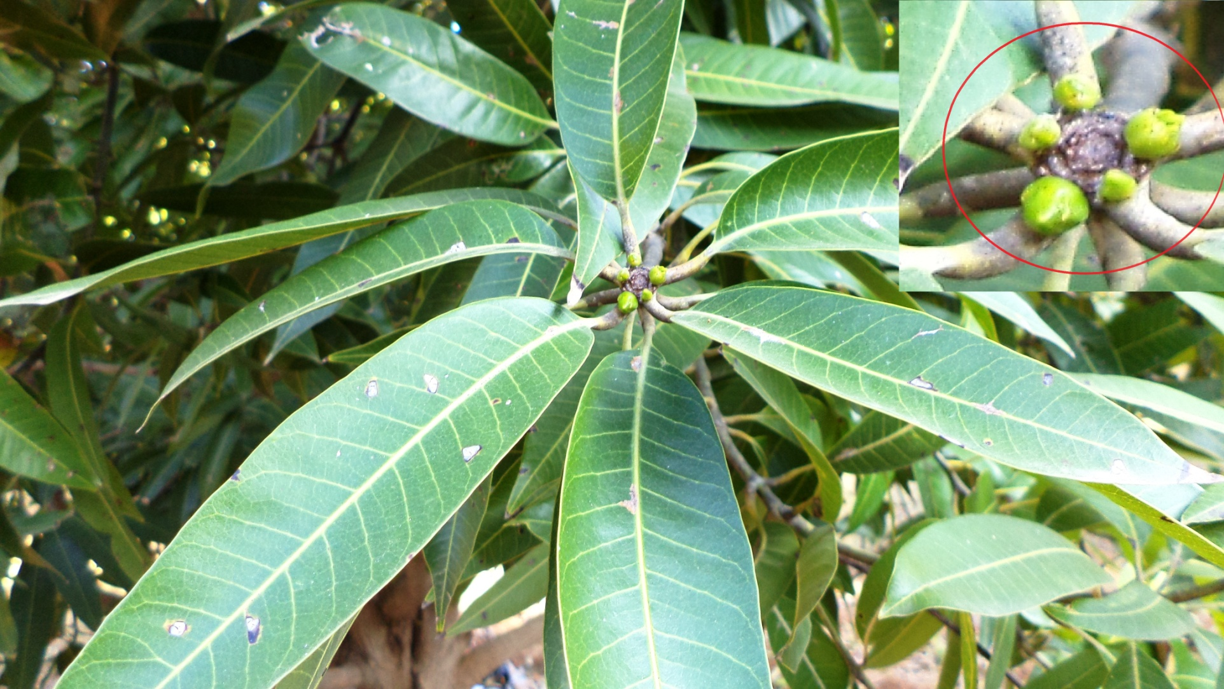 | 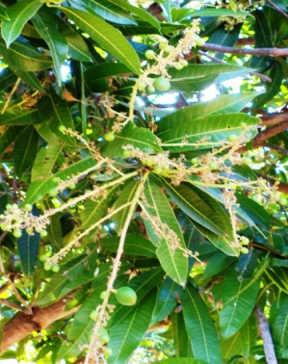 |  | 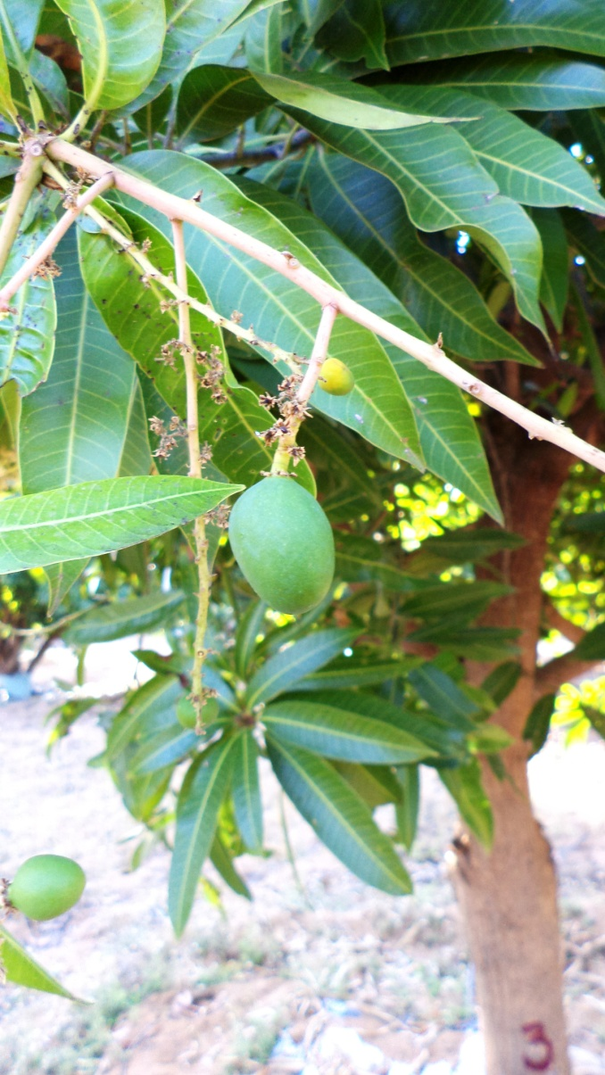 |  |  |  | 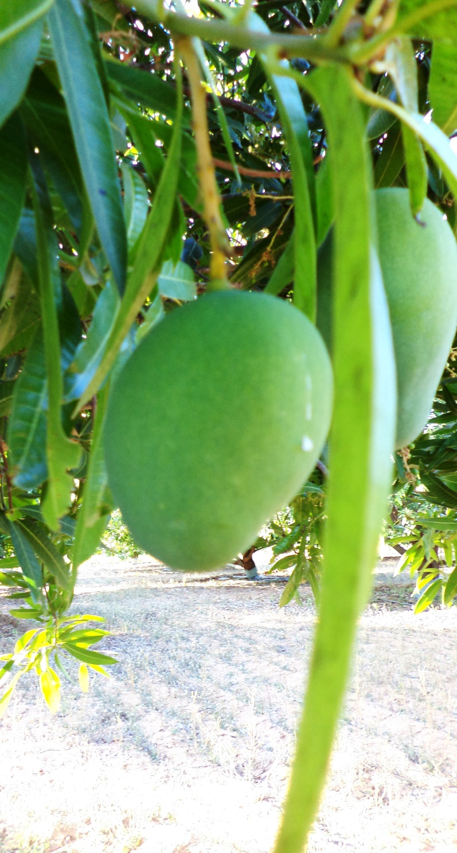
_{BBCH-510} | _{BBCH-619} |  | _{BBCH-701} |  |  | _{BBCH-703}
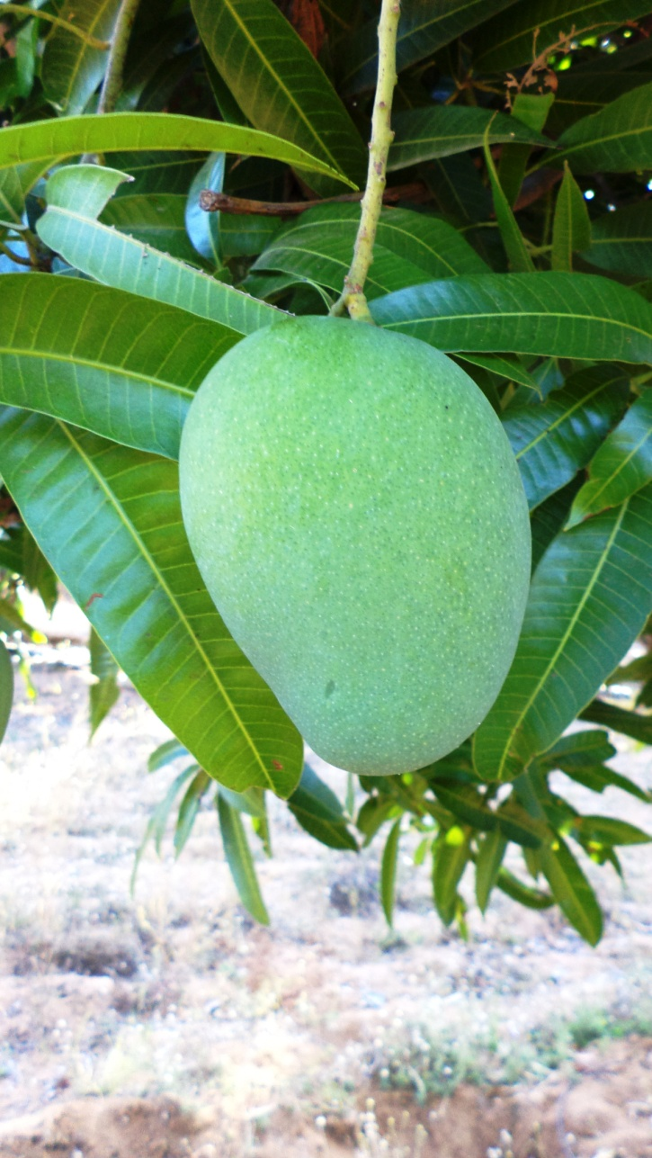 |  | 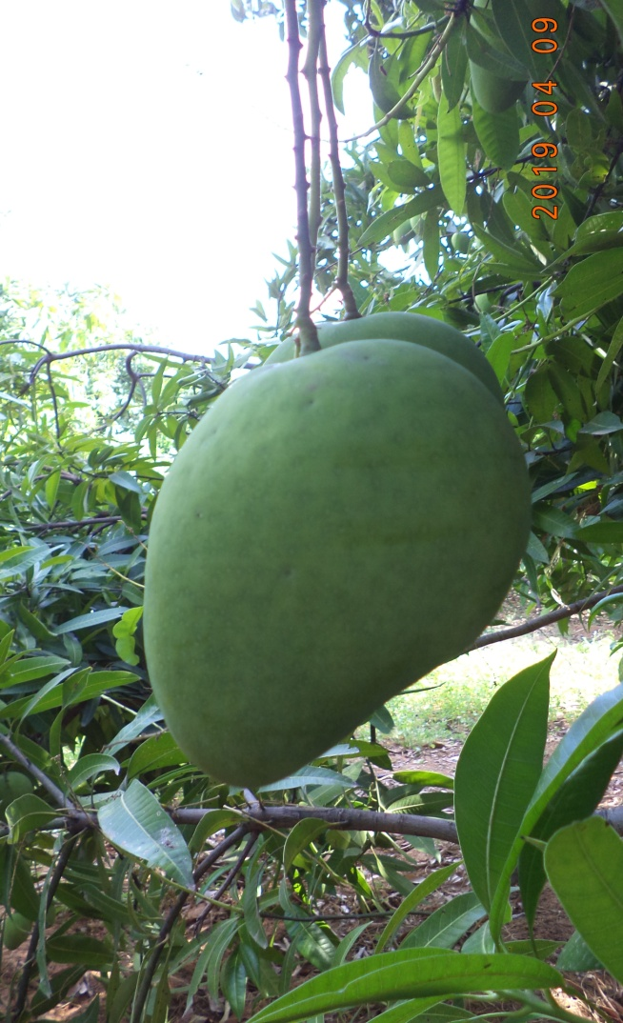 |  | 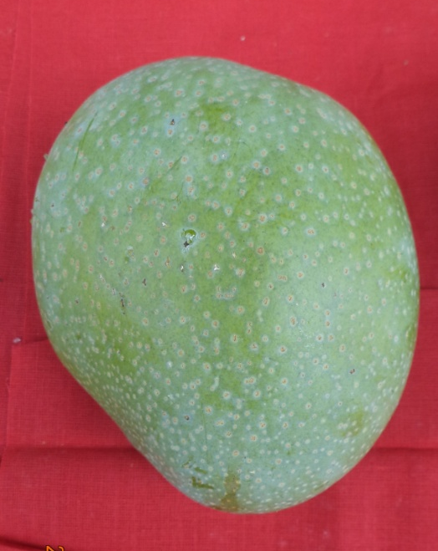
BBCH-705 |  | BBCH-709 |  |  | BBCH-800
Figure 1: Depiction of important phenophases in mango [14]
BBCH-510-Buds closed and covered with green or brownish scales.
BBCH-619-End of flowering: all petals fallen and fruit set.
BBCH-701-Fruits at 10% of final size, styles still visible (beginning of physiological fruit drop).
BBCH-703-Fruits at 30% of final size (end of physiological fruit drop).
BBCH-705-Fruits at 50% of final size.
BBCH-705-Fruits at 50% of final size.
BBCH-709-Fruits at standard cultivar size, shoulders fully developed.
BBCH-800-Physiological maturity: fruit fully developed, pulp creamy green in color.

DA-index
Changes in fruit color can be assessed using the DA-index (difference of absorbance index), which measures the level of chlorophyll-a in the fruit flesh just beneath the skin. Generally, DA-index values decrease with fruit ripening as chlorophyll-a degrades [15]. DA-index measurements were taken at three-day intervals.
Estimation of O₂ and Co₂ (% kg fresh mass⁻¹ hr⁻¹)
The PBI DAN sensor was used to estimate the O₂ and Co₂ (% kg fresh mass⁻¹ hr⁻¹) content and the estimations are made at three days interval by placing silicon Teflon septa on the plastic container. The instrument calibrated under open condition before starting the gas composition estimation, then, the needle of O₂ and Co₂ analyzer was inserted through septa and the gas composition was measured.
Water Use Efficiency (WUE, kg m⁻³)
WUE was calculated using the following equation and expressed in kg of fruit per cubic meter of water applied [16]:
WUE=Y/TWA
where:
- Y = fruit yield (kg tree⁻¹)
- TWA = total water applied (m³ tree⁻¹)
Fertilizer Use Efficiency (FUE, kg kg⁻¹)
The term efficiency refers to the output achieved per unit of input. In plant systems, it quantifies growth, physiological performance, or harvestable yield relative to resources such as land, water, nutrients, or energy. When applied specifically to nutrients, Nutrient Use Efficiency (NUE) measures plant biomass, metabolic activity, or yield per unit of nutrient supplied. Despite this straightforward concept, NUE has been expressed in at least 18 distinct forms, broadly categorized into agronomic efficiency (nutrient uptake per unit applied) and physiological efficiency (yield per unit absorbed).
$${ \text{Fertilizer use efficiency }\text{(kg kg}}^{\text{-1}}\text{)=} {\text{Fruit yield in treated plant}}/{\text{the amount of Nutrient applied}}$$

RESULTS AND DISCUSSION
Impact of Combined Irrigation and Mulching on Soil and Leaf Nutrient Dynamics in Mango
Soil Nutrient Dynamics
No significant interaction effects were observed between irrigation and mulching on soil-available N, P, or K at any of the monitored phenological stages (BBCH 703, 705, and 709). But the highest soil N levels (222–315 kg ha⁻¹) and the lowest P (16.00–17.64 kg ha⁻¹) and K (286.45–317.03 kg ha⁻¹) were recorded under 100% ETc + mulching. Conversely, the lowest N (204–305 kg ha⁻¹) accompanied by the highest P (20.97–23.08 kg ha⁻¹) and K (305.33–334.22 kg ha⁻¹) occurred under 75% ETc without mulch (Table 2).
In this study, the increased available nitrogen content with higher irrigation along with mulching may be attributed due to greater soil moisture availability (Figure 2), which promoted microbial mineralization and reduced NO₃⁻ leaching. Mulching further moderated soil temperature, suppressed erosion, and improved aggregate stability, collectively fostering greater biological N release [18, 19, 20].
In contrast, reduced P₂O₅ and K₂O availability under 100% ETc + mulching may reflect enhanced nutrient solubilization driven by elevated moisture (13–16%; Figure 2). Increased solubility likely boosted plant uptake, as evidenced by the highest FUE (89.11 kg kg⁻¹; Figure 9), thereby depleting residual soil reserves. Comparable responses have been documented in mango [22] and litchi [23].
Leaf Nutrient Dynamics in Mango
Leaf N, P, and K concentrations (%) exhibited significant interaction effects between irrigation and mulching across phenological stages (Table 3). The highest values—N: 0.82–1.11%, P: 0.19–0.22%, K: 0.74–0.91%—were observed under 100% ETc + mulching, whereas the lowest were recorded under 75% ETc without mulch. This difference likely stemmed from elevated soil moisture under full irrigation with mulch (14.0–16.5%) compared to 9.3% in the deficit, non-mulched treatment (Figure 1).
The combined practice of 100% ETc + mulching significantly improved nutrient use efficiency (Figure 8), reflecting a synergistic interaction. Sustained higher soil moisture reduced root shrinkage, expanded root–soil contact, and enhanced nutrient diffusion and uptake from the soil solution. These mechanisms collectively elevated leaf NPK status in the current study. Comparable enhancements in leaf nutrient levels under combined drip irrigation and mulching have been previously reported in pomegranate [24, 25] and sapota [26].
Impact of Combined Irrigation and Mulching on Soil Moisture Dynamics in Mango
The interaction between irrigation and mulching exerted a significant influence on soil moisture levels across six key phenological stages (BBCH 510, 619, 701, 703, 705, and 709) of fruit development (Figure 2). The 100% ETc + mulching treatment consistently maintained the highest moisture content, registering 14.7%, 14.3%, 15.7%, 16.6%, 14.4%, and 13.4% at the respective stages. The 75% ETc + mulching (I₁M₁) treatment ranked second, while 75% ETc without mulching (I₁M₀) recorded the lowest values: 6.5%, 6.2%, 7.1%, 7.5%, 6.2%, and 6.0%.
Superior moisture retention under full irrigation with mulch resulted from daily drip delivery at 100% ETc, which replenished surface soil layers, coupled with the barrier effect of polyethylene mulch. This covering sharply curtailed evaporative loss and stabilized diurnal moisture swings. Vapor rising beneath the film condensed on the inner surface and re-infiltrated the soil, effectively breaking the evaporation–condensation cycle typical of bare ground. The combined action of optimal irrigation and mulching thus maximized water conservation in the root zone. Parallel observations have been documented in mango [27] and sapota cv. Kalipatti [28].

Table 2: Available of nitrogen content (kg ha⁻¹) different phenophases of fruit development

Treatments | Available of nitrogen content (kg ha⁻¹) |  |  | Available of phosphorus content (kg ha⁻¹) in |  |  | Available of potassium content (kg ha⁻¹)
Treatments | BBCH-703 | BBCH-705 | BCH-709 | BBCH-703 | BBCH-705 | BCH-709 | BBCH-703 | BBCH-705 | BCH-709
75% ETc+ without mulch | 204.3ª | 207.72 ª | 257.47 ª | 20.97 ª | 20.93 ª | 23.08 ª | 305.33 ª | 334.22 ª | 327.76
75% ETc+ with mulch | 210.7 ª | 212.74 ª | 262.55 ª | 19.76 ª | 17.87 ª | 19.95 ª | 294.29 ª | 315.44 ª | 325.85 ª
100% ETc+ without mulch | 197.9 ª | 211.83 ª | 254.47 ª | 18.4 ª | 17.29 ª | 21.33 ª | 290.5 ª | 322.24 ª | 325.9 ª
100% ETc+ with mulch | 225.8 ª | 222.65 ª | 268.36 ª | 17.64 ª | 16.00 ª | 17.53 ª | 286.45 ª | 311.5 ª | 317.03 ª
CD (p ≤ 0.05) | 28.37 | 7.49 | 41.10 | 2.16 | 3.30 | 6.18 | 9.42 | 15.36 | 9.15
Note: Letters indicate significant differences (p ≤ 0.05).
Table 3: Leaf NPK content (%) of mango cv. Banganpalli at different phenophases of fruit development.
Treatments | N (%) |  |  | P (%) |  |  | K (%)
Treatments | BBCH-703 | BBCH-705 | BCH-709 | BBCH-703 | BBCH-705 | BCH-709 | BBCH-703 | BBCH-705 | BCH-709
75% ETc+ without mulch | 0.73 ^{b} | 0.63 ^{c} | 0.67 ^{c} | 0.12 ^{c} | 0.12 ^{d} | 0.11 ^{c} | 0.75 ^{b} | 0.75 ª | 0.71 ª
75% ETc+ with mulch | 0.82 ª | 0.7^{b} | 0.74 ^{b} | 0.15 ^{b} | 0.16 ^{c} | 0.14 ^{b} | 0.75 ^{b} | 0.86 ª | 0.72 ª
100% ETc+ without mulch | 0.82 ª | 0.72 ^{b} | 0.73 ^{b} | 0.14 ^{b} | 0.19 ^{b} | 0.15 ^{b} | 0.76 ^{b} | 0.81 ª | 0.73 ª
100% ETc+ with mulch | 0.82 ª | 1.11 ª | 0.86 ª | 0.22 ª | 0.21 ª | 0.19 ª | 0.84 ª | 0.91 ª | 0.74 ª
CD (p ≤ 0.05) | 0.05 | 0.03 | 0.01 | 0.01 | 0.01 | 0.04 | 0.01 | 0.01 | 0.01
Note: Letters indicate significant differences (p ≤ 0.05)

Figure 2: Interaction impact of combined irrigation and mulching on soil moisture content (%) of mango (Data based on PDSR soil moisture sensor readings at BBCH 510 to 709)
Effect of Combined Irrigation and Mulching on Mango Fruit Yield
Irrigation and mulching interacted significantly to influence fruit yield per tree. The 100% ETc + mulching treatment delivered the highest output (89.11 kg tree⁻¹), followed by 75% ETc + mulching (75.78 kg tree⁻¹). The lowest yield (57.18 kg tree⁻¹) occurred under 75% ETc without mulching. Relative to this baseline, 100% ETc + mulching boosted yield by 35.83%. This advantage arose from increased fruit number and individual fruit mass, supported by sustained soil moisture (sensor-monitored) that averaged 9.3% higher than in the 75% ETc without mulch regime. Greater moisture enhanced nutrient solubility, elevating nutrient use efficiency (Figure 9). Consistent water and nutrient supply throughout the season sustained photosynthetic activity, promoted assimilate partitioning, and stimulated auxin-mediated fruit retention and development.
Within the same irrigation level, 100% ETc + mulching outperformed 100% ETc without mulching by 23.06%. Notably, 100% ETc without mulching yielded statistically similar results to 75% ETc + mulching, demonstrating that mulching under deficit irrigation conserved 25% water while maintaining yield parity with full irrigation alone. Comparable yield gains from integrated drip irrigation and mulching have been documented in mango cvs. Dashehari [29], Lat Sinduri [30], and Arka Anmol [31]. In bael, black polyethylene mulch paired with 10-day basin irrigation reduced fruit drop and maximized harvestable yield, whereas mulching without supplemental water increased drop [32].

Figure 3: Interaction impact of combined irrigation and mulching on fruit yield (kg tree⁻¹) at final harvesting

Effect of combined application of irrigation and mulching on fruit quality of mango
Rate of respiration
The combined application of irrigation and mulching in the present study resulted in significantly higher internal oxygen and lower carbon dioxide levels (Figure 4&5). The maximum oxygen and minimum CO₂ content observed with 100% ETc irrigation plus mulching may be attributed to enhanced physiological activity, including greater photosynthate accumulation via increased stomatal conductance and CO₂ assimilation, facilitated by improved soil moisture and nutrient solubility. Furthermore, higher soil moisture likely promoted the translocation of synthesized assimilates from source to sink, leading to elevated sugar and ascorbic acid contents. The increased sugar levels may have contributed to greater fruit firmness, while the elevated ascorbic acid, acting as an antioxidant, likely reduced the respiration rate.

Figure 4: Interaction impact of combined irrigation and mulching on O₂ (% kg fresh mass⁻¹ h⁻¹) consumption of mango fruits after harvest.

Figure 5: Interaction impact of combined irrigation and mulching on Co₂ (% kg fresh mass⁻¹ h⁻¹) emission mango fruits after harvest.
DA index
The data revealed significant differences among the interactions of irrigation and mulching treatments with respect to the DA-index (Figure 6). On the day of harvest, the DA-index showed no significant differences. Thereafter, the DA-index varied significantly across the different irrigation and mulching interactions. The highest DA-index was observed with irrigation at 100% ETc combined with mulching (0.96, 0.74, and 0.55 on the 3rd, 6th, and 9th days of storage, respectively), whereas the lowest was recorded without mulching (I₁M₀) (0.57, 0.44, and 0.10 on the 3rd, 6th, and 9th days of storage, respectively). Higher irrigation levels combined with mulching significantly slowed chlorophyll degradation compared to other treatments. The synergistic effect of irrigation and mulching likely enhanced photosynthetic rates, promoting the production of antioxidants, sugars, and other essential compounds. These elevated levels of antioxidants, sugars, and compounds may have delayed chlorophyll degradation in the present study.

Figure 6: Interaction impact of combined irrigation and mulching on DA index mango fruits after harvest
Shelf life
A comparison of data on shelf life of mango cv. Banganpalli was significantly influenced by different irrigation and mulching treatments (Figure 7). Maximum number of shelf life was observed in 100% ETc along with mulching (13.73), where the minimum shelf life was recorded in 75 % ETc + without mulching (9.00). The maximum number of shelf life with application of 100% ETc along with mulching helped in mitigating the shrinkage of roots and increased in contact surface between the roots and soil solution in presence of favorable hydrothermal regimes. This might have resulted into efficient exploitation of available soil moisture and nutrients have resulted in increased rate of photosynthesis. The increased rate of photosynthesis might have increased fruit sugars other essential components, through increased carbon assimilation thus, probably had resulted in [33] higher amount sugars and ascorbic acid . These increased sugars and ascorbic acid might have resulted in increased cell wall integrity, fruit firmness, reduced chlorophyll degradation (Figure 6), and restricted respiration rate (Figure 4&5) in the present investigation. This ultimately increased the shelf life of mango fruits in the present investigation. Similar findings were earlier reported [34] in blueberry.

Figure 7: Interaction impact of combined irrigation and mulching on shelf life of mango (no. of days)
Effect of Combined Irrigation and Mulching on Water and Fertilizer Use Efficiency in Mango
Water Use Efficiency (WUE, kg m⁻³)
Irrigation and mulching interacted significantly to alter water use efficiency (WUE; Figure 8). The 75% ETc + mulching treatment achieved the highest WUE, while 75% ETc without mulching recorded the lowest. This superior performance under reduced irrigation with mulch stemmed from maximized fruit production per unit of water applied. Mulching optimized the root-zone microclimate, suppressed weeds, curtailed surface evaporation, and sustained elevated soil moisture. These conditions enhanced mineral nutrient solubility and root uptake, thereby boosting photosynthetic efficiency and assimilate partitioning to developing fruit. Consequently, earlier and more robust fruit set and growth contributed to exceptional water productivity. Parallel improvements in WUE under deficit drip irrigation combined with mulching have been documented in mango cv. Dashehari [29] and sapota cv. Kalipatti [26].

Figure 8: Interaction impact of combined application of irrigation and mulching on water use efficiency

Fertilizer Use Efficiency (FUE, kg kg⁻¹)
Irrigation and mulching interacted significantly to influence fertilizer use efficiency (FUE; Figure 9). The 100% ETc + mulching treatment recorded the highest FUE (89.11 kg kg⁻¹), while 75% ETc without mulching yielded the lowest (57.11 kg kg⁻¹). This 35.96% advantage under full irrigation with mulch likely resulted from polyethylene film minimizing evaporative water loss, thereby retaining soil moisture, and curtailing nutrient losses via leaching, runoff, or volatilization. Mulch also suppressed weed competition near the tree base, creating favorable conditions for root proliferation, nutrient absorption, and assimilate allocation. These factors collectively enhanced tree vigor, fruit yield, quality, leaf nutrient status, and water productivity. Comparable FUE improvements under mulching have been reported in apple [35] and guava cv. Lalit [36].

Figure 9: Interaction impact of combined application of irrigation and mulching on fertilizer use efficiency

CONCLUSION

The combined application of drip irrigation and mulching significantly influenced soil and leaf nutrient dynamics, moisture retention, fruit yield, quality, shelf life, and resource use efficiency in mango cv. Banganpalli. The treatment with 100% ETc + mulching consistently emerged as superior, recording the highest soil moisture (13.4–16.6% across phenophases), maximum leaf NPK content (N: 0.82–1.11%, P: 0.19–0.22%, K: 0.74–0.91%), elevated available soil nitrogen (222–315 kg ha⁻¹), and optimal fruit yield (89.11 kg tree⁻¹)—a 35.83% increase over 75% ETc without mulching. This treatment also enhanced internal oxygen levels, reduced CO₂ accumulation, delayed chlorophyll degradation (highest DA-index during storage), and extended shelf life to 13.73 days.
Notably, 75% ETc + mulching achieved comparable yield to 100% ETc without mulching while conserving 25% irrigation water and registering the highest water use efficiency (WUE) due to reduced evaporation, weed suppression, and sustained root-zone moisture. Fertilizer use efficiency was maximized under 100% ETc + mulching (89.11 kg kg⁻¹), reflecting reduced nutrient losses and improved uptake under favorable hydrothermal regimes.
Overall, the synergistic effects of irrigation and mulching optimized soil–plant–water–nutrient interactions, promoting sustainable mango production. The 75% ETc + mulching regime offer a practical, water-efficient alternative without compromising yield or quality, making it highly recommendable for resource-constrained orchards. These findings align with prior reports in mango and other fruit crops, reinforcing the efficacy of integrated drip irrigation and mulching systems in enhancing productivity and input-use efficiency under semi-arid conditions.

Disclaimer (Artificial intelligence)
Authors hereby declare that Grok, an AI language model developed by xAI, was used as a supportive tool during the preparation of this research article.
No original research ideas, data analysis, experimental design, or scientific conclusions were generated by Grok. All data, methodology, results, and interpretations are solely the work of the authors based on field experiments conducted during 2017–2019 at Sathapur, Nagarkurnool District, Telangana, India. The final manuscript has been thoroughly reviewed and approved by all authors, who take full responsibility for its scientific integrity and authenticity.

REFERENCES
- NHB (National Horticulture Board), 2018. Indian Horticulture Database-2017. Ministry of Agriculture, Government of India 85, Institutional Area, Sector-18, Gurgaon - 122 015. Website : www.nhb.gov.in.
- Anonymous. Fruits. Indian Horticulture Database, National Horticulture Board, Ministry of Agriculture, Govt. of India; 2018. Available:http://nhb.gov.in.
- Ganeshamurthy AN*, Rupa TR, Shivananda TN. Enhancing Mango Productivity through Sustainable Resource Management. Journal of horticultural science. 2018;13(1):1-31.
- Adak T, Kumar K, Singh VK, Singh Vinod Kumar, Singh AK. Effect of different soil moisture regimes on soil moisture rd dynamics, yield and quality in mango. In: Proceedings of 3 International Agronomy Congress on “Agriculture Diversification, Climate Change Management and Livelihoods”, held during November 26-30th, 2012 at IARI, New Delhi, India. 2012;1416-1418.
- Daniel PL, Eelco VB. Water Resources Planning and Management: An Overview. Water Resource Systems Planning and Management. 2017;1-49.
- Panigrahi P, Srivastava AK. Deficit irrigation (DI) scheduling for matured Nagpur mandarin (Citrus reticulata Blanco) trees of central India. Indian Journal of Soil Conservation. 2011;39(2):149- 154.
- Ross OC. Reflective mulch effects on the grapevine environment, Pinot noir vine performance, and juice and wine characteristics. Dissertation, Lincoln University; 2010.
- Santosh K. Influence of Drip Irrigation and Mulch on Leaf Area Maximization, Water Use Efficiency and Yield of Potato (Solanum tuberosum L.). Journal of Agricultural Science. 2012;4(1):71-80.
- Singh K. Fall in Water Table in Central Punjab – How Serious? The PunjabState Farmers Commission, Chandigarh. 2006;13.
- Tandon, H. L. S. 1993. Methods of Analysis of Soils, Plants, Water and Fertilizers. Fertiliser Development and Consultation Organisation, New Delhi.
- Sheoran OP, Tonk DS, Kaushik LS, Hasija RC, Pannu RS. Statistical Software Package for Agricultural Research Workers. Recent Advances in information theory, Statistics & Computer Applications by D.S. Hooda & R.C. Hasija Department of Mathematics Statistics, CCS HAU, Hisar. 1998;139-143. 12.
- Shukla, K.N., Singh, P. K. and Singh, K. K. 2001. Crop water requirement under drip irrigation. Plasticulture Development Centre, GBPUAT, Pantnagar. Journal of Geoscience and Environment Protection. 5(7): 22-30.
- Jackson, M.L. (1967) Soil Chemical Analysis. Prentice Hall, Englewood cliffs, NJ.
- Vijay Krishna, G. 2019. Studies on the influence of plant bio regulators and chemicals on phenology, yield and quality of mango cv. Banganpalli. Ph.D., thesis submitted to SKLTSHU-Mulugu, College of Horticulture, Rajendranagar. p-30-55.
- Zhang, B., Zhang, B., Song, C. Z. and Ma, R. 2017. Determination of fruit maturity and its prediction model based on the pericarp index of absorbance difference (IAD) for peaches. PLoS One. 12(5): 1-11.
- Víctor, H. D. Z., Carmen, R. R. P., Baltasar, G. R., Saray, G. G. and Iván, F. G. T. 2019. Water use and fruit yield of mango (Mangiferaindica L.) grown in a subtropical Mediterranean climate, International Journal of Fruit Science, 19:2, 136-150.
- Srivastava, A. K. and Malhotra, S. K. 2017. Nutrient use efficiency in perennial fruit crops-A review. Journal of Plant Nutrition, 40(13), 1928–1953.
- Hooks, C. R. R. and Johnson, M. W. 2003. Impact of agricultural diversification on the insect community of cruciferous crops. Crop Protection. 22: 223-238.
- Mahmoud, I., El –Desouky, Sheren, A. and Abd El- Hamied. 2014. Improving growth and productivity of pomegranate fruit trees planted on sandy dunes slopes at baloza district using different methods of drip irrigation, organic fertilization, and soil mulching. Journal of Agriculture and Veterinary Science. 7(12): 86-97.
- Sarolia, D. K. and Bhardwaj, R. L. 2012. Effect of mulching on crop production under rainfed condition: A review. International Journal of Research in Chemistry and Environment. 2: 8-20.
- Barber, S.A.1995. Soil nutrient bioavailability: A mechanistic approach. John Wiley and Sons, New York.
- Dutta, P. and Kundu, S. 2012. Effect of bio-fertilizers on nutrient status and fruit quality of Himsagar mango grown in new alluvial zones of West Bengal. Journal of Crop and Weed. 8:72-74.
- Anubha, R., Lal, R. L., Uniyal, S. and Chand, S. 2013. Response of organic manures on growth, nutrient status and yield of Litchi (Litchi chinensis Sonn.) cv. Rose Scented. Progressive Horticulture. 45:126–131.
- Rad, P. M. R., Movahedi Naeini, S. A. R. and Pessarakli, M. 2011. Nutrient uptake, soil and plant nutrient content and yield components of wheat plants under different planting systems and various irrigation frequencies. Journal of Plant Nutrition. 1133-1143.
- Haneef, Mohd. Kaushik, R. A., Sarolia, D. K., Mordia, A. and Mahesh Dhakar. 2014. Irrigation scheduling and fertigation in pomegranate cv. Bhagwa under high density planting system. Indian Journal of Horticulture. 71(1): 45-48.
- Tiwari, K. N., Kumar, M., Santosh, D. T., Singh, V. K., Maji, M. K., and Karan, A. K. 2014. Influence of drip irrigation and plastic mulch on yield of sapota (Achras zapota) and soil nutrients. Irrigation and Drainage Engineering. 3: 116-117.
- Singh, R., Bhandari, A. R. and Thakur, B. C. 2004. Effect of mulching on in situ soil moisture, growth, yield and economics of plum fruit trees under rainfed condition of mid hills of Himalayas. Journal of the Indian Society of Soil Science. 52(4): 411-414.
- Tiwari, K. N., Mukesh Kumar, Vikas Kumar Singh and Santosh, D. T. 2016. Response of drip irrigation and plastic mulch on quality of sapota (Achras Zapota) fruits. International Journal of Agriculture, Environment and Biotechnology. 9(4): 699-710.
- Panigrahi, H. K., Narendra Agrawal, R., Agrawal, Saket Dubey and Tiwari, S. P. 2010. Effect of drip irrigation and polythene mulch on the fruit yield and quality parameters of mango (Mangifera indica L.). Journal of Horticultural Sciences. 5 (2): 140-143.
- Dinesh, K., Pandey, V. and Vishal, N. 2008. Effect of drip irrigation regimes on growth, yield and quality of mango hybrid Arka Anmol. Indian Jouran Horticulture. 65(4), December 2008: 409-412.
- Kumar, D., Pandey, V. and Nath, V. 2008. Effect of organic mulches and irrigation scheduling through drip on growth and yield of ‘Lal Sundari’ mango (Mangifera indica) in Eastern region of India. Indian Journal of Agricultural Sciences. 78(5): 385-388.
- Ghosh, S., Mahato, S. and Halder, S. 2020. Effect of mulching and supplementary irrigation on fruit set, fruit drop, fruit retention and yield of bael (Aegle marmelos Correa.). Journal of Crop and Weed Science. 16(3): 38-43.
- Borthakur, P. K. and Bhattacharyya, R. K. 1996b. Organic mulches in guava orchard. India Journal of Horticulture. 37: 43-44.
- David, L., Ehret1, Brenda Frey, Tom Forge and Tom Helmer. 2012. Effects of drip irrigation conFiguration and rate on yield and fruit quality of young high bush blueberry plants. HortScience. 47(3):414–421.
- Neilsen, G. H., Hogue, E. J., Forge, T. and Neilsen, D. 2003. Mulches and biosolids affect vigour, yield and leaf nutrition of fertigated high density apple. Journal of Horticultural Science, 38(1): 41-45.
- Prananath, B., Kanchan Kumar, Srivastava and Tarun Adak. 2017. Response of guava cv. Lalit to plastic mulch, fertigation and micro-nutrient spray under raised bed. Indian Journal of Agriculture and Allied Sciences. 3(4): 1-8.

