Sectoral Economic Potential Analysis for Regional Development Across Regencies in the Lake Toba Area, Indonesia

Abstract
Lake Toba has been designated as a National Tourism Destination and is targeted for tourism-led, sustainable regional development; however, rising tourist arrivals do not automatically generate broad-based income gains when regional economies remain dominated by low–value-added activities and weak inter-sector linkages. This study diagnoses sectoral economic potential across eight Lake Toba regencies (Toba, Simalungun, Samosir, North Tapanuli, Humbang Hasundutan, Karo, Dairi, and Pakpak Bharat) using constant-price GRDP time-series data for 2015–2024. Three complementary tools are applied: Location Quotient (LQ) to identify basic sectors and specialization, Shift–Share to decompose growth and assess local competitiveness, and Klassen Typology to classify sectors by relative growth and contribution. Results are integrated using an overlay rule to prioritize sectors that simultaneously show specialization (LQ > 1), progressive/competitive dynamics, and “advanced and fast-growing” characteristics. Findings indicate that Agriculture, Forestry and Fisheries and Government Administration remain consistently basic across the regencies, while Accommodation and Food Services emerges as a key basic and fast-growing sector in multiple regencies, reflecting the expanding role of tourism services. The overlay highlights differentiated priority sectors by regency, including agriculture (Simalungun, Pakpak Bharat), electricity and gas (Pakpak Bharat), construction (Toba, North Tapanuli, Humbang Hasundutan), transport and warehousing (North Tapanuli, Karo), accommodation and food services (Samosir, Karo, Pakpak Bharat), and education and health services (Karo). Policy implications emphasize value-chain upgrading and local procurement to reduce leakages, connectivity and utility investments to unlock private-sector competitiveness, and cross-regency coordination to align complementary specialization roles for inclusive and sustainable growth.
Keywords: sectoral potential; GRDP; Location Quotient; Shift–Share; Klassen typology; overlay analysis; Lake Toba; regional development

1. Introduction
Lake Toba represents a strategic space for Indonesia’s balanced regional growth agenda because it combines unique natural assets, strong tourism appeal, and a multi-regency economic system that can be developed through coordinated planning. As a national priority destination, Lake Toba is expected to stimulate employment, MSME upgrading, and infrastructure expansion while improving welfare outcomes for local communities. Yet, in many destination regions, the economic benefits of tourism can remain concentrated, seasonal, or weakly linked to local production systems if supporting sectors and institutions are not strengthened. This makes an evidence-based sectoral development strategy essential (Brida, 2020).
A recurring challenge in tourism-oriented regions is the gap between increased visitation and limited income spillovers. Even when visitor numbers rise, local multipliers may stay low if supply chains are imported, logistics are inefficient, or service quality constraints prevent higher-value spending. In Lake Toba, this challenge is amplified by structural dependence on primary sectors with relatively low value added and by uneven inter-regency capacity in services, investment readiness, and connectivity. Therefore, regional development policy must identify which economic sectors can become reliable drivers of growth, both within each regency and across the destination system.
Regional development theory highlights that growth is spatially uneven and often driven by certain leading activities that generate multiplier effects. Economic base theory distinguishes between basic sectors that export goods/services and bring external income into a region and non-basic sectors that mainly serve local demand (Tarigan, 2007). From this perspective, the first step toward a robust development strategy is to identify which sectors function as the economic “engine” for each regency and whether those engines are aligned with Lake Toba’s destination positioning.
Complementary insights come from growth pole thinking and competitive advantage perspectives, which emphasize that a region’s growth can be accelerated when strategic sectors become focal points for investment, technology, and infrastructure, creating forward and backward linkages (Tarigan, 2005; Richardson, 1978). For destination regions, this implies that tourism should not be treated as a stand-alone sector, but as a system that depends on transport, construction, utilities, agrifood supply, creative industries, and human capital services. A sectoral strategy, therefore, must identify both the “tourism core” and the enabling sectors that unlock broader value-chain development.
Another key dimension is sustainability. Sustainable development requires economic upgrading while maintaining environmental integrity and social inclusion, especially in sensitive lake ecosystems and heritage landscapes (Hadad, 2010; Wulung, 2021). In Lake Toba, sustainability is not only an ecological concern; it is also an economic risk management issue because degradation of landscapes and lake quality can undermine destination competitiveness and long-term revenues. Consequently, sectoral prioritization must balance growth potential with feasible governance and sustainable resource management.
Empirically, sectoral potential is commonly assessed using GRDP-based techniques that reveal specialization, growth structure, and competitiveness. Location Quotient (LQ) helps identify whether a sector’s share in a regency economy is larger than its share at the provincial level, suggesting specialization and potential export capacity (Jumiyanti, 2018). Shift–Share analysis decomposes sector growth into components attributable to overall provincial trends, industry mix, and local competitive effects, enabling a more diagnostic interpretation of what drives change (Kasikoen, 2018; Saragih et al., 2014). Klassen Typology then classifies sectors based on their relative growth and contribution, highlighting sectors that are not only large but also growing fast (Sarnowo, 2016).
While each technique is useful, relying on one method can lead to partial conclusions. For example, a sector may be specialized (high LQ) but stagnant, or it may grow rapidly but remain small and structurally weak. Therefore, overlay approaches have been increasingly used to combine multiple indicators and generate more robust priority sector decisions (Hendra Perdana, 2019; Suwarno & Sishadiyati, 2022; Wijaya & Marseto, 2022, Lubis, 2024). For Lake Toba’s multi-regency governance context, an integrated approach is particularly relevant because development priorities must be defensible, targeted, and implementable across institutional boundaries.
This study addresses the practical policy question: which sectors should be prioritized to strengthen regional development in the Lake Toba destination area, and how do those priorities differ by regency? The study uses GRDP time-series data at constant prices for 2015–2024 and applies LQ, Shift–Share, and Klassen Typology, followed by an overlay integration to identify sectors with consistent strength across indicators. The objective is not only to list “leading sectors,” but to interpret what those sectors imply for value chains, connectivity, and tourism-led development pathways.
The contribution of this work lies in three aspects. First, it provides a structured, comparable sectoral diagnosis across eight regencies within one destination system, which is often missing in regency-specific planning documents. Second, it integrates three standard quantitative tools into a single prioritization framework, strengthening the reliability of policy recommendations. Third, it translates quantitative signals into actionable development directions—such as infrastructure sequencing, service upgrading, agrifood linkages, and cross-regency coordination—consistent with sustainable destination development principles.
This manuscript is important for the scientific community because it offers a comparative, multi-regency sectoral diagnosis within a single tourism destination system, an empirical design that remains relatively underdeveloped in regional development and tourism economics research. By triangulating Location Quotient, Shift–Share, and Klassen Typology through an overlay framework, the study reduces the risk of method-specific bias and produces a more defensible basis for sector prioritization than single-tool approaches. The work also contributes to tourism-led development debates by clarifying why rising visitation may yield limited local welfare gains when leakages and weak inter-sector linkages persist, and by identifying which enabling sectors (utilities, logistics, construction, human-capital services) can strengthen multipliers. Finally, the framework is replicable for other multi-jurisdiction destinations and supports future comparative research on destination governance, resilience, and inclusive regional transformation.
2. Literature Review
2.1 Tourism-led regional development, multipliers, and leakages
Tourism-led growth is frequently positioned as a pathway for regional upgrading because visitor expenditures can stimulate employment and local enterprise expansion through multiplier effects. However, the regional development literature emphasizes that tourism benefits may remain limited when destinations face high import dependence, narrow local supplier bases, or weak productive linkages—conditions that increase economic leakages and constrain inclusive welfare gains (Calero & Turner, 2020). Empirical cross-country work also suggests that tourism and economic growth relationships vary across development contexts and are shaped by structural characteristics, resilience, and policy settings rather than tourism expansion alone (Brida et al., 2020). From a sustainability perspective, recent studies further stress that tourism’s developmental contribution must be evaluated alongside broader social and environmental dimensions, reinforcing the need for sector strategies that protect ecological assets while strengthening local value capture (Elgin & Elveren, 2024).
2.2 Destination governance and multi-jurisdiction coordination
The governance challenge becomes more complex in destinations that span multiple administrative jurisdictions, where investment priorities, service standards, and infrastructure sequencing must be coordinated to avoid fragmentation. Contemporary destination management research highlights that effective governance depends on institutional capacity, stakeholder engagement, and context-specific arrangements rather than generic “one-size-fits-all” models (Mandić & Kennell, 2021). In multi-regency systems, sector strategies require not only identifying leading sectors but also clarifying complementary regional roles (e.g., production bases, tourism hubs, connectivity corridors, and human-capital centers) to improve system-wide performance and resilience.
2.3 Sectoral competitiveness mapping and multi-method prioritization
In applied regional economics, sectoral prioritization commonly uses GRDP-based tools to diagnose specialization, growth structure, and competitiveness. LQ identifies basic sectors and potential exporting capacity; Shift–Share separates growth driven by overall trends, sector mix, and local competitive effects; and Klassen Typology distinguishes sectors that are structurally large and fast-growing from those that are emerging or lagging. Yet, studies increasingly caution that single-method conclusions can be misleading because a sector may appear strong under one metric but weak under others. Therefore, overlay integration has been adopted to improve robustness and policy usefulness by selecting sectors that consistently satisfy multiple criteria (Saragih et al., 2024; Suwarno & Sishadiyati, 2022). This study extends that logic to a tourism destination system context, where priority sectors must be defensible across regencies and directly translatable into value-chain, connectivity, and service-upgrading interventions.

3. Methods
3.1 Study Area and Study Period
The study area comprises the Lake Toba destination region in North Sumatra, Indonesia, which administratively includes eight regencies: Toba, Simalungun, Samosir, North Tapanuli, Humbang Hasundutan, Karo, Dairi, and Pakpak Bharat. These regencies form an interconnected regional system in which tourism movements, labor mobility, commodity circulation, and service provision operate across administrative boundaries. Such spatial interdependence implies that sectoral strengths in one regency can function as enabling inputs, markets, or logistics corridors for other regencies; therefore, cross-regency sector diagnosis is essential to support coherent regional planning and coordinated development.
To provide administrative-spatial context, the study refers to official regency administrative maps sourced from the respective Regional Medium-Term Development Plans (RPJMD). The following map titles are used in this article:
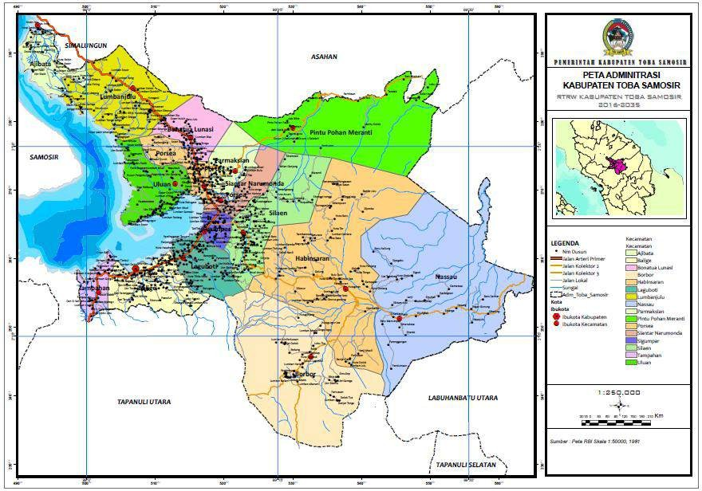
- Figure 1. Administrative Map of Toba Regency (Source: RPJMD Toba Regency 2021–2026)
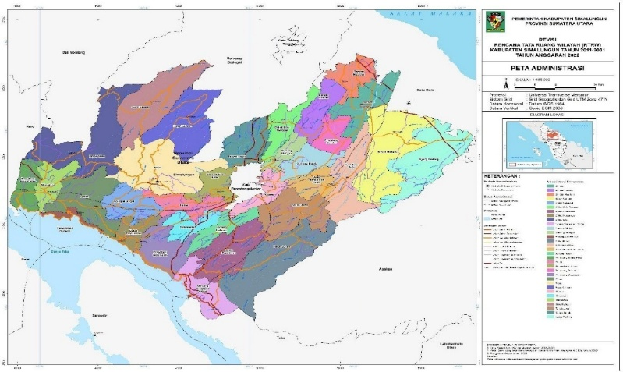
- Figure 2. Administrative Map of Simalungun Regency (Source: RPJMD Simalungun Regency 2025–2029)
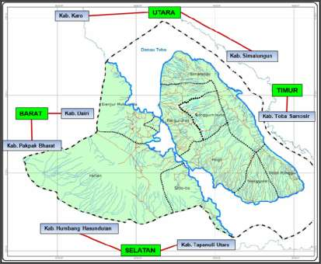
- Figure 3. Administrative Map of Samosir Regency (Source: RPJMD Samosir Regency 2021–2026)
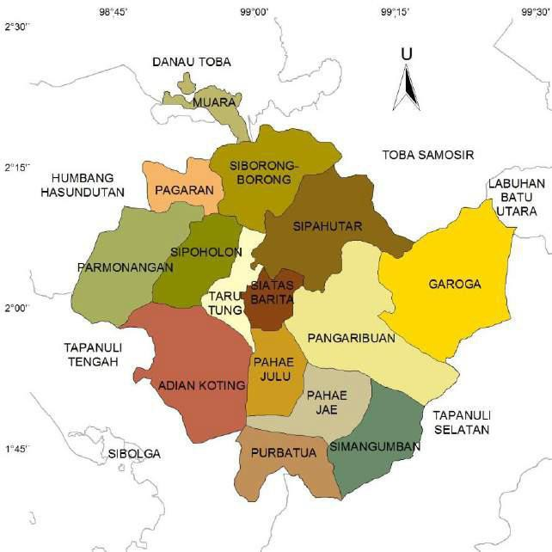
- Figure 4. Administrative Map of North Tapanuli Regency (Source: Revised RPJMD North Tapanuli Regency 2019–2024)
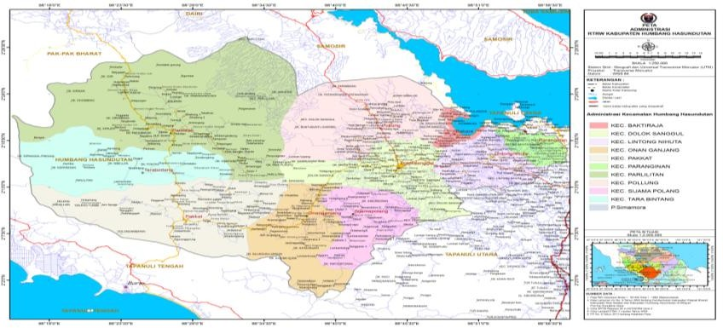
- Figure 5. Administrative Map of Humbang Hasundutan Regency (Source: RPJMD Humbang Hasundutan Regency 2021–2026)
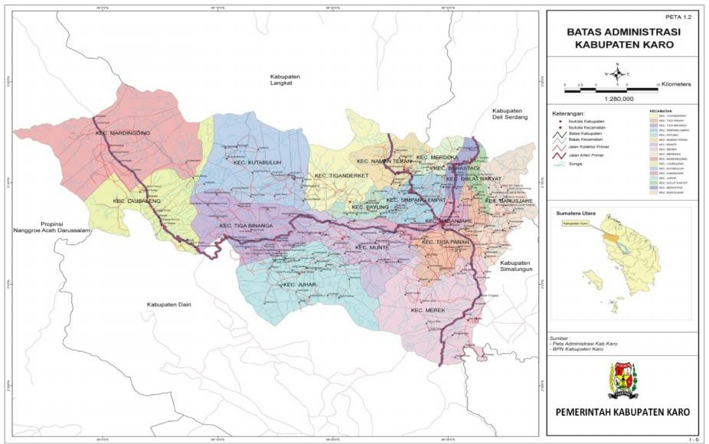
- Figure 6. Administrative Map of Karo Regency (Source: RPJMD Karo Regency 2025–2029)
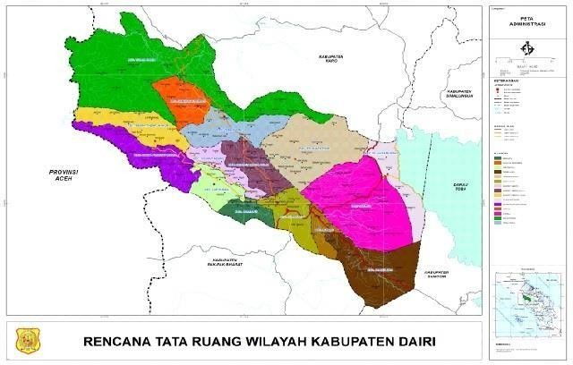
Figure 7. Administrative Map of Dairi Regency

The observation period spans 2015–2024 to capture medium-term structural dynamics, including pre- and post-pandemic shifts, recovery patterns, and changes in the role of tourism-supporting services. The use of a decade-long time series reduces sensitivity to short-run fluctuations and improves the reliability of identifying persistent specialization and growth signals. The provincial benchmark for all comparative computations is North Sumatra Province, which provides a consistent reference structure for the Location Quotient (LQ), Shift–Share, and Klassen Typology analyses.
Spatially, the Lake Toba regencies differ substantially in topography, accessibility, tourism intensity, and economic base. Several regencies retain strong agrarian structures and land-based value chains, while others exhibit stronger service functions associated with urban nodes, public institutions, and destination facilities. Rather than being treated as a limitation, this heterogeneity is central to the analysis because it enables differentiated sector prioritization and supports a complementary development logic across the destination system..
3.2 Research Design and Analytical Approach
This research adopts a quantitative-descriptive design using secondary data. The approach is designed to produce a transparent and replicable sector prioritization process that can be embedded into regional planning workflows. Quantitative tools are selected because GRDP-based indicators are widely available, standardized, and comparable across regencies and over time, enabling systematic diagnosis.
The analysis proceeds in four stages. First, sectoral structure and trends are described to establish baseline conditions and contextual interpretation. Second, LQ is computed to distinguish basic and non-basic sectors and to interpret specialization patterns. Third, Shift–Share analysis is performed to assess whether growth is driven by general provincial trends, sector mix advantages, or local competitive dynamics. Fourth, Klassen Typology classifies sectors into four quadrants based on relative growth and contribution. The final stage integrates these results through overlay rules to identify sectors that consistently satisfy multiple “strength” criteria, producing a more policy-relevant shortlist.
This design aligns with applied regional development planning practice where decision makers require both diagnostic clarity and prioritization outputs. Rather than focusing on statistical inference, the study emphasizes consistency across methods, cross-regency comparability, and translation into planning recommendations.
3.3 Variables, Units of Analysis, and Operational Definitions
The primary unit of analysis is the economic sector (17 GRDP production categories) within each regency. The key quantitative variables are sectoral GRDP values (constant prices), sectoral growth rates, sectoral shares (contribution to total GRDP), and derived indices (LQ, Shift–Share components, Klassen quadrant membership). Because the objective is sector prioritization, the sector is treated as the core “planning object,” while the regency is the spatial container in which sector performance is interpreted.
Operational definitions follow standard regional economics and planning usage. Regional development is defined as a process of improvement in a region’s physical, economic, and social conditions. Economic growth is defined as the annual percentage increase in constant-price GRDP, reflecting real production expansion rather than inflation. GRDP is defined as the gross value added produced by all resident and non-resident production units within a regional territory over a given period, presented through a production approach with 17 sector categories (Tarigan, 2007; Sugiyono, 2018).
A “leading sector” in this study is not defined by a single metric. Instead, it is a sector that (i) shows specialization relative to the province (LQ > 1), (ii) demonstrates progressive or competitive local growth dynamics based on Shift–Share (positive net shift / competitive effects as specified in the decomposition), and/or (iii) falls into the “advanced and fast-growing” quadrant of Klassen Typology (high growth and high contribution). The overlay then identifies sectors that satisfy multiple criteria simultaneously, producing a priority set that is both structurally important and dynamically promising.
The choice of constant-price (real) GRDP ensures that growth and structural comparisons are not distorted by price changes. This is crucial for multi-year diagnosis and for destination regions where sector price movements can vary widely (e.g., agriculture vs. services). Provincial GRDP acts as the benchmark economy representing the wider regional market context and structural baseline.
3.4 Data Sources and Data Collection Procedures
The study uses secondary data compiled from official statistical agencies and regional planning-related documentation. The core dataset is GRDP by sector at constant prices (time series 2015–2024) for North Sumatra Province and the eight Lake Toba regencies. These data allow computation of sector shares, growth rates, and the indices required for LQ, Shift–Share, and Klassen. Complementary documents include medium-term development plans (RPJMD) and relevant regional development reports that support interpretation of sector roles and policy relevance.
Data collection follows a structured procedure. First, sectoral GRDP series are compiled for each regency and the province, ensuring consistent sector classification across years. Second, data are cleaned to ensure comparable units and consistent time coverage. Third, sector shares and growth rates are computed for each year, forming the basis for LQ and Klassen calculations. Fourth, baseline and end-year values (2015 and 2024) are extracted for Shift–Share decomposition, while intermediate years are used for descriptive trend interpretation.
Using official and standardized statistical sources increases reliability and comparability. Moreover, the time-series structure strengthens interpretation by allowing the study to distinguish persistent patterns from one-year anomalies. Where sectoral anomalies appear, interpretation is tied back to structural features (e.g., connectivity constraints, institutional concentration, or tourism infrastructure dynamics) rather than treated as purely numerical artifacts.
3.5 Data Analysis Techniques and Decision Rules
3.5.1 Location Quotient (LQ)
LQ is used to identify whether a sector is relatively specialized in a regency compared with the provincial economy. The standard formula is:
$$LQ_{i,r}=\frac{\left(\frac{GRDP_{i,r}}{GRDP_{r}}\right)}{\left(\frac{GRDP_{i,p}}{GRDP_{p}}\right)}$$
Where $GRDP_{i,r}$is sector $i$GRDP in regency $r$; $GRDP_{r}$is total GRDP in regency $r$; $GRDP_{i,p}$is sector $i$GRDP in the province; and $GRDP_{p}$is total provincial GRDP.
Decision rule:
- $LQ>1$: sector is basic (specialized; potential exporter / driver).
- $LQ=1$: sector is self-sufficient (similar structure to province).
- $LQ<1$: sector is non-basic (more locally oriented; relatively underrepresented).
To reduce sensitivity to year-to-year volatility, the analysis emphasizes the average LQ across the study period alongside the latest-year profile.
3.5.2 Shift–Share Analysis
This study uses the base year (2015) and end year (2024) to decompose sectoral GRDP change into: (i) the overall provincial growth effect (how much the sector would change if it grew at the provincial overall rate), (ii) the industry-mix effect (whether the sector belongs to a faster- or slower-growing sector at the provincial level), and (iii) the competitive effect (whether the regency outperforms the province in that sector). For prioritization, a sector is interpreted as progressive/competitive when the competitive effect is positive (PPW > 0), indicating local advantage beyond provincial trends; the industry-mix effect (PP) is used diagnostically to distinguish whether growth is supported by a favorable sectoral structure or driven primarily by local competitiveness
3.5.3 Klassen Typology
Sector growth rates are calculated as average annual growth (CAGR) over 2015–2024 using constant-price GRDP, while sector contribution is measured as the average sector share over the same period (or the end-year share, applied consistently across regencies)
3.5.4 Overlay Integration for Priority Sector Selection
Overlay analysis integrates LQ, Shift–Share, and Klassen outputs to identify sectors that are consistently strong across indicators. The overlay logic is:
- Specialization filter: $LQ>1$(basic sector).
- Dynamic filter: Shift–Share indicates progressive/competitive dynamics (positive net shift and/or positive competitive component, depending on the decomposition interpretation used).
- Structural-performance filter: Klassen Quadrant I indicates advanced and fast-growing performance.
A sector that satisfies all three is categorized as high priority (often marked as “+++” in applied planning overlays). If a sector satisfies two of the three, it may be categorized as medium priority (“++”), and if only one criterion is met, it is lower priority (“+”). This approach reduces the risk of choosing sectors that are merely “large” but stagnant or “growing” but structurally weak, and it aligns with prior overlay-based sector prioritization practice (Hendra Perdana, 2019; Suwarno & Sishadiyati, 2022; Wijaya & Marseto, 2022).

4. Results and Discussion
4.1 Regional Context and Economic Development Challenge
As a national tourism destination, Lake Toba’s development trajectory depends on how effectively tourism growth is connected to local production and service systems. The destination’s economic structure remains anchored in primary sectors in many regencies, while tourism and modern services are unevenly distributed. This structure implies that growth strategies should not rely on a single “tourism sector,” but should strengthen inter-sector linkages that create durable multipliers—especially agrifood supply chains, construction and infrastructure services, logistics, utilities, and human capital services.
The multi-regency nature of the destination makes coordination and complementarity central. For example, one regency may function as a tourism hub, another as an agrifood production base, and another as a connectivity corridor or education center. Without coordination, regencies may compete for similar investments while missing opportunities for integrated value chains and shared infrastructure solutions. Thus, sector prioritization must be interpreted through a regional systems lens.
A notable finding in destination development is that higher visitor numbers do not automatically yield higher household income if leakages remain high. Leakages occur when destination supply chains depend heavily on imported goods/services, when local labor skills are mismatched with service needs, or when infrastructure bottlenecks limit higher-value tourism products. Therefore, identifying and upgrading leading sectors is not merely a statistical exercise, but a practical pathway to reduce leakages and increase local capture of tourism value.
4.2 Location Quotient: Basic Sectors and Structural Specialization
The LQ results reveal that several sectors consistently function as structural pillars across the Lake Toba regencies. First, Agriculture, Forestry and Fisheries emerges as a basic sector in all regencies, indicating that the Lake Toba region retains a strong primary production base. This is not surprising given the rural character of many regencies and the availability of land-based livelihoods. However, a strong agricultural base alone does not guarantee prosperity if value chains remain limited to raw outputs. Therefore, the planning implication is to move from primary production to value-added processing, quality upgrading, and stronger market linkages, including tourism demand.
Second, Government Administration, Defence and Compulsory Social Security also appears as a basic sector across all regencies. This indicates that public administration contributes a relatively high share of the regional economy compared with the provincial average. In applied planning terms, such a structure can be interpreted in two ways: it provides stability and public service capacity, but it can also signal limited private-sector diversification in certain regencies. The policy goal should be to leverage administrative capacity to catalyze private investment, MSME upgrading, and service innovation rather than allowing the economy to remain overly dependent on government spending.
Third, Accommodation and Food Services emerges as a basic sector in most Lake Toba regencies. This reflects the growing importance of tourism and visitor-related services in the destination system. Yet, the economic development meaning of this finding depends on quality and linkages: a destination can have many small accommodation units but still generate limited income if service quality is low, stays are short, or local sourcing is weak. Therefore, strengthening tourism-services should include standards, skills, destination product diversification, and local procurement systems (e.g., local agrifood and crafts).
Beyond these three broad pillars, LQ also highlights differentiated specialization patterns by regency. Some regencies show relatively stronger specialization in infrastructure-linked sectors (e.g., construction) while others show strength in services (e.g., education and health in Karo). Such differentiation provides the foundation for complementary roles and integrated development: instead of forcing every regency to pursue identical sector targets, planners can assign roles aligned with comparative strengths.
4.3 Shift–Share: Growth Drivers, Industry Mix, and Competitiveness
Shift–Share analysis provides a deeper explanation of sector changes by separating what is driven by general provincial growth trends from what is driven by sectoral mix and local competitiveness. The provincial growth effect is positive across sectors, but the magnitude differs strongly by regency and sector, reflecting how large the base sector is and how provincial growth transmits into local economies.
A key result is that the largest positive provincial growth effect is observed in Agriculture, Forestry and Fisheries across the regencies, showing agriculture’s continued scale and role in regional economic change. In practical terms, this means that even if tourism is rising, agriculture still remains the “mass sector” that shapes the absolute level of economic expansion. Therefore, the transformation challenge is not to abandon agriculture, but to modernize it and connect it with higher-value markets, including destination demand.
Shift–Share also highlights heterogeneity in the number of progressive sectors (sectors with positive net growth dynamics relative to the benchmark). Some regencies exhibit broader progressive sector portfolios—indicating more diversified momentum—while others show fewer progressive sectors, indicating structural constraints or weaker competitiveness. For planners, this suggests differentiated interventions: diversified regencies may focus on coordination and scaling; less diversified regencies may focus on removing specific constraints in a small number of promising sectors.
For example, a regency with many progressive sectors requires policy coherence to avoid fragmented investment and to build cross-sector synergies (e.g., linking transport upgrades to tourism flows and agrifood logistics). In contrast, a regency with few progressive sectors may need targeted enabling investments (e.g., basic utilities, access roads, skills) to unlock competitiveness and shift sectors from slow growth to faster trajectories.
Finally, competitiveness signals (competitive component positive) indicate where local advantages exist beyond provincial trends. In a destination region, competitiveness can be influenced by accessibility, institutional effectiveness, service quality, and brand positioning. Where competitiveness is weak in tourism-related services, the problem may not be the absence of attractions, but the absence of service standards, skills, investment facilitation, and product packaging that convert attractions into marketable experiences.
4.4 Klassen Typology: Sector Positioning by Growth and Contribution
Klassen Typology complements LQ and Shift–Share by distinguishing sectors that are simultaneously “large” and “fast-growing” from those that are large but slowing or small but emerging. In destination contexts, this is critical because tourism-related services can grow rapidly from a small base, while traditional sectors can remain large but grow slowly.
A prominent finding is that Accommodation and Food Services falls into Quadrant I (advanced and fast-growing) in multiple regencies, notably in regencies where tourism intensity and service ecosystems are stronger. This indicates that in those locations, tourism services are not only growing faster than the provincial benchmark but also contribute a relatively large share to the local economy. Such positioning supports prioritization of tourism-service upgrading, but with a strong emphasis on quality and linkages.
Sectors in Quadrant II (advanced but pressured) are structurally important but grow slower than benchmarks. These sectors often require productivity and innovation interventions rather than expansion alone. For example, if agriculture is large but pressured in certain regencies, the response should focus on productivity, post-harvest systems, processing, and market integration rather than merely expanding acreage.
Quadrant III sectors (emerging/potential) are growing fast but remain small. These sectors are often ideal for strategic incubation—supporting them early can diversify the economy and build future competitiveness. In Lake Toba, such sectors may include certain information services, professional services, or creative industries that are linked to tourism and local entrepreneurship. The planning challenge is to ensure that emerging sectors receive the enabling environment they need (skills, digital infrastructure, licensing support) to become structurally meaningful.
Quadrant IV sectors (lagging) require careful interpretation. Some lagging sectors may be low priority because they are neither significant nor growing, while others may be essential basic services that must be improved for welfare reasons rather than growth reasons. Therefore, Klassen results should not be used mechanically; they must be interpreted alongside policy needs and service obligations.
4.5 Overlay Results: Priority Sectors by Regency and Policy Meaning
The overlay integration provides the most policy-ready output by identifying sectors that consistently perform well across specialization, growth/competitiveness, and contribution-growth positioning. The key strength of the overlay is that it reduces the risk of selecting “false positives”—sectors that look strong under one method but not under others.
The overlay identifies priority sectors that differ by regency, reflecting the destination system’s heterogeneity and potential complementarity:
- Agriculture, Forestry and Fisheries is prioritized particularly in Simalungun and Pakpak Bharat, indicating both structural importance and comparative advantage signals. The policy implication is to strengthen value chains (quality upgrading, processing, cold chain/post-harvest, branding) and connect agriculture to tourism demand (local food experiences, farm-to-table supply, specialty products).
- Electricity and Gas emerges as a priority sector in Pakpak Bharat, signaling a utility/infrastructure dimension that can enable broader investment and service development. In destination regions, reliable utilities are foundational for accommodation quality, food services, and investor confidence.
- Construction is prioritized in Toba, North Tapanuli, and Humbang Hasundutan, reflecting the importance of infrastructure development and built environment expansion. This can include transport corridors, destination facilities, accommodation development, and public infrastructure. However, the sustainability implication is to ensure that construction growth aligns with spatial planning, environmental safeguards, and local labor absorption.
- Transport and Warehousing is prioritized in North Tapanuli and Karo, emphasizing connectivity and logistics roles. For Lake Toba, transport is not only a sector but also a system enabler that influences tourist flows, supply chain efficiency, and spatial accessibility of attractions. Strengthening this sector supports both tourism competitiveness and agrifood distribution.
- Accommodation and Food Services is prioritized in Samosir, Karo, and Pakpak Bharat, reflecting tourism-service strength and growth. The critical planning task is to shift from quantity-driven expansion to quality-driven upgrading: service standards, hospitality training, digital marketing capabilities, destination packaging, and local procurement systems.
- Education Services and Health and Social Work are prioritized in Karo, indicating a human-capital and service hub role. This suggests that Karo can function not only as a tourism or agriculture regency but also as a regional center for skills development and social service support that benefits the broader destination system. Investing in education and health improves productivity, destination resilience, and quality-of-life—factors that also influence tourism competitiveness and investment attractiveness.
From a regional planning perspective, these overlay results support a division of development roles. Instead of each regency pursuing identical sector portfolios, the destination can be strengthened through complementary specialization: agrifood upgrading in key production regencies, tourism-service excellence in hub regencies, connectivity leadership in corridor regencies, and human-capital services in institutional centers. This approach reduces unhealthy competition, increases synergy, and aligns with sustainable destination development.
3.6 Discussion: Toward an Integrated Lake Toba Development Strategy
The combined results suggest that Lake Toba’s economy is transitioning toward a stronger service orientation in selected regencies, but the transformation remains anchored in agriculture and public administration across the system. This implies that tourism-led development will be effective only if it builds strong linkages with agrifood systems and local services. Without linkages, tourism can grow while local producers remain marginal, and destination income can leak outward.
A first strategic direction is value chain integration. Agriculture’s dominance indicates that improving productivity and value added can generate large welfare gains. By linking agriculture with accommodation and food services, local producers can access stable demand, improve product quality, and create branded destination products. This can also diversify tourism offerings through culinary tourism and experiential products, increasing visitor spending and length of stay.
A second direction is service quality upgrading and human capital. The prioritization of accommodation and food services must be accompanied by skill development, standards, and business upgrading programs. This includes hospitality training, language and digital marketing skills, hygiene and safety practices, and service design. Education and health sector strength in Karo provides an institutional basis for scaling such programs across the destination region.
A third direction is connectivity and enabling infrastructure. Transport and warehousing priorities highlight that logistics and mobility improvements can unlock both tourism and agrifood multipliers. Construction priorities also show that infrastructure investment remains central. However, infrastructure should follow a sequencing logic: utilities and access first, destination facility upgrading second, and expansion third—while maintaining environmental safeguards for lake and landscape sustainability.
A fourth direction is cross-regency coordination. The Lake Toba destination system is multi-jurisdictional; therefore, sector strategies must be governed through coordination mechanisms that align investment priorities, avoid duplication, and build complementary roles. Coordination is especially important for transport corridors, marketing and destination branding, environmental management, and workforce development systems.
In sum, the findings support an integrated strategy that treats Lake Toba as a regional economic system. Sector prioritization becomes a tool for aligning planning programs, investment facilitation, and institutional capacity building toward inclusive and sustainable destination development.

5. Conclusion and Recommendations
Conclusion
This study analyzed sectoral economic potential for regional development in the Lake Toba destination area using GRDP (constant prices) time-series data for 2015–2024 and three complementary tools: Location Quotient, Shift–Share, and Klassen Typology, integrated through overlay analysis. The results indicate that Agriculture, Forestry and Fisheries and Government Administration function as consistently basic sectors across the eight regencies, reflecting the continued dominance of primary production and public-sector structure. At the same time, Accommodation and Food Services emerges as a key basic sector in most regencies and is classified as advanced and fast-growing in several regencies, confirming tourism services as an increasingly important growth pathway. Overlay integration identifies differentiated priority sectors by regency, demonstrating that Lake Toba’s development should be built through complementary specialization roles rather than uniform sector targets across all regencies.
Recommendations
First, regional governments should strengthen leading sectors through targeted upgrading programs rather than generic development initiatives. For agriculture-led regencies, priorities include productivity improvement, post-harvest systems, processing, certification/quality control, and market linkage programs—especially to tourism-related demand. For tourism-service regencies, priorities include hospitality standards, workforce training, destination product diversification, and MSME upgrading, supported by digital marketing and procurement linkage policies that reduce leakages.
Second, enabling sectors should be treated as system foundations. Construction, utilities (electricity and gas), and transport/logistics priorities indicate that infrastructure and connectivity remain decisive for destination competitiveness. Investment should be sequenced to remove bottlenecks that constrain private-sector growth, while embedding environmental safeguards and spatial planning compliance to protect Lake Toba’s ecological assets and sustain tourism appeal.
Third, a cross-regency coordination mechanism should be institutionalized to align sector priorities, infrastructure plans, and investment promotion across the destination area. This coordination should support complementary development roles—agrifood upgrading, tourism-service hubs, logistics corridors, and human-capital centers—so that Lake Toba’s destination economy evolves as an integrated system delivering inclusive welfare gains.
Disclaimer (Artificial intelligence)
Option 1:
Author(s) hereby declare that NO generative AI technologies such as Large Language Models (ChatGPT, COPILOT, etc.) and text-to-image generators have been used during the writing or editing of this manuscript.
References
- Brida, J. G., Matesanz Gómez, D., & Segarra, V. (2020). On the empirical relationship between tourism and economic growth. Tourism Management, 81, 104131. https://doi.org/10.1016/j.tourman.2020.104131
- Calero, C., & Turner, L. W. (2020). Regional economic development and tourism: A literature review to highlight future directions for regional tourism research. Tourism Economics, 26(1), 3–26. https://doi.org/10.1177/1354816619881244
- Dairi Regency Central Statistics Agency. (2015–2024). Gross Regional Domestic Product (GRDP) at Constant Prices According to Economic Activity (Billion Rupiah), Series 2010. https://dairi.bps.go.id/statictable/2024/04/30/100/produk-domestik-regional-bruto-atas-dasar-harga-konstan-2010-menurut-lapangan-usaha-di-kabupaten-dairi-miliar-rupiah-2024.html
- Elgin, C., & Elveren, A. Y. (2024). Unpacking the economic impact of tourism: A multidimensional approach to sustainable development. Journal of Cleaner Production, 478, 143947. https://doi.org/10.1016/j.jclepro.2024.143947
- Mandić, A., & Kennell, J. (2021). Smart governance for heritage tourism destinations: Contextual factors and destination management organization perspectives. Tourism Management Perspectives, 39, 100862. https://doi.org/10.1016/j.tmp.2021.100862
- Humbang Hasundutan Regency Central Statistics Agency. (2015–2024). Gross Regional Domestic Product (GRDP) at Constant Prices According to Economic Activity (Billion Rupiah), Series 2010. https://humbanghasundutankab.bps.go.id/
- Karo Regency Central Statistics Agency. (2015–2024). Gross Regional Domestic Product (GRDP) at Constant Prices According to Economic Activity (Billion Rupiah), Series 2010. https://www.bps.go.id/indicator/11/1211/1/produk-domestik-regional-bruto-atas-dasar-harga-konstan-2010-menurut-lapangan-usaha-di-kabupaten-karo-miliar-rupiah-.html
- Pakpak Bharat Regency Central Statistics Agency. (2015–2024). Gross Regional Domestic Product (GRDP) at Constant Prices According to Economic Activity (Billion Rupiah), Series 2010. https://pakpakbharatkab.bps.go.id/
- Fauzi, M., & Muta’ali, L. (2017). Analysis of leading sectors and their relationship to regional economic development in North Sumatra Province. Jurnal Bumi Indonesia, 6(1), 228780. http://lib.geo.ugm.ac.id/ojs/index.php/jbi/issue/view/22
- Hadad, I. (2010). Environmental movements and advocacy for sustainable development. In Sustainable Development—The Role and Contribution of Emil Salim (p. 151).
- Hendra Perdana, D. A. N. S. (2019). Overlay analysis to determine the potential of leading economic sectors in regional development (Case study with Pontianak City GRDP). Bimaster: Buletin Ilmiah Matematika, Statistika dan Terapannya, 8(4). https://doi.org/10.26418/bbimst.v8i4.36746
- Jumiyanti, K. R. (2018). Location Quotient analysis in determining basic and non-basic sectors in Gorontalo Regency. Gorontalo Development Review, 1(1), 29. https://doi.org/10.32662/golder.v1i1.112
- Lubis, A. A. R. D., & Marpaung, H. (2024). Assessing the Impact of Sustainable Independent Oil Palm Cultivation on Rural Development: A Case Study of Angkola Sangkunur Sub-District, South Tapanuli Regency. Asian Multidisciplinary Research Journal of Economy and Learning, 1(2), 12-19. https://doi.org/10.70471/wrr95s87
- Kasikoen, K. M. (2018). Shift Share Analysis for regional planning (Case study—Bogor Regency). Forum Ilmiah, 15(03), 442–448.
- Purba, B., Rahmadana, M. F., Basmar, E., & Sari, D. P. (2021). Development Economics. Yayasan Kita Menulis. https://kitamenulis.id/2021/02/23/ekonomi-pembangunan/
- Purba, E. F. (2020). Analysis of the sectoral economic potential of Humbang Hasundutan Regency in 2010–2018. Visi Sosial Humaniora, 1(2), 172–188. https://doi.org/10.51622/vsh.v1i2.64
- Republic of Indonesia. (2024). Presidential Regulation No. 89 of 2024 on the National Tourism Destination Master Plan for Lake Toba 2024–2044. Enacted 22 August 2024. (JDIH Kemenko Marves)
- Richardson, H. W. (1978). Regional and Urban Economics. Penguin. https://books.google.com/books/about/Regional_and_Urban_Economics.html?id=y_0PAQAAMAAJ
- Rustiadi, E. (2018). Regional planning and development. Yayasan Pustaka Obor Indonesia. https://www.gramedia.com/products/perencanaan-dan-pengembangan-wilayah-karya-ernan-rustiadi
- Saragih, J. R., Purwoko, A., & Asaad, M. (2024). Classifying economic sectors to improve regional development priorities in Indonesia. International Journal of Sustainable Development & Planning, 19(5). https://doi.org/10.18280/ijsdp.190515
- Saragih, T. K. Y., Yusmini, Y., & Edwina, S. (2014). Analysis of the role of leading sectors on the economic structure based on the Shift-Share approach in North Sumatra Province 2008–2012 (Doctoral dissertation). https://www.neliti.com/publications/17000/analisis-peran-sektor-unggulan-terhadap-struktur-perekonomian-berdasarkan-pendek
- Sarnowo, H. (2016). Classification of provincial regions in Indonesia with the Klassen Typology approach. Efektif Jurnal Ekonomi dan Bisnis, 7(1), 45–57. https://ejournal.janabadra.ac.id/index.php/efektif/article/view/209
- Sugiyono, T. (2018). Evaluation Research Methods (Quantitative, Qualitative and Combination Approaches). Alfabeta. https://tokobukubandung.com/product/metode-penelitian-evaluasi-pendekatan-kuantitatif-kualitatif-dan-kombinasi/
- Suwarno, E. A., & Sishadiyati, S. (2022). Determination of leading economic sectors with overlay analysis in Surabaya City. EKOMBIS REVIEW: Scientific Journal of Economics and Business, 10(2). https://doi.org/10.37676/ekombis.v10i2.2213

- Suryono, A. (2010). The Prime Dimensions of Development Theory. Brawijaya University Press. https://ubpress.ub.ac.id/index.php/ubpress/catalog/book/104

- Tarigan, R. (2005). Regional Development Planning. Bumi Aksara. https://perpustakaan.kemendagri.go.id/detail-opac?id=1069
- Tarigan, R. (2007). Regional Economics: Theory and Applications (Revised Edition). Bumi Aksara.

- Wijaya, I. A., & Marseto, M. (2022). Analysis of potential economic sectors (Location Quotient, Shift https://www.researchgate.net/publication/360800000_Analisis_potensi_sektor_ekonomi_location_quotient_shift_share_dan_tipology_klassen
- Share, and Klassen Typology). KINERJA, 19(1), 63–70. https://doi.org/10.30872/jkin.v19i1.10902 https://doi.org/10.30872/jkin.v19i1.10902
- Wulung, S. R. P. (2021). Spatial approach for sustainable tourism destination development. Tornare: Journal of Sustainable and Research, 3(2), 68–73.
- Presidential Regulation of the Republic of Indonesia Number 89 of 2024 concerning the National Tourism Destination Master Plan for Lake Toba 2024–2044. https://peraturan.bpk.go.id/Home/Details/266000/perpres-no-89-tahun-2024

