STRATEGIC DESIGN FOR TERMINAL PLANNING IN DOLOKSANGGUL, HUMBANG HASUNDUTAN REGENCY

Abstract
This study aims to assess the need for, and to formulate a planning strategy for, the development of a passenger terminal in Doloksanggul, Humbang Hasundutan Regency, as an instrument to improve connectivity and support local economic development. The analysis focuses on (i) the physical condition of the proposed site, (ii) projected traffic demand, and (iii) community and driver perceptions of the existing terminal condition. A mixed-method approach was employed, combining qualitative and quantitative techniques. Data were collected through surveys, in-depth interviews, and field observations. Quantitative data were analyzed using a vehicle volume estimation model (Vehicle Kilometers Traveled/VKT) and a terminal demand projection framework, while qualitative data were processed through thematic analysis to capture user and public transport driver perceptions. The findings indicate that a terminal in Doloksanggul is urgently required, given a projected 11.8% increase in vehicle volumes over the next five years. The current “shadow terminal” arrangement is unable to accommodate the growing number of vehicles and passengers. Site feasibility results suggest that the proposed location satisfies accessibility criteria and aligns with the regional spatial plan. The planned terminal is expected to enhance transport service quality and improve traffic circulation in Doloksanggul. Furthermore, a terminal integrated with other transport services may accelerate local economic development and strengthen inter-regional connectivity within North Sumatra. This study contributes to terminal planning in emerging urban areas by providing an evidence-based strategic framework and underlining the importance of intermodal integration to support regional economic growth.
Keywords—Terminal Planning; Community Mobility; Public Transport; Doloksanggul; Connectivity; Economic Development.

I. Introduction
Regional development in Indonesia, particularly in urban areas, is inseparable from the pivotal role of an adequate transportation system. One of the most influential drivers of territorial development is the availability of transport facilities capable of accommodating community mobility needs. As centers of economic activity, cities require effective transport infrastructure to support economic transactions and improve inter-area accessibility (Chanieabate, 2023). This view is consistent who argues that limited transport systems constitute a key constraint in regional development. Therefore, planned and sustainable transport infrastructure development is essential to ensure smooth flows of people and goods (Purba, 2025).
Passenger terminals are critical components of transport systems because they enable and organize community mobility. Morlok (1991) defines a terminal as a transport node that facilitates transfers between modes and provides an orderly location for passengers to board and alight. Terminals that are integrated with other transport systems can improve efficiency and accessibility and can reduce congestion commonly observed in city centers (Oliveira, 2022). In this context, effective terminal planning is required to support traffic performance and to improve access to economic activity centers.
However, in many regions—particularly rapidly developing urban areas—congestion and the absence of adequate terminal facilities remain persistent barriers. Doloksanggul, as the capital of Humbang Hasundutan Regency, illustrates this challenge. Despite rapid growth, Doloksanggul still lacks a proper terminal to support public transport demand, contributing to an imbalance between transport supply and demand. Arifin (2020) similarly notes that transport development that does not keep pace with vehicle growth may lead to congestion and declining economic efficiency (Afrin & Yodo, 2020).).
The availability of a well-functioning terminal can improve traffic circulation and enhance the quality of public services. A terminal does not merely serve as a boarding and alighting point but also acts as a node connecting multiple transport modes (Sitorus et al., 2025). Optimal terminal development must therefore consider spatial planning, site selection, and integration with wider transport networks. Nasution (2004) emphasizes that transport planning should account for intermodal connectivity and user accessibility. A well-planned terminal can also become an economic activity center that supports surrounding area development.
As an agropolitan area, Doloksanggul has substantial potential to become an economic hub in the Tapanuli region. Yet, without adequate transport infrastructure, this potential cannot be fully realized. Consequently, passenger terminal planning in Doloksanggul becomes strategically important to link the area with other parts of North Sumatra. Terminal development in Doloksanggul is expected to strengthen inter-regional connectivity and support local economic development (Alda et al., 2024) The terminal may function as a transit node that facilitates passenger and goods movements from multiple areas toward Doloksanggul’s economic centers.
In addition, terminal development can influence land-use dynamics around the terminal site. Zhuang et al. (2023) argues that terminals can drive surrounding area development because they increase economic activities in adjacent zones. As vehicle volumes rise and the urban area expands, selecting an appropriate terminal location becomes increasingly important for accessibility and service quality. Accordingly, terminal site selection in Doloksanggul should consider factors such as traffic density, accessibility, and the availability of supporting facilities.
Terminal development must also address safety and comfort. Spatial organization within and around the terminal should support smooth vehicle and passenger circulation. Rezwana (2025) highlights that terminal layout should reflect vehicle and pedestrian movement patterns and should minimize congestion risks arising from inadequate spatial arrangements. Therefore, terminal design must comprehensively incorporate these considerations to ensure the terminal functions optimally and does not generate new operational problems.
A major challenge in terminal planning in Doloksanggul is the limited awareness among communities and public transport drivers regarding the use of existing terminal facilities. This condition sustains the proliferation of shadow terminals that disrupt traffic performance. Visconti (2025) notes that user and driver awareness is essential to support effective terminal operations. Without broad stakeholder support, even a newly built terminal may not function as intended. Therefore, beyond physical planning, socialization and engagement efforts are required to strengthen understanding of the importance of using terminals effectively.
Within the broader context of regional development, terminals integrated with other transport systems can become essential enablers of local economic growth. Terminals are not merely service points for transport; they may also become economic centers that increase investment attractiveness. A terminal in Doloksanggul that is integrated into the regional transport network can strengthen the area’s potential as an economic hub within Tapanuli. Gao (2025) observe, terminals can concentrate passenger flows and improve the efficiency of goods and service distribution, thereby supporting regional economic growth.
This manuscript contributes to the scientific community by providing an evidence-based terminal planning framework for emerging urban and agropolitan contexts where informal “shadow terminal” operations still dominate. By integrating traffic-growth indicators with stakeholder perceptions and GIS-based land-use feasibility, the study offers a replicable approach for diagnosing terminal needs and selecting viable sites. The findings highlight how formal terminals—when designed for intermodal integration—can reduce roadside congestion, improve service reliability, and strengthen regional accessibility. In doing so, the study bridges transport planning, spatial planning, and local economic development, offering practical guidance for municipalities facing similar transition challenges in developing regions.

II. Research Methods
2.1. Research Design
This study employs a mixed qualitative–quantitative approach to analyze passenger terminal planning and development in Doloksanggul. The qualitative component explores perceptions and operational realities among public transport drivers, users, and relevant stakeholders regarding current terminal conditions, service gaps, and the persistence of shadow-terminal practices. The quantitative component evaluates traffic conditions, site feasibility, and terminal demand using measurable indicators (traffic volume/VKT, accessibility, and physical site attributes). The integration of both components enables triangulation between observed traffic behavior, stakeholder narratives, and spatial feasibility evidence.
2.2. Study Area
The study was conducted in Doloksanggul, the capital of Humbang Hasundutan Regency, North Sumatra Province, Indonesia. Doloksanggul was selected because it functions as a strategic urban service center and a potential transport node that influences intra-regional mobility and local economic activity across surrounding districts.
2.3. Data Collection Techniques
Data were collected through traffic surveys, in-depth interviews, field observations, and GIS-based spatial review.
(a) Traffic surveys (quantitative)
Traffic surveys were conducted to obtain vehicle flow data for estimating travel intensity and supporting demand projections. Vehicle counts were recorded at five key observation points along roads connecting the city center and the planned terminal location. Counts were conducted in fixed time intervals (e.g., 15 minutes) and aggregated into hourly volumes. To reflect typical and peak dynamics, observations were conducted during regular weekdays and, where relevant, during the weekly market (onan) day to capture demand concentration effects. Vehicle types were categorized (e.g., AKAP/AKDP buses, city transport/angkot, private vehicles, motorcycles) to support interpretation of terminal-relevant flows.
Traffic Volume Estimation (Vehicle Kilometres Travelled/VKT):
$$VKT=∑(P_{i}×D_{i})$$
Where:
- VKT = total vehicle-kilometres travelled (veh-km)
- $P_{i}$= number of vehicles passing road segment i per unit time (veh/time)
- $D_{i}$= average travel distance on segment i (km)
(b) In-depth interviews (qualitative)
In-depth interviews were conducted with key stakeholders, including local government actors, transport managers/operators, drivers, and service users. Interviews aimed to capture perceptions of terminal needs, service challenges, governance issues, informal stopping behavior, and policy constraints affecting terminal implementation.
(c) Field observations (qualitative + quantitative support)
Direct observations were conducted at the proposed terminal site and across the main urban corridors to document: (i) physical site conditions (access, land readiness, circulation), (ii) passenger boarding/alighting behavior, and (iii) the presence and operational pattern of shadow terminals that influence traffic circulation. Observations were used to validate and contextualize survey and interview findings (triangulation).
(d) GIS-based spatial review (spatial feasibility and RDTR/land-use conformity)
A GIS-based spatial review was conducted to support site feasibility and planning justification. Spatial layers included administrative boundaries, road hierarchy, activity centers (e.g., market area), and land-use/zoning information from the draft RDTR or equivalent spatial planning references available. Overlay analysis was used to assess (i) site accessibility to dominant corridors and activity generators, (ii) land-use conformity and potential conflict risks, and (iii) feasibility constraints (where data were available, such as slope/drainage proxies). The GIS outputs informed suitability interpretation and strengthened evidence for site selection and access design.
2.4. Population and Sample
The population includes public transport users and actors in Doloksanggul, including passengers, drivers, managers/operators, and government stakeholders involved in transport planning. Purposive sampling was used for interviews based on role relevance and direct involvement in terminal-related mobility.
Interview respondent criteria included:
- Public transport drivers (AKAP, AKDP, city transport/angkot)
- Public transport users (passengers)
- Transport managers/operators in Doloksanggul
- Government officials involved in transport planning/management
A total of 30 interview respondents were included: drivers (15 persons), service users (10 persons), and transport managers (5 persons). For traffic surveys, observations were conducted at five key points along major approaches to the city center and the planned terminal location.
2.5. Research Instruments
The instruments used in this study include:
(a) Survey/traffic count sheets and structured checklist
Used to record vehicle volumes by type, time interval, and location; supplemented by a structured checklist to capture basic road/traffic conditions relevant to terminal operations.
(b) Interview guide
A semi-structured guide consisting of open-ended questions covering: terminal condition, willingness to use formal terminals, reasons for informal stopping, service expectations, safety/comfort issues, and governance/enforcement considerations.
(c) Observation protocol
Used to document site conditions, corridor behavior, passenger movement patterns, and shadow-terminal activities. This protocol supported systematic recording and triangulation.
(d) GIS overlay framework
A set of spatial criteria and overlay procedures for accessibility and RDTR/land-use conformity checks, used to interpret feasibility and risk.
2.6. Data Analysis Techniques
Data were analyzed using complementary quantitative and qualitative techniques.
(a) Quantitative analysis
Traffic survey data were processed to produce VKT-based indicators and to support terminal demand projection. Terminal demand was modelled using regression to examine the relationship between travel intensity (VKT), accessibility, and terminal demand.
Terminal Demand Projection Model (regression form):
$$T=α+β_{1}(VKT)+β_{2}(A)$$
Where:
- T = terminal demand (vehicle units / operational demand indicator)
- $α$= constant
- $β_{1},β_{2}$= regression coefficients
- VKT = total vehicle kilometres travelled (veh-km)
- A = accessibility index/score
Accessibility index (A) was derived from spatial and operational indicators, such as proximity to main corridors and activity centers, ease of entry/exit, and road hierarchy compatibility (supported by GIS review and field verification). Where necessary, A was standardized into a comparable score scale for modelling.
(b) Qualitative analysis
Interview transcripts and observation notes were analyzed using thematic analysis to identify recurring patterns related to transport challenges, terminal needs, governance barriers, and shadow-terminal persistence. The resulting themes were then translated into strategic options using SWOT analysis.
To strengthen the defensibility of SWOT positioning, the study applies IFAS–EFAS scoring:
- IFAS (Internal Factors Analysis Summary) quantifies Strengths and Weaknesses using weighted ratings.
- EFAS (External Factors Analysis Summary) quantifies Opportunities and Threats using weighted ratings.
The SWOT quadrant position is derived from:
- $X=∑S-∑W$
- $Y=∑O-∑T$
This produces an evidence-supported basis for selecting an appropriate strategic posture (e.g., SO/aggressive, ST, WO, WT) and prioritizing programs.
2.7. Validity, Reliability, and Trustworthiness
To ensure methodological rigor, the study applied validity and reliability checks appropriate to mixed-method research.
(a) Quantitative reliability and construct validity
Instrument items and structured checklists were developed from transport planning and terminal service concepts and were refined through expert review and a pilot test to improve clarity and relevance. Internal consistency reliability and construct validity were evaluated using common thresholds:
- Cronbach’s alpha (α) ≥ 0.70 (acceptable internal consistency)
- Composite reliability (CR) ≥ 0.70
- Average variance extracted (AVE) ≥ 0.50 (convergent validity)
- HTMT < 0.85–0.90 (discriminant validity)
List 1. Reliability and validity of the quantitative instrument (fill with your results)
Construct | No. of items | Cronbach’s α | CR | AVE | HTMT (max) | Decision
Terminal accessibility | [ ] | [ ] | [ ] | [ ] | [ ] | Accept/Revise
Service quality & comfort | [ ] | [ ] | [ ] | [ ] | [ ] | Accept/Revise
Safety & orderliness | [ ] | [ ] | [ ] | [ ] | [ ] | Accept/Revise
Willingness to use formal terminal | [ ] | [ ] | [ ] | [ ] | [ ] | Accept/Revise
(b) Qualitative trustworthiness
Trustworthiness of qualitative findings was strengthened through:
- Triangulation across interviews, observations, and traffic evidence;
- Iterative coding with repeated reading of transcripts and notes;
- Cross-group comparison of themes (drivers vs users vs managers) to reduce single-perspective bias; and
- Use of representative evidence (short quotations/field notes) to enhance transparency.
List 2. Summary of qualitative themes and supporting evidence (optional but recommended)
Theme | Stakeholder group(s) | Typical evidence (short quote/field note) | Planning implication
Shadow terminal preference | Drivers, users | “[insert]” | Enforcement + incentives
Comfort/safety gaps | Users | “[insert]” | Improve facilities/security
Corridor convenience & market effect | Drivers, users | “[insert]” | Align access with desire lines
Governance/operations | Managers/authorities | “[insert]” | Scheduling, bays, supervision
2.8. Terminal Planning Model
The terminal planning model developed in this study integrates three decision layers:
- Demand and movement evidence (traffic surveys and VKT-based indicators) to justify terminal need and growth trends;
- Spatial feasibility and conformity (GIS overlay and RDTR/land-use review) to justify location, access, and conflict risk; and
- Strategic implementation design (thematic findings → SWOT + IFAS/EFAS) to translate evidence into prioritized, actionable programs.
The model emphasizes terminal functionality as a controlled mobility node through (i) structured spatial arrangement (circulation, bays, pedestrian safety), (ii) user comfort and minimum service expectations, and (iii) operational governance mechanisms (route/timetable discipline, supervision) to reduce dependence on shadow terminals and improve corridor performance.

III. Results and Discussion (Revised – Copy/Paste Ready)
3.1. Spatial and Socio-Economic Context of Doloksanggul Mobility
Doloksanggul is the administrative capital of Humbang Hasundutan Regency and functions as a service and trade center for surrounding rural areas. Its urban activity is concentrated in the city core, while mobility is shaped by the town’s centric urban form, where movement converges along four primary corridors: Siliwangi (north), Letkol G.A. Manullang (south), Merdeka (east), and Sisingamangaraja (west). This structure naturally concentrates passenger boarding/alighting and vehicle circulation in the same limited road space, making terminal planning a strategic instrument not only for infrastructure provision but also for mobility governance.
A critical demand driver in Doloksanggul is the weekly market day (onan), held every Friday, which attracts sellers, buyers, and commodity distribution flows from multiple subdistricts. The market operates as a recurring mobility “pulse” that intensifies traffic volume, increases roadside stopping behavior, and reinforces the use of informal waiting points. Therefore, terminal feasibility in Doloksanggul must be evaluated not only on ordinary weekdays but also under the Friday onan condition, because this is when network stress and operational disorder become most visible.
3.2. Physical Conditions and Legal Readiness of the Proposed Terminal Site (Integrated with ArcGIS Figures)
The proposed passenger terminal site has an available land area of 31,555.81 m², which is adequate for a functional terminal layout (circulation, parking, passenger facilities, and support services). However, supporting infrastructure around the site remains suboptimal and may constrain efficient terminal operations if not addressed during planning and implementation (e.g., drainage, access treatment, internal circulation, and utility services). Importantly, feasibility is strengthened by land administration clarity (registered land parcels), which reduces implementation risks and supports government-led development.
To strengthen clarity for readers and reviewers (and to avoid relying only on “drone-type” visualization), the article should include a 2D cartographic location map showing: (i) the site boundary, (ii) main access roads, (iii) distance and direction to the market/onan area, and (iv) the site position within the regency transport system. This mapping evidence also supports the spatial-legal readiness of the project because it shows the site’s placement within the urban structure and its relationship to activity centers.
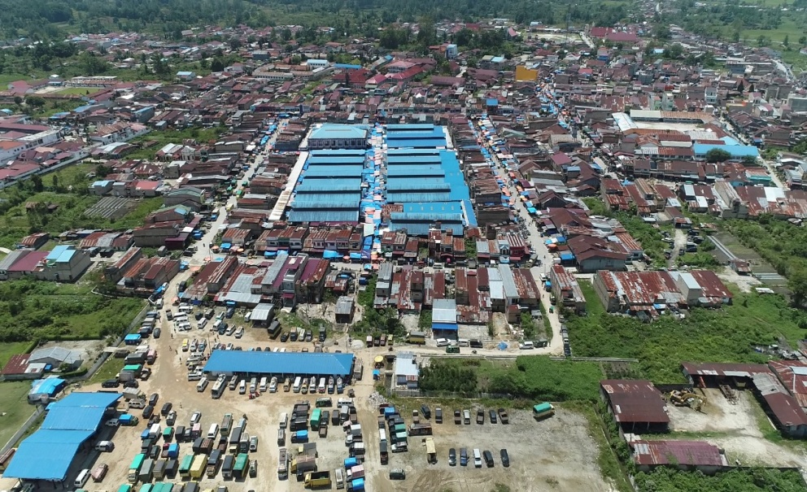
Figure 1. Proposed terminal land location in Doloksanggul (2D cartographic map).
The map confirms that the proposed terminal site is spatially connected to the city’s main activity zones, particularly the market (onan) area, and can be reached through multiple access corridors. The visualization provides a clear spatial argument for the site’s role as a formal service node that can absorb corridor-based boarding/alighting practices.
To strengthen the physical feasibility argument, the GIS-based ArcGIS outputs are also placed here as supporting evidence of land characteristics. Although these maps are commonly presented in a descriptive chapter, integrating them in the Results section makes the feasibility reasoning transparent and data-driven.
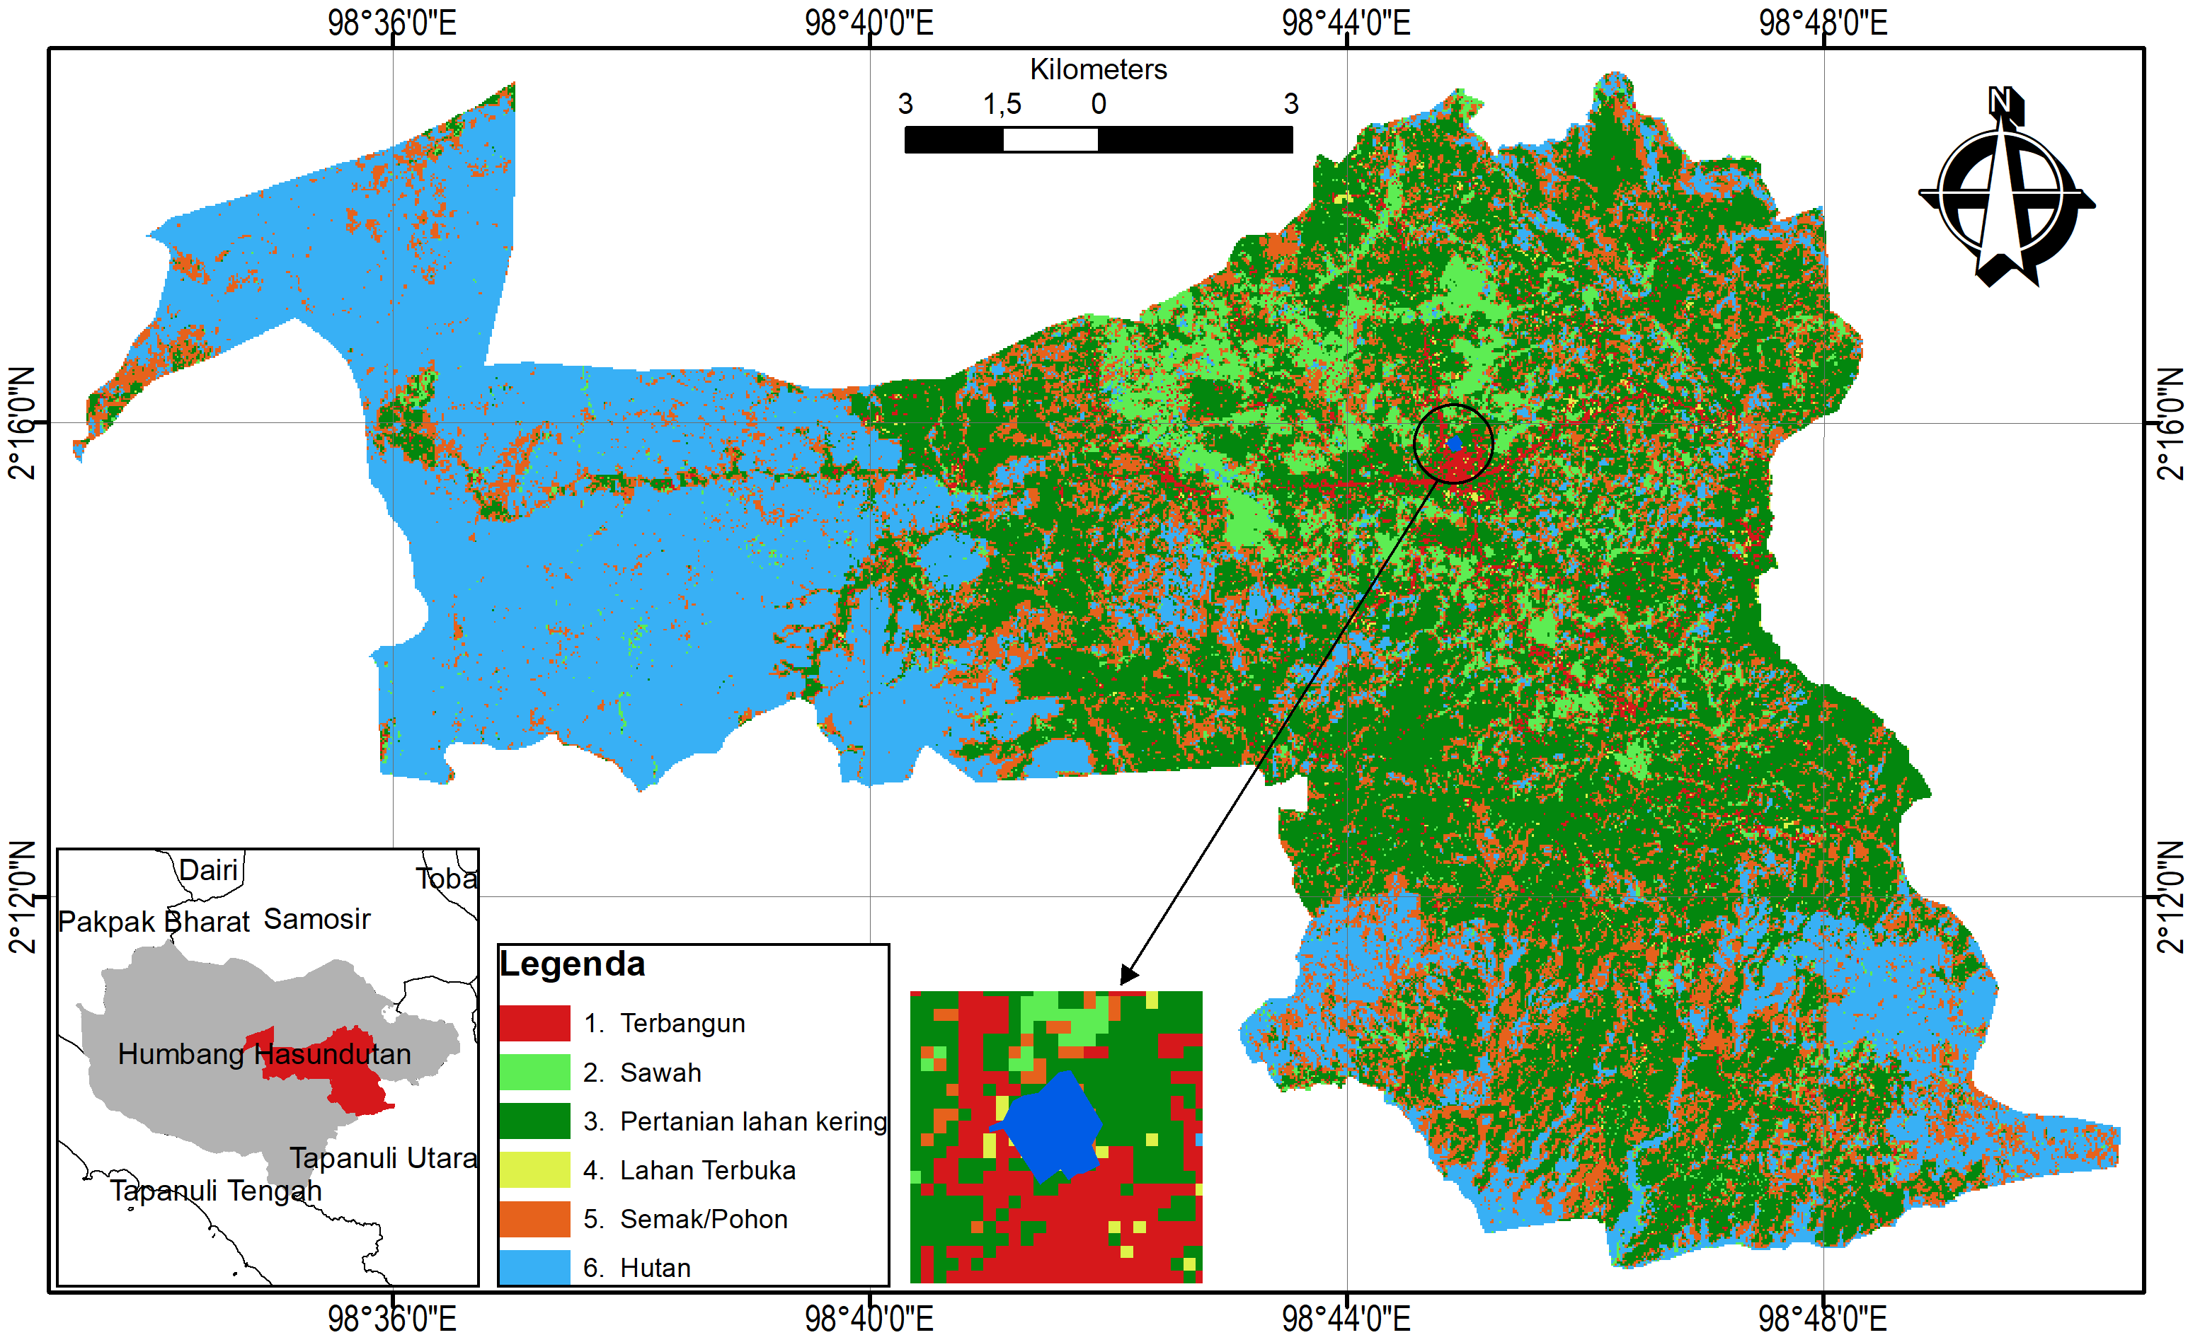
Figure 2. Land-use map of Doloksanggul (ArcGIS output).
The land-use map provides contextual evidence of surrounding spatial functions and helps identify potential land-use compatibility and conflict risks. It supports the interpretation that terminal development must be accompanied by controlled circulation design and buffer management to ensure compatibility with adjacent uses.
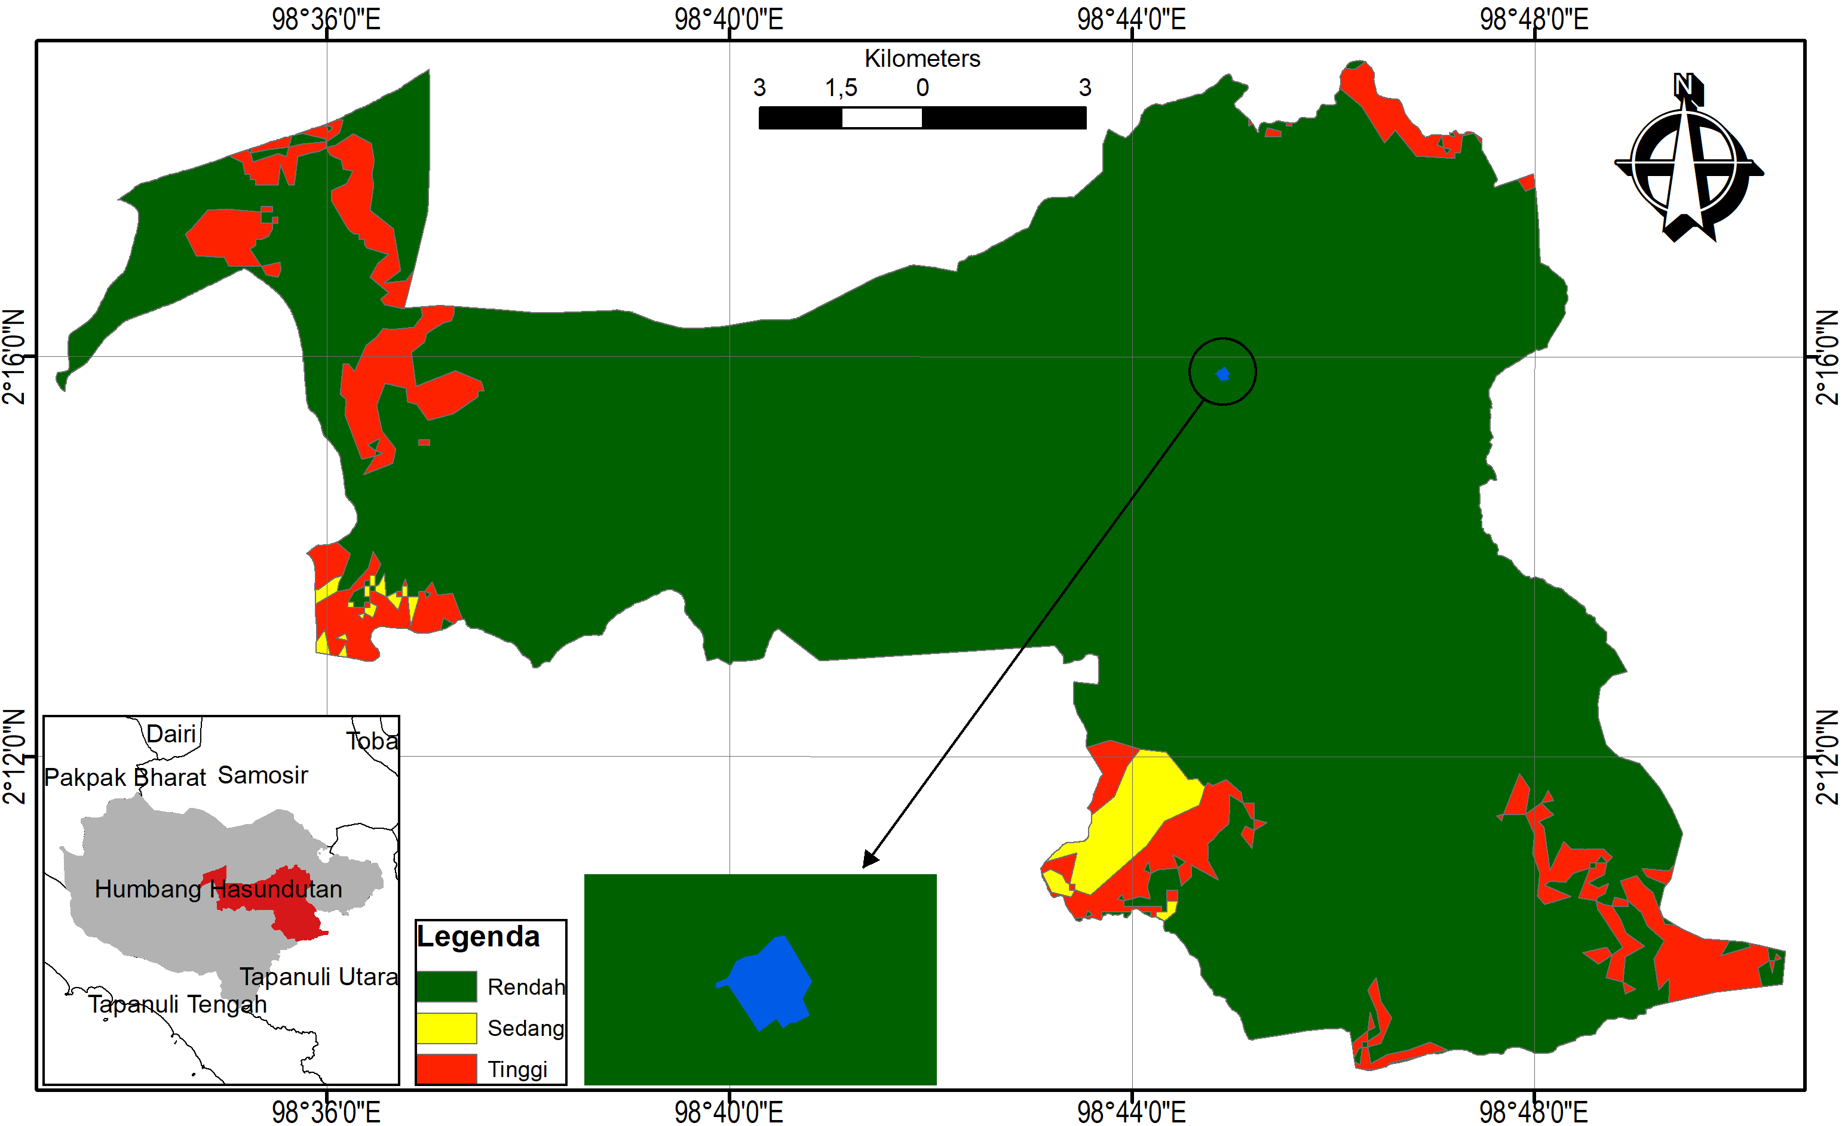
Figure 3. Landslide susceptibility map of Doloksanggul (ArcGIS output).
The landslide susceptibility map strengthens the risk-mitigation basis of terminal planning. Even when the selected site is feasible, terminal design should incorporate preventive measures (e.g., drainage management and safe slope treatment where relevant) to ensure operational safety and long-term infrastructure resilience.
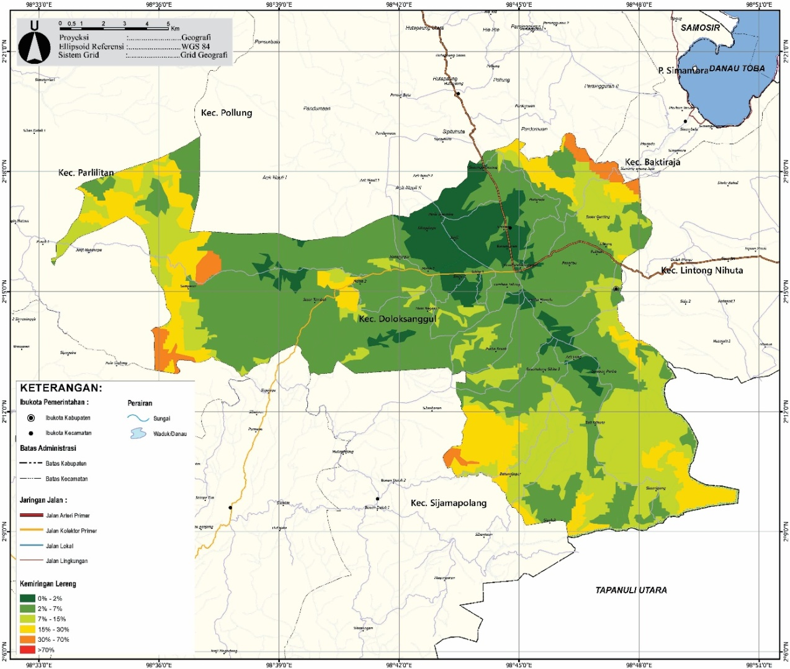
Figure 4. Slope (kelerengan) map of Doloksanggul (ArcGIS output).
The slope map supports the assessment of constructability and physical feasibility. Lower slope classes generally indicate better suitability for terminal construction, while steeper classes indicate where additional engineering treatment may be required. This output is used as one of the key physical layers to justify the development direction and mitigation needs.
Table 1. Proposed terminal site: physical and legal readiness
Attribute | Result (Integrated) | Planning implication
Land availability | 31,555.81 m² | Sufficient for terminal circulation + facilities
Legal status | Registered land parcels (verified) | Low land-tenure risk; supports implementation certainty
Site environment | Feasible for development with controlled design | Requires phased construction + mitigation measures
Supporting infrastructure | Not yet optimal | Needs access upgrading, drainage, utilities, and internal traffic design

3.3. Accessibility Structure and Shadow-Terminal Pattern in the City Core (Integrated with ArcGIS Figures)
Accessibility analysis confirms that Doloksanggul’s mobility is corridor-based and highly concentrated toward the city core. In practice, the four main roads do not only function as movement corridors but also become informal passenger service spaces, because many public transport vehicles stop on road shoulders or at company pools. This creates shadow terminals that reduce road performance, increase side friction, and raise congestion risk—especially near activity centers and high-demand stopping points.
To support this argument visually (as requested by reviewers), the accessibility structure is reinforced using ArcGIS-based network maps showing the configuration of the road and transport system. These maps clarify why stopping behavior becomes dispersed and why consolidation through a formal terminal is necessary.
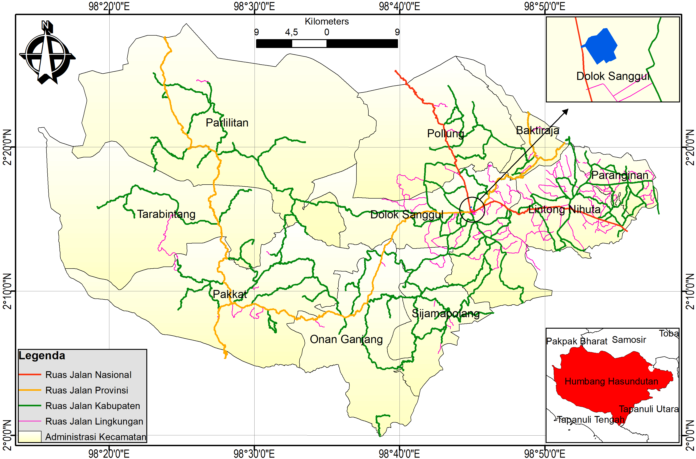
Figure 5. Road network map of Humbang Hasundutan (ArcGIS output).
The road network map explains the hierarchy and connectivity of main corridors feeding the city core. It supports the finding that passenger and vehicle flows are structurally pulled into the same limited corridor space, which increases the tendency for informal stopping points to emerge.
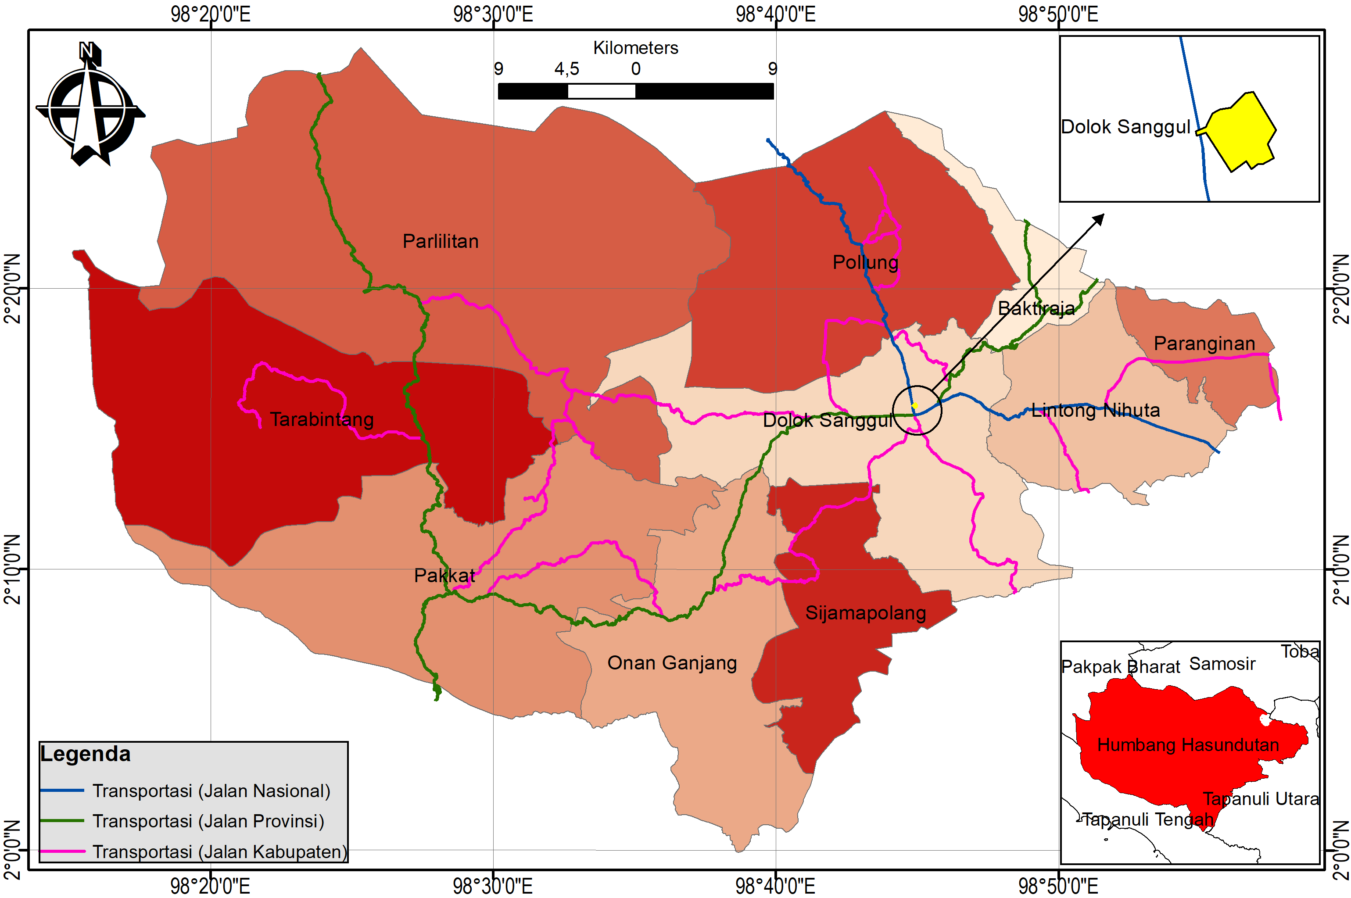
Figure 6. Transportation network map of Humbang Hasundutan (ArcGIS output).
The transportation network map complements the road network by illustrating the broader movement system and functional connectivity. This output strengthens the planning rationale that the terminal should operate as a regulated node to organize routes, stop locations, and transfers.
Table 2. Accessibility conditions and distribution of shadow terminals in Doloksanggul
Main corridor | Typical condition (field-based) | Shadow-terminal symptom | Mobility impact
Siliwangi Road | Main corridor to urban core | Roadside boarding/alighting | Obstructs flow, increases delays
Letkol G.A. Manullang Road | Main corridor to urban core | Pool-based stopping | Intensifies congestion risk
Merdeka Road | Main corridor near activity center | Roadside waiting points | Slows movement, increases conflict
Sisingamangaraja Road | Main corridor to urban core | Roadside boarding/alighting | Increases travel time variability
A key improvement in this revised manuscript is to explicitly explain multi-route connectivity between the market (onan area) and the terminal land. Several access alternatives can be optimized, for example: (i) access from Merdeka Road via connecting streets toward Ricardo Siahaan Road / Maduma Road, and (ii) access from Siliwangi Road via connector streets directly entering the terminal land and linking to Maduma. This multi-route structure is important because it allows access distribution and reduces the risk of creating a single new bottleneck after terminal operation begins, especially during Friday onan peaks when corridor pressure and informal stopping behavior intensify
.

3.4. Traffic Performance Results and the Specific Impact of Friday “Onan”
Traffic performance was evaluated using capacity-based indicators (C), volume (V/LHR), and VCR (V/C) to identify Level of Service (LOS). The results show that traffic remains relatively serviceable on ordinary conditions, but Friday onan conditions degrade performance, particularly on corridors closest to the market and activity centers.
On the measured ordinary condition, the main corridors generally operate at LOS B (stable flow). However, during higher-demand conditions and onan influence, the corridors most directly tied to the market-access function (notably Siliwangi and Merdeka) show degraded service levels (LOS C), meaning speed and maneuvering are increasingly constrained and roadside stopping becomes more disruptive.
Table 3. Summary of LOS indication (ordinary vs higher-demand/on-an influenced conditions)
Corridor | Ordinary condition (general) | Higher-demand / Friday onan effect | Interpretation
Siliwangi (north) | LOS B | LOS C on Friday onan | Market-related demand + roadside stopping increases friction
Letkol G.A. Manullang (south) | LOS B | LOS B (still stable) | Less direct market pressure compared to Siliwangi/Merdeka
Merdeka (east) | LOS B | LOS C on Friday onan | Strong linkage to activity center and market access
Sisingamangaraja (west) | LOS B | LOS B (still stable) | Demand increases exist but less severe than Siliwangi/Merdeka
Meaning for feasibility: The terminal is required not only as a facility but as a traffic management instrument to: (i) consolidate stopping points, (ii) separate waiting areas from road bodies, (iii) regulate circulation, and (iv) reduce the “spillover” effect of pools and roadside boarding/alighting that currently functions like a distributed informal terminal system.
3.5. Service Supply Evidence: Existing Operators and Real Terminal Demand
Observed mobility patterns are supported by the presence of multiple formal and semi-formal public transport services (AKAP/AKDP and local services). Existing operators already form a corridor-based service pattern, but without a formal terminal node, service operations are dispersed across pools and roadside waiting points. This dispersion strengthens shadow-terminal behavior and encourages passengers to board wherever vehicles stop informally.
A formal terminal will therefore serve two linked objectives:
- operational consolidation (routes, schedules, boarding/alighting order), and
- service quality improvement (predictability, safety, passenger comfort, and intermodal transfer).

3.6. User and Driver Perceptions: Comfort, Order, and Operational Efficiency
In-depth interviews with 30 respondents indicate strong dissatisfaction with the current shadow-terminal situation. Most users report discomfort because there is no structured waiting space, information clarity, or safe boarding/alighting zone. Drivers also emphasize operational inefficiency caused by unclear stopping rules, competition for roadside passengers, and lack of designated transfer spaces. These findings confirm that the terminal problem in Doloksanggul is not only an infrastructure gap but also a governance gap, where informal routines have replaced formal service order.
3.7. GIS/RDTR-Based Land-Use Suitability and Land-Capability Implications (Added Detail)
The integrated spatial evidence indicates that Doloksanggul’s built-up land proportion remains limited, implying that allocating a terminal site can be managed with controlled conversion and mitigation. In addition, the land capability assessment (SKL) yields Total SKL = 100 (Class D), meaning the site is feasible for development under controlled design directions, including maximum land-cover ratio guidance and building height limitation. This result strengthens feasibility because it provides a technical basis for how the site can be developed safely and sustainably.
3.8. Comparison of Multiple Candidate Sites (Added as Reviewer-Requested Improvement)
To strengthen the locational argument, this revised manuscript compares multiple feasible candidate locations rather than relying on one site only. Candidate sites were screened based on: (i) land availability, (ii) corridor connectivity, (iii) proximity to activity centers and market access, (iv) operational risk of inducing new bottlenecks, and (v) land/legal readiness.
Table 4. Comparative screening of candidate terminal sites (qualitative)
Candidate site | Strengths | Weaknesses/Risks | Feasibility note
Site A: Near Siliwangi corridor (close to core) | High passenger visibility; direct corridor access | High congestion risk; hard to control roadside stopping | Suitable only if strict traffic engineering is applied
Site B: Near Merdeka corridor (near activity center/market access) | Strong linkage to market flows; high demand capture | High side-friction risk on Friday onan | Requires strong enforcement + dedicated access treatment
Site C: Proposed site (Bonanionan) | Adequate land; multi-route access options; better internal circulation potential | Requires infrastructure upgrading to strengthen access quality | Best balance of land capacity + governance-based operations
This comparison demonstrates that the selected site is not arbitrary; it is chosen because it provides the best combination of land adequacy, access flexibility, and operational controllability.

3.9. SWOT Analysis and Quadrant I Strategy (SO—Aggressive) (Table Restored)
3.9.1. SWOT Variables (IFAS–EFAS) Based on Integrated Findings
The SWOT framework integrates: (i) centric corridor structure, (ii) shadow-terminal behavior, (iii) Friday onan mobility pressure, (iv) multi-route access potential, and (v) land feasibility (SKL Class D).
Table 5. SWOT variables for terminal planning in Doloksanggul (RESTORED TABLE 3)
Strengths (S) | Weaknesses (W)
S1. Centric road network with four main corridors as structured feeders | W1. Shadow terminals persist due to dispersed pools and roadside stopping
S2. Multi-route accessibility to terminal land (via Merdeka/Siliwangi to Ricardo Siahaan/Maduma and direct access) | W2. Supporting infrastructure and formal terminal operation system are not yet available
S3. Strong physical feasibility (SKL Class D) enabling controlled development | W3. Low compliance risk: users/operators prefer roadside convenience
S4. Existing AKAP/AKDP/local services indicate real terminal demand | W4. Weak enforcement and supervision allow informal stopping routines

Opportunities (O) | Threats (T)
O1. Friday onan as a consistent mobility and distribution generator | T1. Operator resistance to relocating from shadow points to terminal
O2. Access alternatives allow network distribution and bottleneck avoidance | T2. If unmanaged, corridor congestion can intensify as demand grows
O3. Spatial conformity and land-status certainty support implementation | T3. Potential implementation delays (budget, construction phasing, coordination)
O4. Route consolidation and service integration can upgrade service quality | T4. Shadow terminals may persist if terminal facilities are not attractive
3.9.2. Quadrant Positioning and Strategic Implications
The analysis indicates that internal strengths and external opportunities dominate and can be mobilized to address operational weaknesses (shadow terminals, compliance, enforcement). Therefore, Doloksanggul is positioned in Quadrant I (SO strategy), meaning the recommended strategy is aggressive/growth-oriented: maximizing strengths to capture opportunities.
3.9.3. SWOT Strategy Matrix (Programs and Policy Direction)
Table 6. SWOT strategy matrix for terminal planning in Doloksanggul
 | Opportunities (O) | Threats (T)
Strengths (S) | SO Strategies (Priority) 1) Consolidate corridor stopping points into terminal-based operations (feeders from four corridors). 2) Integrate terminal design with Friday onan mobility (drop-off zones, pedestrian safety, MSME space). 3) Optimize multi-route access to avoid single bottlenecks. 4) Implement phased development aligned with land capability (SKL Class D). | ST Strategies (Reinforcement) 1) Apply traffic engineering (no-stopping zones, designated official stops) to suppress shadow terminals while migration occurs. 2) Organize schedules/routes through terminal dispatching to reduce roadside competition.
Weaknesses (W) | WO Strategies (Improvement) 1) Upgrade facilities (waiting area, toilets, information system, parking) to shift preference from roadside to terminal. 2) Provide incentives and transition management for operators (departure-slot management, compliance incentives). | WT Strategies (Mitigation) 1) Strengthen cross-agency supervision and staged enforcement. 2) If construction is phased, establish temporary official stops to maintain node functions and prevent shadow-terminal expansion.

3.10. Integrated Discussion: Why the Terminal is Feasible and Necessary
The integrated findings confirm that terminal feasibility in Doloksanggul is supported by: (i) centric corridor structure that naturally requires a formal node, (ii) recurring Friday onan mobility pressure that degrades LOS and amplifies disorder, (iii) land feasibility and controlled development direction (SKL Class D), and (iv) clear evidence of existing service demand (AKAP/AKDP/local). Most critically, the study shows that the terminal must be designed not merely as a building, but as a mobility governance platform: consolidating stopping behavior, structuring feeder corridors, providing safe and comfortable passenger services, and gradually eliminating shadow terminals through a combination of facility attractiveness, enforcement, and operational restructuring.

IV. Conclusion and Recommendations (Revised – Copy/Paste Ready)
4.1 Conclusions
This study concludes that passenger terminal development in Doloksanggul is both necessary and feasible based on integrated spatial, operational, and stakeholder evidence. First, the proposed terminal site provides sufficient land availability (31,555.81 m²) to accommodate functional terminal components (circulation, bays, parking, passenger facilities), although supporting infrastructure upgrades are required to ensure operational efficiency. Second, Doloksanggul’s centric movement structure concentrates mobility along four primary corridors (Siliwangi, Letkol G.A. Manullang, Merdeka, and Sisingamangaraja), and the current dominance of shadow-terminal practices along these corridors disrupts traffic performance and increases congestion risk, particularly near activity centers.
Third, traffic-demand results indicate that peak-hour volume is projected to increase by approximately 11.8% over the next five years, implying that the current dispersed stopping pattern will become increasingly unsustainable without a regulated service node. Fourth, stakeholder perceptions reinforce the operational urgency: 70% of users report discomfort with shadow-terminal conditions and demand basic service facilities (waiting areas, toilets, information boards), while 85% of drivers acknowledge that informal stopping reduces operational efficiency due to the absence of clear rules, bay allocation, and transfer order. Finally, the land capability assessment indicates Total SKL = 100 (Class D; moderately high development category), suggesting the proposed site is physically supportive for development under controlled design and mitigation measures. Overall, the terminal is required not merely as a physical facility, but as a mobility governance instrument to consolidate stopping points, regulate circulation, improve user comfort, and gradually eliminate shadow terminals—especially during the mobility peaks generated by the Friday onan market.

4.2 Recommendations
To ensure that terminal development produces measurable improvements in mobility order and local economic accessibility, the following recommendations are proposed:
- Improve access and supporting infrastructure (pre-operation priority).
Upgrade the access geometry and supporting utilities around the terminal site, including drainage, pavement quality, signage, lighting, and internal circulation design (entry–exit separation, pedestrian safety, and bay layout). This is essential to prevent new bottlenecks and to ensure that terminal operations do not spill over onto the road body.
- Adopt a phased operational migration strategy from shadow terminals to the formal terminal.
Implement migration in stages with clear milestones: (i) designation of official stopping points and temporary holding areas, (ii) gradual restriction of roadside boarding/alighting on the four main corridors, and (iii) full consolidation of pools and boarding activities into terminal-based dispatch. This phased approach reduces resistance and supports gradual behavioral change among drivers and users.
- Strengthen governance and enforcement through cross-agency coordination.
Establish an integrated supervision mechanism involving transport authorities, local government, and enforcement units to regulate stopping behavior, bay discipline, and parking management. Enforcement should be targeted during peak periods—especially Friday onan—because this is when the shadow-terminal pattern intensifies and corridor capacity becomes most vulnerable.
- Enhance terminal service quality to shift user preference from “roadside convenience” to “terminal comfort.”
Provide minimum facilities that users explicitly demand: comfortable waiting areas, toilets, clear information boards, and safe boarding zones. Service quality is a key behavioral driver; without visible improvements, users may continue to prefer the nearest informal stopping points.
- Use information technology to manage schedules and route discipline.
Introduce simple operational tools (dispatch schedules, bay allocation, and route information) to increase predictability and reduce roadside competition among drivers. Terminal-based dispatch should be supported by clear departure slots and incentives for compliance.
- Integrate terminal operations with local economic activity and the Friday onan mobility pattern.
Design terminal access and circulation to support market-related demand peaks, including designated drop-off zones, safe pedestrian connectivity to activity centers, and regulated loading/unloading spaces. This strengthens the terminal’s role as both a mobility node and a local economic catalyst by reducing time-costs and improving accessibility for MSMEs and traders.
- Future research and monitoring (post-implementation).
Future studies should (i) compare multiple candidate sites using standardized multi-criteria evaluation, (ii) quantify changes in corridor performance after terminal implementation (VCR/LOS before–after), and (iii) monitor compliance and user satisfaction to verify whether shadow-terminal activity declines and service reliability improves over time.

References
Chanieabate, M., He, H., Guo, C., Abrahamgeremew, B., & Huang, Y. (2023). Examining the Relationship between Transportation Infrastructure, Urbanization Level and Rural-Urban Income Gap in China. Sustainability, 15(10), 8410. https://doi.org/10.3390/su15108410
Purba, W. B., Nasution, Z. ., & Lubis, S. N. (2025). Analysis of Determinants in the Development of the Medan-Binjai Elevated Railway and Its Contribution to Regional Development: English. Asian Multidisciplinary Research Journal of Economy and Learning, 2(1), 01-09. https://doi.org/10.70471/w4z68x41
Oliveira, L. K. d., Oliveira, I. K. d., França, J. G. d. C. B., Balieiro, G. W. N., Cardoso, J. F., Bogo, T., Bogo, D., & Littig, M. A. (2022). Integrating Freight and Public Transport Terminals Infrastructure by Locating Lockers: Analysing a Feasible Solution for a Medium-Sized Brazilian Cities. Sustainability, 14(17), 10853. https://doi.org/10.3390/su141710853
Afrin, T., & Yodo, N. (2020). A Survey of Road Traffic Congestion Measures towards a Sustainable and Resilient Transportation System. Sustainability, 12(11), 4660. https://doi.org/10.3390/su12114660
Sitorus, M., Lubis, S. N., Sembiring, M. T., Kesuma, S. I., & Lubis, A. A. R. D. (2025). A Bottom-Up Inclusive Growth Model for Peripheral Coastal Cities: Structural Pathway to Regional Development in Post-Decentralized Indonesia. International Journal of Sustainable Development & Planning, 20(7).
Alda, R., Nasution, Z., Lubis, S. N., & Lubis, A. A. R. D. (2024). The influence of education, social, and healthcare expenditures on the Human Development Index (HDI) in Bireuen Regency. Asian Multidisciplinary Research Journal of Economy and Learning, 1(2), 20–25. https://doi.org/10.70471/kbj9w526
Zhuang, P., Li, X., & Wu, J. (2023). The Spatial Value and Efficiency of Inland Ports with Different Development Models: A Case Study in China. Sustainability, 15(17), 12677. https://doi.org/10.3390/su151712677
Rezwana, S., & Lownes, N. (2025). Exploring the Impact of Pedestrian Behavior Parameters on Gap Acceptance in Microsimulation Applications. Future Transportation, 5(2), 44. https://doi.org/10.3390/futuretransp5020044
Gao, S., Shirazian, S., Ward, P. J., & Koks, E. E. (2025). Understanding the vulnerability of multimodal public transportation networks. Civil Engineering and Environmental Systems https://doi.org/10.1080/10286608.2025.2601992

