Identifying Genetic Markers and Molecular Pathways Underlying Emerging Anthelmintic Resistance in Human Helminths
Abstract
Helminth infections remain a major cause of morbidity in low- and middle-income regions, despite decades of large-scale preventive chemotherapy programs. Current control strategies rely heavily on a limited number of anthelmintic drug classes: benzimidazoles, macrocyclic lactones, and cholinergic agonists administered repeatedly through mass drug administration (MDA). This sustained reliance has increased selective pressure on parasite populations, raising growing concern about the emergence of drug resistance that could undermine long-term program effectiveness. While anthelmintic resistance is well documented in veterinary helminths, molecular evidence in human parasites remains fragmented and undercharacterized. This review provides an integrative, human-helminth–focused synthesis of current knowledge on genetic markers and molecular pathways associated with emerging anthelmintic resistance. We summarize evidence for β-tubulin polymorphisms linked to benzimidazole resistance, alterations in ligand-gated ion channels affecting macrocyclic lactone sensitivity, and the upregulation of efflux transporter systems that contribute to multidrug tolerance. We also examine transcriptomic, metabolic, and regulatory pathways—including detoxification networks and epigenetic modifications that may stabilize resistance phenotypes and offset associated fitness costs. Advances in genomics, population genetics, and functional approaches are accelerating the detection of resistance signals, although standardized molecular surveillance frameworks for human helminths remain limited. We discuss the public health implications of these findings, highlight vulnerabilities in MDA-based control programs, and outline future strategies—including molecular diagnostics, combination therapies, and genomic surveillance—to support sustainable helminth control and guide anthelmintic development.
Keywords: Anthelmintic resistance; Helminths; Benzimidazoles; β-tubulin polymorphisms; Macrocyclic lactones; Glutamate-gated chloride channels; ABC transporters; Molecular diagnostics; Mass drug administration

1. Introduction
Human helminth infections remain among the most widespread neglected tropical diseases, disproportionately affecting populations in low- and middle-income countries. Soil-transmitted helminths such as Ascaris lumbricoides, Trichuris trichiura, and hookworms, alongside tissue-dwelling species including Strongyloides stercoralis and various filarial nematodes, collectively infect hundreds of millions of people worldwide. These infections contribute to chronic morbidity through malnutrition, anemia, impaired cognitive development, and reduced economic productivity. Despite notable progress in expanding preventive chemotherapy programs, transmission persists in many endemic regions, underscoring the need for durable long-term control strategies[1].
The global approach to helminth control relies heavily on a limited pharmacological arsenal, primarily benzimidazoles, macrocyclic lactones, and a small number of cholinergic agonists. Mass drug administration (MDA) campaigns, which aim to reduce community-wide worm burden, have intensified selection pressures on parasite populations by repeated reliance on the same drug classes. This restricted therapeutic diversity heightens the risk of developing drug resistance, a problem well documented in veterinary helminths and increasingly suspected in human parasites. Reports of declining cure rates, reduced egg reduction following treatment, and molecular evidence consistent with resistance-associated mutations have raised concern that similar patterns are emerging in human helminth populations.[2].
Understanding the genetic and molecular basis of anthelmintic resistance is therefore crucial for safeguarding the long-term efficacy of current treatment strategies. Identifying mutations in drug targets, elucidating pathways that modulate gene expression or metabolic detoxification, and characterizing mechanisms such as drug efflux can provide early warning indicators of reduced drug susceptibility. Such insights also support the development of improved diagnostics, more effective drug combinations, and surveillance systems capable of detecting resistance before widespread clinical failure occurs.[3].
This paper reviews current knowledge on the genetic markers and molecular pathways implicated in emerging anthelmintic resistance in human helminths. It synthesizes evidence from genomic, transcriptomic, and population-level studies, and outlines the implications of these findings for public health, surveillance, and future drug development.
2. Anthelmintic Drug Classes and Their Mechanisms of Action
Benzimidazoles, macrocyclic lactones, and cholinergic agonists constitute the core of current anthelmintic therapy for human helminths. Each drug class acts on distinct molecular targets, yet all face the risk of diminishing efficacy as selective pressure increases through widespread use in mass drug administration (MDA) programs.
2.1 Benzimidazoles
Benzimidazoles, including albendazole and mebendazole, exert their activity by binding to β-tubulin, a critical component of the parasite’s microtubule cytoskeleton. This binding disrupts microtubule assembly and compromises essential cellular processes such as nutrient uptake. Resistance in multiple helminth species has been linked to single-nucleotide polymorphisms (SNPs) in the β-tubulin gene, particularly at codons 167, 198, and 200. These mutations reduce drug–target affinity and are increasingly reported in human soil-transmitted helminths, mirroring well-established patterns observed in veterinary parasites[4].
2.2 Macrocyclic Lactones
Macrocyclic lactones, such as ivermectin, primarily target glutamate-gated chloride channels, leading to hyperpolarization and paralysis of the worm. Reduced susceptibility in human helminths has been inferred from declining treatment responses and early evidence of changes in ion-channel gene expression or subunit composition. Although definitive markers remain under investigation, observations from related nematodes strongly support the plausibility of emerging resistance.[5].
2.3 Nicotinic Acetylcholine Receptor Agonists and Other Drug Classes
Cholinergic agonists, including pyrantel, act by stimulating nicotinic acetylcholine receptors at the neuromuscular junction, causing sustained depolarization and paralysis. Their effectiveness varies across species, and limited evidence exists regarding resistance mechanisms in human helminths. Additional drug classes remain underutilized or have narrow spectra, further constraining therapeutic options.[6].
2.4 Selective Pressures Created by MDA Programs
Figure 1 provides a schematic overview of the major anthelmintic drug classes, their molecular targets, and the resistance-associated mechanisms discussed in this section. The repeated community-wide administration of the same drug classes intensifies evolutionary pressure on helminth populations. High-frequency exposure, often with suboptimal coverage, favors the survival and spread of resistant genotypes. As MDA continues to expand globally, understanding drug mechanisms and resistance markers becomes essential for sustaining treatment efficacy.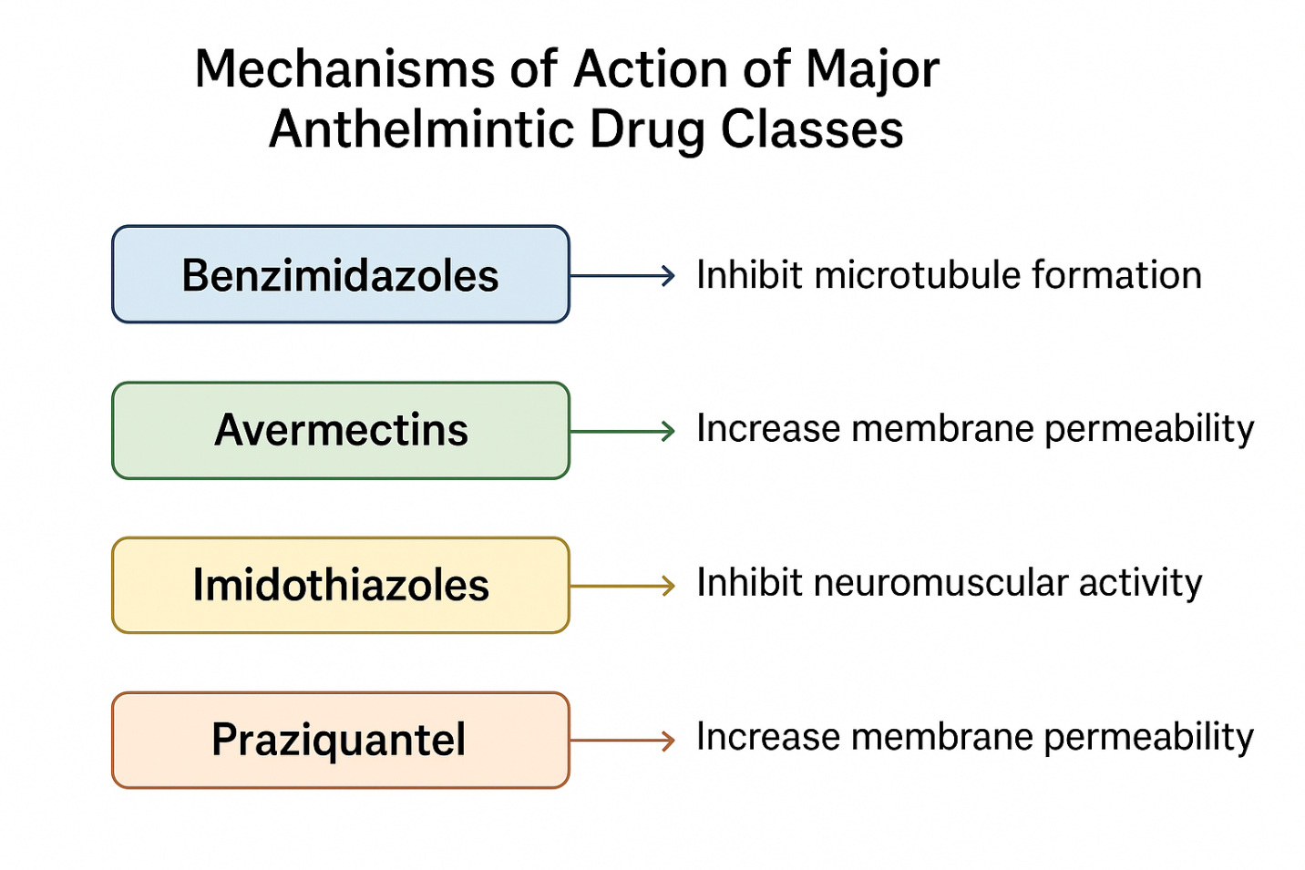

Fig 1:Mechanisms of action of Major Anthelmintic Drug Classes
3. Genetic Markers Associated With Anthelmintic Resistance
The emergence of anthelmintic resistance in human helminths appears to be driven by a combination of target-site mutations, altered gene regulation, and enhanced protective pathways that collectively reduce drug susceptibility. Although the molecular evidence is still developing compared with the extensive data available for veterinary parasites, several genetic markers have gained prominence as potential indicators of resistance.[7].
3.1 β-Tubulin Polymorphisms
Mutations in the β-tubulin gene remain the most widely studied markers of benzimidazole resistance. Three single-nucleotide polymorphisms—F167Y, E198A, and F200Y—have been repeatedly implicated in reduced benzimidazole efficacy. These polymorphisms alter amino acid residues in the drug-binding domain, diminishing the interaction between benzimidazoles and β-tubulin. Evidence from multiple endemic regions suggests parallel evolution of these mutations in human soil-transmitted helminths, particularly Trichuris trichiura and hookworms, mirroring patterns long recognized in livestock nematodes. Field studies report population-level variation in allele frequencies, with some communities showing low prevalence of resistance-associated alleles, while others demonstrate substantial increases following repeated rounds of mass drug administration (MDA). Although the presence of these SNPs does not always correlate perfectly with treatment failure, their rising frequency is considered an important early warning sign of emerging resistance[8].
However, it is important to note that the presence of resistance-associated β-tubulin SNPs does not always directly translate into clinical treatment failure, as phenotypic outcomes may be influenced by parasite population structure, drug exposure intensity, and host-related factors.”

3.2 Mutations and Regulation of Ligand-Gated Ion Channels
Macrocyclic lactones such as ivermectin target glutamate-gated chloride channels (GluCl), and alterations in these channels have been associated with reduced responsiveness. Potential resistance mechanisms include changes in subunit composition, structural variants affecting channel gating, and downregulation of genes encoding GluCl receptors. While definitive causal mutations have not yet been unequivocally validated in human helminths, transcriptomic studies indicate that some populations exhibit altered expression patterns consistent with reduced channel sensitivity. These changes may decrease the efficacy of ivermectin-induced hyperpolarization, contributing to the gradual erosion of treatment effectiveness observed in several endemic settings.[9].
3.3 Efflux Transporters (ABC Transporters)
Another important class of candidate markers involves ATP-binding cassette (ABC) transporters, particularly P-glycoproteins (Pgp). Upregulation of these transporters can enhance drug efflux, thereby reducing intracellular drug concentrations. Genomic and transcriptomic analyses from both model nematodes and human helminths have identified elevated expression of Pgp genes in populations with suspected reduced susceptibility. Such transporters may contribute to multi-drug resistance, given their broad substrate range and ability to decrease the effective concentration of structurally diverse anthelmintics.[10].
3.4 Other Candidate Genetic Markers
A growing number of additional molecular markers are under investigation. Detoxification enzyme families, including cytochrome P450s and glutathione-related enzymes, may play roles in metabolic drug breakdown.[11]. Polymorphisms in regulatory regions could influence gene expression related to drug response, although the functional significance of many such variants remains unclear. Emerging interest also surrounds mitochondrial markers, which may capture population bottlenecks, selective sweeps, or lineage-specific susceptibility patterns.[12].
Table 1 summarizes the principal genetic markers associated with emerging anthelmintic resistance across major human helminths, highlighting species-specific variants, their proposed functional impacts, and the current strength of evidence supporting their roles.”
Table 1. Key Genetic Markers Implicated in Anthelmintic Resistance Across Major Human Helminths
Helminth Species | Drug Class Affected | Primary Genetic Marker(s) | Proposed Functional Impact | Evidence Strength
Trichuris trichiura | Benzimidazoles | β-tubulin E198A | Alters the drug-interaction site, lowering affinity for benzimidazoles | Strong, multiple field studies[13]
Necator americanus (Hookworm) | Benzimidazoles | β-tubulin F167Y, F200Y | Reduces microtubule destabilization by modifying target conformation | Moderate, increasing field detection[14]
Ascaris lumbricoides | Benzimidazoles | β-tubulin variants (candidate SNPs) | Potential alteration of structural binding regions; requires validation | Limited, preliminary[14]
Strongyloides stercoralis | Macrocyclic lactones | GluCl receptor subunit changes (expression or sequence variants) | May influence channel sensitivity and reduce ivermectin-induced signaling | Emerging, largely transcriptomic[13]
Multiple nematode species | Multiple drug classes | Upregulated ABC/P-glycoprotein transporters | Enhances the efflux of diverse anthelmintic compounds, lowering intracellular drug levels | Moderate, consistent across species[15]
Various species (broad category) | Multiple | Detoxification-related gene variants (e.g., cytochrome P450 families) | Alters the metabolic processing of drugs, potentially diminishing potency | Preliminary, under investigation[16]

Importantly, the identification of these resistance-associated genetic markers has direct public health relevance, as they provide molecular targets for surveillance tools capable of detecting early reductions in drug susceptibility before widespread treatment failure occurs.
Evidence strength categories were assigned based on the volume and consistency of available data: ‘strong’ indicates multiple independent field and/or functional studies; ‘moderate’ reflects repeated field detection with limited functional validation; ‘emerging’ denotes transcriptomic or indirect molecular evidence; and ‘preliminary’ refers to early or single-study observations requiring further validation.
4. Molecular Pathways Contributing to Resistance Phenotypes
Anthelmintic resistance in human helminths arises from a network of interacting molecular pathways that collectively reduce drug sensitivity and maintain parasite viability under therapeutic pressure. These pathways encompass modifications in drug–target interactions, altered gene expression, enhanced metabolic defenses, and mechanisms that offset the fitness costs often associated with resistance mutations.[7].
Figure 2 illustrates the integrated molecular pathways that contribute to the development and persistence of anthelmintic resistance in helminths.”
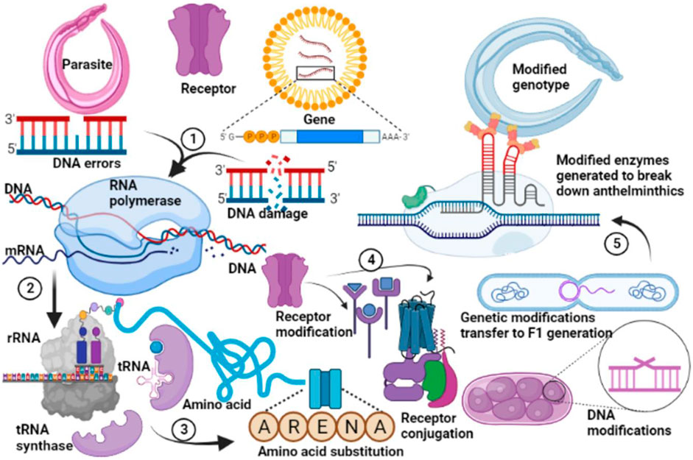
Figure 2. Conceptual illustration of molecular pathways contributing to anthelmintic resistance in helminths.
This schematic depicts how genetic and molecular alterations can accumulate within parasite populations under drug pressure. DNA replication errors, damage, or modifications may result in mutations affecting key proteins, such as receptors or enzymes targeted by anthelmintics. Amino-acid substitutions and receptor reconfiguration can reduce drug binding or alter signaling pathways. Gene expression changes and DNA modifications contribute to phenotypic plasticity and long-term stabilization of resistance traits. Modified enzymes may enable parasites to deactivate or tolerate drug exposure. Genetic changes can be inherited across generations, facilitating the spread of resistant genotypes within parasite populations. Together, these pathways highlight the multifactorial and evolving nature of anthelmintic resistance.
4.1 Altered Drug Binding Affinity
A primary driver of resistance involves structural alterations in drug targets that reduce binding affinity. Mutations in β-tubulin or ligand-gated ion channels can modify amino acid residues critical for drug interaction, leading to conformational changes that diminish drug attachment. Such structural impacts can impair the ability of benzimidazoles to disrupt microtubule formation or reduce the capacity of macrocyclic lactones to induce chloride influx. As a result, helminths maintain core physiological processes despite drug exposure. These target-site modifications often serve as the first step in resistance evolution, providing the parasite with a measurable survival advantage.[17].
4.2 Gene Expression Modulation and Epigenetic Inputs
Drug exposure frequently triggers stress-response pathways, prompting helminths to adjust gene expression profiles that promote survival. Upregulation of protective genes, such as those involved in detoxification or membrane transport, can enhance resilience to repeated drug challenges. Epigenetic changes—including DNA methylation shifts and chromatin remodeling—may further influence the expression of resistance-associated genes. Such modifications can stabilize resistance phenotypes across parasite generations, even in the absence of continued drug pressure, thereby contributing to long-term persistence of reduced susceptibility within populations.[18].
4.3 Enhanced Metabolic Detoxification
Many helminths employ metabolic strategies to diminish the potency of anthelmintic compounds. Upregulation of detoxification enzyme families, such as cytochrome P450s and glutathione-S-transferases, along with their related pathways, can increase the rate at which drugs are neutralized or transformed into less active forms. These changes may be accompanied by metabolic re-routing, allowing the parasite to compensate for drug-imposed stress while maintaining essential biochemical functions. Together, these adaptations create a chemical environment less conducive to effective drug activity.[19].
4.4 Compensatory Fitness Mechanisms
Resistance mutations and metabolic shifts may carry fitness costs, such as reduced reproductive output or altered energy balance. To overcome these disadvantages, helminths may evolve compensatory mechanisms that restore physiological performance. These include adjustments in metabolic pathways, optimized resource allocation, and enhanced stress resilience. The interplay between compensatory adaptations and resistance pathways enables resistant parasites not only to survive drug exposure but also to compete effectively within treated host populations, facilitating the spread and entrenchment of resistance traits.[20].

From a public health perspective, understanding these interconnected molecular pathways is essential for predicting resistance trajectories and informing adaptive mass drug administration strategies in endemic settings.
5. Methods Used to Identify and Validate Resistance Mechanisms
Understanding anthelmintic resistance in human helminths requires an integrated methodological framework that combines genomic, transcriptomic, population-level, and functional approaches. Collectively, these methodologies allow researchers to identify candidate resistance markers, characterize their biological significance, and evaluate their relevance in natural parasite populations.
5.1 Genomic Sequencing and Comparative Genomics
Advances in whole-genome sequencing have transformed the study of resistance by enabling detailed comparisons between susceptible and putatively resistant parasite populations. Comparative genomics allows the identification of single-nucleotide polymorphisms (SNPs), structural variants, and copy-number changes that may influence drug response. These analyses can highlight genes under selection pressure and reveal parallel evolutionary patterns across geographic regions or species, providing strong circumstantial evidence for resistance-associated loci[21].
5.2 Transcriptomic Profiling and Differential Expression Mapping
Transcriptomic approaches examine genome-wide changes in gene expression following drug exposure or across populations with differing susceptibility profiles. Differential expression mapping can reveal upregulated detoxification genes, alterations in receptor or channel subunit expression, or activation of stress-related pathways. Such patterns offer insights into the dynamic biological responses that facilitate survival under pharmacological pressure.
5.3 Population Genetics Approaches for Resistance Surveillance
Population genetics adds a crucial epidemiological dimension to resistance research. By tracking allele frequencies of resistance-associated markers in field populations, researchers can assess the spread, persistence, and selective advantage of candidate mutations. Measurements of genetic diversity, population structure, and selective sweeps contribute to understanding how resistance emerges and disseminates within communities exposed to mass drug administration programs.
5.4 In Vitro and Model-Organism Functional Validation Frameworks
Although direct experimental manipulation of human helminths is limited, conceptual frameworks involving model nematodes or surrogate systems allow researchers to evaluate the functional consequences of candidate resistance genes. These systems help clarify whether specific mutations reduce drug susceptibility or alter key physiological pathways, offering critical evidence for causality.
5.5 Bioinformatic Tools for Integrating Multi-Omic Datasets
As genomic and transcriptomic datasets grow, bioinformatic integration becomes essential. Multi-omic analysis platforms enable researchers to connect genetic variants with expression changes, pathway alterations, and population-level trends. Such integrative approaches provide a comprehensive understanding of resistance mechanisms and help refine targets for surveillance and future drug development[22].
6. Implications for Public Health, Surveillance, and Drug Development
The emergence of anthelmintic resistance in human helminths has significant implications for global public health, particularly in regions where mass drug administration (MDA) serves as the cornerstone of control strategies.[23]. These programs depend heavily on a narrow range of drug classes, and increasing evidence of reduced drug susceptibility threatens their long-term effectiveness. Should resistance become widespread, the ability of MDA campaigns to suppress worm burden, reduce transmission, and protect vulnerable populations could be substantially compromised.[24].
6.1 Threats to MDA-Based Control Programs for Soil-Transmitted Helminths
Declining treatment efficacy, even when modest, may undermine progress toward morbidity reduction goals. Persistent infections in treated communities create conditions for sustained transmission and may erode public confidence in control programs.
6.2 Need for Early-Detection Molecular Diagnostics
Early detection of resistance is essential to prevent programmatic failure. Molecular diagnostics capable of identifying resistance-associated markers, such as β-tubulin polymorphisms or efflux-related gene expression patterns, would enable timely responses. Such tools could guide adaptive adjustments in treatment strategies before clinical failures become widespread.
6.3 Strategies to Slow Resistance Evolution
A range of interventions may help mitigate resistance development. Rotational drug strategies aim to reduce continuous selection for resistance to a single drug class. Combination therapies, widely successful in malaria and HIV control, may also provide synergistic effects or reduce the likelihood that any single mutation can confer broad protection. Targeted treatment approaches, such as treating only high-risk groups or using treatment thresholds based on prevalence, can reduce overall drug pressure on parasite populations[25].
6.4 Opportunities for Novel Drug Discovery Targeting Less Mutable Pathways
The identification of molecular pathways that are less prone to mutation offers opportunities for innovative therapeutics. Drugs that target conserved metabolic processes or regulatory pathways essential for helminth survival could exhibit greater resilience to resistance evolution.[26].
6.5 Integrating Genomic Surveillance Into Global Health Policy
Genomic surveillance systems are increasingly feasible and can provide real-time insights into resistance emergence and spread. Integrating these systems into national and international health policies would support evidence-based decision-making, improve MDA program design, and ensure rapid responses to emerging threats.[27].
7. Conclusion
Growing evidence of anthelmintic resistance in human helminths highlights the need for a deeper understanding of the genetic markers and molecular pathways that underlie reduced drug susceptibility. Mutations in β-tubulin, alterations in ligand-gated ion channels, upregulation of efflux transporters, and shifts in metabolic and regulatory networks collectively demonstrate that resistance is a multifaceted phenomenon shaped by complex biological interactions. These insights underscore the urgent need for coordinated global surveillance capable of detecting early molecular signals of resistance before widespread treatment failure occurs. Robust genomic monitoring systems, integrated with epidemiological data, will be essential for guiding adaptive responses in regions heavily reliant on mass drug administration.
Incorporating molecular knowledge into drug-policy and control strategies can help optimize treatment regimens, inform the development of diagnostic tools, and support evidence-based stewardship of existing anthelmintics. As genomic technologies advance and global cooperation strengthens, harnessing these molecular insights will be critical for sustaining the long-term effectiveness of helminth control programs and safeguarding vulnerable populations worldwide.
Embedding molecular resistance markers into routine surveillance frameworks will be critical for guiding evidence-based policy decisions, optimizing mass drug administration programs, and preserving the long-term effectiveness of existing anthelmintics.

8. Future Directions
Future progress in understanding and mitigating anthelmintic resistance will depend on expanding the genomic and epidemiological foundations that support resistance research and surveillance. A key priority is filling genomic data gaps for neglected human helminth species, many of which currently lack high-quality reference genomes or sufficient population-level sequence data. Improved genomic resources will allow more robust comparative analyses and enhance the detection of resistance-associated variants.[28].
8.2 Expanding Global Surveillance Networks in Endemic Regions
Building comprehensive surveillance systems in regions where helminth infections are most prevalent will be essential for tracking the emergence and spread of resistance. Coordinated international networks can facilitate standardized sampling, data sharing, and rapid response to early warning signals.
8.3 Standardizing Genetic Markers for Resistance Reporting
To ensure comparability across studies, the field must work toward harmonized frameworks for defining and reporting genetic markers of resistance. This includes establishing consensus on which mutations represent validated markers, how evidence levels should be classified, and how allele frequency data should be interpreted in public health contexts[29].
8.4 Emerging Technologies
Technological advances such as AI-guided target identification, long-read sequencing, and improved annotation pipelines hold promise for accelerating the discovery and characterization of resistance pathways. These tools may uncover previously unrecognized molecular targets and provide deeper insight into helminth population structure and evolution.[30,31].
8.5 Moving Toward Precision Anthelmintic Stewardship
Ultimately, integrating molecular insights with treatment strategies may enable precision anthelmintic stewardship, where interventions are tailored to local parasite populations, resistance patterns, and transmission dynamics. Such an approach could maximize drug effectiveness, slow resistance evolution, and improve the sustainability of helminth control efforts.[32].
Such a precision anthelmintic stewardship approach would enable policymakers and control programs to tailor interventions based on local resistance profiles, transmission intensity, and genomic surveillance data, thereby maximizing impact while minimizing selective pressure.”

Disclaimer (Artificial intelligence)
The authors declare that generative artificial intelligence tools were used solely to assist with language editing and clarity. The authors take full responsibility for the scientific content, interpretation, and conclusions presented in the manuscript.
REFERENCES
- Usang, A. U., Imalele, E. E., Effanga, E. O., Ukoha, U. K., & Eleng, I. E. (2025). Soil-transmitted helminth infections and nutritional indices among children (5–9 years) and adolescents (10–12 years) in Calabar, Nigeria. BMC Public Health, 25(1), 1.https://doi.org/10.1186/s12889-024-21210-4
- Schlosser-Brandenburg, J., Midha, A., Mugo, R. M., Ndombi, E. M., Gachara, G., Njomo, D., Rausch, S., & Hartmann, S. (2023). Infection with soil-transmitted helminths and their impact on coinfections. Frontiers in Parasitology.https://doi.org/10.3389/fpara.2023.1197956
- Agrawal, R., Pattnaik, S., Kshatri, J. S., Kanungo, S., Mandal, N., Palo, S. K., & Pati, S. (2024). Prevalence and correlates of soil-transmitted helminths in schoolchildren aged 5–18 years in low- and middle-income countries: A systematic review and meta-analysis. Frontiers in Public Health, 12, 1283054.https://doi.org/10.3389/fpubh.2024.1283054
- Gibson, S. B., Ness-Cohn, E., & Andersen, E. C. (2022). Benzimidazoles cause lethality by inhibiting the function of Caenorhabditis elegans neuronal beta-tubulin. International Journal for Parasitology: Drugs and Drug Resistance, 20, 89–96.https://doi.org/10.1016/j.ijpddr.2022.10.004
- Choudhary, S., Kashyap, S. S., Martin, R. J., & Robertson, A. P. (2021). Advances in our understanding of nematode ion channels as potential anthelmintic targets. International Journal for Parasitology: Drugs and Drug Resistance, 18, 52–86.https://doi.org/10.1016/j.ijpddr.2021.12.001
- Carlson, A. B., & Kraus, G. P. (2025). Physiology, cholinergic receptors. In StatPearls [Internet]. StatPearls Publishing.
Available from: https://www.ncbi.nlm.nih.gov/books/NBK526134/
- Fissiha, W., & Kinde, M. Z. (2021). Anthelmintic resistance and its mechanism: A review. Infection and Drug Resistance, 14, 5403–5415.https://doi.org/10.2147/IDR.S332378
- Tenorio, J. C. B., Heikal, M. F., Kafle, A., Saichua, P., & Suttiprapa, S. (2024). Benzimidazole resistance-associated mutations in the β-tubulin gene of hookworms: A systematic review. Parasitology Research, 123(12), 405.https://doi.org/10.1007/s00436-024-08432-6
- Wolstenholme, A. J., & Rogers, A. T. (2005). Glutamate-gated chloride channels and the mode of action of the avermectin/milbemycin anthelmintics. Parasitology, 131(Suppl. 1), S85–S95.https://doi.org/10.1017/S0031182005008218
- Nagampalli, R. S. K., Vadla, G. P., & Nadendla, E. K. (2025). Emerging strategies to overcome chemoresistance: Structural insights and therapeutic targeting of multidrug resistance-linked ATP-binding cassette transporters. International Journal of Translational Medicine.https://doi.org/10.3390/ijtm5010006
- Aborode, A. T., Adesola, R. O., Onifade, I. A., Adesiyan, R., Ibiam, V. A., Jinadu, N. A., & Bakre, A. A. (2025). Outbreak of cholera in Nigeria: The role of One Health. Discover Public Health, 22(1), 125.https://doi.org/10.1186/s12982-025-00526-5
- Abdelmonem, B. H., Abdelaal, N. M., Anwer, E. K. E., Rashwan, A. A., Hussein, M. A., Ahmed, Y. F., Khashana, R., Hanna, M. M., & Abdelnaser, A. (2024). Decoding the role of CYP450 enzymes in metabolism and disease: A comprehensive review. Biomedicines, 12(7), 1467.https://doi.org/10.3390/biomedicines12071467
- Vosála, O., Krátký, J., Matoušková, P., Rychlá, N., Štěrbová, K., Raisová Stuchlíková, L., Vokřál, I., & Skálová, L. (2025). Biotransformation of anthelmintics in nematodes in relation to drug resistance. International Journal for Parasitology: Drugs and Drug Resistance, 27, 100579.https://doi.org/10.1016/j.ijpddr.2025.100579
- Ramkhelawan, T., Naidoo, P., & Mkhize-Kwitshana, Z. L. (2025). Single nucleotide polymorphisms associated with benzimidazole resistance of the β-tubulin isotype 1 gene in Ascaris lumbricoides isolated in South Africa. Brazilian Journal of Infectious Diseases.https://doi.org/10.1016/j.bjid.2025.104556
- Raza, A., Williams, A. R., & Abeer, M. M. (2023). Importance of ABC transporters in the survival of parasitic nematodes and prospects for the development of novel control strategies. Pathogens, 12(6), 755.https://doi.org/10.3390/pathogens12060755
- World Health Organization. (2020). Guideline: Preventive chemotherapy to control soil-transmitted helminth infections in at-risk population groups. World Health Organization.
Available from: https://www.who.int/publications/i/item/9789240004083
- Ramos-Martín, F., & D’Amelio, N. (2023). Drug resistance: An incessant fight against evolutionary strategies of survival. Microbiology Research, 14(2), 507–542.https://doi.org/10.3390/microbiolres14020037
- Mordvinov, V., & Pakharukova, M. (2022). Xenobiotic-metabolizing enzymes in trematodes. Biomedicines, 10(12), 3039.https://doi.org/10.3390/biomedicines10123039
- Deji-Oloruntoba, O. O., Elufioye, T. O., Adefegha, S. A., & Jang, M. (2025). Can Caenorhabditis elegans serve as a reliable model for drug and nutraceutical discovery? Applied Biosciences.https://doi.org/10.3390/applbiosci4020023
- Lawal, O. P., Babatunde, J. O., Owusu-Ansah, S., et al. (2025). Antibiogram and molecular characterization of extended-spectrum beta-lactamase-producing Klebsiella pneumoniae in a Nigerian teaching hospital. Microbes, Infection and Chemotherapy.https://doi.org/10.54034/mic.e2305
- Lawal, O., Babatunde, E. T., Muhammed, I., Okiki, Q. N., Chibueze, E. S., David, V. O., et al. (2025). Comparative genomics of zoonotic pathogens: Genetic determinants of host switching and cross-species transmission. Journal of Clinical Medicine of Kazakhstan, 22(5), 80–92.
Available from: https://www.clinmedkaz.org
- Lawal, O. P., Igwe, E. P., Olosunde, A., et al. (2025). Integrating real-time data and machine learning in predicting infectious disease outbreaks: Enhancing response strategies in Sub-Saharan Africa. Asian Journal of Microbiology and Biotechnology, 10(1), 147–163.https://doi.org/10.56557/ajmab/2025/v10i19371
- Balogun, A. K., Ibiam, V. A., Otesanya, O. A., & Agbo-Adediran, B. E. (2025). Policy advocacy for inclusive healthcare access from a social work perspective. International Journal of Science and Research Archive, 14(1), 1407–1415.https://doi.org/10.30574/ijsra.2025.14.1.0224
- Nwokedi, V. U., Akanbi, O. O., Ayo-ige, B. A., et al. (2025). Evaluating the role and impact of international collaboration and partnerships on the control, prevention, and elimination of parasitic diseases: A global health perspective. Australian Journal of Biomedical Research, 1(2), aubm009.https://doi.org/10.63946/aubiomed/17426
- Nwosu, P. C., Egwuatu, E. C., Wright, A. K. A., et al. (2024). Diabetic foot ulcers in Africa: A systematic review of microbial profiles and clinical outcomes in the context of multidrug resistance. Epidemiology and Health Data Insights.https://doi.org/10.1093/ehdi/ehdi022
- Balogun, A. K., Atta, J. A., Oyetubo, O. M., Ibiam, V. A., Bakare-Adesokan, K. A., & Ojo, T. O. (2025). Developing culturally competent models for inclusive social work and healthcare interventions. International Journal of Scientific Research Archive, 14(1), 1396–1406.https://doi.org/10.5281/zenodo.10460000
- Sherry, N. L., Lee, J. Y. H., Giulieri, S. G., et al. (2025). Genomics for antimicrobial resistance—Progress and future directions. Antimicrobial Agents and Chemotherapy, 69(5), e01082-24.https://doi.org/10.1128/aac.01082-24
- Yussuf, M. D., Umeh, I. E., Kolawole, H. O., et al. (2025). The role of hormones in the onset and progression of endocrine and gynaecological cancers. International Journal of Advanced Biological and Biomedical Research, 13(5), 573–603.
Available from: http://www.ijabbr.com
- Lawal, O. P., Opara, I. J., Ayo-ige, A., et al. (2025). Artificial intelligence-integrated biosensors for antimicrobial resistance detection and surveillance: A review and future perspectives for global biosecurity. Cureus.https://doi.org/10.7759/cureus.433730
- Jimoh, T. S., Mensah, E. K., Falakin, T. O., & Blessing, A. A. (2025). Black soldier fly meal as a sustainable alternative to fishmeal in rainbow trout: Impacts on growth, nutrient utilization, and sustainability. Journal of Agriculture, Aquaculture, and Animal Science, 2(2), 103–111.https://doi.org/10.69739/jaaas.v2i2.1054
- Omale, L. E., Ibiam, V. A., Sidikat, L. W., & Taiwo, O. (2025). Transformative applications of artificial intelligence in infectious disease forecasting and public health decision support systems. World Journal of Advanced Research and Reviews.https://doi.org/10.30574/wjarr.2025.25.3.1002
- Ibiam, V. A., Omale, L. E., & Taiwo, O. (2025). The role of artificial intelligence models in clinical decision support for infectious disease diagnosis and personalized treatment planning. International Journal of Science and Research Archive, 14(3), 1337–1347.https://doi.org/10.30574/ijsra.2025.14.3.0769

