Review Article

Therapeutic Potential of Plant Bioactives In the Control and Treatment of Schistosomiasis

ABSTRACT
Schistosomiasis, an acute and chronic parasitic disease caused by blood flukes of the genus Schistosoma is prevalent amongst tropical and subtropical regions where access to safe water and sanitation is lacking. Praziquantel is the foremost treatment available but with restricted efficacy and emergence of drug resistance emphasizing an urgent need for novel therapeutic agents. This review was aimed to explore the clinical, pharmacological, and ethnobotanical data on medicinal plants that have been shown to have anti-schistosomal properties. A complete exploration of peer-reviewed literature was carried out through major scientific databases including PubMed, Scopus, Web of Science, ScienceDirect, and Google Scholar, supplemented with reference connecting from significant research and review papers and World Health Organization reports published between 1980 and 2025. A considerable number of plants bioactives have demonstrated significant anti-schistosomal effects due to their anti-fibrotic, anti-inflammatory and antioxidant abilities. The various plant bioactives include thymoquinone, artemisinin, artemether, quercetin, berberine, curcumin, rutin etc. extracted from various plants sources including Artemisia annua, Nigella sativa and Curcuma longa. These compounds reduce worm burden, lessen cercarial and snail motility and impair egg hatching. Plant bioactives when systematically validated, medicinal plants signify a forefront in the development of alternative or complementary remedies against schistosomiasis.
Keywords: Schistosomiasis; Praziquantel; Artemisinin; Curcumin; Thymoquinone.
1. INTRODUCTION
Neglected tropical diseases (NTDs) include a significant category of infectious diseases predominantly located in low- and middle-income nations, where accessibility to sanitation, clean water, and healthcare is restricted. These disorders are prevalent in tropical and subtropical climates (Hotez et al., 2014). According to WHO, over one billion individuals are affected with at least one of 20 recognized NTDs, which encompass lymphatic filariasis, schistosomiasis, onchocerciasis, leishmaniasis, and soil-transmitted helminthiases, alongside others (WHO, 2025). Since NTDs have historically gotten less international attention and research money than well-known infectious disorders like HIV/AIDS, malaria, and TB, they are classified as such. According to Herricks et al. (2017) these illnesses are rarely life-threatening, but they do cause a great deal of morbidity since they often result in chronic disability, stigma, and decreased productivity, all of which feed the cycles of poverty and inequality. Colley et al. (2014) reported that prevalence of schistosomiasis exceeds 240 million, while the susceptibility surpasses 700 million. This results in anemia, impaired cognitive development in children, and diminished work capability in adults. Estimates indicate that NTDs result in 4,657 million DALYs (disability-adjusted life years) annually, equivalent to worldwide rates of tuberculosis and malaria. This signifies that NTDs have a notable economic affect (WHO, 2025). NTDs predominantly impact rural agricultural populations, where infections hinder children's education and academic performance, agricultural output, and long-term obstacles to economic growth (Hotez et al., 2007). Additionally, social marginalization, fewer marriage opportunities, and gender inequality are all made worse by the stigma attached to outward signs of NTD, which encompass deformity in lymphatic filariasis or blindness in onchocerciasis (Molyneux et al., 2017). Despite their massive impact, NTDs get <1% of worldwide R&D funding, which hinders the creation of novel medications, vaccines, as well as diagnostics (Pedrique et al., 2013). Nonetheless, challenges “encompassing logistical obstacles in accessing remote populations, drug resistance, as well as integration with comprehensive health systems have complicated current control initiatives, which generally entail extensive mass drug administration (MDA) campaigns in conjunction with public-private partnerships. These initiatives have achieved significant progress in reducing transmission (Fitzpatrick & Engels, 2016). NTDs both contribute to and stem from poverty, ensnaring individuals and communities in a detrimental cycle where sickness diminishes earning potential, productivity, and educational attainment, while heightening the risk of disease spreading (Hotez et al., 2007; WHO, 2025). To achieve SDGs (Sustainable Development Goals) of UN as well as development goals related to gender equality, education, poverty alleviation, and universal health coverage, NTDs are crucial for enhancing health outcomes. To lessen the global socioeconomic burden of these long-neglected disorders, more research funding is required, NTD programs should be integrated into national health systems, and creative approaches like natural product-based drug discovery should be promoted (Molyneux et al., 2017).

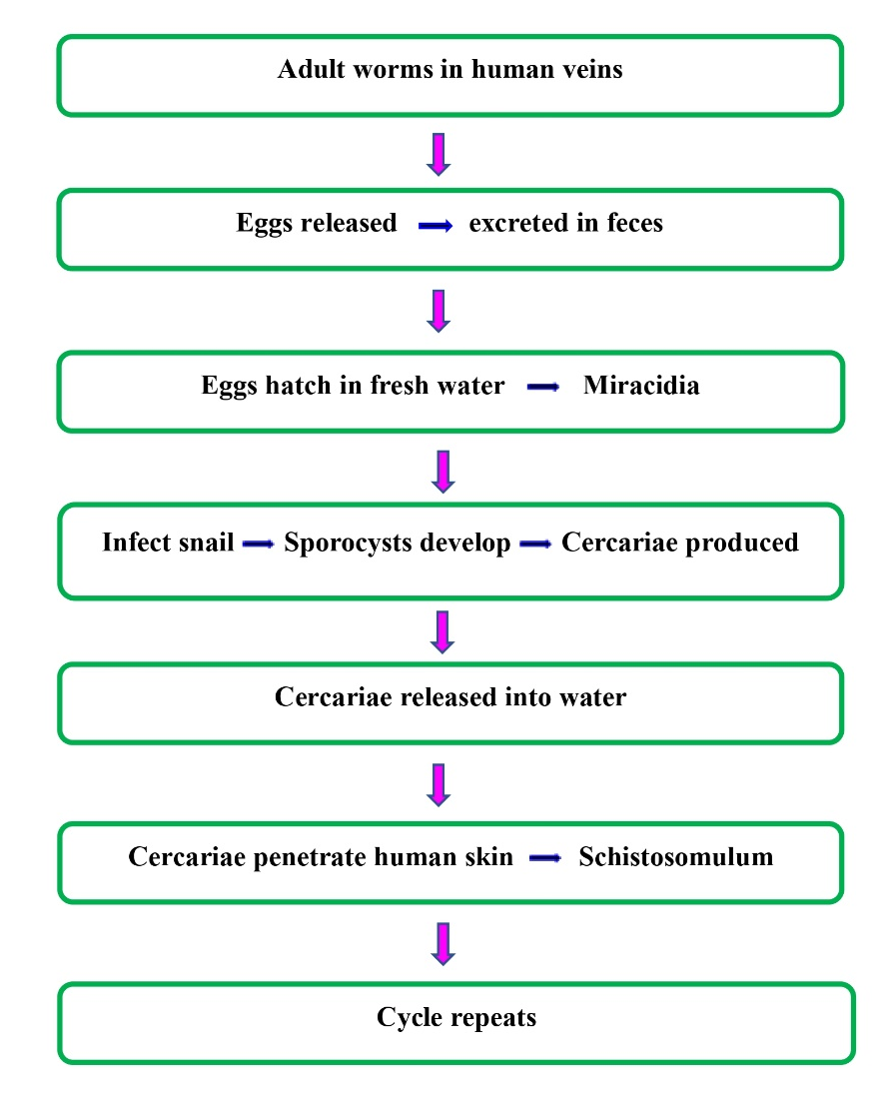
Fig. 1. Schistosoma transmission
Source: WHO (2025)
According to Colley et al. (2014) and WHO (2025), schistosomiasis, also called as bilharzia, is one of most prevalent NTDs. It affects more than 240 million individuals globally, with over 700 million at risk in 78 endemic nations, predominantly in sub-Saharan Africa, although certain areas of South America, Middle East, as well as Asia are also vulnerable. Gryseels et al. (2006) asserted that the disease is induced by blood flukes belonging to genus Schistosoma, with S. haematobium, S. mansoni, and S. japonicum being most notable human pathogenic species. However, other species, which include S. intercalatum and S. mekongi, are implicated in localised instances. After being discharged into freshwater, these free-swimming cercariae actively pierce lose their tails, human skin, and grow into schistosomula, which then move via circulation to liver and mature into adult worms (Fig. 1). To deposit “eggs, male and female worm pairs move to either venous plexus of bladder (in S. haematobium) or the mesenteric venules (in S. mansoni and S. japonicum). Granulomatous inflammation and fibrosis result from the retention of some of these eggs in host tissues and the expulsion of others (Colley et al., 2014). Acute symptoms consisting of rash, fever, and eosinophilia throughout the starting infection (Katayama syndrome) are common, but the clinical manifestation varies by species. In children, chronic challenges encompass hepatosplenic disease, portal hypertension, bladder fibrosis, hematuria, and an enhanced risk of bladder squamous cell carcinoma (SCC) (S. haematobium). As per the GBD 2019 Diseases and Injuries Collaborators (2020), schistosomiasis is estimated to result in about 1.9 million DALYs per year, a figure deemed low due to the omission of chronic morbidity and socioeconomic impact. To combat schistosomiasis, the current control method is MDA using praziquantel (PZQ), which employs a single oral medication. When used against adult worms, PZQ is inexpensive, safe, and very effective (Doenhoff et al., 2008). But PZQ has serious drawbacks: it doesn't work on immature schistosomula, so it needs to be used repeatedly for preventing reinfection; it doesn't provide prophylaxis; its mechanism of action is unclear, though it was thought to disrupt the worms' calcium homeostasis; and its effectiveness is waning in some endemic areas due to potential drug tolerance or developing resistance (Vale et al., 2017; Bergquist et al., 2017). Moreover, utilization of a singular chemotherapeutic intervention presents significant threat to long-term management methods, particularly because of parasite's intricate life cycle (Fig. 2) and elevated rates of reinfection in endemic areas characterized by insufficient sanitation as well as snail control (Gryseels et al., 2006; McManus et al., 2018). Without more extensive measures, schistosomiasis would continue to fuel cycles of poverty, disability, and socioeconomic stagnation in regions where it is endemic.

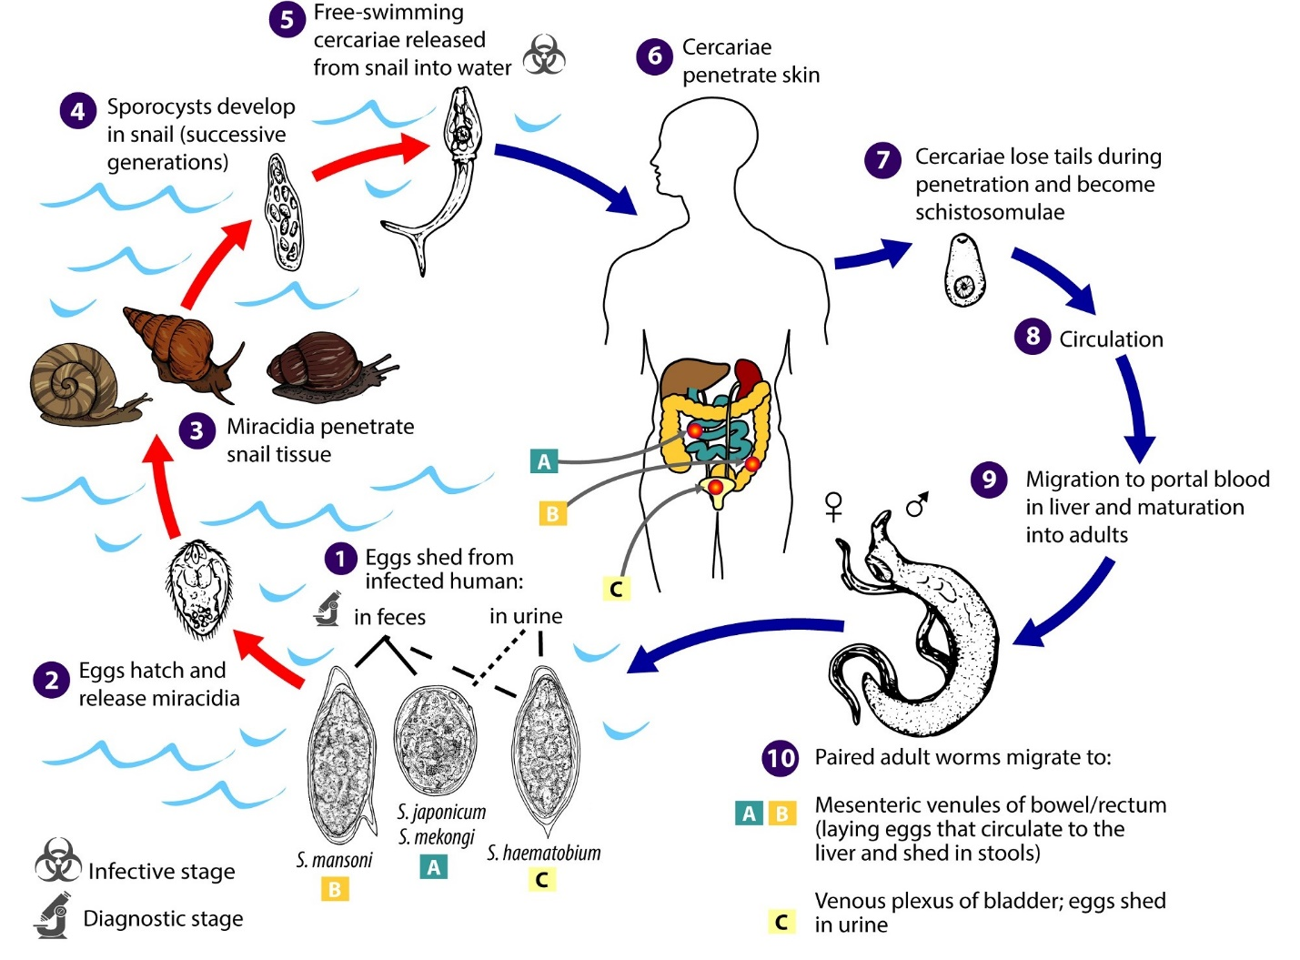
Fig. 2. Life cycle of Schistosoma

Source: Gryseels et al. (2006)

Given the constraints of available chemotherapeutic drugs, enhancing drug resistance, as well as necessity for cost-effective, readily available, and culturally appropriate treatments in resource-limited settings, natural therapies are gaining prominence in the management of NTDs. Conventional drugs, such as ivermectin for onchocerciasis and PZQ for schistosomiasis, have been at the forefront of mass control efforts, but their sustainability, efficacy, and ability to prevent reinfection have been questioned (Geary et al., 2010; Secor, 2014). Furthermore, there are no useful vaccines for most NTDs, and absence of financial perks has hindered enhancement of novel therapeutic drug pipelines (Pedrique et al., 2013). Against this backdrop, medicinal plants provide wealth of bioactive chemicals with anti-inflammatory, anti-parasitic, and immunomodulatory properties that might complement or even replace presently prescribed therapies (Derda & Hadas, 2015). The efficacy of phytochemicals in the identification of NTD pharmaceuticals is evidenced by the origin of several contemporary medicines, such as quinine for fever and artemisinin for malaria, which were initially discovered through ethnopharmacological insights (Newman & Cragg, 2020). In endemic regions with restricted access to standard pharmaceuticals, ethnobotanical studies in South America, Asia, and Africa have uncovered the widespread utilization of plants encompassing Phytolacca dodecandra, Artemisia annua, as well as Nigella sativa (Kloos et al., 1988; Steinmann et al., 2006). Moreover, to show efficacy against parasites at different phases of their life cycles, these natural therapies may work in concert with currently available medications to lower dosages and lower the chance of resistance (Keiser & Utzinger, 2007). Additionally, its incorporation into community-oriented healthcare systems aligns with local traditions, hence enhancing acceptance and adherence. Consequently, systematic examination of medicinal flora as well as bioactive constituents is a rational, economical, and culturally suitable method for addressing neglected tropical diseases and eliminating global health inequities.
Aim of this investigation is to present a thorough synthesis of preclinical, pharmacological, and ethnobotanical data on medicinal plants that have been shown to have anti-schistosomal properties. This includes information on the phytochemical components, mechanisms of action, and prospective therapeutic uses of these plants. In doing so, it aims to draw attention to both lesser-known plants with growing evidence of usefulness and well-studied species like Phytolacca dodecandra, Artemisia annua, along with Jatropha curcas. Furthermore, this review is not just about listing compounds derived from plants; it also critically assesses gaps in present knowledge, methodological limitations in experimental research, moreover issues related to standardization, safety analysis, and clinical application. This review's ultimate goals are to inform next drug development initiatives, facilitate the use of tried-and-true herbal treatments in the treatment of schistosomiasis, and contribute to the global effort to develop accessible, sustainable, and culturally satisfactory therapies for NTDs.
2. METHODOLOGY
A comprehensive search of peer-reviewed literature was carried out across major scientific databases including PubMed, Scopus, Web of Science, ScienceDirect, and Google Scholar, supplemented with reference chaining from relevant research and review papers and World Health Organization (WHO) reports. The search strategy combined Medical Subject Headings (MeSH) and free-text keywords such as “schistosomiasis,” “Schistosoma,” “herbal medicine,” “plant extract,” “natural product,” “molluscicide,” “antischistosomal activity,” and “complementary therapy,” with Boolean operators (AND, OR) to refine results. The inclusion criteria were: (i) original experimental studies on in vitro or in vivo models evaluating the antischistosomal or molluscicidal potential of plant extracts or isolated phytochemicals; (ii) clinical trials or observational studies assessing herbal interventions in schistosomiasis patients; (iii) review articles summarizing plant-based therapies or snail control methods; (iv) publications between 1980 and 2025 in English. Exclusion criteria included studies with insufficient methodological detail, conference abstracts without peer review, reports in languages other than English without available translations, and articles exclusively addressing synthetic drugs or vaccines without reference to plant-derived compounds.
3. OVERVIEW OF SCHISTOSOMIASIS
The genus Schistosoma, responsible for schistosomiasis, is characterized by species-particular geographic distribution, pathophysiology, as well as intermediate snail hosts. According to Colley et al. (2014) and McManus et al. (2018), 6 of more than 20 species that have been discovered are believed to have major medicinal importance for humans: Schistosoma mansoni, S. haematobium, S. japonicum, S. mekongi, S. intercalatum, and S. guineensis. Schistosoma mansoni is predominant species, located in areas of South America, particularly Brazil, as well as the Middle East and sub-Saharan Africa. Intermediate hosts are snails of Biomphalaria species, that cause intestinal schistosomiasis (Gryseels et al., 2006). Urogenital schistosomiasis is induced by Schistosoma haematobium, predominantly seen in Africa and Middle East. The genus Bulinus of freshwater snails’ functions as its intermediate host (Rollinson et al., 2013). IARC Working Group on the Evaluation of Carcinogenic Risks to Humans (2012) denoted that chronic infections are linked with hydronephrosis, hematuria, bladder fibrosis, as well as enhanced risk of bladder SCC. Besides small foci in Indonesia, Schistosoma japonicum is identified in China and Philippines. The snails Oncomelania spp. transmit infections, resulting in intestinal and hepatosplenic schistosomiasis. This is a zoonotic species, and it is challenging to eradicate because of the numerous animal reservoirs, including rodents, cattle, and water buffalo (McManus et al., 2018). Geographically limited to Cambodia and the Lao PDR's Mekong River region, Schistosoma mekongi feeds on Neotricula aperta snails as intermediate hosts. Similar to S. japonicum, the infections are more localised (Attwood et al., 2008). The intestinal schistosomiasis takes place because of S. guineensis and S. intercalatum, which are limited to tiny areas of Central and West Africa. Locally, they are significant, although their epidemiological significance is not as significant as that of the big species. Because these species variances impact the region's health policy, snail control priorities, and intervention approaches, they are crucial to epidemiology, clinical results, and control techniques (Gryseels et al., 2006; Colley et al., 2014).
3.1. Clinical manifestations of schistosomiasis
Acute schistosomiasis, often referred to as Katayama fever, frequently affects non-immune persons, which includes migrants or tourists, several weeks following initial exposure to Schistosoma cercariae. Immune response to migratory schistosomula and egg deposition is responsible for resulting effects. Clinical manifestations comprising diarrhoea, eosinophilia, fever and chills, abdominal discomfort, myalgia, fatigue, and nonproductive cough (Ross et al., 2002; Tabilin et al., 2025). At the location of cercarial penetration, urticarial skin lesions, sometimes known as "swimmer's itch," may develop. Because of their high egg production and potent systemic immunological responses, S. japonicum and S. mansoni infections are especially linked to Katayama syndrome (McManus et al., 2018). Chronic schistosomiasis advances over months and years as a result of granulomatous inflammation, persistent egg deposition, and ensuing fibrosis. The parasite species and the place of egg deposition determine the clinical appearance. 1. Hepatosplenomegaly, periportal fibrosis, diarrhoea, chronic abdominal pain, as well as portal hypertension that can result in esophageal varices along with hematemesis, are the hallmarks of intestinal schistosomiasis (S. mekongi, S. mansoni, S. intercalatum, S. japonicum, and S. guineensis) (Colley et al., 2014; Gryseels et al., 2006). 2. Hematuria, dysuria, bladder wall fibrosis, hydronephrosis, and ureteric blockage are the hallmarks of urogenital schistosomiasis (S. haematobium). Chronic infection is associated with female genital schistosomiasis, infertility, heightened vulnerability to HIV, and is identified as a risk variable for bladder SCC (IARC Working Group on the Evaluation of Carcinogenic Risks to Humans, 2012; Kjetland et al., 2012). Neurological schistosomiasis is characterized by atypical egg deposition in CNS, potentially resulting in spinal cord lesions, seizures, or transverse myelitis, primarily associated with S. japonicum and S. mansoni (Carod-Artal, 2008). Consequently, chronic schistosomiasis arises from enduring granulomatous inflammation and fibrosis, leading to increased morbidity and death in endemic regions, whereas acute schistosomiasis is immune-mediated and transient.
3.2. Current treatment strategies and limitations of schistosomiasis
According to Colley et al. (2014) and Cioli et al. (2014), the major technique of schistosomiasis control is chemotherapy along with PZQ, a pyrazinoisoquinoline derivative that was initially created in the 1970s and is the only medication that is now available that is efficient against all major human Schistosoma species. Because it is safe, affordable, and very successful at lowering the burden of worms, the WHO advocates for widespread preventative chemotherapy using MDA, especially for school aged childs as well as at-risk groups (WHO, 2025). Despite concerns over resistance in malaria-endemic regions, artemisinin compounds exhibit possible synergistic advantages with combined therapy, especially against juvenile schistosomes. Supplementary drugs, which encompass oxamniquine, have efficacy against S. mansoni but are infrequently utilized (Siqueira et al., 2017; Bergquist et al., 2017; Keiser & Utzinger, 2007). Notwithstanding these advancements, notable restrictions persist, including reports of diminished curative effectiveness, particularly in high-transmission areas, indicating potential tolerance development or the selection of less susceptible parasite strains, although the prevalence of clinical resistance to PZQ remains undetermined (Vale et al., 2017). This danger is increased by use of a single medication to achieve worldwide control. 2. Because of continuous interaction with tainted water sources, people in endemic regions are often quickly re-exposed, and PZQ does not prevent reinfection. Due to the need for recurrent mass treatments, this can be both monetarily and logistically difficult (Gryseels et al., 2006; Rollinson et al., 2013). 3. If therapy has been administered quickly after exposure, PZQ can result in chronic infections since it is more efficient against developed worms and has lower effectiveness against juvenile schistosomula (Cioli et al., 2014). 4. Despite decades of study, no approved vaccine is presently on the market. None of the candidates that target surface or tegumental antigens (such as Sm14, Sh28GST, and Sm-TSP-2) has shown enough effectiveness to be used widely, despite the fact that some have started early clinical studies (Hotez et al., 2006). 5. Inadequate snail management, substandard sanitation, and insufficient access to clean water hinder sustainable disease mitigation efforts and extend transmission periods (McManus et al., 2018). PZQ-based chemotherapy is efficient in diminishing morbidity; however, issues such as drug resistance, swift infection transmission, the lack of preventive measures, and the absence of vaccine underscore critical requirement for holistic control strategies that blend chemotherapy along enhanced water quality, sanitation, snail management, moreover continuous vaccine development.
4. PLANT-DERIVED BIOACTIVE COMPOUNDS IN TREATING SCHISTOSOMIASIS
Plant-derived bioactive compounds gain interest as substitutes or supplementary methods for controlling schistosomiasis due to they can directly affect parasites, modify host immunity, target snail intermediate hosts, or function in conjunction along PZQ (de Moraes, 2015; De Carvalho Augusto & De Mello-Silva, 2018). Various phytochemical categories, encompassing saponins, tannins, flavonoids, sesquiterpene lactones (Fig. 3) (which include artemisinins), alkaloids, as well as diterpenoids, exhibit promising antischistosomal or molluscicidal effects. The most well-documented saponins are those from Phytolacca dodecandra (Endod). They were employed in community-level experiments in reducing intermediate host density and exhibit potential molluscicidal impacts by destroying cell membranes as well as surface epithelia of Biomphalaria snails (Lemma et al., 1972; Erko et al., 2002). Saponins have cercaricidal properties, reducing cercarial viability in contaminated water and diminishing transmission risk (De Carvalho Augusto & De Mello-Silva, 2018). Nonetheless, two major obstacles to wider adoption are ecological toxicity to non-target species and fluctuations in saponin concentration. Artemisinin and its derivatives (artesunate, artemether), sesquiterpene endoperoxides sourced from Artemisia annua, produce reactive oxygen species (ROS) via endoperoxide activation in existence of iron/heme, exhibiting schistosomicidal efficacy, especially against juvenile schistosomes, lead to parasite impairment (Xiao et al., 2002; Utzinger et al., 2007). Crucially, PZQ may be supplemented with artemisinins, which target the early embryonic phases that PZQ negatively impacts. Combination therapies have exhibited superior cure rates in both experimental as well as few clinical investigation (Keiser & Utzinger, 2007). The widespread deployment of Plasmodium spp. in malaria co-endemic regions requires caution on account of potential selection pressure and drug interaction problems. Polyphenols and flavonoids (like quercetin) work against parasites by generating radicals, blocking important parasite enzymes, and modifying the immune system. Few tannin-rich extracts reduce egg hatchability, as well as viability, while curcumin (Fig. 3) (Curcuma longa) has anti-fibrotic and anti-inflammatory properties that alleviate hepatosplenic pathology in chronic infections (de Moraes, 2015; El-Seedi et al., 2023). Alkaloids, which encompass berberine and other diterpenoids from Jatropha species, demonstrate cercaricidal and molluscicidal effects in-vitro as a result of membrane rupture as well as metabolic pause (Kela et al., 1989; Vale et al., 2017).
According to De Carvalho Augusto & De Mello-Silva (2018), plant bioactives work in a number of ways, including: (1) direct tegumental disruption moreover metabolic poisoning of worms; (2) induction of oxidative stress; (3) interference with the neuromuscular action of parasites; (4) Restriction in egg production/viability; (5) neurotoxic effects as well as molluscicidal surfactant on snails. Although consistent dose, pharmacokinetics, safety profiles, and formulation continue to be significant obstacles, multi-target action lessens the possibility that single-point resistance may develop quickly. Consequently, phytochemicals present promising opportunities for schistosomiasis management as adjuncts, either as molluscicides for water therapeutic intervention or as supplementary medications to PZQ; however, before widespread application, they must undergo controlled trials, comprehensive preclinical toxicology, along with ecological risk assessments (Bergquist et al., 2017).
4.1. Mechanisms of action
4.1.1. Anti-schistosomal activity
Bioactive compounds obtained from plants that affect tegument integrity, neuromuscular function, oxidative balance, energy metabolism, as well as reproductive capacity provide direct anti-schistosomal effects on cercariae, eggs, schistosomula, and adult worms. For reducing transmission at the environmental stage, Phytolacca dodecandra's saponins (Fig. 3) function as surface-active agents that break down the lipid membranes of snail hosts as well as free-living cercariae, resulting in membrane permeabilization and death (De Carvalho Augusto & De Mello-Silva, 2018; Lemma et al., 1972). Studies conducted in-vitro have demonstrated that extracts high in saponins decrease cercarial motility and vitality, which in turn lowers cercarial infectivity in polluted water (de Moraes, 2015; Erko et al., 2002). In existence of heme/iron, artemisinin along with its derivatives (sesquiterpene endoperoxides from Artemisia annua) produce ROS in a peroxide-dependent manner, which causes macromolecular damage and parasite death in juvenile schistosomula and immature worms (Xiao et al., 2002; Utzinger et al., 2007). PZQ is less efficacious against initial growth phases; thus, artemisinins are particularly beneficial as adjuncts for targeting juveniles, moreover, expedite their maturation into egg-laying adults (Keiser & Utzinger, 2007) (Table 1).
Kela et al. (1989) and Vale et al. (2017) indicate that diterpenoids, triterpenoids, moreover phorbol esters derived from Jatropha spp. along with other therapeutic plants exhibit cercaricidal and adulticidal properties in-vitro, likely due to membrane destabilization as well as disruption of energy metabolism. According to de Moraes (2015), alkaloids like berberine (Fig. 3) and a number of flavonoids might hinder motility and viability by inhibiting important parasite enzymes, including proteases and antioxidant enzymes
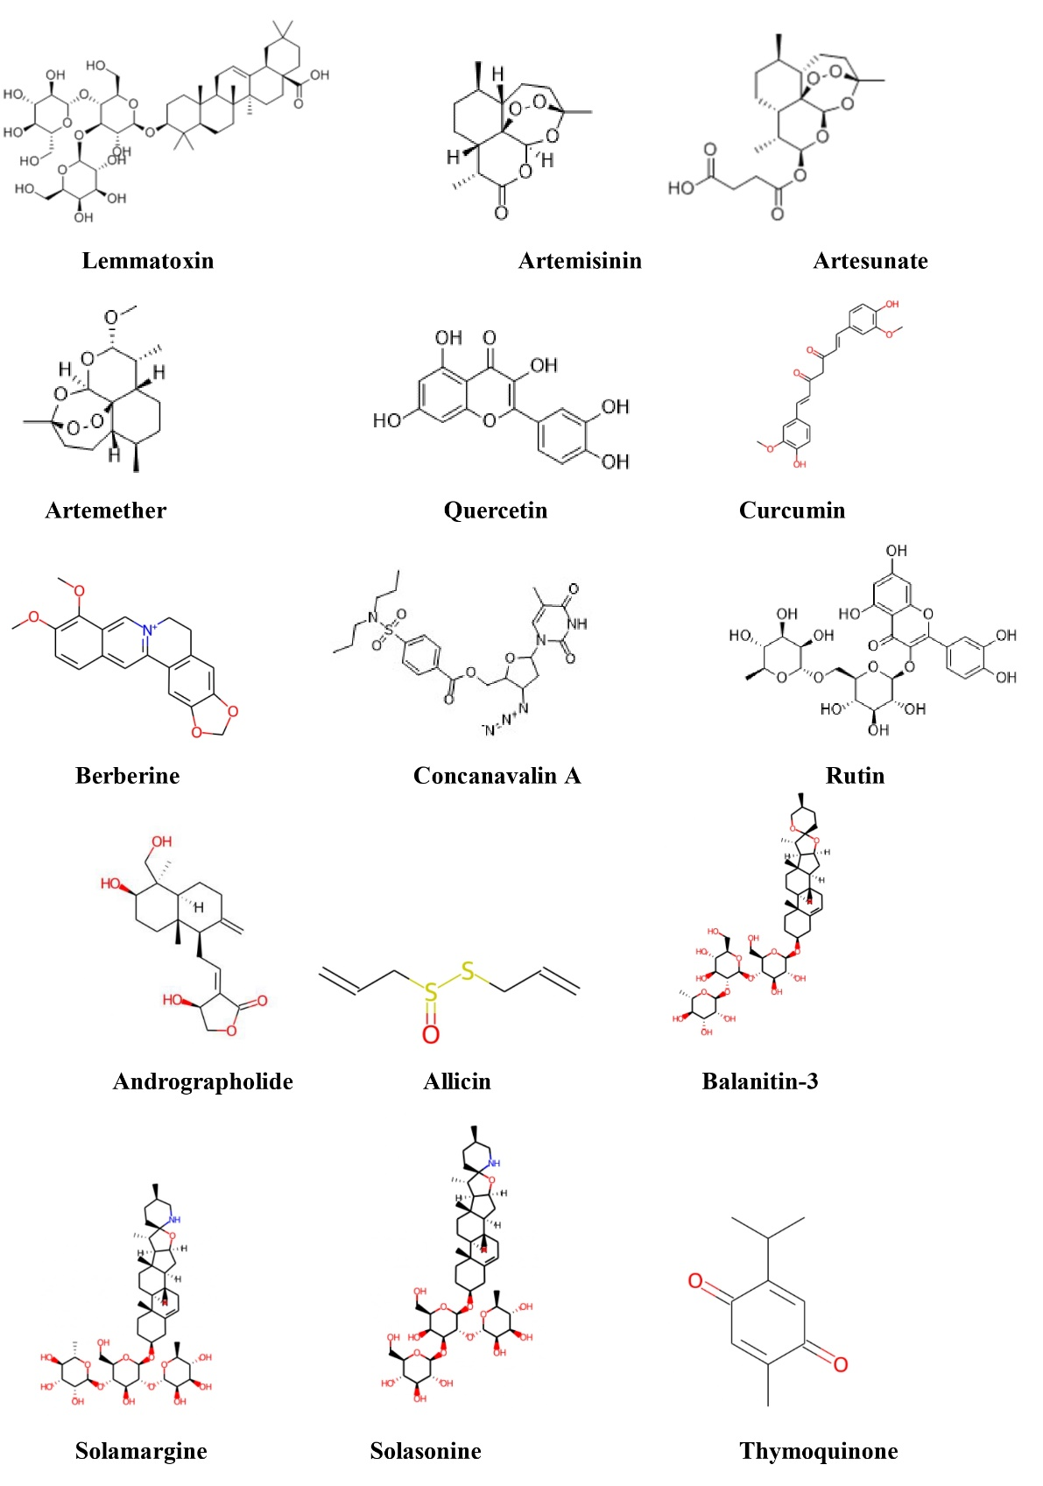
Fig. 3. Bioactive compounds from plants in handling schistosomiasis
Source: PubChem (https://pubchem.ncbi.nlm.nih.gov/)

(Table 1). Tannins and polyphenolic extracts diminish reproductive success and transmission potential by reducing egg viability and obstructing the hatching of miracidia and cercariae (El-Seedi et al., 2023). Schistosome tegument, parasite's outer syncytial layer essential for food absorption moreover immune avoidance, is mechanistically influenced by several plant chemicals. This leads to sloughing, vacuolization, moreover loss of surface antigens, all of which undermine physiology and render worms susceptible to host immunological responses (de Moraes, 2015). Some target neuromuscular signalling to provoke paralysis and disconnection from host tissues, while others produce oxidative stress that surpasses the parasite's antioxidant capabilities. Despite inconsistent potency, insufficient extract standardization, absence of pharmacokinetic data, as well as ecological issues (for molluscicides) hindering swift field implementation, multi-target mechanisms diminish probability of single-point resistance development. To convert promising in-vitro results into safe and efficacious pharmaceuticals, thorough bioassay-guided fractionation, standardization, and in-vivo efficacy and toxicity evaluations are required (Bergquist et al., 2017; De Carvalho Augusto & De Mello-Silva, 2018).
4.1.2. Immunomodulatory actions
Plant bioactives frequently alter host immune responses, facilitating the management of schistosome infections and reducing disease severity. Parasite clearance and tissue damage are affected by immunomodulatory pathways, encompassing modulation of T-helper subsets, enhancement of macrophage as well as dendritic cell functions, alteration of cytokine synthesis, moreover regulation of granuloma formation alongside fibrosis. Various classes of chemicals have the capacity to regulate the immune system. Polysaccharides and lectins derived from medicinal plants function as immunostimulants by promoting antigen presentation, macrophage phagocytosis, and initial synthesis of nitric oxide and pro-inflammatory cytokines, thus enhancing innate recognition as well as preventing early parasite development (de Moraes, 2015). Reports indicate that flavonoids and saponins can enhance Th1-associated macrophage activation, facilitating parasite eradication, or foster a balanced Th1/Th2 response, while simultaneously averting excessive Th2-mediated granulomatous reactions that result in fibrosis (McManus et al., 2018; El-Seedi et al., 2023).
The pathophysiology of schistosomiasis is mostly immune-mediated: fibrosis is caused by chronic type-2 (Th2) inflammation, and granulomas develop around trapped eggs. Certain phytochemicals, such as flavonoids and curcuminoids, can attenuate granuloma size and collagen accumulation by downregulating critical pro-fibrotic moreover pro-inflammatory pathways, including TGF-β (Transforming Growth Factor-beta) signaling, NF-κB (Nuclear Factor kappa-light-chain-enhancer of activated B cells), as well as profibrotic cytokines (Interleukins: IL-13, IL-4). When adequately managed, this immunoregulation may decrease morbidity despite sacrificing anti-parasite immunity. In comparison to antiparasitic treatment alone, experimental models show that combining immune modulators with antiparasitic plant-derived compounds produces synergistic benefits like decreased egg production, decreased worm burdens, as well as attenuated hepatic fibrosis (Keiser & Utzinger, 2007; Bergquist et al., 2017). Derivatives of artemisinin, for example, may alter host immune responses to assist in eradicating lingering parasites in addition to killing young worms directly (Utzinger et al., 2007). Before clinical application, it is essential to standardize extracts, identify active immunomodulatory components, characterize dose-response relationships, and conduct safety assessments, encompassing their impact on immunization response as well as co-infections which encompass malaria or HIV (Hotez et al., 2006).
4.1.3. Anti-inflammatory and antioxidant properties
Portal hypertension, Hepatic periportal fibrosis, and bladder fibrosis are examples of chronic schistosomiasis morbidity that is caused by oxidative tissue damage and persistent inflammation caused by eggs that become stuck in host organs. Plant-originated anti-inflammatory and antioxidant molecules may offer therapeutic benefits by mitigating oxidative damage, suppressing pro-fibrotic signalling, as well as diminishing tissue remodeling. Curcumin, derived from Curcuma longa, is a fundamental anti-inflammatory and antioxidant phytochemical having diverse properties (Table 1). It prevents expression of pro-inflammatory cytokines (TNF-α, IL-1β, and IL-6), obstructs NF-κB activation, moreover down-regulates TGF-β signaling associated with fibrosis (Aggarwal & Harikumar, 2009). Curcumin and associated polyphenols have demonstrated efficacy in experimental schistosomiasis models by reducing hepatic granuloma size, diminishing collagen deposition, and normalizing oxidative stress markers (enhanced glutathione as well as antioxidant enzyme properties, reduced lipid peroxidation), thereby enhancing histopathology (El-Seedi et al., 2023).
Flavonoids (quercetin, rutin) (Fig. 3) demonstrate antioxidant effects by neutralizing free radicals, chelating transition metals, moreover enhancing endogenous antioxidant defenses (catalase, superoxide dismutase, and glutathione peroxidase). These effects reduce the activation of stellate cells that facilitate collagen synthesis and safeguard hepatocytes as well as uroepithelial tissues from oxidative damage caused by eggs (de Moraes, 2015). Together, polyphenols restrict extracellular matrix remodeling by inhibiting matrix metalloproteinases and lowering the synthesis of pro-inflammatory eicosanoids. By reducing the burden of parasites and eggs (via molluscicidal or antiparasitic action), saponins and tannins indirectly give anti-inflammatory effects by lessening antigenic stimulation, which perpetuates chronic inflammation (De Carvalho Augusto & De Mello-Silva, 2018). Certain alkaloids and diterpenoids have direct antiparasitic as well as antioxidant qualities, which allow them to reduce host tissue damage while also eliminating parasites (Kela et al., 1989; Vale et al., 2017).
Antioxidant phytochemicals operate through mechanisms that consist of direct ROS scavenging, inhibition of ROS-generating enzymes (NADPH oxidase), activation of cytoprotective transcription factors (Nrf2-Nuclear factor erythroid 2-related factor 2), and modulation of redox-sensitive pro-fibrotic signalling (e.g., TGF-β/Smad) (Aggarwal & Harikumar, 2009). By lowering oxidative stress and inflammatory signalling, these substances may lessen granuloma, limit collagen deposition, and improve functional results (better renal drainage, decreased portal pressure). Preclinical preponderance of data, dosage variability in crude extracts, and less bioavailability (e.g., curcumin) are some of the drawbacks. Strict pharmacokinetics, controlled trials in endemic communities, and bioavailability enhancement (nanoformulations, adjuvants) are necessary to assess therapeutic value. Additionally, the interactions should be described as safe and non-antagonistic when using popular antiparasitic medications (Bergquist et al., 2017; McManus et al., 2018). Therefore, antioxidant and anti-inflammatory phytochemicals present intriguing supplementary approaches to lower the morbidity of schistosomiasis; nevertheless, standardization of products and human efficacy evidence are necessary for policy translation.

Table 1. Medicinal Plants Investigated for Schistosomiasis
Plant | Key  phytochemical (s) | Mechanism (s) | Experimental evidence | References
Artemisia annua L. | Artemisinin, artemether, artesunate | Endoperoxide activation → ROS generation; damage to tegument; active vs juveniles | In vitro and murine studies showing juvenile killing and reduced worm burdens; human prophylaxis trials vs  S. japonicum | (Xiao et al., 2002; Utzinger et al., 2007)
Jatropha curcas L. | Diterpenoids, phorbol esters | Membrane perturbation; metabolic/neurotoxic effects on cercariae/snails | Laboratory molluscicidal and cercaricidal bioassays | (Kela et al., 1989)
Phytolacca dodecandra L’Hér. | Triterpenoid saponins | Surfactant-like membrane disruption → molluscicidal & cercaricidal | Community and lab studies in Ethiopia: reduced Biomphalaria density and cercarial viability | (Lemma et al., 1972; Erko et al., 2002)
Nigella sativa L. | Thymoquinone, nigellone | Immunomodulation; antioxidant; indirect antiparasitic effects | Rodent studies: reduced worm burden, improved liver histology; small adjunct human observations | (Mahmoud et al., 2002)
Allium sativum L. | Allicin and other organosulfur compounds | Direct antiparasitic (membrane/metabolic disruption); antioxidant & immunomodulatory | Murine studies show reduced worm/egg counts and improved liver markers; adjunct effects with PZQ reported | (Riad et al., 2013)
Curcuma longa L. | Curcumin (curcuminoids) | Anti-inflammatory (NF-κB/TGF-β inhibition); antioxidant; anti-fibrotic | Rodent models: reduced granuloma size, collagen deposition; improved oxidative markers; additive effects with PZQ | (Allam, 2009)
Azadirachta indica A. Juss. | Limonoids (Azadirachtin), flavonoids | Molluscicidal/cercaricidal (neurotoxic & metabolic disruption); immunomodulation | Lab assays: reduced cercarial motility, snail mortality; some in vivo rodent reductions | (Molla et al., 2013)
Other promising species  Balanites aegyptiaca Del.  Solanum nigrum L.  Phyllanthus amarus Schumach. & Thonn.  Withania somnifera (L.) Dunal | saponins  solanine  phyllanthin  withanolides | Mix of molluscicidal, cercaricidal, ovicidal, adulticidal, antioxidant, immunomodulatory actions | Mainly in vitro and rodent evidence showing reduced cercarial viability, impaired egg hatching, lower worm burdens | (Ndamba et al., 1994; El-Seedi et al., 2023)

5. LABORATORY-BASED STUDIES
There is strong evidence from laboratory studies that bioactive chemicals derived from plants have direct anti-schistosomal action at several phases of the life cycle, encompassing cercariae, schistosomula, adult worms, and eggs. These in-vitro investigations are essential for locating possible leads, clarifying processes, moreover directing further in-vivo verification.
5.1. Cercaricidal activity: Phytolacca dodecandra preparations high in saponins have continuously shown potent cercaricidal actions, immobilizing and killing Schistosoma mansoni cercariae quickly upon exposure (Lemma et al., 1972; Erko et al., 2002). The cercaricidal effect of Jatropha curcas seed extracts was also shown to be dependent on both time and concentration, and was ascribed to diterpenoids as well as phorbol esters (Kela et al., 1989). Cercarial motility and viability were similarly affected by ethanolic extracts of Azadirachta indica and Allium sativum, highlighting their action in water treatment methods (Molla et al., 2013) (Table 1).
5.2. Ovicidal activity: Miracidial viability as well as egg hatchability are decreased by a number of plant extracts that include tannin and polyphenols (Table 1). Balanites aegyptiaca methanolic extracts, for instance, prevented S. haematobium eggs from hatching in vitro, indicating disruption of embryonation as well as viability (El-Seedi et al., 2023). By decreasing the production of miracidia and damaging the morphology of eggs, flavonoid-rich extracts of Solanum nigrum also showed ovicidal action (Ndamba et al., 1994). Ovicidal action is particularly significant since it targets egg-to-miracidium phase, therefore directly lowering the risk of transmission.
5.3. Adulticidal activity: It has been discovered that juvenile as well as adult schistosomes in in-vitro microenvironment are very susceptible to artemisinin derivatives (such as artemether and artesunate) of Artemisia annua, which cause vacuolization, tegumental damage, moreover reduced motility (Xiao et al., 2002; Utzinger et al., 2007). Polymerized phenols, such as curcumin, demonstrated their combined anti-parasitic and anti-inflammatory qualities by causing tegumental disruption and reduced viability in adult worms (de Moraes, 2015). Because alkaloids like berberine interfere with neuromuscular co-ordination and metabolic enzymes, they impair worm movement and survival (Vale et al., 2017).
Microscopic analysis has shown distinctive morphologic modifications, which comprises blistering, tegument sloughing, as well as loss of spines, in the majority of these investigations. These changes impair the parasite's ability to fend off host immunity (de Moraes, 2015). Several plant-based chemicals frequently cause declined motility, decreased egg-laying, moreover increased susceptibility to immunological effector mechanisms. The capacity of plant-derived bioactives to directly impair parasite survival and disrupt their lifecycle phases was highlighted by in vitro studies. They have several-target activity, that will supplement existing chemotherapeutics as well as offer logical basis for further in vivo and clinical research since they have cercaricidal, ovicidal, and adulticidal effects.
5.4. Experimental Models (Rodent Studies)
Rodent models (rats and mice) have been primary focus of experimental research on schistosomiasis because they enable the controlled evaluation of plant bioactive components. Preclinical research benefit greatly from these models as they replicate the majority of characteristics of human infection, including but not limited to hepatic fibrosis, granulomatous inflammation, moreover immunological regulation (Colley et al., 2014; McManus et al., 2018). Artemisinin derivatives like artemether and artesunate showed a considerable decrease in the worm load in mice infected with Schistosoma mansoni, especially against young worms that are frequently resistant to PZQ (Xiao et al., 2002). Similarly, oral curcumin corroborated the anti-parasitic and hepatoprotective action by increasing oral dosage in S. mansoni-infected mice and egg load, decreasing granuloma size, as well as oxidative stress markers (Allam, 2009). In mouse models, Nigella sativa seed extracts decreased worms as well as enhanced liver histology, that was linked with thymoquinone's immunomodulatory effects (Mahmoud et al., 2002) (Table 1).
Plant extracts with potent molluscicidal action were shown in vivo. Extracts from Phytolacca dodecandra berries decreased number of eggs and worm burden in mice, confirming previous in-vitro results (Erko et al., 2002). Similarly, in animal models, fruit extracts from Balanites aegyptiaca demonstrated notable schistosomicidal actions, resulting in decreased hepatic granulomas moreover enhanced antioxidant properties (El-Seedi et al., 2023). Studies on rodents have also documented immune-modulatory effects, where phytochemicals reduce parasite burden while also improving protective Th1/Th2 ratios and inhibiting pro-inflammatory cytokines (e.g., TNF-α, IL-6) (Riad et al., 2013). These two outcomes demonstrate both the direct parasiticidal action and therapeutic properties of chemicals derived from plants. Generally speaking, rodent models provide strong experimental evidence in favor of using plant-derived medicines to treat schistosomiasis. These preclinical findings serve as a bridge between actual human clinical trials and laboratory screening.
5.5. Synergistic Effects with Praziquantel and Phytochemicals
Although PZQ is core of therapy for schistosomiasis, its drawbacks, poor efficacy in young worms, emergence of resistance, moreover danger of reinfection necessitate the use of additional treatments (Colley et al., 2014; Vale et al., 2017). Combining PZQ along bioactive compounds obtained from plants has emerged as viable method to increase therapy efficacy and reduced dose. It has been discovered that the artemisinin-based derivatives artesunate and artemether of Artemisia annua work extremely well with PZQ. Combined dose was more efficient than either treatment alone in lowering worm burden, particularly against refractive young worm against PZQ, according to experimental trials done on mice infected with Schistosoma mansoni (Xiao et al., 2002; Utzinger et al., 2007). This dual effect results from the endoperoxide bridge of artemisinin, that produces worm-toxic ROS in addition to PZQ's tegumental disruption.
According to some reports, the schistosomicidal effects of PZQ are enhanced by curcumin, polyphenolic substance derived from Curcuma longa. Curcumin's antioxidant and immunomodulatory properties were demonstrated in mouse models when the combined treatment dramatically decreased granuloma size, oxidative stress, and hepatic fibrosis in comparison to solotherapy (Allam, 2009). Similarly, Nigella sativa (black seed) oil that included thymoquinone enhanced PZQ's antiparasitic action, decreased liver damage, and controlled pro-inflammatory cytokines (Mahmoud et al., 2002). Alternative possible phytochemicals include extracts from Allium sativum, which, when combined with PZQ, enhanced worm mortality as well as liver function in schistosomiasis tests. The association of garlic and PZQ was superior to PZQ in terms of lowering worm egg deposition and restoring normal blood liver enzyme levels (Riad et al., 2013). According to El-Seedi et al. (2023), extracts rich in polyphenols from Solanum nigrum and Balanites aegyptiaca also showed synergistic potential along PZQ, indicating broad application across several medicinal plants. Synergistic effects are not limited to better worm killing. In addition to reducing schistosomiasis-induced liver damage, phytochemicals' anti-inflammatory, immunomodulatory, and antioxidant properties also control host immunity, pathological reaction to parasite moreover its removal. Significantly, combined treatments allow for lower PZQ dosages, which may lower the likelihood of resistance and avoid negative medication interactions.
6. CLINICAL TRIALS AND HUMAN STUDIES
Despite being the primary chemotherapeutic drug for decades in the treatment of schistosomiasis, PZQ has not yet been the subject of human research or clinical studies regarding its limits or potential use as an adjuvant therapy. According to Danso-Appiah et al. (2013) and Colley et al. (2014), PZQ is highly efficacious against adult schistosomes, with cure rates in between 70% and 90%, relying upon the parasite species as well as severity of infection. However, ineffectiveness against young worms, ineffectiveness lack areas with significant transmission, and the risk of drug resistance underscore the need for treatment choices to be more varied (Vale et al., 2017).
6.1. Praziquantel clinical investigation: The incidence and morbidity rates have continued to decline as a result of MDA programs, particularly those implemented on broad scale in sub-Saharan Africa. Single dose of PZQ (40mg/kg) is deemed safe and produces minimal, brief side effects, that encompass dizziness and abdominal pain, as indicated by a meta-analysis of randomized studies (Danso-Appiah et al., 2013). Reinfection persists in endemic regions, requiring numerous rounds of MDA.
6.2. Artemisinin derivatives: Numerous clinical trials have examined the use of artesunate and artemether, which are primarily antimalarials, to treat schistosomiasis. Chinese randomized controlled studies demonstrated that artemether prophylaxis, which targets young worms, was a successful strategy for eradicating S. japonicum infections (Xiao et al., 2002; Utzinger et al., 2007). Results vary according to species and time of administration; nevertheless, combination treatment along PZQ is evaluated in Africa and Asia, demonstrating enhanced efficacy against schistosomes at various developmental stages (Keiser & Utzinger, 2007).
6.3. Plant-derived adjuncts: Despite a shortage of clinical trials on plant-based medicines, preliminary human investigations are promising. A brief study conducted in Egypt indicated that the supplementation of Nigella sativa oil with PZQ had been highly effective than PZQ alone in diminishing egg counts and clinical symptoms (Mahmoud et al., 2002). Similarly, in Sudan, eating Allium sativum has been clinically shown to improve patient outcomes and reduce liver morbidity, although further research is needed (Riad et al., 2013).
6.4. Vaccination trials: In addition to chemotherapy, a number of potential vaccines, which include Sm14 (Schistosoma mansoni 14-kDa fatty acid-binding protein) as well as Sm-TSP-2 (Schistosoma mansoni tetraspanin-2), are evaluated in phase I/II human trials; preliminary results show that they are safe and immunogenic (Molehin, 2020). However, there is insufficient effectiveness data available for use. The crucial significance of PZQ is reiterated by clinical research, which also highlights the need for combination treatments such as vaccinations, natural adjuncts, and combination medicines. Robust, large-scale randomized controlled trials are necessary for establishing safety and therapeutic efficacy of phytochemicals in endemic populations, notwithstanding their success in preclinical as well as small-scale human clinical investigations.
7. CHALLENGES AND LIMITATIONS
Despite promising preclinical findings, a number of barriers stand in the way of the widespread use of plant-based treatments for schistosomiasis. Traditional treatments usually use powders, decoctions, or crude extracts, which might lead to differences in efficacy and repeatability between investigations (De Carvalho Augusto & De Mello-Silva, 2018). It is difficult to gain regulatory permission because the produced findings cannot be compared due to the absence of authorized extraction, purification, and quality control techniques. Geographical location, soil structure, climate, harvest period, and extraction technique all have a significant impact on the amount of bioactive compounds (de Moraes, 2015). For instance, the concentration of curcumin in Curcuma longa or the amounts of saponin in Phytolacca dodecandra might differ greatly, which can affect both safety as well as efficacy. Significant obstacles to scalability and consistent therapeutic application are presented by this chemical variability. Few human randomized control trials (RCTs) have been conducted, despite numerous in-vitro as well as in-vivo investigations demonstrating anti-schistosomal, along with immunomodulatory benefits of plants. There is little information about effectiveness and safety because most clinical trials are small, observational, or adjunctive (Bergquist et al., 2017). Many plant extracts are thought to be natural and hence harmless, yet in high doses, many of the bioactive chemicals are harmful to people or non-target creatures. For example, Phytolacca dodecandra's saponin can kill aquatic life, whereas Jatropha curcas' phorbol ester is irritating and carcinogenic (Erko et al., 2002). For PZQ to be utilized safely in endemic areas, it is crucial to determine its therapeutic windows, pharmacokinetics, and potential herb-drug interactions. Complicated regulatory structures are linked to the development of medications made from natural products. These include adherence to Good Manufacturing Practices (GMP), fair benefit sharing with local people, and intellectual property rights to traditional knowledge (Bergquist et al., 2017). Furthermore, there is no reliable past safety data, and employing human studies in high-burden situations with limited resources raises ethical concerns.
8. FUTURE PROSPECTS
Complementary techniques are being considered as a result of the growing limitations of PZQ monotherapy, including the problem of resistance and low effectiveness in immature worms. If they are methodically integrated into the standard treatment paradigms, phytotherapy, which possesses a powerful array of bioactive chemicals, has the potential to completely transform the way schistosomiasis is managed. Standardized phytomedicines can be used as inexpensive supplements or substitutes, particularly in settings with limited resources (Bergquist et al., 2017). However, robust clinical validation, pharmacovigilance, and quality assurance procedures are required for this integration. Combination treatments might reduce adverse effects, decrease resistance, and allow for lower PZQ dosages. Future clinical research should investigate plant-drug regimens customized for local epidemiological conditions. The bulk of phytochemicals, which include allicin and curcumin, exhibit poor clinical translation due to limited bioavailability and solubility. Polymeric nanoparticles, liposomes, as well as solid lipid carriers exemplify current advancements in nanotechnology that offer a distinctive delivery mechanism for enhancing stability, targeted distribution, and therapeutic efficacy (Bilia et al., 2014). Additionally, systemic toxicity could be reduced by nanoformulations, providing safer long-term treatment or prevention.
High-throughput omics techniques have revolutionized the search for natural products. Genomic, along with metabolomic analysis of medicinal plants, can expedite the identification of schistosomicidal bioactive compounds (Harvey et al., 2015). Additionally, integration of host-parasitic interaction and parasite genomes can guide the development of effective medications and the identification of new molecular targets for phytochemicals. Ndamba et al. (1994) emphasized that scientifically validating ethnopharmacological approaches in endemic locations, along with their documentation, can ensure community involvement and equitable benefit-sharing while generating innovative anti-schistosomal candidates at a reasonable cost. Collaboration among local communities, academic institutions, and global health groups can facilitate sustainable bioprospecting.
9. CONCLUSION
One possible area for future study in the creation of complementary or alternative medicines for the prevention of schistosomiasis is the use of medicinal herbs. Numerous phytochemicals have been shown to have hepatoprotective, immunomodulatory, and anti-schistosomal characteristics in in-vitro and in-vivo models. These encompass artemisinin, curcumin, allicin, and saponins. The limited effectiveness against immature worms, possibility of reinfection, as well as emergence of resistance are some of the main drawbacks of PZQ monotherapy that our studies demonstrate may be addressed using plant-based therapies. Phytotherapy has not been widely used in clinical settings, despite promising preclinical results. The determination of effectiveness, safety, and dose schedules requires pharmacological standardization, toxicity profiling, and well-designed clinical studies. Additionally, it is challenging to be repeatable and get regulatory approval due to methodological and environmental heterogeneity in the phytochemical content. Integrating modern pharmacology with traditional medicine presents a significant opportunity for ongoing medication discovery and culturally acceptable therapy in endemic areas. Ethnopharmacology-based research can both validate traditional techniques and provide fresh approaches to the creation of anti-schistosomal medications. Future requirements include ethical benefit-sharing, community participation, and the integration of phytotherapy with contemporary technology like metabolomics and nanomedicine. Finally, when thoroughly validated via scientific research, medicinal plants serve as valuable sources of bioactive compounds that can enhance patient-centred, effective, and comprehensive treatment strategies, significantly contributing to the global battle against schistosomiasis.
Competing interests
Author declares that no competing interests exist.

Disclaimer (Artificial intelligence)
Option 1:
Author(s) hereby declare that NO generative AI technologies such as Large Language Models (ChatGPT, COPILOT, etc.) and text-to-image generators have been used during the writing or editing of this manuscript.
Option 2:
Author(s) hereby declare that generative AI technologies such as Large Language Models, etc. have been used during the writing or editing of manuscripts. This explanation will include the name, version, model, and source of the generative AI technology and as well as all input prompts provided to the generative AI technology
Details of the AI usage are given below:
1.
2.
3.

REFERENCES
- Hotez, P. J., Alvarado, M., Basanez, M. G., Bolliger, I., Bourne, R., Boussinesq, M., Brooker, S. J., Brown, A. S., Buckle, G., Budke, C. M., Carabin, H., Coffeng, L. E., Fevre, E. M., Furst, T., Halasa, Y. A., Jasrasaria, R., Johns, N. E., Keiser, J., King, C. H., Lozano, R., Murdoch, M. E., O’Hanlon, S., Pion, S. D. S., Pullan, R. L., Ramaiah, K. D., Roberts, T., Shepard, D. S., Smith, J. L., Stolk, W. A., Undurranga, E. A., Utzinger, J., Wang, M., Murray, C. J. L. & Naghavi, M. (2014). The Global Burden of Disease Study 2010: Interpretation and Implications for the Neglected Tropical Diseases. PLoS Neglected Tropical Diseases, 8(7), e2865. https://doi.org/10.1371/journal.pntd.0002865
- World Health Organization (WHO) (2025). Schistosomiasis fact sheet. World Health Organization. Available at: https://www.who.int/news-room/fact-sheets/detail/schistosomiasis (accessed on 21.10.2025).
- Herricks, J. R., Hotez, P. J., Wanga, V., Coffeng, L. E., Haagsma, J. A., Basanez, M. G., Buckle, G., Budke, C. M., Carabin, H., Fevre, E. M., Furst, T., Halasa, Y. A., King, C. H., Murdoch, M. E., Ramaiah, K. D., Shepard, D. S., Stolk, W. A., Undurranga, E. A., Stanaway, J. D., Naghavi, M. & Murray, C. J. L. (2017). The Global Burden of Disease Study 2013: What does it mean for the neglected tropical diseases? PLoS Neglected Tropical Diseases, 11(8), e0005424. https://doi.org/10.1371/journal.pntd.0005424
- Colley, D. G., Bustinduy, A. L., Secor, W. E. & King, C. H. (2014). Human schistosomiasis. The Lancet, 383(9936), 2253–2264. https://doi.org/10.1016/S0140-6736(13)61949-2
- Hotez, P. J., Molyneux, D. H., Fenwick, A., Kumaresan, J., Sachs, S. E., Sachs, J. D. & Savioli, L. (2007). Control of neglected tropical diseases. The New England Journal of Medicine, 357(10), 1018–1027. https://doi.org/10.1056/NEJMra064142
- Molyneux, D. H., Savioli, L. & Engels, D. (2017). Neglected tropical diseases: Progress towards addressing the chronic pandemic. The Lancet, 389(10066), 312–325. https://doi.org/10.1016/S0140-6736(16)30171-4
- Pedrique, B., Strub-Wourgaft, N., Some, C., Olliaro, P., Trouiller, P., Ford, N., Pécoul, B. & Bradol, J.-H. (2013). The drug and vaccine landscape for neglected diseases (2000–11): A systematic assessment. The Lancet Global Health, 1(6), e371–e379. https://doi.org/10.1016/S2214-109X(13)70078-0
- Fitzpatrick, C. & Engels, D. (2016). Leaving no one behind: A neglected tropical disease indicator and tracers for the Sustainable Development Goals. International Health, 8(Suppl 1), i15–i18. https://doi.org/10.1093/inthealth/ihw002
- Gryseels, B., Polman, K., Clerinx, J. & Kestens, L. (2006). Human schistosomiasis. The Lancet, 368(9541), 1106–1118. https://doi.org/10.1016/S0140-6736(06)69440-3
- GBD 2019 Diseases and Injuries Collaborators (2020). Global burden of 369 diseases and injuries in 204 countries and territories, 1990–2019: A systematic analysis for the Global Burden of Disease Study 2019. The Lancet, 396(10258), 1223–1249. https://doi.org/10.1016/S0140-6736(20)30752-2
- Doenhoff, M. J., Cioli, D. & Utzinger, J. (2008). Praziquantel: Mechanisms of action, resistance and new derivatives for schistosomiasis. Current Opinion in Infectious Diseases, 21(6), 659–667. https://doi.org/10.1097/QCO.0b013e328318978f
- Vale, N., Gouveia, M. J., Rinaldi, G., Brindley, P. J., Gärtner, F. & Correia da Costa, J. M. (2017). Praziquantel for schistosomiasis: Single-drug metabolism revisited, mode of action, and resistance. Antimicrobial Agents and Chemotherapy, 61(5), e02582-16. https://doi.org/10.1128/aac.02582-16
- Bergquist, R., Utzinger, J. & Keiser, J. (2017). Controlling schistosomiasis with praziquantel: How much longer without a viable alternative? Infectious Diseases of Poverty, 6, 74. https://doi.org/10.1186/s40249-017-0286-2
- McManus, D. P., Dunne, D. W., Sacko, M., Utzinger, J., Vennervald, B. J. & Zhou, X.-N. (2018). Schistosomiasis. Nature Reviews Disease Primers, 4(1), 13. https://doi.org/10.1038/s41572-018-0013-8
- Geary, T. G., Woo, K., McCarthy, J. S., Mackenzie, C. D., Horton, J., Prichard, R. K., de Silva, N. R., Olliaro, P. L., Lazdins-Helds, J. K., Engels, D. A. & Bundy, D. A. (2010). Unresolved issues in anthelmintic pharmacology for helminthiases of humans. International Journal for Parasitology, 40(1), 1–13. https://doi.org/10.1016/j.ijpara.2009.11.001
- Secor, W. E. (2014). Water-based interventions for schistosomiasis control. Pathogens and Global Health, 108(5), 246–254. https://doi.org/10.1179/2047773214Y.0000000149
- Derda, M. & Hadas, E. (2015). The use of phytotherapy in diseases caused by parasitic protozoa. Acta Parasitologica, 60(1), 1–8. https://doi.org/10.1515/ap-2015-0001
- Newman, D. J. & Cragg, G. M. (2020). Natural products as sources of new drugs over the nearly four decades from 01/1981 to 09/2019. Journal of Natural Products, 83(3), 770–803. https://doi.org/10.1021/acs.jnatprod.9b01285
- Kloos, H., Lo, C. T., Birrie, H., Ayele, T., Tedla, S. & Tsegay, F. (1988). Schistosomiasis in Ethiopia. Social Science & Medicine, 26(8), 803–827. https://doi.org/10.1016/0277-9536(88)90174-8
- Steinmann, P., Keiser, J., Bos, R., Tanner, M. & Utzinger, J. (2006). Schistosomiasis and water resources development: Systematic review, meta-analysis, and estimates of people at risk. The Lancet Infectious Diseases, 6(7), 411–425. https://doi.org/10.1016/S1473-3099(06)70521-7
- Keiser, J. & Utzinger, J. (2007). Advances in the discovery and development of trematocidal drugs. Expert Opinion on Drug Discovery, 2(Suppl 1), S9–S23. https://doi.org/10.1517/17460441.2.S1.S9
- Rollinson, D., Knopp, S., Levitz, S., Stothard, J. R., Tchuem Tchuenté, L. A., Garba, A., Mohammed, K. A., Schur, N., Person, B., Colley, D. G. & Utzinger, J. (2013). Time to set the agenda for schistosomiasis elimination. Acta Tropica, 128(2), 423–440. https://doi.org/10.1016/j.actatropica.2012.04.013
- IARC Working Group on the Evaluation of Carcinogenic Risks to Humans. (2012). Biological agents. IARC Monographs on the Evaluation of Carcinogenic Risks to Humans, 100(Pt B), 1–441. International Agency for Research on Cancer, Lyon, France. ISBN: 978-92-832-1319-2.
- Attwood, S. W., Fatih, F. A., Campbell, I. & Upatham, E. S. (2008). The distribution of Mekong schistosomiasis, past and future: preliminary indications from an analysis of genetic variation in the intermediate host. Parasitology International, 57(3), 256–270. https://doi.org/10.1016/j.parint.2008.04.003
- Ross, A. G. P., Bartley, P. B., Sleigh, A. C., Olds, G. R., Li, Y., Williams, G. M. & McManus, D. P. (2002). Schistosomiasis. New England Journal of Medicine, 346(16), 1212–1220. https://doi.org/10.1056/NEJMra012396
- Tabilin, E. J., Gray, D. J., Jiz, M. A., Mationg, M. L., Inobaya, M., Avenido-Cervantes, E., Sato, M., Sato, M. O., Sako, Y., Mu, Y., You, H., Kelly, M., Cai, P. & Gordon, C. A. (2025). Schistosomiasis in the Philippines: a comprehensive review of epidemiology and current control. Tropical Medicine and Infectious Diseases, 10(2), 29. https://doi.org/10.3390/tropicalmed10020029
- Kjetland, E. F., Leutscher, P. D. & Ndhlovu, P. D. (2012). A review of female genital schistosomiasis. Trends in Parasitology, 28(2), 58–65. https://doi.org/10.1016/j.pt.2011.10.008
- Carod-Artal, F. J. (2008). Neurological complications of Schistosoma infection. Transactions of the Royal Society of Tropical Medicine and Hygiene, 102(2), 107–116. https://doi.org/10.1016/j.trstmh.2007.08.004
- Cioli, D., Pica-Mattoccia, L., Basso, A. & Guidi, A. (2014). Schistosomiasis control: praziquantel forever? Molecular and Biochemical Parasitology, 195(1), 23–29. https://doi.org/10.1016/j.molbiopara.2014.06.002
- Siqueira LDP, Fontes DAF, Aguilera CSB, Timoteo TRR, Angelos MA, Silva LCPBB, de Melo CG, Rolim LA, da Silva RMF, Neto PJR. (2017). Schistosomiasis: Drugs used and treatment strategies. Acta Tropica, 176:179-187. https://doi.org/10.1016/j.actatropica.2017.08.002
- Hotez, P. J., Bethony, J., Bottazzi, M. E., Brooker, S., Diemert, D. & Loukas, A. (2006). New technologies for the control of human hookworm infection. Trends in Parasitology, 22(7), 327–331. https://doi.org/10.1016/j.pt.2006.05.004
- de Moraes, J. (2015). Natural products with antischistosomal activity. Future Medicinal Chemistry, 7(6), 801–820. https://doi.org/10.4155/fmc.15.23
- De Carvalho Augusto, R. & De Mello-Silva, C. C. C. (2018). Phytochemical molluscicides and schistosomiasis: what we know and what we still need to learn. Veterinary Sciences, 5(4), 94. https://doi.org/10.3390/vetsci5040094
- Lemma, A., Brody, G., Newell, G. W., Parkhurst, R. M. & Skinner, W. A. (1972). Studies on the molluscicidal properties of Endod (Phytolacca dodecandra): I. Increased potency with butanol extraction. Journal of Parasitology, 58(1), 104–107. https://doi.org/10.2307/3278251
- Erko, B., Abebe, F., Berhe, N., Medhin, G., Gebre-Michael, T., Gemetchu, T. & Gundersen, S. G. (2002). Control of Schistosoma mansoni by the soapberry Endod (Phytolacca dodecandra) in Wollo, northeastern Ethiopia: post-intervention prevalence. East African Medical Journal, 79(4), 198–201. https://doi.org/10.4314/eamj.v79i4.8878
- Xiao, S., Tanner, M., N'Goran, E. K., Utzinger, J., Chollet, J., Bergquist, R., Chen, M. & Zheng, J. (2002). Recent investigations of artemether, a novel agent for the prevention of schistosomiasis japonica, mansoni and haematobia. Acta Tropica, 82(2), 175–181. https://doi.org/10.1016/S0001-706X(02)00009-8
- Utzinger, J., Xiao, S. H., Tanner, M., & Keiser, J. (2007). Artemisinins for schistosomiasis and beyond. Current opinion in investigational drugs (London, England: 2000), 8(2), 105-116.
- El-Seedi, H. R., Khalifa, S. A. M., Mohamed, A. H., Yosri, N., Zhao, C., El-Wakeil, N., Attia, N. F., Xu, B., AbdElhafez, A. R., Boskabady, M. H., Elseedy, S., Efferth, T. & Verpoorte, R. (2023). Plant extracts and compounds for combating schistosomiasis. Phytochemistry Reviews, 22, 1691–1806. https://doi.org/10.1007/s11101-022-09836-x
- Kela, S. L., Ogunsusi, R. A., Ogbogu, V. C. & Nwude, N. (1989). Screening of some Nigerian plants for molluscicidal activity. Revue d'Élevage et de Médecine Vétérinaire des Pays Tropicaux, 42(2), 195–202. https://doi.org/10.19182/remvt.8831
- Aggarwal, B. B. & Harikumar, K. B. (2009). Potential therapeutic effects of curcumin against neurodegenerative, cardiovascular, pulmonary, metabolic, autoimmune, and neoplastic diseases. International Journal of Biochemistry and Cell Biology, 41(1), 40–59. https://doi.org/10.1016/j.biocel.2008.06.010
- Molla, E., Giday, M. & Erko, B. (2013). Laboratory assessment of the molluscicidal and cercariacidal activities of Balanites aegyptiaca. Asian Pacific Journal of Tropical Biomedicine, 3(8), 657–662. https://doi.org/10.1016/S2221-1691(13)60132-X
- Ndamba, J., Nyazema, N., Makaza, N., Anderson, C. & Kaondera, K. C. (1994). Traditional herbal remedies used for urinary schistosomiasis in Zimbabwe. Journal of Ethnopharmacology, 42(2), 125–132. https://doi.org/10.1016/0378-8741(94)90106-6
- Allam, G. (2009). Immunomodulatory effects of curcumin treatment on murine Schistosoma mansoni. Immunobiology, 214(8), 712–727. https://doi.org/10.1016/j.imbio.2008.11.017
- Mahmoud, M. R., El-Abhar, H. S. & Saleh, S. (2002). The effect of Nigella sativa oil against liver damage induced by Schistosoma mansoni infection in mice. Journal of Ethnopharmacology, 79(1), 1–11. https://doi.org/10.1016/S0378-8741(01)00310-5
- Riad, N. H. A., Taha, H. A. & Mahmoud, Y. I. (2013). Effects of garlic on Schistosoma mansoni harbored in albino mice: molecular characterization of host and parasite. Gene, 518(2), 287–291. https://doi.org/10.1016/j.gene.2013.01.023
- Danso-Appiah, A., Olliaro, P. L., Donegan, S., Sinclair, D. & Utzinger, J. (2013). Drugs for treating Schistosoma mansoni infection. Cochrane Database of Systematic Reviews, 2, CD000528. https://doi.org/10.1002/14651858.CD000528.pub2
- Molehin, A. J. (2020). Schistosomiasis vaccine development: update on human clinical trials. Journal of Biomedical Science, 27, 28. https://doi.org/10.1186/s12929-020-0621-y
- Bilia, A., Isacchi, B., Righeschi, C., Guccione, C. & Bergonzi, M. (2014). Flavonoids loaded in nanocarriers: an opportunity to increase oral bioavailability and bioefficacy. Food and Nutrition Sciences, 5, 1212–1327. http://dx.doi.org/10.4236/fns.2014.513132
- Harvey, A. L., Edrada-Ebel, R. & Quinn, R. J. (2015). The re-emergence of natural products for drug discovery in the genomics era. Nature Reviews Drug Discovery, 14(2), 111–129. https://doi.org/10.1038/nrd4510

