UV and IR Studies of Nano and bulk Schiff base compounds of Cobalt and Nickel transition metals

Abstract
Physical techniques are used in addition to chemical analysis to characterize both pure and mixed compounds. In practically all market sectors and workplaces, optical spectroscopy in the ultraviolet and visible light range (UV/VIS) is widely used for research, production, and quality control for the classification and study of substances, among other techniques that include the determination of melting point, refractive index, and density. Light absorption by a sample serves as the foundation for UV/VIS spectroscopy. Here in the present study samples of cobalt and nickel Schiff base nano and bulk compounds are taken and their UV-IR is done and the results interpreted.

Keywords:
UV-IR , Nano compound ,Bulk compound

Introduction
The relationship between light and matter is the foundation of optical spectroscopy. The action of light beaming on an item is depicted in the following figure. The visible or white light that illuminates both things is symbolised as a rainbow, with the various colours signifying the various elements that make up visible light. An item may absorb light when it is exposed to it; in particular, it may selectively absorb one or more of the light's constituent colours.

Whitelight
Redsurface
Redlight
Greenlight
Whitelight
Greensurface

Figure1:Thelightwhichisnotabsorbedbytheobjectisreflectedandcanbeseenbytheeye
The colours that the items do not absorb are reflected. In our example, the red tomato shell reflects red light, while the green surface of the courgette in Fig. 1 reflects green light. The two items absorb all other colours. When the eyes detect the reflected light, they see the tomato as red and the courgette as green.
Physically speaking, light is a type of energy that travels over space incredibly quickly. More precisely, light is defined as radiant energy—that is, an electromagnetic wave moving across space. As a function of time, light energy regularly oscillates like a wave between a minimum and a maximum. The wavelength, expressed in nanometers (nm), is the separation between two

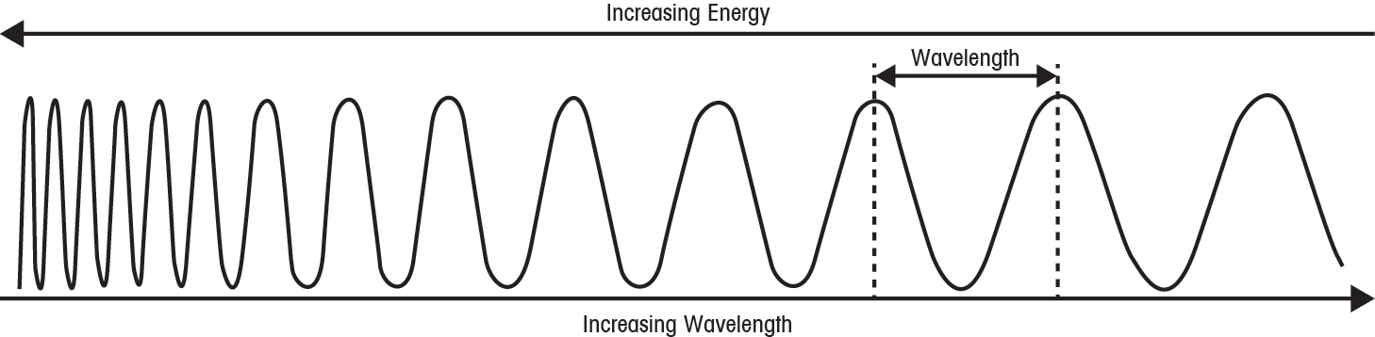
electromagnetic wave peaks or minima, respectively.
Figure 2:Theenergyofanelectromagneticwaveincreaseswithdecreasingwavelength–andviceversa
Red light has a wavelength of 660 nm, whereas green light has a wavelength of 520 nm. Each colour has a distinct wavelength. As a result, each wavelength of light is unique to its constituent parts. A spectrum is the total of all elements, or all wavelengths. A spectrum, in more precise terms, is a dispersion of radiant radiation. For example, visible light's electromagnetic spectrum spans from around 390 nm to roughly 780 nm.
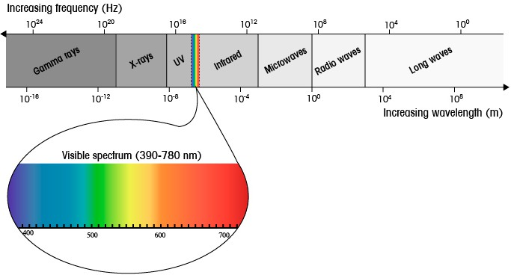
Figure3:Thevisiblespectrum(390–780nm)representsonlyasmallportionofthewholeelectromagneticspectrum
Note that the energy of electromagnetic waves is related to their wavelengths; the shorter the wavelength, the higher the energy. For instance, violet light has a shorter wavelength than red light and therefore, a higher energy level,whereasinfraredlighthaslessenergythanvisiblelightduetoitslongerwavelength.

UV/VISSpectroscopy
In analytical chemistry, light absorption may be utilized to characterize and quantify substances. The UV/VIS spectroscopy approach depends on an unknown material or sample absorbing light. Here, the sample is illuminated by electromagnetic radiation from the visible (VIS, or the various colors) and adjacent ranges, including the ultraviolet (UV) and a section of the lower infrared region (near IR). Light is absorbed differently by different substances. The UV/VIS spectrum of the sample is obtained by recording the transmitted light, or residual light, as a function of wavelength using a suitable detector. Because each substance absorbs light differently, there is a clear and unique connection between a substance and its UV/VIS spectrum. The spectrum can then be used to identify or quantify a chemical.
UV/VIS spectroscopy is often used to examine organic molecules, inorganic ions, or complexes in liquids, while it may also be used to examine solid materials like glass or films. The acquired UV/VIS spectra are highly helpful for measuring a particular substance quantitatively. In actuality, the absorbance at a certain wavelength may be used to calculate the concentration of an analyte in solution. One can determine the sample's concentration by calculating its absorbance value.
UV/VIS spectroscopy is a measuring method in which a spectrophotometer—an instrument that measures a sample's spectrum in the UV/VIS range—is used to record the absorption spectra of various samples using ultraviolet (UV) and visible (VIS) light [Vitha, 2018; Edwards et.al., 2017].

Measurementprinciple
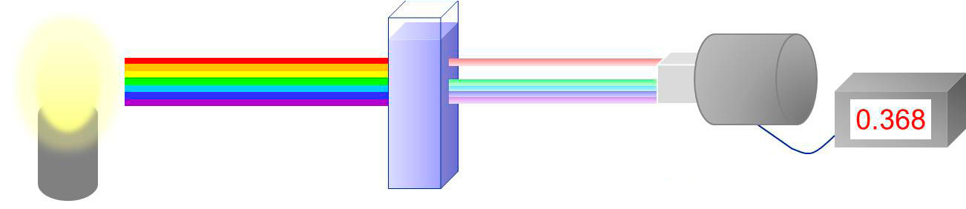With a cuvette containing a sample solution, a UV/VIS spectrophotometer detects the light's intensity and compares it to the light's intensity prior to the sample's passage through the cuvette. A UV/VIS spectrophotometer's primary parts are a light source, a sample container, a dispersive device (such a monochromator) to separate the light's various wavelengths, and an appropriate detector.
Detectionsystem
Recorder
LightsourceCuvettewithsamplesolution
Figure 4:MeasurementprincipleinUV/VISspectroscopy
The following procedures are part of a spectrophotometer's operating principle:
Measurement Blank
1. Fill a cuvette—a appropriate, transparent, non-absorbing container—with the solvent (such as water or alcohol).
2. The solvent-containing cuvette is exposed to a light beam from the light source.
3. After the cuvette, the detector collects the data by measuring the intensity of the light that is transmitted at various wavelengths.
The blank, which is necessary for further sample measurements, is established during this procedure.

Sample Identification
1. Fill the cuvette with the solvent after dissolving the sample in it.
2. The cuvette holding the sample solution is exposed to a light beam from the light source.
3. The sample molecules in the solution absorb some of the light as it travels through the cuvette.
4. After the light leaves the cuvette, it is measured by the detector.
5. Divide the transmitted intensity of the sample solution by the equivalent values from the blank to get the change in light intensity at various wavelengths.
A recorder then stores this ratio.
Transmittanceandabsorbance
A UV/VIS spectrophotometer's detector gauges light intensity after it has passed through the sample solution. The transmitted intensity, or I, is the percentage of light that the detector has detected. The sample solution, for example, absorbs light at certain wavelengths, reducing the intensity of the light that is transmitted. As a result, its value near the light source is less than the initial intensity I₀.
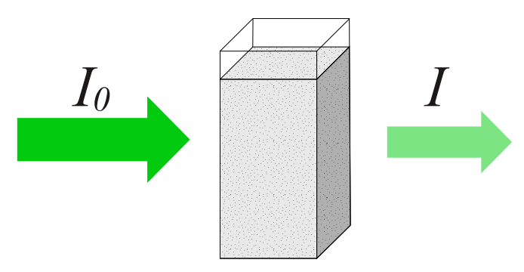
Figure 5:Lightattenuationbyabsorptionofsamplemoleculesinsolution
TheratiobetweenthetwointensitiesI/I₀isdefinedasTransmittanceT,anditsunitis%.
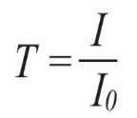
Although it is not the only value found by UV/VIS spectroscopy, the transmittance is the primary one. In actuality, the absorbance A is a further outcome that is frequently utilised while logging UV/VIS spectra. It has a significant benefit and is defined as the transmittance's negative logarithm.
A = −log(T)
There is no unit of measurement for absorbance A. Put otherwise, it is a value without dimensions. However, the letter "A" or the abbreviation "AU" for absorbance units are frequently used to denote it. This graphic displays the outcome of a measurement made using a UV/VIS instrument.
Applications ofUV/VISspectra
UV/VIS spectra should be measured for the following main reasons:
- Component Identification: A sample solution's components can be identified using UV/VIS spectra. Certain chemicals, like organic molecules or solvent purity, can be identified by the location and profile of the absorption peaks.
- Quantification: The sample can be measured using absorption peaks. For example, the absorbance value of the peak can be used to determine the sample concentration.
- Quantitative Analysis: Based on the correlation between absorbance and sample concentration, UV/VIS spectroscopy is employed as a quantitative analytical method in a number of market sectors, such as water testing, food and beverage, pharmaceuticals, chemicals, and the biotech sector.
- Molecular Structure Information: The sample's molecular structure can be inferred from the spectrum's peak positions. Certain functional groups absorb at particular wavelengths, such as carbon-oxygen (C=O) or carbon-carbon double bonds (C=C).
- Physical Properties: Certain physical characteristics of the sample molecules can be revealed by the spectrum. The UV/VIS spectrum, for instance, can be used to:
- Determine the sample's extinction coefficient.
- Measure the UV/VIS spectra at various temperatures to ascertain the melting point of proteins and nucleic acids.
- By tracking the absorption spectra over time, or kinetic measurements, one can ascertain the rate of a reaction.
IR Spectroscopy
The study of how electromagnetic waves (EM) interact with matter is known as spectroscopy. The energy levels of the rainbow's colours are matched to the colour wavelengths. Herschel discovered that the temperature rose from the blue to the red region of the visible spectrum by gradually shifting the thermometer from the blue to the red colour and recording the temperatures along the spectrum. Herschel next chose to take a temperature reading right below the red section, figuring that the rise in temperature would end outside of the visible spectrum. To his astonishment, however, he discovered that the temperature had increased even more. The rays below the red rays were referred to by him as "non colorific rays," or invisible rays. Later on, they were dubbed "infrared rays," or IR light.
The human eye is unable to see this light. The wavelength range that a human eye can detect and respond to is 390 to 750 nm. At 0.75 nm, the infrared spectrum begins. 10^9 m is one nanometer (nm). The terms Near Infrared (NIRS), Mid Infrared (MIRS), and Far Infrared (FIRS) refer to the three divisions of the infrared spectrum.
Overtones, harmonic, and combination vibrations can be studied in the first near-infrared spectrum area (14000–4000 cm^{–1}). While the FIRS (400–10 cm^{–1}) zone studies low heavy atom vibrations (metal–ligand or lattice vibrations), the MIRS (4000–400 cm^{–1}) region studies fundamental vibrations and the rotation–vibration structure of tiny molecules. Electromagnetic radiation having a wavelength of ≤0.7µm, longer than visible light, is known as infrared (IR) light. 10⁻⁶metres is one micrometre (µm).

Theory

Interactionoflightwaveswithmolecules
The foundation of infrared spectroscopy is the interaction between light and molecules. This section provides a brief overview of electromagnetic radiation, molecular energy levels, and the interactions between electromagnetic radiation and molecules and their structures [Sharaha et.al., 2019; Krishnan, 2021].

Electromagneticradiation
Electromagnetic radiation (EM) is created when the electric field (EF) and magnetic field (MF) oscillate at the same frequency but perpendicular to the electrical field (see Fig.6). The wavelength is represented by λ, where wavelength is the distance between two locations in the same phase and frequency is the number of oscillations/unit time of the electromagnetic wave per second. The wavenumber is the quantity of waves per unit length. It is clear [3] that c is given by equation 1.
𝑐 = λߥ (1)
where c is the light wave velocity, or EM wave velocity, which is a constant for the medium in which the waves are moving, c=3x 108m/s.
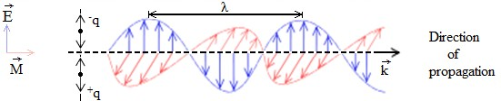
Fig. 6. An Illustration of Electromagnetic Radiation can be imagined as a self-propagatingtransverse oscillating wave of electric and magnetic fields.
A plane linearly polarized wave traveling from left to right is seen in this diagram. The magnetic field is red in a horizontal plane (M) and the electric field is blue in a vertical plane (E).
The frequency, or 1/v, is inversely proportional to the wavelength (λ). Planck's equation provides the energy in quantum terms [8]:
Ε = ℎ̥ (2)
where h is Max Planck's constant, h=6.62606896x 10-34 Js or h=4.13566733x 10-15 ev, and E is the energy of the photon of frequency ν. This was also inferred later by Einstein. The equation links wave number and frequency.
ν = cνⷈ (3)
As we've seen, the electromagnetic spectrum can be separated into multiple sections with varying wavelengths or frequencies. The connection between wavelength (λ), frequency (ν), and speed of light (c) is given below:
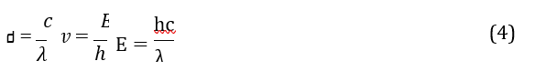
Thefrequencyinwavenumbersisgivenbytheequation:
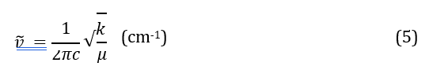
Where,k=bondspringconstant, µ=reducedmass,c=velocityoflight(cm/sec),
µisthereducedmassoftheABbondsystemofmassesandm=massoftheatoms,m_{A}=massof A and m_{B}= mass of B.

Thetechniquesof IR spectroscopy
Our IR spectrophotometers come in two varieties: The Fourier transform and the classical Utilising the interferometer, transform spectrophotometers Four components make up the primary components of the typical IR classical instrumentation.
- An illumination source of light
2. A prism, diffraction grating, or dispersion element
3. An detector
4. Mirror system made of optics
A two-beam absorption spectrometer's schematic is displayed in. Figure 7.
The reference monochromator, the sample, and the infrared radiation from the source are all passed through after reflecting off of a flat mirror. To get the spectrum, the sample and reference beams are alternately sent to the dispersing element and, ultimately, to the detector via a revolving mirror that reflects the beams. The mirror slowly spins while the beams alternate, allowing various infrared radiation frequencies to get through to the detector.

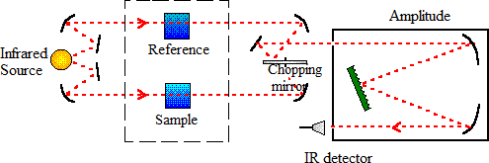
Fig.7:AschematicdiagramoftheclassicaldispersiveIRspectrophotometer.

FourierTransformIRspectrometers
Modern spectrometers were introduced with the development of high performance Fourier Transform Infrared Spectroscopy (FT-IR) and the usage of a Michelson Interferometer [Griffiths and Hasseth, 2007; Campos et.al., 2018]. The data provided by classical and contemporary infrared spectrometers is identical. The primary distinction is the use of a Michelson interferometer, which enables simultaneous detection of all frequencies rather than just one at a time (FT-IR). The following are the components of a spectrometer:
1. A source of light
2. Beam splitter (mirror with half silvering)
3. Mirror translation
4. Indicator
5. Fixed Mirror Optical System
Significant apparatus and electrical breakthroughs were made in infrared spectroscopy after World War II. Thanks to innovative sample handling techniques, the attenuated total reflection method (ATR), and of course the interferometer, these advancements put the approach at the forefront of chemical research and, subsequently in the 1980s, the biosciences in general. the Fourier data transformation.As a regular procedure and a dependable tool for quality control, molecular structure identification, and kinetics [Tsagkaris et.al., 2023; Baker et.al., 2014] in the biosciences, IR spectrophotometry is now widely employed in both research and industry (see Fig. 8). Here, the spectrum of an extremely complicated material—like an atheromatic plaque—is provided and explained.
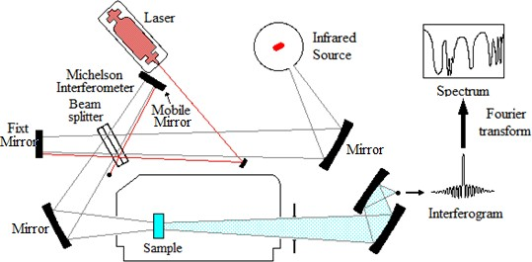
Fig.8:SchematicillustrationofamodernFTIRSpectrophotometer.
Results and Discussion
UV Spectra

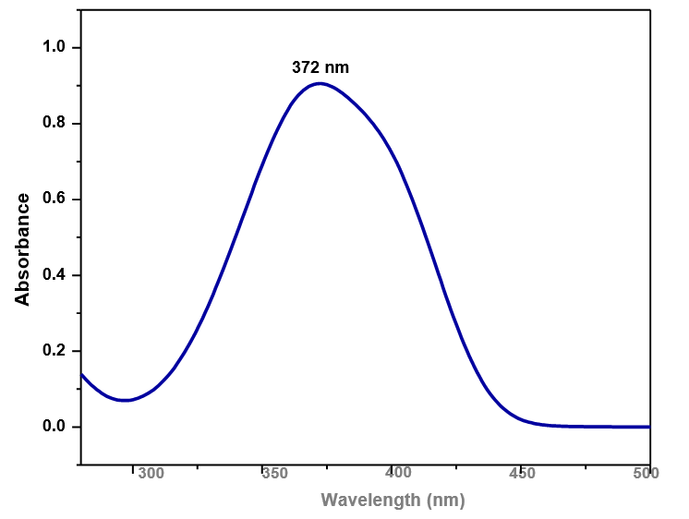
Ni Complex

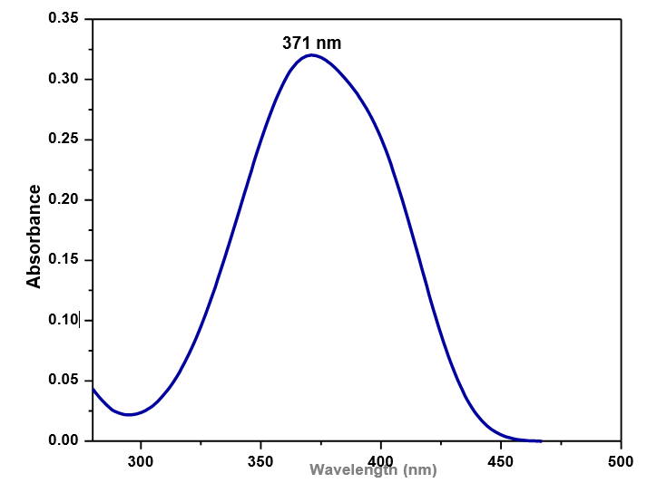
Co Complex

Figure 9: The maximum absorption graph for the different metals

FTIR Spectra
The FTIR spectra for metal complexes are shown below
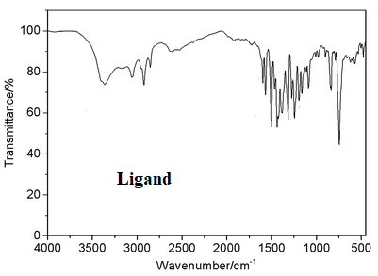
Figure 10: FTIR graph for Ligand
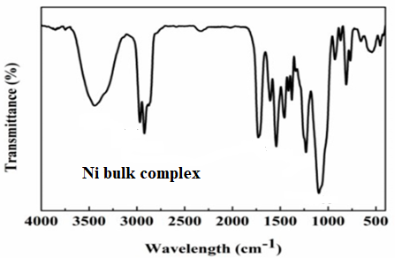
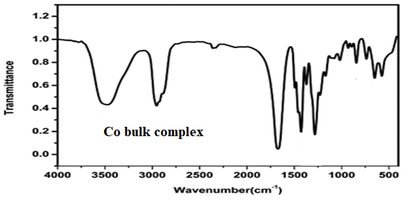

Figure 11: FTIR graphs for bulk synthesized metal complexes
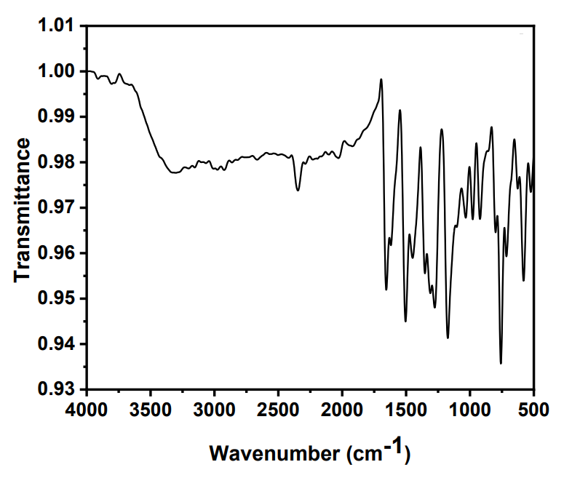
Ni complex

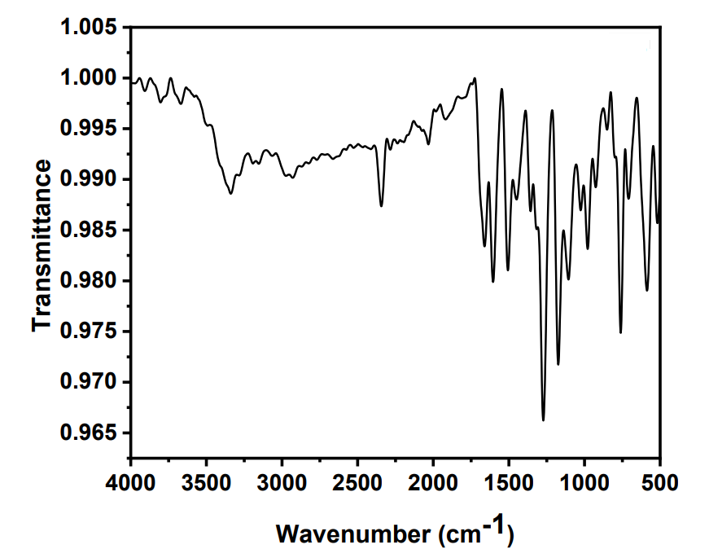
Co complex

Figure 12: FTIR graphs for Nano synthesized metal complexes
The FTIR spectra of the ligands (figure 10) and all the complexes (figure 11 ) show that the ligands are coordinated to the metal ions through the nitrogen atom: υ(NC(Me)) at 2998 cm−1, υ(NC(Ar)) at 2120 cm−1, υ(N-H) at 2240 cm−1, and υ(N=C) at 1629 cm−1 are all shifted to a lower frequency by approximately 10 and 20 cm−1 in the complexes.

Conclusion
The nitrogen-metal stretching vibrations are responsible for the new bands that were exclusively seen in the spectra of the transition metal complexes at 512 and 519 cm−1 and not in the ligand.Therefore, based on the FTIR data, Schiff base ligand connects to metal as bidentate. By comparing the experimental data with the theoretical data, we find that they are identical to each other, and this indicates that the theoretical data is acceptable.

COMPETING INTERESTS DISCLAIMER:
Authors have declared that they have no known competing financial interests OR non-financial interests OR personal relationships that could have appeared to influence the work reported in this paper.
Disclaimer (Artificial intelligence)
Option 1:
Author(s) hereby declare that NO generative AI technologies such as Large Language Models (ChatGPT, COPILOT, etc.) and text-to-image generators have been used during the writing or editing of this manuscript.
Option 2:
Author(s) hereby declare that generative AI technologies such as Large Language Models, etc. have been used during the writing or editing of manuscripts. This explanation will include the name, version, model, and source of the generative AI technology and as well as all input prompts provided to the generative AI technology
Details of the AI usage are given below:
1.
2.
3.

References:
1. Xavier, A., &Srividhya, N. (2014). Synthesis and Study of Schiff base Ligands. IOSR Journal of Applied Chemistry, 7(11 Ver. I), 06-15. https://doi.org/10.9790/5736-071110615.
2. S. Sathe, E. Jayachandran, V. A. Jagtap, and G. M. Sreenivasa, “Synthesis and antibacterial, antifungal activity of novel analogs of fluoro benzothiazole Schiff bases,” Journal of Chemical and Pharmaceutical Sciences, vol. 3, no. 4, pp. 216-217, 2010.
3. Schiff, H. (1864). Mittheilungenaus dem Universitätslaboratorium in Pisa: Eine neueReiheorganischerBasen. Annalen der Chemie und Pharmacie, 131(1), 118-119. https://doi.org/10.1002/jlac.18641310113.
4. Sondhi, S. M., Singh, N., Kumar, A., Lozach, O., & Meijer, L. (2006). Synthesis, anti-inflammatory, analgesic and kinase (CDK-1, CDK-5 and GSK-3) inhibition activity evaluation of benzimidazole/benzoxazole derivatives and some Schiff's bases. Bioorganic & Medicinal Chemistry, 14(11), 3758–3765. https://doi.org/10.1016/j.bmc.2006.01.054.
5. Mishra, R. M., Pandey, S., & Saxena, R. (2011). Homozygous hemoglobin D with alpha thalassemia: case report. The Open Hematology Journal, 2, 1–4..
6. Ajit Kumar and S. N. Pandeya, “Synthesis and anticonvulsant activity (chemoshock) of schiff and mannich bases of isatin derivatives with 2-amino pyridine (mechanism of action),” International Journal of PharmTech Research, vol. 4, no. 2, pp. 590–598, 2012.
7. Aboul-Fadl, T., Mohammed, F. A.-H., & Hassan, E. A.-S. (2003). Synthesis, antitubercular activity and pharmacokinetic studies of some schiff bases derived from 1- alkylisatin and isonicotinic acid hydrazide (inh). Archives of Pharmacal Research, 26(10), 778–784. https://doi.org/10.1007/BF02980020
8. Wei, D., Li, N., Lu, G., & Yao, K. (2006). Synthesis, catalytic and biological activity of novel dinuclear copper complex with Schiff base. Science China Chemistry. https://doi.org/10.1007/S11426-006-0225-8.
9. Avaji, P. G., Kumar, C. H. V., Patil, S. A., Shivananda, K. N., &Nagaraju, C. (2009). Synthesis, spectral characterization, in-vitro microbiological evaluation and cytotoxic activities of novel macrocyclic bis hydrazone. European Journal of Medicinal Chemistry, 44(9), 3552–3559. https://doi.org/10.1016/j.ejmech.2009.03.032
10. Chohan, Z. H., Wardell, J. L., Low, J. N., Meehan, P. R., & Ferguson, G. (1998). Tetraethylammonium bromo(1,3-dithiol-2-one-4,5-dithiolato)diethylstannate(1-). Acta Crystallographica Section C Crystal Structure Communications, 54(10), 1401–1403. https://doi.org/10.1107/S0108270198006027
11. Shoaib, K., Rehman, W., Mohammad, B., & Ali, S. (2013). Synthesis, Characterization and Biological Applications of Transition Metal Complexes of [no] Donor Schiff Bases. Journal of Proteomics & Bioinformatics, 6(7), 153–157. https://doi.org/10.4172/jpb.1000274
12. Kumari, S., Raturi, S., Kulshrestha, S., Chauhan, K., Dhingra, S., András, K., Thu, K., Khargotra, R., & Singh, T. (2023). A comprehensive review on various techniques used for synthesizing nanoparticles. Journal of Materials Research and Technology, 27, 1739-1763. https://doi.org/10.1016/j.jmrt.2023.09.291

