Experimental Analysis of Pre-Ignition Transients and Flow Instabilities in Cryotechnic Space Rocket Engine

.
ABSTRACT

The safe ignition of cryotechnic space launchers is threatened by flow instabilities that occur before ignition, a phase that remains poorly understood. While most research focuses on post-ignition instabilities, we investigated the critical few hundred milliseconds preceding ignition. Using injectors simulating liquid oxygen LOX flow in European space engines (full-scale injector mock-up with liquid nitrogen LN2 at 3.5bar and 77K), we studied the 300ms transient phase for two conditions: 1) with LN2 only, 2) with helium gas injected simultaneously with LN2 during the first 150ms. Thrust, pressure and microwave resonator density sensors were used to calculate the flow rate. Map flow analysis and frequency analysis were undertook to characterize the flow. Our measurements revealed that helium sweep reduces the effect of the secondary 50Hz mode and that it lessens the amplitude of the dominant 13Hz mode during the first 150ms, resulting in reduced amplitudes of these modes for the last 150ms with a stabilizing effect on the flow. We hypothesize this is due to a reduction in the thermal gradient between the wall and the flow, which likely enhances engine ignition reliability. Further experiments or calculations are required (heat flux, subcooling) to better understand the stabilizing effect of the inert gas sweep.

Keywords: cryogenic engine; cryotechnic engine; ignition; instabilities; frequency; space rocket; two-phase.

1. INTRODUCTION

Igniting cryogenic rocket engines is crucial for space missions, as improper timing or power can jeopardize the mission. Controlling ignition and re-ignition based on pre-ignition transients is critical: ignition failure or prolonged ignition can cause launcher loss or engine explosion due to gas accumulation in the combustion chamber, potentially destroying payloads (Haydn et al., 2008).
Cryogenic space rocket engines can function at either low or high pressure under nominal conditions, depending on the specific technology employed. Ignition typically involves a pre-ignition transient phase, characterized by low pressure before the activation of turbopumps required to achieve high pressure (Cho et al., 2004). Most of the studies available in scientific literature address the problems of these engines when ignition has already taken place and the combustion of propellants contributes to the instability of the system (e.g. Vekilov et al.’s review, 2024). This is characterized by high pressures since turbopumps using propergols (usually LOX et LH2) have started to work, contributing to instabilities characterized by high-frequency oscillations (>1kHz). However, the pre-ignition phase is characterized by low pressures and low frequency instabilities: “Strong LF [low frequency] instabilities arose during the start-up transient, […] corresponding to the time when the LOX flow across the injector orifice experienced a phase change with dropping LOX injection temperature and increasing pressure” (Son et al., 2023:2) occurring when coolant flow vaporized (Casiano et al., 2010). LF is usually less than 200Hz (Bennewitz et al., 2013; Vekilov et al., 2024).
The purpose of this paper is to contribute to filling the gap of the characterization of pre-ignition phase in cryogenic rocket engines.

Nomenclature
SYMBOLS & UNITS
Symbol Quantity Units
α Void fraction None
γ Surface tension N/m
ρ Density g/m³
A Area m²
c Sonic velocity m/s
d Diameter m
dp Pressure drop Pa
f, F Force N
G Mass flow g/s
l Characteristic length m
L Length m
p Pressure Pa
r Radius m
s Slip ratio None
T Temperature K
t Time s
v Velocity m/s
We Weber number None
X Vapor quality None

SUBSCRIPTS
Symbol Relates to
Exit Injector exit
g Gas
l Liquid
m two-phase
SG/SL superficial velocity of gas and liquid resp.

ABBREVIATIONS
Symbol Definition
He Helium
LOX Liquid oxygen
LN2/GN2 Liquid / Gas nitrogen
N2 Nitrogen
O2 Oxygen

2. material and methods

2.1. Design

Experiments used a mock-up with liquid nitrogen (LN2) simulating LOX supply in one injector typical of the cryotechnic European space engines HM7B, Vulcain or Vinci (Fig. 1 & 2) during a 300ms pre-ignition transient. LN2 was stored in a pressurized, insulated tank and delivered to the injector through a solenoid gate valve. Stainless steel was used in the construction of the mock-up.
Dimensions and material being similar to real operating conditions, calculations of similitude for the flow was only based on Reynolds number and data given for the cryogenic engine HM7B (Isselhorst, 2010; Popp & Stanke, 2013): LN2 was held at 3.5bar and 77K to simulate pre-ignition conditions prior to turbopump start. An inert gas sweep (0.1g/s), using helium like in the rocket engine, was carried out, maintained constant and independent from downstream pressure by creating a sonic flow through a micrometric valve, thus creating a steady flow during the whole sweep. The sweep was initiated several minutes before opening the LN2 valve at t=0.
The injector was made up of five parts identical to those of HM7B engine (Fig. 2): a converging part (angle: 15°, length: 1.5mm), inlet (diameter: 2mm, length: 3 mm), diverging part (angle: 51°, length: 1mm), cylindrical part (diameter: 4.5mm, length: 14.5mm), converging part (angle: 37°, length: 1mm), outlet part (diameter: 3mm, length: 18mm).

2.2. Procedure

Pre-injection phase preceded the opening of the LN2 valve during 3min: inert gas He (mass flow .1g/s) was injected inside the duct to eject any solid particle or droplet of water that could stay inside. Two conditions were tested: (1) inert gas sweep before opening the LN2 valve, and (2) inert gas sweep before and 150ms after opening the LN2 valve.
In both conditions, the time t=0 was associated with the opening of the LN2 valve which was closed 300ms after, time after which effectiveness of ignition is expected. Data acquisition was performed during these 300ms.

2.3. Metrology

Along the injector, pressure was measured in three points by piezoresistive sensors: before inlet (according to the fluid low) p₁, entrance constriction p₂, before exit p₃. At the exit of the injector where external pressure p₄ ; void fraction and thrust were measured by means resp. of a microwave resonator and a plate mounted on a piezoelectric load cell (Fig. 1 & 2). This metrology is fully described in a previous study (Fauquet-Alekhine, 2016).

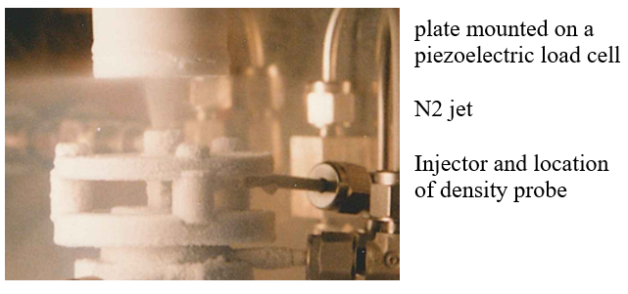
Fig. 1. View of the N2 jet at injector exit impacting plate.

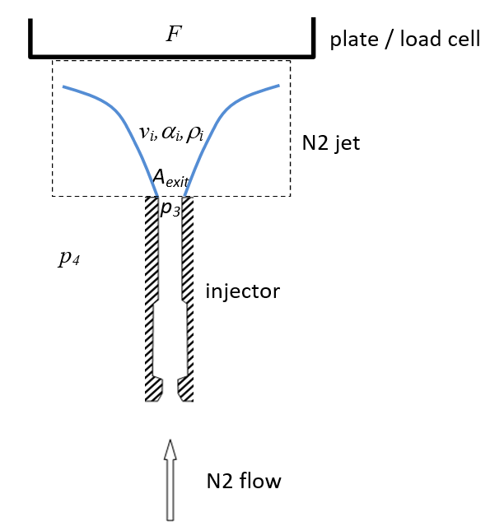
Fig. 2. Sketch of the N2 jet at injector exit impacting plate.

Measurements of these parameters acquired at 5ms interval allowed us to calculate the mass flow rate G vs pressure drop dp=p₃ – p₄ at the exit. Characteristics of pressure and force probes are given in Table 1.

Table 1. Characteristics of pressure and force probes.

Physical quantity |  | probe | sensitivity |  | range | resolution |  | temperature range |  | temperature sensitivity |  | Maximum uncertainty estimation
pressure | miniature piezoresistive sensors |  |  | 5pC/bar | 0-200bar |  | 0.005bar |  | -196 to +240°C |  | 2.10⁻⁴ /°C |  | ±0.065
force | piezoelectric load cell |  |  | 46.8pC/N | -500 to +500N |  | 0.005N |  | -115 to +240°C |  | 2.10⁻⁴ /°C |  | ±0.065

Density measurement was the most sensitive aspect of the metrology. Two-phase flow density was estimated using a cylindrical hyperfrequency resonator placed at the injector exit, with fluid passing through its axis. The method calculated fluid density ρ_{m} from the resonator's resonance frequency, which depends on the fluid's dielectric permittivity. Its principle was described in (Krupka, 2006; Paez et al., 2015) and fully described in a previous study (Fauquet-Alekhine, 2016: eq. 16 to 23). The temperature sensitivity was tested and led to a maximum deviation of .3MHz for the resonance frequency (coherent with results of Ishizaki T. (2010)) leading to a contribution less than .3% of uncertainty for density.

Uncertainty calculation and application with values of the experiments led to estimate uncertainty on ρ_{m} less than 2.5%.

Based on the volume balance indicated by the dotted line in Fig. 2 and applying the momentum conservation equation, the total N2 mass flow G at the injector

$G^{2}= A_{exit}ρ_{m}f$ (1)

with:
$f=F- A_{exit} \left(p_{3}-p_{4}\right)$ (2)
$ρ_{m}= αρ_{g}+ \left(1-α\right)ρ_{l}$ (3)
exit was derived as demonstrated by Fauquet-Alekhine (2016: eq. 1 to 9): the total N2 mass flow G at injector exit can be estimated as follows:
Calculations showed that for the expected values of G and α in the considered experimental conditions, G could be approximated by eq. (1) with negligible error on G. This was obtained by estimating the slip factor s using Premoli et al.’s correlation (1970). For the experimental conditions considered, the error on G was estimated less than 7.2%.

A summary of the uncertainty for derived quantities is given in Table 2.

Table 2. Uncertainty of derived quantities.

Physical quantity | units | Maximum uncertainty estimation
Flow rate G | kg/s | 7.2%
Density ρ_{m}  ${We}_{GS}= \frac{l}{γ} . \frac{G^{2}X^{2}}{{Aρ}_{g}}$ | kg/m³  - | 2.5%  14%

3. results and discussion

3.1. Type of flow

The measurements are similar from one shot to another: the curves exhibit waves of similar amplitude and periods, and a Type A evaluation of standard uncertainty was carried out over ten shots for each condition, leading to a repeatability uncertainty less than 10%.

The data collected clearly show an unstable flow under both conditions, with similar period in both conditions for large amplitude oscillations, and a final flow rate at t=300ms twice higher for condition 2 when compared with condition 1.

The analytical framework for the present research is informed by preceding work of Fauquet-Alekhine (2016). In that study, a detailed analysis of experimental data led to the identification of a distinct flow progression, beginning as an inverted annular flow and evolving into a fully developed mist flow. A mist flow, by definition, is a highly dispersed regime where the liquid phase exists as a population of small, spherical droplets entrained within a continuous gaseous vapor. The propensity of the flow to achieve such a homogeneous state was largely attributed to the specific thermophysical properties of the working fluid, liquid nitrogen. Namely, the small ratio of liquid to vapor density and the intrinsically low viscosity of liquid nitrogen (Qi et al, 2007) acted in concert to reduce interfacial tension and enhance phase mixing, thereby favoring the formation of a uniform mixture. This corresponds to a phenomenon of flash boiling which is critical as the pressure ratio between this of the LN2 tank and this at the exit of the injector is 1 (Rees et al., 2020; Zhong et al., 2024).
Moreover, the flow conditions presented in the present article were studied previously (Fauquet-Alekhine, 2016) and were determined to be critical, with dynamic instabilities manifesting as thermoacoustic oscillations (TAO). To provide a broader context for flow regime classification, the seminal work of Fu et al. (2008) was found highly relevant. Their investigation, which focused on stabilized vertical flows of nitrogen in a narrow duct (1.931 mm internal diameter), produced several types of two-phase flow regime maps. Among these, the map correlating mass flux G with vapor quality X provided a particularly useful benchmark. By cross-referencing the operational parameters of the study with this specific map from Fu et al. (2008), a classification was suggested. The comparative analysis clearly positioned the data within the annular flow regime, as a fundamental characteristic of the flows under the conditions considered in the study.
An illustration is given in Fig.3 for the flow rate.

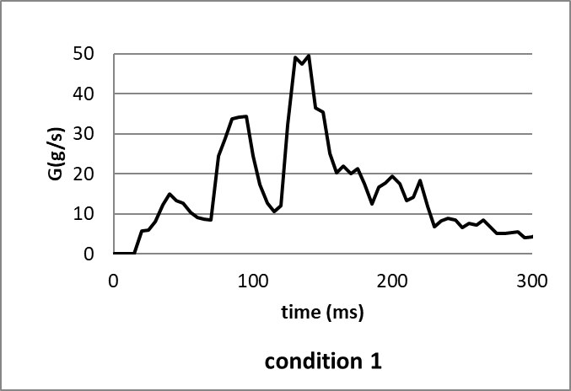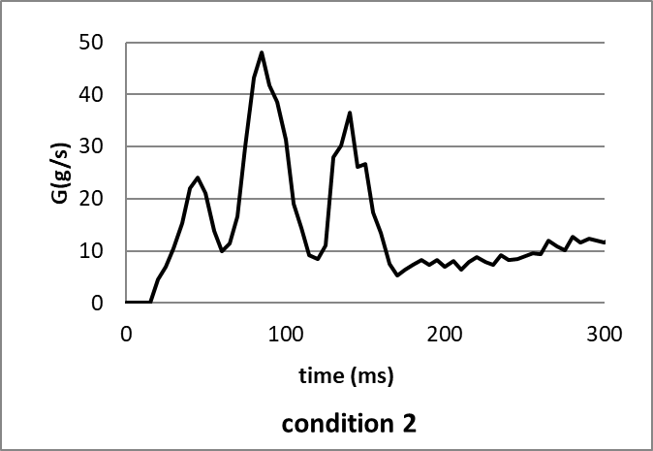
Fig. 3. Flow rate calculated in condition 1 and condition 2.

Reconsidering the work of Fu et al. (2008), we found that the map flow of Fu et al. expressed in terms of We_{GS} versus We_{LS} gave a more accurate characterization with:

${We}_{GS}= \frac{l}{γ} . \frac{G^{2}X^{2}}{{Aρ}_{g}}$ and ${We}_{LS}= \frac{l}{γ} . \frac{G^{2}{(1- X)}^{2}}{{Aρ}_{l}}$ (4a&b)

where l is a characteristic length, taken here as the size of a LN2 droplets in an annular two-phase flow. The mean size was estimated within the range of 5-20µm by Rees et al. (2020): they undertook the measurement in an annular flow inside a 2mm vertical tube for a flow rate up to 50g/s using laser-based Phase Doppler system. The value selected here for LN2 droplet size was the lower because the most discriminating in terms of flow regimes as it will be seen in the following. The characteristic length selected for We calculation is 5µm.

Since vapor quality is close to 1, the value of We_{LS} is close to 0 while We_{GS} varies significantly during flow. It is therefore the value of We_{GS} that characterizes the flow. Fig. 4 represents the map flow of Fu et al. (2008) in terms of We. The points characterizing the flow under both conditions are shown for the last 150ms (mean values), the values for the first 150ms being out of the scale because too high. The points are clearly differentiated: the cumulated uncertainty on We_{GS} (for which the main contributor is un certainty of G) for the two points represents less than 30% of the distance between the two points. This confirms the conclusion of the previous work based on Fu et al.’s map correlating mass flux G with vapor quality X. We_{GS} thresholds for transitions are about .5m/s for churn / slug or bubbly, and 4.5m/s for annular / churn.

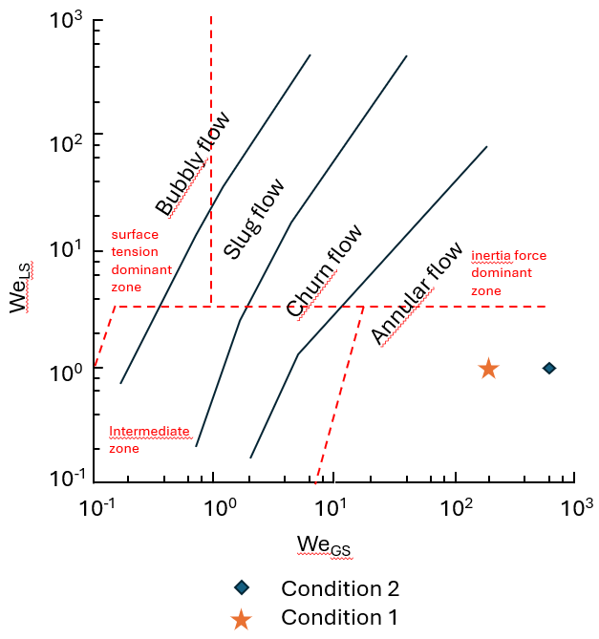
Fig. 4. Flow map superficial Weber numbers from Fu et al. (2008) and location of the present experimental conditions: mean values for the last 150ms flow.

When the evolution of We_{GS} for the two conditions is plotted as a function of the flow time and is compared to the thresholds identified for the flow regime transitions, the transition times are as follows:
These observations are combined with the variation in flow rate beyond t=170ms. For condition 1, the flow G follows a downward slope of 20 to 4 g.s⁻¹, while for condition 2, G follows an upward slope of 5 to 12 g.s⁻¹. In terms of the velocity of the two-phase flow, in condition 1, it oscillates around 40m/s (+-20m/s) before t=170ms then the amplitude of the oscillations decreases (±10m/s) still around 40m/s, while in condition 2, the velocity oscillates around 60m/s (±20m/s) before t=170ms then the amplitude of the oscillations decreases around 70m/s (±10m/s). Regarding the density of the flow, after t=170ms, at the end of the injection period, it is unstable and decreases in condition 1 while it is stable in condition 2.
When considering the cumulative flow rate ∑G along the 300ms injection, Fig. 5 illustrates this significant difference: in condition 2 (with He sweep), ∑G is higher than in condition 1, then both curves reach the same value at t=150ms. After this point, ∑G is increasing faster in condition 2 than in condition 1. Fig.5 also shows that the He flow rate has no incidence on ∑G: the sum of N2+He (curve “condition 2”) superimposes on this of N2 only (curve “condition 2(N2-He)). He flow rate represents a maximum of 0.2% of the total flow rate. Therefore, ∑G value in condition 2 is due to N2, being higher than in condition 1 before t=150ms, suggesting a more efficient cooling of the injector wall in condition 2. A resulting lower temperature gradient between the wall and the flow in condition 2 when compared with condition 1 might explain a more stable flow after t=150ms in condition 2 resulting in an increasing flow rate conversely to condition 1. This leads to a positive factor in condition 2: the evolution of the flow rate over the final 130ms increases due to the increase in velocity combined with a stable density. In condition 1, the flow rate decreases (Fig.3), which is not in favor of a correct ignition of the engine a priori.

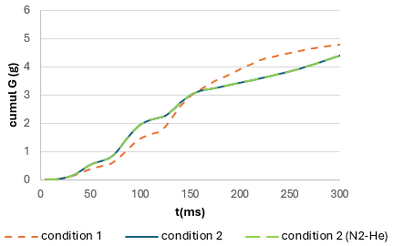

Fig. 5. Cumulative flow rate G(g) along the 300ms injection.

The analysis and interpretation of the present experimental results can be significantly informed by the work of Hu et al. (2012). Their investigation provided a characterization of vertical two-phase nitrogen (N2) flows within an 8mm diameter pipe, employing a robust methodology that combined direct measurement with high-speed videography. This approach allowed for a detailed, visual documentation of the flow regime transitions. Crucially, under conditions analogous to those established in the current study, Hu et al. meticulously delineated the thermal-hydraulic phenomena of the chilldown process, the initial cooldown phase when cryogenic nitrogen first enters a warm pipe. Their observations revealed a dramatic and rapid evolution of flow patterns. Specifically, Hu et al. determined that during the initial stages of chilldown and under high mass flow rates (according to Hu et al.’s criteria, conditions 1 and 2 of the present study are high mass flow rates), the flow structure progresses through distinct phases. It begins as an inverted annular flow, where a continuous liquid core is surrounded by a vapor film, and subsequently transitions into a mist flow regime. The latter is characterized as a highly dispersed flow, consisting of numerous small, spherical liquid droplets entrained within a continuous gaseous vapor phase. A critical insight from their research, which is particularly relevant for the present findings, is their explanation that these specific flow transitions occur while the pipe wall temperature remains elevated when compared with that of the fluid, specifically above the critical rewetting temperature. This suggests that the flow mechanics during early chilldown are dominated by violent boiling and entrainment processes at the liquid-vapor interface, rather than by direct and stable liquid-wall contact.

All these considerations suggest that, in both conditions of the present study, the flow is an annular mist flow type, the continuous phase being gas with a core of liquid microdroplets.

The Fourier transform analysis (FFT) of the frequencies of the evolution of the flow rate G over time also indicates specific characteristics (Fig.6). In both cases, three frequency modes are dominant: a 25Hz mode (period: 40ms) and a 13Hz mode (period: 80ms) corresponding to the flow oscillations. The third mode at 50Hz (period: 20ms) corresponds to the secondary oscillations of the flow rate. These modes are consistent with studies carried out elsewhere (e.g. Kakac & Bon, 2008; Smirnov et al., 1997; Tadrist, 2007). It is interesting to note that beyond t=150ms, the 25Hz mode fades under both conditions and the observation of the evolution of the flow rates Fig. 3 indicates that the high amplitude oscillations disappear beyond t=170ms in both conditions. On the other hand, in condition 1, the 13Hz mode persists while it fades in condition 2. The 50Hz mode remains in condition 1 with a slight offset (40-45Hz) and fades in condition 2.

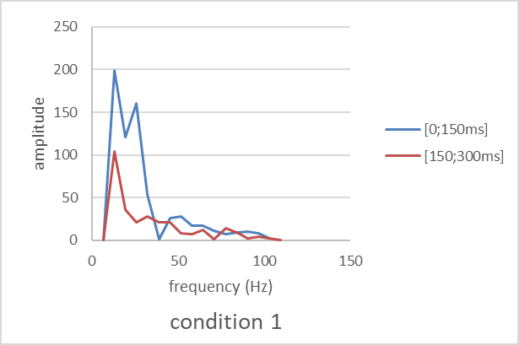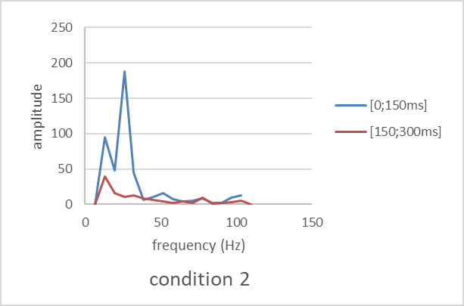

Fig. 6. FFT of flow rate signal in condition 1 and condition 2.

Fig.6 illustrates how He sweep reduces the effect of the secondary 50Hz mode and how it lessens the amplitude of the dominant 13Hz mode during the first 150ms, resulting in reduced amplitudes of these modes for the last 150ms with a stabilizing effect on the flow.
It is tempting to relate oscillations observed in conditions 1 and 2 to the pressure drop oscillation (PDO), or to density wave oscillation (DWO) mechanism due to vaporization of LN2 in the injector, the former sustaining the latter. However, these kinds of instabilities are associated with large amplitude excursion of the physical quantities (Kakac & Bon, 2008). The frequency identified here are typical of low-frequency (LF) thermo-acoustic oscillations (TAO) (Ruspini et al., 2014; Smirnov et al., 1997; Tadrist, 2007), linked with resonance of pressure waves inside the considered system and related to the time needed for the pressure waves to propagate in the system. This is coherent with other studies. Startup of the engine is characterized by LF instabilities (Son et al., 2023) occurring when coolant flow vaporized (Casiano et al., 2010). Tadrist’s review (2007:55) addressing two-phase flow instabilities in narrow spaces concluded that TAO in small millimeter ducts are characterized by low frequency (<100Hz) and explained “This instability is triggered by the amplitude film thickness variation, bubble collapse, which in turn induces a change in pressure. The amplitude of the acoustic oscillations is generally small with frequencies varying in the range 10–100 Hz”.
A sensitivity analysis may be undertaken considering the fundamental resonance frequency f for a tube closed at one end (Keeratirawee & Hauser, 2022), along its length L, given by the following equation:
$f = \frac{c_{m}}{2(L+0.6r)}$ (5)
where c_{m} is the sonic velocity in the two-phase flow that may be approximated by Wood’s law, assuming a homogeneous mist flow with small, well-dispersed droplets (Daude et al., 2014; Delmote et al. 2026; Niknam et al., 2017; Wood, 1930):
$c_{m}= {\left\{ρ_{m} \left[\frac{α}{ρ_{g}c_{g}^{2}}+ \frac{(1- α)}{ρ_{l}c_{l}^{2}}\right]\right\}}^{1/2}$ (6)
Wood’s model (Eq. 5 and 6) shows that f increases with the void fraction α. Conversely, f decreases when L, r or ρ_{m} increase. L and r are equal in both conditions. The mean density for 300ms in condition 1 is .0063kg/m³ while .0047kg/m³ in condition 2. Fig.6 shows that the 13Hz mode has a higher amplitude in condition 1 than in condition 2, while the 25Hz mode is higher in condition 2: this is coherent with Wood’s model. Equations also show that the frequency decreases when the sonic velocity in the mixture decreases, i.e. when the void fraction increases according to Eq. 6. For the last ms in condition 1, the void fraction α tends to .98 and .88 in condition 2: again, this is coherent with Wood’s model.
However, the density during the last tens of ms is lower in condition 2 than in condition 1 while the mass flow rate increases in condition 2 and decreases in condition 1: the difference come from the mixture speed increasing around 70m/s in condition 2 and decreasing in condition 1 around 40m/s. Therefore, the He sweep in condition 2 favors a higher average velocity of the mixture rather than the mixture density, and the differences in velocity and void fraction are significant enough to lead to a higher mass flow rate in condition 2. In other words, in condition 2, the He sweep yields a proportion of liquid higher than in condition 1 (void fraction) with higher velocity.
In summary, the He sweep in condition 2 has an optimizing effect on the flow compared to condition 1 by reducing instabilities and increasing the flow rate.
The hypothesis that is made to explain this difference between the two conditions is that in condition 2, the He sweep increases the temperature of the two-phase medium and reduces the temperature gradient between the injector wall and the fluid flow compared to condition 1. Thus, thermal effects may be assumed as major to explain the differences between the two conditions.
The stability map by Ishii and Ishii & Zuber (1970), which uses dimensionless subcooling and phase change numbers, suggests that He reduces both heat flux and inlet subcooling enthalpy. This shifts the operating point towards a more stable region on the map. Further investigations are needed to discuss this hypothesis in depth.

Conclusion

We studied the pre-ignition transient in a full-scale space rocket engine injector (used in the Ariane 6 launcher) under conditions simulating O2 flow, using N2. Prolonged inert gas (He) sweeping optimized flow during the pre-ignition phase, an important discovery for stabilizing cryotechnic engines and favoring reliable ignition. The flow was found critical with instabilities analyzed as being thermoacoustic oscillations (TAO). Thermal effect was identified as major in the production of these oscillations, with a rapid transition of the continuous phase (around 50ms) from gas to liquid.
Additional experiments are needed to measure how heat flux and subcooling enthalpy contribute to stabilization. Gaining this knowledge could help improve future spaceflight engines, as each (re)ignition phase carries a notable risk of failure.

LIMITATIONS

In mist flow, the gas speed is higher than the droplet speed and the mixture is not homogeneous. This slip affects the average density and the compressibility of the phases and that modifies c_{m}. When the slip factor increases, it reduces c_{m}. In the present study (as explained in the previous study (Fauquet-Alekhine, 2016)), the mixture density is calculated from the measurement of a resonator probe and the slip factor is approximated to 1, which has an impact on the density.

Another limitation is the acquisition frequency for measurements. The calculated values of the mixture velocity suggest that a higher acquisition frequency might improve the resolution of the signals and perhaps reveal other resonance frequency modes.

Disclaimer (Artificial intelligence)

The author hereby declares that NO generative AI technologies such as Large Language Models (ChatGPT, COPILOT, etc.) and text-to-image generators have been used during the writing or editing of this manuscript.

References

Bennewitz, J. W., & Frederick, R. A. (2013). Overview of combustion instabilities in liquid rocket engines-coupling mechanisms & control techniques. 49th AIAA/ASME/SAE/ASEE Joint Propulsion Conference, 4106, 1-14.
Casiano, M. J., Hulka, J. R., & Yang, V. (2010). Liquid-propellant rocket engine throttling: A comprehensive review. Journal of propulsion and power, 26(5), 897-923.
Cho, N., Kim, S., Kim, Y., Jeong, S., & Jung, J. (2004). Two-phase flow characteristics of liquid oxygen flow in low pressure liquid rocket engine. Cryogenics, 44(6-8), 493-500.
Daude, F., Galon, P., Gao, Z., & Blaud, E. (2014). Numerical experiments using a HLLC-type scheme with ALE formulation for compressible two-phase flows five-equation models with phase transition. Computers & Fluids, 94, 112-138.
Delmotte, F., Guillermic, R. M., Leroy, V., & Brunet, T. (2025). On the validity of Wood’s law: From bubbly media to liquid foams. Ultrasonics, 107878.
Fauquet-Alekhine, P. (2016). Improvement of Cryogenic Space Rocket Engine Ignition: Inert Gas Sweep Effects. Physical Science International Journal, 9(2), art.PSIJ.22317, 1-14.
Fu, X., Qi, S. L., Zhang, P., & Wang, R. Z. (2008). Visualization of flow boiling of liquid nitrogen in a vertical mini-tube. International journal of multiphase flow, 34(4), 333-351.
Ishizaki T. (2010). Temperature-stable dielectric TM010-mode resonator and its application to compact base station filter. IEICE Electronics Express.7(6), 454-459.

Isselhorst, A. (2010). HM7B simulation with ESPSS tool on Ariane 5 ESC-A Upper Stage. In 46th AIAA/ASME/SAE/ASEE Joint Propulsion Conference & Exhibit, paper 7047.
Haidn, O. J. (2008). Advanced Rocket Engines. In Advances on Propulsion Technology for High-Speed Aircraft, Educational Notes, Neuilly-Sur-Seine, Vol. 6, No (pp. 1-40). RTO-EN-AVT-150.
Hu, H., Chung, J. N., & Amber, S. H. (2012). An experimental study on flow patterns and heat transfer characteristics during cryogenic chilldown in a vertical pipe. Cryogenics, 52(4-6), 268-277.
Ishii, M., & Zuber, N. (1970). Thermally induced flow instabilities in two phase mixtures. In International Heat Transfer Conference 4, 26, 1-12. Begel House Inc.
Kakaç, S., & Bon, B. (2008). A review of two-phase flow dynamic instabilities in tube boiling systems. International journal of heat and mass transfer, 51(3-4), 399-433.
Keeratirawee, K., & Hauser, P. C. (2022). Determination of binary gas mixtures by measuring the resonance frequency in a piezoelectric tube. Sensors, 22(4), 1691.
Krupka, J. (2006). Frequency domain complex permittivity measurements at microwave frequencies. Measurement Science and Technology, 17(6), R55.
Niknam, P. H., Fiaschi, D., Mortaheb, H. R., & Mokhtarani, B. (2017). An improved formulation for speed of sound in two-phase systems and development of 1D model for supersonic nozzle. Fluid Phase Equilibria, 446, 18-27.
Paez, E. J., Callarotti, R. C., & Sanchez, Y. (2015). Measurable dielectric permittivity range for TE and TM modes in a shielded dielectric resonator. Journal of Electromagnetic Analysis and Applications, 7(06), 189-197.
Popp, M., & Stanke, J. (2013). Experimental investigation of the HM7B thrust chamber start-up transient. In 24th Joint Propulsion Conference, paper 2931.
Premoli, A., Francesco, D., & Prima A. (1970). An empirical correlation for evaluating two-phase mixture density under adiabatic conditions. In European Two-Phase Flow Group Meeting.

Qi, S. L., Zhang, P., Wang, R. Z., & Xu, L. X. (2007). Flow boiling of liquid nitrogen in micro-tubes: Part I–The onset of nucleate boiling, two-phase flow instability and two-phase flow pressure drop. International journal of heat and mass transfer, 50(25-26), 4999-5016.

Rees, A., Araneo, L., Salzmann, H., Lamanna, G., Sender, J., & Oschwald, M. (2020). Droplet velocity and diameter distributions in flash boiling liquid nitrogen jets by means of phase Doppler diagnostics. Experiments in Fluids, 61(8), 182.

Ruspini, L. C., Marcel, C. P., & Clausse, A. (2014). Two-phase flow instabilities: A review. International journal of heat and mass transfer, 71, 521-548.
Smirnov, H. F., Zrodnikov, V. V., & Boshkova, I. L. (1997). Thermoacoustic phenomena at boiling subcooled liquid in channels. International journal of heat and mass transfer, 40(8), 1977-1983.
Son, M., Börner, M., Armbruster, W., & Hardi, J. S. (2023). Orifice flow dynamics in a rocket injector as an excitation source of injector-driven combustion instabilities. Aerospace, 10(5), art.452, 1-16.
Tadrist, L. (2007). Review on two-phase flow instabilities in narrow spaces. International Journal of Heat and fluid flow, 28(1), 54-62.
Vekilov, S., Lipovskyi, V., & Pustovyi, R. (2024). The problem of combustion instability in liquid rocket engines. Challenges and Issues of Modern Science, 2, 100-110.

Wood, AB. (1930). A Textbook of Sound. London: Bell and Sons Ltd.

Zhong, W., Chen, J., Li, C., Huang, Y., Pachiannan, T., Jiang, Z., ... & He, Z. (2024). Visualization study on flash boiling spray characteristics of high-pressure liquid ammonia with different nozzle diameters. Fuel, 367, 131525.

