Short Research Article

Fungal Contamination and Shelf-Life of Peanut Paste Sold in the Markets of Daloa (Central-West, Côte d'Ivoire)

ABSTRACT

Background: Peanut paste is a widely consumed staple in Côte d’Ivoire and is frequently produced by traditional artisanal methods. Inadequate processing, handling and storage conditions can promote contamination by diverse microbial agents such us mycotoxigenic fungi and bacteria. This compromise product quality and safety
Aims: This public health-oriented study assessed the microbiological risks linked to consumption of peanut paste sold in the markets of Daloa.
Methodology: A survey followed by sampling was conducted in February 2024 among nine peanut paste vendors at the markets and 90 households in the Lobia, Main market, and Orly neighborhoods. Hygiene conditions at sales points in the three busiest markets of Daloa were assessed using a survey questionnaire. Thirty-six (36) peanut paste samples collected from the investigated markets were analyzed to determine fungal diversity. The evolution of enterobacteria, total aerobic mesophilic flora, and moulds was monitored for four weeks in 24 peanut paste samples produced under laboratory conditions to evaluate microbiological shelf life.
Results: In the surveyed markets, 95.6% of peanut paste vendors practiced proper hygiene, including handwashing and cleaning of their selling environment. Microbiological analysis revealed a fungal diversity of 21 species, distributed across eight genera: Aspergillus, Cladosporium, Mucor, Neurospora, Penicillium, Rhizopus, Scytalidium, and Scedosporium. During a 4‑week follow‑up period, the mould load decreased from 2.9×10² to 1.1×10² CFU/g. In contrast, total aerobic mesophilic flora and enterobacteria showed a progressive increase, rising from 1.4×10³ CFU/g and 1.4×10² CFU/g to 6.9×10³ CFU/g and 3.9×10² CFU/g, respectively. The estimated best before date/period of peanut paste is 128 days post-production.
Conclusion: Peanut past marketed in Daloa harbors diverse fungal communities, posing a risk of mycotoxin contamination. Vendors and consumers should pay attention to the optimal durability period to reduce health risks associated with it consumption; these findings enhance awareness and promote safer choices in peanut paste use.

Keywords: Peanut past, hygiene, fungal contamination, shelf life, Daloa

1. INTRODUCTION

Peanut (Arachis hypogaea L.), belonging to the Fabaceae family, is an important annual oilseed crop, widely distributed across tropical, subtropical, and warm temperate regions. This plant produces pods that are valuable protein sources high in lysine, which complement cereal-based diets (Ngulube & Kaimoyo, 2023; ICRISAT, 2025). These pods are processed into a wide array of products and by-products that are popular worldwide. From peanut paste, oil, flour and cake to processed snacks and beyond, these items feature prominently in the diets of populations in both high-income and low-income regions (Sithole et al., 2022; Gbétokpanou et al., 2025). In Côte d’Ivoire, peanut paste, produced by grinding roasted seeds to a smooth or coarse paste, is one of the most widely consumed forms, used as a spread or as a base for dishes like peanut sauces (Boli et al., 2024). Production is largely artisanal and household based, relying on diverse seed varieties and carried out by unregulated small-scale producers. The artisanal production, packaging, storage, and sale of peanut paste frequently fall short of food hygiene and safety standards, allowing microbial contamination that lowers product quality and endangers consumers (Boli et al., 2020; Bondom et al., 2025). Salmonella spp. and aflatoxin contamination are the primary food safety hazards in peanut paste, given their high prevalence and significant public health impact. The Codex standards specify a maximum aflatoxin level of 0.5 to 15 µg/kg (Sithole et al., 2022). In developing countries, the predominance of unregulated producers, combined with favourable climatic conditions in subtropical regions, promotes the proliferation of Aspergillus moulds in peanut shells and increases the risk of aflatoxin poisoning (Daou et al., 2021; Gbétokpanou et al., 2025). In Daloa, as elsewhere in Côte d’Ivoire, peanut paste is commonly sold in markets until stocks run out. Unlike some foods where spoilage is obvious from unpleasant odors or visible rot, peanut paste can remain deceptively unchanged despite prolonged storage, yet still pose toxic risks when consumed past its best before date (after long storage) (Ngulube & Kaimoyo, 2023). Moreover, artisanal production methods and inadequate storage at points of sale favour contamination by local fungal flora. Understanding the storage stability and mycological profile of peanut paste produced and sold in Daloa is therefore essential to assess its potential health impact on the local population. This study, conducted within a public‑health framework, aims to elucidate the health risks associated with consumption of peanut pastes sold in the markets of Daloa. The specific objectives were to assess, through a survey, the sanitary and hygiene conditions in the markets (points of sale of peanut paste) and in households in Daloa, evaluate the effect of storage duration on the quality of peanut pastes and determine the fungal diversity present in these peanut pastes.

2. material and methods

2.1 Study site

The research was carried out in Daloa, a major urban center in the Haut-Sassandra region of central-western Côte d'Ivoire. With a population of 261,789 inhabitants and an area of 5,305 km², it ranks as the nation's fourth most populous city (ANSD, 2023). The sites investigated in Daloa are Orly Market, Lobia Market and Main Market, which are heavily frequented and located in areas of high activity.

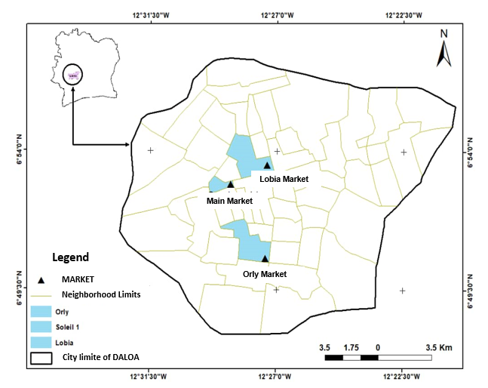
Fig 1. Geographic distribution of survey and sampling sites

2.2 Material

The study materials consisted of peanut paste purchased from markets (PPM) (Orly Market, Lobia Market and Main Market), and artisanal household-produced peanut paste (PPH) (Figure 2).
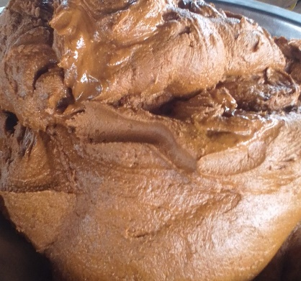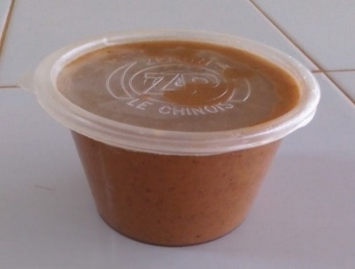
a
b
1.5 cm

Fig. 2. Photography of peanut paste
a: household-produced peanut paste (PPH); b: Peanut Paste from Market (PPM)

2.3 Methods

2.3.1 Survey

A survey was carried out in February 2024 across i) the Lobia market, Main market, and Orly market, among 9 peanut‑paste vendors (at the rate of 3 vendors per market) and ii) 90 households in neighbourhoods housing Lobia market, Main market, and Orly market (30 households per neighbourhood). This survey was conducted using the method observed by Ouina et al. (2025) with some modifications regarding the distance between points of sale. Its purpose was to evaluate health and hygiene conditions in the peanut‑butter sales environment in Daloa that might pose risks to consumers. Data were collected by questionnaire to document vendors’ production and selling practices and to gather information on health issues related to peanut‑paste consumption.

2.3.2 Peanut paste sampling

Sampling was conducted one week after the survey phase to collect household-produced peanut paste (PPH) and peanut paste from market (PPM) for laboratory analysis. PPM sampling took place in March–April 2024 in the Lobia market, main market and Orly market. In each market, 3 vendors located at least 100 m apart were selected. From each selected vendor, 4 individual portions of approximately 100 g were purchased at intervals of five days. PPH sampling was carried out in March 2024 at production sites and consisted of collecting three 100 g portions of peanut paste twice weekly (Monday and Thursday) from the production stock for four consecutive weeks (which corresponds to eight collection phases P1, P2, P3, P4, P5, P6, P7 and P8). All samples (36 PPH samples obtained by purchase from markets and 24 PPM samples obtained from production) were placed in sterile bags and transported to the laboratory in a cooler with dry ice for subsequent analysis.

2.3.3 Microbiological analysis

Different culture media namely buffered peptone water, Sabouraud with chloramphenicol, Plate count agar (PCA), Violet red bile glucose (VRBG) agar were used for analysis. They were prepared according to the manufacturers' instructions.
The stock suspension was prepared from peanut past samples followed by decimal dilutions in accordance with the applicable standard methods ISO 6887-2 (2017). Briefly, 10 g of each peanut past samples were aseptically mixed in 90 mL of buffered peptone water (Difco, Becton Dickinson, Sparks, MD, USA); the whole were stirred for 30 minutes, then allowed to stand for 15 minutes. One volume (1 mL) of stock suspension or tenfold serial dilutions were inoculated into the depth on PCA, VRBG and Sabouraud with chloramphenicol respectively for isolation of total aerobic mesophilic germs (ISO 4833-1:2013/Amd 1, 2022), enterobacteria (ISO 21528-2, 2017) and fungi (GSO ISO 21527-1, 2016). Cultural conditions were 30°C/24h for PCA, 37°C/24h for VRBG and 30°C/3-5 days for Sabouraud with chloramphenicol. After isolation phase, micro-organisms were enumerated.
Fungi were purified and phenotypically identified based on their macroscopic characteristics (shape, relief and colour of the colonies, surface characteristics, pigmentation, culture time) and microscopic characteristics (hyphal partitioning, presence of chlamydospores, shape and size of conidia, phialides); the isolation frequency (IF) of identified fungi was then calculated (Ouina et al., 2020; Aboulaye et al., 2023).

2.3.4 Microbiological stability of peanut paste samples

As part of the stability assessment, PPH peanut paste samples taken from production stock twice weekly over four consecutive weeks (at P1 to P8) were subjected to microbiological analysis. Total aerobic mesophilic germs, enterobacteriaceae and fungi were enumerated for each sample. Measured counts were compared with predefined reference criteria to assess product safety. Results were interpreted according to a three-class scheme recommended by the Codex Alimentarius: counts ≤ m were classified as satisfactory (compliant); counts > m but ≤ M were classified as acceptable; and counts > M were classified as unsatisfactory (non‑compliant). The reference values (m and M) applied to each microorganism in this study are listed in Table 1.

Table 1. Microbiological criteria applied to peanut paste PPH
Micro-organisms | Microbiological limits (CFU/g) |  | Source
 | m | M
Total aerobic mesophilic germs | 10⁴ | 10⁵ | Official Gazette of the Republic of Algeria N° 39. (2017)
Enterobacteria | 10² | 10³ | Official Gazette of the Republic of Algeria N° 39. (2017)
Fungi | 10² | 10³ | Compaoré et al. (2020)

2.3.5 Statistical analysis

Data obtained from the survey and microbial counts were analysed using Statistica 7.1 (Statsoft Inc, Tulsa-USA Headquarters) software. A one-factor analysis of variance with a 5% significance level was performed to compare the mean fungal isolation frequencies among PPH samples from markets.

3. RESULTS

3.1 Sanitary and hygiene aspects of households and the peanut paste sale environment

The survey of households and peanut‑paste vendors in Lobia market, Orly market, and the main market documented the social, health, and hygiene characteristics of households and sellers, which are summarized in Table 2. Most household respondents were female (95.6%). The majority of respondents had received formal education, with primary, secondary, and higher levels together accounting for 58.8%, while 41.2% were illiterate. Peanut paste was most commonly consumed as a peanut sauce, and cases of gastrointestinal discomfort following consumption were frequently reported. Regarding hygiene practices, over 95% of respondents indicated that they maintained a clean working environment and practiced hand washing before cooking (households) or before serving peanut paste (market vendors).

Table 2. Social, health and hygiene characteristics of households and peanut paste sellers
Modality | Frequency (%)
Respondents in households  - Men  - Women | 4.4%  95.6 %
Educational level  - Illiterate  - Primary  - Secondary  - Post‑secondary | 41.20%  23.30%  24.40%  11.10%
Mode of consumption of peanut paste  - Raw peanut paste  - Peanut sauce | 20%  100%
Discomfort after consumption  - Observed  - Not observed | 21.10%  78.90%
Handwashing  - Observed  - Not observed | 95.60%  4.40%
Regular cleaning of market stalls and kitchens for households  - Observed  - Not observed | 97.6%  2.20%
3.2 Evolution of certain microbiological parameters during storage of PPH peanut paste

Different microbial groups —fungi, enterobacteria, and total aerobic mesophilic germs— were sought and enumerated in household-produced peanut paste (PPH) samples. Their counts were monitored over a 4‑week period. The study showed that, unlike fungi, counts of total aerobic mesophilic germs and enterobacteria increased over time during the 4 weeks after an initial stationary level observed in the first week (collecting phases P1 and P2) (Figure 3). Evolution of enterobacteria counts during the study period is showed in figure 3-a. Starting counts at the beginning of the growth were 1.4 × 10² CFU/g and 1.2 × 10² CFU/g for sampling phases P1 and P2, respectively. At the end of the experiment (P8), enterobacteria abundance was approximately 3.9 × 10² CFU/g. Figure 3-b shows the evolution of total aerobic mesophilic germs load. At the start of monitoring, loads were 1.4 × 10³ CFU/g for P1 and 1.6 × 10³ CFU/g for P2, rising to 6.9 × 10³ CFU/g by the final sampling (P8). Two recurring growth cycles are visible: the pattern observed from P1 to P4 is reproduced from P5 to P8. Figure 3-c presents the fungal growth kinetics in PPH samples over four weeks. Three distinct phases were identified: an exponential increase from P1 to P2 (from 2.9 × 10² to 5.4 × 10² CFU/g), a stationary phase between P2 and P3, and a decline from P3 to the end of the study, reaching 1.1 × 10² CFU/g at P8.

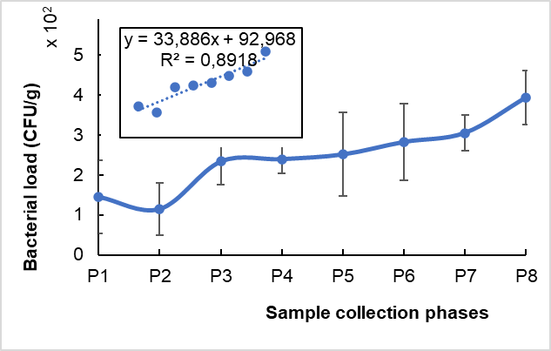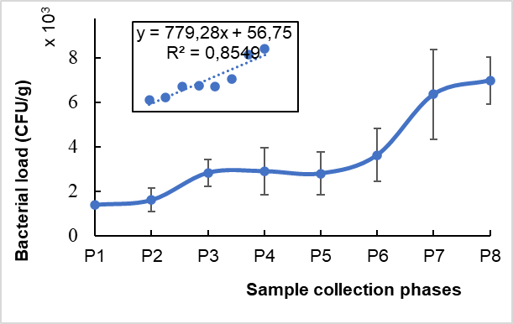

a- Enterobacteria b- Total aerobic mesophilic germs

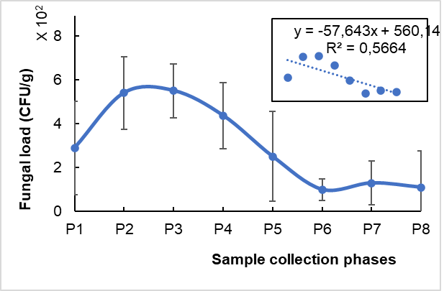

c- Fungi

Fig. 3. Microbial growth monitoring in peanut paste samples over 4 weeks
a- Enterobacteria, b- Total aerobic mesophilic germs, c- Fungi; P1 to P8: Sample collection phases P1 to P8

3.3 Estimation of shelf‑life for peanut paste samples

Analysis of the microbiological parameters measured in the PPH samples allowed to relate microbial loads to product shelf life. Applying the derived mathematical regressions and the applicable microbial standards for each tested microflora enabled estimation of storage duration for the PPHs peanut paste and associated quality (Table 3).
Table 3. Estimated shelf life (in days) of PPH peanut pastes and associated quality
Microbiological quality of peanut paste | Germs and Linear regressions
Microbiological quality of peanut paste | Enterobacteria | GAM | Fungi
Microbiological quality of peanut paste | y = 33,886x + 92,968  R² = 0,8918 | y = 779,28x + 56,75  R² = 0,8549 | y = -57,643x + 560,14  R² = 0,5664
Satisfactory quality | - | ≤ 12 days | -
Acceptable quality | Up to 26 days | 12 – 128 days | -
Unsatisfactory quality | > 26 days | > 128 days | -

3.4 Fungal diversity of peanut paste (PPM) samples

3.4.1 Fungal flora distribution in PPM samples across the surveyed markets

Microbiological analysis of peanut paste samples from the Lobia market, Orly market, and main market revealed a diverse fungal profile. A total of eight mould genera—Aspergillus, Cladosporium, Mucor, Neurospora, Penicillium, Rhizopus, Scytalidium, and Scedosporium—were identified, with varying isolation frequencies across the markets (Figure 4). The Orly market exhibited the highest fungal diversity, notably with Rhizopus showing the highest isolation rate (57.14%), alongside Aspergillus, Cladosporium, Mucor, Neurospora, and Scytalidium. Among these, Aspergillus was consistently present in all three markets, with particularly high frequencies in Lobia market and main market.

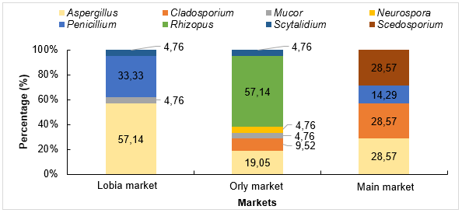

Fig. 4. Fungal richness of peanut paste samples by market

3.4.2 Fungal contamination rates across markets

Analysis of PPM peanut paste samples from all surveyed markets revealed statistically significant differences in micromycete isolation frequencies (P < 0.05). Aspergillus was the most prevalent genus, detected in 35% of samples, followed by Rhizopus (19.04%), Penicillium (15.87%), and Cladosporium (12.7%). The remaining genera showed isolation frequencies below 10%. Based on these patterns, three distinct fungal groups were identified: Group 1: Aspergillus, Group 2: Scedosporium, Cladosporium, Penicillium, Rhizopus, Group 3: Neurospora, Mucor, Scytalidium (Figure 5). Figure 6 illustrates the contamination levels of PPM samples by market. Despite exhibiting lower fungal diversity, the Lobia market showed the highest contamination rate at 67%. This was followed by the Orly market with 22%, and the Main market with 11%.

Fig. 5. Occurrence of fungi in peanut paste samples
Asperg. : Aspergillus, Clados. : Cladosporium, Neuros. : Neurospora, Rhizo. : Rhizopus, Scytal. : Scytalidium, Scedos. : Scedosporium

Fig. 6. Contamination level of PPM peanut paste samples sold in the surveyed markets

3.4.3 Species-level diversity of micromycetes in analyzed peanut paste samples

Microbiological analysis (culture on Sabouraud-chloramphenicol at 30°C) of PPM peanut paste samples collected from the Lobia market, Orly market, and main market revealed a richness in fungal species, with 21 species discriminated and presented in table 4.

 | Table 4. Fungal flora isolated in peanut paste
 | Molds |  | Macroscopic description |  | Microscopic description
 | Aspergillus sp_{1.} |  | 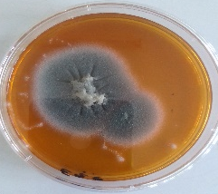 | Grayish colony with a powdery appearance; low mycelium; moderate growth (4 cm diameter on the 5th day) | 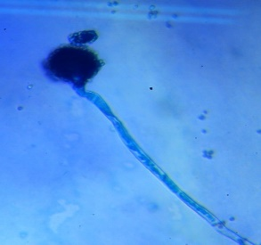 | Long conidiophore ending in a swollen head; septate mycelium
 | Aspergillus sp_{2.} |  | 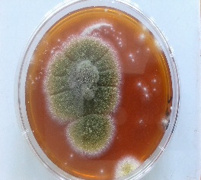 | Yellow-green colony with a powdery appearance; low mycelium; moderate growth | 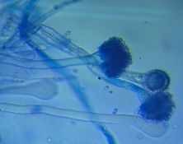 | Long conidiophores ending in swollen heads; mycelium bearing numerous erect conidiophores
 | Aspergillus sp_{3.} |  | 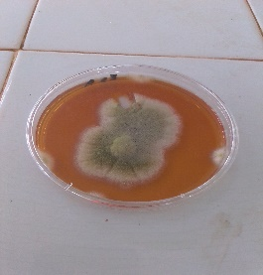 | Yellow-green colony with a powdery appearance; low mycelium; moderate growth | 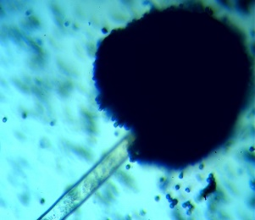 | Smooth conidiophores ending in a blackish aspergillar head at maturity
 | Aspergillus sp_{4.} |  | 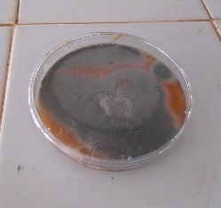 | Grayish colony with a powdery appearance; low mycelium; rapid growth | 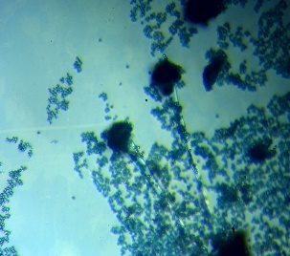 | Long conidiophore ending in a swollen head; septate mycelium
 | Aspergillus sp_{5.} |  | 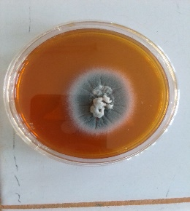 | Grayish colony with a powdery appearance; low mycelium; moderate growth | 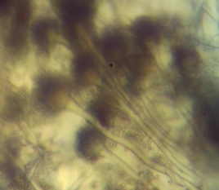 | Long conidiophores ending in swollen heads; mycelium bearing numerous erect conidiophores
 | Aspergillus sp_{6.} |  | 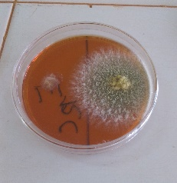 | Yellow-green colony with a powdery appearance; low mycelium; moderate growth | 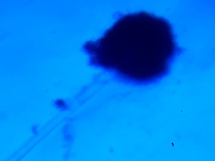 | Smooth conidiophores ending in a blackish aspergillar head at maturity.
 | Aspergillus sp_{7.} |  | 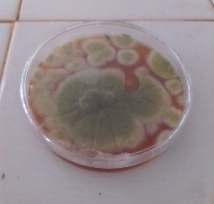 | Yellow-green colony with a powdery appearance; low mycelium; rapid growth | 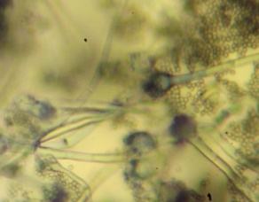 | Presence of brush-like structures associated with aspergillar heads.
 | Aspergillus sp_{8.} |  | 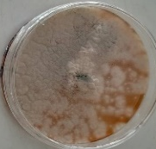 | Grayish colony with a powdery appearance; low mycelium; rapid growth | 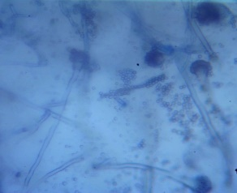 | Presence of aspergillar head; densely grouped phialides; flared conidiophores.
 | Aspergillus sp_{9.} | 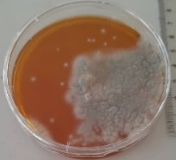 |  | Grayish colony with a powdery appearance; low mycelium; moderate growth | 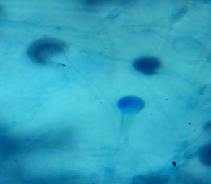 | Presence of aspergillar head; densely grouped phialides; flared conidiophores
 | Aspergillus sp_{10.} | 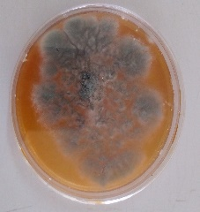 |  | Grayish colony with fluffy appearance; low mycelium; rapid growth | 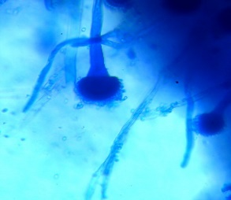 | Presence of aspergillar head; densely grouped phialides; flared conidiophores
 | Aspergillus sp_{11.} | 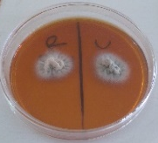 |  | Grayish colony with fluffy appearance; low mycelium; moderate growth. | 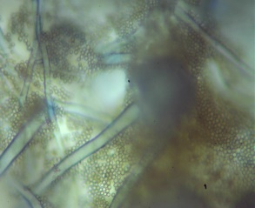 | Smooth conidiophores ending in a blackish aspergillar head at maturity
 | Aspergillus sp_{12.} | 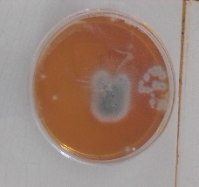 |  | Grayish colony with powdery appearance; low mycelium; slow growth | 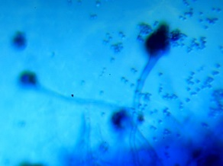 | Presence of brush-like structures associated with aspergillar heads
 | Aspergillus sp_{13.} | 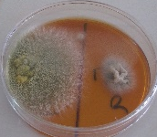 |  | Yellow-green colony with powdery appearance; low mycelium; moderate growth | 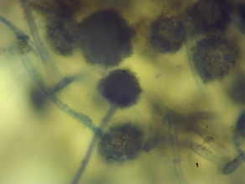 | Smooth conidiophores ending in a blackish aspergillar head at maturity
 | Aspergillus sp_{14.} | 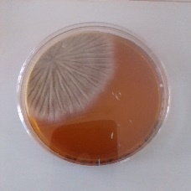 |  | Grayish colony with a downy appearance; low mycelium; moderate growth | 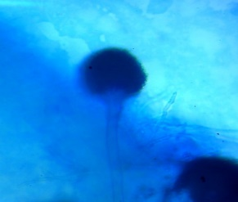 | Smooth conidiophores terminating in aspergillar heads
 | Neurospora |  | 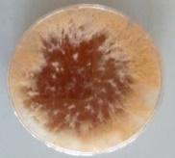 | Orange colony with a cottony appearance; high mycelium; rapid growth | 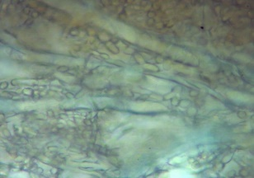 | Septate thallus with the presence of an articulated chain of arthrospores
 | Scedosporium |  | 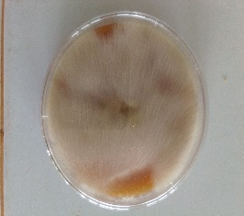 | Whitish colony with a cottony appearance; high mycelium; rapid growth | 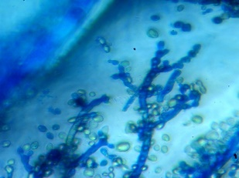 | Conidiophores with branches; conidia arranged in chains
 | Rhizopus |  | 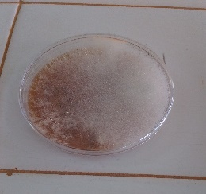 | Whitish colony with a cottony appearance; high mycelium; rapid growth | 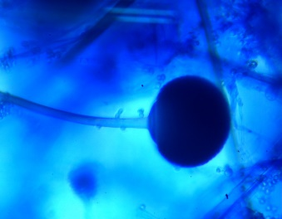 | Coenocytic hyphae, stolon with rhizoids, and sporangiophores bearing globose sporangia with columella
 | Mucor |  | 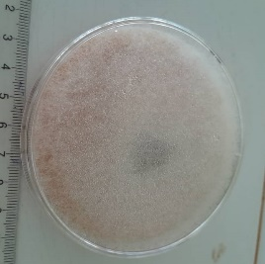 | Whitish colony with a cottony appearance; high mycelium; rapid growth | 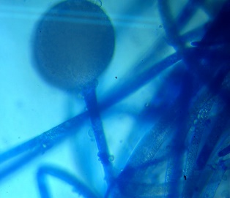 | Septate filaments; globose sporocyst; round spores.
 | Cladosporium |  | 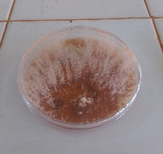 | Orange colony with a cottony appearance; high mycelium; rapid growth | 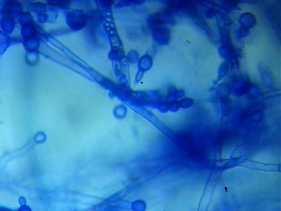 | Conidiophores with branches; conidia arranged in chains
 | Neurospora | 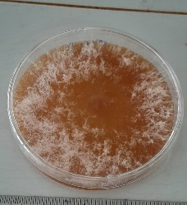 |  | Whitish colony with cottony appearance and high mycelium; rapid growth | 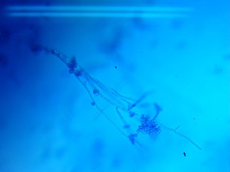 | septate hyphae, phialides arranged in verticils, presence of metulae
 | Scytalidium | 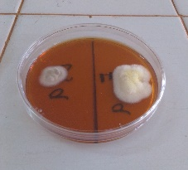 |  | Dark brown colony, dry, felt-like texture | 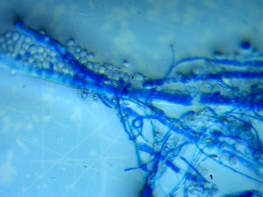 | Septate hyphae with rectangular arthroconidia, often pigmented

4. DISCUSsion

Food safety has become a marketing requirement, as it is a determining factor in human health. This requirement is even more pronounced when it comes to artisanal food products. Indeed, the methods used to obtain such products are subject to little or no control, and their shelf life is difficult to assess or unknown. This can sometimes result in products of variable quality with risks of food poisoning for consumers (Ouina et al., 2025). Peanut paste is produced artisanally and sold until production stocks are exhausted.

Investigation finding indicating the majority of respondents (95.6%) as women within household settings reflects the predominant role of women in food preparation at the household level. Moreover, a relatively high proportion of these women (58.8%) possessed formal education, which constitutes an important asset for understanding and adhering to hygiene practices in food handling. Peanut sauce, a common accompaniment to staple dishes such as rice and foutou, is widely consumed and represents the primary household use of peanut paste. Reports of illness associated with the consumption of this food highlight potential risks linked to production, handling, and storage practices. Field observations reveal inconsistent adherence to hygiene standards among household food preparers and market vendors, including irregular handwashing and inadequate maintenance of kitchen and stall cleanliness. Furthermore, peanut paste is frequently packaged in settings where insects and rodents—known vectors of microbial contamination—are present (Mbata et al. 2024). The utensils employed for handling and scooping peanut paste are often left exposed to ambient air, thereby increasing the risk of contamination. Collectively, these conditions contribute to the susceptibility of peanut paste to spoilage and the introduction of pathogenic microorganisms at multiple points along its distribution chain, from production and sale to eventual consumption (Mukhurov et al., 2022). The resulting contaminants form part of the resident and transient microbial flora associated with peanut paste.
An ageing study of peanut pastes validated their microbiological shelf life and supported determination of an appropriate best-before date. Microbial monitoring over four weeks revealed growth kinetics consistent with classical bacterial models, with a latency phase followed by exponential proliferation of enterobacteria and total aerobic mesophilic flora. In PPH peanut paste, microbial populations remained stable during the first week, reflecting adaptation to the matrix through enzyme and metabolite synthesis as described by Tollerson et al. (2020). Fungi exhibited linear growth followed by decline, likely due to nutrient limitation or inhibitory factors (Gonzalez & Aranda, 2023). Microbial loads increased from 1.4 × 10³ to 6.9 × 10³ CFU/g for total aerobic mesophilic flora, 1.4 × 10² to 3.9 × 10² CFU/g for enterobacteria, and 2.9 × 10² to 1.1 × 10² CFU/g for fungi. These values complied with microbiological specifications, though they exceeded those reported by Compaoré et al. (2020) for peanut paste produced in Burkina Faso.

Peanut paste stability was assessed using microbial indicators (Enterobacteria, total aerobic mesophilic flora, yeasts, and moulds). According to the three-class quality plan, organoleptic deterioration of PPH peanut paste occurs at approximately 128 days post-manufacture, defining the best-before threshold. Beyond this period, structural and functional changes in organic constituents become evident. Prabhakar et al. (2025) reported significant increases in acid value over six months, indicating lipid degradation, accompanied by declines in protein and oil content. Prolonged storage may also promote pathogens, toxins, or mycotoxins, thereby increasing foodborne infection risks (Boli et al., 2020). Peanut paste samples from Lobia, Orly, and the main market contained eight mould genera: Aspergillus, Cladosporium, Mucor, Neurospora, Penicillium, Rhizopus, Scytalidium, and Scedosporium. These microfungi, common environmental contaminants of peanut seeds and market substrates (Isalar et al., 2021), were classified into toxin-producing (Aspergillus, Penicillium), spoilage (Mucor, Rhizopus, Cladosporium, Neurospora), and clinically relevant (Scytalidium, Scedosporium) groups (Zhang et al., 2024; Gbétokpanou et al., 2025). Orly market exhibited the highest fungal abundance, with Rhizopus isolated most frequently (57.14%), while Aspergillus was detected across all markets, particularly in Lobia and the main market. The widespread occurrence of Aspergillus, including toxinogenic species such as A. flavus, A. parasiticus, and A. ochraceus (Hassan et al., 2018; Pandey et al., 2023), underscores significant food safety risks. These findings are consistent with reports of A. niger and A. flavus predominance in peanut pastes from Indonesia (Margareta & Setyowati, 2023). The highest contamination rate (67%) was observed in WFP samples from Lobia market, likely reflecting increased environmental exposure due to its open-air setting and proximity to a roadway

4. Conclusion

This study demonstrates that peanut paste, though widely consumed in Daloa, is vulnerable to contamination due to inadequate hygiene practices during sales and storage. This food harbors diverse fungal communities, posing a risk of mycotoxin contamination. The predominance of Aspergillus species across markets underscores the potential for harmful fungal growth, especially when the product exceeds its estimated best-before period of 128 days. These findings highlight the urgent need for improved hygiene standards, better storage practices, and consumer awareness to reduce health risks and ensure the safety of peanut paste. Ultimately, safeguarding this staple food requires coordinated efforts between vendors, consumers, and public health authorities.

DISCLAIMER (ARTIFICIAL INTELLIGENCE)

Author(s) hereby declare that NO generative AI technologies such as Large Language Models (ChatGPT, COPILOT, etc) and text-to-image generators have been used during writing or editing of this manuscript.

ETHICAL CONSIDERATIONS

The respondents consented to the information presented in this study.

AcknowledgEments

We thank all peanut past vendors and investigated households for their cooperation during this study.

Competing interests

Authors have declared that no competing interests exist

References

- Aboulaye, T. , Sibirina, S. , Emmanuella, A. , Karidia, T. , Abo, K., & Daouda, K. (2023). Fungal flora on weeds in the cashew (Anacardium occidentale L.) orchard in Côte d’Ivoire. American Journal of Plant Sciences, 14, 448-463.
- Boli, Z. A., Zoue, L. T., Koffi-Nevry, R., & Koussémon, M. (2024). Fungal contamination and mycotoxins’ occurrence in peanut butters marketed in Abidjan district (Côte d’Ivoire). Food and Environment Safety, 13(3), 267-275. https://www.fia.usv.ro/fiajournal/index.php/FES/article/view/267
- Boli, Z. B. I. A., Kambire, O., Zoue, L. T., & Koffi-Nevry, R. (2020). Fungal Variation during Peanut Paste Storage. International Journal of Microbiology. https://doi.org/10.1155/2020/8836726
- Bondom, R. L., Lango-Yaya, E., Kolokaté, M., N'yetobouko, S., Moulo-Oli, A. T., Dalenga, Z. V., Djeintote, M., & Koffi, B. (2025). Bacteriological profile of contamination of artisanal peanut pastes sold in the city of Bangui in the Central African Republic. Health, 17, 200-212.https://doi.org/10.4236/health.2025.173015
- Compaoré, C. S., Douamba, Z., Zongo, S., Zagré, M. B., & Sawadogo-Lingani, H. (2020). Technologie et caractéristiques chimiques des pâtes d'arachide vendues dans quelques marchés de la ville de Ouagadougou. Sciences Naturelles et Appliquées, 39 (1), 183-196. https://revuesciences-techniquesburkina.org/index.php/sciences_naturelles_et_appliquee/article/view/1085
- Daou, R., Joubrane , K., Maroun, R.G., Khabbaz , L.R., Ismail, A., Khoury, A.E. (2021). Mycotoxins: Factors influencing production and control strategies. Agriculture and Food, 6(1), 416-447.
- Gbétokpanou, C. S., Jonard, C., Mehinto, O. A., Gofflot, S., Adjéniya, M. J. M., Iko Afe, O. H., Anihouvi, D. G., Boutaleb, S., Bragard, C., Azokpota, P., Mahillon, J., Sindic, M., Scippo, M-L., Madodé, Y. E., & Douny, C. (2025). Peanut and peanut-based foods contamination by toxigenic fungi and mycotoxins: potential risks for Beninese consumers. Toxins, 17, 532. https://doi.org/10.3390/toxins17110532
- GSO ISO 21527-1 (2016). Microbiology of food and animal feeding stuffs — Horizontal method for the enumeration of yeasts and moulds — Part 1: Colony count technique in products with water activity greater than 0.95. https://gso-sims-preview-doc-aws.s3-eu-west-1.amazonaws.com/gso-iso-21527-1-2016-en.pdf
- Gonzalez, J. M., & Aranda, B. (2023). Microbial growth under limiting conditions-future perspectives. Microorganisms, 11(7), 1641. https://doi.org/10.3390/microorganisms11071641
- Hassan, Z.U., Al-Thani, R.F., Migheli, Q., & Jaoua, S. (2018). Detection of toxigenic mycobiota and mycotoxins in cereal feed market. Food Control, 84, 389-394.https://doi.org/10.1016/j.foodcont.2017.08.032
- ICRISAT. (2024). Groundnut overview. https://www.icrisat.org/crops/groundnut/overview
- Isalar, O.F., Ogbuji, N.G., Okungbowa, F.I., & Ataga, A.E. (2021). Contaminants fongiques associés aux graines d'arachide (Arachis hypogaea). Journal of Bioinformatics and Systems Biology, 4(4), 182-193.
- ISO 4833-1:2013/Amd 1. (2022).— Microbiology of the food chain — Horizontal method for the enumeration of microorganisms — Part 1: Colony count at 30 °C by the pour plate technique — Amendment 1: Clarification of scope.https://cdn.standards.iteh.ai/samples/73329/3bbe2b8b0bcb46b092130d393f4ac67a/ISO-4833-1-2013-Amd-1-2022.pdf
- ISO 6887-2. (2017). Microbiology of the food chain — Preparation of test samples, initial suspension and decimal dilutions for microbiological examination.https://cdn.standards.iteh.ai/samples/63336/5d3e3d4271b3440c89b96c47a3036dd9/ISO-6887-2-2017.pdf
- ISO 21528-2. (2017). Microbiology of the food chain — Horizontal method for the detection and enumeration of Enterobacteriaceae — Part 2: Colony-count technique.https://cdn.standards.iteh.ai/samples/63504/5abbe17268eb4268a87a826fdd429a11/ISO-21528-2-2017.pdf
- Margareta, A., & Setyowati, A. (2023). Isolation and Identification of Mold Contaminants in Peanut Paste from the Cengkareng Market of West Jakarta. EduHealth, 14(3), 1259-1264.https://doi.org/10.54209/jurnaleduhealth.v14i3.2662
- Mbata, G. N., Danso, J. K., & Holton, R. L. (2024). Peanut aflatoxin: Impact of postharvest insect infestation and storage systems. Insects, 15(11), 836. https://doi.org/10.3390/insects15110836
- Mukhurov, N.I., Khodin, A.A., & Kim, Y.-J. (2022). Devices and Methods for Measuring of the Ambient Air Dust. Short Review. Devices and Methods of Measurements, 13(1), 7–16.https://doi.org/10.21122/2220-9506-2022-13-1-7-16
- Ngulube, M., & Kaimoyo, E. (2023). Microbial quality of peanut butter manufactured by small-scale producers at two popular open-air markets in Lusaka. International Science and Technology Journal of Namibia, 16, 4051.https://repository.unam.edu.na/bitstream/handle/11070/3900/Ngulube_Kaimoyo_2023_ISTJN_16_40-51.pdf?sequence=1&isAllowed=y
- Official Gazette of the Republic of Algeria N° 39. (2017). Annexe 1; Microbiological criteria applicable to foodstuffs. https://faolex.fao.org/docs/pdf/Alg172357.pdf
- Ouina, T.S., Panoff, J-M., Gente, S., Garon, D., Rioult, J-P., Gonnety, T.J., & Koussémon, M. (2020). Cropping practices and fungal contamination in banana plantations in Côte d’Ivoire. Research Journal of Microbiology, 15 (3), 98-108.
- Ouina, T. S. T., Kouassi, K. C., Ya, K. C., Diegai, J. O. L., Kouassi, K. A., & Koussemon-Camara, M. (2025). Risk assessment of Staphylococcus aureus food poisoning associated with pork barbecues in Daloa, Côte d’Ivoire. Microbiology Research Journal International, 35(11), 138-149.https://doi.org/10.9734/mrji/2025/v35i111660
- Pandey, A.K., Samota, M.K., Kumar, A., Silva, A.S., & Dubey, N.K. (2023). Fungal mycotoxins in food commodities: present status and future concerns. Frontiers in Sustainable Food Systemshttps://doi.org/10.3389/fsufs.2023.1162595
- Prabhakar, B., Mallela, R.R., & Shaik, K. (2025). Effect of natural preservatives on shelf-life extension and quality parameters of Peanut butter. International Journal of Advanced Biochemistry Research, 9(2), 257-265. https://doi.org/10.33545/26174693.2025.v9.i2Sd.3730
- ANSD (National Agency for Statistics and Demography). (2023). 5th General Population and Housing Census (RGPH-5). https://www.ansd.sn/recensement/rgph-5-2023
- Sithole, T. R., Ma, Y.-X., Qin, Z., Wang, X.-D., & Liu, H.-M. (2022). Peanut butter food safety concerns—prevalence, mitigation and control of Salmonella spp., and aflatoxins in peanut butter. Foods, 11, 1874.https://doi.org/10.3390/foods11131874
- Tollerson, R., & Ibba, M. (2020). Translational regulation of environmental adaptation in bacteria. Journal of Biological Chemistry, 295(30), 10434–10445. https://doi.org/10.1074/jbc.REV120.012742
- Zhang, A., Wang, Z., Sheng, H., & Yang, J. (2024). Systemic Scedosporium apiospermum Infection affecting multiple sites after near-drowning: A case report. Infection and Drug Resistance, 17, 5739–5744. https://doi.org/10.2147/IDR.S483524

