Microbiological Quality of Dried Meat consumed in N’Djamena: Focus on pathogenic Escherichia coli

Abstract
Dried meat is widely consumed in Chad, but consumption of uncontrolled meat can expose consumers to food poisoning, causing public health problems through the presence of micro-organism.
Aims: To assess the hygienic quality of dried meat and characterize pathogenic strains of E. coli.

Study design: Cross-sectional descriptive study based on analyses of collected samples and interpretations of the results.
Place and duration of study: Dried meat samples were collected from different sales point in N’Djamena from May to December 2020.

Methodology: Escherichia coli were tested on TBX medium in accordance with ISO 16649-3: 2005. API®20E galleries 20100 CE were used for biochemical identification of isolated Escherichia. Conventional PCR was used to identify the virulence genes of Escherichia coli responsible for food borne diseases in dried meet consumers.

Results: The results revealed that E. coli was 47.5% from total strains bacteria. About the analysis, 40% of the E. coli isolates carried the stx1 gene, which is responsible for hemorrhagic diarrhea, and 00% of the E. coli carried the eaeA gene responsible for watery diarrhoea and gastroenteritis.

Conclusion: This results demontrated the presence of virulence genes in pathogen causing bacteria strain in dried meat from N’Djamena. As a follow up from this finding an easy to used dried meat quality control manual of procedure was developed in view of preseving the health of consumers.

Key words: Meat hygiene, Foodborne pathogens, E coli, and public health risk
1. Introduction
“Meat is a high source of protein which is needed in our diet and contains all the essential amino acids and vitamins A, B12, B6, D and E” (Nfor et al., 2014).
Dried meat called charmout in Chad is obtained by an ancient process in Chad and represents the traditional form of meat preservation. Consumption of uncontrolled meats can expose consumers to intoxication diarrhea, gastroenteritis, and food poisoning, causing public health problems through the presence of micro-organism (Ayalew et al., 2015).
“Escherichia coli have been found in the meats analyzed can cause diarrhea, dysentery, food poisoning and gastroenteritis or typhoid fever” (Kimassoum et al., 2017).
Diarrhea caused by E. coli is widespread particularly among young children in developing countries. E. coli has been identified as the leading cause of food-borne illness worldwide.
Shiga-toxin-producing stx of Escherichia coli, have the denomination STEC, shiga-toxin-producing, are infectious agents responsible for haemorrhagic diarrhea (Tatiane et al., 2014)
“Over 30% of the population in developed countries suffers from food born infectious diseases each year with diarrheal as a common symptom. Globally most of this food borne diseases caused by pathogens have been link to meat consumption” (OMS, 2015).
Pathogenic microorganisms can contaminate meat when it is not properly handled, there are the most important foodborne pathogens (Wójcicki et al., 2022). These pathogens are involved in food poisoning and meat contamination (Tidjani et al., 2013).
Meats can be a simple vehicle for micro-organisms, or the medium of micro-organism multiplication that can reach a dangerous consumption level (Tafida et al., 2014).
The severity of the adverse effects caused to public health by pathogenic micro-organisms originating from meats is important. In the United States, the Center for Disease Control estimates that Escherichia coli is responsible for health problems in over 70,000 people each year, whose main incriminating foods are meat, water, unpasteurized dairy products and foods eaten raw (Afnabi et al., 2015).
A study of meat from slaughterhouses in India showed that 5% of samples analyzed (300) contained Salmonella, 6.66% contained more Staphylococcus, and 7.33% had more Escherichia coli (Pradeep et al., 2014). “The presence of E. coli in meat has been attributed to contamination by the faeces of infected animals or to poor hygiene practices during meat handling” (Diallo et al., 2017).
Reservoirs are mainly cattle, sheep, goats and camels.
In addition, the attachment lesions that characterize enteropathogen infection are caused by the eae gene of E. coli, responsible for watery diarrhea and gastroenteritis through attachment lesions (Pradeep et al., 2014). Enteropathogenic E. coli (EPEC) strains are responsible for watery diarrhea and infantile gastroenteritis.
The main objective of this study was to assess the hygienic quality of dried meat and characterize pathogenic strains of E. coli.

2. Material and methods
2.1 Location of the Study and Sampling
2.1.1 Location and period of study
Dried meat samples were collected from different sales point in N’Djamena from May to December 2020 and analyzed in the laboratory of Public Health Biotechnologies of the Biotechnology Center of the University of Yaounde 1.

2.1.2 Sampling
A total of forty (40) samples of dried meat collected. Thus, 10 Escherichia strains were used by young cultures, after isolation on nutrient agar for 24h.

2.2 Microbiological Analysis
Escherichia coli was enumerated at 44°C for 24 h on Tryptone Bile X-glucuronide Agar plates (NF ISO 21528-2: 2004).
Biochemical tests were carried out using API®20E galleries were used for biochemical identification of isolated Escherichia.

2.3. Polymerization chain reaction (PCR) of E. coli strains DNA material

Extraction of total genomic DNA

Chelex-100 rasine method was used to directly extract DNA from the bacterian culture reisolated (24 h) on nutrient agar. The extracted DNA was used to amplified the targeted genes.
We isolated, extracted and analyzed DNA using conventional PCR to identify pathogenic strains of Escherichia coli isolated. Conventional PCR targeting the virulence genes stx1, and eae was performed by using primers.

Amplification of Targeted Genes:
Conventional PCR was carried out by the Thermocycler to identify the genes.
For the amplification of the stx1 gene the predenaturation was done at 95°C, for 15 minutes; followed by 35 cycles of denaturation at 95°C for 45 seconds; annealing at 55°C, for 45 seconds, elongation at 68°C for 2 minutes and termination at 72°C for 5 minutes (Nicoline et al., 2015).
As concerns the amplification of the eaeA gene, predenaturation was done at 93°C, for 5 minutes followed by 35 cycles of denaturation at 93°C for 1 minute, annealing at 65°C for 30 seconds, elongation in 2 minutes at 72°C and termination at 75°C, for 10 minutes.
The electrophoresis machine used to 100 volts and gel electrophoresis was used to visualized and identify the amplified genes (Khatib et al., 2015). Esherichia coli ATCC 25922 strains from the University of Bologn (Italy) was used for the control.

Results and discussions
The results of the isolation of E. coli strains by biochemical tests or Biomérieux API®20E identification strips are presented in Tables 1.
Table 1 shows the results of the Enterobacteriaceae identification system (API 20E strips galeries), for identified bacteria, Escherichia coli were the most numerous. The percentage of E. coli found on strains bacteria was 47.5%. The other bacteria were also obtained from API 20E galleries.
Table 1 : E. coli profile for urease and Kligler tests.
Bactérie | Uréase | Lactose | Glucose | Gaz | H₂S
E. coli | - | + | + | + | -

In this table 1, E. coli test positive for lactose, glucose and gas production.

Prevalence of amplified virulence genes for ten (10) isolated Esherichia coli strains :
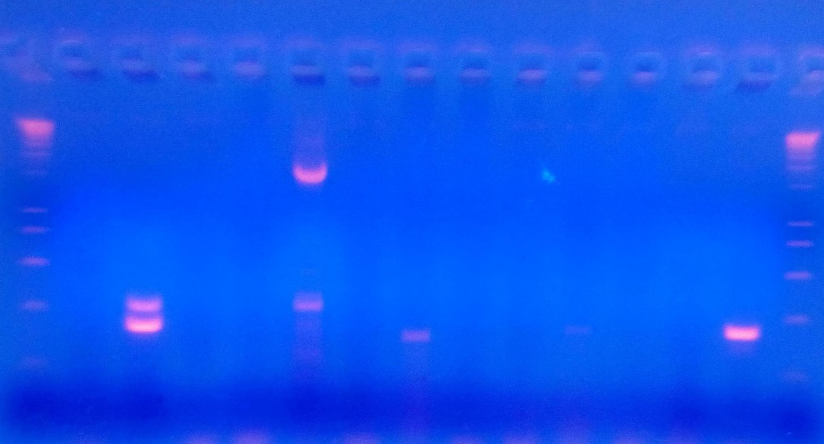
M 1 2 3 4 5 6 7 8 9 10 NC NC PC M

800
320 pb
700

500
300

100
Positive samples

Figure 1 : Profile of PCR products of the stx1 gene of Esherichia coli.
Legend : M : 100 bp marker ; PC : Positive control (Esherichia coli ATCC 25922) ; NC: Negative control; samples number 2, 5, 7 and 10 carry the stx1 gene; samples 1, 3, 4, 6, 8 and 9 are negative.
E. coli (ATCC 25922) was also used as a positive control for the stx1 gene by Ollo et al, (2017), and Shahrani et al, (2014). For 10 E. coli strains isolates analyzed, 4 samples carry the stx1 gene.
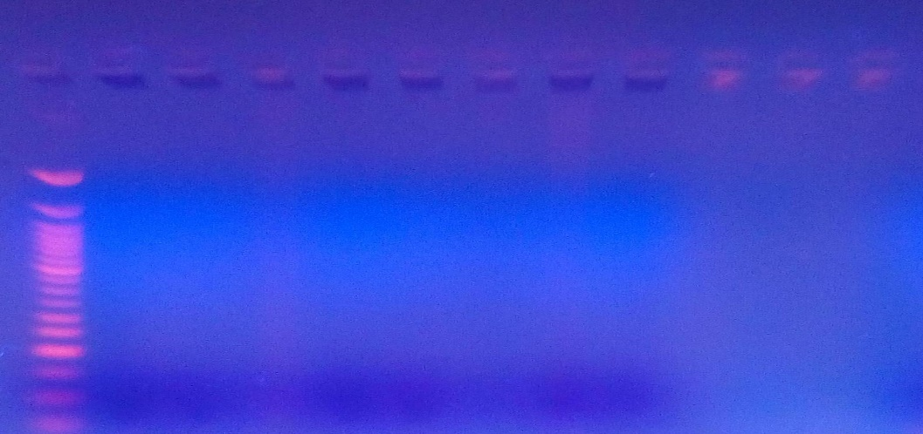
M 1 2 3 4 5 6 7 8 9 10 NC

Absence of the eaeA gene in E. coli

300

200

100
50

Figure 2 : Profile of PCR products of the eaeA gene of Esherichia coli.
Legend : M: 50 bp marker; NC: Negative control; all samples number 1, 2, 3, 4, 5, 6, 7, 8, 9, and 10 are negative for the eaeA gene because there are no bands between 300 and 400 bp. The eaeA gene causing enteropathogenic lesions is absent.
Table 2 : Prevalence of amplified virulence genes.
Pathogen isolated | Gene | Number of samples | Positive samples | Negative samples | Percentage positive
Escherichia coli | stx1 | 10 | 4 | 6 | 40
Escherichia coli | eaeA | 10 | 0 | 10 | 0
Legend : Positive sample: presence of the gene after molecular analysis; Negative sample: absence of the gene after molecular analysis.
The results in Table 2 show that four (4) of 10 Escherichia coli strains carry out the stx1 gene. There are no positive results for the eaeA gene for the 10 Escherichia coli strains.
So, 40% of Escherichia coli carry the stx1 virulence gene responsible for haemorrhagic diarrhoea.

In this study, E. coli (40%) of which carry the shiga-toxin gene stx1, responsible for haemorrhagic diarrhoea, corresponding to the work of Tatiane et al (2014), in Brazil, who demonstrated that 31.1% of their strains (E. coli) carry the stx1 and stx2 genes. Shridhar et al (2017), also demonstrated that 93 isolated E. coli (48.4%) were positive for the stx1 gene in samples of bovine origin in the United States. They observed a significant presence of the stx1 and stx2 genes in beef and milk. Animals could therefore represent a major source of STEC entering the food chain. The Stx gene variants pose a real public health problem, as this gene is often found in clinical isolates from patients with haemorrhagic colitis or enterohaemorrhagic infections (Shridhar et al., 2017).
As in our study, E. coli strain ATCC 25922 was used as a positive control (Ollo et al., 2017 ; Shahrani et al., 2014), the eae gene was also not found by these authors in E. coli strain ATCC 25922 (Ollo et al., 2017).
E. coli carrying the enteropathogenic virulence gene eaeA responsible for watery diarrhoea have been detected (2.7%) of E. coli strains identified in Côte d'Ivoire. ¹⁸ The prevalence of enterovirulent E. coli in meat and milk is relatively low, 1.9% according to Nicoline et al. (2015) and 0.0% Shridhar et al, (2016). Gagara (2014), found 0.0% of E. coli strains carrying the eae and stx1 gene in frozen meat in Senegal. These results are consistents with our results obtained by the absence of the eaeA gene in the E. coli strains identified. The results for the E. coli stx virulence gene (40%) are consistent with studies by Nicoline et al (2015) on the analysis of meat samples from abattoirs in South Africa.
Microorganisms present in dried meat and meat products play an important role in determining product and process quality (Mediani et al., 2022). “Many attributable factors influence microbial activity in dried meat, such as aw values, which indicate the relative moisture balance or available water ratio that provides the conditions necessary for microbial growth” (Mediani et al., 2022).
According to the study by Nummer et al. (2004), E. coli contamination of dried meat also affected the health of 11 people in 1995, the meat in question being venison.
In this study by Nummer et al. (2004), “the cause of contamination was also attributed to drying temperatures that were insufficient to kill bacteria. In addition, it was also reported that an experiment involving dehydrating meat at 62.8°C for 10 hours did not eliminate the E. coli O157:H7 strain inoculated into the dried meat”.
Studies have shown that beef jerky that was salted before drying contained less E. coli O157:H7 after processing (Campbell et al., 2021). “Salting meat with salt, sugar, and sodium nitrite increases the lethality of pathogens such as E. coli O157:H7, L. monocytogenes, and Salmonella” (Nummer et al., 2004).
The absence of the eaeA virulence gene in this study demonstrates that some strains of E. coli are part of the commensal flora of the gastrointestinal tract of mammals.
Conclusion
In this stady, molecular analyzes showed us the presence of virulence genes in the identified pathogens (E. coli strains). The stx1 virulence gene responsible for haemorrhagic diarrhoea (40%) can cause real public health problems among consumers.
To resolve this problem, the development of a protocol for dry meat management would be a solution. Also, the extablished manual of procedure for microbia control in meat with suggestions for easy-to-apply methods, could be used for meat quality control management, in order to preserve the health of the consumer.
Disclaimer (Artificial intelligence)
Author(s) hereby declare that NO generative AI technologies such as Large Language Models (ChatGPT, COPILOT, etc.) and text-to-image generators have been used during the writing or editing of this manuscript.

References

- H. Ayalew, A. Berhanu, B. Sibhat, B. Serda. Microbiological assessment of meat contact surfaces at abattoir and retail houses in Jigjiga town, Somali National Regional State of Ethiopia. ISABB-Journal of Food and Agricultural.DOI : 10.5897/ISABB-JFAS2014.0012 ; Vol 5(3) : 21- 26 (2015).

- Bantama market). Merit Research Journal of Agricultural Science and Soil Sciences. 2(3): 038 - 046 (2014).

- Campbell JA, Gaydos NJ, Egolf SR, Watson S. Fate of Escherichia coli O157:H7, Salmonella spp., and Listeria monocytogenes During Curing and Drying of Beef Bresaola. Meat Muscle Biol. (2021) 5:1–8. doi: 10.22175/mmb. 11621

- Dadie A., Désiré N., Nathalie G., Etienne D., et Mireille D. Prévalence de Escherichia coli entéropathogènes dans le lait non pasteurisé produit à Abidjan, Côte d’Ivoire. International Journal of Biological and Chemical Sciences. 4(1): 11-18 (2010).

- Diallo A. A., Delphine B., Fatou T., Mbaye M., Mohamed M. S., Moussa D., Yacine S., Monique K., Rianatou A., Yaya T., Eric O. and Hubert B. Prevalence of pathogenic and antibiotics resistant Escherichia coli from effluents of a slaughterhouse and a municipal wastewater treatment plant in Dakar. African Journal of Microbiology Research. 11(25) : 1035 -1042 (2017).

- Khatib A., Olama Z. and Khawaja G. Shiga Toxin-Producing E. coli (STEC) Associated with Lebanese Fresh Produce. International Journal of Current Microbiology and Applied Sciences. 4(2): 481 - 496 (2015).

- D. Kimassoum, S. L. Sado Kamdem, B.N. Ngandolo, K.C. Fatou, A.M. Nji, N M. Bawe, B. Mobeal, D. Nadjilem and W.F. Mbacham. Evaluation of microbial adverse effects on fresh and processed bovine meat in N'Djamena (Chad) and Yaoundé (Cameroun). African Journal of Microbiology Research. Vol. 11(16): 637 - 643 (2017).

- Mailafia S., Olabode H.O.K. and Akaefe I. Phenotypic characterization of nosocomial bacterial species on contact surfaces of veterinary clinics and hospitals in Abuja, Nigeria. International Journal of Microbiology Research. 6 (4) : 213 - 223 (2017).

- Mediani A, Hamezah HS, Jam FA, Mahadi NF, Chan SXY, Rohani ER, Che Lah NH, Azlan UK, Khairul Annuar NA, Azman NAF, Bunawan H, Sarian MN, Kamal N and Abas F (2022) A comprehensive review of drying meat products and the associated effects and changes. Front. Nutr. 9:1057366. doi: 10.3389/fnut.2022.1057366

- Nfor BM, M Corazzin, FA Fonteh, A Sepulcri, NT Aziwo, E Piasentier (2014). Fatty acid profile of zebu beef cattle from the Central African sub-region. S. Afr. J. Anim. Sci. 44 (2):148-154.

- Nicoline F. T., Eunice S., Roland N. N., and Pascal O. B. Detection of Pathogenic Escherichia coli and Staphylococcus aureus from Cattle and Pigs Slaughtered in Abattoirs in Vhembe District, South Africa. Scientific World Journal. 1 : 1 - 8 (2015).

- Nummer BA, Harrison JA, Harrison MA, Kendall P, Sofos JN, Andress EL. Effects of preparation methods on the microbiological safety of home-dried meat jerky. J Food Protect. (2004) 67:2337–41. doi: 10.4315/0362-028X-67.10.2337

- Ollo K., Ama A. A., Konan M. Y., and Koffi R. N. Prevalence of Virulence Genes Associated with Diarrheagenic Pathotypes of Escherichia coli Isolates from Water, Sediment, Fish, and Crab in Aby Lagoon, Côte d’Ivoire. International Journal of Microbiology. 1: 1 - 8 (2017).

- Pradeep K., Jagannatha R., Haribabu Y. and Manjunath. Microbiological Quality of Meat Collected from Municipal Slaughter Houses and Retail Meat Shops from Hyderabad Karnataka Region, India. Journal Procedia at ScienceDirect. 8 : 364 - 369 (2014).
- Afnabi, R.B., Nameni, R.P., Kamdem, S.L., Ngang, J.J., & Alambedji, R.B. (2015). Microbial load of beef sold in the traditional slaughterhouse and butcher shops in northern Cameroon. international journal of veterinary science, 4, 183-189.
- Shahrani M., Farhad S D. and Hassan M. Characterization of Escherichia coli virulence genes, pathotypes and antibiotic resistance properties in diarrheic calves in Iran. Biological Research Journal. 47(28) : 1 - 13 (2014).

- Shridhar P. B., Noll L. W., Shi X., Cernicchiaro N., Renter D. G., Bai J. Escherichia coli O104 in Feedlot Cattle Feces: Prevalence, Isolation and Characterization. PLoS ONE. 11(3) : 1 - 17 (2016).

- Shridhar P. B., Siepker C., Noll L. W., Shi X., Nagaraja T. G. and Bai J. Shiga Toxin Subtypes of Non-O157 Escherichia coli Serogroups Isolated from Cattle Feces. Front. Cell. Infection Microbiology journal. 7(121): 1 - 8 (2017).

- Tafida, S.Y., Kwaga J.K.P., Bello M., Kabir J., Umoh V.J., Yakubu S.E. and Nok A.J. Occurrence of Escherichia coli O157 in Retailed-Beef and Related Meat Products in Zaria, Nigeria. Food and Nutrition Sciences. 5: 481- 487 (2014).

- Tatiane V., Debora M. K., Rachel D. M., Claucia F. V., Rosangela U. S., Adriane P. and Ivan C. B. Molecular screening of bovine raw milk for the presence of Shiga toxin-producing Escherichia coli (STEC) on dairy farms. Food Science and Technology, Campinas. 34(3): 604 - 608 (2014).

- Tidjani A., Doutoum A. A., Brahim B. O, Mahamat B., Hourra D., Fatiou T., Comlan A. Assessment of Hygiene Practices and Identification of Critical Control Points Relating to the Production of Skewered Meat Sold in N’Djamena-Chad. Journal of Food Research. 2 (5): 190 - 203 (2013).

- Wójcicki, M.; Chmielarczyk, A; Swider, O.; Srednicka, P.; Strus, ´ M.; Kasperski, T.; Shymialevich, D.; Cie´slak, H.; Emanowicz, P.; Kowalczyk, M. Bacterial Pathogens in the Food Industry: Antibiotic Resistance and Virulence Factors of Salmonella enterica Strains Isolated from Food Chain Links. MDPI Pathogens Journal. 11: (1323) 1- 25 (2022).

