Evaluation of the bacteriological quality of cattle carcasses from the Mpila slaughter areas (Republic of Congo) and antibiotic susceptibility profile of isolated Staphylococcus spp. strains.
ABSTRACT
The objective of this study was to assess the bacteriological quality of cattle carcasses slaughtered in the Mpila slaughter areas. A total of 30 samples were collected and subjected to microbiological analyses to quantify the total aerobic mesophilic flora (TAMF) and identify total coliforms, faecal coliforms, Staphylococcus spp. and Salmonella spp. The results showed a high prevalence of total coliforms (90%), faecal coliforms (56%) and staphylococci (70%). Compared to international food safety standards, 83% of samples were non-compliant for TMAF, 57% for faecal coliforms and 67% for Staphylococcus spp. No Salmonella strains were isolated, indicating a compliance rate of 100%. The antibiotic sensitivity study revealed high resistance of the isolated strains to penicillin (100%), erythromycin (95%) and doxycycline (86%). In addition, 67% of Staphylococcus were resistant to methicillin, indicating the presence of multi-resistant strains. These results highlight a worrying level of contamination in cattle carcasses and call for a strict reinforcement of hygiene measures in slaughter areas, rational management of antibiotic use in livestock farming, and the establishment of an epidemiological surveillance system to limit the spread of multi-resistant bacteria.
Keywords: Bacteriological quality, cattle, sensitivity profile, staphylococcus spp.

1. INTRODUCTION
In recent years, the idea of a direct relationship between optimal nutrition and a healthy lifestyle has gained traction among the general public. As a result, the healthy food market has grown significantly in order to meet the demand of consumers who are increasingly seeking to control their quality of life and health through better nutrition (Iquierdo, 2009) . Beef is an essential component of the diet of many populations around the world. It provides the human body with important nutrients, including protein, iron and vitamins. The growth in meat consumption has been particularly marked in countries that have undergone significant economic transition. Since 1961, China and Brazil have increased their consumption by a factor of 15 and 4 respectively. (Giromini, C.; Givens, D.I, 2022). Beef production is expected to increase in sub-Saharan Africa, mainly due to strong population growth and rising demand for meat among the population (OECD/FAO 2021; Luc Loubamba et al., 2023). However, as a highly perishable product, meat is susceptible to contamination at various stages of the production chain, whether during slaughter, cutting, transport or marketing. It plays an important role as a vector for the transmission of infectious agents from animals to humans (EFSA and ECDC, 2018; Frank et al., 2011), posing a significant risk to consumer health (Philisani, Ishmael, and James 2020). The hygienic quality of cattle carcasses sold in local markets raises significant public health concerns.
Several studies conducted in sub-Saharan Africa report the presence of various pathogens in meat, such as Escherichia coli, Salmonella spp, Staphylococcus aureus and Listeria monocytogenes (Azage & Kibret, 2017; Selby et al., 2006) , which can cause gastroenteritis, systemic infections or neurological complications, particularly in vulnerable populations such as children, the elderly and immunocompromised individuals (Azage & Kibret, 2017; Niyonzima et al., 2018) [7,9]
The work of Luc Loubamba et al. in 2021 reveals that the prevalence of carcasses contaminated with Escherichia coli strains was 99% with an average of 3.03 log10 CFU/cm², and another recent study showed that STEC (Shiga toxin-producing Escherichia coli) carrying the stx1-stx2 genes identified in this study can be considered potentially dangerous to public health. Serogroups O26, O111 and O145, known to pose a risk to human health, were detected. (Luc Loubamba et al., 2023) . A French study also established an epidemiological link with cattle, implicating Escherichia coli O157 in a case of food poisoning (Santé Publique France, 2024) . However, we must not ignore the fact that Salmonella food poisoning is of considerable importance in veterinary and medical terms for animals and has a high incidence in humans (Bornert, 2000). In Congo-Brazzaville, very few or almost no studies have been conducted on the assessment of health risks associated with beef consumption. The lack of suitable facilities for microbiological analysis of foodstuffs, as well as the lack of data on this subject, represent a real public health challenge. This study therefore aims to assess the level of contamination by searching for certain pathogenic germs that indicate faecal contamination or poor hygiene, and to determine the antibiotic sensitivity profile of the isolated Staphylococcus spp.

2. MATERIALS AND METHODS
2.1. Sampling
In our study, the biological material consisted of cattle carcasses collected from the Mpila slaughterhouses. A total of thirty (30) cattle carcass samples were analysed. Samples were taken over a period of ten (10) weeks, at a rate of three (3) samples per week, and analysed by the bacteriology department of the National Public Health Laboratory (LNSP) in Brazzaville. Samples were taken early in the morning under strict aseptic conditions. Approximately 30 g of meat was randomly sampled from different parts of the carcass (leg, flank, rump, shoulder). Each sample was then placed in a zip-lock bag, stored at +4°C in an insulated container and transported to the laboratory for analysis on the same day.
2.2. Bacteriological analysis
A stock solution was prepared. To do this, 25 g of cattle carcasses were ground and then diluted in 225 ml of 0.9% NaCl physiological saline solution. 10 ml of the stock suspension was mixed in a vortex mixer and used for bacteriological analysis. From this stock solution, a series of decimal dilutions were made down to the tenth. Inoculation was carried out under a laminar flow hood under aseptic conditions. One ml of each dilution was taken and spread evenly over the surface of the culture medium poured into Petri dishes . The dishes were then incubated at 37°C in an oven for different lengths of time depending on the bacteria being sought. After bacterial growth, the colonies were counted for each dilution to determine the number of CFU/g. For the enumeration of total aerobic mesophilic flora (TAMF), the samples were seeded on Plate Count Agar (PCA) and incubated at 37°C for 24 to 48 hours.
For the isolation and enumeration of coliforms, the samples were seeded on MacConkey medium and the plates were incubated at 37°C and 44°C to allow the enumeration of total coliforms and faecal coliforms, respectively, for 24 to 48 hours. Staphylococcus strains were isolated on Mannitol Salt Agar (MSA). After inoculation, 0.1 ml of the dilutions obtained were placed on the surface of a previously solidified MSA agar. The plates were then left at room temperature, with the lids closed, for approximately 15 minutes to allow absorption. Incubation was carried out at 37°C for 24 to 48 hours.
The search for Salmonella, on the other hand, was carried out in several stages using different media. First, the suspensions were pre-enriched for 3 hours in 225 ml of buffered peptone water solution, incubated at 37°C to promote the revitalisation of the bacteria present. Next, specific enrichment was carried out using selenite broth, followed by incubation for 18 to 24 hours at 37°C. Finally, to isolate Salmonella, the enriched samples were seeded on Hektoen agar and incubated for 24 to 48 hours at 37 °C to obtain characteristic colonies for identification.
2.4. Identification of isolates
The isolates were identified using conventional microbiological tests, including Gram staining, the KOH test, and enzymatic tests such as catalase and coagulase (Moyen et al., 2014).
- Potassium hydroxide test (3% KOH)
A drop of 3% KOH was placed on a glass slide, then a fraction of the colony to be tested from the isolate was incorporated into the KOH, homogenised using the inoculator in an area of 1 to 2 cm for a maximum of 1 minute, then removed 1 or 2 cm from the surface to test whether the mixture becomes viscous or not. (et al., 1983) The Gram-positive or Gram-negative nature of the bacterium is determined based on whether or not the bacterial preparation is viscous and stringy. A viscous and stringy texture indicates that the bacterial DNA has been exposed. (Carlone et al., 1983)
- Catalase test
This test involves searching for the enzyme responsible for eliminating hydrogen peroxide, catalase. The principle consists of bringing a colony of the strain into contact with a fresh drop of 10-volume hydrogen peroxide. The presence of the enzyme results in the immediate release of gas bubbles.
- Gram staining
Gram staining highlights the properties of the bacterial cell wall and allows these properties to be used to distinguish and classify bacteria.
2-5. Interpretation method
The compliance rate was established with reference to the Codex Alimentarius and Regulation (EC) No 2073/2005, which define the microbiological criteria applicable to beef.
Total Aerobic Mesophilic Flora (TAMF), used as a process hygiene criterion, has a lower limit (m) of approximately 10⁵ cfu/g and an upper limit (M) of approximately 10⁶ cfu/g. Total coliforms are generally accepted within a range of 10² to 10³ cfu/g. For staphylococci, the m limit corresponding to satisfactory quality is set at 10⁴ cfu/g, while the M limit, above which quality is considered unsatisfactory, is 10⁵ cfu/g. Finally, Salmonella must be completely absent in 25 g of fresh or processed beef, as any detection renders the product non-compliant with microbiological safety criteria.

2.6. Data analysis
The data obtained from the microbiological analyses were organised and processed using the Python language. The tables were structured in the form of DataFrames using the Pandas library, allowing the classification and grouping of contamination levels according to regulatory thresholds. Graphs were generated and visualised using the Matplotlib library, which was used to produce a composite figure comprising four sub-graphs illustrating the contamination levels of FMAT, faecal coliforms, staphylococci and Salmonella. Each sub-graph was coded with a specific colour and annotation (a, b, c, d) to ensure a harmonised and easily interpretable representation. The entire process resulted in a standardised presentation of the results, in line with the requirements of scientific publications. Excel was also used.

2.5. Antibiotic sensitivity study
The antibiotic sensitivity study was carried out using the Mueller Hinton agar diffusion method, in accordance with the recommendations of the Antibiogram Committee of the French Society of Microbiology (CASFM, 2021). It consists of placing blotting paper impregnated with a specific concentration of the antibiotics to be tested on the surface of an agar medium. This agar medium is first seeded with a 24-hour-old culture of the strain to be studied. The results are classified as sensitive (S) or resistant (R) after comparison with the critical diameters. The different antibiotic molecules used were: Tobramycin, Vancomycin, Doxycycline, Erythromycin, Levofloxacin, Cefoxitin, Clindamycin, Amoxicillin-clavulanic acid, Norfloxacin and Penicillin.

3. RESULTS

3.1. Distribution of the degree of contamination according to germ groups
The figure below illustrates the variation in contamination levels (CFU/g) according to microbial groups in 30 samples analysed. It can be seen that 83% of the samples exceed the contamination threshold, defined by a lower limit (m) of approximately 10⁵ CFU/g and an upper limit (M) of approximately 10⁶ CFU/g, for Total Aerobic Mesophilic Flora (TAMF) (Figure a). With regard to faecal coliforms, 43% of samples met the quality criteria, while 57% exceeded them (figure b). For staphylococci (figure c), 67% of samples were of unsatisfactory quality, while 33% complied with the acceptable limit of 10⁴ CFU/g. Finally, the total absence of Salmonella was confirmed, corresponding to 100% compliance (figure d).
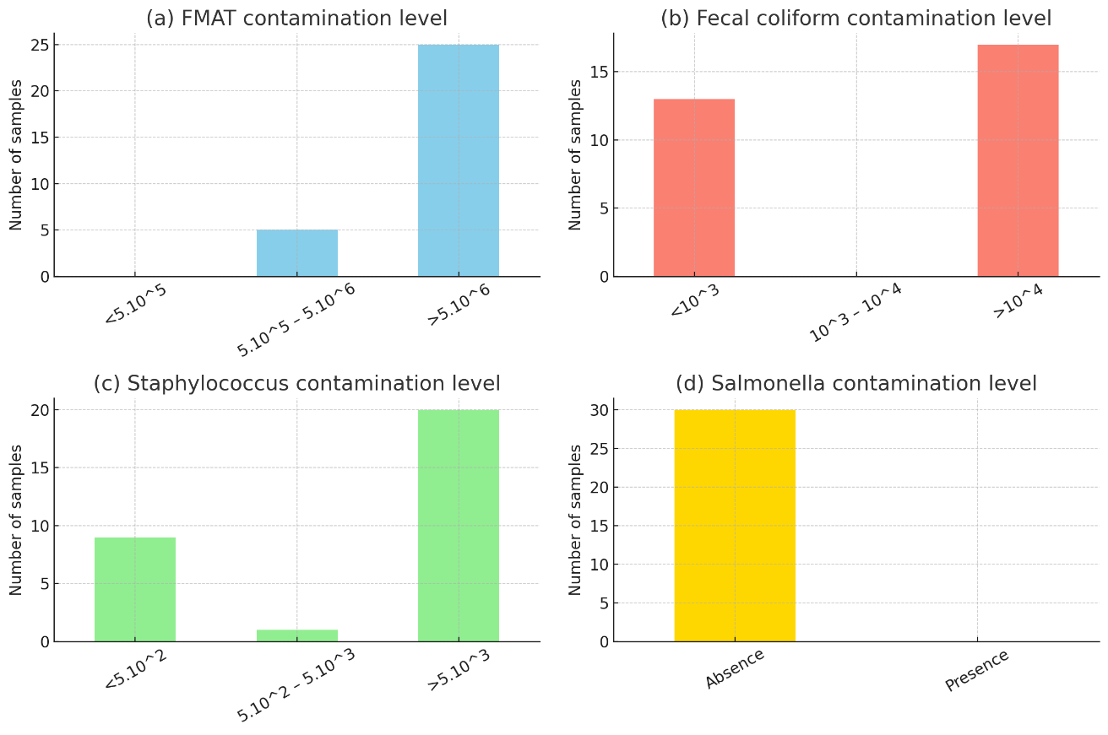
Figure 1: Distribution of microbial load in samples
3.2. Isolation and identification of germ groups in bovine carcasses
Of the 30 samples collected and analysed, 27 contained total coliforms, 17 contained faecal coliforms, and staphylococci were isolated in 21 samples. No salmonella strains were detected in the 30 samples, as mentioned above in the count.
The coagulase test performed on the 21 Staphylococcus spp. isolates identified 3 coagulase-positive isolates, or 14%, while the other 18 were coagulase-negative, representing 86% (Figure 2).
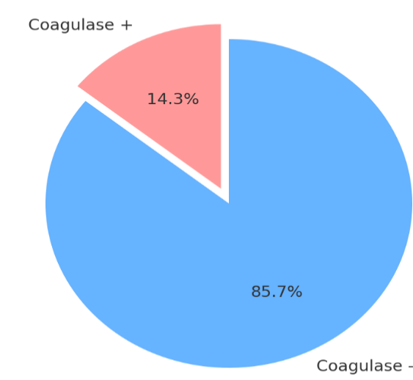
Figure 2: Results of coagulase tests on Staphylococcus strains.

3.3. Sensitivity profile of Staphylococcus spp. strains.
Staphylococcus spp. strains were tested for antibiotic sensitivity. Of the 21 strains tested (Figure 3). The highest sensitivity rates were observed for levofloxacin (86%, 18/21), followed by norfloxacin (62%, 13/21) and amoxicillin/clavulanic acid (57%, 12/21). Moderate sensitivities were observed for cefoxitin (23%, 5/21) and clindamycin (33%, 7/21). The same rate of 14% (3/21) was noted for tobramycin, vancomycin and doxycycline, compared with only 5% (1/21) for erythromycin. However, all strains were resistant to penicillin. Particularly high resistance was observed to erythromycin (95%, 20/21), doxycycline (86%, 18/21), vancomycin (81%, 17/21), tobramycin (76%, 16/21), and cefoxitin and clindamycin (67%, 14/21 each). More moderate resistance rates were recorded for amoxicillin/clavulanic acid (38%, 8/21), norfloxacin (33%, 7/21) and levofloxacin (14%, 3/21).

Figure 3: Susceptibility status of Staphylococcus spp. isolates

3.4. Methicillin resistance
Meticillin resistance was assessed using cefoxitin discs (1). The results show that 14 strains (67%) were resistant to methicillin, while 7 isolates (33%) were sensitive to methicillin. Of the 14 Methi-R strains, 3 were coagulase + and 11 were coagulase -.
Table 1: Distribution of Staphylococcus spp. isolates according to methicillin resistance.
ATB disk | Number of Staphylococcus spp | Frequency
FOX Methicillin-resistant | 14 | 67
FOX Méti-S | 7 | 33%
Total | 21 | 100

4. DISCUSSION
Variation in contamination levels according to germ groups
Total Aerobic Mesophilic Flora (TAMF)
FMAT brings together a group of microorganisms whose quantification serves as a relevant indicator of the application of good hygiene practices. In this study, an average microbial load of 2.^{58×10¹³}CFU/g was measured. These results reveal an alarming rate of non-compliance. Only 17% of samples were deemed fit for human consumption, with the remaining 83% exceeding regulatory thresholds. This high prevalence of non-compliance clearly highlights significant breaches of hygiene rules during carcass preparation. These results differ significantly from those reported by (Mohammed et al., 2023) in Algeria, who observed a compliance rate of 80% and only 13% non-compliance, and those found by Nkolo (2007) in Senegal, who found 76% compliance and 24% non-compliance. This difference is probably explained by the fact that these studies were conducted in structured slaughterhouses where hygiene standards are generally stricter and better regulated.
Detection of faecal coliforms
Analysis of the results reveals that faecal coliforms have a significant impact on sample quality, with only 43% compliance and, correlatively, a non-compliance rate of 57%. This discrepancy highlights a marked deterioration in sample quality or a specificity of the sites studied. These data contrast with the existing literature, as they are significantly lower than those reported by Nkolo (2007) in Senegal, who reported a compliance rate of 88.9% compared to 11.1% non-compliance, and by Salifou et al. (2013) in Cotonou-Porto-Novo, where the average E. coli load was 2.05 log CFU/cm² for all samples
During this study, it was noted that not all samples analysed showed contamination at the dilutions used. Contamination of viscera by faecal coliforms at the time of evisceration would appear to be evident. (Ray, 2001; Savoye, 2011, Grah et al., 2025) reported in their respective studies that the main source of E. coli contamination in meat is the digestive tract of animals. (Luc et al, 2021) reported that the detection of faecal coliforms in meat can be explained by various factors, including hygiene conditions, the rigour of handling practices during evisceration, and the place of slaughter.

Detection of staphylococci
The results obtained in this study revealed the presence of staphylococci in 67% of the samples analysed, representing 33% compliance and 67% non-compliance. Our results differ from those reported by Mohammed et al. (2023) in Algeria. They obtained compliance rates ranging from 60% to 89.57% and non-compliance rates ranging from 11.43% to 40% on samples of raw beef from slaughterhouses and butcher shops. The presence of staphylococci on the samples indicates contamination of human origin, particularly during handling by carriers of these bacteria. These staphylococci are commonly found on human skin and in the nasal cavities. Their presence on fresh meat is unacceptable and is an indicator of poor hygiene.Hand hygiene and the behaviour of those handling the meat are very important, especially during cutting operations. This finding is consistent with the results of previous studies (Agossa et al. 2010), which highlight human-induced contamination whenever the carcass comes into contact with humans, particularly during transport and cutting.

Detection of Salmonella

Bacteriological analyses of the 30 samples for Salmonella were all negative, establishing a compliance rate of 100%.
These results are consistent with those of Karib et al. (1996), who also reported no Salmonella contamination in their bovine samples. It is important to note that the scope of our conclusions is limited to the samples specifically analysed.
Nevertheless, our results differ from those reported by Matafwari et al. (2022), who observed Salmonella contamination rates of 11.8%. This discrepancy can be explained by several factors, including the nature of the meat, the sample size, hygiene conditions, and geographical and environmental differences between the studies.

Sensitivity of Staphylococcus spp. strains to antibiotics
A disparity was observed in the results concerning the sensitivity of the strains to the antibiotics tested. Among the antibiotics tested, penicillin showed no efficacy against the strains studied, with a resistance rate of 100%. Very high resistance rates were also observed for erythromycin (95%), doxycycline (86%), vancomycin (81%) and tobramycin (76%), while the strains showed a resistance rate of 67% to clindamycin and cefoxitin.
However, greater efficacy was observed for several molecules: amoxicillin/clavulanic acid (38% resistance) and norfloxacin (33% resistance). Levofloxacin emerged as the most effective antibiotic in this study, with the lowest resistance rate (only 14%).
On the other hand, greater efficacy was observed for amoxicillin/clavulanic acid (38% resistance), norfloxacin (33% resistance) and levofloxacin, which was the most active antibiotic in this study. These results are consistent with those reported by Marwa et al. (2019), who also found a 100% resistance rate to penicillin, and by Alexandra et al. (2011) and Etinosa et al. 2016), who reported erythromycin resistance rates of 80% and 88% and clindamycin resistance rates of 80% and 79.6% (Alexandra et al., 2011, Etinosa et al., 2016).
These high prevalence rates of resistance could be explained by the inappropriate and often excessive use of antibiotics, particularly due to unregulated use in farming practices. This practice promotes the emergence of resistant bacteria, posing a major risk to public health (Carle, 2009). However, for doxycycline, the results obtained in this study are higher than those reported by Ashraf et al. 2015)[28], who recorded a resistance rate of 32.5%.
With regard to resistance to vancomycin and tobramycin, our results differ from those reported by Etinosa et al., 2016, and Guran et al., 2022), with resistance rates of 98% for vancomycin and 100% for tobramycin. This disparity, particularly for tobramycin, could be explained by variations in antibiotic use policies between the contexts studied. In addition, our results are lower than those of Etinosa et al., 2016) for amoxicillin/clavulanic acid (87%) and norfloxacin (25.9%).
These results are consistent with those of Wu Shi et al. (2019) for cefoxitin, for which a resistance rate of 55.6% was observed. These results are consistent with those of Ashraf et al. (2015) for levofloxacin, who observed a rate of 11.3%.
Sensitivity to methicillin
During this study, 14 strains of methicillin-resistant staphylococci (methi-R) were isolated, and only one was identified as MRSA among the three strains of S aureus isolated, while the other 13 corresponded to methi-R coagulase-negative staphylococci (CNS), representing 7% of MRSA and 93% of methi-R CNS. This prevalence is higher than that reported by Guran et al. (2022), who observed MRSA contamination rates of 3% in beef, 1% in turkey and 0% in chicken and duck. Similarly, Ge et al., 2017) reported an overall prevalence of 1.9% of MRSA in beef, 3.5% in turkey and a minimum of 0.3% in chicken. However, our MRSA prevalence is lower than that reported in the work of De Boer et al., (2009), who reported a prevalence of 11.9% of MRSA in various meat products in the Netherlands, with rates of Furthermore, a meta-analysis conducted by Wu et al. (2018) highlighted a prevalence of 35.0% of MRSA in retail meat in China. These disparities in prevalence can be explained by various factors, including geographical specificities, farming practices, hygiene conditions at slaughter and during processing, and the detection methods used.

- CONCLUSION
The results of this study revealed deficiencies in the slaughtering processes at the Mpila site. The level of contamination of cattle carcasses exceeds regulatory compliance thresholds, suggesting hygiene and handling problems. However, the absence of Salmonella remains a favourable indicator of safety. Of the 30 samples analysed, 83% had an FMAT load above the reference threshold, reflecting poor overall bacteriological quality with only 17% compliance.
For faecal coliforms, 57% of samples exceeded standards, revealing a risk of faecal contamination, while 43% remained within acceptable limits. Finally, with regard to staphylococci, 67% of samples were unsatisfactory, suggesting contamination of human origin.

The study of the resistance profile of Staphylococcus spp isolated from the antibiotics tested revealed worrying resistance to several commonly used molecules, such as penicillin (100%), erythromycin (95%), doxycycline (86%) and vancomycin (81%). Such a high level of resistance suggests excessive and probably unregulated use of antibiotics in livestock farming, promoting the selection of resistant strains and posing a real public health challenge.
Finally, comparing the results obtained in this study with other studies conducted in similar or different contexts, it appears that the situation observed in the Mpila slaughter areas is part of the broader issue of meat safety in the Republic of Congo. Furthermore, the high proportion of meti-R strains observed in this study suggests significant contamination, probably due to poor hygiene practices during meat handling and processing.This study therefore fully meets its initial objectives and highlights the urgent need to introduce strict hygiene measures and rigorously regulate the use of antibiotics in order to limit health risks to consumers.

Disclaimer (Artificial intelligence)
Option 1:
Author(s) hereby declare that NO generative AI technologies such as Large Language Models (ChatGPT, COPILOT, etc.) and text-to-image generators have been used during the writing or editing of this manuscript.
Option 2:
Author(s) hereby declare that generative AI technologies such as Large Language Models, etc. have been used during the writing or editing of manuscripts. This explanation will include the name, version, model, and source of the generative AI technology and as well as all input prompts provided to the generative AI technology
Details of the AI usage are given below:
1.
2.
3.

References
- Agossa, R. (2010). Assessment of the hygienic quality of fresh beef from cattle slaughtered at the Cotonou-Porto-Novo abattoirs (Master's thesis). EPAC, UAC.
- Ashraf, M., Saad, S. M., Hasanine, F., Shaltout, F., & Zaghloul, M. (2019). Prevalence of methicillin-resistant Staphylococcus aureus in some ready-to-eat meat products. Benha Veterinary Medical Journal, 37, 12–15.
- Azage, M., & Kibret, M. (2017). The bacteriological quality, safety, and antibiogram of Salmonella isolates from fresh meat in retail shops of Bahir Dar City, Ethiopia. International Journal of Food Science, 2017, 4317202. https://doi.org/10.1155/2017/4317202
- Bornert, G. (2000). Salmonella-free chicken: Myth or reality? Revue MédVét, 151(12), 1083–1094.
- Bouras, M. (2019). Evaluation of the antibacterial activity of extracts from certain plants in eastern Algeria on antibiotic-resistant strains (Doctoral thesis). Badji Mokhtar-Annaba University, Algeria.
- Carle, S. (2009). Antibiotic resistance: a major public health issue! Pharmactuel, 42(Suppl. 2), 6–13.
- EFSA and ECDC (European Food Safety Authority and European Centre for Disease Prevention and Control). (2018). The European Union summary report on the trends and sources of zoonoses, zoonotic agents and food-borne outbreaks in 2017. EFSA Journal, 16(12), 5500. https://doi.org/10.2903/j.efsa.2018.5500
- Etinosa, I. O., Beshiru, A., Akporehe, L. U., Oviasogie, F. E., & Igbinosa, O. O. (2016). Prevalence of methicillin-resistant Staphylococcus aureus and other Staphylococcus species in raw meat samples intended for human consumption in Benin City, Nigeria: Implications for public health. International Journal of Environmental Research and Public Health, 13(9), 949. https://doi.org/10.3390/ijerph13090949
- Frank, C., Werber, D., Cramer, J. P., Askar, M., Faber, M., Der Heiden, M., et al. (2011). Epidemic profile of Shiga toxin-producing Escherichia coli O104:H4 outbreak in Germany. New England Journal of Medicine, 365(19), 1771–1780. https://doi.org/10.1056/NEJMoa1106483
- Giromini, C., & Givens, I. D. (2022). Benefits and risks associated with meat consumption during key life processes and in relation to the risk of chronic diseases. Foods, 11, 2063. https://doi.org/10.3390/foods11142063
- Izquierdo, E. A. (2009). Bacterial proteins as biomarkers of probiotic activity (Doctoral thesis). University of Strasbourg.
- Luc Loubamba, A. A. Diallo, B. Musabyemariya, R. Moyen, K. S. B. Sylla, & R. B. Alambédjia. (2023). Virulence genes (stx1/stx2/aea) and O serogroups of Escherichia coli strains isolated from slaughtered cattle and ground meat sold in retail markets in Dakar, Senegal. The Microbe. https://doi.org/10.1016/j.microb.2023.100024
- Luc Loubamba, B. Musabyemariya, R. Moyen, A. A. Diallo, K. S. B. Sylla, P. A. Bedekelabou, & R. B. Alambédji. (2021). Hazard assessment and resistance profile of Escherichia coli strains isolated from bovine carcasses at the main slaughterhouses of Dakar, Senegal. African Journal of Microbiology Research, 15(9), 467–474. https://doi.org/10.5897/AJMR2021.9566
- Matafwari, M., Motassim El Hanafi, Bouchrif, B., Derkaoui, S., Dahani, S., Zyate, N., Bouchriti, N., & Nassik, S. (2022). Prevalence of Salmonella spp. in food products of animal origin sold in Rabat, Morocco. International Journal of Innovation and Applied Studies, 40(4), 631–645.
- Mohammed, A., Benhamida, A., & Smail, F. N. (2023). Assessment of the microbiological quality of raw beef in slaughterhouses and butcher shops in the Djelfa region (Algeria) (Master's thesis). Ziane Achour University – Djelfa, Algeria.
- Moyen, R., Ahombo, G., Nguimbi, E., Ontsira, N. E., Niama, R. F., Yala, G. C., & Obengui, L. D. (2014). Activity of beta-lactam antibiotics and production of beta-lactamases in bacteria isolated from wound infections in Brazzaville, Congo. African Journal of Microbiology Research, 8(23), 2290–2294.
- Nkolo, S. C. (2007). Bacteriological quality of frozen buffalo meat imported into Senegal (Doctoral thesis). Cheikh Anta Diop University of Dakar.
- OECD/FAO. (2021). OECD/FAO Agricultural Outlook 2021–2030. OECD Publishing. https://doi.org/10.1787/e32fb104-fr
- Ray, B. (2001). Indicators of bacterial pathogens. In B. Ray (Ed.), Fundamental food microbiology (pp. 409–417). CRC Press.
- Savoye, F. (2011). Optimisation of the protocol for detecting Shiga toxin-producing Escherichia coli (STEC) in food (Doctoral thesis). University of Burgundy.
- Selby, T. L., Berzins, A., Gerrard, D. E., Corvalan, C. M., Grant, A. L., & Linton, R. H. (2006). Microbial heat resistance of Listeria monocytogenes and the impact on ready-to-eat meat quality after post-package pasteurisation. Meat Science, 74(3), 425–434. https://doi.org/10.1016/j.meatsci.2/18

