Original Research Article

Cheap and efficient prosopis gum-based hydrogel for sustained boron and zinc release in water and soil.

Abstract

Conventional method of fertilizer application leads to loss of plant nutrient through leaching, run-off, volatilisation, denitrification etc. These in turn affect the health of environment directly or indirectly. Fertilizer application through controlled release formulation offers a promising direction by improving proper management of nutrient and by reducing environmental threats. In this aspect, plant polysaccharides are of special interest as they are easily available, safe to environment and easy to modify. Adopting microwave assisted technique, prosopis gum-based hydrogel loaded with boron and zinc was synthesized. The synthesized hydrogel was characterized by elemental analyzer, FTIR, EDX and SEM. The synthesized hydrogel was then employed as a controlled release matrix for sustained release of boron and zinc. Release study of boron and zinc in water revealed that % cumulative release during the span of 6 days were 51-58% and 59-68 %repectively. Similarly, release pattern in soil were found to be 62-74 % and 52-58% respectively during the span of 20 days. Beyond this point, the release patterns were found to be constant. Furthermore, release kinetic studies of boron and zinc in water followed Fickian mechanism (n<0.5) whereas in soil it followed non-Fickian mechanism (n>0.5). The hydrogel was found to exhibit excellent sustained release of boron and zinc with a half-life of 33-57 days and 49-86 days repectively. Hence, in situation where environmental pollution is of great concern and effective utilization of micronutrients is indispensable, the synthesized hydrogel can offer better choice instead of coventional method.

Key words: prosopis, boron, hydrogel, nutrient, kinetic.

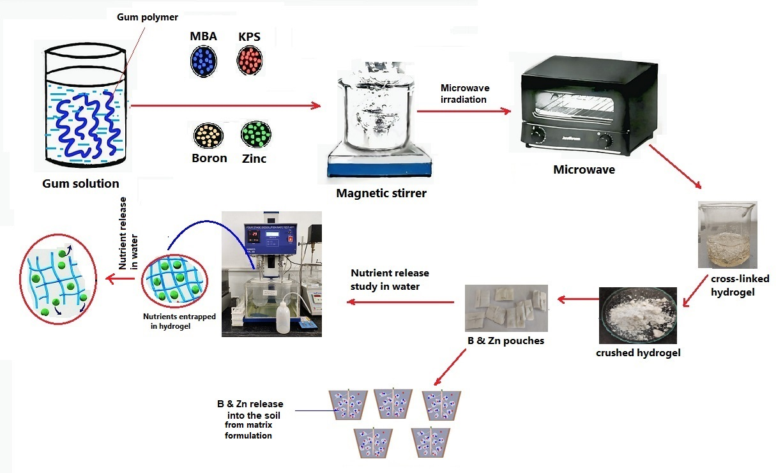
Graphical abstract

1. Introduction
Proper management of plant nutrient is important to obtain maximum yield of the crops. Depending on the requirmentof the plant, nutrient can be grouped as macronutrients and micronutrients [1][see table 1 for plant nutrient classification]. Although micronutrient requirment is low in plant, their negligence in many cases resulted in drastic reduction in yield if timely intervention is not taken up. Even if their requirment is low, their absence directly affects and influences the life cycle and development stage even if other essential nutrients are present in adequate amount [2]. Among the micronutrient, boron occupies important role in plant as it takes part in cell wall synthesis and helps to maintain strcutural integrity of the cell wall. Boron is usually taken by the plant in the form of uncharged boric acid (H₃BO₃) or B (OH)₃ [3, 4]. In acidic soil, deficiency of boron is a major concern. In such soil, boron (anionic form) is fixed in the soil colloid and in some case, leaching is another major loss of boon from the soil profile. Boron deficiency can also result in considerable yeild reduction in many crops such as cereal, legume, perenial crops and oilseed [5, 6]. Another important but often neglected plant nutrient is Zinc (Zn). Zn plays vital role in the plant growth and development. It is a constituent of many enzymes, acts as functional group, regulatory cofactor; helps stablize DNA and RNA and control gene expression [7]. Plant deficient of Zn are reported to be more susceptible to pests and diseases [8, 9]. In fact, Zn and B are often considered to be the most defecientnutrients in the soild worldwide and thus they must be supplement externally through fertilizer [10].
Furthermore, it is a fact that the presence of one element can impede the availability of other elements or in some case induces synergistic effect. Hence, it is essential to understand the synergistic-antagonistic effect between two elements before formulating them as fertilizers mixture. This relationship can be assessed using Mulder’s chart [11] as shown in Fig 1b. Accordingly, it is unlikely that B and Zn to have synergistic-antagonistic effect when they are applied together as fertilizer mixture.
Control Release Formulation (CRF) is often used as means of nutrient release in agricultural practices. This method can deliver nutrients at a desirable rate and dose for extended period of time [12-15]. This is usually achieved by employing matrix formulation where the plant nutrients are dispersed and diffused throughout the pores. Plant polysaccharides are of special interest in the field of controlled release system as they are cheap, biocompatible, biodegradable and non-toxic [16, 17].
Prosopis gum (PG) also known as Mesquite gum is an exudate of Mesquite trees (Prosopis sp.) which belongs to leguminous family. The tree is widely found in arid and semi arid around the globe. For commercial purposes, the gum is mostly extracted from two species namely prosopis juliflora and Prosopis laevigata [18]. The gum is somewhat similar to gum Arabic both in physical appearance and functional properties. The main functional properties of the gum include its unique intrinsic viscosity, emulsifying ability, good surface activity and excellent encapsulating property which make it a functional hydrocolloid [19-22]. The gum is also used for extension of shelf-life in many fruits and as edible films [23].

1.1. Composition and Chemical Structure of prosopis gum (PG))
The gum is found to contain (1-3)-linked β-D-galactose units as a main backbone chain and (1-6)-linked as branches containing L-arabinose in pyranose & furanose ring form, L-rhamnose, β-D-glucuronate& 4-O-methyl-β-D-glucuronate as single monomer unit or as oligosaccharide side chains [24, 25]. On hydrolysis of gum obtained from Prosopis velutina yields L-arabinose & D-galactose as main sugar with small traces of D-glucuronate, D-mannose & D-xylose [26, 27]. The presence of uronic acid (glucuronic acid) was also reported (4%). Chemically, prosopis gum is closely related to gum Arabic except that L-rhamnose is absent in former [28]. [Fig. 1a shows chemical structure of PG]. The gum also contains appreciable amount of protein such as hydroxyproline, valine,serine and glycine which are mainly responsible for its emulsification ability [29]. Since the gum is still unexplored and has not been utilized in the field of nutrient delivery system, slow-release formulation containing micronutrient boron and zincwas synthesized using the gum. This paper reports the release pattern of boron and zinc in water and soil and their release kinetic.

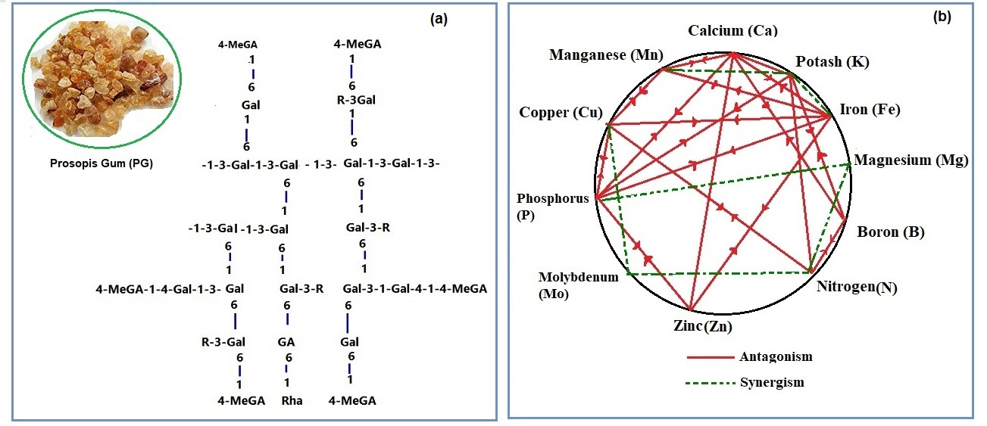
Fig. 1. (a) Chemical structure of Prosopis gum (PG) [27], (b)Mulder’s chart showing different elements exhibiting antagonistic-synergestic pattern.

Essential plant nutrients
Primary Macronutrients | Secondary Macronutrient | Micronutrients
Nitrogen (N) | Calcium (Ca) | Boron (B)
Phosphorus (P) | Magnesium (Mg) | Zinc (Zn)
Potassium (K) | Sulphur (S) | Iron (Fe)
 |  | Manganese (Mn)
 |  | Copper (Cu)
 |  | Molybdenum (Mo)
 |  | Chlorine (Cl)

Table 1. Lists of essential macro and micronutrients [1].

2. Material and methods
2.1. Materials
Boric acid (H₃BO₃) and Zinc sulphate (Zn₂SO₄) were purchased from Sigma-Aldrich.
Prosopis gum was procured from local market, other chemicals like NN’MBA, KPS (potassium persulfate) and acrylamide were purchased HIMEDIA, Mumbai, India.

2.2. Synthesis of hydrogel loaded with micronutrients
In situ incorporation of boric acid (H₃BO₃) and zinc sulphate (Zn₂SO₄) (0.5 mg each) in Prosopis gum solution was carried out adopting microwave assisted technique for synthesis. For this gum solution was prepared, acrylamide, NN’MBA and KPS were added into the solution mixture with uniform stirring through magnetic stirrer. The hydrogel containing uniformly distributed B and Zn was obtained as a gel form which was further dried in oven, cut and sieved. Optimization of initiator and monomer amount were assessed through percentage grafting which is calculated as follows:

$$\% Grafting= \frac{Wt. of graft copolymer-Wt. of polysaccharide }{Wt. of polysaccahride } X 100 Eq. (1)$$

2.3. Characterization
To confirm the synthesis process, the synthesized hydrogel was analyzed using different techniques which are discussed below:

2.3.1. Elemental analysis
The Elemental Analyzer (model: Vario EL III, make – M/s Elementar, Germany) was used to determine the existence of four elements: carbon, hydrogen, nitrogen, and oxygen as depicted in Fig. 4a.

2.3.2. FT-IR analysis
The presence of functional groups was ascertained by Fourier Transform Infrared Radiation (FTIR) Shimadzu Corporation, Japan, Model: IRPrestige21. Using the KBr pellet method, the normal range of analysis is 4000 to 400 cm⁻¹, with a resolution of 4 cm⁻¹. The FTIR graph is shown in Fig 4b.

2.3.3. EDX
Enery Dispersive X-ray Spectroscopy (EDX) equipped with SEM (Oxford EDX, DCL 7673 model) was used measures the distribution of Boron and Zinc which is shown in Fig 4c.

2.3.4. Scanning Electron Microscopy (SEM) analysis
The surface morphological analysis was performed using Scanning Electron Microscopy (SEM, model: JSM-6390LV, Jeol, Japan) and images are given in Fig 4e.

2.4. Release study
Following USP drug dissolution study protocol [30], nutrient release pattern of B and Zn in water at 25°C was carried out in dissolution rate test apparatus (Simeco, Kol-25). In this study soil and water were taken as medium. For water system, solutions containing the matrix were stirred at 65rpm for sufficient time. Aliquot was drawn at interval and amount of micronutrient release from hydrogel into water was determined by UV-VIS at λ_{max}= 430 nm and λ_{max} = 420 nm for zinc and boron respectively [31, 32] using standard calibration curve [Fig.2 shows the standard calibration curve for B and Zn]. The amount of nutrient release (cumulative release (%) was estimated using the formula [33, 34]:
$$Cumulative release \left(\%\right)= \frac{Mt}{M∞} X 100 (1)$$
Here M∞ and Mt represent initial loaded micronutrient amount and micronutrient release after time ‘t’ respectively. Release study of micronutrient in continuous releasing in water is parallel with stagnant water system.
Similarly, the release pattern of micronutrients (B & Zn) was evaluated in the soil to see its feasibility and application in agricultural field. For this study, small amount of hydrogel (loaded with micronutrient) was put in tea pouches (permeable). Plastic beaker containing 200g of dry soil was taken and the pouches were buried 2cm depth into it. The beaker was saturated by adding 150mL of water periodically and maintained at room temperature. One pouch containing the hydrogel was removed every after 2 days and the hydrogel was then gently put in 100mL distilled water [33, 34]. The amount of micronutrient extracted from the hydrogel into the water was determined in UV-VIS using the equation 1.

Fig. 2. Standard calibration curve of zinc and boronatλ_{max =} 430 nm and λ_{max =} 420nm respectively.

2.5. Kinetic study
The drug release kinetic of the hydrogel was studied applying the equation [35, 36].
$\frac{Mt}{ M∞}=k.t^{n}$(2)
Where M∞ is the initial loaded micronutrient amount in the hydrogel and M_{t}, represent micronutrient release after a period of time ‘t’. The releasing exponent and releasing factor are represented by n and k respectively. The ‘n’ describes the type of diffusion. Equation 2 can be linearized as:
$$\log{\frac{Mt}{M∞}= }\log{k +nlog t} (3)$$
Different parameters such as ‘n’, k and R² for all the matices were calculated from the above equation by plotting the graph of log (Mt/M∞) against log (t). The above equation is applicable for only if the first 60% of the fractional drug release from the tablet occurs (Mt/M∞ ≤0.6; log Mt/M∞≤–0.22)[37]. Based on the value of ‘n’ diffusion is said to be Fickian and non-Fickian. For ‘n’ < 0.5, the release is Fickian diffusion in which diffusion rate is less than the relaxation rate [38]. For ‘n’ between 0.5-1.0, the release is non-Fickian in which the rate of diffusion and the rate of relaxation are the same. However, when n=1 the diffusion is zero order kinetic and this situation holds true for most erodible matrices. The half-life (t_{1/2}) was determined using the formula =0.693/k

3. Results and discussion
3.1. Synthesis of hydrogel loaded with micronutrients (PG-g-AM-cl-NN’MBA)
Prosopis Gum based hydrogel (PG-g-AM-cl-NN’MBA) was synthesized using microwave assisted technique [39, 40]. For this, 50 mL of distilled water was taken in a beaker and 1 g of gum was added and allowed to be dissolved through constant stirringin a magnetic stirrer. Then 5g of monomer (acrylamide) was gently added into the gum solution, followed by addition of 0.1g of NN’MBA and 0.1g of KPS as cross-linker and reaction initiator respectively. Simultenously, in situ incorporation of 0.5 mg each of boric acid (H₃BO₃) (water soluble source of B) and Zn₂SO₄ (water soluble source of Zinc) were added into the solution mixturewith uniform stirring [41-43]. The homogenized solution was subjected to microwave reactor (model: Catalyst TM system CATA 4 R) with intermittent irradiation of 700 W while maintaining the temperature up to 70 °C. The irradiation was halted and the solution was precipitated with acetone to obtain gel-like mass. Following the same method, different grades of hydrogel were synthesizedby varying the amount of cross-linker and % graftingwas calculated [Table 2]. It was found that beyond 0.5 g of cross-linker the % grafting decrease. This was due to unavailability of free sites because of competition for space among the grafted chain [44] or termination of free radicals due to bimolecular collision. Similar phenomenon wasalso observed during synthesis of carrageen-based hydrogel [45].

Different Grades | Amount of monomer (g) | Amount of cross-linker (g) | % Grafting  (G%)
PG-g-AM-cl-NN’MBA 1 | 5 | 0.1 | 670
PG-g-AM-cl-NN’MBA 2 | 5 | 0.2 | 700
PG-g-AM-cl-NN’MBA 3 | 5 | 0.3 | 730
PG-g-AM-cl-NN’MBA 4 | 5 | 0.4 | 850
PG-g-AM-cl-NN’MBA 5 | 5 | 0.5 | 900

Table 2. Different grades of PG-g-AM-cl-NN’MBA hydrogel synthesized for sustained release of B and Zn

3.2. Probable mechanism involved during synthesis of micronutrient loaded hydrogel

During the process of synthesis, the initiator (potassium persulfate) reacts with OH group present in the gum polysaccharide to form active centre by forming alkoxy radical on the gum substrate [42]. The active centre further induces free radical polymerization reaction of monomer and cross-linker and resulted in the formation of complex network of cross linked products as showed in scheme 1.
Scheme 1. Probable mechanism involved during synthesis of micronutrient (B & Zn) loaded hydrogel

3.3. Swelling index study
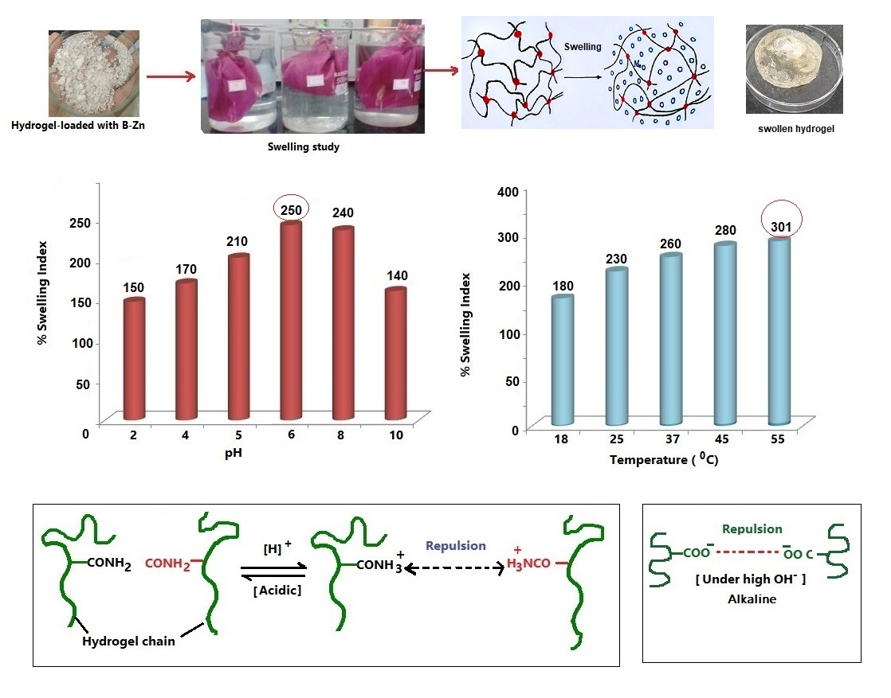
Swelling index of a hydrogel is important as it indicate its water absorption capacity when place in different environments. This index is a crucial parameter for understanding a hydrogel's suitability for various applications, particularly in areas like wound dressing, tissue engineering, and control realse. Under slightly low pH, sufficient H⁺was available to protonate the CONH₂ group present in the hydrogel polymeric chain. This resulted in mutual repulsion between two polymeric chains of the hydrogel and so high swelling index was observed [46]. This type of phenomena is also reported in many synthetic hydrogel [47]. Under slightly alkaline condition (presence of OH), COOH existed as anion (COO-) and consequently mutual repulsion between polymeric chain occurred. Hence high swelling was also observed [48]. Furthermore, swelling was found to be high in higher temperature because the heat ruptured the weak bond existing between cross-linker and monomer chain. Fig. 3 shows swelling index of PG based hydrogel at different pH and temperature.
Fig. 3. Swelling index of PG-g-AM-cl-NN’MBA hydrogel subjected to different pH and Temperature

3.4. Characterization
3.4.1. Elemental Analysis

When analysed under Elemental analyzers, the percentage of Carbon, hydrogen and oxygen were found to be in 36.23, 7.02 and 56.75 % respectively. Whereas, in hydrogel the % was found to be 40.23, 8.12, 38.32 respectively with additional 13.33% for nitrogen as depicted in Fig.4a. This clearly indicates the successful grafting of crude gum and incorporation of nitrogen-containing monomer. In addition, the carbon and hydrogen percentage observed to be increased and the reduction in oxygen content clearly supports the structural modification and formation of grafted hydrogel. This compositional change from crude gum to synthesized hydrogel supports the grafting and crosslinking reaction during the synthesis period.

3.4.2. FTIR

FTIR spectra (Fig.4a) for the crude gum showed two prominent bands at 3240 cm⁻¹and 2900 cm⁻¹ suggesting the stretching behavior of O-H bond and C-H bond, respectively. The peaks at 1050 cm⁻¹ and 1650 cm⁻¹ as also observed that correspond to C-O-C group stretching vibrations and O-H bending [49]. The glucuronic acids present in the gum polysaccharide also displayed a specific peak at 1400 cm⁻¹ due to carbonyl stretching. For the hydrogel spectrum, the following was observed: The band corresponding to the O-H stretching was shifted to a longer wavelength at 3401 cm⁻¹. This usually happens when the O-H group participates in bond formation, probably with a cross-linker NN’MBA. Moreover, absorption band at 1650 (H-O-H bending) vanished which was present in crude Prosopis gum confirming grafting was successful [50].

3.4.3. EDX Analysis
Fig.4c depicts the Energy dispersive X-ray spectroscopy analysis of PG-g-AM-cl-NN’MBA Hydrogel. The analysis confirmed the presence of boron and Zinc as major components along with other elements viz. S, O, P, and K.

3.4.4. SEM Analysis
Fig.4d &4e shows two distinct surface appearances of Prosopis gum and synthesized hydrogel under SEM analysis with 20 kV and 500X magnifications. In the case of the former, the surfacewassmooth without any crack and fissure while the later exhibited profound morphological changed with numerous macro and micro pores. This confirmed successful grafting (Fig.4e).
Fig. 4. a)% of C,H,O& N as analyzed by Elemental analyzer b) FTIR spectra of Prosopis gum and PG-g-AM-cl-NN’MBA hydrogel c)Energy Dispersive X-ray spectroscopy analysis of PG-g-AM-cl-NN’MBA hydrogel d) SEM image of crude prosopis gum and e) SEM image of PG-g-AM-cl-NN’MBA hydrogel.

3.5. Release behavior
The release pattern of micronutrient B and Zn from different grades of hydrogel in water are depicted in Fig 5a & 5b. From the release study, it was found that the cumulative release of B from different grades ranges from 51-58% during the span of 6 days. In the case of Zn, the commulative release was found to be higher (59-68%) during the same span. This difference was observed as the source of boron i.e. H₃BO₃ is slightly less soluble (5.7g/100ml at 25ºC) when compared with Zn₂SO₄ (source of Zn) which has a higher solubility of 57.7g/ 100ml at 25ºC. Furthermore, it was noticed that the release rate for all the hydrogel grades increased gradually and then become constant after 108 hrs in water. Higher grafting % also displayed better sustained release in both B and Zn.
The release pattern of micronutrient B and Zn in soil from different grades of hydrogel are shown in Fig 5c & 5d. From the release study it was observed that the cumulative release of B in soil ranges from 62-74% for all the hydrogel grades upto 20 days and beyond this point, the release pattern was constant. This could be due to fixation of small fraction of boron (H₃BO₃& H₂BO₃⁻) in the soil colloid physically or chemically [51, 52]. Whereas in the case of Zn, the cumulative release was observed to be 52-58 % within the same span of 20 days beyond which the release was constant. As observed, the cumulative release of Zn was far lower than B in soil. This is due to the fact that zinc (II) cations are strongly adsorbed by negative clay colloids [31]. Mechanism of B and Zn fixation in the soil is depicted in Figure 6.

Fig. 5. a). Release pattern of B from different grades of hydrogel in water b). Release pattern of Zn from different grades of hydrogel in waterc)Release pattern of Boron from different grades of hydrogel in soil and d) release patter of zinc from different grades of hydrogel in soil.

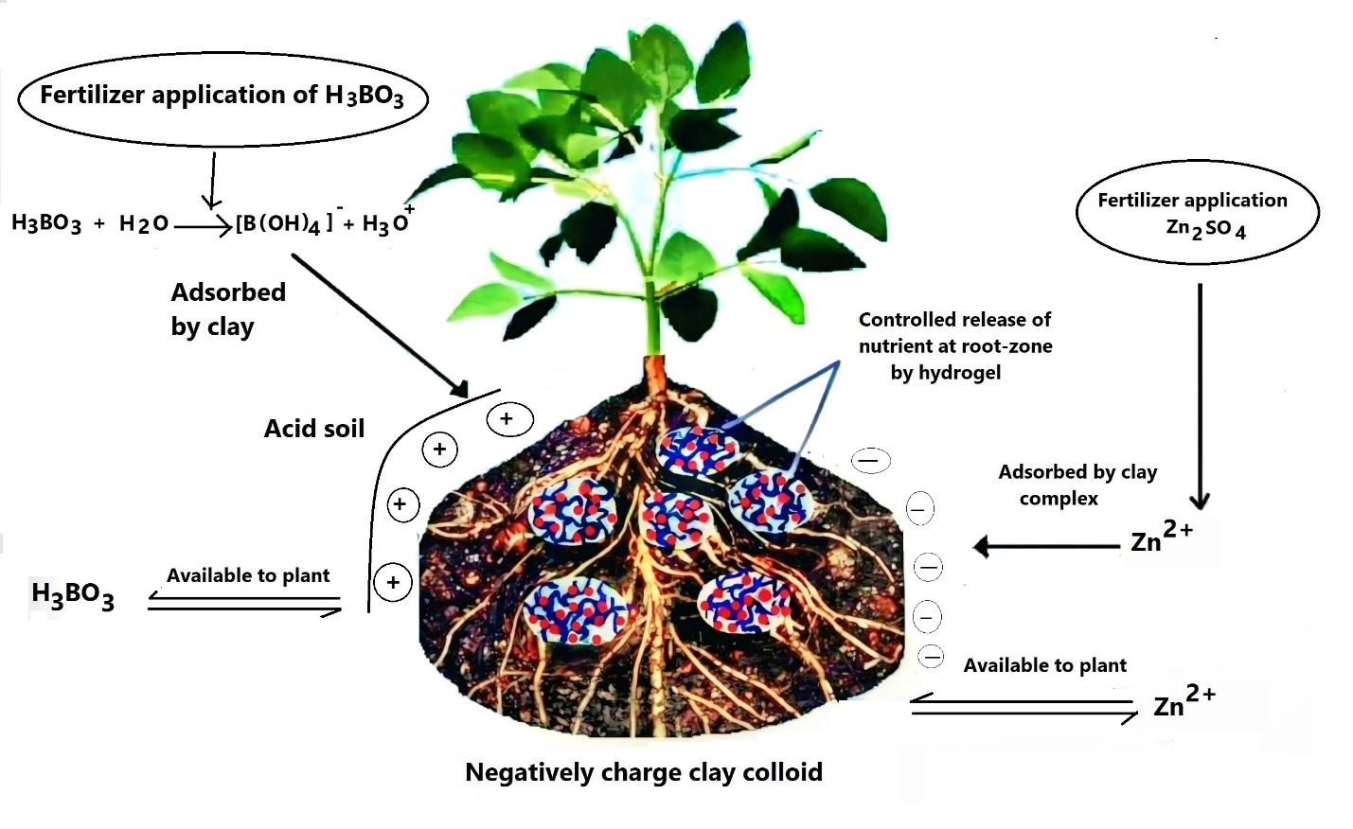

Fig. 6. Mechanism of micronutrients (B & Zn) release in the soil.

3.6. Kinetic study

The release kinetic study of B and Zn studied in water and soil were conducted and the following results were observed. Different kinetic parameters such as ‘n’ (diffusion exponent) and ‘k’ (diffusion constant) for B and Zn were estimated from the plot of log (Mt/M∞) vs log (t) and summarized in table 3. The values of ‘n’ for both B and Zn in water were all less than 0.5. This suggests that the release kinetic of B and Zn in water follows Fickian release behavior. This means the release of micronutrients from hydrogel was largely influenced by rate of relaxation of hydrogel. This also suggests that diffusion was the secondary mechanism of nutrient release method[38]. The study also indicates that half-life was dependent on cross-linking density and according maximum half-life was observed in PG-g-AM-cl-NN’MBA 5 with half-life values of 20 days and 17 days for B and Zn respectively in water.
Furthermore, release kinetic study of B and Zn in the soil (see Fig.7) revealed that the value of ‘n’ was higher than 0.5 for all the grades. This is an indication that in the soil, the release pattern follows non-Fickian mechanism. This means the release of micronutrient is largely influenced by diffusion and relaxation of the hydrogel. The half-life calculated for B and Zn ranges from 33-57 days and 49-86 days respectively. [For comparison with other available CRF, see Table 4].
From the above study it can be said that the total cumulative release of B and Zn in water was higher than that of soil in all the cases. This is because in soil system, the nutrient release took place only when hydrogel is hydrated and swollen by soil solution [53, 54]. Once the hydrogel got swollen, the dissolved part of micronutrient presents in the swollen hydrogel slowly diffused through the pores of hydrogel releasing it into the soil.
The over all study indicates that PG hydrogel (PG-g-AM-cl-NN’MBA) displayed an excellent trait for sustained and effective release of micronutrient which confirmed its edge over the conventional fertilizers.
Fig. 7. Graph of log (Mt/M∞)against log (t) for control release of Boron and Zinc in the soil.

Boron release kinetic profile in water
Grades | n | k | Half-life in days
PG-g-AM-cl-NN’MBA 1 | 0.225 | 0.051 | 13
PG-g-AM-cl-NN’MBA 2 | 0.231 | 0.048 | 14
PG-g-AM-cl-NN’MBA 3 | 0.245 | 0.043 | 16
PG-g-AM-cl-NN’MBA 4 | 0.255 | 0.038 | 18
PG-g-AM-cl-NN’MBA 5 | 0.265 | 0.034 | 20
Zinc release kinetic profile in water
PG-g-AM-cl-NN’MBA 1 | 0.342 | 0.068 | 10
PG-g-AM-cl-NN’MBA 2 | 0.360 | 0.062 | 11
PG-g-AM-cl-NN’MBA 3 | 0.381 | 0.05 | 13
PG-g-AM-cl-NN’MBA 4 | 0.401 | 0.049 | 15
PG-g-AM-cl-NN’MBA 5 | 0.408 | 0.042 | 17
Boron release kinetic in soil half-life in days
PG-g-AM-cl-NN’MBA 1 | 0.54 | 0.021 | 33
PG-g-AM-cl-NN’MBA 2 | 0.56 | 0.019 | 36
PG-g-AM-cl-NN’MBA 3 | 0.58 | 0.017 | 40
PG-g-AM-cl-NN’MBA 4 | 0.59 | 0.013 | 53
PG-g-AM-cl-NN’MBA 5 | 0.63 | 0.012 | 57
Zinc release kinetic in soil (half-life in days)
PG-g-AM-cl-NN’MBA 1 | 0.51 | 0.014 | 49
PG-g-AM-cl-NN’MBA 2 | 0.54 | 0.012 | 57
PG-g-AM-cl-NN’MBA 3 | 0.71 | 0.011 | 63
PG-g-AM-cl-NN’MBA 4 | 0.85 | 0.010 | 69
PG-g-AM-cl-NN’MBA 5 | 0.98 | 0.008 | 86

Table 3. Calculated values of different release kineticparameters of boron and zinc in water and soil with t₅₀ (half-life).

Sl no. | Polymer | Active ingredient | Plant | Release time | Reference
1 | Gelatin | Ammonium  nitrate | Cucumber,  Tomato | 2 days | [57]
2 | Double hydrogel network of sodium alginate and  polymerization of 𝛽-cyclodextrin, acrylic acid, and  acrylamide in the presence of halloysite | Urea | Cotton | 4 days | [58]
3 | Inorganic materialsand organic polymers | Urea | Orchards | 7 days | [59]
4 | NaCMC and carrageenan (CG) | Zinc | Wheatgrass | 10 days | [60]
5 | Wheatstraw | Urea | Tomato | 10 days | [61]
6 | corncob-g-poly (acrylic acid)/bentonite | Urea | Cotton | 30 days | [62]
7 | Acrylic acid | Urea | maize | 40 days | [63]
8 | ZnO Nanoparticle | Zinc | Cyamopsis sp. | 30-40 days | [64]
9 | Composites biopolymers (made of microcrystalline  cellulose, chitosan, and alginate) and ZnOnanoparticles | Zinc | Maize | 30 days | [65]
10 | Poly(hydroxybutyrate) | NPK | Lettuce seed groups | 30 days | [66]
11 | Hydroxy propyl methyl cellulose, PVA, glycerol and blended paper | urea | Cotton | 44 days | [67]
12 | Polyurethane (PU) copolymerized with  hydroxypropyl-terminated polydimethylsiloxane (HP-PDMS | Urea | Maize | over 60 days | [68]
13 | Bio-based epoxy | NPK | Vegetable | 60 days | [69,70]
14 | PG-g-AM-cl-NN’MBA | Zinc & Boron | Not specified | 86 days | This study

Table 4. Types of Hydrogels used as controlled release for nutrients with their release rate.

3.7. Advantage of modified plant polysaccharide as controlled release matrix
Prosopis gum being plant-based polysaccahrides could act as a food for the microbes and is highly prone to microbial degradation [55]. This degradable nature is what makes plant polysaccharide-based hydrogel eco-friendly and environmentally acceptable [56]. Fig. 8 shows the SEM images of hydrogel surface before and after 30 days burial in the soil. The hydrogel displayed morphological and structural changes with numerous cracks and fissuresdue microbial attack and other degradation forces.

Fig. 8. SEM image of a)Hydrogel before incorpartion in the soil b)hydrogelafter 30 days burial in soil.

Conclusion
Prosopis gum-based hydrogel loaded with micronutrients (B & Zn) was synthesized adopting microwave assisted technique. The swelling index studied under different pH and temperature reveals that the hydrogel displayed good swelling property which is desirble for controlled release formulation. The release pattern of the micronutrients from the hydrogel matrix was studied in water and soil. It was observed that cross-linking density affect the release rate in all the cases. The kinetics study suggested that release of boron and zinc in water follow Fickian mechanism (n<0.5). This suggests that in aqueous system, the nutrient release is largely controlled by relaxation of the hydrogel. However, in soil it follows non-Fickian mechanism (n>0.5) which means the release rate is controlled by hydrogel relaxation and diffusion method. The half-life was observed to be 33-57 days for boron and 49-86 days for zinc in soil. Overall, the synthesized hydrogel can be employed in agriculture for achieving sustained release of micronutrient for extended period of time with minimum disturbance to soil quality and efficient utilization of water. Furthermore, its environmental compatibility, reusability, and positive impact on plant growth is what makes natural gum-based hydrogel a champion in the arena of controlled release formulation.

COMPETING INTERESTS DISCLAIMER:
The authors declare that they have no known competing financial interests or personal relationships that could have appeared to influence the work reported in this paper.

Disclaimer (Artificial intelligence)
Option 1:
Author(s) hereby declare that NO generative AI technologies such as Large Language Models (ChatGPT, COPILOT, etc.) and text-to-image generators have been used during the writing or editing of this manuscript.

References
[1] Rau, A.,Zhu, K.,Nurlan, B.,Mirobit, M.,Yessenkul, K.,Hozhaev Bek, M.,Nabiollina, M.,Khurmanbek, Z.,Issakov, Y.,Antal, S.,Ujj, A.,David, L. (2023) Agronomic and reclamation strategies to enhance soil fertility, productivity and water accessibility. Front. Sustain. Food. Syst. Volume 7, https://doi.org/10.3389/fsufs.2023.1288481.
[2] Mansouri, H., Ait Said, H., Noukrati, H., Oukarroum, A., Ben Youcef, H., & Perreault, F. (2023). Advances in Controlled Release Fertilizers: Cost‐Effective Coating Techniques and Smart Stimuli‐Responsive Hydrogels. Advanced Sustainable Systems, 7(9), 2300149. https://doi.org/10.1002/adsu.202300149.
[3] Goldbach, H. E., Wimmer, M. A., &Findeklee, P. (2000). Discussion paper: Boron—How can the critical level be defined?. Journal of Plant Nutrition and Soil Science, 163(1), 115–121. https://doi.org/10.1002/(SICI)1522-2624(200002)163:1<115::AID-JPLN115>3.0.CO;2-#
[4] Brown, P. H., Zhao, F. J., & Dobermann, A. (2022). What is a plant nutrient? Changing definitions to advance science and innovation in plant nutrition. Plant and Soil, 476(1), 11-23. https://doi.org/10.1007/s11104-021-05171-w.
[5] Haynes, R. J., & Mokolobate, M. S. (2001). Amelioration of Al toxicity and P deficiency in acid soils by additions of organic residues: A critical review of the phenomenon and the mechanisms involved. Nutrient Cycling in Agroecosystems, 59(1), 47–63. https://doi.org/10.1023/A:1009823600950.
[6] Shukla, A. K., Behera, S. K., Prakash, C., Patra, A. K., Rao, C. S., Chaudhari, S. K., ... & Green, A. (2021). Assessing multi-micronutrients deficiency in agricultural soils of India. Sustainability, 13(16), 9136. https://doi.org/10.3390/su13169136.
[7] Solanki, M. (2021). The Zn as a vital micronutrient in plants. Journal of microbiology, biotechnology and food sciences, 11(3), e4026-e4026. https://doi.org/10.15414/jmbfs.4026.
[8] Duran, P., Barra, P. J., Mora, M. D. L. L., Nunes-Nesi, A., & Merino-Gergichevich, C. (2022). Boron and zinc diminish grey necrosis incidence by the promotion of desirable microorganisms on hazelnut orchards. Agronomy, 12(4), 868. https://doi.org/10.3390/agronomy12040868.
[9] Al-Zaidi, W. J., Ali, A. M., & Muhsen, T. A. (2023). Efficacy of nanoparticle zinc oxide in the resistance of fungus Rhizoctonia solani causing black scurf disease in local potatoes. Caspian Journal of Environmental Sciences, 21(1), 95-103. https://doi.org 10.22124/cjes.2023.6199.
[10]. Suri, V. K., Choudhary, A. K., Chander, G., & Verma, T. S. (2011). Influence of vesicular arbuscular mycorrhizal fungi and applied phosphorus on root colonization in wheat and plant nutrient dynamics in a phosphorus-deficient acid alfisol of Western Himalayas. Communications in Soil Science and Plant Analysis, 42(10), 1177–1186. https://doi.org/10.1080/00103624.2011.566962.
[11] Jayara, A. S., Kumar, R., Pandey, P., Singh, S., Shukla, A., Singh, A. P., ... & Reddy, K. I. (2023). Boosting nutrient use efficiency through fertilizer use management. Applied Ecology & Environmental Research, 21(4). http://dx.doi.org/10.15666/aeer/2104_29312952.
[12] Zhang, M., & Yang, J. (2021). Preparation and characterization of multifunctional slow release fertilizer coated with cellulose derivatives. International Journal of Polymeric Materials and Polymeric Biomaterials, 70(11), 774-781.https://doi.org/10.1080/00914037.2020.1765352.
[13] Kaur, P., Agrawal, R., Pfeffer, F. M., Williams, R., & Bohidar, H. B. (2023). Hydrogels in agriculture: Prospects and challenges. Journal of Polymers and the Environment, 31(9), 3701-3718. https://doi.org/10.1007/s10924-023-02859-1.
[14] Ni, B., Liu, M., Lü, S., Xie, L., & Wang, Y. (2011). Environmentally friendly slow-release nitrogen fertilizer. Journal of Agricultural and Food Chemistry, 59(18), 10169–10175. https://doi.org/10.1021/jf202131z.
[15] Davidson, D. W., Verma, M. S., & Gu, F. X. (2013). Controlled root targeted delivery of fertilizer using an ionically crosslinked carboxymethyl cellulose hydrogel matrix. Springerplus, 2(1), 318. https://doi.org/10.1186/2193-1801-2-318.
[16] Aouada F. A., de Moura M. R., EMenezes. de A., Nogueira de A. A. R., Mattoso, L. H. C (2008). Hydrogel synthesis and kinetics of ammonium and potassium release, RevistaBrasile De Cencia do Solo 32 (4) (2008) 1643–1649.
[17] Cong, Z., Shen, Y., Du, C., Zhou, J., Wang, H., & Chen, X. (2010). Evaluation of waterborne coating for controlled-release fertilizer using wurster fluidized bed. Industrial & Engineering Chemistry Research, 49(20), 9644–9647. https://doi.org/10.1021/ie101239m.
[18] Vernon-Carter, E. J., Beristain, C. I., & Pedroza-Islas, R. (2000). Mesquite gum (Prosopis gum). In G. Doxastakis& V. Kiosseoglou (Eds.), Novel macromolecules in food systems (pp. 217-238). Elsevier. https://doi.org/10.1016/S0167-4501(00)80011-4.
[19] Vasile, F. E., Martinez, M. J., Ruiz-Henestrosa, V. M. P., Judis, M. A., & Mazzobre, M. F. (2016). Physicochemical, interfacial and emulsifying properties of a non-conventional exudate gum (Prosopis alba) in comparison with gum arabic. Food Hydrocolloids, 56, 245-253. https://doi.org/10.1016/j.foodhyd.2015.12.016.
[20] Vadapalani Nallasivam, L., & Gokhale, J. S. (2022). Rheological, techno‐functional, and physicochemical characterization of prosopis cineraria (sangri) seed gum: a potential food and pharmaceutical excipient. Journal of Food Processing and Preservation, 46(5), e16519. https://doi.org/10.1155/2022/2218029.
[21] Lopez-Franco, Y. L., Valdez, M. A., Hernandez, J., Calderon de la Barca, A. M., Rinaudo, M., & Goycoolea, F. M. (2004). Macromolecular dimensions and mechanical properties of monolayer films of Sonorean mesquite gum. Macromolecular Bioscience. https://doi.org/10.1002/mabi.200400055.
[22] Kumar, G., Kumar, N., Prabhakar, P. K., & Kishore, A. (2023). Foam mat drying: Recent advances on foam dynamics, mechanistic modeling and hybrid drying approach. Critical Reviews in Food Science and Nutrition, 63(26), 8275-8291. https://doi.org/10.1080/10408398.2022.2053061.
[23] Bosquez-Molina, E., Tomas, S. A., & Rodríguez-Huezo, M. E. (2010). Influence of CaCl2 on the water vapor permeability and the surface morphology of mesquite gum based edible films. LWT - Food Science and Technology, 43(9), 1419-1425. https://doi.org/10.1016/j.lwt.2010.04.023.
[24] Zhong, J., Lu, P., Wu, H., Liu, Z., Sharifi-Rad, J., Setzer, W. N., & Suleria, H. A. (2022). Current insights into phytochemistry, nutritional, and pharmacological properties of Prosopis plants. Evidence‐Based Complementary and Alternative Medicine, 2022(1), 2218029. https://doi.org/10.1155/2022/2218029.
[25] Aspinall, G. O., & Whitehead, C. C. (1970). Mesquite gum. II. The arabinan peripheral chains. Canadian Journal of Chemistry, 48(24), 3850–3855. https://doi.org/10.1139/v70-648.
[26] López-Franco, Y. L., Calderón de la Barca, A. M., Valdez, M. A., Peter, M. G., Rinaudo, M., Chambat, G., & Goycoolea, F. M. (2008). Structural characterization of mesquite (Prosopis velutina) gum and its fractions. Macromolecular Bioscience, 8(8), 749–757. https://doi.org/10.1002/mabi.200700285.
[27] Mudgil, D., & Barak, S. (2020). Mesquite gum (Prosopis gum): Structure, properties & applications - A review. International Journal of Biological Macromolecules, 159, 1094-1102. https://doi.org/10.1016/j.ijbiomac.2020.05.153.
[28] M. Rinaudo, F.M. Goycoolea, M.A. Valdez (2008). Emulsifying properties of mesquite gum, Food Foods Ingredients J. Jpn. 213, 239–248.
[29] Alftrén, J., Penarrieta, J. M., Bergenstahl, B., & Nilsson, L. (2011). Comparison of molecular and emulsifying properties of gum arabic and mesquite gum using asymmetrical flow field flow fractionation. Food Hydrocolloids, 26. https://doi.org/10.1016/j.foodhyd.2011.04.008.
[30] USP, General Chapter <711> Dissolution, USP 27, The United States Pharmacopeial Convention, Inc., Rockville, MD. 2003. p. 2303.
[31] D. Nagarjuna Reddy, K. Vasudeva Reddy, K. Hussain Reddy (2011). Simple and sensitive spectrophotometric determination of Zn (II) in Biological and Pharmaceutical samples with 2-Benzoylpyridine thiosemicarbazone (BPT), Journal of Chemical and Pharmaceutical Research 3(3), 205-213.
[32] Anitha, M. S., Anil Kumar, K. S., &Prashantha, G. M. (2015). Distribution of plant available boron in major soil types and their correlation with other properties of the soil. Ecology, Environment and Conservation, 21, S143–S148. https://www.eminternational.co.in/journal-papers/ecology-environment-and-conservation-journal-papers/.
[33] Ma, Z., Jia, X., Hu, J., Liu, Z., Wang, H., & Zhou, F. (2013). Mussel-inspired thermosensitive polydopamine-graft-poly (N-isopropylacrylamide) coating for controlled-release fertilizer. Journal of Agricultural and Food Chemistry, 61(50), 12232–12237. https://doi.org/10.1021/jf4038826.
[34] Jamnongkan, T., & Kaewpirom, S. (2010). Potassium release kinetics and water retention of controlled-release fertilizers based on chitosan hydrogels. Journal of Polymers and the Environment, 18(3), 413–421. https://doi.org/10.1007/s10924-010-0228-6.
[35] Peppas, N. A., &Franson, N. M. (1983). The swelling interface number as a criterion for prediction of diffusional solute release mechanisms in swellable polymers. Journal of Polymer Science: Polymer Physics Edition, 21, 983–997. https://doi.org/10.1002/pol.1983.180210614.
[36] Ritger, P. L., &Peppas, N. A. (1987). A simple equation for description of solute release II. Fickian and anomalous release from swellable devices. Journal of Controlled Release, 5(1), 37-42. https://doi.org/10.1016/0168-3659(87)90035-6.
[37] Singh, B., Sharma, V., Kumar, R., & Mohan, M. (2022). Development of dietary fiber psyllium-based hydrogel for use in drug delivery applications. Food Hydrocolloids for Health, 2, 100059. https://doi.org/10.1016/j.fhfh.2022.100059.
[38] Song, C. X., Labhasetwar, V., & Levy, R. J. (1997). Controlled release of U-86983 from double-layer biodegradable matrices: Effect of additives on release mechanism and kinetics. Journal of Controlled Release, 45(2), 177–192. https://doi.org/10.1016/S0168-3659(96)01551-9.
[39] Ruehrwein, R. A., & Ward, D. W. (1952). Mechanism of clay aggregation by polyelectrolytes. Soil Science, 73, 485–492. https://doi.org/10.1097/00010694-195206000-00007.
[40] Sanghi, R., Bhattacharya, B., & Singh, V. (2006). Use of Cassia javahikai seed gum and gum-g-polyacrylamide as coagulant aid for the decolorization of textile dye solutions. Bioresource Technology, 97(10), 1259–1264. https://doi.org/10.1016/j.biortech.2005.05.004.
[41] Kongparakul, S., Prasassarakich, P., & Rempel, G. L. (2008). Effect of grafted methyl methacrylate on the catalytic hydrogenation of natural rubber. European Polymer Journal, 44(6), 1915–1920. https://doi.org/10.1016/j.eurpolymj.2007.09.021.
[42] Rani, G. U., Mishra, S., Sen, G., & Jha, U. (2012). Polyacrylamide grafted Agar: synthesis and applications of conventional and microwave assisted technique. Carbohydrate Polymers, 90(2), 784–791. https://doi.org/10.1016/j.carbpol.2012.05.069.
[43] Rani, G. U., Dey, K. P., Bharti, S., &Mishra, S. (2014). Controlled drug release of 5-amino salicylic acid by poly(2-hydroxyethylmethacrylate) grafted agar. Frontiers of Chemical Science and Engineering, 8(4), 465–470. https://doi.org/10.1007/s11705-014-1452-8.
[44] Rudin, A., & Choi, P. (2025). The elements of polymer science and engineering. Elsevier.
[45] Hosseinzadeh, H., Pourjavadi, A., Zohuriaan-Mehr, M. J., & Mahdavinia, G. R. (2005). Modified carrageenan. 1. H-CarragPAM, a novel biopolymer-based superabsorbent hydrogel. Journal of Bioactive and Compatible Polymers, 20(5), 475–490. https://doi.org/10.1177/0883911505055164.
[46] Abdelaty, M. S. (2021). Poly (N-isopropylacrylamide-co-2-((diethylamino) methyl)-4-methylphenyl acrylate) thermo-ph responsive copolymer: trend in the lower critical solution temperature optimization of Poly (N-isopropyylacrylamide). Journal of Polymer Research, 28(6), 213. https://doi.org/10.1007/s10965-021-02574-2.
[47] Mahdavinia, G. R., Pourjavadi, A., Hosseinzadeh, H., &Zohuriaan, M. J. (2004). Modified chitosan 4. Superabsorbent hydrogels from poly(acrylic acid-co-acrylamide) grafted chitosan with salt- and pH-responsiveness properties. European Polymer Journal, 40(7), 1399–1407. https://doi.org/10.1016/j.eurpolymj.2004.01.039.
[48] Pourjavadi, A., Soleyman, R., &Barajee, G. R. (2008). Novel nanoporous superabsorbent hydrogel based on poly(acrylic acid) grafted onto salep: Synthesis and swelling behavior. Starch-Stärke, 60(9), 467–475. https://doi.org/10.1002/star.200700706.
[49] Prasad S.S., Rao K.M., Reddy P.R., Reddy N.S., Rao, K. K., Subha M.C.S. (2012). Synthesis and characterization of guar gum-g-poly(acrylamide-glycolic acid) by redox initiator, Indian J Adv.Chem.Sci. 1(1)(2012)28–32.
[50] Krȩglewski, M., & Winther, F. (1992). High-resolution infrared spectrum of methyl amine: assignment and analysis of the wagging state. Journal of Molecular Spectroscopy, 156(2), 261–291. https://doi.org/10.1016/0022-2852(92)90231-C.
[51] Das, R., Kumar, R., Sarkar, D., Das, S., Pradhan, A.K., Das, D., Srivastava, M., Sinha, A.K., Sahoo, S., Datta, S.P. and Mandal, B. (2023). Boron fractions and its availability in soils of the Indo-Gangetic plains. Catena, 222, p.106877.https://doi.org/10.1016/j.catena.2022.106877.
[52] Niharika, K., & Sheeba, S. (2022). Chemistry of boron in soil and management in different crops. International Journal of Plant & Soil Science, 34(22), 374-386. https://doi.org/10.9734/ijpss/2022/v34i2231388.
[53] Vermoesen, E., Bodé, S., Brosens, G., Boeckx, P., & Van Vlierberghe, S. (2024). Chemical strategies towards controlled release in agriculture. Reviews in Chemical Engineering, 40(2), 247-277. https://doi.org/10.1515/revce-2022-0057
[54] Khushbu, Warkar, S. G., & Thombare, N. (2022). Controlled release and release kinetics studies of boron through the functional formulation of carboxymethyl tamarind kernel gum-based superabsorbent hydrogel. Polymer Bulletin, 79(4), 2287-2303. https://doi.org/10.1007/s00289-021-03634-9.
[55] Thombare, N., Jha, U., Mishra, S., & Siddiqui, M. Z. (2016). Guar gum as a promising starting material for diverse applications: A review. International Journal of Biological Macromolecules, 88, 361-372. https://doi.org/10.1016/j.ijbiomac.2016.04.001.
[56] Timilsena, Y. P., Adhikari, R., Casey, P., Muster, T., Gill, H., & Adhikari, B. (2015). Enhanced efficiency fertilisers: A review of formulation and nutrient release patterns. Journal of the Science of Food and Agriculture, 95(6), 1131-1142. https://doi.org/10.1002/jsfa.6812
[57] M.Pulat, N.Yoltay, presented at ICRES:International Conference on Research in Education and Science, Marmaris, Turkey, April 2018.
[58] Shen, Y., Wang, H., Li, W., Liu, Z., Liu, Y., Wei, H., & Li, J. (2020). Synthesis and characterization of double-network hydrogels based on sodium alginate and halloysite for slow release fertilizers. International Journal of Biological Macromolecules, 164, 557. https://doi.org/10.1016/j.ijbiomac.2020.07.154.
[59] Liang, D., Shi, H., Lu, Q., Quirino, R. L., & Zhang, C. (2023). Controlled-release fertilizers with an ultralow coating content. Journal of Materials Chemistry A, 11(9), 4527–4538. https://doi.org/10.1039/D2TA08807J.
[60] Akalin, G. O., &Pulat, M. (2020). Controlled release behavior of zinc-loaded carboxymethyl cellulose and carrageenan hydrogels and their effects on wheatgrass growth. Journal of Polymer Research, 27(1), 6. https://doi.org/10.1007/s10965-019-1950-y.
[61] Sorokin, A. V., Kadyirov, A. I., Saranov, I. A., Tsimmer, E. M., Kiselev, V. A., Zhuravlev, I. A., & Lavlinskaya, M. S. (2025). Transforming Wheat Straw into Superabsorbent Polymers for Sustainable Agricultural Management. Gels, 11(12), 953. https://doi.org/10.3390/gels11120953
[62] Wen, P., Han, Y., Wu, Z., He, Y., Ye, B. C., & Wang, J. (2017). Rapid synthesis of a corncob-based semi-interpenetrating polymer network slow-release nitrogen fertilizer by microwave irradiation to control water and nutrient losses. Arabian Journal of Chemistry, 10(7), 922-934. https://doi.org/10.1016/j.arabjc.2017.03.002.
[63] Cheng, D., Liu, Y., Yang, G., & Zhang, A. (2018). Water- and Fertilizer-Integrated Hydrogel Derived from the Polymerization of Acrylic Acid and Urea as a Slow-Release N Fertilizer and Water Retention in Agriculture. Journal of Agricultural and Food Chemistry, 66(23), 5762-5769. https://doi.org/10.1021/acs.jafc.8b00872.
[64] Raliya, R., & Tarafdar, J. C. (2013). ZnO Nanoparticle Biosynthesis and Its Effect on Phosphorous-Mobilizing Enzyme Secretion and Gum Contents in Clusterbean (Cyamopsis tetragonoloba L.). Agricultural Research, 2(1), 48–57. https://doi.org/10.1007/s40003-012-0049-z
[65] Martins, N. C. T., Avellan, A., Rodrigues, S., Salvador, D., Rodrigues, S. M., & Trindade, T. (2020). Composites of Biopolymers and ZnO NPs for Controlled Release of Zinc in Agricultural Soils and Timed Delivery for Maize. ACS Applied Nano Materials. https://doi.org/10.1021/acsanm.9b01492
[66] Daitx, T. S., de Lima, V. S., Gryczak, M., Petzhold, C. L., Carli, L. N., &Mauler, R. S. (2020). Poly(hydroxybutyrate)-based systems behavior on the controlled release of NPK fertilizers. Polymers for Advanced Technologies, 31(11), 2579–2587. https://doi.org/10.1002/pat.5020
[67] Kareem, S. A., Dere, I., Gungula, D. T., Andrew, F. P., Saddiq, A. M., Adebayo, E. F., Tame, V. T., Kefas, H. M., Joseph, J., & Patrick, D. O. (2021). Synthesis and Characterization of Slow-Release Fertilizer Hydrogel Based on Hydroxy Propyl Methyl Cellulose, Polyvinyl Alcohol, Glycerol and Blended Paper. Gels, 7(4), 262. https://doi.org/10.3390/gels7040262
[68] Dai, C., Yang, L., Xie, J., & Wang, T.-J. (2019). Nutrient Diffusion Control of Fertilizer Granules Coated with a Gradient Hydrophobic Film. Colloids and Surfaces A: Physicochemical and Engineering Aspects, 588, 124361. https://doi.org/10.1016/j.colsurfa.2019.124361.
[69] Chen, S., Yang, M., Han, Y., Liu, H., & Zou, H. (2021). Hydrophobically modified sustainable bio-based polyurethane for controllable release of coated urea. European Polymer Journal, 142, 110114. https://doi.org/10.1016/j.eurpolymj.2020.110114.
[70] Yao, L., Baharum, A., Yu, L. J., Yan, Z., & Haji Badri, K. (2025). Bio-based polyurethane as a sustainable coating material for controlled-release fertilizer. Discover Sustainability, 6(1), 828. https://doi.org/10.1007/s43621-025-01756-y.

