Original Research Article
Development and Performance Evaluation of Quadcopter based Drone Sprayer for Agriculture

Abstract:
The increasing demand for efficient, safe, and cost-effective crop protection has accelerated the application of unmanned aerial vehicles (UAVs) in agricultural spraying. This paper presents the design and Performance Evaluation of a quadcopter drone sprayer for Agriculture and disinfection. The system aims to reduce manpower, running time, spray costs and human exposure to hazardous chemicals that are found in conventional ground-based spraying methods. The customized quadcopter drone is capable of stable and sustained flight up to 800 m in the field, showing a great reliability for agricultural applications. Performance test showed that the drone can carry 700g payload and it lasts for 8 min per flight, moreover its maximum no-load endurance is up to 27 min, which makes it suitable for short-duration and frequent spraying operations. The operational efficiency of the drum sprayer was 87% and it provided an effective field coverage rate of 0.375 ha/h, which indicated that it can be used for small- and medium-scale farms. Spray assessment revealed speed uniformity of 11.5 cm with proper overlap for canopy deposition and spray drift mitigation respectively. The nozzle can be used with pesticides, disinfectants, and antiseptic liquids to apply them in fields, water systems, on building surfaces or other densely populated areas much more safely and accurately. Its efficiency and suitability with a wide variety of crops make it increasingly important in different agricultural scenarios and public health programs.
The developed quadcopter drone sprayer is a simple, effective and safe approach compared to the traditional spraying method and signify a good potential for further application of pest control besides microorganism killing activities in precision agriculture and environmental sanitation.
Keywords: Design and development, Drone Sprayer, Precision Agriculture, Quadcopter, UAV
- INTRODUCTION:
Agriculture is always considered as the backbone of human civilization, providing the essential resources required for survival and growth. With the growing population, there is a greater need than ever for efficient, sustainable, and productive agricultural practices (Saiz-Rubio & Rovira-Más, 2020). Traditional farming methods, while effective, usually are unable to keep up with the rising demands because of labor, time, precision boundaries and exposure to various environmental challenges (Jaiswal & Rawat, 2021). As a result, advanced technologies have been integrated into agriculture, opening the door for innovations like precision farming and smart agriculture (Karunathilake et al., 2023). The implementation of UAVs into agriculture addresses these issues related to traditional farming methods by providing a versatile and efficient tool for a range of tasks (Nahiyoon et al., 2024). From crop monitoring and pest control to irrigation management and yield estimation, quadcopter drones offer unparalleled precision and adaptability. The ability to collect real-time data and perform tasks with high precision makes drones an invaluable tool for modern agriculture (Ahmad et al., 2020). Quad-copter drones are more stable and maneuverable than other drones, which makes them suitable for agricultural operations (Rathod & Shinde, 2023). When drones are integrated with advanced sensors and imaging technologies, these drones can take detailed pictures and data from the air and can provide information to farmers which help them to take smart and needful decisions (Ullo & Sinha, 2021). GPS and real-time data processing also help to improve the precision of agricultural interventions, reducing waste and maximizing resource utilization (Radocaj et al., 2023).
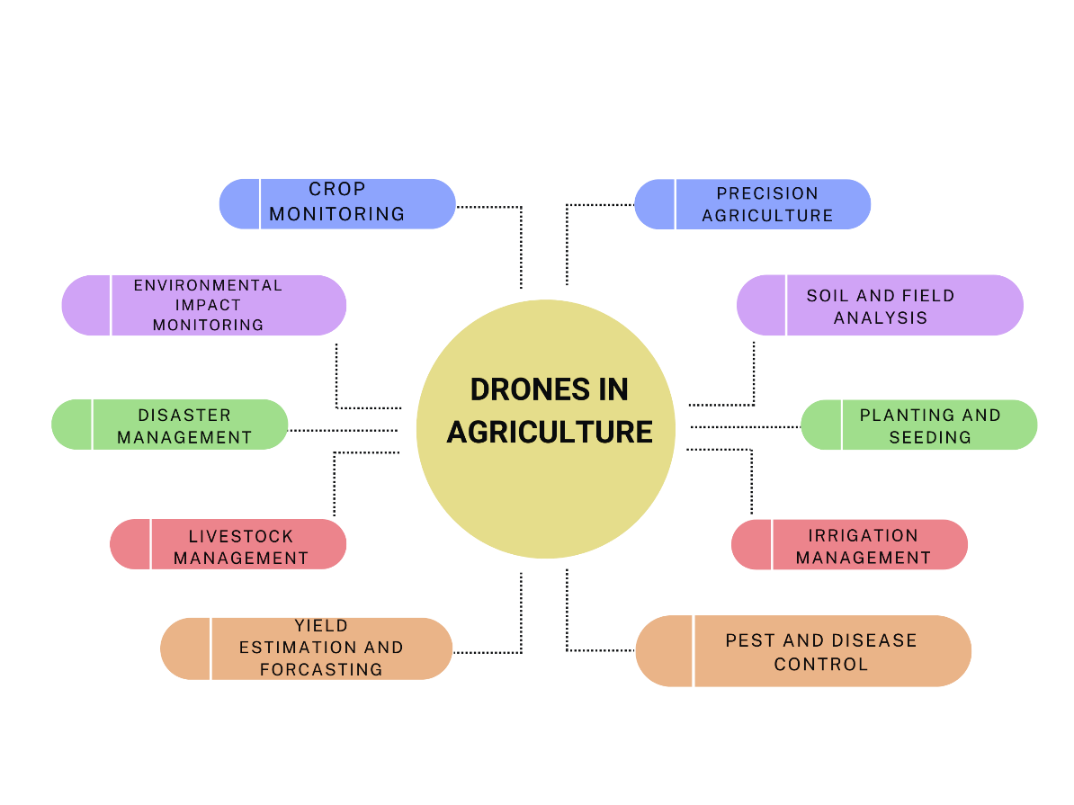
Fig 1: Application of Drones in Agriculture

Methodology
Related Work:
The development of agricultural UAVs based on quadcopter drones has made great strides in the past few years, mainly because of developments in UAV design/structure, autonomous control systems and precision spraying techniques. The initial research mainly concentrated on stabilizing multi-rotor system and maximizing lift capacity load for agricultural payloads to prepare the subsequent implantation of spraying devices. Recent research has developed intelligent high-efficiency platforms that are capable of targeted spraying, field monitoring and real-time decision. Sadhana et al. (2017) have developed a pesticide spraying mechanism with quadcopter drone for agricultural applications. The developed quadcopter drone could carry 1kg of weight including sprayer module. The designed and developed quadcopter drone minimizes health-related issues due to manual pesticide application of the farmers. Ali et al. (2019) presents a modification approach of Quadcopter into a UAV, in such a way that it can fly in manual as well as autopilot mode and can spray on agricultural lands using its ground control station. In this work, a stable system is developed for aerial distribution of pesticides as well as fertilizer to reduce human contact with pesticides. The system consists of; a) a remote-controlled UAV (Unmanned Aerial Vehicle) which is controlled from ground through a flight controller and b) a spraying system which is manually triggered by RF controlled circuit. The reliability of the proposed framework is evaluated on a test area of around 1000m². The pumping rate of sprayer system is adjusted to 40 mL/min with PWM at 45% duty cycle. From results it can be concluded that the integration of UAV with the spray system results in a spraying mechanism which is very efficient and hazard-free for crop pest management in the small field area. Bharambe et al. (2020) finds the key advantage of the quadcopter is the auto-landing capability which reduces the risk factors associated with crashing. It also helps to gather images from a good vantage point to analyze plant quality and health by using the VARI algorithm. Also to determine plant health, our quadcopter captures images of the fields/ area and processes them via the VARI algorithm. The program outputs a value between -1 to 1; -1 indicating bad plant health and 1 indicating good plant health. Shaw et. al. (2020) design a drone mounted with spraying mechanism having 12 V pump, 6 L storage capacity tank, 4 nozzles to atomize in fine spray , an octocopter configuration frame ,suitable landing frame, 8 Brushless Direct Current (BLDC) motors with suitable propellers to produce required thrust about 38.2 kg (at 100% RPM) and suitable Lithium Polymer (LI-PO) battery of current capacity 22000 mAh and 22.2 V to meet necessary current and voltage requirements. A First-Person View (FPV) camera and transmitter can also be fixed in the drone for monitoring the spraying process and for checking pest attacks on plants. This pesticide spraying drone reduces the time, number of labor and cost of pesticide application. This type of drone can also be used to spray disinfectant liquids over buildings, water bodies and in highly populated areas by changing the flow discharge of the pump. Susitra et al. (2020) has proposed and implemented a drone system that is used to spray pesticides and fertilizers on the farm which reduces the health issues of farmer community. This hexacopter technology with Pixhawk is the more stable and cost-efficient method. As a further development of the research, GPS module can be interfaced to Pixhawk. By using this, the drone automatically takes off and lands. It can also reach the desired location using GPS coordinates, this module can also help in mapping the certain amount of land for fertilizer spraying so that the drone will automatically spray the fertilizers following the mapped path. To maintain a constant height and avoid collisions, an ultrasonic sensor can be interfaced with Pixhawk. The drone comes to its initial position during the low battery and low signal range conditions using GPS. Ukaegbu et al. (2021) built a quadcopter, and its components were assembled with lightweight and strong materials to improve its efficiency. It consists of the electric motor, ESC, propellers, frame, li-po battery, flight controller, GPS, receiver. A sprayer module which consists of a relay, Raspberry Pi 3, spray pump, 12 V DC source, water hose, and tank, was built. It operated in such a way that when a weed was detected based on the deep learning algorithms deployed on the Raspberry Pi, GPIO 17 or GPIO 18 were activated to supply 3.3 V, which turned on a DC relay to spray herbicides accordingly. The sprayer module was mounted on the quadcopter, and from the test-running operation carried out, broadleaf and grass weeds were accurately detected and spraying of herbicides according to the weed type occurred in less than a second. Kedar et al. (2023) have designed a drone and found that time required by using drone is about (15 min/acre). It is time effective which saves a lot of time for farmers and reduces the fatigue load. The requirement for money in the traditional method is quite high because of high labour charges and on the other hand by using drone-based spraying it is quite feasible because it can be easily operated even by farmers also. By using the drone based spraying the heath issue of farmers get also reduced as compared to the traditional methods. Rao et al. (2024) have navigated challenging terrains, ensuring comprehensive crop coverage. They study that Quadcopter drones are emerging as an innovative solution for agricultural pesticide spraying, offering numerous advantages over traditional methods. These unmanned aerial vehicles (UAVs) enable precise and targeted application of agro-chemicals, reducing waste and environmental pollution. Deshpande et al. (2024) made a prototype quadcopter and performed flight testing at 40 m altitude at stable conditions. They also performed flight testing simulation on Mission Planner considering the factors like load, flight time, electric power, trust, spraying time etc. Nikam et al. (2024) have made a prototype of hexacopter which flight testing was performed maximum 20 m above the ground level at a speed of 1-10m/sec. The prototype’s Spraying Capacity was 10L for Efficient Coverage, it can Save 90-95% Water Consumption also Boost Yield by 10-15%. They have found that by using that prototype 1 Acre spaying can be done only in Just 5-7 Minutes and Spray up to 25-30 Acres Daily.
Singh et al. (2024) study presents a smart agriculture drone integrated with Internet of Things technologies that use machine learning techniques such as Tensor Flow Lite with an Efficient Det Lite1 model to identify objects from a custom dataset trained on three crop classes, namely, pineapple, papaya, and cabbage species, achieving an inference time of 91 m/s. The system’s operation is characterized by its adaptability, offering two spray modes, with spray modes A and B corresponding to a 100% spray capacity and a 50% spray capacity based on real-time data, embodying the potential of Internet of Things for real-time monitoring and autonomous decision-making. The drone is operated with an X500 development kit and has a payload of 1.5 kg with a flight time of 25 min, travelling at a velocity of 7.5 m/s at a height of 2.5 m.
Together, these researches reveal that the quadcopter UAV in agriculture has developed into a high-efficient agent with precision, complete treatment field coverage safety improvements and smart decision-making potential. They provide a solid foundation for future evolvement of the advanced automated aerial sprayer system in various agricultural applications.
3. DEVELOPMENT OF QUADCOPTER:
The preliminary step for the design and development of quadcopter drone is estimation of payload. Based on payload motor, propeller, Electronic Speed Controller, pump and all other electronics components have been selected. According to the current and voltages requirement of the electronic component’s battery can be selected. In the last step, the thrust requirement must be calculated and based on it the frame configuration of the drone must be selected.
3.1 Self-weight and Payload Estimation of drone:
Weight estimation is a very essential and initial step for the development of UAVs. Weight estimation helps in the selection of required components for drone development.
Table-1: Weight of the components
Parts | Weight (g)
Frame | 320
Battery | 326
Motor | 60× 4= 240
ESC | 23
Propeller | 11× 4=44
Telemetry | 20
GPS | 26
Flight Controller | 40
Radio Receiver | 14
Total weight | 1053
Table-2: Payload Estimation:
Parts | Weight (g)
Liquid | 200
Liquid Tank | 80
Pump | 270
Nozzles & pipes | 150
Total | 700
3.2 Selection of drone Configuration and frame:
Quadcopter drone (four-arm) configuration has been selected due to stability and maneuverability. The frame of the drone is made of polyamide nylon-6 and base plate is made of fiber glass composite material with dimension of 495 mm X 363 mm.
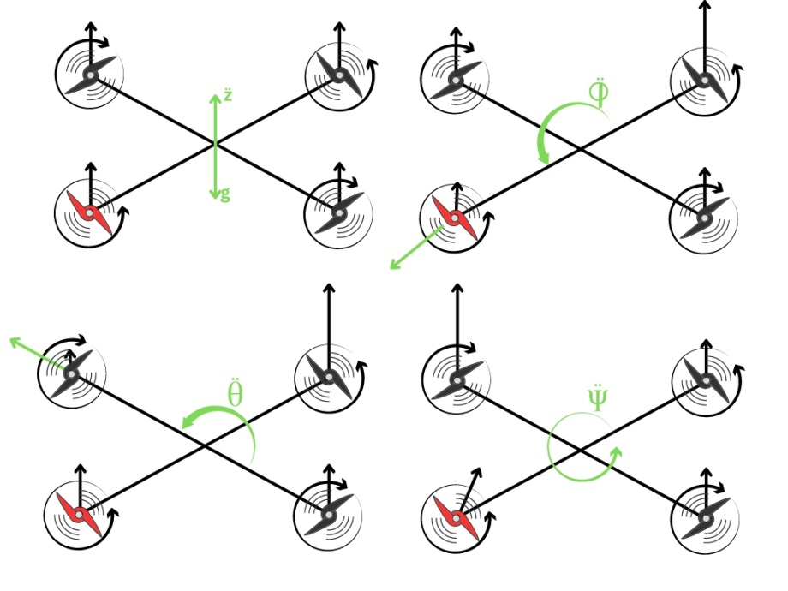
Pitch
Yaw
Roll
Upward Movement
Fig 2: Quadcopter drone flight dynamics for, yaw, pitch and roll

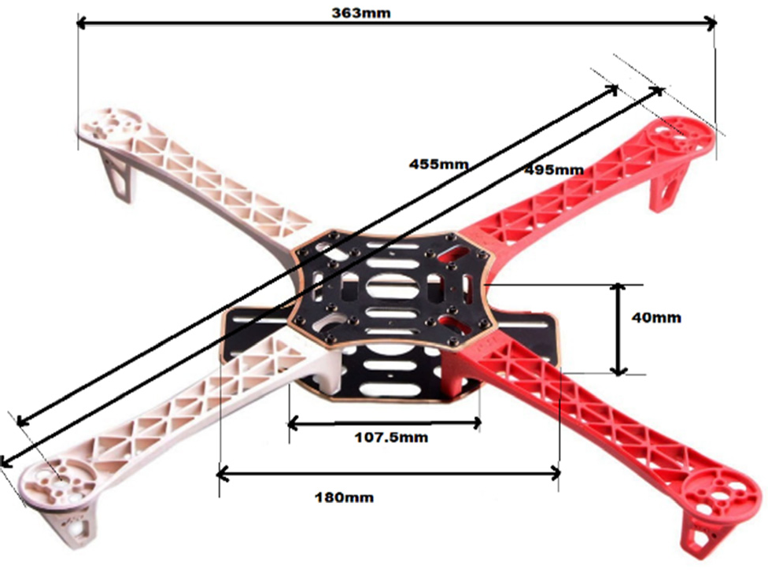
Fig 3: Frame with all dimensions in mm
Table- 3: Properties of polyamide nylon 6 (frame arms)
Name of property | Minimum value | Maximum value
Yield strength, MPa | 35 | 40
Poison ratio | 0.38 | 0.40
Tensile strength, MPa | 48 | 85
Density, kg/m³ | 1120 | 1140
Young’s modulus, MPa | 2300 | 2500

Table- 4: Properties of E-glass fiber (base plate)
Name of property | Minimum value | Maximum value
Bulk modulus, MPa | 43 | 50 x10³
Poison ratio | 0.21 | 0.23
Shear modulus, GPa | 30 | 36
Density, kg/m³ | 2.55 | 2.6
Young’s modulus, GPa | 72 | 85

3.3 Motor Selection:
The drone almost uses brushless DC motors, as they provide thrust-to-weight ratios superior to brushed DC motors. Motors are typically given two ratings: kV ratings and current ratings. The kV rating indicates how fast the motor will spin (RPM) for 1V of applied voltage. Based on the thrust requirement DJI 2212 920kV motor has been selected which can produce a maximum thrust of 500 g.
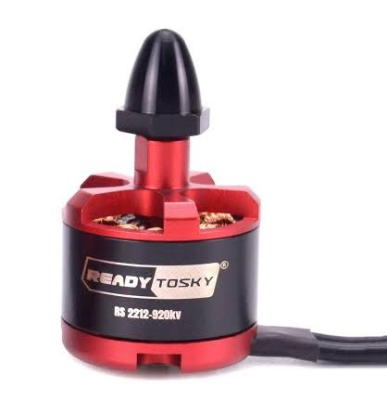
Fig 4: DJI 2212 BLDC Motor with 920 kV
3.4 Selection of Propeller:
Propeller is a type of fan that converts rotational motion into thrust. Generally, propellers are classified on the basis of their diameter and pitch and are represented in terms of product of diameter and pitch. In this work we have used carbon fiber propeller of 10 inches length and has inches pitch. It is made up of carbon fiber which possesses high strength to weight ratio when compared to the propellers made up of plastics.
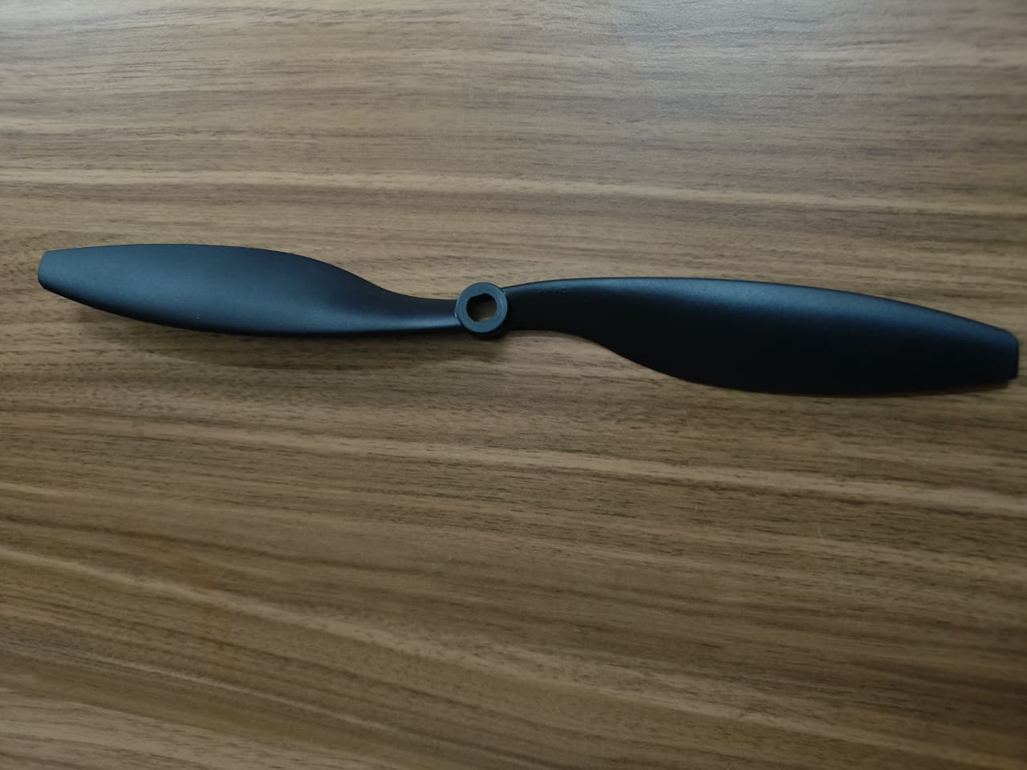
Fig 5: DJI 1045 Pro-range propeller
3.5 Selection of Electronic Speed Controller
The electronic speed controller controls the speed of the motor or advises the motor how quick to turn at a given time. For a quad-copter, 4 ESCs are required, one associated with each motor. The ESCs are then associated legitimately to the battery through either control appropriation board. Each ESC has a present rating, which showed the greatest current that it might give the motor without overheating. ESCs must be chosen to ensure that they can provide enough current for the motors. Depending on calculation we selected Simonk 30A ESC for our work.
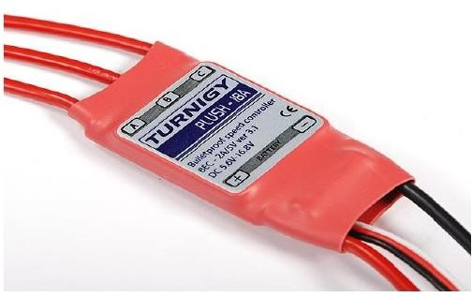
Fig 6: Electronic speed controller
3.6 Selection of Battery (mAh)
The drone sprayer is equipped with lithium-ion batteries because it has a high energy density and hence requires a low overall system weight to offer extended flight times. Moreover, its rapid charging performance, stable discharge output, as well as longer cycle life are seen to be significant advantageous for reliable and efficient UAV spraying usage. We used a Li-ion battery of 8000 mAh for this purpose in our study.
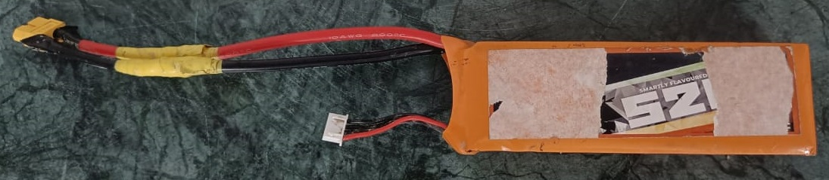
Fig 7: Li-ion battery with 8000 mAh capacity
3.7 Pump selection
In this work we have adopted a mini-DC pump for the delivery of water from the tank to the sprayer nozzles. The water pump that mounted on the drone is WA3510.This pump provides pressure about 0.85MPa and flow rate 5.8 L/min. It works with 24V supply and has maximum current consumption 5A.
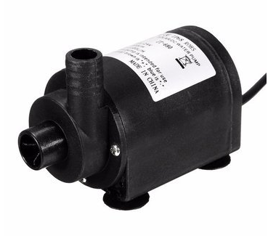

Fig 8: Mini Dc 24V Water Pump
3.8 Nozzle selection
In this work we have taken a SCA/4 solid cone adjustable nozzle which produces very fine to fine droplets size which is the most suitable for Herbicides, Insecticides, and Fungicides application. Recommended to use for Pest & Disease Spraying (P &D), Spot Spraying, Selective Spraying & Circle Spraying for dense weed conditions or broad leaves where high penetration is needed.
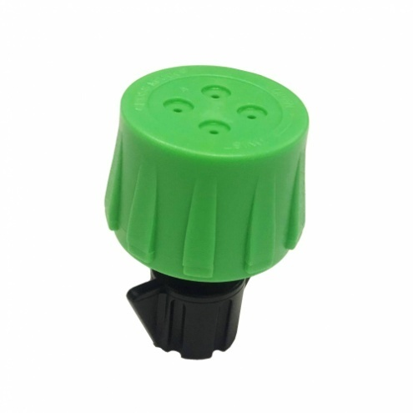
Fig 9: Solid cone nozzle
3.9 IMU (Inertial Measurement Unit)
The IMU is an electronic sensor device which measures the velocity, orientation and acceleration along different directions. This sensor allows the control system to navigate the boot in the environment. The readings of the IMU are fed to the main controller which are then compared with the set points and then appropriate action is taken by the motor controller system. The IMU is a combination of a 3-axis gyroscope and a 3-axis accelerometer, which together makes it a 6 degree of freedom sensor. Sometimes a 3-axis magnetometer is also included to get an absolute yaw control relative to the Earth’s magnetic field. This makes the IMU a 9 degree of freedom sensor.
Components of the IMU
1. Accelerometer
The accelerometer measures the acceleration relative to the gravitational force. So, the 3-axis accelerometer basically gives us components of acceleration in all the 3 directions. It can be used to measure the orientation, vibration and shock and hence is critical for the stability of the Quad copter (in our case). The disadvantage of only using the accelerometer is that it may become extremely sensitive to unwanted vibrations and noise (for example motor vibrations) and may lead to instability of the bot.
2. Gyroscope
A gyroscope is a device which measures and maintains the orientation based on the principle of angular momentum. It measures the angular velocity i.e., how fast something is spinning about an axis as well as rotational acceleration. Unlike accelerometers gyroscopes are not affected by gravity, so they make a great complement to each other. Accelerometer measure acceleration along the specified axes whereas Gyroscopes measure acceleration about the axes.
3. Magnetometer
A magnetometer measures the strength and the direction of magnetic fields and hence can be used to determine the orientation of the bot with respect to Earth’s magnetic field. This helps in additional Yaw stability.
4. Flight Controller
The flight controller helps in the maneuvering operations and also it provides Auto level function. The accelerometer and gyroscope sensor in the Flight controller processes the signals from the receiver and gives the output to the ESC. The Pixhawk 2.4.8 Flight controller board which is PX4 32-bit autopilot is used in the drone as it has inbuilt firmware. The features of this Flight controller board are much easier for calibration. Here the mission plan can be made using the software “Q Ground control Daily”. Pixhawk flight controller is a flexible autopilot hardware design based on the so-called project for the academic, hobby and developer communities. Pixhawk autopilot is applied to control flight modes, drone stability and handles all attitude estimation, inertial navigation, and failsafe monitoring for the drone. It receives data from internal sensors, the external GPS module and the external compass module, in-flight dynamics. Pixhawk outputs telemetry data to the 3DR Link network and sends control commands to drone’s four motors via the electronic speed controllers. Pixhawk communicates with drone onboard computer and ground control stations via the MAVLink telemetry protocol.
It weighs about 1.5 kg itself or 1.8 kg with GoPro camera and Solo Gimbal. The drone has a flight time of about 25 or 20 mins with the 420 g maximum payload. All sensor data from the drone can be wirelessly transmitted to a ground station PC either running Windows or Linux.
Table-5: Basic components of two (Pixhawk and MultiWii) flight controllers
Description | MultiWii (Naze32) | Pixhawk
Processor | STM32F103CB 32-bit | STM32F427 Cortex M4
Frequency (MHz) | 72 | 168
Accelerometer | MPU6500 | MPU6000, LSM303D
Gyroscope | MPU6500 | MPU6000, L3GD20
Magnetometer | HMC5883L | LSM303D
Barometer | MS5611 | MS5611

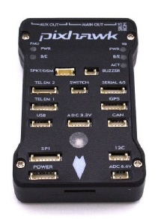
Fig 10: Pixhawk 2.4.8 flight controller
5. Radio Transmitter and Receiver
A Drone Radio Transmitter is an electronic device that uses radio signals to transmit commands wirelessly via a set radio frequency over to the Radio Receiver, which is connected to the drone being remotely controlled. In other words, it’s the device that translates the pilot's commands into the movement of the multirotor. An FPV Drone Radio Transmitter transmits commands via channels. Each channel is an individual action being sent to the aircraft. The Transmitter and receiver used are FlySky CT6B 2.4Ghz 6CH and FS-R6B respectively. This combination provides a range of about 1000 meters. This Transmitter and receiver provide up to 6 channel options.
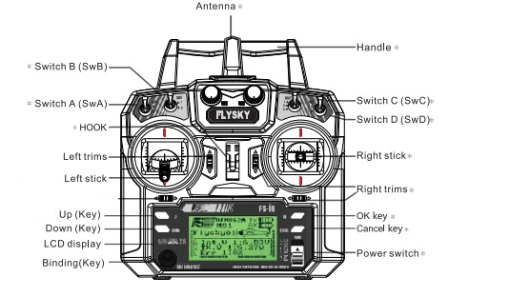
Fig 11: Fly sky CT6B 2.4 6CH Transmitter
A receiver must be compatible with the Radio Transmitter which in most cases means that the same brand of Rx and Tx needs to be purchased in order to establish a communication. Frequencies must also be the same on both Rx and Tx. For instance; a 2.4GHz Transmitter can only work with 2.4GHz Radio Receiver. Thus, while selecting your Drone Transmitter and Receiver, it is important that they are compatible with each other in terms of frequency and other parameters. Also, it is necessary that both the components have the size and features according to the specifics needed. It is recommended to purchase a high-quality Radio transmitter with Receiver when starting out to fly your own drone as it is one of the components that will last long enough.
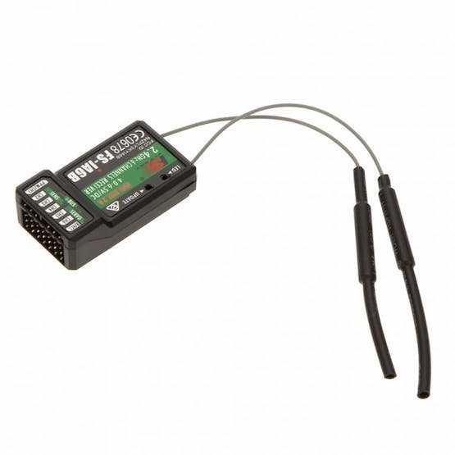
Fig 12: Radio receiver FSI6
6. Radio telemetry

Telemetry is used to refer the unmanned receiving and wireless transmitting of data from sensors (e.g., temperature, pressure, voltage or current) on the UAV to a ground station. In this work Generic 915MHz radio telemetry has been used and on board sensors collected the flight and system real time parameters, that were sent by MAVLink and visualized in Q-Ground-Control, open-source software, which enables full flight control and mission planning. This provided uninterrupted data logging, visualisation and operation control during all experiments.

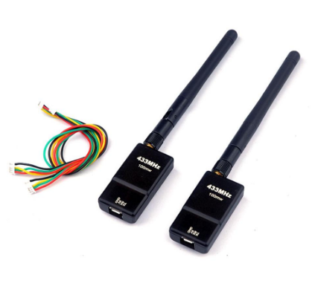

Fig 13: Generic 915MHz radio telemetry

7. GPS (Global Positioning System)

Positioning, navigation, and timing (PNT) services are offered by the Global Positioning System (GPS), a U.S.-owned utility. The space segment, the control segment, and the user segment are the three segments that make up this system. This system will provide way points tracking or provides operator flexibility to operate it from remote distance.

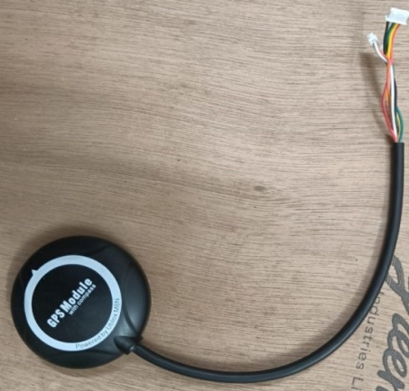

Fig 14: Global Positioning System module
3.10 Design of water storage tank
The water tank is made up of plastic and it has a capacity of 200 ml attached on the drone; the tank has slanting bottom so that the stagnation of water can be avoided. The stored water will be used for spraying purpose.
Table-6: Properties of designed tank for the drone
Properties of the tank
Area | 15541.065 mm²
Density | 0.001 g/mm³
Mass | 80 g
Volume | 170 g
Center of mass | 22.4mm, 6.25mm, 1525r

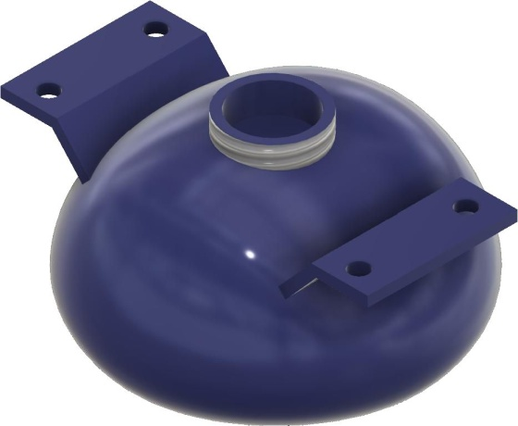 | 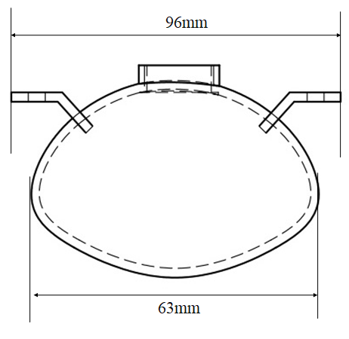
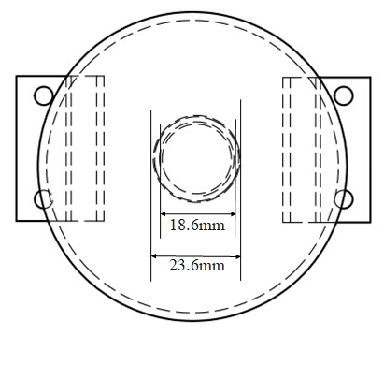
Fig 15: Schematic diagrams of the storage tank

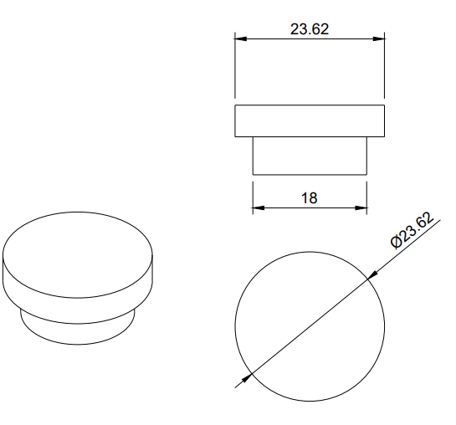 | 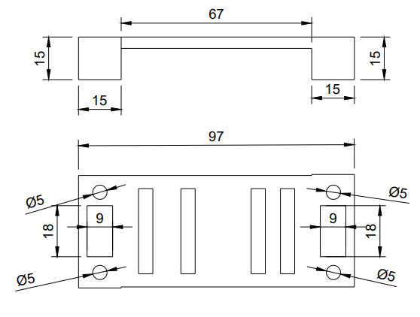
Fig 16: CAD design of tank cap and clamp used for mounting the tank

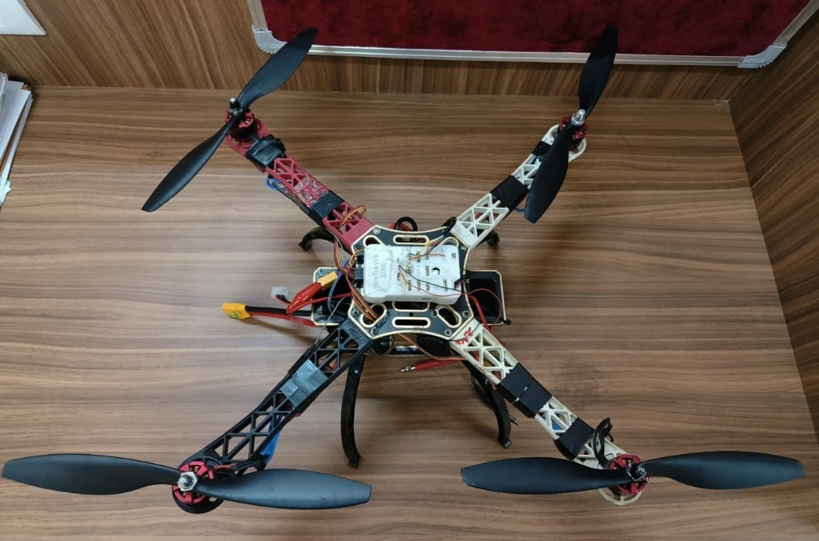
Fig 17: Developed drone sprayer
3.11 Experimental trials and Spraying Performance Evaluation
Comprehensive experimental trials were conducted to evaluate the operational and spraying performance of the developed quadcopter drone sprayer under actual field conditions. The trials focused on determining the Actual Field Capacity (AFC), Theoretical Field Capacity (TFC), Field Efficiency (FE), Area Coverage and overall Spraying Performance. All experiments were performed in open agricultural fields under low-wind conditions to ensure the accuracy and repeatability of results.
Actual field capacity
The effective field capacity (EFC) of a machine in the field can be easily calculated by dividing the acres completed by the hours of actual field time. Recording acres and hours for several fields over the whole season can be used to find an average field capacity in differing terrain and weather conditions.

Theoretical field capacity
It is the rate of field coverage of an implement that would be obtained if the machine were performing its function 100% of the time at the rated forward speed and always covered 100% of its width.

Field efficiency
Field efficiency is the ratio between the productivity of a machine under field conditions and the theoretical maximum productivity.

Area coverage
Area coverage refers to dependable and adequate service that will be or is being provided to all individuals within the affected area as previously described, according to reasonable and customary extension and service rules, rates, charges, and other terms and circumstances.

Spray uniformity
The drone mounted sprayer unit was kept and operated at five different heights viz., 6, 8, 10, and 12 feet and spray liquid at the collecting pipes of the tank was collected and the quantity of liquid from each of channels was measured.

Results and Discussion
The performance of the proposed quadcopter sprayer was assessed using a battery of experimental tests, including load-throttle response, flying duration analysis, and nozzle discharge assessment (Pandipati et al., 2023). These results shed light on the drone's operating stability, payload capabilities, and spraying effectiveness under a variety of situations.
Experimental trials and Spraying Performance Evaluation
Load test with respect to throttle
The load-throttle test was conducted to determine the lifting capability and power requirements of the quadcopter (Quan et al., 2025). Soil samples ranging from 50 to 800 g were used as test weights. The observations indicate a clear proportional relationship between load and throttle percentage. At lower loads (50-150 g), the drone-maintained stability with a throttle requirement of 30-45%. As the load increased, the throttle demand rose correspondingly, reaching 80% for a 600g payload. The drone was able to lift a maximum of 700g comfortably without compromising stability. These results confirm that the quadcopter can safely operate within its designed payload capacity and maintain a sufficient thrust-to-weight ratio for agricultural spraying operations.
Table-7: Load Vs Throttle
Test Replica | Load (g) | Throttle (%)
Replica 1 | 50 | 30
Replica 2 | 100 | 40
Replica 3 | 150 | 45
Replica 4 | 200 | 50
Replica 5 | 250 | 53
Replica 6 | 300 | 55
Replica 7 | 350 | 55
Replica 8 | 400 | 58
Replica 9 | 450 | 60
Replica 10 | 500 | 60
Replica 11 | 550 | 70
Replica 12 | 600 | 80

The line graph shown in fig. 18 clearly indicates that the throttle value varies with increment and decrement in load.

Fig 18: Variation in load with respect to throttle
Flying time with respect to Throttle
Flight time was tested across different throttle levels to assess battery endurance and power consumption (Park, 2025). The results show an inverse relationship between throttle percentage and flight duration. At 30% throttle, the drone achieved a maximum flight time of 26 min, while at 70% throttle the duration decreased to 8 min. This significant reduction is attributed to increased motor power consumption at higher throttle settings. These findings highlight that the drone operates most efficiently under moderate power loads, and heavy payload operations will require careful battery management to ensure adequate mission duration (Zhao et al., 2025). Table-8 is experimental values for flying time(min) with respect to throttle (%) of the test with different throttle different flight time.
Table-8: Flying time Vs Throttle
Test Replica | Throttle (%) | Flying time(min)
Replica 1 | 30 | 26
Replica 2 | 35 | 23
Replica 3 | 40 | 21
Replica 4 | 45 | 20
Replica 5 | 50 | 18
Replica 6 | 55 | 17
Replica 7 | 60 | 15
Replica 8 | 65 | 10
Replica 9 | 70 | 8

Fig-19 is a graphical representation of flying time with respect to throttle and it was clearly indicated that the throttle value increases with decrement and decreases with increment in flying time.

Fig 19. Variation in flying time with respect to throttle
Flying time with respect to weight
Weight-based flight tests further demonstrate how payload affects battery performance. With a minimum load of 50g, the drone achieved a flight time of 28 min, whereas at 500 g payload, the flight time was reduced to 8.5 min. The decreasing trend shows that heavier loads demand greater thrust, resulting in accelerated battery drain (Rai et al., 2025). This reinforces the importance of optimizing payload during spraying, especially for larger fields where extended flight time is critical. Table-9 represents the flying time of the drone according to the different weights that have already measured.
Table-9: Weight vs flying time
Test Replica | Weight(g) | Flying time(min)
Replica 1 | 50 | 28
Replica 2 | 100 | 25
Replica 3 | 150 | 23
Replica 4 | 200 | 20
Replica 5 | 250 | 14
Replica 6 | 300 | 11
Replica 7 | 350 | 10
Replica 8 | 400 | 10
Replica 9 | 450 | 9
Replica 10 | 500 | 8.5
Fig-20 shows the graphical representation of flying time with respect to weight and it was clearly indicated that the flying time increases with decrement and decreases with increment in weight.

Fig 20. Variation in flying time with respect to weight
Nozzle flow rate
To determine the spraying effectiveness, nozzle discharge tests were performed at heights of 6, 8, 10, and 12 feet. The collected discharge remained consistent, ranging from 0.61 to 0.62 L/min at a pressure of 5.46 bar and spray angle of 60°. The uniformity of discharge across varying heights indicates stable atomization and effective spray distribution (Portillo et al., 2025). This uniform spray pattern ensures adequate coverage and supports the suitability of the nozzle for precision pesticide application.
The spray distribution patterns of liquids by the nozzle for 1 min at a pressure of 5.46 bar at air velocity of 5.3 m/s have been given at table 10. In, this study following parameters, we have taken to considerations for the field operation.
Table-10: Parameters taken into consideration for spraying purpose
Pressure of the nozzle | 5.46 bar
Time taken for observation | 60 sec
Spray angle | 60 degrees
Velocity | 5.5 m/s

Table-11: Observations taken at 6, 8, 10, 12 feet height, p-5.46 bar with speed= 5.5m/s
Test Replica | Height(feet) | Volume collected(ml) | Collected discharge (l/min)
Replica 1 | 6 | 621 | 0.62
Replica 2 | 8 | 615 | 0.61
Replica 3 | 10 | 620 | 0.62
Replica 4 | 12 | 625 | 0.62

Fig-21 shows the graphical representation of the results of height, volume of water and the nozzle flow rate

Fig 21. Height vs volume of water vs nozzle flow rate
The field operation of the quadcopter sprayer developed was evaluated in terms of performance, under normal test conditions. The measured field capacity was 0.378 ha/h, the theoretical field capacity was 0.432 ha/h and resulting a field efficiency of 87%, which is indicative of no significant operational losses from turning, refilling or manoeuvring. The system demonstrated an effective area coverage of 0.375 ha/hr, validating the ability to spray quickly and accurately in small to medium vegetation fields.
Conclusion
The development and evaluation of the quadcopter drone sprayer demonstrate its strong potential as an efficient, safe, and highly adaptable tool for modern agricultural and disinfection applications. Experimental trials confirmed that the drone provides stable flight performance, reliable payload handling, and consistent spraying outputs under real field conditions. The system achieved a field efficiency of 87%, with an actual field capacity of 0.375 ha/h, indicating excellent operational effectiveness compared to traditional spraying methods. Spray uniformity assessments further validated the precision of the developed system, showing consistent droplet deposition and controlled overlap necessary for effective crop protection. Moreover, the drone’s ability to fly up to 800 m, carry 700 g of payload, and sustain 27 min of no-load endurance enhances its suitability for diverse field environments, including fragmented terrains and densely populated areas where manual spraying poses safety risks. Its multi-purpose applicability for pesticide delivery, antiseptic spraying, and environmental sanitation highlights its broader utility beyond agriculture.
Overall, the developed quadcopter drone sprayer provides a cost-effective, labour-saving, and technologically advanced solution that significantly improves the efficiency and safety of spraying operations, supporting the advancement of precision agriculture and sustainable farming practices.
Disclaimer (Artificial intelligence)
Option 1:
Author(s) hereby declare that NO generative AI technologies such as Large Language Models (ChatGPT, COPILOT, etc.) and text-to-image generators have been used during the writing or editing of this manuscript.
Option 2:
Author(s) hereby declare that generative AI technologies such as Large Language Models, etc. have been used during the writing or editing of manuscripts. This explanation will include the name, version, model, and source of the generative AI technology and as well as all input prompts provided to the generative AI technology
Details of the AI usage are given below:
1.
2.
3.

COMPETING INTERESTS DISCLAIMER:
Authors have declared that they have no known competing financial interests OR non-financial interests OR personal relationships that could have appeared to influence the work reported in this paper.

References:
- Ahmad, A., García, J., Cartujo, Cassinello., P., & Martos, V. (2020). Remotely Piloted Aircraft (RPA) in Agriculture: A Pursuit of Sustainability. Agronomy. December-2020. https://doi.org/10.3390/agronomy11010007
- Ali, H., Zahir, Ali., Khan, S., Ahmad, N. and Fayyaz, A. A Hazard-Free Framework for Aerial Distribution of Pesticides on Agricultural Land. Mehran University Research Journal of Engineering and Technology. Vol. 39, No. 2, 548 - 553, July 2020. https://doi.org/10.22581/muet1982.2003.10
- B. Sadhana, G. Naik, J. Mythri, R. Puneeth, Hedge. G and B. Shyama, and Sharma, K. Development of Quad Copter Based Pesticide Spraying Mechanism for Agricultural Applications. International Journal of Innovative Research in Electrical, Electronics, Instrumentation and Control Engineering. IJIREEICE/NCAEE.2017.27. https://doi.org/10.17148/IJIREEICE/NCAEE.2017.27
- Bharambe, Y., Singh, D. and Binsale, V. Design and Development of Agricultural Drone for Plant Health Analysis. International Research Journal of Innovations in Engineering and Technology (IRJIET). Volume 4, Issue 8, pp 6-11, August-2020. https://doi.org/10.47001/IRJIET/2020.408002
- Deshpande, A., Dharmadhikari, A., Dhonde, S., Deshmukh, Y., Dewoolka, S. and kotwal, G. Autonomous Agricultural Drone with Sprinkling System. International Research Journal on Advanced Engineering Hub (IRJAEH). Vol. 02, Issue:05 May,2024 Page No: 1187-1192. https://doi.org/10.47392/IRJAEH.2024.0163
- Ghazali, M., Azmin, A. and Rahiman, W. Drone Implementation in Precision Agriculture –A Survey. International Journal of Emerging Technology and Advanced Engineering. Volume 12, Issue 04, April 2022. https://doi.org/10.46338/ijetae0422_10
- Jaiswal, S., & Rawat, G. (2021). IoT-Enabled Smart Farming: Challenges and Opportunities. In A. Choudhury, A. Biswas, T. P. Singh, & S. K. Ghosh (Eds.), Smart Agriculture Automation Using Advanced Technologies: Data Analytics and Machine Learning, Cloud Architecture, Automation and IoT (pp. 123–139). Springer. https://doi.org/10.1007/978-981-16-6124-2_7
- Karunathilake, E. M., Le, A. T., Heo, S., Chung, Y. S., & Mansoor, S. (2023). The Path to Smart Farming: Innovations and Opportunities in Precision Agriculture. Agriculture, 13, 1593. https://doi.org/10.3390/agriculture13081593
- Kedar, G., Bahekar, A., Matode, N., Paralikar, R., Wagh, S. and Wankhede, S. Design and Development of UAV Based Pesticide Sprayer in Agriculture Application. International Journal of Advanced Research in Science, Communication and Technology (IJARSCT). Volume 3, Issue 8, April 2023. https://doi.org/10.48175/IJARSCT-9535
- Nahiyoon, S., Ren, Z., Wei, P., Li, X., Li, X., Xu, J., Yan, X., & Yuan, H. (2024). Recent Development Trends in Plant Protection UAVs: A Journey from Conventional Practices to Cutting-Edge Technologies-A Comprehensive Review. Drones, 8, 457. https://doi.org/10.3390/drones8090457 .
- Nikam, K., Nadkar, U., Prajapati, A. and Reddy, P. Development of Agriculture Spraying Drone. International Journal of Scientific Research in Engineering and Management (IJSREM). Volume: 08 Issue: 03, March – 2024. https://doi.org/10.55041/IJSREM29644
- Pandipati, S., Rakesh, K., Kumar, L. M., Lokesh, P. J. V., Jeevan, Y., & Bammidi, R. (2023). FABRICATION OF QUADCOPTER FOR AGRICULTURAL SPRAYING. International Journal of Advances in Agricultural Science and Technology, 10(4), 13–16. https://doi.org/10.47856/ijaast.2023.v10i04.002
- Park, M. (2025). A weight fraction-based analytical method for initial sizing of hybrid power plant systems in electric vertical take-off and landing aircraft. Energy, 340, 139192. https://doi.org/10.1016/j.energy.2025.139192.
- Portillo, H., Barbosa, R., Beckwith, M., Gullen, T., Haynie, R., Hovinga, S., Kesavaraju, B., Lang, E., Livingston, P., Newton, N., Oostlander, M., Watson, G., & Sinha, R. (2025). Industry (UAPASTF) Response to Pesticide Regulators’ “State of the Knowledge” Review of Drone Use for Pesticide Application: Best Practices for Safe and Effective Application of Pesticides. Drones, 9(6), 388. https://doi.org/10.3390/drones9060388
- Quan, Q., Wang, S., & Gao, W. (2025). Lifting-Wing Quadcopter Modeling and Unified Control. Journal of Guidance, Control, and Dynamics, 48(3), 689–699. https://doi.org/10.2514/1.G008134
- Radocaj, D., Plascak, I., & Jurišić, M. (2023). Global Navigation Satellite Systems as State-of-the-Art Solutions in Precision Agriculture: A Review of Studies Indexed in the Web of Science. Agriculture, 13, 1417. https://doi.org/10.3390/agriculture13071417 .
- Radocaj, D., Plaščak, I., & Jurišić, M. (2023). Global Navigation Satellite Systems as State-of-the-Art Solutions in Precision Agriculture: A Review of Studies Indexed in the Web of Science. Agriculture, 13, 1417. https://doi.org/10.3390/agriculture13071417
- Rai, S., Rawat, A., & Kumar, A. (2025). Design and performance analysis of high-altitude UAVs: Trends, challenges, and innovations. Discover Applied Sciences, 7(8), 833. https://doi.org/10.1007/s42452-025-07357-8
- Rao, M. V., Kavali, A., S, Geetha. and P, S. K. Design and Development of Quadcopter for Agro-Chemical Spray in Agricultural Field. International Research Journal on Advanced Engineering Hub (IRJAEH). Vol. 02 Issue: 05 May 2024 Page No: 1294 – 1302. https://doi.org/10.47392/IRJAEH.2024.0179
- Rathod, P., & Shinde, G. (2023). Autonomous Aerial System (UAV) for Sustainable Agriculture: A Review. International Journal of Environment and Climate Change, 13, 1343–1355. https://doi.org/10.9734/ijecc/2023/v13i82080
- Saiz-Rubio, V., & Rovira-Más, F. (2020). From Smart Farming towards Agriculture 5.0: A Review on Crop Data Management. Agronomy, 10. https://doi.org/10.3390/agronomy10020207
- Shaw, K. and R, V. Design and Development of a Drone for Spraying Pesticides, Fertilizers and Disinfectants. International Journal of Engineering Research & Technology (IJERT). Vol. 9 Issue 05, May-2020. https://www.ijert.org/design-and-development-of-a-drone-for-spraying-pesticides-fertilizers-and-disinfectants
- Susitra, D., Jebaseeli, E., Chitturi, V. and Chadalavada, V. Design and development of an Hexacopter for fertilizer spraying in agriculture fields. First International Conference on Advances in Physical Sciences and Materials. Journal of Physics: Conference Series 1706, 012053-2020. https://doi.org/10.1088/1742-6596/1706/1/012053
- Ukaegbu, U., Tartibu, L., Okwu, M. and Olayode, I. Development of a Light-weight Unmanned Aerial Vehicle for Precision Agriculture. Sensors. 21, 4417,2021. https://doi.org/10.3390/s21134417
- Ullo, S., & Sinha, P. G. (2021). Advances in IoT and Smart Sensors for Remote Sensing and Agriculture Applications. Remote Sensing, 13, 2585. https://doi.org/10.3390/rs13132585
- Zhao, T., Zhang, Y., Wang, M., Feng, W., Cao, S., & Wang, G. (2025). A Critical Review on the Battery System Reliability of Drone Systems. Drones, 9(8), 539. https://doi.org/10.3390/drones9080539

