Effect of Seed Treatments and Hermetic Storage on Storability of Combine Harvested Rice (ADT 54) at Different Maturity Stages

ABSTRACT
Rice variety ADT 54 was harvested using a combine harvester at various maturity stages, including physiological maturity, two days after, four days after, and six days after physiological maturity. The seeds were treated with a water-soluble polymer at a rate of 4 mL + 12 mL water per kg and Vithai Amirtham at 25 mL per kg of seed. They were compared with untreated control seeds and stored in super grain bags and gunny bags under ambient condition (30⁰C & 62%RH). Seed quality parameters such as germination, seedling vigour, electrical conductivity, pathogen and insect infestation were assessed at monthly intervals up to 12 months. Results showed that seeds harvested at physiological maturity had the highest germination rates, longer root and shoot lengths, increased dry matter production, higher seedling vigour index and dehydrogenase activity, lower pathogen incidence and insect infestation,. Seeds treated with the water-soluble polymer showed improved germination, root and shoot length, and vigour index compared to untreated seeds in both super grain bags and gunny bags. Seeds treated with the water-soluble polymer and stored in super grain bags had increased germination (87%) and vigour index (2722) at physiological maturity compared to six days after physiological maturity (84%) and (2219) respectively. The study concluded that ADT 54 rice seed crop harvested at physiological maturity, treated with a water-soluble polymer, and stored in super grain bags maintained seed quality above minimum certification standards for up to 12 months.

Keywords: Rice variety ADT 54; Maturity stages; Water soluble polymer; Super grain bag; Seed storage; Germination; Seedling vigour.

- INTRODUCTION
Rice (Oryza sativa L.) is a crucial staple food crop that sustains a large portion of the global population. It is cultivated on approximately 150 million hectares of land worldwide, with a total production of around 440 million tons, representing about 30% of the world's total grain production (FAO, 2024). Seeds are a vital input in agricultural production, and their quality plays a crucial role in determining crop stand establishment and yield potential. Harvest maturity, post-harvest handling, and storage conditions are critical factors in maintaining seed viability and vigour (Goud et al., 2024). During storage, rice seeds undergo biochemical and physiological changes that lead to a loss in vigour and viability. The primary goal of seed storage is to maintain seed quality from one season to the next (Tan et al., 2025). Storage temperature and moisture content (Vijay et al.,2015) are the most important factors influencing seed lifetime, with moisture levels having a greater impact than temperature (Choudhury and Bordolui, 2023). Harvesting rice at the appropriate maturity stage is crucial to ensure seeds reach their maximum dry weight, germination potential, and vigour (Jeyachandra et al., 2025). Harvesting before or after this stage can result in poor seed quality and reduced storability due to high moisture content or over-drying effects(Vijay et al.,2015a), leading to mechanical damage and deterioration (Singh et al., 2024). The increasing use of combine harvesters for rice harvesting has improved efficiency but introduced challenges such as mechanical seed injury, especially at higher moisture levels (Jeyachandra et al., 2025a). Mechanical damage can disrupt seed coat integrity, increase susceptibility to pathogens, and affect seed viability and vigour during storage (Cavusoglu et al., 2024). Identifying the optimal maturity stage for combine harvesting is crucial for maintaining seed quality during storage. Proper post-harvest storage management is essential for minimizing quality loss. The storage environment, seed treatments, and packaging materials influence moisture fluctuations, seed respiration, and microbial infestation (Paul and Bordolui, 2025). Hermetic containers like super grain bags have proven effective in maintaining seed moisture and viability compared to traditional porous bags like gunny sacks (Suparto et al., 2024). The application of seed protectants and polymer coatings helps maintain seed integrity and delay deterioration during storage (Singh et al., 2024). “The polymer coating with the negligible thickness of the seed coat provides protection from the imposed accelerated ageing, which includes fungal invasion. The polymer coating is simple to apply, diffuses rapidly and is non-toxic to the seed during germination. It reduces chemical wastage, helps to make room for including all required ingredients, protect seed from fungal invasion and insect attack” (Nethra et al., 2024).
Seed quality is determined by physical purity, genetic purity, physiological quality, disease resistance, and yield potential. Quality seeds are essential for low seed rates, quick germination, strong seedling establishment, pest and disease resistance, and higher yields. Quality seeds of high-yielding varieties are necessary for increased crop productivity and small farmer income. Proper storage is crucial for preserving seed viability and vigour. Poor storage conditions or high moisture content can lead to seed quality deterioration. This study aimed to investigate the effect of harvesting at different maturity stages using a combine harvester on the seed quality and storability of ADT 54 rice variety to identify the best harvest stage, treatment, and storage conditions for maintaining seed viability and vigour under ambient storage conditions.
- MATERIALS AND METHODS
The experiments were conducted at the Department of Basic Engineering and Applied Sciences, Agricultural Engineering College and Research Institute, Tamil Nadu Agricultural University, Kumulur, from April 2023 to May 2025. Rice seed crop (Var. ADT 54) was harvested using a combine harvester (Table.1) at different seed moisture levels (19% to 27%) with four distinct maturity stages. The treatments included harvesting the seed crop at physiological maturity (H1), two days after physiological maturity (H2), four days after physiological maturity (H3), and six days after physiological maturity (H4) stage. The seeds collected from different maturity stages were cleaned and graded. The graded seeds were stored in both super grain bag (C1) and gunny bag (C2) containers with 8 and 12.50 percent moisture content respectively for the following treatment of control (T1), water-soluble polymer 4 mL + 12mL water/kg of seed (T2), and vithai amirtham 25mL/kg of seed (T3). The treated seeds were stored under ambient conditions (30⁰C & 62%RH).. The experiment was designed using FCRD with three replications. Various quality parameters were recorded initially and at monthly intervals for 12 months to assess the storability of seeds. For the germination test, seeds were placed on a roll towel. Under each treatment, 400 seeds were sown with eight replications of 50 seeds each. Seed germination was calculated as the percentage of seeds producing normal seedlings. Fourteen days after sowing (ISTA, 2019), ten seedlings from each replication were randomly selected, and the root and shoot lengths were measured, with the mean value recorded. Ten random seedlings were dried in a hot air oven at 85°C for 24 hours, and the dry weight was recorded and expressed as g seedling⁻¹⁰. The vigour index was calculated using the formula (Abdul-Baki and Anderson, 1973): Vigour Index = Percentage germination x Total seedling length (cm). Seeds were also analyzed for electrical conductivity (Presley, 1958), dehydrogenase activity (Kittock and Law, 1968), under each treatment. Pathogen infection percentages were calculated for four replicates of 25 seeds, which were placed equidistantly on three-layered moistened blotter paper in sterilized petri plates. Each treatment was replicated four times. The seeds were then incubated at 20°C for seven days with alternate cycles of 12 hours in the near ultraviolet (NUV) range band and 12 hours in the dark. On the eighth day, the plates were examined under a stereo binocular microscope (50X) to check for the presence of seed-borne fungi. The number of infected seeds was counted and expressed as a percentage. The fungi present on the seeds were identified and recorded according to ISTA guidelines (1999).Insect infestation percentages were also studied. One hundred seeds from each treatment and replication were observed using a magnifying lens to distinguish between insect-damaged and undamaged seeds. The percentage of damaged seeds was calculated using the formula suggested by Mohan (1993).
Insect infestation (%) = | Number of damaged seeds | × 100
Insect infestation (%) = | Total number of seeds taken for counting | × 100

The results were subjected to statistical analysis for significant differences (P=0.05) following Panse and Sukhatme (1999). Percentage values were transformed using arcsine values prior to statistical analysis.
Table 1. The overall dimensions and specifications of Tractor Mounted
Combine Harvester

S. No. | Particulars | Specifications
1. | Hp | 55
2. | Machine weight (kg) | 6030
3. | Wheels | Rear wheel 6-50-20
4. | Number of straw walker | 5
5. | Cutting capacity (acre/hour) | Paddy 1.5 (approx.)
6. | Overall dimension transport (mm) | Length: 11685, Width: 2792,  Height: 3910
7. | Overall dimension working (mm) | Length: 7858, Width: 4300,  Height 3910
8. | Peripheral speed of threshing drum (m s⁻¹) | 22-25
9. | Inlet threshing clearance (mm) | 12-16
10. | Outlet threshing clearance (mm) | 9-12
11. | Upper grain sieve (mm) | 10-12
12. | Lower sieve (mm) | 6-8
13. | Angular velocity of the fan shaft (m s⁻¹) | 30
14. | Effective cutting width (mm) | 3975
15. | Blower type | Centrifugal

- RESULTS AND DISCUSSION
The results of the moisture content, germination percentage, and vigour index of rice seed var. ADT 54 during 12 months of storage are significantly influenced by containers, seed treatments, duration of storage period, and their interactions as shown in Fig. 1. The study revealed that the moisture content of rice seed increased with the storage time in all the containers and throughout the storage duration. Among the maturity stages, the physiological maturity stage recorded the highest moisture content (10.70%) and the lowest moisture content was observed at six days after physiological maturity (10.56%). The super grain bag maintained the lowest moisture content (8.25%) while the gunny bag had the highest moisture content (13.01%). Among the treatments, vithai amirtham had the lowest moisture content (10.63%), followed by water-soluble polymer (10.58%), and the control had the highest (10.69%). A gradual increase in moisture content was observed from the initial month to the twelfth month of storage period. This differential increase may be attributed to the hermetic bags effective moisture control due to their lower permeability, which helps maintain a stable internal environment (Khandai et al., 2025). Tivana et al. (2021) also stated that “the super grain bag was the only storage system that kept grain moisture content stable throughout the storage period”. “The seed moisture fluctuation was greater in cloth bags compared to super grain bags due to less exchange of moisture and gases in green gram seed storage studies” (Adhithya et al., 2024).

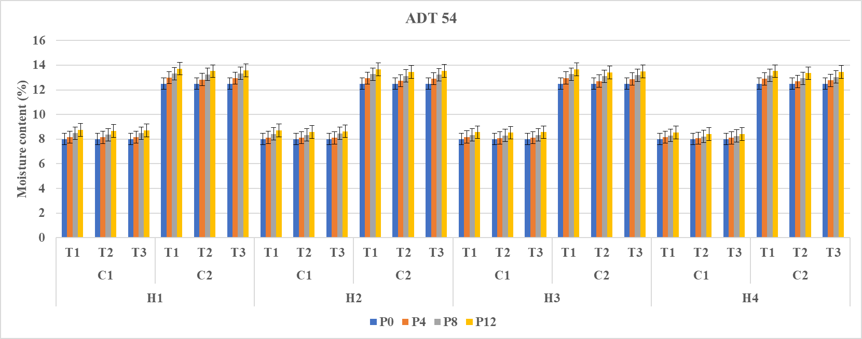

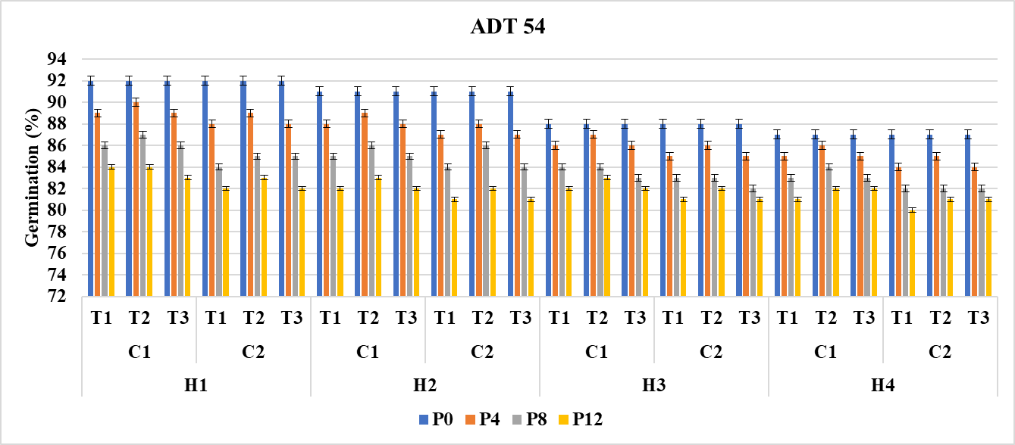

Fig. 1. Effect of maturity stages, combine harvesting, storage containers and seed treatments on moisture content (%) and germination (%) of ADT 54 rice variety

H₁ – At Physiological maturity  H₂ – Two days after physiological maturity  H₃ – Four days after Physiological maturity  H₄ – Six days after Physiological maturity | P0- Initial Period of storage  P4- 4 months of storage  P8- 8 months of storage  P12- 12 months of storage  C₁-Super grain bag  C₂-Gunny bag | T₁-Control  T₂-Water Soluble Polymer 4ml + 12 ml water/kg  T₃- Vithai Amirtham 25 ml/kg of seed

Seed germination was significantly influenced by the containers, treatments, period of storage, and their interactions. Among the maturity stages, the highest germination was recorded at the physiological maturity stage (87%), followed by seeds obtained two days after physiological maturity stage (86%) (Fig.1). The lowest germination was recorded at six days after the physiological maturity stage (84%). Among the containers used for storage, the super grain bag maintained higher germination (86%) while the lower germination was observed in seeds stored in a gunny bag (85%). “This might be due to the higher level of germination maintained in seeds stored in super grain bags, which may be related to lesser moisture fluctuation, reduced autoxidation and depletion of food reserves, higher antioxidative and lower reactive oxygen species (ROS) damage and lower pest and fungal activity” (Radha et al., 2024). Similar findings were reported by Vinodkumara (2020) for soybean. “Among the treatments, seeds coated with water-soluble polymer @ 4 mL + 12 mL water/kg recorded a germination of 86%, followed by vithai amirtham and the control at 85%. Similar results with improved plant growth and yield when treated with polymers for quality seed production in rice (Parimala et al., 2022; Dutta and Bhattacharya, 2020). Raja et al. (2025) found that direct seeded rice treated with vithai amirtham @ 25 mL/kg recorded higher field emergence, root growth, plant height, productive tillers and number of seeds/panicle and yield. A decrease in seed germination was observed with an increase in the storage period. The maximum germination was observed during the initial storage period (90%) and decreased to a minimum after 12 months of storage (82%). The germination percentage of rice seeds decreased with the increase in storage time in all storage materials throughout the storage duration” (Bista et al., 2006). Paddy seeds stored in hermetic bags maintained significantly higher germination than those stored in gunny bags (Sivashankari et al., 2024). These findings are in agreement with Sarmah et al. (2024), who reported that hermetic storage systems preserve seed viability more effectively by providing a stable environment that minimizes insect infestation and prevents fluctuations in seed moisture content.
Similar trends were significantly influenced by seedling length, dry matter production and vigor index in relation to seed treatments, storage containers, and the duration of the storage period. These parameters tended to decrease with an increase in the storage period (Fig.2). “The shoot and root length between the packaging materials were longer in super grain bags compared to cloth bags in soybean. This may be due to the storage container having a significant effect on root length and shoot length, which decreased with an increase in the storage period” (Ramanadane et al., 2024). “Seeds stored in super grain bags showed significantly higher root growth than those stored in cloth bags. Moisture content had an influential effect on seed storage, and high moisture content in cloth bags obviously deteriorated seedling growth. Furthermore, the seed quality in cloth bags was reduced due to a high rate of seed deterioration by biotic and abiotic factors to which cloth bags are more susceptible” (Adhithya et al., 2024). These results are similar to the findings of Tahir et al., 2023 in controlled storage experiments have demonstrated that holding rice seeds at approximately 10-12% SMC preserves germination and vigour for substantially longer periods compared with seeds stored at 14% or higher, where oxidation and biochemical degradation accelerate the loss of viability.

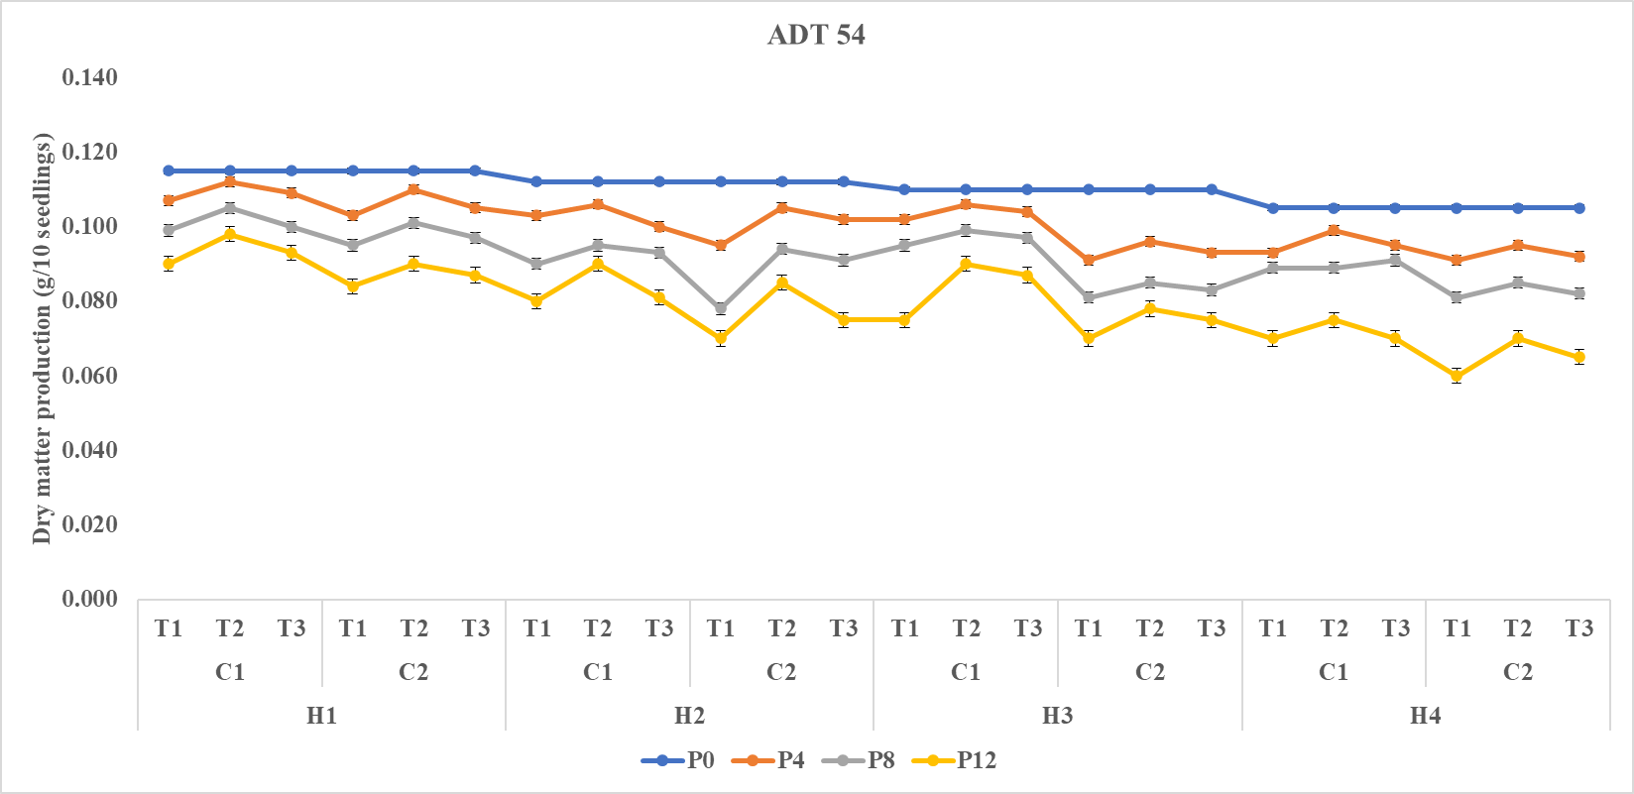

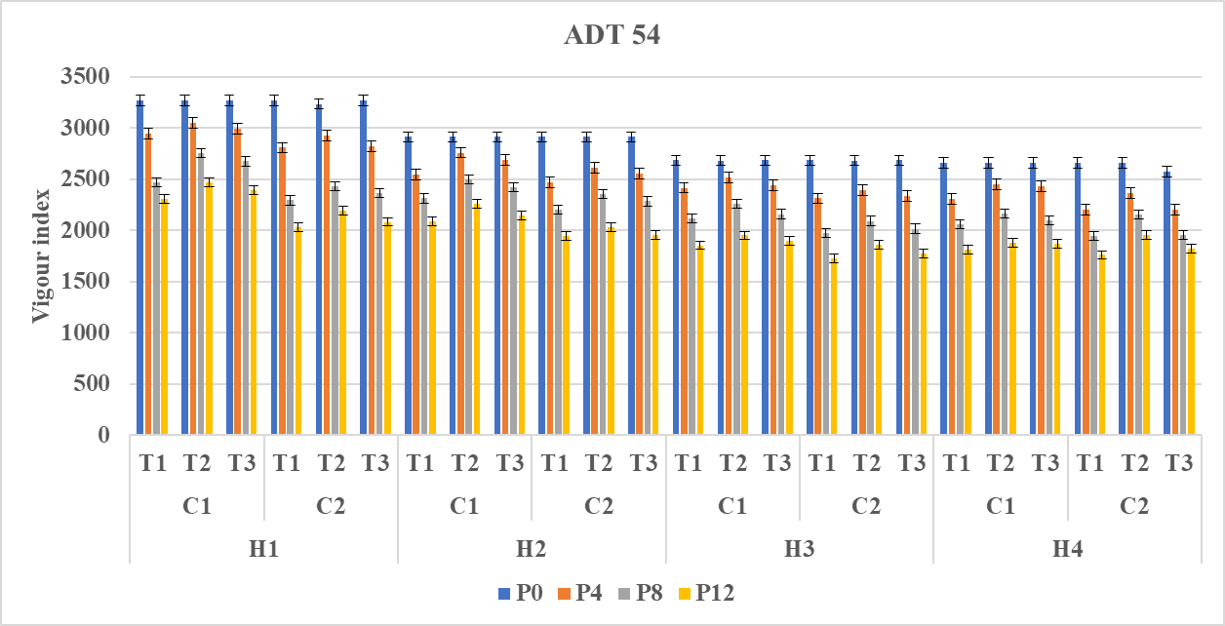

Fig. 2. Effect of maturity stages, combine harvesting, storage containers and seed treatments on dry matter production (g/10 seedlings) and vigour index of ADT 54 rice variety

H₁ – At Physiological maturity  H₂ – Two days after physiological maturity  H₃ – Four days after Physiological maturity  H₄ – Six days after Physiological maturity | P0- Initial Period of storage  P4- 4 months of storage  P8- 8 months of storage  P12- 12 months of storage  C₁-Super grain bag  C₂-Gunny bag | T₁-Control  T₂-Water Soluble Polymer 4ml + 12 ml water/kg  T₃- Vithai Amirtham 25 ml/kg of seed

Electrical conductivity (EC) was significantly influenced by maturity stages, containers, treatments, and storage duration. Among the maturity stages, physiological maturity had the lowest electrical conductivity (0.105 dSm⁻¹), while the highest leachates were obtained six days after physiological maturity (0.116 dSm⁻¹) (Fig.3). Among the containers used for storage, the super grain bag maintained lower electrical conductivity (0.098 dSm⁻¹) while the higher electrical conductivity was observed in seeds stored in a gunny bag (0.113 dSm⁻¹). Among the treatments applied, seeds coated with water-soluble polymer @ 4 mL + 12 mL water/kg had the minimum electrical conductivity (0.101 dSm⁻¹) while the maximum electrical conductivity was observed in the control (0.103 dSm⁻¹). Over the storage period, the electrical conductivity increased. This is caused by seed aging substantially increasing electrolyte leakage in paddy, indicating progressive membrane impairment. Consequently, the reduced germination observed in deteriorated seeds is largely attributed to metabolic disruptions that diminish seed viability and vigor. The highest electrical conductivity recorded during storage confirms that severe membrane disintegration has occurred, ultimately leading to a loss of seed viability (Siddarudh et al., 2019). Seeds with less vigor discharge more leachates, leading to a higher EC in wheat (Lohitha and Dutta, 2024). The soybean seeds stored in cloth and jute bags showed significantly higher electrical conductivity compared to those stored in a polyethylene bag. This may be due to an increase in the permeability of the seed coat, which was more pronounced in cloth and jute bags, respectively, during prolonged storage (Rajesh et al., 2020).

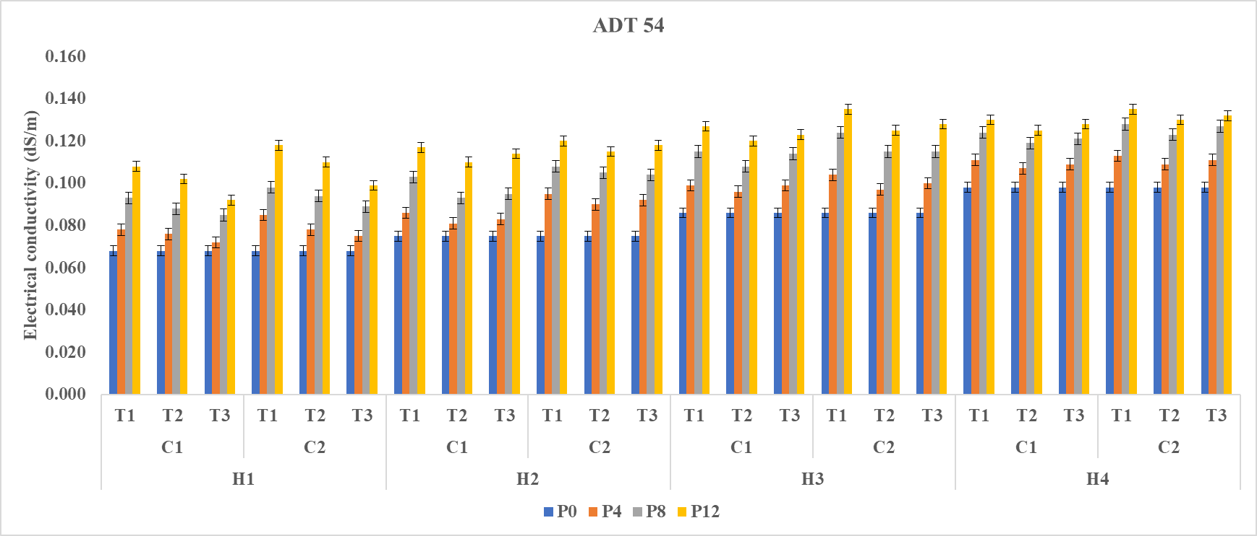

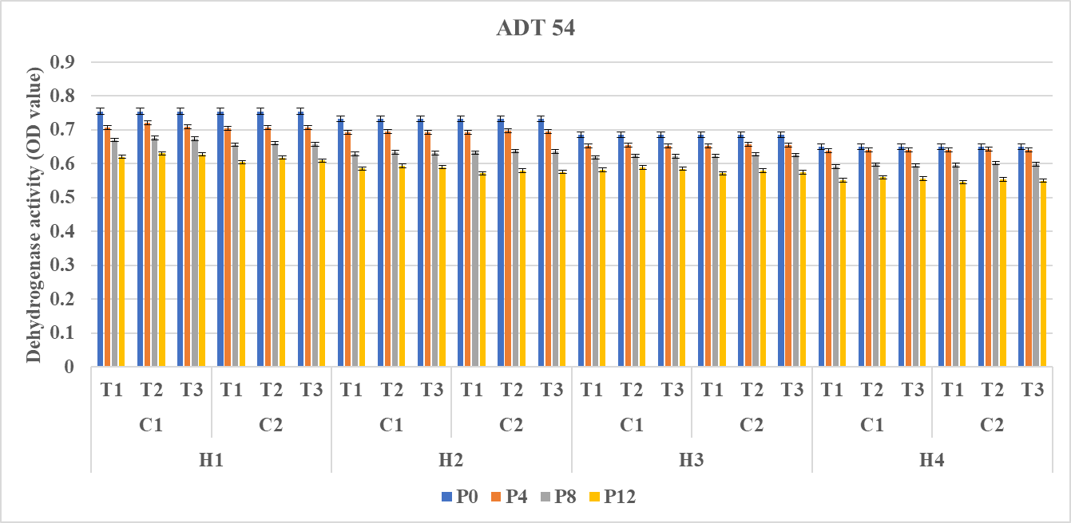

Fig. 3. Effect of maturity stages, combine harvesting, storage containers and seed treatments on electrical conductivity (dS/m) and dehydrogenase activity of ADT 54 rice variety

H₁ – At Physiological maturity  H₂ – Two days after physiological maturity  H₃ – Four days after Physiological maturity  H₄ – Six days after Physiological maturity | P0- Initial Period of storage  P4- 4 months of storage  P8- 8 months of storage  P12- 12 months of storage  C₁-Super grain bag  C₂-Gunny bag | T₁-Control  T₂-Water Soluble Polymer 4ml + 12 ml water/kg  T₃- Vithai Amirtham 25 ml/kg of seed

Dehydrogenase activity was significantly influenced by harvesting stages, containers, treatments, and the period of storage (Fig.3). In the rice variety ADT 54, among the maturity stages, physiological maturity had the highest dehydrogenase activity (0.689) while the lowest dehydrogenase activity was observed six days after physiological maturity (0.617). Among the containers used for storage, the super grain bag maintained higher dehydrogenase activity (0.653) while the lower dehydrogenase activity was observed in the seeds stored in a gunny bag (0.651). Among the treatments applied, seeds coated with water-soluble polymer @ 4 mL + 12 mL water/kg had the maximum dehydrogenase activity (0.653) while the minimum dehydrogenase activity was observed in the control (0.650). Over the storage period, dehydrogenase activity gradually decreased. Similarly, a decline in dehydrogenase activity with the storage period was observed by Adhithya et al. (2024).
The pathogen infection was significantly influenced by harvesting stages, containers, treatments, and period of storage (Fig. 4). Among the harvesting stages, the physiological maturity stage recorded lower pathogen infection (4.1%) than six days after harvesting at the physiological maturity stage (5.2%). Between the containers used for storage, the super grain bag maintained a lower pathogen infection (4.3%) while the higher pathogen infection was observed in the seeds stored in a gunny bag (4.9%). Among the treatments, seeds coated with water-soluble polymer @ 4 mL + 12 mL water/kg registered the minimum pathogen infection (4.1%) while the maximum pathogen infection was observed in the control (5.2%). These results are similar to the findings of Chachslis and Smith (2001) in Soybean, Usman et al. (2025) in Cotton and Mallick et al. (2022) in Groundnut. Among the storage periods, pathogen infection increased gradually with an increase in the storage period. Increased moisture content in a cloth bag caused an increase in disease incidence. There was a similar increase in fungal infection during storage with fluctuations in seed moisture. The super grain bag maintained a low incidence of bruchid and other pest infestation, which might be due to the impervious nature of the super grain bag preventing the entry of pests into seeds. Additionally, these bags help in maintaining seed moisture and seed viability (Adhithya et al., 2024). The IRRI super bag recorded a mean population of 0.14% with no infested grain due to the depletion of O₂ inside the structures, which was sufficient to limit insect activity, thereby stopping grain infestation (Sarmah et al., 2024). Polypropylene woven sacks were consistently superior to jute bags, likely because of their semi-permeable nature which restricts moisture ingress, maintains a lower equilibrated moisture content, and prevents insect movement (Rambabu et al., 2025). Wheat seeds of HPW155 were treated with Polymer+ Vitavax 200 @ 2 g kg⁻¹ of seed and Vitavax 200 @ 2 g kg⁻¹ of seed recorded significant superiority in all the seed quality attributes during storage for bimonthly for 12 months (25th-36th months). Polymer and Vitavax reduce the impact of aging enzymes on seed deterioration, while the polymer film acts as a physical barrier that has been reported to reduce the leaching of inhibitors from the seed coat and restrict oxygen diffusion to the embryo (Jyoti et al., 2025). Seeds of wheat were treated with combination of Deltamethrin 2.8 EC @ 0.5 ml/kg seed + Vitavax power @ 2.5 g/kg seed + Polymer seed coating @ 5 ml/kg seed stored in HDPE bag recorded field emergence (90.61%), germination (92.64%), seedling vigour
index I (1319) and seedling vigour index II (13.17) than the seeds stored in cloth bag due to controlled moisture content (Karjule et al., 2024).

Sweet corn seeds coated with liquid polymer developed a smooth surface on their coats, leaving no option for laying eggs on the seed coat. Additionally, deltamethrin is a pyrithroid that effectively controls insect pests during storage due to its phytotoxic effect (Jolli et al., 2022). These results are similar to the findings of Yousuf et al. (2025) they reported that wheat seeds of six months storage were stored in conventional bags showed a steady increase in moisture content, whereas those stored in hermetic bags exhibited only a slight rise, mainly due to the low permeability, airtight nature of hermetic containers that restrict air and moisture exchange. They also observed that insect infestation was much higher in conventional storage, likely because these bags fail to regulate moisture and oxygen levels, creating favourable conditions for pest multiplication. In contrast, hermetic bags maintain a low O₂ and high CO₂ atmosphere, which suppresses insect development by inhibiting their respiratory and metabolic process.

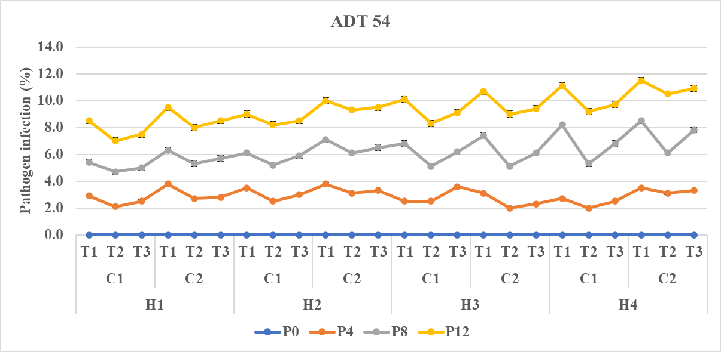

Fig. 4. Effect of maturity stages, combine harvesting, storage containers and seed treatments on Pathogen infection (%) of ADT 54 rice variety

H₁ – At Physiological maturity  H₂ – Two days after physiological maturity  H₃ – Four days after Physiological maturity  H₄ – Six days after Physiological maturity | P0- Initial Period of storage  P4- 4 months of storage  P8- 8 months of storage  P12- 12 months of storage  C₁-Super grain bag  C₂-Gunny bag | T₁-Control  T₂-Water Soluble Polymer 4ml + 12 ml water/kg  T₃- Vithai Amirtham 25 ml/kg of seed
- CONCLUSION
This study concludes that rice seed crop (Var. ADT 54) harvested using a combine harvester at physiological maturity or up to six days after the physiological maturity stage, reduced to a moisture content of 8%, coated with water-soluble polymer @ 4 mL + 12 mL of water per kilogram of seed, and packed in a super grain bag, maintained more than 80% germination. It also met the Indian Minimum Seed Certification Standards for up to twelve months.

Disclaimer (Artificial intelligence)

Author(s) hereby declare that NO generative AI technologies such as Large Language Models (ChatGPT, COPILOT, etc.) and text-to-image generators have been used during the writing or editing of this manuscript.

REFERENCES

- Abdul-Baki, A. A., & Anderson, J. D. (1973). Vigor determination in soybean seed by multiple criteria 1. Crop Science, 13(6), 630-633. https://doi.org/10.2135/cropsci1973.0011183X001300060013x
- Adhithya, G., Siddarju, R., & Parashivmurthy. (2024). Effect of packing material and seed treatment chemicals on seed storability in greengram. International Journal of Advanced Biochemistry Research, 8(5), 102-111. https://doi.org/10.33545/26174693.2024.v8.i5b.1062
- Bista, M., Ghimire, P., Khanal, D., Khatri, N., & Marasini, S. (2022). Effect of Storage Materials and Duration on Quality of Rice Seed. Agronomy Journal of Nepal, 6(1), 36–44. https://doi.org/10.3126/ajn.v6i1.47926
- Cavusoglu, A., Ünal, F., & Özer Uyar, G. E. (2024). Evaluation of the effect of mechanical damage of seeds at different seed ages on faba bean (Vicia faba L.) seedling development and disease. International Journal of Research in Agronomy, 7(4), 750-753. https://doi.org/10.33545/2618060X.2024.v7.i4j.642
- Chachalis, D., & Smith, M. L. (2001). Hydrophobic-polymer application reduces imbibition rate and partially improves germination or emergence of soybean seedlings. Seed Science and Technology, 29(1), 91-98. https://www.seedtest.org/publications/seed-science-and-technology-p10.html
- Choudhury, A., & Bordolui, S. K. (2023). Concept of seed deterioration: reason, factors, changes during deterioration and preventive measures to overcome seed degradation. American International Journal of Agricultural Studies, 7(1), 41-56. https://doi.org/10.46545/aijas.v7i1.291
- Dutta, A., & Bhattacharya, P. K. (2020). Impact of seed film coating polymers on growth, yield and seed quality of rice (Oryza sativa L.). Journal of Crop and Weed, 16(2), 113-116. https://doi.org/10.22271/09746315.2020.v16.i2.1323
- FAO. (2024). World Food and Agriculture – Statistical Yearbook 2024. Food and Agriculture Organization of the United Nations. https://doi.org/10.4060/cd2971en
- ISTA. (1999). International rules for seed testing. Seed Science and Technology, 27(Supplement), 27-31.
- International Seed Testing Association. (2019). International rules for seed testing. Bassersdorf, Switzerland: International Seed Testing Association. https://www.seedtest.org/publications/international-rules-for-seed-testing.html
- Jeya Chandra, R., Masilamani, P., Suthakar, B., Rajkumar, P., Sivakumar, S. D., & Manonmani, V. (2025). Impact of harvesting and threshing methods of rice: A comprehensive review on seed quality and storage behaviour. Plant Science Today, 12, 1-11. https://doi.org/10.14719/pst.8241
- Jeya Chandra, R., Masilamani, P., Suthakar, B., Rajkumar, P., Sivakumar, S. D., & Manonmani, V. (2025). Impact of moisture content on seed quality of combine-harvested rice varieties. Plant Science Today, 12, 1-10. https://doi.org/10.14719/pst.8238
- Jolli, R. B., Nayak, V. H., Boranayaka, M. B., & Latha, H. C. (2020). Effect of polymer coat, seed treatment chemicals and containers on seed germination, vigour index, infestation and other quality traits in sweet corn during seed storage. International Journal of Current Microbiology and Applied Sciences, 9(6), 3090–3105. https://doi.org/10.20546/ijcmas.2020.906.370
- Jyoti, A., Dhiman, K. C., Maurya, C. L., Kanwar, R., & Thakur, A. (2025). Studies on Different Seed Treatments with Polymer and Chemicals on Longevity of Wheat (Triticum aestivum L.) Seeds Stored for 24 Months. International Journal of Economic Plants, 12(3), 1-8. DOI:10.23910/2/2025.5982a
- Karjule, A., Rao, K., Patel, D. A., & Darji, V. B. (2024). Effect of polymer film coating with pesticides and storage containers on longevity of wheat seeds. Seed Research, 47(1), 35-43. https://doi.org/10.56093/sr.v47i1.156668
- Khandai, S., Kumar, V., Baishya, S., Naveen, J., Kumar, V., Balingbing, C. B., Yahaya, R., & Singh, S. (2025). Enhancing the quality of stored rice seeds and grains using hermetic storage grain bag in Assam, India. Results in Engineering, 26, 1-10. https://doi.org/10.1016/j.rineng.2025.105586
- Kittock, D. L., & Law, A. G. (1968). Relationship of seedling vigor to respiration and tetrazolium chloride reduction by germinating wheat seeds. Agronomy Journal, 60(3), 286–288. https://doi.org/10.2134/agronj1968.00021962006000030012x
- Lohitha, B., & Dutta, A. (2024). Effect of storage containers and storage period on physio-biochemical changes in wheat (Triticum aestivum L.) varieties. International Journal of Advanced Biochemistry Research, 8(12), 862-867. https://doi.org/10.33545/26174693.2024.v8.i12k.3318
- Mallick, S., Mohanty, S., Das, S., Beura, J. K., & Naga Jyothi, G. B. (2022). Effect of polymer coating on seed quality during storage of groundnut seeds. The Pharma Innovation Journal, 11(11), 1396–1401. https://www.thepharmajournal.com/archives/2022/vol11issue11/PartT/11-10-100-990.pdf
- Mohan, S. (1993). Studies on detection and management of stored product insect pests of rice. (Ph.D. Thesis), Tamil Nadu Agricultural University, Coimbatore.
- Nethra, N., Uma Rani, K., Gowda, R., & Narayanaswamy, S. (2024). Effect of seed coating with synthetic polymer and seed treatment chemicals on seed quality and storability of maize hybrid Byrava super (Zea mays L.). Seed Research, 44(2), 144–151. https://doi.org/10.56093/sr.v44i2.162663
- Panse, V. G., & Sukhatme, P. V. (1995). Statistical methods for agricultural workers. ICAR.
- Parimala, K., Padmasri, A., Devi, I. S., & Pradeep, T. (2022). Influence of Seed Film Coating Polymers on Seed Yield, its Components and Seed Quality Parameters of Rice. In Biological Forum-An International Journal 14(3), 1226-1228).
- Paul, A., & Bordolui, S. K. (2025). Improving Rice Seed Longevity: Impact of Storage Containers, Conditions and Seed Moisture during Storage. Journal of Experimental Agriculture International, 47(6), 620-632. https://doi.org/10.9734/jeai/2025/v47i63522
- Presley, J. T. (1958). Relation of protoplast permeability to cotton seed viability and predisposition to seedling disease. Plant Disease Reporter, 42(7), 852. https://catalog.hathitrust.org/Record/000060000
- Radha, J., Shakuntala, N. M., Basavegouda, S., Sangeetha, M., Mahantashivayogayya, K., & Masthanreddy, B. G. (2024). Effect of packaging materials and seed treatments on seed quality parameters of rice during seed storage. International Journal of Research in Agronomy, 7(9), 526–532. https://doi.org/10.33545/2618060X.2024.v7.i9g.1599
- Raja, K., Malarkodi, K., Vanitha, C., Manonmani, S., Kathiravan, M., Vakeswaran, V., Natarajan, K., Menaka, C., Vijayalakshmi, V., & Umarani, R. (2025). Evaluation of performance of seed coating formulation for direct seeded rice (DSR) in dry and puddled conditions. Seed Research, 53(1), 18–24. https://doi.org/10.56093/sr.v53i1.3
- Rajesh,G. (2020). Effect of different storage containers on electrical conductivity and moisture content of soybean seeds in four verities under tropical storage conditions. International Journal of Botany Studies, 5(6), 241-247.
- Ramanadane, T., Sathya, S., Hemalatha, G., & Gnanasekar, R. (2024). Effect of Desiccants and Packaging Materials on Seed Storability in Soybean [Glycine max (L.) Merrill]. Agricultural Science Digest. https://doi.org/10.18805/ag.D-5837
- Rambabu, T., Olivya, S. R., Gouthami, A., Navya, K., Patta, S., Jhansi Rani, K., & Padma Sri, A. (2025). Storability assessment of polymer coated and biologically treated maize seeds in different packaging systems. International Journal of Research in Agronomy, 8(12), 07–14. https://doi.org/10.33545/2618060X.2025.v8.i12a.4313
- Dey, P. C., Sarmah, A., Chetia, S. K., Medhi, A. K., Konwar, M. J., Borah, S. R., Bharali, A., Baruah, M., Gummert, M., & Khandai, S. (2024). Effect of different storage conditions on grain quality of paddy. ORYZA-An International Journal of Rice, 61(1), 46-56. https://doi.org/10.35709/ory.2024.61.1.1
- Siddarudhi, K. S. (2019). Influence of Provenances, Fungicides and Foliar Application of Micronutients on Plant Growth, Seed Yield and Quality of Hybrid Rice KRH-4 (Doctoral dissertation), University of Agricultural Sciences, GKVK).
- Singh, P. K., Yadav, S. K., Tonapi, V. A., & Bera, A. (2024). Influence of Seed Treatment on Seed Quality of Rice CMS Line Pusa 6A During Storage. Seed Research, 45(1), 23-32. https://doi.org/10.56093/sr.v45i1.162604
- Sivashankari, M., & Khandai, S. (2024). Studies on the impact of conventional and hermetic storage techniques on the paddy quality: Hermetic bag: An efficient way of storing paddy. ORYZA-An International Journal of Rice, 61(4), 370-380. https://epubs.icar.org.in/index.php/OIJR/article/view/156819
- Suparto, H., Saputra, R. A., & Saragih, N. (2021). Effect of The Type Impermeable Storage Container on The Quality of Rice Seeds. Gontor Agrotech Science Journal. https://doi.org/10.21111/agrotech.v7i2.6524
- Tahir, A., Afzal, I., Khalid, E., Razzaq, M., & Arif, M. A. R. (2023). Rice seed longevity in thecontext of seed moisture contents and hypoxic conditions in the storage environment. Seed Science Research, 33(1), 39-49. https://doi.org/10.1017/S0960258522000289
- Tan, S., Cao, J., Li, S., & Li, Z. (2025). Unraveling the Mechanistic Basis for Control of Seed Longevity. Plants, 14(5), 805. https://doi.org/10.3390/plants14050805
- Tivana, L. D., Nguenha, R. J., Viola, P., Monjane, I., Lungu, O., & Kafwamfwa, N. (2021). Effectiveness of high‐density polyethylene container and Super Grain Bag for the storage system of cowpea grain for smallholder farmers. Legume Science, 3(1), 1-12. https://doi.org/10.1002/leg3.67
- Usman, M., Hussain, N., & Afzal, I. (2025). Hermetic storage maintains seed quality and minimizes the seed vigor losses in cotton (Gossypium hirsutum L.). Pak. J. Bot., 57(2), 727-735. https://doi.org/10.30848/PJB2025-2(24)
- Vijay, M. K., Pandey, S., Pandey, C. D., & Jeshima, Y. (2015). Impact of drying methods on the seed quality of sorghum (Sorghum bicolor (L.) Moench). African Journal of Agricultural Research, 10(16), 1898-1903. DOI:10.5897/AJAR2015.9649
- Vijay, M. K., Sushil Pandey, S. P., & Pandey, C. D. (2015a). Impact of drying methods,
moisture content and aging on seed protein profile of sorghum [Sorghum bicolor (L.) Moench]. Annals of Biology, 31(2), 215-219.
- Vinodkumara. (2020). Studies on effect of seed treatment with fungicides and packaging materials on seed quality during storage in soybean (Glycine max L.) (M.Sc. thesis). University of Agricultural Sciences, Raichur, Karnataka.
- War, F., Peerzade, W. H., Rani, A. P., Ramesh, & Goud, A. S. (2024). Understanding the features of a seed vigour test. The Agriculture Magazine, 4(1), 432-438. https://theagriculturemagazine.com/volume-04-issue-01-september-2024/
- Yousuf, H. M. B., Yasin, M., Rebouh, N. Y., Aldawood, A. S., Ali, U., & Rosentrater, K. A. (2025). Comparative assessment of conventional and hermetic storage facilities on wheat grain quality, pest infestation, and bread development. Scientific Reports, 15(1), 1-22. https://doi.org/10.1038/s41598-025-18340-z

