Original Research Article

The impact of chronic obstructive pulmonary disease (COPD) on workers' work ability

.
ABSTRACT

Background: The symptoms of COPD differ based on the stage of the disease, becoming more noticeable in its severe stages and during exacerbations. They are associated with temporary incapacity for work and cause a decrease in working capacity. Also, occupations with special working conditions and exposure to pollutants at work cause increased bronchial secretion and cough. This research aims to identify the most common symptoms in COPD patients and evaluate their work capacity based on symptom prevalence.
Methods: 200 subjects were included in the prospective study. Participants were divided into two groups: a study group and a control group. Within each group, subgroups were created based on smoking habits, a key risk factor for COPD development.
Results: The dominant symptom in both groups was cough, with 34.67%. In subjects with preserved working capacity, the most common symptoms are chest pressure with 13.33% and shortness of breath with 9.33%, while in the group with reduced working capacity, fatigue (30%) and dyspnea with 26%. In the control group, most subjects had obstructive bronchitis, asthma and chronic simplex bronchitis.
Conclusion: According to the GOLD classification, modified working capacity decreased by 51.33%, while retained working capacity declined by 48.67% in relation to disease severity. Cough was the dominant symptom in both groups, while other symptoms varied independently of the stage of the disease.

Keywords: work ability, cough, fatigue, symptom

1. INTRODUCTION

Chronic obstructive pulmonary disease (COPD) is recognised as an inflammatory disease, with inflammatory process byproducts causing tissue damage and triggering physiological adaptations [1,2,19]. Systemic inflammation has been shown to be responsible for a number of comorbidities in chronic COPD [3,4]. It is characterised by limited airflow in the airways that cannot be completely resolved with therapy. These changes lead to the following manifestations of the disease: cough, difficulty breathing, increased production of secretions, etc. Exacerbations of COPD are frequent and, along with associated comorbidities, contribute to the progression of the disease [5]. Daily activities can become a real challenge for patients. Breathing difficulties can make the simplest tasks impossible and interfere with the patient's work and home environment [6,7]. Both indoor and outdoor air pollution are significant contributors to disease [8,9]. Occupational exposure to harmful particles and gases represents an additional risk factor for disease onset, while factors such as diet, socioeconomic status, and recurrent childhood respiratory infections contribute to COPD development [10].
COPD is characterised by an accelerated deterioration of lung function. Patients seeking medical attention for an acute exacerbation of COPD (AECOPD) typically exhibit increased coughing and purulent sputum, often accompanied by rales and morning expectoration. This research aims to identify the most common symptoms in COPD patients and assess their ability to work based on symptom prevalence.

2. material and methods

The prospective study was carried out at the Pulmonology Department of the Sarajevo Canton Health Centre in 2019. Initially, 307 patients (workers) were selected based on the diagnosis of COPD established and verified during the examinations. A smaller proportion of participants was selected based on previous medical records. To achieve the sample size, every other participant was selected using the systematic random selection method, leaving 150 participants in a study group. In addition to having COPD, these participants were older than 40 years and had given voluntary consent to participate in the study. Participants who were younger than 40 years, had malignancies or pneumoconiosis, did not have COPD, had comorbidities, and had not voluntarily consented to participate were excluded. Patients with other chronic lung diseases were included in a control group (n = 50). In both groups, subgroups were formed according to cigarette consumption habits (smokers and nonsmokers).
Data on age, sex, smoking habits, and occupational history were obtained from medical records. All participants completed a standardised COPD questionnaire, underwent a physical examination with a focus on lung auscultation, and had spirometry tests conducted using a Master Screen Body Jaeger spirometer.
COPD is classified into four stages (A-D) according to the GOLD (Global Initiative for Chronic Obstructive Pulmonary Disease) guidelines, based on the forced expiratory volume in the first second (FEV1) [11,12].
The statistical method for biomedical research was used to obtain results on parameters evaluating temporary disability (number of days lost from work, DALY) and permanent disability (entitlement to a specific type of disability). These results were analysed in relation to sex, age, occupation, smoking habits, subjective complaints, length of service, spirometry, and lung auscultatory findings in workers from both the study and control groups. The results are presented in tables and figures. The quantitative values of the obtained results are represented by arithmetic means and standard deviations, and the categorical values by absolute numbers. Statistical data analysis was performed using the software IBM SPSS Statistics v.21.

3. results

The study included 200 participants, with the study group comprising 105 men and 45 women, with a mean age of 60.16 years (SD ± 5.12). The average disease duration was 25.9 years (SD ± 11.9). In the control group of 50 participants, men (n = 29) slightly outnumbered women (n = 21), with most participants aged between 51 and 60 years. Most participants were on sick leave for up to 42 days, with 127 of them taking sick leave within a year, while 73 were on sick leave for more than 42 days. Table 1 compares the stage of COPD with spirometry results. The lowest mean values for FVC (44.50%) and FEV1 (38.82%) were found in participants with stage D according to the GOLD classification.

Table 1. Compares the stage of COPD with spirometry
Stage of COPD | Patients |  | FVC mean value % | FVC mean value L | FEV1 mean value % | FEV1 mean value L
Stage of COPD | n | %
A | 33 | 22.00 | 75.06 | 2.98 | 61.32 | 1.99
B | 40 | 26.67 | 70.08 | 2.68 | 55.41 | 1.74
C | 44 | 29.33 | 53.55 | 2.00 | 47.49 | 1.48
D | 33 | 22.00 | 44.50 | 1.95 | 38.82 | 1.35

As shown in Figure 1, cough was the leading symptom in half of the participants with reduced work ability and in about one-third of the participants with preserved work ability. In addition, fatigue (30%), dyspnea (26%), and expectoration (20%) were the most common symptoms in participants with limited work ability, while chest pressure (13,33%), shortness of breath (9,33%), and fatigue (8%) were the most common in participants with preserved work ability.

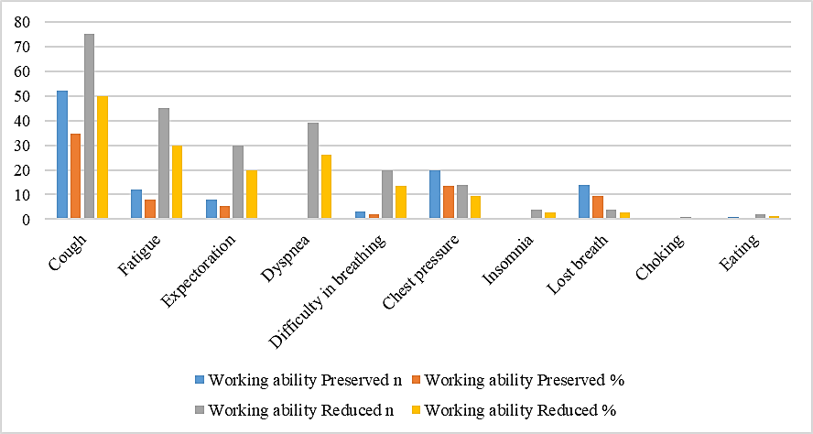
Fig. 1. Changes in working ability in relation to the participants' difficulties

Considering the structure of the control group by diagnosis, most subjects were diagnosed with obstructive bronchitis (n = 19), followed by asthma (n = 15) and chronic simplex bronchitis (n = 9) (Table 2).

Table 2. Structure of the control group by diagnoses
Diagnosis |  | Number of participants
Obstructive bronchitis |  | 19
Asthma |  | 15
Bronchitis chr. simplex |  | 9
Bronchitis simplex |  | 3
Bronchitis spastica |  | 2
Bronchitis. chr. st. post PTE |  | 1
Bronchitis chr. obstructive |  | 1

Figure 2 shows the results of altered work capacity in relation to age. Reduced work capacity was highest in the participant group 61-70 years of age, 35.33%, and was preserved in the same group, 28.67%.

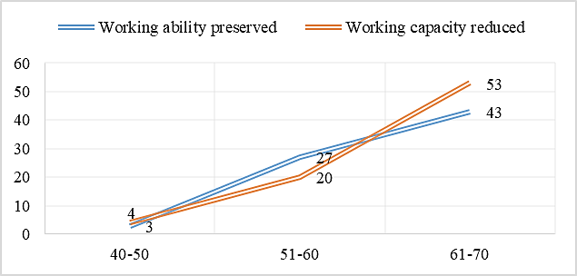
Fig. 2. Changes in the work ability of participants with COPD, categorised by age
Figure 3 illustrates participants' work ability in relation to nicotine use. Among those with impaired work ability, 23 were ex-smokers, and 19 were current smokers, while the frequency was the same for participants with preserved work ability (n = 54).

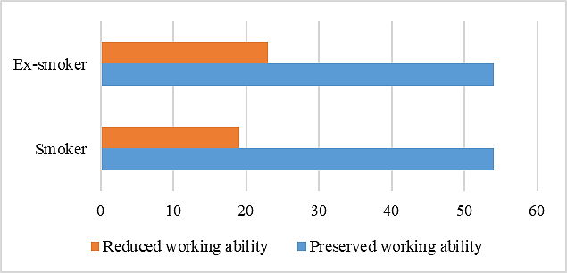
Fig. 3. Working ability in relation to nicotine abuse

Table 3. Working abilities of respondents with COPD
Stage of COPD | Working ability preserved (n) | Relationship working ability preserved (%) | Working ability diminished (n) | Ratio of reduced working ability (%)
A | 33 | 22.00 | 0 | 0.00
B | 38 | 25.33 | 2 | 1.33
C | 2 | 1.33 | 42 | 28.00
D | 0 | 0.00 | 33 | 22.00
Control | 50 | 100.00
Total | 123 | 48.67 | 77 | 51.33

Table 3 shows the work ability of participants with COPD and the control group. In the group of patients with COPD at different stages, the decreased work ability was most pronounced in patients at stage C (n =42) and D (n = 33), whereas we had no patients whose work ability was decreased at stage A. In terms of preserved work capacity, most patients were stage A , while there were no patients with preserved work capacity at stage D. In the control group, the ability to work was 100%.

4. DISCUSSION

A long history of smoking is known to precede the development of COPD, with the disease taking many years to fully manifest. One possible reason for this is inadequate prevention at the primary healthcare level, coupled with a lack of patient education. Many patients continue to smoke and neglect preventive personal protective measures in the workplace, especially when exposed to dust, fumes, and chemical irritants. Quitting smoking offers numerous benefits for individuals with lung disease. These include a lower risk of lung infections and worsening of their condition, a reduced likelihood of needing hospitalisation, improved oxygen levels, and normalisation of carbon monoxide levels. Many symptoms are alleviated, making individuals less likely to experience temporary work absences. However, the findings reveal that the ratio of smokers to ex-smokers among the respondents is unfortunately 3:1. A comparison with existing literature shows that these results align with ours. Convincing smokers to quit is challenging, as smoking is deeply ingrained in their daily habits, highly addictive, and often not perceived as something that impedes lung function or proper treatment. In the case of COPD and other lung diseases, quitting smoking is the most crucial step.
Numerous studies have shown that, in addition to smoking, long-term exposure to polluted air in the workplace is linked to an increased incidence of COPD. These work environments typically involve special working conditions. In a group of 150 patients, the following occupations were included: plumber, car mechanic, painter, police officer, gunsmith, gas station attendant, craftsman, cook, farmer, bricklayer, warehouse worker, hairdresser, cleaner, lathe operator, locksmith, shoemaker, mail carrier, operator, educator, programmer, social worker, physiotherapist, market vendor, security guard, sanitation technician, driver, speech therapist, cashier, architect, and untrained construction worker. These jobs are characterised by specific working conditions where employees are exposed to various health hazards.
COPD is currently the only chronic disease experiencing a significant rise in both morbidity and mortality, with projections indicating further increases in its incidence over the next 20 years. This will likely lead to reduced work capacity and extended absences. As a result, it is crucial to implement timely preventive measures and establish guidelines for smoking cessation at the primary healthcare level. Kuhajda's dissertation [13], "Risk Factors Affecting the Outcome of Respiratory Rehabilitation in COPD Patients," found that rehabilitation outcomes were excellent in 77.3% of patients who had the disease for less than 10 years.
In respondents with limited work capacity, the duration of COPD was 31.83 ± 8.79 years, compared to 19.75 ± 10.35 years in those with preserved work capacity. Concerning disease severity, work capacity was limited in 51.33% of cases and preserved in 48.67%. Unfortunately, we could not find data from other studies on work capacity in relation to the duration and severity of COPD.
Our results indicate that subjects in stage D had the lowest FVC and FEV1 values, with a mean FVC of 44.50% and a mean FEV1 of 38.82%. These findings are consistent with those of other studies. Škrbić reported an FEV1 value of 1.43 L in COPD patients [14], while Fernández-Villar reported a mean value of 40.30% [15].
The symptoms of COPD vary depending on the stage of the disease. Chronic cough is typically the first symptom, initially appearing occasionally in the morning and later becoming a daily occurrence. The cough is usually mild at first and often mistaken for a "normal" smoker's cough, although it is not. During infections, the cough becomes more pronounced and is accompanied by the expectoration of yellow or green secretions [16,17]. Dyspnea, or shortness of breath, is another key symptom. Similar to cough, dyspnea is linked to fatigue and reduced mobility, which limits work capacity. In advanced stages of the disease, dyspnea may even occur at rest, accompanied by a sensation of chest tightness and difficulty breathing.
An analysis of COPD symptom frequency revealed that cough was the most common symptom, affecting 137 subjects. Fatigue was reported by 59 subjects, followed by shortness of breath (42 subjects), expectoration (37 subjects), and chest pressure (34 subjects). Other symptoms, including sweating, insomnia, choking, and additional cases of dyspnea and shortness of breath, were reported by a smaller number of patients.
If we compare the patients' ability to work and their difficulties, we arrive at the number of 75 patients who have limited ability to work and whose main symptom is cough. A total of 52 patients with the same symptom have preserved the ability to work. All primary symptoms were most prevalent among patients with limited work capacity. As previously noted, the majority of these patients were employed in occupations with special working conditions, where they were exposed to workplace pollutants. This exposure contributed to increased bronchial secretion, resulting in a persistent cough. These factors collectively led to more frequent disease exacerbations, resulting in temporary work incapacity and, ultimately, reduced overall work ability.
This study also analysed the ability to work. Our results show that in the group of smokers, there are the same number of patients with preserved and decreased work abilityAmong the group of ex-smokers, work capacity was reduced in 23 individuals and preserved in 19. The subjects' medical history data revealed that they had to stop smoking when COPD was detected, and it was associated with comorbidities. In the study by Okiljević et al [18], it was found that most workers diagnosed with COPD who were examined and assessed for work ability kept their jobs (90.00%), and their work ability was monitored. Monitor regular examinations within the time limits set by the occupational health physician, depending on the stage of the disease and the comorbidities present.

5. Conclusion

Modified work capacity in terms of disease severity according to the GOLD classification was reduced by 51,33%, whereas preserved work capacity was reduced by 48,67%. Cough was the predominant symptom in both reduced work ability (n=75) and maintained work ability (n=52). Since human capital is often the most important national asset for developing countries, the indirect costs of COPD could be a serious threat to their economy. This group of patients should be a special focus of attention for workers, employers and doctors, as well as health and pension insurance funds. Prevention must begin on time by stopping exposure to harmful noxious substances in stage A, quitting smoking and undergoing respiratory rehabilitation. It is necessary to emphasise the already mentioned fact that COPD is the leading cause of morbidity and mortality both in the world and in our country, and significantly contributes to the increase in healthcare system costs. Therefore, it is important to emphasise that the prevention of COPD also includes regular periodic examinations of workers who are exposed to workplace hazards, as part of which their working capacity is assessed. Prevention in preventing illness, and thus a reduction in working capacity, whether temporary or permanent, is also an obligation to monitor compliance with personal protection regulations at work. Personal protective equipment is provided for use by persons exposed to certain hazards during work that cannot be eliminated by other measures.

Consent and Ethical Approval
As per international standards or university standards, Participants’ written consent has been collected and preserved by the author(s). The study was approved by the Ethics Committee of the health facility, and all personal data of the participants were protected in accordance with legislation and the principles outlined in the Declaration of Helsinki.

Disclaimer (Artificial intelligence)
Author(s) hereby declare that NO generative AI technologies such as Large Language Models (ChatGPT, COPILOT, etc.) and text-to-image generators have been used during the writing or editing of this manuscript.

References

- Rossi, A., Butorac-Petanjek, B., Chilosi, M., Cosío, B. G., Flezar, M., Koulouris, N., et al. (2017). Chronic obstructive pulmonary disease with mild airflow limitation: current knowledge and proposal for future research – a consensus document from six scientific societies. *International Journal of Chronic Obstructive Pulmonary Disease*, *12*, 2593–2610. https://doi.org/10.2147/COPD.S132236.
- Pahal, P., Avula, A., & Afzal, M. (2025). Emphysema. In StatPearls. Treasure Island (FL): StatPearls Publishing. https://www.ncbi.nlm.nih.gov/books/NBK482217/
- Sevenoaks, M. J., & Stockley, R. A. (2006). Chronic obstructive pulmonary disease, inflammation and co-morbidity—a common inflammatory phenotype?. Respiratory Research, 7(1), 70. https://doi.org/10.1186/1465-9921-7-70
- Jamison, D. T., Breman, J. G., Measham, A. R., Alleyne, G., Claeson, M., Evans, D. B., Jha, P., Mills, A., & Musgrove, P. (Eds.). (2006). Disease control priorities in developing countries (2nd ed.). The World Bank. https://doi.org/10.1596/978-0-8213-6179-5
- Pavičić F, Tudorić N. Kronična opstruktivna plućna bolest. In: Francetić I, Jakšić B, Labar B, Vučelić B, editors. Interna medicina. Zagreb: Naprijed; 2003. p. 707-714.
- Agustí, A., & Hogg, J. C. (2019). Update on the pathogenesis of chronic obstructive pulmonary disease. The New England Journal of Medicine, 381(13), 1248-1256. https://doi.org/10.1056/NEJMra1900475
- Vogelmeier, C. F., Criner, G. J., Martinez, F. J., Anzueto, A., Barnes, P. J., Bourbeau, J., Celli, B. R., Chen, R., Decramer, M., Fabbri, L. M., Frith, P., Halpin, D. M. G., López Varela, M. V., Nishimura, M., Roche, N., Rodriguez-Roisin, R., Sin, D. D., Singh, D., Stockley, R., Vestbo, J., Wedzicha, J. A., & Agustí, A. (2017). Global Strategy for the Diagnosis, Management, and Prevention of Chronic Obstructive Lung Disease 2017 report: GOLD executive summary. *American Journal of Respiratory and Critical Care Medicine*, *195*(5), 557-582. https://doi.org/10.1164/rccm.201701-0218PP
- Nakawah, M. O., Hawkins, C., & Barbandi, F. (2013). Asthma, chronic obstructive pulmonary disease (COPD), and the overlap syndrome. Journal of the American Board of Family Medicine, 26(4), 470-477. https://doi.org/10.3122/jabfm.2013.04.120256
- Rabe, K. F., Wedzicha, J. A., & Wouters, E. F. M. (Eds.). (2013). *COPD and comorbidity*. European Respiratory Society. https://doi.org/10.1183/1025448x.erm5913
- Fisk, M., McMillan, V., Brown, J., Holzhauer-Barrie, J., Khan, M. S., & Baxter, N. (2017). P29 Clinical characteristics and management of patients with an inaccurate diagnosis of chronic obstructive pulmonary disease (copd) in primary care; results from the Welsh national COPD primary care audit. *Thorax*, *72*(Suppl 3), A171. https://doi.org/10.1136/thoraxjnl-2017-210983.171
- Singh, D., Agusti, A., Anzueto, A., Barnes, P. J., Bourbeau, J., Celli, B. R., Criner, G. J., Frith, P., Halpin, D. M. G., Han, M., López Varela, M. V., Martinez, F., Montes de Oca, M., Papi, A., Pavord, I. D., Roche, N., Sin, D. D., Stockley, R., Vestbo, J., Wedzicha, J. A., & Vogelmeier, C. (2019). Global strategy for the diagnosis, management, and prevention of chronic obstructive lung disease: the GOLD Science Committee report 2019. European Respiratory Journal, 53(5), 1900164. https://doi.org/10.1183/13993003.00164-2019
- Soler-Cataluña, J. J., Cosío, B., Izquierdo, J. L., López-Campos, J. L., Marín, J. M., Agüero, R., Baloira, A., Carrizo, S., Esteban, C., Galdiz, J. B., González, M. C., Miravitlles, M., Monsó, E., Montemayor, T., Morera, J., Ortega, F., Peces-Barba, G., Puente, L., Rodríguez, J. M., ... Viejo, J. L. (2012). Consensus document on the overlap phenotype COPD–asthma in COPD. *Archivos de Bronconeumología*, *48*(9), 331-337. https://doi.org/10.1016/j.arbres.2011.12.009
- Kuhajda, D. (2016). *Risk factors affecting the outcome of respiratory rehabilitation in patients with chronic obstructive pulmonary disease* [Doctoral dissertation, University of Novi Sad]. http://cris.uns.ac.rs/record.jsf?recordId=10000000000000000000&source=UNS&language=en
- Škrbić D. Metabolic syndrome in patients with chronic obstructive pulmonary disease and bronchiectasis [dissertation]. Novi Sad: University of Novi Sad, Faculty of Medicine; 2015.
- Fernández-Villar, A., Represas-Represas, C., Mouronte-Roibás, C., Ramos-Hernández, C., Priegue-Carrera, A., Fernández-García, S., & López-Campos, J. L. (2018). Reliability and usefulness of spirometry performed during admission for COPD exacerbation. PLoS One, 13(3), e0194983. https://doi.org/10.1371/journal.pone.0194983
- López-Campos, J. L., Tan, W., & Soriano, J. B. (2016). Global burden of COPD. Respirology, 21(1), 14-23. https://doi.org/10.1111/resp.12660
- Agarwal, A. K., Raja, A., & Brown, B. D. (2023). Chronic obstructive pulmonary disease. In StatPearls. StatPearls Publishing. https://www.ncbi.nlm.nih.gov/books/NBK559281/
- Okiljević Z, Jovančević-Drvenica M, Kopitović I, Kovačević T, Trivić B, Milutinov S. The algorithm for the assessment of functional work capacity of railway workers with chronic obstructive pulmonary disease (COPD). Praxis Medica. 2014;43(2):55-59.
- Akor, Alexander Agada, Obaseki Daniel, Bamidele Adeniyi & Gregory Efosa Erhabor. (2019). Utilization of Chronic Obstructive Pulmonary Disease Assessment Test (CAT) in Patients with COPD in Low Resource Countries. Journal of Advances in Medicine and Medical Research, 30(9), 1–7. https://doi.org/10.9734/jammr/2019/v30i930236

