Water Quality Dynamics and Correlation Analysis in Freshwater Fish Ponds of Hisar District, India

Abstract
Freshwater aquaculture plays a crucial role in rural development and food security in India, particularly in semi-arid regions like Haryana, where village ponds serve as vital resources. This study comparatively evaluates the physicochemical water quality parameters of managed and unmanaged fish ponds in the Hisar district over a six-month period (January–June 2024). The objective was to assess temporal trends, spatial variations, and ecological interactions influencing pond productivity. Water samples were collected monthly from four ponds (two managed, two unmanaged) and analysed for temperature, pH, dissolved oxygen (DO), biochemical oxygen demand (BOD), total dissolved solids (TDS), salinity, alkalinity, hardness, conductivity, and ammonia. Results indicated distinct seasonal patterns, with water temperature rising from ~22°C to >32°C, correlating with increased salinity and TDS due to evaporation. Spatially, unmanaged ponds exhibited significantly higher pH (>9.0), conductivity, and hardness, indicative of eutrophication and anthropogenic stress, whereas managed ponds-maintained parameters within optimal ranges for aquaculture. Spearman correlation analysis revealed significant relationships, notably a negative correlation between DO and BOD (𝜌 = -0.56) and positive correlations among TDS, conductivity, and ammonia (𝜌 = 0.68). The findings highlight the critical impact of management practices on hydro-geochemistry and underscore the need for regular monitoring and corrective interventions in unmanaged ponds to mitigate risks of high alkalinity and ammonia toxicity, ensuring sustainable aquaculture production.

Keywords: Freshwater aquaculture, water quality, managed vs. unmanaged ponds, physicochemical parameters, seasonal variation, correlation analysis, semi-arid region, Haryana.

1. Introduction
Freshwater aquaculture has established itself as a critical sector for rural development and food security in India, particularly in the semi-arid regions of Haryana where village ponds constitute a primary resource for inland fisheries (Bhatnagar & Singh, 2010). These lentic ecosystems are broadly categorized into managed systems, which receive scientific inputs such as periodic liming and fertilization to optimize yield, and unmanaged systems, which often function as multi-purpose community water bodies subjected to unregulated anthropogenic stress (Bhatnagar & Singh, 2010). In rural India, fish culture is usually practiced in unmanaged village ponds which no proper biosecurity and depend only on natural productivity (Soni et al., 2025a). As the intensification of aquaculture continues to grow to meet nutritional demands, the sustainability of these systems relies heavily on the maintenance of optimal hydrobiological conditions (Das et al., 2023).Unmanaged rural ponds commonly exhibit suboptimal physicochemical conditions, elevatedtemperature, low dissolved oxygen, high ammonia and alkaline pH, which imposephysiological stress on fish and facilitate opportunistic bacterial infections (Boyd, 2000; Ip etal., 2001)

The productivity of pond ecosystems is intrinsically governed by the physicochemical quality of the water, which regulates the physiological health, growth, and survival of cultured fish species (Bhatnagar & Devi, 2013). Water quality is not static; it is a complex, dynamic interplay of variables such as temperature, dissolved oxygen (DO), pH, alkalinity, hardness, and nitrogenous metabolites (Sreenivasan, 1964). Temperature acts as a master variable, influencing metabolic rates and the solubility of essential gases, while dissolved oxygen levels fluctuate based on the balance between photosynthetic production and respiratory consumption by the aquatic community (Sreenivasan, 1976; Mukherjee et al., 2022). Furthermore, parameters like total alkalinity and hardness are crucial for buffering pH fluctuations and supporting the planktonic food web essential for carp culture (Bhatnagar & Devi, 2013).
In tropical and sub-tropical climates, these parameters exhibit pronounced seasonal heterogeneity. Previous studies in the region have highlighted that the transition from winter to the pre-monsoon summer season is characterized by rising air temperatures and high evaporation rates, which significantly alter the concentration of total dissolved solids (TDS) and salinity (Rani, 2023; Singh et al., 2022). Moreover, the management regime introduces significant spatial variability; managed ponds typically maintain water quality within desirable limits through active intervention, whereas unmanaged ponds frequently suffer from eutrophication, characterized by elevated biochemical oxygen demand (BOD) and the accumulation of toxic metabolites like ammonia due to domestic runoff and cattle entry (Bhatnagar & Singh, 2010; Pandey & Chandra, 2015).
Despite the recognized economic potential of these water bodies, there is a scarcity of comprehensive studies that simultaneously evaluate the temporal dynamics and spatial disparities between managed and unmanaged ponds specifically within the Hisar district of Haryana. While recent literature has addressed seasonal hydrochemistry in diverse aquatic environments (Singh et al., 2022; Pandey & Chandra, 2015), the specific interaction between ionic constituents and nutrient cycles in small earthen culture ponds requires further elucidation. Additionally, understanding the statistical interrelationshipssuch as the correlation between temperature and organic load or alkalinity and salinityis vital for developing localized management strategies (Sreenivasan, 1964; Das et al., 2023). Therefore, the present study aims to assess the temporal trends and spatial variations of physicochemical water quality parameters in managed versus unmanaged fish ponds in Haryana and to utilize correlation analysis to interpret the ecological interactions governing their productivity.

2. Materials and methods
2.1 Study Area
The study was conducted in four freshwater earthen ponds located in the Hisar district of Haryana, India, selected to represent distinct management regimes within the semi-arid zone of northwestern India. The specific locations included two managed ponds, M1 (29°03'43" N; 75°48'55" E) and M2 (29°04'40" N; 75°47'15" E), and two unmanaged ponds, U1 (28°59'55" N; 75°50'02" E) and U2 (29°12'23" N; 75°44'29" E). The managed ponds were characterized by standard semi-intensive aquaculture practices, including pre-stocking drying and liming to regulate pH, followed by periodic fertilization and supplementary feeding. In contrast, the unmanaged ponds were maintained as natural systems with minimal anthropogenic intervention, receiving no supplementary feed or chemical fertilizers during the study period. Figure 1 and Table 1 show the study locations and their co-ordinates.
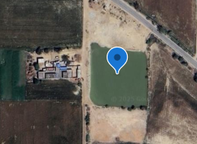 | 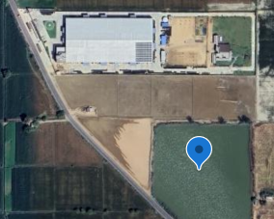
M1 | M2
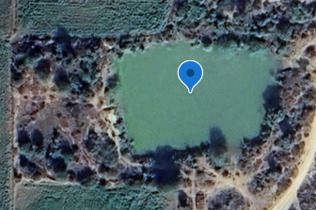 | 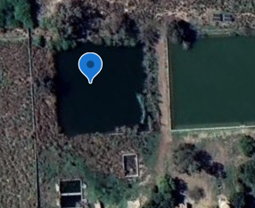
U1 | U2
Fig 1. Map showing the spatial distribution of the four study ponds in Haryana, India, including two managed ponds (M1, M2) and two unmanaged ponds (U1, U2).

Table 1. Geographic coordinates of the aquaculture ponds included in the study
Pond Type | Pond ID | Latitude (N) | Longitude (E)
Managed | M1 | 29°03'43" | 75°48'55"
Managed | M2 | 29°04'40" | 75°47'15"
Unmanaged | U1 | 28°59'55" | 75°50'02"
Unmanaged | U2 | 29°12'23" | 75°44'29"
2.2 Sampling Design
Water sampling was conducted at monthly intervals over a six-month culture period from January to June 2024. Surface water samples were collected in triplicate from varying locations within each pond using acid-washed 1-L polyethylene bottles to ensure representation. Samples destined for Dissolved Oxygen (DO) analysis were fixed immediately at the site to prevent outgassing, while samples for laboratory analysis were preserved and processed according to standard protocols.
2.3 Measured Parameters and Analytical Procedures
The study measured a comprehensive suite of physicochemical parameters critical for evaluating pond health and nutrient dynamics. These included environmental parameters such as Water temperature (°C), pH, Dissolved oxygen (DO; mg/L), Biological oxygen demand (BOD; mg/L), Salinity (PSU), Total Dissolved Solids (TDS; mg/L), Electrical Conductivity (µS/cm), Total Alkalinity (mg/L), Total Hardness (mg/L), and Ammonia (NH₃-N; mg/L). All field measurements and laboratory analyses were conducted following protocols outlined in the Standard Methods for the Examination of Water and Wastewater (APHA, 2017). In situ parameters were recorded immediately upon collection; water temperature and pH were measured using a calibrated digital multi-parameter water quality meter, while salinity was assessed using a handheld optical refractometer. Conductivity and TDS were determined using a portable digital EC/TDS meter. Laboratory analysis included the estimation of Dissolved Oxygen and BOD via the Winkler’s titration method, with BOD samples incubated according to standard procedures. Total Alkalinity and Total Hardness were determined by standard acid and EDTA titrimetric methods, respectively, while Ammonia was analysed using standard spectrophotometric methods (Phenate method).
2.4 Data Analysis
Microsoft Excel was used to compile and preprocess the raw data. Statistical analyses were performed using IBM SPSS Statistics (Version 26) and R Studio. The Shapiro-Wilk test was applied to check the normality of the data distribution; due to non-normal distributions, non-parametric approaches were utilized. The relationships between water quality parameters were assessed using Spearman’s rank correlation coefficient (ρ). Descriptive statistics, including Mean, Standard Error, Median, and Interquartile Range (IQR), were calculated to characterize temporal and spatial trends. Graphical visualizations, including correlation heatmaps and trend lines, were generated using the ggplot2 package in R.
3. Results
3.1 Temporal Trends in Water Quality Parameters
Temporal analysis of water quality from January to June 2024 revealed clear month-wise fluctuations across managed and unmanaged ponds. Temperature in managed ponds increased progressively from January (22–29.3°C) to peak values in April (28.9–32.5°C), followed by slight reductions in May and moderate increases again in June (30–32.5°C). Unmanaged ponds exhibited a similar early-season rise from January (28.5°C) to April (28.5–32.5°C), after which temperatures declined slightly through June (27.7–28.5°C).
pH in managed ponds ranged from 7.8 to 8.8, showing moderate fluctuations across months, whereas unmanaged ponds consistently exhibited higher pH values (7.3–9.5), with monthly maxima in May and June. Dissolved oxygen concentrations in managed ponds varied from 5.2 to 8.2 mg/L, with higher values observed in April, while unmanaged ponds ranged from 3.6 to 8.1 mg/L, with the lowest concentrations appearing in January–February and the highest in June.
Total dissolved solids in managed ponds fluctuated between 560 and 1150 mg/L, whereas unmanaged ponds exhibited greater variability with peaks in March–April (1130–1150 mg/L) and lower values ranging from 610 to 710 mg/L during May–June. Ammonia in managed ponds ranged between 0.2 and 0.65 mg/L, showing reductions during April–May before increasing slightly in June. Unmanaged ponds displayed a similar pattern, with decreasing values from January to March (0.4–0.15 mg/L) and stable concentrations (0.2 mg/L) from April to June.
Conductivity in managed ponds ranged from 580.2 to 1500 µS/cm, with highest values recorded in April, while unmanaged ponds showed consistently higher conductivity overall (820–1800 µS/cm), peaking in March. Alkalinity in managed ponds varied between 249 and 387 mg/L, with higher values in May and June, whereas unmanaged ponds showed values ranging from 278 to 398 mg/L, with consistently higher monthly totals across all months. Hardness in managed ponds ranged from 227 to 358 mg/L, with peaks in March, while unmanaged ponds showed greater hardness (255–475 mg/L), reaching maximum values in May.
Biochemical oxygen demand in managed ponds varied from 2.25 to 6.5 mg/L, with elevated values in March–April, whereas unmanaged ponds recorded a wider range (2.84–6.5 mg/L), peaking similarly in March–April before declining in May–June. Salinity increased gradually across all ponds, with managed systems rising from 0.17–0.18 PSU in January to 0.26–0.27 PSU in June, while unmanaged ponds exhibited higher values beginning at 0.22–0.23 PSU in January and increasing steadily to 0.32–0.36 PSU by June. Figure 2 shows a multi-panel graphs for all parameters.

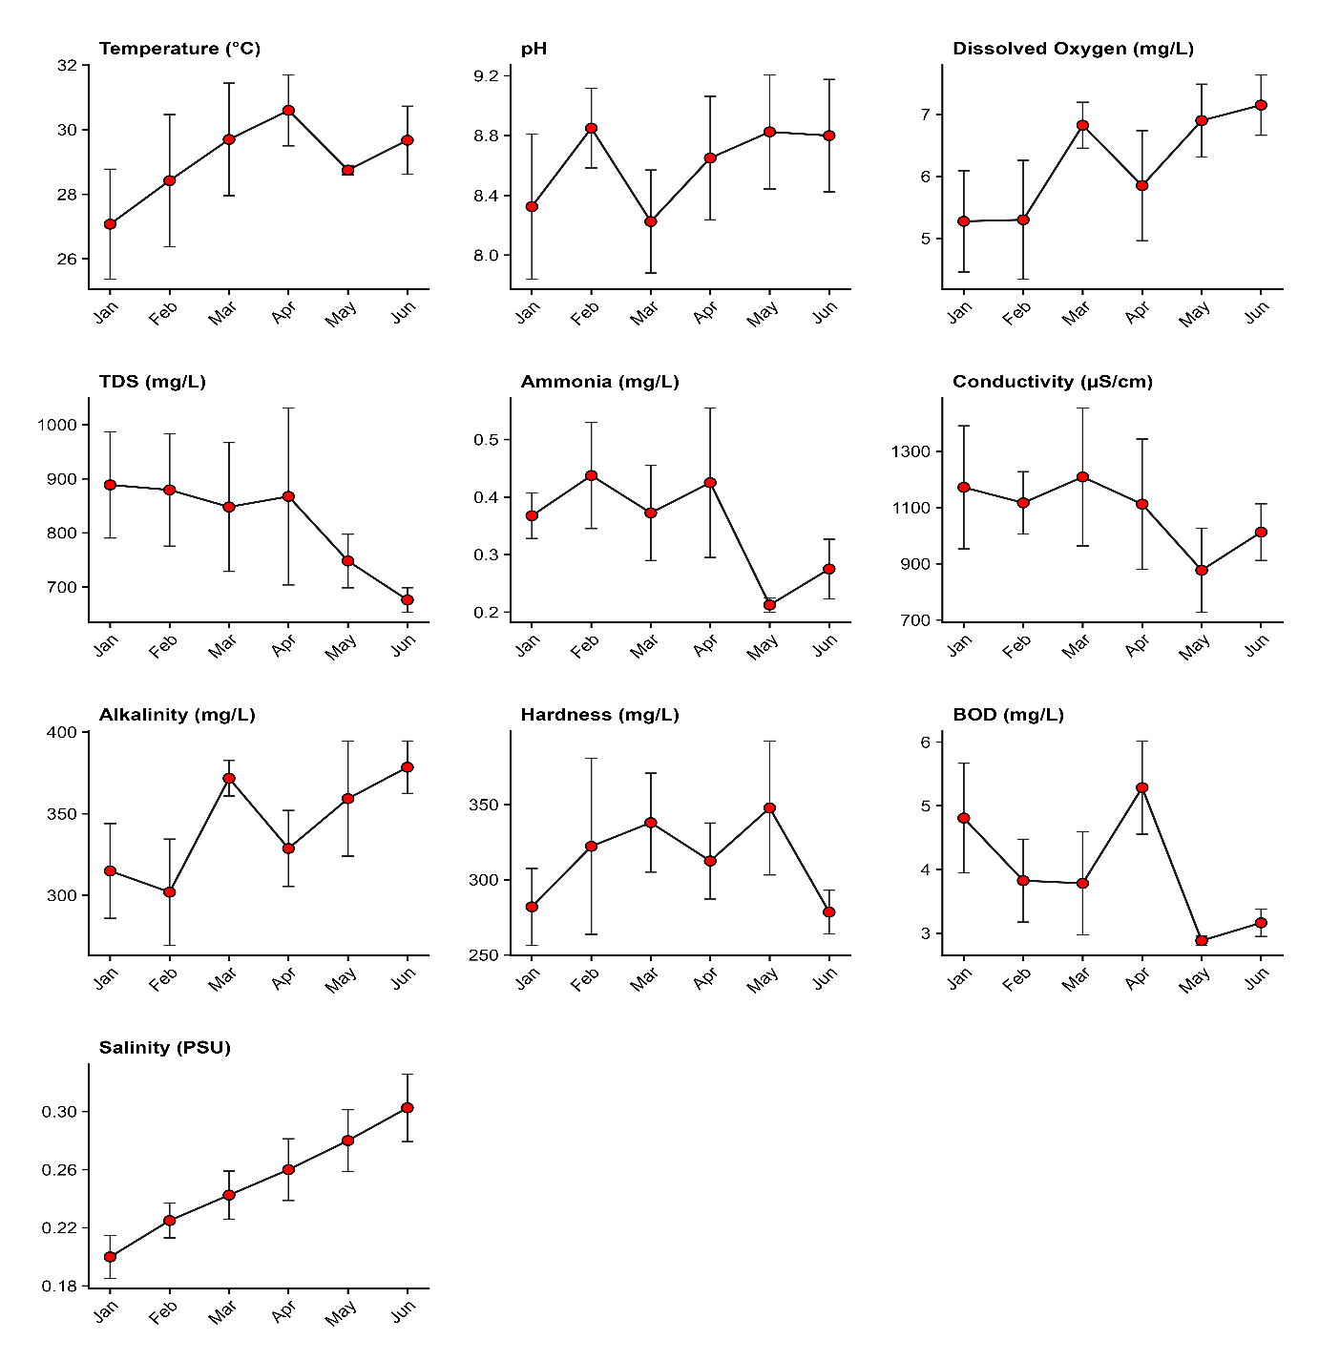
Fig 2. Monthly variation in water-quality parameters, temperature, pH, dissolved oxygen, total dissolved solids, ammonia, conductivity, alkalinity, hardness, biochemical oxygen demand, and salinity from January to June 2024 across all study ponds. Each panel displays mean values for each month with corresponding standard error bars, illustrating temporal fluctuations in physicochemical conditions.
3.2 Spatial Variation between the ponds
Clear spatial differences were observed among the four ponds across all measured water-quality parameters. Temperature exhibited the highest median in M2 (31.25°C; IQR = 3.32) and the lowest in M1 (27.25°C; IQR = 5.33). pH values were consistently higher in the unmanaged ponds, with U2 showing the highest median (9.45; IQR = 0.33), while both managed ponds (M1 and M2) recorded the lowest medians (8.15).
Dissolved oxygen displayed notable pond-to-pond variability, with the highest median in M1 (7.35 mg/L; IQR = 1.12) and the lowest in U1 (5.65 mg/L; IQR = 0.83). Total dissolved solids were substantially elevated in U1 (median = 1105 mg/L; IQR = 317.5), whereas U2 exhibited the lowest levels (median = 660 mg/L; IQR = 100). Ammonia concentrations were highest in U1 (median = 0.42 mg/L; IQR = 0.28) and lowest in U2 (median = 0.20 mg/L; IQR = 0.00).Conductivity also differed considerably among ponds, with U1 presenting the highest median (1422.90 µS/cm; IQR = 557.50) and M1 the lowest (817.45 µS/cm; IQR = 209.30). Alkalinity was greatest in U2 (median = 392.50 mg/L; IQR = 87.50) and lowest in M1 (median = 285 mg/L; IQR = 61.25). Hardness reached its highest median in U1 (352 mg/L; IQR = 72.00) and its lowest in M2 (263.50 mg/L; IQR = 78.50).
Biochemical oxygen demand varied spatially, with M2 recording the highest median (4.64 mg/L; IQR = 2.76), while U2 showed the lowest (median = 2.99 mg/L; IQR = 1.19). Salinity ranged from a median of 0.21 PSU (IQR = 0.03) in M2 to 0.30 PSU (IQR = 0.07) in U2, highlighting consistent elevation in the unmanaged ponds.
Overall, the spatial patterns indicate distinct differences in physicochemical conditions among the managed (M1, M2) and unmanaged (U1, U2) ponds, reflected in the distribution of temperature, pH, dissolved oxygen, nutrients, and ionic constituents. Table 2 shows the median and IQR and Figure 3A and 3B shows the boxplots.
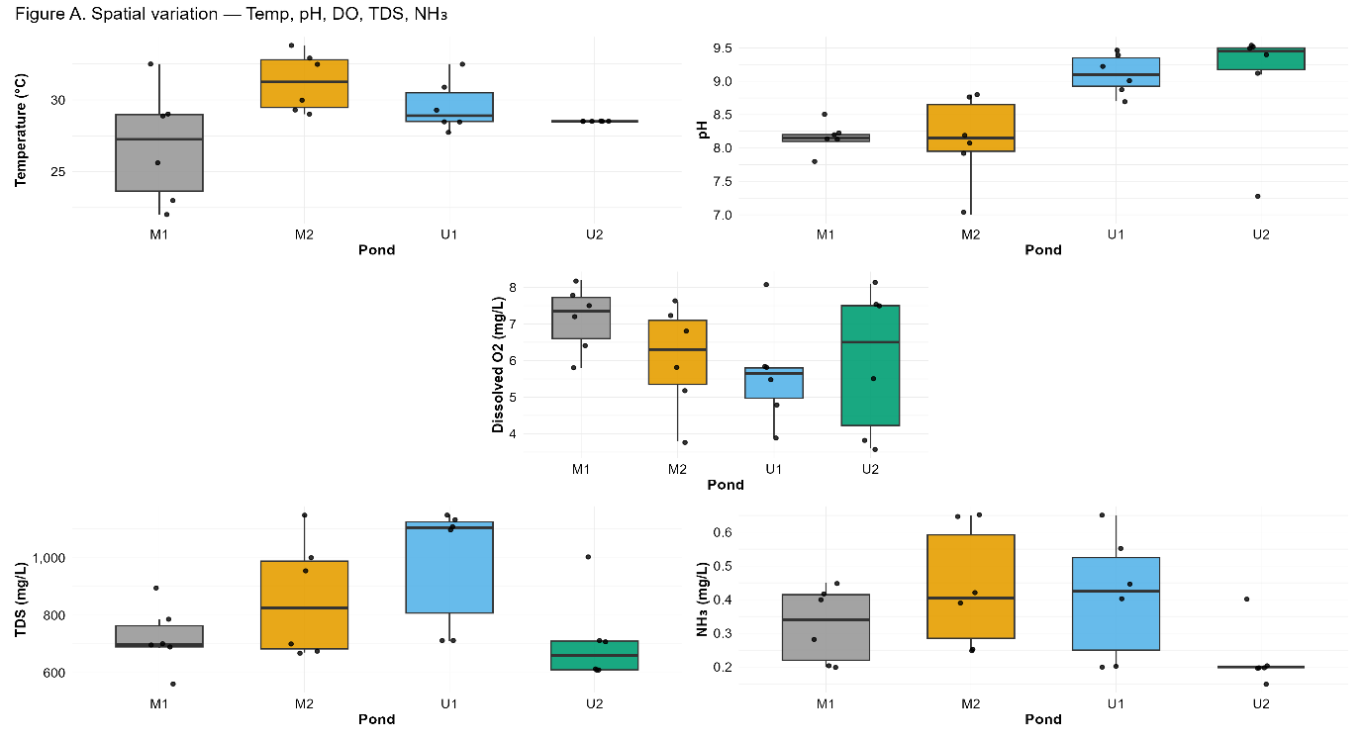
Figure 3A. Spatial variation in temperature, pH, dissolved oxygen, total dissolved solids, and ammonia across the four study ponds (M1, M2, U1, U2) during January–June 2024. Boxplots represent the distribution of monthly observations, with points showing individual measurements.
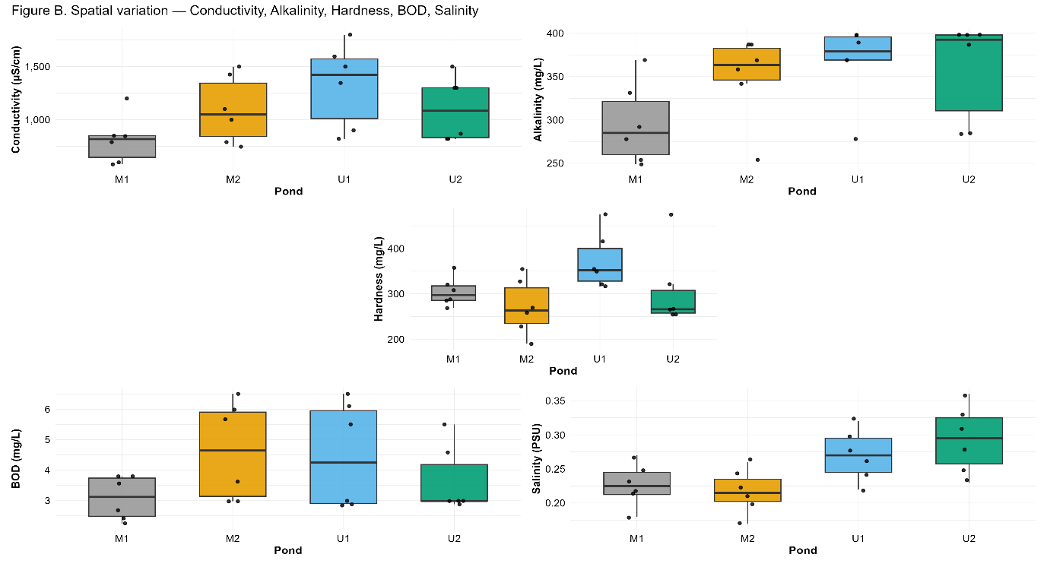
Figure 3B. Spatial variation in conductivity, alkalinity, hardness, biochemical oxygen demand, and salinity among the managed (M1, M2) and unmanaged ponds (U1, U2) from January to June 2024. Boxplots depict median values, interquartile ranges, and individual monthly data points.
Table2. Spatial variation in water-quality parameters across ponds (Jan–Jun 2024)
Parameter | M1 | M2 | U1 | U2
Temperature (°C) | 27.25 (5.33) | 31.25 (3.32) | 28.90 (2.00) | 28.50 (ND)
pH | 8.15 (0.10) | 8.15 (0.70) | 9.10 (0.43) | 9.45 (0.33)
Dissolved Oxygen (mg/L) | 7.35 (1.12) | 6.30 (1.75) | 5.65 (0.83) | 6.50 (3.28)
TDS (mg/L) | 698 (73.5) | 826 (305) | 1105 (317.5) | 660 (100)
NH₃ (mg/L) | 0.34 (0.20) | 0.40 (0.31) | 0.42 (0.28) | 0.20 (0.00)
Conductivity (µS/cm) | 817.45 (209.30) | 1050.30 (525.00) | 1422.90 (557.50) | 1083.95 (557.50)
Alkalinity (mg/L) | 285 (61.25) | 363.50 (36.50) | 379 (26.75) | 392.50 (87.50)
Hardness (mg/L) | 297.50 (32.25) | 263.50 (78.50) | 352 (72.00) | 266 (50.00)
BOD (mg/L) | 3.12 (1.25) | 4.64 (2.76) | 4.25 (3.04) | 2.99 (1.19)
Salinity (PSU) | 0.22 (0.03) | 0.21 (0.03) | 0.27 (0.05) | 0.30 (0.07)
*ND: Not Determined due to instrument error.
3.3 Correlation Analysis
Correlation analysis using Spearman’s rank coefficients revealed several significant associations among the measured water quality variables across ponds and months. Temperature showed a positive correlation with BOD (ρ = 0.51, p = 0.012), while its correlations with other parameters were non-significant. pH exhibited significant positive correlations with conductivity (ρ = 0.41, p = 0.048) and salinity (ρ = 0.53, p = 0.007). Dissolved oxygen was negatively correlated with TDS (ρ = −0.48, p = 0.019) and BOD (ρ = −0.56, p = 0.004), while other associations were non-significant.
TDS showed strong positive correlations with ammonia (ρ = 0.68, p < 0.001) and conductivity (ρ = 0.68, p < 0.001). Ammonia also correlated positively with conductivity (ρ = 0.58, p = 0.003) and BOD (ρ = 0.41, p = 0.047), and negatively with salinity (ρ = −0.52, p = 0.010). Conductivity exhibited positive correlations with pH (ρ = 0.41, p = 0.048), TDS (ρ = 0.68, p < 0.001), ammonia (ρ = 0.58, p = 0.003), and BOD (ρ = 0.49, p = 0.016).
Alkalinity showed a significant positive correlation with salinity (ρ = 0.62, p = 0.001), while no other correlations reached significance. Hardness did not show significant associations with any parameter. BOD displayed positive correlations with temperature (ρ = 0.51, p = 0.012), ammonia (ρ = 0.41, p = 0.047), and conductivity (ρ = 0.49, p = 0.016), and a negative correlation with dissolved oxygen (ρ = −0.56, p = 0.004). Salinity was positively correlated with pH (ρ = 0.53, p = 0.007) and alkalinity (ρ = 0.62, p = 0.001), and negatively correlated with ammonia (ρ = −0.52, p = 0.010).
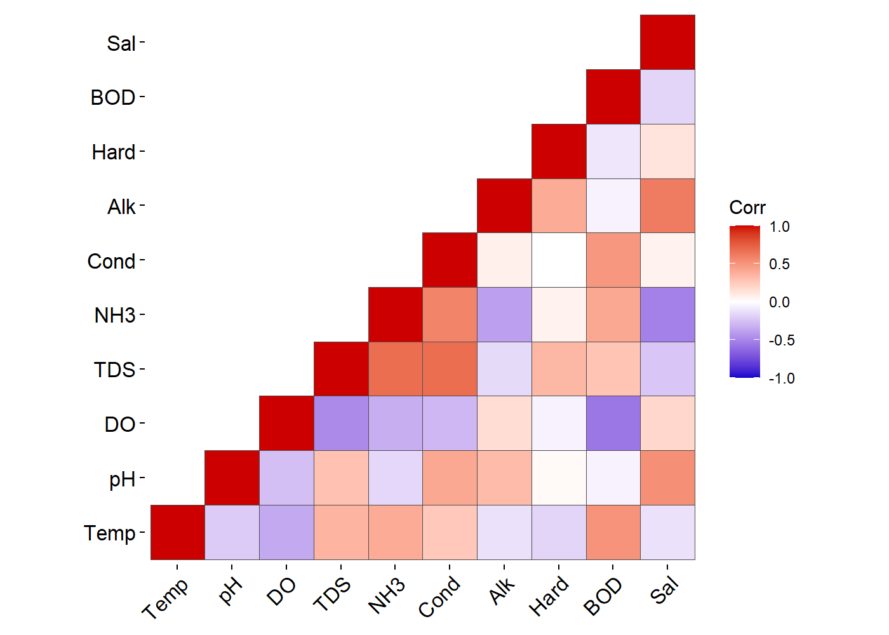
Fig 4. Spearman correlation heatmap showing pairwise relationships among ten water-quality parameters (Temperature, pH, DO, TDS, NH₃, Conductivity, Alkalinity, Hardness, BOD, Salinity) across all ponds sampled from January to June 2024. Warm colours indicate positive correlations; cool colours indicate negative correlations.
4. Discussion
The present investigation revealed distinct temporal and spatial variations in the physicochemical characteristics of the studied ponds, governed by both seasonal climatic progression and specific management regimes. These findings align with established limnological evidence that water quality serves as a dynamic index of aquatic health, heavily influenced by the interaction between atmospheric conditions and biological metabolism (Bhatnagar & Devi, 2013; Sreenivasan, 1964).Monitoring these parameters is pivotal, as recent studies by Nayak et al. (2024) emphasize that understanding seasonal water quality patterns is essential for effective disease management and sustainability in aquaculture systems.
4.1 Temporal Trends and Seasonal Dynamics
The temporal analysis from January to June demonstrated a progressive increase in water temperature across all ponds, correlating with the seasonal shift from winter to the pre-monsoon summer characteristic of the semi-arid region. This thermal trajectory, rising from approximately 22°C to over 32°C, mirrors trends reported by Mukherjee et al. (2022) and Rani (2023), who identified air temperature as the primary driver of thermal regimes in shallow water bodies.Nayak et al. (2024) similarly observed significant seasonal temperature variations in freshwater farms, recording summer peaks that hold critical significance for fish physiology and health management. The rise in temperature has significant ecological implications; as noted by Sreenivasan (1964), elevated temperatures accelerate metabolic rates and community respiration, thereby increasing the biological oxygen demand (BOD). Hoque et al. (2018) further cautioned that high water temperatures, specifically those rising above 30°C, play a prominent role in reducing dissolved oxygen levels, potentially stressing the aquatic population.This relationship was evident in the current study, where rising temperatures in the later months coincided with fluctuations in dissolved oxygen and organic load which is having similar trends to the study in Batapady (Chaturvedi et al., 2025).
Concurrently, a monotonic increase in salinity was observed from January to June. This trend is consistent with findings by Singh et al. (2022), who attributed increased ionic concentration in pre-monsoon seasons to high evaporation rates and reduced water volume. In the semi-arid context of Haryana, evaporation concentrates dissolved salts, a phenomenon also noted by Bhatnagar and Singh (2010), leading to the elevated conductivity observed towards the end of the dry season.
4.2 Spatial Variation: Managed vs. Unmanaged Systems
Distinct spatial heterogeneity was observed between the managed (M1, M2) and unmanaged (U1, U2) systems. Unmanaged ponds consistently exhibited significantly higher pH values, with U2 recording a median pH of 9.45. While a pH range of 7.5–8.5 is considered optimal for fish culture, values exceeding 9.0 can induce stress (Bhatnagar & Devi, 2013). Nayak et al. (2024) noted that while slightly alkaline environments are generally suitable, adverse conditions leading to alkalosis can precipitate disease outbreaks, highlighting the need for careful monitoring. The elevated pH in unmanaged ponds likely results from intense photosynthetic activity by unchecked phytoplankton blooms, which deplete free carbon dioxide and shift the carbonate-bicarbonate equilibrium, a mechanism described in tropical temple ponds by Sreenivasan (1976). Hoque et al. (2018) also reported that traditional farmers often lack the technical means to monitor these fluctuations scientifically, relying instead on indigenous methods which may not always effectively control such sharp variations. In contrast, managed ponds maintained a buffered pH closer to the optimal range, likely due to regulated liming and fertilization practices (Das et al., 2023). Unmanaged ponds also displayed significantly higher ionic loads, with median conductivity values in U1 (1422.90 µS/cm) far exceeding those in managed ponds. This aligns with observations by Bhatnagar and Singh (2010), who reported that village ponds receiving cattle inflow and domestic runoff exhibit higher conductivity, hardness, and organic load. The high total hardness in U1 (median 352 mg/L) exceeds the desirable range of 75–150 mg/L suggested by Bhatnagar and Devi (2013), potentially limiting phosphorus availability through precipitation.
Nutrient dynamics also differed markedly between the systems. While total ammonia nitrogen (TAN) generally remained below the lethal limit of $1.0~mg/L$, unmanaged pond U1 showed higher median ammonia concentrations compared to U2. This suggests localized organic pollution, consistent with Pandey and Chandra (2015), who linked high ammonia and nitrate levels to domestic sewage discharge. This is supported by Hoque et al. (2018), who noted that toxic gases and ammonia often form in pond bottom sediments due to the overloading of manures and decomposition of organic matter⁷. However, managed ponds also exhibited ammonia presence, likely a byproduct of supplementary feeding and metabolic excretion essential for semi-intensive culture (Das et al., 2023).
4.3 Correlation Analysis and Ecological Interactions
The Spearman correlation analysis provided critical insights into the functional relationships governing water quality. A significant negative correlation was observed between Dissolved Oxygen (DO) and BOD (𝜌= -0.56). This inverse relationship is a fundamental limnological concept; as organic matter decomposes (indicated by high BOD), microbial respiration consumes oxygen, reducing DO availability (Sreenivasan, 1964; Bhatnagar & Singh, 2010). Hoque et al. (2018) reinforced this mechanism, stating that the decomposition of algae and phytoplankton requires significant amounts of dissolved oxygen, which can lead to critical depletion in nutrient-rich waters. The positive correlation between Temperature and BOD (𝜌= 0.51) further confirms that warmer temperatures stimulate microbial decomposition rates.
Strong positive correlations were found between TDS, Conductivity, and Ammonia (𝜌= 0.68). This triad suggests that in these closed pond systems, the accumulation of dissolved solids is closely linked to nutrient loading. Singh et al. (2022) similarly reported strong associations between TDS and electrical conductivity, attributing it to sediment flux and dissolved minerals.Mishra et al. (2008) provided further context for this correlation, observing that high temperature favours the degradation of organic pollutants, which in turn increases the ionic concentration and conductivity of the water body. In the context of the present study, this reinforces the premise that unmanaged ponds, which act as sinks for village runoff, accumulate salts and nitrogenous wastes simultaneously.
Interestingly, a positive correlation was noted between Salinity and Alkalinity (𝜌= 0.62) and Salinity and pH (𝜌= 0.53). This association suggests that the ionic composition contributing to salinity is largely dominated by carbonates and bicarbonates, which drive alkalinity and pH. This supports the findings of Sreenivasan (1976), who noted that high alkalinity in temple ponds is often driven by evaporation and the concentration of carbonate salts.Furthermore, Nayak et al. (2024) highlighted that alkalinity levels can vary significantly across seasons, with higher values often recorded during summer months due to evaporative concentration, influencing the overall water chemistry.
4.4 Conclusion
In conclusion, this study demonstrates that management practices significantly influence the hydro-geochemistry of aquaculture ponds in Haryana. Managed ponds exhibited stable physicochemical profiles conducive to fish growth, whereas unmanaged ponds were characterized by high alkalinity, hardness, and significant ionic accumulation indicative of eutrophication and evaporative concentration. The strong statistical correlations identified between temperature, BOD, and nutrients highlight the sensitivity of these shallow systems to seasonal climatic drivers. These findings underscore the necessity for regular monitoring and corrective interventionssuch as water exchange or bio-treatmentin unmanaged village ponds to mitigate the risks of high pH and ammonia toxicity, thereby ensuring the sustainability of inland aquaculture in semi-arid regions.
Disclaimer (Artificial intelligence)
Author(s) hereby declare that NO generative AI technologies such as Large Language Models (ChatGPT, COPILOT, etc.) and text-to-image generators have been used during the writing or editing of this manuscript.

References
- American Public Health Association. (2017). Standard methods for the examination of water and wastewater (23rd ed.). American Public Health Association. https://www.standardmethods.org/ .
- Bhatnagar, A., & Devi, P. (2013). Water quality guidelines for the management of pond fish culture. International Journal of Environmental Sciences. https://doi.org/10.6088/ijes.2013030600019 .
- Bhatnagar, A., & Singh, G. (2010). Assessment of culture fisheries in village ponds: a study in district Hisar, Haryana, India. International Journal of Environmental Research, 4(1), 57–64. https://doi.org/10.22059/ijer.2010.156 .
- Boyd, C. E. (2000). Water quality: an introduction. Springer Science & Business Media.
- Chaturvedi, P., Annappaswamy, T. S., Sheethal, K. U., Khalasi, B. R., Ajith, K., Maurya, N. K., Devaguptapu, V., & Lakshmipathi, M. T. (2025). Assessment of Spatial-Temporal Patterns of Nutrient Dynamics in Batapady Mangrove Ecosystem, Southwest India. International Journal of Environment and Climate Change, 15(8), 270-283. https://doi.org/10.9734/ijecc/2025/v15i84971 .
- Das, S., Dey, S., Ghosh, D. D., & Panigrahi, A. K. (2023). Comparative study on physico-chemical parameters of water, zooplankton and macrophytes diversity under the exposure of farm-made prebiotics in a semi-intensive aqua-farming system. Environment and Ecology, 41(4A), 2411–2421. https://doi.org/10.60151/envec/YBNE1540 .
- Hoque, F., Hussan, A., Das, A., & Chakraborty, P. (2002). Managing water quality and fish health in aquaculture: Farmer’s traditional practices in west Bengal. Health, 5(8).
- Ip, Y. K., Chew, S. F., & Randall, D. J. (2001). Ammonia toxicity, tolerance, and excretion. Fish physiology, 20, 109-148.
- Mishra, R. R., Rath, B., &Thatoi, H. (2008). Water quality assessment of aquaculture ponds located in Bhitarkanika mangrove ecosystem, Orissa, India. Turkish journal of fisheries and aquatic sciences, 8(1), 71-77.
- Mukherjee, P., Kumar, P., Gupta, S. K., & Kumar, R. (2022). Seasonal variation in physicochemical parameters and suitability for various uses of Bouli pond water, Jharkhand. Water Science, 36(1), 125–135. https://doi.org/10.1080/23570008.2022.2127552 .
- Nayak, S. K., Mogalekar, H. S., Brahmchari, R. K., & Srivastava, P. P. (2024). Seasonal dynamics of water quality and fish diseases in freshwater aquaculture farms of north bihar, india. Journal of Experimental Zoology India, 27(1).
- Pandey, A. K., & Chandra, P. (2015). Monthly variations in physico-chemical parameters of water of protected wetland, Bakhira Lake, Sant Kabir Nagar (Uttar Pradesh), India. National Journal of Life Science, 12(2), 145–154. https://connectjournals.com/toc2.php?abstract=3021002H_145-154-A.pdf&&bookmark=CJ-034662&&issue_id=02&&yaer= .
- Rani, S. (2023). Impact of seasonal variations on the water quality and zooplankton diversity of pond in Haryana, India. Kurukshetra University. http://hdl.handle.net/10603/577248 .
- Singh, K. K., Singh, K. K., Usha, K., Das, S., & Singh, S. S. (2022). Evaluation of seasonal dynamics of the surface water hydrochemistry using multivariate statistical techniques and aquatic macrophyte productivity in a mountainous lake, Northeast India. Environmental Science and Pollution Research, 29, 69048–69067. https://doi.org/10.1007/s11356-022-20631-1 .
- Soni, V., Gulati, R., Tiwari, V. K., Tripathi, V., Singh, S., Qureshi, Q. A., Chaturvedi, P., Mishra, R. K., Khan, M. I. R., & Chaudhary, V. (2025a). Evaluation of Curcuma longa Aqueous Extract for Bactericidal Activity Toward Enterobacter ludwigii Isolated from Diseased Catlacatla. Journal of Advances in Biology & Biotechnology, 28(10), 1048-1058. https://doi.org/10.9734/jabb/2025/v28i103125 .
- Soni, V., Gulati, R., Tripathi, V., Tiwari, V. K., Lowanshi, A., Kumar, R., George, A. S., & Mishra, R. K. (2025b). Potential opportunistic role of Kosakoniasacchari in common carp (Cyprinus carpio) from unmanaged village ponds in Hisar. International Journal of Advanced Biochemistry Research, 9(11S), 1150–1157. https://doi.org/10.33545/26174693.2025.v9.i11So.6398
- Sreenivasan, A. (1964). The limnology, primary production, and fish production in a tropical pond. Limnology and Oceanography, 9(3), 391–396. https://doi.org/10.4319/lo.1964.9.3.0391
- Sreenivasan, A. (1976). Limnological studies of and primary production in temple pond ecosystems. Hydrobiologia, 48(2), 117–123.

