Occupants’ Perceptions of Natural Ventilation in an Urban Apartment Building: A Case Study from Bhubaneswar

Abstract

Natural ventilation is a method to introduce fresh air into an interior space without utilising mechanical systems. The natural wind flow and buoyancy effect circulate the air and maintain a suitable indoor air quality and thermal comfort. Natural ventilation is preferred over mechanical ventilation due to its NetZero energy concept. However, several variables, including the surrounding environment, local climate, and building design, significantly affect the natural ventilation. The objective of this article is to study the opinion of the inmates of an existing apartment regarding natural ventilation. A total of 200 participants from 88 flats, above 12 years, were interviewed for this survey. Participants were asked questions regarding their house and the equipment used for maintaining thermal comfort. Some specific information on the electricity bill, window opening time and duration, number of air conditions, fan, exhaust fan used, and the duration of usage of these electrical appliances at their home is requested. Whether they are satisfied/unsatisfied with the natural ventilation of the home, and what are the reasons for satisfaction, etc., data are collected, compiled, tabulated and represented.

The study reveals the insights into electricity consumption, window usage habits, air conditioning and fan usage, as well as overall satisfaction with natural ventilation. Key findings include a prevalence of high summer electricity bills due to insufficient natural ventilation, varied window-opening habits, and common use of air conditioning to get comfort and satisfaction.

Keywords: Natural ventilation, thermal comfort, Design and layout, Cross ventilation

Introduction:
Natural ventilation refers to the use of passive airflow techniques to circulate fresh air throughout the living space without relying on mechanical systems. It harnesses the power of natural forces such as wind and temperature differences to facilitate the exchange of indoor and outdoor air, creating a healthier and more comfortable living environment. In densely populated urban areas, apartment buildings are often designed with limited access to outdoor spaces, making it challenging to maintain optimal indoor air quality. This is where natural ventilation plays a vital role. By incorporating carefully designed openings, such as windows, doors, and vents, apartment dwellers can take advantage of the natural elements to regulate airflow and improve ventilation. One of the primary benefits of natural ventilation is its ability to remove stale air, odours, and pollutants from the apartment. Opening windows strategically allows the escape of indoor air that may contain airborne particles, volatile organic compounds (VOCs), or excessive moisture. Simultaneously, fresh air from outside enters the apartment, replenishing the oxygen levels and creating a more pleasant living environment. While natural ventilation offers numerous advantages, it is crucial to strike a balance between air exchange and maintaining thermal comfort. Apartment design and layout play a vital role in optimising natural ventilation. This issue is prevalent in cities throughout India, including Bhubaneswar, where a significant number of poorly ventilated apartments can be found. In my survey, I have chosen to focus on one such apartment complex located in the northern regions of Bhubaneswar, specifically in Raghunathpur. This particular building was constructed with a greater number of flats in a limited amount of space, prioritising economic benefits over the provision of natural ventilation and natural light. The consequences of such poor ventilation in these apartments can have a detrimental impact on the health and well-being of the residents.
Improper ventilation adversely affects the physical and psychological aspects of occupants, particularly those who spend a longer time in this environment. Moreover, improper natural ventilation compels to run mechanical ventilation system, which increases the cost of living in terms of electricity bills. In this work, the influence of the compelled mechanical ventilation on the financial budget and the thermal comfort experienced by natural ventilation is investigated through occupants’ interviews. Moreover, some recommendations are made to improve the natural ventilation in the existing apartment.
Review of literature:
As India is a developing country, the building sector is developing rapidly in India. It has been predicted that by 2050, the total building area will cross 40 billion(Belleri, Lollini, & Dutton, 2014). Natural ventilation mainly depends on building orientation, location and climate of the building, building design and layout, external obstruction, internal heat source and operable elements like doors and windows opening(Aflaki, Mahyuddin, Mahmoud, & Baharum, 2015; Ahmed, 2003). Therefore, architectural parameters play a key role in an effective natural ventilation system(Burridge et al., 2023; Dugolli, 2023). Although the climate and location of the building are not under the control of an architect but it is possible to enhance the effective natural ventilation by proper designing of the building and proper placement of windows, and proper size of windows as well(Al-Yasiri, Alktranee, Szabó, & Arıcı, 2023). Designing buildings with open floor plans, atriums, and courtyards can promote cross-ventilation and airflow throughout the interior spaces. The installation of vents, louvres, or clerestory windows at high points in the building facilitates the release of warm air and promotes stack effect ventilation. Natural ventilation is the process of moving air through an enclosed space naturally, i.e., without the use of a fan or other mechanical device (Yin, Zhang, Yang, & Wang, 2010). It utilises exterior airflow brought on by pressure differences between the building and its surroundings to provide ventilation and space cooling. It helps to decrease interior temperatures and maintain internal humidity (Costanzo et al., 2019). Natural ventilation also helps in supplying fresh oxygen, minimising the build-up of impurities, including smoking, carbon dioxide, odours, bacteria, dust, and moisture that can occur when space is engaged, and it helps in generating air movement to enhance occupant comfort (Bal-Fontaine, Jay, & Rouchier, 2025; Escombe et al., 2007). Natural ventilation offers building occupants fresh air while saving money and using less energy.
An improperly designed building window and its improper positioning affect the natural ventilation. If windows are oversized, a higher surface area allows to move the air in and out across the room. At the same time, it receives more solar radiation energy and makes the room hot if the windows are closed. Similarly, window positioning direction and its configuration also play an important role in effective ventilation. Operable windows can be opened or closed, but non-operable windows, primarily used as decorative elements and light sources, cannot be used for ventilation; rather, they increase the heat due to solar radiation (Zhai, Johnson, & Krarti, 2011). When configured and controlled effectively, the use of movable windows has been shown to lower the annual energy consumption in buildings with high occupancy. The control method for the apertures is the most important consideration when building a natural ventilation system. Depending on the building's geometry, the surrounding temperature, wind speed, and direction, different amounts of airflow through moveable windows are produced. A window is described as an opening in a building's wall, door, or roof that allows light and, if not closed or sealed, air and sound to pass through. A well-placed, shaded window on a building can significantly reduce the building's energy use. When correctly placed and maintained, windows can have a significant impact on the use, productivity, and aesthetic comfort of building occupants. A window is one of the many fenestration system characteristics that affect the thermal performance of a naturally ventilated structure by regulating the air exchange rate between indoor and outdoor. In a tropical climate, human thermal comfort is a major issue. The building envelope, or shelter, should operate satisfactorily in terms of regulating heat and light. To accomplish the desired ventilation rate and proper dispersion of fresh air throughout the building, ventilation openings are arranged, located, and controlled to take advantage of the wind and temperature driving forces (Szokolay & Koenigsberger, 1973).
Pathirana et al. examined the effect of window-to-wall ratio, orientation and building shape on lighting and thermal comfort in a tropically located naturally ventilated house (Pathirana, Rodrigo, & Halwatura, 2019). It has been mentioned that by increasing the value of to wall-to-surface ratio, thermal comfort increases by 20-55% whereas electricity consumption for lighting is reduced by 1.5-9.5% only. Aldawoud emphasised window design to obtain maximum cross ventilation (Aldawoud, 2017) through CFD simulations. Several CFD simulations were conducted by varying the window-to-wall ratio for a fixed window size, where the building orientation and shading effects are also considered. It is reported that though desired thermal comfort is not achieved, with a proper design of windows, 2º-6ºC of temperature can be reduced with the natural ventilation process. Sacht and Lukiantchuki investigated the effect of window size and incidence angle of external wind on the performance of natural ventilation (Sacht & Lukiantchuki, 2017).
Methodology:

The study was done by in-depth analysis of selected apartments first, as a case study conducted for the apartment building on location, Climate and topography, Orientation, Planning concept, etc. And secondly, an interview was conducted with residents of the apartment, using a structured interview schedule. A purposive random sampling technique was employed to select participants. The interviews were conducted with family members aged 18 and above to get a reliable answer. In this interview, participants were asked questions regarding their house and the equipment used for maintaining thermal comfort and ventilation. Since there were 88 houses in total, the sample size was N=88. An interview schedule was developed and pretested on 20 respondents. The interview schedule has different questions on different aspects, like demographic information and some specific information on electricity bill, window opening time and duration, number of air conditions, fan, exhaust fan used, and the duration of usage of these electrical appliances at their home. Whether they are satisfied/unsatisfied with the natural ventilation of the home, and what are the reasons for dissatisfaction, etc., the collected data were compiled, tabulated and represented in the form of a graph by using MS Excel.

Result and discussion:

Case study of selected apartment:
The selected sample apartment is situated in Raghunathpur, Bhubaneswar, Odisha, India, and is an apartment developed by a private builder. The apartment comprises four distinct blocks: Block A, Block B, Block C, and Block D. Offering a total of 88 flats, it provides residents with a choice between 16 2 BHK flats, having 1120 sq. ft. each, and 72 3 BHK flats, having a floor area of 1540 sq. ft. The construction of the selected sample apartment commenced in November 2012, and it was completed by August 2016. With a height reaching 72 ft, having a basement and five stories in total, the apartment primarily serves residential purposes. The basement and the first floor are dedicated to parking facilities, while the remaining four floors house the residential units.

Climate and topography
Bhubaneswar experiences a tropical climate characterised by two distinct seasons: a dry season spanning from November to May, and a rainy season brought on by the monsoon, occurring from June to October. The rainy season typically concludes in early to mid-October. Before the arrival of the monsoon, which typically begins in early March and lasts until early June, the city undergoes scorching temperatures accompanied by sporadic showers, particularly in May. During the peak of summer, temperatures can soar up to 45 °C (113 °F), and in June 2022, it even reached an exceptionally high temperature of 46.7 °C (116 °F). Bhubaneswar receives an annual average rainfall of and the wettest month is September, with precipitation measuring approximately 8.41 inches. As for wind patterns, April stands as the windiest month, with an average wind speed of 11 mph. In terms of the coldest month, January takes the lead, with an average temperature of 73 degrees Fahrenheit.(Garg, 2022)

Orientation
The selected apartment is facing towards the west direction with a latitude of 20.3747ºN °N and a longitude of 85.8305ºE °E. A road is located to the front of the apartment which connects Bhubaneswar to Cuttack. The wind orientation is from South and South west, mainly in the range of 1.5 -4.5 m/s over the year. The sun rises from west of the plot. (Pradhan, 2013)
. 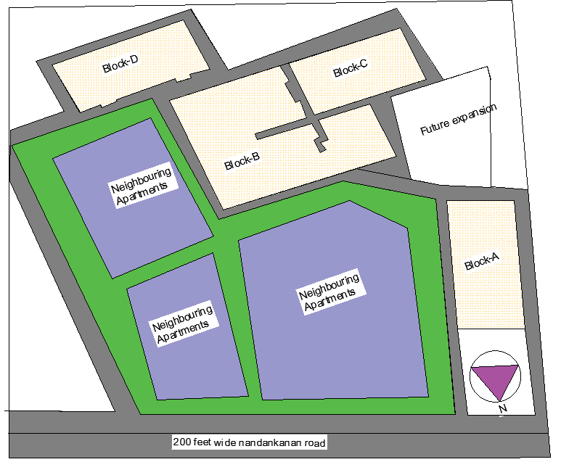
Figure 1: Lay out the plane of the blocks of the selected apartment for study

Planning concept of the selected apartment for study
The sample apartment is an economically designed building that maximises the available space while compromising on natural ventilation and lighting. The building consists of four blocks named Block-A, Block-B, Block-C, and Block-D, with a congested layout. Three blocks shown in fig-1 are situated closely together, while Block A is positioned separately. The shape of all blocks is rectangular, featuring narrow passages for circulation. Among the blocks, Block-B is particularly congested, housing eight flats arranged in a mirrored position with another set of four flats, connected by a narrow corridor measuring only 3 feet in width and 75 feet in length. All blocks consist of three bedrooms, one dining space, one living room, one kitchen, two toilets, and two balconies, except for Block-A, which has two bedrooms, one dining space, one living room, two toilets, and one balcony. It is clearly shown in fig-2. Among the total 77 flats in the building, 17 flats in Block D have a size of 1540 square feet, while the remaining 60 flats in Block B and Block C have a super built-up area of 1455 square feet. Additionally, there are 16 two-bedroom flats, with eight flats measuring 1120 square feet and the other eight measuring 1175 square feet of super built-up area. Each block is equipped with one staircase and one lift for vertical connections between floors, except for Block B, which has three staircases and three lifts. The apartment also features two community halls and one gym space for the residents. Parking is available on the basement and first floor, connected through a cemented ramp. Notably, there is an unused and unconstructed swimming pool near Block D.
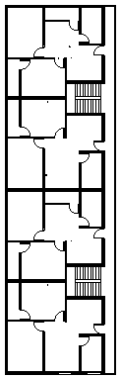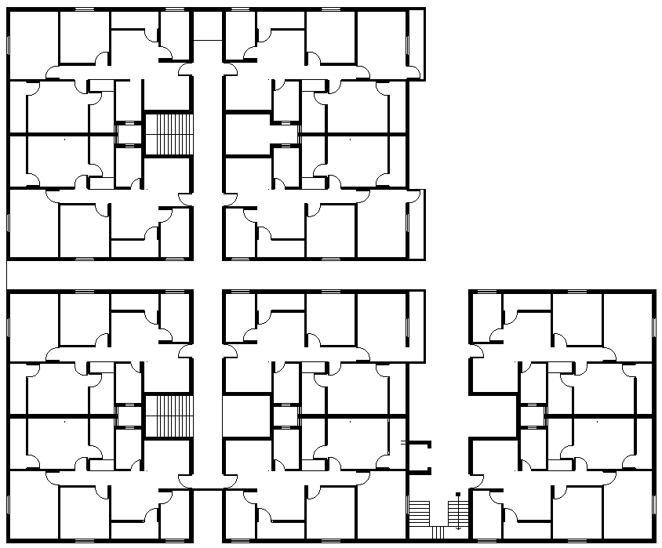
Floor plan of block -A Floor plan of block-B
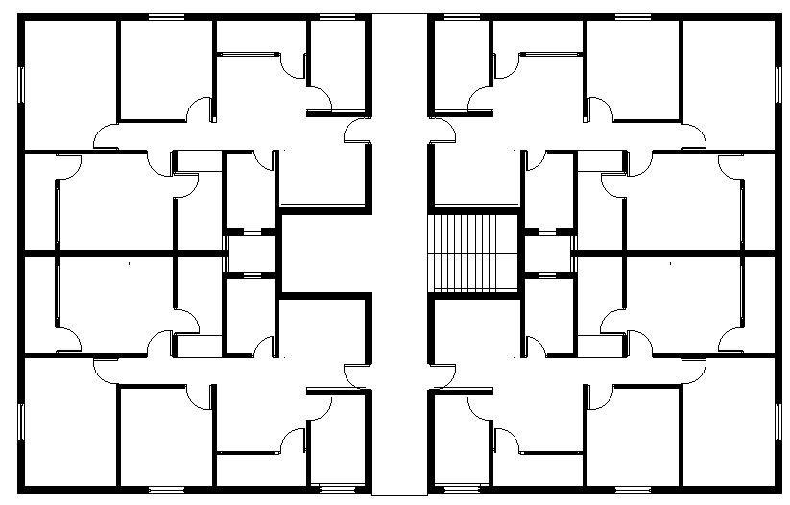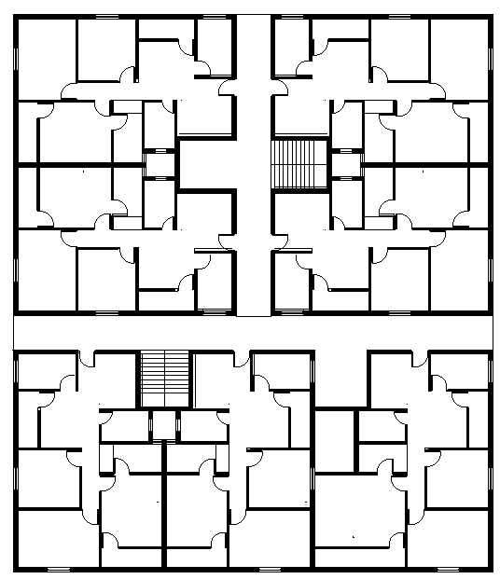
Floor plan of block-C Floor plan of block-D
Figure 2: Floor plan of different blocks

Built-up area.
Hear built-up area refers to carpet area, pulse area of thickness of wall and ducts, pulse area of balcony, corridor, which is usually more than 10% of the carpet area. Built-up area for 3 bhk is 950sq ft, and built-up area for 2 bhk is 755 sq ft. The apartment has having service area like ducts, 54 sq ft floor area each, two lifts, 23 sq ft and the remaining four lifts of 16 sq ft of floor area each. Floor area of each staircase is 16 4”.
Below placed several figures depicting various elements within the apartment that contribute to poor ventilation. These elements are illustrated in the 3 Conjugated Blocks and Figure 4 Narrow Spaces within the Sample Apartment. These figures provide a visual representation of the factors responsible for the inadequate ventilation in the apartment.
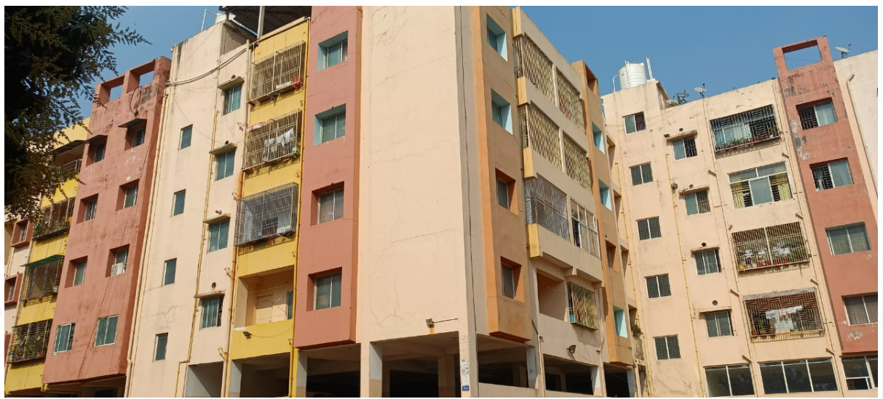
Figure 3: Conjugated blocks (Block-B) and (Block-C)
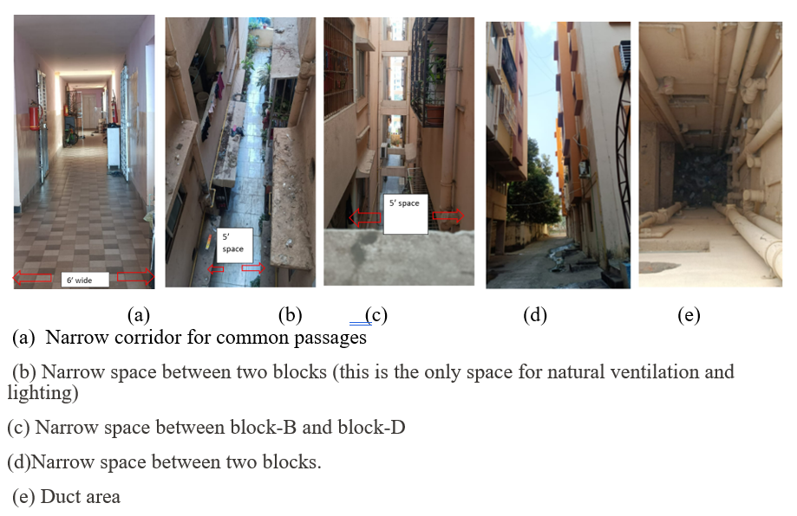
Figure 4: Different narrow spaces present in the sample apartment. (a), (b), (c), (d), (e).

The builder has maximised space usage to construct a densely populated building, primarily driven by economic considerations, unfortunately, compromising the well-being of its occupants. However, an attempt to mitigate this issue is visible in 5, where a rooftop vent has been incorporated to facilitate natural ventilation.
In addition, some of the residents have taken proactive measures to enhance air quality and beautify the surroundings, as depicted in Figure 5, by creating immediate exterior plantations. These green spaces serve the dual purpose of purifying the air and enhancing the aesthetic appeal of the environment.

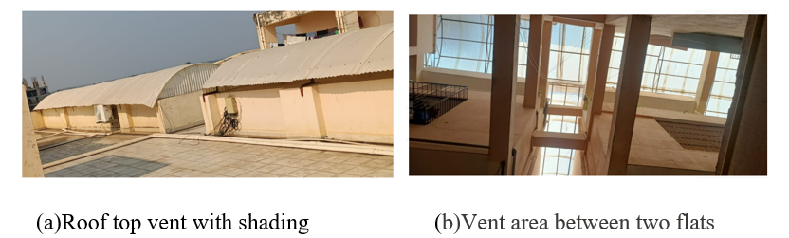
Figure 5 Architectural feature for natural ventilation and natural lighting(a), (b)
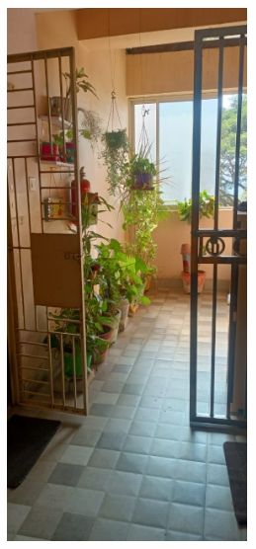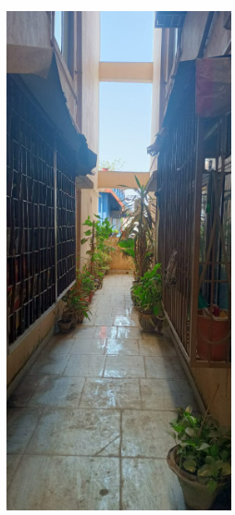
Figure 6: Immediate exterior plantation for clean air and beautification.
Table 1: Number, sizes and percentage of openability of doors and windows
Bedroom type | No of Door | sizes | Openability  (%) | No of window | sizes | Openability  (%)
3 bhk | 6 | 3’ x7’ | 100 | 4 | 4’ x4’ | 50
 | 2 | 2’6”’x7’ | 100 | 1 | 6’ x 4’ | 33.3
2 bhk | 5 | 3’ x7’ | 100 | 5 | 4’ x4’ | 50
 | 2 | 2’6” x7’ | 100 | 1 | 6’ x4’ | 33.3

Table 1 provides information on the openability of doors and windows in different bedroom types, with a specific focus on ventilation. The data is categorised into two-bedroom types: 3 BHK (3 bedrooms, hall, and kitchen) and 2 BHK (2 bedrooms, hall, and kitchen). For each bedroom type, the table displays the number of doors, their sizes, and openability percentages, as well as the number of windows, their sizes, and openability percentages. The data reveals that the openability of windows in both 3 BHK and 2 BHK bedroom types is limited. Windows play a crucial role in facilitating natural ventilation, and the low openability percentages signify that residents may face challenges in achieving adequate airflow

Opinion of the inmate on the apartment regarding natural ventilation:
The information for this study was obtained by conducting interviews with residents of the apartment, using a structured interview schedule. A purposive random sampling technique was employed to select participants. The interviews were conducted with family members aged 12 and above, who were free from ailments such as anaemia, diabetes, heart problems, or any other chronic health disorders, and who were present during the interview. Beyond this 12-year limit, a Random sampling approach is used for this survey work in order to generate unbiased and generalised results. The interview schedule has different questions on different aspects, like some general information about the family and some specific information on the electricity bill, window opening time and duration, number of air conditions, fan, exhaust fan used, and the duration of usage of these electrical appliances at their home. Whether they are satisfied/unsatisfied with the natural ventilation of the home, and what are the reasons for dissatisfaction, etc., the collected data were compiled, tabulated and represented in the form of a graph by using MS Excel. And the result was discussed below.

Information obtained from the respondents of the families 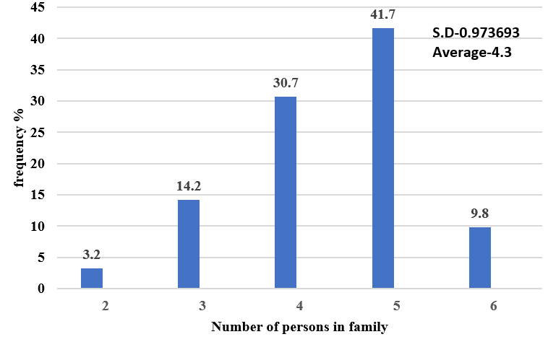
Figure 7: No. Of persons living in the family
Figure 7 provides a breakdown of the family sizes in the apartment. Among the 88 flats surveyed, it is evident that 3.2% of the flats are occupied by 2 family members, 14.2% by 3 family members, 30.7% by 4 family members, 41.7% by 5 family members, and 9.8% by 6 family members. On average, each family in this apartment consists of 4 members, with a standard deviation of 0.97.
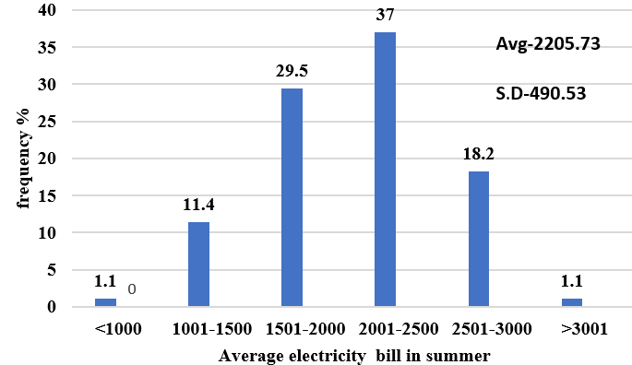
Figure 8: Average electricity bill in the summer per household

In Figure 8, it can be observed that during the summer months (May, June, July, and August), a significant proportion of families experience higher electricity bills. Specifically, 37 per cent of families pay more than Rs 2000 to 2500 per month, while 29.5 per cent pay between Rs 1500 and Rs 3000. Additionally, 18.2 per cent of families pay bills ranging from Rs 2500 to Rs 3000, and 1.1 per cent pay more than Rs 3000. It is found that among 88 families, the average electricity bill is Rs 2205.73, with a standard deviation of approximately Rs 490.53. The main reason for the majority of families experiencing higher electricity bills is attributed to inadequate natural ventilation or airflow in their houses.
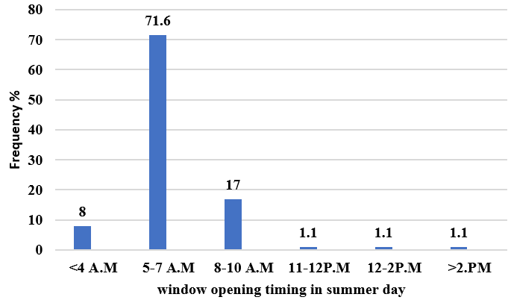
Figure 9: The chosen time for the family to open the windows.
The findings from the research on respondents' window-opening habits at different times of the day, as depicted in Figure 9, provide valuable insights into the behaviour of families in relation to window usage. The primary objective of this inquiry was to examine the timing of window openings throughout the day, the data revealed that a significant number of families residing in the apartment opened their windows between 5 to 7 am in the morning, with the exact timing depending on their wake-up routines. Approximately 17 percent of the families reported opening their windows between 8 to 10 am. Additionally, 8 percent of the families mentioned that they opened their windows in the very early hours, specifically before 4 am. The remaining 1.1 percent of families opened their windows between 11 to 12 pm, 12 to 2 pm, and after 2 pm, respectively. A study on Malaysia home by (Kubota & Ahmad, 2005) shows that by opening the windows, these households can effectively enhance the thermal conditions within their residences.
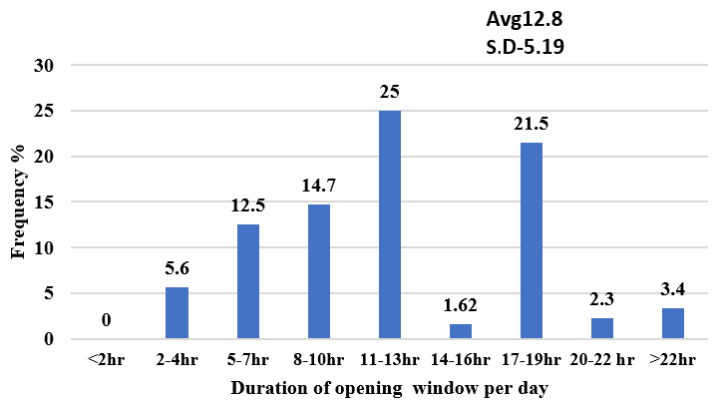
Figure 10: The daily duration for opening windows in the household.

The findings in Figure 10 indicate that a significant portion of families, approximately 25 percent, open their windows for 11 to 13 hours each day. This duration allows for a sufficient exchange of fresh air and ventilation within the house. Furthermore, approximately 21.5 percent of the surveyed families mentioned that they keep their windows open for a slightly longer period, ranging from 14 to 16 hours daily. This extended window opening duration suggests that these households prioritize natural ventilation and air circulation within their living spaces. A smaller portion of the families, comprising 12.5 percent, reported opening their windows for 5 to 7 hours daily. While this duration may be comparatively shorter, it still allows for some fresh air to enter the common areas of the house, such as the dining, living, and kitchen rooms. Interestingly, a minority of families, representing 5.6 percent, reported only opening their windows for a limited duration of 2 to 4 hours. Although this percentage is relatively low, it is worth noting that even a short window opening period can contribute to the overall ventilation and air quality within a home. The study also highlighted that approximately 3.4 percent of families consistently keep their windows open for more than 22 hours. This extended window usage suggests a strong preference for fresh air and a desire to maintain a well-ventilated environment throughout the day. In contrast, households with air conditioning installed in their rooms tend to keep the windows closed when the air conditioning is in use.

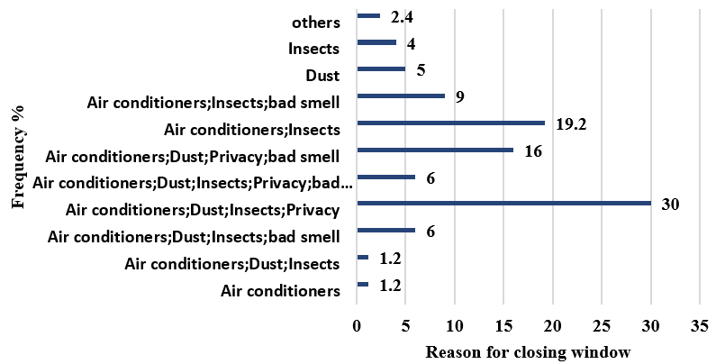
Figure 11: Reason for window closer.

With regards to the reason for not opening windows at all times, as shown in Figure 11, 30 percent of the families mention that due to running air conditions, dust outside the house, insects and for the privacy they have to close their windows. 19.2 percent families said due to use of air condition and entry of insects they are closing window.16 percent of the families expressed the reasons as air conditioners, dust, privacy and bed smell for closing the window .9 percent of the families given the answer as A.C, insects and bad smell as the reason.6,6 percent stated the reason as A.C, dust, insects, privacy, bad smell respectively. Furthermore, 19.2 percent of the families indicated that the use of air conditioning and the entry of insects were the primary factors behind their decision to close the windows. windows closed is influenced by a variety of reasons, as demonstrated by the study findings. These include the use of air conditioning systems, concerns regarding dust, insects, privacy, and unpleasant odours. By understanding these factors and their respective impacts, families can make informed choices to create a comfortable, healthy, and secure living space.

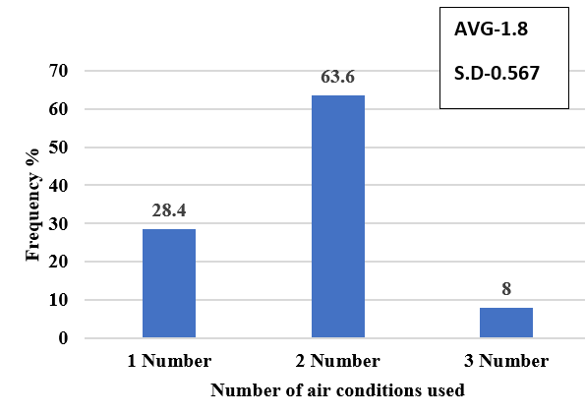
Figure 12: Number of air conditioning units installed per household.

Figure 12 shows the data on the number of air conditions used. in selected apartment all flats had installed air condition as due to less air entered inside the house and the temperature outside is very high in summer days. Out of 88 families present in apartment, 63.6 percent of the families having two numbers of Air conditions, 28.4 percent of the family having one Air conditions in their home and 8 percent of the family says they have installed three Air condition in their home. According to the data presented it can be observed that the usage of air conditioners in apartment is influenced by several factors. The main reason behind the high installation rate of air conditioners in this residential building is the limited air circulation and the extremely high temperatures experienced during summer days.

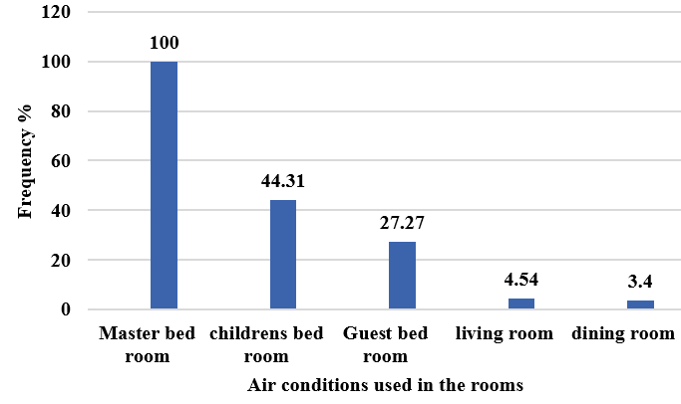
Figure 13: The room equipped with an installed air conditioning system
Based on the findings presented in Figure 13, from the finding it is clear that air conditioning usage varies among 88 families. The data clearly demonstrates that 100 percent of the families surveyed utilize air conditioning in their master bedrooms, indicating its widespread use in this particular room. Furthermore, it was observed that 44.31 percent of the families surveyed also installed air conditioning in their children's bedrooms. Upon further examination, it was discovered that out of the total 100 families surveyed, 27.27 percent of them utilize air conditioning in their guest bedrooms. Moreover, a smaller proportion of families, specifically 4.54 percent, make use of air conditioning in their living rooms, while 3.4 percent of families reported using air conditioning in their dining rooms. These findings are supported by existing research on the prevalence of air conditioning usage in residential settings. According to a study conducted(Kubota, Jeong, Toe, & Ossen, 2011), it was observed that the master bedroom is one of the most commonly air-conditioned spaces in households, due to the emphasis placed on individual comfort during sleep. Additionally, the study also highlighted the significance of air conditioning in children's bedrooms, as it contributes to maintaining suitable temperatures for optimal sleep and overall well-being. Furthermore, the study conducted by (Lin & Deng, 2006) found that guest bedrooms often have air conditioning units to ensure the comfort and satisfaction of visiting guests. Similarly, the inclusion of air conditioning in living rooms and dining rooms was also noted, as these areas are frequently utilized for social gatherings and relaxation, necessitating a pleasant indoor environment.

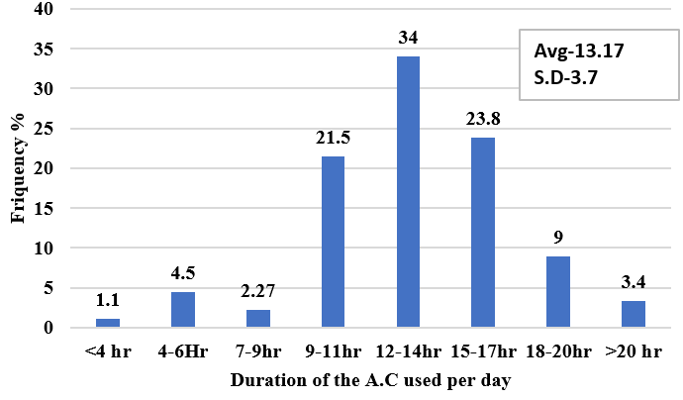
Figure 14: Daily duration of air conditioning usage in hours
According to the findings illustrated in Figure 14, the respondents' views on the duration of air conditioner (A.C.) usage during summer vary significantly. Approximately 34 percent of the families reported using A.C. for 12 to 14 hours per day, while 23.8 percent stated a usage duration of 15 to 17 hours. Furthermore, 21.5 percent of the families reported using A.C. for 9 to 11 hours, 9 percent for 18 to 20 hours, and 3.4 percent for more than 20 hours. Only 4.5 percent of the families reported using A.C. for 4 to 6 hours, and a mere 1.1 percent reported usage of less than 4 hours per day. The primary reason for the extended usage of air conditioners in these households can be attributed to their location within the apartment complex. These houses are situated in the middle of the building and are surrounded by neighbouring flats on all sides, resulting in limited natural airflow and reduced natural light entering the premises. As a consequence, these families heavily rely on air conditioning systems to maintain a comfortable indoor environment.
On the other hand, some households within the same apartment complex reported using air conditioners for significantly less time. This can be attributed to the fact that these families primarily consist of older individuals who face health issues such as joint pains and cold symptoms when spending an extended period in an air-conditioned room. Due to these health concerns, they opt for limited A.C. usage to minimize any potential discomfort or adverse effects on their well-being.

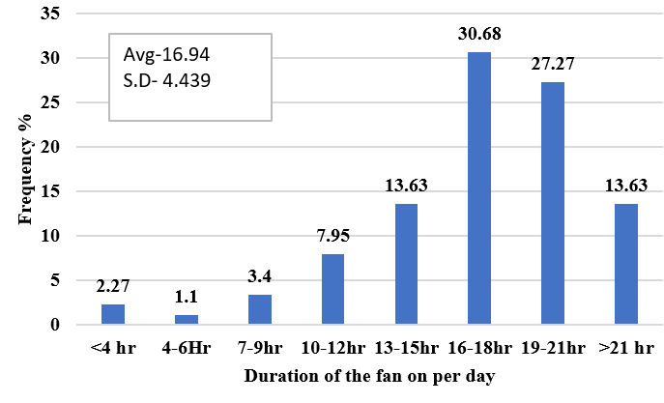
Figure 15: Daily Duration of Fan Usage

The findings indicate that in Figure 15, the majority of households heavily rely on fans for cooling during summer days (May-August), with only a few exceptions for the kitchen and toilet. A comprehensive survey was conducted to understand the usage patterns of fans in different households. The findings revealed that 30.68 per cent of families used fans for 16-18 hours daily, while 27.27 per cent used fans for 19-21 hours. Additionally, 13.63 per cent of households reported running fans for 13-15 hours, and an equal percentage for more than 21 hours per day. A smaller portion, 7.95 per cent, utilised fans for 10-12 hours during summer. Further analysis showed that 3.4 per cent of families relied on fans for 7-9 hours, and only 2.27 per cent ran fans for less than four hours per day. Surprisingly, a mere 1.1 per cent of households used fans for 4 to 6 hours. The primary reason behind such extensive fan usage was the limited natural airflow in the respondents' homes. Many households reported feeling inadequate natural ventilation, compelling them to depend heavily on either fans or air conditioning to maintain a comfortable indoor environment during hot summer days.
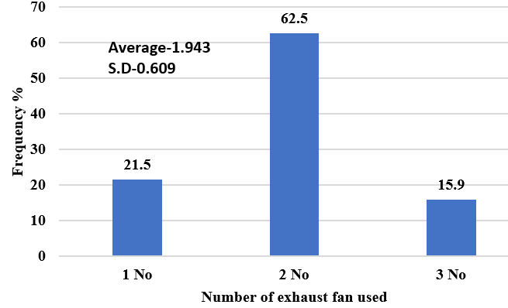
Figure 16: Number of exhaust fans used
According to Figure 16, the respondents' view of all 88 flats in selected apartments, 62.5 per cent of families are using two numbers of exhaust fans in their houses, whereas 21.5 per cent of households use one exhaust fan in their house and 15.9 per cent of families use three numbers of exhaust fans. The families who used one exhaust fan specifically used it in their frequently used toilet. The families who used two numbers of exhaust fans have used one in the kitchen and one in their toilet, and a few families used the three exhaust fans, one in the kitchen and two in their toilets, to sucks air out of the toilets and kitchens and direct it outdoors. Using an exhaust fan in the house creates air circulation in the space or ventilates the area and dries out the air. If the exhaust fan is not used in the toilets, especially then moist air remains long time for it makes paint peel off, promotes mould growth and rusts metal fixtures. It can even damage the wall and ceiling framings.
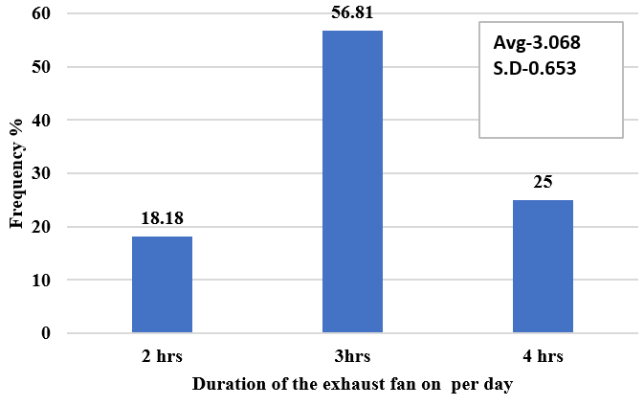
Figure 17: Daily duration of exhaust fan usage.

According to Figure 17, a significant proportion of households, approximately 56.81 per cent, utilise exhaust fans for a duration of 3 hours. About 25 per cent of the surveyed households run their exhaust fans for 4 hours, while 18.18 per cent of families prefer a usage time of 2 hours. As the apartments are located in the middle section of the building, there are narrow corridors on three sides and one common wall on the other side. To optimise ventilation in such flats, residents tend to operate their exhaust fans for 4 hours.
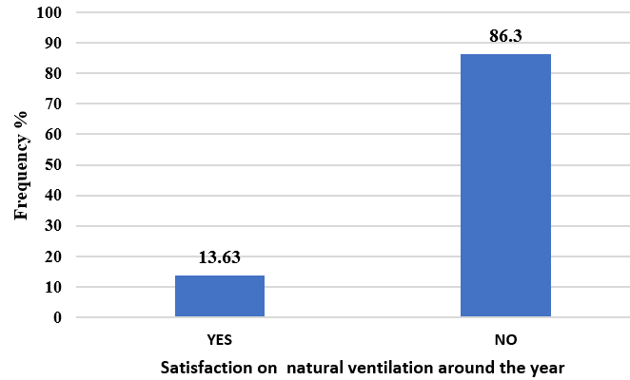
Figure 18: Satisfaction on natural ventilation

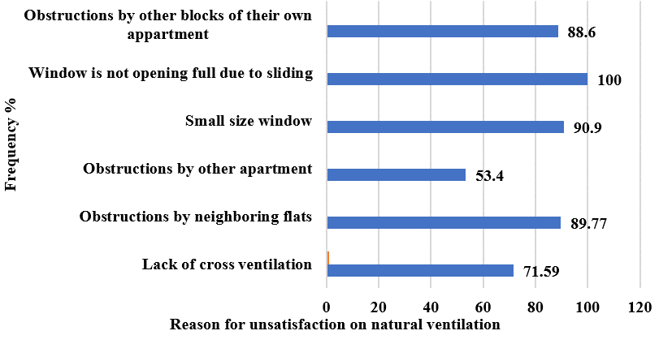
Figure 19: Reason for less natural ventilation
According to the findings presented in Figure 19, a significant majority of households, 86.3 per cent, express dissatisfaction with the natural ventilation in their homes. However, there is a minority of households, comprising 13.63 per cent, who report being satisfied with the natural ventilation. Upon further investigation, as indicated in Figure 18, it was discovered that the primary reason for unsatisfactory natural ventilation among respondents is the limited opening of windows. In fact, 100 per cent of the participants highlighted that their windows only open to 50 per cent of their full capacity due to the sliding design, resulting in reduced airflow into their homes. Furthermore, the study participants also mentioned other factors contributing to their dissatisfaction with natural ventilation. Ninety per cent of the respondents expressed dissatisfaction due to small-sized windows, while 89.77 per cent attributed their lack of satisfaction to neighbouring flats obstructing the airflow. Additionally, 88.6 per cent of households reported that their homes were hindered by other blocks within the same apartment complex. Lack of cross ventilation was cited as a reason for unsatisfactory natural ventilation by 71.59 per cent of families, and 53.4 per cent of respondents claimed that their homes were less ventilated due to obstructions from neighbouring apartments. These observations are supported by various research studies that shed light on the importance of proper ventilation in residential buildings. For instance, a study conducted demonstrated that inadequate ventilation can lead to poor indoor air quality, which in turn can have negative effects on occupants' health and well-being. The research findings further emphasise the significance of natural ventilation in reducing the risk of airborne diseases and improving overall indoor comfort.
    - Conclusion:
- The findings from the survey conducted in the apartment shed light on various aspects related to family sizes, electricity bills, window usage habits, air conditioning usage, fan usage, exhaust fan usage, and satisfaction with natural ventilation.
- The data shows that a significant proportion of families face higher electricity bills. Among the 88 surveyed families, the average electricity bill is Rs. 2205.73, with a standard deviation of approximately Rs. 490.53. The primary reason for these high electricity bills is inadequate natural ventilation or airflow in homes, which forces the inmates to depend on air conditioning and mechanical ventilation.
- Families tend to open their windows in the morning and keep them open for a considerable duration to enhance air circulation. However, there are several reasons for closing windows, including the use of air conditioning, dust, insects, and privacy concerns.
- The installation of air conditioners is common in the apartment, with the master bedroom being the most frequently air-conditioned room. The usage duration of air conditioners varies among families, with some using them for extended periods.
- Fan usage is prevalent in households due to limited natural airflow, and exhaust fans are primarily used in toilets and kitchens.
- A significant 86.3% of households report being dissatisfied with the natural ventilation in their houses, primarily because of windows that only open halfway. Inadequate ventilation is also caused by small windows (90%) and obstructions from nearby apartments (897.7%) and other buildings in the same complex (88.6%). Furthermore, 53.4% of families report impediments from nearby apartments, and 71.59% of families are impacted by a lack of cross ventilation. The percentage of homes satisfied with their natural ventilation is just 13.63%.
These findings highlight the importance of optimising natural ventilation, designing energy-efficient buildings, and promoting healthy indoor environments in residential settings.

Few recommendations
- Association between poor natural ventilation and increased electricity consumption has been investigated. It is observed that 86.1% of family have higher electricity bills between Rs.1500- 3000 and above because of frequent use of A.C. due to improper natural ventilation. Therefore, study on different types of windows on air flow pattern and air exchange efficiency can be suggested.
- Approximately 21.5 percent of the surveyed families mentioned that they keep their windows open for a slightly longer period, ranging from 14 to 16 hours daily. This extended window opening duration suggests that these households prioritize natural ventilation and air circulation within their living spaces. For this some research has to be conducted and hundred percent opening of the window should be designed to induce maximum air flow to the apartment building.
- 83.6% respondents are not satisfied with natural ventilation because windows cannot fully open, small size of window, obstruction by other blocks, obstruction by neighboring flats and lack of cross ventilation. Study of air flow pattern from windows and position of furniture for better natural ventilation can be carried out

Ethical Issues
No human-subjects research is reported, and no ethical issues are apparent. The review uses secondary literature only.

Disclaimer (Artificial intelligence)
Option 1:
Author(s) hereby declare that NO generative AI technologies such as Large Language Models (ChatGPT, COPILOT, etc.) and text-to-image generators have been used during the writing or editing of this manuscript.

References:

- Aflaki, A., Mahyuddin, N., Mahmoud, Z. A.-C., & Baharum, M. R. (2015). A review on natural ventilation applications through building façade components and ventilation openings in tropical climates. J Energy Buildings, 101, 153-162.
- Ahmed, Z. N. (2003). Natural ventilation in dense residential areas: studying alternatives. J Department of Architecture, Bangladesh University of Technology, Banglades.
- Al-Yasiri, Q., Alktranee, M., Szabó, M., & Arıcı, M. (2023). Building envelope-enhanced phase change material and night ventilation: Effect of window orientation and window-to-wall ratio on indoor temperature. J Renewable Energy, 218, 119263.
- Aldawoud, A. (2017). Windows design for maximum cross-ventilation in buildings. J Advances in building energy research, 11(1), 67-86.
- Bal-Fontaine, S., Jay, A., & Rouchier, S. (2025). Performance of natural ventilation in office buildings: impact of climate, building properties and building use. Paper presented at the Journal of Physics: Conference Series.
- Belleri, A., Lollini, R., & Dutton, S. M. (2014). Natural ventilation design: An analysis of predicted and measured performance. J Building Environment, 81, 123-138.
- Burridge, H. C., Bontitsopoulos, S., Brown, C., Carter, H., Roberts, K., Vouriot, C., . . . Noakes, C. (2023). Variations in classroom ventilation during the COVID-19 pandemic: Insights from monitoring 36 naturally ventilated classrooms in the UK during 2021. J Journal of Building Engineering, 63, 105459.
- Costanzo, V., Yao, R., Xu, T., Xiong, J., Zhang, Q., & Li, B. (2019). Natural ventilation potential for residential buildings in a densely built-up and highly polluted environment. A case study. J Renewable Energy, 138, 340-353.
- Dugolli, M. (2023). Energy efficient cooling through natural ventilation in Kosovo. J Journal of Energy Systems7(1), 30-45.
- Escombe, A. R., Oeser, C. C., Gilman, R. H., Navincopa, M., Ticona, E., Pan, W., . . . Moore, D. A. J. (2007). Natural ventilation for the prevention of airborne contagion. J PLoS medicine, 4(2), e68.
- Garg, R. (2022). Evaluating the Impact of Climate Change on the Urban Environment Using Geospatial Technologies in Bhubaneswar, India. J The International Archives of the Photogrammetry, Remote Sensing Spatial Information Sciences, 48, 159-166.
- Kubota, T., & Ahmad, S. (2005). Questionnaire survey on behavior for natural ventilation and electricity consumption in terraced houses: A case study of Johor Bahru City. Paper presented at the Asian Planning Schools Association (APSA) Conference.
- Kubota, T., Jeong, S., Toe, D. H. C., & Ossen, D. R. (2011). Energy consumption and air-conditioning usage in residential buildings of Malaysia. J Journal of international Development Cooperation, 17(3), 61-69.
- Lin, Z., & Deng, S. (2006). A questionnaire survey on sleeping thermal environment and bedroom air conditioning in high-rise residences in Hong Kong. J Energy Buildings, 38(11), 1302-1307.
- Pathirana, S., Rodrigo, A., & Halwatura, R. (2019). Effect of building shape, orientation, window to wall ratios and zones on energy efficiency and thermal comfort of naturally ventilated houses in tropical climate. J International Journal of Energy Environmental Engineering, 10(1), 107-120.
- Pradhan, A. C. (2013). The New Capital at Bhubaneswar. J Odisha Review.
- Sacht, H., & Lukiantchuki, M. A. (2017). Windows size and the performance of natural ventilation. J Procedia engineering, 196, 972-979.
- Szokolay, S., & Koenigsberger, O. (1973). Manual of tropical housing and building. Retrieved from
- Yin, W., Zhang, G., Yang, W., & Wang, X. (2010). Natural ventilation potential model considering solution multiplicity, window opening percentage, air velocity and humidity in China. J Building Environment, 45(2), 338-344.
- Zhai, Z. J., Johnson, M.-H., & Krarti, M. (2011). Assessment of natural and hybrid ventilation models in whole-building energy simulations. J Energy Buildings, 43(9), 2251-2261.

