Original Research Article

Transfer Learning for Black Pepper Disease Detection Using Entropy Based Segmentation

Abstract
Black pepper encounters significant production challenges due to major foliar diseases such as foot rot, pollu, and mottle virus. Pre-trained CNNs has been demonstrated to be effective for disease classification, but the accuracy of these models is suboptimal for black pepper disease classification due to similarity in symptoms. Furthermore, Preliminary interpretability analysis using LIME reveals that even the better-performing models do not focus on key symptomatic regions and were often influenced by irrelevant factors such as shadows and background regions, indicating their unreliability and a lack of true symptom recognition. This indicates the necessity of symptom-based segmentation prior to model training. The objective of this research is to improve the performance and reliability of pre-trained CNNs for black pepper disease classification through entropy-based symptom-aware segmentation. A dataset of 2,881 leaf images comprising five classes, Healthy, Foot rot, Pollu (initial), Pollu (advanced), and Viral disease, was collected from major pepper-growing regions of Kerala. Then entropy-based segmentation was done on the collected dataset to effectively segment disease-specific regions. Subsequently, the performance of the 15 state-of-the-art CNN architectures were evaluated on the segmented dataset. Experimental results revealed that, the use of the segmented dataset improved the accuracy of all 15 pre-trained CNN models, and LIME results indicated that the predictions were based on the relevant symptoms. Moreover, entropy-based segmentation enabled the lightweight architectures like MobileNetV2 to achieve comparable performance to deeper and more computationally intensive models. Specifically, DenseNet201, VGG19, and MobileNetV2 outperformed on the segmented dataset with accuracy above 99%. These results suggest that, combining CNNs with symptom-based segmentation can create a reliable and practical tool for monitoring black pepper diseases in real-world conditions.
Keywords: Machine Learning(ML); Deep Learning(DL); LIME (Local Interpretable Model-Agnostic Explanations); Convolutional Neural Network(CNN); Global Average Pooling(GAP), Histogram of Oriented Gradients(HOG); Gray-Level Co-Occurrence Matrix(GLCM)

Introduction
India, renowned as the home of spices, boasts a rich tradition of cultivating various spices, among which black pepper (Piper nigram L.) stands out as the "King of spices" and "Black gold." India produces about 8% of the world's black pepper, placing it fourth in the world rankings (V.Shivakumar, et al., 2022) . Its significance is not only cultural but also economic, as it holds the distinction of being the most traded spice globally (Yogesh & Mokshapathy, 2013). The states of Karnataka, Kerala, Tamil Nadu, and Andhra Pradesh are pivotal in its cultivation, with Karnataka leading in production and Kerala in terms of area (Ministry of Agriculture and Farmers Welfare, 2019-20)(National Horticulture Board, 2019-20). Kerala and Karnataka contribute 92% of the production of black pepper in the country (Thomas & Naik, 2017) . However, black pepper production faces significant challenges due to various diseases and pests affecting both nurseries and fields.
In India, pepper vines are primarily grown in hilly areas of Karnataka and Kerala, where they are susceptible to a variety of diseases due to the high temperatures and plentiful rainfall. Among the myriad of diseases, foot rot (Phytophthora capsici), anthracnose/ Pollu (Colletotrichum gloeosporioides), and mottle virus disease are prominent. These diseases manifest through diverse foliar symptoms, primarily affecting the leaves. Foot rot, in particular, a debilitating disease, is leading to high mortality rates among cuttings and substantial crop losses at any time, even in very older vines (Ravindran, et al., 2000). The major visual symptoms associated with these diseases are as follows:
- Foot rot disease
  - Lesions appear dark brown to black in colour and are relatively large in size
  - The margins of the spots are fimbriated, giving them a fringed or irregular appearance
  - Yellow halos are mostly absent around the infected areas
- Pollu disease-initial
  - Small, circular dark brown spots appear in the early stage
  - Spots are typically surrounded by a yellow halo
- Pollu disease-advanced
  - Lesions enlarge into large, irregularly shaped dark brown spots with well-defined margins
  - Small depressions are observed within the lesion areas
  - A distinct yellow halo continues to surround the lesions
- Viral Disease
  - Irregular yellow and green patches appear on the leaf surface
  - The patches are unevenly distributed, giving a mosaic appearance
Timely and accurate detection of these diseases is imperative for effective disease management. Early detection enables swift intervention measures, minimizing crop losses and preserving yields. However, traditional methods of disease detection often fall short in terms of accuracy and efficiency. The advent of machine learning (ML) presents a promising avenue for revolutionizing disease detection in agriculture. Within the realm of ML, deep learning (DL) emerges as a particularly promising technique for precisely detecting and classifying diseases from leaf images. Pre-trained convolutional neural networks (CNNs) have demonstrated remarkable capabilities in image recognition tasks, surpassing human-level performance in various domains. CNN can automatically learn features from the training data, but it may not always focus on the true symptomatic regions as it is a black-box model. So, the classification can be influenced by non-diagnostic patterns of the training data. To gain deeper insight into the trustworthiness and reliability of the model, we trained the collected black pepper dataset using pre-trained DenseNet201 architecture and subsequently applied LIME for interpretability analysis. LIME (Ribeiro, et al., 2016) is a tool designed to interpret the predictions of machine learning models. It operates by generating local surrogate models that mimic the behaviour of the original model in the neighbourhood of a specific prediction, thereby providing insight into the model’s decision-making process.
Figure 1 presents the top six features highlighted using LIME for the classification of all four diseases. We observed that the model performs well in detecting key symptomatic features such as black or brown lesions in Footrot disease, yellow halos and brown spots in Pollu disease, and yellow patches in viral infections. However, LIME does not consistently highlight all clinically relevant features, particularly in the case of Footrot disease. For instance, a distinct characteristic of Footrot, fimbriated margins, is not captured, even among the top six features identified by LIME. Also, from the features extracted in Footrot disease, it is evident that the background like shadow is influencing the model. Additionally, the 5th and 6th features in the case of early-stage Pollu disease primarily highlight unaffected leaf regions rather than symptomatic areas. In the case of viral disease, disproportionate emphasis is placed on light green regions.
This interpretability analysis reveals that, the model trained on raw dataset fails to focus on critical symptomatic regions, indicating a lack of true symptom understanding and reduced model reliability. The primary goal of this research is to improve the performance and reliability of transfer learned CNN architectures for the identification of major black pepper diseases through entropy-based symptom-aware segmentation.
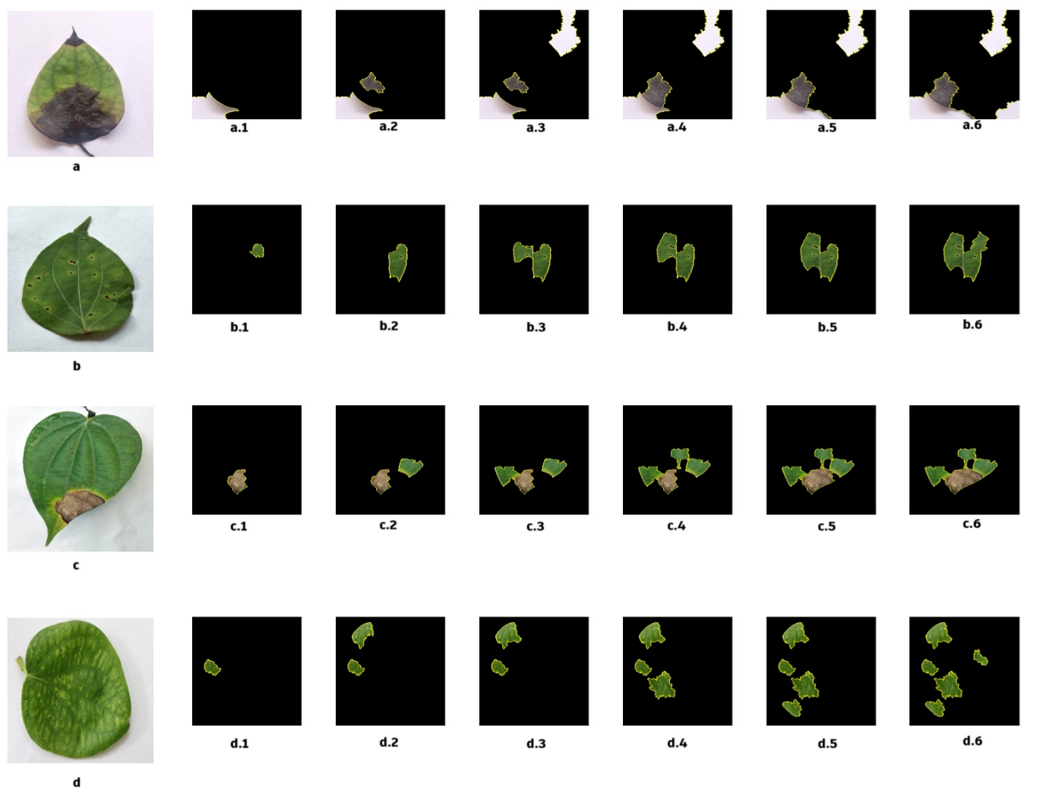
Figure 1: Top six features highlighted using LIME for the classification of all four diseases. a. Footrot Disease. b. Pollu Initial Stage. c.Pollu Advanced Stage. d.Viral(Mottle) Disease
In this paper, Section 2 is Literature Survey, Section 3 details Materials and Methods, section 4 contains Results and Discussion and Section 5 covers the Conclusions.

Literature Survey
This section provide a comprehensive overview of various plant disease detection techniques based on Deep Learning and Machine Learning.
Sudheesh et. al. (Sudhesh, et al., 2023) attempted rice leaf disease identification using DMD and transfer learning technology. The dataset includes 3416 images with classes leaf blast, bacterial blight, brown spot, tungro and healthy. DMD based preprocessing were employed to extracted the infected region or disease localization. Then they used pretrained transfer learning model such as VGG family, ResNet, Inception V3, XceptionNet, MobileNet etc. They analysed the performance of different classification models such as Random forests, Naive-Bayes and SVM models with XceptionNet features of DMD preprocessed image. Maximum accuracy (100%) were obtained for XceptionNet model. Andrew et al. (Andrew, et al., 2022) used pre-trained models based on CNN using transfer learning for accurate plant disease identification. They used plant village dataset and the images' were resized into 224 x 224 and then applied various preprocessing techniques. For classification, pre-trained models VGG-16, Inception V4, ResNet-50 and DenseNet-121 were examined. They got higher accuracy(99.81%) in DenseNet-121. Rao et al. (Rao, et al., 2021) attempted to detect and classify the leaf diseases of Grapes and Mango using the pre-trained AlexNet model. They utilized a dataset of 8,438 photos of healthy and diseased leaves were collected from the plant village dataset. The model achieved classification accuracy of approximately 99.03%. Sladojevic et. al. (Sladojevic, et al., 2016) proposed a method to detect plant diseases of apple, peach pair and grapevine, with classes healthy leaf, powdery mildew, Rust, gray leaf spot, downy mildew etc. Preprocessing included manually cropping each image to create a square around the leaves in order to highlight the area of focus. A DL caffe framework, was used to perform deep CNN training as the adopted classification algorithm. They achieved average 96.3% of accuracy. Mohanty et. al. (Mohanty, et al., 2016) made an attempt to diagnose smartphone assisted crop diseases on a global scale. They took a dataset of 54,306 images of 38 crop disease pair such as apple scab, apple black rot, apple cedar rust, blueberry healthy, tomato leaf mold etc. They evaluated the performance of AlexNet and GoogLeNet in 3 versions of the collected dataset: color, gray-scale, and leaf segmented. The model has an accuracy varies from 85.53% (in case of AlexNet) and 99.34% (in case of GoogLeNet). Sara et. al. (Sara, et al., 2025) introduced a segmentation guided transformer-based framework for leaf disease detection. To isolate disease region, U-Net++ is used and features were extracted using EfficientNetV2, SLIC superpixels and Grad-CAM. Extracted features were optimized using Bayesian optimization, and a Vision Transformer was employed for final classification. The framework is evaluated on the Cassava dataset and PlantDoc leaf disease dataset and achieved 96.2% across 16 classes.
Devi and Amarendra (Devi & Amarendra, 2020) proposed a method based on ML to extract textural information for pepper leaf disease diagnosis. Images of pepper leaves are subjected to background removal to eliminate unwanted background noise. The feature extraction methods used are, HOG and LBP. The retrieved feature's dimension was then reduced using PCA. Logistic Regression, Decision Tree, SVM, Naive Bayes with linear and RBF kernel, and HistGradientBoosting are used for classification. It has been discovered that SVM with RBF kernel & HistGradientBoosting kernels performs better than the other classifiers and highest accuracy was 89.11%. Geetha et al. (Geetha.G, et al., 2020) provides a method for the leaf disease identification to locate flaws in tomato plants with an accuracy of 70%. They took a total of 200 leaf images in which 50 for each healthy, bacterial spot, early blight and TYLCV. Before feature extraction, they did noise removal (median filter) and segmentation (K means). They chose Grey level Co-occurrence Matrix (to extract spatial dependency of texture) and Histograms of Oriented Gradients (to capture general structure of the object) for feature extraction. KNN were used for classification. Xian et al. (Xian & Ngadiran, 2021) made an attempt to classify the diseases of tomato. The preprocessing methods involves image resizing, colour space conversion (converted to HSV) and image segmentation (For removing the background). Subsequently, features were extracted using HSV histograms and Haralick texture features from each channel of the RGB color space. To classify the disease types in tomato leaves, classifiers such ELM, SVM and Decision Tree were employed. The accuracy of ELM was 84.94%, SVM was 91.43%, decision tree with 77.8%. Singh and Misra (Singh & Misra, 2016) presented a leaf disease detection of Banana, Beans, Lemon and Rose. They first retrieved the diseased/infected section by blocking green images, and then they clustered it using genetic algorithms. Various features of texture such as Contrast, Energy, Local homogeneity and entropy were computed. Maximum accuracy 95.71% is identified when SVM classifier is applied along with this. Prakash et al. (Prakash, et al., 2017) conducted the study to identify infected citrus leaves [6]. To determine luminosity, chromaticity and color space conversion were done and image enhancement technique such as K means algorithm and cluster centroids were done as the preprocessing techniques. GLCM features such as contrast (measure intensity contrast of the pixel), energy (measure uniformity), homogeneity (measures similarity among the pixel) and correlation (how the pixel and its neighborhood related) were extracted and SVM model was used for classification purpose.

Materials and Methods
The workflow of the proposed black pepper disease detection using entropy-based segmentation is presented in Figure 2.
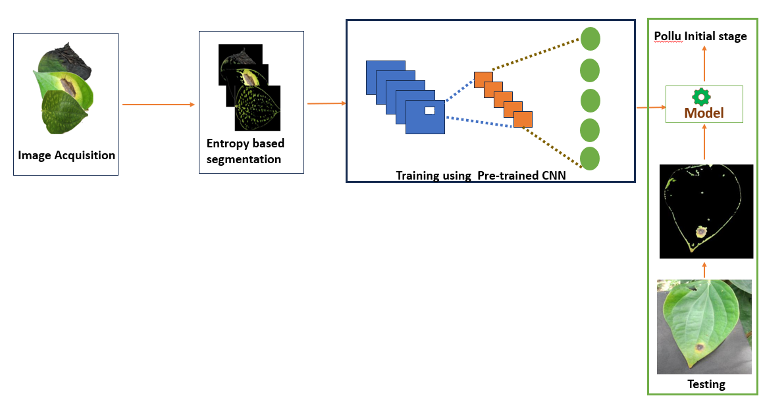
Figure 2: Classification of black pepper leaf diseases using entropy based pre-processed image

  - Dataset
The dataset includes the black pepper leaf images of various varieties like Panniyur-1, Panniyur-4, Panniyur-5, Panniyur-2, Panniyur-3, etc are sampled from different pepper growing regions in Kerala (Farmers field, Pepper research station Panniyur etc.) using smartphone devices and digital camera. The leaf samples of Healthy, Foot rot disease, Pollu disease-initial stage, Pollu disease-advanced stage and Mottle disease were collected and figure 3 shows sample images of these classes. A total of 2,881 images are taken in different light and background condition and the statistics of different classes are given in Table 1.
Table 1: Details of collected dataset
Class | Collected Dataset
Foot rot disease | 666
Pollu disease-initial | 583
Pollu disease-advanced | 280
Mottle(Viral) disease | 526
Healthy | 826

Randomly selected 10% of the collected images and kept as test dataset. Then, the training dataset is again randomly split into train and validation dataset in the ratio of 80:20, i.e., 2,060 number of images were kept for training and 518 of images were kept for validation.
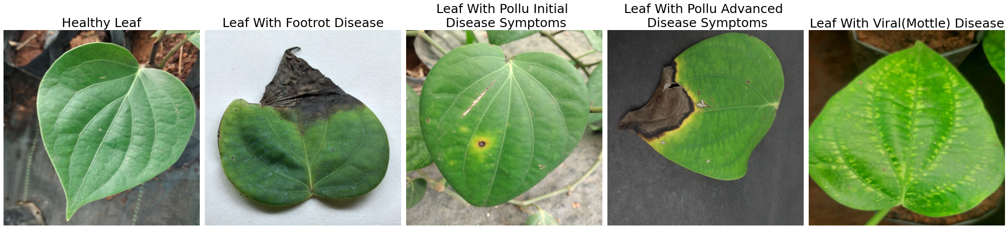
Figure 3: Sample images from each class in the black pepper leaf dataset.
To enhance the model's generalization and reduce overfitting, image augmentation has done on the training dataset using various image processing techniques. 11,088 number of images are generated after applying the image augmentation technique such as Random Rotation, Sharpening, Brightness adjustment, Color adjustment, Horizontal flipping and Vertical flipping. The augmentation technique such as zooming and shifting are not used as it is slicing the diseased area in some collected images. The number of images in Pollu disease-advanced class was less than the other classes. This would have an influence on the performance of the deep learning models. So, more artificial images were generated for Pollu disease-advanced class and the number of images after augmentation are given in Table 2.
Table 2: Number of Images Generated Through Data Augmentation
Dataset | Training Dataset
Dataset | Before Augmentation | After Augmentation
Foot rot disease | 477 | 2,385
Pollu disease-initial | 419 | 2,095
Pollu disease-advanced | 202 | 2,020
Mottle(Viral) disease | 370 | 2,220
Healthy | 592 | 2,368

  - Image Segmentation
To develop a reliable and symptom-aware model for black pepper disease detection, preprocessing is carried out to segment visually distinguishable disease symptoms. The dataset analysis revealed that, most symptoms are associated with characteristic color patterns, including black or brown lesions, yellow halos, and light green or yellow discoloration. While black and brown regions can often be segmented using simple color thresholding, detecting light yellow or green symptoms is more difficult, as healthy tender leaves may naturally exhibit similar shades and lighting variations can further affect leaf coloration. In addition to color, texture provides an important cue, since healthy leaves usually show smooth and uniform patterns, whereas diseased regions present localized irregularities. To exploit this property, an entropy-based color thresholding approach was employed, enabling the model to capture local texture variations and thus better distinguish between healthy and diseased areas.
For each pixel x, the entropy H(x) over a neighbourhood is defined as:
$-\sum_{i=0}^{n-1}{p_{i}\log_{b}{p_{i}}}$

Here, n represents the number of gray levels, pᵢ denotes the probability of a pixel having gray level i within the neighborhood, and b is the base of the logarithmic function used in the computation.
Figure 4 shows entropy visualization of selected healthy and infected leaf samples. Healthy regions of the leaf will have relatively uniform texture and thus lower entropy values, while infected region such as light green or yellow patches and fimbriated margins show higher local entropy due to increased variability. This observation served as the basis for adopting entropy-based segmentation approach.

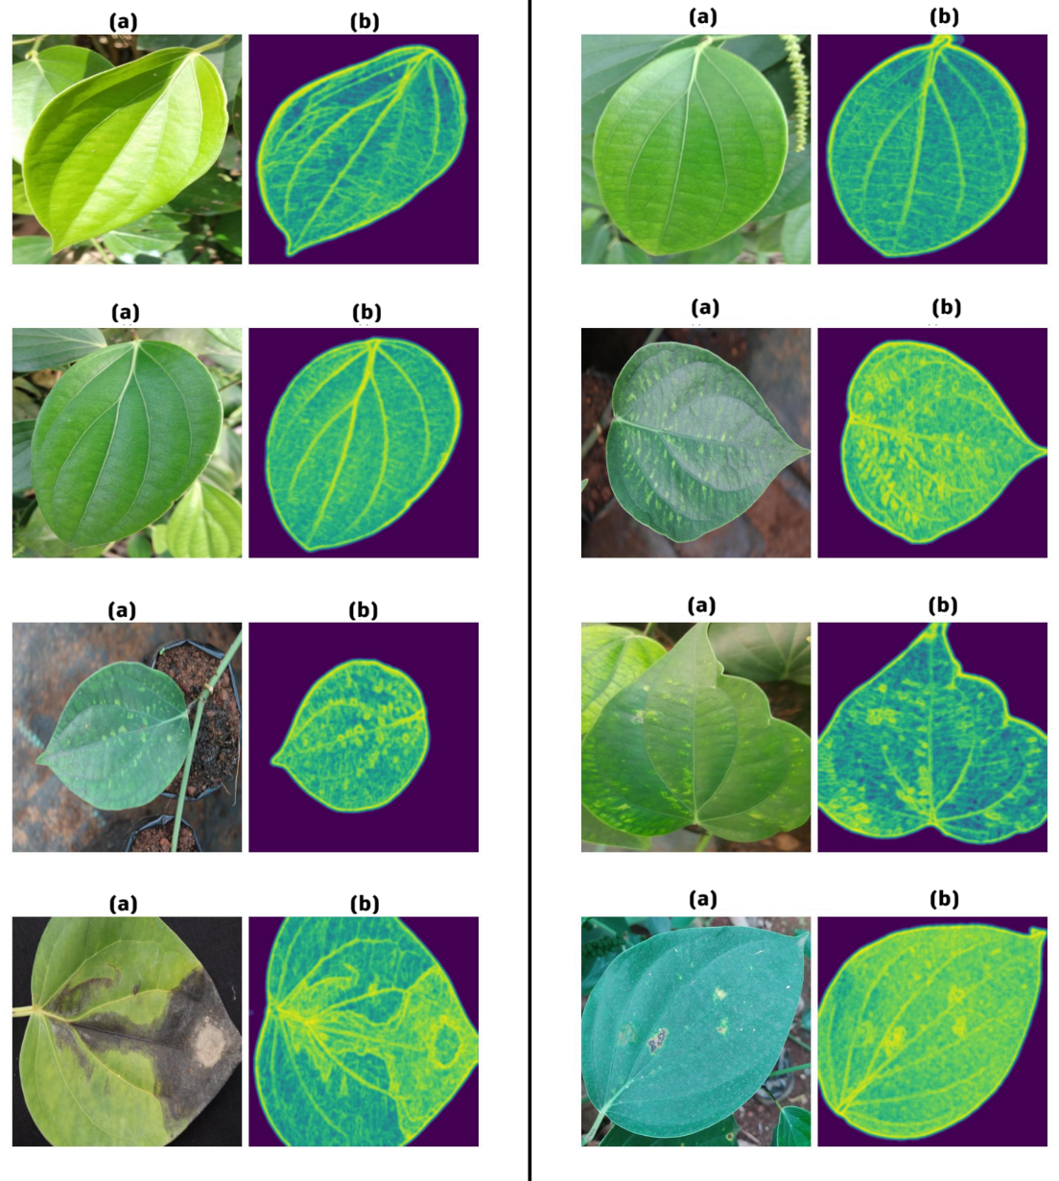
Figure 4: Entropy Visualization: (a) Original leaf image (b) Entropy of background removed image
The segmentation process involves first removing the image background to eliminate its influence on classification, followed by generating a mask to exclude green and light-yellow areas, thereby retaining only brown, black, and yellow-halo regions. Entropy is then computed on the background-removed image, and thresholding is applied to highlight subtle symptomatic areas such as light green or yellow patches and fimbriated margins. Finally, the non-green and entropy masks are combined and applied to the original image, ensuring that only disease-specific symptoms are effectively segmented.
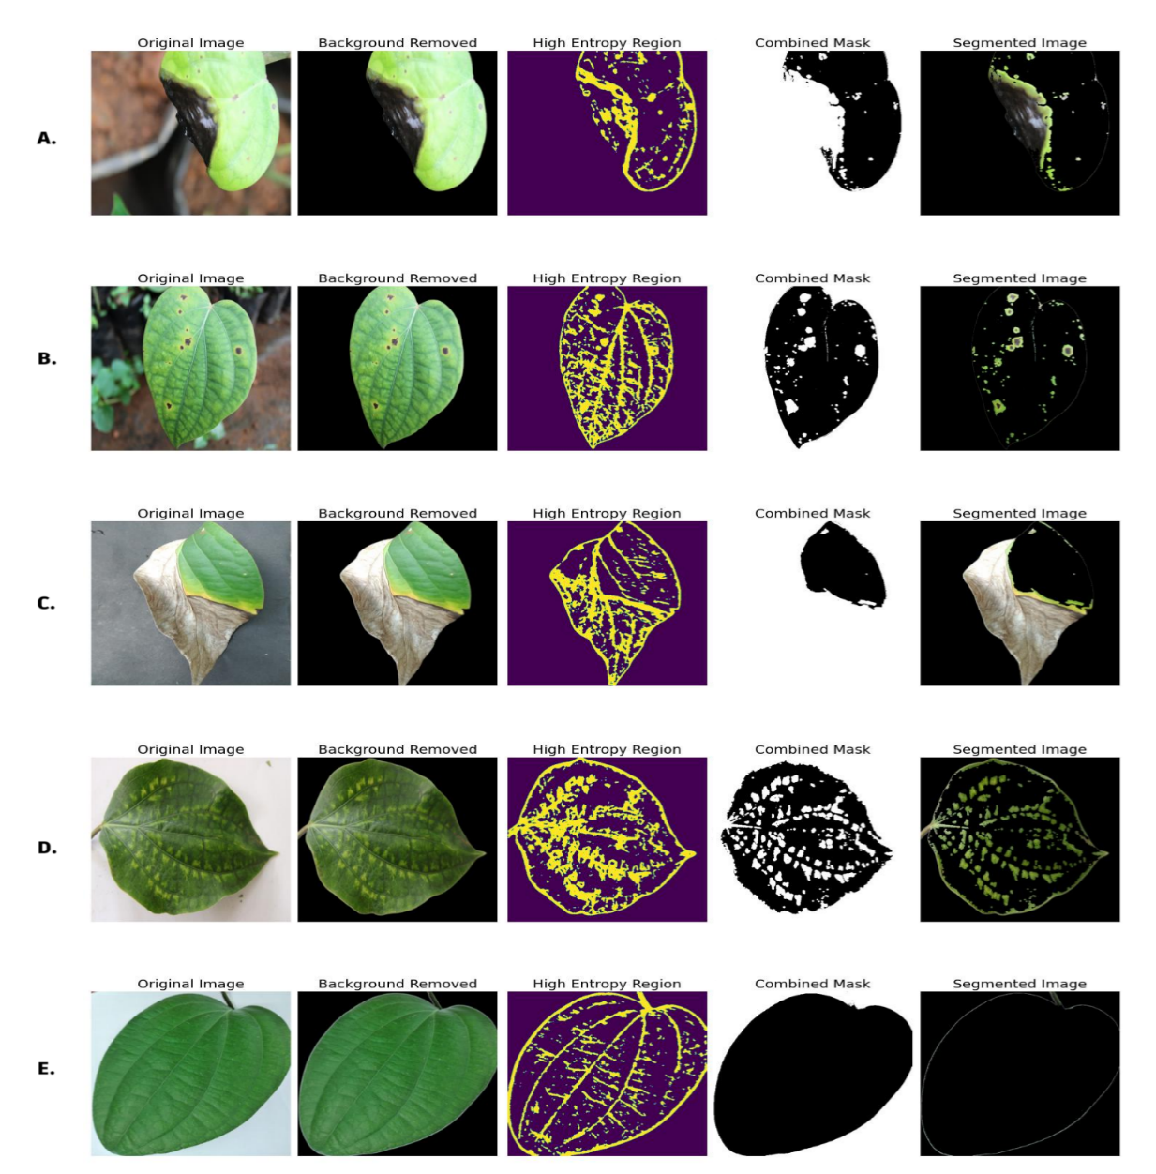
Figure 5: Different stages of proposed segmentation algorithm. A. Footrot disease. B. Pollu initial stage disease. C. Pollu advanced stage disease. D. Viral(Mottle) disease. E. Healthy leaf
The algorithm used for segmentation is summarized as follows:
- Remove the background of the image
- Create a mask to get non-green region.
- Compute the entropy of background removed image and retain only high entropy regions. Create a mask to get light yellow or light green or darker areas.
- Combine non green mask and entropy mask to get final mask.
- Apply this final mask on the original image to get segmented image.

Different stages of the segmentation algorithm is given in Figure 5. From this figure, we can say that, the algorithm is performing well in segmenting all disease symptoms. Background removal will remove non-leaf region including shadows. Non-green mask will extract the major symptoms like lesions with dark brown to black color of Footrot disease, yellow halo, dark or brown spots and black margines of pollu disease. The entropy mask is good in capturing the light yellow and green patches of viral disease and fimbriated margins of footrot disease. So, all symptoms have been effectively captured by the proposed method. Compared to deep segmentation-guided frameworks, entropy-based segmentation is computationally lightweight and do not require pixel-level annotated masks, reducing both training cost and annotation effort.
  - Training
Transfer learning is an effective approach in machine learning where a CNN trained on one problem is adapted to address a different but related problem by leveraging the knowledge gained from the original task. In this work, the performance of the 15 popular CNN pre-trained models were analysed on the segmented dataset. The steps followed are:
- Read the segmented black pepper disease dataset and resize the images.
- Load pre-trained neural network, without the final layers. Add a GAP layer and an output layer with 5 nodes.
- Train the final layers and generate model.
- Analyse the performance of the model.
The model considered for training are VGG 16, VGG 19 (Simonyan K, 2014), DenseNet121, DenseNet169, DenseNet201 (Gao Huang, 2017), ResNet50, ResNet101 (Kaiming He, 2016), Inception v3, InceptionResNet v2 (Christian Szegedy, 2016), EfficientNet (Le, 2019), MobileNet, MobileNetv2, NASNetMobile (Andrew, et al., 2017), XceptionNet (Chollet, 2016) and ConvexTiny (Radu Timofte, 2019). The approach of using GAP layer instead of flatten layer was inspired by the findings of Haque et al. (Md., et al., 2022), who demonstrated that incorporating a GAP layer in an Inception-v3-based architecture led to improved classification accuracy in maize disease detection.
The system used for training and performance analysis has the following specifications:
- CPU 12th Gen Intel Core i7-12700 CPU @ 2.10GHz, 16GB RAM and GPU NVIDIA GeForce RTX 3060 12GB.
The below hyperparameters are used in training:
- Learning Rate 0.0001, Epoch=30 with early stopping of patience level 5(Minimum validation loss), Batch size=32, Adam optimizer.
Quick convergence is observed in the models as they finished the training before 20th epoch. That why we set the epoch as 30.

Results and Discussion
The performance matric used are: accuracy, precision, recall and f1 score.
- Precision: It indicates the positive prediction accuracy of the model.
  - Precision = (𝑇𝑃) /(𝑇𝑃 +𝐹𝑃)
- Recall: It denote ability of model in detecting positive samples.
  - Recall = (𝑇𝑃)/(𝑇𝑃 +𝐹𝑁)
- F1 Score: It measures correct predictions percentage of the model.
  - 𝐹1 𝑆𝑐𝑜𝑟𝑒 = 2 ∗ (Recall ∗ Precision) /(Recall + Precision)
Here, TP is True Positive, FP is False Positive, FP is False Positive and FN is False Negative.
Python is used for training and performance analysis. Initially, image normalization and resizing were performed on the collected dataset, which is then used for building the model. The image size is chosen based on the model under consideration. Then pre-trained model is loaded, excluding the fully connected layers. Subsequently, a GAP layer and an output layer with five nodes is added. The final layers were then trained, and the results are presented in Table 3.
Most of the architectures achieved very high accuracy, precision, recall, and F1-scores, typically in the range of 98–99%, indicating the robustness of segmentation in enhancing model generalization. Among them, DenseNet201, DenseNet169, MobileNetV2, and VGG19 performed exceptionally well, each achieving testing accuracies above 99%, with balanced precision, recall, and F1-scores of 99%. This highlights their superior ability to extract discriminative features from complex symptom patterns such as yellow halos, fimbriated margins, and discoloration. Lightweight architectures such as MobileNet and MobileNetV2 showed performance comparable to deeper and computationally heavier models like DenseNet201. This suggests that the segmentation step effectively simplified the feature space by eliminating background noise, allowing even computationally efficient networks to achieve high accuracy. It is particularly useful in real-time agricultural applications, as lightweight models require less memory and lower computation time making them more suitable for edge devices, mobile platforms and resource-constrained environments. On the other hand, NASNetMobile comparatively lower testing accuracies (92.41%). It is likely due to its architectural bias toward large-scale image datasets, making it less adaptable to fine-grained leaf disease classification.

Table 3: Performance of Transfer-Learned CNN on Segmented Dataset
Model | Training Accuracy | Testing Accuracy | Precision | Recall | F1 Score
XceptionNet | 99.81% | 98.35% | 98.00% | 98.00% | 98.00%
VGG19 | 99.61% | 99.01% | 99.00% | 99.00% | 99.00%
VGG16 | 98.85% | 97.69% | 98.00% | 98.00% | 98.00%
DenseNet121 | 99.75% | 98.68% | 99.00% | 99.00% | 99.00%
DenseNet169 | 99.86% | 99.01% | 99.00% | 99.00% | 99.00%
DenseNet201 | 99.96% | 99.01% | 99.00% | 99.00% | 99.00%
EfficientNet | 99.72% | 96.37% | 97.00% | 97.00% | 97.00%
InceptionV3 | 99.85% | 96.04% | 96.00% | 96.00% | 96.00%
InceptionResNetV2 | 99.90% | 97.69% | 98.00% | 98.00% | 98.00%
MobileNet | 99.94% | 99.01% | 99.00% | 99.00% | 99.00%
MobileNetV2 | 99.84% | 99.34% | 99.00% | 99.00% | 99.00%
NASNetMobile | 99.81% | 92.41% | 94.00% | 92.00% | 92.00%
ResNet50 | 98.85% | 97.36% | 97.00% | 97.00% | 97.00%
Resnet101 | 98.84% | 98.68% | 99.00% | 99.00% | 99.00%
ConvNeXtTiny | 98.58% | 95.71% | 96.00% | 96.00% | 96.00%

We also evaluated the performance of these 15 models on the unsegmented dataset as well. The result obtained is given in Table 4. The comparative analysis of models shows that, DenseNet201 and XceptionNet achieved the best overall performance, with testing accuracies of 97.03% and 96.70%, respectively, along with consistently high precision, recall, and F1-scores (97%). Lightweight models such as MobileNet and MobileNetV2 achieved only moderate performance (93–94% accuracy). EfficientNet and ConvNeXtTiny delivered lower accuracies (~91%), and NASNetMobile performed the weakest (89.44% testing accuracy, F1-score 89%) despite high training accuracy, indicating overfitting.

Table 4: Performance of Transfer-Learned CNN on unsegmented Dataset
Model | Training Accuracy | Testing Accuracy | Precision | Recall | F1 Score
XceptionNet | 99.98% | 96.70% | 97.00% | 97.00% | 97.00%
VGG19 | 99.65% | 94.72% | 95.00% | 95.00% | 95.00%
VGG16 | 98.94% | 95.05% | 95.00% | 95.00% | 95.00%
DenseNet121 | 99.95% | 96.04% | 96.00% | 96.00% | 96.00%
DenseNet169 | 99.82% | 96.04% | 97.00% | 96.00% | 96.00%
DenseNet201 | 99.86% | 97.03% | 97.00% | 97.00% | 97.00%
EfficientNet | 99.68% | 91.42% | 92.00% | 91.00% | 91.00%
InceptionV3 | 99.93% | 95.38% | 95.00% | 95.00% | 95.00%
InceptionResNetV2 | 99.91% | 94.06% | 94.00% | 94.00% | 94.00%
MobileNet | 94.32% | 93.07% | 94.00% | 93.00% | 93.00%
MobileNetV2 | 99.77% | 94.39% | 95.00% | 94.00% | 94.00%
NASNetMobile | 99.91% | 89.44% | 91.00% | 89.00% | 89.00%
ResNet50 | 99.86% | 94.72% | 95.00% | 95.00% | 95.00%
Resnet101 | 99.30% | 95.05% | 95.00% | 95.00% | 95.00%
ConvNeXtTiny | 99.91% | 91.42% | 93.00% | 91.00% | 91.00%

The comparison on model Performance with unsegmented vs Segmented Leaf images is shown in Figure 6. It reveals that segmentation significantly enhances classification accuracy across pretrained CNN architectures. The graph highlights the advantage of segmentation in suppressing background noise and emphasizing symptomatic regions, thereby enabling the models to generalize better and achieve higher testing accuracy. Overall, these results confirm that segmentation is a critical preprocessing step for disease detection in black pepper. It not only enhances the performance of state-of-the-art architectures but also allows lightweight models to achieve accuracy on par with deeper networks, offering both accuracy and efficiency for practical applications.
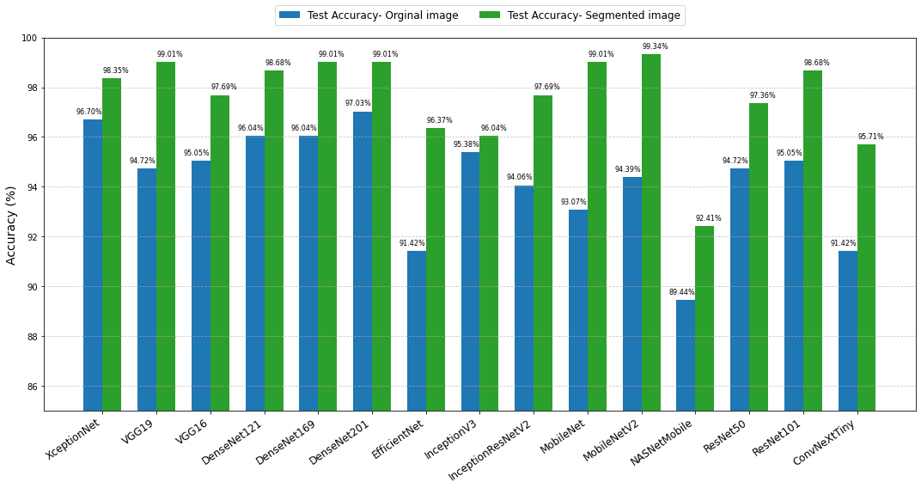
Figure 6: Model Performance: Unsegmented vs Segmented Leaf Images

The confusion matrix of MobileNetV2(Better Performed Model) with unsegmented dataset and segmented dataset is given in Figure 7. In the unsegmented case (Figure a), misclassifications were observed in all classes except Pollu_initial. In contrast, the segmented approach (Figure b) significantly improved class-level accuracies, with near-perfect classification across most disease categories. For example, Footrot accuracy improved from 84.29% to 98.57%, while Healthy, Pollu Advanced, and Pollu Initial reached 100% classification accuracy. Misclassification of viral diseases was also reduced, achieving 98.33%. Overall, segmentation minimized inter-class confusion, particularly between Footrot and Viral symptoms, resulting in more reliable disease discrimination.

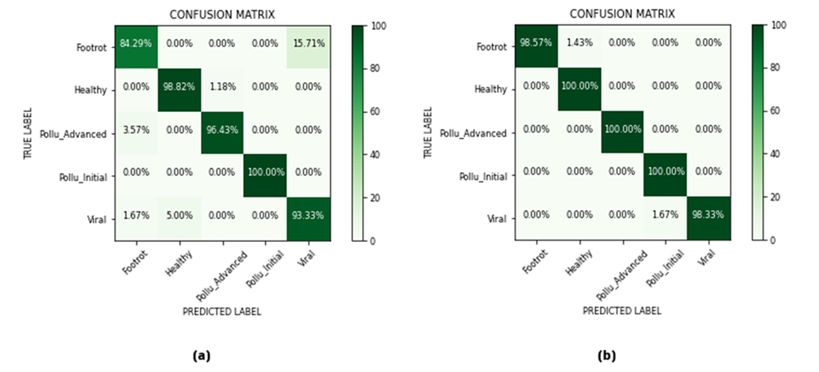
Figure 7: Confusion Matrix of MobileNetV2: (a) with unsegmented dataset (b) with segmented dataset
To assess the trustworthiness and reliability of the model trained on the segmented dataset, we employed LIME. Figure 8 shows the top six features highlighted using LIME for the classification of all four diseases with the segmented dataset. First column shows the image of leaf with symptom, 2nd one shows the corresponding segmented image, a to f shows the extracted top six features.
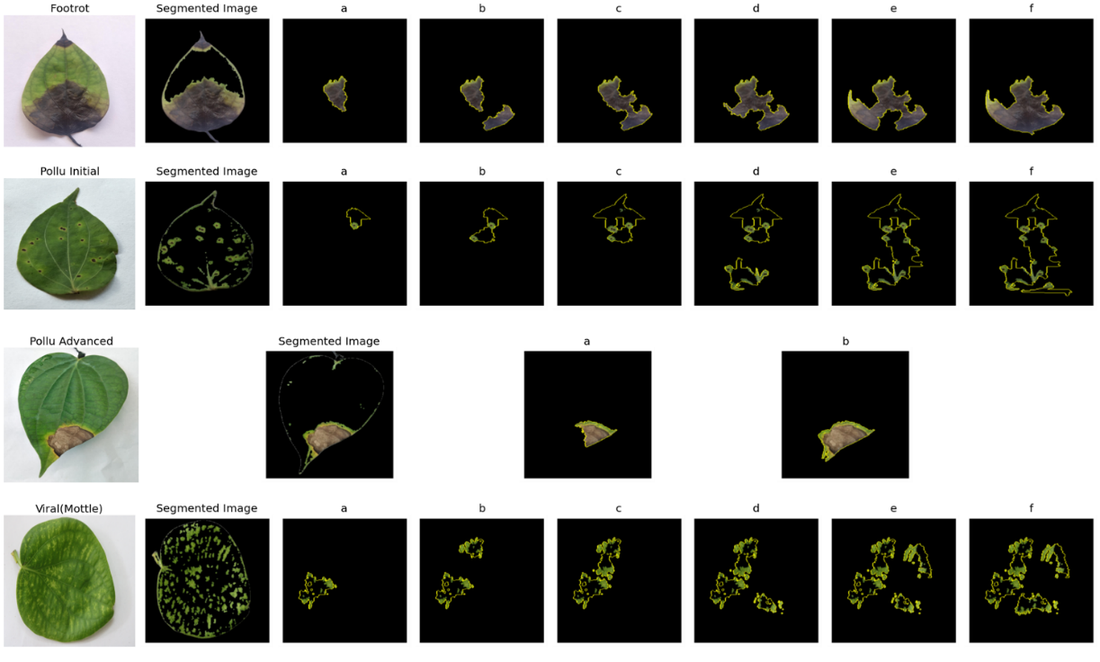
Figure 8: Top six features highlighted using LIME for the classification of all four diseases on segmented image
The LIME results indicate that the model effectively identifies all major symptoms associated with the four black pepper diseases. In the case of Footrot disease, the fimbriated margin, a key distinguishing feature, is prominently highlighted in the first feature itself, along with accurate detection of black and brown lesions. All features on Pollu initial stage, highlights atleast one symptom,i.e., brown spot with yellow halo. The brown lesions with depression and yellow halo is highlighted in the first and second features of pollu advanced stage. Similarly, for viral disease, equal importance is given to both yellow and green patches, reflecting a balanced understanding of symptom distribution. These factors indicate the symptom-aware segmentation significantly improved the explainability and reliability of the disease detection model.
The experimental results demonstrate that transfer learning with pre-trained CNN architectures with entropy-based segmentation significantly enhances black pepper disease detection accuracy and reliability.

Conclusion
The integration of machine learning, particularly deep learning, holds immense potential for advancing disease detection and management in black pepper cultivation. In this study, the performance and reliability of 15 pre-trained CNNs were analysed on black pepper disease dataset with five classes, Healthy, Foot rot, Pollu (initial), Pollu (advanced), and Viral disease. Explainable AI is employed, Specifically, LIME is used to visualize, interpret and validate the predictions made by the deep learning model. XceptionNet(96.70%) and DenseNet201(97.03%) with GAP layer has showed highest accuracy on the collected dataset. But the interpretability analysis using LIME revealed that, models do not focus on key symptomatic regions, suggesting their unreliability and a lack of true symptom recognition. To improve the accuracy and reliability of the model, entropy-based symptom-aware segmentation is done and it is an effective method to segment all disease symptoms including light green and yellow shades of viral disease. With segmentation, Models such as DenseNet201, VGG19, and MobileNetV2 consistently achieved superior performance with testing accuracies above 99%. LIME results on the segmented dataset indicated that the predictions were based on the major disease symptoms. Overall, the integration of domain-specific preprocessing offers a robust and reliable solution for disease classification in black pepper, with potential for practical deployment and real-time monitoring in agricultural diagnostics.
Declarations Conflict of interest statement
The authors state that there are no conflicts of interest.
Disclaimer (Artificial intelligence)
Option 1:
Author(s) hereby declare that NO generative AI technologies such as Large Language Models (ChatGPT, COPILOT, etc.) and text-to-image generators have been used during the writing or editing of this manuscript.

References
Andrew, J., Eunice, J., Popescu, D. E., Chowdary, M. K., & Hemanth, J. (2022). Deep Learning-Based Leaf Disease Detection in Crops Using Images for Agricultural Applications. Agronomy. https://doi.org/10.3390/agronomy12102395
Howard, A. G., Zhu, M., Chen, B., Kalenichenko, D., Wang, W., Weyand, T., Andreetto, M., & Adam, H. (2017). MobileNets: Efficient Convolutional Neural Networks for Mobile Vision Applications. https://arxiv.org/abs/1704.04861
Chollet, F. (2017). Xception: Deep Learning with Depthwise Separable Convolutions. 2017 IEEE Conference on Computer Vision and Pattern Recognition (CVPR) https://doi.org/10.1109/CVPR.2017.735
Szegedy, C., Vanhoucke, V., Ioffe, S., Shlens, J., & Wojna, Z. (2016). Rethinking the Inception Architecture for Computer Vision. 2016 IEEE Conference on Computer Vision and Pattern Recognition (CVPR). https://doi.org/10.1109/CVPR.2016.308
Devi, M. B., & Amarendra, K. (2021). Machine Learning-Based Application to Detect Pepper Leaf Diseases Using HistGradientBoosting Classifier with Fused HOG and LBP Features. In S. K. Saha, P. S. Pang & D. Bhattacharyya (Eds.), Smart Technologies in Data Science and Communication (pp. 359-369). Springer. https://doi.org/10.1007/978-981-16-1773-7_29
Huang, G., Liu, Z., van der Maaten, L., & Weinberger, K. Q. (2017). Densely Connected Convolutional Networks. Proceedings of the IEEE Conference on Computer Vision and Pattern Recognition (CVPR). https://doi.org/10.1109/CVPR.2017.243
Geetha, G., Samundeswari, S., Saranya, G., Meenakshi, K., & Nithya, M. (2020). Plant Leaf Disease Classification and Detection System Using Machine Learning. Journal of Physics: Conference Series. https://doi.org/10.1088/1742-6596/1712/1/012012
Huang, G., Liu, Z., van der Maaten, L., & Weinberger, K. Q. (2017). Densely Connected Convolutional Networks. Proceedings of the IEEE Conference on Computer Vision and Pattern Recognition (CVPR), 2261-2269. https://doi.org/10.1109/CVPR.2017.243
He, K., Zhang, X., Ren, S., & Sun, J. (2016). Deep Residual Learning for Image Recognition. Proceedings of the IEEE Conference on Computer Vision and Pattern Recognition (CVPR) https://doi.org/10.1109/CVPR.2016.90
He, K., Zhang, X., Ren, S., & Sun, J. (2016). Deep Residual Learning for Image Recognition. 2016 IEEE Conference on Computer Vision and Pattern Recognition (CVPR). https://doi.org/10.1109/CVPR.2016.90
Weiss, K., Khoshgoftaar, T. M., & Wang, D. (2016). A survey of transfer learning. Journal of Big Data, 3(1), 1–40. https://doi.org/10.1186/s40537-016-0043-6
Tan, M., & Le, Q. V. (2019). EfficientNet: Rethinking Model Scaling for Convolutional Neural Networks. https://doi.org/10.48550/arXiv.1905.11946.
Tan, M., & Le, Q. V. (2019). EfficientNet: Rethinking Model Scaling for Convolutional Neural Networks. arXiv preprint arXiv:1905.11946. https://doi.org/10.48550/arXiv.1905.11946
Haque, M. A., Marwaha, S., Deb, C., Singh, R. K., Jha, S. K., Singh, R. K. P., & Agrawal, R. (2022). Deep learning-based approach for identification of diseases of maize crop. Scientific Reports. https://doi.org/10.1038/s41598-022-10140-z
Ministry of Agriculture and Farmers Welfare, Government of India. (2020). Annual Report 2019-20. https://agriwelfare.gov.in/sites/default/files/Annual%20Report%202019-20.pdf
Mistry, V. (2024). Explainable AI(XAI) using LIME and Disease Detection in Mango Leaf by Transfer Learning Approach. *International Research Journal of Engineering and Technology (IRJET)*, *11*(02), 72-76. https://www.irjet.net/archives/V11/i2/V11I2.pdf
Mohanty, S. P., Hughes, D. P., & Salathé, M. (2016). Using deep learning for image-based plant disease detection. Frontiers in Plant Science, 7, 1419. https://doi.org/10.3389/fpls.2016.01419
Prakash, M. R., Saraswathy, G. P., & Ramalakshmi, G. (2017). Detection of leaf diseases and classification using digital image processing. International Conference on Innovations in Information, Embedded and Communication Systems (ICIIECS). https://doi.org/10.1109/ICIIECS.2017.8275915
Timofte, R., Horiguchi, S., Kanezaki, A., & Suzuki, S. (2019). ConvexTyni: Efficient Architecture Search for Convex Neural Networks. https://doi.org/10.1109/ICCVW.2019.00090
Rao, S. U., Swathi, R., Sanjana, V., Arpitha, L., Chandrasekhar, K., Chinmayi, & Naik, P. K. (2021). Deep Learning Precision Farming: Grapes and Mango Leaf Disease Detection by Transfer Learning. Global Transitions Proceedings, 2, 535-544. https://doi.org/10.1016/j.gltp.2021.08.002
Ravindran, P. N., Nirmal Babu, K., Sasikumar, B., & Krishnamurthy, K. S. (2000). Botany and crop improvement of black pepper. In P. N. Ravindran (Ed.), *Black pepper: Piper nigrum* (pp. 23-142). Harwood Academic Publishers. https://doi.org/10.1201/9780203303870.
Ribeiro, M. T., Singh, S., & Guestrin, C. (2016). “Why Should I Trust You?”: Explaining the Predictions of Any Classifier. https://doi.org/10.48550/arXiv.1602.04938
Sandler, M., Howard, A., Zhu, M., Zhmoginov, A., & Chen, L.-C. (2018). MobileNetV2: Inverted Residuals and Linear Bottlenecks. IEEE/CVF Conference on Computer Vision and Pattern Recognition. https://doi.org/10.1109/CVPR.2018.00474
Simonyan, K., & Zisserman, A. (2014). Very Deep Convolutional Networks for Large-Scale Image Recognition. arXiv preprint https://arxiv.org/abs/1409.1556
Simonyan, K., & Zisserman, A. (2014). Very deep convolutional networks for large-scale image recognition. https://doi.org/10.48550/arXiv.1409.1556
Singh, V., & Misra, A. K. (2016). Detection of plant leaf diseases using image segmentation and soft computing techniques. Information Processing in Agriculture, 4(1), 41-49. https://doi.org/10.1016/j.inpa.2016.10.005.
Sladojevic, S., Arsenovic, M., Anderla, A., Culibrk, D., & Stefanovic, D. (2016). Deep neural networks based recognition of plant diseases by leaf image classification. Computational Intelligence and Neuroscience, 2016, Article ID 3289801. https://doi.org/10.1155/2016/3289801.
Sudhesh, K. M., Sowmya, V., Sainamole Kurian, P., & Sikha, O. K. (2023). AI based rice leaf disease identification enhanced by Dynamic Mode Decomposition. Engineering Applications of Artificial Intelligence, 120, 105836. https://doi.org/10.1016/j.engappai.2023.105836
Szegedy, C., Ioffe, S., Vanhoucke, V., & Alemi, A. (2017). Inception-v4, Inception-ResNet and the impact of residual connections on learning. Proceedings of the AAAI Conference on Artificial Intelligence, 31(1). https://doi.org/10.1609/aaai.v31i1.11231
Szegedy, C., Vanhoucke, V., Ioffe, S., Shlens, J., & Wojna, Z. (2016). Rethinking the Inception Architecture for Computer Vision. 2016 IEEE Conference on Computer Vision and Pattern Recognition (CVPR) https://doi.org/10.1109/CVPR.2016.308
Thomas, L. M., & Naik, B. G. (2017). Survey for the Incidence of Foot Rot of Black Pepper Caused by Phytophthora capsici Leonian in Shivamogga and Chickmagaluru Districts of Karnataka State. International Journal of Pure & Applied Bioscience, 5(1), 293-298. https://doi.org/10.18782/2320-7051.2562
Shivakumar, K. V., Somasekhara, Y. M., Nagaraju, N., Ravikumar, R. L., Rangaswamy, K. T., & Narsegowda, N. C. (2022). Survey for the incidence of foot root disease of black pepper in Karnataka. *The Pharma Innovation Journal*, *11*(Special Issue 9), 1386-1390. https://www.thepharmajournal.com/archives/2022/vol11/issue9/
Xian, T. S., & Ngadiran, R. (2021). Plant Diseases Classification using Machine Learning. Journal of Physics: Conference Series, 1962(1), 012024. https://doi.org/10.1088/1742-6596/1962/1/012024
Yogesh, B. G., & Mokshapathy, S. (2013). The King of Spices: A Review on Black Pepper (Piper nigrum L.). Asian Journal of Plant Science and Research, 3(2), 62-70.
Zoph, B., Vasudevan, V., Shlens, J., & Le, Q. V. (2018). Learning Transferable Architectures for Scalable Image Recognition. 2018 IEEE/CVF Conference on Computer Vision and Pattern Recognition. https://doi.org/10.1109/CVPR.2018.00907 .
Mumtaz, Sara & Jalal, Ahmad. (2025). Bayesian-Optimized Framework For Segmentation Guided Transformer-based Leaf Disease Detection.

