Chilli Performance under Integrated Organic and Inorganic Nutrient Management
Abstract
Chilli (Capsicum annuum L.) is a nutritionally and economically important crop that requires balanced nutrient management for optimal growth and yield. A two-year field study (2022–23 and 2023–24) was conducted at the Vegetable Research Farm, Institute of Agricultural Sciences, BHU, Varanasi, to evaluate the effect of integrated nutrient management (INM) on growth, yield and quality of chilli cultivar Kashi Anmol. Thirteen treatments combining inorganic fertilizers, organic manures (vermicompost, poultry manure, farmyard manure) and biofertilizers (Azospirillum and Phosphate Solubilizing Bacteria) were tested in a randomized block design with three replications. Results revealed that treatments T₅ (50% RDF + 50% vermicompost + biofertilizers) and T₇ (50% RDF + 50% poultry manure + biofertilizers) significantly enhanced plant height, branching, leaf area index, fruit weight, shelf life, total soluble solids and ascorbic acid content, while maintaining soil health and reducing chemical fertilizer dependency. The study demonstrates that integrated application of organic and inorganic nutrients, along with biofertilizers, is an effective and sustainable strategy to improve chilli productivity and quality.
Keywords: Capsicum annuum, integrated nutrient management, vermicompost, poultry manure, biofertilizers, growth, yield, quality, sustainable agriculture
Introduction
Chilli (Capsicum annuum L.) is an economically significant spice and vegetable crop of the family Solanaceae (Chouhan et al., 2018). It is widely cultivated in tropical and subtropical regions of the world due to its adaptability, high market demand and diverse culinary applications. India leads in both production and export of dry chilli, contributing around 42% of the global output with 1.74 million tonnes from 0.78 million hectares (FAOSTAT, 2021). Chilli is valued for its pungency, flavour and aroma, enhancing various dishes such as curries, pickles, sauces and chutneys. Nutritionally, it is a rich source of vitamins A, C and E, capsaicin, carotenoids, antioxidants and essential minerals like potassium, calcium, phosphorus and iron, contributing to human health and nutrition (Chakrabarty et al., 2017; Behera et al., 2020). Despite its nutritional and economic importance, chilli is a nutrient-exhaustive crop that depletes significant amounts of nutrients from the soil. The widespread adoption of high-yielding varieties and hybrids has further increased the dependency on chemical fertilizers to meet crop nutrient demands. Although chemical fertilizers have contributed to enhancing chilli productivity, their continuous and imbalanced use has resulted in soil degradation, nutrient imbalance, reduced microbial activity, environmental pollution and adverse effects on human health. Moreover, the escalating cost of chemical fertilizers increases production expenses and reduces farmers’ profitability.
To mitigate these challenges, Integrated Nutrient Management (INM) has emerged as a sustainable approach. INM involves the judicious combination of organic manures, biofertilizers and inorganic fertilizers to ensure balanced nutrient supply, improve soil health and enhance crop productivity. Organic sources such as farmyard manure, vermicompost, neem cake and poultry manure, along with biofertilizers like Azospirillum, Azotobacter and Phosphate Solubilizing Bacteria (PSB), improve soil structure, water-holding capacity, enzymatic activity and microbial diversity (Ali et al., 2024). When integrated with recommended doses of chemical fertilizers, bio-organic inputs enhance nutrient synchronization with crop demand, minimize nutrient losses and sustain soil fertility in the long term. Among biofertilizers, PSB and Azospirillum, along with balanced application of NPK fertilizers, play a crucial role in improving nutrient availability in chilli. PSB convert insoluble forms of phosphorus into plant-available forms through the secretion of organic acids and enzymes, thereby enhancing phosphorus uptake and root development (Mahfouz et al., 2007). Azospirillum, as associative nitrogen-fixing bacterium, inhabits the rhizosphere of chilli plants and promotes biological nitrogen fixation, root proliferation, chlorophyll synthesis and overall plant growth (Arancon et al., 2005; Mahfouz et al., 2007). While NPK fertilizers are essential for achieving higher yield and fruit quality, their excessive use can lead to soil nutrient degradation and ecological imbalance. The integration of NPK fertilizers with PSB and Azospirillum in an INM system has demonstrated significant potential to enhance nutrient use efficiency, sustain yield and maintain soil health. The synergistic effect of biofertilizers and inorganic fertilizers ensures continuous nutrient supply, promotes microbial activity, boosts nutrient mineralization and improves soil physical and biological properties (Meena et al., 2025). Several studies have reported that the combined application of NPK, PSB and Azospirillum significantly enhances nutrient uptake, fruit yield, quality attributes and profitability in chilli while reducing dependency on chemical fertilizers (Ali et al., 2024; Sheetal et al., 2024). Therefore, the present investigation was undertaken to evaluate the effect of integrated application of NPK, PSB and Azospirillum and organic amendments on crop growth, yield and quality in chilli cultivation.
Materials and Methods
The study was conducted during the Rabi seasons of 2022–23 and 2023–24 at the Vegetable Research Farm, Department of Horticulture, Institute of Agricultural Sciences, BHU, Varanasi, Uttar Pradesh, India. The experimental site, located at 25°10′ N latitude and 83°03′ E longitude at an elevation of 80.71 m, falls in the North Gangetic Alluvial Plains and features well-drained alluvial soils with uniform topography. The region experiences a humid subtropical climate with hot summers (32–45°C), cool winters (6–9°C) and an annual rainfall of ~1,110 mm (Figure 1). Pre-planting composite soil samples (0–15 cm) indicated sandy clay loam texture, slightly alkaline pH (7.78–7.85), 0.44–0.45% organic carbon and low to medium levels of available N (200–205 kg ha⁻¹), P (26.5–27.8 kg ha⁻¹) and K (190–192 kg ha⁻¹).
The experiment was carried out on chilli variety Kashi Anmol using 13 treatments combining inorganic fertilizers (RDF), organic manures (vermicompost, poultry manure, FYM) and biofertilizers (Azospirillum + Phosphate Solubilizing Bacteria) arranged in a Randomized Block Design (RBD) with three replications. Each 3 × 3 m plot contained 25 plants spaced at 60 × 45 cm. Uniform agronomic practices, including irrigation, weeding, staking and pest management, were maintained across treatments. Growth, yield and quality traits were recorded at 60 days after transplanting (DAT), including plant height (PH60), number of primary branches per plant (NPB60), internodal length (IL60), average fruit weight (AFW, g), seed yield per plot (SYPP, kg/ha), shelf life (days), fruit pH, total soluble solids (TSS, °Brix) and ascorbic acid content (mg/100 g). Data were statistically analyzed using analysis of variance (ANOVA) for a RBD as described by Panse and Sukhatme (1985) with pooled ANOVA over two years and treatment differences were tested using F-test at 5% probability level. Standard error of mean (SEm ±) and least significant difference (LSD) at 5% were calculated for mean comparisons, with statistical computations performed using OPSTAT and R-studio.
Table 1: List of Treatment Details
Symbol | Treatment Description
T₁ | Vermicompost (100% @ 6 t/ha)
T₂ | Farmyard Manure (100% @ 25 t/ha)
T₃ | Poultry Manure (100% @ 5 t/ha)
T₄ | RDF (100% @ 150 kg N, 60 kg P₂O₅, 60 kg K₂O/ha)
T₅ | RDF (50%) + VC (50%) + Azospirillum and PSB (100%) @ 2.5 kg/ha each
T₆ | RDF (50%) + FYM (50%) + Azospirillum and PSB (100%) @ 2.5 kg/ha each
T₇ | RDF (50%) + PM (50%) + Azospirillum and PSB (100%) @ 2.5 kg/ha each
T₈ | RDF (50%) + 16.6% VC + 16.6% FYM + 16.6% PM + Azospirillum and PSB (100%) @ 2.5 kg/ha each
T₉ | RDF (25%) + VC (75%) + Azospirillum and PSB (100%) @ 2.5 kg/ha each
T₁₀ | RDF (25%) + FYM (75%) + Azospirillum and PSB (100%) @ 2.5 kg/ha each
T₁₁ | RDF (25%) + PM (75%) + Azospirillum and PSB (100%) @ 2.5 kg/ha each
T₁₂ | RDF (25%) + 25% VC + 25% FYM + 25% PM + Azospirillum and PSB (100%) @ 2.5 kg/ha each
T₁₃ | Untreated control

Results and Discussion
The pooled data over two years revealed significant differences among treatments for vegetative growth parameters. T₄ recorded the highest PH60 (39.09 cm), followed by T₁ and T₈ (38.45 and 38.13 cm, respectively), which were statistically at par (Table 2 and Figure 2). The lowest PH60 was in T₁₃ (control; 33.48 cm). These results suggest that RDF ensures maximum vegetative growth, however, partial substitution with organics and biofertilizers (T₅, T₆, T₈, T₁₀) provided comparable growth while reducing dependency on chemical fertilizers. Similar findings were reported by Jayanthi et al. (2014) and Khaitov et al. (2019). A maximum number of NPB60 was recorded in T₅ (7.72), followed by T₇ (7.49) and T₁₀ (7.32). The untreated control (T₁₃) recorded the minimum number (5.61). Enhanced branching under T₅ may be attributed to improved nutrient synchronization and microbial activity. These results agree with Divya et al. (2018) and Khan et al. (2012). LAI60 was maximized in T₅ and T₁₁ (0.88), followed closely by T₆, T₁, T₁₀, T₄ and T₁₂ (0.85–0.86). The lowest LAI60 was observed in T₁₃ (0.76). Increased LAI60 under INM indicates improved canopy development due to balanced nutrient supply. Similar observations were documented by Meena et al. (2025) and Kumar et al. (2024). IL60 was highest in T₁ (4.80 cm), followed by T₄, T₁₂ and T₁₃ (4.71 cm). Minimum IL60 was observed in T₂ (3.96 cm). Vermicompost-based treatments enhanced internode elongation due to better soil structure, aeration and sustained nutrient release (Chitla et al., 2024).
The data pertaining to yield and quality attributes are presented in Table 3 and Figure 2. For AFW, T₇ (3.44 g) was superior, followed by T₅ (3.38 g) and T₉ (3.28 g), whereas the lowest was in T₁₃ (2.68 g). Poultry manure and vermicompost combined with biofertilizers improved nutrient uptake and assimilate partitioning, resulting in better fruit development. These results align with Soreng and Kerketta (2017) and Ramesh et al. (2023). SYPP ranged from 0.43 kg (T₁, T₇, T₁₃) to 0.44 kg in most other treatments, indicating negligible differences among treatments. However, nutrient-enriched treatments ensured slightly better seed formation and filling. Jat et al. (2011) and Kumar et al. (2024) reported similar trends in chilli and other crops.
SL was highest in T₅ (9.05 days), followed by T₇ (8.88 days) and T₆ (8.79 days), while the minimum was in T₁₃ (7.95 days). This indicates that INM enhances post-harvest storability due to improved physiological and biochemical stability of fruits. Fruit pH ranged from 5.35 (T₁₃) to 5.44 (T₈), while TSS was maximum in T₅ (6.05 °Brix) followed by T₇ (5.76 °Brix). AA content was highest in T₄ (133.14 mg/100 g), followed by T₈ (131.42 mg/100 g). Enhanced biochemical quality under integrated treatments may be due to balanced nutrient supply and improved antioxidant metabolism. These results corroborate the findings of Chouhan et al. (2018), Raturi et al. (2019) and Gangadhar et al. (2020).
The correlation heatmap (Figure 3) demonstrates strong positive correlations among growth, yield and quality attributes of chilli under different nutrient management treatments. Traits such as LAI60, NPB60, AFW, SL and ascorbic acid content exhibited high interdependence, suggesting that treatments enhancing vegetative growth simultaneously improved fruit quality and storability. A strong positive correlation between AFW and SL (r = 0.95) and between NPB60 and SL (r = 0.95), suggested that a greater photosynthetically active surface supports assimilate synthesis and translocation towards developing fruits and seeds. Similar findings were reported by Chouhan et al. (2018) and Ramesh et al. (2023), confirming the role of canopy architecture in yield improvement. In contrast, internodal length showed a negative correlation with seed yield (r = –0.46), suggesting that excessive vegetative elongation reduces reproductive efficiency. This indicates that compact and well-branched plants are more efficient in resource allocation towards seed formation. PH60 showed a positive correlation with AA (r = 0.71), implying that vigorous plant growth favours higher synthesis of antioxidants. Moreover, SL exhibited a strong positive correlation with AA (r = 0.90), highlighting that fruits with higher antioxidant concentrations maintain cellular integrity and resist post-harvest deterioration for longer periods. These results are in agreement with Singh et al. (2009) and Kumar et al. (2014), who emphasized that balanced nutrient supply enhances biochemical quality and storability.
Conclusion
Integrated nutrient management, particularly T₅ (50% RDF + 50% vermicompost + biofertilizers) and T₇ (50% RDF + 50% poultry manure + biofertilizers), was most effective in enhancing growth, yield and quality of chilli. These treatments reduced dependence on chemical fertilizers, improved soil health and promoted sustainable productivity. Such combined nutrient strategies offer an efficient cost effective and eco-friendly approach for chilli cultivation.
Acknowledgements
The authors acknowledge the Department of Horticulture ANDUAT, Faizabad, for providing technical support and infrastructure for the successful completion of this research.
Conflict of interest
Authors do not have any conflict of interests to declare.

Disclaimer (Artificial intelligence)
Option 1:
Author(s) hereby declare that NO generative AI technologies such as Large Language Models (ChatGPT, COPILOT, etc.) and text-to-image generators have been used during the writing or editing of this manuscript.
References
- Ali, A., Niu, G., Masabni, J., Ferrante, A., & Cocetta, G. (2024). Integrated nutrient management of fruits, vegetables, and crops through the use of biostimulants, soilless cultivation, and traditional and modern approaches—A mini review. Agriculture, 14(8), 1330. https://doi.org/10.3390/agriculture14081330
- Arancon, N. Q., Edwards, C. A., Bierman, P. M., Metzger, J. D., & Lucht, C. (2005). Effects of vermicomposts produced from cattle manure, food waste and paper waste on the growth and yield of peppers in the field. Pedobiologia, 49(4), 297–306. https://doi.org/10.1016/j.pedobi.2005.02.001
- Behera, S., Pradhan, P. P., Sahu, G., & Santra, G. H. (2020). Integrated nitrogen management in growth and yield of chilli (Capsicum annuum L.) under red and lateritic soils of Odisha. International Journal of Plant & Soil Science, 32(12), 28–34. https://doi.org/10.9734/IJPSS/2020/v32i1230349
- Chakrabarty, S., Islam, A. M., & Islam, A. A. (2017). Nutritional benefits and pharmaceutical potentialities of chili: A review. Fundamental and Applied Agriculture, 2(2), 227–232.
- Chouhan, K. S., Baghel, S. S., Mishra, K., Singh, A. K., & Singh, V. (2018). Effect of integrated nutrient management on yield, quality and economic of chilli (Capsicum annuum L.). Current Horticulture, 6(1), 37–40. https://currenthorticulture.com/journals/index.php/ch/issue/view/10
- Divya, M., Pradeep, S., Srikanth, C. D., & Ullasa, M. Y. (2018). Productivity, growth and soil microflora of chilli as influenced by variable rates of different organic manures. Annals of Agricultural Research, 39(4), 435–441.
- Food and Agriculture Organization of the United Nations. (2021). Crops and livestock products: Chillies and peppers, dry – Production quantity (India). FAOSTAT. https://www.fao.org/faostat/
- Gangadhar, K., Devakumar, N., Vishwajith, G., & Lavanya, G. (2020). Growth, yield and quality parameters of chilli (Capsicum annuum L.) as influenced by application of different organic manures and decomposers. International Journal of Chemical Studies, 8(1), 473–482. https://doi.org/10.22271/chemi.2020.v8.i1g.8299
- Jat, R. A., Wani, S. P., Sahrawat, K. L., Singh, P., & Dhaka, P. L. (2011). Fertigation in vegetable crops for higher productivity and resource use efficiency. Indian Journal of Fertilizers, 7(3), 22–37. http://oar.icrisat.org/id/eprint/23
- Jayanthi, L., Sekar, J., Ameer Basha, S., & Parthasarathi, K. (2014). Influence of vermi-fertilizer on soil quality, yield and quality of chilli (Capsicum annuum). International Interdisciplinary Research Journal, 4(1), 206–218.
- Khaitov, B., Yun, H. J., Lee, Y., Ruziev, F., Le, T. H., Umurzokov, M., Bo Bo, A., Cho, K. M., & Park, K. W. (2019). Impact of organic manure on growth, nutrient content and yield of chilli pepper under various temperature environments. International Journal of Environmental Research and Public Health, 16(17), 3031–3042. https://doi.org/10.3390/ijerph16173031
- Khan, Z., Tiyagi, S. A., Mahmood, I., & Rizvi, R. (2012). Effects of N fertilisation, organic matter, and biofertilisers on the growth and yield of chilli in relation to management of plant-parasitic nematodes. Turkish Journal of Botany, 36(1), 73–81. https://doi.org/10.3906/bot-1009-60
- Kumar, U., Singh, S. K., Yadav, K. K., Kumari, K., Mehmi, V., & Singh, L. (2024). Effect of different organic manures on chilli (Capsicum annuum L.) production in central region of Punjab, India. Asian Journal of Soil Science and Plant Nutrition. https://doi.org/10.9734/ajsspn/2024/v10i2282
- Kumar, V., Thakur, S., Amit, K., & Ahad, I. (2014). Genetic variability and correlation studies for growth and yield characters in chilli (Capsicum annuum L.). Journal of Spices and Aromatic Crops, 23(2), 170–177. https://updatepublishing.com/journal/index.php/josac/article/view/5059
- Mahfouz, S. A., & Sharaf-Eldin, M. A. (2007). Effect of mineral vs. biofertilizer on growth, yield, and essential oil content of fennel (Foeniculum vulgare Mill.). International Agrophysics, 21(4), 361–366. https://doi.org/10.1055/s-2007-987419
- Panse, V. G., & Sukhatme, P. V. (1985). Statistical methods for agricultural workers (4th ed.). Indian Council of Agricultural Research.
- Ramesh, E., Sikder, S., & Vandana, K. S. (2023). Effect of integrated nutrient management for growth, yield and post-harvest quality of tomato. International Journal of Environment and Climate Change. https://doi.org/10.9734/ijecc/2023/v13i51736
- Raturi, H. C., Uppal, G. S., Singh, S. K., & Kachwaya, D. S. (2019). Effect of organic and inorganic nutrient sources on growth, yield and quality of bell pepper (Capsicum annuum L.) grown under polyhouse condition. Journal of Pharmacognosy and Phytochemistry, 8(1), 1788–1792.
- Chitla, S. R., Dayal, A., & Dileep, R. (2024). Impact of Organic Manures and Inorganic Fertilizers on Growth, Yield and it’s Attributing Traits of Chilli (Capsicum annum L.). International Journal of Plant & Soil Science, 36(4), 118-122. https://doi.org/10.9734/ijpss/2024/v36i44460
- Meena, H. L., Meena, H. S., Sharma, P., Meena, R. K., & Yadav, B. D. (2025). Effect of integrated nutrient management on growth and yield of green chilli (Capsicum annuum L.). International Journal of Environment, Agriculture and Biotechnology, 10(5), 247-253. https://doi.org/10.22161/ijeab.105.26
- Sheetal, K.C. Sharma, Shivam Sharma, Neha Sharma, D.R. Chaudhary, Sandeep Manuja and Akhilesh Sharma (2024). Impact of Different Nutrient Management Strategies for Nitrogen, Phosphorous and Potassium Uptake and Availability in Chilli (Capsicum annuum var. annuum L.). Asian Res. J. Agric. https://journalarja.com/index.php/ARJA/article/view/430
- Singh, Y., Sharma, M., & Sharma, A. (2009). Genetic variation, association of characters, and their direct and indirect contributions for improvement in chilli peppers. International Journal of Vegetable Science. https://doi.org/10.1080/19315260903004158
- Soreng, M. K., & Kerketta, N. S. (2017). Effect of organic manures on different plant varieties of chilli (Capsicum annum) under subabul (Leucaena leucocephala) based Horti silviculture system. Journal of Medicinal Plants Studies, 5(5), 273–276. https://www.plantsjournal.com/archives/2017/vol5issue5/PartD/5-5-9-305.pdf

Figure 1: Weather Data during cropping window
Table 2: Influence of Integrated Nutrient Management on key growth attributes of chilli (year wise and pooled data of 2022–23 and 2023–24).
Treatment | Plant Height at 60 DAT (cm) |  |  | Number of primary branches per plant at 60 DAT |  |  | Leaf Area Index at 60 DAT (m²) |  |  | Internodal length at 60 DAT (cm)
Treatment | 2022-2023 | 2023-2024 | Pooled | 2022-2023 | 2023-2024 | Pooled | 2022-2023 | 2023-2024 | Pooled | 2022-2023 | 2023-2024 | Pooled
T₁ | 37.53 | 39.37 | 38.45 | 6.45 | 7.04 | 6.75 | 0.87 | 0.83 | 0.86 | 4.79 | 4.81 | 4.8
T₂ | 34.07 | 38.87 | 36.47 | 6.36 | 6.87 | 6.61 | 0.87 | 0.79 | 0.83 | 4.54 | 3.37 | 3.96
T₃ | 35.57 | 37.6 | 36.58 | 6.34 | 6.66 | 6.5 | 0.89 | 0.8 | 0.84 | 4.77 | 4.48 | 4.63
T₄ | 38.13 | 40.04 | 39.09 | 7 | 7.63 | 7.32 | 0.88 | 0.82 | 0.85 | 4.84 | 4.57 | 4.71
T₅ | 35.68 | 38.22 | 36.95 | 7.3 | 8.13 | 7.72 | 0.92 | 0.84 | 0.88 | 4.64 | 4.38 | 4.51
T₆ | 36.73 | 37.44 | 37.09 | 7.03 | 7.05 | 7.04 | 0.89 | 0.83 | 0.86 | 4.78 | 4.26 | 4.52
T₇ | 35.4 | 37.43 | 36.42 | 7.15 | 7.83 | 7.49 | 0.88 | 0.78 | 0.83 | 4.69 | 4.35 | 4.52
T₈ | 37.37 | 38.9 | 38.13 | 6.57 | 6.97 | 6.77 | 0.87 | 0.81 | 0.84 | 4.7 | 4.45 | 4.57
T₉ | 36.51 | 37.56 | 37.04 | 7.12 | 7.34 | 7.23 | 0.87 | 0.81 | 0.84 | 4.66 | 4.47 | 4.57
T₁₀ | 36.23 | 38.17 | 37.2 | 7 | 7.64 | 7.32 | 0.9 | 0.8 | 0.85 | 4.26 | 4.2 | 4.23
T₁₁ | 34.53 | 38.17 | 36.35 | 6.92 | 6.93 | 6.93 | 0.92 | 0.81 | 0.86 | 4.71 | 4.4 | 4.56
T₁₂ | 34.73 | 37.56 | 36.14 | 6.89 | 7.37 | 7.13 | 0.88 | 0.8 | 0.84 | 4.7 | 4.71 | 4.71
T₁₃ (Control) | 32.5 | 34.47 | 33.48 | 5.93 | 5.29 | 5.61 | 0.83 | 0.7 | 0.76 | 4.63 | 4.79 | 4.71
Mean | 35.77 | 37.98 | 36.88 | 6.77 | 7.14 | 6.95 | 0.88 | 0.8 | 0.84 | 4.67 | 4.4 | 4.54
CD at 5% | 2.62 | 1.95 | 1.71 | 0.65 | 0.68 | 0.6 | 0.03 | 0.07 | 0.05 | 0.26 | 0.44 | 0.5
C.V. | 4.34 | 3.05 | 3.68 | 5.73 | 5.67 | 5.57 | 2.34 | 7 | 5.02 | 3.29 | 5.98 | 4.59
SEm | 0.9 | 0.67 | 0.56 | 0.22 | 0.23 | 0.16 | 0.012 | 0.032 | 0.017 | 0.09 | 0.15 | 0.09

Table 3 : Influence of Integrated Nutrient Management on key yield and quality attributes of chilli (year wise and pooled data of 2022–23 and 2023–24).
Treatment | Average fruit weight (g) |  |  | Seed yield per plot (kg) |  |  | Shelf life |  |  | Fruit pH |  |  | Total Soluble Solids (◦Brix) |  |  | Ascorbic Acid (mg/100g)
 | 2022-2023 | 2023-2024 | Pooled | 2022-2023 | 2023-2024 | Pooled | 2022-2023 | 2023-2024 | Pooled | 2022-2023 | 2023-2024 | Pooled | 2022-2023 | 2023-2024 | Pooled | 2022-2023 | 2023-2024 | Pooled
T₁ | 2.94 | 3 | 2.97 | 0.41 | 0.43 | 0.43 | 8.48 | 8.58 | 8.51 | 5.31 | 5.37 | 5.36 | 5 | 5.35 | 5.13 | 124 | 128.84 | 125.93
T₂ | 2.72 | 2.89 | 2.81 | 0.42 | 0.46 | 0.44 | 8.27 | 8.49 | 8.31 | 5.3 | 5.38 | 5.36 | 4.97 | 5.08 | 4.92 | 124.49 | 127.86 | 125.64
T₃ | 2.8 | 2.98 | 2.89 | 0.43 | 0.43 | 0.44 | 8.28 | 8.53 | 8.34 | 5.3 | 5.37 | 5.36 | 4.91 | 5.13 | 4.93 | 122.89 | 128.06 | 124.77
T₄ | 3.24 | 3.07 | 3.16 | 0.4 | 0.46 | 0.43 | 8.76 | 8.72 | 8.78 | 5.35 | 5.51 | 5.4 | 5.46 | 5.61 | 5.57 | 131.86 | 132.61 | 133.14
T₅ | 3.46 | 3.3 | 3.38 | 0.41 | 0.48 | 0.44 | 8.85 | 9.05 | 9.05 | 5.38 | 5.37 | 5.37 | 5.8 | 6.04 | 6.05 | 127.51 | 133.94 | 131.25
T₆ | 3.41 | 3.13 | 3.27 | 0.42 | 0.5 | 0.44 | 8.77 | 8.73 | 8.79 | 5.37 | 5.37 | 5.37 | 5.67 | 5.63 | 5.7 | 126.11 | 132.81 | 129.68
T₇ | 3.43 | 3.44 | 3.44 | 0.41 | 0.41 | 0.43 | 8.84 | 8.79 | 8.88 | 5.36 | 5.4 | 5.37 | 5.51 | 5.85 | 5.76 | 125.93 | 133\2 | 129.88
T₈ | 3.03 | 3.03 | 3.03 | 0.44 | 0.49 | 0.44 | 8.56 | 8.66 | 8.61 | 5.35 | 5.73 | 5.44 | 5.44 | 5.54 | 5.51 | 131.63 | 130.03 | 131.42
T₉ | 3.2 | 3.36 | 3.28 | 0.43 | 0.43 | 0.44 | 8.76 | 8.72 | 8.78 | 5.34 | 5.38 | 5.37 | 5.41 | 5.57 | 5.51 | 130.14 | 130.58 | 130.83
T₁₀ | 3.08 | 3.07 | 3.08 | 0.44 | 0.46 | 0.44 | 8.63 | 8.68 | 8.67 | 5.32 | 5.39 | 5.37 | 5.15 | 5.55 | 5.35 | 128.13 | 130.13 | 129.3
T₁₁ | 3.2 | 3.22 | 3.21 | 0.42 | 0.47 | 0.44 | 8.62 | 8.71 | 8.68 | 5.33 | 5.38 | 5.37 | 5.32 | 5.56 | 5.46 | 129.11 | 130.55 | 130.16
T₁₂ | 2.98 | 3 | 2.99 | 0.41 | 0.47 | 0.44 | 8.53 | 8.59 | 8.55 | 5.32 | 5.38 | 5.37 | 5.31 | 5.53 | 5.43 | 125.45 | 129.68 | 127.36
T₁₃ (Control) | 2.55 | 2.8 | 2.68 | 0.41 | 0.39 | 0.43 | 7.88 | 8.31 | 7.95 | 5.26 | 5.35 | 5.35 | 4.61 | 5.07 | 4.71 | 119.94 | 124.01 | 120.44
Mean | 3.08 | 3.1 | 3.09 | 0.42 | 0.45 | 0.44 | 8.56 | 8.66 | 8.61 | 5.33 | 5.41 | 5.37 | 5.27 | 5.5 | 5.39 | 126.71 | 130.19 | 128.45
CD at 5% | 0.4 | 0.44 | 0.3 | 0.02 | 0.01 | 0.02 | 0.6 | 0.4 | 0.44 | 0.04 | 0.24 | 0.12 | 0.56 | 0.64 | 0.48 | 8.11 | 6.14 | 6.09
C.V. | 7.66 | 8.52 | 7.74 | 2.53 | 1.73 | 2.08 | 5.23 | 3.48 | 4.19 | 0.5 | 3.45 | 2.48 | 7.28 | 8.74 | 7.47 | 4.86 | 3.55 | 4.24
SEm | 0.14 | 0.15 | 0.1 | 0.006 | 0.005 | 0.004 | 0.258 | 0.174 | 0.156 | 0.016 | 0.108 | 0.054 | 0.222 | 0.278 | 0.178 | 3.554 | 2.667 | 2.222

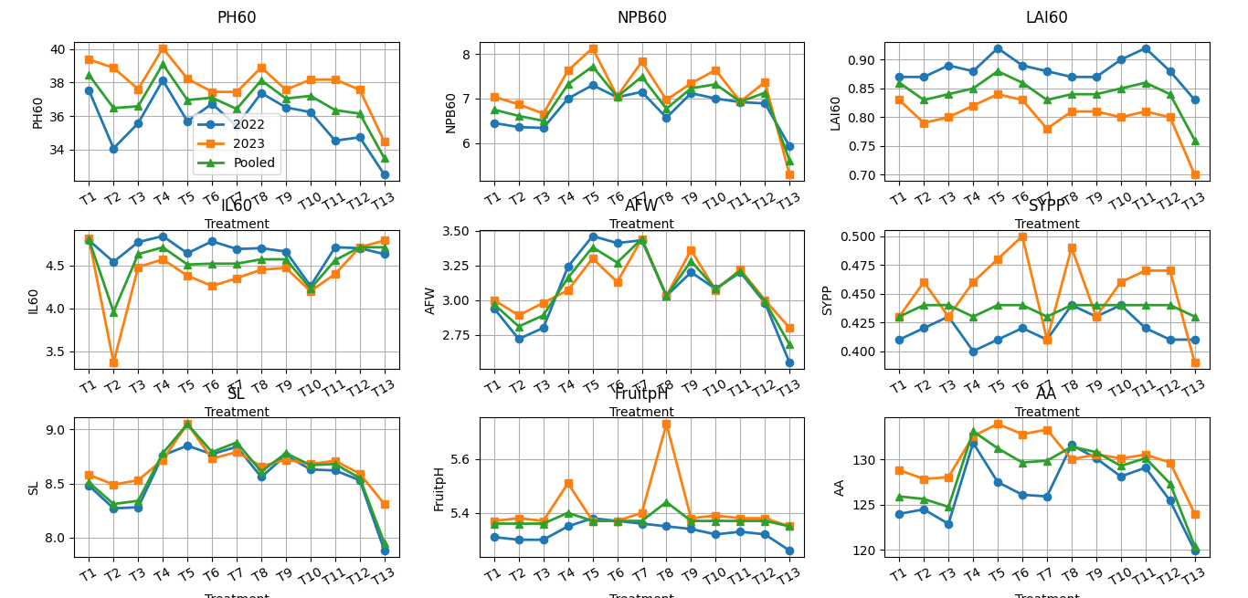
Figure 2: Year-wise (2022–23, 2023–24) and pooled performance of chilli under different INM treatments for key growth, yield and quality traits.
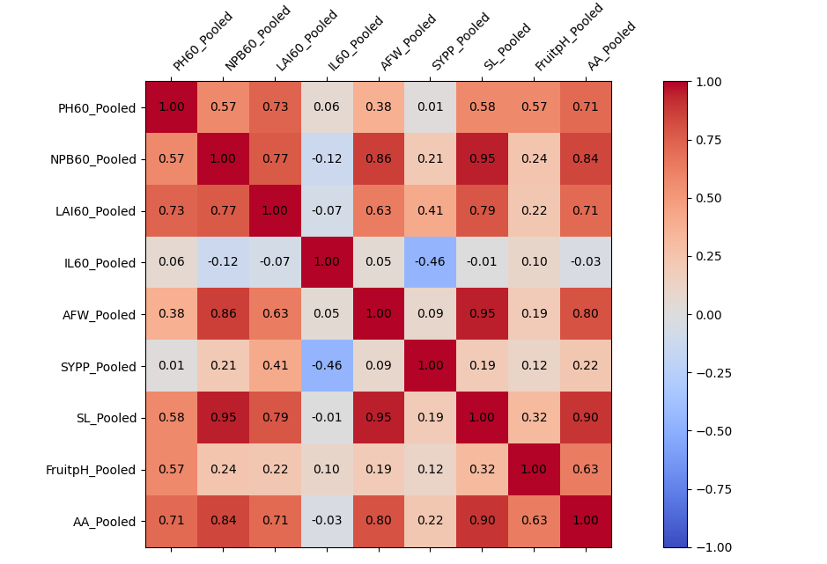
Figure 3: Correlation heatmap indicating strong positive correlations among growth, yield and quality attributes of chilli under different nutrient management treatments

