Identification of sources of resistance against Fusarium wilt of safflower

Abstract
A comprehensive field experiment, comprising three replications, was executed at the All India Coordinated Research Project (AICRP) on safflower, situated at the Agricultural Research Station in Annigeri, UAS, Dharwad, during the Rabi season of 2021-22 &2022-23, and was aimed at the assessment of various genotypes in relation to their susceptibility to the predominant wilt disease. In the context of evaluating wilt resistance against F. oxysporum f. sp. carthami, a total of forty-one genotypes or elite materials were subjected to rigorous testing alongside a susceptible control within a wilt-affected plot. Among the forty-one genotypes assessed, twenty-six exhibited a highly susceptible response, while the susceptible check, Nira, demonstrated a wilt incidence of 56.78% at 30 days after sowing (DAS), which escalated to 88.60% at 90 DAS. Twelve genotypes were categorized as having a susceptible reaction, including ISF-123-Sel-15 and GMU-1815. Furthermore, three genotypes displayed a moderately resistant reaction, namely PYT 10-4 and A-2020, whereas DSAF was identified as exhibiting a resistant reaction. This study elucidates that the screening of genotypes for disease resistance constitutes a critical phase in the development of cultivars or hybrids endowed with enhanced resistance to wilt disease.
Keywords: Fusarium wilt, Safflower, Wilt resistant, genotypes
Introduction
Safflower (Carthamus tinctorius L.) constitutes an oilseed crop primarily cultivated during the post-monsoon season, predominantly within the Vertisol soils of the Deccan region in India. Globally, India holds the distinction of being the foremost producer of safflower, encompassing an area of 0.56 lakh hectares with an average yield of 640 kg ha⁻¹. Safflower is classified as a rabi crop and possesses resilience to drought, salinity and saline irrigation. In India, safflower is cultivated for its vegetable oil and fodder applications, in addition to the extraction of the orange-red dye (carthamin) from its florets (Anon., 2006).
“Safflower is susceptible to a variety of fungal pathogens, including leaf spot/blight (Alternaria carthami), wilt (Fusarium oxysporum f.sp.carthami), root rot (Rhizoctonia bataticola), powdery mildew (Erysiphe cichoracearum DC), anthracnose (Colletotrichum capsici) and charcoal rot (Macrophomina phaseolina (Tassi) Goid) as well as bacterial (leaf blight/spot (Pseudomonas syringae van Hall)) and viral diseases (Mosaic (cucumber mosaic virus), necrosis (tobacco streak virus)) at various developmental stages of crop growth” (Klisiewicz and Houston 1962; Prabhavathi & Ashwini, 2025).
Seed and soil-borne pathogens, particularly fungi, directly and indirectly impact both the quality and quantity of oilseed crops by causing deterioration and reducing oil content, germination rates, seed viability and overall yield potential. A primary concern is that seed-borne plant pathogens can introduce diseases into regions that were previously unaffected by such pathogens. In safflower cultivation, known seed-borne fungi such as Fusarium wilt, Macrophomina root rot, and Alternaria blight lead to significant losses for this crop (Dighule et al., 2025).
“Wilt of safflower caused by Fusarium oxysporum f. sp. carthami Klisiewicz and Houston is an important soil-borne disease occurring mainly in poor drained areas of Karnataka and Maharashtra leading to yield losses as high as 80%” (Sastry et al., 1997). “The disease is reported to be seed transmitted up to 10-40% and the fungus perpetuates as mycelium and spores on the seed and seed coat or as chlamydospores in plant debris in soil. Wilt of safflower is a soil and seed borne disease and therefore, efforts were made to control the disease and to reduce the yield losses” (Chakrabarti& Basuchaudhary,1980).
“Breeding for disease resistance is the most economical and convenient method for controlling major diseases of safflower. Though, germplasm lines or cultivars showing partial or full resistance to some of the major diseases have been identified, the availability of genetic resistance is found to be rare” (Deokar et al., 1998). Though a number of resistance sources identified against wilt across the globe, as mentioned above, continuous change in the genetic makeup of pathogen warrants continuous search for host resistance. To overcome this problem, the present study was carried out with an objective to find out genotypes with resistance to wilt.
Material and methods
The experimental study was conducted at the Agricultural Research Station in Annigeri, UAS, Dharwad during the Rabi season of 2021-22 and 2022-23. The research was executed utilizing a randomized block design methodology. Each genotype line was planted in a length of 3 meters in a two-row arrangement with spacing of 30 × 20 cm, as a reduced distance is conducive to the proliferation of diseases.
Safflower genotypes from various institutions, including the Indian Institute of Oilseed Research in Hyderabad, ARS Tandur, ARS Solapur, and ARS Annigeri, were evaluated for their susceptibility to wilt within a wilt sick plot, which was maintained at the Agricultural Research Station in Annigeri during the rabi season of 2021-22 &2022-23. Recommended agronomic practices and integrated pest management strategies were adhered to and the disease intensity was systematically recorded under field conditions. Approximately 41 safflower genotypes were assessed within the wilt sick plots for their resistance to wilt. The disease incidence was quantified utilizing a modified 0-9 disease scale, as delineated by Mayee and Datar (1986), with observations recorded at intervals of 30, 60, and 90 days post-sowing.
The per cent incidence of wilt was calculated using the following formula:
Number of wilted plants
Percentage wilt incidence (%) = × 100
Total plant population
Table 1. Disease scale and reactions
(0-9) scale | Particulars | Reactions
0 | 0 (%) no wilting symptoms on plant | HR (Highly resistant)
3 | 0.1- 10 (%) plants wilted | R (Resistant)
5 | 10.1- 20 (%) plants wilted | MR (Moderately resistant)
7 | 20.1- 30 (%) plants wilted | S (Susceptible)
9 | More than 30.1 (%) plants wilted | HS (Highly susceptible)

Result and Discussion
The results revealed that the safflower genotypes exhibited the considerable variation towards diseasese reaction (Table 2). Entries were differentiated into five groups in relation to their resistance reaction (Table 3). Out of 41 entries, no entry has showed the highly resistant reaction with zero wilting, one genotype (DSAF) exhibited resistant reaction with 0.1 - 10 (%) wilted plants, two genotypes (PYT -10 -4, A2020) were recorded moderately resistant reaction with 10.1-20(%) wilted plants, twelve genotypes (ISF-123-Sel-15, SSF-18-72, SAF -P -1911, 1902, 19 -20, SAF -1906, 2002, 1911, PBNS -208, 210, TSF -88, GMU -1815) recorded susceptible reaction with 20.1 - 30 (%) wilted plants and remaining genotypes were highly susceptible with more than 30.1 (%) wilted plants (Table 3).
It was noticed that majority of the genotypes recorded susceptible and highly susceptible reactions to Fusarium wilt. The susceptible check (Nira) exhibited the mean per cent wilt incidence of 73.92 per cent (Table 2). Phad and Jagtap (1990), Sastry and Ramachandram (1994), shinde et al. (1994), Anonymous. (2001), Sastry and Chattopadhyay (2003), Murumkar et al. (2013), Rupesh and Aarshit (2014), Reddy et al. (2017) and Rajendraprasad et al. (2021) evaluated the safflower genotypes against Fusarium wilt and recorded the differential responses. Similar studies were made by Zote, (1983) who studied “sources of resistance to chickpea wilt and reported that none of the 42 lines of Cicer arietinum tested in a wilt sick plot infested with F. oxysporum f. sp. ciceri were highly resistant, 4 developed less than 10% and 6 others less than 29% disease”. Similarly, Govil and Rana (1984) evaluated “239 cultivars representing a range of variability among Indian and Iranian germplasm in wilt sick plot for years. None was found to be immune but the maximum resistance was shown by Indian cultivars such as P-597, P-621, P-3649, P-4128 and P-4245”. Khalid (1993) evaluated “122 test lines against Fusarium wilt under field conditions and found 37 of them to be resistant while all the remaining test lines exhibited moderate resistance to highly susceptible reaction”. Our study revealed that at seedling stage majority of the genotypes and cultivar were resistant whereas at reproductive stage majority of the genotypes and cultivar appeared to be highly susceptible. Similarly, various workers have reported variation in wilt resistance at two stages (Nene, 1981; Haware 1996). Tullu (1996) reported “variation in chickpea genotype that was consistently and uniformly resistant”. These findings are quite in conformity with our results. Iftikhar, (1997) screened “31 chickpea germplasm lines received from ICARDA and found that all of them were highly resistant to wilt disease”. Whereas, Bajwa, (2000) found that “out of 32 genotypes only one line was resistant, 4 lines were tolerant, and 27 were susceptible to highly susceptible against Fusarium wilt”. Iqbal, (2005) also report “the sources of resistance against Fusarium wilt in chickpea germplasm originating from national and international research institutes. They identified 14 chickpea lines to be resistant to wilt at seedling stage but no line found to be resistant at reproductive stage”. Chaudhry, (2007) screened 196 chickpea germplasm lines/cultivars for resistance to wilt disease in a wilt sick plot. None of the test line was found immune or highly resistant. Whereas, Naser Ahmad, (2010) evaluated “321 test lines against Fusarium wilt under greenhouse and field conditions and found 173 resistant, 54 tolerant and 94 susceptible at seedling stage. Whereas, 102 genotypes were observed resistant, 36 tolerant and 183 susceptible at reproductive stage”. Iqbal, (2010) screened “145 chickpea genetic sources of resistance against wilt disease under artificial disease condition and found, 14 genotypes were resistant, 65 tolerant and 66 were susceptible at seedling stage, on the contrary, at reproductive stage, no genotype was resistant, 12 were tolerant and 133 susceptible”. Nazir & khan (2012) screened “137 chickpea germplasm lines/cultivars for resistance to against wilt disease in a wilt sick plot none of the test lines were found immune and resistant”. “The most efficient method for the management of disease is using resistant cultivars” (Karimi, 2012). “The resistant genotypes and cultivars at seedling stage may be planted in areas where disease occurs at seedling stage only. Delay in sowing can also help to escape disease from such areas. On the other hand the genotypes and cultivars that showed resistance or tolerance at both the stages are most suitable for exploitation in breeding programs or for direct sowing in wilt prone areas. The susceptible cultivars at seedling stage may be categorized as early wilting cultivars and at reproductive stage may be classified as late wilting genotypes. There was a common relationship between disease severities at two stages. This indicated that different genotypes could be utilized according to prevalence of disease at various growth stages. These genotypes can be used in hybridization program for the development of chickpea resistance cultivars for commercial cultivation in the country” (Mirzapour et al., 2014).
It is also observed in earlier studies of Murumkar et al. (2008) who evaluated “nine safflower varieties against wilt under sick plot conditions. They reported that none of the popular varieties (Bhima, Phule Kusuma, Sharada, Manjira, PBNS-12, A-l, JSI-7) were immune or resistant to wilt disease. Only two hybrids NARI-NH-1, DSH129 and one non-spiny variety NARI6 recorded least disease intensity”. Similar a screening trial conducted by Sastry and Chattopadhyay (2003) screened with “51 promising safflower germplasm lines in Fusarium wilt infested plot resulted in identification of highly wilt resistant selections viz., 86-93-36A, 237550, VI-92-42 and II-13-2A, with moderate resistance in HUS-305”. These findings suggest that, it is possible to improve an existing genotype/ elite line through further selection and screening of the progenies of the parental line.
Conclusion
In the context of evaluating wilt resistance against F. oxysporum f. sp. carthami, a total of forty-one genotypes or elite materials were subjected to testing alongside a susceptible control in a wilt-infested plot. Among the forty-one genotypes assessed, twenty-six entries exhibited a highly susceptible response, while the susceptible control, Nira, recorded a wilt incidence of 56.78% at 30 days after sowing (DAS), which further escalated to 88.60% at 90 DAS. Additionally, twelve genotypes demonstrated a susceptible response, notably including ISF-123-Sel-15 and GMU-1815. Furthermore, three genotypes were identified as exhibiting a moderately resistant response, specifically PYT 10-4 and A-2020, whereas DSAF displayed a resistant reaction. The severity of disease incidence was observed to increase from 30 to 60 days post-sowing. These findings suggest that, it is possible to improve an existing elite line through further selection and screening of the progenies of the parental line.

Disclaimer (Artificial intelligence)
Option 1:
Author(s) hereby declare that NO generative AI technologies such as Large Language Models (ChatGPT, COPILOT, etc.) and text-to-image generators have been used during the writing or editing of this manuscript.
Option 2:
Author(s) hereby declare that generative AI technologies such as Large Language Models, etc. have been used during the writing or editing of manuscripts. This explanation will include the name, version, model, and source of the generative AI technology and as well as all input prompts provided to the generative AI technology
Details of the AI usage are given below:
1.
2.
3.
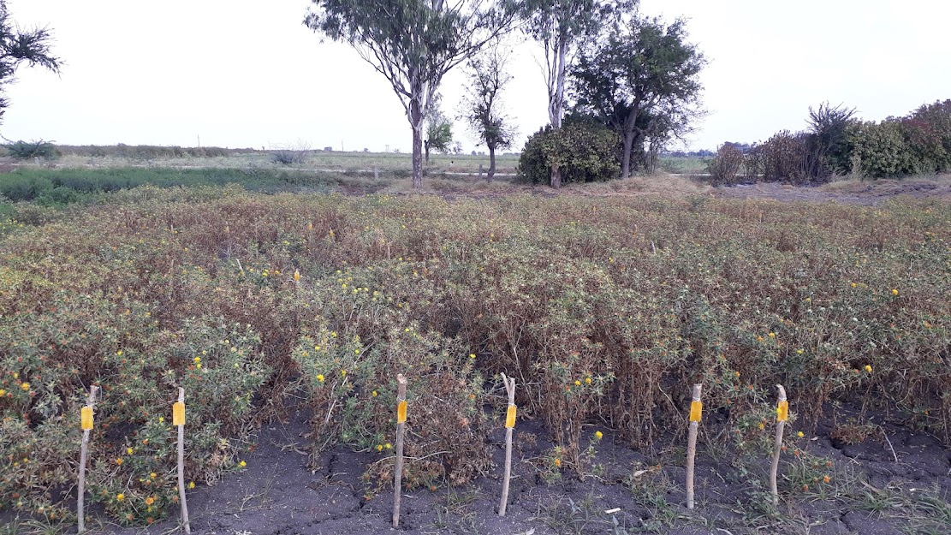
Fig .1 Field view of Wilt Sick plot

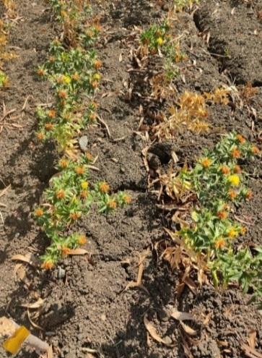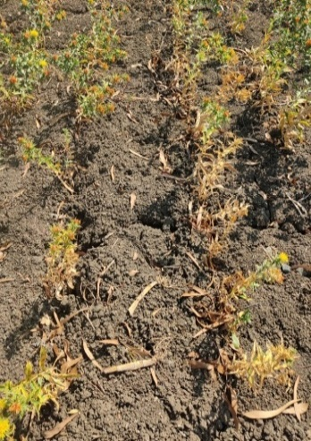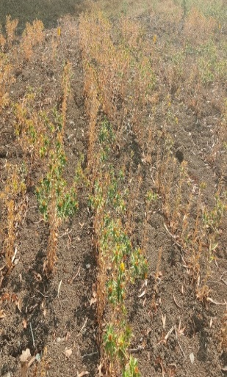
Fig.2 Genotypes resistant (R) and moderately resistant (MR) and highly susceptible (HS) to wilt
Nira : HS
A-2020: MR
A-18-01(DSAF): R
References
- Anonymous, 2001, Annual progress report, safflower 2000 - 2001. Directorate of Oilseeds Research, Rajendranagar, Hyderabad, p. 117 - 131.
- Bajwa KM, Khan IA, Alam SS, Ahmad I and Gill MA. 2000. Screening against phytotoxins for resistance to Fusarium wilt. Pak. J. Phytopathol., 12:66-70.
- Chakrabarthi D K and Basuchaudhary K C, 1980, Correlation between virulence and fusaric acid production in by Fusarium oxysporum f. sp. carthami.
Phytopatholologische Zeitschirft, 99(1): 43 - 46.
- Chaudhry MA, Ilyas MB, Muhammad F and Ghazanfar MU. 2007. Sources of resistance in chickpea germplasm against Fusarium wilt. Mycopath., 5(1): 17-21.
- Govil JN and Rana BS. 1994. Stability of host plant resistance to wilt (Fusarium oxysporum f.sp. ciceri) in chickpea. International J. Trop. P1. Dis. 2(1):55-60.
- Haware MP, Nene YL and Natarajan M. 1996. Survival of Fusarium oxysporum f. sp. ciceri. Plant Disease, 66: 809-810.
- Iftikhar K, Kahlid T and Ilyas MB. 1997. Field screening of chickpea germplasm for the sources of resistance against Fusarium wilt. Pak. J. Phytopathol., 9(1): 31-33.
- Iqbal SM, Ghafoor A, Bakhsh A, Ahmad I and Sher A. 2010. Identification of resistant sources multiple disease resistance in chickpea. Pak. J. phytopathology., vol. 22(2): 89-94.
- Iqbal SM, IHaq IU, Bukhari A, Ghafoor A and Haqqani AM. 2005. Screening of chickpea genotypes for resistance against Fusarium wilt. Mycopath., 3(1-2): 1-5.
- Karimi K, Amini J, Harighi B and Bahramnejad B. 2012. Evaluation of biocontrol potential of Pseudomonas and Bacillus spp. against Fusarium wilt of chickpea. Australian Journal of Crop Siensce 6(4):695-703
- Klisiewicz, J.M and Houston, B.R. 1962. Fusarium wilt of safflower. Plant Diseases Report. 46(10):748-749
- Mayee C D and Datar V V, 1986, Phytopathometry Technical Bulletin No 1, Marathwada Agricultural University, Parbhani, Maharashtra, India. https://www.cabidigitallibrary.org/doi/full/10.5555/19861318793
- Murumkar D R, Gud M A, Indi D V and Kadam J R, 2008, Variability among the isolates of Fusarium oxysporum f. sp. carthami from Maharashtra state. Journal of Plant Disease Sciences, 3(1): 24-28.
- Murumkar D R, Shinde S K and Kadam J R, 2013, In vitro screening of safflower genotypes for resistance towards Fusarium wilt using fusaric acid.
Bioinfolet, 10: 1a.
- Phad H B and Jagtap V S, 1990, Field resistance against safflower wilt. Indian Phytopathology, 43(2): 312.
- Rajendraprasad M, Sagar B V, Devi G, Reddy C N and Triveni S, 2021, Screening of germplasm lines against safflower wilt caused by Fusarium Oxysporum f. Sp. carthami. The J. Res. Pjtsau Vol. Xlix No. 4 Pp 1-111, p.108.
- Reddy T R, Pushpavalli S, Sudhakar C and Sudharani S, 2017, Screening of safflower elite material for resistance to Fusarium wilt. Life Science International Research Journal, 4(1): 106 - 109.
- Rupesh A and Aarshit V, 2014, Screening major diseases of safflower over elite
material under field conditions. International Journal of Mycology and Plant Pathology, 1(9): 85 - 87.
- Sastry K R and Chattopadhyay C, 2003, Development of Fusarium wilt
resistant genotypes in safflower. European Journal of Plant Pathology, 109(2): 147-151. https://link.springer.com/article/10.1023/A:1022502618887
- Sastry K R and Ramachandram M, 1994, Effect of wilt on yield attributes of safflower. Indian Phytopathology, 42: 80-84. https://epubs.icar.org.in/index.php/IPPJ/article/view/21010
- Shinde P B, Zope R E and Ghorpode D S, 1994, Screening of safflower cultivars aginst Fusarium wilt. Sesame and Safflower Newsletter, 9: 51 – 53
- Zhang, S., Raza, W., Yang, X., Hu, J., Huang, Q., Xu, Y., ... & Shen, Q. (2008). Control of Fusarium wilt disease of cucumber plants with the application of a bioorganic fertilizer. Biology and Fertility of Soils, 44(8), 1073-1080.

- Zote KK, Khalikar PV and Dandnaik BP. 1983. Source of resistance to chickpea wilt. Internat.Chickpea Newslett. 8: 23.

- Mirzapour, S., Darvishnia, M., Bazgir, E., & Goodarzi, D. (2014). Identification of resistant sources in chickpea against Fusarium wilt under greenhouse condition. International Journal of Farming and Allied Sciences, 3(7), 772-776.

- S. B. Dighule, D. R. Murumkar, H. J. Rajput, S.B. Gawade & N. J. Ranshur. (2025). Biointensive Integrated Management of Soil Borne Diseases of Safflower. Journal of Advances in Biology & Biotechnology, 28(5), 839–843. https://doi.org/10.9734/jabb/2025/v28i52346

- Prabhavathi & Ashwini. (2025). Chemical and Biological Management of Wilt Disease of Safflower. Journal of Experimental Agriculture International, 47(1), 530–541. https://doi.org/10.9734/jeai/2025/v47i13253

Table 2: Disease incidence on safflower genotypes against wilt caused by Fusarium oxysporum f. sp. carthami
Sl no | Entry | Per cent wilt incidence |  |  | Mean PDI | Reaction
Sl no | Entry | 30 DAS | 60 DAS | 90 DAS | Mean PDI | Reaction
1 | A2020 | 8.73  (17.19)* | 14.32  (22.24) | 19.03  (25.86) | 14.03  (21.76) | MR
2 | Nira (SC) | 56.78  (48.89) | 76.38  (60.92) | 88.60  (70.27) | 73.92  3(60.03) | HS
3 | DSAF | 5.24  (13.23) | 7.43  (15.82) | 9.47  (17.92) | 7.38  (15.66) | R
4 | PYT -10 -4 | 11.78  (20.07) | 16.41  (23.90) | 18.72  (25.64) | 15.64  (23.20) | MR
5 | PYT -10 -3 -10 | 30.81  (33.71) | 41.73  (40.24) | 52.85  (46.63) | 41.79  (40.19) | HS
6 | PYT -10 -6 | 38.82  (38.54) | 50.12  (45.07) | 70.50  (57.10) | 53.15  (46.90) | HS
7 | ISH -413 | 33.01  (35.06) | 45.39  (42.35) | 66.86  (54.85) | 48.42  (44.09) | HS
8 | ANG -18 -02 | 44.48  (41.83) | 56.53  (48.75) | 67.52  (55.25) | 56.17  (48.61) | HS
9 | RVS -18-1 | 34.88  (36.20) | 47.82  (43.75) | 68.63  (55.94) | 50.44  (45.29) | HS
10 | PBNS -198 | 40.86  (39.73) | 52.79  (46.60) | 73.61  (59.09) | 55.75  (48.47) | HS
11 | PBNS -12 | 35.75  (36.72) | 46.50  (42.99) | 68.19  (55.67) | 50.15  (45.13) | HS
12 | ISH -400 | 30.60  (33.58) | 41.64  (40.18) | 52.46  (46.41) | 41.57  (40.06) | HS
13 | RVS -18-3 | 33.80  (35.55) | 44.46  (41.82) | 65.86  (54.25) | 48.04  (43.87) | HS
14 | ISF -123-Sel-15 | 21.57  (27.67) | 25.62  (30.41) | 28.43  (32.22) | 25.21  (30.10) | S
15 | SSF -18-72 | 23.78  (29.19) | 26.57  (31.03) | 29.12  (32.66) | 26.49  (30.96) | S
16 | PBNS -183 | 30.87  (33.75) | 43.11  (41.04) | 63.67  (52.93) | 45.88  (42.57) | HS
17 | PBNS -201 | 35.14  (36.35) | 46.99  (43.27) | 67.50  (55.24) | 49.87  (44.95) | HS
18 | SAF –P -1906 | 37.47  (37.74) | 48.78  (44.30) | 69.73  (56.62) | 51.99  (46.22) | HS
19 | SAF –P -1911 | 20.46  (26.89) | 25.01  (30.00) | 27.29  (31.49) | 24.25  (29.46) | S
20 | PBNS -203 | 38.46  (38.33) | 49.48  (44.70) | 70.60  (57.16) | 52.85  (46.73) | HS
21 | SAF -1906 | 22.45  (28.28) | 25.51  (30.34) | 26.35  (30.89) | 24.77  (29.83) | S
22 | SAF -2003 | 41.86  (40.32) | 52.91  (46.67) | 74.43  (59.62) | 56.40  (48.87) | HS
23 | PBNS 208 | 23.12  (28.74) | 26.47  (30.96) | 28.73  (32.41) | 26.11  (30.71) | S
24 | TSF 88 | 21.45  (27.59) | 24.02  (29.34) | 27.21  (31.44) | 24.22  (29.46) | S
25 | SAF -2001 | 31.41  (34.09) | 43.06  (41.01) | 64.24  (53.27) | 46.24  (42.79) | HS
26 | SAF -2002 | 20.75  (27.10) | 24.68  (29.78) | 29.48  (32.88) | 24.97  (29.92) | S
27 | SAF -200 | 32.21  (34.58) | 43.85  (41.47) | 64.48  (53.42) | 46.85  (43.15) | HS
28 | GMU 7874 | 38.87  (38.57) | 50.37  (45.21) | 71.83  (57.94) | 53.69  (47.24) | HS
29 | SAF –P -1902 | 20.53  (26.94) | 25.29  (30.19) | 28.27  (32.12) | 24.69  (29.75) | S
30 | SAF –P -1901 | 40.06  (39.27) | 51.89  (46.08) | 72.84  (58.59) | 54.93  (47.98) | HS
31 | GMU 3624 | 32.03  (34.47) | 46.09  (42.76) | 66.87  (54.86) | 48.33  (44.03) | HS
32 | SAF –P -19 -20 | 21.37  (27.51) | 24.56  (29.70) | 28.92  (32.53) | 24.95  (29.92) | S
33 | SAF -1921 | 30.20  (33.34) | 41.63  (40.18) | 62.20  (52.06) | 44.68  (41.86) | HS
34 | SAF -1902 | 35.83  (36.77) | 47.92  (43.81) | 68.47  (55.84) | 50.74  (45.47) | HS
35 | GMU 1815 | 23.79  (29.19) | 27.41  (31.57) | 29.94  (33.17) | 27.04  (31.31) | S
36 | TSF -83 | 33.52  (35.37) | 45.49  (42.41) | 52.26  (46.30) | 43.75  (41.36) | HS
37 | PBNS -210 | 24.33  (29.55) | 27.65  (31.72) | 29.07  (32.63) | 27.02  (31.30) | S
38 | GMU -7960 | 31.70  (34.27) | 42.74  (40.82) | 63.79  (53.00) | 46.07  (42.70) | HS
39 | SAF -1911 | 20.57  (26.97) | 24.28  (29.52) | 28.16  (32.05) | 24.34  (29.51) | S
40 | SAF -P -1882 | 48.90  (44.37) | 56.34  (48.64) | 76.93  (61.29) | 60.72  (51.43) | HS
41 | PBNS -199 | 33.79  (35.54) | 44.02  (41.56) | 64.54  (53.45) | 47.45  (43.52) | HS
 | S. Em. ± | 1.22 | 1.53 | 2.29 | - | -
 | C. D. at 5% | 3.51 | 4.40 | 6.55 | - | -
 | C. V. (%) | 5.30 | 5.71 | 7.06 | - | -

* Figures in parenthesis indicate arc sine values

Table 3. Disease incidence and disease reaction of genotypes or elite materials against wilt of safflower caused by Fusarium oxysporum f. sp. carthamiContro
Disease reaction | Disease incidence | Genotype name | Total no. of genotypes
HR -Highly resistant | 0 (%) No wilting symptoms | - | -
R -Resistant | 0.1- 10 (%) plants wilted | D-SAF | 1
MR -Moderately resistant | 10.1- 20 (%) plants wilted | PYT -10 -4, A2020 | 2
S -Susceptible | 20.1- 30 (%) plants wilted | ISF-123-Sel-15, SSF -18-72, SAF -P -1911, 1902, 19 -20, SAF -1906, 2002, 1911, PBNS -208, 210, TSF -88, GMU -1815 | 12
HS -Highly susceptible | >30.1 (%) plants wilted | Nira (SC), PYT -10 -3 -10, PYT -10 -6, ISH -413, PBNS -198, PBNS -201, PBNS-183, SAF -P -1906, 1901, 1882, PBNS -203, 199, SAF -2003, 2001, 200, 1921, 1902, GMU -7874, 3624, TSF -83, GMU -7960, ANG -18 -02, RVS-18-1, PBNS -12, ISH-400, RVS-18-3, | 26
Total |  |  | 41

SC: SC: 1 2 3 4 5 6
SC: Susceptible check

