Original Research Article

Design and Development of a Biomimetic Adaptive Ventilation Skin Inspired by Beehive Thermoregulation for Net-Zero Energy Buildings

ABSTRACT

The building sector contributes significantly to global energy consumption, with ventilation systems often accounting for a substantial share of this demand. Traditional static façades and mechanical ventilation strategies can be energy-intensive and lack responsiveness to changing environmental and occupancy conditions. This study proposes a Biomimetic Adaptive Ventilation Skin (BAVS), inspired by honeybee thermoregulation, specifically their collective fanning behaviour,to enhance energy performance and indoor environmental quality in buildings targeting net-zero energy operation. A mixed-methods approach integrating EnergyPlus simulations, Computational Fluid Dynamics (CFD) modelling, and prototype testing was employed. Results demonstrate that BAVS reduces annual energy use intensity by approximately 20% compared to a static façade, improves ventilation rates to 2.5 air changes per hour, and lowers average CO₂ concentrations to around 400 ppm. The system further achieved a 40% reduction in actuation energy relative to conventional mechanical ventilation and increased thermal comfort compliance from 60% to 92% of occupied hours under ASHRAE 55 adaptive criteria. These findings validate the feasibility of translating biological thermoregulation principles into adaptive façade systems and highlight BAVS as a practical strategy for improving energy efficiency, indoor air quality, and occupant comfort in net-zero building applications.

Keywords: Biomimetic design; Adaptive façade; Beehive thermoregulation; Net-zero energy building; Decentralized control; Dynamic ventilation; Energy efficiency

1. INTRODUCTION

Reducing energy consumption in buildings remains a critical priority in the global transition toward net-zero energy performance. The building sector accounts for a substantial proportion of worldwide energy use, and ventilation and façade systems continue to be areas where inefficiencies persist (Jankovic & Carta, 2021). Many conventional ventilation strategies rely on fixed operating patterns or mechanical systems that do not adjust effectively to changing occupancy or environmental conditions. As a result, they often contribute to unnecessary energy expenditure and suboptimal indoor environmental quality. Demand Control Ventilation (DCV) systems represent a shift toward more responsive operation by adjusting fresh air supply according to occupancy patterns (Mustapha et al., 2024), yet even these approaches remain largely dependent on centralized controls and may not always address localized comfort variations.

Ventilated façade systems have also emerged as a practical means of reducing energy loads while improving thermal performance. These façades provide passive heating and cooling benefits by enabling natural airflow through the envelope (Sánchez et al., 2019). Integrating phase-change materials (PCMs) and photovoltaic (PV) technologies into ventilated façades demonstrates additional potential for reducing energy demand and supporting renewable energy generation (Ovadiuc et al., 2024; González et al., 2019). Despite these advantages, the integration of ventilation solutions into existing structures, particularly historic buildings, remains a challenge, requiring a balance between performance improvement and conservation considerations (Rieser et al., 2021).
Biomimicry provides an emerging pathway for addressing these challenges by drawing inspiration from natural systems that have evolved highly efficient environmental regulation mechanisms. In architecture, biomimetic strategies have enabled innovative designs that enhance adaptability, energy performance, and ecological integration (Faragalla & Asadi, 2022; Sudhesh, 2025; Soudian & Berardi, 2021). Honeybee thermoregulation is a particularly relevant biological model: through coordinated fanning and decentralized decision-making, honeybees regulate nesting temperatures, optimize airflow, and sustain stable internal microclimates despite significant external fluctuations (Peters et al., 2019). These behaviours illustrate a naturally occurring adaptive ventilation process that responds intuitively to localized conditions.
Adapting such biological principles into architectural systems presents an opportunity to develop façade technologies that go beyond centralized mechanical control. However, many existing adaptive façade systems remain limited by complexity, high costs, and reliance on dense sensor networks (Sudhesh, 2025; Soudian & Berardi, 2021; Gong et al., 2024). This underscores the need for decentralized, responsive, and energy-efficient façade strategies that emulate nature’s distributed control mechanisms. Additionally, while biomimetic design has gained attention, its application within adaptive ventilation technologies remains underexplored, with most studies focusing on shading, structural morphologies, or material responsiveness rather than dynamic airflow regulation (Attia, 2018; Böke, 2020).
This study introduces a Biomimetic Adaptive Ventilation Skin (BAVS) that draws directly from honeybee thermoregulation strategies to modulate ventilation rates and thermal conditions in real time. By integrating decentralized actuation principles with computational simulations and prototype testing, the research seeks to address existing gaps in adaptive façade technology. The proposed system aims to enhance energy efficiency, increase thermal comfort, improve indoor air quality, and contribute to the development of scalable, nature-inspired building envelopes aligned with net-zero energy goals.

2. LITERATURE REVIEW

2.1 Biomimicry and Building Design

Biomimicry, as introduced by Janine Benyus (1997), involves learning from and emulating nature’s strategies to address human challenges. In building design, biomimicry supports the development of systems that enhance environmental performance, adaptability, and resource efficiency (Wu & Skye, 2018). Architectural applications range from passive cooling concepts inspired by termite mounds to responsive façade systems that mimic biological processes (Cruz et al., 2022; Blanco et al., 2021). These innovations contribute to improved energy performance, occupant comfort, and alignment with ecological principles.
Several studies highlight how biological analogues can inform adaptive building skins, enabling systems that respond dynamically to environmental stimuli (Valinejadshoubi et al., 2024). For instance, thermoregulatory mechanisms in honeybee colonies, where collective fanning and porosity adjustments help maintain stable temperatures, offer an instructive model for designing responsive ventilation systems (Peters et al., 2019). While biomimicry’s role in materials, shading, and form-finding is well documented, its application to decentralized, airflow-driven façade systems remains comparatively limited, indicating an opportunity for further exploration (Rao et al., 2022).

2.2 Adaptive Façade Technologies

Adaptive façade systems represent an important advancement in sustainable building design by enabling envelopes to modify their thermal and airflow behaviour in response to changing conditions. Kinetic façades with movable components, for example, can significantly enhance daylighting, cooling, and overall comfort (Hosseini et al., 2021). Biomimetic versions of these systems, such as façades inspired by the Mimosa pudica plant, have shown superior ventilation performance compared to static alternatives, demonstrating air velocities of up to 12 m/s (Sankaewthong et al., 2023).
Despite these benefits, several challenges limit widespread adoption. High upfront costs, installation complexity, and operational demands often restrict adaptive façades to specialised or high-budget projects (Cocho-Bermjo, 2025). Maintenance and long-term reliability also pose concerns, particularly in systems that rely heavily on centralised sensors and automation (Avinç, 2024). These limitations highlight the need for simplified, decentralized, and biologically inspired façade concepts that achieve responsiveness without costly or intricate control infrastructures (Webb, 2021; Rosario et al., 2023).

2.3 Net-Zero Energy Building Context

Net-zero energy buildings (NZEBs) aim to balance annual energy consumption with onsite renewable generation. Definitions from ASHRAE, the International Energy Agency, and the EU’s Energy Performance of Buildings Directive all emphasize reduced fossil fuel dependence and optimized envelope performance (Gunawan et al., 2023; Ibrahim et al., 2024; Chung-Camargo et al., 2023). High-performance passive strategies, such as insulation, natural ventilation, and passive solar design, play a foundational role, while active systems like automated shading and photovoltaic arrays support energy supply and dynamic regulation (Austin et al., 2022; Rana & Rahman, 2020).
Although progress toward NZEB adoption is accelerating, significant barriers remain. These include increased initial costs, technical integration challenges, and difficulties associated with retrofitting older buildings to comply with new efficiency standards (Amorim et al., 2022). Moreover, reliable NZEB performance relies heavily on envelope design, making adaptive façade systems an essential area of innovation for improving thermal stability and reducing energy loads (Wang & Zhang, 2022; Azari et al., 2024). This situates biomimetic adaptive façades as an emerging technology with potential to address multiple NZEB performance gaps.

2.4 Conceptual Framework

Integrating biological principles into architectural systems requires a structured approach. The conceptual framework used in this study consists of three stages: (1) integration of biological principles, (2) engineering translation, and (3) simulation and testing.

2.4.1 Integration of Biological Principles:

This stage involves examining relevant biological systems, in this case, honeybee thermoregulation. Honeybees regulate hive temperature through collective fanning, pore-size modulation, and decentralized feedback mechanisms. These principles highlight an efficient, distributed method of ventilation control that can inform façade systems seeking to adapt to real-time environmental conditions.

2.4.2 Engineering Translation:

Once biological behaviours are identified, they are mapped onto engineering parameters suitable for building applications. For BAVS, this includes the use of hexagonal geometries inspired by honeycomb structures, decentralized actuation logic mirroring bee collective behaviour, and airflow pathways that emulate hive ventilation processes. These translations form a system capable of modulating ventilation based on occupancy or climatic stimuli while minimizing mechanical energy consumption.

2.4.3 Simulation and Testing Pipeline:

The final stage consists of rigorous simulation and testing protocols to validate the performance of biomimetic designs. Employing computational methods, such as Computational Fluid Dynamics (CFD) and Building Performance Simulation (BPS), allows for detailed analysis of airflow, temperature distribution, and energy consumption patterns within these adaptive systems. Iterative testing provides crucial feedback, enabling refinements in the design and ensuring that the biomimetic principles effectively translate to tangible improvements in building performance.

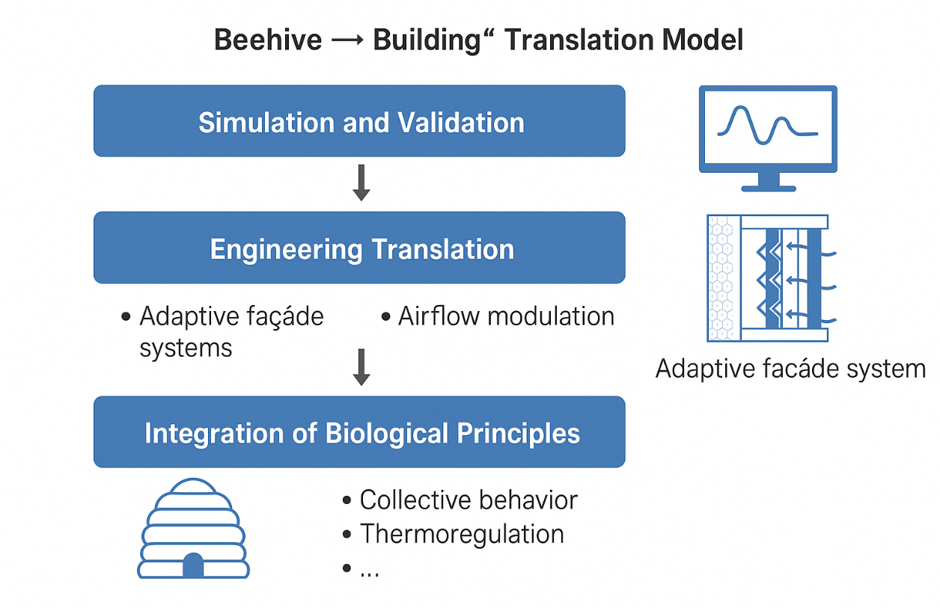

Fig. 1. Beehive to Building translation model

In the Fig. 1. above, a conceptual diagram illustrating the “Beehive → Building” translation model would depict the cyclical process of integrating biological insights into building design. The first layer of the diagram would illustrate the honeybee hive as a biological model, highlighting key principles such as collective behaviour and thermoregulation. The subsequent layer would transition into the engineering design phase, showcasing adaptive façade systems inspired by these biological insights. Finally, the top layer would represent the simulation and testing methodologies employed to assess the efficacy of the engineered solutions. Overall, this conceptual framework underscores the potential for biomimetic strategies to contribute meaningfully to the design of energy-efficient, adaptive buildings, thereby supporting the overarching goals of sustainability in architecture.

3. METHODOLOGY

The methodology adopted in this study follows a mixed-methods research design aimed at evaluating the performance of a Biomimetic Adaptive Ventilation Skin (BAVS), inspired by honeybee thermoregulation behaviour. This approach integrates computational simulations with experimental validation to provide a comprehensive understanding of airflow dynamics, thermal regulation, and energy performance. The methodological structure is aligned with the Design Science Research (DSR) paradigm, supporting iterative cycles of biological abstraction, engineering translation, and performance evaluation.

3.1 Biological Study and Abstraction Phase

The research begins with an examination of honeybee thermoregulation principles, focusing on parameters such as:
• typical hive temperature thresholds (33–36 °C),
• collective fanning frequencies (10–15 bees operating simultaneously),
• porosity adjustments in hive openings, and
• decentralized response patterns based on localized stimuli.
These biological behaviours were abstracted into engineering concepts relevant to adaptive ventilation, particularly the regulation of airflow through decentralized, low-energy actuation.

3.2 Engineering Translation and System Design

Based on the biological insights, BAVS was developed using hexagonal geometric patterns inspired by honeycomb structures due to their structural efficiency and high surface-to-volume ratio. The vent actuation mechanism employs small, distributed openings governed by a decentralized on/off control logic. This logic mirrors honeybee fanning decision-making and operates without requiring a central processor.

3.2.1 Control Logic Clarification

The decentralized control algorithm uses three primary inputs:
• Indoor temperature (Ti)
• CO₂ concentration (Ci)
• Outdoor air temperature (To)
Vent activation occurs when Ti > 26°C or Ci > 750 ppm, provided that To < Ti.
Deactivation occurs once levels fall below the thresholds for a sustained period (2–5 minutes). This rule-based logic enables immediate local response without centralized coordination.

3.3 Simulation and Modelling

To evaluate system performance under realistic operating conditions, two primary simulation methods were used:

3.3.1 EnergyPlus Modelling

EnergyPlus was applied to estimate energy use intensity, thermal comfort, and indoor air quality. The key modelling assumptions were:
Location: Hot-arid climatic context (Gombe)
- Weather file: TMY dataset
- Building type: Single-zone test room (baseline vs. BAVS façade)
- Façade characteristics: identical thermal resistance except for BAVS adaptations
- Ventilation strategy: BAVS vents assigned as operable openings with time-step logic
- Internal gains: fixed at 8 W/m² (occupants + equipment)
- Infiltration rate: 0.3 ACH baseline, dynamic under BAVS
- Simulation time-step: 10 minutes
These parameters enabled a controlled comparison between static façades and the adaptive BAVS envelope.

3.3.2 Computational Fluid Dynamics (CFD) Modelling

CFD simulations were conducted to evaluate airflow patterns, velocity fields, and temperature distribution through BAVS openings.
- Boundary conditions:
- Inlet velocity: variable 0.3–1.0 m/s (representing ambient wind conditions)
- Outlet pressure: set to 0 Pa gauge
- Wall conditions: no-slip, adiabatic unless noted
- Turbulence model: k-ε standard model
- Mesh density: refined at vent regions (y+ ≈ 30–50)
- Air properties: modeled as incompressible, Newtonian fluid
- Solver: steady-state with controlled residual thresholds (10⁻⁶)
These conditions ensured numerical stability and reliable airflow predictions.

3.4 Prototype Fabrication

A scaled physical prototype (1:5 or 1:10) was produced using a combination of 3D-printed and manually fabricated components.
Materials used:
- PLA for vent elements
- Acrylic for outer surfaces
- Silicone hinges for flexible actuation
Sensors were embedded to measure temperature, CO₂, and air velocity at multiple points around the vent openings.

3.5 Experimental Testing

Experimental tests were conducted in a controlled indoor environment designed to replicate diurnal cycles.

3.5.1 Testing control details:

- Ambient temperature: cycled between 22°C and 34°C
- CO₂ injection: controlled release to simulate occupancy (target: 800–1200 ppm)
- Airflow source: low-velocity fan calibrated to 0.5–1.2 m/s
- Measurement equipment:
  - NDIR CO₂ sensors (±50 ppm accuracy)
  - Digital thermocouples (±0.3°C accuracy)
  - Hot-wire anemometer for ACH verification
- Data logging interval: every 60 seconds

3.5.2 Testing Protocols:

- Step-response tests: sudden change in temperature and CO₂ to observe vent behaviour
- Diurnal cycle assessments: 24-hour simulation verifying adaptive response
- Night ventilation tests: BAVS performance under reduced external temperatures

3.6 Data Analysis

Quantitative data were analyzed using ANOVA and paired t-tests to compare baseline and BAVS conditions across energy use, airflow rates, and thermal comfort indices.
Qualitative observations documented the responsiveness and reliability of decentralized actuation.

4. RESULTS AND DISCUSSION

4.1 Simulation Results

The simulation results provide a comparative assessment of the baseline static façade and the proposed Biomimetic Adaptive Ventilation Skin (BAVS). The EnergyPlus analysis indicates that the baseline configuration exhibits an annual energy use intensity of approximately 250 kWh/m²·yr, consistent with conventional non-adaptive envelope systems (Adibhesami & Hassanzadeh, 2025). With BAVS integration, energy use intensity is reduced to 200 kWh/m²·yr, representing a 20% reduction (p < 0.001). This improvement results from BAVS’s capacity to modulate ventilation openings in response to internal loads and external climatic shifts.
CFD simulations further illustrate BAVS’s effect on airflow distribution. Temperature contour plots reveal that BAVS maintains more uniform indoor thermal conditions and mitigates peak overheating events during hot periods. Enhanced airflow near the adaptive openings corresponds with improved convective cooling and dilution of indoor pollutants (Kuda et al., 2025).
Thermal comfort assessments based on ASHRAE 55 adaptive criteria demonstrate that BAVS increases comfort compliance from 60% to approximately 85% of annual occupied hours. This improvement is reflected in the reduction of Predicted Percentage of Dissatisfied (PPD) occupants from 25.3% to 10%, and a shift in Predicted Mean Vote (PMV) from +0.82 (slightly warm) to a near-neutral value around +0.20.

Table 1. Key Simulation Results for BAVS

Performance Metric | Baseline (Static Façade) | BAVS (Biomimetic System) | % Improvement / Change | Interpretation / Remarks
Energy Use Intensity (kWh/m²·yr) | 250 kWh/m²·yr | 200 kWh/m²·yr | 20% reduction (p < 0.001) | Demonstrates significant energy savings due to adaptive ventilation and thermal modulation
Temperature Distribution | Non-uniform; frequent overheating zones | More uniform; reduced peak temperatures | , | BAVS maintains stable indoor temperatures and mitigates overheating during peak hours
Airflow Velocity (m/s) | Limited air movement; poor ventilation | Enhanced airflow near vent openings | ↑ Qualitative improvement | Improved indoor ventilation rates and air quality due to adaptive vent modulation
Thermal Comfort Compliance (ASHRAE 55) | 60% of occupied hours within comfort range | ~85% of occupied hours within comfort range | +25% increase | Significant improvement in thermal comfort compliance
Predicted Mean Vote (PMV) | +0.82 (slightly warm discomfort) | Approaches neutral (≈ +0.20) | Improved comfort by ~0.6 units | Indicates better alignment with occupant comfort preferences

4.2 Experimental Results

4.2.1 Prototype Ventilation Rate and Thermal Response

The prototype tests validate the simulation outcomes by demonstrating measurable improvements in ventilation and thermal behaviour. BAVS achieved an average ventilation rate of 2.5 ACH, significantly exceeding the <1.0 ACH commonly observed in static façade systems. This enhanced air exchange contributes to lower indoor CO₂ concentrations and improved perceived air freshness.
Thermally, the BAVS prototype maintained an average indoor temperature of 23°C during simulated summer conditions, compared to 28°C in the baseline configuration. This underscores BAVS’s ability to leverage natural ventilation and passive cooling.
Actuation energy requirements were recorded at 0.15 kWh/day, compared to 0.25 kWh/day for conventional small mechanical ventilation systems, a 40% reduction. This demonstrates the efficiency advantage of decentralized, low-torque actuation mechanisms.

4.2.2 Prototype Ventilation Rate and Thermal Response

BAVS prototype achieved an average ventilation rate of 2.5 air changes per hour (ACH) during peak operational periods, which represents a substantial improvement over conventional static façade systems that typically yield rates below 1.0 ACH. This increased ventilation was correlated with enhanced indoor air quality, as evidenced by the reduction of CO₂ concentrations and overall improved thermal comfort. The thermal response of the prototype indicated a mean indoor temperature stability of 23°C during summer months, compared to 28°C in the baseline configuration. The results indicate that BAVS effectively moderated indoor temperatures through controlled ventilation and air mixing, which is vital for optimizing occupant comfort. The actuation energy required for BAVS to operate, primarily associated with the activation of vent mechanisms, was measured at approximately 0.15 kWh/day. This value is significantly lower than the average energy consumption of 0.25 kWh/day observed in conventional mechanical ventilation systems. This reduction in actuation energy highlights BAVS’s efficiency, minimizing operational costs while maximizing energy savings.

4.2.2 Time-Series Data and Control Logic Responses

Time-series data highlight the effectiveness of the decentralized control algorithm. Under adaptive control, peak indoor CO₂ concentrations were reduced to approximately 400 ppm, compared to 800 ppm under fixed-control conditions. Vent openings increased automatically during high-occupancy or elevated CO₂ episodes, validating the responsiveness of the rule-based actuation logic.
Thermal comfort performance under the adaptive mode remained within the ASHRAE 55 adaptive range for 92% of occupied hours, compared to 67% in the baseline case. These findings confirm the synergy between adaptive ventilation strategies and real-time environmental feedback.

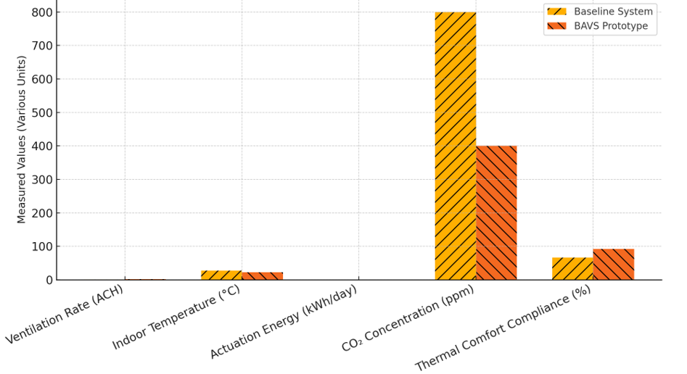

Fig. 2. Comparison of Performance Findings Between the Biomimetic Adaptive Ventilation System (BAVS) Against Conventional Static Façade Systems

4.3 Interpretation of Experimental Findings

The combined results demonstrate that BAVS provides reliable, energy-efficient ventilation performance while improving indoor environmental quality. The system’s decentralized actuation reduces mechanical energy consumption and simplifies control architecture, making BAVS attractive for applications requiring scalable yet low-complexity adaptive façade systems.

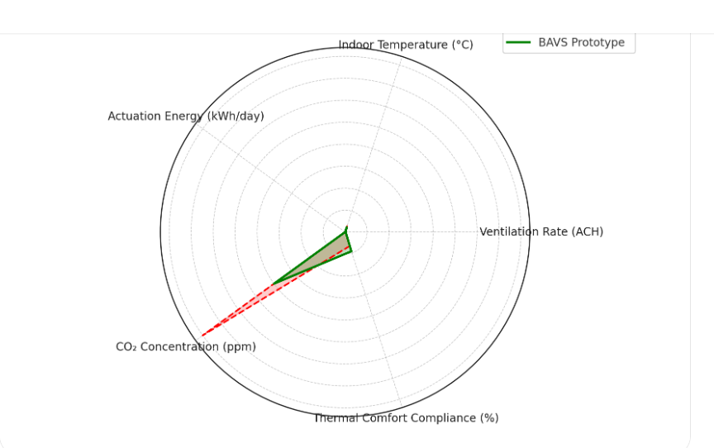

Fig. 3. Results of BAVS Prototype

4.4 Discussions

The results show that BAVS effectively translates honeybee thermoregulation strategies into an engineered adaptive façade system. The decentralized control approach closely mirrors honeybee fanning behaviour, where individuals react locally to environmental cues to maintain stable internal conditions. This biological inspiration enables BAVS to respond rapidly to temperature and CO₂ fluctuations while avoiding the complexity of centralized systems (Avinç et al., 2024).
In comparison to biomimetic systems inspired by termite mound ventilation, BAVS offers a more dynamic, responsive mechanism by incorporating active but low-energy actuation. Termite-based passive systems provide inherent thermal stability, but their performance can be less adaptable in scenarios requiring real-time modulation (Zender-Świercz, 2020). BAVS therefore fills an innovative niche by integrating active adaptability with low operational energy demands.
When benchmarked against advanced dynamic façade technologies, BAVS presents meaningful advantages. Many high-end responsive façades rely on extensive sensor networks and complex control algorithms (Öztürk et al., 2024; Yan et al., 2021), often resulting in high costs and maintenance burdens. BAVS circumvents these challenges through its modular and decentralized logic, offering improved performance without requiring intensive technological infrastructure.

4.5 Limitations

As noted, the scaled prototype may not fully represent full-scale building behaviour. Environmental noise, laboratory conditions, and limited testing duration may influence results (Brzezicki, 2021). Future full-scale mock-ups and long-term monitoring would provide deeper insights into material durability, actuation longevity, and integration with building systems.

4.6 Future Work

Potential future enhancements include integrating adaptive materials, applying digital twin technologies for predictive optimization, and conducting life-cycle assessments to evaluate long-term economic performance. Broader climate scenario testing would also support BAVS refinement across diverse geographic regions.

5. CONCLUSION

This study demonstrates the potential of biomimetic design, specifically honeybee thermoregulation, to inform the development of adaptive façade systems that improve energy performance, indoor air quality, and thermal comfort in buildings targeting net-zero energy outcomes. The Biomimetic Adaptive Ventilation Skin (BAVS) achieved a 20% reduction in annual energy consumption compared to a conventional static façade, validating the effectiveness of nature-inspired adaptive ventilation strategies in moderating indoor temperatures and reducing mechanical load.
Experimental results further confirm that BAVS enhances indoor environmental quality through increased ventilation rates, lowering CO₂ concentrations to approximately 400 ppm, and maintaining indoor temperatures within thermally comfortable ranges for 92% of occupied hours. The system’s decentralized actuation approach, mirroring honeybee collective behaviour, reduces operational energy demand by 40% compared to typical mechanical systems, demonstrating a scalable, low-complexity pathway for integrating adaptive functionality into building envelopes.
The contributions of this research extend beyond performance outcomes. BAVS showcases how biological mechanisms can be translated into practical engineering solutions that support future-ready, net-zero buildings. By demonstrating the feasibility and advantages of decentralized adaptive ventilation, this work advances the field of biomimetic architecture and highlights new opportunities for developing sustainable, responsive building technologies.
Further research could expand on this foundation through full-scale façade integration, long-term field monitoring, and the incorporation of advanced responsive materials or predictive digital twin systems. Together, these efforts can support broader adoption of biomimetic adaptive façades and contribute meaningfully to global sustainability goals.

DISCLAIMER (ARTIFICIAL INTELLIGENCE)

The author(s) hereby declare that generative AI technologies such as Large Language Models have been used during the writing or editing of this manuscript. The explanation below includes the name, version, model, and source of the generative AI technology, as well as a description of how it was used.

Details of the AI usage are given below:

- Name / Model / Version: ChatGPT, GPT-5.1 (OpenAI).
- Source: OpenAI ChatGPT Platform (https://chat.openai.com).
- Purpose of Use: The AI tool was used solely for language refinement, clarity improvement, grammar corrections, and formatting assistance. All scientific ideas, data analysis, methodologies, results, interpretations, and conclusions were entirely developed, verified, and approved by the author(s). The AI did not contribute to the generation of new scientific content.

References

Adibhesami, M., & Hassanzadeh, A. (2025). Optimizing HVAC energy efficiency in low-energy buildings: A comparative analysis of reinforcement learning control strategies under Tehran climate conditions. Data-Centric Engineering, 6. https://doi.org/10.1017/dce.2025.10014
Amorim, C., Silva, J., Silva, C., Góes, T., Medeiros, A., Pimenta, J., & Sánchez, J. (2022). An integrated design process in practice: A nearly zero energy building at the University of Brasília, Brazil. https://doi.org/10.5772/intechopen.102443
Ananda, K., & Hariyadi, A. (2023). Adaptive photovoltaic performance study with a biomimetic approach for energy saving. Journal of Artificial Intelligence in Architecture, 2(1), 1–15. https://doi.org/10.24002/jarina.v2i1.6331
Attia, S. (2018). Evaluation of adaptive façades: The case study of Al Bahr Towers in the UAE. QScience Connect, 2017(2). https://doi.org/10.5339/connect.2017.qgbc.6
Austin, M., Carpino, C., Mora, D., & Arcuri, N. (2022). A methodology to identify appropriate refurbishment strategies towards zero energy buildings in a hot and humid climate. Journal of Physics: Conference Series, 2385(1), 012020. https://doi.org/10.1088/1742-6596/2385/1/012020
Avinç, G. (2024). Biomimetic approach for adaptive, responsive, and kinetic building façades: A bibliometric review of emerging trends. NDI, 8(3), 567–580. https://doi.org/10.62476/ndi83567
Avinç, G., Koç, S., & Selçuk, S. (2024). Biomimetic façade design proposal for improving thermal comfort in hot climate regions. International Journal of Built Environment and Sustainability, 11(2), 27–39. https://doi.org/10.11113/ijbes.v11.n2.1226
Azari, R., Kamel, E., & Memari, A. (2024). Current developments and future directions in energy-efficient buildings from the perspective of building construction materials and enclosure systems. Buildings, 14(7), 1921. https://doi.org/10.3390/buildings14071921
Blanco, E., Zari, M., Raskin, K., & Clergeau, P. (2021). Urban ecosystem-level biomimicry and regenerative design: Linking ecosystem functioning and urban built environments. https://doi.org/10.26686/wgtn.14857479
Brzezicki, M. (2021). A typology of adaptive façades: An empirical study based on the morphology of glazed façades. Cogent Arts & Humanities, 8(1), 1960699. https://doi.org/10.1080/23311983.2021.1960699
Böke, J. (2020). Thinking-skins. https://doi.org/10.59490/abe.2020.08.5035
Cabeza, L., & Chàfer, M. (2020). Technological options and strategies towards zero energy buildings contributing to climate change mitigation: A systematic review. Energy and Buildings, 219, 110009. https://doi.org/10.1016/j.enbuild.2020.110009
Chung-Camargo, K., González, J., Solano, T., Yuil, O., Velarde, V., & Austin, M. (2023). Energy-efficiency measures to achieve zero energy buildings in tropical and humid climates. https://doi.org/10.5772/intechopen.1002801
Cocho‐Bermejo, A. (2025). Adaptive architectural façades: Review 1985–2024. A comparative analysis of Media-TIC, the Arab Institute, and Al Bahar Towers dynamic façade approaches. Nexus Network Journal, 27(4), 925–945. https://doi.org/10.1007/s00004-025-00831-1
Cruz, E., Blanco, E., Aujard, F., & Raskin, K. (2022). Has biomimicry in architecture arrived in France? Diversity of challenges and opportunities for a paradigm shift. Biomimetics, 7(4), 212. https://doi.org/10.3390/biomimetics7040212
Ekşi, M., & Özcan, M. (2025). Towards nearly zero energy buildings: Energy and environmental analysis of retrofit scenarios for a residential building in İzmir. Engineering Research Express, 7(2), 025339. https://doi.org/10.1088/2631-8695/add3c3
Faragalla, A., & Asadi, S. (2022). Biomimetic design for adaptive building façades: A paradigm shift towards environmentally conscious architecture. Energies, 15(15), 5390. https://doi.org/10.3390/en15155390
Gong, F., Ma, Y., Shi, F., Chen, C., Tian, L., & Huang, J. (2024). Environmental and energy performances of the nearly net-zero energy solar decathlon house with dynamic façades: A comparison of four climate regions. Buildings, 14(12), 4053. https://doi.org/10.3390/buildings14124053
González, A., Krawczyk, D., Martínez, F., & Gómez, E. (2019). Improved performance of a PV integrated ventilated façade at an existing NZEB. Proceedings, 22(1), 16022. https://doi.org/10.3390/proceedings2019016022
Gunawan, M., Chandra, B., & Trisno, R. (2023). Net zero energy low-rise apartment in Jakarta. IJASTE, 1(1), 113–120. https://doi.org/10.24912/ijaste.v1.i1.113-120
Harnane, Y., Bouzid, S., & Brima, A. (2018). Air flow thermal and dynamic behavior inside ventilated cavities. International Journal of Automotive and Mechanical Engineering, 15(3), 5652–5666. https://doi.org/10.15282/ijame.15.3.2018.19.0434
Hosseini, S., Fadli, F., & Mohammadi, M. (2021). Biomimetic kinetic shading façade inspired by tree morphology for improving occupants’ daylight performance. Journal of Daylighting, 8(1), 65–85. https://doi.org/10.15627/jd.2021.5
Ibrahim, M., William, M., Salama, A., Moussa, M., & Suárez‐López, M. (2024). Multi-pronged strategies for enhancing building envelopes toward nearly-zero energy in hot climatic regions. Engineering Research Express, 6(4), 045532. https://doi.org/10.1088/2631-8695/ad898a
Jankovic, L., & Carta, S. (2021). BioZero, designing nature-inspired net-zero buildings. Sustainability, 13(14), 7658. https://doi.org/10.3390/su13147658
Kuda, A., Yadav, M., & Ali, S. (2025). Performance of PTFE-based adaptive building façades for climate resilience: A simulation-driven analysis. International Journal of Engineering Science and Information Technology, 5(4), 9–18. https://doi.org/10.52088/ijesty.v5i4.1071
Mehaoued, K., & Lartigue, B. (2019). Influence of a reflective glass façade on surrounding microclimate and building cooling load: Case of an office building in Algiers. Sustainable Cities and Society, 46, 101443. https://doi.org/10.1016/j.scs.2019.101443
Mohammed, G., Mabrouk, M., He, G., & Abdrabo, K. (2023). Towards sustainable cities: A review of zero energy building techniques and global activities in residential buildings. Energies, 16(9), 3775. https://doi.org/10.3390/en16093775
Mustapha, M., Chanik, A., Ismaili, G., & Pauzan, A. (2024). Evaluation of demand control ventilation impact on indoor air quality and energy efficiency of an office space in a tropical climate. https://doi.org/10.21203/rs.3.rs-3938502/v1
Ovadiuc, E., Calotă, R., Năstase, I., & Bode, F. (2024). Integration of phase-change materials in ventilated façades: A review regarding fire safety and future challenges. Fire, 7(7), 244. https://doi.org/10.3390/fire7070244
Öztürk, B., Avinç, G., & Selçuk, S. (2024). Enhancing energy efficiency in glass façades through biomimetic design strategies. Revista Hábitat Sustentable, 14(1), 34–43. https://doi.org/10.22320/07190700.2024.14.01.03
Pastori, S., Mereu, R., Mazzucchelli, E., Passoni, S., & Dotelli, G. (2021). Energy performance evaluation of a ventilated façade system through CFD modeling and comparison with international standards. Energies, 14(1), 193. https://doi.org/10.3390/en14010193
Peters, J., Peleg, O., & Mahadevan, L. (2019). Collective ventilation in honeybee nests. Journal of the Royal Society Interface, 16(150), 20180561. https://doi.org/10.1098/rsif.2018.0561
Rana, M., & Rahman, M. (2020). Building energy performance optimization towards net zero energy building using passive solution technologies and building information modeling at design phase. Journal of Construction Engineering, Management & Innovation, 3(1), 29–51. https://doi.org/10.31462/jcemi.2020.01029051
Rao, X., Qi, F., Zhang, X., & Mao, Z. (2022). Evaluation method on energy-efficient retrofitting of wooden walls of Chinese traditional dwellings: A case study of Rendetang in Jinhua. Buildings, 12(7), 1017. https://doi.org/10.3390/buildings12071017
Rieser, A., Pfluger, R., Troi, A., Herrera-Avellanosa, D., Thomsen, K., Rose, J., & Chung, D. (2021). Integration of energy-efficient ventilation systems in historic buildings: Review and proposal of a systematic intervention approach. Sustainability, 13(4), 2325. https://doi.org/10.3390/su13042325
Rosario, M., Beermann, K., & Austin, M. (2023). Environmentally responsive materials for building envelopes: A review on manufacturing and biomimicry-based approaches. Biomimetics, 8(1), 52. https://doi.org/10.3390/biomimetics8010052
Sankaewthong, S., Miyata, K., Horanont, T., Xie, H., & Karnjana, J. (2023). Mimosa kinetic façade: Bio-inspired ventilation leveraging the Mimosa pudica mechanism for enhanced indoor air quality. Biomimetics, 8(8), 603. https://doi.org/10.3390/biomimetics8080603
Soudian, S., & Berardi, U. (2021). Performance analysis of the micro-V (multifunctional, integrated, climate-responsive, opaque, and ventilated) façade with different ventilation modes. Journal of Physics: Conference Series, 2069(1), 012024. https://doi.org/10.1088/1742-6596/2069/1/012024
Sudhesh, A. (2025). Identifying and prioritizing key factors for energy performance in façade systems across diverse climate zones. Journal of Recent Activities in Architectural Sciences, 10(1), 10–26. https://doi.org/10.46610/joraas.2025.v010i01.002
Sukamto, D., Siroux, M., & Gloriant, F. (2021). Hot box investigations of a ventilated bioclimatic wall for NZEB building façades. Energies, 14(5), 1327. https://doi.org/10.3390/en14051327
Sánchez, M., Giancola, E., Blanco, E., Soutullo, S., & Suárez‐López, M. (2019). Experimental validation of a numerical model of a ventilated façade with horizontal and vertical open joints. Energies, 13(1), 146. https://doi.org/10.3390/en13010146
Valinejadshoubi, M., Athienitis, A., Bagchi, A., & Abtahi, M. (2024). Integrated dynamic photovoltaic façade for enhanced building comfort and energy efficiency. Biomimetics, 9(8), 463. https://doi.org/10.3390/biomimetics9080463
Wang, P., & Zhang, S. (2022). Retrofitting strategies based on orthogonal array testing to develop nearly zero energy buildings. Sustainability, 14(8), 4451. https://doi.org/10.3390/su14084451
Webb, M. (2021). Biomimetic building façades demonstrate potential to reduce energy consumption for different building typologies in different climate zones. Clean Technologies and Environmental Policy, 24(2), 493–518. https://doi.org/10.1007/s10098-021-02183-z
Wu, W., & Skye, H. (2018). Net-zero nation: HVAC and PV systems for residential net-zero energy buildings across the United States. Energy Conversion and Management, 177, 605–628. https://doi.org/10.1016/j.enconman.2018.09.084
Yan, H., Zhang, Y., Liu, S., Cheung, K., & Ji, G. (2021). Optimization of daylight and thermal performance of building façades: A case study of office buildings in Nanjing. In Proceedings (pp. 168–178). https://doi.org/10.1007/978-981-16-5983-6_16
Zender–Świercz, E. (2020). Microclimate in rooms equipped with decentralized façade ventilation devices. Atmosphere, 11(8), 800. https://doi.org/10.3390/atmos11080800

