DEVELOPMENT OF A SENSOR-BASED SOLAR POWERED HYDROPONIC FODDER PRODUCTION SYSTEM

Abstract
Aims: The aim of this study was to develop and evaluate a solar-powered, sensor-based hydroponic maize fodder production system capable of providing a sustainable, energy-efficient and year-round solution for green fodder cultivation.
Study Design: Engineering development followed by system evaluation under controlled hydroponic growing conditions.
Place and Duration of Study: Department of Farm Machinery and Power Engineering and Department of Renewable Energy Engineering, University of Agricultural Sciences, Raichur, Karnataka, India.
Methodology: A sensor-integrated hydroponic fodder unit was developed using AHT10, AHT25 and DHT11 sensors connected to an Arduino Uno for automated monitoring of temperature and humidity. Solar PV panels with a charge controller and battery storage powered the system. The structure consisted of multi-tier trays with micro-sprinklers to ensure uniform irrigation. Sensors were evaluated based on mean absolute error and accuracy. Hydroponic maize was grown under different seed rates, temperatures and harvest periods, and green fodder yield was recorded in kg m⁻².
Results: Among the sensors tested, AHT10 demonstrated the highest accuracy and lowest mean absolute error for both temperature and humidity, making it the most suitable for automated hydroponic control. Maximum green fodder yield of 19.78 kg m⁻² was achieved at an optimum temperature of 29–32 °C, 11-day harvest period, and 600 g seed rate. The solar-powered system ensured uninterrupted operation while reducing dependence on external electricity.
Conclusion: The developed solar-powered, sensor-based hydroponic maize fodder unit proved efficient, cost-effective and highly suitable for rural farming systems. It offers a sustainable solution for year-round green fodder production, overcoming limitations of traditional cultivation such as high labour, water requirement and seasonal dependence.

1. INTRODUCTION
India faces a persistent shortage of quality feed and fodder due to the combined effects of limited cultivable land, increasing livestock numbers and rising pressure on natural resources (Bari et al., 2020). Current estimates indicate deficits of 35.6% in green fodder and 10.5% in dry fodder, posing a major constraint on livestock productivity and profitability (Dhamodharan et al., 2024; Harsimran et al., 2025). The feed scarcity has been the main limiting factor in improving the livestock productivity (Pratap and Jha, 2005).

The government’s livestock department reports deficits ranging from 11% to 32% in green fodder and around 23% in dry fodder, highlighting persistent shortages that threaten dairy productivity and animal health (Murphy, 2024). In Karnataka, ruminant livestock—cattle, buffalo, sheep and goats—account for 98.83% of the state’s 29.013 million livestock population (Patil et al., 2019).Karnataka’s ruminant livestock are vital to farmers’ livelihoods, and the state ranks 12th in indigenous and 13th in total cattle population. However, cattle numbers have sharply declined, with total and indigenous populations dropping by 11.01% and 30.94% (2012–2022), and by 19.36% and 45.11% from 2007–2020.(Behl et al., 2023).

Conventional methods of fodder cultivation require large areas of land, substantial labour and long growing durations, and are highly dependent on seasonal and climatic conditions (Naik et al., 2014). These challenges make it difficult for farmers—especially small and marginal holders—to produce adequate fodder throughout the year (Begam 2024). Major constraints limiting green fodder production for dairy farmers include small landholdings, high labour demand, long crop duration (45–60 days), inconsistent year-round quality, need for manure and fertilizers, uncertain rainfall, water scarcity or salinity, fencing requirements, and vulnerability to wild animals and natural calamities (Naik et al., 2014). Owing to these challenges in conventional fodder cultivation, hydroponic technology has emerged as a viable alternative for producing fodder for livestock (Sneath & McIntosh, 2003; Naik et al., 2015)
Hydroponic fodder production has emerged as a sustainable alternative, enabling rapid, soil-free production of green fodder within 6–10 days. Crops such as maize, barley and wheat grown under hydroponic conditions can yield 7–10 kg of fresh fodder per kilogram of seed (Treftz & Omaye, 2016 & Jolad et al 2018), while requiring significantly less water and land compared to conventional systems (Muela et al., 2005). The technique also ensures better nutrient availability and has been associated with improved livestock health and productivity (Naik et al., 2015; Al-Karaki & Al-Momani, 2011).

Integrating hydroponic systems with solar power and sensor-based automation improves efficiency by enabling precise control of temperature, humidity and irrigation while reducing labour and reliance on grid electricity (Varmora et al., 2018). This makes the technology ideal for rural, resource-limited areas. A solar-powered, sensor-integrated hydroponic fodder system thus offers an eco-friendly, cost-effective and practical solution to India’s persistent fodder scarcity and supports sustainable livestock production.

2. MATERIALS AND METHODS

2.1 Selection of Sensors
Sensors are essential components in automated hydroponic systems because they enable continuous monitoring and regulation of environmental conditions. Temperature and humidity sensors help maintain optimal microclimate conditions, while integration with a microcontroller allows real-time decision-making for irrigation, cooling and environmental control. The sensors were selected based on compatibility, accuracy, sensitivity, working range, reliability, power requirements and cost-effectiveness. Three sensors—AHT10, AHT25 and DHT11—were evaluated for accuracy, operational range and power consumption. The sensor with the highest accuracy and stability was used to transmit real-time data to the microcontroller for automated irrigation control.

2.1.1 Temperature and Humidity Sensors

2.1.1.1 AHT10 Sensor
The AHT10, developed by Aosong Electronics, is a compact digital temperature and humidity sensor widely used in environmental monitoring, IoT systems and automation. It incorporates a capacitive humidity element, bandgap temperature sensor, analog-to-digital converter (ADC) and an I²C interface (address 0×38). It measures 0–100% RH and –40°C to +85°C, providing reliable and stable data under varying climatic conditions.
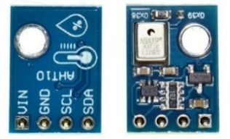

Fig. 1. AHT10 Temperature and Humidity Sensor

2.1.1.2 DHT11 Sensor
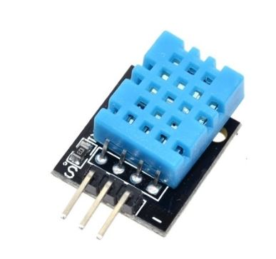
The DHT11 is a low-cost, basic temperature and humidity sensor suitable for small-scale projects and DIY automation. It uses single-wire digital communication and measures 20–80% RH and 0–50°C with accuracies of ±5% RH and ±2°C. Although less accurate than advanced sensors, it is widely used due to its affordability and ease of integration.

Fig. 2. DHT11 Temperature and Humidity Sensor

2.1.1.3 AHT25 Sensor
The AHT25 offers higher accuracy (±0.3°C, ±2% RH) and wide operational ranges (–40 to +85°C, 0–100% RH). It is factory-calibrated, compact (3.2 × 3.0 × 0.8 mm) and communicates via I²C (0×38). Due to its precision and fast response, it is preferred for smart agriculture, HVAC and climate-controlled farming systems.
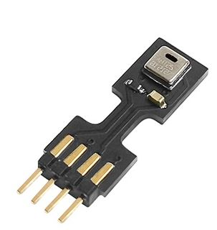
Fig. 3. AHT25 Temperature and Humidity Sensor

2.1.2 Arduino Uno Microcontroller
The Arduino Uno, based on the ATmega328P microcontroller, was used as the central processing unit for sensor data acquisition and irrigation control. It operates at 16 MHz with 14 digital I/O pins (six PWM), six analog inputs, 32 KB flash memory and 2 KB SRAM. It supports both DC power (7–12 V) and USB input through a CH340G USB-to-serial interface. Its versatility, reliability and ease of programming make it ideal for automated hydroponic applications.
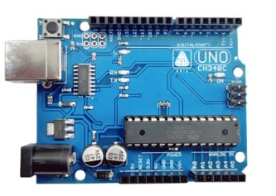

Fig. 4. Arduino Uno Board

2.1.3 Comparison of Temperature and Humidity Sensors
Table 1. Comparison of DHT11, AHT10 and AHT25 sensors
SL.No | Parameter | DHT11 | AHT10 | AHT25
 | Humidity range | 20 – 90 %RH | 0 – 100 %RH | 0 – 100 %RH
 | Humidity accuracy | ±5 %RH | ±2 %RH | ±2 %RH
 | Temperature range | 0 –50 °C | -40 – 85 °C | -40 – 85 °C
 | Temperature accuracy | ±2 °C | ±0.3 °C | ±0.3 °C
 | Communication interface | Single-wire digital | I²C | I²C
 | Operating voltage | 3.0–5.5 V | 1.8–3.6 V | 2.2–5.5 V
 | Power consumption | 0.5 mA | <0.5 mW | <0.5 mW
 | Resolution | Rh:1%, Temp: 1 °C | Rh:~ 0.024%, Temp: 0.01 °C | Rh :~ 0.024%, Temp: 0.01 °C

2.1.4 Integration of Sensors with Control System
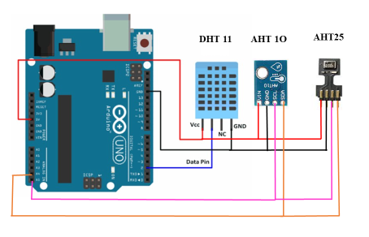
The sensors (AHT10, AHT25 and DHT11) were integrated with the Arduino Uno using both digital and I²C communications. The DHT11 was connected via digital pin 2, whereas AHT10 and AHT25 communicated via I²C (SDA = A4, SCL = A5). The Arduino received continuous temperature and humidity readings and controlled irrigation pumps based on threshold values, enabling low-power, automated system operation.

Fig. 5. Wiring Connections of AHT10, AHT25 and DHT11 Sensors with Arduino Uno

2.1.5 Sensor Calibration and Testing
All sensors were calibrated and tested against a reference standard. Recalibration was performed periodically to correct deviations arising from condensation, humidity stress or temperature fluctuations. The Arduino IDE was used for data logging, employing DFRobot_AHT20 (AHT10, AHT25) and DFRobot_DHT11 libraries.

2.2 Development of a Sensor-Based Solar Powered Hydroponic Fodder Production System
The hydroponic structure was designed to maximize space utilization, ensure uniform irrigation and operate with solar-based automation. The system consisted of 24 trays arranged in three tiers, supported by a durable aluminium frame. Each tray measured 0.138 m², giving a total planted area of 3.312 m². Despite a frame footprint of only 1.1375 m², vertical stacking tripled the effective cultivation area.

2.2.1 Area Calculations
- Total Planted Area:
24 trays × 0.138 m² = 3.312 m²
- Frame Footprint Area:
1.25 m × 0.91 m = 1.1375 m²

2.2.2 Tray Arrangement
Multiple configurations were evaluated; the most feasible was a 2 × 4 layout with trays rotated such that the 300 mm side aligned with frame length:
- Occupied Length = 1200 mm (fits within 1250 mm)
- Occupied Width = 920 mm (exceeds by 10 mm; adjustable due to flexible frame and shade net)

2.2.3 Vertical Spacing
- Level heights: 900 mm, 1430 mm, 1960 mm
- Vertical gap per tier: 530 mm
- Tray depth: 80 mm
- Clear plant growth space: 450 mm per tier

2.2.4 Sprinkler Arrangement
- 2 sprinklers per level × 3 levels = 6 sprinklers
- Mounted at 416.7 mm and 833.3 mm from the starting edge
- Ensures uniform spray distribution across all 8 trays per level

2.2.5 System Operation and Power Supply
The irrigation system was controlled via an electronic board programmed for automatic spray cycles. The solar-powered setup included:
- Solar panel
- Charge controller
- Rechargeable battery
- Arduino Uno
- Sensors
- Micro-sprinklers
- Diaphragm pump
The battery stored excess daytime energy and powered the system at night. Grid power could be used as a backup.

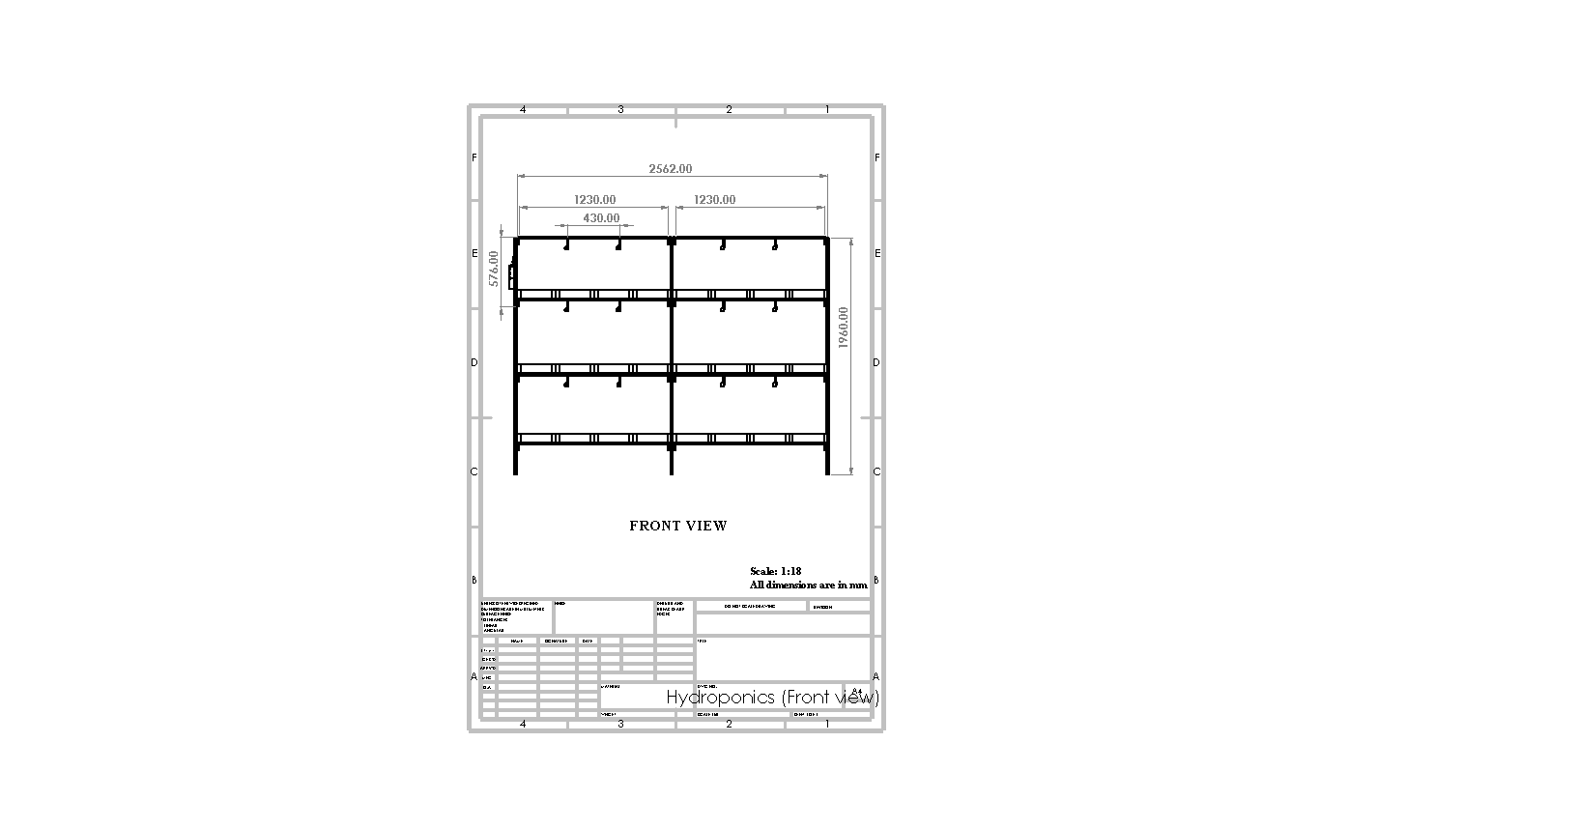
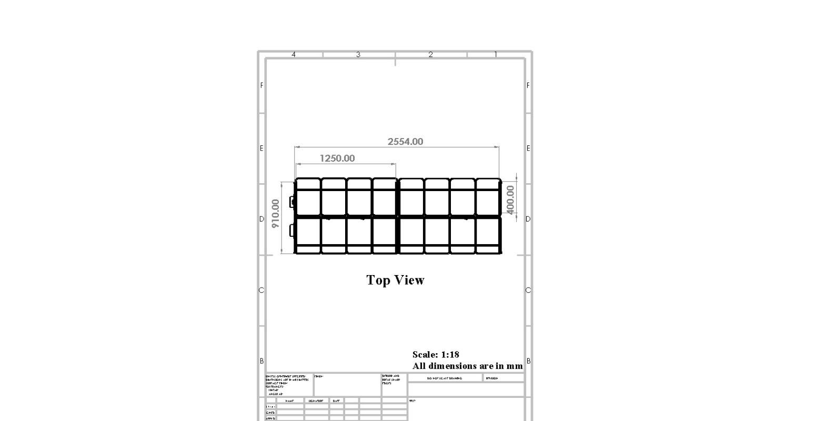

Fig. 6. Front View of Hydroponic System Fig. 7. Top View of Hydroponic System
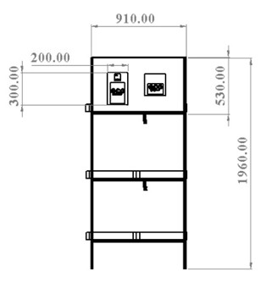
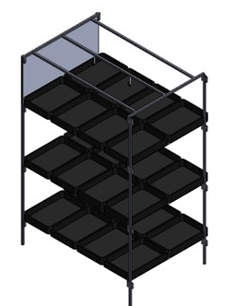

Fig. 8. Side View of Hydroponic System Fig. 9. Isometric View of Hydroponic System

2.2.6 Components Used
Table 2. Components Used in the Solar-Powered Hydroponic System
Sl.no | Component | Specification
1 | Solar panel | EIL40P36, 40 Wp, dimension :0.56×0.42×0.03 m, Vmp: 18V, Imp: 2.23A, Voc: 1000V.
2 | Solar charge controller | PWM type, prevents overcharge/overvoltage, regulates current from PV to battery
3 | Battery | Lead-acid, 12V 26Ah for continuous system operation
4 | Adapter | TRC I-01205, AC-DC (100–240V to 12V 5A), includes short-circuit and overload protection
5 | Converter | DC-DC buck converter, input: 6–24V, output: 5V, components: inductor, MOSFET, Schottky diode, USB port
6 | Microcontroller | Arduino, processes sensor data, automates watering, monitors temp/humidity
7 | AHT-10 | Maintains 26–35°C temp, ensures plant comfort and growth, Measures Rh
8 | Display unit | 3×2.5" LCD, shows real time temperature and humidity, connected to Arduino
9 | Cat-6 cable | Used for sensor to controller networking (Arduino, sensors)
10 | Pump | Diaphragm type, dual head, 12V, 6–8 A, 9–10 LPM, max 250 PSI
11 | Pipe | 5-layer 8.5 mm PVC spray hose + black flexible pipe for delivery
12 | Micro sprinklers | 20–100 L/hr, low pressure (1–2 bar), spray covers 4 trays
13 | Water tank | One tank of 300 litres store and supply water for irrigation
14 | Tray | Dimensions: 460 mm × 300 mm × 80 mm.  Size: 0.138 m² made of food grade plastic
15 | Seeds | African Tall Maize(zea seeds)
16 | Hydrogen peroxide | 3% solution for sterilizing trays and equipment, eco-safe, effective against bacteria/fungi

2.3 Protocol for Hydroponic Fodder Production
- Seed Selection: Use bold, healthy seeds with >90% germination.
- Seed Soaking: Soak 1 kg seeds in 2–3 L water for 12–24 hours; add vermiwash (20–25%).
- Seed Sprouting: Incubate soaked seeds for 24–30 hours in a moist gunny bag.
- Tray Filling: Spread sprouted seeds uniformly in trays.
- Watering: Automated microcontroller-operated sprinkler system based on temperature.
- Harvesting: Fodder ready in 7–11 days.
- Feeding: Replace part of daily feed with hydroponic green fodder.
- Tray Cleaning: Sanitize trays with chlorine water, KMnO₄ or H₂O₂.

2.4 Working of the Sensor-Based Hydroponic System
The system functions as an automated solar-powered smart irrigation unit, with the Arduino microcontroller as the central control hub. Power is supplied either from the battery or DC adapter with diode-based protection to avoid reverse currents. The solar charge controller regulates charging and prevents overcharging.
The Arduino receives 5 V via a buck converter and continuously reads temperature and humidity using the AHT10 sensor. Data are displayed on a 2×16 LCD. A hysteresis-based control algorithm activates or deactivates the pump when temperature thresholds are exceeded, maintaining a stable microclimate.
The irrigation system is driven by a relay-based switching circuit powered by an NPN transistor (BC547). A push-button allows the user to modify temperature setpoints. Micro-sprinklers distribute water uniformly across trays during pump operation.
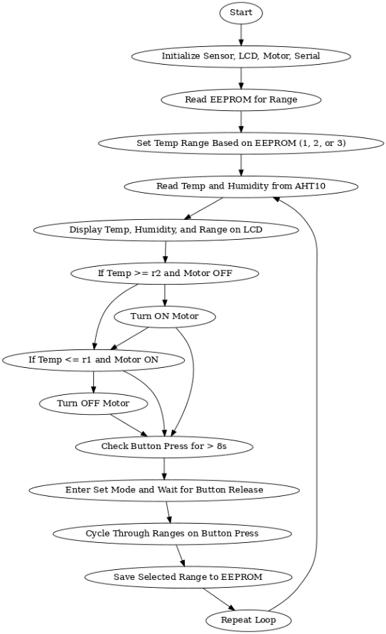

Fig. 10. Flowchart of Arduino-Based Temperature-Controlled Irrigation System
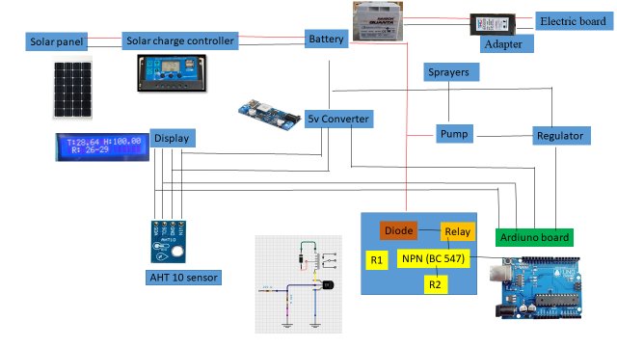
Fig. 11. Circuit Diagram of the Sensor-Based Solar Hydroponic System

2.5 Water Requirement Calculation
- Tray size: 0.138 m²
- No. of trays: 48
- Crop duration: 11 days
- Spray output: 65 ml spray⁻¹
- Spray frequency: 24 sprays day⁻¹
- 1 spray covers: 4 trays
- No. of sprayers: 12

2.5.1 Per-Tray Water Use
Water per spray:
65 ml ÷ 4 trays = 16.25 ml tray⁻¹
Daily water per tray:
16.25 × 24 = 390 ml day⁻¹ = 0.39 L day⁻¹
11-day water requirement:
0.39 × 11 = 4.29 L tray⁻¹

2.5.2 Total System Requirement
For 48 trays:
4.29 × 48 = 205.92 L ≈ 206 L

2.5.3 Daily Water Requirement
48 trays × 0.39 L = 18.72 L day⁻¹

3. RESULTS

3.1 Sensor Performance Evaluation
The performance of AHT10, AHT25 and DHT11 sensors was evaluated under two controlled environments—common room (30–32°C) and cooled (26–28°C)—to identify the most reliable sensor for automated hydroponic systems. IR thermometer and HTC2 were used as reference instruments for temperature and humidity.

3.1.1 Common Room Environment

All sensors showed temperature values close to the reference, but humidity readings varied widely. DHT11 consistently overestimated humidity, AHT25 showed moderate deviation, whereas AHT10 remained closest to reference for both parameters.MAE analysis confirmed AHT10 had the lowest error (Temp: 0.40–1.78; RH: 0.77–2.65). AHT25 performed well for temperature but poorly for humidity (RH error: 4.74–9.06). DHT11 showed the highest errors, especially for humidity (6.00–9.00). ANOVA results indicated significant effects of sensor type, parameter and their interaction (p < 0.0001), with humidity having much higher errors. AHT10 was the most reliable with high accuracy (Temp: 94.08–98.67%; RH: 91.77–97.61%). AHT25 and DHT11 were acceptable for temperature but weak for humidity. Sensitivity analysis showed DHT11 had the highest temperature sensitivity, while AHT25 and DHT11 were more sensitive to humidity. AHT10 showed lower but more stable sensitivity. Optimization results (Table 3) identified AHT10 (Temperature) as the best combination with the lowest MAE (1.250), high accuracy (95.844%) and positive sensitivity.

3.1.2 Cooled Environment
Compared to reference values, AHT10 slightly underestimated temperature and moderately overestimated humidity. AHT25 showed greater humidity deviation, while DHT11 recorded mid-range values. Humidity deviation was greater than temperature for all sensors. MAE analysis showed AHT10 had moderate errors (Temp: 2.47–3.93; RH: 4.10–7.88). AHT25 performed slightly better in temperature but had very high humidity error (10.16–14.31). DHT11 had low temperature error but high humidity error. ANOVA confirmed significant effects of sensor type, parameter and interaction (p < 0.0001) with strong model reliability (R² = 0.9534).
Accuracy under cooled conditions showed AHT25 highest for temperature (87.96–92.86%), DHT11 slightly higher at some points but inconsistent, and AHT10 acceptable (86.25–91.35%). For humidity, AHT10 again performed best (77.48–88.28%), while AHT25 and DHT11 showed low accuracy. Sensitivity results showed DHT11 most sensitive to temperature, AHT10 moderate and AHT25 least responsive. For humidity, AHT10 showed better sensitivity than AHT25 and DHT11.Optimization (Table 4) again identified AHT10 (Temperature) as the most desirable configuration with minimum MAE (2.970), highest accuracy (95.840%) and strong sensitivity.
Across both environments and all evaluation criteria (MAE, accuracy, sensitivity, ANOVA, and optimization models), AHT10 for temperature measurement consistently emerged as the most accurate, stable and optimal sensor, offering low error, high accuracy and reliable performance for automated hydroponic systems.

Table 3. Sensor performance under warm environment
SL.no | Type of sensor | Parameter | Mean  absolute error | Accuracy | Sensitivity | Desirability | Remark
1 | AHT10 | Temperature | 1.250 | 95.844 | 1.250 | 0.641 | Selected
2 | DHT11 | Temperature | 1.720 | 94.282 | 1.720 | 0.638
3 | AHT25 | Temperature | 1.748 | 94.190 | 1.748 | 0.638
4 | AHT10 | Humidity | 5.992 | 81.392 | 5.992 | 0.450
5 | AHT25 | Humidity | 1.980 | 93.852 | -1.672 | 0.380

Table 4. Sensor performance under cooled environment
SL.no | Type of sensor | Parameter | Mean absolute error | Accuracy | Sensitivity | Desirability | Remark
1 | AHT10 | Temperature | 2.970 | 95.840 | 2.224 | 1.000 | Selected
2 | DHT11 | Temperature | 1.987 | 94.287 | 1.494 | 0.915
3 | AHT25 | Temperature | 2.447 | 94.197 | 1.001 | 0.910
4 | AHT10 | Humidity | 4.120 | 93.733 | 1.252 | 0.885
5 | AHT25 | Humidity | 11.690 | 81.313 | 0.029 | 0.204

3.2 Hydroponic Fodder Yield
The hydroponic maize fodder system recorded a maximum green fodder yield of 19.78 kg m⁻², achieved under an optimally maintained temperature range of 29–32°C, an 11-day harvesting period, and a 600 g seed rate per tray. These conditions created an ideal environment for rapid germination and accelerated biomass accumulation. The precisely regulated microclimate—continuously monitored and controlled using the AHT10 sensor—ensured highly stable temperature and humidity levels throughout the growth cycle. This stability minimized physiological stress on the sprouts, promoted uniform seed germination, and supported vigorous root–shoot development.
The system further facilitated the formation of dense, fresh, nutrient-rich, and mold-free fodder mats, which are critical indicators of high-quality hydroponic produce. The absence of mold or fungal growth can be attributed to efficient ventilation, accurate humidity regulation, and optimal irrigation intervals maintained by the automated setup. Together, these factors enhanced overall fodder health, appearance, and nutritional value. The study thus demonstrates that integrating precise sensor-based environmental control with optimized agronomic parameters significantly improves the productivity and quality of hydroponic maize fodder, making the system highly viable for sustainable, year-round fodder production.

4. CONCLUSION
The study clearly demonstrated that the AHT10 sensor is the most suitable option for automated hydroponic applications. Its high accuracy in temperature and humidity measurement, combined with minimal mean absolute error (MAE) and stable performance under both warm (30–32°C) and cooled (26–28°C) environments ensures precise environmental monitoring. This level of accuracy is essential in hydroponics, where even small fluctuations in humidity or temperature can affect nutrient uptake, germination, and overall fodder biomass yield. The reliable performance of AHT10 throughout the cultivation cycle enabled timely control of irrigation cycles, misting operations, and ventilation systems. This not only maintained optimal micro-climatic conditions but also reduced manual labour and operational errors often associated with traditional methods.
The development of a solar-powered, sensor-integrated hydroponic fodder production system further enhanced the sustainability and efficiency of fodder cultivation. By utilizing renewable solar energy, the system drastically reduced dependence on grid power and minimized energy costs, making the technology more accessible and affordable for rural farming communities. Automated irrigation ensured uniform moisture distribution and prevented water wastage, while the controlled environment supported the consistent growth of nutrient-dense green fodder throughout the year—irrespective of weather conditions or crop seasonality.
This innovative approach is particularly beneficial for small and marginal farmers, who often face severe challenges related to land scarcity, high labour costs, and limited water availability. The system requires only a small floor area and uses 70–90% less water than conventional fodder cultivation, enabling fodder self-sufficiency even in drought-prone and resource-constrained regions. By integrating renewable energy with automated hydroponic technology, the system provides a scalable, climate-resilient and eco-friendly solution to address India’s ongoing green fodder deficit. The widespread adoption of such systems has the potential to improve livestock nutrition, enhance milk yield and quality, and ultimately contribute to the socio-economic upliftment of dairy farmers.
Disclaimer (Artificial intelligence)
Option 1:
Author(s) hereby declare that NO generative AI technologies such as Large Language Models (ChatGPT, COPILOT, etc.) and text-to-image generators have been used during the writing or editing of this manuscript.
Option 2:
Author(s) hereby declare that generative AI technologies such as Large Language Models, etc. have been used during the writing or editing of manuscripts. This explanation will include the name, version, model, and source of the generative AI technology and as well as all input prompts provided to the generative AI technology
Details of the AI usage are given below:
1. chatGPT is used to check the grammatical mistake and correct formation of sentences
2.
3.

5.REFERENCES
- Al-Karaki, G. N. and Al-Momani, N., 2011. Evaluation of some barley cultivars for green fodder production and water use efficiency under hydroponic conditions. Jordan Journal of Agricultural Sciences, 7(3): 448–457. https://journals.ju.edu.jo/JJAS/issue/view/JJAS_2011_V7_N3
- Anonymous, 2025 a. Government report on agriculture and allied output: Livestock share in GVO and GVA. The Economic Times, New Delhi.
- Bari, M. S., Islam, M. N., Islam, M. M., Siddiki, M. S. R., Habib, M. R. and Islam, M.A., 2020, Partial replacement of conventional concentrate mixture with hydroponic maize and its effect on milk production and quality of crossbred cow. Journal of the Bangladesh Agricultural University, 18(3): 629-635. https://doi.org/10.5455/JBAU.98462
- Begam, A., Das, K. S., Dutta, S., Ghosh, S., and Mondal, S. K., 2024. Fodder production: Importance in dairy farming and its scope in Eastern India. Agro Science Today, 5(3): 803–810. https://scholar.google.com/scholar?hl=en&as_sdt=0%2C5&q=Fodder+production+-+Importance+in+Dairy+Farming+and+its+Scope+in+Eastern+India&btnG=
- Behl, R., Behl, J. D., Kulkarni, V. S. and Jain, A., 2023, Ruminant genetic resources of Karnataka state: Status, distribution and characteristics. Indian Journal of Animal Sciences, 93(2): 123-132. https://doi.org/10.56093/ijans.v93i2.103774
- Dhamodharan, P., Bhuvaneshwari, J., Sowmiya, S. and Chinnadurai, R., 2024. Revitalizing fodder production: Challenges and opportunities. International Journal of Research in Agronomy, 7: 208–217. https://doi.org/10.33545/2618060X.2024.v7.i1c.215
- El Rahman, A., Yasser, S. M., Morad, M. M., El-Hanafy, E. H. and Abdel-Aziz, M. M., 2017, Construction and performance evaluation of a hydroponic unit for barley green fodder production. Zagazig Journal of Agricultural Research, 44(3): 11-13. https://vertexaisearch.cloud.google.com/grounding-api-redirect/AUZIYQEELKPjgjLmi_n5tG3Dtd_TjhqVnivNe6McQec50_nJ2rphi2Lq7fedWEKZtm_9BUx6VGlRHae0RNDS42BYka1NcfmwHuxxVYRT7283xCOJgWmykfwBC3s6lDHjz7hrmgPMtBbS7-IBw1hlH1xdGa6OUDh3Tw-DvXPHbdAMlcnjtUwz7YX4vZl1Dw==
- Harsimran, K. S., Singh, R. and Singh, H., 2025. Agri Articles E-Magazine, ISSN: 2582-9882, 5, p. 03. http://www.agriarticles.com/uploads/issues/0503/may-june-2025/1.pdf
- Jolad, R., Sivakumar, S. D., Babu, C. and Srithran, N., 2018, Performance of different crops under hydroponics fodder production system. Journal of Madras Agricultural Journal:105. http://masujournal.org/105/180101.pdf
- Kamat, V. R., Kulkarni, V., Raghavendra, V. and Veerangouda, M., 2018. Design and development of solar assisted hydroponic maize fodder gadget. International Journal of Current Microbiology and Applied Sciences, 7(3): 124–131. https://doi.org/10.20546/ijcmas.2018.703.014
- Muela, C. R., Rodriguez, H. E., Ruiz, O., Flores, A., Grado, J. A. and Arzola, C., 2005. Use of green fodder produced in hydroponic systems as supplement for Salers lactating cows during the dry season. Proceedings of the American Society of Animal Science, Cincinnati, OH, USA, p. 271–274. https://www.researchgate.net/publication/267926955_Use_of_green_fodder_produced_in_hydroponics_systems_as_supplement_for_salers_lactating_cows_during_the_dry_season
- Murphy, H., 2024. Climate, fodder crisis threatens India’s dairy industry. Devex News.
https://www.devex.com/news/devex-newswire-climate-fodder-crisis-threatens-india-s-dairy-industry-108224#:~:text=India's%20dairy%20farms%20in%20crisis,to%20sell%20at%20distress%20rates.
- Naik, P. K., Dhuri, R. B., Karunakaran, M., Swain, B. K. and Singh, N. P., 2014. Effect of feeding hydroponics maize fodder on digestibility of nutrients and milk production in lactating cows. Indian Journal of Animal Science, 84(8): 880–883. https://doi.org/10.56093/ijans.v84i8.43275
- Naik, P. K., Swain, B. K. and Singh, N. P., 2015, Production and utilisation of hydroponics fodder. Indian Journal of Animal Nutrition, 32(1): 1-9. https://vertexaisearch.cloud.google.com/grounding-api-redirect/AUZIYQEvB-KtbcehvbbG4fhlbffo1TT-o3JW1SJC34eXnbrEby_kzS2zkccgaHTM11HtJ-VxSxrIQN1GsQi6JDo_m9QEkN9t6IV4RAxWR_4rz5fqnhQ5GcHEYiAyGYvsEPFMYf0HXfDF1-6SXu4BbpccILOcq87j2iqNNPH73F4PEB6nJ8p9N0g2_grPUAi-4ndp
- Prathap, B. S. and Jha, A. K., 2005, Economic losses due to various constraints in dairy production in India. The Indian journal of animal sciences,5(12)23-27. https://epubs.icar.in/index.php/IJAnS/article/view/9411
- Singh, Deo & Bohra, Jitendra & Tyagi, Vishal & Singh, Tejbal & Banjara, Tej & Gupta, Gaurendra. (2022). A review of India’s fodder production status and opportunities. Grass and Forage Science. 77. 10.1111/gfs.12561.
- Sneath, R. and Mc.Intosh, F., 2003, Review of hydroponic fodder production for beef cattle. Department of Primary Industries, Queensland, Australia, 50:54. https://www.mla.com.au/research-and-development/search-rd-reports/review-of-hydroponic-fodder-production-for-beef-cattle/
- Treftz, C., and Omaye, S. T. (2016). Hydroponics: Potential for augmenting sustainable food production in non-arable regions. Nutrition & Food Science, 46(5), 672-684. https://doi.org/10.1108/NFS-10-2015-0118
- Varmora, P., Shah, H., Shah, S., Makadiya, P. and Morasiya, P., 2018, Design and development of solar powered smart hydroponic greenhouse. International Journal of Engineering Research and Applications, ISSN: 22-26. https://www.ijera.com/papers/Vol8_issue5/Series-1/17.pdf

