Review Article

Blockchain-Enabled Circular Agri-Food Systems: Advances and Applications

ABSTRACT

The threat to global agri-food systems has been on the rise due to climate change, environmental degradation, and resource inefficiencies. This study examines the potential of blockchain technology, combined with digital technologies such as the Internet of Things (IoT) and Artificial Intelligence (AI), to facilitate the transition to more circular and sustainable agri-food systems. The discussion relates the decentralized, immutable data model of blockchain to the concepts of the circular economy (CE) to enhance transparency, accountability, and value generation throughout agricultural production, clean energy generation, and resource recovery. The potential of blockchain to remove information asymmetry, lower transaction fees, and secure data integrity is used to support new nutrient recycling mechanisms, renewable energy trading, and carbon credit markets. The successful application of blockchain-driven models in Europe, India, Africa, and Latin America has proven the resource efficiency, sustainable biomass feedstocks, and smallholder empowerment using fair and automated payment systems. The socio-economic dimensions are also addressed, and the emphasis is on inclusiveness, fair distribution of benefits, and compatibility of regulations in the context of the UN Sustainable Development Goals (SDGs). The study finds that blockchain-enabled circular agri-food systems provide a credible, data-driven solution to a sustainable environment and socio-economic transformation.

Keywords: Agri-Food Systems, Blockchain Technology, Circular Economy, Sustainable Development Goals.

1. INTRODUCTION
Agri-food systems in the modern world are at the nexus of global crises of sustainability, currently in terms of Climate disruption, biodiversity loss, and soil degradation (Pazhanisamy et al., 2026), and in the future, with increasing greenhouse gas emissions and deteriorated linear production patterns that perceive resources as non-exhaustible (Pakseresht et al., 2022). These forces place smallholder communities under threat, where crop failure and poverty exist (Karri et al., 2026). Alongside this, globalized value chains must react to increasing consumer pressures for transparency, sustainability, and fairness. Conventional traceability systems are disjointed and ineffective in detecting integrity breaches (Sarpong, 2014) and provenance (Ellahi et al., 2023). In order to develop resilience and environmental justice, researchers suggest a scientific shift towards circular economy (CE) frameworks that focus on resource efficiency and waste reduction. The principles of CE in agriculture promote reduction, reuse, and recycle by re-circulating nutrients and energy, valorizing agricultural residues, and looping of materials. They rely on valid information flows among producers, processors, consumers, and regulators.
Emerging digital technologies provide new opportunities. Internet of Things (IoT) sensors, remote sensing, and artificial intelligence (AI) can give real-time data on farm-level activities, including crop health, soil moisture, to supply chain activity (Wang et al., 2025). Combining blockchain and IoT with AI can be used to aid real-time decision making, precision farming, decentralized energy trading, and equitable incentive systems (Wang et al., 2025). The scholarly and policy interest in blockchain-enabled agricultural systems has grown rapidly in recent years, reflecting its potential to enhance transparency, sustainability, and resilience in food systems. The following figure, constructed from the literature metadata extracted from the Scopus database searched using “blockchain” AND “agriculture,” illustrates the increasing number of publications on blockchain applications in agriculture from 2020 to 2024 (Fig. 1), excluding the year before 2020 due to a fragmented and distorted publication trend.
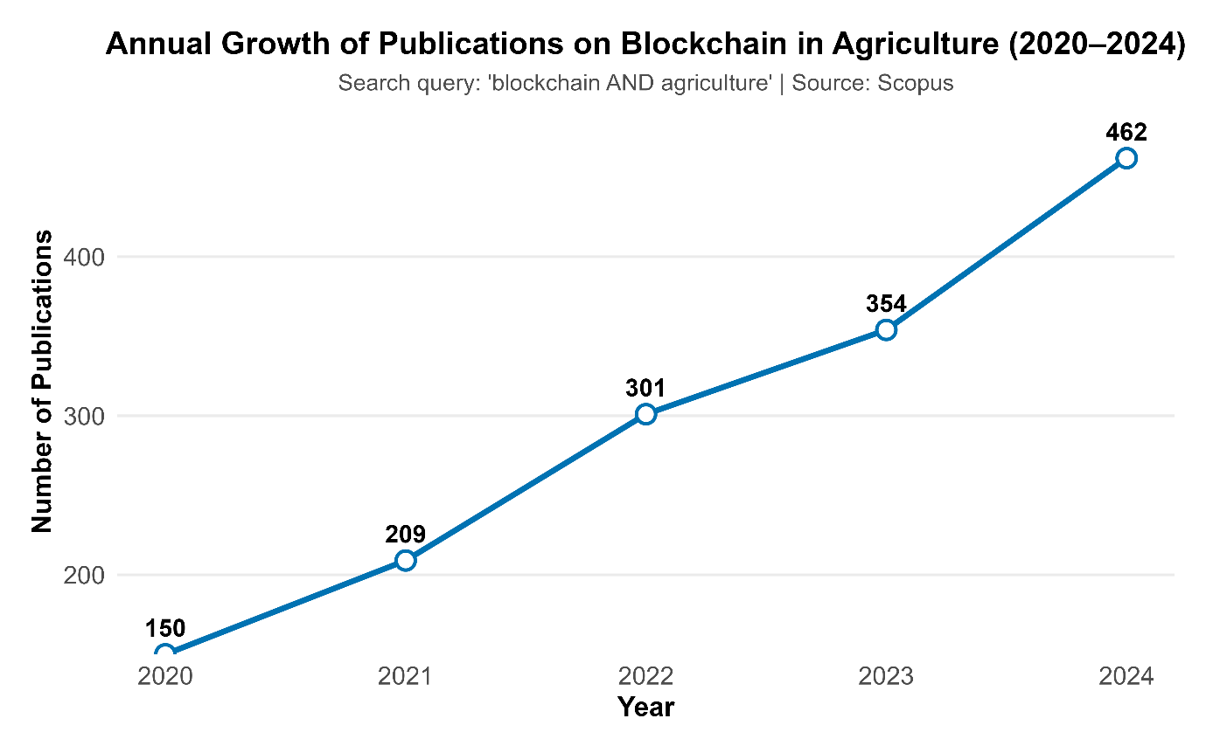
Fig. 1. Global trend in blockchain-related agricultural research publications (2020–2024) based on Scopus database
This paper examines how blockchain-enabled circular agri-food systems can improve the production of clean energy, resource recovery, and traceability by the conceptual and theoretical frameworks supporting the connections between data-driven blockchain technology and the circular economy (CE) in agri-food systems. It analyzes how blockchain-enabled systems can support the development of transparent and effective carbon credit markets as well as the adoption of clean energy practices in agriculture, specifically through the valuation of biomass and agricultural residues. Using case studies from Europe, India, and Africa, the study explores the institutional arrangements and socioeconomic effects connected to these technological integrations. In-depth identification of current research gaps, policy implications, and future directions for promoting data-driven sustainability and environmental resilience within agricultural systems.

2. Conceptual and Theoretical Framework
Blockchain is a distributed, decentralized registry (Alwyn & Sera, 2007), where one block of information is cryptographically connected to the previous one to ensure records are resistant to modification (Morillo and Mateo, 2025). Agreement mechanisms ensure that every participant in the network verifies transactions without a central authority. Smart contracts constitute a system of automatic verification and settlement to allow safe peer-to-peer transactions (Abiri et al., 2023). In agri-food systems, such attributes can offer absolute provenance, reduce data tampering and support real-time payments (Uyar et al., 2025), like weather index insurance and quality-based premiums (Abiri et al., 2023). Blockchains, including those based on Hyperledger Fabric and Corda, provide the ability to control access and reduce energy usage without compromising the integrity of data (Vangipuram et al., 2022).
The Circular Economy (CE) approach calls for the restructuring of agricultural production to compete with the cyclical and regenerative processes inherent in natural ecosystems (Santos et al., 2024). The biomass residues can be used to produce bioenergy, biochar (Elmnifi et al., 2023). Biogas systems capture methane from animal waste, and nutrient recycling can harvest phosphorus and nitrogen to convert them into fertilizer (Chen et al., 2025). A recent study by Lee et al (2022) expresses that by-products can be turned into inputs and renewable energy resources with the help of sufficient storage, logistics and processing infrastructure. Integrating data between these loops using blockchain, it is possible to guarantee that recycled materials are safe, and the waste exchange markets are established by implementing smart contracts (Santos et al., 2024).
Resource recovery and the adoption of CE are often impeded by transaction costs and information asymmetry (Nandi et al., 2020). Farmers may lack incentives to invest in biogas digesters or share data due to mistrust and uncertain returns (Burg et al., 2021). The transparent ledger of blockchain has the potential to lower the costs of monitoring, create trust and allow new payment models, including tokens in regenerative practices and carbon sequestration (Schletz et al., 2023). It also enhances equity as it brings value distribution into the supply chains, which may empower smallholders and marginalized stakeholders (Jemi et al., 2024). Environmental economics emphasizes the necessity of internalizing the external effects; carbon markets and carbon credits based on blockchains are some instruments that can be used to price the ecosystem services and to reward circular activities (Merlo et al., 2025).
Integrating blockchain with IoT sensors, AI, and remote sensing, human cyber-physical systems (H CPS) can maximize resource utilization (Zhao et al., 2021). Wang et al (2025) proposed an H CPS architecture in which AI-driven analytics and IoT sensors monitor crop health, while blockchain stores and secures supply chain data. This combined method aids precision farming, reduces irrigation and fertilizer inputs, and ensures end-to-end traceability (Vinod et al., 2024). Models such as applied LoRaWAN sensors, LSTM algorithms and Hyperledger Fabric to automate irrigation decisions; it was found that the use of data-driven technologies saved 20 per cent of the water and increased yields by 12 per cent (Munaganuri et al., 2025). The following illustrates (Fig. 2) an integrated blockchain circular economy (CE) model for agri-food systems.
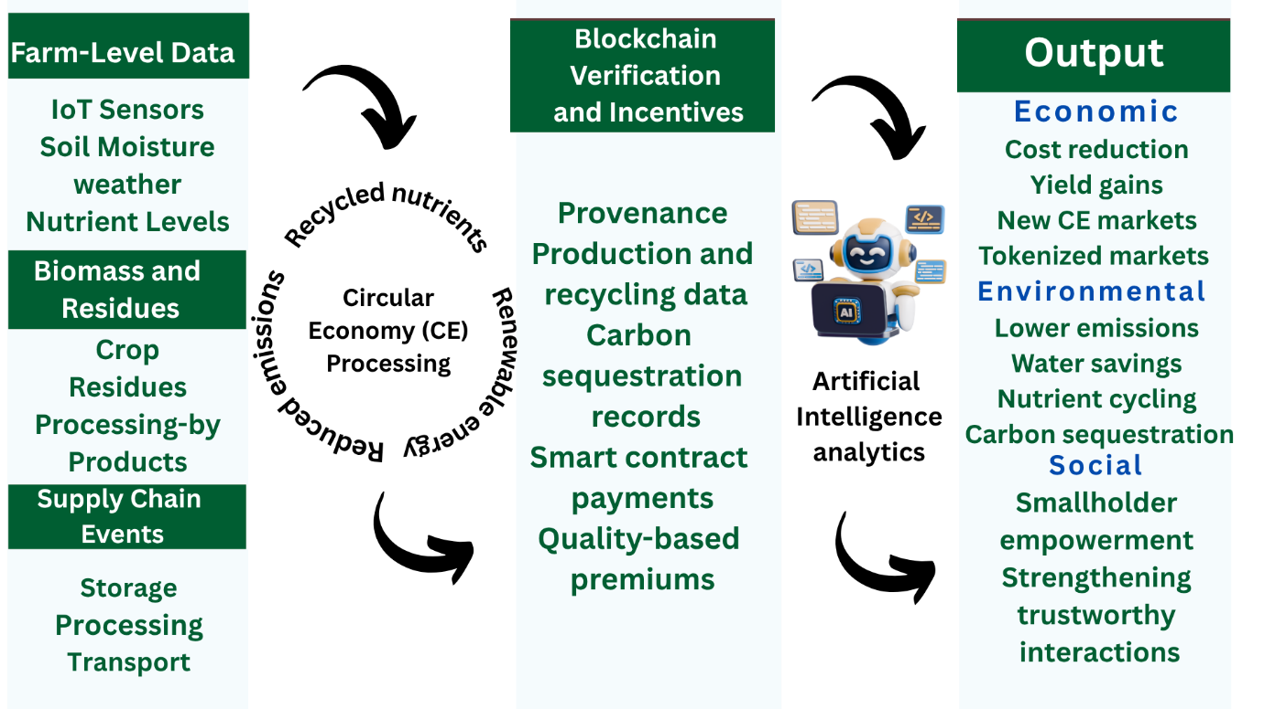
Fig. 2. Conceptual Framework of Blockchain-Enabled Circular Agri-Food Systems

3. Blockchain for Clean Energy in Agriculture

Agricultural activities remain a major contributor to global methane (CH₄) emissions, particularly from rice cultivation and residue burning, highlighting the urgency of sustainable energy transitions and transparent carbon accounting. The following figure (Fig. 3) presents global methane emissions from agriculture and land use between 2020 and 2023, demonstrating the dominance of rice cultivation as a source. The agricultural systems have large biomass residues, which can be converted into renewable energy (Saleem, 2022). Bioenergy, biogas, or biofuels can be produced using bagasse, straw, husks, and manure, which will give farmers another source of income and decrease dependence on fossil fuels (Kabeyi & Olanrewaju, 2022).

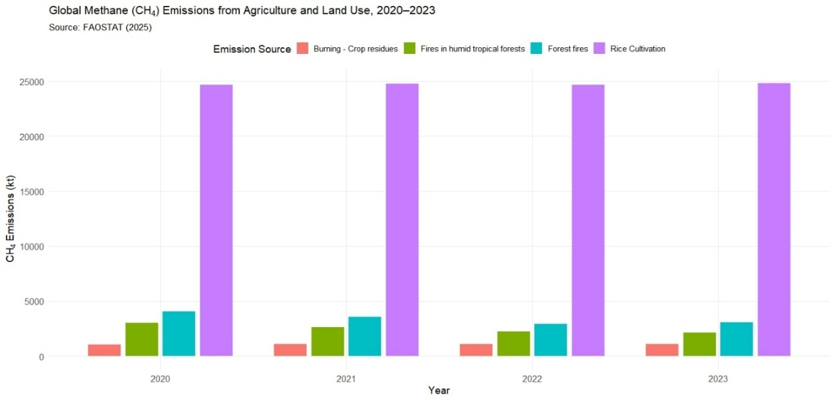

Fig. 3. Global Methane (CH4) emissions from agriculture and land use (2020-2023)

The global bioenergy potential and biomass resource trends are illustrated in Fig. 4. However, biomass supply chains often suffer from fragmented coordination and a lack of transparency (Ahl et al., 2020). The blockchain can generate permanent histories of the origin, quality, and logistics of biomass, which can certify sustainable feedstocks and access energy markets. Rejeb et al (2024) examined that blockchain in renewable energy indicates that peer-to-peer energy trading, microgrids, and smart contracts to balance supply and demand are increasingly using decentralized ledgers. Blockchain can facilitate green energy source verification, automate settlement, and minimize the transaction costs by storing the data on energy generation and secure consumption (Kumar et al., 2020).

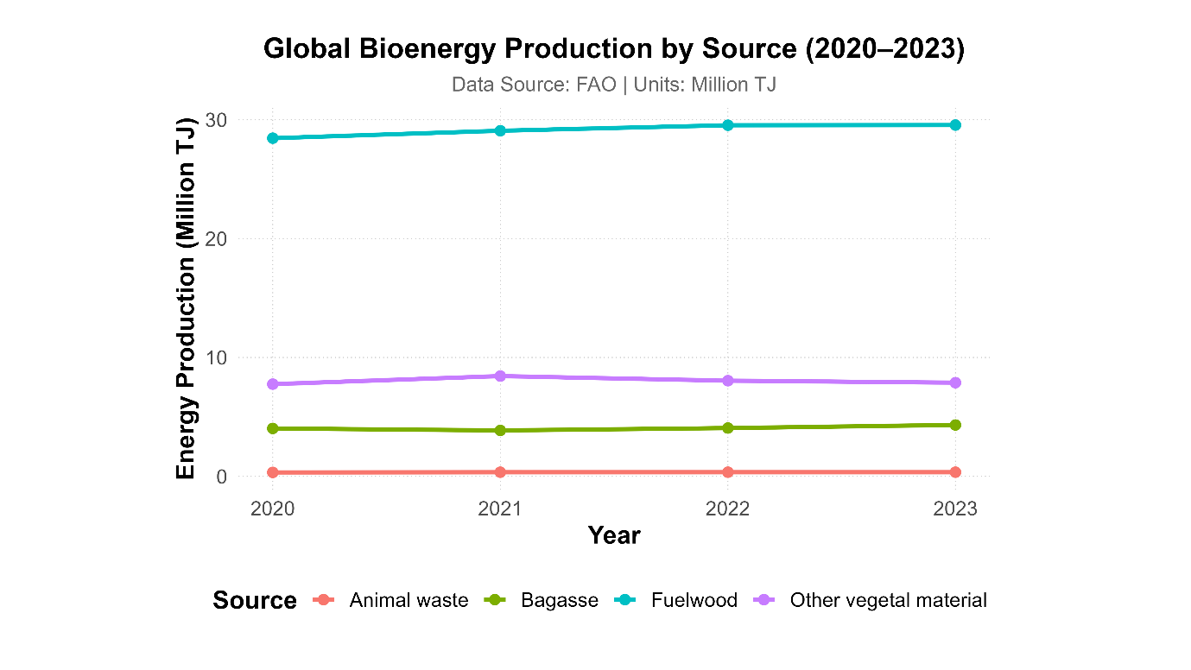
Fig. 4. Global Bioenergy Production by various sources
The Enerchain and Powerledger projects in the European Union have demonstrated the feasibility of blockchain-enabled peer-to-peer trading in bioenergy and solar electricity (Evens et al., 2023): these platforms trace renewable certificates, automate dispatch, and allow small producers to sell excess power, thus creating rural income and reducing carbon footprints (Guo & Feng, 2024). According to Taherdoost (2024), blockchain has been viewed to improve transparency in certificate trading and can be integrated with carbon credit schemes to ensure that farmers are fairly compensated for emission reductions. In India, pilot projects are implemented based on blockchain to trace paddy straw from farms to bioenergy plants (Suthagar & Mishra, 2025). Hyperledger-based systems document the processes of collection, transportation, and processing; Smart contracts make payments to farmers upon delivery, creating incentives for residue recycling and mitigating stubble burning (Vladucu et al., 2024). Through such systems, information asymmetry is minimized due to which leads the trust, and decentralized bioenergy markets are developed (Sulewski et al., n.d.). African nations are developing blockchain-based off-grid solar systems; pay-as-you-go models involve smart contracts to coordinate micro transactions and blockchain records credit histories of customers, making it possible to finance rural electrification (Vangipuram et al., 2022).
Carbon credit markets are also a possible avenue through which blockchain can empower farmers (Jemi et al., 2024). Blockchain platforms can provide verifiable tokens in the form of carbon credits by recording regenerative practices, soil carbon sequestration, and emissions reductions (Espenan, 2023). These tokens can be exchanged on decentralized markets, giving farmers an extra income and motivating them to adopt sustainable practices (Munir et al., 2022). Transparent records will eliminate the possibility of double-counting, which will enhance the confidence of investors and regulators (Panwar et al., 2025). According to Zhao et al. (2022), carbon market schemes based on blockchain may reduce the costs of transactions and increase the number of participants, including smallholders.
The application of blockchain to clean energy and resource recovery is technically and socio-institutionally challenging (Yongjun, 2023). The energy intensity of public blockchains has brought up environmental concerns, and as such, industrial uses of blockchains prefer private blockchains or consortium blockchains that have efficient consensus mechanisms (e.g., Proof of Authority). There is an unequal distribution of digital literacy, infrastructure and regulatory frameworks. The supply chain actors need to agree on data standards, cost sharing and governance. According to (Yogarajan et al., 2023), trust in technology increases when the farmers and cooperatives are co-designing the platforms and when governments have supportive policies and carbon pricing mechanisms (Wei et al., 2025). However, blockchain combined with IoT, AI and renewable energy technologies can facilitate a circular economy in agriculture, turning waste into energy, empowering producers with transparent data and markets, and fostering environmental resilience.
4. Blockchain Applications in Agri-Food Climate Governance
Blockchain’s immutable ledger can support climate governance by ensuring transparent monitoring of greenhouse gases and climate-smart practices (Thanasi-Boçe & Hoxha, 2025). To illustrate, in carbon markets, blockchain enhances the transparency and automation of checking emission credits (Merlo et al., 2025). Decentralized traceability is the basis of low-carbon agri-food chains: reviews by Almutairi et al. (2023) and Ekene Cynthia Onukwulu et al. (2022) state that blockchain supports renewable-energy trading, emissions tracking, and circular-economy supply chains. This type of record-keeping establishes trust: blockchain fosters resource efficiency, supply-chain traceability, and can integrate IoT‐sensed data for real‐time verification (Ellahi et al., 2024). As illustrated in the following Sankey diagram (Fig. 5), distinct development pathways, notably governance and technological innovation, channel into adaptation and mitigation outcomes through mechanisms that blockchain can help operationalize decentralized Measurement, Reporting, and Verification (MRV), tokenized incentives, and transparent supply-chain records.
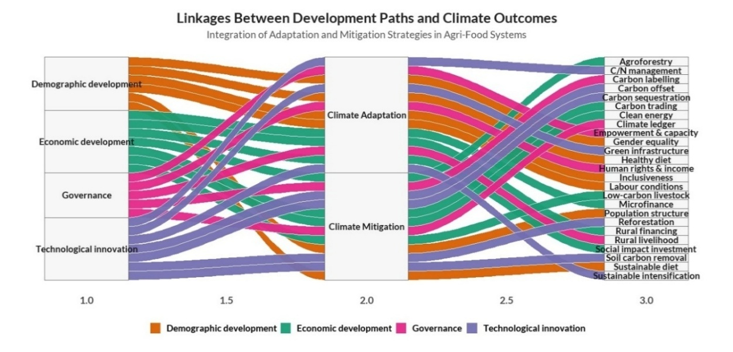Fig. 5. Linkages between development paths and climate outcomes in agriculture (Data Source: Van Wassenaer et al., 2021)
At the farm level, blockchain can link smallholders to climate finance. To illustrate, tokenized vouchers allow farmers to obtain microloans and insurance based on verified resilient practices (United Nations Development Programme [UNDP], 2021). Permanent documentations of agroforestry and soil-carbon projects encourage claims on carbon or resilience credits. In supply chains, pilots (e.g., IBM’s Food Trust) report 25% reductions in food waste, directly lowering emissions from spoilage (Ellahi et al., 2024). Other initiatives tokenize environmental assets: blockchain‐based renewable‐energy certificates and carbon offsets ensure authenticity and eliminate double-counting (Thanasi-Boçe & Hoxha, 2025).
On the policy front, FAO and UNDP are integrating blockchain into Nationally Determined Contributions (NDCs) and adaptation plans through codification of the "Key Data Elements" of climate-smart agriculture (United Nations Development Programme [UNDP], 2021). More broadly, immutable chains could streamline the MRV of agricultural emissions under Paris frameworks (Merlo et al., 2025). Although researchers identify challenges such as energy use (Khan et al., 2021), governance (Grover et al., 2021), there are reasons to believe that blockchain transparency and auditability can enhance accountability and facilitate both objectives of mitigation through verified carbon accounting (Alotaibi et al., 2024) and adaptation through tracking of the outcomes of resilient practices (Ali & Kamraju, 2025).
Table 1 presents emerging blockchain-based strategies that support agri-food climate governance by facilitating transparent carbon accounting, decentralized MRV systems, and inclusive policy mechanisms across diverse global contexts. These innovations directly advance SDG-13 (Climate Action) by strengthening institutional capacities for mitigation and adaptation, enhancing the credibility of emission reporting, and enabling climate-resilient decision-making within agri-food value chains.

Table 1. Emerging Blockchain Applications in Agri-Food Climate Governance
Theme | Key Applications | Regional Focus | Benefits | Reference
Carbon farming and soil carbon verification | Blockchain can digitally certify soil carbon sequestration data by linking field sensor and satellite measurements to on‐chain records, creating a verifiable registry of carbon farming practices. | Piloted in diverse regions including Europe, Africa, and Asia. | Provides an absolute and transparent audit of soil carbon credits, enhancing trust and credibility of carbon farming outcomes. | Kingfisher et al. (2025)
Decentralized MRV systems | A blockchain‐enabled MRV system integrates IoT and satellite data with a decentralized ledger, automatically recording and validating emissions or sequestration. | Applied in nature‐based projects in Latin America, Africa, and Asia. | Creates a secure and transparent monitoring framework that reduces intermediaries and ensures accurate, traceable climate data. | Bendale et al. (2025); Saraji & Borowczak, (2021)
Blockchain-linked carbon credit markets | Blockchain platforms such as DAO IPCI, Toucan, and Energy Web Foundation are used to convert verified emission reductions into tradeable tokens, enabling secure peer-to-peer trading of carbon credits. | Global voluntary carbon market activity in Europe and North America, expanding in Asia | Ensures transparency and integrity in carbon trading by maintaining an immutable ledger of credit issuance, addressing issues like double-counting. | Marchant et al. (2022); Merlo et al. (2025)
Climate governance frameworks | Blockchain is being explored to underpin climate policy frameworks by maintaining distributed registries for emissions reporting, linking multi-level climate pledges, and digital compliance systems. | Multilateral governance, like the UNFCCC and polycentric climate initiatives. | It is argued to improve the reliability, transparency, accountability, and democratic quality of climate governance processes. | Hull et al. (2021)

5. Blockchain for Resource Recovery and Circular Agri-Food Systems
Blockchain technology, through capturing all transactions, including production and consumption, has the potential to reduce food wastage, maximize resource utilization, and drive socio-economic inclusion within the circular bioeconomy system (Ellahi et al., 2024). Blockchain provides end-to-end visibility of food products, which enables stakeholders to track food quality, movement, and shelf life in real time (Omar et al., 2023). Every transfer between farm, processor, distributor, and retailer is documented, enabling rapid identification of spoilage and inefficiency points (Bosona & Gebresenbet, 2023). Retailers like Walmart, through the IBM Food Trust initiative, have demonstrated that blockchain-based traceability significantly minimizes losses and ensures food safety (Collart & Canales, 2022). This transparency helps not only to reduce waste but also to meet the global objectives of the circular economy by increasing product lifespan and decreasing environmental externalities.
The use of blockchain in the recovery of resources is demonstrated internationally. As an example, the SUEZ Sludge Advanced program of France uses blockchain technology to track the phosphorus- and nitrogen-contaminated wastewater sludge of treatment plants to farm fields (Prashant, 2020). Every transaction, from processing to field application, is verified on-chain, ensuring data integrity and regulatory compliance. According to the European Environment Agency (EEA) (2022), this transparent process helps stakeholders, such as utilities, regulators, and farmers, can verify the quality and safety of treated biosolids as fertilizer substitutes, reducing dependence on synthetic fertilizers and avoiding approximately 6,000 tonnes of nitrogen emissions every year. Likewise, blockchain-based solutions for water quality certification and savings can be certified by digital credits, thus motivating the conservation and reuse of water via smart contracts (Dogo et al., 2019).
The dynamics of international experiences are examples of how blockchain can be used to recover resources. In the European Union, the Horizon Europe and TrustEat projects integrate blockchain with IoT and sensors to verify sustainability claims under the EU Green Deal and Farm-to-Fork strategy (Alabrese & Cristiani, 2023). The circular bioeconomy plans of China use blockchain to track waste-to-energy and biomass recycling as part of its carbon neutrality strategy (Chen et al., 2024). A Shanghai pilot project of blockchain-enabled carbon trading in biomass showed quantifiable improvements in efficiency and traceability (Yang et al., 2025). In Latin America, initiatives by cooperatives like the Chile-based Atando Cabos are using blockchain to track plastic waste generated by fisheries by using recycling chains, so that there are clear tracks of material flows and equal distribution of revenues between fishers and recyclers (Sekhri, 2018). All of these instances indicate that blockchain is an enabler of circularity, enhancing trust, traceability, and fair participation across regions and sectors.
Transforming waste streams into verifiable economic resources, blockchain supports livelihood security and inclusive value creation (Boçe & Hoxha, 2024). Small-scale producers and waste collectors can be compensated fairly through tokenization of compost, biomass, and carbon credits for the services offered to the environment (Sörman, 2023). The blockchain also lowers the costs of transactions by eliminating intermediaries and automating trust using smart contracts, which offer timely and transparent payments (Ajuwon et al., 2021). This peer-to-peer model democratizes participation, empowering rural communities and cooperatives (Sutherland & Marchand, 2021). Transparent ledgers further enhance bargaining power, as participants' contributions, such as volumes of waste processed or nutrients recovered, are publicly verified (Downes & Reed, 2020). The potential of the technology to redistribute value in a fair and balanced way is in line with SDG 2 (Zero hunger), SDG 8 (Decent Work), and SDG 12 (Responsible consumption and production) (Shafik, 2025).
6. Socio-Economic and Ethical Implications of Blockchain in Rural Circular Economies
The blockchain can help in establishing trust and transparency in circular rural economies (Panwar et al., 2023). Smart contracts and immutable ledgers simplify transactions and provenance tracking, automating payments and deposit-refunds in closed-loop systems (Ellahi et al., 2024). Indicatively, QR-coded waste packaging exhibits circular movement of materials (Santos et al., 2024). Similarly, the Taiwan irrigation association water-use ledgers were transparent, enhancing community resource governance (Pakseresht et al., 2022). Decentralized finance models are also being developed: services such as BanQu allow farmers to record sales and obtain credit (Ninsiima et al., 2025). Notably, increased transparency will contribute to more equitable prices, Panwar et al. (2023) indicate that blockchain can be used to guarantee that smallholders get compensated according to the product quality and effort. These data-driven innovations hold the potential to incorporate circular practices in the context of sustainable rural agri-food systems (Chiaraluce et al., 2024).
However, ethical and equity concerns should be taken seriously. Inclusive adoption may be impeded by high costs, complicated interfaces, and low rural digital literacy (Akella et al., 2023). Absolute transparency will also undermine privacy and shift power imbalances: unless regulated effectively, blockchain can provide an advantage to marginalize vulnerable producers (Samoggia et al., 2025). Researchers have pointed out that blockchain’s fairness gains depend on company policies and community agency (Panwar et al., 2023). Persistent barriers, such as a lack of technical standards, network access, and regulatory clarity, must be overcome (Prewett et al., 2020). Kassen (2021) highlights participatory governance and contextual design to avoid imposing tech fixes that widen existing divides. Akella et al. (2023) note that adoption depends on a combined approach of addressing the three aspects of trust, standards, and training, and that blockchain initiatives must be complemented by capacity-building across multiple stakeholders and inclusive policies (Jha & Singh, 2024). Smart contracts, provenance tracking, and DeFi-enabled applications have socio-economic potential to support circular rural economies, though the benefits will be realized based on equity and ethical considerations (Ooi, 2025; Viano et al., 2022).
Table 2 synthesizes the socio-economic and ethical dimensions of blockchain adoption in rural circular economies, highlighting how inclusive governance, gender-responsive access, data ethics, livelihood diversification, and digital literacy collectively advance equitable and sustainable agri-food transformation.
Table 2. Socio-Economic and Ethical Implications of Blockchain in Rural Circular Economies
Dimension | Focus Area | Socio-Economic Outcomes | Implementation Insights | Relevant SDG name | References
Inclusiveness and participation | Stakeholder-inclusive governance | Blockchain democratizes decision-making via distributed governance. Farmer-controlled consensus has been shown to increase smallholder participation by 58%, reducing inequalities and strengthening trust in rural communities. | Such evidence indicates that platforms should be co-designed with multi-stakeholder governance to align institutional frameworks with blockchain tech, ensuring transparent and equitable participation. | Reduced Inequalities (SDG 10) | Dzreke, (2025)
Gender equity and empowerment | Gender-responsive access | Blockchain’s anonymity and digital ID mechanisms empower rural women without formal documents to transact autonomously, increasing asset ownership and income; these systems also improve women farmers’ access to market information and bargaining position, thereby advancing gender equity. | Implementation requires gender-inclusive design and outreach, e.g. blockchain-linked identity solutions and training tailored to women’s contexts to bridge the digital gap and ensure inclusive participation. | Gender Equality (SDG 5) | Amrita Bahri (2021); Sindhu, (2025)
Ethical and data privacy frameworks | Data governance and privacy | Clear ethical and data-protection rules are critical for trust: guidelines must let farmers control their data and ensure blockchain is used fairly, protecting vulnerable groups from exploitation. | This entails using permissioned ledgers, encryption, and smart contracts that enforce data consent, alongside international data standards. Government and industry should co-develop transparent protocols to safeguard privacy and fairness in agrifood systems. | Peace, Justice, and Strong Institutions (SDG 16) | Barton et al. (2025); Neethirajan (2025)
Livelihood diversification | Circular economy entrepreneurship | Blockchain can create circular-value linkages by enabling new market channels for byproducts and recycled inputs, diversifying rural incomes. Decentralized platforms empower smallholders through direct market access and premium retention, strengthening local economies and decent work. | Governments and cooperatives can incentivize blockchain-enabled circular projects and support farmer-led marketplaces. Embedding blockchain in agri-waste and renewable-energy chains helps rural areas develop multiple income streams. | Decent Work and Economic Growth (SDG 8) | Thanasi-Boçe & Hoxha, (2025)
Digital literacy and capacity building | Education and skills training | Investing in digital literacy is vital to prevent tech-driven inequities. Training programs equip farmers and rural entrepreneurs to use blockchain tools effectively, increasing adoption and productivity. | Actions include subsidized blockchain education, cooperative training, and user-friendly interfaces. Experts highlight farmer education and co-op-led initiatives (with incentives) to scale equitable data-sharing systems. Partnerships with local NGOs and extension services can further amplify inclusion efforts. | Quality Education (SDG 4) | Barton et al. (2025); Dey, (2025)

7. Blockchain for Securing Traceability in Agri-Food and Energy Systems
Traceability in agri-food and bioenergy systems is important in ensuring authenticity, safety, and sustainability (Anastasiadis et al., 2025). Traditional paper-based documentation and centralized data management have proven vulnerable to errors, data manipulation, and inefficiency (Thanigesan & Vinothiyalakshmi, 2025). In contrast to it, blockchain technology will provide a decentralized, non-manipulable digital registry, registering all transactions, including farm inputs and final products, and offering transparency, responsibility, and confidence among all parties (Kargacier, 2021). This transformation addresses key challenges in food provenance, energy certification, and environmental compliance, making blockchain a pillar of digital sustainability.
The characteristics of global agri-food supply chains are multifaceted networks of a large number of intermediaries and ineffective record-keeping systems (Shiraishi et al., 2025). These conditions create opportunities for food authenticity violations, including adulteration, mislabelling, and counterfeiting, undermining consumer confidence and market fairness (Chukwugozie et al., 2024). Inefficiencies in tracking also delay recalls and obscure responsibility when contamination occurs. A study by Boni et al. (2022) indicates that nearly one-third of global food output is lost annually due to poor logistics and traceability gaps. Blockchain eliminates such risks by providing verifiable and immutable data that records every action of the supply chain. Information recorded can never be changed, which means that every stakeholder, from producer to retailer, can receive real-time and authenticated data on origin, safety, and sustainability certifications (Boni et al., 2022).
Numerous global initiatives are currently integrating blockchain within agri-food systems to enhance transparency, traceability, and environmental performance. The following Sankey diagram (Fig.6) illustrates selected blockchain-based initiatives across commodities, stakeholders, and objectives, emphasizing the predominance of traceability and waste reduction as core goals. In energy systems, especially where recycled biomass and agricultural residues are used, a verifiable provenance is essential in terms of regulatory compliance and consumer confidence (Larsen et al., 2019). The transparent nature of the blockchain structure enables the validation and the ability to track all the transactions with bioenergy feedstocks, including crop residues, animal waste, and organic by-products (Semaan et al., 2024). As an example, European bioenergy manufacturers are testing blockchain applications to confirm that recycled residues are of renewable certification and comply with carbon accounting regulations under the EU Renewable Energy Directive (RED II) (Delardas & Giannos, 2022). Similar blockchain initiatives in India and East Africa track agricultural residues used in biomass and biogas production, ensuring that each batch is sourced ethically and sustainably (Tagne et al., 2021). The transparent ledger not only prevents greenwashing and false sustainability claims but also enables accurate quantification of carbon credits and ecosystem benefits derived from clean energy transitions. The Food and Agriculture Organization (FAO) has launched several blockchain programs, including livestock tracking, smallholder traceability, and open data standards in developing countries (Ellahi et al., 2023). These initiatives aim to empower farmers through transparent value chains, improving both market access and environmental accountability. In the European Union, the Green Deal and its Digital Product Passport framework reinforce blockchain as a core technology for monitoring sustainability performance (Götz et al., 2022). The EU promotes cross-sector traceability in food, energy, and manufacturing by necessitating standardized, verifiable digital records of production inputs and environmental impact (Puzhankara, 2024).

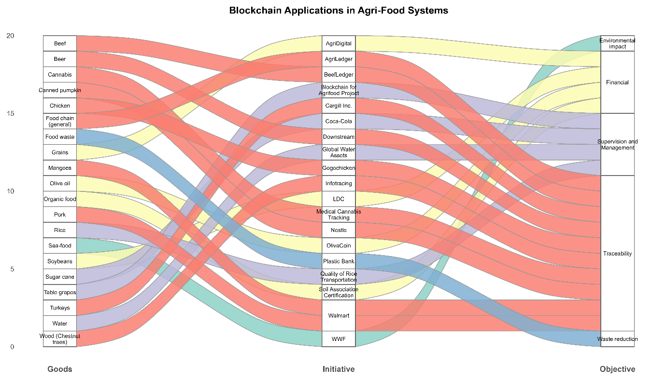

Fig. 6. Global blockchain initiatives across agri-food systems linking major commodities, organizations, and sustainability objectives (Source: Boehm et al., 2017; Bunge, 2017; Caro et al., 2018; Davcev et al., 2018; Hoffman & Munsterman. 2018; Kamilaris et al., 2019; Kim et al., 2018; Kumar & Iyengar, 2017; Lucena et al., 2018; Poberezhna, 2018; Van Arendonk, 2018)
The economic reason behind a blockchain-based traceability is that it lowers the costs of transactions and verifications and enhances consumer confidence (Vazquez Melendez et al., 2024). Blockchain ensures efficient supply chains by removing unnecessary certification processes and reducing data manipulation, which improves the efficiency of quality assurance (Li et al., 2020). There is empirical evidence indicating that consumers are prepared to pay high-end fees on products that have their origins and sustainability assertions verified by blockchain, especially in organic and fair-trade markets (Balzarova, 2021). Moreover, transparent traceability reduces disputes and facilitates efficient carbon credit trading, unlocking new income streams for producers engaged in sustainable practices (Shukla et al., 2024).
8. Blockchain Integration with AI and IoT in Predictive Agri-Food Systems
Integrating blockchain with AI and IoT creates a data-driven agri-food framework in which real-time sensor data operates predictive analytics while maintaining secure (Halder et al., 2025), shared records (Mirikar et al., 2025). In this vision, IoT devices collect detailed soil, weather, and crop data (Sharafat et al., 2025). AI (Goel & Pandey, 2024) and ML (Meroni et al., 2021) algorithms utilise this data to forecast yields and pest risks (Upadhyay et al., 2025), and blockchain logs all transactions in an immutable ledger (Kulothungan, 2025). Kasera et al. (2022) propose a farm-to-fork model where IoT streams input into AI models for future predictions and blockchain permanently stores every sensed datum for verification. A recent study by Plakantara and Karakitsiou (2025) confirms that these Industry-4.0 tools provide real-time monitoring and prediction of hazards, and blockchain and IoT significantly enhance agri-food chain traceability and transparency (Khan et al., 2020). In practice, this means tamper-proof records underpin predictive smart farming by anticipating irrigation needs.
There is a positive impact on environmental sustainability. By enabling precision management, AI and IoT systems reduce waste and resource use, while blockchain-backed traceability ensures these gains are verified (Ali et al., 2025; Wang et al., 2025). As Zhang et al. (2025) note, BlockIoT platforms (blockchain + IoT) can significantly reduce food waste and minimize the environmental footprint. For instance, soil-moisture sensors and predictive irrigation prevent overutilization of water, and blockchain can verify the source of organic or low-carbon produce (Jayabal et al., 2025; Loria & Lal, 2025; Shee Weng, 2025), which facilitates circular flows by tracking compost and bioenergy. Bibliometric surveys emphasize that blockchain-based IoT improves sustainability monitoring of soil, weather, and inputs, which results in a credible pool of data used in adaptive and low-impact farming (Safeer et al., 2024).
This also enhances the economic efficiency. Predictive insights optimize yields and sales timing, while blockchain reduces intermediaries and unauthorized alterations (Arogundade & Njoku, 2024). Research in developing countries emphasizes that the implementation costs are difficult to impose on smallholders, yet the advantages, such as improved access to the market and reduced spoilage, are likely to overshadow them (Tang et al., 2024). In particular, pilot programs in Africa indicate that specific blockchain and IoT projects should be cost-efficient by adapting to the local requirements (Tang et al., 2024). Meanwhile, agribusinesses such as Walmart, Cargill, and large retailers around the world are already testing IoT -blockchain traceability to simplify logistics and reduce loss (Bhat et al., 2021). Overall, AI-based predictions and smart supply chain management will enable increased yields and profits, as well as reduced input costs.
Finally, traceability can be significantly improved. Blockchain’s immutable ledger ensures end-to-end provenance of food, which is essential for safety, certification, and consumer trust. According to Plakantara and Karakitsiou (2025), there is a general agreement that blockchain enhances transparency in agri-food systems and that IoT integration provides detailed tracking data. Sensor-enabled transactions recorded on-chain create audit trails that expose contamination and misrepresentation. Emerging pilots in India, Kenya, and other countries are testing smart contracts over blockchain with field data to verify organic labels and automate climate insurance payments (Miller et al., 2025). Collectively, these innovations create a predictive, circular agri-food design: AI and IoT drive efficiency and resilience, while blockchain guarantees data integrity and traceability across the entire system.
Table 3 presents the integration of blockchain with Artificial Intelligence (AI) and the Internet of Things (IoT) in predictive agri-food systems, highlighting global applications that enhance sustainability, efficiency, and data-driven decision-making across agricultural value chains.
Table 3. Blockchain Integration with Artificial Intelligence (AI) and IoT for Predictive Agri-Food Systems
Integration Focus | Technological Components | Applications in Agriculture | Key Benefits | Reference
AI–Blockchain hybrid models | Systems combine AI models like deep neural networks with blockchain infrastructure such as distributed ledger, consensus protocols, and smart contracts to secure data analytics. | Applied to predictive farming tasks such as disease and pest detection, yield forecasting, model outputs are cryptographically signed and stored on-chain. | These hybrids improve accuracy and trust: one system reported 96% classification accuracy and a 43% reduction in crop losses via early detection. Consequently, decision-making becomes more reliable and resource use more efficient, supporting sustainable intensification. | Huang et al. (2025)
IoT-based blockchain systems | Integrates IoT devices such as soil, environment and product sensors with blockchain networks like Ethereum and smart contracts to automate data capture and verification. | Enables real-time monitoring and traceability: IoT sensor data from an olive oil supply chain was recorded on-chain with smart contracts automatically validating authenticity. | This fusion greatly enhances transparency and provenance, providing immutable records that reduce data tampering and strengthen supply-chain integrity. Such provenance systems also facilitate regulatory compliance and boost consumer trust. | Vellimalaipattinam Thiruvenkatasamy et al. (2025; Vitaskos et al. (2024)
Smart logistics optimization | Employs IoT devices, including RFID, GPS, and environmental sensors and AI analytics within blockchain platforms to coordinate agri-food supply chains. | Shipments are tracked via on-chain records of location and condition, enabling AI-driven dynamic routing, inventory management and automated compliance example, verifying cold-chain conditions. | This end-to-end visibility enables efficient recalls and waste reduction: blockchain-enabled systems have yielded 15% lower post-harvest losses and more reliable distribution. The immutable audit trail also speeds incident response and can improve shelf-life. | Duguma & Bai (2024); Kumar et al. (2022)
Predictive maintenance systems | Combines IoT sensors on farm machinery such as tractors, pumps, and drones with AI predictive models and blockchain-based maintenance logs. | Sensors continuously monitor equipment; AI predicts failures, and blockchain records repair history and parts provenance, even causing smart contracts for scheduling service. | Reduces downtime significantly: IoT-driven maintenance halves equipment downtime, extending machinery life and improving operational resilience. This anticipatory upkeep ensures more consistent operations and boosts yield stability. | Alabadi & Habbal, (2023); Duguma & Bai, (2024)
Data interoperability | Uses blockchain as a unified trust layer to integrate diverse agri-data via standardized schemas and APIs. | Links heterogeneous datasets such as soil sensor feeds, satellite imagery, and market data in a coherent platform for analytics, often using oracles or cross-chain bridges to consolidate information. | Enables comprehensive analytics: blockchain-enabled integration improves data sharing and accuracy, supporting precise decision-making and resource optimization across food systems. | Vellimalaipattinam Thiruvenkatasamy et al. (2025); Westerlund et al. (2021)
9. Global Perspectives and Policy Dimensions
Blockchain technology is rapidly emerging as a tool for sustainable agricultural and food systems worldwide (Bosona & Gebresenbet, 2023). Carbon credit markets (Basu et al., 2024), renewable energy systems (Wu & Tran, 2018), and end-to-end supply chain management (Moosavi et al., 2021) are some of the areas where the technology is being used to address SDGs and ESG (Chandan et al., 2023). According to Mulligan et al. (2024), blockchain has been proposed as a means to implement sustainable development through various solutions, including carbon credit trading, energy systems, and supply chain management. Nevertheless, there are not many studies, as of now, that have applied blockchain to new regulatory frameworks and systematic research to harmonize blockchain solutions with net-zero and sustainability policies. Practically, the regulatory interest is becoming more global: frameworks such as the EU Corporate Sustainability Reporting Directive (CSRD) and UN SDGs are becoming more interested in data transparency and data traceability, which incentivizes blockchain-based traceability in agri-food chains (Bosona & Gebresenbet, 2023).
The promotion of sustainable, traceable food systems is a specific focus of policies in the European Union, including the Farm-to-Fork Strategy and the Green Deal, and blockchain would be a natural and intuitive complement to this policy by offering tamper-proof provenance data. The Farm-to-Fork proposals of the EU to transform production toward making it environmentally friendly and minimizing waste fit well into the traceability capabilities of blockchain, with EU research initiatives such as Horizon 2020 and EIT-Food often integrating blockchain pilots of transparent supply chains (Galanakis et al., 2025). North American adoption has, on the other hand, been industry-led, with large technology and large retailers like Walmart, IBM Food Trust, deploying blockchain to trace produce and meat in response to food safety requirements. The Food Traceability Rule of the U.S. FDA on leafy greens is a regulation indirectly encouraging the use of blockchain, but the United States does not have a single policy on blockchain, whereas Canada is more active with government-supported blockchain pilots in beef, grain, and supply chain finance. In both of these continents, consumer safety, trade efficiency, and regulatory compliance continue to be prioritized, and, according to Mulligan et al. (2024), even new global reporting standards will gradually incline towards technologies capable of producing verifiable ESG data, such as blockchain. In Asia, it is being adopted widely: China has focused more on blockchain outside of cryptocurrency, using it in agriculture, fisheries, and food safety, with efforts like the Blockchain Service Network (Chen et al., 2020), and India has taken the approach of encouraging small-scale pilots of fertilizer subsidies and seed distribution despite uncertain regulatory treatment of cryptocurrencies (Singh et al., 2021). Most Asian governments are piloting blockchain national Industry 4.0 agendas, exporting high-value products and smart farming, but provide incentives or regulatory sandboxes at the national level rather than nationally (Yang & Gu, 2021). Japan, South Korea, and Vietnam are experimenting with blockchain in national Industry 4.0 divisions and exporting goods (Wang et al., 2019). The blockchain in Africa is not yet fully developed, although it has the potential to address food security issues. Elkoraichi et al. (2025) illustrate pilots like blockchain-RFID in Tunisia with olive oil, "SmartRice" in Nigeria with cocoa, a GHG traceability register in Ghana, and a GHG track system in Senegal, but adoption is hindered due to a lack of infrastructure and a lack of regulations, as cited as the most significant barriers to adoption. Nevertheless, blockchain has the potential to enhance food safety and resource management despite these challenges; organizations such as the FAO have pilots that enhance SDGs 2 (Zero Hunger) and 12 (Responsible Consumption). Finally, Latin America is also becoming interested in blockchain applications in commodities like coffee, cocoa, beef, and palm oil, with pilot projects in Mexico and Brazil connecting smallholders with export markets via blockchain-verified certification. Nonetheless, like Africa, the area is limited infrastructurally and in governance, and all projects at the moment rely heavily on private efforts and co-operatives (Rivera et al., 2024). Despite its relative lack of maturity in comparison to Asia or Europe, the existence of a robust export base and the need to achieve EU and U.S. import traceability standards, as well as regional integration schemes such as the digital agenda of Mercosur, will outgrow blockchain use in agri-food in Latin America.
10. Research gaps
The literature reveals major gaps in understanding the application of digital technologies such as blockchain, AI, and IoT to the development of circular agri-food economies. Ideally, there are limited frameworks that directly connect blockchain to the circular economy (CE) in agriculture. Recent reviews note that most blockchain studies in agri-food focus on traceability and efficiency, but rarely consider these innovations in the context of CE objectives (Romeo et al., 2025). Pakseresht et al. (2022) note that the current work is mostly theoretical and lacks focus on resource recovery. Similarly, Santos et al. (2024) implement a CE lens on blockchain in agriculture, and find that there are still limited real-world examples of CE use in practice, including recycling bioplastics, remanufacturing. In this way, frameworks that combine blockchain with circular agri-food models have not been developed yet (Wassenaer et al., 2023).
The field lacks methodological interdisciplinary models and empirical validation. The literature is mostly qualitative. Stanescu et al. (2025) demand holistic frameworks and quantitative measures to determine socio-environmental impact. Empirical case studies often involve a limited stakeholder, ignoring multi-actor dynamics (Miller et al., 2025). Indicatively, (Guangjie et al., 2023) observe that the majority of pilots engage with a few supply-chain partners and that studies are not usually dispersed across regions.
The benefit-cost ratios (BCRs) for cloud adoption among smallholders by Michael (2024) report positive 2.8 in Ghana, 2.1 in Kenya, and 1.5 in Nigeria. Significant gaps remain in understanding how these digital gains translate when integrated with blockchain-enabled circular economy models in agri-food systems, particularly for smallholder farmers. Miller et al. (2025) indicate a lack of compatibility between research and practice, with AI and IoT models often lacking consideration with small-holder farmers. Manzoor et al. (2025) in Low- and Middle-Income Countries (LMICs) identify studies that isolate factors instead of modelling their interaction on adoption. Overall, there is a lack of data-driven, interdisciplinary frameworks incorporating agronomic, economic, and climate variables, and few longitudinal studies or simulations examine the effects of blockchain and AI together alter CE outcomes.
Practical and implementation issues are also under investigation. The major gaps involve infrastructure, regulation, and inclusion (Prisco & Strangio, 2025). In Africa, the internet and regulatory environments are the most critical factors to blockchain adoption. Elkoraichi et al. (2025) identify lack of regulation and lack of infrastructure as the two highest barriers to agritech in African supply chains. Similarly, Acheampomaa & Bellini (2025) document that the implementation of blockchain by African farmers is largely theoretical because of low levels of digital literacy and policy gaps. In developed countries, scalability is challenged by the high deployment costs and legacy systems (Rajput et al., 2025). Indicatively, the big pilots such as IBM Food Trust, Carrefour demonstrate the potential of blockchain (Stanescu et al., 2025); however, Rajput et al. (2025) note that these systems do not bring significant value without the complete cooperation of a supply chain and standard protocols. There are other concerns, such as data privacy and energy consumption: although blockchain provides data security, interoperability, and the issue of energy consumption and scalability are still present. Finally, socio-digital inclusion is often ignored: smallholder access to IoT sensors, AI tools, and even reliable access to power, yet these farmers produce much of the food supply. (Miller et al. (2025)) stress that rural connectivity, farmer training, and fair data governance are critical but under-addressed.
11. Opportunities, Challenges, and Future Pathways
Circular and sustainable agri-food systems can be developed through blockchain because of its inherent characteristics, including decentralization (Rana et al., 2021), immutability, and smart contracts, which can be used to increase transparency, coordination, and accountability (Santos et al., 2021). Irreversible registries enable tracking of farm inputs and outputs, reduce food waste and loss by rapidly determining food contamination origins, thus helping to meet SDGs 2 (Zero Hunger) and 12 (Responsible Consumption) (Parmentola et al., 2022). Transparency and traceability are quoted as the most effective enablers of a circular food economy, and smart contracts can be used to automate transactions like instant farmer payments on successful deliveries or peer-to-peer renewable energy transactions, which SDGs 7 (Clean Energy) and 9 (Industry and Innovation) (Kanjere, 2021). Documenting organic activities (Hilten et al., 2020), input application (Dey & Shekhawat, 2021), and waste reuse, blockchain enhances resource reuse and recyclability (Iyer et al., 2019), which provides a strong basis for data-driven sustainability. Kashyap et al. (2025) highlighted that smart contracts, IoT integration, and digital identities play a critical role in improving efficiency and climate action (SDG 13). However, this potential is limited by growth due to regulatory lethargy, insufficient infrastructure, and institutional inactivity. In most countries, blockchain governance remains unclear, and in those where it does exist, it is compounded by conflicting policies with data privacy laws. The infrastructure issues, like poor Internet connectivity and poor electricity supply in rural areas, further impede adoption. Low throughput, lack of scalability, and high energy consumption of some blockchain networks are some of the technical limitations that diminish practical applicability (Elkoraichi et al., 2025). In addition, data reliability and integrity continue to be significant challenges, with blockchain systems relying on precise data as key inputs from IoT sensors and human users (Hang & Kim, 2019).
Social and organizational barriers, including a lack of trust, limited digital literacy, and technological change, create reluctance among farmers. According to Mhlanga and Ndhlovu (2023), African farmers face the problem of inadequate expertise and digital infrastructure, and data privacy concerns, which are also closely reflected in blockchain adoption challenges. These challenges require agronomists, economists, ICT professionals, and policymakers to work on solving blockchain problems in an interdisciplinary approach that is both inclusive and contextual. The future plans need to rely on transparent regulatory frameworks, country blockchain strategies, and economic incentives in favour of digital adoption. Uptake may be boosted by providing supportive infrastructure, legalizing the use of digital ledgers, and providing specific subsidies as a way of helping policymakers. Interoperability and standardization are also critical to prevent system silos, and technical research should focus on lightweight, low-power blockchain models that can be deployed in rural areas and hybrid blockchain-cloud frameworks to enhance scalability. Farmer trust and literacy will also be a necessity through capacity building and participatory demonstration projects. More importantly, the alignment of blockchain with SDGs should be clear, enhancing food security (SDG 2), clean energy (SDG 7), climate action (SDG 13), and industrial innovation (SDG 9) with the help of transparent and data-driven systems. The implementation of smart contracts and the Internet of Things, in turn, promotes SDGs 9 and 13 with assistance to efficient and climate-sensitive agriculture (Stankovic,2022). The future research must incorporate SDG-based evaluation measures, collaboration between the government and businesses, and socio-economic research on the adoption behaviour. Thus, by aligning blockchain innovation with the principles of the circular economy and sustainability goals with governance, capacity-building, inclusive approach, shifts global agri-food systems towards climate-resilient, transparent, and economically viable models (Upadhyay et al., 2021).
12. Conclusion
Blockchain technology has emerged as a transformative instrument for building transparency, efficiency, and trust across global agri-food and energy systems. The smart contract and decentralized ledger mechanisms tackle crucial sustainability issues, including food loss, waste management, and carbon accountability, by ensuring traceable, secure, and verifiable data transactions. In circular agri-food systems, blockchain enhances the relationships among producers, processors, and consumers, enabling the valorization of agricultural residue and waste into renewable energy, fertilizers, and secondary raw materials. European Union, Indian, and Latin American case studies exemplify how blockchain enhances traceability in carbon credit trading, bioenergy certification, and waste-to-value processes, connecting technological innovation and social equity, as well as environmental stewardship. The study highlights the fact that the success of blockchain is not only in its technical functionality but in its integration within broader digital and institutional ecosystems. Combined with IoT and AI, blockchain enables real-time control and decision-making for resource utilisation, precision agriculture, and renewable energy generation. Its transparent structure minimizes transaction costs, reduces malicious interventions, and facilitates inclusive participation in digital marketplaces for farmers and small cooperatives by providing new income sources. Environmental gains that are associated with the socio-economic benefits include emission reductions, better resource recovery, and climate resilience. However, challenges persist regarding governance, interoperability, infrastructure, and digital literacy, especially in developing contexts. challenges persist regarding governance, interoperability, infrastructure, and digital literacy, especially in developing contexts. International cooperation, coherent policy frameworks, and capacity-building efforts should therefore underpin the adoption of blockchain. A combination of blockchain innovations with CE principles will allow the agri-food systems to transform into regenerative, transparent, and economically viable systems.
Disclaimer (Artificial intelligence)
Option 1:
Author(s) hereby declare that NO generative AI technologies such as Large Language Models (ChatGPT, COPILOT, etc.) and text-to-image generators have been used during the writing or editing of this manuscript.
Option 2:
Author(s) hereby declare that generative AI technologies such as Large Language Models, etc. have been used during the writing or editing of manuscripts. This explanation will include the name, version, model, and source of the generative AI technology and as well as all input prompts provided to the generative AI technology
Details of the AI usage are given below:
1.
2.
3.

13. References

Abiri, R., Rizan, N., Balasundram, S. K., Shahbazi, A. B., & Abdul-Hamid, H. (2023). Application of digital technologies for ensuring agricultural productivity. Heliyon, 9(12), e22601. https://doi.org/10.1016/j.heliyon.2023.e22601
Acheampomaa, N. A., & Bellini, F. (2025). Blockchain Application for Sustainable Farming in Africa: Insights from Literature and Policy Documents. Proceedings of the International Conference on Business Excellence, 19(1), 1323–1337.
Ahl, A., Goto, M., & Yarime, M. (2020). Smart technology applications in the woody biomass supply chain: interview insights and potential in Japan. Sustainability Science, 15(5), 1531–1553. https://doi.org/10.1007/s11625-019-00728-2
Ajuwon, A., Adewuyi, A., Nwangele, C. R., & Akintobi, A. O. (2021). Blockchain technology and its role in transforming financial services: The future of smart contracts in lending. International Journal of Multidisciplinary Research and Growth Evaluation, 2(2), 319–329.
Akella, G. K., Wibowo, S., Grandhi, S., & Mubarak, S. (2023). A Systematic Review of Blockchain Technology Adoption Barriers and Enablers for Smart and Sustainable Agriculture. Big Data and Cognitive Computing, 7(2), 86. https://doi.org/10.3390/bdcc7020086
Alabadi, M., & Habbal, A. (2023). Next-generation predictive maintenance: leveraging blockchain and dynamic deep learning in a domain-independent system. PeerJ Computer Science, 9, e1712. https://doi.org/10.7717/peerj-cs.1712
Alabrese, M., & Cristiani, E. (2023). Cultivating sustainability: navigating the EU legal landscape in organic farming amidst climate change challenges. In EU law on sustainable and climate resilient agriculture after the European Green Deal (Vol. 1, pp. 57–75). Rurinnova srls.
Ali, G., Asiku, D., Mijwil, M. M., Adamopoulos, I., & Dudek, M. (2025). Fusion of Blockchain, IoT, Artificial Intelligence, and Robotics for Efficient Waste Management in Smart Cities. International Journal of Innovative Technology and Interdisciplinary Sciences, 8(3), 388–495. https://doi.org/https://doi.org/10.15157/IJITIS.2025.8.3.388-495
Ali, M. A., & Kamraju, M. (2025). Accountability, Transparency, and Adaptation Strategies. In Global Climate Governance: Strategies for Effective Management (pp. 135–154). Springer Nature Singapore. https://doi.org/10.1007/978-981-96-2727-1_6
Almutairi, K., Hosseini Dehshiri, S. J., Hosseini Dehshiri, S. S., Hoa, A. X., Arockia Dhanraj, J., Mostafaeipour, A., Issakhov, A., & Techato, K. (2023). Blockchain Technology Application Challenges in Renewable Energy Supply Chain Management. Environmental Science and Pollution Research, 30(28), 72041–72058. https://doi.org/10.1007/s11356-021-18311-7
Alotaibi, E. M., Khallaf, A., Abdallah, A. A.-N., Zoubi, T., & Alnesafi, A. (2024). Blockchain-Driven Carbon Accountability in Supply Chains. Sustainability, 16(24), 10872. https://doi.org/10.3390/su162410872
Amrita Bahri. (2021). Blockchaining international trade: a way forward for women’s economic empowerment? https://doi.org/https://wtochairs.org/blockchaining-international-trade-forward-women-s-economic-empowerment#:~:text=Blockchain technology holds considerable promise,with exporting and importing%2C and
Anastasiadis, F., Apostolidou, I., & Tsolakis, N. (2025). Challenges and opportunities of supply chain traceability: insights from emergent agri-food sector. Supply Chain Management: An International Journal, 30(1), 106–126. https://doi.org/10.1108/SCM-05-2024-0322
Arogundade, J. B., & Njoku, T. K. (2024). Enhancing Agricultural Supply Chain Efficiency through Blockchain for Maximum Yield and Profitability. International Journal of Research Publication and Reviews, 5(10), 1944–2010. https://doi.org/https://doi.org/10.5281/zenodo.13959939
Alwyn, K. G., & Sera, R. J. (2007). Blockchain: A Road Ahead for India. College, 1.
Balzarova, M. A. (2021). Blockchain technology – a new era of ecolabelling schemes? Corporate Governance: The International Journal of Business in Society, 21(1), 159–174. https://doi.org/10.1108/CG-08-2020-0328
Barton, R., Burchard, J., Cabrera, V. E., Cook, D., Cooley, W., Cue, R., Fadul, L., Mattison, J., & Saha, A. (2025). Data Ownership and Privacy in Dairy Farming: Insights from U.S. and Global Perspectives. Animals, 15(4), 524. https://doi.org/10.3390/ani15040524
Basu, P., Deb, P., & Singh, A. (2024). Blockchain and the carbon credit ecosystem: sustainable management of the supply chain. Journal of Business Strategy, 45(1), 33–40. https://doi.org/10.1108/JBS-09-2022-0157
Bendale, S., Shinde, M., Kokane, M., Sakunde, M., Shruti, M., & Hod. (2025). Blockchain and IoT-Driven Carbon Offsetting for a Decentralized Carbon Economy. International Journal of Advanced Research in Science Communication and Technology, 5, 211–216. https://doi.org/10.48175/IJARSCT-27040
Bhat, S. A., Huang, N.-F., Sofi, I. B., & Sultan, M. (2021). Agriculture-Food Supply Chain Management Based on Blockchain and IoT: A Narrative on Enterprise Blockchain Interoperability. Agriculture, 12(1), 40. https://doi.org/10.3390/agriculture12010040
Boçe, M. T., & Hoxha, J. (2024). Blockchain technology as a catalyst for sustainable development: Exploring economic, social, and environmental synergies. Academic Journal of Interdisciplinary Studies, 13(2).
Boehm, V. A. J., Kim, J., & Hong, J. W.-K. (2017). Holistic tracking of products on the blockchain using NFC and verified users. International Workshop on Information Security Applications, 184–195.
Bosona, T., & Gebresenbet, G. (2023). The Role of Blockchain Technology in Promoting Traceability Systems in Agri-Food Production and Supply Chains. Sensors, 23(11), 5342. https://doi.org/10.3390/s23115342
Burg, V., Troitzsch, K. G., Akyol, D., Baier, U., Hellweg, S., & Thees, O. (2021). Farmer’s willingness to adopt private and collective biogas facilities: An agent-based modeling approach. Resources, Conservation and Recycling, 167, 105400. https://doi.org/10.1016/j.resconrec.2021.105400
Caro, M. P., Ali, M. S., Vecchio, M., & Giaffreda, R. (2018). Blockchain-based traceability in Agri-Food supply chain management: A practical implementation. 2018 IoT Vertical and Topical Summit on Agriculture-Tuscany (IOT Tuscany), 1–4.
Chandan, A., John, M., & Potdar, V. (2023). Achieving UN SDGs in Food Supply Chain Using Blockchain Technology. Sustainability, 15(3), 2109. https://doi.org/10.3390/su15032109
Chen, S. C., Dang, X., Xu, Q., & Own, C.-M. (2024). Transforming Waste into Value: Sustainable Recycling of Agricultural Resources Under the ‘Carbon Peak and Carbon Neutrality’ Vision. Sustainability, 17(1), 55. https://doi.org/10.3390/su17010055
Chen, T.-Y., Zheng, Y.-Y., Wang, Y.-H., Yeh, C.-C., Liao, C.-H., & Lee, T.-M. (2025). A zero-waste approach to Sarcodia suiae valorization: Recycling aquaculture wastes and carbon dioxide for biostimulant, biofertilizer, and bioenergy production. Bioresource Technology, 418, 131929. https://doi.org/10.1016/j.biortech.2024.131929
Chen, Y., Li, Y., & Li, C. (2020). Electronic agriculture, blockchain and digital agricultural democratization: Origin, theory and application. Journal of Cleaner Production, 268, 122071. https://doi.org/10.1016/j.jclepro.2020.122071
Chiaraluce, G., Bentivoglio, D., Finco, A., Fiore, M., Contò, F., & Galati, A. (2024). Exploring the role of blockchain technology in modern high-value food supply chains: global trends and future research directions. Agricultural and Food Economics, 12(1), 6. https://doi.org/10.1186/s40100-024-00301-1
Chukwugozie, D. C., Njoagwuani, E. I., David, K., Okonji, B. A., Milovanova, N., Akinsemolu, A. A., Mazi, I. M., Onyeaka, H., Winnall, L., & Ghosh, S. (2024). Combatting food fraud IN SUB-SAHARAN Africa: Strategies for Strengthened safety and security. Trends in Food Science & Technology, 150, 104575. https://doi.org/10.1016/j.tifs.2024.104575
Collart, A. J., & Canales, E. (2022). How might broad adoption of blockchain‐based traceability impact the <scp>U.S.</scp> fresh produce supply chain? Applied Economic Perspectives and Policy, 44(1), 219–236. https://doi.org/10.1002/aepp.13134
Davcev, D., Kocarev, L., Carbone, A., Stankovski, V., & Mitresk, K. (2018). Blockchain-based distributed cloud/fog platform for IoT supply chain management. Eighth International Conference on Advances in Computing, Electronics and Electrical Technology (CEET), 51–58.
De Boni, A., Ottomano Palmisano, G., De Angelis, M., & Minervini, F. (2022). Challenges for a Sustainable Food Supply Chain: A Review on Food Losses and Waste. Sustainability, 14(24), 16764. https://doi.org/10.3390/su142416764
Delardas, O., & Giannos, P. (2022). Towards Energy Transition: Use of Blockchain in Renewable Certificates to Support Sustainability Commitments. Sustainability, 15(1), 258. https://doi.org/10.3390/su15010258
Dey, K., & Shekhawat, U. (2021). Blockchain for sustainable e-agriculture: Literature review, architecture for data management, and implications. Journal of Cleaner Production, 316, 128254. https://doi.org/10.1016/j.jclepro.2021.128254
Dey, S. (2025). Leveraging AI and Blockchain for Digital Transformation (pp. 291–314). https://doi.org/10.4018/979-8-3693-8664-4.ch013
Di Prisco, D., & Strangio, D. (2025). Technology and financial inclusion: A case study to evaluate potential and limitations of Blockchain in emerging countries. Technology Analysis & Strategic Management, 37(4), 448–461.
Dogo, E. M., Salami, A. F., Nwulu, N. I., & Aigbavboa, C. O. (2019). Blockchain and Internet of Things-Based Technologies for Intelligent Water Management System. In F. Al-Turjman (Ed.), Artificial Intelligence in IoT (pp. 129–150). Springer International Publishing. https://doi.org/10.1007/978-3-030-04110-6_7
dos Santos, R. B., Torrisi, N. M., & Pantoni, R. P. (2021). Third Party Certification of Agri-Food Supply Chain Using Smart Contracts and Blockchain Tokens. Sensors, 21(16), 5307. https://doi.org/10.3390/s21165307
Downes, L., & Reed, C. (2020). Distributed Ledger Technology for Governance of Sustainability Transparency in the Global Energy Value Chain. Global Energy Law and Sustainability, 1(1), 55–100. https://doi.org/10.3366/gels.2020.0006
Duguma, A. L., & Bai, X. (2024). How the internet of things technology improves agricultural efficiency. Artificial Intelligence Review, 58(2), 63. https://doi.org/10.1007/s10462-024-11046-0
Dzreke, S. S. (2025). Beyond The Hype: a Real World Evaluation of Blockchain’s Role in Democratizing Agri Food Systems. Economics and Business Journal (ECBIS), 3(6), 519–550. https://doi.org/https://doi.org/10.47353/ecbis.v3i6.232
Ekene Cynthia Onukwulu, Mercy Odochi Agho, & Nsisong Louis Eyo-Udo. (2022). Circular economy models for sustainable resource management in energy supply chains. World Journal of Advanced Science and Technology, 2(2), 034–057. https://doi.org/10.53346/wjast.2022.2.2.0048
Elkoraichi, Y., Elfezazi, S., & Belhadi, A. (2025). Analysis of barriers to blockchain technology adoption in the African agri-food supply chain. Discover Sustainability, 6(1), 289. https://doi.org/10.1007/s43621-025-01125-9
Ellahi, R. M., Wood, L. C., & Bekhit, A. E.-D. A. (2023). Blockchain-Based Frameworks for Food Traceability: A Systematic Review. Foods, 12(16), 3026. https://doi.org/10.3390/foods12163026
Ellahi, R. M., Wood, L. C., & Bekhit, A. E.-D. A. (2024). Blockchain-Driven Food Supply Chains: A Systematic Review for Unexplored Opportunities. Applied Sciences, 14(19), 8944. https://doi.org/10.3390/app14198944
Elmnifi, M., Almaktar, M., Vambol, S., Trush, O., Sydorenko, V., & Mykhailov, V. (2023). Agricultural waste in Libya as a resource for biochar and methane production: An analytical study. Ecological Questions, 35(2), 1–20. https://doi.org/10.12775/EQ.2024.021
Espenan, N. P. (2023). Improving voluntary carbon markets through standardization and blockchain technology. Wyo. L. Rev., 23, 141.
Evens, M., Ercoli, P., & Arteconi, A. (2023). Blockchain-Enabled Microgrids: Toward Peer-to-Peer Energy Trading and Flexible Demand Management. Energies, 16(18), 6741. https://doi.org/10.3390/en16186741
Galanakis, C. M., Daskalakis, M. I., Galanakis, I. M., Nehrey, M., Spanou, M., Vetsou, A., Chalkidou, A., & Agrafioti, E. (2025). Landscape of policies, standards, approaches, and projects for EU food security: an overview. Discover Food, 5(1), 117. https://doi.org/10.1007/s44187-025-00387-6
Goel, M., & Pandey, M. (2024). Crop Yield Prediction Using AI: A Review. 2024 2nd International Conference on Disruptive Technologies (ICDT), 1547–1553. https://doi.org/10.1109/ICDT61202.2024.10489432
Götz, T., Berg, H., Jansen, M., Adisorn, T., Cembrero, D., Markkanen, S., & Chowdhury, T. (2022). Digital Product Passport: the ticket to achieving a climate neutral and circular European economy?
Grover, B. A., Chaudhary, B., Rajput, N. K., & Dukiya, O. (2021). Blockchain and Governance: Theory, Applications and Challenges. In Blockchain for Business (pp. 113–139). Wiley. https://doi.org/10.1002/9781119711063.ch6
Guo, S., & Feng, T. (2024). Blockchain-based smart trading mechanism for renewable energy power consumption vouchers and green certificates: Platform design and simulation. Applied Energy, 369, 123351. https://doi.org/10.1016/j.apenergy.2024.123351
Halder, S., Rafiqul Islam, M., Mamun, Q., Mahboubi, A., Walsh, P., & Zahidul Islam, M. (2025). A comprehensive survey on AI-enabled secure social industrial Internet of Things in the agri-food supply chain. Smart Agricultural Technology, 11, 100902. https://doi.org/10.1016/j.atech.2025.100902
Hang, L., & Kim, D.-H. (2019). Design and Implementation of an Integrated IoT Blockchain Platform for Sensing Data Integrity. Sensors, 19(10), 2228. https://doi.org/10.3390/s19102228
Huang, Y., Li, X., Xu, L., & Ma, Y. (2025). Digital traceability in horticulture: a systematic review of edge-cloud-blockchain-terminal (ECBT) integration with IoT and AI technologies. Frontiers in Blockchain, 8. https://doi.org/10.3389/fbloc.2025.1636627
Hull, J., Gupta, A., & Kloppenburg, S. (2021). Interrogating the promises and perils of climate cryptogovernance: Blockchain discourses in international climate politics. Earth System Governance, 9, 100117. https://doi.org/10.1016/j.esg.2021.100117
Iyer, S., Thakur, S., Dixit, M., Katkam, R., Agrawal, A., & Kazi, F. (2019). Blockchain and Anomaly Detection based Monitoring System for Enforcing Wastewater Reuse. 2019 10th International Conference on Computing, Communication and Networking Technologies (ICCCNT), 1–7. https://doi.org/10.1109/ICCCNT45670.2019.8944586
Jayabal, R., Sivanraju, R., & Prabhakar, P. (2025). Low‐Carbon Agricultural Strategies: Toward Environmental Protection and Energy Efficiency. Energy Science & Engineering. https://doi.org/10.1002/ese3.70320
Jemi, T. R., Foysal Habib, & Md. Rashed Alam. (2024). Strategies for Integrating Marginalized Communities into Supply Chains: Empowering Suppliers, Producers, and Distributors. Journal Of Creative Writing (ISSN-2410-6259), 8(1), 37–54. https://doi.org/10.70771/jocw.v8i1.92
Jha, A., & Singh, S. R. (2024). Bridging the Divide (pp. 133–150). https://doi.org/10.4018/979-8-3693-6392-8.ch007
Kabeyi, M. J. B., & Olanrewaju, O. A. (2022). Biogas Production and Applications in the Sustainable Energy Transition. Journal of Energy, 2022, 1–43. https://doi.org/10.1155/2022/8750221
Kamilaris, A., Fonts, A., & Prenafeta-Boldύ, F. X. (2019). The rise of blockchain technology in agriculture and food supply chains. Trends in Food Science & Technology, 91, 640–652.
Kanjere, J. (2021). A Blockchain-enabled System to enhance Food Traceability in Local Food Supply Chains (FSCs) suitable for Small Co-operatives in South Africa.
Kargacier, C. (2021). Benefit and cost analysis of blockchain technology in the supply chain and monitoring in the automotive industry. Politecnico di Torino.
Karri, R. R., Ravindran, G., Pingili, V., Mubarak, N. M., Ruslan, K. N., & Tan, Y. H. (2026). Integrating the Food-Energy-Water Nexus: Strategies for climate change mitigation with SDG alignment. Environmental Impact Assessment Review, 116, 108070. https://doi.org/10.1016/j.eiar.2025.108070
Kasera, R. K., Deb, R., & Acharjee, T. (2022). A framework for blockchain-, AI-, and IoT-driven smart and secure new-generation agriculture. In Blockchain for IoT (pp. 185–215). Chapman and Hall/CRC.
Kashyap, A., Shukla, O. J., Soni, G., & Ramtiyal, B. (2025). Blockchain-Driven Circular Economy Practices in Perishable Supply Chain for Mitigating Food Loss and Waste. Journal of Systems Science and Systems Engineering. https://doi.org/10.1007/s11518-025-5657-9
Kassen, M. (2021). Understanding decentralized civic engagement: Focus on peer-to-peer and blockchain-driven perspectives on e-participation. Technology in Society, 66, 101650. https://doi.org/10.1016/j.techsoc.2021.101650
Khan, D., Jung, L. T., & Hashmani, M. A. (2021). Systematic Literature Review of Challenges in Blockchain Scalability. Applied Sciences, 11(20), 9372. https://doi.org/10.3390/app11209372
Khan, P. W., Byun, Y.-C., & Park, N. (2020). IoT-Blockchain Enabled Optimized Provenance System for Food Industry 4.0 Using Advanced Deep Learning. Sensors, 20(10), 2990. https://doi.org/10.3390/s20102990
Kim, M., Hilton, B., Burks, Z., & Reyes, J. (2018). Integrating blockchain, smart contract-tokens, and IoT to design a food traceability solution. 2018 IEEE 9th Annual Information Technology, Electronics and Mobile Communication Conference (IEMCON), 335–340.
Kingfisher, L., Nguyen Thi, T. T., Lehtonen, S., Saidi, T., van de Burgwal, L., & Loeber, A. (2025). Tensions in stakeholder perspectives on blockchain technology in sustainable food system transformation. Frontiers in Blockchain, 8. https://doi.org/10.3389/fbloc.2025.1569106
Kulothungan, V. (2025). Using Blockchain Ledgers to Record AI Decisions in IoT. IoT, 6(3), 37. https://doi.org/10.3390/iot6030037
Kumar, K. P., Murthy, H., Pillai, V. J., & Prathap, B. R. (2022). Blockchain-Enabled Model for Minimizing Post Harvest Losses. ECS Transactions, 107(1), 17475–17482. https://doi.org/10.1149/10701.17475ecst
Kumar, M. V., & Iyengar, N. C. S. (2017). A framework for Blockchain technology in rice supply chain management. Adv. Sci. Technol. Lett, 146, 125–130.
Kumar, N. M., Chand, A. A., Malvoni, M., Prasad, K. A., Mamun, K. A., Islam, F. R., & Chopra, S. S. (2020). Distributed Energy Resources and the Application of AI, IoT, and Blockchain in Smart Grids. Energies, 13(21), 5739. https://doi.org/10.3390/en13215739
Larsen, S., Bentsen, N. S., & Stupak, I. (2019). Implementation of voluntary verification of sustainability for solid biomass—a case study from Denmark. Energy, Sustainability and Society, 9(1), 33. https://doi.org/10.1186/s13705-019-0209-0
Lee, J.-Y., Lee, S.-E., & Lee, D.-W. (2022). Current status and future prospects of biological routes to bio-based products using raw materials, wastes, and residues as renewable resources. Critical Reviews in Environmental Science and Technology, 52(14), 2453–2509. https://doi.org/10.1080/10643389.2021.1880259
Li, J., Maiti, A., Springer, M., & Gray, T. (2020). Blockchain for supply chain quality management: challenges and opportunities in context of open manufacturing and industrial internet of things. International Journal of Computer Integrated Manufacturing, 33(12), 1321–1355. https://doi.org/10.1080/0951192X.2020.1815853
Loria, N., & Lal, R. (2025). The Role of Technology in Carbon Farming. In Carbon Farming: Science and Practice (pp. 257–290). Springer Nature Switzerland. https://doi.org/10.1007/978-3-032-00842-8_9
Lucena, P., Binotto, A. P. D., Momo, F. da S., & Kim, H. (2018). A case study for grain quality assurance tracking based on a Blockchain business network. ArXiv Preprint ArXiv:1803.07877.
Lv, G., Song, C., Xu, P., Qi, Z., Song, H., & Liu, Y. (2023). Blockchain-based traceability for agricultural products: A systematic literature review. Agriculture, 13(9), 1757.
Lv, Y. (2023). Transitioning to sustainable energy: opportunities, challenges, and the potential of blockchain technology. Frontiers in Energy Research, 11. https://doi.org/10.3389/fenrg.2023.1258044
Manzoor, F., Wei, L., & Siraj, M. (2025). Digital Agriculture Technology Adoption in Low and Middle-Income Countries-A Review of Contemporary Literature. Frontiers in Sustainable Food Systems, 9, 1621851.
Marchant, G. E., Cooper, Z., & Gough-Stone, P. J. (2022). Bringing technological transparency to tenebrous markets: the case for using blockchain to validate carbon credit trading markets. Nat. Res. J., 62, 159.
Merlo, A. L. C., Mendonça, D. S., Santos, J., Carvalho, S. T., Guerra, R., & Brandão, D. (2025). Blockchain for the carbon market: a literature review. Discover Environment, 3(1), 68. https://doi.org/10.1007/s44274-025-00260-4
Meroni, M., Waldner, F., Seguini, L., Kerdiles, H., & Rembold, F. (2021). Yield forecasting with machine learning and small data: What gains for grains? Agricultural and Forest Meteorology, 308–309, 108555. https://doi.org/10.1016/j.agrformet.2021.108555
Mhlanga, D., & Ndhlovu, E. (2023). Digital Technology Adoption in the Agriculture Sector: Challenges and Complexities in Africa. Human Behavior and Emerging Technologies, 2023, 1–10. https://doi.org/10.1155/2023/6951879
Michael, I. (2024). Cost-Benefit Analysis of Cloud Adoption in Agriculture in Ghana, Kenya, and Nigeria.
Miller, T., Mikiciuk, G., Durlik, I., Mikiciuk, M., Łobodzińska, A., & Śnieg, M. (2025). The IoT and AI in Agriculture: The Time Is Now—A Systematic Review of Smart Sensing Technologies. Sensors, 25(12), 3583. https://doi.org/10.3390/s25123583
Mirikar, A., Kaur, A., & Singh, P. (2025). Enhancing Food Quality and Transparency in Agri-Food Supply Chains via IoT Sensing and Blockchain Traceability. 2025 International Conference on Innovations in Intelligent Systems: Advancements in Computing, Communication, and Cybersecurity (ISAC3), 1–7. https://doi.org/10.1109/ISAC364032.2025.11156367
Moosavi, J., Naeni, L. M., Fathollahi-Fard, A. M., & Fiore, U. (2021). Blockchain in supply chain management: a review, bibliometric, and network analysis. Environmental Science and Pollution Research. https://doi.org/10.1007/s11356-021-13094-3
Morillo Reina, J. D., & Mateo Sanguino, T. J. (2025). Decentralized and Secure Blockchain Solution for Tamper-Proof Logging Events. Future Internet, 17(3), 108. https://doi.org/10.3390/fi17030108
Mulligan, C., Morsfield, S., & Cheikosman, E. (2024). Blockchain for sustainability: A systematic literature review for policy impact. Telecommunications Policy, 48(2), 102676. https://doi.org/10.1016/j.telpol.2023.102676
Munaganuri, R. K., Yamarthi, N. R., & Bolem, S. C. (2025). Design of an improved graph-based model integrating LSTM, LoRaWAN, and blockchain for smart agriculture. PeerJ Computer Science, 11, e2896. https://doi.org/10.7717/peerj-cs.2896
Munir, M. A., Habib, M. S., Hussain, A., Shahbaz, M. A., Qamar, A., Masood, T., Sultan, M., Mujtaba, M. A., Imran, S., Hasan, M., Akhtar, M. S., Uzair Ayub, H. M., & Salman, C. A. (2022). Blockchain Adoption for Sustainable Supply Chain Management: Economic, Environmental, and Social Perspectives. Frontiers in Energy Research, 10. https://doi.org/10.3389/fenrg.2022.899632
Nandi, S., Sarkis, J., Hervani, A., & Helms, M. (2020). Do blockchain and circular economy practices improve post COVID-19 supply chains? A resource-based and resource dependence perspective. Industrial Management & Data Systems, 121(2), 333–363. https://doi.org/10.1108/IMDS-09-2020-0560
Neethirajan, S. (2025). Safeguarding digital livestock farming - a comprehensive cybersecurity roadmap for dairy and poultry industries. Frontiers in Big Data, 8. https://doi.org/10.3389/fdata.2025.1556157
Ninsiima, R., Mshenga, P., & Okello, D. (2025). Determinants of smallholder barley farmers’ intentions to adopt blockchain technology: a Technology Acceptance Model approach in Uganda. Frontiers in Sustainable Food Systems, 9. https://doi.org/10.3389/fsufs.2025.1552637
Omar, I., Hassan, H., Jayaraman, R., Salah, K., & Omar, M. (2023). Using Blockchain Technology to Achieve Sustainability in the Hospitality Industry by Reducing Food Waste. https://doi.org/10.2139/ssrn.4530352
Ooi, R. (2025). The Regenerative Wealth Economy: From ESG to EEoM in Transforming Capitalism via Multi-Capital Reinvestment & AI Governance.
Pakseresht, A., Ahmadi Kaliji, S., & Xhakollari, V. (2022). How Blockchain Facilitates the Transition toward Circular Economy in the Food Chain? Sustainability, 14(18), 11754. https://doi.org/10.3390/su141811754
Panwar, A., Khari, M., Misra, S., & Sugandh, U. (2023). Blockchain in Agriculture to Ensure Trust, Effectiveness, and Traceability from Farm Fields to Groceries. Future Internet, 15(12), 404. https://doi.org/10.3390/fi15120404
Panwar, R., Kumar, A., Dhar, P., Sharma, A. K., Sharma, A. K., & Goel, P. K. (2025). Ensuring Transparency in Carbon Markets With Blockchain Technology. In Advanced Systems for Monitoring Carbon Sequestration (pp. 149–172). IGI Global Scientific Publishing.
Parmentola, A., Petrillo, A., Tutore, I., & De Felice, F. (2022). Is blockchain able to enhance environmental sustainability? A systematic review and research agenda from the perspective of Sustainable Development Goals (SDGs). Business Strategy and the Environment, 31(1), 194–217. https://doi.org/10.1002/bse.2882
Plakantara, S. P., & Karakitsiou, A. (2025). Transforming Agrifood Supply Chains with Digital Technologies: a Systematic Review of Safety and Quality Risk Management. Operations Research Forum, 6(3), 113. https://doi.org/10.1007/s43069-025-00511-3
Poberezhna, A. (2018). Addressing water sustainability with blockchain technology and green finance. In Transforming climate finance and green investment with blockchains (pp. 189–196). Elsevier.
Prashant, P. (2020). SUEZ launches blockchain-based recycling solution for agricultural waste.
Prewett, K. W., Prescott, G. L., & Phillips, K. (2020). Blockchain adoption is inevitable—Barriers and risks remain. Journal of Corporate Accounting & Finance, 31(2), 21–28. https://doi.org/10.1002/jcaf.22415
Puzhankara, G. (2024). Exploring the adoption of blockchain in the implementation of Digital Product Passports (DPP).
Rajput, D. V., More, P. R., Adhikari, P. A., & Arya, S. S. (2025). Blockchain technology in the food supply chain: a way towards circular economy and sustainability. Sustainable Food Technology, 3(4), 930–946. https://doi.org/10.1039/D5FB00065C
Rana, R. L., Tricase, C., & De Cesare, L. (2021). Blockchain technology for a sustainable agri-food supply chain. British Food Journal, 123(11), 3471–3485. https://doi.org/10.1108/BFJ-09-2020-0832
Rejeb, A., Rejeb, K., Zrelli, I., Süle, E., & Iranmanesh, M. (2024). Blockchain technology in the renewable energy sector: A co-word analysis of academic discourse. Heliyon, 10(8), e29600. https://doi.org/10.1016/j.heliyon.2024.e29600
Rivera, L., Gauthier-Umaña, V., & Chauhan, C. (2024). Blockchain: An opportunity to improve supply chains in the wake of digitalization. International Journal of Information Management Data Insights, 4(2), 100290. https://doi.org/10.1016/j.jjimei.2024.100290
Romeo, E., Virglerova, Z., & Giampaola, V. (2025). Cultural and organizational challenges of adopting technology, traceability and blockchain in the Italian agri-food supply chain: a qualitative study. British Food Journal, 1–22. https://doi.org/https://doi.org/10.1108/BFJ-04-2025-0555
S., P., Singh, D., Devi, R. C., Meena, V. S., Kumar, S., Singh, R. S., Prasad, S. S., Devi, R. S., Prasad, J. S., Damodar, K., Singh, A., Sridevi, V., Mala, S., Kavita, & Meena, S. K. (2026). Conservation agriculture for riverine agri-food systems under the climate crisis: enhancing soil health and mitigating erosion. Soil and Tillage Research, 255, 106830. https://doi.org/10.1016/j.still.2025.106830
S.S., V. C., S., A. H., & Albaaji, G. F. (2024). Precision farming for sustainability: An agricultural intelligence model. Computers and Electronics in Agriculture, 226, 109386. https://doi.org/10.1016/j.compag.2024.109386
Safeer, S., Mastro, G. De, & Pulvento, C. (2024). IoT based climate smart agriculture succeeded by blockchain database—A bibliometric analysis. Frontiers in Sustainable Food Systems, 8. https://doi.org/10.3389/fsufs.2024.1406871
Saleem, M. (2022). Possibility of utilizing agriculture biomass as a renewable and sustainable future energy source. Heliyon, 8(2). https://doi.org/10.1016/j.heliyon.2022.e08905
Samoggia, A., Fantini, A., & Ghelfi, R. (2025). The promised potential of blockchain technology for transparency and fairness in agri-food chains: insights from the coffee sector. Frontiers in Sustainable Food Systems, 9. https://doi.org/10.3389/fsufs.2025.1401735
Santos, R. de A., Teles, E. O., & Freires, F. G. M. (2024). Applying the Circular Economy Framework to Blockchain Agricultural Production. Sustainability, 16(18), 8004. https://doi.org/10.3390/su16188004
Saraji, S., & Borowczak, M. (2021). A Blockchain-based Carbon Credit Ecosystem. https://doi.org/10.48550/arXiv.2107.00185
Sarpong, S. (2014). Traceability and supply chain complexity: confronting the issues and concerns. European Business Review, 26(3), 271–284. https://doi.org/10.1108/EBR-09-2013-0113
Schletz, M., Constant, A., Hsu, A., Schillebeeckx, S., Beck, R., & Wainstein, M. (2023). Blockchain and regenerative finance: charting a path toward regeneration. Frontiers in Blockchain, 6. https://doi.org/10.3389/fbloc.2023.1165133
Sekhri, P. (2018). Harvesting the plastic we have sowed: costs and challenges in, and a novel application of blockchain for implementing extended producer responsibility in Chile. Massachusetts Institute of Technology.
Semaan, G., Wang, G., Vo, Q. S., & Kumar, G. (2024). The Potential Relationship between Biomass, Biorefineries, and Bitcoin. Sustainability, 16(18), 7919. https://doi.org/10.3390/su16187919
Shafik, W. (2025a). SDG 12: Responsible Consumption and Production---The Circular Economy. In Factoring Technology in Global Sustainability: A Focus on the Sustainable Development Goals (pp. 365–390). Springer Nature Singapore. https://doi.org/10.1007/978-981-96-7299-8_13
Shafik, W. (2025b). SDG 8: Decent Work and Economic Growth---Technology for Employment and Economic Opportunities. In Factoring Technology in Global Sustainability: A Focus on the Sustainable Development Goals (pp. 277–301). Springer Nature Singapore. https://doi.org/10.1007/978-981-96-7299-8_10
Sharafat, M. S., Kabya, N. Das, Emu, R. I., Ahmed, M. U., Onik, J. C., Islam, M. A., & Khan, R. (2025). An IoT-enabled AI system for real-time crop prediction using soil and weather data in precision agriculture. Smart Agricultural Technology, 12, 101263. https://doi.org/10.1016/j.atech.2025.101263
Shee Weng, L. (2025). Water Resilience in Global Supply Chains: Innovations, Challenges, and Strategic Solutions for Sustainable Resource Management. https://doi.org/10.2139/ssrn.5164323
Shiraishi, C. S. H., Roriz, C. L., Carocho, M., Prieto, M. A., Abreu, R. M. V., Barros, L., & Heleno, S. A. (2025). Blockchain revolution in food supply chains: A positive impact on global food loss and waste. Food Chemistry, 467, 142331. https://doi.org/10.1016/j.foodchem.2024.142331
Shukla, S., Abiha, U., Bhutani, R., Kapoor, N., & Shukla, S. K. (2024). Blockchain Technology for Environmental Conservation. In A. Kumar & M. K. Solanki (Eds.), Microbial Biocontrol Techniques: Importance in Ensuring Food Security (pp. 323–362). Springer Nature Singapore. https://doi.org/10.1007/978-981-97-8739-5_17
Sindhu, S. (2025). Blockchain-enabled decentralized identity and finance: Advancing women’s socioeconomic empowerment in developing economies. Journal of Women, Innovation, and Technological Empowerment, 19–24.
Singh, B., Sharma, K. P., Sharma, N., & Kumar, P. (2021). Blockchain-based Claim Verification and Approval System for Disbursing Fertilizer Subsidy. SSRN Electronic Journal. https://doi.org/10.2139/ssrn.3814155
Sörman, L. (2023). Enabling small-scale production of biochar in carbon markets: A multi-actor governance approach.
Stanescu, S.-G., Ionescu, C. A., Ștefan, M. C., Ionescu, L., Bondac, G.-T., & Cristea, A. M. (2025). Digitalization and Blockchain Integration in Agri-Food Supply Chains: Towards a Resilient, Circular, and Sustainable Future. Sustainability, 17(20), 9276.
Sulewski, P., Wąs, A., & Ignaciuk, W. (n.d.). Information Asymmetry and Trust in the Green Energy Chain: Evidence from the Biogas Sector. In Trust and Supply Chains (pp. 220–239). Routledge.
Suthagar, K. S., & Mishra, U. (2025). An Optimizing Sustainable Integrated Agricultural Model with Zero Waste and Carbon Neutrality by Bioethanol Truck Transportation with Blockchain Transaction. Process Integration and Optimization for Sustainability, 9(1), 291–315. https://doi.org/10.1007/s41660-024-00469-5
Sutherland, L.-A., & Marchand, F. (2021). On-farm demonstration: enabling peer-to-peer learning. The Journal of Agricultural Education and Extension, 27(5), 573–590. https://doi.org/10.1080/1389224X.2021.1959716
Tagne, R. F. T., Dong, X., Anagho, S. G., Kaiser, S., & Ulgiati, S. (2021). Technologies, challenges and perspectives of biogas production within an agricultural context. The case of China and Africa. Environment, Development and Sustainability, 23(10), 14799–14826. https://doi.org/10.1007/s10668-021-01272-9
Taherdoost, H. (2024). Blockchain Integration and Its Impact on Renewable Energy. Computers, 13(4), 107. https://doi.org/10.3390/computers13040107
Tang, A., Tchao, E. T., Agbemenu, A. S., Keelson, E., Klogo, G. S., & Kponyo, J. J. (2024). Assessing blockchain and IoT technologies for agricultural food supply chains in Africa: A feasibility analysis. Heliyon, 10(15), e34584. https://doi.org/10.1016/j.heliyon.2024.e34584
Thanasi-Boçe, M., & Hoxha, J. (2025). Blockchain for Sustainable Development: A Systematic Review. Sustainability, 17(11), 4848. https://doi.org/10.3390/su17114848
Thanigesan, M. P., & Vinothiyalakshmi, D. P. (2025). Advanced Blockchain-Enabled Electronic Document Management System with Integrated Verification Module: A Review. International Journal of Environmental Sciences, 735–752. https://doi.org/10.64252/mjpgec20
Upadhyay, A., Mukhuty, S., Kumar, V., & Kazancoglu, Y. (2021). Blockchain technology and the circular economy: Implications for sustainability and social responsibility. Journal of Cleaner Production, 293, 126130. https://doi.org/10.1016/j.jclepro.2021.126130
Upadhyay, A., Patel, A., Patel, A., Chandel, N. S., Chakraborty, S. K., & Bhalekar, D. G. (2025). Leveraging AI and ML in Precision Farming for Pest and Disease Management: Benefits, Challenges, and Future Prospects. In H. S. Jatav, V. D. Raiput, & T. Minkina (Eds.), Ecologically Mediated Development: Promoting Biodiversity Conservation and Food Security (pp. 511–528). Springer Nature Singapore. https://doi.org/10.1007/978-981-96-2413-3_23
Uyar, H., Papanikolaou, A., Kapassa, E., Touloupos, M., & Rizou, S. (2025). Blockchain-enabled traceability and certification for frozen food supply chains: A conceptual design. Smart Agricultural Technology, 12, 101085. https://doi.org/10.1016/j.atech.2025.101085
van Hilten, M., Ongena, G., & Ravesteijn, P. (2020). Blockchain for Organic Food Traceability: Case Studies on Drivers and Challenges. Frontiers in Blockchain, 3. https://doi.org/10.3389/fbloc.2020.567175
Van Wassenaer, L., van Hilten, M., van Ingen, E., van Asseldonk, M. (2021). Applying blockchain for climate action in agriculture: state of play and outlook. In FAO and WUR. FAO and WUR. https://doi.org/https://doi.org/10.4060/cb3495en
van Wassenaer, L., Verdouw, C., Kassahun, A., van Hilten, M., van der Meij, K., & Tekinerdogan, B. (2023). Tokenizing circularity in agri-food systems: A conceptual framework and exploratory study. Journal of Cleaner Production, 413, 137527.
Vangipuram, S. L. T., Mohanty, S. P., Kougianos, E., & Ray, C. (2022). agroString: Visibility and Provenance through a Private Blockchain Platform for Agricultural Dispense towards Consumers. Sensors, 22(21), 8227. https://doi.org/10.3390/s22218227
Vazquez Melendez, E. I., Bergey, P., & Smith, B. (2024). Blockchain technology for supply chain provenance: increasing supply chain efficiency and consumer trust. Supply Chain Management: An International Journal, 29(4), 706–730. https://doi.org/10.1108/SCM-08-2023-0383
Vellimalaipattinam Thiruvenkatasamy, K., Ghanimi, H. M. A., Sengan, S., & Alharbi, M. G. (2025). An online tool based on the Internet of Things and intelligent blockchain technology for data privacy and security in rural and agricultural development. Scientific Reports, 15(1), 27349. https://doi.org/10.1038/s41598-025-13231-9
Viano, C., Avanzo, S., Cerutti, M., Cordero, A., Schifanella, C., & Boella, G. (2022). Blockchain tools for socio-economic interactions in local communities. Policy and Society, 41(3), 373–385. https://doi.org/10.1093/polsoc/puac007
Vitaskos, V., Demestichas, K., Karetsos, S., & Costopoulou, C. (2024). Blockchain and Internet of Things Technologies for Food Traceability in Olive Oil Supply Chains. Sensors, 24(24), 8189. https://doi.org/10.3390/s24248189
Vladucu, M.-V., Wu, H., Medina, J., Salehin, K. M., Dong, Z., & Rojas-Cessa, R. (2024). Blockchain on Sustainable Environmental Measures: A Review. Blockchains, 2(3), 334–365. https://doi.org/10.3390/blockchains2030016
Wang, X., Wu, Q., Zeng, H., Yang, X., Cui, H., Yi, X., Piran, M. J., Luo, M., & Que, Y. (2025). Blockchain‐Empowered H‐CPS Architecture for Smart Agriculture. Advanced Science, 12(27). https://doi.org/10.1002/advs.202503102
Wang, Y., Ren, J., Lim, C., & Lo, S.-W. (2019). A Review of fast-growing Blockchain Hubs in Asia. The Journal of the British Blockchain Association, 2(2), 1–16. https://doi.org/10.31585/jbba-2-2-(5)2019
Wang, Z., Yu, L., & Zhou, L. (2025). Navigating the Blockchain-Driven Transformation in Industry 4.0: Opportunities and Challenges for Economic and Management Innovations. Journal of the Knowledge Economy, 16(1), 3507–3549. https://doi.org/10.1007/s13132-024-02007-7
Wei, C., Yuankun, C., & Xin, H. (2025). Low-carbon technology investment strategies with blockchain under subsidy policies. Humanities and Social Sciences Communications, 12(1), 1459. https://doi.org/10.1057/s41599-025-05590-5
Westerlund, M., Nene, S., Leminen, S., & Rajahonka, M. (2021). An exploration of blockchain-based traceability in food supply chains: On the benefits of distributed digital records from farm to fork. Https://Timreview.ca/Sites/Default/Files/Article_PDF/TIMReview_2021_June%20-%201.Pdf#:~:Text=is%20one%20of%20the%20key,2020.
Wu, J., & Tran, N. K. (2018). Application of Blockchain Technology in Sustainable Energy Systems: An Overview. Sustainability, 10(9), 3067. https://doi.org/10.3390/su10093067
Yang, F., Abedin, M. Z., Hajek, P., & Qiao, Y. (2025). Blockchain and machine learning in the green economy: Pioneering carbon neutrality through innovative trading technologies. IEEE Transactions on Engineering Management.
Yang, F., & Gu, S. (2021). Industry 4.0, a revolution that requires technology and national strategies. Complex & Intelligent Systems, 7(3), 1311–1325. https://doi.org/10.1007/s40747-020-00267-9
Yogarajan, L., Masukujjaman, M., Ali, M. H., Khalid, N., Osman, L. H., & Alam, S. S. (2023). Exploring the Hype of Blockchain Adoption in Agri-Food Supply Chain: A Systematic Literature Review. Agriculture, 13(6), 1173. https://doi.org/10.3390/agriculture13061173
Zhang, Y., Gupta, V. K., Karimi, K., Wang, Y., Yusoff, M. A., Vatanparast, H., Pan, J., Aghbashlo, M., Tabatabaei, M., & Rajaei, A. (2025). Synergizing blockchain and internet of things for enhancing efficiency and waste reduction in sustainable food management. Trends in Food Science & Technology, 156, 104873. https://doi.org/10.1016/j.tifs.2025.104873
Zhao, C., Sun, J., Gong, Y., Li, Z., & Zhou, P. (2022). Research on the Blue Carbon Trading Market System under Blockchain Technology. Energies, 15(9), 3134. https://doi.org/10.3390/en15093134
Zhao, W., Jiang, C., Gao, H., Yang, S., & Luo, X. (2021). Blockchain-Enabled Cyber–Physical Systems: A Review. IEEE Internet of Things Journal, 8(6), 4023–4034. https://doi.org/10.1109/JIOT.2020.3014864

