Original Research Article

Performance of Indian sandalwood (Santalum album L.) seeds from different seed sources under laboratory conditions in Jammu sub-tropics

ABSTRACT
The present investigation was carried out in the laboratory of the Division of Silviculture and Agroforestry at Sher-e-Kashmir University of Agriculture Sciences and Technology of Jammu (SKUAST-J), Jammu & Kashmir UT, during the year 2023–24. The experiment was designed to evaluate the germination behaviour of Indian sandalwood seeds which were from authenticated seed-supply nurseries representing the selected sources procured at the time of the study. A one-way analysis of variance (ANOVA) was employed with seed source as the sole experimental factor, consisting of four treatments i.e. four seed sources- Karnataka, Kerala, Tamil Nadu and Himachal Pradesh. Each treatment was replicated five times and every replication comprised 12 seeds, making a total of 60 seeds per treatment. The seeds were placed on moistened germination paper arranged in germinator trays and maintained under controlled laboratory conditions to ensure uniformity. A comprehensive assessment of germination traits was undertaken, including germination percentage, germinative energy, coefficient of velocity of germination (CVG), mean daily germination (MDG) and mean germination time (MGT). Results revealed that all the parameters such as germination percentage, germinative energy, coefficient of velocity of germination (CVG), mean daily germination (MDG) and mean germination time (MGT) were significantly influenced by seed sources, indicating a strong influence of seed sources on seed performance under controlled conditions. Karnataka source achieved highest germination (75 %), germinative energy (36.67%), CVG (10.07), MDG (0.43) and fastest rate (MGT = 9.94 days), while the Himachal source performed poorest.
Keywords: Santalum album, seed source, germination parameters, CVG, MGT, MDG, laboratory conditions.
INTRODUCTION
Santalum album L., commonly called sandalwood or Chandana, is a valuable evergreen tree known for its fragrant heartwood, medicinal uses and cultural importance (Sahu et al., 2021). It is a hemi-parasite, forming root connections (haustoria) to host plants to draw nutrients (Silva et al., 2016). It is widely used for cultural, ritual, pharmaceutical and perfumery purposes (Vignesh et al., 2022). The tree can grow up to 12–20 m in height over many decades, flowering from an early age and producing single-seeded drupes and thrives in a wide variety of soil and climate (Srinivasan et al., 1992, Das and Tah, 2017)). Sandalwood is distributed throughout India especially in peninsular regions mostly found in dry deciduous and scrub forests distributed over around 17,432 hectares (Sharma and Kumari, 2022). However, nearly 90% of the naturally occurring populations are concentrated in the southern region of the country covering an area of 9600 km² (Srikantaprasad et al., 2022), particularly in Karnataka (5,245 sq. km) and Tamil Nadu (3,045 sq. km). Due to its exceptional fragrance, medicinal value and industrial applications, sandalwood commands a huge global annual demand of 5,000–6,000 metric tonnes (MT) for heartwood and 100–120 MT for sandalwood oil (Subasinghe, 2013). In the Indian domestic market, sandalwood heartwood currently trades at approximately ₹3,000 to ₹6,000 per kg depends upon the grade class of heartwood (Sharma, 2021). This market price and rising demand and low supply highlights the enormous potential and economic prospects for sandalwood cultivation in the near future in northern states also. Its propagation by seed is challenging due to inherent dormancy, low germination percentages and extended germination periods (e.g. sporadic germination up to 4–12 weeks) (Das and Tah, 2017). One factor influencing germination success is seed source, which encompasses genetic variation, maternal environmental effects, and adaptation to local climatic/edaphic conditions (Balasubramanian et al., 2018). Various tree species have shown that seed source can significantly affect germination percentage, speed and other germination indices (Madhuvanthi et al., 2024). However, comparative data across different seed sources under uniform laboratory conditions are relatively scarce. Therefore, a study was conducted at SKUAST-Jammu (2023-24), Chatha to investigate the germination behaviour of seeds from four seed sources (Karnataka, Tamil Nadu, Kerala, Himachal Pradesh) under controlled laboratory conditions. The goal was to see how the origin of the seed influences important germination parameters viz., germination percentage (%), germinative energy (%), coefficient of velocity of germination (CVG), mean daily germination (MDG) and mean germination time (MGT).
MATERIAL AND METHODS
Study area
A study was conducted in the laboratory of the Division of Silviculture and Agroforestry, Sher-e-Kashmir University of Agriculture Sciences and Technology of Jammu, Chatha (SKUAST-J), in the Jammu & Kashmir Union Territory (JKUT) in the year 2023-24. It lies at an altitude of 332 m above mean sea level (MSL) at 32° 40’ 15’’N latitude and 74° 58’ 4’’E longitude. (Figure 1).
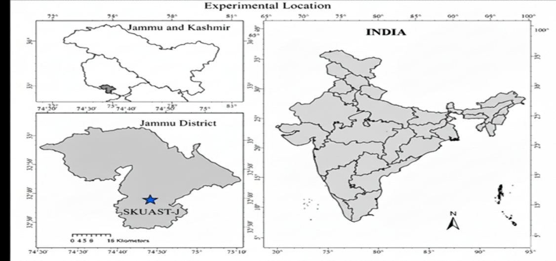
Figure 1- Site map of the study area in the Union Territory of Jammu & Kashmir
Experimental design and methodology
The experiment was laid out in one-way ANOVA with single factor i.e. seed source. In the experiment, there were four treatments combination (four seed sources/provenances) with five replications each. A total of 60 seeds per treatment (12 per replication) was spread over germinator paper in the seed germinator trays and observations were recorded on daily basis for every sprouted seed upto 21 days (3 weeks). Provenance/Origin of sandalwood (Santalum album L.) seeds were acquired from authentic forest nurseries located at below mentioned locations to investigate the performance of sandalwood seeds under uniform Laboratory conditions.
Origin/Location of seed sources: Four
- S₁: Seed source 1 (Karnataka)
- S₂: Seed source 2 (Tamil Nadu)
- S₃: Seed source 3 (Kerela)
- S₄: Seed source 4 (Himachal Pradesh)
Seeds from each source were soaked in 0.05 percent (%) Gibberellic acid (GA₃) solution for 24-36 hours. Each single floated seed to the surface of GA₃ solution was eradicated. Rest of the soaked seeds were treated with 0.25 percent (%) Dithane M-45 and 0.1 percent (%) Carbendazim to prevent seeds from fungal attack. Thereafter, the seeds were kept in the seed germinator from March to May. Seeds were spread over the germinator paper in the seed germinator tray (petriplates). During the experimental period, the temperature and the relative humidity was maintained at 25˚C and 85-100 % respectively. The seeds were watered at regular intervals and were regularly examined for germination. Spreading of seeds in seed germinator trays and sprouting of seeds in seed germinator has been depicted in Plate 1.
Observations
As per the experiment, the following observations were recorded:
1 Germination percentage (%): | Germination percentage was calculated by dividing the total number of seeds germinated by total number of seeds spread over germinator tray and multiply by 100.
2 Germinative energy (%): | Germinative energy (GE) was calculated based on the percentage of the total number of seeds that had germinated when the germination reached its peak.
3 Coefficient of velocity of germination: | The coefficient of velocity germination (CVG) was calculated according to Jones and Sanders (1987):  $$Coefficient of velocity germination=\frac{\sum{Ni}}{\sum{NiTi}} x 100$$  Where, Ni ₌ Number of seed germination on i^{th} day (i = 1,2,3….x)  Ti ₌ Number of days from the start of the experiment (i = 1,2, 3….x).
4 Mean daily germination: | Mean daily germination (MDG) was calculated as the cumulative percentage of full seed germination at the end of the test divided by the number of days taken from sowing to the end of the test or total percentage germination divided by total days in the test gives the mean daily germination (Paul, 1974).
5 Mean germination time: | The mean germination time (MGT) was calculated according to Orchard (1977):  $$Mean Germination Time (MGT)=\frac{\sum{Ni}Ti}{\sum{Ni}}$$  Where, Ni = Number of seeds germinated on i^{th} day (i = 1, 2, 3….x)  Ti = Number of days from the start of the experiment (i = 1,2, 3….x)
Statistical Ananlysis
The data generated from the present investigation were analysed using R software version 4.5.1 (R Core Team. 2024) and accordance with the procedure outlined by Gomez and Gomez (1984).
EXPERIMENTAL RESULTS
Data pertaining to seed germination have been presented in Table 1. Significant variations were observed among different seed sources with respect to germination percentage, germinative energy, coefficient of velocity of germination (CVG), mean daily germination (MDG), and mean germination time (MGT).
Table 1- Effect of Seed Source on Germination Parameters of Sandalwood (Santalum album L.)
Seed Sources | Germination Percentage (%) | Germinative Energy (%) | CVG | MDG | MGT
S_{1:} (Seed source 1- Karnataka) | 75.00ª | 36.67ª | 10.07ª | 0.43ª | 9.94^{d}
S_{2:} (Seed source 2- Tamil Nadu) | 71.67ª | 31.67^{ab} | 8.56^{b} | 0.41ª | 11.73^{c}
S_{3:} (Seed source 3- Kerela) | 63.34^{b} | 26.67^{b} | 7.72^{c} | 0.36^{b} | 12.87^{b}
S_{4:} (Seed source 4- Himachal Pradesh) | 51.67^{c} | 15.74^{c} | 6.47^{d} | 0.29^{c} | 15.45ª
CD _{(0.05)} | 9.43 | 9.37 | 0.60 | 0.05 | 0.84
SE(m) ± | 3.13 | 3.11 | 0.20 | 0.02 | 0.28

Germination Percentage (%)
The data presented in Table 1 revealed that germination percentage differed significantly among the various seed sources. The highest germination percentage (75.00%) was observed in S_{1:} (Seed source 1- Karnataka), which was statistically at par with S_{2:} (Seed source 2- Tamil Nadu) (71.67%). In contrast, the lowest germination percentage (51.67%) was recorded in S_{4:} (Seed source 4- Himachal Pradesh), suggesting comparatively poor seed quality and reduced germination potential.
Germinative Energy (%)
Germinative energy reflects the speed and uniformity of germination. Data presented in Table 1 revealed significant differences among the seed sources with respect to germinative energy. The highest germinative energy (36.67%) was recorded in S₁: (Seed source 1 – Karnataka), which was statistically at par with S₂: (Seed source 2 – Tamil Nadu) (31.67%). This indicates that these two seed sources exhibited faster and more uniform early germination. Meanwhile the lowest germinative energy (15.74%) was observed in S₄: (Seed source 4 – Himachal Pradesh), reflecting delayed and less vigorous initial germination behaviour.
Coefficient of Velocity of Germination (CVG)
The coefficient of velocity of germination (CVG) expresses the rapidity of germination; higher values denote faster germination. Data pertained in Table 1 indicated that Coefficient of Velocity of Germination (CVG) varied significantly among the different seed sources. The maximum CVG value (10.07) was recorded in S₁: (Seed source 1 – Karnataka), signifying the fastest rate of germination. This was followed by S₂: (Seed source 2 – Tamil Nadu) (31.67%). (8.56) and S₃: ((Seed source 3 – Kerala) (7.72), while the minimum CVG (6.47) was observed in S₄: (Seed source 4 – Himachal Pradesh), which corresponds to a slower germination process and reduced seed vigour compared to the other sources.
Mean Daily Germination (MDG)
Mean daily germination (MDG), an indicator of daily germination rate, followed a similar trend as shown in Table 1, the highest MDG (0.43) was recorded in S₁: (Seed source 1 – Karnataka), which was statistically at par with S₂: (Seed source 2 – Tamil Nadu) (0.41), indicating a steady and consistent germination rate per day in these sources, whereas the lowest MDG (0.29) was recorded in S₄: (Seed source 4 – Himachal Pradesh), suggesting a slower and less consistent daily germination rate.
Mean Germination Time (MGT)
Mean germination time (MGT) represents the average time taken for seeds to complete germination; a lower value indicates faster germination The results summarized in Table 1 revealed significant differences among the seed sources about mean germination time. The shortest mean germination time (9.94 days) was observed in in S₁: (Seed source 1 – Karnataka), indicating the fastest completion of the germination process. This was followed by S₂: (Seed source 2 – Tamil Nadu) (11.73 days) and S₃: (Seed source 3 – Kerala) (12.87 days), showing moderate germination durations. The longest MGT (15.45 days) occurred in S₄: (Seed source 4 – Himachal Pradesh), signifying delayed germination and lower seed vigour in comparison to the other sources. Thus, Karnataka seeds germinated in the shortest duration, reflecting better vigor and metabolic activity.

Figure 2- Graph showing the trends in CVG, MGT and MDG over the study period.
DISCUSSION
The variability in results pertaining to the seed germination parameters could be attributed to the geographically distinct local environmental conditions, diversity of edaphoclimatic conditions, altitude, precipitation and soil status which ultimately effect the genetic constitution of the species, the seed sources and plant population in the growing area. Variations in germination percentage within a species arise due to strong genetic influence (Vakshasya et al., 1992). The genetic constitution of the species also depends on the age of mother tree and its habitat, which influence the production of fertile seeds (Debi and Parkash, 2015). As reported by sandalwood information system, (IWST-2014), the natural range of sandalwood in India covers nearly 9,000 square kilometers. Out of which about 90% of this area (approximately 8,300 sq. km) predominantly located in Karnataka, Tamil Nadu, and select regions of Kerala. Of this, Karnataka alone accounts for an estimated 5,245 square kilometers of the total distribution (Chavan et al., 2024). These findings provide empirical support for the observed pattern in our results. The higher germination percentage, greater germinative energy, higher CVG and MDG, and shorter MGT recorded in the Karnataka (S₁) and Tamil Nadu (S₂) seed sources likely reflect superior seed lot vigour, more favourable maternal environments perhaps lower stress, better seed fill and a provenance better matched to the laboratory germination conditions. In contrast, the lower performance of the Himachal Pradesh (S₄) source may reflect a provenance adapted to cooler or more variable climatic conditions, resulting in slower or less uniform germination under the test regime.
The results of this study are in conformity with earlier studies conducted on sandalwood seed sources. Shwetha et al. (2024) reported in her findings that Gottipura seed source from Karnataka recorded the higher germination percentage (51.67%) indicating higher probability establishment and can contribute to the selection of suitable seed sources for sandalwood plantation and breeding programs in Karnataka, promoting the conservation and sustainable utilization of this valuable timber species as compared to Marayoor source from Kerela. Similarly, Annapurna et al. (2006) investigated different clones of Santalum album for germination traits. The results of germination parameters investigation showed remarkable difference, indicating the significant effect of seed sources. Similar results have also been reported by Verma (2022) and Dutt (2000) in sandalwood seeds under laboratory conditions.
Summary
Overall, seeds from Karnataka (S₁) consistently outperformed other sources in all germination parameters, followed closely by Tamil Nadu (S₂). Kerala (S₃) exhibited moderate performance, while Himachal Pradesh (S₄) showed the least germination efficiency and speed. These variations may be attributed to genetic diversity, environmental adaptation, and seed maturity differences among the sources.

Disclaimer (Artificial intelligence)
Option 1:
Author(s) hereby declare that NO generative AI technologies such as Large Language Models (ChatGPT, COPILOT, etc.) and text-to-image generators have been used during the writing or editing of this manuscript.
Author’s Reply: Confirmed. I certify that all content in this manuscript was created entirely by the authors and that no generative AI technologies were used in its writing, editing, or preparation.
Option 2:
Author(s) hereby declare that generative AI technologies such as Large Language Models, etc. have been used during the writing or editing of manuscripts. This explanation will include the name, version, model, and source of the generative AI technology and as well as all input prompts provided to the generative AI technology
Author,s Reply: NA
Details of the AI usage are given below:
1. NA
2. NA
3. NA

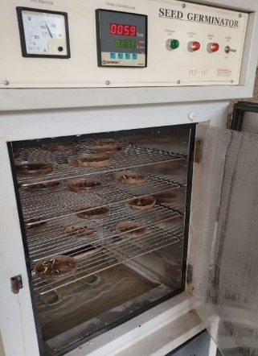
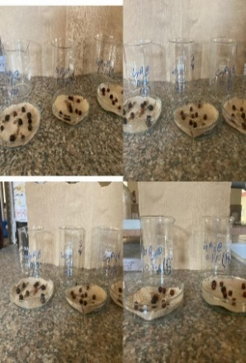
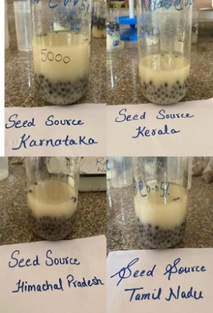

a.) seeds treated with GA₃ b.) Seeds spread over petriplates c.) Seeds kept in Seed Germinator

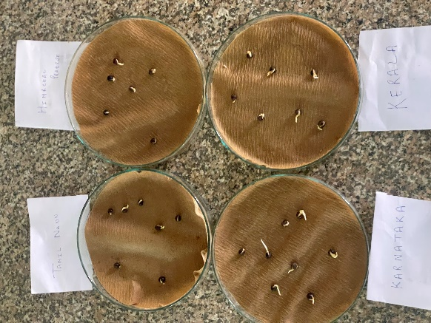
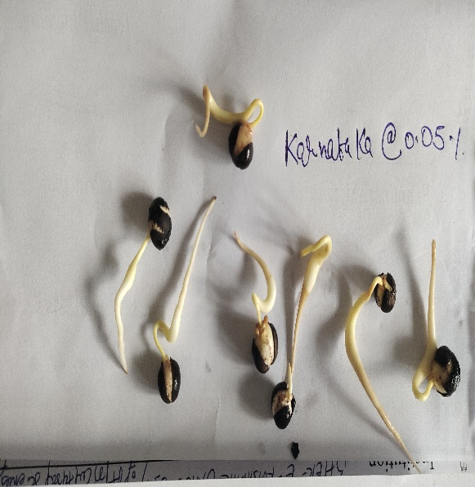
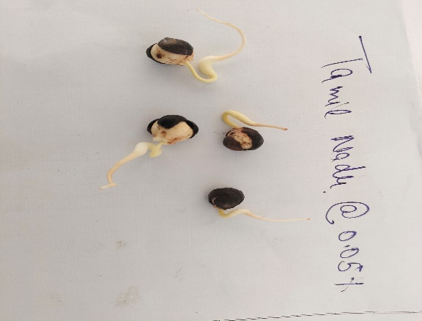

d.) Germination Status at the end of the Experiment

Plate 1: An overview of seed germinator experiment

References
Annapurna, D., Rathore, T. S. and Joshi, G. 2006. Modern nursery practices in the production of quality seedlings of Indian sandalwood (Santalum album L.)– stage of host requirement and screening of primary host species. Journal of Sustainable Forestry, 22(3/4): 33-55.
Balasubramanian, A., Hariprasath, C. N., Manivasakan, S. and Radhakrishnan, S. 2018. Influence of host on the early growth performance of sandal tree (Santalum album) grown in farm settings. International Journal of Ecology and Environmental Sciences, 44(4): 369-372.
Chavan, S. B., Uthappa, A. R., Chichaghare, A. R., Ramanan, S., Kumar, R., Keerthika, A., ·Arunachalam, A., Hegde, R., Jinger, D., Meena, V. S., Kumar, M., Harisha, C. B., Kakade, V. D., Morade, A. S., Rawale, G. B., Singh, R. and Reddy, K. S. 2024. Past, present and future of Indian sandalwood (Santalum album) cultivation and commercial prospects. Discover Applied Sciences, 6: 627.
Das, S. C. and Tah, J., 2017. Role of host plants for white sandal (Santalum album L.) cultivation in West Bengal. Asian Journal of Science and Technology, 8(10): 6060-6067.
Debi, C. and Parkash, V.2015. Seed source and habitat variation affect seed germination in Oroxylum indicum (L.) Benth. ex Kurz: An important threatened medicinal tree. International Journal of Life Sciences and Technology, 8(1): 1-9
Dutt, S. 2000. Present Status, Nursery and Plantation Technology of Sandalwood (Santalum album Linn.) in Low Hills of Himachal Pradesh. Ph.D. Thesis, Dr Y.S. Parmar University of Horticulture and Forestry, Nauni, Solan, Himachal Pradesh, India.
Gomez, K.A and Gomez, A.A. 1984. Statistically Procedure for Agricultural Research. John Wlley and Sons, Newyork, U.S.A.
IWST. 2014. Sandalwood information system. Indian Council of Forestry Research and Education (ICFRE). Availabe at: https://iwst.icfre.gov.in/database/SIS/index.html. (Accessed on 10 July, 2025).
Jones, K. and Sanders, D. 1987. The influence of soaking pepper seed in water or potassium salt solutions on germination at three temperatures. Journal of Seed Technology, 11: 97–102.
Madhuvanthi, C. K., Eswaran, M., Karthick, T., Balasubramanian, A. and Dasgupta, M. G. 2024. Assessment of seed and seedling-related traits in Santalum album (Indian sandalwood) reveals high adaptive potential. Journal of Biosciences, 49(13): 1-15.
Orchard, T., 1977. Estimating the parameters of plant seedling emergence. Seed Science and Technology, 5: 61–69.
Paul, W. D. 1974. Germination control of stratified sugar maple seeds. Forest Chronicle, 50: 112-113.
Sahu, S., Maheswarappa, V., Hedge, R., Kencharaddi, R. N. and Sathish, B. N. 2021. Effect of host plants and potting mixture on growth of sandalwood seedlings at nursery stage. International Journal of Current Microbiology and Applied Sciences, 10(09): 545-559.
Sharma, D. and Kumari, D. 2022. Lantana camara as a potential secondary host for natural populations of Santalum album in foothills of Himalayas: A hope to stand along with noxious weed. Biological Forum – An International Journal, 14(3): 179-183.
Sharma, S. D. 2021. Scope of Chandan (Santalum album) cultivation in Himachal Pradesh. Just Agriculture, 1: 1-4.
Shwetha, V. R., Mahadevamurthy, M., Raghu, H. B. and Lalitha, B. S. 2024. Assessment of potential seed sources from Karnataka for the production of quality planting stock in Santalum album L. Mysore Journal of Agricultural Sciences, 58(1): 285-294.
Silva, J. A. T., Kher, M. M., Soner. D., Page, T., Zhang, X., Nataraj, M. and Ma, G. 2016. Sandalwood: basic biology, tissue culture, and genetic transformation. Planta, 8: 243-847.
Srikantaprasad, D., Gowda, A. P. M., Pushpa, T. N., Thimmagowda, K., Ravikumar, R. L. and Prasanna, K. T. 2022. Identification of suitable host for sandalwood cultivation in Northern dry zone of Karnataka. Industrial Crops & Products, 18(2): 1-11.
Srinivasan, V. V., Sivaramakrishnan, V. R., Rangaswamy, C. R., Ananthapadmanabha, H. S. and Shankaranarayana, K. H. 1992. Sandal (Santalum album L.). ICFRE, Dehradun: 233pp.
Subasinghe, S. M. 2013. Sandalwood research: a global perspective. Journal of Tropical Forestry and Environment, 3(1): 1-8.
Vakshasya, R. K., Rajora, O. P. and Rawat, M. S. 1992. Seed and seedling traits of Dalbergia sissoo seed source variation studies among ten sources in India. Forest Ecology and Management, 48: 265-275.
Verma, S. 2022. Studies on Population Dynamics and Nursery Performance of Santalum Album Linn. in Himachal Pradesh. Ph.D. Thesis, Dr Y.S. Parmar University of Horticulture and Forestry, Nauni, Solan, Himachal Pradesh, India.
Vignesh, M., Sivaprakash, M., Balasubramanian, A., Tilak, M., Radhakrishnan, S., Hari Prasath, C. N., Anjali, K. S. and Navaneetha Krishnan, S. 2022. Effect of spacing on the growth of sandalwood (Santalum album L.) trees under farm conditions in Tamil Nadu, India. The Pharma Innovation Journal, 11(7): 785-787.

