SCREENING OF BLACK PEPPER CULTIVARS FOR RESISTANCE TO ROOT-KNOT NEMATODE, Meloidogyne incognita

ABSTRACT
The study aimed to find out the source of resistance against root-knot nematode, Meloidogyne incognita in different black pepper cultivars. The experiment was conducted in the nursery of Plantation Crop Garden, Biswanath College of Agriculture, AAU, Biswanath Chariali, Assam during kharif season 2025. Plastic pots of 1000 cc capacity were filled with sterilized soil, sand and cow dung mixture in the ratio of 2:1:1. After filling of pots a single rooted cutting of six different black pepper cultivars were planted in each pot. The pots were arranged in completely randomized design with five replications for each cultivar. Fifteen day after planting each plant was inoculated with freshly hatched second stage juveniles of M. incognita @1 J₂/cc soil. Two months after inoculation plants were uprooted and number of galls and egg masses per root system was recorded. Number of galls per root system is more than 31 in all the cultivars viz. Panniyur-1, Panniyur-2, Panniyur-3, Karimunda, Doddiga and Local. Hence the cultivars were categorized as susceptible. From this experiment it can be concluded that no one cultivar found to be resistant against root-knot nematode. In absence of resistant and moderately resistant cultivars other ecofriendly nematode management methods can be incorporated in endemic areas.
Key words: Black pepper, cultivar, resistant, root-knot nematode, susceptible

- INTRODUCTION
Black pepper (Piper nigrum L.) is considered as the most important spice crop belongs to the family Piperaceae. It is originated in India. Black pepper is known as the King of Spices. Due to its durability and value it is called as “Black gold”. “In India black pepper is cultivated in several states like Kerala, Karnataka, Tamil Nadu, Andhra Pradesh, Goa, some areas of Assam and adjoining North Eastern States. Among the states Karnataka produces majority of black pepper in India. All over India black pepper is cultivated in 1, 37,378 ha area with a production of 61,000 ton in 2019-20” (Subha and Balamurugan, 2020). “Several biotic and abiotic factors are responsible for low production of black pepper” (Thangaselvabal et al., 2008; Karmawati et al., 2020; Negi et al., 2021). “Among the different factors, plant parasitic nematodes are considered to be important one, causing yield losses ranging from 15-35%” (Abd-Elgawad and Askary, 2015, Vyamasani & Uma 2023).
“Phytoparasitic nematodes have been identified as a primary cause of early decrease in black pepper output” (Thuy et al., 2012). “Black pepper plant is found to be infected by 29 genera and 48 species of plant parasitic nematodes” (Sundararaju et al., 1979; Koshy and Bridge, 1990). “Out of several species of plant parasitic nematodes associated with black pepper cultivation, root-knot nematode, Meloidogyne incognita is found to be the most prevalent species” (Ravindra et al., 2013; Gomez-Rodriguez et al., 2017; Pervez, 2018). “Due to infestation by plant parasitic nematodes plant height and root development were reduced and leaves of stunted plants turn yellow colour” (DeSouza et al., 2021). The diagnostic symptom of root-knot nematode infestation is production of galls or knots in root system which could be easily recognized by naked eyes (Fig. 1). “Root-knot nematode, M. incognita and burrowing nematode Radopholus similis were implicated in the etiology of slow decline of black pepper” ( Ramana, 1986; Ramana et al., 1987). Two to three months after planting in sunny, warm and dry weather after a severe infection by root-knot nematode wilting symptoms appear (Shahnazi et al, 2012). “Root-knot nematode, Meloidogyne spp. has been implicated in the decreased unprofitable development of black pepper in India” (Narayana et al., 2018), Malaysia (Leong et al., 2021), and Brazil (De Souza et al., 2021).
“Plant parasitic nematodes can effectively be managed by application of chemical nematicides” (Deka and Das, 2003; Soriano and Reversat, 2003; Mostafa and Abd El-Kholy, 2008; Latif et al; 2011; Neog and Chauhan, 2015). Due to restricted use as well as cost of effective nematicide and also considering health hazards and environment pollution, in sustainable agriculture host plant resistance is effective nematode management tool (Mukhtar et al, 2017; Nayak et al., 2018; Gandhi et al., 2019; Mahalik and Mahapatra, 2020; Yadav et al, 2023). A completely resistant plant allows no nematode multiplication and reproduction. With these facts in view, the present investigation have been undertaken to find out the source of resistance through screening of black pepper cultivars against root-knot nematode, M. incognita.
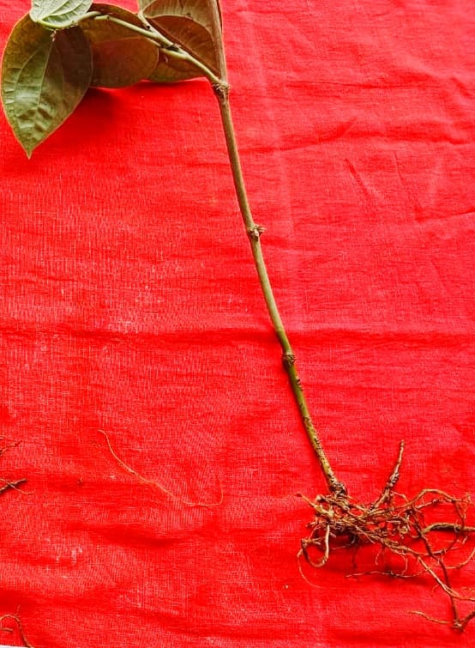
Fig. 1. Galling on roots of black pepper
- MATERIALS AND METHODS
A pot experiment was conducted in the nursery of Plantation Crop Garden, Biswanath College of Agriculture [26.7267° N latitude and 93.1479° E longitude and altitude 105m AMSL], AAU, Biswanath Chariali, Assam, India during kharif season 2025 to assess the reaction of some black pepper cultivars against root-knot nematode, M. incognita. Cutting of six black pepper cultivars were collected from the Plantation Crop Garden of Biswanath College of Agriculture, AAU, Biswanath Chariali, Assam and the cuttings, ten from each cultivar were planted separately in six different earthen pots of 5000cc capacity containing sterilized soil for rooting and regular watering was done. Plastic pots of 1000 cc capacity were filled with sterilized soil, sand and cow dung mixture in the ratio of 2:1:1. After filling of pots a single rooted cuttings of different black pepper cultivars were planted in each pot. The pots were arranged in completely randomized design with five replications for each cultivar. Fifteen days after planting plants were inoculated with freshly hatched second stage juveniles of M. incognita @ 1000J₂ per pot. “Regular watering was done till the completion of the experiment. Two months after inoculation plants were uprooted carefully and roots system was properly washed under running tap water to remove the adhering soil particles in roots. Observations on number of galls, egg masses per root system and root-knot index were recorded. After uprooting of plants final nematode population in soil from each pot was also recorded. For recording final nematode population in soil extraction of nematodes from soil was done by modified Cobb’s sieving and decanting technique, followed by Baerman’s funnel technique” (Christie and Perry, 1951). For extraction, soil sample from each pot was thoroughly mixed and 200cc of soil was drawn from the homogeneous mixture. After extraction nematodes were counted in a multi chambered counting dish under a stereoscopic binocular microscope. Laboratory works were conducted in the Department of Nematology, Biswanath College of Agriculture, Assam Agricultural University, Biswanath Chariali. The varieties were categorized as highly resistant (HR), resistant(R), moderately resistant (MR), susceptible(S) and highly susceptible (HS) on the basis of number of galls per plant following the 1-5 gall index scale by Taylor and Sasser (1978).

Table1. Gall index (1to 5 scales)
Scale | Particulars | Reaction
1. | No gall, no eggmass | Highly Resistant(HR)
2. | 1-10 galls with eggmasse per plant | Resistant (R)
3. | 11-30 galls with eggmasses per plant | Moderately Resistant(MR)
4. | 31-100 galls with eggmasses per plant | Susceptible (S)
5. | Above 101 galls with eggmasses per plant | Highly Susceptible(HS)
Data were evaluated statistically using analysis of variance and Fisher’s least significant difference (FLSD) was determined for separation of mean. The analysis was carried out in Agri Analyze platform.
3. RESULTS AND DISCUSSION
Data presented in Table2 showed that all the cultivars of black pepper screened against M. incognita were found to be susceptible. Among the screened cultivars number of galls produced per root system ranged between 31.6 to 34.4. Maximum numbers of galls (Table 2) were recorded in the cultivar Karimunda (34.40) followed by Doddiga (34.20) and minimum numbers of galls were recorded in the cultivar Panniyur-2 (31.60). Highest final nematode population in soil was recorded in the cultivar Karimunda (1450) and lowest was recorded in Panniyur-2(1262). This observation is consistent with those reported by Eapen et al. (2011). They screened 431 black pepper accessions (108 cultivated 147 wild and 176 hybrids) against root-knot nematode, M. incognita and reported that out of 431 black pepper accessions only 27 accessions were fund to be resistant. Similarly, several other workers were also screened “different cultivars of black pepper against M. incognita” (Koshy and Sundararaju, 1979; Ramana and Mohandas, 1986; Paulus et al., 1993). Likewise from a screening trial Ravindran et al. (1992) reported that “Pournami a high yielding black pepper selection tolerant to root-knot nematode” (M. incognita).
Due to presence of resistance gene in resistant cultivars makes the plants roots less attractive for attacking by root-knot nematodes. Hence there is decrease in number of gall production in root system. The susceptible cultivars allow nematode to multiply its fullest capacity. “Resistance and susceptibility to plant parasitic nematodes reflect the effect of the plant on the nematode’s ability to reproduce” (Sharma et al., 2006). “The resistant host does not allow the nematode to enter the roots or kill the nematode after it penetrated the roots or the nematode is unable to develop or reproduce in the host. The production of maximum egg masses on the roots of susceptible cultivars concludes that maximum numbers of juveniles entered the roots and were successful in completing their life cycles in the host. Experimental findings of different varietal screening trial indicates that resistant and moderately resistant germplasm only few juveniles can enter into the roots and developed which is obvious by the number of egg masses and their reproductive factors” (Adegbite et al., 2005; Patel and Dash, 2021; Gurjar et al, 2022). Several research findings indicates that “variability in tolerance to nematode might be influenced by host plant genetics and prevailing environmental conditions” (Kadam et al., 2014; Negi et al., 2014).
“Varietal screening programme is very essential to identify the source of resistance, further so that the resistance traits can be transferred in to susceptible commercial cultivars. Resistant cultivars can be combined with other management strategies within an integrated nematode management programme to achieve improved crop productivity. The use of resistant varieties is a practical and cost effective approach that enhances yield even when nematode populations exceed economic damage thresholds” (Castagnone-Sereno, 2002).

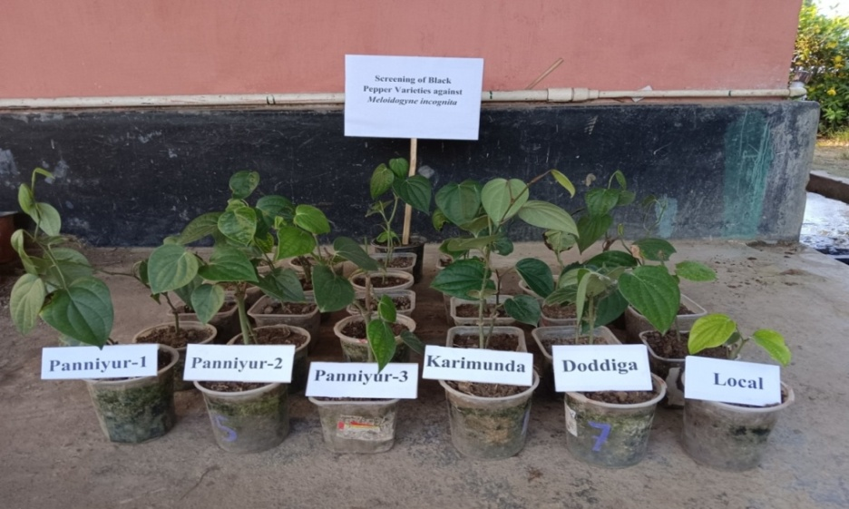
Fig. 2. View of the experiment
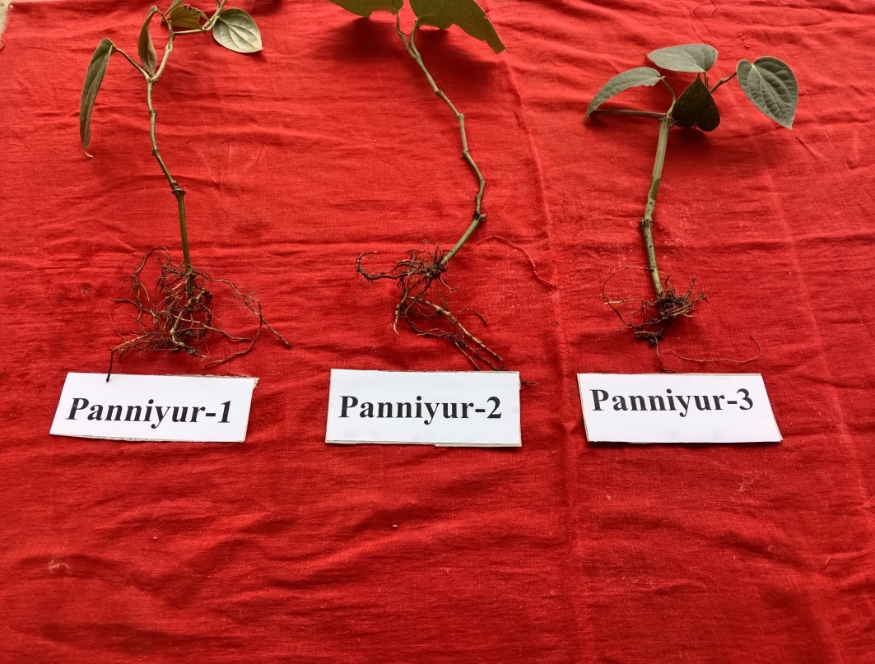
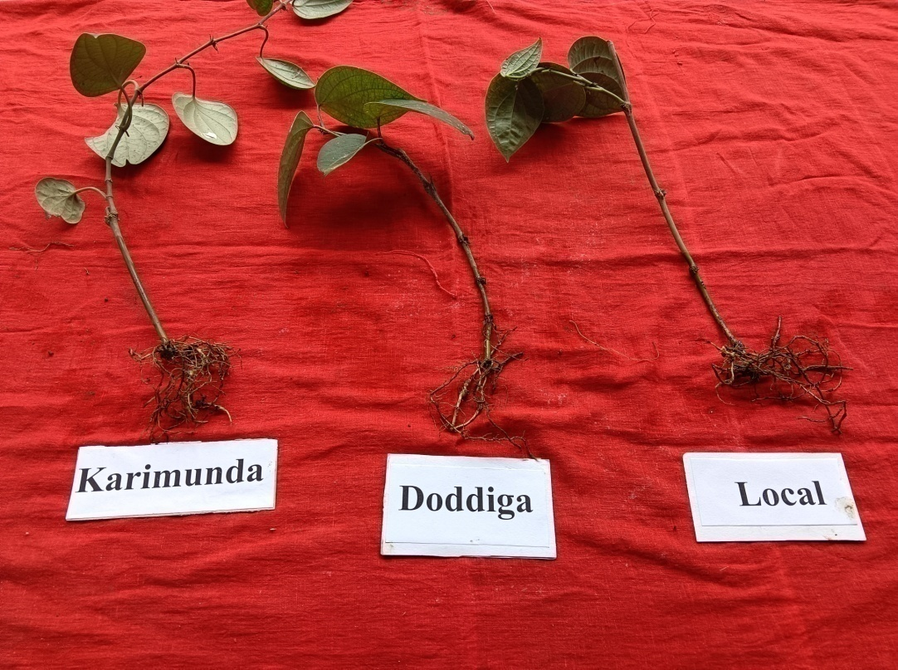
Fig.3. Galls on the roots of different black pepper cultivars

Table2. Screening of black pepper cultivars against root-knot nematode, M. incognita
(Mean of five replications)

Cultivars | Number of galls/plant | Number of eggmasses /plant | Final nematode population in soil (200cc) | Root-knot index | Reaction
Panniyur-1 | 33.60 | 13.40 | 1351(36.77) | 4.00 | Susceptible
Panniyur-2 | 31.60 | 11.40 | 1262(35.54) | 3.60 | Susceptible
Panniyur-3 | 32.60 | 12.40 | 1271(35.67) | 3.60 | Susceptible
Karimunda | 34.40 | 16.80 | 1450(38.09) | 4.00 | Susceptible
Doddiga | 34.20 | 16.20 | 1366(36.97) | 4.00 | Susceptible
Local | 33.00 | 13.20 | 1279(35.78) | 3.80 | Susceptible
SE(d) | 1.82 | 1.04 | 0.13 | 0.23
CD(0.05) | 3.83 | 2.19 | 0.27 | 0.48
* SE (d): Standard error deviation * CD: Critical difference
** Figures in parentheses are square root transformed values

- CONCLUSION
Results from the experiment indicated that none of the cultivars showed resistant reaction against root-knot nematode. In absence of resistant cultivars integrating of two or more other suitable ecofriendly strategies may be recommended for effective control of root-knot nematode in endemic areas.
- FUTURE SCOPE
To identify the potential source of resistance in future it is essential to screen a large number of black pepper cultivars against root-knot nematode as this is a serious threat in black pepper cultivation.
DISCLAIMER (ARTIFICIAL INTELLIGENCE
Author(s) hereby declare that NO generative AI technologies such as Large Language Models (ChatGPT, COPILOT, etc.) and text-to-image generators have been used during the writing or editing of this manuscript.
ACKNOWLEDGEMENTS
The author extend his sincere gratitude to all field staff of Plantation Crop Garden, Biswanath College of Agriculture, AAU, Biswanath Chariali for providing support to conduct the experiment during entire experimental period.

COMPETING INTERESTS
Authors have declared that no competing interests exist.
REFERENCES
Abd-Elgawad, M.M.M. & Askary, T.H. (2015). Impact of phytonematodes on agriculture economy. In Biocontrol agents of phytonematodes. (Eds. Askary, T.H. and Martinelli,
P.R.) CABI, Wallingford, pp. 3–49. https://doi.org/10.1079/9781780643755.0003.
Adegbite, A.A., Amusa, N.A., Agbaje, G.O. & Taiwo, L.B. (2005). Screening of cowpea
varieties for resistance to Meloidogyne incognita under field condition. Nematropica, 35(2), 155-159.
Castagnone-Sereno, P.(2002). Genetic variability in parthenogenetic root knot nematodes,
Meloidogyne spp., and their ability to overcome plant resistance genes. Nematology, 4,
605-608.
Christie, J. R. and Perry, V. G. (1951). Removing nematodes from soil. Proc. Helminth. Soc.
Wash. 18: 106-08.
Deka, B.C. & Das, P. (2003). Efficacy of different groups of chemicals in managing
Meloidogyne graminicola on rice as seed treatment. Indian J. Nematol.33, 65-66.
De Souza, R.A., Alves, F.R., De Oliveira, C.M.G., Rosa, J.M.O., Pinheiro, J.D.A., De
Aguiar, G.P. & Moraes, W.B.(2021). Occurrence of Meloidogyne arenaria in black
pepper (Piper nigrum L.) in the extreme south of the State of Bahia. Brazil.
Helminthologia, 58 (2), 213–216.
Eapen, Santhosh J. ; Ramana, K.V. & Saji, K.V. (2011). Host resistance in black pepper (Piper
nigrum L.) against root-knot and burrowing nematode. Journal of Plantation Crops, 39
(3), 341-346.
Gandhi, D.P., Bharathi, T.U., Umamaheswari, R., Kalaivanan, D. & Prathibha, S. (2019).
Response of tuberose genotypes to root-knot nematode, Meloidogyne incognita:
biochemical, histological and nutritional characterization of host pathogen interaction.
Journal of Environmental Biology, 40, 1151-1158.
Gómez-Rodríguez, O., Corona-Torres, T. & Aguilar-Rincón, V.H.( 2017). Differential response
of pepper (Capsicum annuum L.) lines to Phytophthora capsici and root-knot nematodes . Crop protection, 92, 148–152.
Gurjar, O.P., Sharma, M.K. & Chandrawat, B.S. (2022). Screening of tomato varieties for source
of resistance against root-knot nematode, M. incognita in poly house. Journal of
Progressive Agriculture, 13(1), 1-5.
Kadam, G. B., Kumar, G., Saha, T. N., Tiwari, A. K., & Kumar, R. (2014). Varietal evaluation
and genetic variability studies on gladiolus. Indian Journal of Horticulture, 71(3), 379-
384.
Karmawati, E., Ardana, I.K. & Soetopo, D.(2020). Factors effecting pepper production
and quality in several production center. IOP Conference Series: Earth Environ. Sci. 418 (1), 12051.
Koshy, P. K. & Bridge, J. (1990). Nematode parasites of spice, In: Plant Parasitic Nematodes in Subtropical and Tropical Agriculture.(Eds. Lue, M., Sikora, R.A. and Bridge, J.) CAB International, Willingford, U.K. pp.557-582.
Koshy, P.K. & Sundararaju, P. (1979). Response of seven black pepper cultivars to
Meloidogyne incognita. Nematol. Medit. 7, 123-125.
Latif, M.A., Ullah, M.W., Rafi, M.Y. & Tajul, M.I.(2011). Management of ufra disease of rice
caused by Ditylenchus angustus with nematicides and resistance. Afr. J. Microbio. Res.
5(13), 1660-1667.
Leong, S.S., Leong, S.C.T., Pau, C.G., & Beattie, G.A.C. (2021). In Vitro Bioassay of
Purpureocillium lilacinum and Bacillus thuringiensis for Control of Meloidogyne
incognita on Black Pepper (Piper nigrum L.) in Sarawak, Malaysia, Northern
Borneo. Journal of the Entomological Research Society, 23 (1), 41–59.
Mahalik, J.K. & Mahapatra, S.N. (2020). Pathogenicity and resistance reaction of gladiolus
varieties against Meloidogyne incognita (Race-2). Annals of Plant Protection Sciences,
28(2), 180.
Mostafa, M.A. & Abd El-Kholy, R.M.(2008). Chemical control of the root-knot nematode
Meloidogyne incognita infecting tomato plants (Lycopresicon esculentum) grown in different soil types. J.Agric. Sci. Mansoura Univ., 33(12), 8919-8930.
Mukhtar, T., Hussain, M.A. & Kayani, M.Z.(2017). Yield responses of 12 okra cultivars to
southern root-knot nematode(Meloidogyne incognita). Bragantia, 75, 108-112.
Narayana, R., Thomas, S. & Sheela, M.S. (2018). Management of root-knot nematode
Meloidogyne incognita infecting black pepper. Indian J. Nematol. 48 (1), 51–55.
Nayak, D.K., Pandey, R.K.,& Baa, S. (2018). Screening and evaluation of gerbera varieties
against root- knot nematode, Meloidogyne incognita. Journal of Plant Protection and
Environment, 15(2), 63-65.
Negi, A., George Kokkat, J., Jasrotia, R.S., Madhavan, S., Jaiswal, S., Angadi, U.B. &
Kumar, D. (2021). Drought responsiveness in black pepper (Piper nigrum L.): Genes associated and development of a web-genomic resource. Physiologia Plantarum, 172 (2), 669–683.
Negi, R., Kumar, S. & Dhiman, S. R. (2014). Evaluation of different cultivars of gladiolus
(Gladiolus grandiflorus L.) suitable for low hills of Himachal Pradesh. Indian Journal of
Scientific Research and Technology, 2(6), 6-11.
Neog, P.P. & Chauhan, M.K.(2015). Incidence and management of ufra disease caused by
Ditylenchus angustus in deep water rice in Assam. Ann. Pl. Protec. Sci. 23(1), 189-190.
Patel, S & Dash, B.K.(2021). Screening of urd bean germplasm for their reactions to root-knot
nematode, Meloidogyne incognita. The Pharma Innovation Journal, 10(4), 1023-1029.
Paulus, A.D., Eng, L., Teo, C.H. & Sim, S.L. (1993). Screening of black pepper genotypes and
Piper spp. for resistance to root-knot nematode. In: The Black Pepper Industry– Problems and Prospects. University Pertanian Malaysia Bintulu Campus, Sarawak, Malaysia. pp. 132-139.
Pervez, R.(2018). In: Indian Spices. Springer International Publishing, Cham, pp.
205–247. https://doi.org/10.1007/978-3-319-75016-3_8.
Ramana, K. V. (1986). Slow wilt disease of black pepper and the role of plant parasitic
nematodes in its etiology. J. Coffee Res., 16, 17-21.
Ramana, K.V. & Mohandas, C. (1986). Reaction of black pepper germplasm to root-knot
nematode, Meloidogyne incognita. Indian Journal of Nematology, 16, 138-139.
Ramana, K. V., Mohandas, C. & Balakrishnan, R. (1987). Role of plant parasitic nematodes in
the slow wilt disease complex of black pepper (Piper nigrum L) in Kerala. Indian
Journal of Nematology, 17, 225-230.
Ravindra, H., Sehgal, M., Manu, T.G., Murali, R., Narasimhamurthy, H.B., Khan, I. &
Latha, M.(2013). Status of plant parasitic nematode problems of Karnataka and
their management with special reference to genus Meloidogyne. Current Nematology, 24(1, 2), 39-48.
Ravindran, P.N., Ramana, K.V., Nair, M.K., Nirmal Babu, K. & Mohandas, C. (1992).
Pournami - A high yielding black pepper selection tolerant to root-knot nematode
(Meloidogyne incognita). Journal of Spices and Aromatic Crops, 1 (2), 136-141
Shahnazi, S., Meon, S., Vadamalai, G., Ahmad, K.& Nejat, N. ( 2012). Morphological and
molecular characterization of Fusarium spp. associated with yellowing disease of black pepper (Piper nigrum L.) in Malaysia. J. General Plant Pathol. 78 (3), 160–169.
Sharma, A., Akhtar, H.& Syed, A. (2006). Screening of field pea (Pisum sativum) selections for
their reactions to root-knot nematode (Meloidogyne incognita). Journal of Zhejiang
University Science B, 7(3), 209-214.
Soriano, I.R. & Reversat, G. (2003). Management of Meloidogyne graminicola and yield of
upland rice in South-Luzon, Philippines. Nematology, 5, 879-884.
Subha, S.P.& Balamurugan, S.( 2020). Economic analysis of pepper cultivation in India.
SSRG International Journal of Economics and Management Studies, 1–5.
Sundararaju, P., Koshy, P. K. & Sosamma, V. K. (1979). Plant parasitic nematodes associated
with spice. J. Plant. Crops, 7, 15-26.
Taylor, A.L & Sasser, J.N. (1978). Biology, identification and control of root-knot nematodes
(Meloidogyne spp.) North Carolina State University and United States Agency for
International Development Raleigh, N.C. USA. p.3.
Thangaselvabal, T., Justin, C.G.L. & Leelamathi, M.(2008). Black pepper (Piper nigrum L.)
‘ King of Spices’ – a review. Agric. Rev. 29 (2), 89–98.
Thuy, T.T.T., Yen, N.T., Tuyet, N.T.A., Te, L.L. & De Waele, D. (2012). Plant parasitic
nematodes and yellowing of leaves associated with black pepper plants in Vietnam. Arch. Phytopathol. Plant Protect. 45 (10), 1183–1200.
Yadav, R., Bhatia, A.K., Arora, I., Rahul & Kumar, A.(2023).Screening of tomato genotypes
against root-knot nematode (Meloidogyne incognita) under screen-house conditions.
International Journal of Advanced Biochemistry Research, SP-7(1), 19-21.
Vyamasani Shravani & Uma Shankar Singh. (2023). Investigation on Management of Root-Knot Nematode, Meloidogyne incognita through Soil Application of Bio-control Agents in Field Pea. International Journal of Plant & Soil Science, 35(17), 504–513. https://doi.org/10.9734/ijpss/2023/v35i173238

