ORIGINAL RESEARCH ARTICLE
Farm-to-Market Supply Chain Analysis of Nutmeg in Pollachi and Anaimalai Hills of Coimbatore District
ABSTRACT
Nutmeg cultivation and trade play an important role in the agrarian economy of Pollachi and Anaimalai, a spice-growing region in Tamil Nadu, India. The present paper investigates the nutmeg supply chain in Pollachi and Anaimalai, focusing on the various stages such as production, procurement, processing, distribution, and marketing. The overall goal of this study is to map the actors involved in nutmeg supply chain analysis, to investigate the current state of nutmeg marketing in Pollachi and Anaimalai, to examine the marketing efficiency of various channels in nutmeg, to analyze the price spread in the nutmeg supply chain and to examine the problems faced by the actors in the nutmeg supply chain using tools such as price spread, percentage analysis, marketing efficiency and Garrette ranking. By surveying 125 Nutmeg farmers, 20 intermediaries and 20 consumers, we noticed that the study area had 4 marketing channels. The study concentrated on both the nut and mace marketing. Among the 4, Channel I was found to be the best for marketing of nuts and mace of nutmeg. Therefore, encouraging and assisting Farmer-Producer Organisations (FPOs) may help them aggregate produce, bargain for better prices and lessen their reliance on middlemen.
Keywords: Channels, Constraints, Marketing efficiency, Price spread, etc.
INTRODUCTION
Nutmeg, derived from the seeds of the Myristica fragrans tree, has significant cultural, economic and culinary value globally. The tree is dioecious and necessitates cross-pollination (Gupta, 2011). Nutmeg fruit is a pendant drupe with a reddish aril surrounding the seed; the aril yields mace, while the inner kernel contains nutmeg (Nair, 2021). It is native to the Moluccas (Banda Islands) of Indonesia, but is now widely cultivated in Grenada, India, Sri Lanka, Mauritius, Malaysia, China, and South America (Naeem et al., 2019; Mangsule et al., 2025). Every year, approximately 8,000 tonnes of nutmeg and 1,000 tonnes of mace are produced globally, with Indonesia, Grenada and Sri Lanka accounting for 85% of total production (Prabhu et al., 2023). Only a small number of goods are exported from India.
The present area under nutmeg cultivation in India is about 24,176 hectares, with an annual production of 18,254 tonnes (Spice Board, 2024). In India, it is cultivated throughout Kerala, some parts of Karnataka, Tamil Nadu, Goa and Maharashtra (Farhana et al., 2025). The Pollachi and Anaimalai regions benefit from a lower-humidity climate and more staggered rainfall patterns, which are ideal for drying nutmeg. As a result, the nutmeg from these regions has a significantly lower incidence of fungal contamination and aflatoxin presence than that from Kerala. Nutmeg is grown as an intercrop in coconut plantations spanning 235.7 hectares in the Pollachi region, with approximately 175 farmers involved (Anonymous, 2025).
Historically, the supply chain of Nutmeg was heavily intermediated, which led to low returns to the farmers. The formation of Farmer-Producer Organisations (FPOs) might simplify direct marketing for domestic as well as international markets by eliminating multiple levels of intermediaries. Notably, Nutmeg farmers in Pollachi have formed a community in an effort to take their produce directly to the end customer without the interference of traders and increase their profit margins (Anonymous, September 20, 2023). They have formed a Farmer-Producer Organisation (FPO) to revolutionise the nutmeg trade. In 2022, a group of 50 farmers banded together and received ₹470 per kg of nutmeg, compared to the market price of ₹440 (Anonymous, September 24, 2023).
Thus, the farm-to-market supply chain for nutmeg in Pollachi and Anaimalai Hills has transitioned from fragmented, middleman-dominated channels to a collective, FPO-driven model that optimises financial returns, quality control and export potential. Farmers have been achieving increased profitability, global market recognition and resilience to market volatility by centralising aggregation, standardising quality, enabling direct marketing and adding value through secondary products. The Anaimalai Hills follow similar collectivisation patterns, often in collaboration with Pollachi-based FPOs and have established a regional hub for nutmeg trade and premium export branding. This study's overall objectives were to map the actors involved in the analysis of the nutmeg supply chain, look into the current status of nutmeg marketing in Pollachi and Anaimalai, assess the effectiveness of different nutmeg channels in terms of marketing, analyse the price spread in the nutmeg supply chain and assess the issues that the actors in the nutmeg supply chain are facing.
METHODOLOGY
The present study was conducted in rural regions of Pollachi and Anaimalai block of Coimbatore district. Our study area included three major blocks that produced nutmeg in abundance, i.e. Anaimalai, Pollachi North and Pollachi South. The reference year for the study was the agricultural year 2025 and the collection of data from the sample respondents was taken up during the months of February to August 2025. The data was collected by a survey method from farmers, intermediaries and consumers. The sample size was limited to 165, where we covered 125 farming communities, 20 intermediaries and 20 consumers.
Table 1. Sampling design:
S.NO | PARTICULARS | NO. OF RESPONDENTS
1. | Farmers | 125
2. | Intermediaries | 20
3. | Consumers | 20
 | Total | 165
The primary data required for the study were collected through a personal interview method with the help of a comprehensive pre-tested interview schedule. Three separate interview schedules were prepared, one for the farmers, one for the intermediaries and another one for consumers. The interview schedule for the farmers covered aspects such as general particulars of farmers, production and farm details, data on marketing of nutmeg, problems in production and marketing of the same, etc. In the interview schedule for intermediaries, general particulars, procurement details, grading methods, the system of price fixing, marketing, problems faced during price fixation and marketing, etc., were collected. Information about the cost incurred and profit realised by different market functionaries was also collected to estimate the price spread.
Tools of analysis
1. Price spread analysis: Price spread, in general, is referred to as the difference between the price paid by the consumer and the price received by the farmers for an equivalent unit of the commodity. The following formula was used to calculate the price spread in nutmeg marketing (Affandi & Handayani, 2020; Das et al., 2023; Rusiana et al., 2025).
Price spread = price paid by the consumer- price received by the farmer
2. Assessment of Marketing Efficiency: Marketing efficiency is the degree of market performance. The movement of goods from the producers to the ultimate consumers at the lowest possible cost consistent with the provision of service desired by the consumer is termed marketing efficiency. Marketing efficiency can be calculated using various methods, such as the Output by Input method, Shepherd’s Method and Acharya’s Method. Among all, Acharya’s method was used in the current study as it focuses on various elements such as price, cost and margin.
- Acharya’s method: Acharya suggested the modified measure of marketing efficiency (MME) as follows (Singh et al., 2016; Kiruthika et al., 2025):
MME= FP/ (MC+MM)
Where, FP is the price received by the farmer; MC is the marketing cost of the nutmeg and MM is the marketing margin. A farmer’s price and marketing efficiency have a direct relationship. When the price received by a farmer increases, it indicates that the farmer is having efficient marketing practices. Whereas, when the farmer gets a lower price, then he/she is following inefficient marketing practices. Contrastingly, Marketing cost and marketing margin have an inverse relationship with marketing efficiency. When either one or both increase, the efficiency of the marketing will decline and vice versa.
3. Garrett Ranking Technique (GRT): The Garrett Ranking Technique was used to rank the problems faced by the respondents during their marketing. In this technique, the respondents were asked to rank the criteria and factors and these ranks were converted into ranking positions by using the formula (Phukan et al., 2025; Khodang & Sharma, 2025; Varma et al., 2025).
Percent position = 100(R_{ij}-0.5) / N_{j}
Where,
R_{ij} = Rank given for the i^{th} variable by the j^{th} respondent
N_{j} = Number of variables ranked by the j^{th} respondent
With the help of Garrett’s Table, the percentage position estimated is converted into scores. Then, for each factor, the scores of each individual are added and the total value of scores and the mean values of scores are calculated. The factor having the highest mean value is considered to be the most important factor. Garrett's ranking is used in the analysis of the ranking of eight factors, which the respondents ranked.
RESULTS AND DISCUSSIONS
The collected data from the respondents were analysed using the methodologies mentioned above and represented below as pictures, graphs and tables.
Marketing Channels: High-quality nutmeg cultivation is well-known in the Pollachi and Anaimalai regions of Tamil Nadu and farmers use a variety of marketing channels to reach consumers. In channel I, the Farmer Producer Organisation, or FPO, serves as a group for marketing and collective bargaining. Produce is gathered by farmers, graded, packaged and sold to exporters. Nutmeg is exported to countries such as Canada, Australia and France. Channel II is the traditional channel involving multiple intermediaries. The village merchants here usually have direct contact with the farmers and purchase at lower prices. From village merchants, traders aggregate to purchase and sell to processors who convert nutmeg into value-added products. Final consumers purchase these processed products through retail or wholesale. Under channel III, the village merchants sell the produce to the organised retailer who offers branded nutmeg products to urban consumers. This channel often provides market visibility but lacks price transparency for farmers. In channel IV, farmers maintain contact with the wholesalers who handle bulk aggregations. Exporters purchase from wholesalers and ship internationally to foreign customers.
CHANNEL-1

CHANNEL-2

CHANNEL -3

CHANNEL -4

Fig 1: Marketing channels of Nutmeg in Pollachi and Anaimalai regions
Price Spread and Marketing Efficiency: The comparative analysis of nutmeg marketing channels (Nuts only) in Table 2 showed distinct variations in cost, margin and efficiency. Price spread was lowest in Channel I, i.e., Rs 200/kg and highest in Channel II (Rs 300/kg), while Channels III and IV recorded spreads of Rs 280/kg and Rs 250/kg, respectively. Marketing cost was also lowest in Channel I (Rs 26/kg), followed by Channel IV (Rs 45/kg), whereas in Channel III it was Rs 50/kg and highest in Channel II (Rs 60/kg). Similarly, Marketing margins were lowest in Channel I (Rs 174/kg) and highest in Channel II (Rs 240/kg), indicating that greater intermediary involvement increases the margin at the expense of farmers’ share. In terms of Marketing efficiency, Channel I ranked highest (2.00), followed by Channel IV (1.40), Channel III (1.14) and lowest in Channel II (1.00). A higher marketing efficiency reflects better returns to farmers compared to the marketing cost and margin incurred. FPOs purchase products straight from farmers, avoiding a number of middlemen. FPO-led farmer participatory value chain development entails actively engaging farmers at all levels of the value chain, starting from production to consumption (Kale et al., 2024).
Table 2: Price spread and Marketing efficiency for nut in nutmeg in Rs per Kg
S.NO | PARTI-CULARS | MARKETING CHANNEL I | MARKETING CHANNEL II | MARKETING CHANNEL III | MARKETING CHANNEL IV
1 | Farmer’s price | 400 | 300 | 320 | 350
2 | Consumer price | 600 | 600 | 600 | 600
3 | Price spread | 200 | 300 | 280 | 250
4 | Marketing cost | 26 | 60 | 50 | 45
5 | Marketing margin | 174 | 240 | 230 | 205
6 | Marketing efficiency | 2.00 | 1.00 | 1.14 | 1.40
The comparative analysis of nutmeg marketing channels (mace alone) in Table 3 showed visible differences in price spread, marketing cost, margin and efficiency among the 4 channels. Price spread was lowest in Channel I (Rs 600/kg) and highest in Channel II (Rs 1000/kg) and Channel IV (Rs 900/kg), while the price spread of Channel III stood at Rs 800/kg. Marketing cost was minimum in Channel I (Rs 100/kg) and maximum in Channel II (Rs 150/kg), followed by Channel III (Rs 120/kg) and Channel IV (Rs 130/kg). Similarly, marketing margins were lowest in Channel I (Rs 500/kg) and highest in Channel II (Rs 850/kg), with Channel III recording Rs 680/kg and Channel IV recording Rs 770/kg. The measure of marketing efficiency revealed that Channel I was the most efficient (4.00), followed by Channel IV (2.30), Channel III (2.25) and lastly Channel II (1.80). This ensures that farmers of Channel 1 keep a greater portion of consumer spending by lowering marketing expenses (transport, commission, handling) and narrowing the price spread.
Table 3: Price spread and Marketing efficiency for mace in nutmeg in Rs per Kg
S.NO | PARTI-  CULARS | MARKETING CHANNEL I | MARKETING CHANNEL II | MARKETING CHANNEL III | MARKETING CHANNEL IV
1 | Farmer’s price | 2400 | 1800 | 1800 | 1200
2 | Consumer price | 3000 | 2800 | 2600 | 3000
3 | Price spread | 600 | 1000 | 800 | 900
4 | Marketing cost | 100 | 150 | 120 | 130
5 | Marketing margin | 500 | 850 | 680 | 770
6 | Marketing efficiency | 4.00 | 1.80 | 2.25 | 2.30
Based on the combined evaluation of price spread, marketing costs, margins, and efficiency for both nut and mace, Channel I is concluded as the best marketing channel for marketing the nutmeg. It ensures the lowest price spread, the lowest marketing cost, the lowest margin for intermediaries and the highest efficiency. This indicates that farmers in Channel I receive a significantly higher share of the consumer’s rupee compared to other channels. On the other hand, Channel II is the least efficient, owing to the highest spread, highest cost, and margin, thereby reducing farmer profitability. Channels III and IV are moderately efficient, but still less favourable compared to Channel I. Under channel I, better pricing, quality assurance and direct access to international markets are all guaranteed to the nutmeg farmers by FPOs involved in the channel. The Pollachi village farmers took a creative and revolutionary step to maximise their nutmeg yield profits by cutting out the middlemen in order to escape the highly unorganised sector. In order to sell their produce to final consumers, up to 120 farmers banded together to form the Pollachi Nutmeg Farmer Producer Organisations (FPO). A major turning point in the farmers' agricultural journey was reached when they were able to personally export nutmeg produce to foreign markets like Australia, Canada, and France (Chandini, 2024; Gupta, 2024).
Constraints faced in the Marketing of Nutmeg: The constraints faced by the farmers, intermediaries and consumers were ranked using the Garrette ranking method. Fig. 2 represents the constraints faced by the farmers in the marketing of nutmeg. The numerical represented in the figure represents the Garette mean score. Among the 8 constraints, seasonal variation ranked as the major constraint, followed by colour changes and high aflatoxin. Aflatoxin formation and fungal infection occur during the south-west monsoon, which also happens to be the peak harvesting season (Sabu, 2019). Fig. 3 represents the constraints faced by the intermediaries in the marketing of nutmeg. Among the constraints listed, the transport issue was the primary challenge faced by the intermediaries, followed by late payment and lack of storage facilities. Joy (2023) also studied the economic feasibility of nutmeg cultivation in Kerala and concluded that the lack of infrastructure, such as a storage facility, ranked as the major constraint faced by the farmers. Meanwhile, Fig. 4 represents the constraints faced by the consumers in purchasing the nutmeg. Of the three, price variability was considered to be the major constraint, followed by adulteration and limited availability.
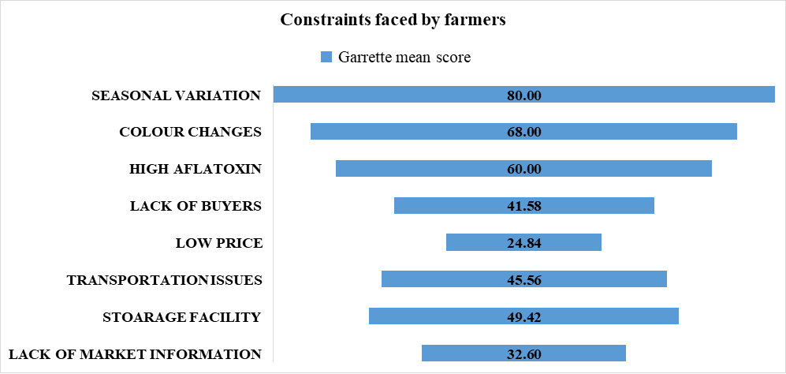
Fig.2: Constraints faced by the farmers in the marketing of nutmeg
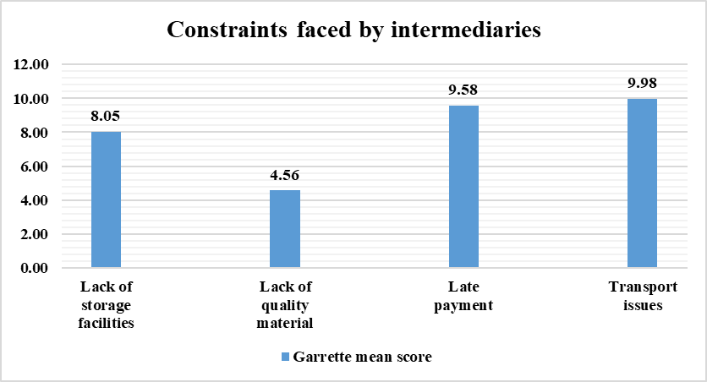
Fig.3: Constraints faced by the Intermediaries in the marketing of nutmeg
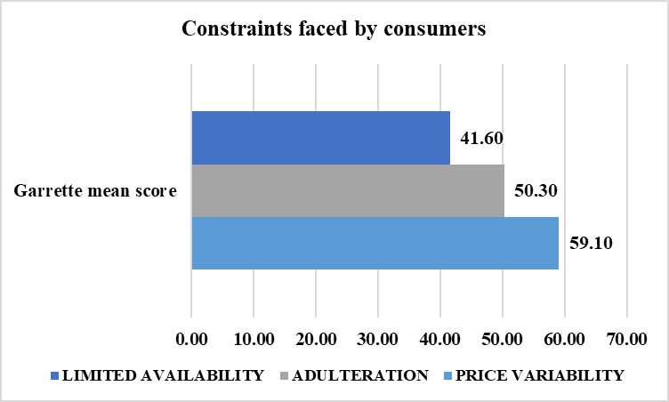
Fig.4: Constraints faced by consumers in purchasing the nutmeg
CONCLUSION
The results show that the supply chain for nutmeg is complex and includes several stakeholders, such as farmers, commission agents, traders, wholesalers, traders, processors, exporters and consumers. Farmers are essential among them as primary producers, but because of their reliance on middlemen, they frequently struggle to obtain fair prices. Farmer margins are severely impacted by price swings, a lack of bargaining, and inadequate infrastructure for processing and storage. The prevalence of middlemen who take a sizable portion of the customer price has an additional impact on marketing efficiency. Overall, encouraging farmers to take up direct sales to consumers via FPCs and e-commerce platforms can reduce the price variability, which may be advantageous for both producers and consumers. We can also train farmers to adopt Good Agricultural Practices (GAP) to maintain the quality of the produce and this in turn helps in easy reaching of the export destinations.
Disclaimer (Artificial intelligence)
Option 1:
Author(s) hereby declare that NO generative AI technologies such as Large Language Models (ChatGPT, COPILOT, etc.) and text-to-image generators have been used during the writing or editing of this manuscript.
REFERENCES
Affandi, M. I., & Handayani, S. (2020, April). Marketing efficiency of organic rice In Lampung Province. In Journal of Physics: Conference Series (Vol. 1500, No. 1, p. 012063). IOP Publishing.
Anonymous. (2025). Pollachi Nutmeg Farmer Producer Company Ltd. Retrieved from Pollachi Nutmeg - Farmer Producer Company Ltd
Anonymous. (September 20, 2023). Nutmeg farmers from Pollachi form a community to protect trade. The Times of India. Retrieved from Pollachi: Nutmeg Farmers From Pollachi Form Community To Protect Trade | Coimbatore News - Times of India
Anonymous. (September 24, 2023). Nutmeg farmers in Pollachi join hands to form community for better price. Retrieved from Nutmeg farmers in Pollachi join hands to form community for better price - The Hindu
Chandini, R. (2024). How this Cambridge engineer made Pollachi’s nutmeg a global sensation with Rs 30 crore annual turnover. 30 Stades. Retrieved from How this Cambridge engineer made Pollachi's nutmeg a global sensation with Rs 3 crore annual turnover
Das, M., Dwivedi, P., Kumar, A., & Mishra, A. (2023). Identify Marketing Channel & Marketing Efficiency, Marketing Margin, Marketing Cost, Price Spread of Gobindobhog Rice in Purba Bardhaman District of West Bengal, India. Asian Journal of Agricultural Extension, Economics & Sociology, 41(9), 673-678.
Farhana, C. F., Vikram, H. C., Anitha, P., & Mini Raj, N. (2025). Vegetative propagation and rootstock for nutmeg: A review. Agricultural Reviews, 46(1), 1–12. https://doi.org/10.18805/ag.R-2710
Gupta, A. D., & Rajpurohit, D. (2011). Antioxidant and antimicrobial activity of nutmeg (Myristica fragrans). In Nuts and seeds in health and disease prevention (pp. 831-839). Academic Press.
Gupta, S. (2024). How 120 Farmers in Tamil Nadu Are Exporting Nutmeg Without Middlemen; Earning Rs 3 Cr in Revenues. The Better India. Retrieved from How 120 Farmers in Tamil Nadu Are Exporting Nutmeg Without Middlemen
Joy, P. (2023). Economic Feasibility of Nutmeg Cultivation in Kerala. Journal of Emerging Technologies and Innovative Research. 10(7). a619- a629.
Kale R.B., Gadge S.S., Kanak Durga P., Bhat R., Khandagale K. and Mahajan V. (2024). ‘Agri-business ecosystem of Farmer Producer Organizations’. National Institute of Agricultural Extension Management (MANAGE) and ICAR-Directorate of Onion and Garlic Research, Pune
Khodang, C., & Sharma, A. (2025). Economics and Constraints of Organic Turmeric at Kakching District of Manipur. Agricultural Science Digest, 45(2).
Kiruthika, S., Poorvika, R., & Preethi, S. (2025). Economic Analysis of Marketing of Paddy in Northern Tamil Nadu, India. Asian Journal of Agricultural Extension, Economics & Sociology, 43(3), 144-151.
Mangsule, R. A., Savitribai Phule Pune University. (2025). Beyond The Spice Rack: The Medicinal Benefits Of Nutmeg. IJCRT, 13(1), d971-d981.
Naeem, N., Rehman, R., Mushtaq, A., & Ghania, J. B. (2016). Nutmeg: A review on uses and biological properties. Int. J. Chem. Biochem. Sci, 9, 107-110.
Nair, K. P. (2021). Mace and Nutmeg. In Minor Spices and Condiments: Global Economic Potential (pp. 143-155). Cham: Springer International Publishing.
Phukan, P., Barman, U., & Kalita, H. C. (2025). A Study on Determining Marketing Problems of Agricultural Commodities Faced by Farmers of Longleng District of Nagaland, India. Journal of Scientific Research and Reports, 31(2), 288-298.
Prabhu, T., Shenbagavalli, S., & Shalini, K. (2023). Package of practice for cultivation of nutmeg. Horticulture Science, 2, 158-165.
Rusiana, R., Jahroh, S., & Juwita, R. (2025). Supply Chain Analysis of Nutmeg in North Maluku Province. Jurnal Manajemen & Agribisnis, 22(1), 29-29.
Sabu, R. S. (2019). Economic Analysis of Production, Marketing and Price Behaviour of Nutmeg in Kerala. M.Sc. Thesis submitted to the College of Horticulture, Vellanikkara, Thrissur. Retrieved from https://kau.in/sites/default/files/documents/pm10.pdf
Singh, P. K., Singh, O. P., RANI, R., & TIWARI, S. (2016). Price Spread and Marketing Efficiency under Different Marketing Channels: A Case Study of Rice Marketing in Bihar, India. The J. Rural Agric. Res, 16(2), 1-4.
Spice Board, 2024. Retrieved from Major spice state wise area production 2023-24 web.xls
Varma, K. V., Jyothi, S. H., Gopal, P. V., & Umar, S. K. (2025). Economic Analysis and Feasibility of Turmeric Processing Units in Guntur District of Andhra Pradesh, India. Asian Journal of Agricultural Extension, Economics & Sociology, 43(3), 32-38.

