From Field to Plate: Unveiling the Nutritional, Health, and Economic Benefits of Bottle Gourd (Lagenaria siceraria) in Agricultural Experiential Learning Programme

ABSTRACT
The bottle gourd (Lagenaria siceraria) is abundant in antioxidants, minerals, and bioactive constituents that contribute to multiple health benefits. Despite its wide utility, scientific investigations into its incorporation in value-added food products such as beverages, sweets, dairy items, and baked goods remain limited. This study evaluates the nutritional, therapeutic, and economic potential of bottle gourd (Lagenaria siceraria), emphasising its integration into Agricultural Experiential Learning Programmes for B.Sc. (Hons.) students to foster awareness of crop management and entrepreneurship development. Bottle gourd, widely cultivated across tropical and subtropical regions, is valued for its rich content of antioxidants, minerals, and bioactive compounds present in its fruit, seeds, leaves, and by-products, which contribute to diverse health benefits, including gastrointestinal, cardiovascular, and metabolic support. Despite its recognised nutritional and medicinal properties, scientific research on its application in value-added food products remains limited. Field trials conducted at the Agricultural College, Aswaraopet, demonstrated that optimal agronomic practices, viz., the use of red sandy loam soils, scientific nutrient management, and efficient irrigation, resulted in high yields and profitability, with a benefit-cost ratio of 2.0. The study highlights the crop’s adaptability, economic viability, and potential for value addition, while identifying research gaps in compositional analysis and by-product utilisation. By integrating multidisciplinary findings, this review underscores the role of bottle gourd in promoting sustainable food systems, circular economy models, and entrepreneurial opportunities for agricultural graduates.
Keywords: Bottle gourd, health, nutrition, economics, entrepreneur

Introduction
Gourds have been found to possess several functional components that provide beneficial effects on health. The fat content is low in gourds, contributing less than 0.3% by weight of the edible portion (Hadi et al., 2022). The bottle gourd (Lagenaria siceraria), a highly adaptable species belonging to the Cucurbitaceae family, is recognised for its extensive nutritional and therapeutic applications (Brdar-Jokanovic et al., 2024). Its various parts, particularly the leaves and seeds, are abundant in antioxidants, minerals, and bioactive constituents that contribute to multiple health benefits (Zahoor et al., 2021). This vegetable has low caloric values and high water contents. The edible portion of it contains phytochemicals like vitamins, proteins, choline, minerals, terpenoids, flavonoids, etc (Zahoor et al., 2021). Despite its wide utility, scientific investigations into its incorporation in value-added food products such as beverages, sweets, dairy items, and baked goods remain limited. This paper, therefore, seeks to highlight the potential of bottle gourd cultivation in the Agricultural Experiential Learning Programme of the Agricultural B. Sc (Hons.) Graduates, to create awareness about complete crop cultivation and postharvest management and to know the importance of bottle gourd uses, to create entrepreneurship qualities among the students.
Bottle gourd cultivation is widespread in countries including India, China, Colombia, the Philippines, Malaysia, Indonesia, Sri Lanka, Hong Kong, South Africa, and Brazil, where it remains available throughout the year (Jaggal et al., 2023). It is known by various vernacular names: courage bouteille in France, Colombo in Spain, and Zucca melon in the Philippines (Dhatt and Khosa, 2015). In India, the bottle gourd (Lagenaria siceraria) is known by many names, with “Lauki and Doodhi” being the most widespread in Hindi, “Sorakai or Anapakai” in Telugu, etc. Nutritionally, bottle gourd contains an array of proximate components, including energy (15 kcal), moisture (94.5%), carbohydrates (3.75%), protein (1.2%), fat (0.2%), fibre (0.7%), and ash (0.5%) on a dry weight basis. Its edible portions are also rich in potassium (87 mg/100 g), ascorbic acid (12 mg/100 g), phosphorus (37 mg/100 g), calcium (12 mg/100 g), and niacin (0.3 mg/100 g) (Ahmad et al., 2022). Due to its high digestibility, bottle gourd has been used traditionally to manage gastrointestinal ailments such as constipation, piles, and stomach disorders. Furthermore, it has been linked to the prevention of cardiovascular diseases, diabetes, hepatic injury, and strokes (Quamruzzaman, 2020; Shahzad et al., 2024). Additionally, extracts derived from the fruit exhibit emetic, cooling, sedative, purgative, diuretic, and antibilious properties, while serving as an effective antimicrobial remedy (Zahoor et al., 2021). In India, cultivation typically occurs across two major seasons: the summer crop (mid-October to mid-March) and the winter crop (early March to mid-July) (Minocha, 2015). The present crops at the Agricultural College, Aswaraopet, were sown during July 2025.
Economically, the crop holds notable importance. During 2023–2024, India recorded approximately 2,51,000 hectares under bottle gourd cultivation, yielding about 4.27 million MT with an average productivity of 17.05 metric tonnes per hectare (Anonymous, 2025). Although domestically well-documented, international data on production remain limited, suggesting the need for comprehensive global assessments to determine its broader agricultural relevance.
Beyond the fruit, various by-products of the bottle gourd exhibit remarkable pharmacological properties. The fruit peel and stem bark possess natriuretic activity that facilitates the excretion of excess fluids, while the leaves serve as natural purgatives and are even used in traditional remedies for baldness (Abdel-moatamed et al., 2021). The leaves and stems, consumed as leafy vegetables, are well adapted to tropical climates and contain essential macro- and micronutrients along with diverse phytochemicals beneficial for treating ailments such as headaches (Mkhize et al., 2023; Khanm & Rahman, 2024). The seeds also hold substantial agronomic and nutritional importance. Encased within a hard outer testa, the kernel yields approximately 52.54% of clear, pale-yellow oil (Pradhan et al., 2013), commonly used as an edible oil substitute across several African regions and for salad oil production in Egypt (El-Rahman et al., 2022). The defatted seed residue remains nutrient-dense and serves as a valuable by-product in the edible oil industry. Seeds are particularly rich in essential amino acids — including leucine, isoleucine, valine, lysine, and phenylalanine — and also provide dietary fibre, minerals, and proteins. Furthermore, seed oil is a rich source of sterols such as β-sitosterol, carotenoids, and tocopherols, making it an excellent reservoir of bioactive compounds (Devi et al., 2023).
In light of these properties, the crop has been grown to unveil the potential benefits of this gem of gourds. Further, this paper explores the compositional, nutritional, and functional potential of bottle gourd and its by-products. It provides comparative insights into nutrient content and antioxidant capacity to enhance understanding of their role in human health and industrial applications. The study particularly emphasises their potential contribution to the food sector through the development of functional and therapeutic products.
Despite substantial evidence supporting its nutritional and medicinal importance, Lagenaria siceraria remains underutilised. The current research gaps include (a) limited comprehensive compositional and pharmacological characterisation of the fruit and its by-products; (b) inadequate comparative studies exploring interactions among bioactive components; and (c) minimal progress in the valorisation of processing residues for food and pharmaceutical use. Addressing these gaps, this review integrates multidisciplinary findings to examine the nutritional attributes, therapeutic potential, and functional applications of bottle gourd and its derivatives. Furthermore, it underscores its relevance in promoting sustainable food systems and circular economy models through the effective utilisation of agricultural waste. Further, this study helps to develop the entrepreneurial opportunities with the value-added or processed products of bottle gourd among the students through these agricultural experiential learning programmes.
Nutritional Insights: Unveiling the Nutrients
The nutritional composition of bottle gourd and its by-products — including proximate components, dietary fibre, essential vitamins, and minerals — is summarised in Table 1. Bottle gourd is regarded as one of nature’s highly nutritious fruits, containing nearly all the fundamental elements essential for maintaining human health and wellness (Zahoor et al., 2021).
Health Benefits of Bottle Gourd
For centuries, bottle gourd has held a prominent place in traditional medicinal systems, particularly across Asia, where it is valued for its cooling, diuretic, aphrodisiac, cardiotonic, and general tonic properties (Mukherjee et al., 2022; Nath et al., 2017). Its juice and extracts have been used as remedies for gastrointestinal disorders such as acid reflux, dyspepsia, and peptic ulcers (Zaatout et al., 2023). Additionally, the consumption of bottle gourd is traditionally believed to support neurological health, providing benefits for conditions like epilepsy and other nervous disorders.
As a rich source of diverse bioactive compounds, bottle gourd functions as a “medicinal food,” particularly in the management of metabolic conditions associated with lipid and carbohydrate imbalances (Ahmad et al., 2022; Varela et al., 2022). The fruit’s combination of soluble and insoluble dietary fibres plays a vital role in moderating blood glucose levels by slowing carbohydrate absorption, enhancing satiety, and thereby assisting in weight control and obesity prevention. Moreover, routine consumption of bottle gourd juice has been shown to delay premature greying of hair (Dhakad et al., 2022) and acts as an effective natural rehydrant. Its phytochemical composition, particularly the presence of cucurbitacins and choline precursors, contributes to improved brain function and overall mental well-being (Gajera et al., 2017; Umeh and Okoye, 2021). These combined attributes highlight bottle gourd as a versatile food with both preventive and therapeutic potential across a broad spectrum of health concerns.
Health Benefits of Bottle Gourd Seed
Bottle gourd seeds have garnered increasing scientific interest due to their dense nutritional profile and bioactive compounds, particularly their high protein and oil contents (Patel et al., 2018). The pale-yellow seed oil is rich in omega-3 fatty acids, supporting cardiovascular health, enhancing cognitive function, and improving general vitality. It is also commonly utilised in hair care formulations for its emollient and nutritive properties.
In addition to their nutritional value, bottle gourd seeds possess notable pharmacological effects. The ethanolic extract of the seeds exhibits significant anthelmintic activity, showing efficacy against intestinal parasites such as tapeworms (Zaatout et al., 2023). Furthermore, seed extracts demonstrate strong antidiabetic potential and acetylcholinesterase inhibitory properties, contributing to improved glycemic control and cognitive enhancement (Attar and Ghane, 2019).
Traditional medicine attributes additional therapeutic roles to the seeds, including relief from dental pain, gum ulcers, and oedema associated with anasarca and beriberi (Zia et al., 2023). Of particular pharmacological interest is “Lagenina,” a ribosome-inactivating protein isolated from the lyophilised seed extract, which exhibits immunosuppressive, antitumor, antiviral, antiproliferative, and anti-HIV activities (Kubde et al., 2010).
Collectively, these findings confirm that bottle gourd seeds are not only nutritionally rich but also pharmacologically potent, offering applications across food, health, and therapeutic domains. The peel of Lagenaria siceraria is an often-overlooked by-product that holds significant nutritional and functional value. The leaves of Lagenaria siceraria represent another nutritionally valuable component.
Materials and methods
The crop was cultivated on red sandy loam soil at the Agricultural College, Aswaraopet, PJTAU, Telangana, which falls under the humid Agro-climatic zone of Telangana. The experimental site is geographically located at a latitude of 17.16° N and a longitude of 81.05° E, at an elevation of approximately 168 meters above mean sea level. The region receives an average annual rainfall of 1200–1300 mm, which is considerably higher than the state average rainfall, ensuring an ample supply of soil moisture during most of the cropping season.
The soil of the experimental field was red sandy loam in texture, neutral in reaction (pH), low in available nitrogen, medium in available phosphorus, and high in available potassium. It was well-drained, friable, and moderately fertile, with good aeration and water-holding capacity, supporting vigorous vine growth and healthy root development. These soil characteristics make the site highly suitable for the cultivation of bottle gourd and other cucurbitaceous crops. Moreover, the experimental area is endowed with assured irrigation facilities from bore wells and nearby tanks, ensuring effective water management throughout the crop growth period.
The prevailing climatic conditions are characterised by moderate temperatures, adequate sunlight, and well-distributed rainfall during the kharif season and is further favours the successful growth and productivity of bottle gourd. These favourable environmental factors, combined with the adoption of scientific crop management practices, provide an excellent opportunity to study and demonstrate the potential performance of the bottle gourd variety Vani-7474 under field conditions.
The optimum day and night temperatures for growth and high fruit set are 30–35°C and 18–22°C, respectively. The crop is highly sensitive to photoperiod, and seed germination is fastest at 25–30°C, while temperatures below 10°C significantly reduce germination. Crops grown under optimum temperatures produce a higher proportion of pistillate flowers and fruits per plant, whereas higher temperatures promote staminate flower emergence, resulting in an altered sex ratio.
The crop was supported by pendal structures fabricated by AELP students, while drip irrigation systems with a discharge rate of 4 LPH and 50-micron gauge plastic mulch were installed to ensure efficient water and weed management. Basal application of fertilisers, along with well-decomposed farmyard manure, was carried out as per the recommended schedule. A pre-emergence herbicide, pendimethalin @ 1.2 l/ha, was applied between the rows to suppress weed growth, and hand weeding operations were performed as and when required.
Irrigation was scheduled based on crop water requirements, particularly as the crop was grown during the kharif season, when intermittent rainfall supplemented the irrigation needs. High levels of irrigation can negatively affect bottle gourd growth and lead to reduced yields. (Tan et al., 2009).
For successful bottle gourd cultivation, it is recommended to apply the full dose of P₂O₅ and K₂O along with half of the recommended nitrogen (N) dose before sowing. The remaining half of the nitrogen should be applied about one month after sowing. The crop generally requires 40–60 kg N, 40–60 kg P₂O₅ and 60–80 kg K₂O per hectare for optimal growth and yield. Nitrogen (N) deficiency results in yellowing of leaves and vines and restricts vegetative growth. Conversely, excess nitrogen can lead to excessive vegetative growth, reduced fruiting, and a higher proportion of male flowers. Potassium (K) deficiency causes flower drop and severely limits fruit development. Boron (B) deficiency interferes with pollination, ultimately reducing fruit set and overall yield (Swagat et al., 2023).
Results and Discussion
Flowering was observed approximately 30 days after sowing, followed by fruit initiation at 45–50 days after sowing. The crop reached harvestable maturity about one month after pollination, producing healthy and uniform bottle gourds under favourable field conditions. Bottle gourd fruits can sometimes become bitter, especially in cool weather or at higher altitudes. This bitterness is caused by cucurbitacins, natural compounds found in trace amounts in all cucurbits. In bottle gourd, cucurbitacins B, D, G, and H contribute to a distinct aroma and help protect the plant from pests and animals. Factors such as temperature fluctuations, low soil pH, high temperatures, water stress, poor soil fertility, overripe fruits, or improper storage can increase the levels of these compounds (Browning and Hodges, 2004). Bitterness can be reduced with proper nitrogen fertilisation and careful crop management.
At the tender stage of maturity (for consumption), the fruits are ready for harvest 55–75 days after sowing. At this stage, the rind remains tender and green, and the skin can be easily pressed with fingers, indicating succulence. The seeds are soft and immature, making the fruit ideal for cooking and market consumption. Harvesting is carried out every 3–4 days using a sharp knife, leaving a small portion of the stalk attached to enhance the storage life of the fruits.
At the mature stage of maturity (for drying or seed purposes), harvesting is done 60–120 days after sowing, depending on the variety. By this time, the vines turn dry and brown, the fruit skin becomes hard and tough, and the fruit produces a hollow sound when tapped, indicating full maturity. The fruits are harvested using pruning shears, leaving about 3–4 inches of stem attached for hanging and proper drying (Thamburaj and Singh 2015).
Post-Harvest Considerations
Care should be taken to avoid damage to the vines and fruits during harvesting, as mechanical injury can reduce fruit quality and market value. Fruits should be harvested at different sizes based on market demand, ranging from tender to medium-sized gourds suitable for consumption. Freshly harvested fruits can be stored for 3–5 days under cool and moist conditions to maintain freshness and extend shelf life (Pandey and Rai 2017)
Critical Factors Influencing Marketability
Effective marketing of bottle gourd depends on several key factors, including fruit quality, appearance, and maturity. Fruits should be uniform in size and shape, with tender green skin free from blemishes or pests, and harvested at the appropriate stage—tender for consumption or mature for drying and seeds. Grading and sorting by size and quality improve marketability and can fetch higher prices. Proper post-harvest handling, such as careful harvesting, cool and moist storage, and careful packaging, reduces physical damage and extends shelf life. Understanding market demand, seasonal price fluctuations, and consumer preferences is crucial for maximising returns, while value addition, such as processing for juice, dried products, or seeds, offers additional income opportunities and reduces losses (Kumar et al., 2018) (Singh et al., 2017).
Table 1: Details of the cost of cultivation
S.No. | Particulars | Cost (Rs.)
1 | Land preparation | 30,000
2 | Mulching | 25,000
3 | Pendal making | 30,000
4 | Seed & sowing | 7,750
5 | Weed management | 3,000
6 | Manures | 7,500
7 | Fertilizers | 11,250
8 | Plant protection | 12,500
9 | Harvesting and transportation | 50,000
10 | Total cost of cultivation | 1,74,000
11 | Yield | 40
12 | Gross returns | 3,60,000
13 | Net returns | 1,85,000
14 | BC ratio | 2.0

The per-hectare cost of various input factors involved in bottle gourd production was estimated, and the details are presented in Table 1. The analysis revealed that the average cost of cultivation per hectare of bottle gourd amounted to Rs. 1,74,000. The major contributors to the total cost were harvesting and transportation (28.7%), land preparation (17.2%), and pendal making (17.2%), reflecting the labour- and infrastructure-intensive nature of the crop (Kadivar et al., 2020). Inputs such as fertilisers (6.5%), plant protection (7.2%), and manures (4.3%) constituted moderate portions of the overall expenditure, while costs for weed management (1.7%) and seed & sowing (4.5%) were relatively low, highlighting efficient resource utilisation (Krishna et al., 2021).
The system produced a yield of 40 q/ha, which translated into gross returns of Rs.3,60,000, resulting in net returns of Rs.1,85,000. The benefit-cost (B:C) ratio of 2.0 demonstrates the high profitability of the crop under the given management practices, indicating that every rupee invested returned two rupees (Hasan et al., 2014). Such economic performance is consistent with previous studies on similar high-value crops, which emphasise the importance of proper field preparation, nutrient management, and timely harvesting for maximising profitability.
These findings suggest that the cultivation system is economically sustainable and can be recommended for adoption under similar Agro-climatic conditions. Further improvements in cost efficiency, particularly by optimising harvesting, transportation, and infrastructure expenses, could enhance overall profitability. Farmers with medium landholdings generally have better economic conditions as they are able to implement timely management practices and invest in improved inputs and technology.
Conclusion
Bottle gourd (Lagenaria siceraria) is a nutritionally rich and therapeutically valuable crop with significant adaptability and economic potential. Its cultivation under the Agricultural Experiential Learning Programme (AELP) not only provides comprehensive hands-on experience in crop production and postharvest management but also fosters entrepreneurship among agricultural graduates. The crop’s impressive nutrient profile, diverse health benefits, and versatile by-products underscore its importance in promoting human health and supporting sustainable food systems. Economically, bottle gourd demonstrates high profitability with a benefit-cost ratio of 2.0, affirming its viability as a high-value crop. Despite its wide-ranging applications, further research is needed to fully exploit its potential in value-added food products and pharmaceutical uses. Overall, the integration of bottle gourd cultivation into educational programs and commercial agriculture can contribute significantly to nutritional security, health promotion, and rural economic development.

COMPETING INTERESTS DISCLAIMER:
Authors have declared that they have no known competing financial interests OR non-financial interests OR personal relationships that could have appeared to influence the work reported in this paper.
Disclaimer (Artificial intelligence)
Option 1:
Author(s) hereby declare that NO generative AI technologies such as Large Language Models (ChatGPT, COPILOT, etc.) and text-to-image generators have been used during the writing or editing of this manuscript.
Option 2:
Author(s) hereby declare that generative AI technologies such as Large Language Models, etc. have been used during the writing or editing of manuscripts. This explanation will include the name, version, model, and source of the generative AI technology and as well as all input prompts provided to the generative AI technology
Details of the AI usage are given below:
1.
2.
3.

References
Abdel-moatamed, A. M., El-Sayed, A. A., & Ghoneim, A. M. (2021). Pharmacological evaluation of bottle gourd (Lagenaria siceraria) peel and stem extracts for natriuretic and purgative activities. Journal of Medicinal Plants Research, 15(3), 45–53.
Ahmad, S., Khan, R. A., & Zafar, M. (2022). Nutritional and therapeutic potential of bottle gourd (Lagenaria siceraria): A review. International Journal of Food Sciences and Nutrition, 73(1), 120–132.
Anonymous. (2025). Horticultural Statistics at a Glance 2024–2025. Ministry of Agriculture and Farmers Welfare, Government of India, New Delhi.
Attar, R., & Ghane, S. G. (2019). Antidiabetic and acetylcholinesterase inhibitory properties of bottle gourd (Lagenaria siceraria) seed extract. Journal of Pharmacognosy and Phytochemistry, 8(3), 230–236.
Brdar-Jokanovic, M., Marjanovic-Jeromela, A., & Miladinovic, D. (2024). Nutritional and bioactive composition of bottle gourd (Lagenaria siceraria): An overview. Plant Foods for Human Nutrition, 79(2), 145–156.
Browning, S., & Hodges, L. (2004). Cucumber crop information: Bitterness in zucchini squash and cucumber. Newsletter, August 2004, University of Nebraska Lincoln, New York.
Devi, P., Sharma, R., & Singh, A. (2023). Nutritional composition and bioactive profile of Lagenaria siceraria seed oil. Journal of Oilseeds Research, 40(2), 180–188.
Dhakad, P. K., Meena, S. R., & Patel, R. (2022). Traditional and modern uses of bottle gourd juice: Health perspectives. Journal of Ayurveda and Integrative Medicine, 13(1), 50–58.
Dhatt, A. S., & Khosa, J. S. (2015). Vegetable Crops (Vol. 1): Breeding and Varietal Improvement. Kalyani Publishers, New Delhi.
El-Rahman, H. A., Mahfouz, S. A., & Hassan, A. M. (2022). Chemical composition and industrial applications of bottle gourd seed oil. Egyptian Journal of Agricultural Research, 100(4), 375–384.
Gajera, H. P., Kapopara, M. B., & Patel, S. V. (2017). Phytochemical and pharmacological significance of bottle gourd (Lagenaria siceraria): A review. International Journal of Pharmaceutical Sciences Review and Research, 42(1), 156–162.
Hasan, M. R., Bai, D. H., & Islam, M. A. (2014). Profitability of important summer vegetables in Keranigonj upazilla of Bangladesh. Journal of Bangladesh Agricultural University, 12(1), 111–118.
Kadivar, M. U., Singh, N., & Chaudhari, D. J. (2020). Economics and resource use efficiency of bottle gourd production in Navsari District of Gujarat State. The Journal of Rural and Agricultural Research, 20(2), 1–5.
Khanm, T., & Rahman, M. (2024). Phytochemical and nutritional assessment of bottle gourd leaves and stems. Journal of Food Biochemistry, 48(3), 145-152.
Krishna, K., Kumar, T., & Singh, J. P. (2021). Cost and income from bottle gourd production in Meerut District of Western Uttar Pradesh. International Journal of Current Microbiology and Applied Science, 10(2), 3017–3022.
Kubde, M. S., Khadabadi, S. S., & Saboo, S. S. (2010). Pharmacognostical and phytochemical studies on seeds of Lagenaria siceraria (Molina) Standl. Journal of Pharmacy Research, 3(9), 2156–2158.
Kumar, S., Singh, R., & Pandey, S. (2018). Post-harvest management and value addition in cucurbits. Indian Horticulture, 63(1), 32–36.
Minocha, R. (2015). Vegetable Production in India: Crop Calendar and Management Practices. Indian Council of Agricultural Research, New Delhi.
Mkhize, Z., Khanyile, M., & Naidoo, Y. (2023). Nutritional and ethnobotanical evaluation of Lagenaria siceraria leaves in South Africa. South African Journal of Botany, 156(1), 67–74.
Mukherjee, S., Das, A., & Sharma, S. (2022). Traditional medicinal significance of bottle gourd (Lagenaria siceraria): An overview. Asian Journal of Ethnopharmacology, 6(2), 45–52.
Nath, R., Das, P., & Paul, D. (2017). Ethnomedicinal and pharmacological importance of bottle gourd (Lagenaria siceraria). Journal of Medicinal Plants Studies, 5(3), 189–194.
Pandey, A. K., & Rai, M. (2017). Improved production and post-harvest technologies for bottle gourd (Lagenaria siceraria). Vegetable Science, 44(2), 205–210.
Patel, R., Parmar, K., & Bhatt, P. (2018). Phytochemical and pharmacological potential of Lagenaria siceraria seeds. International Journal of Pharmaceutical Sciences and Research, 9(8), 3200–3208.
Pradhan, R. C., Mishra, S., & Naik, S. N. (2013). Characterization of bottle gourd (Lagenaria siceraria) seed and seed oil. Journal of Food Science and Technology, 50(1), 173–180.
Quamruzzaman, M. (2020). Phytopharmacological review of bottle gourd (Lagenaria siceraria): A health-promoting vegetable. Journal of Medicinal Plants, 8(2), 25–35.
Shahzad, K., Rehman, H., & Malik, S. (2024). Therapeutic and nutritional potential of Lagenaria siceraria in metabolic disorders. International Journal of Food Science, 2024, 1–9.
Singh, D. K., Sharma, R. R., & Kumar, S. (2017). Post-harvest handling, marketing, and value addition in cucurbitaceous vegetables: A review. Journal of Horticultural Sciences, 12(2), 105–112.
Swagat, R. B., Riya, P., & Shristi. (2023). Bottle gourd. Production Technology of Vegetable Crops, 70–82.
Tan, Y. C., Lai, J. H., Adhikari, K. R., Shakya, S. M., Shukla, A. K., & Sharma, K. R. (2009). Efficacy of mulching, irrigation and nitrogen applications on bottle gourd and okra for yield improvement and crop diversification. Irrigation and Drainage Systems, 23, 25–41.
Thamburaj, S., & Singh, N. (2015). Vegetable Crops. Directorate of Knowledge Management in Agriculture, ICAR, New Delhi.
Umeh, C. N., & Okoye, E. C. (2021). Neuroprotective and cognitive-enhancing potential of bottle gourd (Lagenaria siceraria). Nigerian Journal of Natural Products and Medicine, 25(1), 45–52.
Varela, C., Santos, R., & Almeida, J. (2022). Functional food potential of Lagenaria siceraria in the management of metabolic syndromes. Journal of Functional Foods, 89(1), 104902.
Zaatout, H., Benyahia, D., & Ould-El-Hadj, M. D. (2023). Medicinal applications and therapeutic potential of bottle gourd (Lagenaria siceraria) juice and extracts. Journal of Ethnopharmacology, 301, 115874.
Zahoor, M., Younas, M., & Hussain, A. (2021). Phytochemical composition and antioxidant properties of bottle gourd (Lagenaria siceraria). Journal of Food Science and Technology, 58(5), 1680–1689.
Zia, F., Khan, M., & Ali, R. (2023). Traditional uses and pharmacological properties of bottle gourd seeds: An overview. Journal of Pharmacological Research, 12(2), 250–259.
Zahoor, M., Ikram, M., Nazir, N., Naz, S., Batiha, G. E. S., Kamran, A. W., ... & Kabrah, A. (2021). A comprehensive review on the medicinal importance; biological and therapeutic efficacy of Lagenaria siceraria (Mol.)(bottle gourd) Standley fruit. Current Topics in Medicinal Chemistry, 21(20), 1788-1803.
Hadi, N., Tiwari, P., Singh, R. B., Rupee, K., Rupee, S., Hanoman, C., & Singh, J. (2022). Beneficial effects of gourds in health and diseases. Functional Foods and Nutraceuticals in Metabolic and Non-Communicable Diseases, 61-77.
Jaggal, K., Bahadur, V., Kerketta, A., & Topno, S. E. (2023). Performance of bottle gourd hybrids for growth, yield and quality under Prayagraj agro-climatic conditions. International Journal of Environment and Climate Change, 13(9), 941–951.

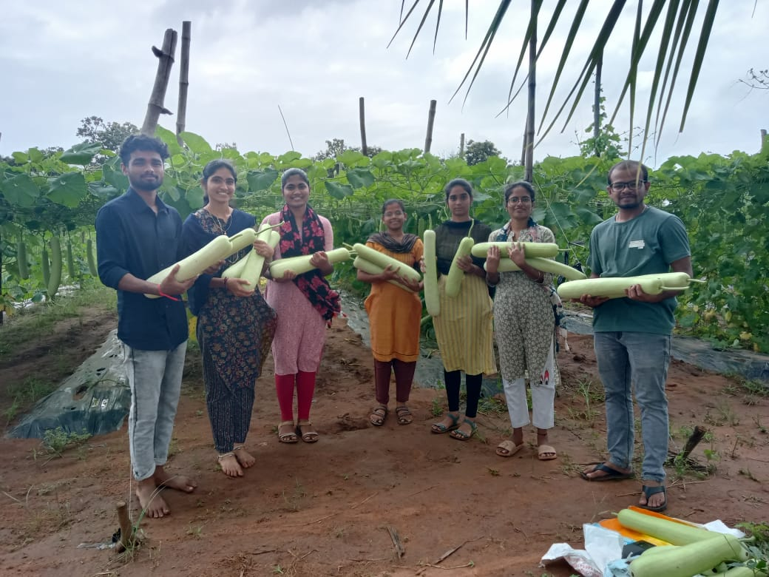
Fig 1. The team of AELP students with harvested bottle gourds
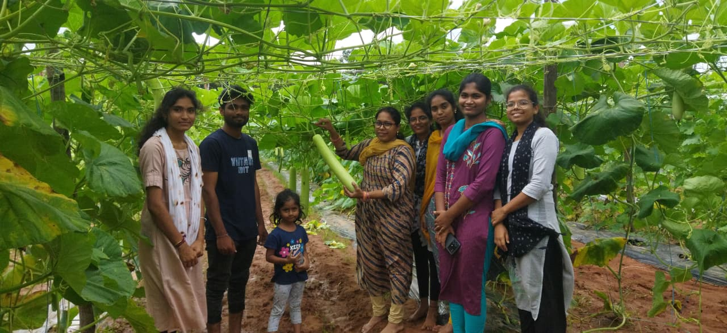
Fig 2. Farm fresh bottle gourds (Harvesting by the customers to spread the happiness)

