A Survey-Based Study on the Adoption Patterns of Sericulture Technologies in Poonch District, Jammu And Kashmir.
ABSTRACT
Sericulture is a vital industry that plays a central role in supporting the livelihood of local farmers, serving as a key economic sector with significant contributions to their income. It offers numerous entrepreneurial possibilities and the potential to enhance the consistent frequency of financial gains. However, the gradual decline in the sub-sectors, driven mainly by socio-economic and environmental challenges, underscores the pressing need to overhaul the current sericulture framework. To rejuvenate sericulture in Poonch district of Jammu and Kashmir a revised approach is essential. To revitalize sericulture in Poonch district, Jammu and Kashmir, it is crucial to implement innovative methods, conduct focused extension programs, and methodically evaluate data by gathering insights from farmers throughout the districts. This study was carried out to assess the adoption levels of advanced sericulture techniques and identify the resources for their non-adoption in six key villages of Poonch district. The primary barriers identified during the survey included a lack of awareness, costly and complex technologies, unavailability of modern tools, and reliance on traditional practices, which were cited as the main reasons for non-adoption. The success of cocoon production heavily depends on the efficiency of rearing practices and the methods applied during the rearing phases. Moreover, specialized training skills and scientific understanding are essential for effective silkworm cultivation. The study unequivocally shown that there exist significant influence of 53.3% livestock contribution and 48.6% of the differences in the technology conditions of sericulturists in Tehsil Haveli, Poonch District, alongside differences in their knowledge and application of sericulture practices. This analysis seeks to pinpoint major challenges and opportunities to improve sericulture productivity and sustainability by promoting advanced sericulture techniques to boost cocoon yield.
Core Terms: Uptake innovations, non-implementation, eco-friendliness, challenges.
- INTRODUCTION
Sericulture, an environmentally sustainable, labor-intensive rural industry, supports the livelihood of economically disadvantaged farmers by providing supplemental income and employment. It encourages numerous semi-skilled workers in raw silk and fabric production, with significant value addition at stages like cocoon production, silk reeling, and fabric processing. This industry fosters equitable socio-economic growth in populous nations like India and China, S=significantly contributing to rural economic transformation by ensuring year-round employment and consistent returns (Aslam, et al. 2020). In Jammu and Kashmir, an agrarian region, sericulture supports over 23,000 families, leveraging the region’s favorable climate, silk-friendly traditions, and growing markets revealed by (Gupta, S. K, et al., 2021). However, like other cottage industries, it faces decline. With many rural communities, especially in remote hilly areas, relying on sericulture for income. Its growth is vital to address rural-urban disparities. A fresh approach is needed to enhance sericulture’s role in bolstering the agriculture – based economy in areas with limited livelihood options. The adoption of new technologies depends on farmer’s knowledge and engagement, influenced by various factors Anonymous, (2022 February). Despite government-led extensions programs, many farmers in the Kashmir valley adhere to traditional practices. This study evaluated the adoption of improved sericultural techniques. Identifies barriers to their uptake and proposes strategies to enhance adoption at the farmer level. In India, small and marginal farmers comprising 78.20% of the agricultural sector, manage landholdings averaging under 1.43 hectares, producing mainly for subsistence. To enhance their livelihoods, diversifying into high-value commercial crops that require low investment, ensure steady income, and utilize family labor is essential. India policymakers have prioritized reducing poverty and employment through sustainable job creation that ensures a minimum wage and decent living standards. Sericulture, integrating agriculture and industry, stands out as a highly suitable, labor-intensive rural activity. This practice of raising silkworms on mulberry trees requires minimal initial investment while generating significant employment in rural areas. As a lucrative crop, sericulture delivers consistent, year-round profits, offering farmers stable income and work observed by (Sujatha, B, et al., 2015). Often called the Kalpavriksha or Kamadhenu for the underprivileged, it serves as an agro-based cottage industry with low investment and high returns (Girish, et al., 2020). The silk sector. Encompassing various on and off farm activities, demands robust support in technology, financing, raw material supply, market linkages. Technology transfer, often perceived as a top-down process from researchers to farmers, requires improved accessibility and adoption.
Research institutions often see farmers as the end -users of technological advancements, praising those who adopt new methods while labelling non-adopters as traditional or resistant to modern practices. There’s an assumption that scientific, advanced technologies are inherently superior to local methods. Non-adoption is often linked to farmer’s failure to see benefits or to issues the technology transfer process (Khan et al 2018). This up-stake of sericultural technology in both traditional and non-traditional regions is heavily shaped by farmer’s socio-economic conditions.
- OBJECTIVE OF THE STUDY
The present investigation was undertaken to evaluate the adoption patterns of sericulture technologies among farmers in Poonch District, Jammu and Kashmir. Specifically, the study aimed to assess the level of awareness and adoption of improved sericulture technologies, determine the extent of adoption across major sericulture practices. The findings are expected to provide insights for strengthening extension services and improving the dissemination of sericulture innovations in the region.
- PROSEPECTIVE ADOPTION OF SERICULTURE TECHNOLOGIES AMONG FARMERS OF POONCH DISTRICT
Chart-01: Driving Growth in Sericulture: Enhancing Income, Technology, and Market Development
Increased income opportunities.

Expansion of mulberry cultivation can promote large scale adoption.

Technological advancement enhance productivity.

Government and institutional support can motivate farmers to adopt improved technologies.

Market development can assure farmers for better returns

Sustainability and rural employment can accelerate the adoption of new sericulture technologies.

Youth participation in sericulture activities could modernize the sector and increase adoption.
- MATERIAL AND METHODOLOGY
The present survey based study was conducted in Tehsil Haveli of Poonch District, Jammu and Kashmir, India. Geographically the district lies between 33◦ 45′ to 34◦ 05′ N latitude and 73◦ 58′ to 74◦ 35′ E longitude, at an average elevation of about 981 m above the sea level. The study covered six villages, selected purposively based on the concentration of sericulture farmers and accessibility.
  - Coordinate Recording Method and Presentation: The geographical coordinates of sampled villages were recorded using GPS in order to ensure the spatial accuracy. These presented in the Table-01:

S.no | Village Name | Latitude (N) | Longitude (E)
1 | Digwar | 33.78 | 74.11
2 | Kasalia | 33.76 | 74.13
3 | Ajote | 33.75 | 74.10
4 | Gulpur | 33.73 | 74.08
5 | Salotri | 33.80 | 74.09
6 | Jallas | 33.81 | 74.12
7 | Dharadullian | 33.79 | 74.15
Table-01: GPS coordinates of surveyed villages in Tehsil Haveli, District Poonch.
  - Map preparation and GIS Application: A location map of the study area was prepared using ArcGIS 10.8 software, to illustrate the sampling sites within the Tehsil Haveli and their spatial distribution across the Poonch District. The map shows the relevant geographic boundaries and the coordinate reference framework for clarity. The map is provided in figure 01:
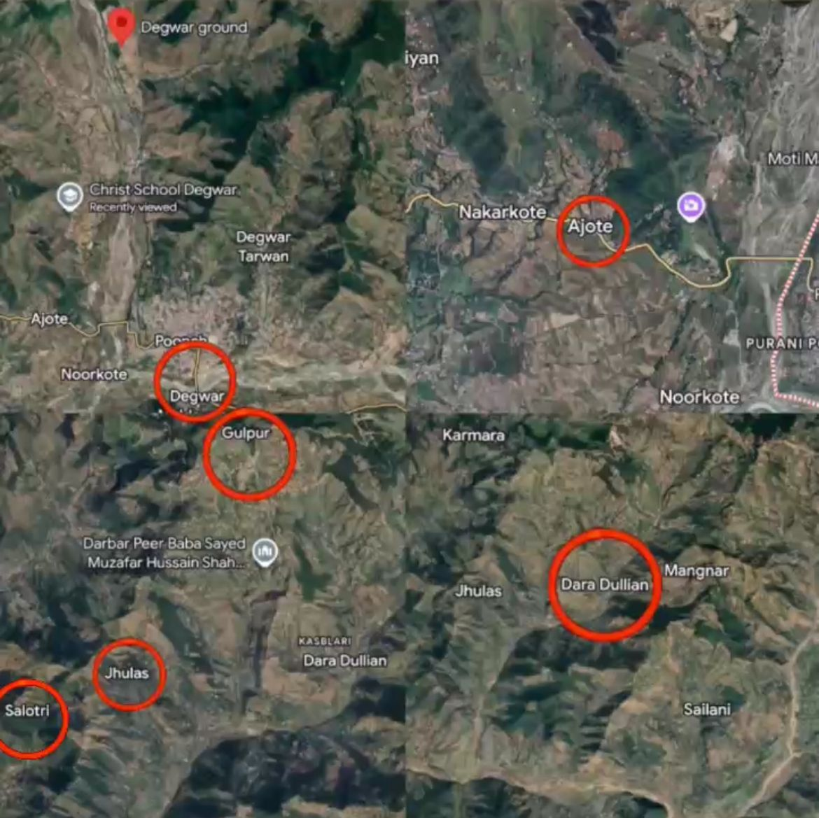
Figure 01: Location map illustrates these sampling circled villages and sites in Tehsil Haveli of Poonch District.
  - Source and Method of Data Collection: Primary data was collected from selected respondents through pre-tested, structured interviews and personal conversations. A tailored questionnaire served as the data collection tool during interviews conducted in June and July 2022. The data was compiled and analyzed using simple percentage calculations to draw conclusions.
  - Method of Data Analysis
    - Adoption Level and Non-adoption level: Sericultural technologies were employed to assess both adoption and non-adoption levels, as well as knowledge levels among respondent. Responses regarding technology adoption and nom-adoption were documented similar to the approach used for evaluating knowledge. Percentage were assigned to various block categories accordingly.
Table 02: Assessment of Adoption of Recommended Sericultural Practices by Farmers in Poonch District under the Material and Methodology Framework.
Category | Methods | Response Frequency (Yes/No)
No. Of Farm Surveyed | 06 | -
Villages Covered | 06 | -
Block | 02 | -
Adoption Of Sericulture Technology | Yes/No | -
Rearing Tray Dis-infection | Lime, 2%Bleaching Powder, Others | -
Bed Disinfectant | Lime, Formalin, Others | -
Type Of Mountages Used | Plastic, Local(Traditional) | -
Type Of Appliances For Cocoon Harvesting | Deflosser, Manual, Machine | -
Intercultural Operations | Power Tiller, Manual | -
Pruning/Leaf Cutting Method | Manual, Cutting Machine | -

- RESULTS
The uptake of sericulture technologies in Poonch District reflects varying levels of awareness and technological spread among farmers. Despite sericulture being a key livelihood source, the adoption of recommended practices differs across villages and farmers group. While most farmers known basic sericultural techniques, the consistent is of advanced methods is limited. Practices like rearing trays, disinfection, lime and bleaching powder use, bed disinfectants, improved plastic mountages, significantly impact cocoon quality and yield, yet many farmers stick to traditional methods due to limited resources, technical guidelines, and extension support. The adoption of intercultural operations and pruning techniques reveals a gap between recommended practices ad actual implementation. Although power tillers and mechanical tools are available, they are underused, with many farmers favoring manual methods due to small farm sizes, limited input access and high costs of modern equipment.
  - FARMER WISE COMPILATION OF SERICULTURE TECHNOLOGY ADOPTION RECORD: The success of sericulture hinges on effectively adopting and applying recommended practices at the field level Data from Table-02 highlights the adoption levels of mulberry cultivation practices under varying conditions and reasons foe low or non-adoption. The data shows that limited adoption of leaf harvesting timing, fertilizer application methods and quantities, recommended varities and manure use stems from inadequate knowledge across different blocks in Poonch District. Low fertilizer use is also linked to lack of awareness and high costs, while improper plant spacing results from insufficient knowledge and reliance on traditional methods. For silkworm rearing practices, non- adoption was most prevalent in Ajote (57 farmers), followed by Gulpur, Jhulas, Dingla, Mandi and Loran respectively.
Table 03: Farmer Wise Consolidated Record of Sericulture Technology Practices
S. NO | Number of farmers | Village/Block | Adoption of Sericulture Technology
S. NO | Number of farmers | Village/Block | YES/NO | Adopted(YES) | Not-Adopted (NO)
1 | 112 | Jhulas | Yes | 101 | 11
2 | 88 | Gulpur | Yes | 65 | 23
3 | 24 | Dingla | Yes | 10 | 14
4 | 12 | Mandi | Yes | 5 | 7
5 | 8 | Loran | Yes | 2 | 3
6 | 67 | Ajote | Yes | 10 | 57

  - APPRAISAL OF SERICULTURE TECHNOLOGY ADOPTION AT THE FARMER LEVEL
The sampled farmers indicated that the adoption of sericulture technologies is shaped by economics, social, and institutional factors. Non-adoption of new technologies was primarily due to limited awareness and a preference for traditional silkworm rearing methods. Practices such as maintaining separate rearing houses and controlling temperature and humidity were hindered by high costs. The study found that improved mulberry cultivation practices, particularly leaf harvesting methods, achieved 100% adoption, followed by harvesting timing, while other practices had low uptake. Lack of knowledge was a key barrier to adopting improved practices. In silkworm rearing, practices like temperature and humidity control and disinfection showed higher adoption, but separate rearing houses, mounting ripened worms, bed cleaning and leaf chopping for chawki were less practiced. Overall, adoption of improved mulberry cultivation and silkworm rearing practices was high in the study area.
Table 04: Evaluation of Farmers Adoption Of Sericulture Technologies.
S. No | Village/Block | Rearing Tray | Disinfection | Bed Disinfection | Mountages | Deflossing | Interculture Operation | Cutting Preparation
S. No | Village/Block | Rearing Tray | 2% Bleaching Powder/ Lime | (Yes/No) | Local/ Plastic | Manual/Machine | Power Tiller/Manual | Manual/Machine
S. No | Village/Block | Rearing Tray | YES/NO
1 | Jhulass | Yes | Yes | Yes | Plastic | Machine | Power Tiller | Machine
2 | Gulpur | Yes | Yes | Yes | Plastic | Machine | Power Tiller | Machine
3 | Dingla | Yes | Yes | Yes | Plastic | Manual | Power Tiller | Manual
4 | Mandi | Yes | Yes | Yes | Local | Manual | Manual | Manual
5 | Loran | Yes | Yes | Yes | Local | Manual | Manual | Manual
6 | Ajote | Yes | Yes | Yes | Plastic | Machine | Manual | Machine

  - REGIONAL DISPARITIES IN ADOPTION OF SERICULTURE TECHNOLOGIES BY FARMERS: Table 04 shows the adoption levels of technological innovations in silkworm rearing. About 87% of farmers in Jhulas village effectively adopted these innovations. High adoption rates were also observed in Gulpur, followed by Ajote, Dingla, Mandi and Loran in that order.

Fig. 02: Spatial Variation in Adoption Rate of Sericulture Technologies among Farmers (Villages/Block-wise analysis)
  - ADOPTION DYNAMICS OF IMPROVED PRACTICES: A PERCENTAGE-BASED EVALUATION
Table 05: Adoption And Non-Adoption of Improved Silkworm Rearing Practices: A Percentage Analysis
S.No | Technology | Adoption |  | Non-Adoption
S.No | Technology | Number | Percentage | Number | Percentage
1 | Rearing House | 3 | 2.20% | 88 | 97.80%
2 | Disinfection | 65 | 72.20% | 25 | 27.80%
3 | Chawki Rearing | 85 | 88.90% | 15 | 16.60%
4 | Bed Disinfectant | 60 | 66% | 30 | 33.30%
5 | Mountages | 4 | 4.40% | 85 | 94.50%

Fig. 03: Graphic representation of Adoption and Non-Adoption Analysis among the farmers in the study area.
All sampled farmers fully adopted leaf harvesting methods. Rearing house disinfection was adopted by 72.2%, chawki rearing by 88.9%, bed disinfectant use 66%, and mounting of ripened worms by 4.4%. However, most farmers did not adopt recommended plant protection measures (96.6%), fertilizer quantity (95.5%), manure use (88.8%), fertilizer application methods (86.6%), leaf transportation methods (83.3%) or recommended varieties (77.7%). Despite prevalent plant diseases, adoption of plant protection measures remained low. Successful cocoon production relies on both nutrient-rich mulberry leaves and adherence to recommended silkworm rearing practices. Although sericulture in Poonch has a strong traditional foundation, the shift to scientific, technology-driven practices is slow. Adoption is shaped by farmer’s socio-economic conditions, access to extension services and institutional support.
- DISCUSSION
The study in Poonch District showed varied adoption of sericulture technologies among farmers. Many adopted improved mulberry cultivation and silkworm rearing practices due to their positive impact on cocoon yield and income. However, technologies requiring significant investment or skill, like disinfection, advanced rearing houses, and mechanized reeling, had lower adoption rates. Factors such as land size, literacy, training access, and institutional support influenced adoption, with better-connected farmers showing higher uptake. Traditional knowledge, family labor, and reliable cocoon markets also boosted adoption, while lack of awareness, financial limitations, and poor infrastructure hindered it. Research highlights include: 59% literacy in Mysore District, varying education levels observed by (Singh et al 2015); 80% of farmers with small landholdings analyzed by (Jaishankar, et al., 2005); and ignorance causing incomplete fertilizer use (Neelaboina, et al., 2018). No link was found between socio-economic status and adoption revealed by (Ali et al 2017 and Chanotra, et al., 2019). Improved rearing methods yielded 27.72 kg/100 DFLs in rainfed areas acknowledged by (Khan et al 2010 and Chanotra, et al., 2021). Education boosts technology adoption determined by (Langerodi, et al., 2017), low adoption of new methods led to reduced yields out looked by (Ahmed, et al., 2017). All farmers adopted mulberry variety and plant spacing practices voked by (Chanotra, et al., 2019). No correlation was found between age, knowledge and adoption noted by (Chouhan, et al., 2016), though middle-aged farmers adopted more observed by (Dar, et al., 2017) and younger farmers were more open to complex technologies like uzicide revealed by (Sharma, et al., 2020). Overall the findings emphasized the enhanced training, input access, and market linkages, a critical role to increase the technology adoption in the district.
- CONCLUSION
The study concludes that Poonch District has a significant potential to boost state wide productivity, with its tribal communities possessing strong skills, work capacity, and favorable environmental conditions for sericulture adoption. Extension agencies should organize timely training programs, workshops and Kisan Melas to promote sericulture as a skill-oriented venture, particularly among tribal youth. The research highlights the need to raise awareness about rearing practices to help farmers achieve profitable returns. As a rural agro -bases industry, sericulture offers tribal farmers, often with limited or no land, a viable opportunity for income generation. Despite their keen interest in silkworm rearing farmers face challenges due to inadequate awareness and facilites, limiting their output. Enhanced extension services, such as farmers meets, awareness campaigns, and training can promote sericulture enabling tribal farmers to improve yields, increase income and elevate their socio-economic status through low-investment, high-return opportunities in a short time frame.
- DISCLAIMER (ARTIFICIAL INTELLIGENCE)
Author(s) hereby declare that NO generative AI technologies such as Large Language Models (ChatGPT, COPILOT, etc.) and text-to-image generators have been used during the writing or editing of this manuscript.
- COMPETING INTERESTS
Author has declared that no competing interests exist.
- REFERENCES
- A. Sharma, S. Chanotra, R. Gupta, R and R. Kumar (2020). Influence of climate change on cocoon crop loss under subtropical conditions. Int. J. Curr. Microbiol. App. Sci., 9: 167-171.
- Anonymous, (2022 February) Reshme Krishi Bimonthly magazine, Department of Sericulture, Karnataka [4].
- B. K. Neelaboina, G. A. Khan, M. Gani, S. Ahmed, M. N. Ahmed and M. K. Ghosh. (2018). Exploration of sericulture in unexplored region of Jammu and Kashmir. J. Entomol. Zool. Stud., 6: 1922-1925.
- C. E. Girish, K.S. Kadian, B.S. Meena and K. Mandi (2020). Knowledge assessment of farmers regarding sericulture based Dairy Farming in Karnataka State. Asian J. Agric. Ext. Economics Sociol., 38: 16-20.
- G. A. Khan, S N. Ah. Saheb, A. Ah. Shabnam, H. Rashid and M. K. Ghos (2018). Institute village linkage programme- A participatory approach for the development of sericulture in India. Int. J. Adv. Eng. Res. Sci., 7: 2155-2162.
- Gupta, S. K., & Dubey, R. K. (2021). Environmental factors and rearing techniques affecting the rearing of silkworm and cocoon production of Bombyx mori Linn. Acta Entomology and Zoology, 2(2), 62-67.
- H. Singh and R. H. Andrabi (2015). Spatial differentiation in agricultural development in Jammu and Kashmir: a geographical approach. Int. J. Sci. Res. Publications, 5: 1-9.
- L. Ali, S. K. Kher, P. S. Slathia, L. K. Sharma, P. K. Sharma and S. Kumar (2017). Sericulture in hills: contribution to economy of small and marginal farmers in hills of Jammu (J&K). Maharashtra Jn. of Agril. Economics. 20: 150-153.
- M. Aslam, D. Mohammad and D. Singh (2020). Organizational setup, status and prospect of sericulture Industry in Haryana. EPRA Int. J. Res. Dev., 5: 2455-7838.
- N. Ahmed, M. Abbas, A. Malik, A. H. Akhand, B. A. Lone and L. Ali (2017). Traditional handloom of Kargil District, Ladakh. British J. Economics, Management Trade, 17: 1-8.
- S. A. Dar, R. Akhter and S. M. Geelani (2017). Impact of sericulture industry of Jammu and Kashmir economy: (With Special reference to District Baramulla). Int. J. Multi. Edu. Res., 2: 60-64.
- S. Chanotra, K. Bali and R. K. Bali (2019). Sericulture: an opportunity for the upliftment of rural livelihood. J. Entomol. Zool. Stud., 7: 1100-1103.
- S. Chanotra, S. Devi and M. A. Bhat (2021). Sericulture as an important agro-enterprise for the marginal farmers. Guj. J. Ext. Edu., 32: 195-201.
- S. Chouhan, V. Mittal, Babular, S. P. Sharma and M. Gani (2016). Situation analysis of sericulture industry in Jammu and Kashmir. Bio Bulletin, 2: 52-57.
- Sujatha, B., Reddy, P. L., Babu, M. A., Reddy, B. A., Kumar, P. S., & Naik, S. S. (2015). Socio-economic factors influencing the adoption levels of new sericulture technologies by different farming groups in Anantapur District of Andhra Pradesh. International Journal of Agricultural Extension, 3(2), 149-153.

