Review Article

Types of Dyes and their Effects on the Environment and their removal: A Review

Abstract
Dyes are extensively used in textile, leather, paper, plastic, cosmetic, and food industries, and during the staining process a large amount of dye components is discharged into the environment through industrial effluents. Because of their complex aromatic structures and high chemical stability, many dyes resist biodegradation and persist for long periods in natural ecosystems. Their contamination in water bodies reduces light penetration, which disrupts the photosynthesis process and alters dissolved oxygen levels, ultimately affecting aquatic biodiversity. Some types of dyes, especially azo and anthraquinone dyes, can degrade under environmental conditions and produce carcinogenic and mutagenic secondary compounds that pose serious risks to aquatic life, soil quality, and human health. This review emphasizes the major classes of dyes, the pollutants generated from dye-based industries, their environmental impacts, and associated health hazards. Moreover, the paper highlights various dye removal techniques using both conventional and advanced technologies, and discusses their advantages, limitations, and future prospects for developing sustainable, eco-friendly, and economical methods to mitigate the effects of dye pollutants on the environment.
Key words: Azo dyes, biodiversity, ecosystem, dyes, dying, environmental effects
1. Introduction
A wide range of organic compounds acts as dyes that widely employed in development of color on textile, (Ahmed, et. al., 2024 & Alegbe et.al., 2024) paper (Berry, T.,1998, Das, S. et.al., 2023) leather, plastics, food products, cosmetics and pharmaceuticals (Kumari, U. 2024, Liaqat, M. et.al, 2025 & Oguanobi, N.C., et.al., 2025). Because of their worldwide demand continuously increases that caused the development of industrialisation and advance synthetic stains having durability, brightness and economically applicable. There is more than one lac of different stains are worldwide use recently while annual production of dyes are more than seven lac tonnes among these about 10-15% of dyes directly passed into the atmosphere during the synthesising, staining and finishing progressions (Radhakrishnan, S. et.al., 2024).
The widely use of synthetic stains has increased substantial atmospheric issues (Kumar, et.al., 2025). Almost dyes contain complex molecular structures with aromatic molecules that facilitate them to restrict the natural degradation mechanism through the effect of sunlight, oxidation and microbial activities (Hongyu, T., et.al.,2024). So that unprocessed of moderately treated effluents with dyes frequently released into the water system which caused severe ecological conflicts (Islam, M.M.,2024). Though very small concentration of dyes responsible for the make intense color to water that minimise the penetration of light, affect the activity of photosynthesis and it also affects the aquatic life (EL-SADAAWY, M.M. et.al., 2024 & Verma, R.K., et.al, 2022). Moreover, some kinds of dye especially azo, anthraquinone and alkaline dyes generates toxic, carcinogenic, mutagenic secondary products via chemically or biologically decomposition (Al-Tohamy, R. et.al.,2022 & Goswami, D. et.al., 2024).
Pollution generated by synthetic dyes cause impacts not only aquatic atmospher but also degrades soil quality, retards plant growth, and also causes risks to human health (Methneni, N., et al., 2021, Malvika et al., 2024). A numbers of dyes and their degradation generates secondary products exhibit bioaccumulative behavior (Pham, V.H.T., 2023 & Waheed, S., 2004), allowing them to build up within biological tissues. As a result, they can shows chronic toxicity, allergic reactions, organ impairment, and various other health concerns. Since the insistent behaviour and extensive use of dyes, considerate their atmospheric effects and the procedure of contamination is important (Gita, S., et.al., 2017 & Datta, P. et.al., 2022).
The aims of this review to deliver a complete summary about the types of dye, dye pollution source, their atmospheric and health influences and recent advancements in technologies used in dye removal. By summarizing prevailing research, this review stresses the need of economical, supportable treatment approaches and development of biodegradable dye’s substituents to mitigate atmospheric degradations.
2. Classification of Dyes
Dyes can be classified based on chemical structure, application method, and ionic nature shown in Scheme1 (Alegbe, E.O., 2024 & Yadav, C.K. 2023).
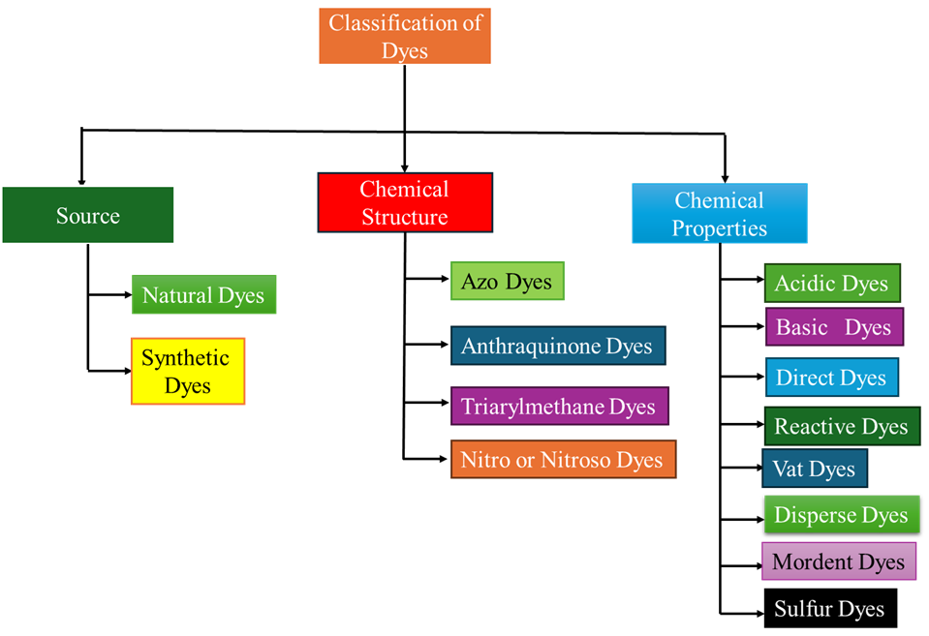
Scheme 1: Classification of dyes
2.1. Based on source
2.1.1. Natural dyes:
The dyes which are derived from plants, animals and minerals (Negi, A., (2025 & Yadav, S., 2023).
2.1.1.1. Vegetable dyes: (Bishal, A., et.al., 2023) Some dyes obtained from plants e.g. indigo dyes obtained from Indigofera plants and logwood that structure and color is given in Figure 1 (Chin-Chun, L. et.al., 2021)
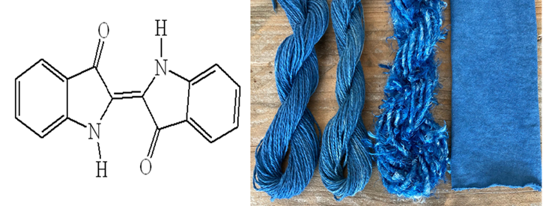
Figure 1: Structure and color of indigo dyes

2.1.1.2. Dyes from Animals: There are cochineal dye (red/orange) or Tyrian purple dyes are derived from insects or shellfish, the structure and color of Tyrian dyes (Alashkar, A. et.al., 2021 & Apau, E. et.al.,, 2025) are shown in Figure2.

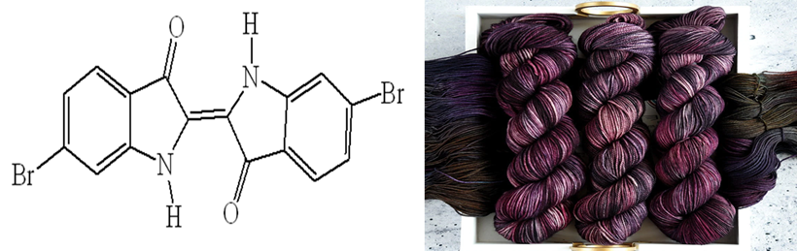
Figure 2: Chemical structure and dying of Tyrian purple (Alashkar, A. et.al.,, 2021 & Apau, E. et.al.,, 2025)

2.1.1.3. Mineral dyes: Yellow -orange dyes are isolated from minerals of iron buff (Ameen,S.S.M et.al.,, 2025).
2.1.2. Synthetic Dyes: These class of dyes derived artificially, their primary source is coal tar and petrochemicals (Liaqat, M. et.al., 2025 & Negi, A. 2025).
In these types of dyes containing a wide variety that employed in textile, paper and food.
2.2. Classification on the basis of application methods:
These are of following types of dyes as:
2.2.1. Acid dyes: These class of dyes are anionic in nature and soluble in water, having acidic groups in the structure (Al-Zawahreh, K. 2025 & Singh, K. et.al., 2025) Basically, it used for dyeing of protein fibres as wool and silk, these are also applied for dyeing nylon and certain altered acrylics (Bokhari, T.H. et.al.,, 2024). These dyes used in form of acidic solution hence it bonds with the positively charges that available in fibres and attached with ionic linkage, hydrogen bond or van der Waals forces. Though its known are acid dyes hence no essential of pH for dyeing, their chemical structure and colour are representing in Figure 3.
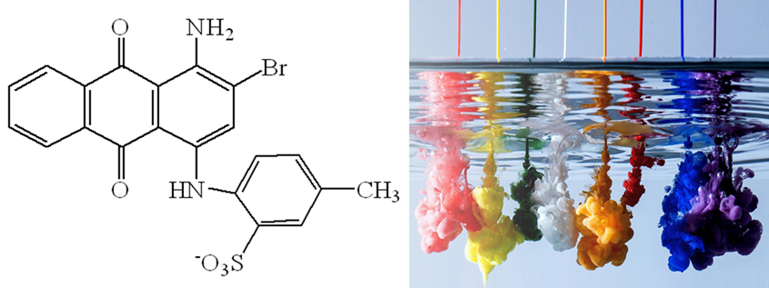
Figure 3: Chemical structure of Acid Blue 78 dye and their colour (Elzahar, M.M.H. et.al., 2023)
2.2.2. Basic dyes: These types of dyes containing cationic nature basically it applying for the staining of anionic materials acrylic fibres, woods, silk treads, jute and paper (Negas, A. et.al., 2023 & Tolkou, A.K. et.al., 2024). Commercially it used in textile industries for exciting colors on certain threads (Sukmana, H. et.al., 2023). These dyes also applied into the staining of paper, leather, plastics, and dyes to the biological microscopic substances and it produce bright shaded color (Kumar, A. et.al., 2021 & Sohaib, M. et.al.,2024) that chemical structure and color shown in Figure 4.
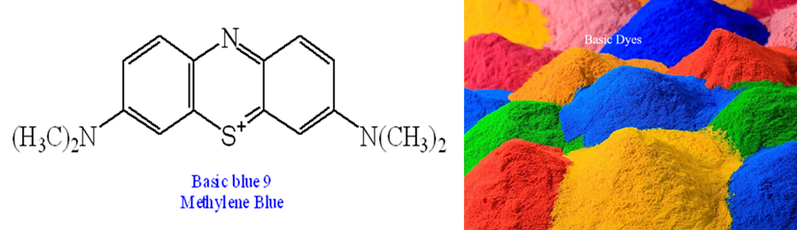
Figure 4: Chemical structure and color of Basic blue 9 Methylene Blue dye (Kumar, A. et.al., 2021).
2.2.3. Direct dyes: These class of dyes are water soluble colorant that can be used without any mordent to the substances like cotton, rayon, silk or paper, the dying application of these dyes are very simple, basically neutral and slightly basic bath facilitate it economical for staining cellulosic and proteins fibres. Therefor commonly direct dyes have very low wash fastness and may necessitate an aftertreatment to enhance their stability (Ishegbe, J. E. et.al., 2014).
2.2.4. Reactive dyes: These types of dyes containing reactive groups that can make a stable covalent bond to the nucleophilic sites on fibres of cotton, wool and silk this means that the dyes make them integral parts of fibers as a result in admirable colorfastness and stability. Some dyes contain a chromophore as bridging and reactive groups which produce color during dying processes. These dyes are soluble in water and make permanent covalent bond with substrates, because of their brilliant wash and light fastness it widely used as stains (Elsisi, H. et.al.,2025). These are applying for dying clothing, home textile and concert costume with common process including use dyeing, release printing and inkjet printing (Kushwaha, R. et.al.,, 2025)
2.2.5. Vat dyes: These dyes are insoluble in water it generated more stable and colorfast shades on cotton fabrics. During dying process first of all chemically reduced these dyes that converts into water soluble form after that it used on fiber then it oxidised in presence of atmospheric oxygen or oxidising agents then it again coverts into water insoluble form hence color locked into the substance. (Naveed, M., et.al.,, 2025 & Shrwardi, M.H.S. et.al.,2023). After treatment the dyes substances washed at high temperature hence removed unfixed dye and finally produced true shade.
2.2.6. Disperse dyes: These types of dyes are synthetic and water insoluble that applied to dying for polyester and acetate like synthetic fibres. During staining process in disperse in water with the help of dispersing representative that facilitate in penetration and colouration of dyes in hydrophobic fibers (Iria C-T. et.al., 2025). This method required high temperature and thermosol staining and it represents good shining and wash fastness, representing them ideal toward clothing, technical textiles and digital printing.
2.3. Role of structure: Such class of dyes classified on the basis of functional groups that responsible for their color and the chromophore present in their moieties:
2.3.1. Azo dyes: These types of dyes are a group of synthetic organic compounds in which on azo (-N=N-) groups is available in their structure (Alzain, H. et. al., 2023) shown in Scheme 2, which are universally adopted as colorants. They are considered by their capability to produce an extensive range of colors, from yellow to blue and it synthesised by diazotization and coupling process. Because of their wide adaptability, they are frequently applied in textile, food, cosmetics and the pharmaceutical industries. Though, few azo dyes can be injurious, it can release secondary product which are potentially carcinogenic aromatic amines, foremost its embargos on certain kinds in consumer products (Benkhaya, S., et.al., 2020 & Qasim, S.H. et.al., 2025)
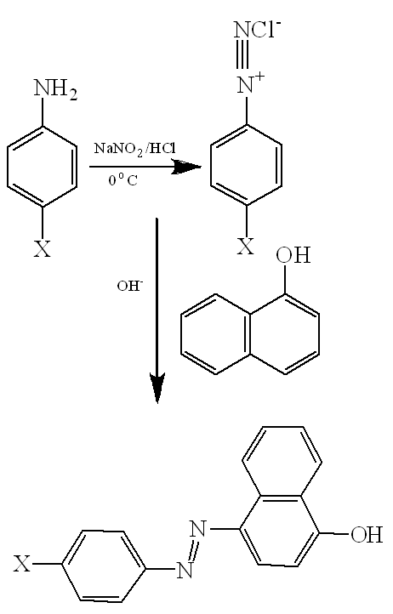
Scheme 2: Synthetic route of azo dyes
2.3.2. Nitro dyes: These dyes are generally representing as “O-Nitro dyes” that synthesized by using nitro compounds it seems that it is first synthetic dyes their synthetic routs is given in Scheme 3. There are at least on nitro functional group is available in their chemical structure and are recognized as a hue of yellow, brown, orange and green dyes. Picric acid, Martius yellow and Naphthol yellows S, are an example of nitro compounds that historically were applied for the staining wool and silk (Bommel, M.R.V. et.al., 2025 & Haleem, A. et.al, 2023).
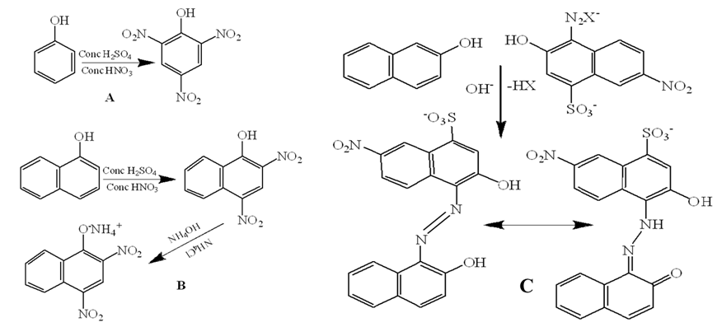
Scheme 3: Synthetic routs of Nitro dyes as A Picric acid B. Martius yellow C. Naphthol yellows S,
2.3.3. Quinone dyes: These hues of dyes represent as “o quinone dyes” and it refers to ortho-quinone dyes. These types of dyes contain a basic o-quinine or o-benzoquinone structure, it means that two carbonyls’ groups are available in adjacent on a benzene rings, synthesis and color of this dye given in scheme 4. These class of dyes are a part of bigger quinone family and are recognised for their color, aimed at their color, resultant from the prolonged conjugation of their ring arrangements. Some examples are as Naphthoquinones with two fused rings, compounds lawsone active compounds present in henna dyes, Anthraquinones three fuse rings compounds Alizarine a red dye derived from madder plants (Dulo, B. et.al.,2021).
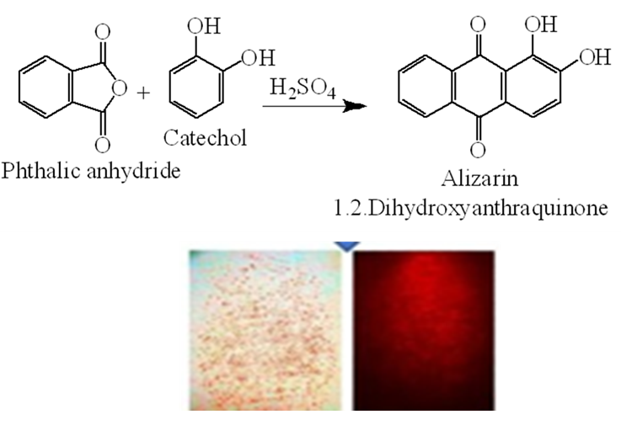
Scheme 4: Synthetic mechanism and color of Alizarin dye.
3. Sources of Dye Pollution: There are some major sources of dyes pollutants:
3.1. Textile industries: The simultaneous growth of the population increased the needs of human beings, which led to industrial development, with textile industries playing a key role. These industries produce a variety of valuable products. To make these products durable and attractive, various dyes are used for staining. Several classes of dyes are used for dyeing textile products, among which 10–15% of dyes, especially azo dyes, do not fix to the fibers and easily pass into the water. As a result, untreated or partially treated wastewater is discharged after dyeing into local rivers or water reservoirs, causing environmental pollution. Other chemical additives used as supporting substances in dyeing and finishing processes, along with heavy metals applied in dye production, are also released into the environment through wastewater. This leads not only to water pollution but also to soil and air pollution (EL-SADAAWY, M. M. et.al., 2024, Dutta, P. et.al., 2022 & Dutta, S. et.al.,2024)
3.2. Pulp and paper mills: Dyes are also substantial contaminants produced from pulp and paper mills, causing water pollution through the release of stained effluents containing both synthetic and natural dyes. This wastewater also carries several other detrimental contaminants, including synthetic organic compounds such as dioxins, furans, and chlorophenols, which belong to the organochlorine group, as well as heavy metals and volatile organic compounds. These pollutants are toxic in nature; they alter water quality, reduce oxygen levels, and damage aquatic life, ultimately affecting human health and ecosystems (Meshabaz, R.A. et.al., 2022 & Ren, J. et.al., 2022).
3.3. Leather tanning: In the leather industry, leather tanning units are highly important, as leather dyeing occurs in this stage. For this process, various dyes are used that are synthesized from different organic compounds, many of which are harmful to life. Major dye pollutants are produced during the re- tanning, dyeing, and finishing stages. A substantial portion of the chemicals applied in the tanning process, including dyes and pigments, is not completely absorbed by the leather, and the remaining portion is discharged into water (Ardila-Leal, L.D. et.al., 2021 & Bhardwaj, A. et.al., 2023).
The types of dyes commonly used in the tanning process include:
3.3.1. Azo Dyes: More than 60% of the colorants used in the leather industry are azo dyes. These dyes contain –N=N– groups, and after degradation, they produce aromatic amines that have carcinogenic characteristics products (Benkhaya, S., et.al., 2020 & Qasim, S.H. et.al., 2025).
3.3.2. Metal-Complex Dyes: Most leather dyes are composed of metal-complex dyes; therefore, their wastewater often contains heavy metals such as chromium (Abhisek, K. et.al., 2025 & Kumar, M. et.al., 2025)
3.3.3. Other Dyes: Some other dyes, such as anthraquinone dyes (Dulo, B. et.al., 2021)., triphenylmethane dyes (Lu, X. et.al.,, 2023) (e.g., Crystal Violet, Malachite Green), nitro dyes (Bommel, M.R.V. et.al.,, 2025 & Haleem, A. et.al, 2023)., and indigoid dyes (Chin-Chun, L. et.al.,, 2021), are also used and pose toxic risks.
3.4. Cosmetic and Pharmaceutical Industries; Several major synthetic organic dyes are widely used in various industries, including cosmetics and pharmaceuticals (Kadam, S.et. al., 2024) These dyes belong to a few important chemical classes, such as:
3.4.1. Azo Dyes: This is the largest group of dyes, characterized by having at least one –N=N– (azo) group shown in scheme 2. Examples include Sunset Yellow, Tartrazine, and Allura Red, which are used as colorants in foods, drugs, and cosmetics (Benkhaya, S., et.al., 2020 & Qasim, S.H. et.al., 2025).
3.4.2. Triphenylmethane Dyes: This class includes dyes such as Malachite Green and Crystal Violet, which are used in pharmaceuticals as antiseptics, particularly in veterinary medicine. These dyes have a higher toxic potential and are associated with genotoxic effects (Lu, X. et.al., 2023).
3.4.3. Anthraquinone Dyes: Brilliant Blue and other anthraquinone dyes given Scheme 4 are used in foods, pharmaceuticals, and cosmetics. They are known to exhibit neurotoxic properties (Dulo, B. et.al.,2021).
3.4.4. Phthalocyanine Dyes; These dyes show excellent colorfastness and chemical stability and are used to produce blue and green shades. They often contain copper and nickel ions; thus, their effluents may be contaminated with these heavy metals (Christie, R. et.al., 2021).
3.4.5. Printing and Dyeing Operations: Dyes used in printing and dyeing processes frequently contain heavy metals such as chromium, lead, and mercury. These metals are carcinogenic, can cause cancer in humans, and also adversely affect aquatic ecosystems (Oladimeji, T.E. et.al.,2024).
3.5. Food Coloring Industries: Dyes used in food-coloring industries may contain heavy metals, aromatic amines, and other toxic compounds. Consequently, their waste effluents often contain pollutants such as heavy metals and aromatic amines (Kavitha, G. et.al., 2025).
4. Environmental Effects of Dyes
During the staining process about 20% of dyes pigments are not attached with fabrics of substances which release into the atmosphere, hence it caused adverse effect of various systems as:
4.1 Water Pollution
Unabsorbed dyes directly enter the water system through wastewater produced during the staining process. Most of the components in dye effluents are colored compounds that form a colored layer on the surface of water, reducing the penetration of light into water bodies. Poor availability of light decreases photosynthesis in aquatic plants, disturbing the balance of dissolved oxygen and affects to the microbial activity that essential for natural biodegradation. These effects alter the aquatic ecological system (Bommel, M.R.V. et.al., 2025 & Haleem, A. et.al, 2023) which directly affects to the aquatic animal and reached into the food chain.
4.2 Toxicity to Aquatic Organisms
Wastewater containing dye pigments is present in dissolved form and also has the ability to accumulate within living organisms through bioaccumulation and biomagnification. These contaminants pass into aquatic plants and animals through respiration and consumption of contaminated plants. Dyes enter the bodies of fish through respiration and by feeding on infected aquatic plants. These dye pollutants can damage the gills, liver, and kidneys of aquatic organisms; they are also fatal to plankton and affect the entire food chain (Bommel, M.R.V. et.al., 2025 & Haleem, A. et.al, 2023).
4.3 Soil Pollution
Contaminated water containing dye pigments, when discharged untreated into agricultural fields, leads to the accumulation of contaminants in the soil matrix. This alters soil pH, adversely affects soil fertility (Bommel, M.R.V. et.al., 2025 & Haleem, A. et.al, 2023), and hinders seed germination. Some dyes contain heavy metals such as chromium, cadmium, and lead, which accumulate in soil and crops. These metal ions then reach herbivorous animals and enter the food chain. Such metals show toxicity to both plants and animals, causing severe damage to living organisms. They may also cause cancer in animals and human beings (Benkhaya, S., et.al., 2020 & Qasim, S.H. et.al., 2025).
4.4 Air Pollution
Various dyes release volatile organic compounds during manufacturing and staining process it caused photochemical smog that passed into the bodies through and respiration that also cause respiratory irritation (Rofi, M.R.I. et.al., 2025).
4.5 Human Health Impacts
Most dyes are organic compounds, and some also contain heavy metals. These dyes can degrade and produce secondary products that cause adverse effects on living organisms. For example, azo dyes form aromatic amines after degradation, which exhibit carcinogenic and mutagenic behavior. They may also cause skin irritation, dermatitis, allergic reactions, and respiratory problems, and long-term exposure to these dyes can damage the liver and kidneys (Kavitha, G. et al., 2025; Kishore, R. et al., 2021).
5. Tenacity and Degradation of Dyes
The availability of aromatic ring, electron withdrawing and donating groups, -SO₃H, -Cl, -NH₂ substituents enhanced the stability of synthetic dyes. Generally insufficient degradation occurs through biodegradation and sunlight exposure that facilitate long term atmospheric contamination (Kumbhar, G.B. et al., 2025).
6. Dye Removal Process
For the mitigation of adverse effects on living being, it is necessary to removal of dyes contaminants from atmosphere. There some common methods are frequently used as:
  - Conventional Methods: In this process some basic methods are applied in these methods as:
6.1.1. Coagulation–flocculation: In this method foreign materials are used as coagulants and flocculants. It involved process coagulants and flocculants favour the formation of smaller contaminants into bigger form that easily coagulate then it can easily remove by filtration process shown in Figure 5, it is effective but produces sludge (Nath, A. et.al., 2021, Nath, A. et.al., 2022 & Mishra, A. et.al., 2021).
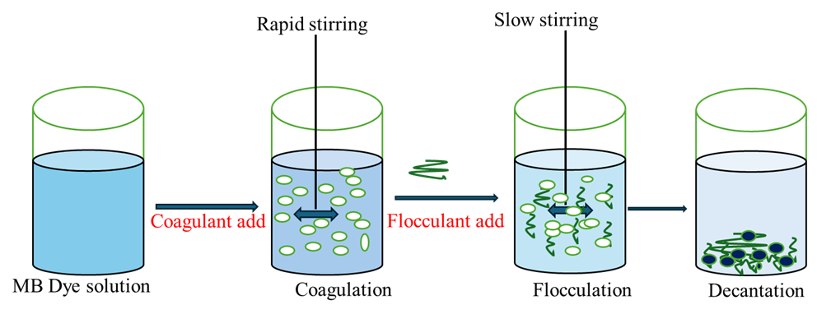
Figure 5: Coagulayion – Flocculation process for dye removal from wastewater
6.1.2. Activated carbon adsorption: the contaminated dyes contaminants easily adsorbed on the surface of activates charcoal that are easy for removal of contaminants, this method is highly effective but expensive shown in Figure 6 (Nath, A. et.al., 2021, Nath, A. et.al., 2022 & Moosavi, S. et.al., 2020).
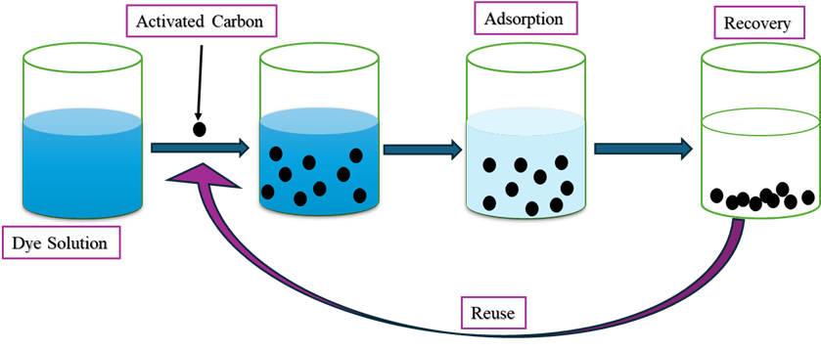
Figure 6: Removal of dyes by activated carbon
6.1.3. Chemical oxidation (ozonation, chlorination): in this process dyes components easily oxidized by the using of suitable oxidants, it is fast process but may produce harmful byproducts shown in Scheme 5 (Zhang, E. et.al., 2004).
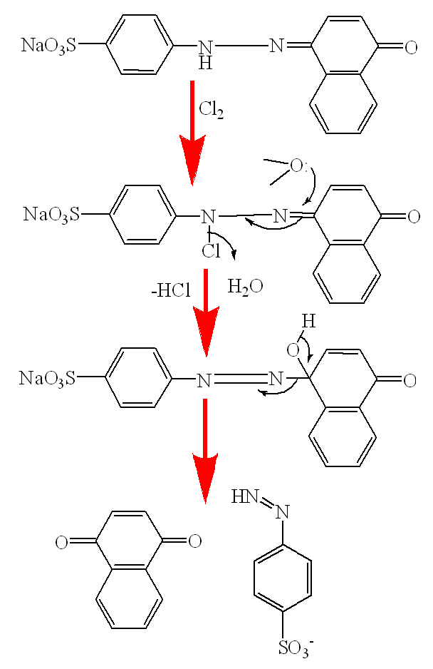
Scheme 5: Removal of dyes through chemical oxidation
6.1.4. Membrane filtration: this process utilized by using suitable membrane that hold the dyes pollutants molecules, although it has high removal efficiency but costly and prone to fouling (Jadwiga Sójka-Ledakowi c.z. et.al., 1998 & Nath, A. et.al., 2021).
6.1.5. Biological treatments: in this method utilized substances derived from natural sources which eco-friendly but slow and ineffective for recalcitrant dyes (Nath, A. et.al., 2022 & Sohaib. et.al., 2024).
  - Advanced and Emerging Methods
Some advance process applied for the removal of dyes residue available in atmosphere that make healthy environment as
6.2.1. Advanced oxidation processes (AOPs): Most of the dyes consists of organic compound which can easily oxidise by using suitable oxidants as UV/H₂O₂, Fenton, photocatalysis that produce reactive radicals to degrade dyes completely (Ismail, O. et.al., 2025).
6.2.2. Nanomaterials as adsorbents: for the removal of dyes pollutants as Magnetic nanoparticles, graphene oxide, bio-nanocomposites which facilitate a wide surface area and facilitate adsorption and make easy to removal (Tamjidi et.al., 2024).
6.2.3. Biodegradation using microbes: This process is healthy for atmosphere in which dyes degradation facilitate through the bacteria, fungi, algae capable of breaking dye molecules (Singh, A. et.al., 2022).
6.2.4. Polymeric and natural adsorbents; Some natural occurring substances as Chitosan, cellulose derivatives, polysaccharides are applied as the natural adsorbents that facilitate to adsorption of dyes on the surface of adsorbents which can easily remove form the environment (Nath, A. et.al., 2021, Nath, A. et.al., 2022 & Mishra, A. et.al., 2021).
6.2.4. Low-cost adsorbents: It more important process in which developed the low-cost adsorbent as activated agricultural wastes like rice husk, sawdust, bagasse (Gargiulo, V. et.al.,, 2024).
7. Regulations and Environmental Standards
There are numbers of national and international agencies are working for the protection of environment for pollutants contaminants of dyes release into the atmosphere. International environmental agencies emphasize (Ramani, V. et.al.,, 2024 & Wu, Y. et.al.,, 2023) that strict discharge that ideals for color and COD/BOD, use of cleaner creation technologies, acceptance of zero-liquid-discharge (ZLD) systems and promotion of green dyes and biodegradable colorants.
8. Future Perspectives
The researchers have challenges for production of biodegradable and non-toxic dyes, that utilize microbial groups for enhanced degradation. Development of Green approaches are utilized for dye synthesis, Integration of AI-based monitoring in wastewater treatment and globular economy: recycling and reuse of dyes in industries
9. Conclusion
Dye pollution has become a serious environmental challenge due to the wide use of synthetic dyes and their persistent, toxic nature. Their release into water bodies affects aquatic ecosystems, soil quality, and human health. Although several treatment techniques exist, many are costly, inefficient, or environmentally unsustainable. Therefore, developing eco-friendly, cost-effective, and highly efficient methods for dye removal is essential. Future research must focus on advanced materials, green technologies, and biological approaches to minimize environmental impacts and ensure sustainable wastewater management.

Disclaimer (Artificial intelligence)
Option 1:
Author(s) hereby declare that NO generative AI technologies such as Large Language Models (ChatGPT, COPILOT, etc.) and text-to-image generators have been used during the writing or editing of this manuscript.
Option 2:
Author(s) hereby declare that generative AI technologies such as Large Language Models, etc. have been used during the writing or editing of manuscripts. This explanation will include the name, version, model, and source of the generative AI technology and as well as all input prompts provided to the generative AI technology
Details of the AI usage are given below:
1.
2.
3.

References:
Abhisek, K., Vhatkar, S., Mathew, H.T. et. al. (2025). A critical review on the challenges and techno-economic assessment of dyes removal technologies from waste water. Discov. Chem. 2, 41. Doi:/10.1007/s44371-025-00111-4
Ahmed, T.,Toki, G. F. I., Mia, R.,Islam S. R., Al Fahad, M. A., Adeel,S. & Alpár,T.(2024). New trends in printing applications of natural dyes and pigments. Renewable Dyes and Pigments, 139-163. Doi:/10.1016/B978-0-443-15213-9.00003-X.
AlAshkar, A. & Hassabo, A. (2021). Recent Use of Natural Animal Dyes in Various Field. Journal of Textiles Coloration and Polymer Science, DOI:10.21608/jtcps.2021.79791.1067
Al-Tohamy, R., Ali, S.S.,Li, F., Okasha, K.M., Mahmoud, Y. A.G., Elsamahy, T., Jimoh., Fu, Y. & Sun, J. (2022). A critical review on the treatment of dye-containing wastewater: Ecotoxicological and health concerns of textile dyes and possible remediation approaches for environmental safety. Ecotoxicology and Environmental Safety, 231,113160. Doi:/10.1016/j.ecoenv.2021.113160.
Al-Zawahreh, K. (2025). A Screening Guide for Efficient Acid Dyes Adsorbents. Environ. Process. 12, 6, Doi:/10.1007/s40710-025-00746-6
Alegbe, E.O. & Uthman, T.O. (2024). A review of history, properties, classification, applications and challenges of natural and synthetic dyes. Heliyon, 10(13), e33646, Doi:/10.1016/j.heliyon. 2024.e33646.
Alzain, H., Kalimugogo, V. Hussein, K., Aramco, S. & Karkadan, M. (2023). A Review of Environmental Impact of Azo Dyes, International Journal Of Engineering Research and General Science 10(6):673-689, DOI:10.52403/ijrr.20230682
Ameen, S.S.M., Hassan, D.D.,Mohammed, D.S.,Omer,K.M., Latif, D.A. & Mohammad, Y.O.(2025). Natural-based chalcopyrite nanoparticles as high-performance mineral adsorbents for organic dye removal in water,Materials Advance, 6, 2192-2201,DOI: 10.1039/D5MA00038F.
Apau, E., Tawiah, B.& Boadi, M.A. (2025). Advancement in Natural Dyes Extraction and Application for Textile Finishing. In: Jiang, SX., Seidu, R.K., Tawiah, B. (eds) Advances in Textile Materials and Processing Techniques for Sustainability. SDGs and Textiles. Springer, Singapore. Doi:10.1007/978-981-95-0469-5_4.
Ardila-Leal, L.D., Poutou-Piñales, R.A., Pedroza-Rodríguez, A.M.& Quevedo-Hidalgo, B.E. (2021). A Brief History of Colour, the Environmental Impact of Synthetic Dyes and Removal by Using Laccases. Molecules. 26(13), 3813. doi: 10.3390/molecules26133813.
Benkhaya, S., Souad, M., rabet, & El Harfi, A., (2020). A review on classifications, recent synthesis and applications of textile dyes, Inorganic Chemistry Communications,115,107891, Doi:10.1016/j.inoche.2020.107891.
Berry, T. (1998). Progress in paper coloration. Review Progress Coloration. 28. 18-25.
Bhardwaj, A.,Kumar, S. & Davinder Singh, D. (2023). Tannery effluent treatment and its environmental impact: a review of current practices and emerging technologies Open Access. Water Quality Research Journal, 58 (2), 128–152, Doi:/10.2166/wqrj.2023.002
Bishal, A., Ali, K.A., Ghosh, S., Parua, P., Bandyopadhyay, B., Mondal, S. et.al., (2023). Natural dyes: Its Origin, Categories and Application on Textile Fabrics in brief. European Chemical Bulletin 12(8),9780-9802, DOI:10.48047/ecb/2023.12.8.804.
Bokhari, T.H., Shabbir, M.U., Adeel,S.,Usman, M.& Yousaf, A. (2024). Dyeing of Wool and Wool Blends with Natural and Synthetic Dyes, Advances in Natural Dyes for Environmental Protection Edition1st,35.
Bommel, M.R.V & de Keijzer, M. (2025). The Nitro Dyes.Bright Colours from the Past, 111-132, DOI:10.1007/978-3-031-88664-5_10
Chih-Chun L. & Ching-Erh C. (2021). A Study on Sustainable Design for Indigo Dyeing Color in the Visual Aspect of Clothing, Sustainability, 13(7), 3686, DOI:10.3390/su13073686.
Christie, R. & Abel, A. (2021). Phthalocyanine blue pigments. Physical Sciences Reviews, 6(9), 391-404. Doi:10.1515/psr-2020-0192
Das, S. & Roy Maulik, S. (2023). Recent Approaches and Advancements in Natural Dyes. In: Muthu, S.S. (eds) Natural Dyes and Sustainability. Sustainable Textiles: Production, Processing, Manufacturing & Chemistry. Springer, Cham. Doi:10.1007/978-3-031-47471-2_4.
Dulo, B., Phan, K., Githaiga, J. et al. (2021). Natural Quinone Dyes: A Review on Structure, Extraction Techniques, Analysis and Application Potential. Waste Biomass Valor, 12, 6339–6374. https://Doi:/10.1007/s12649-021-01443-9
Dutta, P., Md. Razaya Rabbi, M. R., Sufian, M.A.& Mahjebin, S. (2022). Effects of textile dyeing effluent on the environment and its treatment: A review. Engineering and Applied Science Letters (EASL), A5(1),1- 17, Doi:10.30538/psrp-easl2022.0080.
Dutta, S., Adhikary, S., Bhattacharya, S., Roy, D., Chatterjee, S., Chakraborty, A. et.al., (2024). Contamination of textile dyes in aquatic environment: Adverse impacts on aquatic ecosystem and human health, and its management using bioremediation. Journal of Environmental Management,353,120103, Doi: 10.1016/j.jenvman.2024.120103.
EL-SADAAWY, M. M. & AGIB, N. S. (2024). Removal of Textile dyes by ecofriendly aquatic plants from wastewater: A review on Plants Species, Mechanisms, and Perspectives," Blue Economy. 2(2), 108-120., Doi:/10.57241/2805-2994.1023.
Elsisi, H., Negm, E., Abou Elmaaty, T. et al. (2025). Development of Special Reactive Disperse Dyes for the Coloration of Wool and Nylon-6 Fabrics in Supercritical CO2. Fibers Polym 26, 2017–2029. Doi:/10.1007/s12221-025-00924-1
Elzahar, M.M.H.& Bassyouni, M. (2023). Removal of direct dyes from wastewater using chitosan and polyacrylamide blends. Sci Rep 13, 15750. Doi:H10.1038/s41598-023-42960-y
Gargiulo, V., Natale, F.D. & Alfe, M. (2024). From agricultural wastes to advanced materials for environmental applications: Rice husk-derived adsorbents for heavy metals removal from wastewater. Journal of Environmental Chemical Engineering, 12(5),113497, Doi:/10.1016/j.jece.2024.113497.
Gita,S.,Hussan,A.& Choudhury, T.G.(2017).Impact of Textile Dyes Waste on Aquatic Environments, and its Treatmen. Environment & Ecology 35 (3C) : 2349—2353.
Goswami, D., Mukherjee, J., Mondal, C. & Bhunia, B. (2024). Bioremediation of azo dye: A review on strategies, toxicity assessment, mechanisms, bottlenecks and prospects. Science of The Total Environment. 954,176426, Doi:/10.1016/j.scitotenv.2024.176426.
Haleem, A., Shafiq, A., Chen, S.-Q., & Nazar, M. (2023). A Comprehensive Review on Adsorption, Photocatalytic and Chemical Degradation of Dyes and Nitro-Compounds over Different Kinds of Porous and Composite Materials. Molecules, 28(3), 1081. Doi:/10.3390/molecules28031081
Hongyu, T., Yuping, D., Xinyu, L., Jingjing, D., Siyu, C., Xiaomin, H., et.al.,, (2024). Understanding visible light and microbe-driven degradation mechanisms of polyurethane plastics: Pathways, property changes, and product analysis. Water Research, 259, 121856, Doi:/10.1016/j.watres.2024.121856.
Iria, C-T., Bàrbara, M-V.,Jorge, J-N.& Daniel, L-R. (2025). Sustainable Removal and Reuse of Disperse Dyesfrom Wastewater Using Laponite® Nanoclay: A Circular Approach for Polyester Dyeing. Research Square DOI:10.21203/rs.3.rs-6799654/v1
Ishegbe,J. E., Bello K. A. and Kog, A. A. (2014). Synthesis and Application of Direct Dyes Derived From Terephthalic and Isophthalic Acids on Cotton Fabrics. IOSR Journal of Polymer and Textile Engineering (IOSR-JPTE), 1(3), 50-58. DOI:10.9790/019X-0135058.
Islam, M.M., Aidid, A.R., Mohshin, J.N., Mondal, H., Ganguli, S. & Kumar Chakraborty, A.K. (2025). A critical review on textile dye-containing wastewater: Ecotoxicity, health risks, and remediation strategies for environmental safety. Cleaner Chemical Engineering,11,100165. Doi:/10.1016/j.clce.2025.100165.
Ismail, O., Farrag, T.E., Reda, Y. et al. (2025). Comparative experimental evaluation and empirical modeling of advanced oxidation processes for organic compounds removal from cosmetic wastewater with statistical assessment. Scientific Reports, 15, 33335. Doi:/10.1038/s41598-025-18131-6
Jadwiga Sójka-Ledakowi c.z., Koprowski, T., Machnowski, W. & Knudsen, H. H. (1998). Membrane filtration of textile dyehouse wastewater for technological water reuse. Desalination,119(1–3),1-9, Doi:10.1016/S0011-9164(98)00078-2.
Kadam, S., Deore, S., Tare, H.& Wagh, V. (2024). The Use of Biological Pigments in Cosmetics for Eco-friendly and Sustainable Coloring. International Journal of Pharmaceutical Quality Assurance, 15(01), 539-545, DOI:10.25258/ijpqa.15.1.81
Kavitha, G., Govindhan, M.& Premkumar, S.(2025).Dye pollution and its implications for human health, aquatic ecosystems, and sustainable wastewater treatment: A comprehensive review. Journal of Water Process Engineering, 80,109071.Doi:/10.1016/j.jwpe.2025.109071.
Kishor, R.,Purchase, D., Saratale,G.D.& Saratale, R.G.(2021).Ecotoxicological and health concerns of persistent coloring pollutants of textile industry wastewater and treatment approaches for environmental safety. Journal of Environmental Chemical Engineering 9(2),105012,DOI:10.1016/j.jece.2020.105012
Kumar, A., Dixit, U., Singh, K., Prakash Gupta, S., & S. Jamal Beg, M. (2021). Structure and Properties of Dyes and Pigments. Intech Open. doi: 10.5772/intechopen.97104
Kumar, M., Singh, V.P., Bhat, S. & Kumar, R. (2025). Environmental risks of textile dyes and photocatalytic materials for sustainable treatment: current status and future directions. Discover Environment 3(1), DOI:10.1007/s44274-025-00337-0.
Kumar, M., Mishra, A., Patel, S.K., Kushwaha, J., Singh, S., Vinay Mishra, V. et. al. (2025). Environmental Impacts and Strategies for Bioremediation of Dye-Containing Wastewater. Bioengineering, 12(10), 1043, Doi:/10.3390/bioengineering12101043
Kumari, U. (2024). Textile Dyes and Their Impact on the Natural Environment. In: Singh, P. (eds) Dye Pollution from Textile Industry. SDGs and Textiles. Springer, Singapore. https://Doi:/10.1007/978-981-97-5341-3_2.
Kumbhar, G. B., Shingare, S. P., Bagal, M. V., Suryawanshi, M. A., & Mane, V. B. (2025). Evaluating the Mechanisms of Decolouration and Degradation in Textile Dyes Environmental Impacts and Sustainable Solutions. Environmental Claims Journal, 1–35, Doi:/10.1080/10406026.2025.2529843
Kushwaha, R., Kesarwani, P.& Kushwaha, A. (2025). A comprehensive review on reactive dye and its chemical components, Industrial Engineering Journal, 54(1), 147-151.
Liaqat, M., Khan, R. M., Iqbal, T., & Fu, X.-Z. (2025). Introduction to Dyes. Sustainable Dyes and Pigments - Bridging Tradition and Technology. doi: 10.5772/intechopen.1011071.
Lu, X., Che, O., Niu, X., Zhang, Y., Chen, Y., Qing Han, Q. et.al., (2023). Catalytic Degradation of Triphenylmethane Dyes with an Iron Porphyrin Complex as a Cytochrome P450 Model. Molecules, 28(14), 5401; https://Doi:/10.3390/molecules28145401.
Meshabaz, R. A. & Umer, M. I.(2022).Assessment of industrial effluent impacts on soil physiochemical properties in Kwashe Industrial Area, Iraq Kurdistan Region.IOP Conference Series: Earth and Environmental Science, 1120, 012037.Doi:/10.1088/1755-1315/1120/1/012037
Methneni, N., Ezdini, K., Ben, A. N., Van L. J., Van den, H. K., Jabeur, R. et.al.,, (2021). Occurrence of Textile Dyes and Metals in Tunisian Textile Dyeing Effluent: Effects on Oxidative Stress Status and Histological Changes in Balb/c Mice. International Journal of Molecular Science. 22(22), 12568. doi: 10.3390/ijms222212568.
Mishra,A., Nath, A., Pande,P.P. & Shankar, R. (2021). Treatment of gray wastewater and heavy metal removal from aqueous medium using hydrogels based on novel crosslinkers, Journal of Applied Polymer Science, 138(16), 50242,DOI: 10.1002/app.50242.
Moosavi, S.,Lai, C. w., Gan, S.,Zamiri, G., Akbarzadeh Pivehzhani, O.& Johan, M. (2020). Application of Efficient Magnetic Particles and Activated Carbon for Dye Removal from Wastewater.ACS Omega, doi.10.1021/acsomega.0c01905
Nath, A., Mishra, A. & Pande,P.P.(2021). A review natural polymeric coagulants in wastewater treatment. Materials Today: Proceedings, 46, (14),6113-6117, Doi:/10.1016/j.matpr.2020.03.551.
Nath, A., Mishra,A., Pande,P.P. & Shankar, R. (2022). Synthesis of Disaccharide-Based Xanthates for the Removal of Some Heavy Metals from Aqueous Solutions, Iran. J. Chem. Chem. Eng. 41(4),1137-1150
Naveed, M., Arshad, A., Aziz, T., Ali, A., Ibrahim, S., Atta, A. et.al, (2025). Comparative analysis of the degradation potential of enzymes obtained from Escherichia coli against toxicity of VAT dyes through molecular docking. Desalination and Water Treatment, 321,101064. Doi:/10.1016/j.dwt.2025.101064
Negash, A., Tibebe, D., Mulugeta, M.& Kassa, Y. (2023) A study of basic and reactive dyes removal from synthetic and industrial wastewater by electrocoagulation process. South African Institution of Chemical Engineers (SAIChE),46. 122 – 131. Doi:/10.1016/j.sajce.2023.07.015
Negi, A. (2025). Natural Dyes and Pigments: Sustainable Applications and Future Scope. Sustainable Chemistry, 6(3), 23. https://Doi:/10.3390/suschem6030023.
Negi, A. (2025).Environmental Impact of Textile Materials: Challenges in Fiber-Dye Chemistry and Implication of Microbial Biodegradation. Polymers (Basel). 17(7), 871. doi: 10.3390/polym17070871.
Oguanobi, N.C., Aniagor, C.O., Okoronkwo, G., Ude, C.N., Onu, C.E. & Anike, E.N., (2025). Industrial dye effluent sources, generation, and value-added products}. Engineered Bio composites for Dye Adsorption,1-10. Doi:/10.1016/B978-0-443-29877-6.00001-9.
Oladimeji, T.E., Oyedemi,M., Emetere, M.E., Agboola, O, Adeoye, J.B.& Odunlami,O.A. (2024). Review on the impact of heavy metals from industrial wastewater effluent and removal technologies. Heliyon, 10(23), e40370, Doi:/10.1016/j.heliyon.2024.e40370
Pham, V. H. T., Kim, J., Chang, S., & Bang, D. (2023). Investigating Bio-Inspired Degradation of Toxic Dyes Using Potential Multi-Enzyme Producing Extremophiles. Microorganisms, 11(5), 1273. https://Doi:/10.3390/microorganisms11051273.
Qasim, S.H. & Ibrahim, D.R. (2025). An overview of azo dyes environmental impacts. GSC Advanced Research and Reviews, 24(01), 102-111, Doi:/10.30574/gscarr.2025.24.1.0196
Radhakrishnan, S., Rajangam, R.& Peruran, P. (2024). Social and Environmental Impact of Natural Dyeing. Natural Dyes and Sustainability 127-152. DOI:10.1007/978-3-031-47471-2_7.
Ramani, V., Rani Kuiti, M., Ghosh, D., & Swami, S. (2024). Effectiveness of environmental regulations: firm’s decisions and welfare implications. Journal of the Operational Research Society, 75(12), 2443–2463. https://Doi:/10.1080/01605682.2024.2323664
Ren, J., Li, X., Zhang, W., Li, Z., Wang, Q., Li, S., Wang, S.& Li, H. (2022). Evaluation of application potential of dye-decolorizing peroxidase from Bacillus amyloliquefaciens in bioremediation of paper and pulp mill effluent. Front. Microbiol.,13, Doi:/10.3389/fmicb.2022.1031853.
Rofi, M.R.I. & Rahman, M. R. (2025). A critical review on environmental pollution caused by the textile industry. Explora: Environment and Resource, 2(2), 025160032. https://Doi:/10.36922/EER025160032
Shrwardi, M.H.S., Das, S.C. & Al Mamun, M.A. (2023). A green approach of vat dyeing of cotton fabric with natural reducing agents. Heliyon,9(9), e19663, Doi:/10.1016/j.heliyon. 2023.e19663.
Singh, A., Pal, D.B., Mohammad, A., Alhazmi, A., Haque,S., Taeho Yoon, T. et.al., (2022). Biological remediation technologies for dyes and heavy metals in wastewater treatment: New insight. Bioresource Technology,343,126154, Doi:/10.1016/j.biortech.2021.126154.
Singh, K., Sharma, S., Pathak, S. et al. (2025). Comprehensive review on acid dye treatment and sustainability: engineering approaches, AI and ML integration. Environ Sci Pollut Res 32, 22812–22839. Doi:/10.1007/s11356-025-37000-3.
Slama, H. B., Chenari Bouket, A., Pourhassan, Z., Alenezi, F. N., Silini, A., Cherif-Silini, H., Oszako, T., Luptakova, L., Golińska, P., & Belbahri, L. (2021). Diversity of Synthetic Dyes from Textile Industries, Discharge Impacts and Treatment Methods. Applied Sciences, 11(14), 6255. Doi:/10.3390/app11146255.
Sohaib,M., Ali1, S., Chaudhry, A.H.,Sial, N., Qurban, S. & Farooq, M.U. (2024). Dyes and effectiveness of fixing agents for fixation of reactive dyes, Journal of Natural and Applied Sciences Pakistan, 6 (1),1768-1792.
Song, Y., Wang, L., Qiang,X., Gu, W., Maz. & Wang,G.(2023). An overview of biological mechanisms and strategies for treating wastewater from printing and dyeing processes. Journal of Water Process Engineering, 55,104242,Doi:/10.1016/j.jwpe.2023.104242.
Sukmana, H., Etelka Tombácz, E., Ballai, G., Gábor Kozma, G., Kónya, Z. & Hodúr, C. (2023). Comparative Study of Adsorption of Methylene Blue and Basic Red 9 Using Rice Husks of Different Origins, Recycling 2023, 8(5), 74; Doi:/10.3390/recycling8050074.
Tamjidi, S., Moghads, B.K., khoo, E.S., Parnian, N., Abdollahi,P. & Zerehpoush, M.(2024). Nanomagnetic carbon-based adsorbents for intensifying dye uptake from wastewater (a review study). Desalination and Water Treatment,320,100858, Doi:/10.1016/j.dwt.2024.100858.
Tolkou, A.K., Tsoutsa, E.K., Kyzas, G.Z. et al. (2024). Sustainable use of low-cost adsorbents prepared from waste fruit peels for the removal of selected reactive and basic dyes found in wastewaters. Environ Sci Pollut Res 31, 14662–14689.Doi:/10.1007/s11356-024-31868-3
Verma, R.K., Sankhla, M.S., Rathod, N.V., Sonone, S.S., Parihar, K. & Singh, G.K. (2022). Eradication of Fatal Textile Industrial Dyes by Wastewater Treatment. Biointerface Research in Applied Chemistry,12(1),567 - 587, Doi:/10.33263/BRIAC121.567587.
Waheed, S., & Khan, G. R. (2004). Toxicity of dyes and dye intermediates. Biological Sciences - PJSIR, 47(1), 76–90.
Wu,Y.& Tham,J.(2023). The impact of environmental regulation, Environment, Social and Government Performance, and technological innovation on enterprise resilience under a green recovery, Heliyon, 9(10), e20278, Doi:/10.1016/j.heliyon.2023.e20278.
Yadav, C.K. & Basnet, N. (2023). Dyes and their importance: A review, Damak Campus Journal, 11 (1), 102-110. DOI: https://doi.org/10.3126/dcj.v11i1.63487
Yadav, S., Tiwari, K.S., Gupta, C., Tiwari, M.K., Khan, A. Sonkar, S.P. (2023). A brief review on natural dyes, pigments: Recent advances and future perspectives. Results in Chemistry,5,100733. Doi:/10.1016/j.rechem.2022.100733.
Zhang, F., Yediler, A., Liang, X. & Kettrup, A. (2004). Effects of dye additives on the ozonation process and oxidation by-products: A comparative study using hydrolyzed C.I. Reactive Red 120, Dyes and Pigments 60(1),1-7, DOI:10.1016/S0143-7208(03)00111-6.
Malvika Singh, Seema Bhadauria & Sumit Meena. (2024). Physico-Chemical Analysis of Textile Effluents from Bagru, Jaipur (Rajasthan, India): Implications for Environmental Impact and Treatment Needs. Asian Journal of Environment & Ecology, 23(11), 118–130. https://doi.org/10.9734/ajee/2024/v23i11627

