Method Article

COMPARISON OF ENVIRONMENTAL IMPACT OF HYDROGEN PRODUCYION VIA GASIFICATION AND ELECTROLYSIS USING LIFE CYCLE ASSESSMENT

.
ABSTRACT

Aims: The goal of this study was develop a life cycle assessment model for evaluating he environmental impacts of the hydrogen production based on Electrolysis and Gasification, processes carrying out sensitive analysis and Monte Carlo simulations focused on the impact category Global Warming. Background: Climate change and renewable processes, solutions and their products and materials evolved in this chain have been discussed since the past decade. The international pressure to adapt the countries industrial environmental to more sustainable practices have taken place in many areas around the world. One of the strategic areas to translate into this move are the fuel, chemicals and energy production, transportation, storage and usage. Hydrogen is one of the leading options for storing energy from renewables and looks promising to be a lowest-cost option. Study design: The software openLCA Nexus is linked with the open source, and freely available, openLCA LCA software. Place and Duration of Study: Department of Chemical Engineering, SUNY College of Environmental Science and Forestry, Syracuse, New York, USA from October to November 2025. Methodology: OpenLCA was used to perform a Life Cycle Assessment (LCA). Results: Electrolysis and Gasification are viable processes to produce hydrogen and the energy source as the type of electricity modal have a significative impact for hydrogen production. The following processes have the higher to the lower impacts in the global warming category: Electrolysis (Hydropower - 153.93 kg CO2 eq) < Gasification (Hydropower – 22.08 kg CO2 eq) < Electrolysis (Wind – 0.27 kg CO2 eq) < Electrolysis (Grid mix - -12.31 kg CO2 eq). Conclusions: Finally, energy supplied from hydropower are significative CO2 input in the processes studied. It is recommended for the next studies include transportation in the processes that evolves raw materials for each technology as their investments to build the producer facility. Also increase the number of runs in a hundred factor.

Keywords: [Electrolysis; Gasification; Green hydrogen, LCA, Wood]

1. INTRODUCTION

The global transition toward sustainable energy systems has positioned hydrogen as a critical energy carrier for achieving carbon neutrality goals [7,11]. Climate change and renewable processes, solutions and their products and materials evolved in this chain have been discussed since the past decade. The international pressure to adapt the countries industrial environmental to more sustainable practices have taken place in many areas around the world. One of the strategic areas to translate into this move are the fuel, chemicals and energy production, transportation, storage and usage.
The time is right to tap into hydrogen’s potential to play a key role in a clean, secure, and affordable energy future. Hydrogen can help tackle various critical energy challenges. It offers ways to decarbonize a range of sectors – including long-haul transport, chemicals, and iron and steel – where it is proving difficult to meaningfully reduce emissions. It can also help improve air quality and strengthen energy security. Hydrogen can enable renewables to provide an even greater contribution. It has the potential to help with variable output from renewables, like solar photovoltaics (PV) and wind, whose availability is not always well matched with demand. Hydrogen is one of the leading options for storing energy from renewables and looks promising to be a lowest-cost option for storing electricity over days, weeks or even months [1].
Green hydrogen is gaining global recognition as a clean energy solution, but its true potential lies in understanding the underlying science that makes it a viable alternative to fossil fuels. As a chemical element, hydrogen is the most abundant substance in the universe, yet it is rarely found in its free form on Earth. Instead, it is bound to other elements in compounds such as water and hydrocarbons. Extracting hydrogen efficiently and sustainably requires advanced scientific processes, the most prominent of which is electrolysis, powered by renewable energy sources. However, challenges remain in terms of efficiency, production costs, and storage technologies [10]. Also, biomass gasification represents a thermochemical conversion process that transforms organic matter into a combustible gas mixture (syngas) primarily composed of hydrogen, carbon monoxide, carbon dioxide, and methane [7,12]. The process occurs at elevated temperatures (700–1000 ◦C) in a controlled atmosphere with limited oxygen supply, enabling the breakdown of complex biomass structures into simpler gaseous compounds [7,13]. The hydrogen-rich syngas can be further processed through water–gas shift reactions and purification steps to produce high-purity hydrogen suitable for various applications, including fuel cells, industrial processes, and energy storage [7,13,14].
Electrolysis could be divided into 3 major processes called: Alkaline electrolysis (AEL); Proton exchange membrane electrolysis (PEM) and Solid oxide electrolysis (SOE). And Gasification is a thermochemical conversion processes via syngas generation form biomass [7, 9, 10, 29, 30]. All electrolysis processes could be classified as carbon-free however the gasification is a renewable process, non-carbon-free [7,9,10]. AEL is a well established method using liquid alkaline electrolytes (KOH/NaOH). It offers 60-80% efficiency and cost-effective nickel-based catalysts. Ideal for large-scale hydrogen production but requires a stable power supply. Challenges include gas crossover and limited adaptability to renewable energy fluctuations. PEM uses a solid polymer membrane for higher-purity hydrogen production. Highly responsive to renewable energy variation but relies on costly materials like platinum and iridium. Research focuses on cost reduction and improve membrane durability. SOE operates at high temperatures (700-900 ºC), utilizing thermal energy for efficiency. Suitable for industrial heat integration and energy storage but faces material degradation and high costs. Research aims to enhance durability and scalability. Finally, syngas production processes involve complex chemical reactions occurring in multiple stages: drying, pyrolysis, oxidation, and reduction. During the initial drying stage, moisture is removed from the biomass at temperatures below 200 ◦C, followed by pyrolysis at 200–500 ◦C where volatile compounds are released, leaving behind char. The oxidation stage occurs at 700–1500 ◦C with limited oxygen supply, producing heat for the endothermic gasification reactions, while the reduction stage involves the conversion of char and volatiles into syngas components. Research aims for reduce costs and improve biomass efficiency [7, 9, 10].

The gasification process can be represented by several key reactions that determine the final syngas composition. The primary reactions include the Boudouard reaction, the water–gas reaction, and the methanation reaction. These reactions are influenced by temperature, pressure, residence time, and the gasifying agent used. The equilibrium composition of syngas depends on thermodynamic conditions, with higher temperatures generally favoring hydrogen and carbon monoxide production over methane [7, 15-17]. The theoretical hydrogen yield from biomass gasification depends on the biomass composition and process conditions. Stoichiometric calculations based on ultimate analysis data provide upper limits for hydrogen production, typically ranging from 80 to 150 kg H2 per ton of dry biomass [7,18–23]. Nevertheless, the most environmentally friendly method of hydrogen production is electrolysis, a process that uses electricity to split water molecules (H2O) into hydrogen (H2) and oxygen (O2). Finally for electrolysis to be classified as green, the electricity used must come from renewable sources, such as solar, wind, or hydropower [10]. Life cycle assessment (LCA) is a systematic tool for analyzing and evaluating the cost and impacts over the entire life cycle of a product or system or service from “cradle to grave” (Jensen, 1998). LCA involves tracing of all the major stages and processes involved over the life cycle of a product or system or service covering. The impact due to extraction of raw materials, manufacturing, product use, recycling, and final disposal needs to be identified and quantified at each stage from the cradle to grave, or accordingly your definitions or system boundary defined in your study.

The goal of this study will be developing a life cycle assessment (LCA) model and evaluate the environmental impacts of the hydrogen production systems based on both technologies, Electrolysis and Gasification, carrying out sensitive analysis and Monte Carlo simulations focused on the impact category Global Warming.

2. MATERIAL AND METHODS

2.1 Material
2.1.1 Workplan
Figure 1 shows the proposed scenarios for green hydrogen production considering the available raw materials and technologies. The first scenario was focused on hydrogen from forest biomass and the second scenario was focused on electrolysis considering hydroelectricity, wind and electricity from the regular grid mix as energy sources for the process.
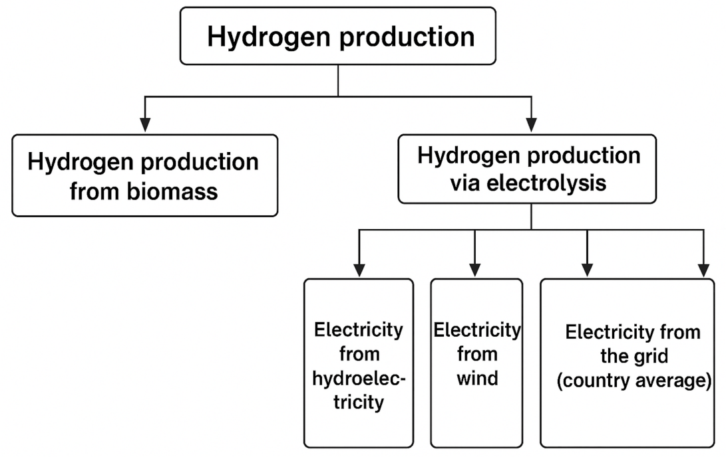
Figure 1. Scenarios for green hydrogen production and their LCA studies [2].

2.1.2 Data collection
From the workplan and their proposed scenarios considering Electrolysis and Gasification, the input and output information’s was entered in the software as global parameters and flow properties accordingly each input category. Figure 2 illustrates the software structure accordingly each box properly named considering the input information inputted for each proposed scenario.
Figure 2. Input information in the software structure. Adapted from openLCA manual [6].

2.2 METHODS
2.2.1 Environmental impacts calculations and databases
In this study, we used a practitioner's perspective. TRACI 2.1 was chosen to use as method provided by EPA [3,4] and all impact categories as acidification (kg SO2eq), carcinogenics (CTUh), ecotoxicity (CTUe), eutrophication (KgNeq), fossil fuel depletion (MJ surplus), global warming (KgCO2eq), non carcinogenics (CTUh), ozone depletion (KgCFC-11eq), respiratory effects (KgPM2.5eq) and smog (KgO3eq) was calculated for the desired conditions according ISO 14040 and ISO 14044, ISO (2025) [24,25]. Also, sensibility analysis and Monte Carlo simulations was carried out. For the sensibility analysis an tax of 20 % were considered to calculate minimum and maximum values. Considering Monte Carlo simulations 100 runs was adopted after incorporation into TRACI 2.1 model.
Figure 3. Calculation method and their structure in the software. Adapted from openLCA manual and Traci manual provided by EPA [3,4,6].

2.2.2 LCA software
OpenLCA was used to perform a Life Cycle Assessment (LCA). The software openLCA Nexus is linked with the open source, and freely available, openLCA LCA software [5]. After created an structure of flow properties based on the input, output and global parameters; the processes flow was created and finally a product system for each scenario studied. The last step considering comparing all the processes was enable a project structure to compare all the scenarios in the same base accordingly the choose databases and TRACI method 2.1.
Figure 4. Open LCA structure and software enhancement. Adapted from Nexus website and openLCA manual [5,6].

3. results and discussion
3.1 Environmental impact categories
Figure 5 shows the environmental impact categories (kg.CO₂eq) for hydrogen production for both processes: Gasification (84.4 kg H2) and Electrolysis (8.77 kg H2 considering 3 different electricity sources, wind, hydropower and grid mix) all in USA accordingly model graphs in Figure 6. It is relevant to the mentioned that the proposed scenarios exclude any transportation of biomass in case of gasification. Thus means, for all the impact categories evaluated the input parameters for gasification were wood chips as biomass; natural gas; electricity from hydropower and water. In case of the electrolysis processes the input, parameters were deionized or desalinized water and electricity. The electricity sources for electrolysis processes vary from hydropower, wind and grid mix from United States location.
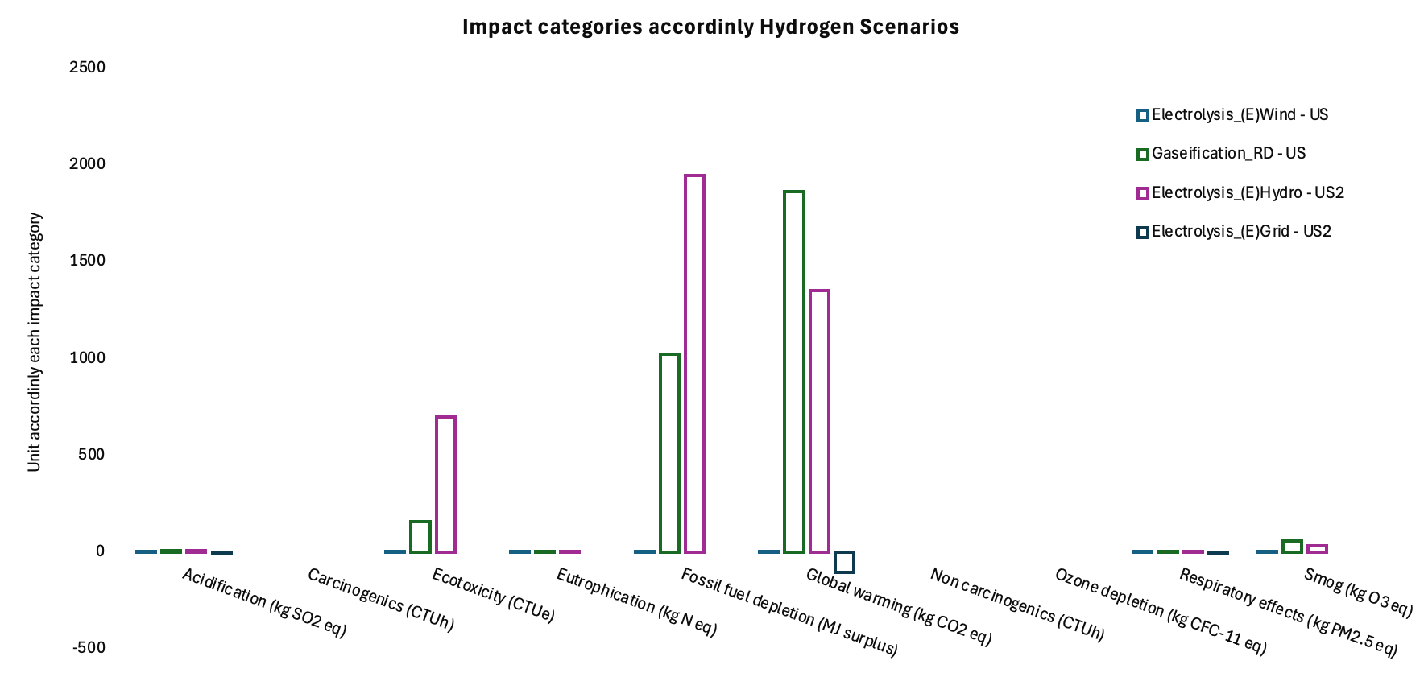Figure 5. Environmental impact categories for hydrogen production. Gasification (84.4 kg H2) and Electrolysis (8.77 kg H2 considering 3 different electricity sources, wind, hydropower and grid mix) all in USA.
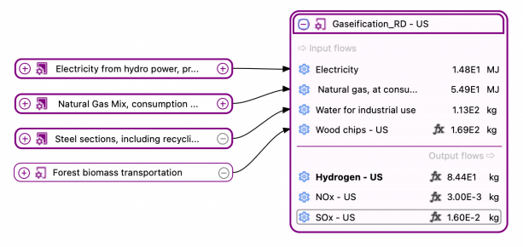 | 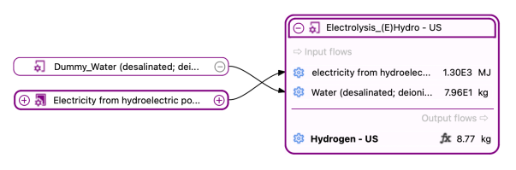
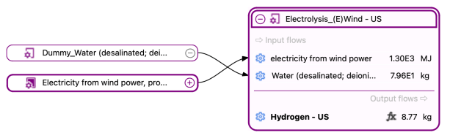 | 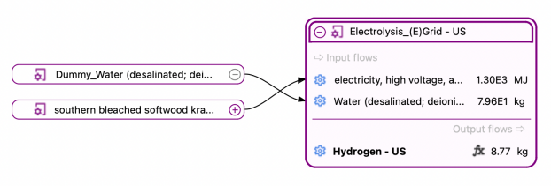
Figure 6. Model graphs of each studied scenario based on Electrolysis and Gasification.

Without normalization or balance for the same production yield, the higher values for impact categories were for Ecotoxicity (CTUe), Fossil fuel depletion (MJ surplus), Global warming (KgCO2eq) and Smog (KgO3eq) considering Electrolysis and Gasification, both using the energy source from hydropower.
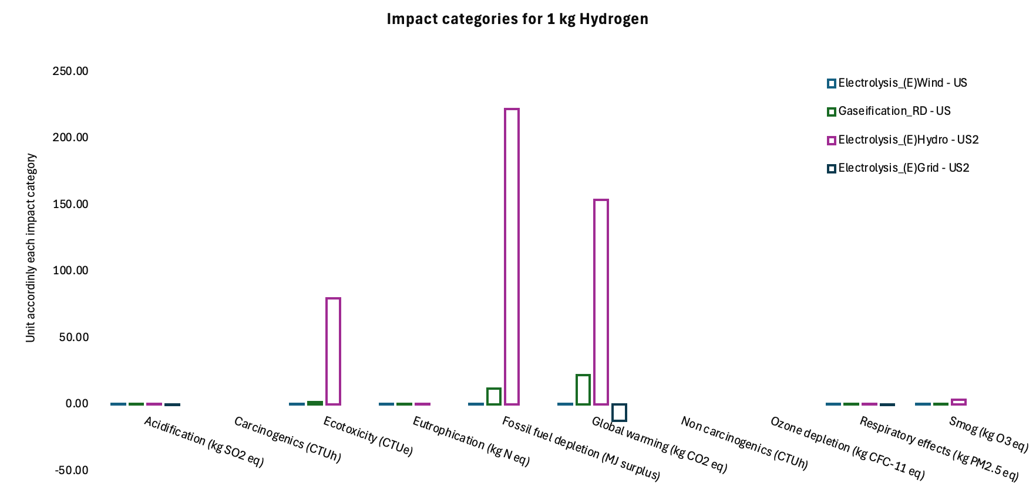Figure 7. Environmental impact categories for 1 kg of hydrogen production accordingly technology and electricity source in USA.
Figure 7 above shows the environmental impact categories for 1 kg of hydrogen production accordingly technology and electricity source in USA. As same case discussed in fig.5, in this case all scenarios for this technology sustainability, risk hazardous and health assessment regarding all impact categories are listed according to ISO 14040 and ISO 14044, ISO (2025) [24,25]. As previously study case Electrolysis and Gasification, both using the energy source from hydropower was present the higher values for impact categories were respectively for Ecotoxicity (79.61 CTUe and 1.88 CTUe), Fossil fuel depletion (222.04 MJ surplus and 12.10 MJ surplus), Global warming ( 153.93 KgCO2eq and 22.08 KgCO2eq) and Smog (3.60 KgO3eq and 0.66 KgO3eq) considering Electrolysis and Gasification, both using the energy source from hydropower. It is relevant to mention that for the normalized production of 1 kg of H2, the Electrolysis processes using energy source from hydropower present the most significative environmental impact compared with all other technologies.
Even classified as carbon-free technology in this case, due to the many effects considering all environmental impact categories to generate pollution throughout the local environmental linked to the facility production, this process is not recommended based on this study and the pollution levels are higher even the non-carbon free processes as gasification. Although, this both case scenarios leaded the pollution considering the studied environmental categories it is very important mentioned that no case study considering all scenarios for energy source regarding Electrolysis and Gasification processes, accordingly the methodology and databases used at these level present carcinogenic effects.
3.2 Sensitivity Analysis
Sensitivity analysis indicates the variable input parameters that most influence Electrolysis and Gasification net emissions in this study. Figure 8 and 9 shows respectively sensitivity analysis for global warming environmental impact category of1 kg of hydrogen production via Gasification and Electrolysis processes, applying hydropower in the electrical source of energy, normalized by the higher input contribution value in kg.CO₂eq/1kg of Hydrogen. In case of electrolysis 3 energy sources were evaluated as previously mentioned, wind, hydropower and from grid mix.
Figure 8. Sensitivity analysis for global warming environmental impact category for 1 kg of hydrogen production via Gasification processes, hydropower in the electrical source of energy, normalized by the higher input contribution value in kg.CO₂eq/1kg of Hydrogen. | Figure 9. Sensitivity analysis for global warming environmental impact category for 1 kg of hydrogen production via Electrolysis processes, comparing 3 electrical sources of energy, normalized by the higher input contribution value in kg.CO₂eq/1kg of Hydrogen.

For both cases the higher values of emissions (kg.CO₂eq/1kg of Hydrogen) considering impact category as global warming was applied as baseline to normalize the following input parameters for both technologies. For Electrolysis, the emission reference value for hydropower electricity (153.94 kg.CO₂eq/1kg of Hydrogen), and for Gasification, the emissions reference value for steel section+recycling (21.13 kg.CO₂eq/1kg of Hydrogen); as this both input parameters were already presented the higher emissions. Considering we assume 20 % of ratio to calculate the minimum and maximum values presented in the figure 8 and 9, the same input categories thus presented the most significative variations as -0.8 to 1.2 for steel section+recycling and for hydropower electricity also. Based on this the second highest input parameters contribution for the global warming category was in case of the Gasification, electricity from hydropower, and in case of Electrolysis was electricity from the grid mix both varying -0.0345 to 0.0517 and 0.0639 to -0.0959 respectively. It is relevant to mention that considering that natural gas and water (desalinated, deionized) weren’t present significative contributions and in case of water for the model applied with the assumptions adopted was 0 kg.CO₂eq/1kg of Hydrogen. The input parameters evaluation in this case study wasn’t selected considering costs.

3.3 Monte Carlo Simulations
The Monte Carlo method, also known as statistical simulation method, is a very precise method of numerical calculation guided by probability statistical theory. It uses random numbers (or more commonly pseudo-random numbers) to solve many calculation problems [26, 27]. This uncertainty analysis was adopted, and Figure 10 shows the Monte Carlo histograms for global warming environmental impact category considering 1 kg of hydrogen produced via Gasification and Electrolysis processes; comparing 3 electrical sources of energy, from hydropower, wind and grid mix in kg.CO₂eq at USA. Monte Carlo method can randomly sample the values of uncertain variables based on probabilistic analysis, and combine with the pre-determined impact assessment method to simulate, so as to obtain statistically significant environmental impact evaluation results, which can reflect the influence of uncertain factors more accurately [26].
Figure 10. Monte Carlo histograms for global warming environmental impact category considering 1 kg of hydrogen produced via Gasification and Electrolysis processes; comparing 3 electrical sources of energy, from hydropower, wind and grid mix in kg.CO₂eq at USA.
Monte Carlo histograms show visually how the data population are behaving accordingly the assumptions, input parameters and method for calculation used, TRACI 2.1. However, the supplementary data presented in this study support all the tendencies discussed in the items above. Regarding the electrical source only the Electrolysis case that apply wind as energy source present approximated statistical significance (0.0065) and the lower values for standard deviation (0.03314) and sample variance (0.0010) compared with all the other conditions tested. Visually figure 10 for the same case that uses wind as electrical source to supply energy, was the unique that present a similar normal distribution in a small data group. Nevertheless, the electrical input for energy from hydropower supply was the worst case scenario for both studied technologies, Electrolysis and Gasification, there was the higher statistical variation presented in this study as statistical significance (4.08), standard deviation (20.5664) and sample variance (422.9800). Also, the presented histograms confirm the lack of normal distribution, however this type of energy source was still the worst case scenario.

4. Conclusion and future outlook

Electrolysis and Gasification are viable processes to produce hydrogen and the energy source as the type of electricity modal have a significative impact for hydrogen production. The following processes have the higher to the lower impacts in the global warming category: Electrolysis (Hydropower - 153.93 kg CO2 eq) < Gasification (Hydropower – 22.08 kg CO2 eq) < Electrolysis (Wind – 0.27 kg CO2 eq) < Electrolysis (Grid mix - -12.31 kg CO2 eq). Finally, energy supplied from hydropower are significative CO2 input in the processes studied. It is recommended for the next studies include transportation in the processes that evolves raw materials for each technology as their investments to build the producer facility. Also increase the number of runs in a hundred factor.
CONSENT AND ETHICAL APPROVAL
It is not applicable.

DISCLAIMER (ARTIFICIAL INTELLIGENCE)
Author(s) hereby declare that generative AI technologies such as Large Language Models, etc. have been used only to generate the Fig. 1 to support the Worplan of this study. The authors acknowledge the Microsoft Copilot. Copilot. Scenarios for green hydrogen production and their LCA studies [illustration]. Microsoft Copilot; October 2025. Accessed November 17, 2025.

Details of the AI usage are given below: Illustration: Fig. 1 generation - Scenarios for green hydrogen production and their LCA studies

COMPETING INTERESTS DISCLAIMER:

Authors have declared that they have no known competing financial interests OR non-financial interests OR personal relationships that could have appeared to influence the work reported in this paper.

References

[1] International Energy Agency. The Future of Hydrogen: Seizing Today’s Opportunities. Paris, France: International Energy Agency; 2019. Accessed November 17, 2025. https://doi.org/10.1787/1e0514c4-en
[2] Copilot. Hydrogen Production Pathways [Figure]. Created November 17, 2025.
[3] Henderson, A.D., B. Niblick, H.E. Golden, and J.C. Bare. Modeling spatially resolved characterization factors for eutrophication potential in life cycle assessment. International Journal of Life Cycle Assessment, 2021, 26: 1832 – 1846. https://doi.org/10.1007/s11367-021-01956-4
[4] U.S. Environmental Protection Agency. Tool for the Reduction and Assessment of Chemicals and Other Environmental Impacts (TRACI). EPA. Published 2024. Accessed November 19, 2025. https://www.epa.gov/chemical-research/tool-reduction-and-assessment-chemicals-and-other-environmental-impacts-traci
[5] GreenDelta. openLCA Nexus. Nexus openLCA. Published 2025. Accessed November 19, 2025. https://nexus.openlca.org/
[6] GreenDelta. openLCA 2 Manual. GreenDelta; 2025. Accessed November 23, 2025. https://greendelta.github.io/openLCA2-manual/print.html
[7] Nunes, L.J.R. Gasification Processes of Portuguese Biomass: Theoretical Analysis of Hydrogen Production Potential. Energies 2025, 18, 4453. https://doi.org/10.3390/en18164453
[8] Wang, X.; Chen, H.; Luo, K.; Shao, J.; Yang, H. The influence of microwave drying on biomass pyrolysis. Energy Fuels 2008, 22, 67–74. [CrossRef] https://doi.org/10.1021/ef700300m
[9] Mahamulkar, S.; Yin, K.; Agrawal, P.K.; Davis, R.J.; Jones, C.W.; Malek, A.; Shibata, H. Formation and oxidation/gasification of carbonaceous deposits: A review. Ind. Eng. Chem. Res. 2016, 55, 9760–9818. [CrossRef] https://doi.org/10.1021/acs.iecr.6b02220
[10] Kumar, Ashwani & Thangavel, Sivasakthivel & Dwivedi, Gaurav. (2025). Green Hydrogen Production: Storage, Transportation and Applications. https://doi.org/10.1201/9781003530633
[11] Dincer, I.; Aydin, M.I. New paradigms in sustainable energy systems with hydrogen. Energy Convers. Manag. 2023, 283, 116950 [CrossRef] https://doi.org/10.1016/j.enconman.2023.116950
[12] Alves, C.T.; Onwudili, J.A.; Ghorbannezhad, P.; Kumagai, S. A review of the thermochemistries of biomass gasification and utilisation of gas products. Sustain. Energy Fuels 2023, 7, 3505–3540. [CrossRef] https://doi.org/10.1039/D3SE00365E
[13] Demirba¸s, A. Biomass resource facilities and biomass conversion processing for fuels and chemicals. Energy Convers. Manag. 2001, 42, 1357–1378. [CrossRef] https://doi.org/10.1016/S0196-8904(00)00137-0
[14] Thijs, B.; Houlleberghs, M.; Hollevoet, L.; Heremans, G.; Rongé, J.; Martens, J.A. Hydrogen, fueling the future: Introduction to hydrogen production and storage https://doi.org/10.1515/9783110596281-010
[15] Haghighi, M.; Sun, Z.-q.; Wu, J.-h.; Bromly, J.; Wee, H.L.; Ng, E.; Wang, Y.; Zhang, D.-k. On the reaction mechanism of CO2 reforming of methane over a bed of coal char. Proc. Combust. Inst. 2007, 31, 1983–1990. [CrossRef] https://doi.org/10.1016/j.proci.2006.07.029
[16] Snoeck, J.-W.; Froment, G.; Fowles, M. Steam/CO2 reforming of methane. Carbon filament formation by the Boudouard reaction and gasification by CO2, by H2, and by steam: Kinetic study. Ind. Eng. Chem. Res. 2002, 41, 4252–4265. [CrossRef] https://doi.org/10.1021/ie010777i
[17] Pen, M.; Gomez, J.; Fierro, J.G. New catalytic routes for syngas and hydrogen production. Appl. Catal. A Gen. 1996, 144, 7–57. [CrossRef] https://doi.org/10.1016/0926-860X(96)00108-1
[18] Shayan, E.; Zare, V.; Mirzaee, I. Hydrogen production from biomass gasification; a theoretical comparison of using different gasification agents. Energy Convers. Manag. 2018, 159, 30–41. [CrossRef] https://doi.org/10.1016/j.enconman.2017.12.096
[19] Kalinci, Y.; Hepbasli, A.; Dincer, I. Biomass-based hydrogen production: A review and analysis. Int. J. Hydrogen Energy 2009, 34, 8799–8817. [CrossRef] https://doi.org/10.1016/j.ijhydene.2009.08.078
[20] Kan, T.; Strezov, V. Hydrogen production from biomass. In Renewable Energy Systems from Biomass; CRC Press: Boca Raton, FL, USA, 2018; pp. 207–224. https://doi.org/10.1201/9781315153971
[21] Abuadala, A.; Dincer, I. A review on biomass-based hydrogen production and potential applications. Int. J. Energy Res. 2012, 36, 415–455. [CrossRef] https://doi.org/10.1002/er.1939
[22] de Jong, W. Sustainable hydrogen production by thermochemical biomass processing. In Hydrogen Fuel; CRC Press: Boca Raton, FL, USA, 2008; pp. 197–238. https://doi.org/10.1201/9781420045772
[23] Mohanty, P.; Pant, K.K.; Mittal, R. Hydrogen generation from biomass materials: Challenges and opportunities. In Advances in Bioenergy: The Sustainability Challenge; JohnWiley & Sons: Hoboken, NJ, USA, 2016; pp. 93–108. https://doi.org/10.1002/9781118957844.CH8
[24] International Organization for Standardization (ISO). ISO 14040: Environmental Management—Life Cycle Assessment—Principles and Framework. ISO; 2006. Accessed November 25, 2025. https://www.iso.org/standard/37456.html
[25] International Organization for Standardization (ISO). ISO 14044: Environmental Management—Life Cycle Assessment—Requirements and Guidelines. ISO; 2006. Accessed November 25, 2025. https://www.iso.org/standard/38498.html
[26] Sun, Shouheng & Ertz, Myriam. (2020). Life cycle assessment and Monte Carlo simulation to evaluate the environmental impact of promoting LNG vehicles. MethodsX. 7. https://doi.org/10.1016/j.mex.2020.101046 .
[27] R.Y. Rubinstein , D.P. Kroese , Simulation and the Monte Carlo Method, 10, John Wiley & Sons, 2016 . https://doi.org/10.1002/9781118631980
[28] Jensen, Allan & J, Elkington & Christiansen, Kim & L, Hoffmann & BT, Møller & Schmidt, Anders & F, van. (1998). Life cycle assessment (LCA) - a guide to approaches, experiences and information sources.
[29] Zainal BS, Ker PJ, Mohamed H, Ong HC, Fattah IM, Rahman SA, Nghiem LD, Mahlia TI. Recent advancement and assessment of green hydrogen production technologies. Renewable and Sustainable Energy Reviews. 2024 Jan 1;189:113941.
[30] Ali Mohamed Elshafei and Rawia Mansour. Green Hydrogen as a Potential Solution for Reducing Carbon Emissions: A Review. J. Energy Res. Rev. [Internet]. 2023 Feb. 15 [cited 2025 Nov. 27];13(2):1–10. Available from: https://journaljenrr.com/index.php/JENRR/article/view/257

APPENDIX

SUPLEMENTARY INFORMATION
Environmental impact categories calculation tables

Table 1. Environmental impact categories for hydrogen production. Gasification (84.4 kg H2) and Electrolysis (8.77 kg H2 considering 3 different electricity sources, wind, hydropower and grid mix) all in USA
Indicator | Electrolysis_(E)Wind - US | Gaseification_RD - US | Electrolysis_(E)Hydro - US2 | Electrolysis_(E)Grid - US2
Acidification (kg SO2 eq) | 0.00923984 | 5.68E+00 | 6.32E+00 | -1.07E+00
Carcinogenics (CTUh) | 1.5104E-07 | 6.49E-06 | 6.46E-05 | 0.00E+00
Ecotoxicity (CTUe) | 1.78568 | 1.58E+02 | 6.98E+02 | 0.00E+00
Eutrophication (kg N eq) | 0.000683997 | 3.43E-01 | 2.26E-01 | 0.00E+00
Fossil fuel depletion (MJ surplus) | 2.12786 | 1.02E+03 | 1.95E+03 | 0.00E+00
Global warming (kg CO2 eq) | 2.38139 | 1.86E+03 | 1.35E+03 | -1.08E+02
Non carcinogenics (CTUh) | 1.63352E-07 | 1.82E-04 | 6.25E-05 | 0.00E+00
Ozone depletion (kg CFC-11 eq) | 6.96745E-11 | 8.13E-05 | 9.60E-05 | 0.00E+00
Respiratory effects (kg PM2.5 eq) | 0.000678061 | 6.75E-01 | 3.56E-01 | -6.55E-02
Smog (kg O3 eq) | 0.0730212 | 5.54E+01 | 3.15E+01 | 0.00E+00

Table 2. Environmental impact categories for 1 kg of hydrogen production accordingly technology and electricity source in USA
Indicator | Electrolysis_(E)Wind - US | Gaseification_RD - US | Electrolysis_(E)Hydro - US2 | Electrolysis_(E)Grid - US2
Acidification (kg SO2 eq) | 0.001053574 | 6.73E-02 | 7.21E-01 | -1.22E-01
Carcinogenics (CTUh) | 1.72223E-08 | 7.69E-08 | 7.37E-06 | 0.00E+00
Ecotoxicity (CTUe) | 0.203612315 | 1.88E+00 | 7.96E+01 | 0.00E+00
Eutrophication (kg N eq) | 7.79928E-05 | 4.07E-03 | 2.58E-02 | 0.00E+00
Fossil fuel depletion (MJ surplus) | 0.242629418 | 1.21E+01 | 2.22E+02 | 0.00E+00
Global warming (kg CO2 eq) | 0.271538198 | 2.21E+01 | 1.54E+02 | -1.23E+01
Non carcinogenics (CTUh) | 1.86262E-08 | 2.16E-06 | 7.12E-06 | 0.00E+00
Ozone depletion (kg CFC-11 eq) | 7.94464E-12 | 9.63E-07 | 1.09E-05 | 0.00E+00
Respiratory effects (kg PM2.5 eq) | 7.7316E-05 | 8.00E-03 | 4.06E-02 | -7.47E-03
Smog (kg O3 eq) | 0.008326249 | 6.56E-01 | 3.60E+00 | 0.00E+00

Table 3. Set od non-parametric/descriptive statistics from each group of one hundred samples from Monte Carlo simulations considering the global warming category of 1 kg of hydrogen produced via Gasification and Electrolysis processes; comparing 3 electrical sources of energy, from hydropower, wind and grid mix in kg.CO₂eq at USA
  Gaseification_Global warming (kgCO2eq)
  Mean | 22.30276603
  Standard Error | 0.286483445
  Median | 21.99841619
  Mode | #N/A
  Standard Deviation | 2.864834446
  Sample Variance | 8.207276401
  Kurtosis | -1.309944542
  Skewness | 0.313221989
  Range | 9.086645662
  Minimum | 18.44552899
  Maximum | 27.53217466
  Sum | 2230.276603
  Count | 100
  Largest(1) | 27.53217466
  Smallest(1) | 18.44552899
  Confidence Level(95.0%) | 0.568445307
  Electrolysis(Wind)_Global warming (kgCO2eq)
  Mean | 0.273615932
  Standard Error | 0.003314799
  Median | 0.264524146
  Mode | #N/A
  Standard Deviation | 0.033147987
  Sample Variance | 0.001098789
  Kurtosis | -1.12638485
  Skewness | 0.390922832
  Range | 0.109752177
  Minimum | 0.227296361
  Maximum | 0.337048538
  Sum | 27.36159316
  Count | 100
  Largest(1) | 0.337048538
  Smallest(1) | 0.227296361
  Confidence Level(95.0%) | 0.00657728
  Electrolysis(Hydro)_Global warming (kgCO2eq)
  Mean | 156.5210662
  Standard Error | 2.05664793
  Median | 152.9299804
  Mode | #N/A
  Standard Deviation | 20.5664793
  Sample Variance | 422.9800708
  Kurtosis | -1.226075915
  Skewness | 0.3447054
  Range | 63.28830781
  Minimum | 128.4431792
  Maximum | 191.731487
  Sum | 15652.10662
  Count | 100
  Largest(1) | 191.731487
  Smallest(1) | 128.4431792
  Confidence Level(95.0%) | 4.080835686
  Electrolysis(Grid)_Global warming (kgCO2eq)
  Mean | -12.465009
  Standard Error | 0.146469263
  Median | -12.2341178
  Mode | #N/A
  Standard Deviation | 1.464692632
  Sample Variance | 2.145324507
  Kurtosis | -1.08381197
  Skewness | -0.29078793
  Range | 5.031386399
  Minimum | -15.2884094
  Maximum | -10.257023
  Sum | -1246.5009
  Count | 100
  Largest(1) | -10.257023
  Smallest(1) | -15.2884094
  Confidence Level(95.0%) | 0.290626795

