Eco-friendly water purification using copper-oxide nanoparticles enhanced with neem leaves for heavy metal removal
UNDERPEERREVIEW

ABSTRACT

The method of using nanoparticles with plant extract to remove heavy metals from waste water has gain a lot of interest. Heavy metals have given rise to several problems not only to humans but also to plants and animals because of their extremely toxic effects. The aqueous waste streams generated from different industries such as manufacturing industries and agricultural industries generally contain high levels of heavy metal contamination. Copper oxide neem nanoparticle (CuONpNm) was utilized as low-cost adsorbents for the removal of Zn2+, Cu2+, Ni2+ and Cd2+ ions from aqueous solution. The nanoparticles were prepared using copper sulphate. Batch adsorption methodology was used to evaluate the effects of solution pH, contact time and adsorbent dose, scanning electron microscope (SEM), Fourier transform infrared spectrophotometer (FTIR) and Transmission electron microscopy (TEM) were used to characterize the adsorbents. The equilibrium isotherm data were analyzed using the Langmuir and Freundlich isotherm models. The kinetic data were analyzed using the pseudo-first order and pseudo-second order equations. Maximum adsorption of CuONpNm on Zn2+, Cu2+, Ni2+ and Cd2+was 93.71 %, 90.93%, 89.92% and 83.91 % respectively at pH 6. The optimum conditions for adsorbent dose were determined at 0.1 g and 30 o C. The amount of metal uptake increased with contact time for all metal ions studied until equilibrium was reached. The Freundlich isotherm model provided the best fit to the experimental data for CuONpNm as indicated by the regression coefficient values (R2> 0.994). The pseudo-second order equation gave the best fit to the experimental data for all the metal ions (R2> 0.961).

Key words: Nanoparticles, CuONpNm, Adsorption, Heavy metals, Adsorption kinetics, Adsorption isotherms.

1. INTRODUCTION
In 1978, the United States environmental protection agency (USEPA) prepared a list of 129 organic and inorganic pollutants found in wastewater that constitute serious health hazards. This list, known as the Priority Pollutants List, includes the following thirteen metals: antimony, arsenic, beryllium, cadmium, chromium, copper, lead, mercury, nickel, selenium, silver, thallium, and zinc (America, 1998). Unlike organic compounds, metals are non-biodegradable and, therefore, must be removed from wastewater. Among all the possible pollutants that are responsible for the contamination of surface and ground water, heavy metals are most important.. The aqueous waste streams generated from different industries such as metal plating industries, manufacturing industries and other agricultural source producing industries (fertilizers and fungicides) generally contain high levels of heavy metal contamination (Azonaon,2008).
Heavy metals tend to accumulate in the living organisms since they are not readily biodegradable and cause various diseases and disorders. Effluent from essential industries have been characterized with heavy metals which are non – biodegradable in nature and also detrimental to health when accumulated in the body tissue over long exposure (Lekan,2021). The discharge of wastewaters containing heavy metals to the environment have been increased specifically in developing countries prompted by growth of industries such as metal plating facilities, mining operations, fertilizer industries, tanneries, batteries, paper industries and pesticides as shown in figure 1.

1


Figure 1 Sources of water contamination
UNDERPEERREVIEW

Removal of contaminants in wastewater, such as heavy metals, has become a severe problem in the world. Some individuals are primarily exposed to these contaminants in the workplace, for most people the main route of exposure to these toxic elements is through the diet (food and water). Researchers have, thus, devoted efforts to find effective methods for the removal of contaminants from waste, but these processes are often economically expensive; therefore, we must find ways to bypass conventional and high-cost advanced adsorption technologies. The adsorption of contaminants on the surfaces of solids is an effective method for heavy metals removal. Interest in nanomaterials and especially nanoparticles has exploded in the past decades primarily due to their novel or enhanced physical and chemical properties compared to bulk material. These extraordinary properties have created a multitude of innovative applications in the field of medicine, electronic, agriculture, chemical catalyst, food industry and many others. Recently nanoparticles have been synthesized biologically through the use of plant or micro-organism-mediated processes as an environmentally friendly alternative to expensive energy intensive and potentially toxic physical and chemical synthesized methods (Theerthalgiri,2022).. Consequently, existing techniques like precipitation, membrane processes, and ion exchange are often ineffective or expensive, especially when dealing with high concentrations of heavy metals. Nanoparticles are a highly effective alternative used for the adsorption of heavy metals from wastewater among its counterparts. The present researcher method of preparing nanoparticles equally creates problems while solving a particular problem as they make use of hazardous chemicals, high interval energy consumption and high temperature during the nanoparticle preparation. The limitations of current techniques have driven the development of new chemical and biological methods.

Bio-remediation with agricultural materials approach is gaining momentum because it is: 1. Low-cost and abundant
2. Effective even in dilute solutions 3. Works within a short time period 4. Antimicrobial in nature
Adsorption using agricultural materials is a promising alternative. Copper oxide nanoparticles modified with neem leaves is an example of agricultural material that is readily available, inexpensive and easily regenerated for use as effective adsorbents including the antimicrobial properties which destroy bacteria and virus in humid or aqueous medium. The present work studies the adsorption of cadmium, copper, zinc and nickel ions from waste water using copper oxide nanoparticles modified with neem leaves, which is considered environmentally safe, low cost, antimicrobial and evaluate the potential of using the prepared Nano-particles from leaves extract. Adsorption behavior of neem leaves extract was studied through equilibrium, adsorption isotherms and kinetics (Alaa,2021; Dundar,2008; Fungaro,2013; Theerthalgiri,2003; Kazeem et al., 2018; Khlifi,2010; Manisha,2023; Nuhuglu,2009).

2. Related Articles

2

Preparation of Copper oxide Nanoparticles “a Novel Adsorbent for the Isolation of Tartaric Acid”, dio.org/10:1080/00032719:2020:1842434 (2020).

Green synthesis of copper oxide nanoparticles impregnated on activated carbon using moringa oleifera leaves Extract for the removal of nitrates from water.dio:10.1590/19805373-mk-20180460. (2018)

Nanoparticles properties, applications & toxicities. Arab Journal Chem. 12 (7), 908-931. Dio.org/10.1016/j.arabjc 2017.0.5.011 (2019).

Green Copper Oxide Nanoparticle for lead, nickel & cadmium removal from contaminated water. PMCID: PMC820-6336/PMID, 11-2547 dio:10.1038/s41598-021-91093-7 (2021).
UNDERPEERREVIEW

Singh J. et.al. (2018). Green synthesis of metals and their oxide nanoparticles. Applications for environmental remediation Journal Nanobiotechnology, 16,84, dio.org/101186/s12951-018-0408-4.nol, 16,84, dio.org/101186/s12951-018-0408-4. (2018).

Biogenic synthesis of copper oxide nanoparticles using plant extract and its prodigious potential for photocatalytic degradation of dyes. Environ. Res.177,108569 dio.org/10.1016/j.envres.2019.108569 (2019).

Adsorption of methylene blue dye by Calix (6) Arene-modified Lead Sulphide (Pbs): Optimisation using Response surface methodology, Int J. Environ. Res. Public Health, 18(2) 39, dio. org/103390/ijerph18020397 (2021).

Absorption Spectrophotometric method, Standard methods for the Examination of Water & Wastewater 20th Edition Alpha AWWA WEF (1998).

3.0 MATERIAL AND METHODS

3.1 Materials

3.1.1 Natural Materials:

Neem leaves (purchased from Aba botanical market)

3.1.2 Chemicals:
Copper sulphate pentahydrate (CuSO4.5H2O) (98%), Nickel sulphate hexahydrate (Ni SO4.6H2O) (98%), Cadmium chloride pentahydrate (Cd Cl2.5H2O) (98%), Zinc nitrate hexahydrate (Zn(NO3)2.6H2O) ) (98%),Copper (ll) nitrate trihydrate (Cu(NO3)2.3H2O) (98%).Distilled water. Ethanol, Sodium hydroxide (NaOH) (98%) and Nitric acid (HNO3) (98%)

3.1.3 Supplier:
All chemicals for the batch adsorption work were supplied by Finlab Chemical Ltd. Owerri.

3.2 Preparation of neem leaves extract

3.2.1 Materials: Neem (Azadirachta Indica) leaves were bought from botanical markets in Aba.

3.2.2 Drying and Grinding: The leaves were washed, sundried and dried in an oven at 90°C for 2-3 hours until they turned pale yellow. Then ground into a fine powder and sieved to a particle size of 15 micrometers, 20g of ground neem leaves was weighed into a 250 ml baker containing 200ml of distilled water then stirred to form a paste which was boiled at 90°C for 30 minutes, cooled to ambient temperature and filtered with Whatman No.1 filter paper. The filtrate was stored at 4OC in a dry air tight plastic ready for use (Dundar,2008; Falak,2019; Massoh,2015; Kumar,2004).

3.3 Biosynthesis of the Copper-Oxide Nanoparticles used for the Adsorption

3

Method Used: Aqueous solution thermal decomposition was used to prepare the copper oxide nanoparticles modified with neem leaves.

Preparing the Copper Sulphate Solution
A 0.08 M aqueous solution of copper sulfate (Cu SO4) was prepared by mixing 20 g of copper sulphate pentahydrate (Cu (SO4.5H2O) with 100 mL of distilled water. This solution was transferred to a 250 mL Erlenmeyer flask and mixed with an additional 200 mL of distilled water then transferred to a 500 ml flask to create a homogeneous liquid. The flask was then placed on a hot plate and heated to 50°C.
UNDERPEERREVIEW
25 mL of the neem leaves extract was slowly added to the boiling copper sulphate solution in a 1:1 (v/v) ratio using a pipette with tip under continuous stirring and shaking.
8 g of sodium hydroxide (NaOH) was weighed and dissolved in 100 mL of distilled water to form a clear solution. This NaOH solution was gradually added to the boiling mixture while stirring. This process created a deep blue-green precipitate of copper hydroxide.
The mixture was heated and stirred for 15 minutes at a temperature of 90°C. The copper hydroxide precipitate then decomposed to form dark brown copper oxide nanoparticles.
The synthesized copper oxide (CuO) nanoparticles were separated by centrifugation at 6000 rpm for 20 minutes. They were then filtered using Whatman filter paper. The nanoparticles were washed twice with ethanol to remove any unbound phytochemicals and residual ions or soluble impurities. Then washed 3-4 times with distilled water. Finally, the washed copper oxide nanoparticles were transferred into a clean porcelain crucible and dried in a hot-air oven for 12 hours at 100°C to remove residual moisture and obtain a dry powder, which was ground into a fine powder and stored in a dry container for later use To eliminate the oily organic residual and ensure phase purity, the dried nanoparticles were calcined in a muffle furnace. The temperature was gradually raised from 5O C/min to 450 OC and maintained for 2 hours in air. After calcination the nanoparticle appeared black, confirming the formation of copper oxide (CuO) nanoparticles (Chowdhury,2011; Kumar, 2004; Crislaine,2018; Ho,2006;; Ho & Ofamaja,2006; Jacob,2021; Kellang,2023; Wang,2007; Nuhoglu,2009).

3.5 Microscopy and Characterization of Structure
The synthesized nanoparticles were characterized to confirm their formation and properties: ● SEM (Scanning Electron Microscope): for morphology
● FTIR (Furrier Transmission Infra-Ray) for functional group
● TEM (Transmission Electron Microscopy) for particle size and shape

3.6. Batch Adsorption Experiments
Batch adsorption tests were carried out to study the removal of Zn2+, Cu2+, Ni2+ and Cd2+ ions.
● Stock Solution: 1000 mg/g solutions of each metal ion were prepared and diluted as required.
● Effect of pH: Experiments were conducted at pH 2-10 using o.1 M NaOH or HNO3 for adjustment. ● Effect of Contact Time: Solution was shaken at intervals ranging from 10- 120 minutes.
● Effect of Adsorbent Dose: Adsorbent amount of 0.1 g – 0.5g were used.
● Procedure: 50 mL of metal ion solution was mixed with a fixed dosage of 0.1 g of CuONpNm and shaken at 150 rpm at room temperature. After adsorption, solutions were filtered and residual concentrations were measured using Atomic Adsorption Spectroscopy (AAS).

3.7 Data Analysis

● Adsorption capacity(qe) and removal efficiency (%) were calculated.
● Adsorption isotherms were fitted using the Langmuir and Freundlich models
● Kinetics were analyzed using pseudo-first-order and pseudo-second-order equations.

4 RESULT AND DISCUSSION

4.1 Scanning Electron Microscope (SEM) Analysis

4

The physical morphology of the surfaces of CuONpNm was carried out using SEM PHENOM PreoXjpeg. SEM images for CuONpNm sample was shown in figure 2, the image at 2000x magnification was carried out. In some cases, a well developed porous surface was observed at higher magnification. The pores observed from SEM images are having diameter in micrometer (µm) range. These pores are considered as channels to the microporous network. From the figure below, it can be observed that the adsorbent has texture with heterogeneous surface and a variety of randomly distributed pore sizes.

From CuONpNm, pores cavities can be prominently observed in figure 2 which are responsible for the increase in the surface area, adsorption capacities and efficiencies. The generation and formation of these pores and cavities is the result of the evolving volatiles of CuONpNm. These porous structures are also due to the chemical reaction between NaOH, CuSO4 and the leaves in formation of these adsorbents which further results in the augmentation of pores. From the structures demonstrated in figure below, number of pores and development of the pores are shown in CuONpNm (Kazeem,2018; Kellang,2003). The possible reasons for this highly porous structure of CuONpNm is because of the efficient and proportionate mixing between CuSO4 acid and Neem extract. Cavity development is much more prominent in figure 2. This is because of the fact that NaOH penetrated to the inside of the surface and introduce hydroxyl ion which displace the sulphate ion in the copper sulphate of CuONpNm, due to the slight porous surface of Neem extract which resulted in the development of the cavities on the surface of CuONpNm that enhance metal adsorption (Alaa,2021).

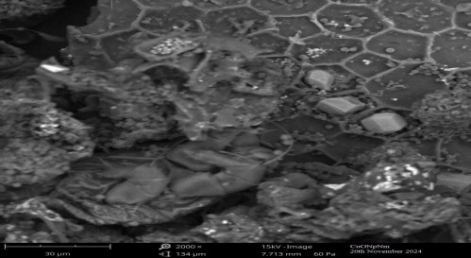
UNDERPEERREVIEW

Figure 2 SEM image of CuONpNm at 2000x

4.2 Transmission Electron Microscopy (TEM) Analysis
Topographical and morphological information about the synthesized TEM image of CuONpNm is shown in figure 3. TEM was employed to study the particle size and the surface morphology of the modified CuONpNm nanoparticles. The result from the image analysis showed a different magnification of the sample crystalline structure at 50nm. The average grain sizes were estimated as 3.53 nm for CuONpNm indicating that its small nanoparticles range show that it has more active sites per unit mass making it more structurally stable and very good for adsorption work and from the TEM image, the nanoparticles are visible as a dark spot on the magnified image of the samples. The result suggested that the CuO nanoparticles are monoclinic crystals that are polydisperse in a spherical structure. The presence of diffraction rings in selected area electron diffraction patterns (SAED) support the existence of a single crystallite polymer of CuO nanoparticles. All the grains of CuONpNm are separated from each other in the same highly ordered arranged polymer chain in a three-dimensional lattice plane of monoclinic grain boundaries of normal CuO structural phases in a specific orientation. The uniform crystalline structures and qualities gave CuONpNm an excellent property in its unique adsorption application (Jacob,2021; Manisha,2023).

5

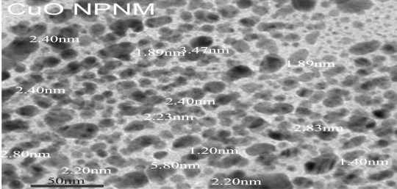
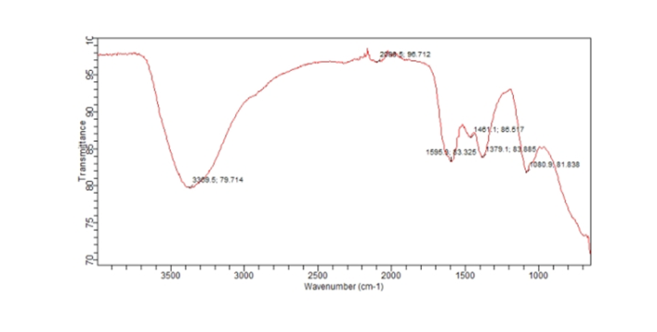
UNDERPEERREVIEW

Figure 3: TEM of CuONpNm at 50nm magnification

4.3 Fourier Transform Infrared Spectroscopy of CuONpNm

To understand the nature of the functional groups, present in CuONpNm. The FTIR was obtained by AGILENT ECHNOLOGYIES. FTIR spectra in figure 4 displayed a number of peaks with each band indicating a specific vibration or adsorption of the band. Each position of the band indicates the frequency of the band while the intensity reflects the amount of adsorption. The FTIR of CuONpNm band observed at 3369 cm-1 is due to the free OH stretch broad at middle of the transmission state. The band at 2088.5 cm-1 is attributed to C-triple bond stretch desorption. The peak at 1595.9 indicates alkenes and aromatic functional groups due to the C=C vibration. Bands appearing at 1461.1cm-1 is due to CH2 characteristic bending and the peak at 1088.4 is due to middle stretching of C-C-C bending. CuONpNm showed higher percentage removal in equilibrium parameter (pH, contact time & adsorbent dose) dependent adsorption tests, it is possible that CuONpNm capping agents and present functional groups in figure 4, provided more accessible adsorption sites that enhanced the adsorption of the metal ions. These surface ligands are likely coordinated to the CuO surface and act as reducing and capping agent difference in capping chemistry. It explains the variation in surface chemistry and hence adsorption behavior of CuONpNm on metal adsorption, suggesting it is good for the adsorption work (Alaa,2021; Joudeh,2022; Pyiya,2025).

Figure 4 FTIR Analysis for CuONpNm

4.4 Effect of Operating Parameters

4.4.1 Effect of pH

6

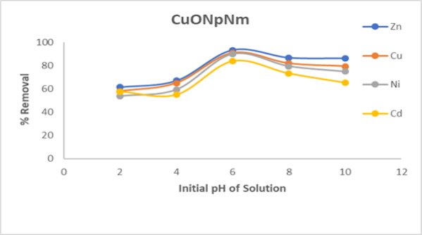
pH is one of the most important parameters controlling uptake of heavy metals from wastewater and aqueous solution. Figure 5 showed the effect of pH on Zn2+Cu2+,Ni2+ and Cd2+ removal by CuONpNm. These studies were conducted at a constant initial metal ion concentration of 200 mg/L, adsorbent dose of 0.1 g/L, contact time of 180 min and at temperature of 280𝐶. The effect of pH adsorption of CuONpNm on the four metal ions was evaluated with pH values ranging from 2 to 10 at equilibrium time. The percentage removal of Zn2+,Cu2+,Ni2+ and Cd2+ by CuONpNm increased with pH. The maximum percentage removal for Zn2+ ,Cu2+,Ni2+ and Cd2+ was found to be 93.71 %, 90.93 %, 89.92 % and 83.91 % by CuONpNm. The percentage removal was high at pH of 6-8 and lower between pH 2-4 thereby having lower adsorption capacity for the nanoparticle before pH 6. This is due to the formation of hydroxyl complexes and decrease in competition between protons and the metal cations for some functional group, thereby decreasing in positive surface charge, which results in a lower electrostatic repulsion between surface and metal ions. Decrease in adsorption at pH below 6 is due to the formation of hydroxyl complexes. At higher pH, that is at pH of 6, decrease in OH- ions cause an increase in adsorption of metal ions at adsorbent-adsorbate interface (Shin,2011). The difference in adsorption behavior of different heavy metal ions may be due to the difference in their ion exchange capacity on the surface depending on their charge density, extent of hydrolysis and solubility of hydrolyzed metal ions in solution under present experimental condition (Alaa, 2021; Ruth,2014; Shin,2011).
UNDERPEERREVIEW

Figure 5 Effect of pH on percentage removal of CuONpNm

4.4.2 Effect of Contact Time

The effect of contact time on the percent removal of Zn2+ ,Cu2+ ,Ni2+ and Cd2+ions on CuONpNm was studied. These studies were conducted at constant initial metal ion concentration of 200 mg/L, adsorbent dose of 0.1 g/L, pH at 6.0 and at temperature 28 oC from figure 6 it was observed that the rate of removal of the adsorbate increased with time, until an equilibrium time was established. Equilibrium time was achieved at about 90 minutes, and increased slightly up to 120 minutes, hence, a contact time of 120 minutes was chosen to ensure optimum removal of metal ions. The maximum percentage removal of Zn2+ ,Cu2+ ,Ni2+ and Cd2+ions by CuONpNm was 90.85 %, 88.92.2%, 85.00 % and 82.78 % respectively. Adsorption rapidly occurs and is normally controlled by the diffusion process from the bulk of the solution to the adsorbent surface. The adsorption was noticed to be fast initially and then became slower. This can be attributed to the strong attractive force between the ions and the CuONpNm adsorbent (Alaa,2021).

7

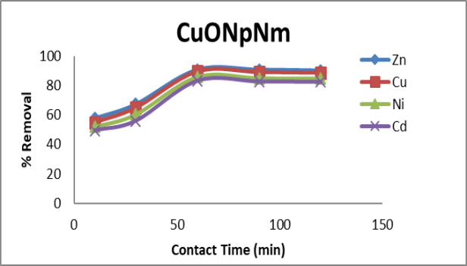
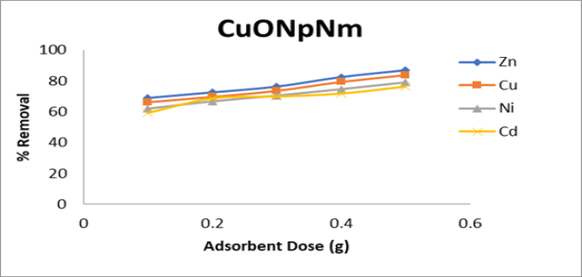
Figure 6 Effect of Contact Time on percentage removal of CuONpNm
UNDERPEERREVIEW

4.4.3 Effect of Adsorbent Dose

The effect of adsorbent dose on adsorption of Zn2+,Cu2+ ,Ni2+ and Cd2+ removal by CuONpNm was illustrated in figures 7. Different dose adsorbents ranging from 0.1 to 0.5 g/L were considered and other operating parameters were maintained (metal concentration-200 mg/L, contact time-180 min, pH 6.0 and temperature 28 oC. From the experiment, it was observed that percentage adsorption increased with increase in adsorbent dose. For the nanoparticles the maximum adsorption dose was 0.5 g and the maximum percentage removal by CuONpNm was 89.92% ,86.64%, 84.72% and 80.57 %. It is apparent that the percentage removal of heavy metals increases rapidly with increase in the dose of adsorbents due to the greater availability of the exchangeable sites or surface area. There are more binding site on the surface of the nano-sorbents to the complexing of the metal ions, which follow a sequence of Zn2+> Cu2+>,Ni2+ >Cd2+ .Moreover the percentage of metal ion adsorption on the adsorbents was determined by the adsorption capacity of the adsorbents for various metal ions which equally depends on the electronegativity and size of hydrated radius which caused Cd2+ to be least adsorbed (Alaa,2021).

Figure 7 Effect of Adsorption Dose on percentage removal of CuONpNm

4.5 Adsorption Equilibrium Study

8

Adsorption isotherm expresses the relationship between the amount of adsorbate removed from the liquid phase by unit mass of adsorbent at a constant temperature. Adsorption isotherms are basic requirements for the design of adsorption systems. A precise mathematical description of equilibrium adsorption capacity is very important for reliable prediction of adsorption parameters and quantitative comparison of adsorption behavior for different adsorbent systems.
The parameters of equilibrium isotherms often give useful information on the sorption mechanism, surface properties and affinity of the adsorbent. It is therefore important to determine the most suitable correlation of equilibrium curves in order to optimize the conditions for designing adsorption systems (Crini,2007; Sun,2003; Wan,2008).
In this study, the Langmuir and Freundlich isotherms were tested to analyze the equilibrium data, and the results are shown in Tables 1.
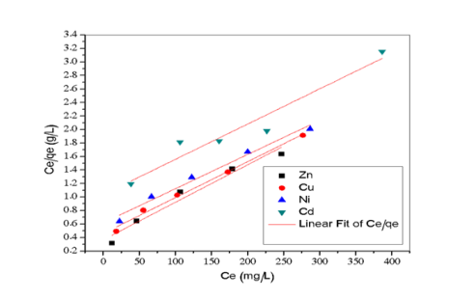
UNDERPEERREVIEW
4.5.1 Langmuir Isotherm

The equilibrium adsorption data for Zn2+,Cu2+ ,Ni2+ and Cd2+ions on CuONpNm were analyzed using the Langmuir isotherm model, as presented in figure 8. The Langmuir plot of ce/qe versus Ce yielding linear relationship for all metal ions indicating that adsorption followed a monolayer coverage on a homogenous surface. The strong linearity of the plots suggests the applicability of the Langmuir model with correction coefficient (R2) approaching unity.

The calculated Langmuir constant (Qmax and KL) confirmed the high adsorption capacity of CuONpNm for the studied ions. Among the metal Zn2+ and Cu2+ showed slightly higher adsorption capacities compared to Ni2+ and Cd2+ions reflecting their strong affinity toward the CuONpNm surface. The monolayer adsorption capacities were consistent with the nanoscale structure and high surface area of the synthesized adsorbent as evidenced by TEM and XRD results.

Adherence to the Langmuir model implies that adsorption occurs at specific homogenous sites on the CuONpNm surface without interaction between adsorbed ions This observation supports the assumption that active sites are uniformly distributed and that once a site is occupied, no further adsorption occurs at that surface.
The results further highlight the suitability of CuONpNm for single layer adsorption processes in wastewater treatment application, offering predictable and efficient removal of heavy metal concentration (Alaa,2021; Joudeh,2022; Chowdhury,2011; Crini,2007; Hameed, 2008; Sun,2003; Wan,2008).

Figure 8 Langmuir plot CuONpNm

4.5.2 Freundlich Isotherm

The adsorption data were further analyzed using the Freundlich isotherm model to evaluate the heterogeneity of adsorption sites and the multilayer adsorption tendency of CuONpNm. The Freundlich plot of Log qe versus Log Ce is shown in figure 9 and the linearity of the plots confirms the applicability of this model to the experimental data.

9

Freundlich constant (Kf and n) derived from the slope and intercept provide insight into the adsorption intensity and surface heterogeneity of the adsorbent. The value of it was greater than one for all the studied ions. Indicating favorable adsorption and suggesting that CuONpNm possess a heterogenous surface with sites of varying affinities. Higher Kf values for Zn2+ and Cu2+ compared to Ni2+ and Cd2+ions confirm stronger interaction with adsorbents, consistent with the Langmuir result.

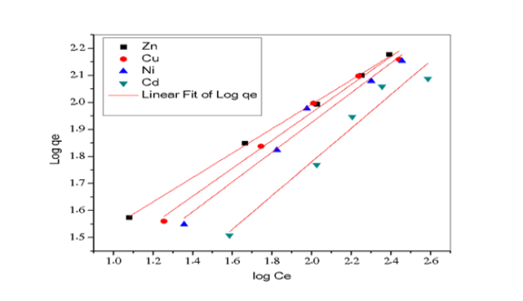
The Freundlich model applicability implies that in addition to monolayer adsorption, multilayer adsorption processes may also contribute to the overall uptake, especially at high concentrations. This observation is reasonable given the nanoscale structure and porous morphology of CuONpNm, which provides diverse binding sites for heavy metal ions. Thus the combined evaluations of Langmuir and Freundlich model reveals that adsorption Zn2+,Cu2+ ,Ni2+ and Cd2+ion onto CuONpNm occurs via a complex mechanism involving both monolayer adsorption on uniform sites and multilayer adsorption on heterogeneous surfaces The value of 𝐾𝐹 signifies adsorption intensity and higher 𝐾𝐹 The value of the adsorbent confirmed the higher adsorption capacity for CuONpNm. The values of n lie between 1 and 10 indicating favorable adsorption. The isotherms were found to be linear as evidenced from correlation coefficients obtained in the range of 0.998-0.940. The Freundlich isotherm showed a better fit adsorption data than Langmuir isotherm suggesting heterogeneous nature of the adsorbents (Alaa,2021; Joudeh,2022).
UNDERPEERREVIEW

Figure 9 Freundlich Plot of CuONpNm

Table 1 Langmuir and Freundlich isotherm constants for CuONpNm adsorption on different adsorbate

CuONpNm
Langmuir Isotherm Result
Parameter Zn2+ Cu2+ NI2+ Cd2+

Freundlich Isotherm Result Zn2+ Cu2+ NI2+ Cd2+

qL 200.1

KL 0.0030
206.7

0.00136
211.3

0.00311
225.3

0.00482
KF 8.09 20.94 33.19 39.35

N 3.00 3.53 3.97 5.40

R2 0.903 0.984 0.964 0.940 R2 0.998 0.989 0.977 0.959

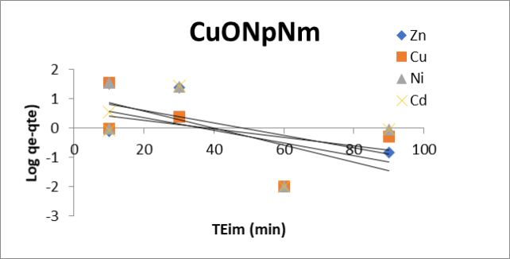
10
UNDERPEERREVIEW
𝑞
4.6.1 Adsorption Kinetics (Pseudo-First-Order Kinetic Model)
The kinetics data for the adsorption of Zn2+,Cu2+ ,Ni2+ and Cd2+ions on CuONpNm were first analyzed using the pseudo-first-order kinetics model as illustrated in figure 10. The model assumed that the rate of occupation of adsorption sites was proportional to the number of unoccupied sites and the linearized form of the model was applied by plotting Log (qe-qt) against time.

Although the plot produced approximately straight lines the calculated equilibrium adsorption capacity (qe cal) obtained from the pseudo -first-order model (Table 1), showed a poor agreement with the experimental value (qe exp). Additionally, the regression coefficients (R2) were significantly lower compared to those of the pseudo pseudo-second-order model (figure 11). The discrepancy indicates that the pseudo-first-order model does not adequately describe the adsorption process.

The weak fit of the pseudo-fist-order model suggests that the adsorption of heavy metal ions onto CuONpNm is not solely governed by physical adsorption mechanisms such as diffusion instead, the better correction with the pseudo-second-order model confirms that adsorption process is primarily chemisorption. Controlled, involving stronger interaction between the metal ions and the functional sites of the CuONpNm sites.

Therefore while the pseudo-first-order kinetics model provides some insight, it is not suitable for describing the adsorption kinetics of Zn2+,Cu2+ ,Ni2+ and Cd2+ion onto CuONpNm (Alaa,2021; Fungaro,2013;Hammed,2008; Hu,2009;Kazeem,2018; Nethaji,2013; Trans,2018).

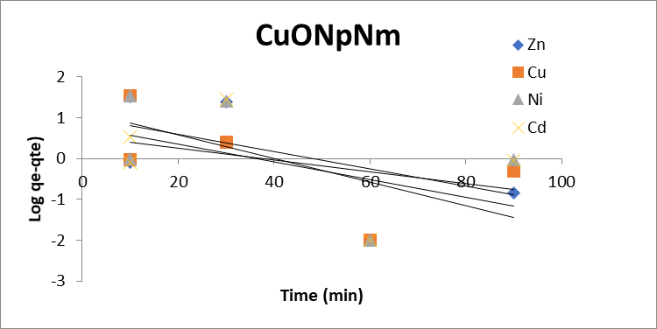

Figure 10 Pseudo-first-order plots for adsorption of CuONpNm

11

4.6.2 Pseudo-Second-Order Kinetic Model

The adsorption kinetics of Zn2+,Cu2+ ,Ni2+ and Cd2+ion onto CuONpNm were further analyzed using the pseudo-second-order model, as presented in figure 11. The linearized form of this model was applied by plotting t/qt

versus 𝑡, which produced a highly linear relationship for all metal ions, with regression coefficients (R2) constantly close to unity.

Unlike the pseudo-first-order model (Table 2), the calculated equilibrium adsorption capacities (qe cal) derived from the pseudo-second-order model showed an excellent agreement with the experimental value (qe exp). The strong correction indicates that the adsorption is better represented by the pseudo-second -order model.

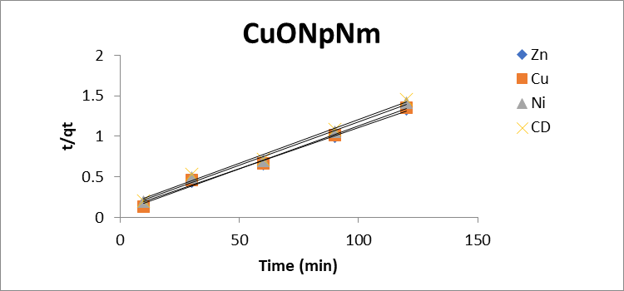

Figure 11 Pseudo-second-order plots for adsorption of CuONpNm

The superior fit suggests that the rate-limiting step of the adsorption process is predominantly chemisorption, involving valence force through sharing or exchange of electrons between the metal ions and the active functional
group present on the CuONpNm surface.

This mechanism is consistent with the observed high removal efficiencies and strong interactions between CuONpNm and the tested metal ions.

Therefore the pseudo-second-order kinetics model provides the most reliable description of the adsorption behavior of Zn2+,Cu2+ ,Ni2+ and Cd2+ion onto CuONpNm, confirming that the process is primarily controlled by chemical interaction rather than physical diffusion (Alaa,2021;Ho,2006;Mail,2005; Vadivelan,2005; Padmaarathy,2008).

UNDERPEERRE

Table 2 Pseudo-second order parameters for the adsorption of CuONpNm on Zn2+, Cu2+, Ni2+ and Cd2+

Parameter

qe (Calculated) qe (Experimental) K1/2
ho R2
CuONpNm Pseudo-second-order
Zn2+ Cu2+ NI2+ Cd2+ 100.0 90.00 83.33 76.02 90.90 89.42 85.92 83.30 0.010 0.011 0.012 0.013
8.600 8.634 9.615 10.416 0.994 0.993 0.990 0.986

Pseudo-first-order Zn2+ Cu2+ NI2+ Cd2+
16.92 16.82 16.52 16.07 90.90 89.42 85.92 83.30 0.046 0.044 0.041 0.039 - - - -0.625 0.724 0.624 0.305

5. CONCLUSION

The utilization of bio-sorbents for treatment of aqueous solution containing metal ions is gaining attention as an efficient and economical means of wastewater treatment. In the research work copper oxide neem nanoparticles base extract were used to remove cationic ions from aqueous solutions. Copper oxide nanoparticles coated with neem extract have a low commercial value and were found to be low cost and promising adsorbents for heavy metal ions (Zn2+,Cu2+ ,Ni2+ and Cd2+) in aqueous solutions. This was investigated in batch mode. The equilibrium adsorptive quantity (qe) and percent adsorption were determined to be a function of solution pH, contact time and adsorbent dose.

The SEM analysis of CuONpNm shows that the nanoparticles are very porous and that it has cavities for the adsorption of Zn2+, Cu2+, Ni2+ and Cd2+ions. The FTIR spectra of CuONpNm show that several peaks were observed

12

in the spectra which indicated that they are composed of various functional groups which are responsible for the binding of the cations. The percentage removal (%R) increased with increase in pH, contact time and adsorbent dose. The obtained result showed an order of Zn2+> Cu2+> Ni2+> Cd2+for CuONpNm. The results established that neem-modified CuO nanoparticles (CuONpNm) show higher adsorption efficiency for Zn2+, Cu2+,Ni2+ and Cd2+ due to present of capping agent, functional group, active site, pore cavities and small nanoparticle size which integrate to make CuONpNm good for the adsorption work.

The linear regression of the experimental results for the two adsorbents fitted better to the Freundlich than the Langmuir model isotherms. This suggests that the biosorption system of Zn2+, Cu2+, Ni2+ and Cd2+could have more than one functional group which is responsible for the metal binding. Second-order parameters from the entire sorption period confirms that the sorption follows a pseudo-second-order mechanism. The pseudo-second-order expression better predicted the sorption kinetics of the metal ion adsorption onto Zn2+, Cu2+, Ni2+ and Cd2+than pseudo-first-order.
UNDERPEERREVIEW

The successful application of copper oxide nanoparticles modified with neem leaves extract on aqueous solution of Zn2+, Cu2+, Ni2+ and Cd2+ as bio-sorbent introduces a less expensive, antimicrobial and environmentally friendly method for treatment of heavy metal ions from aqueous solution.

Disclaimer (Artificial intelligence)
In compliance with the journal’s ethical policies and recent guidelines regarding the use of artificial intelligence (AI) tools, we would like to formally confirm that no AI tools (such as ChatGPT or other generative AI models) were used in the writing, editing, data analysis, or any part of manuscript preparation.

REFERENCE

Alaa, E. L., Din, M., Khairia, M.A., Sahab, O., Salma, F. A. O. & Fatan, A. A. (2021). Green copper oxide nanoparticle for lead, nickel & cadmium removal from contaminated water. PMCID: PMC820-6336/PMID, 11-2547 dio:10.1038/s41598-021-91093-7.

America Public Health Association (1998). Absorption Spectrophotometric method, Standard methods for the Examination of Water & Wastewater 20th Edition Alpha AWWA WEF.

Azonaon, N., Sadaoni , Z. & Mokaddem, H. (2008).” Removal of cadmium from aqueous solution by adsorption on vegetable wastes”, Journal of Applied Science pp 4638-4643, doi: 103933/jas.2008.4838.4643.

Chowdhury,S., Mishra, R.,Saha, P. & Kushwaha, P. (2011). Adsorption, thermodynamic, kinetics and Isosteric heat of adsorption of malachite green onto chemically modified rice husk. Desalination,265,159-168 dio.org/10.1016/jdesal.2010.07.047.

Crini,G. Peindy, H., Gimbert, F. & Robert, C. (2007). Removal of C.I. Basic Green (Malachite Green) from Aqueous Solution Using Cyclodextrin-Based Adsorbent: Kinetic and Equilibrium Studies Separation and Purification Technology. 53,97-110 dio.org/10.1016/j.seppur 2006.06.018.

Crislaine, R., Galan, R. (2018). Green synthesis of copper oxide nanoparticles impregnated on activated carbon using moringa oleifera leaves extract for the removal of nitrates from water.dio:10.1590/19805373-mk-20180460.

Dundar,M.,Nuhoglu,C.,Nuhoglu, Y. (2008). Biosorption of Cu(ll) ion onto the litters of natural trembling poplar forest. Journal of Hazardous Material. 151 (1): 86-95.dio:10.1016/jhazmat.2007.05.055.

Falak, S., Syed, S., Ali, G., Muhammad,S., Mhammad, B., Igra,S. (2019). Eco-friendly green & biosynthesis of copper oxide nanoparticle using citrofortunella microcarpe leaves extract for efficient photocatalytic degradation of Rhodamn B-dye from textile wastewater.dio.org/10.1016/j.ijleo.2019.164053.

Fungaro, D.A., Borrely, S. I. & Carvalho, T. E. M. (2013). Surfactant modified zeolite from cyclone ash as adsorbent for removal of reactive orange from aqueous solution. American Journal of Environmental Protection,1,1-9. dio.org/10,12691/env-1-1-1.

13

Hameed, B.H. & El-Khaiary, M.I. (2008). Batch removal of malachite green from adsorption solution by adsorption on oil palm tree trunk fibre : Equilibrium Isotherms and Kinetics Studies Journal of Hazardous Materials 154,237-244.dio.org/10.1018/j.jhazamat.2007.10.017.

Ho,Y.S. & Ofamaja,A.E. (2006). Biosorption thermodynamic of cadmium on coconut copra meal as Biosorbent. Biochem and Engineering Journal,30,117-123.dio.org/10.1016/j.bej.2006.02.012.

Ho. Y. (2006). Review of second-order models for adsorption systems. Journal of Hazardous Material, 136,681-689.dio.org/10.1016/j.jhazmat.2005.12.04.
UNDERPEERREVIEW

Hu, O., Lu, L. V., Pen, B.C., Zhang, Q. J., Zhang, W.M. & Zhang, Q.X. (2009). Critical review of adsorption kinetic models. Journal of Zhejiang University Science A, 10,716-724. dio.org/10.1631/jzus.A0820524.

Joudeh, N. & Linke, D. (2022). Nanoparticle classification, physiochemical properties, characterization & application: A comprehensive review for biologists. Journal Nanobiotechnol. Vol. 20, (262), dio.org/10.1186/s1251-022-01477-8.

Kazeem, T. M., Lateef, G. A.,Ganiyu, S.A.,Qamaruddish, M.Timinu, A., Suiaiman, K.O., Jilani,S..S. & Ahooshani, K. (2018). Aluminum modified activated carbon as an efficient adsorbent for cleaning cationic dye in Wastewater Journal of Cleaner Production,205,303-312. dio.org/10.1016/j.jclepro.2018.09.114.

Kellang, Z., Hao B., Zbenguo, L. (2003). A simple method for the synthesis of copper nanoparticles from metastable, Natural Library of Medicine, dio10.1039/dzrao10823.

Khlifi, R. &Hamza-Chaffai, A. (2010). Head and neck cancer due to heavy metal exposure via tobacco smoking and professional exposure: A review. Toxicol. Appl. Pharma.248, 71–88. doi: 10.1016/j.taap.2010.08

Kumar,S.,et al. (2004). Adsorption of Pb2+ using biosynthesized ZnO nanoparticles derived from azadirachta indica leaf extract Biomass Conversion and Biorefinery. Dio:10.1007/s13399-024-054119-2

Lekan T.P. & Alnaji, S. G. (2021). Adsorption of heavy metal from industrial waste using nanoparticles from agro. Wastes. Journal Chapter Metrics Overview 64, doi :10.5772/intechopen.98241.

Mail, I. I. D., Srivastava, V.C., Agarwal, N. K. & Mishra, I. M. (2005). Removal of Congo red from aqueous solution by bagasse fly ash and activated carbon:kinetic study and Equilibrium Isotherm Analyses Chemsphere 6,492-501.dio.org/10.1016/j-chemosphere.2005.03.065.

Manisha, K., Sunita C. H., Ashok, K., Kamakhya, P. M., Devendra, S. R. & Rama, K. K. (2023). Asterarcysquadri cellular algae-mediated copper oxide nanoparticles as a robust and recyclable catalyst for the degradation of noxious dyes from wastewater, Open Access Article, 13,28179-28196. doi:10.1039/D3RA05254K.

Massod, F., Malik, A., (2015). Single and multi component adsorption of metal ios by Acinetobacters. FM4. Sep. Sci. Technol. 50, 892-900 Doi.org/10.1080/01496395.2014.989378.

Nethaji, S., Sirasany, A. & Mandal, A.B. (2013). Adsorption isotherm, kinetics and mechanism for the adsorption of cationic and anionic dyes onto carbonaceous particles prepared from Julans regia shell biomass. International Journal of Environmental Science & Technology 10.231-243. dio.org/10.1007/s13762-012-0112-0.

Nuhoglu,Y.,Malkoc E. (2009). Thermodynamic & kinetics studies for environmentally friendly Ni (ll) biosorption using waste pomace of olive oil factory. BioresourceTechnology.2009;100(8):2375-2380. dio:10.1016/j. biortech.2008.11.016.

Padmaarathy,V. (2008). Biosorption of nickel (ll) ions by Baker’s yeast: kinetic, thermodynamic and desorption Studies. Bioresource Technology,99, 3100-3109. dio.org/10.1016/j-biotech.2007.05.070.

14

Priya, D. D. (2025). Aerva lanata-mediated bio-treated production of copper oxide nanoparticles, optimization by BBD-RSM method and its behavior against water related mosquito. Appl.Nanosci.. 11,207-216 dio.org/10.1007/s/3204-020-01573-x.

Ruth A.C.U., Aura, R. H. V., Consuelo, J. C. P., Paul, C.M. (2014). Thermodynamic, kinetics, equilibrium parameter for the removal of lead & cadmium from aqueous solution with calcium. Alginate Bead the Scientific World Journal 27: b47512. doi : 10.1155/2014/647512.
UNDERPEERREVIEW

Shin, K. T., Hong, J. Y, Jang, J. (2011). Heavy metals ion adsorption behavior in nitrogen-drop magnetic carbon nanoparticles: isotherms & kinetics study, Journal of Hazardous Materials 190 (1) 3:36-44 doi: 10.1016/j.jhazmat.2010.12.102.

Sun, Q. Y. & Yang, L. Z. (2003). The adsorption of basic dye from aqueous solution modified peat-resin particle. Water. Research, 37, 1535-1544. dio.org/10.1016/50043-1354 (02)00520-1.

Theerthalgiri, J. (2022). Fundamentals and comprehensive insight on pulsed laser synthesis of advanced materials for diverse photo and electrocatalytic applications Light Sci. Appl. 11,250 dio.org/10.1038/s41377-022-00904-7.

Trans, H.N.,You,S. & Chao, H.P. (2018). Fast and effective dsorption of methylene green in activated carbon preparation from Ne chemical activation method. Journal of Environmental Management, 188,322-336. dio.org/10.1016/j.jenvmani2016.12.0.

Vadivelan, V. & Vasauth K.K. (2005). Equilibrium, kinetics, mechanism & process design for the sorption of Methylene Blue onto Rice Husk. Journal of Colloid and Interface Science, 286,90-100.dio.org/10.1016/j.jcis2005.01.007.

Wan, N. W. S. & Hanafiah, M. A. K. M. (2008). Adsorption of copper on rubber (hevea brasiliensis) leaf powder. kinetic, equilibrium & thermodynamic studies Biochemical Engineering Journal, 39, 531-530.dio.org/10.1016/j.bej.2007.11.006.

Wang,Y.,Gao, B.Y.,Yue,W.W. & Yue,Q.Y. (2007). Adsorption kinetics of nitrates from aqueous solution onto modified wheat residue, colloids & surfaces, Physicochemical & Engineering Aspects, 308,1-5.dio.org/10.1016/j.colsurfa.2007.05.014

15

