Assessment of Soil Index Properties, Asphalt Thickness and Drainage Design as Factors in Pavement Distress: A Case Study of Agbaje–Ijokodo Residential Road, Southwestern Nigeria

Abstract
Road infrastructure plays a crucial role in economic growth, mobility, and social development, yet premature failures remain a recurring challenge in many developing regions. This study investigates the geotechnical propert+ies of subgrade soils, pavement asphalt thickness, and drainage conditions along the Agbaje–Ijokodo residential road in Ibadan North Local Government Area, Oyo State, Nigeria, with the aim of identifying the underlying causes of early pavement deterioration. Fieldwork involved reconnaissance surveys, visual inspections, measurement of asphalt thickness at 26 failed locations, and collection of disturbed soil samples for laboratory analysis. Tests conducted included grain size distribution, Atterberg limits, compaction, California Bearing Ratio (CBR), and consolidation. Results revealed that the soils are predominantly fine-grained, with fines content (38.2–67.7%) exceeding the Federal Ministry of Works and Housing (FMWH) limit of 35%. Most samples exhibited high liquid limits (>35%), high plasticity indices, and linear shrinkage above the 8% threshold, indicating poor engineering quality. Natural moisture contents (17–40%) frequently surpassed the FMWH limit of 16%, while unsoaked CBR values (13–15%) fell short of the 30% requirement for sub-base materials, rendering the soils suitable only as subgrade support. Compaction tests yielded high optimum moisture contents (17.7–18.6%), and consolidation results confirmed medium to high compressibility, further suggesting settlement risk and moisture sensitivity. Asphalt pavement thicknesses were grossly inadequate, ranging from 0.8 to 1.7 in. (average 1.1 in.), below the FMWH/AASHTO minimum of 2.0–2.5 in. for residential roads. Additionally, drainage systems were poorly designed, undersized, or blocked, with some sections lacking drainage entirely. The findings attribute premature failure of the Agbaje–Ijokodo road to the combined effects of weak soil properties, insufficient asphalt thickness, and inadequate drainage infrastructure. Sustainable rehabilitation will require soil stabilization, improved drainage design, and reconstruction with pavement layers that meet established engineering standards.
Keywords: Geotechnical Properties, Subgrade soils, pavement Failure, Drainage Design, Southwestern
Nigeria.

Introduction
Roads are one of the most important infrastructures for economic growth, mobility and social development. Despite this, premature road failures continue to be a reoccurring issue in numerous part of the world, particularly in developing countries, where roads continually deteriorate before reaching their design life (Adesanya and Bello, 2021; Afrane et al., 2022; Mohseni and Ghassemali, 2023). These failures commonly result from geotechnical inadequacies in the subgrade, deficient pavement asphaltic thickness, and inappropriate drainage design (Zakaria et al., 2014). The subgrade is the foundation of the pavement structure, and its strength and stability influence to a large extent the overall performance of the road (Das and Sobhan, 2018). Similarly, asphaltic thickness plays a vital role in distributing traffic loads, while effective drainage systems prevent water infiltration that weakens both the pavement and subgrade (Huang, 2004; Ki et al., 2021; Von Quintus and Hughes, 2019). When these three factors are inadequately designed and built, roads become very prone to distresses such as rutting, cracking, potholing, and eventual structural failure (Okigbo and Akpan, 2019). This study, therefore, focuses on understanding the interplay between geotechnical properties of the subgrade, pavement asphaltic thickness, and drainage design of residential Agbaje-Ijokodo road, southwest Nigeria, in order to identify their contributions to road failure and to propose measures for sustainable pavement performance. A sound understanding of the impact of geotechnical and structural factors on the overall service ability of asphaltic roads can help in making better decisions regarding road design and maintenance.
Location and Accessibility
The study area covers the road linking the Ijokodo–Agbaje environs in Ibadan North Local Government Area of Oyo State, Southwestern Nigeria (Fig. 1). This section of the road lies around Latitude 7°25′30.68″N and Longitude 3°52′34.28″E. The Ijokodo–Agbaje axis is situated in the northeastern part of Oyo State, about 4 km from the major Eleyele–Sango road. The area is mainly residential, with only a few scattered trees providing vegetation cover. From a geological perspective, it forms part of the Southwestern Nigeria Basement Complex, a diverse terrain made up of migmatite, orthogneisses, paragneisses, and a variety of basic to ultrabasic metamorphosed rocks (Rahaman, 1976; Akinola and Obasi, 2020; Doro et al., 2023).
Methods of Research
To achieve the objectives of the study, detailed field investigations that involved reconnaissance surveys, visual inspections of the pavement surface, and measurements of asphalt layer thickness at failed sections were carried out. Drainage design and conditions were also assessed to understand their contribution to pavement performance. Trial pits were opened at selected failed sections, and their GPS coordinates were recorded. At 26 failed locations, asphalt pavement thickness was measured at four points using a digital caliper for accuracy. Eight number of disturbed soil samples (25kg) were collected at a depth of about 0.5 m below the surface from each trial pit at failed sections of the road and at a distance of 30m, bagged in sample sacks and carefully sealed, and labeled to preserve their natural moisture content before being transported to the laboratory within 24 hours. In addition to this, two number of control soil sample were equally collected from the stable sections of the road with no visible distress located about 20 meters of the failed sections to determine if inherent geological variation exist.

Fig. 1: Location map of the study area.

Fig. 2: Geology of the study area showing sample locations.

Sample Preparation and Laboratory Tests
In the laboratory, a series of geotechnical tests were conducted to determine the physical and engineering properties of the soils. These results provided valuable insights into the underlying causes of pavement distress and failure in the study area. The bulk soil samples collected from the field were first air-dried at room temperature for about three weeks before laboratory testing commenced. To achieve uniform drying, the samples were spread out on a clean platform and carefully turned over at intervals throughout the period.
After preparation, a series of geotechnical tests were performed to evaluate the engineering properties of the lateritic soils. The objective of these tests was to assess the soils’ suitability for use as subgrade and sub-base materials in pavement construction, providing a basis for understanding their performance under traffic loading and environmental conditions.
Grain Size Distribution Analysis
Grain size distribution describes the relative proportions of gravel, sand, silt, and clay within a soil sample and it strongly influences engineering properties such as permeability, compaction, and shear strength (Olusola et al., 2022). In this study, the analysis was carried out in accordance with ASTM D422 using sieve and hydrometer methods. The sieve analysis involved wet sieving, where 500 g of soil was soaked in a dispersing solution and washed through a 0.075 mm sieve to separate fines, followed by oven-drying of the retained portion. Dry sieving was then performed using a stack of standard sieves (4.75 mm–0.075 mm) in a mechanical shaker, with the fraction retained on each sieve recorded to determine percentage passing and construct the grain size distribution curve. To capture finer fractions below 0.075 mm, hydrometer analysis was applied, based on Stokes’ law of sedimentation. A 50 g soil sample was dispersed in sodium hexametaphosphate, agitated, and placed in a 1000 ml sedimentation cylinder, where particle settlement was monitored using a hydrometer at timed intervals with temperature corrections. This provided the distribution of silt and clay particles. The combined results of sieve and hydrometer analyses produced a complete particle size distribution curve, which enables soil classification and offers insight into its likely performance in geotechnical applications.

Specific Gravity Test
The specific gravity of soil solids (Gs) is the ratio of the weight of a given volume of soil particles to the weight of an equal volume of water at 4°C. In this test, a known weight of air-dried, sieved soil was placed in a pycnometer, gradually filled with water, and shaken thoroughly to remove air bubbles before weighing. The bottle was then emptied, cleaned, refilled with water, and weighed again. The procedure was repeated, and the average values obtained were used to calculate the specific gravity of the soil.
Consistency Limit Test
The consistency limit of soil is the moisture content at which it changes from one physical state to another. These limits, measured through the Atterberg limits test (Atterberg, 1911), include the liquid limit, plastic limit, and shrinkage limit. They are widely used to classify and identify fine-grained soils (Gana et al., 2020).
The liquid limit is the moisture content at which soil begins to flow under its own weight, determined when a groove in a soil paste closes at about 25 blows of the Casagrande apparatus. The plastic limit is the lowest moisture content at which soil can be rolled into 3 mm threads without crumbling, with the difference between liquid and plastic limits giving the plasticity index (Coe and Johnson, 1961; ASTM International. 2017). A low plasticity index makes soil suitable for road construction, while higher plasticity favors workability, such as in brick production (Gidigasu, 1972).
The shrinkage limit is the moisture content below which further drying does not reduce the soil’s volume. It is measured using a linear shrinkage test, where changes in sample length after drying indicate the degree of shrinkage (Atterberg, 1911). These limits are essential for understanding soil behavior in construction and geotechnical engineering (Abouzaripour and Vafaei, 2020).
Compaction Tests
Compaction tests were carried out to establish the Maximum Dry Density (MDD) and Optimum Moisture Content (OMC) of the soils using both the Modified AASHTO and West African compaction levels. Soil samples were air-dried, weighed (6 kg), and mixed with water (about 5% by weight) before being compacted in five layers in a CBR mould using a 4.4 kg rammer falling from 0.45 m. The West African level involved 25 blows per layer, while the Modified AASHTO used 55 blows per layer. Moisture contents were determined from the top, middle, and bottom of the mould, and the procedure was repeated with increasing water until the dry density began to fall. A density–moisture curve was then used to obtain MDD and OMC. Over-compaction was noted as a limitation, as it may cause particle breakdown and reduce soil stability (Gidigasu, 1976).
Grain size distribution analysis was also carried out on compacted soil to assess the effect of compaction on particle degradation. Sieve analysis was used to detect increases in the fine fraction. A marked increase in fines indicates particle breakdown, which can compromise mechanical stability and render the soil unsuitable for road construction under field conditions (De Graft-Johnson et al., 1969).
California Bearing Ratio (CBR) Tests
California Bearing Ratio (CBR) tests were conducted on both soaked and unsoaked samples to evaluate soil strength, expansion, and water absorption. The unsoaked CBR test was performed immediately after compaction, while the soaked test involved immersing compacted samples for 48 hours under a surcharge load of at least 4.5 kg, with swell readings recorded at regular intervals. After soaking, samples were drained, weighed, and tested in a CBR machine, and load–penetration curves were plotted. The absorbed water was calculated as the difference between soaked water content and OMC. Although CBR is not a direct measure of shear strength, it has been shown to correlate strongly with unconfined compressive strength (Sandoval-Vallejo, and Rivera-Mena, 2019; Adeyemi 1995). The test remains one of the most practical and cost-effective methods of assessing subgrade and subbase performance in highway construction (Bashdar 2025; Eze, et al. 2025).
The consolidation test was conducted to determine the magnitude and rate of volume decrease of a laterally confined soil specimen subjected to different vertical pressures. The data obtained were used to evaluate the coefficient of consolidation, which reflects the rate of both primary and secondary settlement, and the coefficient of compressibility, which provides the magnitude of settlement.
The experiment utilized a consolidation device (oedometer), sample trimming tools; dial gauge, filter papers, porous stones, glass plates, weighing scale, moisture cans, and other standard accessories. The empty consolidation ring with its glass plate was first weighed, and the ring’s dimensions were measured. The soil specimen was then extruded, trimmed carefully to fit the ring, and its initial moisture content and specific gravity were determined. Excess soil was removed to make the specimen flush with the ring, after which the assembly was weighed.
Saturated porous stones and filter papers were placed on the top and bottom surfaces of the specimen, and the sample was submerged in water to ensure saturation. The loading device was set up with the dial gauge adjusted to zero, and vertical loads of increasing magnitude (14 kg, 23 kg, 56 kg, and 224 kg) were applied sequentially. At each load, dial readings were recorded at selected time intervals to monitor compression. After completion, the sample was removed, weighed again, oven-dried for 12–18 hours, and reweighed to obtain its final moisture content. Results were processed by plotting reduction in thickness against the square root of time to determine the coefficient of consolidation (Cv). The coefficient of compressibility (Mv) was obtained from the compression curve, which related specimen thickness to applied pressure.
Result and Discussion
The summary of the geotechnical properties of the study soils is presented in Table 1, while the grading curve was obtained by plotting the percentage passing against particle size on a semi-logarithmic graph. The particle size distribution analysis provides insight into both the range of particle sizes present in a soil and the distribution of particles within that range (Apanpa et al., 2019).
Table 1: Summary of Index and Engineering Properties of Tested Soil Samples
Sample Number | % Passing No.200 | Liquid Limit | Plastic Limit | Plasticity Index | Linear Shrinkage | MDD (kg/ms³) | OMC (%) | CBR (Soaked) | CBR (Unsoaked) | Coefficient of vol. compressibility | Coefficient of consolidation
L1 | 67.7 | 57.10 | 23.00 | 34.10 | 12.10 | 1866.00 | 18.30 | 14.00 | 10.00 | 0.28312 | 0.01424
L2 | 54.3 | 43.30 | 26.00 | 17.30 | 10.00 | 1859.00 | 18.60 | 13.00 | 9.00
L3 | 38.2 | 23.00 | 11.00 | 12.00 | 6.40 | 1873.00 | 18.10 | 15.00 | 10.00 | 0.62712 | 0.01173
L4 | 45.9 | 47.00 | 24.00 | 23.00 | 10.70 | 1868.00 | 18.30 | 14.00 | 10.00
L5 | 52.6 | 44.90 | 26.00 | 18.90 | 9.30 | 1880.00 | 17.90 | 16.00 | 11.00 | o.53597 | 0.01281
L6 | 41.8 | 51.40 | 28.00 | 23.40 | 10.00 | 1868.00 | 18.30 | 14.00 | 10.00
L7 | 48.7 | 55.70 | 30.00 | 25.70 | 11.40 | 1887.00 | 17.70 | 16.00 | 11.00
L8 | 59.4 | 58.90 | 28.00 | 30.90 | 12.90 | 1873.00 | 18.10 | 15.00 | 10.00 | 0.30110 | 0.01389
L9 control | 24.8 | 25.00 | 18.00 | 7.00 | 4.30 | 2025.00 | 15.30 | 30.00 | 20.00
L10 control | 28.9 | 29.80 | 21.00 | 8.80 | 2.90 | 2052.00 | 14.30 | 32.00 | 22.00 | 0.27765 | 0.01650

Grain Size Distribution Analysis
According to Clause 6201 of the Federal Ministry of Works and Housing (FMWH) specifications, soils intended for sub-grade or base use must contain no more than 35% by weight passing the No. 200 sieve (75 μm). If the percentage passing exceeds this limit in a lateritic base course, the material is automatically rejected (FMWH, 1997). Results from the study indicate that the soil samples collected along the failed road section contain fines ranging from 38.2% to 67.7% (Location 3), all exceeding the FMWH specification limit. Consequently, these samples are fair to good as subgrade but unsuitable for use as sub-base, or base materials. The high fines content is likely a major factor contributing to the instability of the road pavement along the studied section. In contrast, the control samples (Locations 9 and 10) contained fines within acceptable limits, ranging from 24.8% to 28.9%. These values conform to FMWH standards and indicate suitability for use as sub-grade material. Based on AASHTO classification, the soils fall within Groups A-4 to A-6, which are generally considered fair to poor sub-grade materials for road construction.
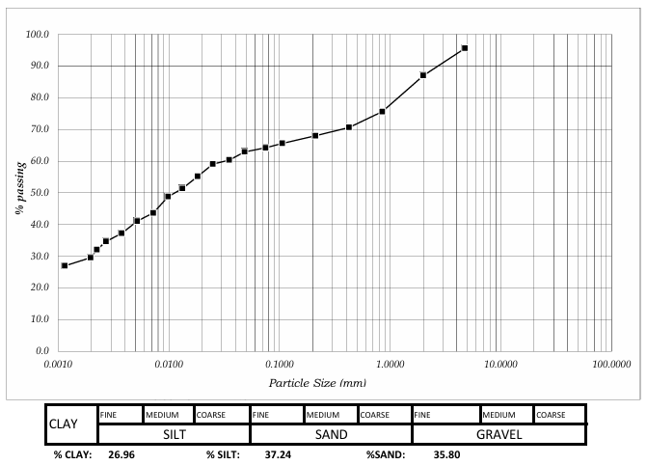
Figure 3: Grain size distribution curve depicting high amount of fines– Location 1
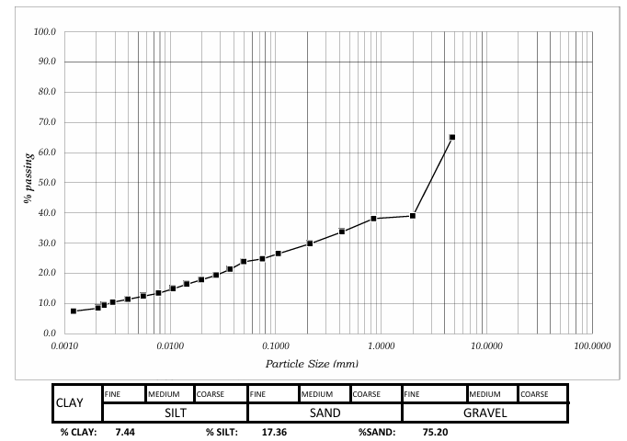
Figure4: Grain size distribution curve depicting low amount of fines– Location 10 (control)

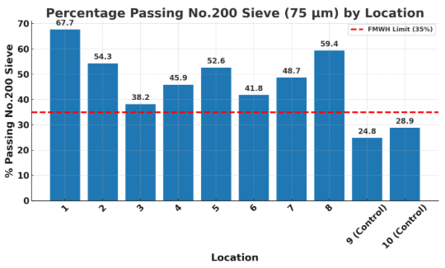
Figure 5: Fines Content Distribution by Location Relative to FMWH Specification

Consistency Limit Test
The plastic limit (PL) values ranged from 11% (Location 3) to 30% (Location 7), while the plasticity index (PI) ranged from 12% (Location 3) to 30.9% (Location 8). Except for Location 3, all the samples exhibited PI values greater than 30%, exceeding the FMWH (1997) specification. Soils with high PI typically exhibit fair to poor engineering properties, as lower PI values are associated with better soil competence as foundation material (Akintorinwa and Adeusi, 2009). Based on Casagrande’s plasticity chart, the soils fall within the medium to high plasticity range, further confirming their limited suitability for pavement applications. For the control soils (Locations 9 and 10), PL values of 18% and 21% were recorded, both within acceptable limits and indicative of better engineering behavior. The linear shrinkage (LS) values varied between 6.4% (Location 3) and 12.9% (Location 8). The control samples recorded LS values of 4.3% (Location 9) and 2.9% (Location 10).
FMWH (1997) recommends maximum LS of 8% for soils used in highway construction. Only Location 3 and the two control samples fell within this limit, while 87.5% of the samples exceeded it. High LS values typically imply swelling and shrinkage potential, which adversely affect pavement stability. The situation is further aggravated by poor drainage along the investigated roadway, which likely contributed to premature pavement failure.
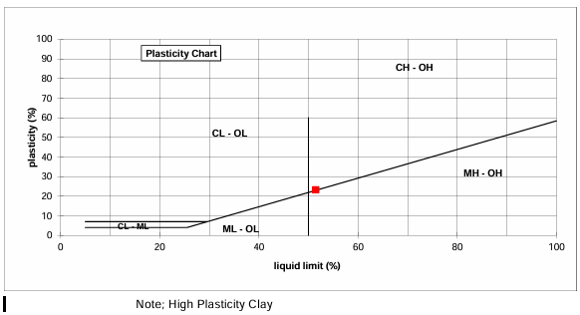
Figure 6: Casagrande plasticity chart showing classification of tested soil as CH – High Plasticity Clay – Location 1)

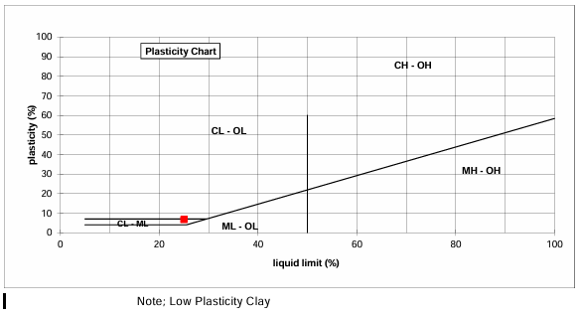
Figure 7: Casagrande plasticity chart showing classification of tested soil as CH – Low Plasticity Clay – Location 10 (control)

Natural Moisture Content and California Bearing Ratio (CBR) Tests
The natural moisture content of the soils varied from 17% to 40%, with most locations falling above the 16% threshold specified by the Federal Ministry of Works and Housing (FMWH, 1997). Soils with moisture content greater than this limit are generally considered unsuitable for road construction because of their tendency to retain water and lose strength. Only a few locations approached the acceptable range, suggesting that much of the studied material is prone to instability if left untreated.
The California Bearing Ratio (CBR) test results further support this limitation. Natural soil samples recorded unsoaked CBR values between 13% and 15%, which fall short of the 30% requirement for sub-base layers and are well below the 80% required for base courses (FMWH, 1997). The unsoaked and soaked CBR indicate fair to good general and strength rating (Figure 8). These values indicate that the soils can only function fairly as sub-grade support. In contrast, the control samples achieved higher CBR values (30–32%) at lower moisture contents (about 14%). The unsoaked and soaked CBR indicate excellent rating as subgrade and good subgrade strength respectively (Figure 9).
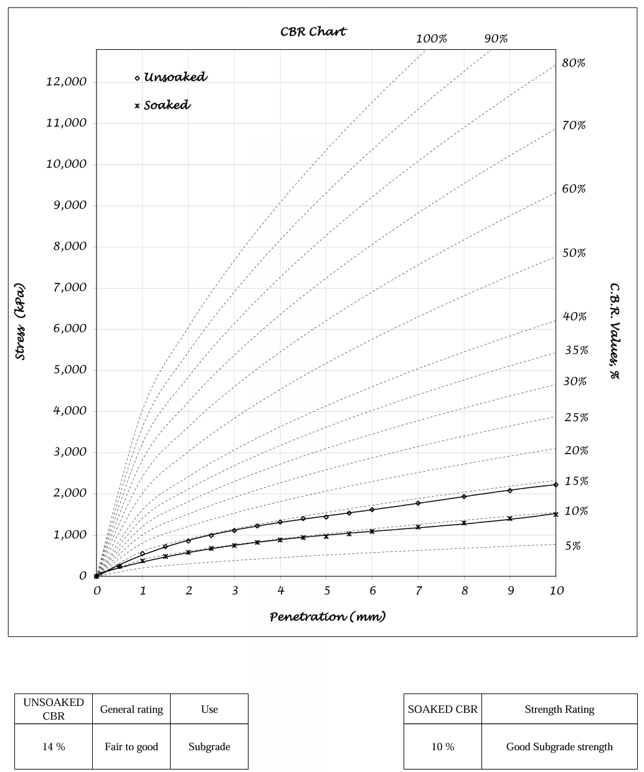
Figure 8: Soaked and Unsoaked CBR General Rating – Location 1

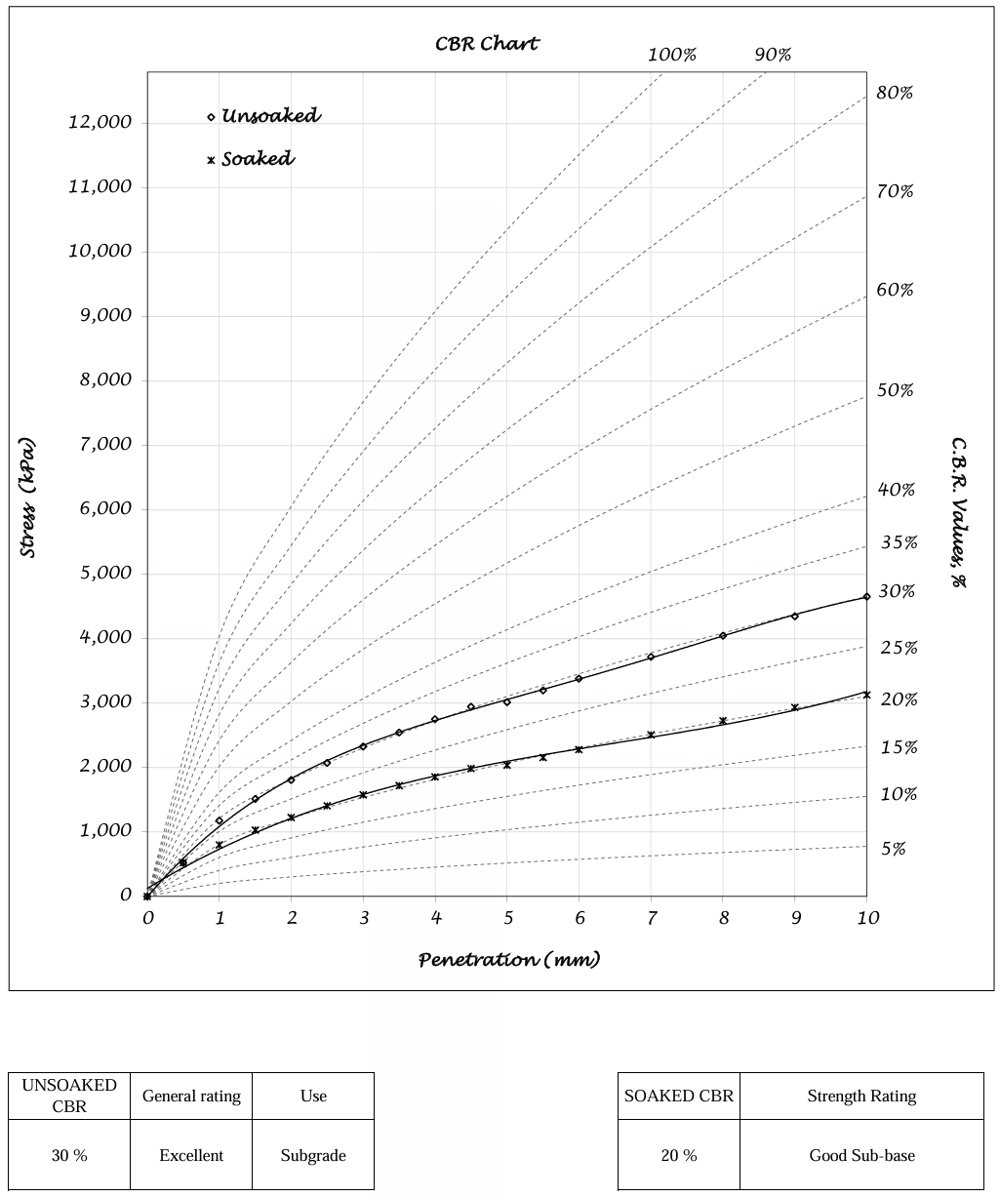
Figure 9: Soaked and Unsoaked CBR General Rating – Location 10(Control Sample)

Compaction and Consolidation Tests
Compaction results showed maximum dry densities ranging from 1859 to 1887 kg/m³ and optimum moisture contents between 17.7% and 18.6%. These OMC values are considerably higher than the 8–10% range typically associated with lateritic soils of good engineering quality (Layade and Ogunkoya, 2018). This means the studied soils are relatively moisture-sensitive and will require stabilization to achieve satisfactory performance in road construction.
The consolidation results reveal medium to high compressibility, with volume compressibility values ranging between 0.28 m²/MN and 0.62 m²/MN. While soils with lower compressibility can withstand loads with minimal deformation, the studied samples are more prone to settlement under sustained traffic and structural loads. This poses a risk of differential settlement and eventual pavement failure if such soils are used without improvement.
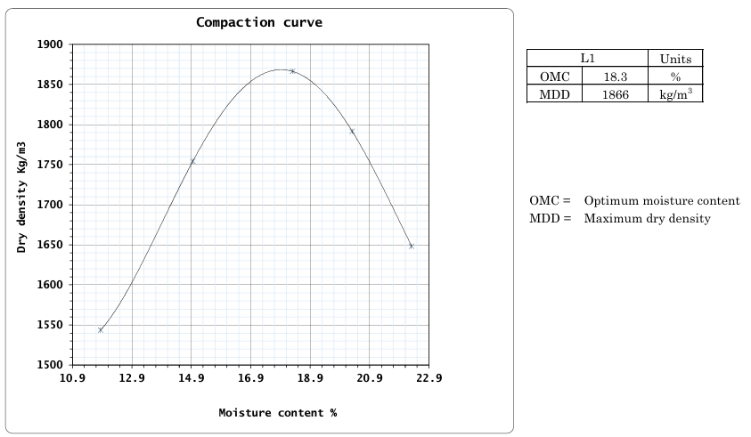
Figure 10: Optimum Moisture Content (OMC) and Maximum Dry Density – Location 1

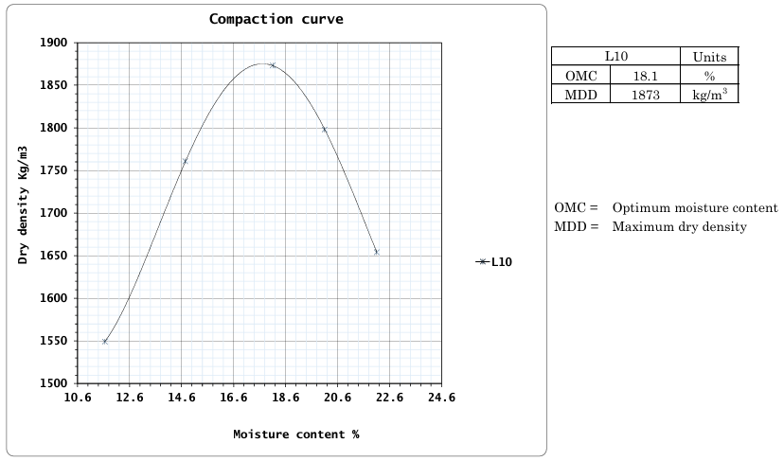
Figure 11: Optimum Moisture Content (OMC) and Maximum Dry Density – Location 10

Asphaltic Pavement Thicknesses
Pavement thickness across the 26 test points varied between 0.8 and 1.7 in., averaging 1.1 in. The thickest layer was recorded at Location 15 (1.7 in.), while the thinnest occurred at Locations 6, 8, and 25 (0.8 in.). This variation reflects inconsistent construction quality and lack of uniform control during placement. When compared with standards, the pavement is clearly below specification. Both FMWH (1997) and AASHTO guidelines recommend a minimum of 2.0–2.5 in. for residential roads, yet none of the sections met this threshold. Even the thickest layer (1.7 in.) was insufficient. Such under-design limits the pavement’s ability to carry loads and protect the base and subgrade, making it vulnerable to cracking, raveling, potholes, and rapid deterioration. This deficiency alone significantly reduced structural capacity and protection of underlying layers, accelerating deterioration.

Drainage Designs
The preliminary investigation revealed drainage inadequacy as the primary cause of road deterioration. Undersized structures failed to convey peak storm water, causing ponding, infiltration, and pavement distress. Widespread blockages from silt, debris, and vegetation, aggravated by poor maintenance, further restricted flow and induced flooding. Structural failures, including cracked, eroded, or collapsed culverts, were observed, while some sections lacked drainage entirely, leading to uncontrolled runoff, erosion, and edge failures. Collectively, these deficiencies reduced pavement performance and road safety, underscoring the need for hydraulic redesign, routine desilting, and timely rehabilitation of drainage systems to ensure long-term road sustainability.

Conclusion
The geotechnical investigation of soils along the failed roadway reveals that the majority of the studied materials are unsuitable for use as sub-base or base course layers without prior stabilization. The predominance of medium to high plasticity clays and silts implies high shrink, swell potential, a condition further corroborated by linear shrinkage values above the acceptable 8% threshold for most samples. Control samples, by contrast, consistently satisfied specification limits, reinforcing the conclusion that material quality plays a decisive role in pavement performance. The premature failure of the road is attributable to a combination of poor soil properties, inadequate pavement thickness, and deficient drainage infrastructure. The soils in their natural state are unsuitable beyond sub-grade application and require stabilization for improved performance. To achieve sustainable rehabilitation, corrective measures should include: (i) redesign and upgrading of drainage facilities, (ii) replacement or stabilization of weak soils, and (iii) reconstruction or overlay of the pavement with asphalt thickness meeting FMWH/AASHTO standards. Only through such integrated geotechnical and structural improvements can long-term pavement serviceability and road safety be assured.

Disclaimer (Artificial intelligence)
Author(s) hereby declare that NO generative AI technologies such as Large Language Models (ChatGPT, COPILOT, etc.) and text-to-image generators have been used during the writing or editing of this manuscript.

Reference:
- Abouzaripour, M., & Vafaei, B. (2020). Consistency limits, a review of testing methods and geotechnical significance. Periodica Polytechnica Civil Engineering, 64(2), 522–530. DOI: 10.3311/PPci.14571. https://doi.org/10.3311/PPci.14571
- Adeyemi G. O. (1995). The influence of parent rock on the contribution of fines to the properties of some highway subgrade soils. Bulletin of the International Association of Engineering Geology, 52(1), 3-8. https://www.google.com/search?q=https://doi.org/10.1007/BF02602677
- Adesanya, A. O., & Bello, W. A. (2021). Analysis of road transportation infrastructure construction and maintenance for sustainable development in South-Western Nigeria. Journal of Sustainable Development of Transport and Logistics, 6(1), 49–58. DOI: 10.14254/jsdtl.2021.6-1.4https://jsdtl.sciview.net/index.php/jsdtl/article/download/131/88/563
- Afrane, S. K., Alagbe, S. O., Appiah, D. A., & Agbleze, E. A. (2022). Sustainable road infrastructure development in sub-Saharan Africa: Review of challenges and strategies. Journal of Engineering, Design and Technology, 20(5), 1541–1558. DOI: 10.1108/jedt-02-2022-0056.https://doi.org/10.1108/jedt-02-2022-0056
- Akinola, O., & Obasi, R. A. (2020). Migmatite and Gneisses in the Basement Complex of Southwestern Nigeria: a re-appraisal of their structural, mineralogical, and geochemical diversity. IJRDO - Journal of Applied Science, 6(8), 1–11. https://www.ijrdo.org/index.php/as/article/view/3817
- Akintorinwa, O. J., & Adeusi, F. A. (2009). Integration of geophysical and geotechnical investigations for a proposed lecture room complex at the Federal University of Technology, Akure, SW, Nigeria. Journal of Applied Sciences, 2(3), 241–254.https://www.researchgate.net/publication/339900000_Integration_of_Geophysical_and_Geotechnical_Investigations_for_a_Proposed_Lecture_Room_Complex_at_the_Federal_University_of_Technology_Akure_SW_Nigeria
- Ameh, O. J., Odoh, M. E., & Ojo, B. I. (2018). Road failures in Nigeria: Causes and remediation. Journal of Multidisciplinary Engineering Science Studies, 4(3), 2074–2081.
- Apanpa, A. K., Olayiwola, H., & Anjonrin, A. (2019). Geotechnical Evaluation of Road Pavement Failure along the Awotan-Akufo Road, Oyo State Southwestern Nigeria. Journal of Geography, Environment and Earth Science International, 23(2), 1-11.https://doi.org/10.9734/jgeesi/2019/v23i230166
- ASTM International. (2017). D4318-17: Standard Test Methods for Liquid Limit, Plastic Limit, and Plasticity Index of Soils. ASTM International, West Conshohocken, PA. https://doi.org/10.1520/D4318-17.
- Atterberg, A. (1911). Die Plastizität der Tone. Internationale Mitteilungen für Bodenkunde (International Soil Science Bulletin), 1, (1), 10–43. A common point of access is the Biodiversity Heritage Library (BHL) or Google Books.
- Bashdar, O. (2025). Machine learning techniques and multivariable mathematical models for predicting modified soil compaction parameters based on particle size and consistency limits. Modeling Earth Systems and Environment, 11(1). DOI: 10.1007/s40808-024-02247-1
- Coe, R. L., & Johnson, C. D (1961). The plastic limit and plasticity index. Géotechnique, 11(1), 22–28.https://doi.org/10.1680/geot.1961.11.1.22. Journal Link (ICE Virtual Library): Institution of Civil Engineers (ICE) - Géotechnique
- Das, B. M., & Sobhan, K. (2018). Principles of geotechnical engineering (9th ed.). Cengage Learning.https://www.cengageasia.com/product/principles-of-geotechnical-engineering-si-edition-9th-edition-9781305970953
- De Graft-Johnson, J. W. S., Attoh, K. O., & Amegashie, J. K., (1969). The breakdown of laterite aggregates during compaction. Géotechnique, 19(3), 408–412.https://doi.org/10.1680/geot.1969.19.3.408
- Doro, K. O., Adegboyega, C. O., Aizebeokhai, A. P., & Oladunjoye, M. A. (2023). The Ibadan Hydrogeophysics Research Site (IHRS)—An Observatory for Studying Hydrological Heterogeneities in A Crystalline Basement Aquifer in Southwestern Nigeria. Water, 15(3), 433. DOI: 10.3390/w15030433.https://www.mdpi.com/2073-4441/15/3/433
- Eze, V. H. U., et al. (2025). Evaluation of Sub-Base Material Using California Bearing Ratio and Triaxial Compression Tests. F1000Research, 14:941. http://doi.org/10.12688/f1000research.169385.1
- Federal Ministry of Works and Housing (FMWH). (1997). General specification for roads and bridges (Volume II, Revised Ed.). Federal Government of Nigeria. Scribd: General Specifications (Roads & Bridges
- Gana, K. M., Abubakar, A. S., & Hassan, S. A. (2020). Geotechnical properties of cement-stabilized lateritic soil using quarry dust as filler. Transportation Research Interdisciplinary Perspectives, 6, Article 100147. DOI: 10.1016/j.trip.2020.100147. https://doi.org/10.1016/j.trip.2020.100147
- Gidigasu, M. D. (1976). Laterite soil engineering: Pedogenesis and engineering principles. Elsevier.https://doi.org/10.1016/b978-0-444-41283-6.x5001-1
- Gidigasu, M. D. (1976). Laterite soil engineering: Pedogenesis and engineering principles. Elsevier Scientific Publishing Company. https://doi.org/10.1016/b978-0-444-41283-6.x5001-1
- Huang, Y. H. (2004). Pavement analysis and design (2nd ed.). Pearson Education.https://www.pearson.com/us/higher-education/program/Huang-Pavement-Analysis-and-Design-2nd-Edition/PGM10000000000000000112900000000000.html
- Ki, B. I. J., Ba, M., Gueye, R., Hornych, P., & Sana, A. (2021). Effect of Water Content and Grains Size Distribution on the Characteristic Resilient Young's Modulus (Ec) Obtained Using Anisotropic Boyce Model on Gravelly Lateritic Soils from Tropical Africa (Burkina Faso and Senegal). Open Journal of Civil Engineering, 11(1), 160-176.https:/doi.org/10.4236/ojce.2021.111011
- Layade, A. A., & Ogunkoya, A. S. (2018). Geotechnical properties of lateritic soils in parts of southwestern Nigeria. International Journal of Civil Engineering and Technology, 9(9), 475–484.http://www.iaeme.com/ijciet/issues.asp?JType=IJCIET&VType=9&IType=9
- Mohseni, E., & Ghassemali, E. (2023). Review of the challenges and solutions for sustainable pavement maintenance in developing countries. Case Studies in Construction Materials, 18, Article e01962. DOI:10.1016/j.cscm.2022.e01962. https://doi.org/10.1016/j.cscm.2022.e01962
- Okigbo, R. N., & Akpan, U. E. (2019). Structural defects in road pavements: A review of causes and solutions. International Journal of Civil and Environmental Engineering, 11(3), 45–53. DOI:10.33923/ijcee.2019.11.3.45-53. https://www.longdom.org/open-access/structural-defects-in-road-pavements-a-review-of-causes-and-solutions-33929.html
- Olusola, K. O., Olajide, M. A., & Agbede, O. A. (2022). Influence of particle size distribution on the performance of stabilized laterite-clay composites in road construction. International Journal of Pavement Engineering, 23(1), 164–177. DOI: 10.1080/10298436.2020.1762140.https://doi.org/10.1080/10298436.2020.1762140
- Rahaman, M. A. (1976). Review of the basement geology of Southwestern Nigeria. In C. A. Kogbe (Ed.), *Geology of Nigeria* (pp. 41–58). Elizabethan Publishing.https://books.google.com/books/about/Geology_of_Nigeria.html?id=2_4bAAAAMAAJ
- Sandoval-Vallejo, E. A., & Rivera-Mena, W. A. (2019). Correlation between CBR and Resistance to Unconfined Compression. Ciencia e Ingeniería Neogranadina, 29(1), 135-151.DOI:10.18359/rcin.3478
- Von Quintus, H. L., & Hughes, C. S. (2019). Design & Construction of Heavy-Duty Pavements, Second Edition (Quality Improvement Series QIP-123). National Asphalt Pavement Association, Lanham, Maryland.https://www.asphaltpavement.org/uploads/documents/EngineeringPubs/QIP123_Heavy-Duty_Pavements_2e.pdf
- Yousef, A. (1961). The California bearing ratio test: An appraisal. Proceedings of the Institution of Civil Engineers, 19(4), 529–543. https://doi.org/10.1680/iicep.1961.10770
- Zakaria, R., Hassan, N., & Shaaban, S. (2014). Causes of road failure and deterioration. International Journal of Civil and Environmental Engineering, 8(4), 467–471. Retrieved fromhttps://publications.waset.org/publication/10000305

