Seasonal Groundwater Quality and Hydrogeochemical Assessment in Idemili South and Nnewi North, Anambra State, Nigeria

Abstract
Understanding seasonal variations in groundwater chemistry is crucial for sustainable water resource management and agricultural planning. This study presents a comprehensive assessment of groundwater quality and hydrogeochemical processes in Idemili South and Nnewi North of Anambra State , Southeastern, Nigeria, across dry and rainy seasons. A total of 48 groundwater samples were analysed for major cations (Ca²⁺, Mg²⁺, Na⁺, K⁺), anions (HCO₃⁻, Cl⁻, SO₄²⁻), pH, electrical conductivity (EC), total dissolved solids (TDS), and minor constituents (NO₃⁻, Fe). Hydrochemical facies were characterized using Piper, Durov, Schoeller, ionic plots, and Stiff diagrams, and irrigation suitability was evaluated using Wilcox diagrams. Pearson correlation analyses elucidated interrelationships among water quality parameters, revealing the dominant geochemical controls. Results indicate that dry season groundwater is slightly acidic (mean pH 5.65) with low to moderate mineralization (mean TDS 162.2 mg/L), dominated by Na⁺ and HCO₃⁻ due to carbonate dissolution, silicate weathering, and ion exchange. Na-Cl waters exhibited medium to high salinity hazards, whereas most waters were suitable for irrigation based on low sodium adsorption ratios (SAR). During the rainy season, increased recharge led to higher TDS (mean 226.6 mg/L) and greater hydrochemical diversity, including Ca-HCO₃ and Na-SO₄ water types. Strong correlations among Ca²⁺, HCO₃⁻, and TDS indicate enhanced carbonate dissolution, while Na⁺ and SO₄²⁻ reflect silicate weathering and sulphate mineral contributions. Notably, Na-Cl and Na-SO₄ waters pose significant salinity risks for irrigation. These findings provide critical insights into seasonal hydrogeochemical dynamics, guiding sustainable groundwater utilization and agricultural water management in regions with variable hydrological conditions.
Keywords: Groundwater quality; Seasonal hydrogeochemistry; Irrigation suitability; TDS; SAR; and Water-rock interaction.
- Introduction
Groundwater plays a central role in sustaining domestic supply, industrial growth, and agricultural productivity across many developing regions (Vorosmarty et al., 2010). In Nigeria, increasing dependence on groundwater has been driven by population expansion, urbanization, and inadequacies in surface water infrastructure, placing significant pressure on aquifer systems (WHO, 2017). Growing evidence from southeastern Nigeria indicates rising concern over groundwater quality due to rapid industrialization, poor waste handling, and unregulated land-use activities (Adeyemi et al., 2019). These pressures amplify the need for systematic hydrogeochemical assessments, particularly in regions where groundwater constitutes the primary source of potable water (UN-Water, 2021).
Idemili South and Nnewi North LGAs are among the most densely populated and commercially active areas of Anambra State, characterized by automotive markets, metal-fabrication clusters, industrial establishments, and numerous waste disposal sites. These activities introduce potential contaminant pathways into the subsurface through leaching and infiltration, especially in areas lacking engineered waste management systems. Previous studies in southeastern Nigeria have documented elevated dissolved solids, variable trace metals, and microbial contaminants in groundwater, reflecting both natural geologic controls and anthropogenic inputs (Amah-Jumbo et al., 2019; Ololade et al., 2020). The dominance of private boreholes as household water sources in these LGAs further underscores the need for continuous groundwater quality monitoring.
Despite these known concerns, groundwater in Idemili South and Nnewi North remains understudied from a seasonal perspective. Although regional studies have examined hydrochemistry in southeastern Nigeria, few have specifically addressed the combined effects of seasonal recharge, geochemical processes, and land-use pressures within this urban-industrial corridor. Additionally, comprehensive analyses integrating hydrochemical facies, ionic ratio relationships, and multivariate statistics are lacking for this region, limiting understanding of solute sources and groundwater evolution pathways. This study addresses these gaps by providing a comprehensive seasonal assessment of groundwater quality and hydrogeochemical processes in the area, thereby contributing critical information for sustainable groundwater management in one of southeastern Nigeria’s most rapidly urbanizing
Geology of the Study Area
The study area (Fig.1) lies between longitudes 6º48’0’’E and 6º59’0’’E and latitudes 5º59’0’’N and 6º7’0’’N. It covers Oba, Ojoto, Alor, Oraukwu, Nnobi and Awka-etiti in Idemili South and Nnewi in Nnewi North Local Government Areas, of Anambra State, southeastern Nigeria. The study area lies within the Niger Delta Basin, a major structural and sedimentary basin in southeastern Nigeria. The geology is dominated by Late Cretaceous to Tertiary sedimentary formations, which include sequences of shales, sandstones, siltstones, and claystones deposited under various continental and shallow marine environments (Reyment, 1965; Nwajide, 2013).
The study area is underlain by the Paleocene to Oligocene stratigraphic units which include the Imo Formation that comprises dark fissile shale, mudstone, and claystone and generally acts as an aquitard due to its low permeability. The Ameki Formation which is predominantly cross-bedded sandstones, sandy clay, and nodular limestone; known for relatively high permeability and moderate aquifer potential. The Nanka Formation, highly porous and permeable sand units that often host productive aquifers (Nwajide, 2013). The Ogwashi-Asaba Formation and part of the Benin Formation. Finally, the Alluvial Deposits occurring along valley bottoms and floodplains, consisting of sand, gravel, and clay lenses which may host shallow unconfined aquifers.
The local geology influences groundwater chemistry through water–rock interactions, mineral dissolution, and ion exchange processes (Offodile, 2002). Areas underlain by sandstone formations typically yield low-mineralized water, whereas shale-dominated terrains may contribute iron, manganese, and other metals to groundwater through geochemical weathering.

Hydrogeology of the Study Area
Groundwater in the study area occurs mainly within unconfined and semi-confined aquifers hosted by sandstone units of the Ameki and Nanka Formations. These aquifers are characterized by high porosity and moderate to high transmissivity, making them important sources of domestic and industrial water. The depth to water table generally varies between 20 and 60 meters depending on topography and lithology.
Climatically, the region experiences two distinct seasons: the dry season (November–March) and the rainy season (April–October). The dry period is marked by intense aridity, dusty conditions, and a lowering of both surface water and shallow groundwater levels, coupled with widespread leaf fall (Onwuemesi et al., 1991; Egboka et al., 1985). The region’s high annual rainfall approximately 2000 mm contributes to seasonal rises in groundwater levels.
Recharge occurs primarily through direct infiltration of rainfall, percolation from surface runoff along gullies and depressions, and lateral groundwater flow from adjacent uplands. During the rainy season, high infiltration enhances groundwater replenishment but also increases the risk of contaminant transport from surface sources such as pit latrines, dumpsites, and industrial areas (Amah-Jumbo et al., 2019). Conversely, the dry season is associated with reduced recharge, seasonal decline in water table, and concentration of dissolved ions due to evaporation and reduced dilution capacity. Given the shallow depth of some aquifer units and the presence of permeable sandy formations, the study area is particularly vulnerable to pollution from anthropogenic activities making water quality monitoring essential.
Need for Evaluating Physical, Chemical and Biological Indicators
Physical, chemical, and biological parameters are central to assessing water quality and determining suitability for drinking and domestic use (Chapman, 2017; Sawyer et al., 2003). Parameters such as pH, turbidity, electrical conductivity, dissolved ions, trace metals, and microbial content provide insight into pollution levels, geochemical processes, and potential health risks. Dissolved metals including iron, manganese, lead, and zinc may originate from geological formations or from industrial and domestic wastes (Alloway, 2013). Excess concentrations beyond permissible limits are associated with adverse health effects including organ toxicity, neurological impairments, and carcinogenic outcomes (WHO, 2017). Microbial contamination, particularly from Escherichia coli, often reflects inadequate sanitation and infiltration of fecal sources into groundwater.
Seasonal Variations in Water Quality
Seasonal patterns exert significant influence on hydrochemical and microbiological water characteristics. Rainy-season recharge enhances infiltration but may mobilize contaminants from agricultural lands, waste dumps, and industrial sites into groundwater systems (Bhatt & McDowell, 2019) especially in areas like the study area where annual rainfall amount is about 2000mm. The dry season, characterized by reduced rainfall amount and dilution, often leads to higher electrical conductivity, total dissolved solids, and ionic concentration due to evaporative enrichment. Understanding seasonal dynamics is essential for designing treatment strategies and predicting potential contamination trends in groundwater bodies. The findings of this research will assist in developing targeted water management strategies and enhance the understanding of hydrochemical processes influencing groundwater in southeastern Nigeria. Despite being a primary source of water for domestic and industrial use, the seasonal hydrogeochemical characteristics of groundwater in Idemili South and Nnewi North remain poorly understood, necessitating a detailed assessment to inform sustainable management and safeguard public health.”
2.0. Methodology
2.1 Study Area and Sampling
Groundwater samples were collected from twenty-four (24) wells and boreholes across the study area, covering both the dry and rainy seasons to capture temporal variations in water chemistry (Fig. 1). Field measurements of pH, temperature, electrical conductivity (EC), and turbidity were recorded in situ using calibrated portable instruments to ensure sample integrity and minimize alterations during collection. Low-flow sampling protocols were adopted, whereby wells were purged at minimal pumping rates until parameters such as EC and pH stabilized, consistent with standard procedures for obtaining representative groundwater samples (APHA, 2005). Water samples were collected in pre-cleaned polyethylene bottles, with filtration through 0.45 μm membranes for major cation ion analysis. Samples designated for cation analysis were acidified to preserve ionic composition until laboratory processing. Quality assurance and quality control measures included the collection of duplicate samples and field blanks for approximately 10% of the sampling points to monitor potential contamination and analytical precision. Ionic balance checks were performed on laboratory results, with samples showing charge balance errors exceeding ±5% reanalyzed.
2.2 Laboratory Analysis
Major cations (Ca²⁺, Mg²⁺, Na⁺, K⁺) and anions (HCO₃⁻, Cl⁻, SO₄²⁻) were determined following standard laboratory procedures (APHA, 2005). The cations concentrations were analyzed using atomic absorption spectrophotometry and complexometric titration methods, while chloride was determined by titration with silver nitrate and sulphate by turbidimetric spectrophotometry. Bicarbonate concentrations were determined through acid–base titration, consistent with standard hydrogeochemical techniques. Minor constituents, including nitrate (NO₃⁻) and total iron (Fe), were quantified using colorimetric assays and atomic absorption spectroscopy, respectively. Total dissolved solids (TDS) were measured gravimetrically and corroborated through electrical conductivity measurements, using standard conversion factors. All concentrations were converted to milliequivalents per liter for hydrochemical plotting and multivariate analysis.

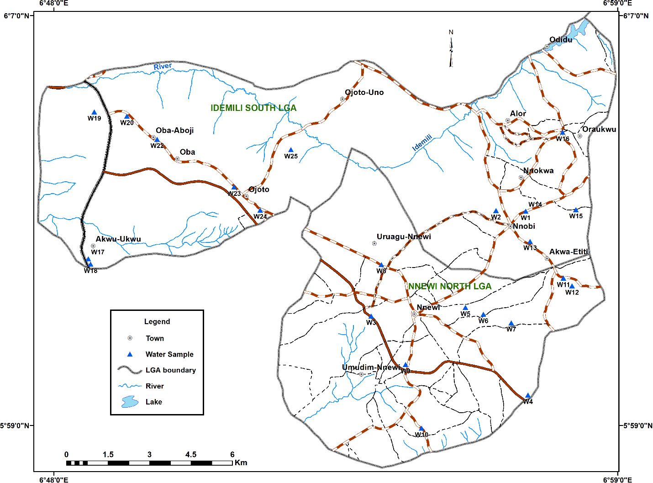
Fig. 1: Map of the Study Area and Groundwater Sampling Locations. The figure shows the spatial distribution of 24 sampling points (APHD1–APHD24) across the study area, providing context for seasonal hydrogeochemical variations.
2.3 Hydrochemical Interpretation
Hydrochemical facies were classified using Piper diagrams to visualize the relative proportions of cations and anions and to identify dominant water types. Durov diagrams were employed to provide detailed insight into hydrochemical processes and to assess the spatial distribution of water types. Ionic ratio scatter plots, such as Na⁺ versus Cl⁻, Ca²⁺ + Mg²⁺ versus HCO₃⁻ + SO₄²⁻, and Na⁺ + K⁺ versus Cl⁻ + SO₄²⁻, were utilized to infer controlling processes such as carbonate dissolution, ion exchange, and evaporite mineral contributions (Gibbs, 1970; Appelo & Postma, 2005). Schoeller diagrams were constructed to compare the concentrations of major ions across all sampling points, while Stiff diagrams were plotted for individual wells to illustrate spatial variations in ionic composition.
Statistical analyses were conducted to quantify the interrelationships among hydrochemical parameters. Descriptive statistics, including mean, median, standard deviation, minimum, and maximum values, were computed to characterize seasonal distributions. Pearson’s correlation coefficients were calculated to examine linear relationships among parameters. These analyses provided insight into the dominant hydrogeochemical processes influencing groundwater chemistry during both dry and rainy seasons.
2.4 Quality Control and Data Validation
The analytical results were validated through ionic balance calculations to ensure the reliability of the laboratory data. Samples exhibiting ionic balance errors greater than ±5% were excluded from further interpretation. Field duplicates and blanks confirmed that sampling and transportation procedures maintained sample integrity. Metadata, including well depth, location coordinates, and sampling date, were meticulously recorded for reproducibility and spatial analysis.
Results and Discussion
3.1 Groundwater Quality Overview
The groundwater quality of the study area exhibits notable seasonal variations. During the rainy season, water is generally fresh to moderately mineralized, with a mean Total Dissolved Solids (TDS) of 226.6 mg/L and Electrical Conductivity (EC) of 84 µS/cm (Table 1), while the dry season shows slightly lower TDS values (162.2 mg/L) but higher EC (242 µS/cm) (Table 2). This pattern of lower solute loads during recharge and higher ionic concentration during dry periods is consistent with classical hydrogeological theory (Freeze & Cherry, 1979) and has been reported in several recent studies from tropical regions, including Nigeria (Olaoye et al., 2022; Ololade et al., 2020). The pH in both seasons is slightly acidic, with means of 5.86 (rainy) and 5.65 (dry), although rainy-season values exhibit higher variability (SD = 1.224) compared to the dry season (SD = 0.552). Such pH fluctuations during periods of high recharge have similarly been attributed to differential buffering capacity, enhanced CO₂ dissolution, and spatially variable water–rock interactions (Kurunc et al., 2016). Contrasting findings from semiarid basins where dry-season pH increases due to evaporite dissolution (Mtoni et al., 2013) highlight that local geology and recharge dynamics strongly influence seasonal responses. Overall, the observed trends align with regional hydrogeochemical behavior in humid tropical aquifers, where dilution and enhanced mineral interaction during the rainy season produce greater hydrochemical heterogeneity.
Table 1: Rainy Season Groundwater Quality Summary. Statistical overview of pH, TDS, EC, major cations and anions, nitrate, and total iron, showing mean, range, and standard deviation. Highlights variability in hydrochemical parameters across sampling points.

Parameter | Unit | EPA MCL | EPA MCL | WHO MCL | Minimum | Maximum | Arithmetic Mean | Standard deviation
Temperature | °C |  |  |  | 25.9 | 27.6 | 27.16 | 0.381
pH |  |  |  |  | 4.62 | 8 | 5.86 | 1.224
EC | uS/cm |  |  |  | 17 | 190 | 84 | 45.9
TDS |  |  |  |  | 137.6 | 484.4 | 226.6 | 114.6
Ca | mg/L |  |  |  | 6.33 | 68.7 | 20.57 | 18.23
Mg | mg/L |  |  |  | 1.653 | 5.58 | 4.12 | 1.21
Na | mg/L |  |  |  | 18.05 | 98.8 | 49.1 | 26.35
K | mg/L |  |  |  | 0.347 | 4.95 | 2.32 | 1.11
Cl | mg/L |  |  |  | 11 | 135 | 36.4 | 30.5
Measured Alkalinity | mg/L |  |  |  | 4 | 724 | 130.8 | 243.7
HCO₃ | mg/l |  |  |  | 34.5 | 225 | 85.5 | 42.4
SO₄ | mg/L |  |  |  | 5 | 62.8 | 22 | 16.77
NO₃ | mg/L | 10 | 10 | 50 | 0.119 | 9.29 | 6.66 | 2.91
Fe | mg/L |  |  |  | 0.0627 | 0.434 | 0.1767 | 0.0945

Table 2: Dry Season Groundwater Quality Summary. Same parameters as Table 1; shows the effects of lower recharge on ion concentrations and mineralization patterns.
Parameter | Unit | EPA MCL | EPA MCL | WHO MCL | Minimum | Maximum | Arithmetic Mean | Standard deviation
pH |  |  |  |  | 4.9 | 7.64 | 5.65 | 0.552
EC. | uS/cm |  |  |  | 144 | 362 | 242 | 60.2
TDS | mg/L |  |  |  | 97 | 243 | 162.2 | 40.3
Ca | mg/L |  |  |  | 2.04 | 16.85 | 6.59 | 2.945
Mg | mg/L |  |  |  | 5.18 | 12.16 | 7.64 | 1.69
Na | mg/L |  |  |  | 11.13 | 81.5 | 39.6 | 23.5
K | mg/L |  |  |  | 1.983 | 8.78 | 5.9 | 1.755
Cl | mg/L |  |  |  | 9 | 64 | 29.16 | 13.6
Measured Alkalinity | mg/L |  |  |  | 18 | 46 | 32.16 | 8.75
HCO₃ | mg/L |  |  |  | 48.5 | 161.7 | 106.3 | 31.8
SO₄ | mg/L |  |  |  | 4 | 54 | 17.36 | 10.86
NO₃ | mg/L | 10 | 10 | 50 | 1.273 | 7.19 | 3.614 | 1.39
Fe | mg/L |  |  |  | 0.007 | 0.278 | 0.0849 | 0.067

Major cations and anions exhibit distinct seasonal and spatial patterns that reflect the dominant hydrogeochemical processes in the aquifer system. Calcium concentrations are notably higher in the rainy season (mean = 20.57 mg/L) compared to the dry season (mean = 6.59 mg/L), a pattern consistent with enhanced dissolution of carbonate minerals during periods of increased recharge (Appelo & Postma, 2005). Similar seasonal increases in Ca–HCO₃ composition during wet periods have been documented in Nigerian crystalline basement terrains and sedimentary aquifers (Onoyima et al, 2025). Magnesium displays the opposite trend, with slightly elevated concentrations in the dry season, likely due to evaporative enrichment or selective mineral weathering an observation also reported in other West African aquifers experiencing seasonal fluctuations
Sodium remains a dominant cation year-round and shows strong associations with Na–HCO₃, Na–Cl, and Na–SO₄ water types. Its strong correlation with TDS and EC (r > 0.85 in both seasons) supports the interpretation that silicate weathering and cation exchange are major controls on groundwater chemistry (Drever, 1997). Recent studies across southern Nigeria similarly attribute Na enrichment to feldspar weathering and ion exchange processes, particularly during prolonged residence times (Olalekan et al, 2023).
Bicarbonate remains the dominant anion in both seasons, confirming the central role of carbonate dissolution in shaping groundwater chemistry. Minor constituents such as nitrate and total iron remain within recommended drinking water limits, with lower values typically observed during the dry season (Tables 1–2). This reduction in nitrate during dry periods has been linked to decreased surface runoff, reduced agricultural leaching, and possible shifts in redox conditions (Todd and Mays, 2005). The higher rainy-season nitrate values (mean = 6.66 mg/L) compared to the dry season (mean = 3.61 mg/L) align with regional studies showing increased mobilization of nitrogen species during intense rainfall and flooding events (Giovanni et al., 2021).
3.2 Hydrochemical Facies and Water Types
Piper and Durov diagrams reveal clear hydrochemical facies differentiation between seasons (Figs. 2a–b; Figs. 3a–b). During the rainy season, four major water types are identified: Na–HCO₃, Na–Cl, Ca–HCO₃, and Na–SO₄. Na–HCO₃ waters dominate, plotting in the upper-left diamond of the Piper diagram (Fig. 2a) and upper-left quadrant of the Durov plot (Fig. 3a), indicating active cation exchange processes in which Ca²⁺ and Mg²⁺ are replaced by Na⁺ (Hem, 1985). This dominance of Na–HCO₃ facies is consistent with aquifers influenced by silicate weathering and clay–water exchange reactions across southern Nigeria and comparable tropical systems (Aisha et al., 2022).
The occurrence of Ca–HCO₃ facies, which occupy the lower-left section of the Piper diamond, is linked to carbonate dissolution, supported by the strong correlation between Ca²⁺ and HCO₃⁻ (Pearson r = 0.917; Table 3 and 4). This hydrochemical pattern is widely documented in recharge-influenced alluvial and sandstone aquifers (Subba Rao, 2006).
Localized Na–Cl and Na–SO₄ waters, characterized by higher TDS, likely reflect inputs from halite and gypsum dissolution or mixing with saline sources. Similar observations have been reported in studies across coastal and inland basins where salinization arises from evaporite dissolution, anthropogenic intrusion, or paleo-saline water interaction (Vasanthavigar et al., 2022). Schoeller and Stiff diagrams corroborate these distinctions and further illustrate spatial hydrochemical variability across the groundwater system (Figs. 4–6), a pattern also noted in recent Nigerian groundwater assessments (Abdulsalam et al., 2022).
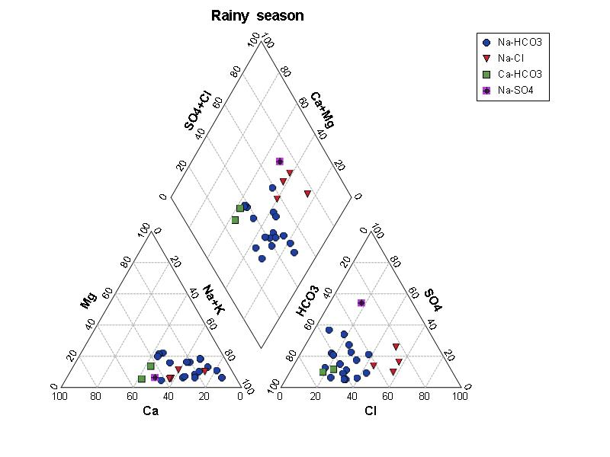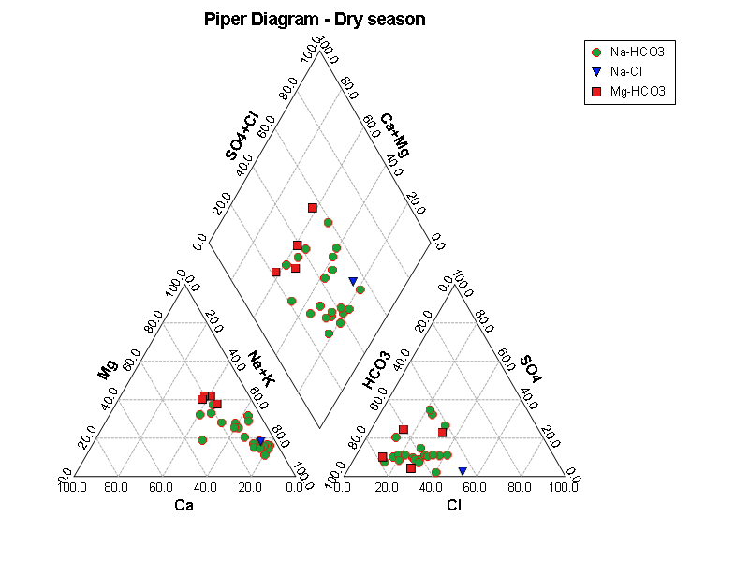
- (b)
Figs. 2 Piper Diagram: (a) Rainy Season. The trilinear diagram classifies groundwater into Na-HCO₃ (blue circles), Na-Cl (red triangles), Ca-HCO₃ (green squares), and Na-SO₄ (purple diamonds) types, revealing dominant cation and anion compositions.
(b) Dry Season. The diagram highlights the predominance of Na-HCO₃ water type during the dry season, with reduced hydrochemical facies diversity compared to the rainy season.
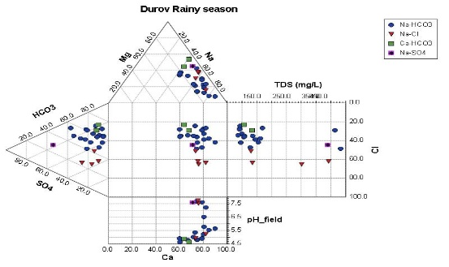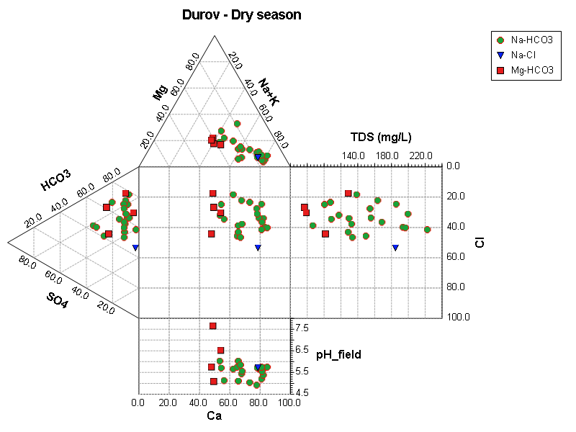
- (b)
Fig. 3: Durov Diagram for (a) Rainy Season. This plot shows cation and anion dominance, TDS, and pH variations. Four distinct clusters corresponding to the main water types are observed, indicating varying hydrogeochemical processes including carbonate dissolution, ion exchange, and saline influence.
(b) Dry Season. The diagram confirms the predominance of Na-HCO₃ waters and shows moderate TDS, reflecting concentration effects during low recharge periods.
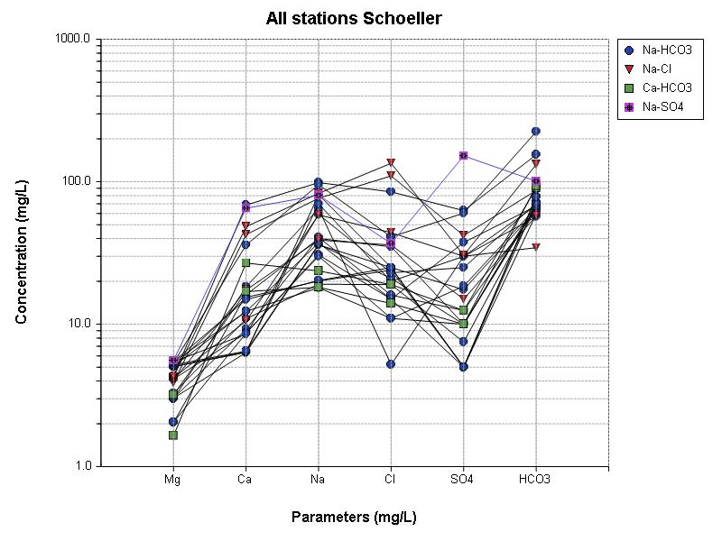
Fig.4: Schoeller Diagram for all Seasons. Semi-log plots comparing major ion concentrations highlight distinct hydrochemical patterns among the four water types, with characteristic peaks for Na, Ca, HCO₃, Cl, and SO₄.
During the dry season, the hydrochemical facies are simplified, with Na-HCO₃ water type predominating (Figs. 3b, 5b). Reduced rainfall and limited recharge lead to lower variability in ion concentrations and a narrower range of water types, consistent with increased ion concentration due to evaporative enrichment.
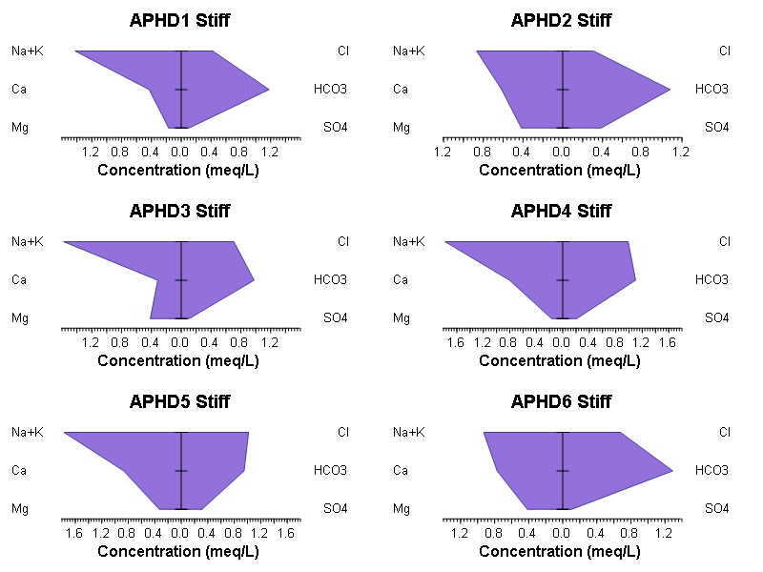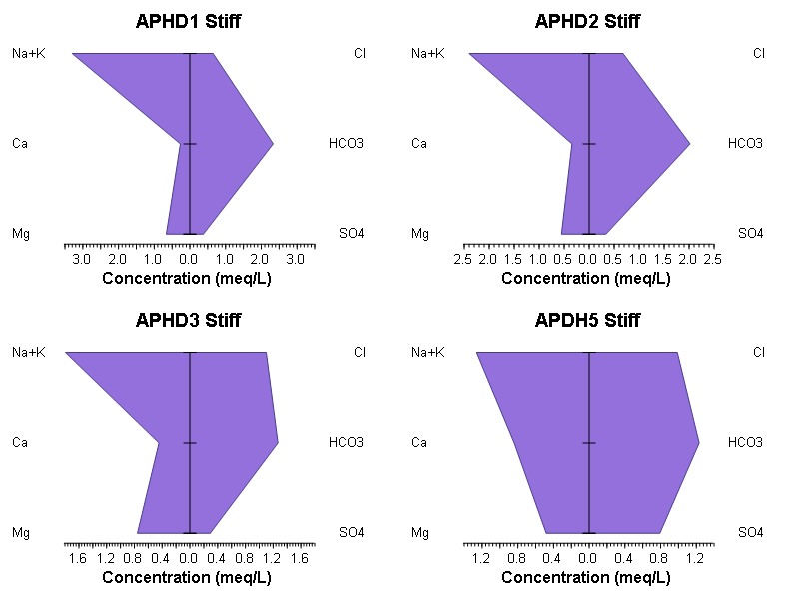
- (b)
Fig. 5: Stiff Diagrams for Selected (a) Rainy Season Samples. Individual diagrams show the polygonal representation of major ion compositions, indicating Na-HCO₃ dominance and highlighting spatial variability among sampling points.
- Dry Season Samples. Individual Stiff diagrams illustrate the reduced variability and consistent Na-HCO₃ facies across most samples.

3.3 Hydrogeochemical Processes
Ionic ratio plots and correlation matrices provide deeper insight into the hydrogeochemical processes governing groundwater evolution in the study area (Figs. 6–7). The Na–Cl plot shows that most Na-HCO₃ and Ca-HCO₃ samples fall below the 1:1 equiline, indicating that sodium enrichment is primarily governed by silicate weathering and cation exchange rather than halite dissolution (Foster et al., 2002). This pattern agrees with findings from southwestern Nigeria, where Na-HCO₃-type groundwater was similarly attributed to silicate weathering of feldspars under tropical humid conditions. In contrast, Na-Cl samples in this study plot close to the 1:1 line, indicating a near-stoichiometric relationship typical of halite dissolution or mixing with saline water sources. Such trends have been widely reported in coastal and inland aquifers influenced by anthropogenic or evaporite-derived salinity.
The Ca+Mg versus HCO₃+SO₄ plot demonstrates that most Na-HCO₃ and Ca-HCO₃ waters align close to the 1:1 line, confirming carbonate mineral dissolution as a dominant process during both seasons. This is consistent with global carbonate-rich aquifers in monsoonal climates, where rainfall-induced recharge enhances dissolution of calcite and dolomite. Only a few samples deviate significantly, suggesting contributions from secondary processes such as ion exchange or sulphate mineral dissolution. The Na+K versus Cl+SO₄ plot further supports that Na and K are predominantly balanced by HCO₃ in most samples, reinforcing the role of silicate weathering and cation exchange. High-salinity Na-Cl and Na-SO₄ points plot above the 1:1 line, indicating additional inputs from saline or sulphate-rich sources, a pattern also observed in crystalline basement terrains of northern Nigeria where anthropogenic inputs and evaporite dissolution locally elevate salinity (Anekwe & Egboka, 2022).
Overall, the ionic ratio diagrams strongly support a hydrogeochemical system dominated by silicate weathering, carbonate dissolution, and ion exchange, with localized halite or sulphate contributions. Recent regional studies across West Africa report similar process interactions under tropical seasonal hydrology, suggesting that the present findings are consistent with broader hydrogeochemical patterns in comparable geological settings (Afolabi et al., 2022).

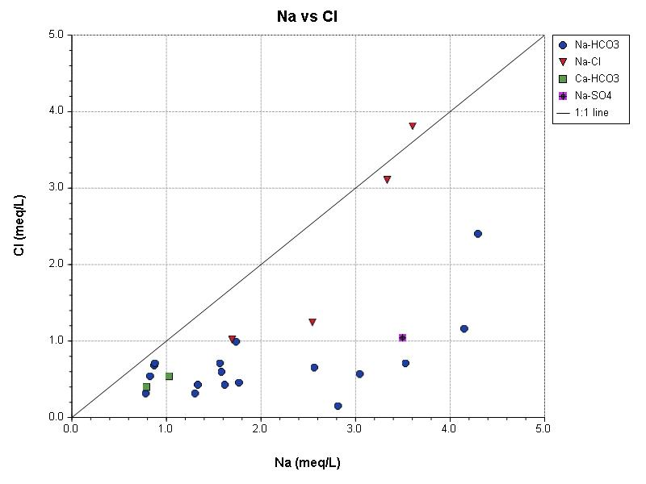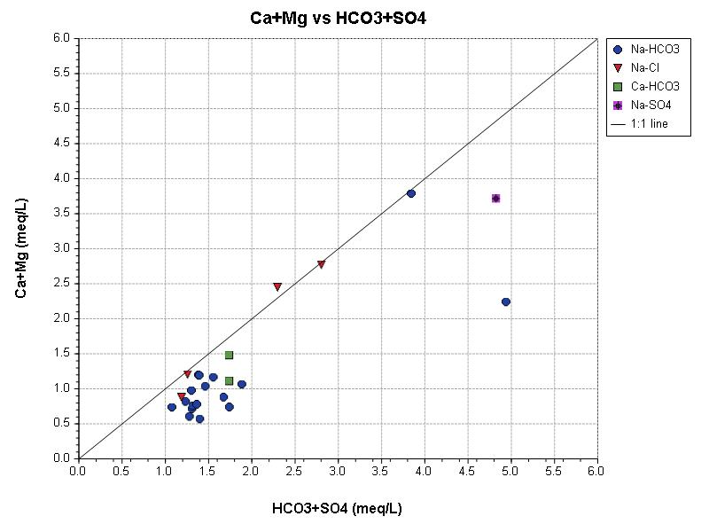
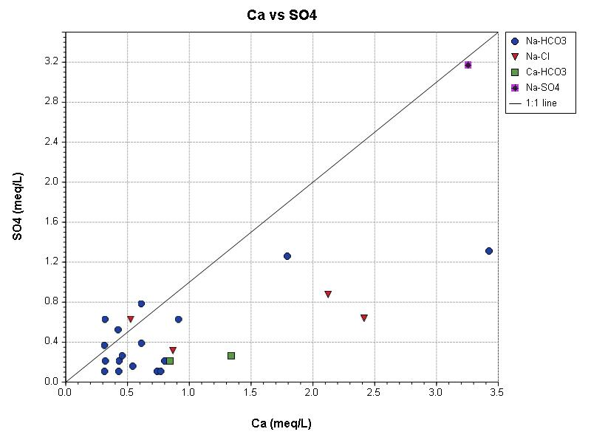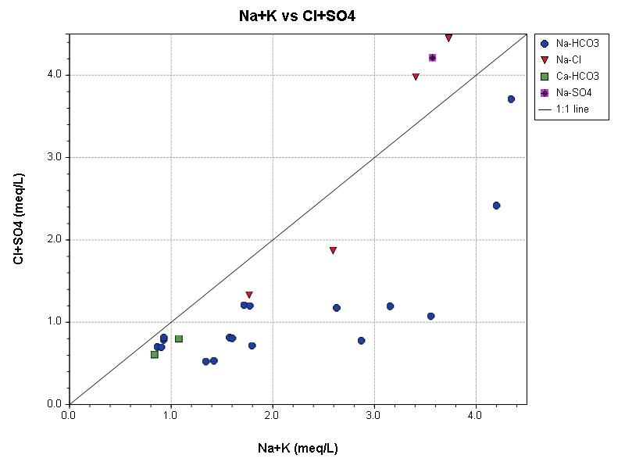
Fig. 6: Ionic Ratio Plots for Rainy Season. Scatter plots of Na vs Cl, Ca+Mg vs HCO₃+SO₄, Na+K vs Cl+SO₄ indicate hydrogeochemical processes such as silicate weathering, carbonate dissolution, ion exchange, and mineral dissolution (halite/gypsum).
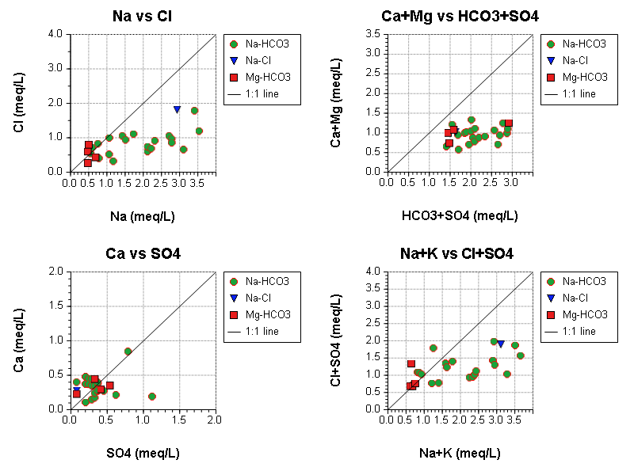
Fig. 7: Ionic Ratio Plots for Dry Season. Similar plots highlight the dominant Na-HCO₃ facies and confirm that Na and HCO₃ are largely controlling the water chemistry under low recharge conditions.
Correlation analyses provide quantitative evidence for the dominant geochemical processes controlling groundwater chemistry in the study area. During the rainy season, the strong correlations observed between EC, TDS, and major ions including Ca (r = 0.907), Na (r = 0.849), HCO₃ (r = 0.919), and SO₄ (r = 0.699) indicate that these solutes are primary contributors to groundwater mineralization. Such patterns are consistent with findings from regional and global hydrogeochemical studies where mineral dissolution, particularly carbonate and silicate weathering, drives ion enrichment during periods of active recharge. The strong positive correlations between pH and Ca, Na, HCO₃, and alkalinity further suggest that carbonate dissolution provides buffering capacity and modulates groundwater acidity, a behavior also reported in tropical and semi-humid aquifer systems with active water–rock interaction.
The moderate negative correlation between pH and nitrate (r = –0.303) may reflect localized denitrification occurring under higher pH or bicarbonate-rich conditions. Similar relationships have been documented in shallow alluvial and sedimentary aquifers where microbial denitrification or nitrate dilution during recharge reduces nitrate concentrations in zones with elevated alkalinity (Subba, (2006).
In the dry season, the correlation structure shifts slightly, with Na and HCO₃ showing dominant control on both EC and TDS. This pattern aligns with the observed homogenization toward Na-HCO₃ facies and reflects longer groundwater residence times, reduced recharge, and increased influence of cation exchange under drier conditions. Comparable dry-season enrichment in Na-HCO₃ waters has been reported in several West African and South Asian sedimentary aquifers, where evaporative concentration and ion-exchange intensification are prevalent. The persistence of strong EC–TDS–cation correlations across seasons reinforces the interpretation that water–rock interaction processes dominate solute acquisition in the aquifers, despite seasonal hydrological variations.

Table 3: Pearson Correlation Matrix for Rainy Season. Shows linear correlations among major water quality parameters; highlights strong relationships between EC/TDS and Ca, Na, HCO₃, SO₄, and alkalinity, indicating dominant hydrogeochemical processes.
 |  | Temp | pH _field | Cond | TDS | Ca | Mg | Na | K | Cl | Meas _Alk | HCO3 | SO4 | NO3
Temp | °C | 1.00 | 0.05 | 0.09 | 0.10 | 0.14 | 0.24 | 0.01 | 0.06 | 0.09 | 0.06 | 0.09 | 0.20 | -0.03
pH |  |  | 1.00 | 0.76 | 0.76 | 0.69 | 0.21 | 0.68 | 0.20 | 0.69 | 0.73 | 0.61 | 0.52 | -0.30
Cond | uS/cm |  |  | 1.00 | 1.00 | 0.89 | 0.27 | 0.88 | 0.30 | 0.82 | 0.91 | 0.84 | 0.71 | -0.28
TDS | mg/l |  |  |  | 1.00 | 0.91 | 0.25 | 0.85 | 0.29 | 0.83 | 0.92 | 0.86 | 0.70 | -0.28
Ca | mg/l |  |  |  |  | 1.00 | 0.13 | 0.63 | 0.26 | 0.82 | 0.92 | 0.77 | 0.68 | -0.12
Mg | mg/l |  |  |  |  |  | 1.00 | 0.18 | 0.15 | 0.12 | 0.23 | 0.27 | 0.38 | -0.01
Na | mg/l |  |  |  |  |  |  | 1.00 | 0.16 | 0.70 | 0.73 | 0.58 | 0.66 | -0.28
K | mg/l |  |  |  |  |  |  |  | 1.00 | 0.37 | 0.28 | 0.16 | 0.14 | -0.04
Cl | mg/l |  |  |  |  |  |  |  |  | 1.00 | 0.80 | 0.51 | 0.53 | -0.19
Meas_Alk | mg/L |  |  |  |  |  |  |  |  |  | 1.00 | 0.77 | 0.68 | -0.14
HCO3 | mg/l |  |  |  |  |  |  |  |  |  |  | 1.00 | 0.56 | -0.32
SO4 | mg/l |  |  |  |  |  |  |  |  |  |  |  | 1.00 | -0.08
NO3 | mg/l |  |  |  |  |  |  |  |  |  |  |  |  | 1.00

Table 4: Pearson Correlation Matrix – Dry Season. Highlights linear relationships under lower recharge conditions; Na-HCO₃ facies dominate the correlation patterns.
 |  | pH _field | Cond | TDS | Ca | Mg | Na | K | Cl | Meas _Alk | HCO3 | SO4 | NO3 | Fe
pH |  | 1.00 | -0.01 | -0.01 | 0.18 | 0.31 | -0.18 | -0.61 | 0.10 | 0.03 | 0.27 | -0.16 | -0.01 | -0.34
Cond | uS/cm |  | 1.00 | 1.00 | 0.01 | 0.14 | 0.92 | -0.14 | 0.69 | 0.08 | 0.58 | 0.04 | -0.13 | 0.20
TDS | mg/l |  |  | 1.00 | 0.01 | 0.14 | 0.92 | -0.14 | 0.69 | 0.09 | 0.58 | 0.04 | -0.13 | 0.20
Ca | mg/l |  |  |  | 1.00 | -0.06 | -0.24 | -0.20 | 0.08 | -0.21 | 0.07 | 0.12 | 0.02 | -0.18
Mg | mg/l |  |  |  |  | 1.00 | 0.00 | -0.36 | 0.16 | 0.05 | 0.38 | -0.27 | -0.44 | -0.18
Na | mg/l |  |  |  |  |  | 1.00 | -0.05 | 0.64 | 0.12 | 0.41 | -0.05 | -0.13 | 0.25
K | mg/l |  |  |  |  |  |  | 1.00 | -0.22 | -0.14 | -0.22 | 0.14 | 0.13 | 0.29
Cl | mg/l |  |  |  |  |  |  |  | 1.00 | -0.04 | 0.12 | -0.25 | -0.19 | -0.03
Meas_Alk | mg/L |  |  |  |  |  |  |  |  | 1.00 | 0.14 | -0.02 | -0.20 | -0.02
HCO3 | mg/l |  |  |  |  |  |  |  |  |  | 1.00 | -0.34 | -0.23 | 0.09
SO4 | mg/l |  |  |  |  |  |  |  |  |  |  | 1.00 | 0.29 | 0.07
NO3 | mg/l |  |  |  |  |  |  |  |  |  |  |  | 1.00 | 0.53

3.4 Seasonal Variations
Seasonal comparisons reveal important hydrogeochemical contrasts that broadly align with published findings but also admit alternative interpretations. Wet-season recharge commonly enhances carbonate dissolution, increasing Ca²⁺, HCO₃⁻, and alkalinity, a pattern consistent with observations in both Nigerian and global aquifers where intensified infiltration promotes mineral weathering and facies diversification (Kurunc et al, 2016). The dry season, by contrast, typically exhibits reduced Ca and alkalinity but elevated Mg and K, reflecting evaporative concentration and longer residence periods, as documented in several coastal and inland aquifers influenced by seasonal water-table decline (Afolabi, 2022). The predominance of Na–HCO₃ water type across seasons in the present study is therefore reasonable, although the appearance of Na–Cl and Na–SO₄ facies during the rainy period may derive from both natural influx of surface-derived salts via preferential flow and anthropogenic contributions mobilized during storm events, as recent hydrogeochemical assessments in urbanized terrains show mixed lithologic–anthropogenic seasonal signatures. Nonetheless, some studies caution that rapid flow paths and shallow residence times in certain aquifers can limit the extent of carbonate dissolution or salt mobilization expected from seasonal recharge, implying that structural controls, flow regimes, and land-use factors may interact with hydrological force to shape the observed facies evolution. These lines of evidence together support the general seasonal pattern recorded in the study area while highlighting plausible alternative mechanisms that may modulate the magnitude of the chemical shifts.

3.5 Groundwater Suitability for Irrigation
Wilcox diagrams indicate that Na–HCO₃ and Ca–HCO₃ waters generally fall in the low to medium salinity hazard zones (C1–C2) and low sodium hazard (S1), confirming their relative suitability for irrigation. In contrast, Na–Cl and Na–SO₄ waters exhibit high salinity hazard (C3), although sodium hazard remains low (S1), suggesting potential risks for crop salinization under those facies. TDS vs ion concentration plots further demonstrate that Na, Cl, HCO₃, and SO₄ dominate the dissolved solids budget, which underscores the importance of selective monitoring in areas where these ions accumulate. Overall, while most groundwater in the study area appears safe for irrigation in terms of sodium hazard, the seasonal emergence of saline or sulphate-rich waters during the rainy season demands proactive salinity management. Similar concerns have been raised in recent studies of semi-arid and tropical aquifers, where high salinity waters can impair agricultural productivity despite acceptable SAR values (Madu et al., 2022).
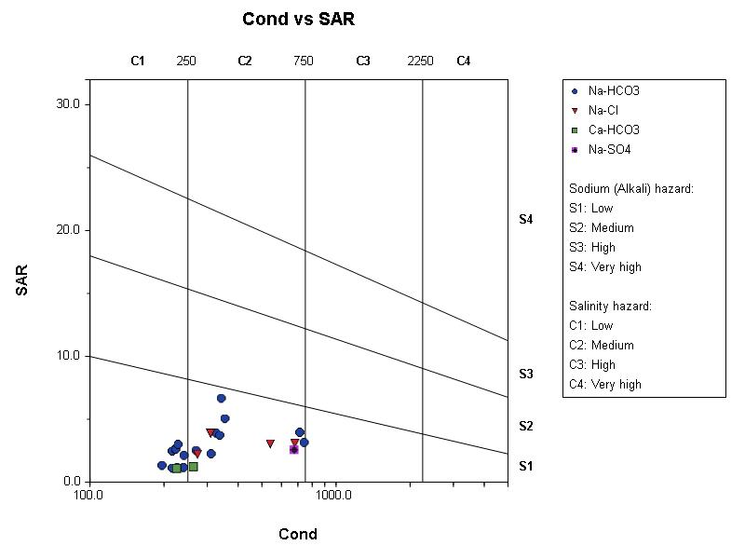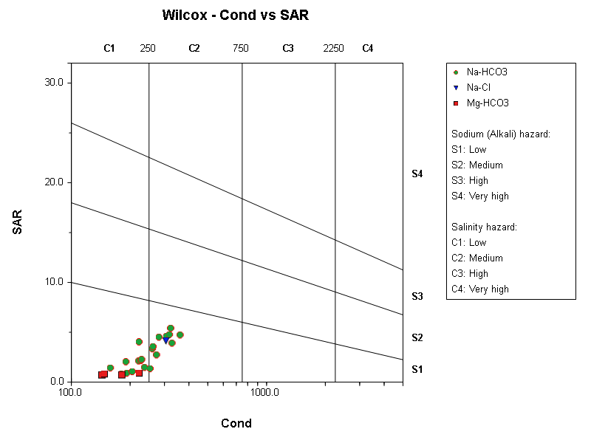
- (b)
Fig. 8: Wilcox Diagram for (a) Rainy Season. SAR vs EC plot shows that Na-HCO₃ and Ca-HCO₃ samples have low to medium salinity hazard (C1–C2) and low sodium hazard (S1), while Na-Cl and Na-SO₄ waters have high salinity hazard (C3). (b) Dry Season. Most samples remain in the low sodium hazard (S1) category, confirming suitability for irrigation, while some concentration effects are noted in salinity hazard.
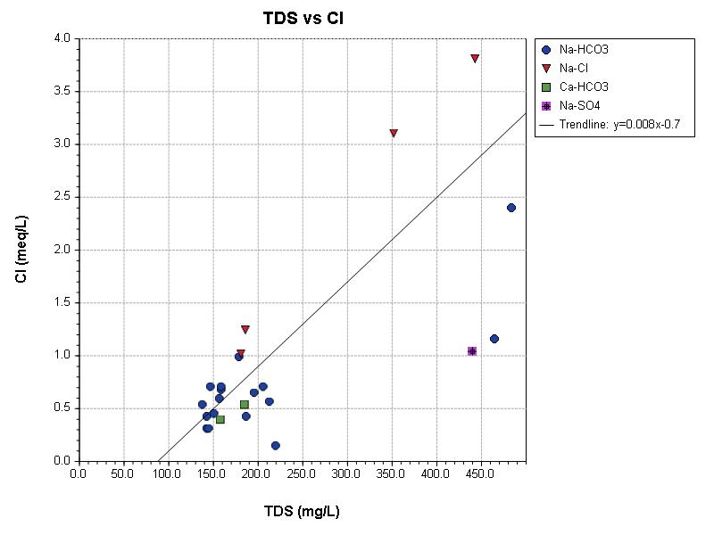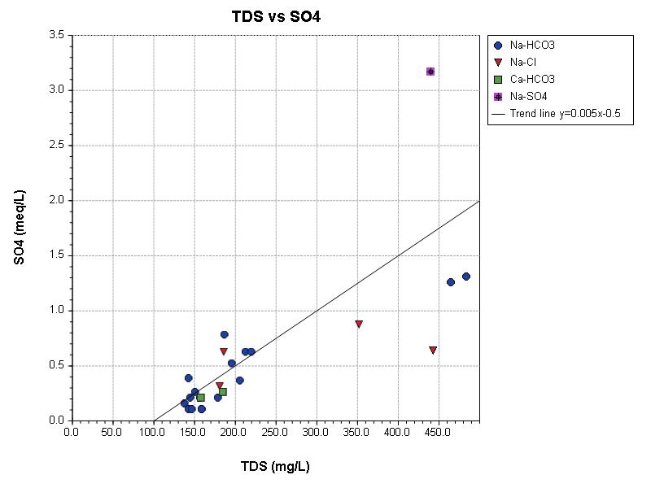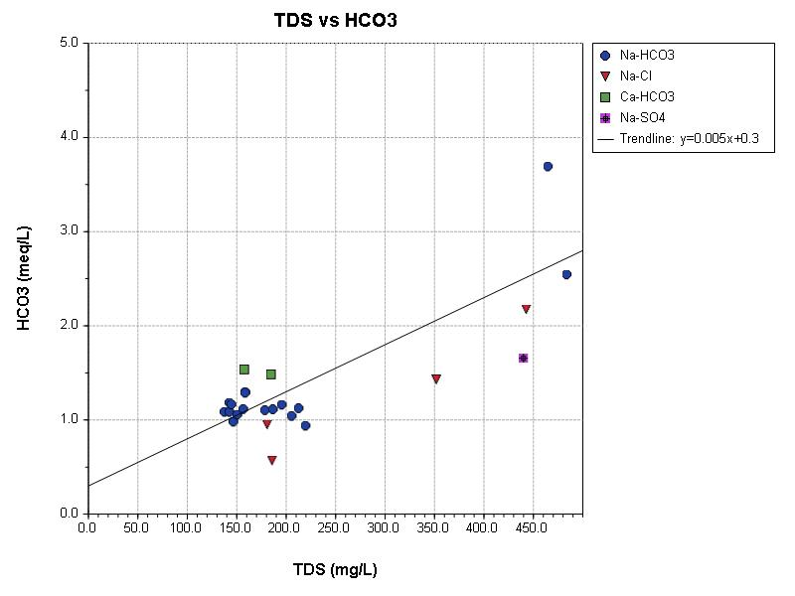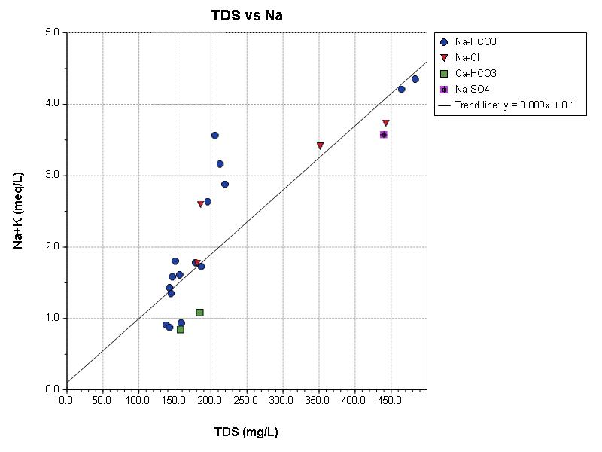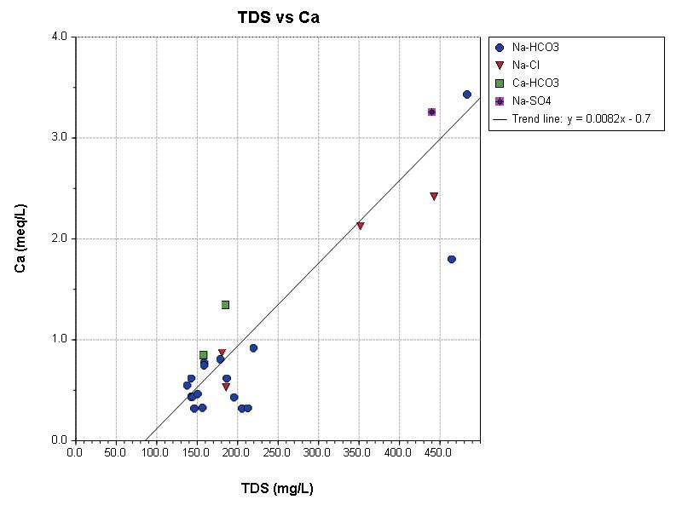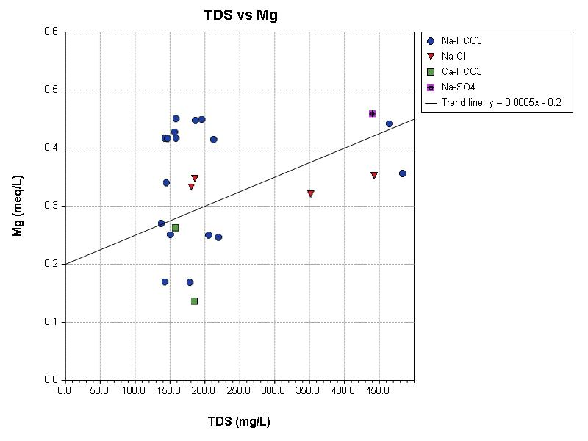
Fig. 9: TDS vs Major Ion Plots for Rainy Season. Scatter plots show strong positive correlations between TDS and Na, Cl, SO₄, Ca, Mg, HCO₃; identifying the major contributor to groundwater mineralization.
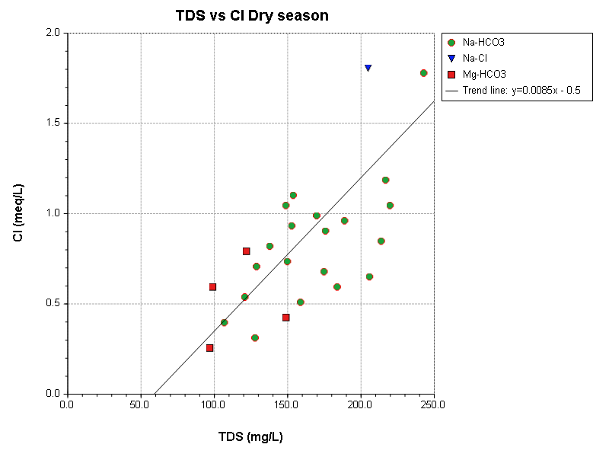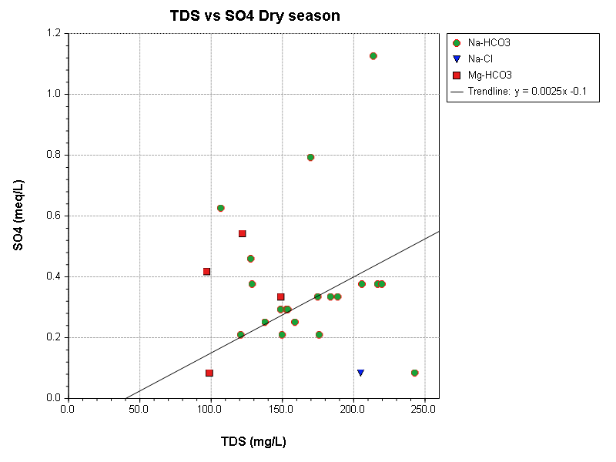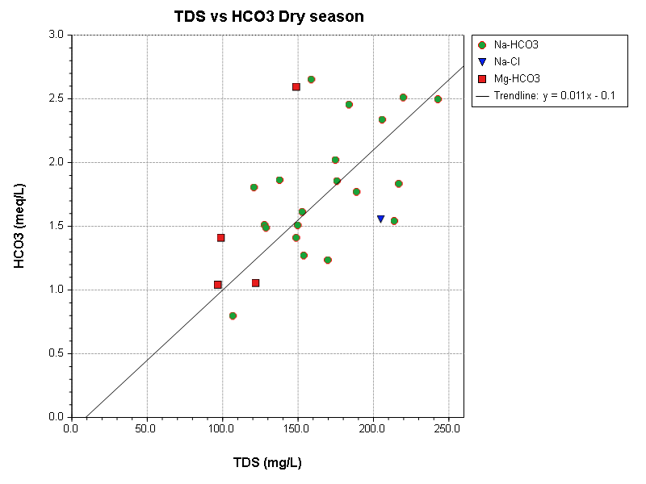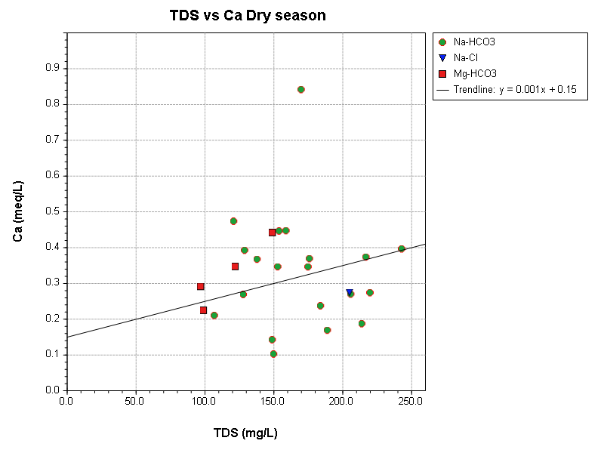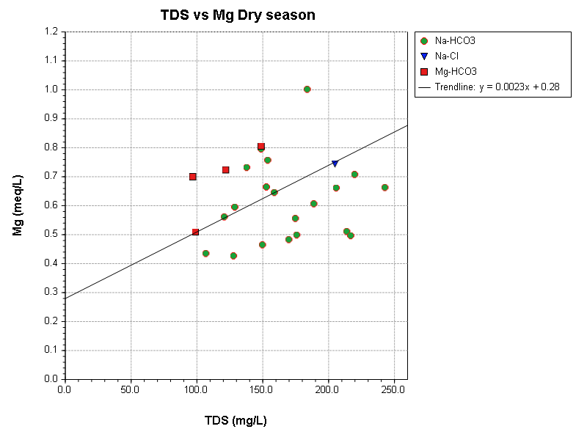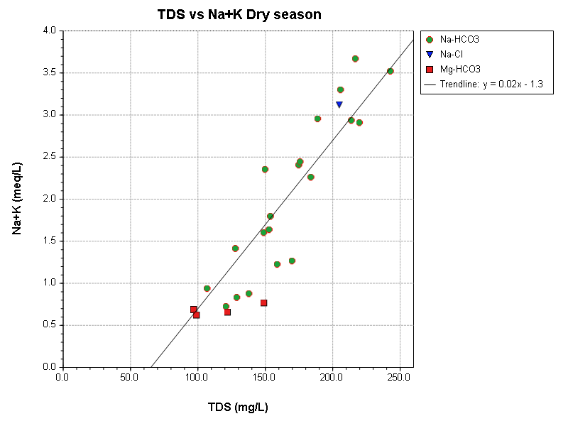
Fig. 10: TDS vs Major Ion Concentrations for Dry Season. Scatter plots confirm that Na, Cl, and HCO₃ dominate TDS contributions, with weaker influence from Mg, reflecting seasonal concentration effects.
The combined analyses of hydrochemical facies, ionic ratios, TDS correlations, and seasonal variability indicate that the groundwater system in the study area is principally controlled by silicate weathering, carbonate dissolution, and ion-exchange processes, with subordinate inputs from evaporite minerals such as halite and gypsum. These processes, and their seasonal expression, are consistent with regional and global studies showing that rock–water interaction and cation exchange govern shallow groundwater evolution while episodic recharge mobilizes additional solutes and produces greater spatial heterogeneity (Appelo & Postma, 2005; Subba, (2006). In the local context, recent hydrogeochemical investigations in southeastern Nigeria report similar controls of carbonate and silicate weathering coupled with ion exchange with seasonal recharge particularly responsible for the emergence of more saline or sulphate-rich facies during the wet season (Olaoye et al., 2022). Empirical studies of recharge dynamics further demonstrate that increased rainfall events modify flow paths and accelerate mineral dissolution, explaining the seasonal shift from diverse rainy-season facies (Na–HCO₃, Na–Cl, Ca–HCO₃, Na–SO₄) to a more homogenized Na–HCO₃ signature in the dry season. The strong statistical covariation of EC and TDS with major cations and anions in this study quantitatively reinforces these process interpretations and agrees with recent multiregional syntheses of groundwater hydrochemical evolution (Subba, 2006)
Conclusion
This study provides a comprehensive evaluation of groundwater quality and hydrogeochemical evolution in Idemili South and Nnewi North Local Government Areas of Anambra State, Nigeria, integrating physicochemical assessment, hydrochemical facies characterization, ionic ratio relationships, seasonal variability, and statistical correlations. Results demonstrate that groundwater chemistry in the study area is primarily controlled by silicate weathering, carbonate dissolution, and cation exchange, with secondary contributions from evaporite minerals such as halite and gypsum. These processes collectively shape the dominant facies observed across seasons, ranging from Na–HCO₃, Ca–HCO₃, and Na–SO₄ to Na–Cl water types.
Seasonal comparison shows that recharge during the rainy season enhances hydrochemical diversity by diluting solute concentrations and activating multiple geochemical pathways, whereas the dry season promotes chemical homogenization towards Na–HCO₃ dominance due to reduced recharge and evaporative concentration. The strong correlations among EC, TDS, major cations, and anions further validate the identified geochemical controls and highlight the predictability of groundwater evolution in the area. Overall, most groundwater samples fall within acceptable limits for domestic and agricultural uses, although localized elevations in EC, TDS, and chloride indicate zones of potential anthropogenic or geogenic influence requiring continued monitoring.
The findings underscore the importance of seasonally resolved water quality assessment for groundwater-dependent communities in southeastern Nigeria. They also provide a scientific basis for informed groundwater management, well-siting decisions, and the development of long-term water protection strategies. Continued monitoring and incorporation of isotopic or geophysical data are recommended to refine understanding of recharge dynamics, flowpaths, and potential contamination sources in this rapidly urbanizing region.

Disclaimer (Artificial intelligence)
Option 1:
Author(s) hereby declare that NO generative AI technologies such as Large Language Models (ChatGPT, COPILOT, etc.) and text-to-image generators have been used during the writing or editing of this manuscript.
References
- Adeyemi, O., Ojekunle, Z., & Oguntoase, A. (2019). Surface and groundwater quality assessment in rural communities of Oyo State, Nigeria. Environmental Monitoring and Assessment. https://doi.org/10.1007/s10661-019-7326-9
- Afolabi, T. A., Adelana, S. M. A., & Tijani, M. N. (2022). Hydrogeochemical processes controlling groundwater quality in a tropical basement complex terrain, southwestern Nigeria. Environmental Earth Sciences, 81(5), 1–18. https://doi.org/10.1007/s12665-022-10332-3
- Aisha Abubakar Kana, Abu Nasiru Enebi, and Ahmad Abubakar Kana (2022). Hydrogeochemical Processes of Groundwater from Basement Complex Rocks in Keffi, Central Nigeria. Earth Sci. 2022;11(5):307-315. doi: 10.11648/j.earth.20221105.17
- Abdulsalam, A., Ramli, M.F., Jamil, N.R. et al. Hydrochemical characteristics and identification of groundwater pollution sources in tropical savanna. Environ Sci Pollut Res 29, 37384–37398 (2022). https://doi.org/10.1007/s11356-022-18552-0
- Alloway, B. J. (2013). Heavy metals in soils: Trace metals and metalloids in soils and their bioavailability (3rd ed.). Springer. https://doi.org/10.1007/978-94-007-4470-7
- Amah-Jumbo, S. D., Obiora, D. N., & Anikwe, M. A. (2019). Hydrogeochemical characterization and water quality assessment in parts of Southern Nigeria. Environmental Earth Sciences. https://doi.org/10.1007/s12665-019-8378-1
- American Public Health Association, American Water Works Association, & Water Environment Federation. (2005). *Standard methods for the examination of water and wastewater* (21st ed.). https://www.standardmethods.org/

Giovanni Castaldo., Ate Visser., Graham E. Fogg., and Thomas Harter (2021). Effect of Groundwater Age and Recharge Source on Nitrate Concentrations in Domestic Wells in the San Joaquin Valley. Environ. Sci. Technol. 2021, 55, 2265−2275
- Anekwe, O. S., & Egboka, B. C. E. (2022). Hydrogeochemical evolution and salinity sources in crystalline basement aquifers of northern Nigeria. Groundwater for Sustainable Development, 18, 100743. https://doi.org/10.1016/j.gsd.2022.100743
- Appelo, C. A. J., & Postma, D. (2005). Geochemistry, groundwater and pollution (2nd ed.). CRC Press. https://doi.org/10.1201/9781439833544
- Bhatt, M. P., & McDowell, J. (2019). Controls of major ions and trace metals in groundwater systems: A global review. Hydrogeology Journal.https://doi.org/10.1007/s10040-018-1905-4
- Chapman, D. (1996). Water quality assessments: A guide to the use of biota, sediments and water in environmental monitoring (2nd ed.). UNESCO/WHO/UNEP. https://doi.org/10.1201/9781003062103
- Drever, J. I. (1997). The geochemistry of natural waters: Surface and groundwater environments. Prentice Hall. https://www.groundwaterproject.org/books/the-geochemistry-of-natural-waters/
- Egboka, B. C. E., & Orajaka, I. P. (1988). Soil and gully erosion models for effective control programs. Geoforum, 18(3), 333–341.
- Foster, S., Hirata, R., Gomes, D., D'Elia, M., & Paris, M (2002). Groundwater Quality Protection: A Guide for Water Utilities, Municipal Authorities, and Environment Agencies. World Bank Publications

- Freeze, R.A. and Cherry, J.A. (1979) Groundwater. Prentice-Hall Inc., Englewood Cliffs, Vol. 7632, 604.
- Hem, J. D. (1985). Study and interpretation of the chemical characteristics of natural water (3rd ed.). U.S. Geological Survey Water-Supply Paper 2254.https://doi.org/10.3133/wsp2254
- Mtoni, Y., Mjemah, I. C., Bakundukize, C., van Camp, M., Walraevens, K., & Nkotagu, H. H. (2013). Saltwater intrusion in a coastal aquifer of Dar es Salaam, Tanzania: Hydrogeochemical evidence. Environmental Earth Sciences, 70(3), 1091–1111.https://doi.org/10.1007/s12665-012-2191-7
- Nwajide, C.S. (2013) Geology of Nigeria’s Sedimentary Basins. CSS Bookshop Ltd., Lagos, 1-565.
- evaluation of groundwater systems in the Anambra region, Nigeria. Journal of African Earth Sciences, 142, 33–45. [https://doi.org/10.1016/j.jafrearsci.2018.03.009](https://doi.org/10.1016/j.jafrearsci.2018.03.009)
- Olalekan, A. S., Adewoye, S. O., & Henry, S. O. (2023). Comprehensive understanding of hydrogeochemical evaluation of seasonal variability in groundwater quality dynamics in the gold mining areas of Osun state, Nigeria. International Journal of Hydrology, 7(5), 206–220. https://doi.org/10.15406/ijh.2023.07.00359
- Olaoye, T. J., Aladejana, J. A., Oke, S. A., & Ojo, A. O. (2022). Seasonal hydrogeochemical controls on groundwater quality in a tropical basement complex terrain, southwestern Nigeria. Environmental Monitoring and Assessment, 194, 337.https://doi.org/10.1007/s10661-022-09961-0
- Ololade, I. A., Ologundudu, A. F., & Adeleke, B. B. (2020). Seasonal variability and pollution sources of groundwater quality in a rapidly urbanizing city in southwest Nigeria. Environmental Science and Pollution Research.https://doi.org/10.1007/s11356-019-07433-2
- Onoyima, C. C., Okpanachi, C. B., & Akoji, J. N. (2025). Hydro-geochemical characterization and groundwater quality assessment of Mariri Aquifer, Kano, Nigeria. Journal of Agriculture and Environment for International Development, 119(1), 469–486. https://doi.org/10.36253/jaeid-17814
- Onwuemesi, A. G., Egboka, B. C. E., Orajaka, I. P., & Emenike, E. A. (1991). Implications of hydrogeophysical investigations of the Agulu-Nanka gullies area of Anambra state of Nigeria. Journal of African Earth Sciences, 13(3-4), 519–526.https://doi.org/10.1016/0899-5362(91)90114-E
- Reyment, R. A. (1965). Aspects of the geology of Nigeria: The stratigraphy of the Cretaceous and Cenozoic deposits. Ibadan University Press. https://books.google.com/books/about/Aspects_of_the_Geology_of_Nigeria.html?id=2_0tAAAAMAAJ
- Sawyer, C. N., McCarty, P. L., & Parkin, G. F. (2003). Chemistry for environmental engineering and science (5th ed.). McGraw-Hill.
- Todd, D. K., & Mays, L. W. (2005). Groundwater Hydrology (3rd ed.). John Wiley & Sons. https://www.wiley.com/en-us/Groundwater+Hydrology,+3rd+Edition-p-9780471059370
- UN-Water. (2021). Summary progress update 2021: SDG 6 — water and sanitation for all. United Nations. https://www.unwater.org/publications/summary-progress-update-2021-sdg-6-water-and-sanitation-all
- Al Maliki, A., Kumar, U. S., Falih, A. H., Sultan, M. A., Al-Naemi, A., Alshamsi, D., Arman, H., Ahmed, A., & Sabarathinam, C. (2024). Geochemical processes, salinity sources and utility characterization of groundwater in a semi-arid region of Iraq through geostatistical and isotopic techniques. Environmental Monitoring and Assessment, 196(4), 365. https://doi.org/10.1007/s10661-024-12533-1
- Vörösmarty, C. J., McIntyre, P. B., Gessner, M. O., Dudgeon, D., Prusevich, A., Green, P., Glidden, S., Bunn, S. E., Sullivan, C. A., Liermann, C. R., & Davies, P. M. (2010). Global threats to human water security and river biodiversity. Nature, 467(7315), 555–561. https://doi.org/10.1038/nature09440
- Subba Rao, N. (2006). Seasonal variation of groundwater quality in a part of Guntur District, Andhra Pradesh, India. Environmental geology, 49(3), 413-429.
- https://link.springer.com/article/10.1007/s00254-005-0089-9

- Kurunc, A., Ersahin, S., Sonmez, N. K., Kaman, H., Uz, I., Uz, B. Y., & Aslan, G. E. (2016). Seasonal changes of spatial variation of some groundwater quality variables in a large irrigated coastal Mediterranean region of Turkey. Science of the Total Environment, 554, 53-63.https://www.sciencedirect.com/science/article/pii/S0048969716303692

- Irrigation Water Quality Assessment and Hydrochemical Facie of Oguta Lake, Southeastern Nigeria. (2022). European Journal of Environment and Earth Sciences, 3(1), 1-6. https://doi.org/10.24018/ejgeo.2022.3.1.221
- World Health Organization. (2017). Guidelines for drinking-water quality (4th ed., incorporating the first addendum). World Health Organization.https://apps.who.int/iris/bitstream/10665/254637/1/9789241549950-eng.pdf

