Impact of Climate Change on Tourism and Adaptation Measures in Vjosa Basin

Abstract. Abstract. Tourism is one of the most climate sensitive economic sectors, but at the same time, like many economic activities, it also contributes to climate change. The effects of climate change are becoming a growing concern, especially in the tourism sector, which urgently and needs to find solutions, especially considering its contribution to climate change.
Over the past decades there has been a growing interest in issues related to the connections between climate change and tourism. However, in much of this literature, the present climate change is often referred to as a new phenomenon, which presents the researchers with new challenges and problems. However, we must bear in mind that climate change is not a completely new phenomenon. In fact, over the course of history there have been various interactions between climate change and tourism and various approaches.
In this paper we have analyzed the impact of Climate Change on Tourism sector in the Vjosa Basin by taking in consideration different indicators and methods such as: indicators of capacity utilization of hotels and similar structures, tourists’ number and accommodation facilities, tourism climate index etc.
Keywords: Climate change, Vjosa Basin, tourism activity, impact, adaptation measures.

- Introduction
Tourism is widely recognized as one of the economic sectors most directly influenced by climatic conditions. Temperature, precipitation, humidity, and extreme weather events shape both the seasonal distribution and overall attractiveness of destinations. At the same time, tourism itself contributes to climate change through increased mobility, energy consumption, and land-use pressures. As a result, the reciprocal relationship between tourism and climate has become an important research focus, particularly in regions undergoing rapid socio-environmental transitions.
Over the past decades, scientific interest in the climate–tourism nexus has grown substantially. While contemporary climate change is often portrayed as an unprecedented challenge for destination planning and management, historical and paleo-environmental evidence shows that human mobility and recreation patterns have always responded to climatic fluctuations. What distinguishes the present era is the accelerated rate of warming, the growing frequency of extreme heat events, and the increasing spatial disparities in climate suitability—all of which create new pressures and adaptation needs for the tourism sector.
The Vjosa River Basin, one of the most ecologically valuable and culturally rich regions in Albania, has witnessed increasing tourism activity in recent years, especially in nature-based, cultural, and adventure tourism. However, the basin’s complex topography and varied microclimates make it particularly sensitive to temperature rise, changes in precipitation regimes, and seasonal humidity patterns. Understanding these dynamics is crucial for evaluating how future climatic conditions may affect tourism potential and visitor comfort.
In this study, we assess the impact of climate change on tourism in the Vjosa Basin by integrating tourism indicators (tourist arrivals, overnight stays, accommodation capacity, and the Tourism Climate Index) with spatial climatic indicators. Specifically, we calculate and map the De Martonne Aridity Index (2000–2019) to evaluate the basin’s humidity and aridity gradients, and the Thermal Humidity Index (THI) to assess heat-stress and thermal comfort conditions across the basin. These spatial analyses reveal clear climatic contrasts between the upper and lower valley and highlight emerging vulnerabilities related to warming trends.
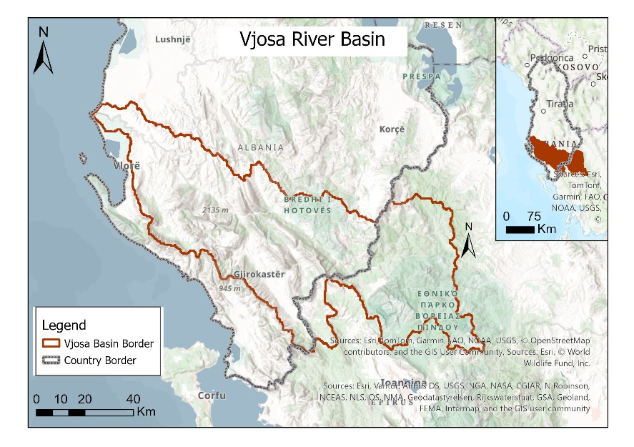
By combining climatic and tourism data, the study provides a comprehensive evaluation of how climate change is shaping tourism suitability in the Vjosa Basin and identifies areas where targeted adaptation measures will be necessary to ensure sustainable development of the sector. (Figure 1).
Fig. 1. Map of Vjosa River Basin
Figure 1. Geographical position of Vjosa River Basin (VRB)

- Methodology
The methodological framework applied in this study adopts an integrated approach to evaluate the climatic conditions of the Vjosa Basin and their implications for tourism development. The analysis combines climatic datasets, spatial processing techniques, and climate–tourism indicators to assess environmental suitability and potential exposure of the tourism sector to climate-related pressures. All procedures were designed to ensure internal consistency between climatic inputs, GIS operations, and interpretive outputs.

Data Sources for Tourism Indicators
Tourism-related variables—including visitor arrivals, overnight stays, and accommodation capacity—were retrieved from the official statistical system of Albania. Data were obtained from INSTAT tourism statistics (2014–2023) and the Tourism Accommodation Survey (2019–2021). These datasets provide insights into temporal dynamics and structural characteristics of the tourism sector within the basin.
(a) Climate Trend Analysis: Climatic indicators were derived from the ERA5-Land reanalysis dataset, covering the period 2000–2019. Original raster layers for temperature and precipitation were clipped to the extent of the Vjosa Basin and reprojected to WGS 1984 UTM Zone 34N to achieve spatial alignment across all inputs.
Mean annual rasters for Tmax, Tmin, and precipitation were produced and classified using fixed manual intervals, reflecting climatological categories typically applied in Mediterranean and Balkan regional studies.
Spatial operations—including raster processing, symbology standardization, layout preparation, and map compilation—were carried out in ArcGIS Pro. This ensured a consistent representation of spatial patterns in temperature and rainfall, enabling reliable comparison across variables.
(b) Climate Variables and the De Martonne Aridity Index: To characterize the basin’s climatic regime, three core variables were analyzed: mean annual maximum temperature, mean annual minimum temperature, and mean annual precipitation.
Temperature ranges were grouped into widely used agroclimatic and bioclimatic intervals (≤10°C, 10–12°C, 12–14°C, etc.), while precipitation was classified according to hydrological relevance for Mediterranean catchments (very low <900 mm; low 900–1100 mm; medium 1100–1300 mm; high 1300–1500 mm; very high 1500–1700 mm; extremely high >1700 mm).
To further interpret the interaction between temperature and precipitation, the De Martonne Aridity Index (AI) was calculated:
$$AI=\frac{P}{Tmean+10}$$

where P represents mean annual precipitation (mm) and Tmean the mean annual temperature (°C).
Although the Vjosa Basin falls entirely within the humid climatic domain, the resulting AI raster was subdivided into five internal classes to highlight spatial heterogeneity. This refinement allowed a more detailed interpretation of microclimatic differences within the basin.
(c) Thermal Humidity Index (THI): To evaluate thermal comfort and potential heat stress relevant to tourism activities, the Thermal Humidity Index (THI) was computed using mean annual temperature and precipitation:
THI=T−0.01×P

where T denotes mean annual temperature (°C) and P annual precipitation (mm).
The THI captures combined thermal and moisture effects on human comfort.
The resulting index was classified into five comfort categories. These classes follow standard thresholds used in bioclimatic comfort studies and reflect the range of conditions experienced within the basin.
(d) Spatial Visualization and Cartographic Design: Spatial visualization in maps was made by using coherent color schemes that facilitate the interpretation of climatic gradients: Blue–green tones for humid conditions and lower stress levels; Yellow–red tones for warmer or drier conditions associated with higher stress.
Each map layout includes all the components and in all of them it was used the same projection, symbology, and classification rules to allow direct comparison between temperature, precipitation, and other climatic indexes.

3. Results and Discussion

3.1 The prognosis of tourist number and accommodation capacities
Tourism activity in Albania has shown an increasing trend in the last years, which is also reflected in the Vjosa River Basin (VRB). National data indicate an 80% increase in foreign visitor arrivals from 2011 to 2016 (from 2.53 million to 4.58 million visitors), followed by an additional rise of 16% in 2016 compared to 2015. Tourism revenue reached €1.528 billion in 2016, marking a 13% increase relative to the previous year. Travel- and tourism-related investments totaled 28.9 billion ALL in 2016, contributing significantly to national economic growth.
During 2018, foreign visitor entries increased by 15.8% compared to 2017. In the 2014–2018 period, overnight foreign visitors reached approximately 21 million, showing a 10.7% increase in 2018 alone. Same-day visitors also increased markedly, doubling in 2018 compared to the previous year. Personal-purpose travel dominates foreign arrivals, accounting for an average of 98.7%, while business-related entries represent about 1.5%, increasing by 27.2% in 2018.
Accommodation utilization indicators for 2019 reflect continued growth:
– visitor numbers increased by 0.9% compared to 2018;
– overnight stays increased by 5.8%;
– room utilization in “Hotels and Similar Structures” rose to 26.5% (from 17.5%);
– bed utilization increased to 24.4% (from 19.3%).
The highest accommodation activity in 2019 occurred in coastal zones (58.8%) and the Southern Region (33.8%), which historically overlaps with most of the VRB. Because no finer-scale municipal data exist for the VRB, tourism projections rely on Southern Region patterns.
Observing the 2014–2019 trends, total annual visitor growth averaged around 12% (excluding 2020 due to COVID-19 anomalies). Based on this trend and adjusting for future constraints—accommodation standard reforms (DCM 730/2016; DCM 415/2019), coastal erosion, beach capacity regulations, and competition with neighboring markets—the prognosis shows an increase of approximately 113,977 tourists by 2030 and 332,605 by 2050. These estimates suggest that by 2030 VRB tourist numbers may exceed 3.3 million, and by 2050 could surpass 3.6 million, assuming gradual shifts toward higher-quality, longer-stay tourism.

3.2 Prognosis of Accommodation Capacities

The capacity of accommodation structures remains one of the key constraints for the sustainable growth of tourism in the VRB. During the full summer season (11 cycles of 10 days), hotels can host approximately 36,481 tourists, supporting around 4,012,910 overnight stays. However, a large share of visitors relies on informal, undeclared accommodation—private rentals, family homes—which complicates planning for future capacity needs.
As climate conditions evolve, tourist expectations for thermal comfort and service quality are likely to increase. Rising summer temperatures and more frequent heatwaves imply greater reliance on cooling systems, 24-hour electricity, adequate water supply, recreational facilities, and high-quality room insulation. At the same time, major infrastructural developments such as the Vlora International Airport, new yacht marina, and road improvements are expected to expand tourist inflows.
If the summer tourist season extends from 11 to 13 day cycles due to warming temperatures (May–late September), the Vjosa Basin will require approximately 620,177 beds by 2030 and 948,506 beds by 2050. These projections highlight the urgent need for regulated capacity expansion, improved service quality, and sustainable development practices. Persistent challenges include accommodation shortages, limited hotel brands, insufficient tourism infrastructure, informality, technological gaps, and inadequate standardization—all of which reduce the sector’s resilience under climate change.

3.3 Spatial Climate Conditions and Their Implications for Tourism

The spatial analysis of climatic variables reveals clear environmental gradients across the Vjosa River Basin. Mean maximum temperatures (Tmax) range primarily between 14–18°C in the central and eastern sectors, with the warmest areas (>18°C) concentrated along the southwestern lowlands near the Adriatic influence. In contrast, cooler zones (<14°C) are restricted to higher elevations along the basin’s eastern margins. These patterns reflect the basin’s strong altitudinal variation and the transitional character between Mediterranean and mountainous climates.
Mean minimum temperatures (Tmin) similarly exhibit a west–east gradient, with the lowest values (≤4°C) found in elevated interior sections and progressively higher values (8–10°C and up to 11°C) toward the western and southern lowlands. This distribution is consistent with nocturnal cooling in higher altitudes and the moderating effects of lower elevations and maritime influence.
Precipitation patterns display the most pronounced spatial variability. The central and northeastern parts of the basin—especially areas around Përmet and the mountainous ridges—receive very high to extremely high precipitation (1500–1800 mm). Meanwhile, western and northwestern lowland areas record significantly lower values (895–1100 mm). This gradient corresponds to orographic uplift along the Pindus and Gramos mountain systems, which enhance moisture deposition on windward slopes while leaving leeward sectors comparatively drier.
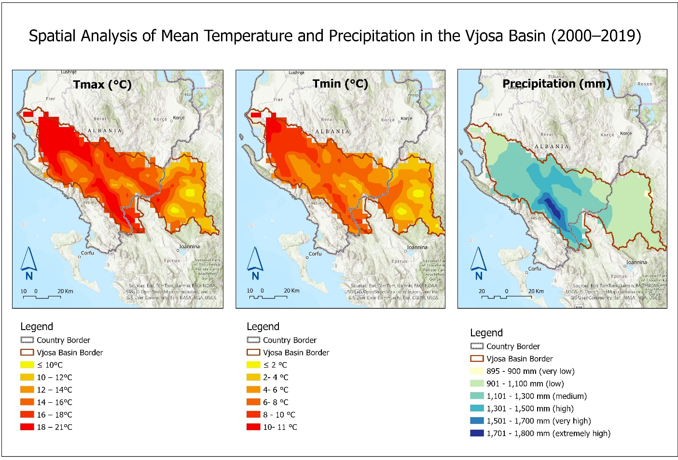
Figure 2. Spatial distribution of mean maximum temperature (Tmax), mean minimum temperature (Tmin), and mean annual precipitation in the Vjosa Basin for the period 2000–2019. Data are derived from ERA5-Land climate reanalysis and processed using ArcGIS Pro. The maps highlight clear spatial gradients, with warmer conditions toward the western lowlands and cooler, wetter conditions in the eastern mountainous areas.
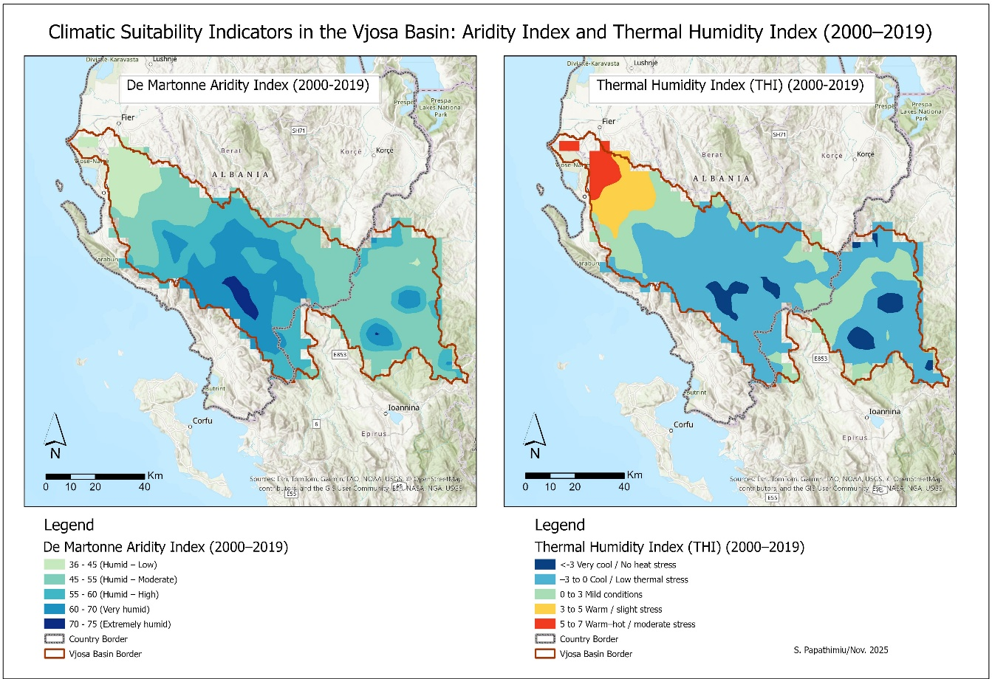
The combined effect of these variables is clearly reflected in the De Martonne Aridity Index (Figure 3), which confirms that the entire Vjosa Basin lies within humid to very humid climatic conditions. Aridity index values span 36 to 75, with the driest conditions (36–45) concentrated in the western and northwestern lowlands—areas characterized by higher temperatures and lower rainfall. Conversely, the most humid conditions (60–75) occur in the central and eastern mountainous parts of the basin, where precipitation is abundant and mean temperatures are lower. These findings align closely with regional climatic studies and corroborate the Mediterranean–mountain climatic transition that defines the Vjosa watershed.
Figure 3. The maps illustrate the basin’s internal climatic gradients, showing how humidity levels and thermal comfort vary between the lowland and highland areas. These spatial patterns serve as a baseline for assessing environmental sensitivity and potential implications for tourism activities.
Overall, the maps of Martonne Aridity Index and Thermal Humidity Index reveal a basin characterized by mild-to-warm temperatures, substantial precipitation inputs, and consistently humid climatic conditions, indicating a landscape with high ecological productivity and relatively low aridity stress. These spatial climatic patterns hold important implications for water resource management, biodiversity conservation, agricultural suitability, and vulnerability to climate change.
Implications for Tourism and Climate Change
The combined climate maps (Tmax–Tmin–P; Aridity and THI) illustrate a basin characterized by:
- mild-to-warm temperatures;
- substantial precipitation;
- consistently humid conditions;
- localized heat stress during summer.
These findings align with the broader theory of Mediterranean climate warming, where:
– maximum temperatures exhibit upward trends,
– precipitation becomes more variable,
– humidity and extreme rainfall events increase,
– heat stress intensifies in lowlands.
Such changes directly affect tourism seasonality, nature-based tourism, accessibility in villages during heavy rainfall, cultural tourism in high-humidity environments, and seaside attractiveness under warming waters and ecosystem changes.
3.4 Current Adaptation Measures in Tourism
Currently, Albania lacks a sector-specific climate adaptation strategy for tourism. Nonetheless, several national and cross-border initiatives contribute indirectly to risk reduction and resilience building.
Key initiatives include:
– AQUANEX Project, supporting environmental monitoring of the Vjosa and Drino rivers to promote eco-tourism;
– European Development Bank Loan (€100 million) for infrastructure and tourism development;
– BLUE COAST Interreg Program, addressing coastal climate vulnerability;
– Vlora Airport Project, designed considering flood risks and expected to extend accessibility and diversify tourism demand.
Despite these efforts, adaptation measures remain fragmented. Strengthening long-term planning—particularly addressing coastal erosion, water availability, cultural heritage degradation, high-temperature stress, and accommodation standards—is crucial for ensuring that the VRB’s tourism sector remains resilient under accelerating climatic change.

4. Discussions

The integrated climatic analysis and tourism trends presented in this study reveal a dynamic set of interactions between environmental change and tourism development in the Vjosa River Basin. The spatial climate maps show substantial heterogeneity across the basin, highlighting the role of topography, elevation, and proximity to the Adriatic Sea in shaping thermal regimes, precipitation patterns, humidity conditions, and ultimately tourism suitability. These findings align with broader Mediterranean climate projections, which indicate rising temperatures, increased variability in precipitation, and a higher frequency of heatwave and extreme rainfall events.
The De Martonne Aridity Index demonstrates that the Vjosa Basin remains consistently humid, with values ranging from humid-low to extremely humid conditions. This suggests a relatively resilient hydrological system; however, elevated humidity during mid-summer and transitional seasons may reduce comfort levels for outdoor and village-based tourism. At the same time, the basin’s mountainous and elevated areas exhibit very humid yet thermally comfortable conditions, which could become increasingly attractive as lowland areas face higher thermal stress. Similar patterns of climate-driven shifts in tourism attractiveness have been documented in other Mediterranean and Balkan regions, where mountain destinations gain competitiveness under warming conditions.
The Thermal Humidity Index further reinforces this spatial differentiation. Western lowlands, including peri-urban Vlora and coastal lowland belts, are projected to experience warm-to-warm–hot thermal stress, especially during peak summer months. These trends correspond to observations of intensified heatwaves in Albania over the past two decades. For the tourism sector, this means that seaside tourism—currently the dominant market—may face reduced comfort levels during July–August unless adaptation measures are systematically implemented. In contrast, the central and eastern zones of the basin retain mild to cool THI conditions, indicating that rural, ecotourism, adventure, and cultural tourism could experience expanded climatic suitability. This diversification would be consistent with global shifts toward climate-resilient tourism portfolios.
Socioeconomic indicators complement these climate findings. The considerable increase in tourist arrivals, overnight stays, and sector investments between 2014 and 2019 demonstrate strong demand for tourism in the region. However, the expansion of capacity, season extension, and infrastructure upgrading needed to support growing visitor numbers remain only partially addressed. Rising temperatures may lengthen the viable tourism season—from early spring to late autumn—yet the risk of extreme events, coastal erosion, water shortages, and heat stress may undermine long-term sustainability if left unmanaged. The tourism system appears vulnerable to climate change not simply due to higher temperatures but due to the compound effects of humidity, rainfall intensity, and infrastructural limitations.
The projections of accommodation demand also highlight important planning challenges. If bed capacities do not increase in parallel with tourist inflows and climate-driven season extension, overcrowding and pressure on natural and cultural assets may escalate. This risk is amplified in lowland areas, where humidity, sea-level rise, and extreme events may jeopardize beach quality and coastal amenities. Conversely, the inland cultural and mountainous areas may benefit from more favorable climatic conditions, provided that accessibility, service quality, and destination management improve.
Current adaptation initiatives—such as the AQUANEX project, Blue Coast Interreg program, and infrastructure improvements—demonstrate growing institutional awareness but remain fragmented and not yet integrated into a coherent climate-resilient tourism strategy. International literature consistently emphasizes that early planning, diversification of tourism supply, investment in heat mitigation, water efficiency, and cultural heritage protection are essential for climate-resilient tourism in Southern and Eastern Europe. The Vjosa Basin shows similar needs, particularly in safeguarding riverside ecosystems, improving mountain access, and strengthening coastal defenses.
The results indicate that climate change will not affect the Vjosa Basin uniformly; rather, it will reshape the region’s tourism geography, increasing stress on lowland and coastal destinations while creating new opportunities in inland and mountainous zones. Strategic planning, infrastructural investments, and ecosystem-based adaptation will be critical to ensure that tourism growth remains sustainable under accelerating climatic change.

- Conclusions
This study provides an integrated assessment of climate change impacts on tourism in the Vjosa River Basin by combining long-term climate analysis, climatic indices, tourism trends, and spatial visualization. The findings show that the basin is characterized by warm temperatures, high humidity, and substantial precipitation, with significant west–east gradients influenced by elevation and orographic processes. While the basin remains predominantly humid according to the De Martonne Index, the Thermal Humidity Index identifies lowland zones with increased thermal stress, particularly during summer, signaling potential challenges for coastal and peri-urban tourism.

Projected increases in temperature and humidity are likely to extend the tourism season but may reduce comfort during peak months in low-lying areas. Conversely, mountainous and inland areas—where cooler and more stable bioclimatic conditions persist—could become increasingly attractive for nature-based, adventure, and cultural tourism. This spatial redistribution of tourism suitability reinforces the importance of diversification and regional planning.
Tourism demand in the basin has grown significantly in the past decade, yet infrastructure, accommodation capacity, service quality, and environmental management lag behind this expansion. Without targeted adaptation measures, climate-exacerbated pressures—such as heat stress, coastal erosion, water scarcity, and extreme rainfall—may undermine both visitor experience and long-term development potential. Strengthening adaptive capacity requires coordinated action, including environmentally sensitive infrastructure investments, improved destination management, enhanced monitoring of climate risks, and integration of climate considerations into tourism planning.
The results confirm that climate change represents both a challenge and an opportunity for the Vjosa Basin. If adaptation strategies are implemented proactively, the region can transition toward a more resilient, diversified, and sustainable tourism model. The maps and indicators produced in this study provide a scientific foundation for such planning efforts, offering insights into climatic suitability, vulnerability hotspots, and zones with emerging tourism potential.

Disclaimer (Artificial intelligence)
Author(s) hereby declare that NO generative AI technologies such as Large Language Models (ChatGPT, Copilot, etc) and text-to-image generators have been used during the writing or editing of this manuscript.
- References
- Amelung, B., Moreno, A. (2009). Impacts of climate change in tourism in Europe. PESETA-Tourism study. European Commission, Joint Research Centre. Retrieved from https://publications.jrc.ec.europa.eu/repository/handle/JRC50593
- Amelung, B., Nicholls, S., & Viner, D. (2007). Implications of global climate change for tourism flows and seasonality. Journal of Travel Research, 45(3), 285–296. https://doi.org/10.1177/0047287506295937
- Bruci, E. (2010). Projection of climate change for Southeastern Europe. In V. Alexandrov, M. F. Gajdusek, C. G. Knight, & A. Yotova (Eds.), Global Environmental Change: Challenges to Science and Society in Southeastern Europe (pp. 169–178). Springer. https://doi.org/10.1007/978-90-481-8694-5_14
- Bruci, E. (2020). Projection of climate change for Southeastern Europe. Climate Monthly Bulletin, 5(55), July 2021. Polytechnic University of Tirana, Institute of Geosciences.
- Dube, K. (2024). Evolving Narratives in Tourism and Climate Change. Atmosphere, 15(4), 455. https://doi.org/10.3390/atmos15040455
- EC. (2009). Directive 2009/125/EC of the European Parliament and of the Council of 21 October 2009 establishing a framework for the setting of eco-design requirements for energy-related products. Official Journal of the European Union, L 285, 10–35. Retrieved from https://eur-lex.europa.eu/legal-content/EN/TXT/?uri=CELEX:32009L0125
- EEA. (2009). Impact of Europe’s changing climate – 2009 indicator-based assessment (EEA Report No. 4/2009). European Environment Agency. Retrieved from https://www.eea.europa.eu/publications/eea_report_2009_4
- EEA. (2017). Climate change, impacts and vulnerability in Europe 2016: An indicator-based report (EEA Report No. 1/2017). European Environment Agency. Retrieved from https://www.eea.europa.eu/publications/climate-change-impacts-and-vulnerability-2016
- Gasparrini, A. (2017). Projections of temperature-related excess mortality under climate change scenarios. The Lancet Planetary Health, 1(9), e360–e367. https://doi.org/10.1016/S2542-5196(17)30156-0
- Giordano, F., Capriolo, A., & Mascolo, R. (2013). Planning for adaptation to climate change – Guidelines for municipalities. LIFE ACT Project – Adapting to Climate Change in Time. Retrieved from https://www.lifeact.eu
- Gössling, S., & Scott, D. (2025). Climate change and tourism geographies. Tourism Geographies, 27(3–4), 642–652. https://doi.org/10.1080/14616688.2024.2332359

- INSTAT (Albanian Institute of Statistics). (various years). Tourism statistics reports. Retrieved from https://www.instat.gov.al/en/themes/tourism/
- Laçi, E., Papathimiu, S., & Laçi, S. (2023). Impact of climate change on infrastructure, population, settlement, and adaptation measures in Vjosa Basin. In N. Ademović, E. Mujčić, M. Mulić, J. Kevrić, & Z. Akšamija (Eds.), Advanced Technologies, Systems, and Applications VII. IAT 2022. Lecture Notes in Networks and Systems, 539 (pp. 533–545). Springer. https://doi.org/10.1007/978-3-031-17697-5_40
- Laçi, S. (2010a). Identification and implementation of adaptation response measures to Drini. Ministry of Tourism and Environment, Albania.
- Lemesios, I. (2024). Effects of Climate Change on the Future Attractiveness of Greece’s Tourism Sector. Atmosphere, 15(10), 1185. https://doi.org/10.3390/atmos15101185
- Mieczkowski, Z. (1985). The tourism climatic index: A method of evaluating world climates for tourism. The Canadian Geographer, 29(3), 220–233. https://doi.org/10.1111/j.1541-0064.1985.tb00365.x
- Mitrică, B. (2025). The tourism sector’s vulnerability to climate-change-related impacts: a case study of Romania. Sustainable Cities and Society, 102, 105472. https://doi.org/10.1016/j.ijdrr.2025.105248
- Muçaj, L. (2010). Climate change scenarios for Drini-Mati River Deltas area. Ministry of Environment, Albania.
- Muçaj, L. (2010). The expected future climate impacts/risks on the coastal ecosystems, agriculture, water resources, tourism and settlements for Drini-Mati River Deltas area. Third National Communication of Albania to the UNFCCC. Retrieved from https://unfccc.int/documents
- Pang, S. F., McKercher, B., & Prideaux, B. (2013). Climate change and tourism: An overview. Asia Pacific Journal of Tourism Research, 18(1-2), 4-20.
- Papathimiu, S., Laçi, E., Begu, E., Laçi, S., & Çela, G. (2025). Integrating GIS and Remote Sensing to Assess Natural Heritage Management Challenges under Climate Change: The Case of Prespa National Park, Albania. Journal of Geography, Environment and Earth Science International, 29 (11), 123–133. https://doi.org/10.9734/jgeesi/2025/v29i11971
- Rosselló-Nadal, J. (2014). How to evaluate the effects of climate change on tourism? Tourism Management, 42, 334–340. https://doi.org/10.1016/j.tourman.2013.11.006
- Sharma, G. D., Taheri, B., Chopra, R., & Parihar, J. S. (2025). Relationship between climate change and tourism: an integrative review. The Service Industries Journal, 45(3–4), 426–453. https://doi.org/10.1080/02642069.2023.2254714
- Stocker, T. F., Qin, D., Plattner, G.-K., Tignor, M., Allen, S. K., Boschung, J., Nauels, A., Xia, Y., Bex, V., & Midgley, P. M. (Eds.). (2013). Climate Change 2013: The Physical Science Basis. Contribution of Working Group I to the Fifth Assessment Report of the IPCC. Cambridge University Press. https://doi.org/10.1017/CBO9781107415324
- Tanrisever, C., Pamukçu, H., & Baydeniz, E. (2024). Climate change in tourism: Understanding the impacts and opportunities for sustainability. In Future tourism trends Volume 1: Tourism in the changing world (pp. 33–45). Emerald Publishing Limited. https://doi.org/10.1108/9781837533513-004
- CRU-TS 4.09 (Harris et al., 2020) downscaled with WorldClim 2.1 (Fick and Hijmans, 2017).
- Fick, S.E. and R.J. Hijmans, 2017. WorldClim 2: new 1km spatial resolution climate surfaces for global land areas. International Journal of Climatology 37 (12): 4302-4315.

