Geospatial Analysis of the Impact of Land Cover Change on Land Surface Temperature in Abuja, Nigeria (1986-2021)

.
ABSTRACT

Urbanization has significantly altered land cover patterns, leading to rising land surface temperatures (LST) and the intensification of the Urban Heat Island (UHI) effect. This study examines the impact of land cover change on LST in the Federal Capital Territory (FCT) - Abuja, Nigeria, from 1986 to 2021, using geospatial techniques. Landsat 5 TM, Landsat 7 ETM+, and Landsat 8 OLI imagery were analyzed to assess land cover changes, extract LST, and compute the Normalized Difference Vegetation Index (NDVI). Supervised classification was performed using ERDAS Imagine, and LST was derived through radiometric calibration, brightness temperature estimation, and regression analysis. Results indicate a substantial decline in vegetation cover from 52.7% in 1986 to 37.5% in 2021, alongside a significant increase in built-up areas from 3.15% to 16.8%. Correspondingly, LST values showed an upward trend, with mean surface temperatures rising from 27.4°C in 1986 to 33.2°C in 2021, highlighting the intensification of UHI effects. A strong inverse correlation (-0.76) between NDVI and LST suggests that vegetation loss contributes directly to rising surface temperatures. The study recommends enhanced urban planning policies focused on afforestation, green infrastructure, and
Climate-responsive land use to mitigate urban heating effects and enhance sustainability.

Keywords: Land Surface Temperature (LST), Land Cover Change, Remote Sensing, Geographic Information System (GIS) and Urban Heat Island (UHI), Normalized Difference Vegetation Index (NDVI)

1. INTRODUCTION

Urbanization, in its term, means the transformation of the natural land surfaces to modern land use land cover such as buildings and pavement, which include roads, driveways and other impervious surfaces, causing urban scenery to fragment and adversely affecting the habitability of cities. The massive growth and changes in major cities play a vital role in land use and land cover change, which leads to the urban heat island (Zaharadeen et. al. 2016). The degree and rate of global environmental changes, that is, greenhouse gas emission, desertification, deforestation, or loss of biodiversity, are the key factors in the population explosion in the cities (Grimmond, 2007). Land cover and land use are always used interchangeably in the literature, while they possess separate meanings and characteristics. Land cover refers to the biophysical features on the Earth’s surface, such as forests, water, and others, while land use simply implies the use of land for different purposes by man, such as farmlands and urban planning (cities) (Jensen, 2007). Research has indicated that, in the last 20 years, Federal Capital Territory city has witnessed significant growth in population and change in landscape, built-up areas and urban form and the city have experienced a rise in urban temperature (Liu, 2024; Aderele et al., 2020) Also, Nigerian Meteorological Agency (NiMET) and other medical experts have cautioned on the impending outbreak of epidemics due to the hot weather condition. However, the effect of Urban Heat Island (UHI) is expected to affect a huge number of people in the city. This study tends to investigate the extent of the effect and the relationship the identified land surface temperature (LST) could have on vegetation cover measured through Normalized Difference Vegetation Index (NDVI) and Land use and cover change from 1985 to 2021. The Spatio-temporal pattern and trend of land surface temperature (LST) and the extent of urban heat island (UHI) within the stipulated period will be estimated. Saha et al. (2024) demonstrated significant seasonal variation in both land‑use change and land surface temperature (LST) over 15 years in a developing city context, underscoring the importance of temporal resolution in assessing urban thermal dynamics.
In recent years, remote sensing and GIS have been proven to be important tools in examining land use and land cover change. Many studies have been carried out on the application of thermal remote sensing of urban areas to identify the relationship with surface parameters, surface energy and land surface temperature. Land use and land cover play a momentous role in the Urban Heat Island (UHI) phenomenon. The UHI phenomenon can be associated with changes in surface energy rate as a result of the substitution of permeable and evaporating surfaces with impermeable ones (Wong et al. 2013; Babalola and Akinsanola 2016). Identification and representation of surface urban heat island (SUHI) are mainly based on land surface temperature (LST) that differs spatially as a result of the intricacy of the land surface, which can be regarded as a combination of impervious surface features, green vegetation, and bare lands, as well as water bodies. These features are the most primary components of urban ecosystems (Aryal et al. 2021; Ridd, 1995). The area and intensity of impervious surfaces differ most significantly between urban and suburban areas and their presence is the main indicator for surface urban heat island (Li et al. 2009). Multi-temporal Landsat imagery can be effectively used to map land cover changes and assess their impact on LST, following the approaches demonstrated in studies of metropolitan regions such as Chennai, India (Chanu et al., 2021).
The Federal Capital Territory has witnessed significant expansion and growth in population structure and urban development, such as built-up areas, roads and other anthropogenic activities (Makinde & Oyebanji, 2020). Aderele et al. (2020 indicate that there is a sharp decline in vegetation land cover and a rapid upsurge in built-up areas in the city between 1986 and 2006, with a possible further decrease in vegetation cover. Epuh et al. (2022) attested and predicted a likely rise in temperature in the Federal Capital Territory in the last few decades. Additionally, in 2012, the Nigerian Meteorological Agency (NiMET) included in one of its quarterly publications a projection that some states, including the Federal Capital Territory, would continue to experience an increase in temperatures. The consistent change in land use and land cover, the impervious surface nature of urban areas, which affects Land surface temperature and the rapid increase in population and urbanization have resulted in Urban Heat Island. Against this backdrop, this study aims to assess the effects of land cover changes on land surface temperature and examine their relationship with land cover through LST parameters and impervious surface characteristics, which serve as major indicators of the Urban Heat Island in the Federal Capital Territory, using remote sensing techniques.
2. material and methods
2.1 Study Area
The study area, Federal capital territory, is located between latitudes 8˚40'00'' and 9˚20'00'' north of the equator, and longitudes 6˚40'00'' and 7˚40'00'' east of the Greenwich Meridian. It is bound to the north by Kaduna State, to the east by Nasarawa, to the south by Kogi, to the west by Niger, and southeast by Nasarawa State, as shown in Figure 1. It has an area of approximately 7,315 km2. The federal capital is regarded as the administrative headquarters of Nigeria. It comprises six local government areas, including Abuja Municipal Area Council, Kuje Area Council, Gwagwalada Area Council, Bwari Area Council, Kwali, and Abaji Area Council. The Federal Capital Territory has an estimated population of 2,238,800 as of 2011. FCT, under the Koppen climate classification (Aw), has a tropical wet and dry climate. The FCT experiences three weather conditions annually. This includes a warm, humid rainy season and a scorching dry season. In between the two, there is a brief interlude of harmattan (northeast trade wind) with the main features of dust haze, intensified coldness, and dryness. In FCT, the rainy season begins from April and ends in October, with September being the peak. Due to the hilly and mountainous nature of FCT, orographic activities bring heavy and frequent rainfall of about 1500 mm (59.1 in) during the rainy season. Annual rainfall is the highest within the FCC, about 1631.7 mm.
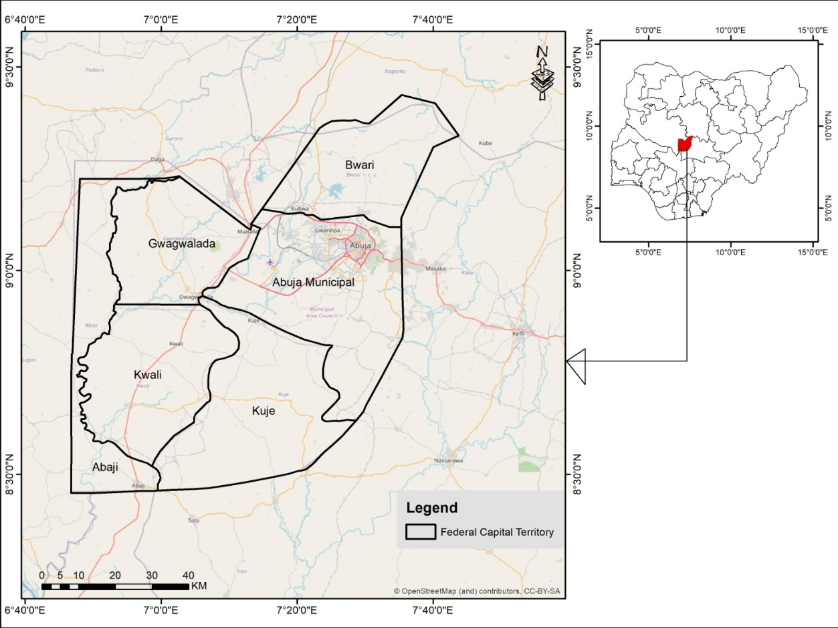
Figure 1. Map of the Study Area

2.2 Materials and Tools for Data Collection
To establish the ambiguous nature and relationship between land cover change, retrieval and estimation of the land surface temperature using LST parameters and indices, we carried out the following procedures and methods to determine LST using Landsat data: radiometric calibration, brightness temperature, proportional vegetation, top atmosphere, NDVI, and regression analysis, among others. A secondary source of data acquisition was employed for this study, as much of the data was remotely sensed. Different materials and tools were used for the data collection, processing of data and spatial analysis, which include articles and journals from reputable publications, conference papers, Google Earth images, Satellite images, and eBooks. We also used the Microsoft Office package, such as Excel, for basic data computation and analysis. Remote sensing and Geographic Information System (GIS) software, such as ERDAS Imagine, QGIS, and ArcGIS 10.2, were utilized, respectively. The secondary data used for this study include Landsat satellite imagery: Landsat 5 Thematic Mapper (TM), Landsat 7 Enhanced Thematic Mapper (ETM+) and Landsat 8 Operational Land Imager (OLI), which were acquired using the Path/Row of 189/54 on April/Nov, 1986; April/Nov, 2002; and April/November 2021. However, we acquired the Landsat data from the USGS platform (http://earthexplorer.usgs.gov/). To ensure an appropriate comparison of the land surface temperature, we identified and assessed UHI and land cover effects, satellite images from the months of April and November for all three years, which lie in the same season. Hence, details of the Landsat imagery acquired are presented in Table 1.
Table 1. Detailed Characteristics of Satellite Images
S/N | Data | Sensors | Bands | Resolution (m) | Date obtained
1 | Landsat 5 | TM | 7 | VNIR 30  TIR 60 | April, 1986  Nov, 1986
2 | Landsat 7 | ETM+ | 8 | VNIR 30  TIR 60 | April, 2002  Nov, 2002
3 | Landsat 8 | OLI | 11 | VNIR 30  TIR 60 | April, 2021  Nov, 2021
2.3 Data Preprocessing
ERDAS Imagine was used to classify the Land Cover, while ArcGIS 10.2 was employed to retrieve and process the land surface temperature (LST). We categorized the methods into the phases, including preprocessing of Landsat, classification of the land cover pattern using Supervised Classification, Normalized Difference Vegetation Index (NDVI); extraction and estimation of LST patterns, examination of the relationship between Land cover and land surface temperature, and finally, the difference in LST between seasons of the year. Due to the amount of haze contained in the obtained Landsat images, we subjected the images to systematic haze and noise reduction within the radiometric correction procedure in the ERDAS Imagine application software.

2.3.1 Supervised Classification of Land Cover Land Use Map
We carried out image composition (band stacking) and layer stacking of multispectral bands of Landsat images using the ERDAS Imagine application software by appropriately selecting the required bands for this research. Thus, the imagery alert problems were corrected to prevent negative effects and changes in spectral reflection. Afterward, at the menu bar of the ERDAS interface, the spectral layers were composed, which enables multiple bands to be stacked into a single output of a multi-band image. In order to identify the spatial-temporal change in land cover between 1986, 2002, and 2021, the land cover map of April and November, which represent the wet and dry seasons, was computed. After layer stacking, false colour composite was performed and for this research, we set at band 4, 3, 2, which is the standard false colour composite for Landsat 5 TM. This was repeated based on data type such that 5, 4, 3 for Landsat 8 OLI, for easy training of samples in the ERDAS Imagine interface to enhance image interpretation. We established a collection of training samples and image classification by applying a supervised classification algorithm. Thus, with the aid of the signature editor tool in the ERDAS Imagine interface, several training samples were assigned to the pixels for land cover classes, which were randomly collected from the false colour image for each class as training samples. We assigned five classification classes for land cover land use classes, including Built-up, Vegetation, Agriculture, Water bodies and Bare soil. Finally, we produced land use land cover maps for all three years, 1986, 2002, and 2021, respectively.
2.3.2 Normalized Difference Vegetation Index (NDVI)
Normalized Difference Vegetation Index (NDVI) is a function of the difference between the Near Infrared (NIR) band and the (R) Red band over the summation of the Near Infrared (NIR) band and (R) Red band. Normalized Difference Vegetation Index (NDVI) of wet and dry seasons for the years 1984 and 2000 was estimated using the function of band 3 (0.63-0.69 μm) and Near-Infrared band 4 (0.75-0.90 μm) bands of the Landsat 5 TM and Landsat 7 ETM+ data sets. Similarly, the equivalent bands of 4 (Red 0.64-0.67 μm) and band 5 (NIR 0.85-0.88 μm) were used to calculate NDVI for both wet and dry seasons of 2016 from Landsat 8 OLI. For the purpose of this study, we used the ERDAS Imagine application software to automatically estimate the NDVI of both seasons (wet and dry) from 1986, 2002, and 2021, respectively, using the NDVI formula (Equation 1).

$NDVI= \frac{NIR-Red}{NIR+Red}$ Equation (1)

2.3.3 Spatial Distribution of Land Surface Temperature
2.3.3.1 Retrieval of Land Surface Temperature (LST)
We retrieved Land surface temperature from the thermal band of Landsat images, which includes band 6 of both Landsat 5 TM, Landsat 7 ETM+, and thermal infrared band 10 of Landsat 8 OLI. However, for this research, Land surface temperature was retrieved using LST parameters with the aid of QGIS application tool to estimate and analyse Top of Atmosphere (TOA), Brightness Temperature (TP), NDVI, Proportional Vegetation Index (PVI), Error Correction (E) and Land Surface Temperature (LST) which was conducted for all the years of 1986, 2002 and 2021.
2.3.3.2 Conversion of Digital Numbers to TOA spectral Radiance
The value of Top of Atmosphere (TOA) spectral radiance (Lλ) was determined by multiplying band band-specific multiplicative rescaling factor of Thermal Infrared (TIR) bands with its corresponding TIR band and adding band band-specific additive rescaling factor to it using the function below (Equation 2).
$Lλ = M L*Qcal + A$ Equation (2)
However, we estimated the TOA estimation by adding clipped thermal infrared bands of the study area for the years 1986, 2002, and 2021 into the ArcMap interface. Through the spatial analysis tool via raster calculator of the ArcGIS, we carefully input TOA using information from each of the years’ Landsat images metadata.
2.3.3.3 Conversion of spectral radiance to at-sensor brightness temperature (BT)
After the digital numbers (DN) have been converted to reflectance, we converted the thermal infrared (TIRS) band image from spectral radiance to brightness temperature (BT) using the thermal constants provided in the Landsat image metadata file. However, the expression in Equation 3 was employed in the spatial analysis tool’s algorithm via the raster calculator of ArcGIS to convert the reflectance to BT for band 6 in the years 1986 and 2002, and for band 10 in the year 2021.
$TB=\frac{K2}{In(\frac{K1}{Lλ+1}})$ Equation (3)

2.3.3.4 Land surface temperature (LST)
The final land surface temperature (LST) is calculated using the expression in Equation 5, derived from satellite thermal data, which utilizes brightness temperature (BT) and surface emissivity (ε). The formula LST = BT/[1 + (λ·BT/ρ)·ln(ε)] incorporates the thermal band's wavelength (λ) and Planck's constant (ρ). Emissivity is estimated using land cover data or NDVI thresholds. The results are validated against ground measurements and are used for environmental monitoring. While effective, this method assumes uniform emissivity and works best under clear skies.
$LST=(\frac{BT}{1+(0.00115* \frac{BT}{1.4388})*}*Ln(e))$ Equation (5)

2.4 Correction Analysis
2.4.1 Pearson Correlation
We adopted the Pearson correlation coefficient, which ranges from -1 to +1. The Pearson correlation was calculated to determine the relationship between the normalized differential vegetative index and the Land surface temperature.
Table 2: Classification scheme for Land Use Land Cover Changes
Code | Land Use/Land Cover Categories | Description
1 | Vegetation | Vegetation refers to any plant life in an area, including trees, shrubs, grasses, and other forms of vegetation. The elements of vegetation include different types of plant species and their respective habitats, such as forests, meadows, grasslands, and savannas.
2 | Wetland | Wetlands are areas where the land is saturated with water for at least part of the year. The elements of wetlands include various types of vegetation such as cattails, bulrushes, sedges, and other hydrophilic plants, as well as standing water or very slow-moving water, such as ponds, marshes, and swamps.
3 | Bare Rock/Bare lands | Bare surfaces refer to areas of land that are devoid of vegetation or other forms of life. The elements of bare surfaces include various types of geological formations such as rock outcrops, dunes, and desert landscapes, as well as human-made surfaces such as paved roads, parking lots, etc.
4 | Built-up area | Built-up areas refer to areas that have been developed for human habitation or other human activities, such as commercial or industrial uses. The elements of built-up areas include buildings, roads, parking lots, sidewalks, and other infrastructure necessary for human activities.
5 | Water bodies | Water refers to any naturally occurring or human-made bodies of water, including rivers, lakes, streams, ponds, and oceans. The elements of water include the quality, quantity, and distribution of water in an area, as well as its use by humans and other animals.

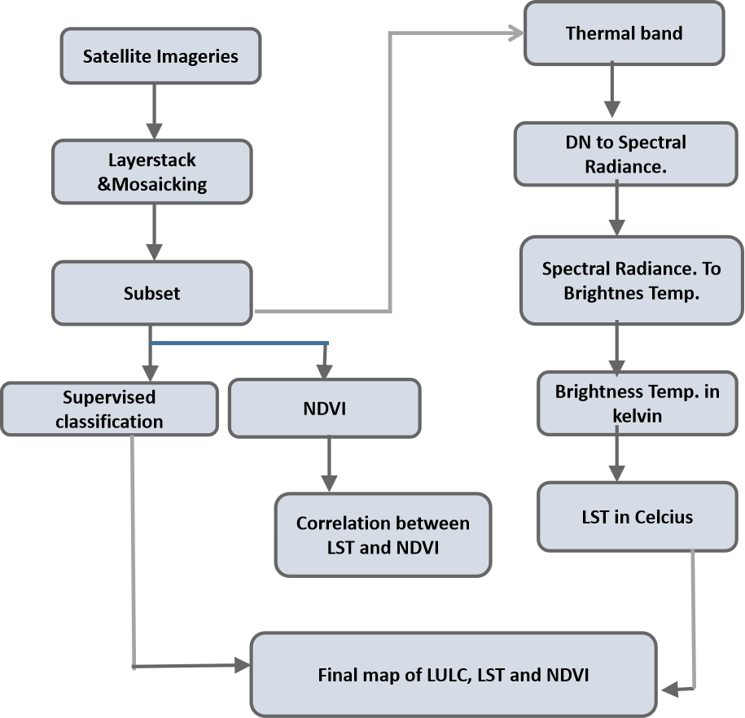
Figure 2 Methodological Flowchart
3. results and discussion
3.1 Spatio-Temporal Land Cover Pattern of the Study Area between 1986 and 2021
The results of the land use/land cover classification of the study area for 1986, as shown in Figure 3, suggest that a mix of different types of land cover characterizes the study area. The wetlands cover an area of 2326.7 (32%) square kilometers, indicating the presence of significant waterlogged land that supports aquatic vegetation and wildlife. Vegetation covers the largest area of land at 3897.7 square kilometers, which represents about 52.7% of the total land used. This indicates that the study area has a significant amount of forested or vegetated land. Vegetation is an essential component of healthy ecosystems as it provides numerous ecological services, including oxygen production, carbon sequestration, and soil stabilization. Water covers only 1.3% spread across an area of about 96.4 square kilometers, which suggests that the study area may be prone to water scarcity or drought conditions. Built-up areas cover 233.1 square kilometers, which is 3.15%, suggesting that the study area has undergone some degree of urbanization or development. Also, bare surfaces/Rocks cover 834.1 square kilometers, which represents 11.1% of the land use and land cover, which may indicate the presence of desert or semi-arid regions in the study area. Bare surfaces are prone to soil erosion, and they provide limited habitat for plant and animal species.

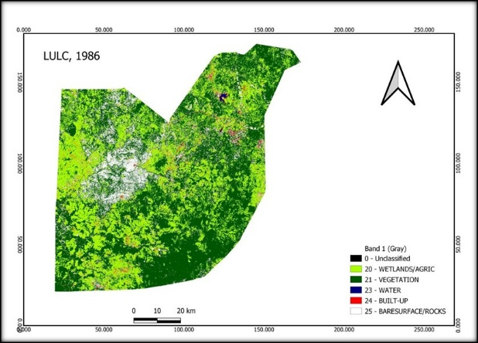 | 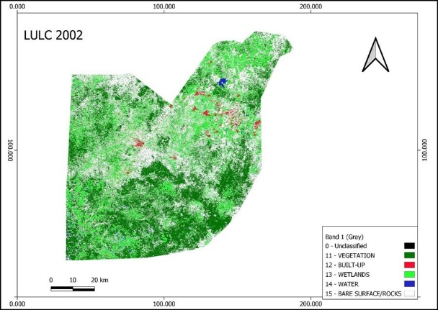
(a) | (b)
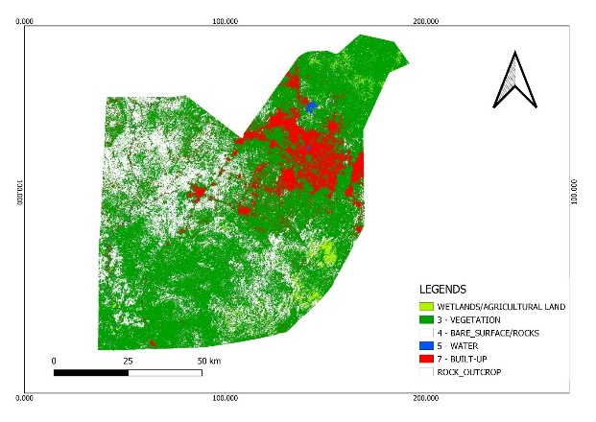
(c)
Figure 3. (a) Land Use Land Cover Classification of Federal Capital Territory for 1986, (b) 2002; and (c) 2021
In 2002, vegetation covered an area of 2566 square kilometers, which is slightly lower than in 1986. This decrease may be due to factors such as deforestation or the conversion of forested land to other uses. Built-up areas in 2002 covered 308.1 square kilometers, which is a slight increase compared to 1986. This increase indicates continued urbanization or development in the study area. We observed that the Wetlands/ Agricultural land in 2002 covered an area of 1508 square kilometers, which is a decrease compared to 1986. This reduction may be due to factors such as drainage or the conversion of wetland areas to other uses. The water cover in 2002 was 94 square kilometers, which is a slight decrease compared to 1986. Bare surfaces/Rocks covered 2911 square kilometers in 2002, which is an increase compared to 1986. The increase in bare surfaces may be due to factors such as land degradation or desertification, as shown in Figure 3.

Wetlands covered an area of 1148 square kilometers in 2021, which is a decrease compared to both 1986 and 2002. Vegetation covered an area of 3200 square kilometers in 2021, which is higher than in 2002 but slightly lower than in 1986. Bare surfaces and rocks covered an area of 1695 square kilometers in 2021, which is higher than in 1986 and 2002. Built-up areas in 2021 cover 714.6 square kilometers, which is a significant increase compared to both 1986 and 2002. This increase may indicate continued urbanization or development in the study area. Water covers only 25 square kilometers in 2021, which is a slight decrease compared to both 1986 and 2002.

Table 3. Land Use Land Cover Distributions in Federal Capital Territory between 1986 and 2021
LULC | 1986 |  | 2002 |  | 2021
LULC | Area  (km2) | Area  (%) | Area  (km2) | Area  (%) | Area  (km2) | Area  (%)
Built-Up Area | 233.1 | 3.15 | 308.1 | 4 | 714.6 | 10
Water Body | 96.4 | 1.3 | 94 | 1.27 | 25 | 0.34
Vegetation | 3897.7 | 52.7 | 2566 | 34 | 3200 | 43
Rocks/Bare Surface | 834.1 | 11.2 | 2911 | 39.4 | 2300 | 31.1
Wetland | 2326.7 | 31.4 | 1508 | 20 | 1148 | 15
TOTAL | 7388 | 100 | 7388 | 100 | 7388 | 100

The statistics derived from the land use/land cover classification for the year 1986, 2002 and 2021, as shown in Table 3 shows that in the 1986 where we have vegetation to have the highest area cover with 52.7%, was closely followed by wetland with 31.4% with bare surfaces/rocks and built-up with a land cover of 11% and 3.15% respectively. This further proves that a considerable amount in excess of 80% of the landmass was covered with vegetation in total between vegetative areas and wetlands, which are made up of significant plant species. Considering the context of this research, the land surface temperature is expected to be minimal as the study area is largely dominated by vegetation.

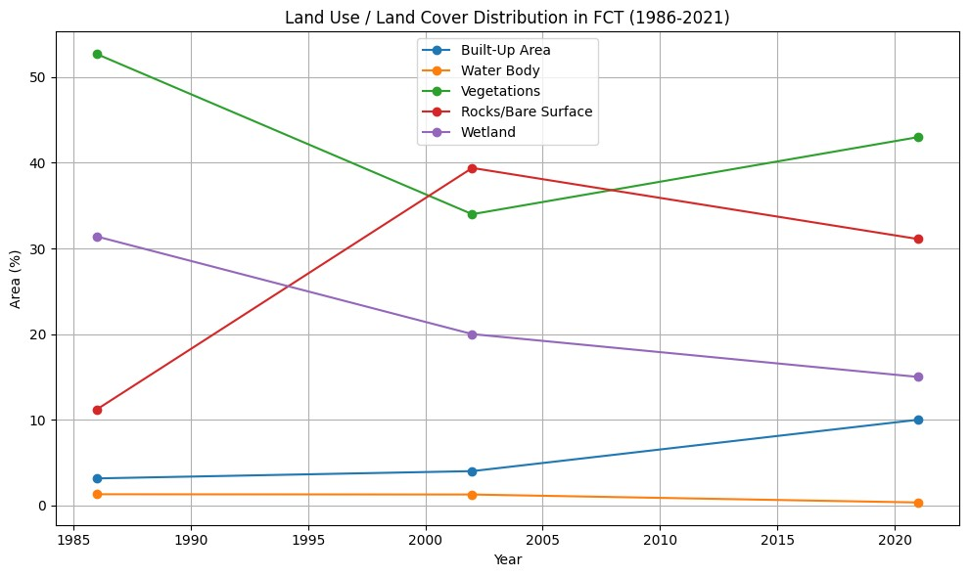
Figure 4. Land Use Land Cover Distribution in Federal Capital Territory (1986-2021)

Table 4. Statistics of Land Use/Land cover Classes in the Study Area
LULC | LULC Area 1986 (ha) | LULC Area 2002 (ha) | LULC Area 2021 (ha) | Change between  1986 & 2002 (ha) | Change between  2002 & 2021 (ha)
Built-Up Area | 233.1 | 308.1 | 714.6 | 75 | 406
Water Body | 96.4 | 94 | 25 | -2.4 | -69
Vegetation | 3897.7 | 2566 | 3200 | -1331.7 | 634
Rocks/Bare Surface | 834.1 | 2911 | 2300 | 2076 | -611
Wetland | 2326.7 | 1508 | 1148 | -818.7 | -360

In the year 2002, vegetation cover was reduced by a total of 1331.7 square kilometers from the previous year 1986. These changes in vegetation could be associated with urban growth, seasonal changes in climatic conditions, such as rainfall. The period of physical development between 1986 and 2002 is so significant, considering Abuja is considered a “New Town’’, during this period, a significant change occurred in built-up, as it was during this period that the Abuja masterplan implementation was carried out. The growth was slow as lots of relocation and redevelopment were carried out during this period. The bare surface/rocks had increased significantly during this period, a considerable tangible portion of which was found around the Abuja municipal area council; this was as a result of rapid development being carried out within the study area. Although seasonal changes, such as the rainy and dry seasons, could significantly affect the extent of bare surface in the study area, deforestation and desertification could also impact this.
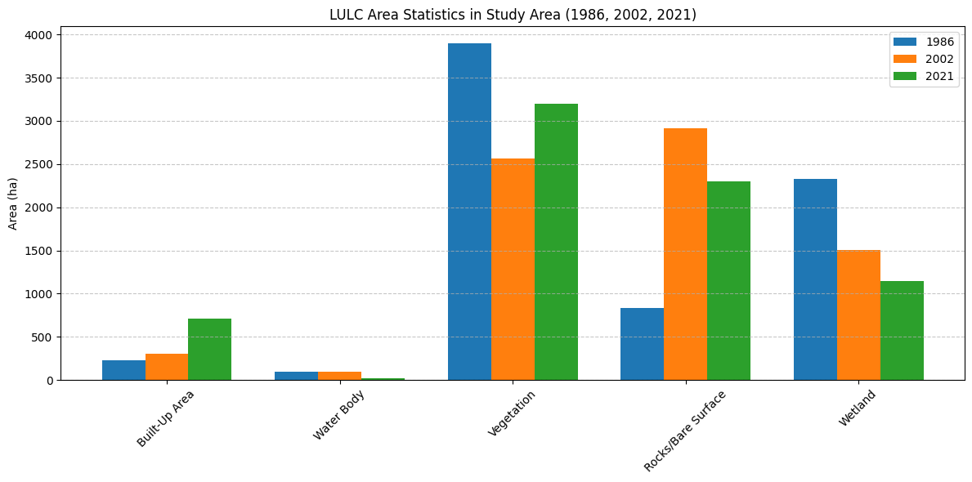

Figure 5. LULC Area Cover (1986, 2002, 2021)

The vegetation further gained significantly over 634 square kilometers in year 2021 and this is largely be associated to climatic condition and conversion from one land use to another such as wetlands, although wetlands continue to witness loss in area cover, it is of note that built-up has gained massively between the year 2002 and 2021, the percentage of change has more than doubled during this period. This could largely be associated with rapid urban growth, from LULC, Abuja municipal area council witnesses more significant land cover changes when compared to other land uses/land cover. Waterbodies continued their gradual loss over the years, which could be linked to climate change.

3.2 Normalized Difference Vegetation Index (NDVI) Trend
NDVI (Normalized Difference Vegetation Index) values typically range from -1 to +1, with negative values indicating non-vegetated or sparsely vegetated areas and positive values indicating vegetated areas. It's worth noting that NDVI is a standardized index used to measure vegetation greenness and health. The NDVI image, as shown in Figure 6(a), shows a positive value of 0.326733 and a negative value of -0.172414. A healthy vegetative portion of the study area is found to be dominant in the eastern part of the FCT and towards the northeast part of the map, where the Abuja municipal area council is located. The average vegetation is predominantly covered by yellow, which could be interpreted as being predominantly grassland in nature. The unhealthy vegetation covers the image indicated area, that are predominantly bare surface and rocky outcropped areas.

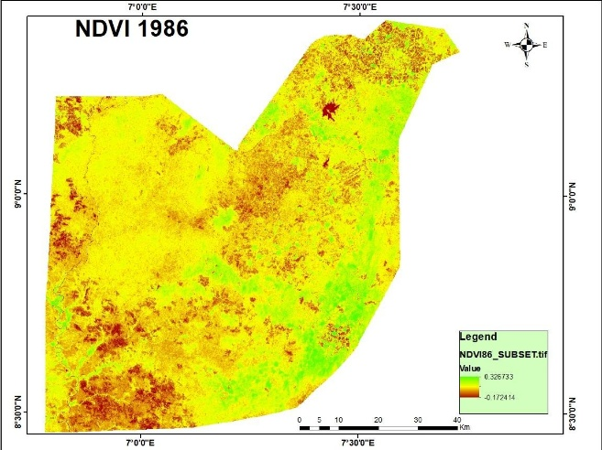 | 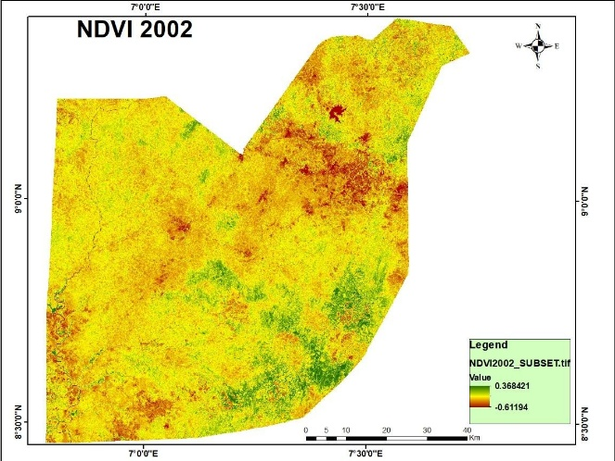
(a) | (b)
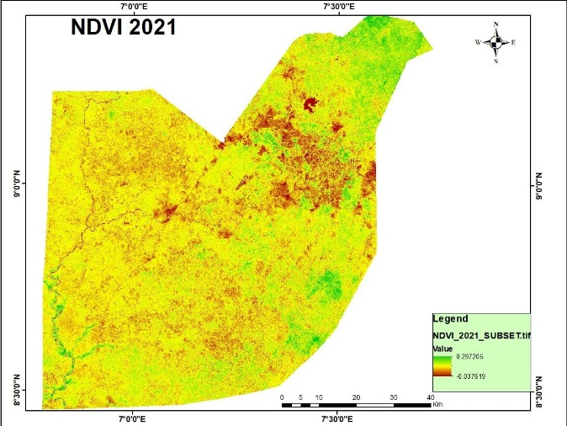
(c)
Figure 6. Normalized Differential Vegetative Index Map of FCT for (a) 1986, (b) 2002, (c) 2021
Figure 6 shows that a much healthier vegetation was noted compared to the earlier year of 1986, but the vegetation is not more predominant in the study area. Although in this case, the Abuja municipal area council and Kuje area council have shown more unhealthy vegetation in this case, this could be attributed to an increase in Bare Surface/Rocky area/ as explained earlier in Figure 6(b). It is also worth noting that unhealthy vegetation has further increased in this case, even though the highest health vegetation was found to be present. This could be attributed to climatic conditions as a result of a prolonged period of seasonal rainfall.
The Normalized difference vegetation index in Figure 6(c) shows that the proportion of healthy vegetation has drastically reduced compared to the previous year, revealing a positive value of 0.297205 and a negative value of -0.037619. which also indicated a further decline in Bare Surface and the unvegetated portion of the study area. This increase could largely be associated with the rapid rate of urban development within the study area. Observation of the image in Figure 6(c) further shows that Abuja Municipal area, Gwagwalada, Kuje, and Kwali area councils, which all have experienced rapid growth in the study area, have also observed loss of vegetation, an increase in Bare Surface as a result of urban development. A major decline in the proportion of vegetative cover is noted more in the Abuja Municipal Area Council.
Table 5: Normalize Differential Vegetative Index values for each year.
Year | Maximum Values | Minimum Values
1986 | +0.326733 | -0.172414
2002 | +0.368421 | -0.61194
2021 | +0.297205 | -0.037619

3.3 Landsat Derived Spatio-Temporal Distribution and Variability of Land Surface Temperature in the Federal Capital Territory
Figure 7 shows the land surface temperature profile of the study area in 1986. It was observed that the highest temperature was found in the northeast part of the study area, where Abuja Municipal Area Council and Bwari are located. The highest temperature value recorded in the year 1986 is 32.05℃, the average temperature of 24.15°C, and the lowest is 15.1°C. The land surface temperature, when compared to the land use/land cover, further demonstrates that areas occupied by built-up, bare surfaces and open spaces have the highest land surface temperature range between 26°C-32°C. Kuje area council and Abaji also tend to have the lowest temperature values in the study area, which ranges between 200C 15°C. The areas dominated by this low land surface temperature reveal a high presence of wetlands and vegetative covers. An average temperature range between 23°C - 28°C is highly predominant in the study area. This temperature range is found mostly in Gwagwalada, Abaji, and some parts of the Bwari and Kwali Area Council.

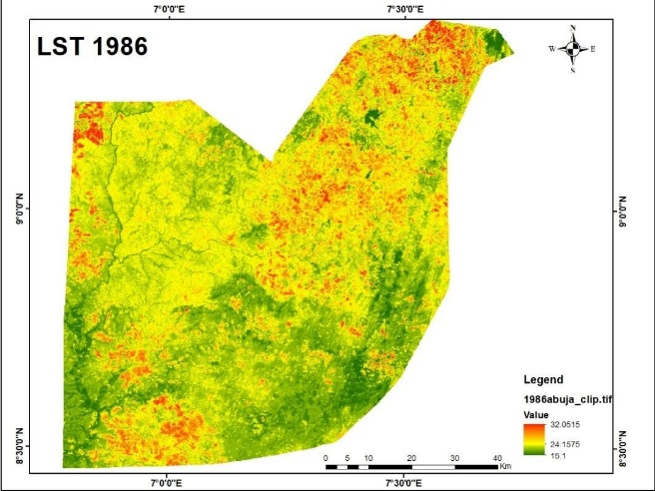 | 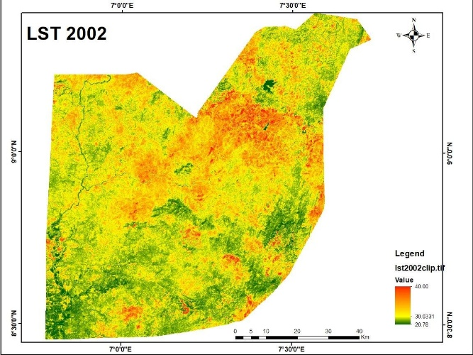
(a) | (b)
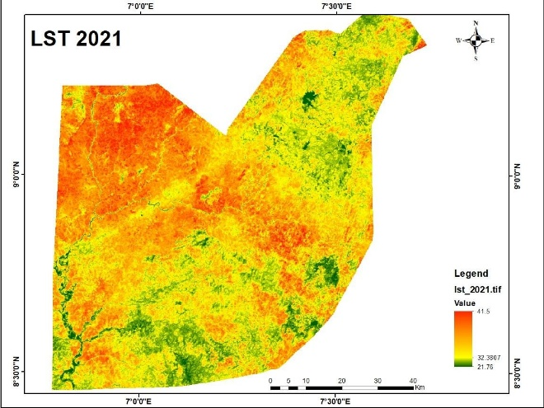
(a)
Figure 7. Land Surface Distribution Map of FCT for (a)1986; (b) 2002; (c) 2021

The surface temperature show some significant changes in pattern distribution of across the study area. The highest temperature value recorded is 40℃, an increase from the previous year of 32.05℃, as revealed in Figure 7(b), while the lowest value also increased from 15.1℃ to 20.78℃ in 2002. The average temperature has also increased to about 30°C in 2002. Location with the highest temperature value as a result of the thermal properties, as dominated in the Figure 7, still remains the same, but has witnessed a significant increase in values. The Built-up, Bare Surfaces and open spaces remain the major drivers of increase in lands surface temperature, the increase correspond to increase in built, Bare Surface and open spaces as depicted in the land use/land cover map in Figure 7, the highest land surface temperature range of locations such as Abuja Municipal Area council and Abaji which was between 26℃ - 32℃ in 1986 had increased to 32℃ - 40℃ in 2002. Loss of vegetative cover and wetlands was responsible, as the result of the land use /land cover map of 2002 was indicative of this assertion. The areas dominated by this low land surface temperature reveal a high presence of wetlands and vegetative covers with an average temperature range between 23℃ - 35℃, which were found in Gwagwalada, Abaji, and some parts of the Bwari and Kwali area councils.
The land surface temperature of the study area for the year 2021, as shown in Figure 7(c), indicates highest temperature has increased slightly compared to the previous year of 2002. In 2002, we observed that the highest temperature value had increased from 40.00℃ to 41.5℃, while the lowest value also increased from 20.78℃ in 2022 to 21.76℃ in 2021. From the image, we observe that the proportion of high temperatures has spread more over the study area. This can be attributed to the rapid rate of urban development. Table 6 shows that the magnitude of built-up has more than doubled between the year 2002 and the year 2021. Although the proportion of Bare Surface and wetland had reduced in the year 2021, the loss could be attributed to some gains in built-up, and climatic condition such as prolong annual rainfall during the year could have left some bare surfaced area to be covered with vegetation, it is important to note that the imagery were acquired during the dry season of November/December, so a longer rainfall into this period could have resulted into slightly vegetated cover in some areas. The highest temperature values are spread across majorly Gwagwalada Area, Kuje Area council, Abaji, and Kuje Area council, with average temperatures exceeding 35℃. While Areas such as the Bwari Area council average temperature ranges between 30℃ - 35℃.
Table 6. Mean Temperature Difference in the Study Area over the Years
Surface Temperature (ST) | YEAR |  |  | Difference between 1986 and 2002 | Difference between 2002 and 2021
Surface Temperature (ST) | 1986 | 2002 | 2021 | Difference between 1986 and 2002 | Difference between 2002 and 2021
Highest ℃ | 32.05 ℃ | 40.0 ℃ | 41.5 ℃ | 7℃ | 1.5℃
Lowest ℃ | 15.10 ℃ | 20.78 ℃ | 21.76 ℃ | 5.68℃ | 6.66℃
3.4 Relationship between Normalized Difference Vegetation Index (NDVI) and Land Surface Temperature (LST
As shown in Figures 8 (a), (b), and (c), the coefficient of correlation (R) is -0.798, -0.671, and -0.319. It can be inferred that there is a strong negative correlation between Land Surface Temperature (LST) and Normalized Difference Vegetation Index (NDVI). This means that as vegetation in a particular area increases, the intensity of LST decreases, and this could be used to mitigate the Urban Heat Island effect. The correlation coefficients for each year are also given in the table, which show a decrease in the strength of the negative correlation over time, possibly due to urban growth and vegetation reduction in the study area. The strong negative correlation observed between surface temperature and NDVI suggests that it is possible to use linear regression to predict surface temperature if NDVI values are known. This could be a useful tool for predicting the impact of urbanization on surface temperature and for developing strategies to mitigate the Urban Heat Island effect.

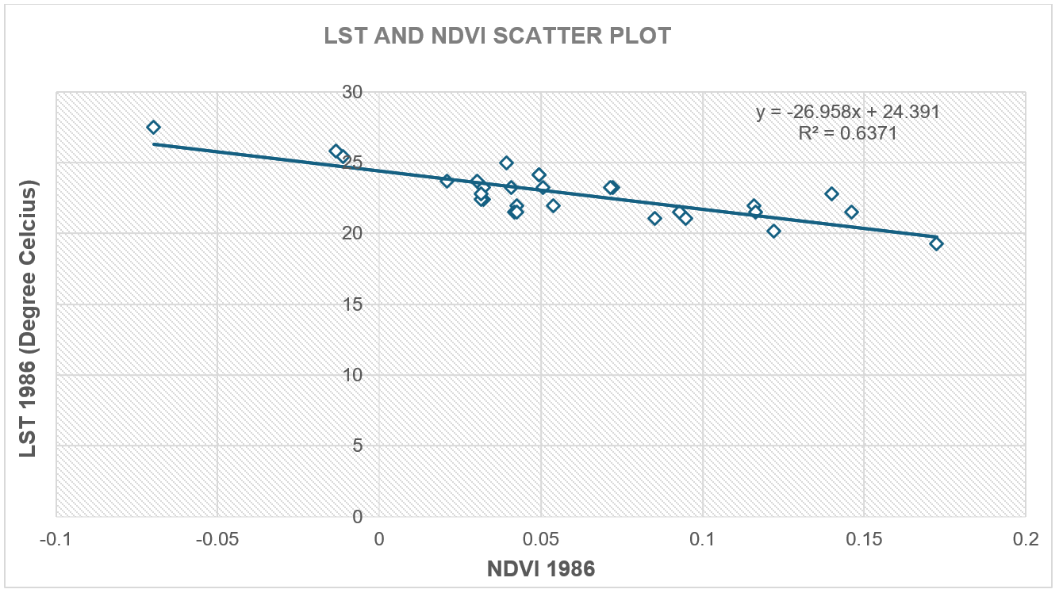  (a) | 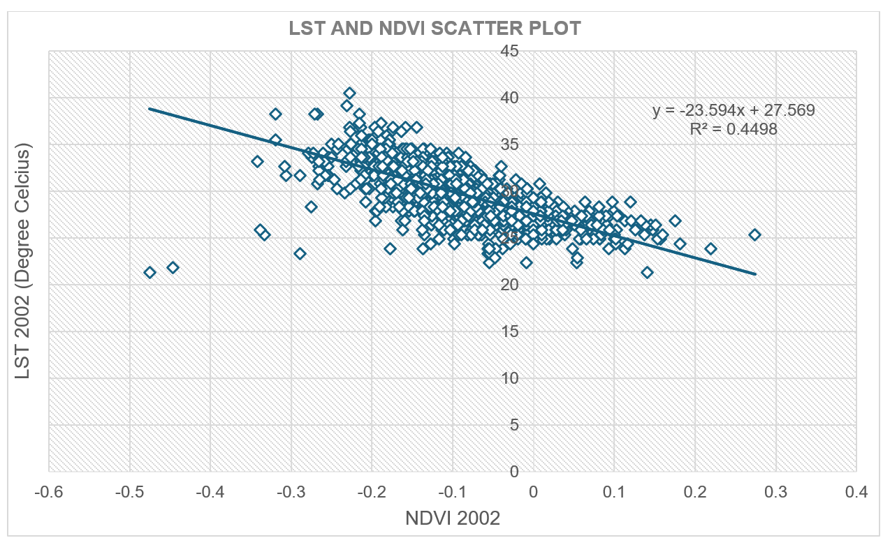  (b)
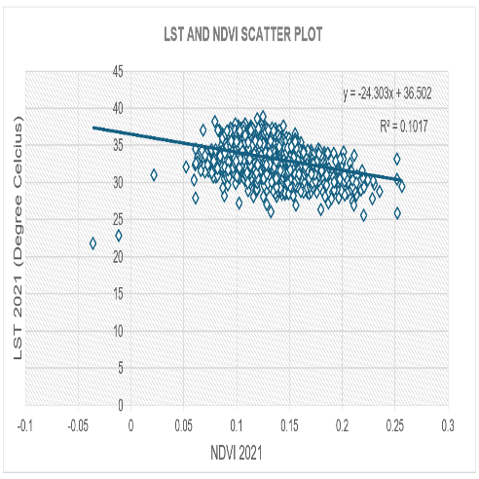
(c)
Figure 8. Relationship between Land Surface Temperature and NDVI for (a) 1986; (b) 2002; (c) 2021

Table 7. Correlation coefficient values for each year

Year | Coefficient of determinant ($R^{2}$ ) | Coefficient of correlation (R)
1986 | -0.6371 | -0.798
2002 | -0.4498 | -0.671
2021 | -0.1017 | -0.319

The findings of this study highlight the impact of urbanization and changes in land use cover on land surface temperature. The observed increase in LST is attributed to the rapid expansion of built-up areas, which replace vegetation and other natural land cover types. The urban heat island (UHI) effect becomes more pronounced as vegetation decreases, leading to higher temperatures in urbanized regions compared to surrounding areas. The study's results align with previous research on urban heat dynamics, confirming that built-up areas retain more heat due to the presence of impervious surfaces such as asphalt and concrete. The significant decrease in vegetation cover in the FCT-Abuja has major environmental implications, including increased energy consumption for cooling, altered local climate conditions, and potential impacts on biodiversity. The study's analysis using remote sensing and GIS techniques provides valuable spatial understanding into these changes, demonstrating the effectiveness of these tools in environmental monitoring. Moreover, the study emphasizes the importance of sustainable urban planning and green infrastructure. Through integrating urban forestry, green roofs, and open spaces, cities can mitigate the adverse effects of rising LST. We believe Policymakers and urban planners must take proactive steps in implementing sustainable land management practices to enhance urban resilience against climate change.

5. Conclusion

The analysis of the effects of land use/land cover change on land surface temperature in the Federal Capital Territory (FCT) Abuja has revealed a significant increase in LST over the years due to changes in land use/land cover. The study found that the built-up area had the highest LST values, while water bodies and vegetation had the lowest LST values. Urbanization and expansion of built-up areas were identified as the main drivers of land use/land cover change in the FCT, leading to a significant decrease in vegetation cover. The study highlights the importance of adopting sustainable land use practices to mitigate the effects of land use/land cover change on LST in the FCT. The findings of this research provide valuable information for policymakers and urban planners to make informed decisions toward sustainable land use practices. The use of remote sensing and GIS techniques employed in this study can be replicated in other regions to analyze the relationship between land use/land cover change and LST. Further research is necessary to explore more sustainable land use practices and their effectiveness in mitigating the effects of land use/land cover change on LST.

Disclaimer (Artificial intelligence)
Option 1:
Author(s) hereby declare that NO generative AI technologies such as Large Language Models (ChatGPT, COPILOT, etc.) and text-to-image generators have been used during the writing or editing of this manuscript.
Option 2:
Author(s) hereby declare that generativ AI technologies such as Large Language Models, etc. have been used during the writing or editing of manuscripts. This explanation will include the name, version, model, and source of the generative AI technology and as well as all input prompts provided to the generative AI technology
Details of the AI usage are given below:
1.
2.
3.

References

Aderele, Meshach O., Tomiyosi S. Bola, and David O. Oke. 2020. "Land Use/Land Cover Changes of Ago-Owu Forest Reserve, Osun State, Nigeria Using Remote Sensing Techniques." Open Journal of Forestry 10 (4): 401-411.
Aniekan Eyoh and Onuwa Okwuashi. (2017). Assessment of Land Surface Temperature across the Niger Delta Region of Nigeria using Thermal Infrared Dataset from Landsat Imageries. International Journal of Scientific and Engineering Research, 8(8), 301-307
Aryal, A., Shakya, B. M., Maharjan, M., Talchabhadel, R., & Thapa, B. R. (2021). Evaluation of the land surface temperature using satellite images in Kathmandu Valley. Nepal Journal of Civil Engineering, 1(1), 1–10. https://doi.org/10.3126/njce.v1i1.43368
Babalola, F.D. & Akinsanola, A.A. (2016). "An assessment of the urban heat island intensity of Lagos, Nigeria using remote sensing data." International Journal of Applied Earth Observation and Geoinformation, vol. 52, pp. 139-147
Chanu, C. S., Elango, L., & Shankar, G. R. (2021). A geospatial approach for assessing the relation between changing land use/land cover and environmental parameters including land surface temperature of Chennai metropolitan city, India. Arabian Journal of Geosciences, 14, 132. https://doi.org/10.1007/s12517-021-06747-1
Grimmond, S. (2007). Urbanization and global environmental change: Local effects of urban warming. The Geographical Journal, 173(1), 83–88. https://doi.org/10.1111/j.1475-4959.2007.232_3.x
Jensen, R. R. (2007). "Remote Sensing of the Environment: An Earth Resource Perspective." Upper Saddle River, NJ: Pearson Prentice Hall
Li, J.J., Wang, X.R., Wang, X.J., Ma, W.C., & Zhang, H. (2009). Remote sensing evaluation of urban heat island and its spatial pattern of the Shanghai metropolitan area, China. Ecological Complexity, 6(4), 413-420. https://doi.org/10.1016/j.ecocom.2009.02.002
Liu, S. (2024). Assessment of regional climate effects of urbanization around subtropical city Wuhan in summer using numerical modeling. Atmosphere, 15(2), 185. https://doi.org/10.3390/atmos15020185
Loveland, T.R., Reed, B.C., Brown, J.F., Ohlen, D.O., Zhu, Z., Yang, L., and Merchant, J.W. (1999). "Development of a Global Land Cover Characteristics Database and IGBP DISCover from 1 km AVHRR Data." International Journal of Remote Sensing, vol. 21, no. 6-7, pp. 1303-1330
Lu, D. and Q. Weng. 2007. A survey of image classification methods and techniques for improving classification performance. International Journal of Remote Sensing 28(5):823-870
Lunetta, R. S., Knight, J. F., Ediriwickrema, J., Lyon, J. G., & Worthy, L. D. (2006). Land-cover change detection using multi-temporal MODIS NDVI data. Remote Sensing of Environment, 105(2), 142-154. doi: 10.1016/j.rse.2006.06.018
Maini, A. K., & Agrawal, V. (2011). Land-use and land-cover change detection through remote sensing approach: A case study of Hathras district, India. Journal of environmental protection, 2(06), 656-663.
Makinde, E. O., & Oyebanji, E. I. (2020). Remote sensing and GIS application to erosion risk mapping in Lagos. Nigerian Journal of Environmental Sciences and Technology (NIJEST), 4(1), 83–97. https://doi.org/10.36263/nijest.2020.01.0081
Olarenwaju, A.N. (2009). "Application of remote sensing and GIS in the assessment of groundwater potential in Ibadan, southwestern Nigeria." Environmental Geology, vol. 56, no. 8, pp. 1527-1534
Ridd, M.K. (1995). "Exploring a V-I-S (Vegetation-Indices-Soil) Model for Estimating Soil Moisture from Remote Imagery with Field Validation." Journal of Hydrology, vol. 167, no. 1-4, pp. 105-122
Saha, J., Ria, S. S., Sultana, J., Shima, U. A., Seyam, M. M. H., & Rahman, M. M. (2024). Assessing seasonal dynamics of land surface temperature (LST) and land use land cover (LULC) in Bhairab, Kishoreganj, Bangladesh: A geospatial analysis from 2008 to 2023. Case Studies in Chemical and Environmental Engineering, 10, 100560. https://doi.org/10.1016/j.cscee.2023.100560
Tan, J., Zheng, Y., Tang, X., & Guo, C. (2009). The urban heat island and its impact on heat waves and human health in Shanghai. International journal of biometeorology, vol. 53, no. 5, pp. 243-254
Turner II, B. L., Lambin, E. F., & Reenberg, A. (Eds.). (2007). Land-use and land-cover change: science/research plan. International Geosphere-Biosphere Programme Book Series, No. 6. Stockholm, Sweden: IGBP Secretariat
Turner, B. L., Lambin, E. F., & Reenberg, A. (Eds.). (2007). Land-use and land-cover change: science/research plan. International Geosphere-Biosphere Programme Book Series, No. 6. Stockholm, Sweden: IGBP Secretariat
Turner, B. L., Meyer, W. B., & Skole, D. L. (1995). Global land-use/land-cover change: towards an integrated study. AMBIO: A Journal of the Human Environment, 24(1), 3-10. doi: 10.2307/4313872
Weng, Q. (2009). Thermal infrared remote sensing for urban climate and environmental studies: methods, applications, and trends. ISPRS Journal of Photogrammetry and Remote Sensing, vol. 64, no. 4, pp. 335-344
Wong, M. S., Nichol, J. E., To, P. H., & Wang, J. (2010). A simple method for designation of urban ventilation corridors and its application to urban heat island analysis. Building and Environment, 45(8), 1880–1889. https://doi.org/10.1016/j.buildenv.2010.02.019
Wong, M.S., & Nichol, J.E. (2013). Classification of high-resolution remotely sensed imagery over urban areas using texture and color. International Journal of Remote Sensing, vol. 34, no. 3, pp. 883-898
Woodcock, C. E., Macomber, S. A., Pax-Lenney, M., & Cohen, W. B. (2002). Monitoring large areas for forest change using Landsat: Generalization across space, time and Landsat sensors. Remote Sensing of Environment, 82(2-3), 227-242. doi: 10.1016/S0034-4257(02)00037-4
Zaharaddeen, I., Baba, I. I., & Ayuba, Z. (2016). Estimation of land surface temperature of Kaduna metropolis, Nigeria using Landsat images. Science World Journal, 11(3), 1-6.

