Original Research Article
A Method for Constructing a Digital Twin Monitoring System for Bridge Cranes Based on Unity3D

ABSTRACT
With the rapid advancement of intelligent manufacturing, ensuring the safe operation and real-time monitoring of bridge cranes has become increasingly critical. Traditional monitoring methods are often hampered by data silos, limited real-time capabilities, and weak visualization, failing to meet the demands of modern industrial equipment management. To address these challenges, this study developed a digital twin-based monitoring system for bridge cranes using the Unity3D engine. The system integrates 3D modeling, physical simulation, and cyber-physical data interaction to enable real-time visualization and historical reconstruction of operational status. A multi-layer architecture—comprising data acquisition, processing, virtual model construction, and application display—was designed to integrate multi-source sensor data and support real-time mapping of key components such as the trolley, bridge travel mechanism, and hoisting device. The system was validated experimentally using a 20-ton double-girder bridge crane in an industrial indoor environment, demonstrating high-precision synchronization with the physical entity, along with reliable monitoring, historical replay, and anomaly recognition. This approach provides practical value for industry users by enhancing operational safety, facilitating predictive maintenance, and improving intelligent management of special industrial equipment.
Keywords: Digital Twin; Bridge Crane; Unity3D; Real-time Monitoring; 3D Visualization

1 INTRODUCTION
As the Made in China 2025 initiative approaches its concluding phase, a wave of new-generation information technologies has driven profound transformations in the manufacturing sector. Factories are rapidly evolving from labor-intensive facilities into highly automated production environments, resulting in an unprecedented global demand for intelligent machinery¹. Among these intelligent systems, equipment condition monitoring is essential in automated factories, enabling operators to obtain real-time operational status, accurately assess machine health, and prevent human or equipment-related accidents that could lead to substantial economic losses.
Bridge cranes, as one of the most commonly used special-purpose devices in industrial workshops, currently exhibit a relatively low level of intelligence. Given the significant damage caused by crane-related failures and accidents, enhancing the intelligence level of bridge cranes has become a pressing necessity.
Digital twin technology constructs a virtual representation corresponding to a physical entity, enabling real-time data perception and comprehensive mapping of physical systems. This aligns seamlessly with the core requirements of industrial monitoring, providing a novel solution for real-time supervision of workshop bridge cranes. In recent years, digital twin technology has seen extensive application across water conservancy, healthcare, mechanical engineering, and aerospace industries.
Song Xueguan’s team at Dalian University of Technology discussed key challenges and solutions for integrated digital-twin technologies in major equipment systems, offering theoretical and technical guidance for industrial-scale implementation¹. Similarly, Wei Yixiong’s research group at Anhui University developed a real-time workshop monitoring system based on real-time data acquisition, achieving real-time visualization, predictive analysis, fault warning, and health management². Christos Vasileiou et al. established a digital twin for a bipedal robot. They designed and fabricated a physical prototype, and conducted simulations using its digital counterpart. The high consistency between the simulation and experimental results validated the effectiveness of the model³.
In the field of special equipment, scholars have conducted numerous studies on applying digital twin technology to cranes. Jia Zhengnan and colleagues developed a digital twin system for boom-type tower cranes, utilizing artificial neural networks to perform online prediction of structural performance, thereby significantly enhancing operational safety⁴. Similarly, Dong Qing et al. introduced a closed-loop structural optimization method for cranes based on digital-twin-driven design principles. Using point-cloud stress data under varying operating conditions and employing K-Nearest Neighbors, Ball-Tree algorithms, and radial basis function neural networks, they constructed predictive models capable of rapidly estimating structural stress distribution.
These studies collectively demonstrate that digital twin technology is becoming increasingly integrated with crane operation and monitoring, offering enhanced intelligence and improved operational safety⁵.
While extensive research has focused on digital-twin-based structural analysis of cranes, studies concerning real-time operational monitoring of bridge cranes remain limited. Addressing this gap, this study develops a digital twin model of a bridge crane using the Unity engine⁶. The system enables real-time monitoring and predictive maintenance through virtual-physical data interaction. By incorporating 3D modeling, physics simulation, and data visualization techniques, this research validates the effectiveness of digital twin technology in industrial equipment management.

Methodology

2 OVERALL DESIGN OF THE BRIDGE CRANE OPERATION STATUS MONITORING SYSTEM
To address the limitations of single-mode data storage and insufficient real-time monitoring during bridge crane operation, it is essential to monitor the entire operational state of the crane. Effective process monitoring not only enables comprehensive data acquisition free from data isolation and fragmented analysis, but also facilitates more thorough supervision and management of complex system dynamics. With the rapid development of industrial intelligence, field equipment has achieved a significantly higher level of digitization, and both control and monitoring methods are evolving toward intelligent and unified architectures. In this context, digital twin technology provides a novel approach for crane monitoring.
A digital twin constructs a fully mapped virtual model in the digital domain corresponding to the physical entity. The digital model reflects and replicates the real operational state of the physical equipment. By building a monitoring system based on digital twin technology, the physical system can be visualized and monitored in a more comprehensive, safer, and intelligent manner. Furthermore, the digital model supports digital-space storage and processing of operational data, enabling replication of system behavior, threshold-based fault prediction alarms, and automatic control instructions. These commands can then be fed back to the physical system to support shutdown inspection and maintenance when required.
Referring to the four-dimensional architecture model of digital twin systems, the core architecture of the bridge crane monitoring system proposed in this work adopts a hierarchical design⁷. It consists of four layers: a data acquisition layer, a data processing layer, a virtual model layer, and an application and visualization layer, as illustrated in Figure 1
.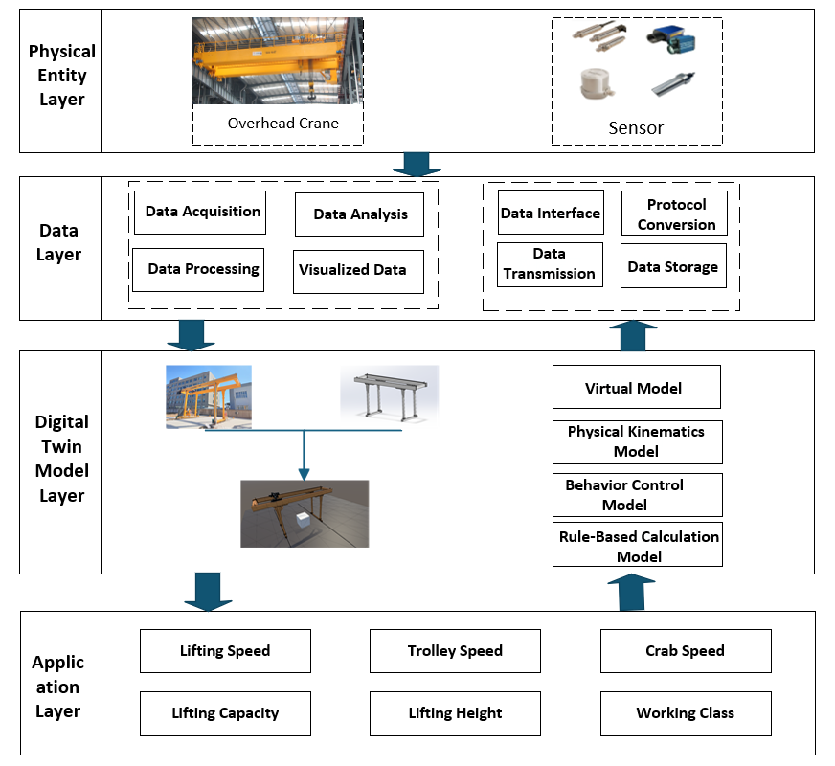

Figure1 Bridge Crane Monitoring System Structure Diagram

2.1 Data Acquisition Layer
The data acquisition layer represents the foundational tier of the entire digital twin system and serves as the structural base of the architecture. Key functional components of the bridge crane—including the trolley, hoist mechanisms, end trucks, and main girders—are equipped with various sensing and control devices, such as sensors, electrical control units, controllers, drives, and absolute encoders.
Operational status data from these critical components are transmitted to the virtual environment through IoT communication technologies, including Wi-Fi and 5G networks⁸. The acquired data continuously drive the digital twin model to perform simulation and dynamic operation, while all simulation data are recorded in a database. Subsequently, the data undergo analysis and visualization processing, enabling the real-time representation of the crane’s operational state within the virtual space.

2.2 Data Processing Layer
The data processing layer functions as the bidirectional communication channel between the physical system and the digital twin. This layer enables seamless data exchange between both entities, ensuring an integrated and interactive monitoring ecosystem.
On one hand, operational data collected from the physical crane are transmitted to the data processing layer, where they are cleaned, filtered, and converted for digital-model execution. The processed data are then communicated to the virtual model, enabling the application and visualization layer to reflect real-time physical state changes.
On the other hand, the digital model performs status evaluation and operational reasoning based on incoming data. When anomalies or threshold-triggered events are detected, the model can issue reverse control commands to the physical crane, facilitating intelligent intervention and establishing closed-loop interaction between the physical and virtual domains⁹.

2.3 Virtual Layer
As the core component of the digital twin framework, the virtual layer constructs a fully mapped digital representation of the physical entity through high-fidelity modeling and simulation technologies. This layer comprises two essential modules: a multi-dimensional digital twin database and a physics-based simulation model set¹⁰.
The virtual model integrates geometric topology (spatial coordinates, structural dimensions), physical features (material properties, surface characteristics), and hierarchical relationships among mechanical components. Through a real-time mapping mechanism, the model accurately reproduces operational conditions of the physical crane, thereby providing a visual foundation for condition monitoring.
Raw sensor data from the physical layer undergo preprocessing, annotation, and structuralization to build time-series datasets. These datasets include operational parameters, environmental variables, and operational logs. Predefined algorithms then drive dynamic parameter updates and behavioral simulation, ensuring high-fidelity reproduction of crane motions and mechanical responses.

2.4 Application Layer
The application layer serves as the primary human-machine interaction interface, delivering both real-time 3D visualization and operational state traceability. By integrating heterogeneous sensor data, a high-precision dynamic 3D model of the bridge crane is constructed, enabling real-time visualization of lifting displacement, trolley and bridge-travel speeds, structural stress distribution, and dynamic loads¹¹.
Unlike traditional manual inspection and video monitoring, this system supports multi-perspective viewing and parameter-linked interaction, enabling in-depth monitoring and identification of mechanical wear in concealed components.
The operational traceability module leverages time-stamped historical data to reconstruct past working scenarios, accurately reproducing load trajectories, vibration abnormalities, and deviation patterns. This supports reverse diagnostic analysis for fault events such as wire-rope failure and gearbox overheating. Furthermore, abnormal-operation monitoring strengthens preventive control and enhances safety management during crane operations.

3 CONSTRUCTION OF THE DIGITAL TWIN-BASED 3D VISUALIZATION SYSTEM

3.1 Development of the 3D Scene
Based on the physical structure of the bridge crane, an initial digital model was generated through laser scanning of the physical equipment. The scanned model was then decomposed into individual component-level models, including the trolley, hoist, hook assembly, and crane rails. Unity3D was used to construct the initial virtual scene, perform scene optimization, design the user interface, and establish a real-time rendering environment. This ensures that the digital-twin visualization system maintains high performance even on low-specification hardware.

3.2 Model Implementation and Simulation
The implementation process of the real-time monitoring digital twin model for bridge cranes based on Unity3D is depicted in Figure 2.
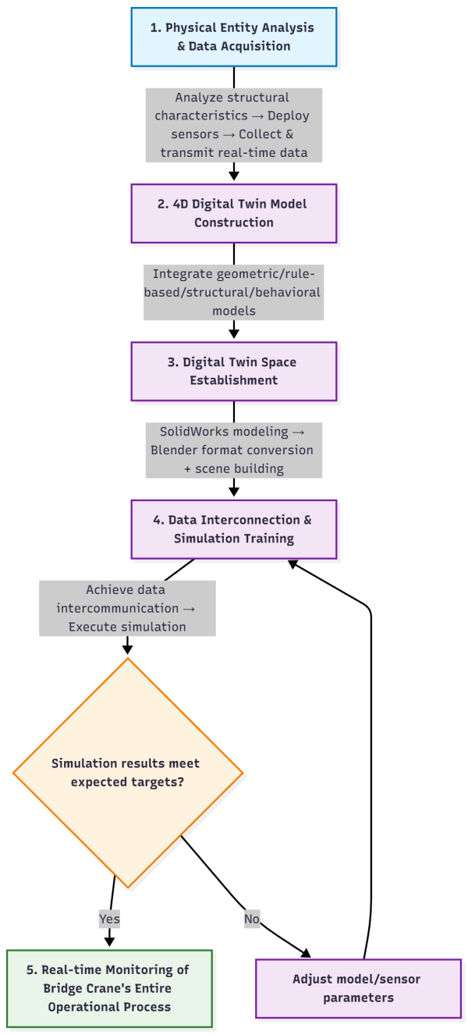
Figure2: Simulation Process

Simulation workflow:
Analyze the physical bridge crane and deploy appropriate sensors according to its structural characteristics to collect and transmit real-time operational data.
Integrate the geometric, rule-based, structural, and behavioral models of the crane to construct a four-dimensional digital-twin model¹².
Develop the preliminary digital model using SolidWorks, convert the model format in Blender, and build the initial virtual environment to establish the digital-twin space.
Achieve data interoperability between the physical and virtual systems, conduct simulation training, and evaluate the simulation results. If the outputs meet the expected goals, the simulation ends; otherwise, system parameters are adjusted and the simulation is repeated.
Through iterative adjustments, a satisfactory simulation model is obtained. This model supports real-time monitoring of the full operational process of the bridge crane within the digital-twin environment¹³.

Result & Discussion

4 EXPERIMENTAL EVALUATION AND APPLICATION OF TH DIGITAL TWIN MONITORING SYSTEM FOR BRIDGE CRANES

4.1 Experimental Setup
The experiment is conducted on a bridge crane manufactured by Henan Mine Group, comprising the main trolley, auxiliary trolley, and hoisting mechanisms. A set of sensors, as listed in the Table1, is installed on the crane to monitor structural safety and collect operational status data for the entire system.

Table 1: Sensors of the Bridge Crane

Sensor Type | Monitoring Range
Pressure Sensor | 0-20000 kg
Bridge Crane Trolley Displacement Sensor | 0-20m
Bridge Crane Crab Displacement Sensor | 0-15 m
Spreader Displacement Sensor | 0-5m
Temperature Sensor | 0-100 ℃

4.2 Experimental Results and Analysis
In the system’s main interface, three principal panels are prominently featured: the Launch Panel, the Operational Status Panel, and the Monitoring Data Panel, as depicted in Figure 3. The Launch Panel serves as the control center for initiating and terminating the monitoring process. Concurrently, the Operational Status Panel provides a clear indication of whether the equipment is operating within normal parameters. Furthermore, the Monitoring Data Panel furnishes real-time operational data of the equipment currently in use¹⁴.
This division of panels ensures a structured and efficient approach to system monitoring and control, allowing for a comprehensive overview of the system’s performance and status. The Launch Panel is pivotal in managing the monitoring lifecycle, while the Operational Status Panel offers a snapshot of the system’s health, and the Monitoring Data Panel delivers detailed, up-to-date information essential for system analysis and decision-making.
The experimental objective is to evaluate the functionality of the 3D visualization monitoring system and verify the real-time updating capability of the operational status. The constructed experimental environment demonstrates the feasibility of providing real-time visual monitoring for the physical bridge crane¹⁵.
Testing of Operational Status Reproduction
To validate the accuracy of the data, a comparison was conducted between the historical data retrieved by the virtual model and the real-time data transmitted by the controller. Taking the displacement data of a section of the bridge crane as a case study, Tables 2 and 3 serve as the comparative datasets. The data from both tables are largely consistent, which suggests that the data transmission and parsing are accurate.

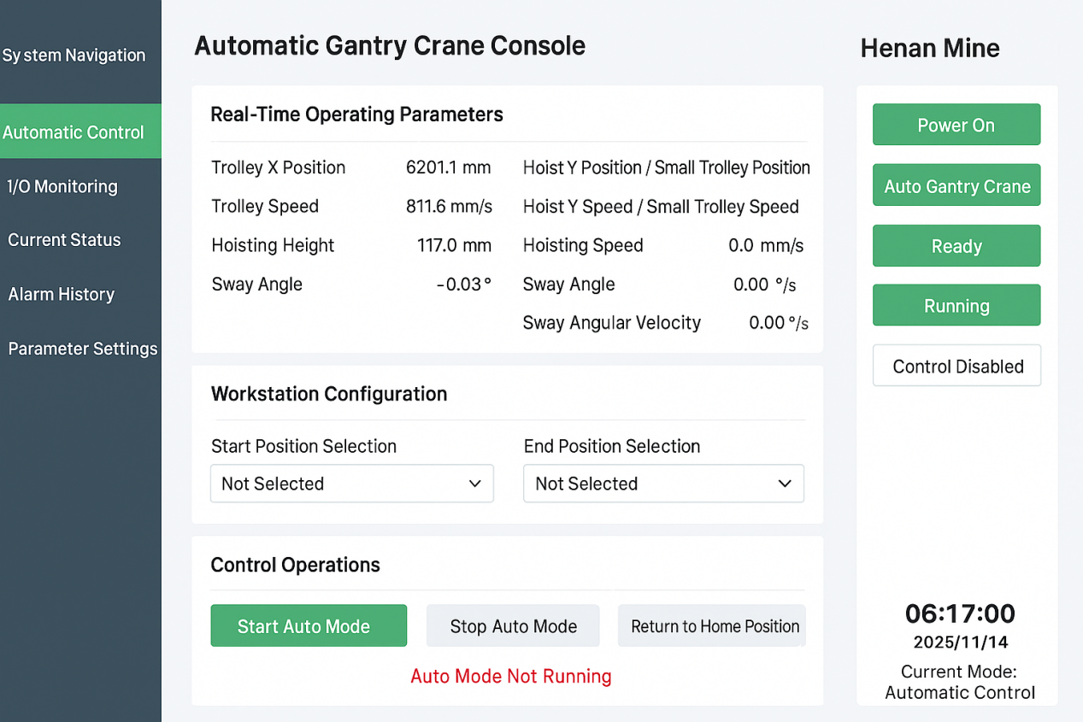
Figure 3 HMI Interface

Table2: Sensor Data Stored in Database

Bridge Position(mm) | Trolley Position(mm) | Hoisting Height(mm) | Swing Angle (Horizontal)(°) | Load Weight(kg) | Bridge Travel  Speed(m/s) | Trolley Travel Speed(m/s)
6568.1 | 8117.6 | 1710.8 | -0.03 | 10452 | 0.35 | 0.28
6580.1 | 8112.6 | 1740.8 | 0.07 | 10652 | 0.38 | 0.25
6553.1 | 8137.6 | 1610.8 | -0.23 | 10152 | 0.30 | 0.32
6573.1 | 8127.6 | 1720.8 | 0.00 | 10452 | 0.40 | 0.30
6560.1 | 8105.6 | 1910.8 | 0.15 | 10952 | 0.50 | 0.45
6588.1 | 8087.6 | 1660.8 | -0.50 | 9452 | 0.25 | 0.22
6569.1 | 8120.6 | 1715.8 | 0.02 | 10502 | 0.35 | 0.28
6548.1 | 8167.6 | 1510.8 | 0.40 | 10752 | 0.45 | 0.40
6577.1 | 8102.6 | 1790.8 | -0.10 | 10252 | 0.33 | 0.27
6562.1 | 8118.6 | 1690.8 | 0.05 | 10552 | 0.36 | 0.29

Table 3: Real-Time Data Transmitted by Sensors

Bridge Position(mm) | Trolley Position(mm) | Hoisting Height(mm) | Swing Angle (Horizontal)(°) | Load Weight(kg) | Bridge Travel  Speed(m/s) | Trolley Travel Speed(m/s)
6571.0 | 8115.0 | 1720 | -0.01 | 10460 | 0.36 | 0.27
6577.0 | 8114.0 | 1735 | 0.06 | 10640 | 0.36 | 0.26
6558.0 | 8139.0 | 1605 | -0.2 | 10170 | 0.31 | 0.3
6579.0 | 8125.0 | 1718 | 0.02 | 10440 | 0.39 | 0.31
6562.0 | 8107.0 | 1900 | 0.12 | 10980 | 0.48 | 0.46
6591.0 | 8085.0 | 1655 | -0.55 | 9440 | 0.24 | 0.2
6564.0 | 8123.0 | 1722 | 0.03 | 10490 | 0.34 | 0.29
6552.0 | 8165.0 | 1518 | 0.45 | 10760 | 0.44 | 0.38
6579.0. | 8101.0 | 1785 | -0.08 | 10260 | 0.34 | 0.26
6563.0 | 8119.5 | 1695 | 0.04 | 10540 | 0.35 | 0.3

A comprehensive quantitative analysis was conducted on the synchronization performance for all core crane parameters, including positional data, load weight, and operational speeds. The metrics, calculated directly from the experimental data pairs, are authoritatively summarized in Table 4.
The results demonstrate exceptionally high synchronization fidelity across the entire digital twin system. The load weight data exhibited outstanding accuracy with an MAE of merely 26.0 kg (MAPE: 0.25%) and a maximum deviation of 60 kg, confirming the system’s reliability for real-time safety assessments. Regarding positional data, the trolley achieved the highest precision (MAE: 1.95 mm, MAPE: 0.023%), followed closely by the bridge (MAE: 3.34 mm, MAPE: ~0.051%) and the hoisting mechanism (MAE: 11.34 mm), reflecting their respective physical and control characteristics. The low Maximum Absolute Errors across all positional parameters further attest to the system’s stability.
For speed parameters, both bridge travel speed and trolley travel speed showed good synchronization performance with MAEs of 0.016 m/s (MAPE: 4.63%) and 0.015 m/s (MAPE: 5.45%) respectively, and a maximum observed error of 0.03 m/s. These error levels are well within acceptable limits for operational monitoring and dynamic simulation purposes.
The close proximity of RMSE values to their respective MAEs for all datasets indicates a stable error distribution without significant outliers. Collectively, these comprehensive quantitative results unequivocally validate that the proposed digital twin system provides highly accurate and reliable real-time data synchronization for both operational monitoring and safety-critical decision-making across all key crane parameters.

Table 4. Comprehensive synchronization performance metrics of the digital twin system.
Metric | Bridge Position(mm) | Trolley Position(mm) | Hoisting Height(mm) | Load Weight(kg) | Bridge Speed(m/s) | Trolley Speed(m/s)
Mean Absolute Error | 3.34 | 1.95 | 11.34 | 26.0 | 0.016 | 0.015
Root Mean Square Error | 3.67 | 2.05 | 12.67 | 28.46 | 0.018 | 0.017
Maximum Absolute Error | 5.9 | 2.6 | 18 | 60 | 0.03 | 0.03
Mean Abs. Percent Error | ~0.051% | 0.023% | - | 0.25% | 4.63% | 5.45%
Number of Data Pairs | 10 | 10 | 10 | 10 | 10 | 10

The comparison of data from the aforementioned tables is illustrated in Figures 4, 5, and 6, which display a comparison between historical data and real-time data.
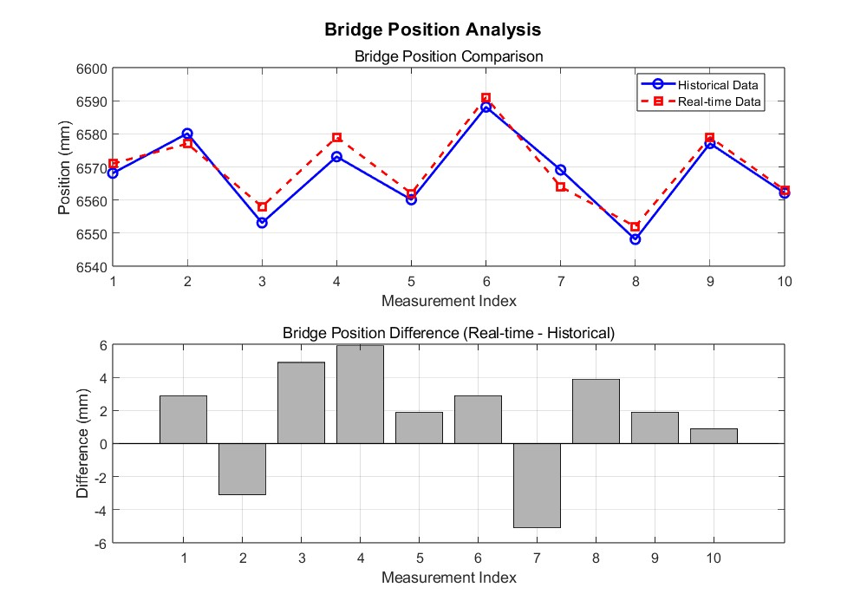

Figure4: Bridge Position Comparison Chart
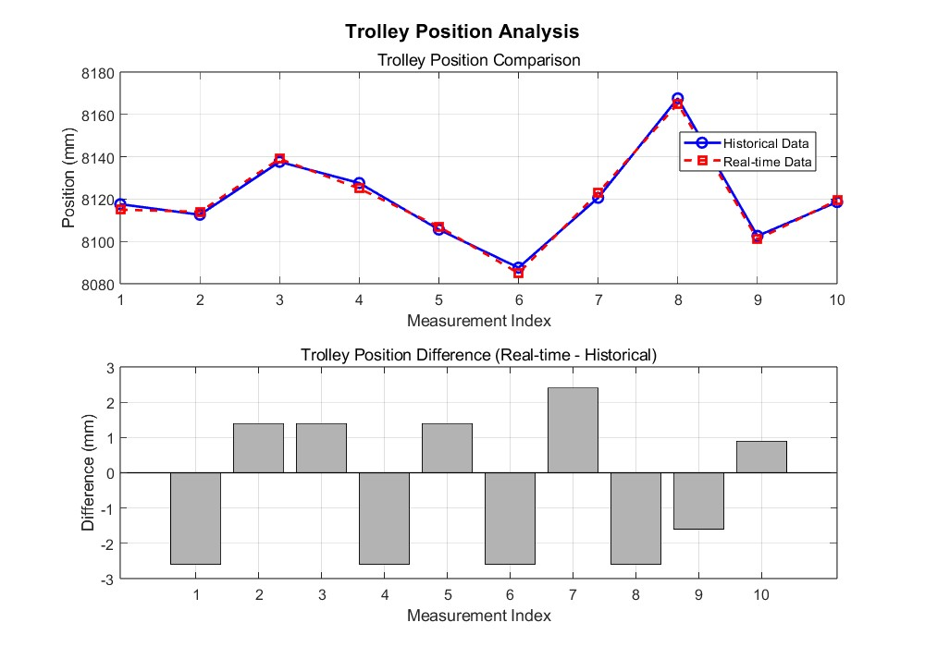
Figure5: Trolley Position Comparison Chart
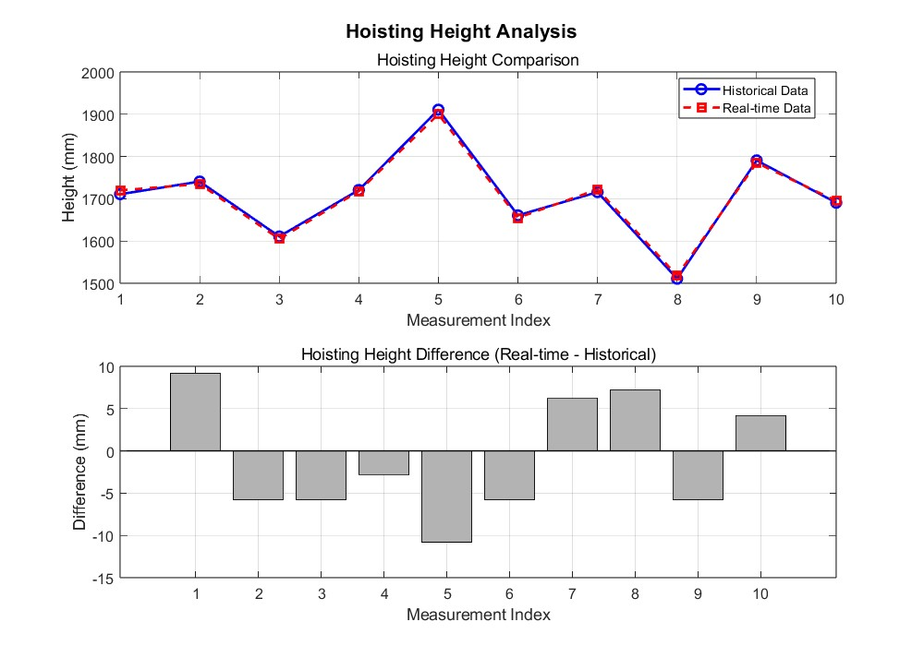
Figure5: Hoisting Position Comparison Chart
The digital twin model of the bridge crane, as demonstrated through the analysis of the provided tables and comparative figures, exhibits commendable performance in real-time monitoring capabilities. It effectively captures the operational states of the trolley and hoist, including critical parameters such as hook position and load pressure. This real-time data acquisition is pivotal for operators to promptly assess the equipment status and respond accordingly.
The consistency between the historical data presented in the tables and the real-time data depicted in Figures 4 and 5 is noteworthy. This high degree of congruence validates the model’s core functionality by demonstrating its fidelity in accurately reflecting the actual operational dynamics of the bridge crane, thereby ensuring the reliability of the digital replica for real-time monitoring.
The model’s adaptability to harsh operating environments is a significant finding. It not only enhances the crane’s operational stability but also bolsters its reliability and durability by ensuring continuous operation under varying conditions.
In terms of operational safety, the digital twin model’s real-time monitoring and early warning mechanisms are instrumental in preempting potential operational hazards, thereby augmenting the safety of bridge crane operations.
The timeliness of control commands issued by the model, based on real-time data analysis, is another critical aspect. It contributes to the enhancement of operational responsiveness and accuracy, which is essential for the efficient functioning of the crane.
Lastly, the model’s accuracy in data parsing is a testament to its robustness. Its ability to accurately receive and interpret data from the controller is fundamental to the model’s reliability and practical utility.
In summary, the digital twin model of the bridge crane has demonstrated superior performance in real-time monitoring, data consistency, environmental adaptability, operational safety, control command timeliness, and data parsing accuracy. These attributes collectively contribute to the efficient and safe operation of the bridge crane, providing substantial support for its high-performance and secure functioning.

CONCLUSION
This study successfully developed a Unity3D-based digital twin monitoring system for bridge cranes, achieving real-time bidirectional data mapping between physical equipment and its virtual counterpart. Through the construction of a 3D crane model, the design of data acquisition and processing mechanisms, and the implementation of cyber–physical synchronization, the system effectively visualizes the operational status of key components, including the bridge, trolley, and hoisting mechanisms. Experimental validation confirmed that the system ensures high accuracy in data synchronization, reliable historical reconstruction, and intuitive visualization. The results demonstrate that the proposed system not only enhances situational awareness and safety monitoring but also provides essential support for fault diagnosis and predictive maintenance.
However, this study has certain limitations. The current system was primarily validated on a single crane unit, and its scalability for large-scale deployment and robustness under extreme operating conditions require further evaluation.
Building on these findings, future work will focus on the following directions:
- Enhancing System Intelligence: Leveraging the high-fidelity synchronized data stream provided by the system, machine learning algorithms will be integrated to develop predictive maintenance and intelligent control capabilities, enabling a transition from “describing the present” to “predicting the future.”
- Expanding Application Scale: Distributed system architectures and edge computing will be explored to support the monitoring of digital twin clusters across multiple cranes in a port, addressing scalability challenges.
- Deepening Human–Machine Interaction: Research will be conducted to integrate the digital twin with cutting-edge technologies such as augmented reality (AR), providing operators with more intuitive interactive experiences and decision-making support.
In summary, this work not only establishes a feasible and reliable technological pathway for advancing intelligent monitoring of bridge cranes but also lays a solid foundation for its evolution toward smarter, more generalizable, and more powerful applications.

DISCLAIMER (ARTIFICIAL INTELLIGENCE)
Author(s) hereby declare that NO generative AI technologies such as Large Language Models (ChatGPT, COPILOT, etc) and text-to-image generators have been used during writing or editing of manuscripts.

COMPETING INTERESTS DISCLAIMER:
Authors have declared that they have no known competing financial interests OR non-financial interests OR personal relationships that could have appeared to influence the work reported in this paper.

Disclaimer (Artificial intelligence)
Option 1:
Author(s) hereby declare that NO generative AI technologies such as Large Language Models (ChatGPT, COPILOT, etc.) and text-to-image generators have been used during the writing or editing of this manuscript.
Option 2:
Author(s) hereby declare that generative AI technologies such as Large Language Models, etc. have been used during the writing or editing of manuscripts. This explanation will include the name, version, model, and source of the generative AI technology and as well as all input prompts provided to the generative AI technology
Details of the AI usage are given below:
1.
2.
3.

REFERENCES
- Liu Y, Feng J, Lu J, et al. A review of digital twin capabilities, technologies, and applications based on the maturity model[J]. Advanced Engineering Informatics, 2024, 62: 102592.
- Wei, Y., Guo, L., Chen, L., et al. (2021). Research and implementation of digital twin workshop based on real-time data driven. Computer Integrated Manufacturing Systems, 27(02), 352–363. https://doi.org/10.13196/j.cims.2021.02.004
- Vasileiou C, Smyrli A, Drogosis A, et al. Development of a passive biped robot digital twin using analysis, experiments, and a multibody simulation environment[J]. Mechanism and Machine Theory, 2021, 163: 104346.
- JIA Z, WANG X, GAO S, et al. Online structural performance monitoring method of tower crane based on digital twin[J]. Computer Integrated Manufacturing System, 2024, 30(12): 4468.
- Es-haghi M S, Anitescu C, Rabczuk T. Methods for enabling real-time analysis in digital twins: A literature review[J]. Computers & Structures, 2024, 297: 107342.
- Zhang, Y., Sun, W., Liu, G., & Niu, J. (2024). Research on robot visualization monitoring based on Unity3D and multi-source data fusion. Manufacturing Technology & Machine Tools, (12), 30–37. https://doi.org/10.19287/j.mtmt.1005-2402.2024.12.003
- Xu, J., Liu, G., Zhao, Y., Zheng, Z., & Yan, H. (2024). The Synchronous Grasping Method of Virtual-real Assembly Robot Based on Digital Twin. Journal of System Simulation, 36(9), 2181-2192. https://doi.org/10.16182/j.issn1004731x.joss.23-0575
- Zhang, W., Liao, Y., Jiang, L., & Zhang, T. (2021). Internet of Things-based Safety Monitoring System for Tower Cranes. China Safety Science Journal, 31(02), 55-62. https://doi.org/10.16265/j.cnki.issn1003-3033.2021.02.008
- Jang D H, Roh G T, Jeon C H, et al. Simulation-based optimization of crane lifting position and capacity using a construction digital twin for prefabricated bridge deck assembly[J]. Buildings, 2025, 15(3): 475.
- Yuan E, Yang J, Saafi M, et al. Realization of the physical to virtual connection for digital twin of construction crane[J]. Journal of Industrial Information Integration, 2025, 44: 100779.
- Li, H., Hui, Y., Wang, Q., Wang, H., & Zhou, Y. (2024). Autonomous operation system of overhead crane based on digital twins. Journal of Mechanical & Electrical Engineering, 41(04), 691-700. https://doi.org/10.3969/j.issn.1001-4551.2024.04.015
- Chen, S., Lu, S., Wang, J., et al. (2024). Construction method of digital twin model for safe operation of cable crane by integrating Unity3D. Journal of Safety Science and Technology, 20(1), 154-159. https://doi.org/10.11731/j.issn.1673-193x.2024.01.022
- Tao, F., Cheng, Y., Cheng, J. F., Zhang, M., Xu, W. J., & Qi, Q. L. (2017). Theory and technologies for cyber-physical fusion in digital twin shop-floor. Computer Integrated Manufacturing Systems, 23(8), 1603-1611. https://doi.org/10.13196/j.cims.2017.08.001
- Xu, J., Liu, G., Zhao, Y., Zheng, Z., & Yan, H. (2024). The Synchronous Grasping Method of Virtual-real Assembly Robot Based on Digital Twin. Journal of System Simulation, 36(9), 2181-2192. https://doi.org/10.16182/j.issn1004731x.joss.23-0575
- Wu, P. Y., Guo, Y., Huang, S. H., et al. (2021). Visual Real-Time Monitoring Method for Discrete Manufacturing Workshops Based on Digital Twin. *Computer Integrated Manufacturing Systems*, *27*(06), 1605-1616. https://doi.org/10.13196/j.cims.2021.06.007

