A Comprehensive Review of Hybrid Solar-Assisted Air Conditioning and Space Heating Systems with Advanced Evacuated Collector Designs

Abstract
The review emphasizes specifically on combined solar energy with classical energy sources. A key feature is the analysis of advanced evacuated collector designs, which signify a major technical progression in solar thermal energy harvesting. We inspect how these high-efficiency collectors contribute to the overall presentation and viability of hybrid systems. Cooling and air-conditioning design are the main consumers of energy sources in hot and cold sites. The dependence on classical schemes, driven electrically, is the chief aim behind the worsening and ever-rising demand for power in construction. This is similarly related to a massive quantity of carbon dioxide released and other ecological anxieties. Solar power has been presented by way of a crucial other for many requests, which has been established to be a consistent and reliable source. The popularity of solar power systems driven by sunlight thermal energy is expounded in aspect, considering their process and growth characteristics. The rising worldwide demand for energy, combined with the crucial need to decrease emissions of greenhouse gas, that driven an important interest in renewable and sustainable energy technologies. It highlights the key knowledge related to active solar thermal systems, concentrating on their applications in space heating and domestic hot water (DHW) systems. The hybrid of solar energy with heat pump design is deliberated as a real method to cumulatively overall energy efficiency, chiefly in variable climatic circumstances.
Keywords: Power Energy, Renewable Energy Systems, Thermal Collectors, Solar Energy, Evacuated Solar Collector

Nomenclature
RES Renewable Energy Systems
ILP interval linear programming
MILP chance-constrained programming
OPEC: Organization of the Petroleum Exporting Countries
EU European Union
PV photovoltaic
DHW domestic hot water
ETC evacuated tubular collectors
ROI return on investment
GHP geothermal heat pump
VHP vertical heat exchangers
DC direct current
AC alternating current
T temperature, K
T∞ free streams temperature, K u velocity component in x, m/s v velocity component in y, m/s x coordinate from the leading edge, m y coordinate normal to plate, m
z₁, z₂, z₃, z₄, z₅ variables, eq (19)

1. Introduction
They are infinite and can be used as many times as the ways of civilization are essential. The main source of renewable energy is solar energy from the sun. Planet Earth gets abundant energy from solar radiation all day [1]. As this energy reaches the earth, it starts to be dissipated, generating other energy sources such as wind and geothermal. One of the vital elements for the cumulative sustainability of an energy system is the reduction of CO₂ emissions. A relevant influence is the rise of renewable energy use, with a resulting reduction of fossil fuel [2]. Renewable Energy Systems (RES) can be used for providing both process heat and electricity in the civil and manufacturing sectors. Renewable energy sources are now good-looking other energy sources owing to their low emission of carbon emissions, price stability, unlimited source, and economic welfare [3].
Though the growth of RES has been amped by its variability to be used to encounter electricity base load demand, its harmonic problem, and high cost [4]. Given that heat now makes up about 50% of global final energy demand, the renewable heating manufacturing is still expected to have a important influence. The main attraction of solar thermal systems is their ability to meaningfully increase the proportion of low-temperature heat made by solar radiation. It is vital to increase the amount of heat produced by solar energy sources for industrial needs [5].

1.1 Solar Energy
It demonstrates the highest practical feasible potential (about 60TW) among all sources of renewable energy, which exceeded the total world energy consumption. Knowledge of the sun is very significant in the optimization of photovoltaic design [6]. Solar radiation is the term secondhand to describe the electromagnetic waves that the sun emits. Geographical location, time of day, period, local geography, and weather are some of the variables that affect how much sunlight spreads over any given area on the ground [7]. The sun is the source of all of the planet's energy, as will be accentuated recurrently throughout this examination. Instead, solar power is energy that is derived directly from the sunlight. Subsequently, it serves as this report's main renewable energy source. To give a quick overview of this energy type, it is valuable to state that solar energy is the most plentiful and consistent energy source [8].
Through the atmosphere, solar radiation is fascinated, reflected and transmitted. The area geography under work also meaningfully affects how well solar energy plants operate. Several technical investigations have been conducted to find models that define the irradiation statistics on the surface. Central solar power plants are more real-world excellent for high and intermediate power, however. Although molten salts are characteristically used as the heat transfer fluid, other approaches, for example, direct steam production, could raise system competence [9].

1.2. Geothermal Energy
This energy basis comes from heat escaping from the inside soil layers. The energy latent is 35 thousand million times the world's energy consumption [10]. Though only a minor part of this energy can be removed owing to the 5 km depth limit to be discovery. The temperature rises by 30ºC for km on normal at this depth, though this quantity varies from region to region. This energy is the source of natural geysers and spas. They also recognized the world's finest spaces to use knowledge to extract energy from the earth's core [11]. These comprise parts of eastern Africa, the western Arabian, the Alpine-Himalayan crag variety, and a few Pacific Ocean archipelagos such as Hawaii and Samoa [12].

1.3. Wind Energy
This energy is a fresh, renewable basis of power produced by harnessing the kinetic energy of wind through turbines for electricity production. The turbines change the wind's force into mechanical energy to spin a generator, which then produces electrical energy for the grid [13]. Large-scale wind and smaller usages both use this inexpensive and maintainable energy source, which is vital for lowering carbon releases [14]. About the world, this energy source has industrialized meaningfully and rapidly. The cost of this energy has reduced to levels that permit it to compete in the energy marketplace [15]. Subsequently ancient times, wind has been used for a variety of responsibilities, including moving large ships, grinding grain in windmills, and conveying water to higher areas. Really, the growth of wind farms to produce electricity was largely based on windmills. Modern wind farms cause noise and visual contamination even though they don't release any polluting substances into the environment [16].

1.4. Biomass
Waste from manufacturing and agriculture is the main source of this energy. However, biomass power has been an important energy source since the primeval era. Once more, the sun is the source of this type of energy. The important component of this basis is the sun, which is essential for photosynthesis in plants [17]. The key elements that are a used in photosynthesis are lignin, crop waste, and animal dung. Wood is used to cook and heat homes all over the world, but particularly in developing nations. To reduce carbon dioxide emissions into the environment, biofuels are the subject of numerous studies and investments in industrial nations. Though, because energy must be produced by red-hot materials, its competence is somewhat low [18].

1.5. Hydraulic Energy
The two main functions of water-storage dams are to increase the water level to release potential energy and to store water to offset differences in river flow or power demand. Though the ecologies that grow up close to the streams are wedged by these tanks, flooding high zones. Moreover, floodplains have fertile soils for undeveloped areas, and rivers offer angling possibilities even when nearby towns do not use them for undeveloped areas. The expropriation of lands required to flood large areas close to rivers is accompanied by these ecological problems. Because of political thoughts, this duty is crucial to creativity [19]. Around the ecosphere, this energy source is well-established and often used. Large facilities of hydraulic power in developed nations with wide hydropower systems are already fully utilized. Consequently, small-scale hydro projects are now the chief focus to get the bordering[20].

1.6. Ocean Energy
Since about two-thirds of the world is enclosed by water, oceans absorb most of the sun's light by heating system of air overhead and creating air currents that move the water and create waves, which causes the oceans to warm [21]. Thus, the seas signify a vast tank of energy that chiefly originates from four sources: the salinity incline, sea currents, tides, and waves. Furthermore, tides are caused by the sun's and the moon's gravitational pull. This energy source's utmost feature is how foreseeable its timing and production are. Though some locations—like the United Kingdom and France—are better suited to the installation of these power plants than others, since tides may be used to produce energy when they are large enough. The variations of temperature occur over the deep seas in both hot and cold regions of the world [22].
Assumed that this temperature differential happens throughout the day, its making might be continuous. Large pipes and pumps form the foundation of this knowledge, which needs a temperature difference of at least 20ºC, which must store this energy and convert it into other forms of energy, such as hydrogen. The ocean's salinity gradient can be used to make electricity. In theory, freshwater and a saltwater reservoir are separated by membrane treatment. This reservoir would fill up to the point where it could be unconfined into a water turbine to make electricity.[23].

2. Renewable and Sustainable Energy Methods
Technical change in energy schemes is a vital and unavoidable aspect that authors must come to terms with because energy resources are vital from a financial and political position for all countries [24]. The methods are perspectives of design, planning, and control. Assumed the growing global demand for energy, the growth of distribution networks has arisen as a concern of paramount importance. From the viewpoint of energy system design and long-term planning, selecting the optimal option among the numerous renewable energy systems is of key significance because of the significant investment expenses involved in developing a renewable energy structure [25]. Planning for community-scale renewable energy systems is an important issue that comprises defensive patterns of energy resource and service distribution, developing native policies pertaining to consumption of energy, financial growth, and energy structure, and analyzing the relationships between system dependability, energy-supply security, and financial cost. With the intention of finding solutions that can offer the intended energy reserve distribution and capacity-expansion strategies with the lowest conceivable system price, highest possible system dependability, and highest possible energy safety, some writers have tackled this challenging problem with interval linear programming (ILP), chance-constrained programming, and mixed integer-linear programming (MILP) methods [26].
Since renewable energy sources address many of the drawbacks of fossil fuels, both monetarily and environmentally, they are being promoted as the primary substitutes. From an ecological standpoint, there would be a novel opportunity to combine conservative and renewable methods to increase ecological care and competence while constantly satisfying energy demand at the best balance [27]. Natural gas would be the chief fuel used as backup in renewable energy power plants because it takes an average of 41 years for oil and 67 years for natural gas to meet demand. Also, the grid may obtain electrical energy directly from renewable sources, substituting traditional sources, which would eliminate the need for energy storage. From an economic viewpoint, the advent of new energy sources expands energy producers and offers a multitude of ways to power the planet, permitting each location to choose the most suitable energy source. Also, considering the disparities between renewable energy sources, varying them would increase competition in a important market that has historically been conquered by oil companies [28].
As a result, there is a chance to offshore energy production, which permits other nations to enter this market in a diversity of ways because some places are better than others for the assignment of renewable energy services. Furthermore, it would result in the development of jobs across a wide range of trades, levels, and locations. It must be careful, though, that the creation of these jobs would also result in the loss of other jobs in other trades [29]. Changes in market circumstances are essential for the combined of renewable energy sources into the energy sector. First and leading, private companies must properly understand the financial advantages of this type of energy. A project can be financially studied in a variety of ways, and renewable energy is a long-term asset that takes time to pay off. Second, taxes and rules ought to recover investment choices by accounting for ecological costs, which are difficult to quantify.. Thirdly, governments ought to inspire research into renewable energy knowledge by allocating more resources and workers to this field of work. And finally, the establishment of a huge and powerful organization in the fossil fuel market that is comparable to the Organization of the Petroleum Exporting Countries (OPEC) [30]. The goal of the agreement was to lower emissions of carbon dioxide and lessen the greenhouse effect. Because of this, the European Union member states decided to break the control that had been in place until the 1990s and open up the energy markets to new competitors. These states' initial move was to clearly distinguish between the non-competitive features of the market, such as the operation of the energy networks, and the elements that could be subject to competition, like direct customer service. Second, the companies that controlled the market up to that point were compulsory to let outsiders use the technology and infrastructure. As a third step, these nations lifted limits on consumers' ability to switch suppliers, increasing competition in this market. Finally, independent regulators were tasked with keeping an eye on the manufacturing to find a more neutral valuation of the market. Nonetheless, even with all of the work done to raise competition and, so, the market's usage of renewable energy, it was inadequate to provide new skills and a firm foothold in the industry [31].
As a result, the government started applying policies to level the playing field for renewable energy technologies against more recognized ones. Three primary models have been created throughout the European Union (EU) for this objective. The first is the so-called "Feed-in Model," which entails setting a long-term minimum price for the renewable electric energy production [32]. Its positive application in nations such as Denmark, Germany, and Spain shows its high efficiency when associated with other renewable technology growths like wind power. Since it contravenes market regulations, it presents a challenge when presented in markets. The United Kingdom developed the "Tender System" is another tool for promoting RES. With this approach, contracts are offered at various intervals, and a renewable energy plant receives a quota if it submits the lowest tender price [33]. For the period of the contract, the effective bidder sells its electric production at a set price. Even though it appears to be a more competitive and superior system than the Feed-in Model, disputes over wind farm locations throughout the United Kingdom have produced worse consequences for both bureaucratic and landscape reasons. The "Certificates Trading Model" is the model that is used in the Netherlands. The market price plus the market price of the green documentation are the prices at which the renewable energy producer sells their energy under this strategy. Green certificates, which are merchandise that may be traded, attest to the fact that the energy was produced using renewable resources [34].

3. Solar energy technologies
An alluring substitute for classical air-conditioning design is solar energy for summertime thermal comfort because the peak cooling stresses of the building accord with the peak solar potential. A solar thermal collector is a device that powers sorption systems by converting solar radiation into thermal energy. Numerous types of solar thermal systems are illustrious based on their geometry, operation, and temperature range. Fig. 1 shows how solar thermal methods are considered with solar photovoltaic (PV) panels; solar energy may be directly transformed into electrical power. Conservative vapor compression systems can be powered by this electric energy to generate the air conditioning effect. However, PV panels have a relatively poor efficiency of only 15% to 20% [35]. Moreover, because solar energy is irregular, it requires a storage system; though, electric energy storage is more costly than thermal energy storage. So, due to their better efficiency (up to 80%) than PV panels, solar thermal collectors can also be used as another method to capture solar thermal energy for use in heat-driven sorption cycles [36].
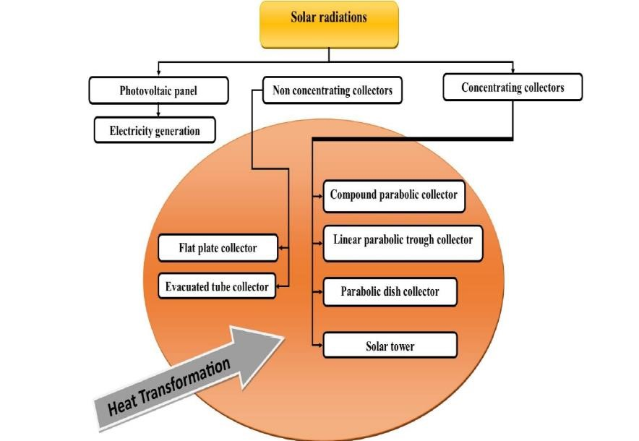
Figure 1. Arrangement of solar energy technologies [26]

3.1 Non-concentrating collectors
Flat plate and evacuated tube solar thermal collectors are often utilized for solar air conditioning requests. Low temperature requests are often appropriate for the flat plate collector. Instead, the evacuated tube collector may produce heat energy at temperatures as high as 150 °C [37].

3.2 Concentrating collectors
Fig. 1 describes the main concentrating collector knowledge. Though, because of the appropriate temperature range wanted for solar air conditioning requests, only compound parabolic concentrators are typically optional. Also, the low concentration ratio parabolic trough collector has not yet been given much care for use in air conditioning. Consequently, its presentation and potential appraisal must be assessed [38].

3.3 Application of different thermal collectors
Figure 2 provides a summary of the solar thermal collectors' efficacy trends and request range. The horizontal axis displays the temperature change ratio in relation to event radiations, though the primary vertical axis shows the collector's competence. The efficiency curves match test results for various collectors in relation to an average ambient temperature of 25 °C and 1000 W/m² of incident solar energy [39].
For the reason that they operate at roughly 60°C, it has been found that flat plate collectors with selective coating, air collectors with selective coating, and compound parabolic concentrators (CPC) are ideal for desiccant cooling systems. Also, adsorption and single-stage absorption systems can make use of this knowledge. It has been noted that as the temperature differential between the ambient and collector averages grows, efficiency tends to decline more quickly [40]. However, the heat pipe evacuated tube collector is more beneficial because a greater temperature gradient has less of an influence on its efficiency. Direct contact and high-competence evacuated tube collectors work well with two-stage absorption systems that have an operating temperature of 140°C [41].
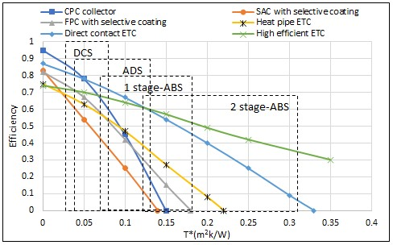
Figure 2 Types of solar thermal collectors with their potential application [42]

4. Technology of solar thermal active systems
The phrase "active solar systems" is often used to designate groups of devices that source hot water, heating, or cooling in housing and profitable constructions. Other standards, such as the subsequent, are infrequently used to distinguish between active and passive systems. While natural circulation (of air) happens in passive buildings, active systems characteristically need auxiliary energy to cause the transfer fluid to circulate. In active solutions, a specific control device governs system operation, while passive systems are fundamentally self-regulating [43].
Equipment that produces power or biological process products is classically left out. Moreover, except are resources and designs that can decrease the need for old-style energy by permitting solar energy to enter a structure, typically through windows or other translucent and transparent surfaces. Active solar space systems use collectors to heat a fluid, storage units to store solar energy pending it is wanted, and delivery devices to send the energy to the heated rooms in a controlled manner [44]. So as to transport energy to storage or to the load, a full system also involves pumps or fans, which depend on a steady supply of non-renewable energy, typically electricity. Space cooling, heating, or a combination of these, plus a hot water supply, can constitute the load. Solar heating offers the same degree of comfort, temperature stability, and reliability as traditional heating apparatus when used in conjunction with it. The knowledge of solar space heating and cooling procedures will be clarified individually. In additional research, a solar space heating and cooling system in combination with a domestic hot water (DHW) system will be employed [45].

4.1 Solar-aided space heating and DHW arrangement
Any specific application, whether inhabited or profitable, new or retrofit, can be housed by a solar scheme for space and water heating. Though it is theoretically conceivable to generate a solar system that can deliver a building's entire heating requirements, doing so is typically not cost-effective. Auxiliary heating systems must be able to supply the entire heating load when no solar energy is existence composed and when stored solar energy has been used up. Applied, this design is made to replace up to 50% of conservative fuel requirements [46]. It is cost-effective to include DHW heating in space heating systems that service busy structures. When there is no space heating load in the summer, the whole solar scheme can be used, aimed at water heating in occupied systems, permitting solar to meet most, if not all, of the DHW heating supplies. Though it might not be helpful for big, profitable systems to run through the summer to meet a moderately low DHW request. The solar loop, also known as the collector loop, is made up of parts that absorb solar energy, or electromagnetic radiation from the sun's light, convert it into heat, and then transfer that heat to storage. A collection of solar collectors that allows a heat-transfer fluid to flow through them is the fundamental part of the solar loop. Though other fluids, like air or an organic thermal liquid, can also be used, this liquid is typically water. There are many different kinds of collectors obtainable. Flat-plate solar collectors are the most popular for low-temperature applications, but other varieties, such as evacuated tubular collectors (ETC), can also work [47].
The solar loop is finished with a circulation pump, a pipe circuit, and numerous safety and maintenance parts. The heat from the solar loop is characteristically moved to the heat storage device either directly or through a heat exchanger when different liquids are used in the collectors and storage. To ensure that liquid only circulates when a net energy improvement is achievable, a differential thermostat controls the solar loop by rotating the pump on and off. Because solar obtainability and energy demand rarely align, storage is essential. The most popular type of storage is an insulated water tank, and it typically takes the form of sensible heat (or occasionally latent heat). Storage tanks exhibit a thermal stratification, with hot water rising to the top, meanwhile it is lighter than cold water. This physical effect is augmented in well-designed systems to boost presentation [48]. Depending on the request, the distribution loop's link to the load changes. The proportion of the overall load that a solar system is predictable to supply determines the system's size for a given construction. Location and climate also affect size. The application and the designer's favorite play a main role in deciding the system type, whether it is liquid or air-based. To better suit the purpose, large systems are often subdivided into multiple smaller systems [49].
Though the limited space for collector assignment may limit system size for chiefly large constructions, solar heating systems are technically as versatile for profitable requests as they are for housing ones. Design or owner selections have a major role in deciding whether to use a liquid or air-based system for the majority of residential requests. Air-based solar systems can be just as well-organized as fluid-based ones, and they cost around the same for systems of the same size. It costs more to move heat through huge air ducts than it does to move a liquid through pipes [50]. The choice of solar system type and design may also be limited by the current heating and distribution framework. It makes sense that finances would determine the solar system's size. Total capital investment, least energy cost, life cycle cost reductions, payback, and return on investment (ROI) are some of the merit-based economic metrics. Although households are more likely to comprehend favorable life-cycle cost savings and short-term payback, business systems often require a substantial return on assets. Using sunlight as a solar system that can source between 30% and possibly 50% of the total yearly heating supplies is a practical decision, even though other, non-economic considerations may affect the choice of system size for inhabited requests. Although they are partly determined by financial limits, the sizes of profitable systems also depend on the convenience of suitable locations for collectors. The essential for space heating is inversely connected with the obtainability of solar radiation; in areas where clouds predominate during the winter, temperatures are often low, and high heating demand. It is usually believed that climates between these two excesses can benefit from solar heating systems. The fall and spring seasons may offer important opportunities for the spurring of outdated heating fuels, even if solar radiation is lowest during the coldest winter months [51].

4.1.1 Conformation Systems for Active Solar Heating
Though it is conceivable to envisage a large variety of solar design systems, there are far fewer potentials aimed at the solar loop itself. There are a few fundamental designs that are genuine by the request, and there are only a few differences. A solar loop with a heat exchanger (an indirect loop) and one without (a direct loop) can be distinguished from one another. Figure 3 shows a straightforward direct loop setup in which solar heat from the collector is sent traditional to the storage. Since the same liquid flows throughout, the direct loop is unsuitable when the collector wants antifreeze liquid[52].
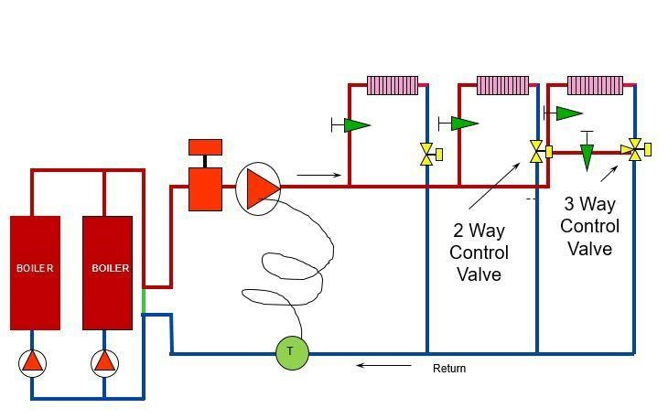
Figure 3. Direct collector loop [53]
A variation of this system is shown in Figure 3, where a three-way valve is controlled by a differential thermostat, and the pump runs constantly during the day.
The thermal performance of these two control approaches is almost identical. Consequently, the former—the most basic—is often chosen. Though it is better to avoid turning the pump on and off too frequently. Because anti-freeze solutions are luxurious, they are rarely utilized as storage fluids, even though they typically work to protect collector loops from frost. Therefore, between the collection loop and the storage, a heat exchanger is needed. The most straightforward scenario is a heat exchanger engrossed in the storage tank, typically in the lower section. Single-family solar water heaters often employ this design. With similar sensor locations, the previously discussed control methods are still applicable in this case. Low flow rates are not suitable because, usually speaking, this arrangement prevents the storage from being stratified, though the collector is operating [54].
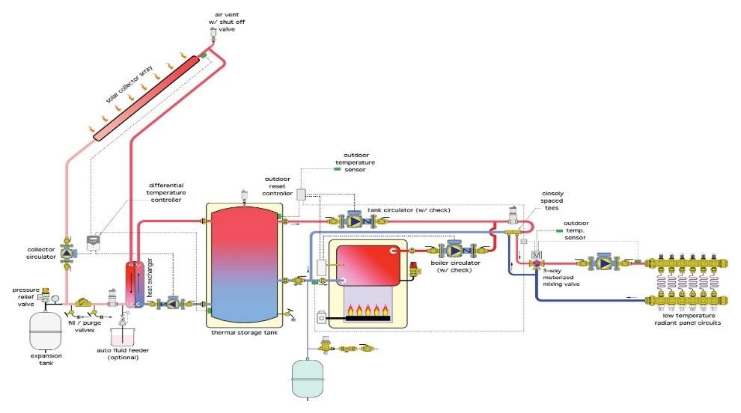
Figure 4. Indirect collector loop
A schematic representation of a typical space heating system is shown in Figure 5. Three loops make up the system: collector, store, and load. Also, as was already designated, in order to increase the solar load factor throughout the year, the majority of space heating systems are combined with a home water heating system. A thermodynamic match of collector to task suggests that an effective flat plate collector or low-concentration solar collector is the favored device because space heating is a comparatively low-temperature request of solar energy.
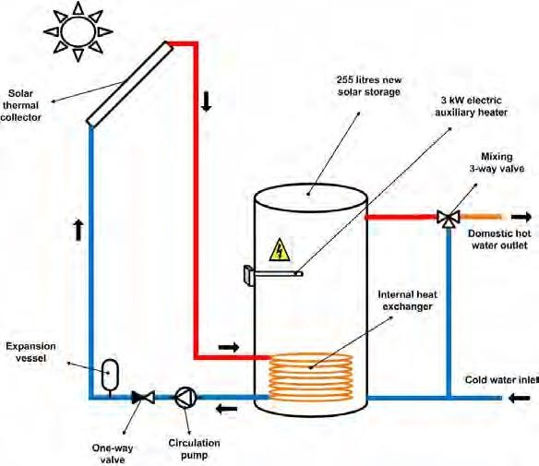
Figure 5. The combined design of space heating and DHW [55]
An expansion tank, collector pump, heat exchanger, fluid manifolds, and other supplementary parts are all part of the collector fluid loop. Meanwhile, a high demand designates the attendance of subfreezing temperatures; all solar space heating systems characteristically use a collector heat exchanger and antifreeze in the collector loop. The collector heat exchanger's tube side, the pump, and the storage tank are all part of the storage loop. This strategy ensures that the low-temperature liquid obtainable in the collector loop is presented at the collector inlet for high efficacy, as shown in Figure 6 shows the expected configuration for a solar air heater with pebble-bed storage unit [56].
Heat exchange from the air from the collector to a domestic water preheat tank, similar to the liquid system, provides energy for domestic hot water. An old-style water heater is used to provide additional heat to the hot water if needed. A seasonal, manually operated storage bypass damper is utilized to prevent heat loss from the hot bed into the structure during summer operation. Also, liquid or air is heated by the typical solar home water heater collector. A heat exchanger transfers the collected energy to a residential water preheat tank, which then delivers solar-heated water to a traditional water heater. If obligatory, conventional fuel is used to raise the water's temperature even more.
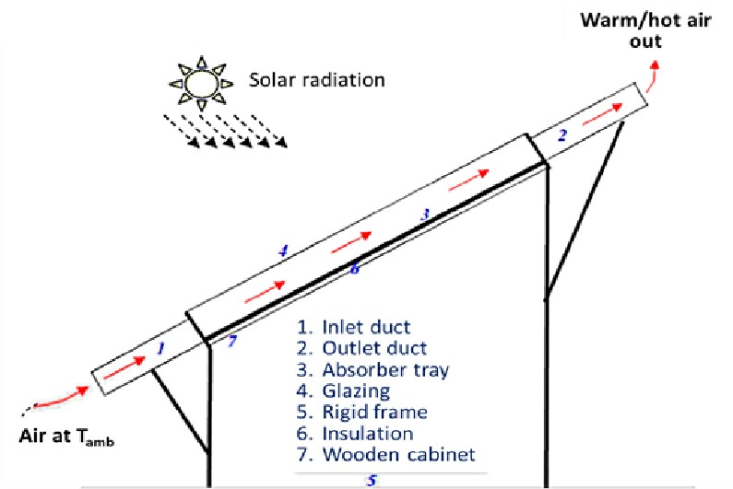
Figure 6. Solar air heating system [57]
The drain back solar scheme is an additional option for DHW and space heating. In this case, water is inlet to the collector by pump P1 in response to the difference between thermostat T1 from a sizable atmospheric pressure storage tank. Since the amount of antifreeze needed would be unaffordable, the drain back is working to keep things from freezing. A heat exchanger coil is positioned in the storage close to the top to provide service hot water; even in the event of stratification, the warmest water will be found there. As the essential of heating increases, standby heat becomes more and more crucial. It is essential to ascertain the cost and convenience of the extra energy, as well as the heating load during the winter months when solar radiation is obtainable. It is rarely inexpensive to use a solar heat collecting and storage system alone to heat a place or provide hot water for services. A solar drain-back system for DHW and space heating is shown in Figure 7. A disadvantage of the system shown in Figure 7 is that water needs to be circulated against full static head wounded as well as friction head losses in the supply piping and through the collector [13].
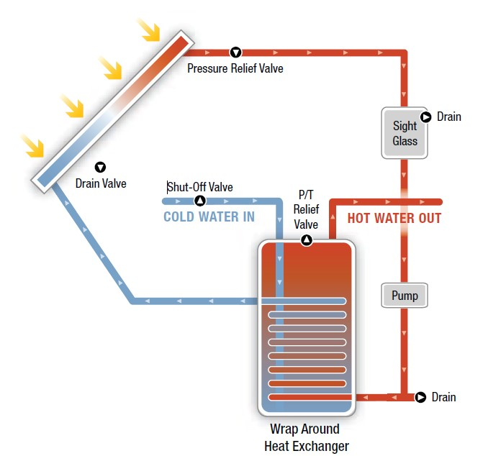
Figure 7. Arrangement of drain back for combined system [58]

4.1.2 Solar energy and heat pumps
The heat pumps' heat source can be added with thermal energy from the sun. It can be used to renew the ground temperature aimed at ground source heat pumps or to warm the air entering the heat pump evaporator. Classically, heat pumps are vapor compression refrigeration units, with the condenser removing heat from the scheme at high temperatures and the evaporator bringing heat into the system at low temperatures. In both residential and business settings, heat pumps have been secondhand in conjunction with solar schemes. The high constant of presentation and lower working temperature of the collector subsystem more than make up for the extra complexity and expenses compulsory by such a system. A diagram of a common housing heat pump system is shown in Figure 8 [59].
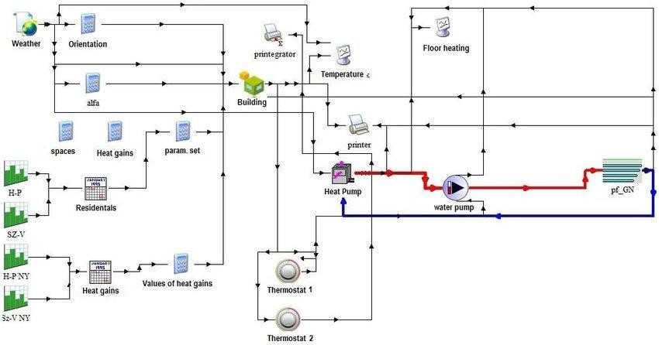
Figure 8. Schematic diagram of a domestic water-to-air heat pump system[60]
This configuration permits solar energy to be transferred directly to the forced air system, though the heat pump is off throughout ideal weather circumstances. The solar system provides the energy for the heat pump evaporator in the series design shown in Figure 9. When the water temperature in the storage is high, energy from the collection system is sent straight to the construction. The heat pump uses the moderately high temperature of the solar energy scheme, which is greater than the room temperature, to boost its coefficient of performance when the storage temperature is insufficient to meet the load. As shown in Figure 9, a parallel configuration is also feasible in which the heat pump functions as a separate extra energy source for the solar energy scheme. A water-water heat pump is employed in this instance.
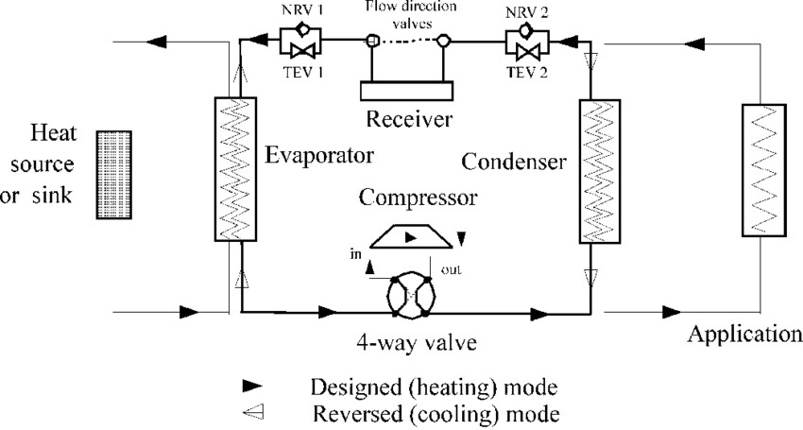
Figure 9. Arrangement design of a domestic water-to-water heat pump [60]
The vertical heat exchangers (BHE) have increased in the housing sector over the last period because they offer better performance. Meanwhile, horizontal heat exchangers are buried between 0.80 and 1.50 meters; they are, in fact, directly wedged by local climate circumstances. In contrast, boreholes can take advantage of ground temperature orderliness below 6 meters, which guarantees good performance all year round irrespective of local climate circumstances. Though, since drilling knowledge is required for connection, the main disadvantage of BHE systems is the high cost of boreholes. However, a BHE's soil surface area is much smaller than that of a horizontal ground heat exchanger, which is beneficial in places where land prices are high. Though using a geothermal heat pump (GHP) in conjunction with BHE to heat and/or cool buildings may result in yearly imbalances in ground loads. The soil may experience thermal heat depletion in heating-dominated constructions, which gradually lowers the heat pump's entering liquid temperature[59].

5. Air Conditioning Compressor System
Solar combined air conditioning design works the same way as a traditional system, with one component, an evacuated tube solar collector. The compressor and condenser are separated by the evacuated tube solar collector. High-efficiency vacuum tubes that additionally superheat the refrigerant offer some heating and compression pressure in the solar collector. High-pressure liquid refrigerant is produced as a result of the condenser's condensation process being aided by the greater temperature and pressure difference. By lessening the strain on the electric compressor, this arrangement meaningfully lowers energy usage. Moreover, high-efficacy direct current (DC) compressors, which use significantly less energy at the same load than AC compressors, are used in place of alternating current (AC) compressors. A high torque brushless motor that can run at variable speed and is lower in size powers the DC compressor [55].
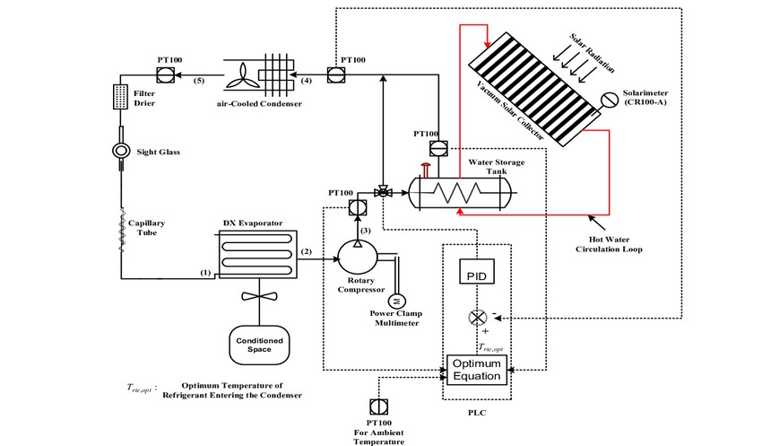
Figure 10. Solar Air Conditioning System [47]

6. Evacuated Solar Collector Type

6.1. Heat Pipe Evacuated Solar Collector
A heat pipe solar collector has a metal heat pipe, devoted to a discerning absorber plate in the evacuated tube. A small amount of fluid, such as acetone and water, along with particular additives, is contained in the heat pipe. The system can function even at low temperatures because the heat pipe inside is evacuated, lowering the working fluid's boiling point. The working liquid rapidly evaporates and climbs to the copper header when solar light hits the collector [40]. Despite one broken tube, the system continues to function; subsequently, there is no direct link between the evacuated tubes and the refrigerant flowing through them. Moreover, replacing a single tube eliminates the need to shut down the system or empty the refrigerant, making the installation process simpler [61].

6.2. U-tube Evacuated Solar Collector
The long copper pipe in a U-tube collector guides the flow of refrigerant through the evacuated tube. This makes it conceivable to exchange more heat, which is very wanted since refrigerant vapor has an incomplete thermal conductivity. To enhance solar radiation absorption, a unique coating is applied to the fin of the copper pipe [60]. The evacuated tube effectively stops the loss of heat from radiation and convection. In terms of initial cost and smaller size, the U-tube collector is superior to the heat pipe. Moreover, the installation position of a U-tube collector is less restricted, allowing for perfect horizontal or vertical mounting. U-tube collectors, though, lag in terms of dependability and maintenance. Meanwhile, the evacuated tube is where the refrigerant flows; a damaged tube will impact the entire scheme, and replacing pipes will require emptying the refrigerant, as shown in Figure 11 [62].
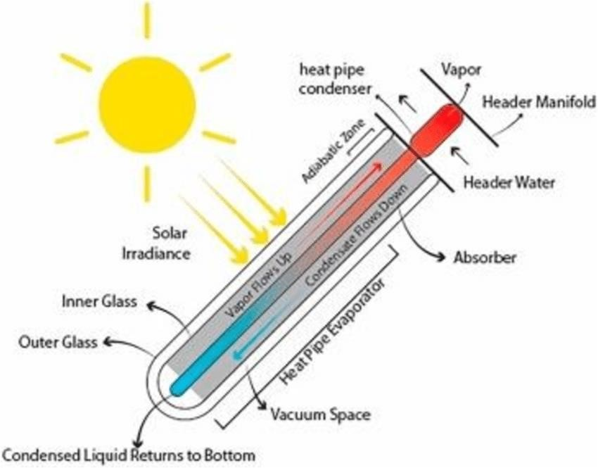
Figure 11. Heat Pipe and U-tube evacuated solar collector [63]

7. Conclusions
In conclusion, the integration of renewable energy sources into air conditioning systems signifies a transformative step to attaining energy efficiency, conservation, sustainability, and reduced reliance on fossil fuels. Solar air conditioning, at the front of this change, leverages solar thermal and photovoltaic methods to harness plentiful solar energy, providing effective space cooling and heating. The synergy between solar energy and other renewable sources, for example, geothermal, wind, biomass, hydraulic, and ocean energy. Generally, the convergence of manifold renewable energy skills, innovative system designs, and hybrid configurations proves the immense potential of solar air conditioning as a core constituent of future sustainable energy approaches. Continued investigation, development, and policy provision will be vital to further advance these systems and ease their widespread adoption across different climatic zones and request scales.

Conflicts of interest
This research did not receive any specific grant from funding agencies in the public, commercial, or not-for-profit sectors.
Acknowledgment: This study was completed at Al-Muthanna University. The authors gratefully acknowledge the outstanding support provided by the specialists of the workshop in the College of Engineering.
Funding: Not applicable
Data Availability: The data generated through the experiments and analyzed during this study are included in this article.

References
- R. Gugulothu, N. S. Somanchi, H. B. Banoth, and K. Banothu, “A Review on Solar Powered Air Conditioning System,” Procedia Earth Planet. Sci., vol. 11, pp. 361–367, 2015, doi: 10.1016/j.proeps.2015.06.073.
- Y. Al-Douri and F. M. Abed, “Solar energy status in Iraq: Abundant or not - Steps forward,” J. Renew. Sustain. Energy, vol. 8, no. 2, 2016, doi: 10.1063/1.4947076.
- M. Ni, M. K. H. Leung, D. Y. C. Leung, and K. Sumathy, “A review and recent developments in photocatalytic water-splitting using TiO₂ for hydrogen production,” Renew. Sustain. Energy Rev., vol. 11, no. 3, pp. 401–425, 2007, doi: 10.1016/j.rser.2005.01.009.
- O. Bamisile, O. Olagoke, M. Dagbasi, F. Dika, and B. Okwesi,
“Review of solar-assisted HVAC systems ; Its performance analysis using CO2 as Energy Sources, Part A : Recovery, Utilization, and Review of solar-assisted HVAC systems ; Its performance analysis using CO₂ as a refrigerant,” Energy Sources, Part A Recover. Util. Environ. Eff., vol. 0, no. 00, pp. 1–18, 2019, doi: 10.1080/15567036.2019.1582736.
- A. A. Hassan and I. K. Shakir, “Kinetic Insights into Solar-Assisted Fabrication and Photocatalytic Performance of CoWO₄/NCW Heterostructure,” Bull. Chem. React. Eng. Catal.., p. 10, 2024.
- S. Rahim Pouran, A. R. Abdul Aziz, and W. M. A. Wan Daud,
“Review on the main advances in photo-Fenton oxidation system for recalcitrant wastewaters,” J. Ind. Eng. Chem., vol. 21, pp. 53–69, 2015, doi:
10.1016/j.jiec.2014.05.005.
- A. O. Adekanmbi, N. Ninduwezuor-Ehiobu, U. Izuka, A. Abatan, E. C. Ani, and A. Obaigbena, “Assessing the environmental health and safety risks of solar energy production,” World J. Biol. Pharm. Heal. Sci., vol. 17, no. 2, pp. 225–231, 2024.
- A. O. M. Maka and J. M. Alabid, “Solar energy technology and its roles in sustainable development,” Clean Energy, vol. 6, no. 3, pp. 476–483, 2022.
- K. Ukoba, K. O. Yoro, O. Eterigho-Ikelegbe, C. Ibegbulam, and T.-C. Jen, “Adaptation of solar energy in the Global South: Prospects, challenges and opportunities,” Heliyon, vol. 10, no. 7, 2024.
- M. A. Raza, M. A. Al-Khasawneh, Y. Z. Alharthi, M. Faheem, R. Haider, and L. Kumar, “Power generation expansion planning with high penetration of geothermal energy–Potential, prospects and policy,” Environ. Sustain. Indic., vol. 26, p. 100614, 2025.
- R. E. Okoroafor, “Technology Focus: Geothermal Energy (March 2025),” J. Pet. Technol., vol. 77, no. 03, pp. 74–75, 2025.
- K. Salhein, C. J. Kobus, and M. Zohdy, “Forecasting installation capacity for the top 10 countries utilizing geothermal energy by 2030,” Thermo, vol. 2, no. 4, pp. 334–351, 2022.
- A. H. Shneishil, J. O. Dahloos, and K. G. Mohammed, “Investigation of a Solar Space Heating System Based on an Evacuated Tube Collector for Baghdad Climatic Conditions,” Karbala Int. J. Mod. Sci., vol. 8, no. 4, pp. 607–616, 2022, doi: 10.33640/2405-609X.3261.
- R. J. Barthelmie and S. C. Pryor, “Climate change mitigation potential of wind energy,” Climate, vol. 9, no. 9, p. 136, 2021.
- C. Jung, L. Sander, and D. Schindler, “Future global offshore wind energy under climate change and advanced wind turbine technology,” Energy Convers. Manag., vol. 321, p. 119075, 2024.
- S. Liu et al., “Advances in urban wind resource development and wind energy harvesters,” Renew. Sustain. Energy Rev., vol. 207, p. 114943, 2025.
- I. K. S. A. A. Hassan, “Fabrication of Solar-Driven New Composite Heterostructure CoWO₄/NCW Photo catalysts for Enhanced Adsorption/Photo Degradation Activity of Organic Pollutants,” Prog. Color Color. Coat., vol. 18, pp. 201–218, 2025.
- S. Ranote, B. Ram, D. Kumar, G. S. Chauhan, and V. Joshi,
“Functionalization of Moringa oleifera gum for use as Hg²⁺ ions adsorbent,” J. Environ. Chem. Eng., vol. 6, no. 2, pp. 1805–1813, 2018, doi: 10.1016/j.jece.2018.02.032.
- K. J. Rustamov and N. R. Rustamova, “Advanced hydraulic drive systems in multi-purpose machinery: Enhancing efficiency and performance in modern engineering,” in AIP Conference Proceedings, AIP Publishing LLC, 2025, p. 30093.
- X. Liu and Z. Chen, “A hydraulic system energy analysis method for energy-saving design of crane lifting mechanism,” in Journal of Physics: Conference Series, IOP Publishing, 2025, p. 12131.
- M. A. Hassaan, A. El Nemr, and F. F. Madkour, “Testing the advanced oxidation processes on the degradation of Direct Blue 86 dye in wastewater,” Egypt. J. Aquat. Res., vol. 43, no. 1, pp. 11–19, 2017, doi: 10.1016/j.ejar.2016.09.006.
- M. Esteban and D. Leary, “Current developments and prospects of offshore wind and ocean energy,” Appl. Energy, vol. 90, no. 1, pp. 128–136, 2012.
- T. J. Plocek and R. J. Varley, “Ocean Thermal Energy Conversion (OTEC) an Imminent Distributed Hundred Billion Dollar Industry,” in Offshore Technology Conference, OTC, 2025, p. D031S041R004.
- N. H. M. Salleh, F. Chatri, and L. Huixin, “Economic and environmental analysis of Malaysia’s 2025 renewable and sustainable energy targets in the generation mix,” Heliyon, vol. 10, no. 9, 2024.
- A. W. Budiarto and A. Surjosatyo, “Indonesia’s road to fulfill national renewable energy plan target in 2025 and 2050: current progress, challenges, and management recommendations–a small review,” in IOP Conference Series: Earth and Environmental Science, IOP Publishing, 2021, p. 12032.
- F. Manzano-agugliaro, F. G. Montoya, C. Gil, A. Alcayde, J. Gómez, and R. Ba, “Optimization methods applied to renewable and sustainable energy : A review,” vol. 15, pp. 1753–1766, 2011, doi: 10.1016/j.rser.2010.12.008.
- A. Senegačnik, M. Sekavčnik, S. R. Oprešnik, U. Mlakar, Š. Ivanjko, and U. Stritih, “Integration of renewable energy sources for sustainable energy development in Slovenia till 2050,” Sustain. Cities Soc., vol. 96, p. 104668, 2023.
- R. Akpahou, F. Odoi-Yorke, L. D. Mensah, D. A. Quansah, and F. Kemausuor, “Strategizing towards sustainable energy planning: Modeling the mix of future generation technologies for 2050 in Benin,” Renew. Sustain. Energy Transit, vol. 5, p. 100079, 2024.
- D. Atstāja, “Renewable energy for sustainable development: opportunities and current landscape,” Energies, vol. 18, no. 1, p. 196, 2025.
- M. Golzarian, M. Ghiasvand, S. Shokri, M. Bahreini, and F. Kazemi, “Performance evaluation of a dual-chamber plant microbial fuel cell developed for electricity generation and wastewater treatment,” Int. J. Environ. Sci. Technol., vol. 21, no. 7, pp. 5947–5954, 2024, doi: 10.1007/s13762-023-05415-5.
- T. Umar and C. Egbu, “Global commitment towards sustainable energy,” in Proceedings of the Institution of Civil Engineers-Engineering Sustainability, Thomas Telford Ltd, 2019, pp. 315–323.
- A. Inglis, A. Parnell, and C. B. Hurley, “Visualizing Variable Importance and Variable Interaction Effects in Machine Learning Models,” J. Comput. Graph. Stat., no. 818144, pp. 1–26, 2021, doi: 10.1080/10618600.2021.2007935.
- D. E. Ekechukwu and P. Simpa, “A comprehensive review of innovative approaches in renewable energy storage,” Int. J. Appl. Res. Soc. Sci., vol. 6, no. 6, pp. 1133–1157, 2024.
- D. Gayen, R. Chatterjee, and S. Roy, “A review on environmental impacts of renewable energy for sustainable development,” Int. J. Environ. Sci. Technol., vol. 21, no. 5, pp. 5285–5310, 2024.
- J. M. Vindel, E. Trincado, and A. Sánchez-Bayón, “European Union green deal and the opportunity cost of wastewater treatment projects,” Energies, vol. 14, no. 7, pp. 1–18, 2021, doi: 10.3390/en14071994.
- M. F. Yaden, M. Melhaoui, R. Gaamouche, K. Hirech, E. Baghaz, and K. Kassmi, “Photovoltaic system equipped with digital command control and acquisition,” Electron. , vol. 2, no. 3, pp. 192–211, 2013, doi:
10.3390/electronics2030192.
- A. Qadeer, S. Alam, and H. Z. Jafri, “Performance analysis of nanofluid on concentrating and non-concentrating collectors’ array,” Int. J. Energy Water Resour., vol. 9, no. 3, pp. 1389–1401, 2025.
- R. Stieglitz and W. Platzer, “Concentrating Collectors,” in Solar Thermal Energy Systems: Fundamentals, Technology, Applications, Springer, 2024, pp. 603–753.
- Ma, M., Pektezel, O., Ballerini, V., Valdiserri, P., & Rossi di Schio, E. (2024). Performance Predictions of Solar-Assisted Heat Pumps: Methodological Approach and Comparison Between Various Artificial Intelligence Methods. Energies, 17(22), 5607.‏
- Al-Waeli, A. H., Kazem, H. A., Chaichan, M. T., & Sopian, K. (2019). Photovoltaic/thermal (PV/T) systems: principles, design, and applications. Springer Nature.‏P. Raval and B. Ramani, “Heat transfer enhancement techniques using different inserts in absorber tube of parabolic trough solar collector: A review,” J. Therm. Eng., vol. 10, no. 4, pp. 1068–1091, 2024.
- G. Q. Chaudhary, M. Ali, M. Ashiq, H. M. Ali, and K. P. Amber, “Experimental and model-based performance investigation of a solid desiccant wheel dehumidifier in subtropical climate,” Therm. Sci., vol. 23, no. 2 Part B, pp. 975–988, 2019.
- W. M. Shaban, A. E. Kabeel, M. E. H. Attia, and F. M. Talaat, “Optimizing photovoltaic thermal solar systems efficiency through advanced artificial intelligence-driven thermal management techniques,” Appl. Therm. Eng., vol. 247, p. 123029, 2024.
- B. Sharma, A. Kumar, V. P. Singh, Y. Gori, S. Sarathe, and G. Dwivedi, “Smart Solar Thermal Energy Technologies: Applications and Future Directions,” in Computational Intelligence and Smart Technologies in Solar Thermal Systems, CRC Press, 2026, pp. 1–24.
- Z. Aslam, S. I. U. H. Gilani, T. I. Mohamad, M. Muhammad, and K. T. Alao, “Technological frontiers and optimization in solar power towers: innovations in thermal energy storage, receivers, and heliostat systems,” Clean Technol. Environ. Policy, pp. 1–29, 2025.
- A. Charles and C. Kui Cheng, “Recent Advances in Photocatalytic Treatment of Palm Oil Mill Effluent (POME): A Review,” Int. J. Eng. Technol., vol.. 7, no. 4.34, p. 389, 2018, doi: 10.14419/ijet.v7i4.34.26880.
- G. Q. Chaudhary et al., “Transient analysis of an efficient solar-assisted air-conditioning system for subtropical climate with various solar thermal collectors,” Energy Convers. Manag. X, vol. 23, p. 100634, 2024.
- S. Hussain, A. Kalendar, M. Z. Rafique, and P. Oosthuizen, “Numerical investigations of solar-assisted hybrid desiccant evaporative cooling system for hot and humid climate,” Adv. Mech. Eng., vol. 12, no. 6, pp. 1–16, 2020, doi: 10.1177/1687814020934999.
- H. T. Naeem, A. A. Hassan, and R. T. Al-Khateeb, “Wastewater(Direct red dye) treatment-using solar fenton process,” J. Pharm. Sci. Res., vol. 10, no.
9, pp. 2309–2313, 2018.
- T. Li, Q. Liu, X. Wang, J. Gao, G. Li, and Q. Mao, “A comprehensive comparison study on household solar-assisted heating system performance in the hot summer and cold winter zone in China,” J. Clean. Prod., vol. 434, p. 140396, 2024.
- S. Mao, S. Zeng, L. Li, X. Han, and J. Yu, “Effect of synchronous surface grafting and intercalation of bentonite on properties of SBS modified bitumen,” Constr. Build. Mater., vol. 411, p. 134777, 2024.
- G. A. Mohammed, A. A. M. Saleh, and A. H. N. Khalifa, “Reduction of electric power consumption by solar-assisted space heating system in Mosul CityIraq,” Int. J. Thermofluids, vol. 26, p. 101071, 2025.
- A. A. Shahhath, H. Shahad, and ..., “Overview of Solar Assisted Cooling Technologies,” Int. J. …, vol. 15, no. 8, pp. 843–863, 2020, [Online]. Available: http://www.ripublication.com/ijaer20/ijaerv15n8_14.pdf
- G. A. Mohammeda, A. A. M. Saleha, and A. H. N. Khalifab, “A comprehensive review of the hybrid heating systems consisting of heat pumps and solar collectors for hot water and space heating application,” Eng. Technol. J., vol. 42, no. 07, pp. 1031–1047, 2024.
- A. Rahman, N. Abas, S. Dilshad, and M. Shoaib, “Case Studies in Thermal Engineering: A case study of thermal analysis of a solar-assisted absorption air-conditioning system using R-410A for domestic applications,” Case Stud. Therm. Eng., vol. 26, no. December 2020, p. 101008, 2021, doi: 10.1016/j.csite.2021.101008.
- Z. Wang, M. Luther, P. Horan, J. Matthews, and C. Liu, “Residential space heating electrification through a PV-driven hot water heat pump,” Energy Build., vol. 330, p. 115319, 2025.
- R. Simonetti, L. Molinaroli, and G. Manzolini, “Experimental performance evaluation of a solar-assisted heat pump driven by PV/T panels in real ambient conditions,” Proc. ISES Sol. World Congr. 2019 IEA SHC Int. Conf. Sol. Heat. Cool. Build. Ind. 2019, pp. 213–223, 2020, doi: 10.18086/swc 2019.05.07.
- E. T. Kho, T. H. Tan, E. Lovell, R. J. Wong, J. Scott, and R. Amal, “A review on photo-thermal catalytic conversion of carbon dioxide,” Green Energy Environ., vol. 2, no. 3, pp. 204–217, 2017, doi: 10.1016/j.gee.2017.06.003.
- R. Kumar, L. Singh, Z. A. Wahid, and M. F. M. Din, “Exoelectrogens in microbial fuel cells toward bioelectricity generation: a review,” Int. J. energy Res., vol. 31, 2015, doi: 10.1002/er.
- S. Rahman, Z. Said, and S. Issa, “Performance evaluation and life cycle analysis of new solar thermal absorption air conditioning system,” Energy Reports, vol. 6, pp. 673–679, 2020, doi: 10.1016/j.egyr.2019.11.136.
- C. Brahmankar, H. Bhushan, A. Ghule, and H. Ranjan, “Study of solar-thermal collector-assisted hybrid split air conditioner,” Int. Res. J. Eng. Technol., vol. 5, no. 4, pp. 2921–2925, 2018, [Online]. Available: www.irjet.net
- Z. Kaneesamkandi, A. Almujahid, and B. Salim, “Selection of an Appropriate Solar Thermal Technology for Solar Vapor Absorption Cooling—An MADM Approach,” Energies, vol. 15, no. 5, 2022, doi: 10.3390/en15051882.
- M. K. Assadi, S. I. Gilani, and T. C. J. Yen, “DESIGN a solar hybrid air conditioning compressor system,” MATEC Web Conf., vol. 38, pp. 1–7, 2016, doi:
10.1051/matecconf/20163802001.

