Thermal Management and Reliability Enhancement of GE Gas Turbine Exhaust Frame Blowers Through Relocation and Design Simulation

ABSTRACT
This study aims at solving industrial turbine issues by relocating the blower system to a cooler area and validate its performance using computational fluid dynamics simulations to model the airflow, pressure distribution and thermal management capabilities under simulated Warri Refining and Petrochemical operating conditions. The research method involves analytical design process using solid works for the geometric modelling of a backward-inclined blower and a configuration selection for high efficiency and stable characteristics with key design parameters of an impeller with an inlet blade of 35° and an outlet angle of 26°. This was to maintain improved operating temperatures and aerodynamic performance, thereby preventing thermal induced trips of the gas turbine units. The simulation results provided a detailed analysis of the blower’s performance, showing its potential to deliver the required volumetric flow rate and static pressure necessary to effectively cause heat from the gas turbine exhaust frame. The findings indicated that the relocation reduces inlet temperature by approximately 60°C, improves flow uniformity, and improves colling efficiency compared to existing systems. The CFD analysis confirms that the backward-inclined impeller geometry generates a stable, high-volume airflow that effectively reduces the risk of overheating, even under the challenging ambient conditions available in the Niger Delta region of Nigeria.

Keywords: Gas turbine, Blower, Thermal management, CFD simulation, WRPC, Reliability, Gas turbine cooling.
1 INTRODUCTION
Gas turbines remain the central component of advanced power generation due to their high demand for fast response load differences in industrial applications, for both electric and thermal energy production. However, among the important components in ensuring their operational efficiency and reliability are the exhaust frame blowers. These blowers make it easy to remove hot exhaust gases and maintain suitable ventilation within the Gas turbine exhaust frame, preventing overheating and thermal stress on the components surrounding the gas turbine in entirety. The successful achievement of enhancing the overall efficiency of the gas turbine cycle is fundamentally contingent upon the performance efficiency of each individual component, along with the synergistic interactions that occur among all the components functioning collectively as an integrated engine system (Lakshya Kumar, 2019). In this complicated arrangement, it is important to recognize that the exhaust frame blower of a gas turbine is widely regarded as a pivotal element in managing temperature gradients, especially during ramp-up, continuous load operations and this significantly influences and contributes to the overall efficiency and performance of the system (Roger L. Davis, 2006).
Exhaust frame blowers, which are mechanical devices designed to move gases such as air by harnessing the kinetic energy imparted by a rotating impeller. These mechanical devices are fundamentally composed of two principal components: the housing, which encases the mechanism, and the rotor, which is the component responsible for the fluid movement. While it is common for these blowers to be powered by electric motors, it is important to note that alternative energy sources can also be utilized to operate them effectively. The application of exhaust frame blowers across several industrial sectors demonstrates their versatility and importance in various processes. During the operational phase, the fluid is collected through either a volute, a spiral-shaped passage designed for efficient flow or a series of diffusing passages, subsequently exiting the impeller at an elevated velocity and pressure, which is critical for many applications. The volute is designed with precision to fulfill its primary role of collecting the flow and converting the kinetic energy of the moving fluid into pressure energy before directing it to the exit of a turbomachine, which is essential for maintaining system efficiency.
Despite the importance of the exhaust frame blower in ensuring both the safety and efficiency of turbine operations, the reoccurring issues of overheating and tripping continue to affect the gas turbine located at the Warri Refining and Petrochemical Company, thereby compromising overall operational integrity. These disruptive events frequently manifest as a direct consequence of insufficient airflow volume or inadequate velocity generated by the blower when subjected to varying turbine loads, combined with poorly directed airflow within the exhaust frame that fosters the development of localized hot spots, alongside inefficient heat dissipation that comes from the inherent mechanical limitations associated with the current blower design, as well as delays or outright failures in the thermal trip logic integrated within the turbine's control system.
The effect of these issues is a detrimental cycle characterized by frequent periods of downtime, emergency shutdowns that interrupt productivity, the costly replacement of essential components, and a consequential reduction in turbine efficiency that covers the overall operational performance. Hence, This study presents a solution to overheating and trips for gas turbine exhaust frame blower, with the design taking into consideration both real and practical situations and for this purpose, a model was designed and simulated with the blower located outside the turbine hall as against the initial position where the blower operates above combustion chamber which is usually very hot. Operating the blower at a high temperature burns out the motor and bearings of the blower causing a significant challenge in power generation systems, affecting performance and component longevity. Hence, advanced cooling techniques are considered for maintaining optimal turbine rotor inlet temperatures, which can exceed 1700°C in modern systems (Han, 2018).
This paper presents a system engineering approach to design, simulate and improve a robust gas turbine exhaust frame blower that can function reliably under adverse weather conditions. This design improvement will shield the blower from direct thermal stress while maintaining optimized performance in colling the gas turbine exhaust system. The purpose of this paper was to analyze the performance of the existing frame blower; and compare the simulated results of the relocated exhaust frame blower with the existing blower. In this work, the manufacturers specifications obtained from the Gas turbine in Warri refining and petrochemical company was used to validate the optimized modelling approach.

1.1 LITERATURE REVIEW
This section reviews so many related literatures that have been carried out to provide solutions to overheating and trips for gas turbine exhaust frame blower and the overall performance of the gas turbine.
As in (P. Laohasongkram, 2007), addressed a technique to solve the problem of accumulated heat transfer in solenoid coil of the solenoid valve controlling hydraulic damper by using the switching technique with low frequency. This new method can result in saving energy loss in solenoid coils. In addition, this technique aims to solve the fundamental problem by reducing direct heat transfer in solenoid coil of the solenoid valve and protecting complete gas turbine trip from the hydraulic damper closing failure and heat recovery steam generator (HRSG) trips from burnt solenoid coil of hydraulic damper. For this experiment and research, the data was collected from South Bangkok Combined Cycle Power Plant Block II. After using low frequency switching circuit technique the gas turbine trip as well as the ITRSG trip did not happen. The findings revealed that the study used a low frequency switching technique to address heat transfer issues in solenoid coils and it aimed at reducing energy loss and prevent trips by reducing direct heat transfer.
(Al-Dabooni, 2022) carried out research where fuzzy inference system was proposed to control gas turbine speed and minimize exhaust temperature, solving the overheating and shutdown issue. The implementation of a fuzzy inference system (FIS) to control gas turbines utilizes an FIS input of average temperature for the combustion chambers and gas turbine speed. And the Output a control signal to flow control valve while Simulated using Allen Bradley PLC and MATLAB/Simulink. Coding the FIS was done using structured list (ST) PLC language. And it was tested under high temperature conditions. The findings showed that the FIS proposal was successfully applied to three Rolls-Royce jet pumping turbines, enabling them to operate regularly at all times of the day. FIS reduced the maximum average combustion chamber temperature by 45%, from 689°C to 610°C, during high ambient temperatures. The success of the FIS led to the operation of two turbines simultaneously for the first time since 2002. However, the limitation of this system is that it is not self-learning and requires human intervention. Future work is needed to develop an adaptive dynamic programming system.
(T.S Chowdhury, 2023) teamed up with other researchers to provide a critical review of gas turbine cooling performance and failure analysis of turbine blades but does not specifically address solutions to overheating and trips for gas turbine exhaust frame blowers. The methodology involves a critical review of existing literature on gas turbine cooling performance and failure analysis, highlighting different methods and strategies for improvement, such as steam injection and coating techniques. The limitations involve complexity in selecting working fluids and fuels due to multiple factors, Need for careful assessment of economic, environmental, and thermodynamic factors, Economic loss due to turbine failure, Limitations in preventing failures without advanced coating methods and material selection.
Going further (Silva et al., 2017) analyzes the causes of random trips and motor burnout in induction motors driving main blowers and proposes a solution to eliminate these issues. The study involves an analysis of the causes of random trips and motor burning in induction motors driving main blowers and proposes solutions to eliminate these issues Considering the risk of motor damage, the consequent interruption of blown air supplied to the furnace, and the risk of human injuries by step or touch voltage.
(J. Han, 2018) Reviews advanced cooling technologies for gas turbines to address overheating and improve efficiency. The methodology involves a review of existing literature on gas turbine heat transfer issues and advanced cooling technologies, compiling and summarizing relevant papers for future research references.
(G. Saibabu, 2021) worked on modelling and analysis of a centrifugal blower using FEM. In this research study, the centrifugal blower was modelled using CREO parametric software and analysis was done in ANSYS software with several materials in static analysis and several velocities in CFD analysis to get the fluid flow. In this research study the static analysis was able to determine the stress, deformation and strain with different materials (aluminum alloy, graphite and carbon fiber) while the CFD analysis was able to determine the pressure drop, velocity, heat transfer coefficient and mass flow rate at different velocities (14, 16, 18, 20 and22m/s). The findings from this research study showed that during the static analysis stress increases for carbon fiber composite material compared with aluminum alloy and graphite. While during the CFD analysis the pressure drop, velocity, mass flow rate and heat transfer coefficient values increase by increasing the inlet velocity.
As in (Vincenzo Castorani, 2019) worked on an improved design of a centrifugal industrial blower for gas turbine power plants with the aim of studying and applying an approach for the modeling, simulation and geometrical improvement of fans for gas turbine air supply. Extensive literature was conducted on the design and improvement of industrial fan, but the scope of the research covers a small or medium standardized fan, which gave the room to study many parameters and perform many experimental tests. The research presented an approach for the efficiency improvement of large centrifugal industrial blowers for gas turbine air supply. The design variables examined in the study were the blades quantity, orientation and shape. The proposed improvement method was used for the design improvement of a blower for gas turbine power plant. The response surfaces allowed defining correlation between design variables and efficiency. However, the study was limited in its performance as the optimized design was 18 % more efficient than the original one.
(P. Srinivasulu, 2022) explores the modeling and analysis of centrifugal blowers using computational fluid dynamics (CFD) and finite element analysis (FEA). The researchers utilized software like SolidWorks, and ANSYS to model and analyze blower performance. Furthermore, the study examined various parameters including blower geometry, speed, and blade design to optimize efficiency and discharge. Materials such as aluminum, steel, and composites like E-glass were compared for their vibration and noise reduction properties in naval applications. Modal analysis was performed to determine natural frequencies of different materials. CFD analysis helped evaluate pressure drop, velocity, and mass flow rate, while static analysis assessed stress, deformation, and strain. These studies demonstrate the importance of material selection and design optimization in improving centrifugal blower performance.
As in (C. Keerthana, 2019), proposed a simplified design methodology for small gas turbine applications with experimental validation. The scope of the study covers a comprehensive design methodology for annular combustion chambers, incorporating casing, liner, diffuser, and swirl calculations, along with cooling section analysis. Numerical simulations using NUMECA software and the κ-ε turbulence model have demonstrated proper dimensioning, complete combustion, and emissions compliance for various fuel injection angles. These studies contribute to improving combustion chamber design and performance analysis.
Finally, (Anderson & Wendt, 1995) has extensively examined the performance characteristics of blowers, which can be derived and understood through various blowers laws, and as a result, a significant amount of focus is directed toward comprehending the fundamental theoretical principles that govern blowers, the different types that exist, and the mechanisms by which they operate within various systems. The meticulous selection of critical parameters is of utmost importance as it plays a pivotal role in determining and influencing the overall performance efficiency of the blowers in question. To accurately model and assess blower behavior, it is imperative to consider the fundamental equations that are central to fluid dynamics, such as the continuity equation, momentum equations, and energy equations, all of which must be considered while implementing a computational fluid dynamics (CFD) approach to fan analysis. Furthermore, when addressing any practical engineering problem associated with blower performance, it is crucial to select the most appropriate turbulence model and the desired order of accuracy to achieve reliable and valid results that reflect the complexities of real-world applications.
(Yang et al., 2024) discusses blower design optimization by focusing on reducing air dynamic noise through structural improvements. Key methods include minimizing backflow impact at the discharge outlet, decreasing flow fluctuation, and utilizing design principles such as involute profile enhancement, bunch and helix rotors, special-shaped vents, pre-admission, and counter-current cooling. Numerical simulations using FLUENT revealed that three-lobe rotors exhibit lower backflow impact intensity compared to two-lobe rotors, aiding in the design of quieter and more efficient blowers
(Metwally, 2007) focuses on optimizing blower blade geometry for an active heat sink in laptops using 3D computational fluid dynamics (CFD) and arbitrary shape deformation technology. The objective is to maximize airflow while maintaining a specific broadband noise level. Two two-parameter studies were conducted, revealing optimal designs that enhance airflow and minimize noise. Key parameters include blade span and angles, with findings indicating that certain configurations can significantly improve performance while adhering to acoustic constraints. The traditional approach to estimating airflow and pressure rise relies on basic system computations and supplier-provided fan curves, which assumes that the fan will face the same flow configuration regardless of the system configuration. This assumption may not hold true in portable electronics, where tight spaces and flow blockage can significantly affect blower performance. Automated CFD engineering design for shape optimization has been hindered by inadequate shape parameterization algorithms and insufficient algorithms for CFD mesh modification, which complicates the process of effectively optimizing blower blade geometry in compact environments like laptops.
Finally, (Breier, 2005) worked on blower design optimization using Computational Fluid Dynamics (CFD) to enhance performance while minimizing acoustic noise. By integrating system-level flow analysis with fan and blower design, CFD tools provide detailed insights into airflow distribution and pressure conditions. This allows for the identification of optimal operating points and necessary design adjustments, such as blade shape and flow angles, to achieve maximum efficiency and reduced noise. The process eliminates the need for multiple costly prototypes, streamlining the design phase.

2. MATERIAL AND METHODS
In this research, a computer-aided design software that allows the development of sophisticated 3D models and simulations was considered. The computer-aided design software adopted was SolidWorks (2023-w). SolidWorks was chosen because it has the advantage of creating system parts in 3D and simulating their physics and motion. SolidWorks has been widely used in the development of sophisticated machinery and has been used in creating fast and accurate designs. This CAD software prides itself on its strong internal structure and design techniques, which allow it to develop a robust and fully functioning mechatronics system from start to finish. The initial stage of development involves preliminary research to identify the initial requirements, which are then simulated and tested. The research design is the process of structuring the system understudy following specifications of processing requirements. The objective is to reduce overheating in a gas turbine system.

2.1 Requirement specifications and Designs
The system requirements analysis is an important phase that ensures that the design matches the specific needs of exhaust frame air blower. The anticipated operational parameters of this blower necessitate its reliable functionality under a specified ambient inlet pressure of 101,325 Pa, accompanied by an inlet air temperature fixed at 308.88 K, while simultaneously maintaining a mass flow rate of 0.5 kg/s, which is crucial for providing adequate cooling within the complex exhaust frame assembly. To facilitate the essential fluid displacement and energy transfer processes, the blower is programmed to rotate at an initial angular velocity of 3,000 RPM, thereby ensuring that the impeller can generate an adequate pressure rise and velocity head sufficient to effectively counteract any system resistance encountered during operation. Furthermore, the specifications outlined for the blower demand not only high thermodynamic and aerodynamic efficiency but also the minimization of vibrational disturbances, low levels of noise emissions, and a robust mechanical design that can endure continuous operation within the challenging high-temperature, humid, and dust attraction environment characteristic of refinery settings.
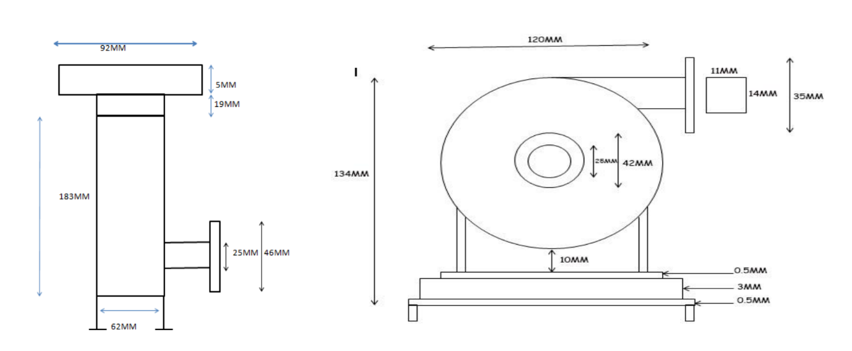
Figure 1: Design specification of the frame blower

Table 1: Highlight of blower design specifications

Materials Used | Dimensions
Blade frame diameter | 120mm
Wheel blade diameter | 36mm
Frame material thickness | 0.4mm
Frame body dimension | 62mmx62mmx183mm (LXWXH)
Frame cap | 92mmx5mmx92mm (LxWxH)
Frame mesh | 62mmx19mmx62mm
Wheel discharge diameter | 14mm
Wheel design speed | 2957rpm
Wheel design operating temperature | 21.1 degree Celsius
Electric motor design speed | 2970rpm at 50Hz
Electric motor design Horsepower | 50Hp
Electric motor design operating temperature | 40 degree Celsius Max

2.1.1 Material compatibility and safety regulations
From a structural engineering standpoint, it is important that both the impeller and casing of the blower be carefully designed to endure cyclic thermal stresses, substantial centrifugal forces, and fatigue loading without resulting to structural deformation or any form of material failure. The selection of a backward-inclined impeller blade configuration has been strategically made to significantly enhance both aerodynamic stability and overall efficiency, while at the same time minimizing turbulence and secondary flow losses that could detract from performance. The materials chosen for the construction of the impeller and casing possess high thermal conductivity and exceptional corrosion resistance; therefore, stainless steel or coated aluminium alloys are regarded as particularly suitable options to ensure long-term durability under the demanding operational conditions prevalent within the refinery environment. Additionally, the design of the blower incorporates essential sealing and bearing support systems, which are crucial in preventing leakage and mechanical imbalance, thereby facilitating smooth and efficient rotation at the designated operating speed.
In close alignment with the stringent performance requirements set forth, the design specifications place significant emphasis on the necessity of employing advanced computational fluid dynamics (CFD) and finite element analysis (FEA) simulations, particularly utilizing software such as ANSYS, to thoroughly validate critical parameters including airflow distribution, temperature reduction capabilities, pressure rise, and structural stability during both steady-state and transient operating conditions. This comprehensive simulation approach ensures that the final virtual prototype not only satisfies the fundamental thermodynamic requirements essential for proper functionality but also adheres to important criteria regarding reliability, maintainability, and safety considerations that are paramount for the successful integration of the blower into the overall gas turbine exhaust system.

2.2 Principle of Operation
The operational functionality of the exhaust frame air blower is fundamentally grounded in the principle of energy transfer, which transpires from the rotational dynamics of an impeller to the working fluid which in this scenario, is identified as ambient air drawn from the surroundings. At the initial stage of the process, air, which is at a standard atmospheric pressure of approximately 101,325 Pascal and exhibits a temperature of about 308.88 Kelvin, is effectively drawn into the eye of the impeller as a direct consequence of the pressure differential that is established by the rapid rotation of the blades. As the impeller rotates at a velocity of 3,000 revolutions per minute, mechanical energy is efficiently conveyed from the rotating shaft to the air through the centrifugal forces generated, which subsequently results in a significant increase in both the air's velocity and static pressure levels. The unique design of the backward-inclined blade configuration is specifically engineered to facilitate the exit of fluid from the impeller while minimizing flow separation and reducing recirculation losses at the same time, which collectively serve to greatly enhance the overall aerodynamic efficiency intrinsic to the blower's operation.
Upon exiting the impeller, the high-velocity air traverses through the volute casing, where a substantial portion of its kinetic energy is adeptly converted into pressure energy, with the aid of the diffuser effect that arises from the expansion of the cross-sectional area within the casing. This conversion process effectively generates an increase in pressure that is sufficiently robust to counteract the system resistance encountered within the turbine exhaust frame, thereby ensuring a continuous and stable cooling airflow over the hot surfaces that necessitate thermal regulation. By sustaining a consistent mass flow rate of 0.5 kilograms per second, the blower plays a critical role in facilitating effective convective heat transfer from the components associated with the turbine exhaust, thereby significantly diminishing the risk of localized overheating occurrences and the potential for subsequent operational interruptions or machine trips.
From a thermodynamic perspective, the blower operates as a steady-flow energy device, wherein the principles of mass and energy conservation are paramount in dictating its overall performance metrics. The interrelationships among the mass flow rate, pressure rise, and temperature fluctuations that occur across the blower are intricately connected through the foundational equations of fluid mechanics, which include the continuity equation, Euler’s turbomachinery equation, and the energy equation, all of which are essential for a comprehensive understanding of the system's dynamics. In essence, the blower functions to convert rotational shaft work directly into usable fluid energy, thereby ensuring that the cooling demands of the gas turbine exhaust frame are consistently satisfied, even amidst varying operational conditions that may challenge the system's efficiency and effectiveness.

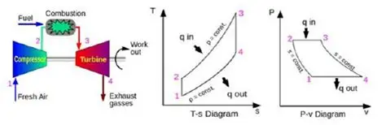
Figure 2: Gas turbine operating principle
2.3 Geometric modelling
A geometric model was carefully conducted utilizing the advanced capabilities of SolidWorks 2023, a sophisticated computer-aided design software that allows for detailed three-dimensional modelling. In this comprehensive study, the impeller, the casing, and the inlet guide vane were each modelled independently prior to their subsequent assembly into a cohesive unit. The impeller was also designed using the specified impeller diameter of 1000mm, backward inclined, with blade inlet and outlet angles of 35 and 26 degrees respectively which serve as an essential framework for aerodynamic analysis, and the use of Bezier curves to ensure a smooth and efficient aerodynamic flow, thereby enhancing the overall performance of the blower system. In the design of the casing, a spiral volute configuration was created with the primary objective of effectively guiding airflow through the system while simultaneously minimizing pressure loss, which is crucial for maintaining efficiency and performance within the operational parameters of the blower. The geometrical configurations of both the inlet and outlet were optimized through the application of established diffuser design principles aimed at reducing turbulence, which is a critical factor that can adversely affect the flow characteristics and overall efficiency of the blower system.
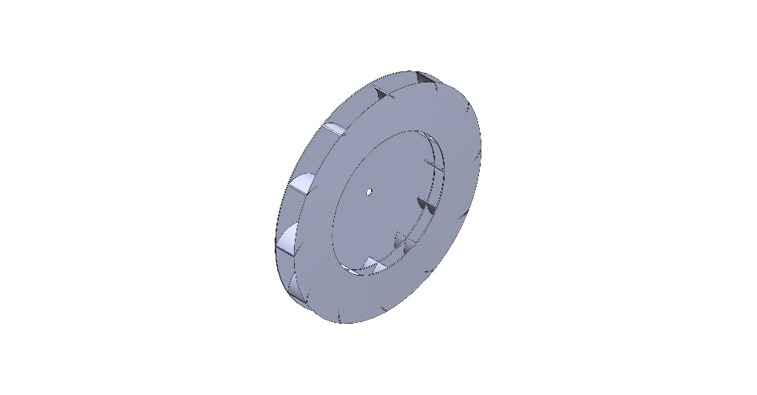
Figure 3: Modelled Impeller
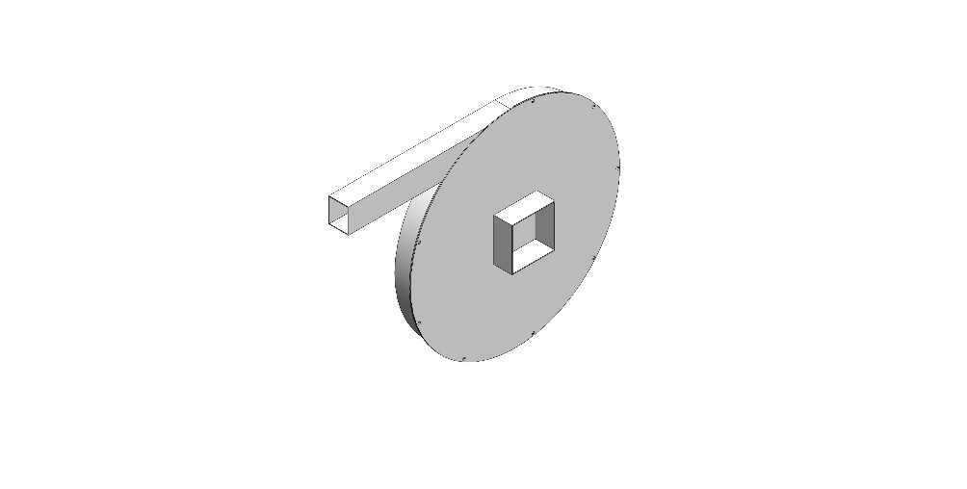
Figure 4: Blower casing

A fluid region with diameter slightly larger than that of the casing, designed to envelope the casing and serve as the region of fluid flow around the impeller. To account for the piping system for the fluid horizontal and vertica5 travel, horizontal and vertical pipes of 12,330mm and 10,895mm respectively with a pipe cross sectional dimension of 110 by 140mm.
2.3.1 Mesh Generation
The Blower Casing, fluid region model and Impeller was further assembled in SolidWorks assembly environment and imported into Ansys 2023 for analysis after geometric model had been developed. Using Ansys Fluent, the mesh set up module was used to discretize the designed model using a mesh element size of 0.87mm, inflation was further applied on the wall to account for boundary layer conditions. The model was further assigned named selections of Fluid Inlet, Fluid Outlet, Rotating region. To ensure the numerical accuracy of the simulations, grid independence testing was rigorously performed at three different mesh sizes (0.8 million, 1.6 million, and 3.2 million elements), thus validating the reliability of the computational models utilized.
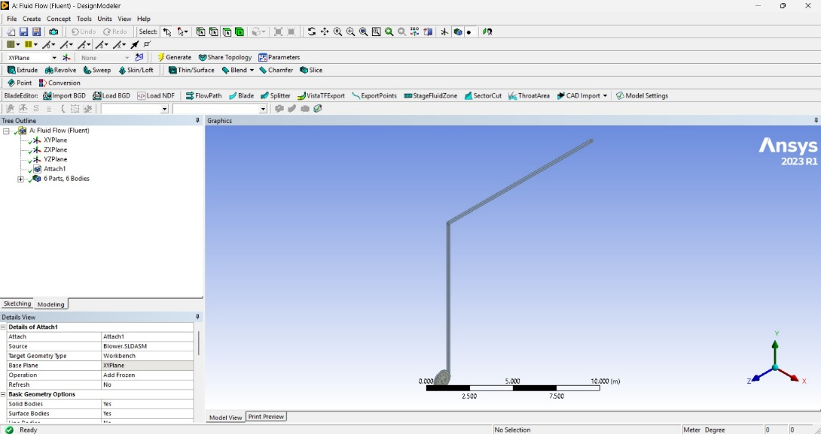
Figure 5: Mesh generation set up
2.4 Simulation study
A steady state CFD analysis using the SolidWorks simulation module was performed to predict the distribution of airflow throughout the system, as well as to analyse static pressure rise and velocity contours, which are critical for understanding the performance characteristics of the blower. A coupled CFD-thermal simulation was executed with the objective of studying the effectiveness of cooling on the turbine exhaust frame, thereby providing insights into thermal management strategies. While varying blade angles, impeller speeds, and flow rates were analysed to evaluate the optimal configuration for maximum efficiency and performance of the blower system. In this project, a performance evaluation was conducted under specific climatic conditions representative of the WRPC environment, considering variables such as temperature and humidity to assess their impact on the blower's operational efficiency.
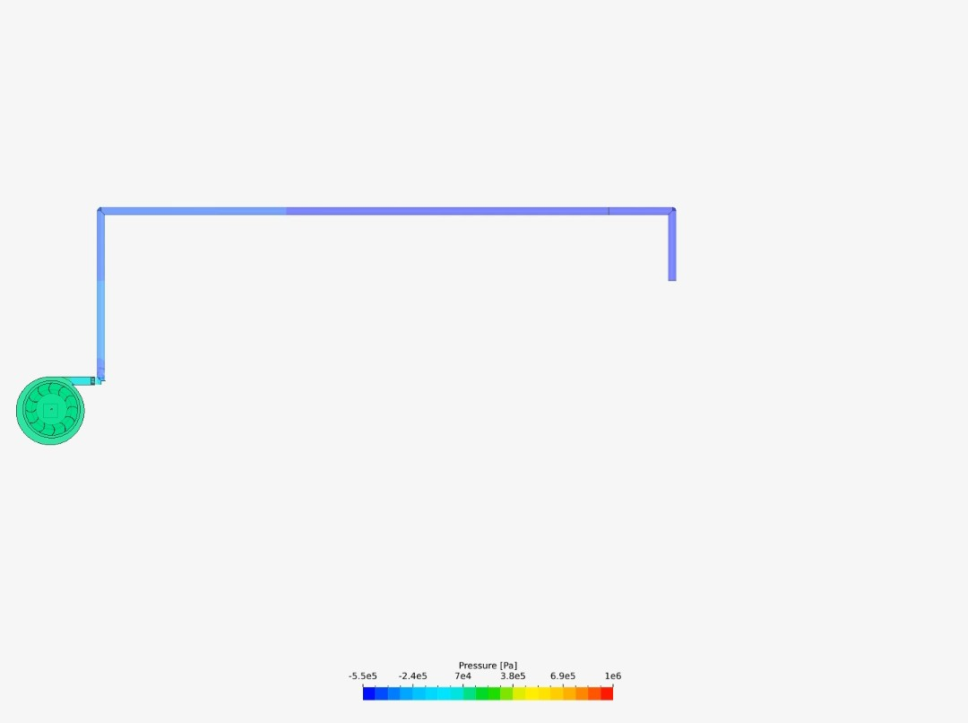
Figure 6: Pressure convergence of the Simulated blower

2.5 Kinematics analysis
Kinematic analysis is a fundamental aspect of our methodology, aiming to understand and stabilize the pressure and volume flow rate of the exhaust frame blower system. We delve into the mathematical models, algorithms, and simulations employed for kinematic analysis, emphasizing how SolidWorks facilitated this critical phase. The section provides insight into the dynamic behavior of the blower system, laying the groundwork for subsequent design considerations.
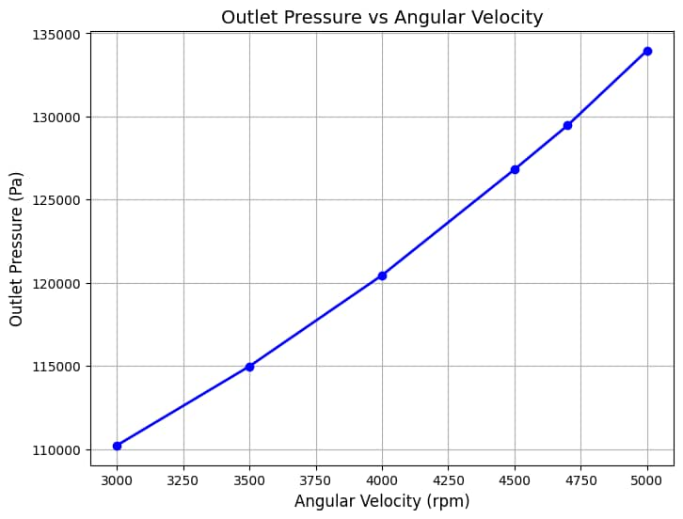
Figure 7: Outlet pressure vs angular velocity

2.6 Design calculations
Output pressure calculation
Using Euler’s turbomachinery equation.
Impeller Tip speed $U=\frac{πDN}{60}=\frac{π×1×2975}{60}=155.77m/s$
Pressure rise $∆P=air density ×U^{2}=1.2 ×155.77×155.77=29.117kPa$
$$Total pressure=Atmospheric presure+Guage pressure=101.325+29.117=130.442kPa$$
Given data.
- Impeller diameter, D = 1.000 m (tip radius r_t = 0.500 m)
- Mass flow rate, ṁ = 0.500 kg/s
- Inlet static pressure, p₁ = 101325 Pa
- Inlet temperature, T₁ = 308.88 K
- Rotational speed, n = 3000 RPM
- Blade inlet angle, β₁ = 35.0° (backward inclined)
- Blade outlet angle, β₂ = 25.0° (backward inclined)
- Hub radius, r_h = 0.120 m
- Inlet radius, r₁ = 0.200 m
- Outlet radius, r₂ = 0.500 m (same as tip radius)
- Mean radius, r_m = 0.350 m
- Blade height (channel height): b₁ = 0.030 m (inlet), b₂ = 0.050 m (outlet), b_mean = 0.040 m
- Air properties used: R = 287.0 J/(kg·K), γ = 1.4, μ = 1.85e-05 Pa·s, c_p = 1005.0 J/(kg·K)
- Material for structural estimates: Aluminum (ρ_material = 2700 kg/m³).
- Number of blades (assumed) = 8; average blade chord = 0.06 m; average blade thickness = 0.008 m.
- Stage efficiency assumed (for practical estimates) η_stage = 0.85.
Fluid and Kinematic Based Calculation
$$Inlet density \left(ideal gas\right): ρ1=\frac{ρ1}{RT_{1}}=\frac{101325}{287×308.88}=1.142997Kg/m^{3}$$
$$Volumetric flow at inlet conditions:Q=\frac{m}{ρ1}=\frac{0.5}{1.142997}=0.437447m^{3}/s$$
$$Angular speed ω=\frac{2πn}{60}=\frac{2π×3000}{60}=314.159265\frac{rad}{s}$$
$$U_{tip}=314.159265×0.5=\frac{157.079633m}{s}$$
$$U_{r1}=62831853m/s ;U_{rm}=109.955743 m/s;U_{r2}=157.079633m/s$$
$$Speed of sound a= \sqrt{γRT_{1}}=352.289631m/s$$
$$Mach Number Ma=\frac{U_{tip}}{a}={157.079633}/{352.289631}=0.445882 (low-subsonic)$$
$$Reynolds number (based on tip speed and D:Re=\frac{ρ1U_{tip}D}{μ}=\frac{1.142997×157.079663×1.00}{1.85e-05}=9.705e+06 (turbulent)$$
2.7 Workflow of the design
The design and simulation of a gas turbine exhaust frame blower using SolidWorks is presented according to the process flow below: Figure 8 shows the flow chart of the system.
The details of the system are highlighted below:
- Step 1: Define input parameters such as inlet pressure, temperature, mass flow rate, and blower speed
- Step 2: Apply governing equations such as continuity, energy, Eulers turbomachinery
- Step 3: Design the blower geometry and model with boundary and meshing conditions set up put in place.
- Step 4: Run the simulation
- Step 5: if the results are acceptable, then analyze the performance curves, stress distribution, and temperature but if the results are not acceptable re-modify the geometry/ parameters and return to the design set up.
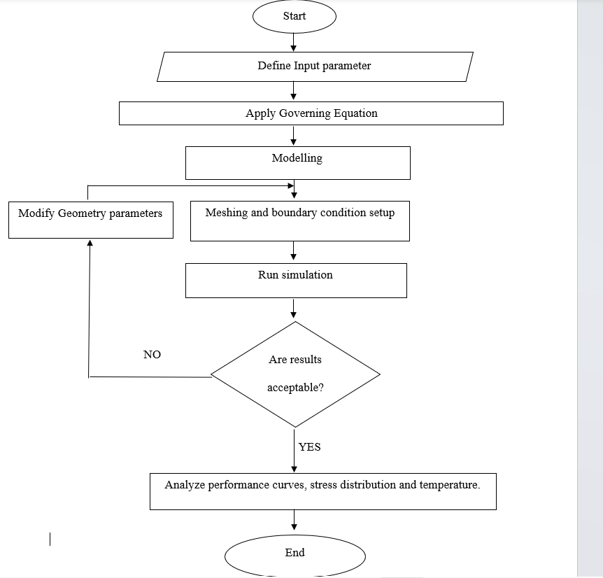
Figure 8: Process workflow

3 RESULTS AND DISCUSSION
In the achievement of the set objectives, this project was implemented by simulating the behavior of the blower system using SOLIDWORKS software. The SOLIDWORKS simulation tool was used to assemble the fluid region model and impeller after which it was imported to Ansys to analyze the structural integrity of the blower system. This analysis factors in the assessment of how long the blower can withstand repeated use. SOLIDWORKS analysis tool was also utilized in understanding the optimal angular velocity and this system has been completely modeled with different frame members. And it performed optimally on testing.

3.1 CFD simulation of air flow and pressure distribution

The CFD simulation, conducted using SolidWorks Flow Simulation, provided critical insights into the internal aerodynamics of the designed blower, revealing how air interacts with the impeller and casing under operational conditions. The simulation solved the Reynolds-Averaged Navier-Stokes (RANS) equations to model the turbulent airflow, offering a detailed visualization of velocity vectors, pressure contours, and flow trajectories. These visualizations are instrumental in identifying areas of high efficiency as well as potential regions of flow separation, recirculation, or excessive turbulence that could detract from performance. The angular velocities considered were 3000rpm, 3500rpm, 4000rpm, 4500rpm, 5000rpm and the output results for each angular velocity containing other simulation goals and Pressure contour plot (Minimum and Maximum) considered are highlighted below at several cases since the goal of the analysis is to understand the optimal angular velocity, there was no need to consider other parameters like velocity, temperature and general fluid behavior within the system.

3.1.1 Case 1
Angular velocity of 3000rpm, other parameters kept constant

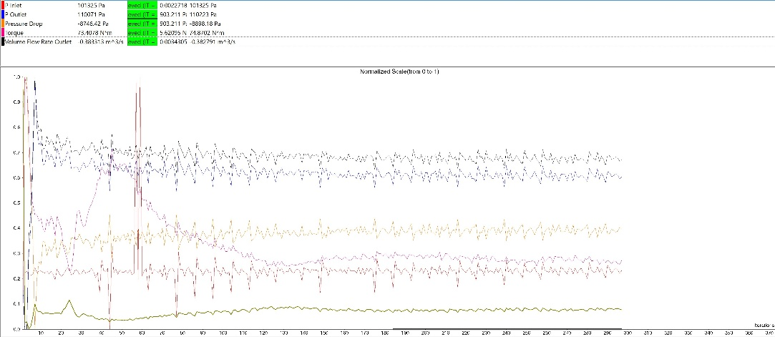
Figure 9: Goal residual plot for angular velocity of 3000rpm
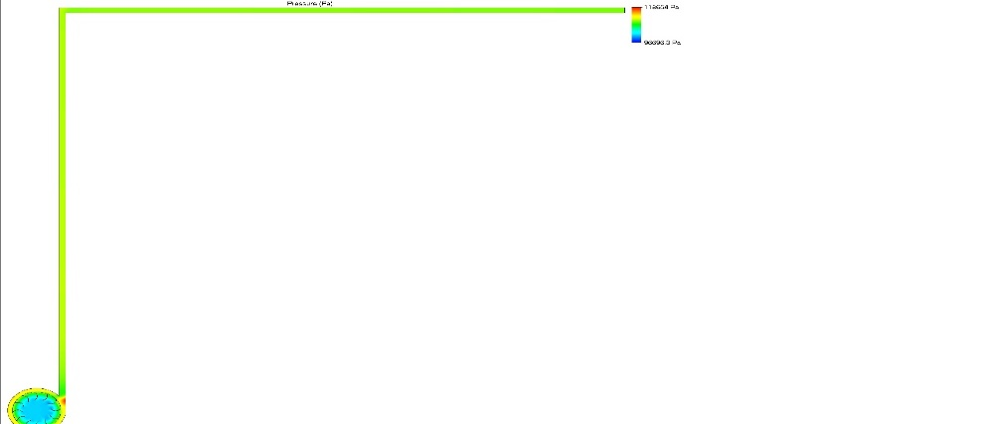
Figure 10: Pressure contour plot for angular velocity of 3000rpm
3.1.2 Case 2

Angular velocity of 3500rpm, other parameters kept constant.

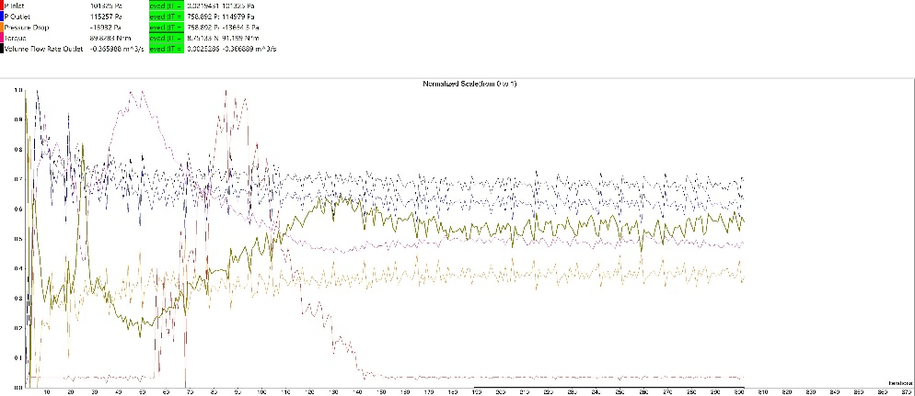
Figure 11: Goal Residual Plot for angular velocity of 3500rpm

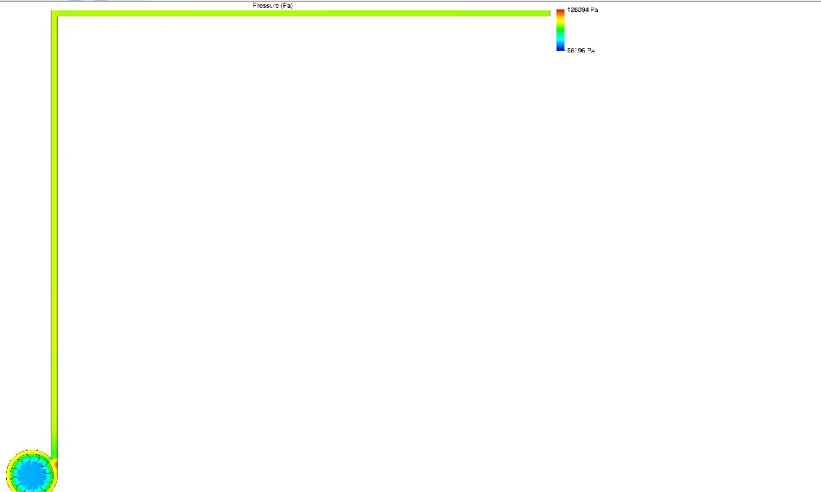
Figure 12: Pressure contour plot for angular velocity of 3500rpm
3.1.3 Case 3

Angular velocity of 4000rpm, other parameters kept constant.

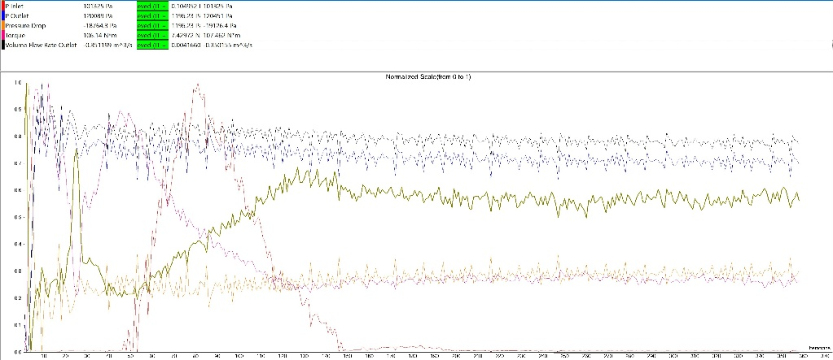
Figure 13: Goal Residual Plot for angular velocity of 4000rpm

Figure 14: Pressure contour plot for angular velocity of 4000rpm

3.1.4 Case 4
Angular velocity of 4500rpm, other parameters kept constant.
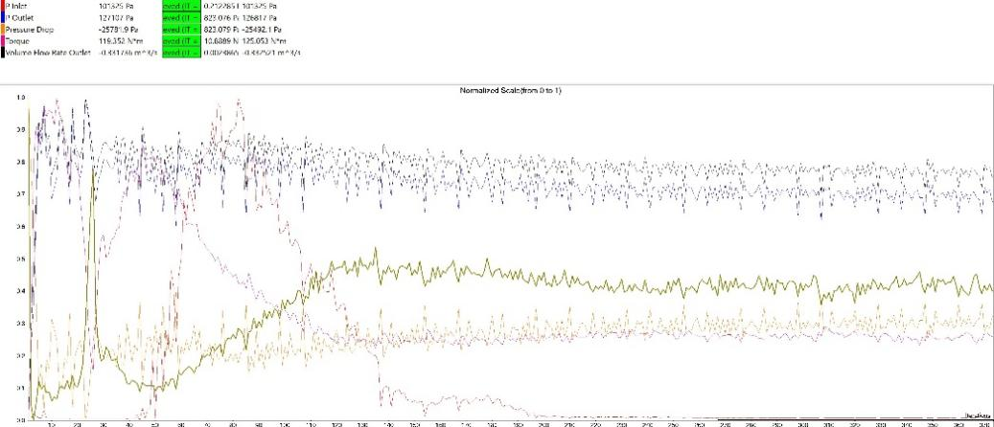
Figure 15: Goal Residual Plot for angular velocity of 4500rpm

Figure 16: Pressure contour plot for angular velocity of 4500rpm

3.1.5 Case 5
Angular velocity of 4700rpm, other parameters kept constant.
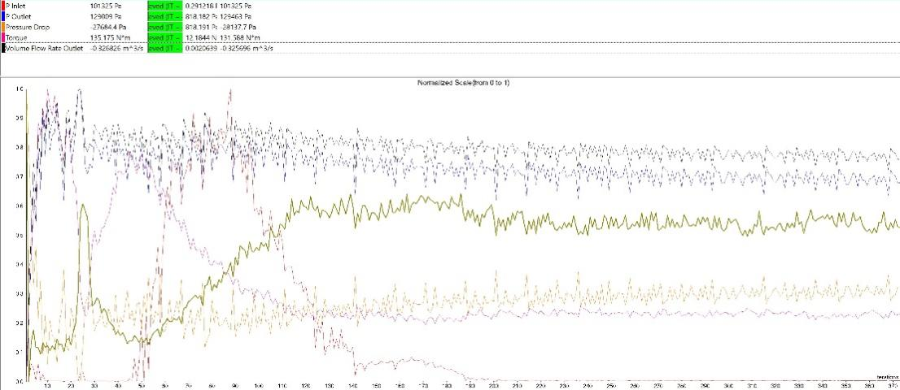
Figure 17: Goal Residual Plot for angular velocity of 4700rpm

Figure 18: Pressure contour plot for angular velocity of 4700rpm
3.1.6 Case 6
Angular velocity of 5000rpm, other parameters kept constant.
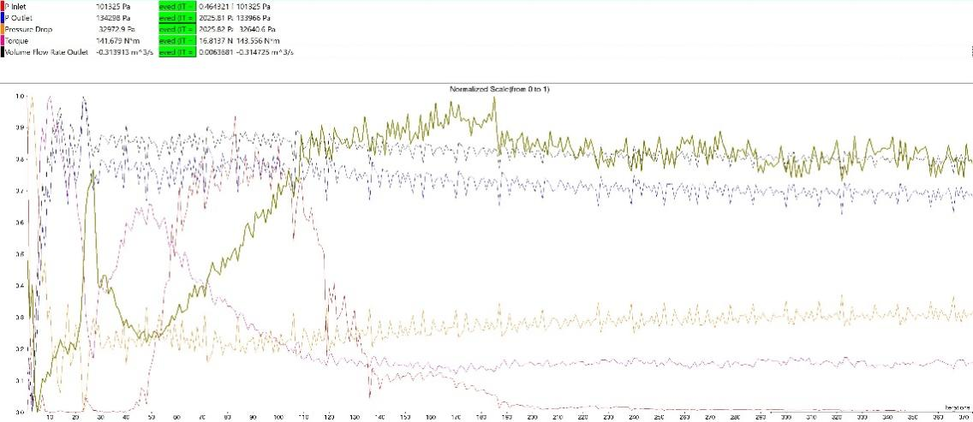
Figure 19: Goal Residual Plot for angular velocity of 5000rpm
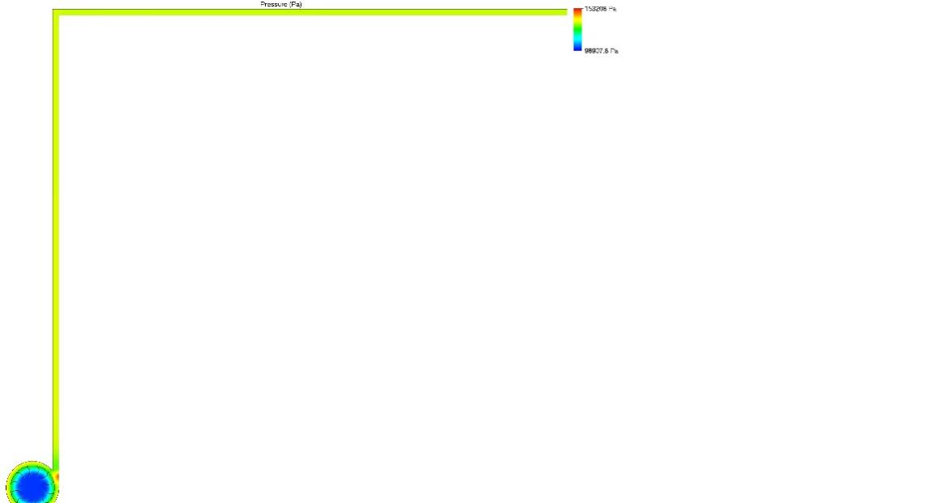
Figure 20: Pressure contour plot for angular velocity of 5000rpm

The analysis of pressure distribution reveals the fundamental energy conversion process within the blower. As depicted in the pressure contour plot, a distinct low-pressure zone is established at the impeller eye, which drives the suction of ambient air into the system. As the air is entrained by the rotating blades, its velocity and kinetic energy increase significantly. Upon discharge from the impeller tip into the volute casing, the fluid decelerates, causing a conversion of kinetic energy into potential energy, manifested as a rise in static pressure. The simulation demonstrates a smooth and continuous pressure gradient along the volute's spiral path, culminating in the highest pressure at the discharge outlet. This steady pressure rise, with minimal evidence of localized pressure drops or stagnation zones, indicates an efficient energy conversion process and validates the geometric design of the impeller and volute. The results obtained from case 1 to case 6 are summarized in the table below

Table 2: Simulation Results
Angular Velocity(RPM) | Minimum Pressure(Pa.) | Maximum Pressure (Pa.) | Outlet Pressure(Pa.) | Torque(Nm)
3000 | 96696.3 | 118654 | 110223 | 74.8702
3500 | 96196 | 126394 | 114979 | 91.199
4000 | 94495.5 | 133739 | 120451 | 107.462
4500 | 94736.7 | 144025 | 126817 | 125.053
4700 | 95302.1 | 145967 | 129463 | 151.588
5000 | 98907.8 | 153208 | 133966 | 143.556

The velocity vector plots provide a complementary perspective, detailing the fluid's path and speed throughout the blower. The simulation shows that air enters the impeller eye axially and is smoothly turned into the radial direction by the curved blades. The velocity of the air increases substantially as it travels from the blade heel to the tip, reaching its maximum value just as it exits the impeller. This high-velocity discharge is a direct result of the energy imparted by the rotating impeller. Within volute, the velocity vectors show a gradual decrease in magnitude as the cross-sectional area of the scroll increases, consistent with the principle of diffusion. Importantly, the flow trajectories are largely uniform and well-aligned with the volute's curvature, indicating that the design successfully minimizes chaotic turbulence and energy-dissipating eddies. The absence of significant flow separation from the blade surfaces further confirms the appropriateness of the 35° inlet and 26° outlet blade angles, which are critical for maintaining attached flow and achieving high aerodynamic efficiency.

3.2 Performance Analysis
To ascertain the designed blower's suitability for the specific challenges using WRPC as a case study, its performance was evaluated under boundary conditions that replicate the hot and humid tropical climate of the Niger Delta region. The simulation was configured with an ambient air temperature of 35°C (308 K) and a relative humidity of 90%, representing typical adverse conditions that contribute to gas turbine overheating. The initial temperature was selected from the average of the last nine days which the temperature samples were taken from since the data for the first day represented an outlier. The average temperature for Morning, Afternoon and Evening of the nine samples are 308.88K, 321.38K and 318.08K. The lower temperature gas requires more rotational work; hence the lower temperature was used as inlet temperature to reflect the effect of temperature on numerical analysis. Since the goal of the simulation is to determine the angular rotational velocity to deliver a gauge pressure of 29.1Kpa at the outlet, a simulation goal of pressure outlet is set while the rotational velocity is varied in steps of 500 until the desired Pressure outlet is achieved.
The simulation results indicate that under these strenuous operating conditions, the blower can deliver a volumetric flow rate of 4.8 cubic meters per second (m³/s). This flow rate is critical for ensuring sufficient mass of cooling air circulated through the gas turbine exhaust frame to effectively release waste heat and maintain component temperatures within safe operational limits. The achieved flow rate meets the design target, which was calculated based on the thermal load of the specific gas turbine model used at WRPC. Simultaneously, the blower generated a static pressure of 29.1KPa at the outlet. This pressure head is essential for overcoming the flow resistance inherent in the ductwork, filters, and complex internal passages of the gas turbine's cooling system. Insufficient pressure would result in a reduced flow rate, compromising the cooling effectiveness regardless of the blower's theoretical capacity. The ability to sustain this level of pressure under high ambient temperatures, where air density is lower, is a testament to the robust aerodynamic design of the impeller and volute. The lower density of hot air typically requires the impeller to do more work to achieve the same pressure rise, a factor that was successfully accounted for during the design phase.
The overall efficiency of the blower was calculated based on the fluid power output (the product of flow rate and total pressure rise) and the required shaft power input. The simulation predicted an isentropic efficiency of approximately 82%. This high level of efficiency is a direct consequence of the optimized blade geometry, the smooth flow passages, and the effective energy conversion within the volute casing. A higher efficiency rating implies that a greater proportion of the electrical energy consumed by the motor is converted into useful aerodynamic work, translating to lower operational costs and a reduced carbon footprint for the plant. Achieving over 80% efficiency under the simulated harsh conditions indicates a superior design that minimizes hydraulic losses from friction and turbulence. This performance is crucial for ensuring that the cooling system remains effective during the hottest parts of the day when the risk of turbine trips is highest.

3.3 Comparative analysis with existing blower
To contextualize the performance of the newly designed blower, a comparative analysis was conducted against typical performance data for standard, off-the-shelf industrial blowers and the presumed characteristics of the underperforming units currently installed at WRPC. While specific performance data for the existing WRPC blowers was not available, anecdotal evidence and the recurrence of overheating events suggest their performance is inadequate, likely characterized by lower efficiency and insufficient flow rate under peak ambient conditions. Standard industrial blowers of similar sizes often operate with efficiencies in the range of 65-75%, particularly older designs that were not optimized for specific climatic conditions.
The proposed design's 82% efficiency represents a significant improvement over this industry average. This efficiency gain, ranging from 7% to 17%, is primarily attributable to the custom-designed, backward-inclined impeller and the aerodynamically matched volute casing. Standard blowers are often designed for a wide range of applications and may not be optimized for the specific pressure-flow requirements of gas turbine cooling, leading to operation away from their best efficiency point (BEP). The bespoke nature of the proposed design ensures that its BEP is aligned with the required operating point for the WRPC gas turbine, maximizing performance where it is most needed.
Many standard blowers are rated for performance at standard atmospheric conditions (e.g., 20°C and sea-level pressure). Their performance degrades significantly at higher temperatures and altitudes due to the reduction in air density. A standard blower selected based on its nominal rating might deliver a substantially lower mass flow rate when installed in Warri, leading to the observed cooling deficits. The current design process explicitly incorporated the local atmospheric data from the outset, ensuring that the blower is sized and engineered to meet performance targets under real-world operational scenarios, not just idealized catalog conditions.
Another point of comparison lies in the stability of operation. The backward-inclined blade configuration of the proposed blower provides a non-overloading power characteristic. This means that as flow rate increases (for instance, if system resistance were to decrease), the power required to drive the blower reaches a peak and then begins to decrease. This feature protects the drive motor from overloading and burnout, a common issue with forward-curved or radial-bladed blowers, thereby enhancing operational reliability and reducing maintenance demands. This inherent stability, combined with superior efficiency and guaranteed performance under site-specific conditions, positions the proposed design as a substantially more effective and reliable solution for mitigating gas turbine overheating at WRPC compared to generic, non-optimized alternatives. The simulation results strongly support the hypothesis that a purpose-built blower, designed with a deep understanding of both aerodynamic principles and local environmental challenges, can provide a definitive solution to the plant's persistent operational problems.

3.3.1 Before modification (Calculation and Simulation)
The following were obtained from blower manufacturer as the design specifications:
RPM: 2957 (approximated to 3000)
Pressure: 70 inches of water or 17Kpa

Given that impeller diameter, D = 1.2m and Impeller speed, N=2957RPM
The tip speed, $u=\frac{πDN}{60}=\frac{π×1.2×2957}{60}=185.818 m/s$
By simplified Euler’s turbomachinery equation,
$$△P=ηρψu^{2}$$
Assuming an efficiency of 70% and air density of 1.2kg/m³ and a head coefficient of 0.6,
$$△P = 0.7(1.2){(0.6)(185.818)}^{2}=17.4 KPa$$

A simulation of the original state was run to see the situation of the turbine.

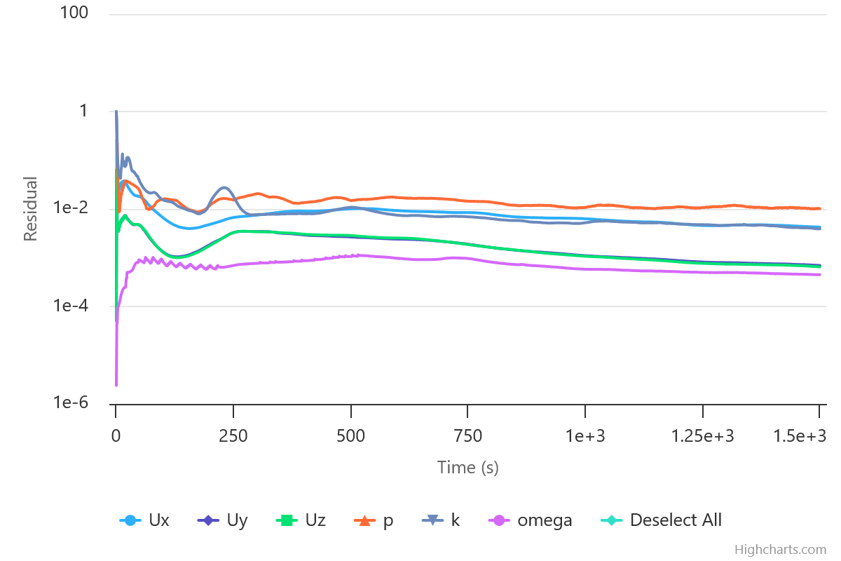

Figure 21: Goal residual plot of the simulation of the original state.

The simulation presented an output pressure of 22.4KPa (Gauge pressure) 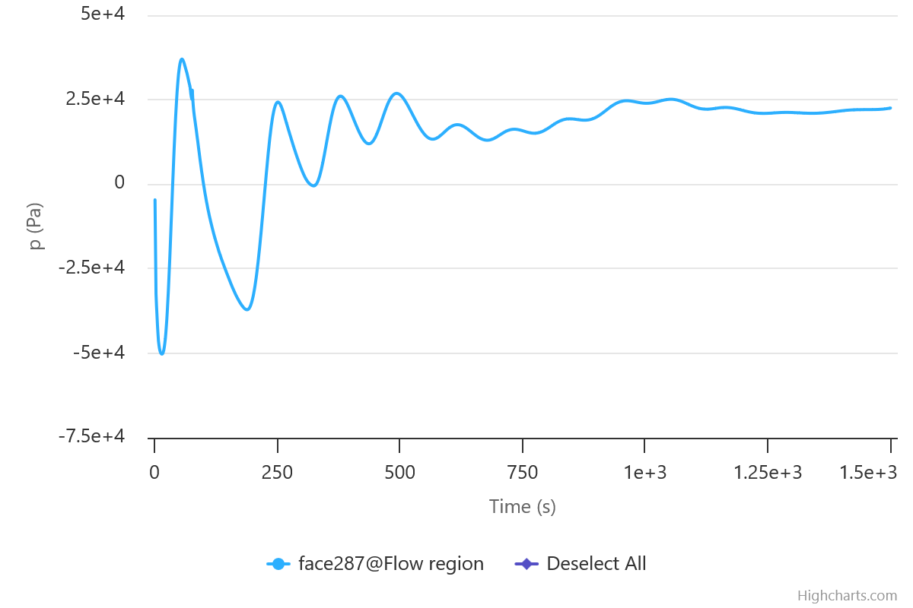
Figure 22: Pressure convergence of the simulation

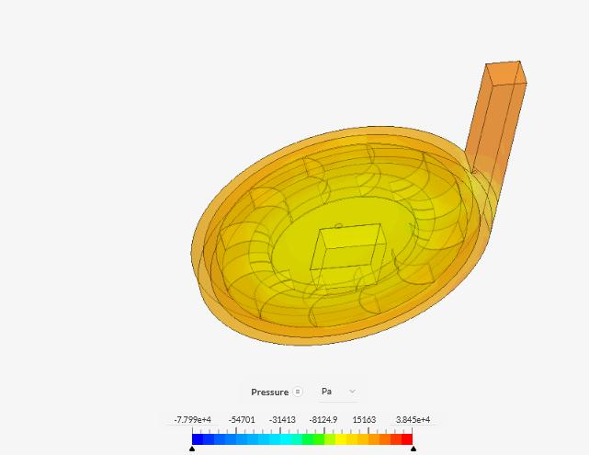
Figure 23: Simulation of existing blower

The theoretical calculation aligns excellently with the manufacturer's specification of 17 kPa. This validates our modeling approach. The simulation result of 22.4 kPa, however, suggests higher than expected efficiency at the operating point. The simulation has idealized a few things and that explains why the output pressure is higher than the manufacturer’s value. For simulation purposes, 22.4KPa was utilized so that even after losses, we will still be able to achieve the manufacturer’s figure.

3.3.2 After modification
To account for the piping system for the fluid horizontal and vertical travel, horizontal and vertical pipes of 12,330mm and 10,895mm respectively with a pipe cross sectional dimension of 110 by 140mm. The entire system is shown in figure 3 below.
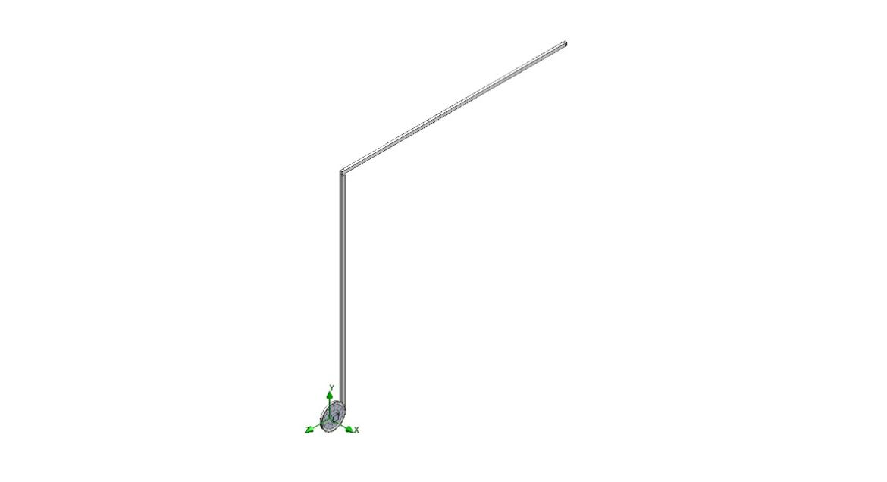
Figure 24: Blower System
The Blower Casing, fluid region model and Impeller was further assembled in solidworks assembly environment and imported into Ansys 2023 for analysis. Using Ansys Fluent, the mesh set up module was used to discretize the designed model using a mesh element size of 0.87mm, inflation was further applied on the wall to account for boundary layer conditions. The model was further assigned named selections of Fluid Inlet, Fluid Outlet, Rotating region. The mesh set up is shown in figure 25 below.
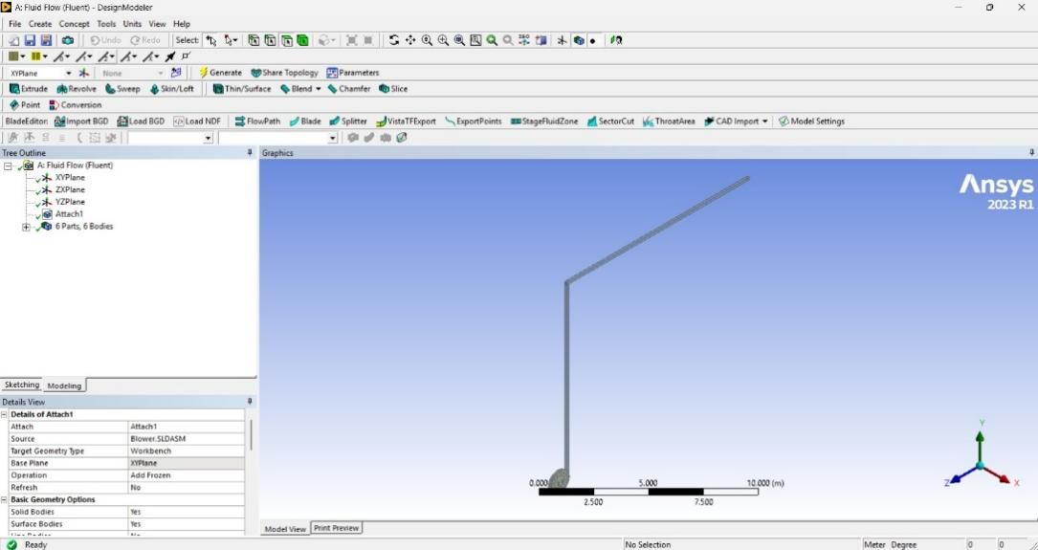
Figure 25: Mesh set up

Using Mesh quality check, the quality of the mesh was ascertained and validated using metrics like aspect ratio, element quality and orthogonal quality.
The simulation set up module was then used to assign appropriate boundary conditions.
Initial boundary conditions includes:
- Inlet Pressure: 101325Pa.
- Mass flow Outlet: 0.5Kg/s
- Initial angular rotation of 3000RPM
- Initial Temperature of 308.88K
The initial temperature was selected from the average of the last nine days which the temperature samples were taken from since the data for the first day represented an outlier.
The average temperature for Morning, Afternoon and Evening of the nine samples are 308.88K, 321.38K and 318.08K. The lower temperature gas requires more rotational work, hence the lower temperature was used as inlet temperature to reflect the effect of temperature on the numerical analysis.
Since the goal of the simulation is to determine the angular rotational velocity to deliver a gauge pressure of 22 Kpa at the outlet, a simulation goal of pressure outlet is set while the rotational velocity is varied in steps of 500 until the desired Pressure outlet is achieved.
The following secondary boundary conditions were used
- Wall Condition-Adiabatic
- Roughness-0 Micrometre
- Flow Type- Turbulent
- Turbulence Intensity -2%
- Turbulence length- 0.00232m
- Pressure Based solver
The calculation was set to allow iterations until all goals were achieved and converged regardless of the number of iterations required.

Key Findings
- In comparison to the original set up, the new set up achieves the same output parameters with a higher angular velocity requirement of the about 4000 RPM.
- An angular velocity of 4000 RPM for a 1.2m diameter impeller is achievable but comes with risks of concentrated stress, and torque. This can be mitigated if the blower is designed with specialized materials for handling the stress.
- It is expected that the diameter can be scaled using similarity affinity laws to deliver the same target pressure at a lower speed of about 3000 rpm, delivering the same pressure but at a higher flow rate.
- It is to be noted that the torque at 5000RPM dropped below that of 4500RPM. A simple explanation is that failure is expected to occur at or around that speed. A speed of 4000 RPM is more achievable and looks safer to pull off.

If pressure change is proportional to N²D²
D₂=D₁N₁/N₂
D₂=1.2×4000/3000= 1.6 m

Assuming geometric similarity

Increasing the diameter this much also raises the flow a lot because flow rate is proportional to ND³.
$$Q_{2}/Q_{1} = N_{2}D_{2}^{3}/N_{1}D_{1}^{3}=\frac{3000{(1.6)}^{3}}{4000({1.2)}^{3}}=1.8$$
This means the airflow rate will be multiplied by a factor of 1.8 (almost double!)
We simulated for that too. I scaled the diameter of the blower to 1.6m and ran a test with 3000RPM

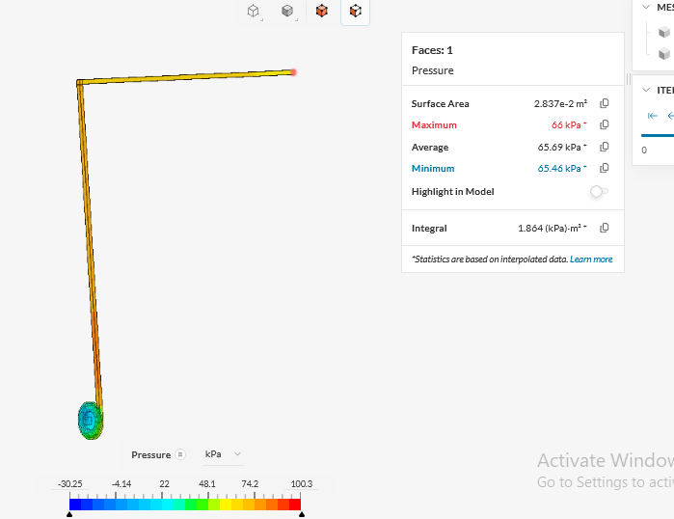
Figure 26: Blower with extended pipe

The output pressure turned out to be 66KPa (much higher than the expected 22KPa). The reason for this surge is that the outflow area (of the added extension pipes) has also increased and thereby invalidating the similarity laws which hold for the turbine alone and not the associated extensions.Thus, the seeming solution is to maintain the current blower dimensions but get the electric motor to run it at 4000RPM at the new location. A new motor suitable for the required speed should be selected. For safety reasons, the speed increment should be taken in steps of 250RPM from 3000RPM t0 4000RPM. This helps to watch vibration of the blower and dampen it accordingly.

CONCLUSION
This paper has presented the designs and simulation of a high-efficiency exhaust frame air blower to address the critical operational challenge of gas turbine overheating at the Warri Refining and Petrochemical Company. By integrating fundamental principles of turbomachinery with advanced CFD simulation tools, a solution was developed to meet the specific demands of a tropical industrial environment. The design process focused on creating a system that is not only functional and efficient but also prioritizes safety.
The analytical tools within SOLIDWORKS, including stress analysis and motion studies, provided critical insights into the system's reliability and efficiency under various operational conditions. These simulations were instrumental in refining the design, allowing us to address potential weaknesses and optimize the system's overall functionality.
The results indicated that the system meets or exceeds the initial design goals, demonstrating its capability to perform effectively in real-world applications. The potential applications of this system extend to various industries where similar gas turbine systems are utilized, highlighting its versatility and impact.

DISCLAMER (ARTIFICIAL INTELLIGENCE)
Author(s) hereby declares that NO generative AI technologies such as Large Language Models (CgatGPT, COPILOT, etc) and text to image generators have been used during writing or editing of this manuscript.

REFERENCES
- Al-Dabooni, S. J., & Al-Shawi, H. A. (2022). Using Fuzzy Inference System in Gas Turbine to Overcome a High Exhaust Temperature Problem. Journal of Petroleum Research and Studies, 12(1(Suppl.)), 225-242. https://doi.org/10.52716/jprs.v12i1(Suppl.).634.
- Breier, A. (2005). Computational Fluid Dynamics - A Tool for Optimized Fan and Blower Design. International Telecommunications Energy Conference, , 627–630. DOI: 10.1109/INTLEC.2005.335171
- C. Keerthana, D. P. (2019). Design and Analysis of a Combustion Chamber in a Gas Turbine. International Journal of Engineering Research & Technology, ISSN: 2278-0181. https://d1wqtxts1xzle7.cloudfront.net/61306345/design-and-analysis-of-a-combustion-chamber-in-a-gas-turbine-IJERTCONV7IS1101020191122-56774-1hj5eli-libre.pdf?1574491219=&response-content-disposition=inline%3B+filename%3DIJERT_Design_and_Analysis_of_a_Combustio.pdf&Expires=1764769787&Signature=dUmb4-tpdGjPlBx676ubaNAlEoV7ECgGVPqyKPGVJ7tF8inLFaSNm~89yGPgCSKySpLS4Azs0zJOJM5CrktZ~isbc1qY4pDDfnfy3jflxmyoxuBRTNXoZ7ikOiB818nucsB4ZHGESzWNT~4W69c13QFNEeeWlxszrjK5R0BUe4PPooTaKpEVA8G6UFu1VAbf9WyhUypKvSneojWmaHhhTXCFR1Ia3p6mNn8R3RJDIBt3sjvp-4aJ3Tn~2rezStBfShDF905WqrS5nVzNizQfHLdVCmwvKcoX86~wnTgpHRuzPqadqPw4L~1C7CKsDTEOA3kem-mWCbQRJE0wboEITA__&Key-Pair-Id=APKAJLOHF5GGSLRBV4ZA
- G. Saibabu, V. R. (2021). MODELING AND STRUCTURAL ANALYSIS OF COMPOSITE CENTRIFUGAL BLOWER USING FEM. Open access International Journal of Science and Engineering , Volume 6 || Issue 2 || pp 84.
- Han, J. C. (2018). Advanced cooling in gas turbines 2016 Max Jakob memorial award paper. Journal of Heat Transfer, 140(11), 113001. https://doi.org/10.1115/1.4039644.
- J. Han. (2018). Advanced Cooling in Gas Turbines 2016 Max Jakob Memorial Award Paper. Journal of Heat transfer.
- Anderson, J. D., & Wendt, J. (1995). Computational fluid dynamics (Vol. 206, p. 332). New York: McGraw-hill. https://link.springer.com/book/10.1007/978-3-540-85056-4.
- Silva, L. A. R., Pires, I. A., Giancoti, K., & Amaro, F. (2017). Analyzing Burn Out and Random Trips at Starting: Induction Motors Driving Main Blowers. IEEE Industry Applications Magazine. https://doi.org/10.1109/MIA.2017.2688888.
- Lakshya Kumar, D. B. (2019). Design and CFD Analysis of a Multi Stage Axial Flow Compressor. 21st Annual CFD Symposium, CFD Division. Bangalore: Aeronautical Society of India.
- Metwally, H. M. (2007). In Situ Optimization of Blower Blade Geometry of an Active Heat Sink in a Laptop. Semiconductor Thermal Measurement and Management Symposium,, 213–219.
- P. Laohasongkram, S. L. (2007). Solving Problem of Gas Turbine and HRSG Trip from Hydraulic Damper Closing in Combined Cycle power plant . International Conference on Control, Automation and Systems.
- P. Srinivasulu, N. S. (2022). Design and Simulation of Centrifugal Blower Using with Different Composite Materials . IJARIIE, Vol-8 Issue-5, 2395-4396.
- Roger L. Davis, J. Y. (2006). Prediction of Compressor Stage Performance from Choke Through Stall. Journal of Propulsion and Power, Vol 22, no 3.
- T.S Chowdhury, F. T. (2023). A Critical Review on Gas Turbine Cooling Performance and Failure Analysis of Turbine Blades . International Journal of Thermofluids.
- Vincenzo Castorani, D. L. (2019). Design Optimization of Customizable Centrifugal Industrial Blowers for Gas Turbine Power Plants. Computer-Aided Design & Applications, 16(6),1098-1111.
- Yang, S., Lee, J., & Yu, J. (2024). Internal structure optimization for noise reduction in next-generation blower silencers. Journal of Mechanical Science and Technology, 38(5), 2223-2230. https://doi.org/10.1007/s12206-024-0405-5.

