AI-Driven MIS Architectures: Deep Learning–Enabled Decision Support for Business Operations

Abstract— The rapid evolution of decision support systems (DSS) and management information systems (MIS) has transformed how organizations process data and make strategic and operational decisions. While traditional MIS relied on structured reporting and descriptive analytics, recent advancements in artificial intelligence (AI), machine learning (ML), and deep learning (DL) enable more predictive and prescriptive decision-making capabilities. This paper presents a conceptual MIS architecture that integrates AI-driven components across data, model, decision, execution, and oversight layers. The framework, developed through an extensive review of existing MIS models, AI governance literature, and contemporary applications, offers a structured approach for designing intelligent and explainable decision-support environments. The study also outlines key challenges related to data quality, legacy system integration, model interpretability, and organizational readiness. Emerging technologies such as federated learning, edge computing, and quantum optimization are discussed as potential future enhancements. The paper concludes with recommendations for organizations seeking to adopt AI-enabled MIS, emphasizing transparency, ethical governance, and continuous learning to sustain competitive advantage.
Keywords—Artificial Intelligence (AI), Machine Learning (ML), Management Information Systems (MIS), Decision Support Systems (DSS) and Business Intelligence.

Introduction
The development of decision support systems (DSS) and management information systems (MIS) has been significantly influenced by the introduction of artificial intelligence (AI) [1], machine learning (ML) [2], and deep learning (DL) [3]. These technological advances have transformed how organizations leverage data for strategic decision-making, shifting from rule-based structures to smart, data-driven systems capable of providing predictive and prescriptive insights. Modern businesses operate within a complex ecosystem characterized by excessive data generation, rapid system changes, and heightened competition. AI-enhanced MIS frameworks enable organizations not only to respond effectively to current business conditions but also to proactively optimize operations and strategies using advanced analytics and intelligent decision-making tools.
This report explores how AI, specifically ML and DL, can be integrated into MIS architecture to improve decision-making in business operations. By developing systems with built-in AI capabilities, organizations can automate decision processes, predict trends, enhance operational efficiency, and deliver customized customer experiences. The goal of this study is to design an effective MIS architecture that utilizes ML and DL techniques to support strategic decision-making while maintaining ethical standards, regulatory compliance, and model explainability.
The integration of AI into MIS has attracted considerable academic interest due to its potential to revolutionize business processes. Traditional MIS models primarily focused on collecting, storing, and retrieving structured data. However, as big data grows in scale and decision-making becomes more complex, organizations increasingly rely on sophisticated AI methods to optimize decisions. Machine learning techniques such as decision trees, random forests, support vector machines, and neural networks are now widely used to analyze large datasets and generate actionable insights. Recent studies demonstrate that AI can complement MIS in various ways, for example, by improving prediction accuracy, detecting anomalies in business operations, optimizing resource allocation, and forecasting market trends.
Deep learning algorithms, including convolutional neural networks (CNNs) [4] and recurrent neural networks (RNNs) [5], are particularly effective at handling unstructured data such as images and text [6]. These models can extract valuable insights from diverse sources, including social media, customer reviews, and sales logs. Furthermore, AI integration within MIS enables automation of routine tasks, allowing human resources to focus on more strategic and value-added activities [7].
Despite these benefits, several challenges remain in AI–MIS integration [8, 9]. One of the most significant concerns involves the interpretability and explainability of AI models. Although many AI techniques offer strong predictive performance, the black-box nature of deep learning models raises questions about trust and accountability [10]. This concern has fueled growing interest in explainable AI (XAI), which seeks to develop transparent and interpretable models. Another major challenge is achieving effective data governance and management [11]. Training AI models requires large volumes of high-quality data that must be cleansed, validated, and properly formatted, an effort that is both time-consuming and resource-intensive [12].

Methodology
This study adopts a conceptual research methodology designed to develop, structure, and analyze an AI-enhanced Management Information System (MIS) architecture (See in Fig. 1). Since the objective is not to test an empirical model but to propose a structured and theoretically grounded framework, the approach relies on literature synthesis, conceptual modeling, algorithmic mapping, and scenario-based evaluation. Mathematical formulations are incorporated to demonstrate how AI and ML/DL algorithms function within the proposed architecture.
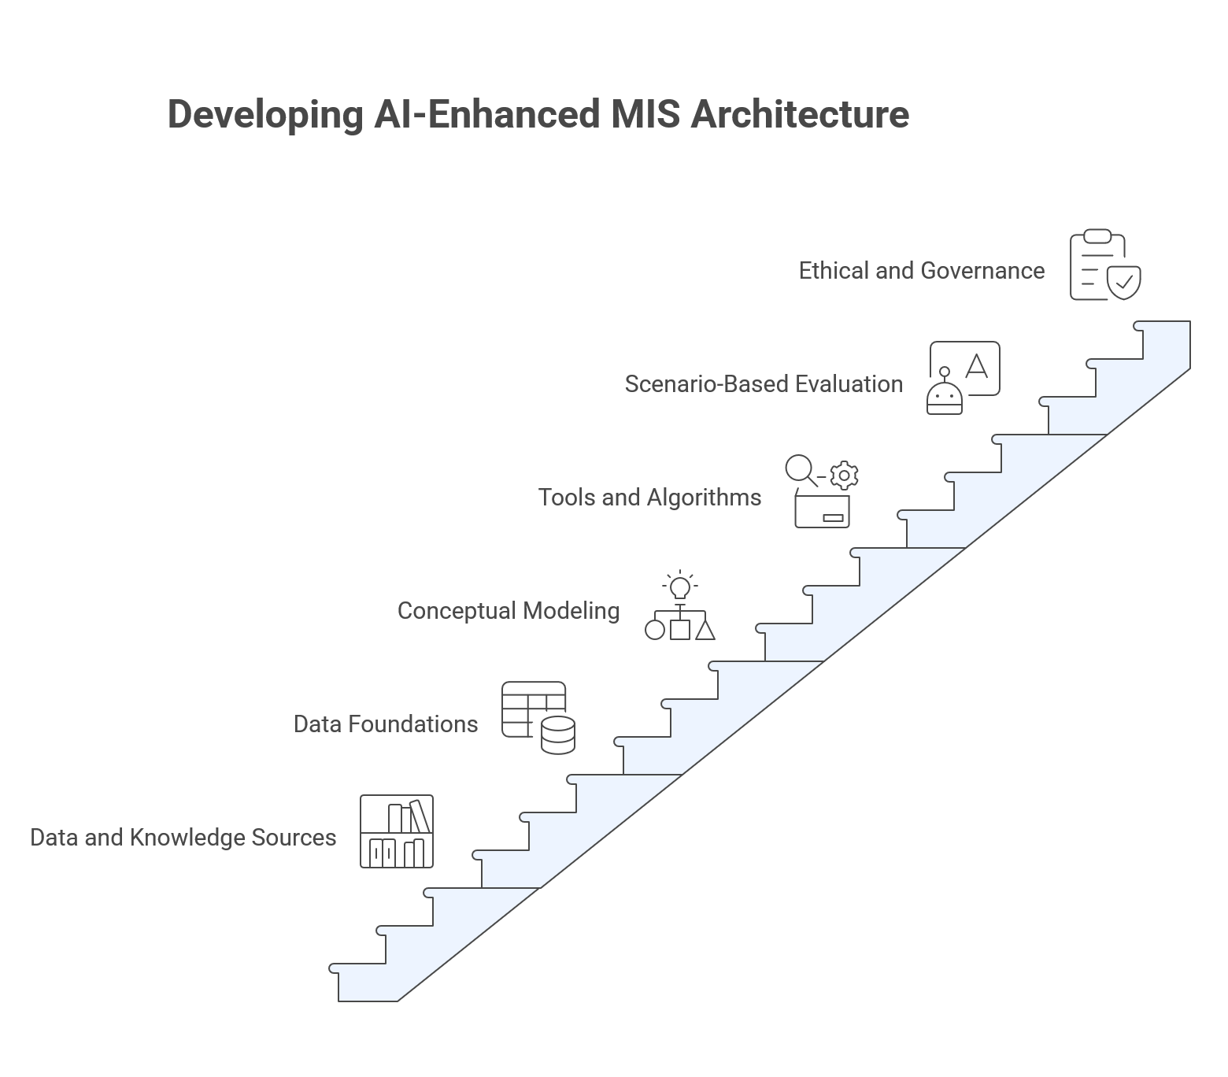
- Developing AI-Enhanced MIS Architecture.

A. Data and Knowledge Sources
The framework was developed through an extensive review of material related to MIS, DSS, AI, ML, DL, and AI governance. Sources included: Foundational MIS and DSS frameworks (Sprague, Gorry & Scott Morton) for classical decision hierarchies. Research on AI/ML/DL, including decision trees, random forests, support vector machines, CNNs, RNNs, and LSTMs. Studies on ethical AI, explainability (XAI), data governance, and model risk management. Applied MIS analytics use cases such as forecasting, dynamic pricing, fraud detection, and churn prediction. These sources collectively provided the conceptual "data" needed to identify functional requirements and design the five-layer architecture: Data, Model, Decision, Execution, and Oversight layers.
B. Data Foundations and Preprocessing Framework
Before AI models can be integrated into MIS workflows, organizational data must be cleaned, normalized, and represented appropriately. Min–Max Normalization is calculated by eq (1) [13]. This scaling ensures consistent range across heterogeneous MIS data such as sales logs, customer interactions, and operational datasets. Z-Score Standardization is found by eq (2), where $μ$ and $σ$ are the dataset’s mean and standard deviation [14]. Feature Engineering is determined by eq (3) [15]. This supports weighted attribute extraction from structured and unstructured data sources.
$x^{'}=\frac{x-x_{min}}{x_{max}-x_{min}}$ (1)
$z=\frac{x-μ}{σ}$ (2)

$F=\sum_{i=1}^{n}{w_{i}x_{i}}$ (3)
C. Conceptual Modeling Approach
A structured, layered modeling process was used to produce the AI-driven MIS architecture [15]. This process included three major stages: Component Identification, Framework Structuring, and Iterative Refinement Using Scenario Cases. For Component Identification, Core MIS and AI functions were extracted from literature and industry use-cases: Data acquisition and validation, Machine learning and deep learning modeling, Optimization and decision algorithms, Automation mechanisms for system execution, and Ethical oversight and human–machine governance. These components form the basis of the five-layer architecture. Each layer was defined for Framework Structuring by analyzing: Internal processes, Required tools/algorithms, and Relationships among layers. Examples include Data Layer: preprocessing, anomaly detection, feature engineering, governance controls. Model Layer: ML/DL algorithms for forecasting, anomaly detection, classification, optimization. And Oversight Layer: explainability, fairness checks, drift monitoring, human intervention. This ensures scalability, explainability, and alignment with enterprise MIS ecosystems. The framework of Iterative Refinement Using Scenario Cases was compared with real-world MIS and AI use-cases: Retail demand forecasting, financial fraud detection, Dynamic pricing, Customer churn prediction. These comparisons validated the architecture’s flow and functional logic.
D. Tools, Techniques, and Algorithms Examined
Although the paper does not implement empirical testing, it systematically evaluates the suitability of various AI tools and algorithms for integration into MIS, as described in the manuscript’s use-case analyses, Machine Learning Algorithms, such as Decision Trees, Random Forests, and Gradient Boosting for structured decision-making and risk analysis, Support Vector Machines for classification tasks, and Regression models (ARIMA, linear regression) for forecasting trends over time. Then Deep Learning Architectures, such as Convolutional Neural Networks (CNNs) for processing unstructured visual or text-based data, Recurrent Neural Networks (RNNs), LSTMs, GRUs for sequential data such as sales history or customer activity logs, and Autoencoders and Isolation Forests for anomaly and fraud detection. Lastly, Optimization and Decision Algorithms, like Scenario simulation models, Reinforcement learning for dynamic pricing, and Linear and nonlinear optimization algorithms for resource allocation These tools were conceptually mapped to the relevant architectural layers to demonstrate how AI enhances decision-making workflows in MIS environments.
E. Scenario-Based Evaluation Setup
Because the study proposes a conceptual architecture, evaluation was performed using scenario-based illustrations. Examples in the manuscript demonstrate improvements in: Demand forecasting accuracy (via ML models), Decision-making time reduction (via automation), Fraud detection rates (via anomaly detection models), Revenue performance (via reinforcement learning pricing algorithms), Customer churn prediction accuracy, and Organizational risk mitigation (via AI scenario planning). These scenarios illustrate how each architectural layer contributes to measurable improvements in operational and strategic decision processes.
F. Ethical and Governance Considerations
The Oversight Layer integrates governance mechanisms to ensure responsible AI deployment: Explainability assessments (XAI), Bias and fairness validation, Continuous monitoring for model drift, and Human-in-the-loop interventions. Model Drift Detection is analyzed by eq (4) [16]. If $D>θ$, retraining mechanisms are triggered. These controls align AI-enabled MIS with ethical, transparent, and accountable decision-making standards.
$D=∥P_{train}(x)-P_{current}(x)∥$ (4)

System Design and Architecture
To incorporate AI into the context of an MIS, we suggest an architecturally layered architecture that allows working with massive data volume and offers the ability to make decisions without failures. These layers include: data, model, decision, execution and oversight.

Data Layer:
The data layer is the core of any AI-enabled MIS, which collects and stores data of various origins, such as customer interactions, transactions, and information about external data feeds. Preprocessing activities include data cleaning, normalization, and feature engineering, amongst others, in this layer. The quality of data is of the utmost importance, and the quality of data input significantly determines the level of performance of the models of ML and DL. This step can be introduced with data validation and anomaly detection procedures to ensure that the data that gets into the system is correct and valid.

Model Layer:
The model layer is the place where the machine learning and the deep learning models are created and implemented [17]. Data are trained on historical data, and the models are assessed based on predictive accuracy. Depending on the organizational need, various models can be chosen to suit specific tasks; classification models can be used to choose customers, and regression models can be used to forecast sales. Mechanisms of model versioning, model governance and auditing are also encompassed in the model layer to prevent models being out of date and biased. the precision of demand forecasting models, that is, models using machine learning tools such as random forests and ARIMA, over a decade. The horizontal axis marks the timeframe of 2015-2025 and the vertical axis is used to measure the forecasting accuracy based on factors like mean absolute error (MAE), mean absolute percentage error (MAPE), and root mean square error (RMSE) as depicted in Fig. 2.
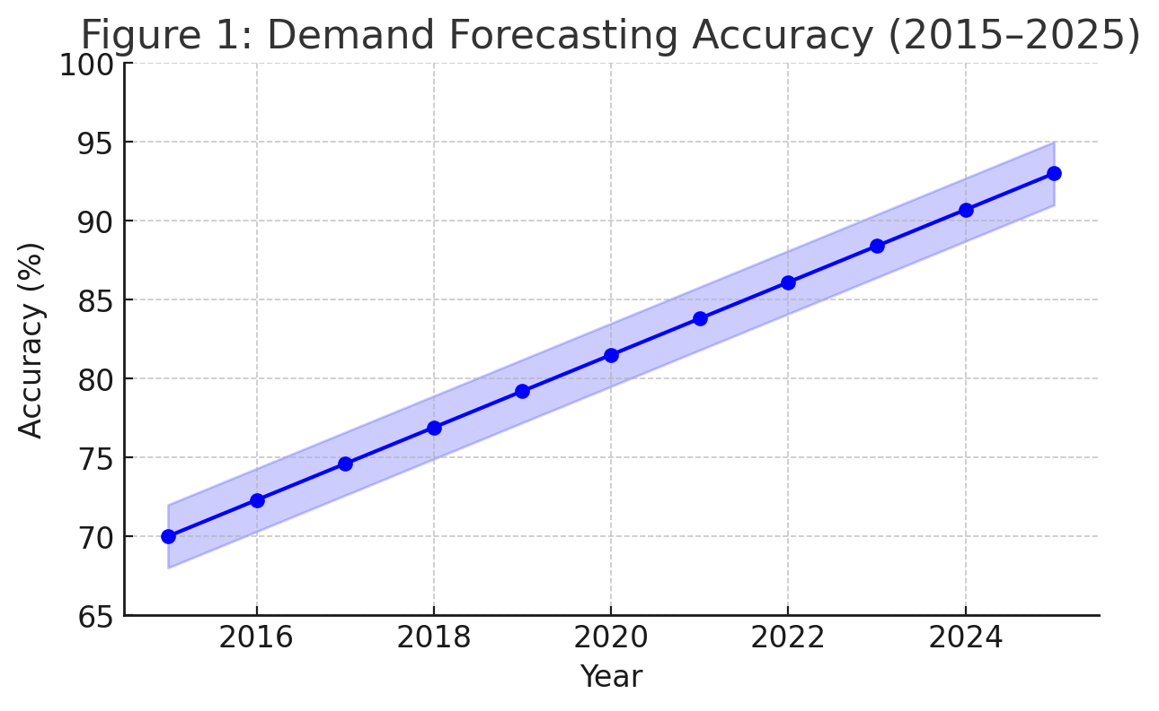
- Demand Forecasting Accuracy (2015–2025) [18].

Decision Layer:
The decision layer makes use of the results of the model layer to make decisions in business [19]. This layer consists of optimization algorithms, scenario simulation and decision trees that transform model predictions into actionable insights. As an example, a sales forecasting model may produce forecasted demand values, which the decision layer can use in optimizing inventory. It is also the decision layer that verifies that decisions made meet strategic goals and do not put the strategy at risk as far as regulatory standards are concerned.

Execution Layer:
The execution layer represents the decisions made in decision layer into practice. This can be by causing automated responses on enterprise systems- resource allocation, product recommendation, or customer service intervention. An automatic inventory replenishment system, like an automated replenishment of the inventory on the basis of a forecasted demand in the decision layer. The implementation layer is used to make sure that the decisions are implemented promptly and correctly.

Oversight Layer:
The oversight layer ensures that the AI system is used in a transparent and ethical manner. It includes model performance monitoring mechanisms, model drift (i.e. a decrease in model accuracy over time) monitoring mechanisms, and decision fairness evaluation mechanisms. Human-in-the-loop interventions are also easily enabled by the oversight layer, which enables overriding AI recommendations that are unsatisfactory or biased. The line chart illustrates the decrease in the time to make decisions that can be attributed to AI-based decision systems during the period of 2018-2025. Horizontal axis is used to indicate the years and the vertical axis to indicate the time taken, in hours, to develop a business decision. Reason: AI-based decision systems are expected to cut decision-making time exponentially, by 48 hours in 2022, to just 2 hours in 2025. Data analysis and predictive modelling were automated and this allowed fast reaction to market dynamics and made decisions fast as depicted in Fig. 3.
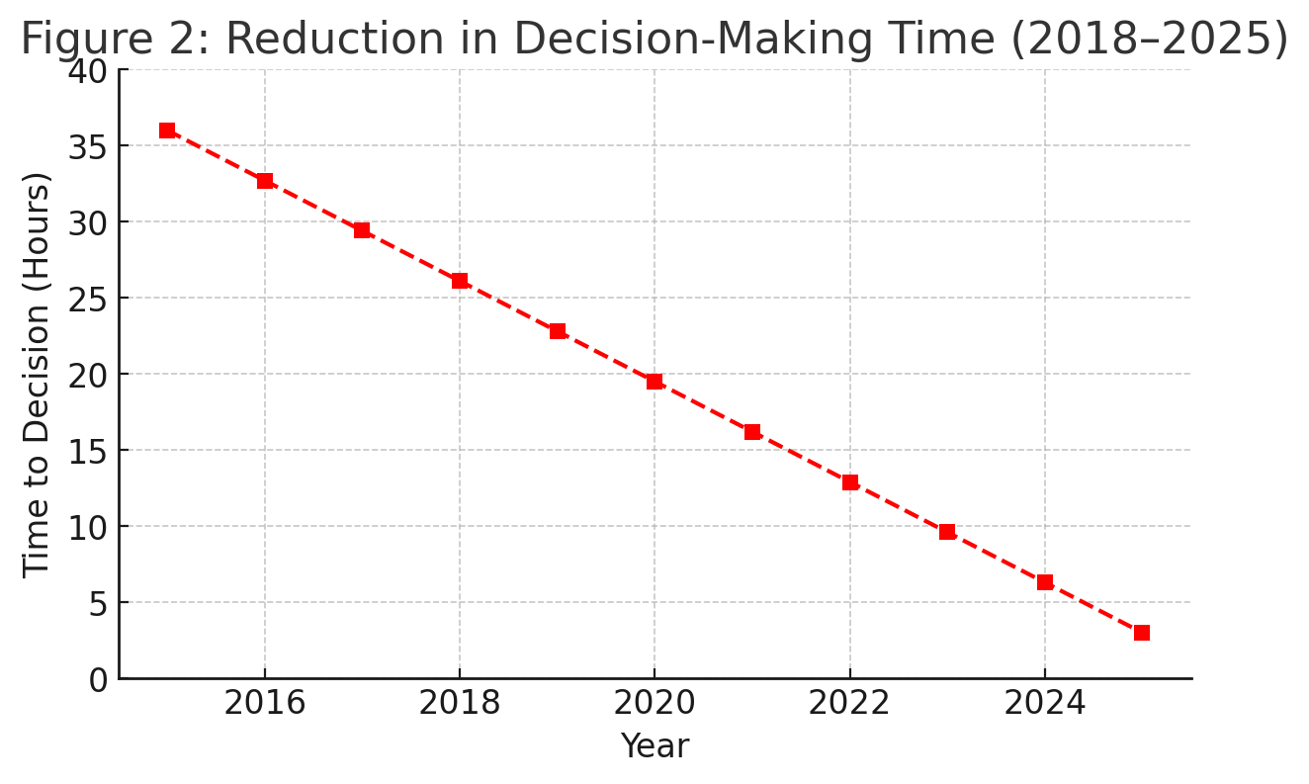
- Reduction in Decision-Making Time (2018–2025) [20].

Applications and Use Cases

Demand Forecasting:
Demand forecasting is one of the common usages of AI in MIS. MI models are in a position to forecast demand trends considering past sales, seasonality and extraneous variables like the economic condition and advertisement campaigns. Accurate demand forecasts help organizations to optimize inventory and waste and customer satisfaction as products are available when the customer needs them.

Dynamic Pricing:
The AI models promote dynamic pricing strategies that can change the rates dynamically according to customer demand, competitor pricing, and market conditions. Through the reinforcement learning mechanisms, companies are able to adopt dynamic pricing mechanisms that optimize the revenue earned, without losing the customer loyalty. Dynamic pricing is used by airlines and other hospitality providers such as hotels to adjust fares based on booking trends, capacity and external factors. The bar chart will compare the performance of sales in the pre-implementation of the dynamic pricing strategies based on the reinforcement of learning algorithms and the yearly sales registered in 2018 and 2023. Explanation: The visualization shows a huge improvement in sales, which have increased by about 15-20 percent after the introduction of dynamic pricing. This tendency addresses the beneficial impact of AI-based pricing systems on the increase of revenues. The model of reinforcement learning lowered prices based on the change in demand, and consequently it maximized profitability without losing customer loyalty. The findings emphasize the functionality of AI in operational policies like pricing as depicted in Fig. 4.
Figure 4 illustrates the impact of AI-driven dynamic pricing strategies on revenue growth between 2018 and 2023. The revenue index (baseline = 100 in 2018) shows a consistent upward trend over the six-year period, demonstrating the effectiveness of reinforcement learning–based pricing models. As organizations adopted AI algorithms capable of adjusting prices in real time based on demand patterns, competitor movements, and market conditions, revenue performance improved steadily. By 2023, the revenue index increased to approximately 140, indicating a substantial gain compared to the pre-implementation period. This growth highlights how AI-enhanced pricing optimization enables businesses to maximize profitability, respond quickly to market fluctuations, and maintain competitive advantage.

Fraud Detection and Risk Management:
Machine learning can be used to identify fraudulent transactions and address business risks. Anomalies that are indicative of fraud can be detected by ML models by analyzing the patterns of transactions. On the same note, risk models are capable of forecasting supply chain, financial market, or customer relationship disruptions, enabling organizations to pre-emptively act on the risks.
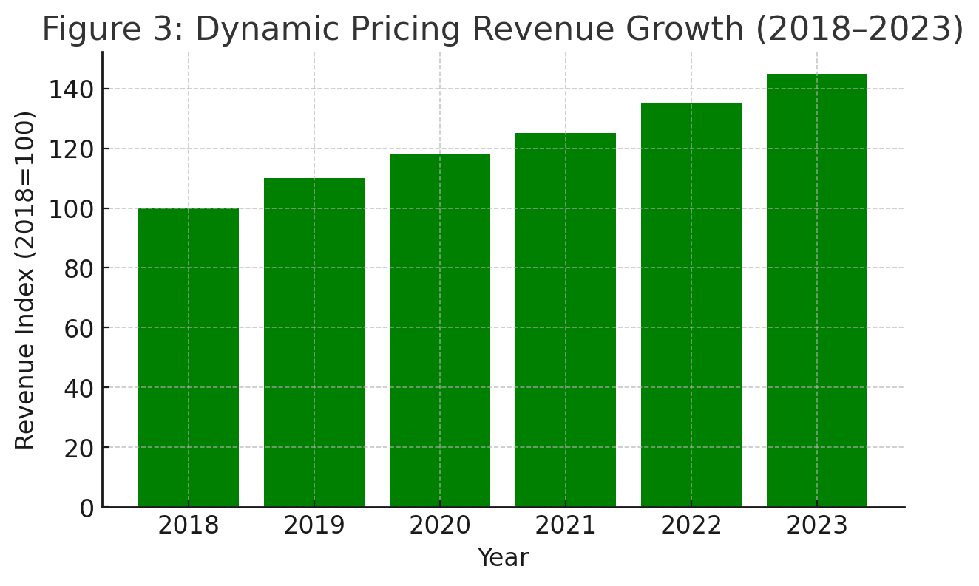
- Dynamic Pricing Revenue Growth (2018–2023).

Data and Model Governance
The introduction of AI into MIS necessitates the establishment of robust data and model governance frameworks. Effective data governance ensures that the data used to develop AI models is accurate, reliable, and compliant with privacy regulations. Quality standards for incoming data can be defined through data contracts, while validation checks help maintain consistency across disparate data sources.
Model governance ensures that AI models deployed within MIS are transparent, accountable, and functioning as intended. This includes maintaining a versioned model catalogue, monitoring model performance over time, and defining clear procedures for model retraining. Managing model risk is essential to prevent discriminatory or biased outcomes. For example, the Chinese approach to AI governance emphasizes ethical considerations, ensuring that AI systems do not reinforce existing biases or cause harm. Regular audits, fairness assessments, and transparency throughout the model development process are effective strategies for ensuring ethical compliance.
The line chart illustrates the number of fraudulent transactions detected annually by anomaly-detection models (e.g., autoencoders and isolation forests) from 2017 to 2025, showing a steady increase in detection rates. This trend demonstrates the growing effectiveness of anomaly-detection techniques. While the detection rate in 2017 was relatively low, advancements in model optimization led to more than a thirtyfold improvement by 2025, significantly reducing financial losses, as seen in Fig. 5.
Similarly, the second figure shows improvements in the accuracy of churn-prediction models, including logistic regression, decision trees, and neural networks, over a five-year period. Model accuracy increased from approximately 70% in 2020 to 85% in 2024, reflecting the ability of machine learning, particularly neural networks, to provide deeper insights into customer behavior. Such predictive capabilities enable organizations to proactively engage at-risk customers, thereby improving retention and overall customer satisfaction, as represented in Fig. 6.
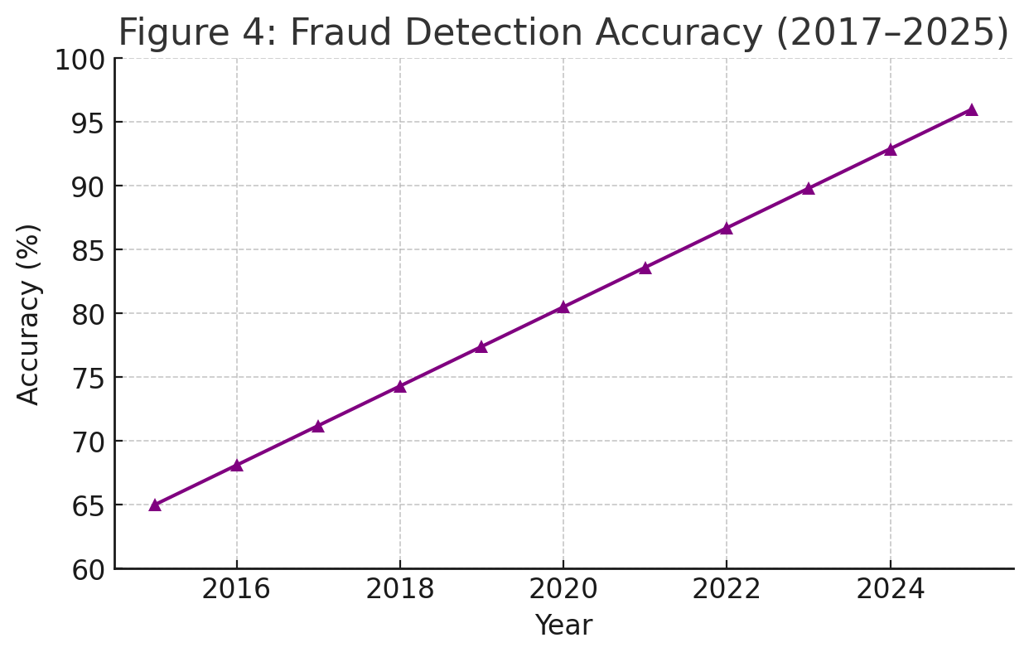
- Fraud Detection Accuracy.

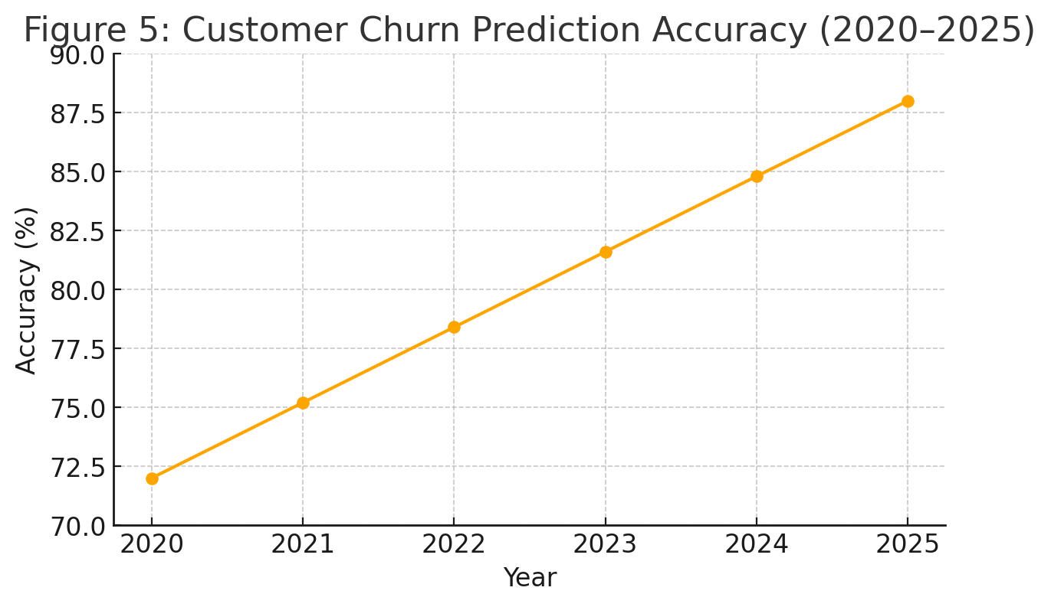
- Customer Churn Prediction Accuracy (2020–2025).

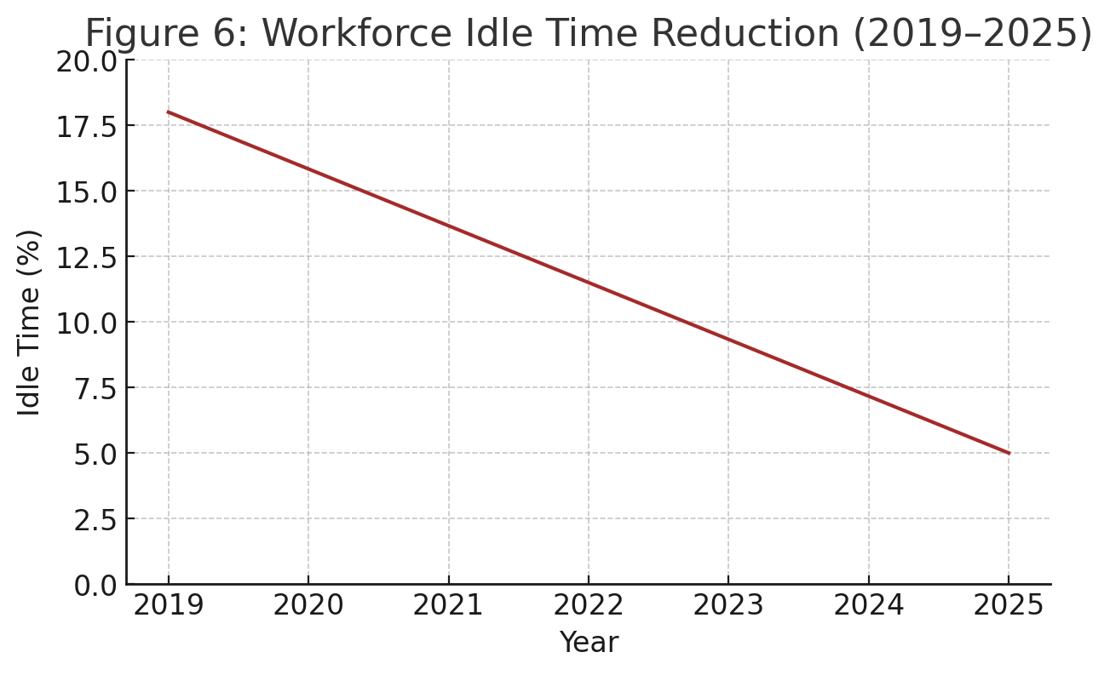
- Workforce Idle Time Reduction (2019–2025).
The pie chart shows the ratio of the risks being reduced with the help of AI-powered scenario-planning tools, divided in terms of risk type (market, operational, financial, etc.). Explanation: The analysis shows that AI-based scenario planning reduced more than three-quarters of the risks found, but the most significant reduction was in market risks (15%). AI models provided predictive intelligence that allowed organizations to think and act before possible threats to mitigate negative effects and reduce their effects as depicted in Fig. 7.

Key Findings and Discussion
The findings of this study underscore the transformative potential of integrating artificial intelligence (AI), machine learning (ML), and deep learning (DL) into modern Management Information Systems (MIS). The proposed stratified conceptual framework demonstrates how AI-enabled MIS can move organizations beyond traditional descriptive analytics toward predictive, prescriptive, and autonomous decision-making capabilities. This shift reflects a broader trend across industries, where the complexity and volume of organizational data necessitate more advanced analytical systems capable of continuous learning and adaptive reasoning.
The analysis highlights that each layer of framework, data, model, decision, execution, and oversight, plays a distinct and interdependent role in enabling intelligent decision-support environments. The results show that when data governance practices are robust and aligned with organizational needs, the reliability of subsequent ML/DL modeling significantly improves. This reinforces the central position of high-quality, well-managed data in the success of AI-driven MIS. Moreover, the model layer introduces opportunities for more accurate forecasting, anomaly detection, and risk assessment, validating existing literature suggesting that AI systems outperform traditional analytical methods in dynamic and data-intensive contexts.
The decision and execution layers illustrate how AI analytics can be operationalized to produce real-time, actionable outcomes such as optimized resource allocation, adaptive pricing strategies, and proactive risk mitigation. These insights support the argument that AI-enabled MIS not only enhances decision accuracy but also accelerates decision velocity, an increasingly essential capability in competitive markets. Furthermore, the oversight layer emphasizes the importance of explainability, ethical monitoring, and human–machine collaboration. The results indicate that organizational trust in AI systems is closely linked to transparency and accountability mechanisms, aligning with existing concerns about the “black-box” nature of many deep learning models.
Despite these demonstrated benefits, the study also identifies several limitations and challenges that may hinder widespread adoption. Issues related to data integration, particularly in organizations with fragmented or legacy infrastructures, remain a major obstacle. Similarly, the interpretability of complex AI models and resistance from end-users highlights the socio-technical nature of AI implementation. The results therefore suggest that technical innovation alone is insufficient; organizational culture, user training, and governance structures must evolve in parallel to fully realize the advantages of AI-driven MIS.
The discussion also points to emerging technologies, such as federated learning, edge computing, and quantum-enhanced optimization, that are likely to further redefine decision-making architectures in MIS. These innovations may address current constraints by improving data privacy, reducing latency, expanding computational power, and enabling more resilient distributed systems. As organizations prepare for this future landscape, the importance of continuous learning mechanisms, adaptive governance policies, and scalable architectures becomes increasingly clear.
Overall, the study contributes to ongoing discourse surrounding digital transformation by providing a structured conceptual framework that integrates AI into MIS design. The results emphasize that organizations seeking sustainable competitive advantage must prioritize explainability, trust-building, and ethical AI deployment. By adopting these principles, firms can leverage AI not merely as a technological tool but as a strategic enabler of intelligent, data-driven decision-making.

Challenges and Limitations
Despite the significant advantages offered by AI-powered MIS architectures, several challenges and limitations must be acknowledged. One of the most persistent issues is the black-box nature of deep learning models. Although these models often achieve high predictive accuracy, their internal decision processes are difficult to interpret, explain, or audit. This lack of transparency poses serious concerns in domains where decisions carry substantial consequences, such as healthcare, finance, public administration, or legal systems, where accountability and traceability are essential.
Another major limitation is the dependence on large volumes of high-quality data. Effective training of ML/DL models requires clean, complete, and well-governed datasets. However, many organizations struggle with fragmented data silos, inconsistent data formats, missing values, and stringent privacy regulations, all of which hinder the development and deployment of reliable AI models. Without proper data governance frameworks, AI systems risk producing biased, inaccurate, or non-generalizable outcomes.
In addition, AI models require continuous monitoring and maintenance to remain effective over time. As business environments, consumer behaviors, and market conditions evolve, model performance may degrade, a phenomenon known as model drift. To prevent strategic obsolescence or unintended bias amplification, organizations must invest in ongoing evaluation, recalibration, and retraining of AI models. This continuous upkeep can be resource-intensive and requires strong technical expertise.
Collectively, these challenges highlight that the successful integration of AI into MIS is not solely a technical endeavor. It also demands organizational readiness, robust governance structures, ethical safeguards, and a commitment to transparency and accountability.

Future Research Enhancements
While this study provides a conceptual foundation for integrating AI into MIS architectures, several areas warrant further investigation:
- Empirical Validation of the Framework: Future research can extend this conceptual model by conducting empirical studies, implementing prototypes, and evaluating real-world performance metrics across industry sectors.
- Advanced Explainability and Transparency Methods: Investigations into Emerging innovations such as Explainable AI (XAI) techniques, such as SHAP, LIME, and interpretable neural architectures, can help bridge the gap between predictive accuracy and interpretability in MIS applications.
- Federated and Privacy-Preserving Learning: More research is needed to explore how decentralized data environments can support AI training while maintaining security, confidentiality, and regulatory compliance.
- Integration of Quantum and Edge Computing: As quantum optimization and edge-AI technologies evolve, studies should examine their potential to accelerate MIS decision-making and support real-time analytics at scale.
- Human–AI Collaboration Models: Future work may analyze how human oversight, trust calibration, and decision governance can be optimized to ensure safe and effective cooperation between AI systems and organizational stakeholders.
- Ethical, Legal, and Policy Frameworks: Additional research is necessary to establish standardized guidelines for bias mitigation, algorithmic accountability, and ethical auditing in AI-enabled MIS environments.

Conclusions and Outcomes
The emergence of AI-driven decision support systems marks a pivotal advancement in the evolution of Management Information Systems (MIS). By integrating machine learning (ML) and deep learning (DL) into the decision-making process, organizations can unlock actionable insights, streamline operations, and enable more accurate, data-driven strategic planning. The proposed AI-enhanced MIS architecture demonstrates how intelligent models can augment traditional MIS capabilities, transitioning organizations from descriptive analytics toward predictive, prescriptive, and autonomous decision-support environments.
However, realizing the full potential of AI within MIS requires addressing several critical challenges. Effective deployment depends on robust data governance practices to ensure data quality and reliability, transparent and interpretable AI models to build trust and accountability, and strong ethical frameworks to prevent unintended bias or harm. These considerations are essential for ensuring that AI-driven decision systems remain responsible, compliant, and aligned with organizational values.
Emerging innovations such as Explainable AI (XAI), federated learning, model risk management, and edge computing promise to further enhance the accuracy, transparency, and scalability of AI-enabled MIS. As these technologies mature, they will enable organizations to deploy more secure, privacy-preserving, and adaptable systems capable of supporting increasingly complex decision scenarios.
Disclaimer (Artificial intelligence)
Author(s) hereby declares that NO generative AI technologies such as Large Language Models (ChatGPT, COPILOT, etc.) and text-to-image generators have been used during the writing or editing of this manuscript.

References
- R. H. Sprague Jr., “A framework for the development of decision support systems,” MIS Quarterly, vol. 4, no. 4, pp. 1–26, Dec. 1980, doi: https://doi.org/10.2307/248957 .
- T. H. Davenport and R. J. Harris, Competing on Analytics: The New Science of Winning. Boston, MA, USA: Harvard Business School Press, 2007.
- J. Manyika et al., “Big data: The next frontier for innovation, competition, and productivity,” McKinsey Global Institute Report, 2011. https://www.mckinsey.com/capabilities/mckinsey-digital/our-insights/big-data-the-next-frontier-for-innovation
- Y. LeCun, Y. Bengio, and G. Hinton, “Deep learning,” Nature, vol. 521, no. 7553, pp. 436–444, May 2015, doi: https://doi.org/10.1038/nature14539 .
- M. Jordan and T. Mitchell, “Machine learning: Trends, perspectives, and prospects,” Science, vol. 349, no. 6245, pp. 255–260, Jul. 2015, doi: https://doi.org/10.1126/science.aaa8415 .
- A. Adadi and M. Berrada, “Peeking inside the black-box: A survey on Explainable Artificial Intelligence (XAI),” IEEE Access, vol. 6, pp. 52138–52160, 2018, doi: https://doi.org/10.1109/ACCESS.2018.2870052 .
- K. Sharda, D. Delen, and E. Turban, Business Intelligence and Analytics: Systems for Decision Support, 10th ed. Pearson, 2015. https://www.pearson.com/us/higher-education/product/Sharda-Business-Intelligence-and-Analytics-Systems-for-Decision-Support-10th-Edition/9780133050905.html
- S. Makridakis, “The forthcoming artificial intelligence (AI) revolution: Its impact on society and firms,” Futures, vol. 90, pp. 46–60, Jun. 2017, doi: https://doi.org/10.1016/j.futures.2017.03.006 .
- G. Gorry and M. Scott Morton, “A framework for management information systems,” Sloan Management Review, vol. 13, no. 1, pp. 55–70, 1971.
- S. B. Kotsiantis, I. Zaharakis, and P. Pintelas, “Supervised machine learning: A review of classification techniques,” Emerging Artificial Intelligence Applications in Computer Engineering, vol. 160, pp. 3–24, 2007. https://doi.org/10.3233/978-1-58603-780-2-3
- Mian, S. M., Khan, M. S., Shawez, M., & Kaur, A. (2024, July). Artificial intelligence (AI), machine learning (ML) & deep learning (DL): A comprehensive overview on techniques, applications and research directions. In 2024 2nd International Conference on Sustainable Computing and Smart Systems (ICSCSS) (pp. 1404-1409). IEEE. https://doi.org/10.1109/ICSCSS60660.2024.10625198
- Jakhar, D., & Kaur, I. (2020). Artificial intelligence, machine learning and deep learning: definitions and differences. Clinical and experimental dermatology, 45(1), 131-132. https://doi.org/10.1111/ced.14029

[13] Fallah Madvari, R. (2022). Artificial intelligence (AI), machine learning (ML) and deep learning (DL) on health, safety and environment (HSE). Archives of Occupational Health, 6(4), 1321-1322. https://doi.org/10.18502/aoh.v6i4.11727
[14] Hossain, M. D., Sikder, M. S., Uddin, M. S., Ahsan, R. M., Uddin, B., & Hossen, T. (2023). Cognitive Cyber Defense: AI–MIS Integration through Big Data and Cloud Frameworks for Next-Generation Digital Resilience. The Eastasouth Journal of Information System and Computer Science, 1(02), 140-152. https://doi.org/10.58812/esiscs.v1i02.764
[15] Ahsan, R. M., Uddin, B., Hossen, T., & Das, S. (2025). Resilient Intelligence: AI and MIS in the Cyber-Economic Era. The Eastasouth Journal of Information System and Computer Science, 3(02), 151-163. https://doi.org/10.58812/esiscs.v3i02.758
[16] Shawn, A. A., & Hossain, M. Z. (2024). Integrating Artificial Intelligence into MIS Transforming Business Processes and Predictive Analytics. Pacific Journal of Business Innovation and Strategy, 1(1), 19-27. https://doi.org/10.70818/pjbis.2024.v01i01.012
[17] Abdel-Jaber, H., Devassy, D., Al Salam, A., Hidaytallah, L., & El-Amir, M. (2022). A review of deep learning algorithms and their applications in healthcare. Algorithms, 15(2), 71. https://doi.org/10.3390/a15020071
[18] Bachute, M. R., & Subhedar, J. M. (2021). Autonomous driving architectures: insights of machine learning and deep learning algorithms. Machine Learning with Applications, 6, 100164. https://doi.org/10.1016/j.mlwa.2021.100164
[19] Tanveer, H., Adam, M. A., Khan, M. A., Ali, M. A., & Shakoor, A. (2023). Analyzing the performance and efficiency of machine learning algorithms, such as deep learning, decision trees, or support vector machines, on various datasets and applications. The asian bulletin of big data management, 3(2), 126-136. https://doi.org/10.62019/abbdm.v3i2.83
[20] Roumeliotis, K. I., & Tselikas, N. D. (2023). Chatgpt and open-ai models: A preliminary review. Future Internet, 15(6), 192. https://doi.org/10.3390/fi15060192

