Original Research Article

Cluster-Based Geospatial Optimization of Gas Flaring Sites in the Niger Delta for Enhanced Gas Recovery

.
ABSTRACT

Aims: The Niger Delta experiences high levels of routine gas flaring. This leads to wasted associated gas, economic losses, and contributes to environmental degradation. The fragmented spatial distribution of flare sites further complicates gas capture and infrastructure planning. This study aims to apply a geospatial cluster-based optimization approach to group twenty-four (24) onshore gas-flaring sites in the Niger Delta. The objective is to improve flare-gas recovery potential and guide the design of centralized gas-gathering infrastructure.
Study Design: It follows a quantitative geospatial clustering using Python-based K-means analysis, supported by internal cluster-validation metrics.
Place and Duration of Study: The study was carried out using flare-volume records and GPS data from 24 onshore flowstations across the Niger Delta, covering approximately 100 days of operational reporting between July to December 2024.
Methodology: Daily flare-volume datasets were pre-processed to compute average active-day flare rates for each flowstation. Latitude and longitude coordinates were compiled using Google Earth Pro and field entries. The Elbow Method was used to determine the optimal number of clusters (K) based on inertia values. K-means clustering was then applied to group the flowstations into distinct geospatial clusters. Internal cluster quality was evaluated using the silhouette coefficient. Aggregated flare volumes were computed for each cluster to assess recovery potential.
Results: The Elbow Method identified four clusters as the optimal configuration. K-means clustering produced coherent spatial groupings reflecting natural geographic alignments within the region. Cluster 0 recorded the highest aggregated average flare volume (≈ 45.99 mmscf/day), followed by Cluster 3 (≈ 30.22 mmscf/day), Cluster 1 (≈ 24.56 mmscf/day), and Cluster 2 (≈ 22.55 mmscf/day). Silhouette analysis confirmed strong internal cohesion and clear separation between clusters, with no misclassified points. Together, Clusters 0 and 3 accounted for approximately 63% of total aggregated flare volume; this indicates priority zones for possible centralized gas-gathering development.
Conclusion: Geospatial clustering provides a robust foundation for designing shared-infrastructure flare-gas recovery systems in the Niger Delta. The four-cluster model presented two priority hubs suitable for centralized infrastructure development. This can reduce total pipeline distance. The cluster model forms a baseline for subsequent techno-economic feasibility studies.

Keywords: Gas flaring; Geospatial clustering; K-means algorithm; Elbow Method; Silhouette coefficient;

1. INTRODUCTION

Gas flaring in the Niger Delta is not only persistent but evolves across operational stages. And according to Emekwuru (2024) it contributes to avoidable energy loss and environmental degradation. This calls for robust recovery strategies. It remains a persistent challenge in Nigeria’s oil and gas sector, particularly within the Niger Delta region, where the majority of the nation’s petroleum production occurs.
The practice of flaring results in significant losses of recoverable associated gas: it contributes to greenhouse-gas emissions, and limits the nation’s ability to meet energy-security objectives. Despite long-standing government efforts—including the Nigerian Gas Master Plan and the Decade of Gas initiative—the absence of optimized gas-gathering infrastructure and gas processing plants near many flare sites continues to undermine flare-reduction goals. A major barrier is the spatial dispersion of flare sites, which makes it difficult to design economically viable gas-recovery systems when sites are evaluated in isolation.
Clustering analysis offers a data-driven framework for grouping geographically proximate flare sites to enable shared-infrastructure development. Clustering theory seeks to maximize similarity within groups and minimize similarity between groups, thereby reducing pipeline distances and capital expenditure when planning centralized gas-gathering hubs. Numerous authors have elaborated on the strengths and applications of clustering, including Jain (2010), Ghosh (2019), and Ikotun et al. (2023). In flare-gas management systems, clustering enables dispersed sites to be grouped such that associated gas can be captured and routed efficiently to a central processing plant, thereby transforming what would otherwise be wasted as flared gas into a viable energy resource. Related studies show that geographic clustering reduces redundant pipelines, increases economic feasibility, and enhances sustainability outcomes in gas-gathering networks (Wu, 2022; Fagbami et al., 2024).
In this study, 24 onshore flowstations in the Niger Delta were analyzed using geospatial clustering techniques. Their coordinates were obtained from field GPS measurements and Google Earth Pro mapping, representing active and accessible flare sites across the region. The Niger Delta’s complex terrain—comprising coastal wetlands, mangrove swamps, and a dense hydrological network—necessitates a clustering approach that accounts for spatial proximity to minimize pipeline length, cost, and environmental impact (Awulu, 2021).
Recent advances in Geographic Information System (GIS) driven emission monitoring—such as The Pyxis Project (Fan et al., 2025), demonstrate industry adoption of spatial intelligence frameworks for gas-source estimation and infrastructure planning. This aligns with the present study on geospatial clustering for flare-site optimization in the Niger Delta.
Also, recent studies now approach pipeline routing as a multi-objective spatial optimisation problem rather than a simple distance-minimisation task. Zhao et al. (2025) developed a route-selection framework for long-distance natural-gas transmission pipelines. They used an improved A* algorithm and multi-level cost raster maps to minimises construction cost. Their model accounts for topography, environmental sensitivity and safety buffers while demonstrating how geospatial optimisation can convert high-level clustering decisions into practical routing corridors. Complementing this, Alavi et al. (2025) advanced a metaheuristic GIS-based routing technique; that incorporates probabilistic seismic risk assessment into pipeline alignment, using particle-swarm optimisation to avoid high-risk zones and reduce expected damage cost. Together, these studies indicate that optimal routing requires a multi-criteria evaluation of terrain, safety and environmental constraints, suggesting clear pathways for extending the present flare-gas clustering framework toward full pipeline design and deployment in the Niger Delta.

Use of the Elbow Method to Determine the Optimal Number of Clusters
In order to determine the appropriate number of clusters (K), the Elbow Method was applied using Python’s scikit-learn library. Inertia values (within-cluster sum of squares) were computed for K = 1 to 10, and the resulting plot revealed a clear inflection point at K = 4, indicating that four clusters provided the best balance between compactness and over-segmentation. The Elbow Method is consistent with established clustering practice and is supported in literature as an effective optimisation technique (Umargono et al., 2020). It partitions points such that variance within clusters is minimized while separation between clusters is maximized (Jain, 2010).
K-Means Clustering of Flare Sites
With K = 4 determined, the K-means algorithm was implemented to partition the 24 flowstations into four coherent and geographically logical clusters. Each centroid was computed as the mean latitude and longitude of all sites within a cluster, following the standard centroid formulation described in clustering literature (Jain, 2010).
This process produced distinct clusters reflecting natural spatial patterns of flaring activity across the Niger Delta—consistent with established infrastructural corridors such as the Sapele–Kwale–Oben axis.
Silhouette Coefficient for Internal Cluster Validation
Following clustering, the silhouette coefficient was computed to validate cohesion and separation within the clusters. Introduced by Rousseeuw (1987), the silhouette metric quantifies how well each data point fits within its assigned cluster relative to neighbouring clusters. This validation method has been widely applied in modern clustering assessments, including engineering and environmental datasets (Shutaywi, 2021; Dalmaijer, 2022).
The silhouette values close to +1 indicate well-separated clusters, values near 0 indicate overlapping boundaries, and negative values indicate possible misclassification.
Purpose of the Study
The overarching purpose of this paper is to apply a cluster-based geospatial optimization framework to flare-gas sites across the Niger Delta, enabling:
- reduced total pipeline distance,
- lower infrastructure cost,
- prioritization of high-volume flaring zones,
- more efficient placement of gas-gathering hubs, and
- a structured foundation for downstream gas-utilization projects such as gas-to-power systems.

2. methodology

2.1 Study Area
The study was conducted in the Niger Delta region of Nigeria, where 24 onshore flowstations were selected based on the availability of consistent flare-volume measurement records. Offshore facilities were excluded because pipeline routing, seabed topography, and marine logistics introduce an entirely different cost and terrain dynamic that falls outside the scope of this initial land-based optimisation model. Restricting the dataset to accessible onshore locations enabled direct comparison of cluster connectivity.
Geographic coordinates for each flowstation were obtained using field GPS measurements and cross-verified through Google Earth Pro mapping tools. These coordinates formed the geospatial dataset used for clustering analysis. Table 2.1 gives the geographical coordinates of the twenty-four (24) identified flare sites.
Table 2.1 Geographical coordinates of twenty-four (24) flare sites in Niger Delta
Flowstation | Latitude (°) | Longitude (°) | Average Flare Volume (MMscf/d)
FS-01 | 5.864393 | 5.691883 | 0.234012422
FS-02 | 6.013072 | 5.867695 | 3.899729458
FS-03 | 5.897791 | 5.582705 | 4.825422497
FS-04 | 4.974801 | 7.1968 | 3.504896552
FS-05 | 4.844472 | 7.253451 | 2.741333333
FS-06 | 4.872862 | 7.227171 | 1.356045
FS-07 | 4.514167 | 7.751389 | 16.9550163
FS-08 | 5.569937 | 6.303998 | 4.404632768
FS-09 | 5.463208 | 6.173989 | 2.626865672
FS-10 | 5.491187 | 6.121989 | 3.070938806
FS-11 | 5.327008 | 6.243257 | 8.848947761
FS-12 | 5.368208 | 6.147989 | 1.765409091
FS-13 | 5.58333 | 6.03333 | 4.560639344
FS-14 | 5.383666 | 6.036311 | 0.229360294
FS-15 | 5.633116 | 6.03342 | 0.23024087
FS-16 | 5.545316 | 6.027298 | 7.651804688
FS-17 | 5.5145 | 5.9367 | 4.709552486
FS-18 | 5.5001866 | 5.993833 | 4.543753521
FS-19 | 5.573598 | 5.4804 | 2.767027027
FS-20 | 5.548006 | 5.456 | 20.17545455
FS-21 | 5.622001 | 5.437 | 2.063983051
FS-22 | 5.683302 | 5.3833 | 5.216016949
FS-23 | 5.433 | 6.243 | 3.343486842
FS-24 | 6.065329 | 5.583723 | 13.59328804

2.2 Data Collection and Pre-Processing
Daily associated-gas flare volumes were obtained from operational field records covering approximately 100 days between July and December 2024. Several entries contained zeros or blanks due to non-operational days. The daily flare gas volumes gotten from field reports were subjected to statistical analysis; this was to determine average flare rates per flowstation. To ensure accuracy, only operational days (i.e., days with non-zero entries) were considered in the calculation of average daily flare volumes. This will avoid distortion caused by downtime and it will provide a realistic measure of recoverable gas.
Using Python programming, the mean flare volumes were computed per flowstation based solely on active days. A custom script was developed and executed as shown in Figure 2.1.
This procedure ensured that calculated averages reflected true flaring behaviour rather than downtime-induced distortions. Python was used to automate preprocessing and reduce the risk of manual calculation errors.
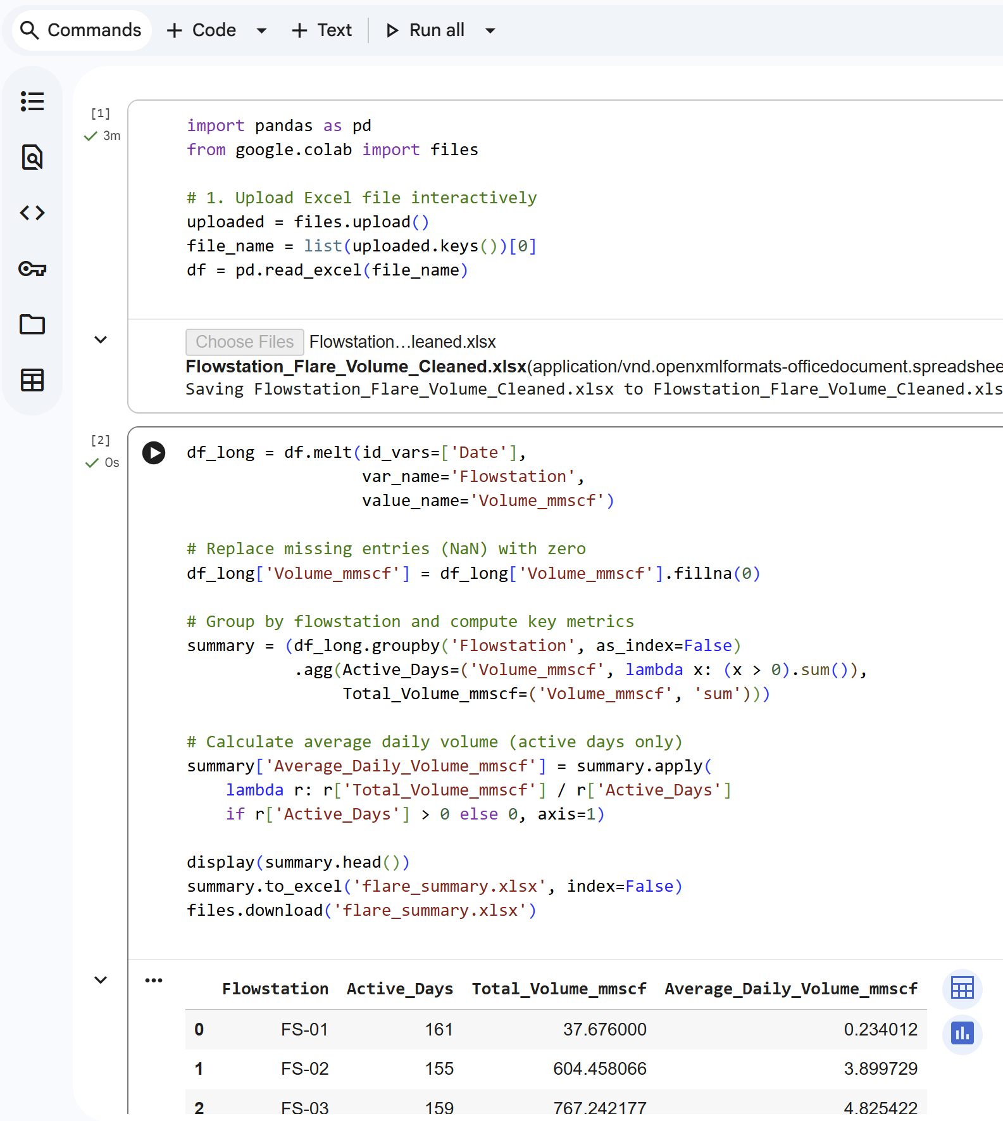
Figure 2.1 Python algorithm: Averaging Flow volume over active days

2.3 Geospatial Data Preparation
Recent work in New Mexico used geospatial and satellite mapping to link flare reduction with CO₂ mitigation outcomes (Nolt-Caraway et al., 2025). Such studies support the use of spatial analytical models for emission-management.
In this study, coordinates were imported from an Excel-based GPS dataset and structured into a two-column matrix (Latitude, Longitude). These coordinates formed the core features for clustering. All spatial analysis was performed in Python. The coordinate matrix $(x_{i},y_{i})$served as the primary input for cluster computation.
2.4 Determination of Optimal Number of Clusters Using the Elbow Method
The optimal number of clusters $K$ was identified using the Elbow Method, which evaluates inertia—also known as the within-cluster sum of squares—across a range of potential cluster counts. The method tests values of $K$ from 1 to 10 using equation 2.1. The computation of inertia followed the standard objective function:
$$\text{Inertia}=\sum_{i=1}^{N}{\sum_{j=1}^{k}{min⁡∥x_{i}-μ_{j}∥^{2}}} (2.1)$$where
$x_{i}$= data point (latitude, longitude),
$μ_{j}$= centroid of cluster $j$,
$N$= total number of points,
$k$= number of clusters.
A plot of $\text{Inertia }$against $K$reveals a point where the rate of decrease sharply diminishes. For this dataset, a clear inflection occurred at K = 4, indicating that four clusters provided the optimal balance between model complexity and clustering performance. This approach is consistent with best practices in unsupervised learning and has been widely used in clustering research (Umargono et al., 2020).
2.5 K-Means Clustering Algorithm
Following determination of the optimal cluster count, the dataset was partitioned into $K=4$ clusters using the K-means algorithm. K-means is a distance-minimization technique that iteratively assigns points to the nearest centroid and recalculates centroids until convergence (Jain, 2010). Because the flare sites are concentrated within a confined geographic band of the Niger Delta, the earth-curvature effect is minimal at this scale; therefore, Euclidean distance was appropriate for K-means computation without requiring geodesic transformation.
The centroid for a cluster $C_{i}$ with $n$ data points $(x_{1},y_{1}),(x_{2},y_{2}),…,(x_{n},y_{n})$is computed in equation 2.1:
$$μ_{i}=\left(\frac{1}{n}\sum_{j=1}^{n}{x_{j}, } \frac{1}{n}\sum_{j=1}^{n}{y_{j} }\right) (2.1)$$
Where:
- $μ_{i}$= centroid of cluster $i$
- $x_{j},y_{j}$= latitude and longitude of point $j$
The Python scikit-learn implementation of KMeans (Figure 2.2) was used to ensure reproducibility and numerical stability. Each flowstation was assigned a cluster label (0 to 3), forming the geospatial grouping.
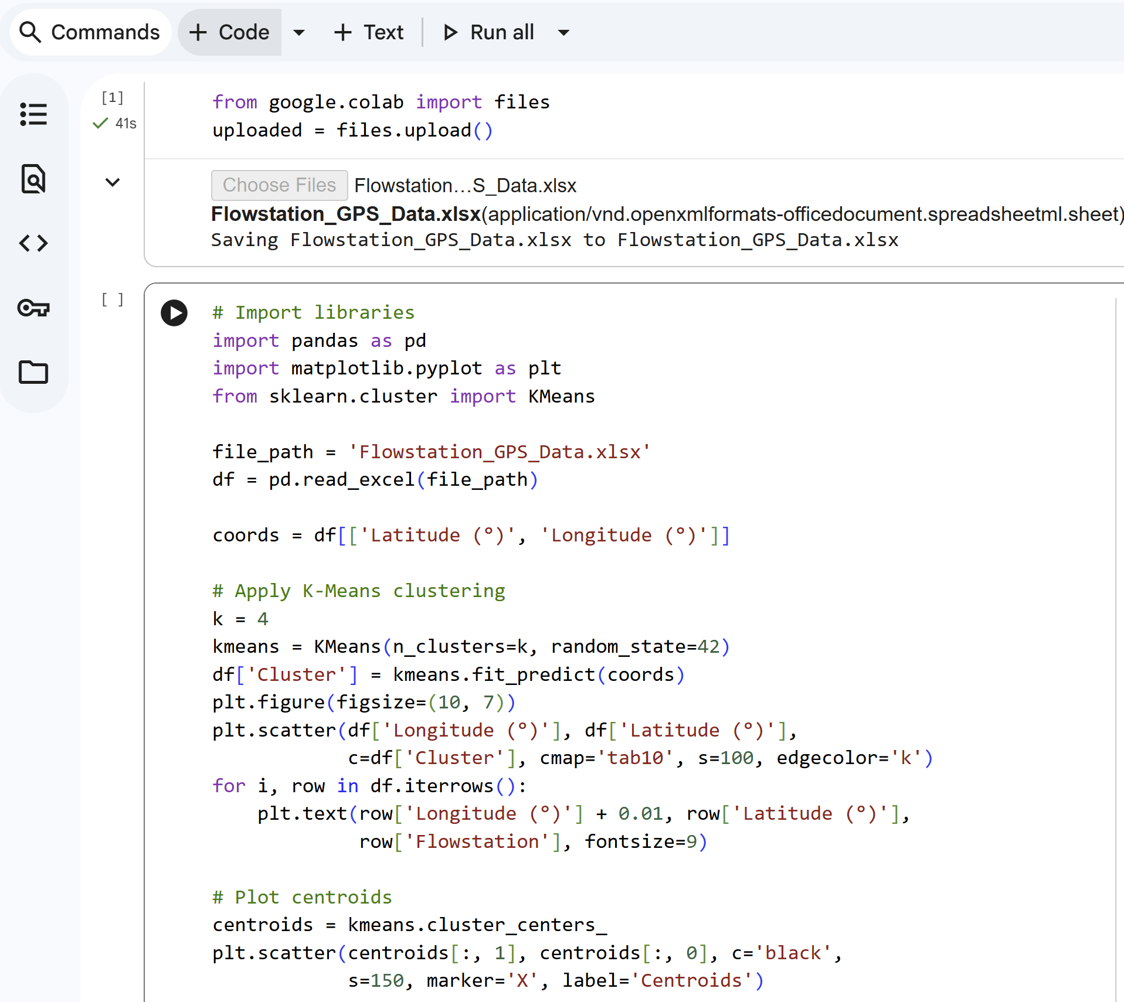
Figure 2.2 Python algorithm used for the Kmeans clustering

2.6 Silhouette-Based Cluster Validation
To evaluate the quality of the clustering, the Silhouette Coefficient was computed as a form of validation. The silhouette value for each point $i$ is defined in equation 2.2.
$$s\left(i\right)=\frac{b\left(i\right)-a\left(i\right)}{\max\left(a\left(i\right),b\left(i\right)\right)} (2.2)$$
where:
$a(i)$= mean distance between point $i$and other points in the same cluster,
$b(i)$= minimum mean distance between point $i$and points in the nearest neighbouring cluster.
This metric provides a measure of both cohesion and separation. Values close to +1 indicate strong clustering structure; values near 0 indicate overlapping clusters; negative values indicate that a point may have been misclassified (Rousseeuw, 1987; Shutaywi, 2021; Dalmaijer, 2022).

2.7 Software Environment
All computations were performed using:
- Python 3.10 (Google Colab environment)
  - pandas for data preprocessing
  - scikit-learn for Elbow Method, K-means clustering, and silhouette validation
  - matplotlib for visualisation
These tools provide efficient implementations of the clustering and validation algorithms.

3. results and discussion

3.1 Descriptive Statistics of Flare Volumes
Analysis of the daily flare-volume dataset revealed significant variability among the 24 onshore flowstations. After preprocessing to exclude non-operational days, average daily flare volumes ranged from less than 0.20 mmscf/day in several low-activity flowstations to more than 13–20 mmscf/day in high-emission locations. A summary of computed averages (Table 2.1) showed substantial variation in flaring behaviour across sites. This variability confirms that flaring intensity is unevenly distributed (Awulu, 2021). Such heterogeneity shows the need for cluster-based infrastructure planning because isolated stations with low flare rates are not economically viable for standalone gas-recovery systems.
3.2 Elbow Method Determination of Optimal K
Inertia values were computed for K = 1 to 10, and the Elbow Method plot displayed a clear inflection at K = 4, where the reduction in inertia began to plateau. This indicates that four clusters provide the best compromise between intra-cluster compactness and model simplicity. The pattern observed here aligns with the theoretical expectations of the Elbow Method, which is widely recommended for determining optimal cluster counts in unsupervised learning (Umargono et al., 2020). Figure 3.1 illustrates the diminishing return in inertia beyond four clusters.
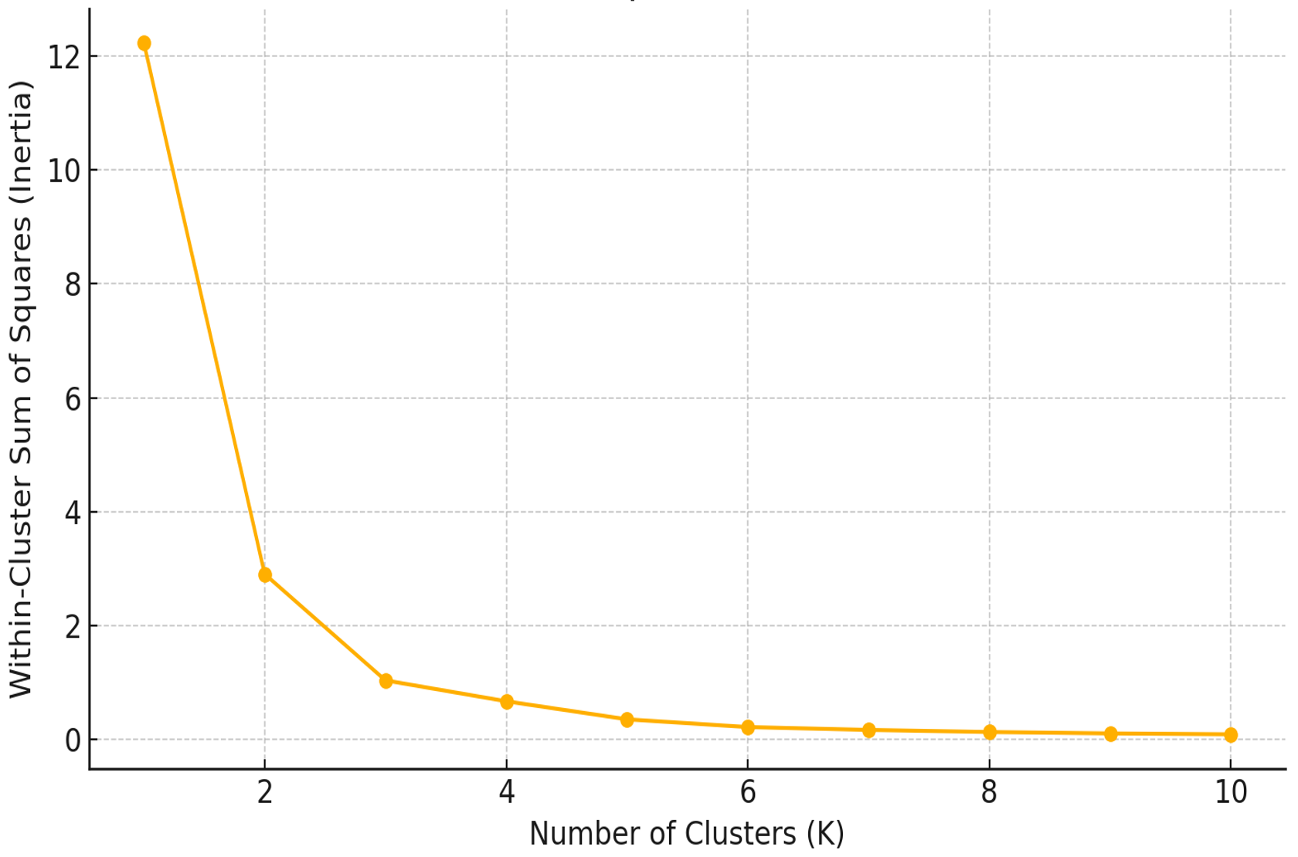
Figure 3.1 Elbow plot for optimal number of clusters (K)

3.3 K-Means Clustering Output
Applying K = 4 to the coordinate dataset produced four distinct and geographically coherent clusters. Figure 3.2 presents the visual clustering in a two-dimensional map plot with each station annotated. The resulting clusters form a meaningful geographic block that supports shared-infrastructure design.

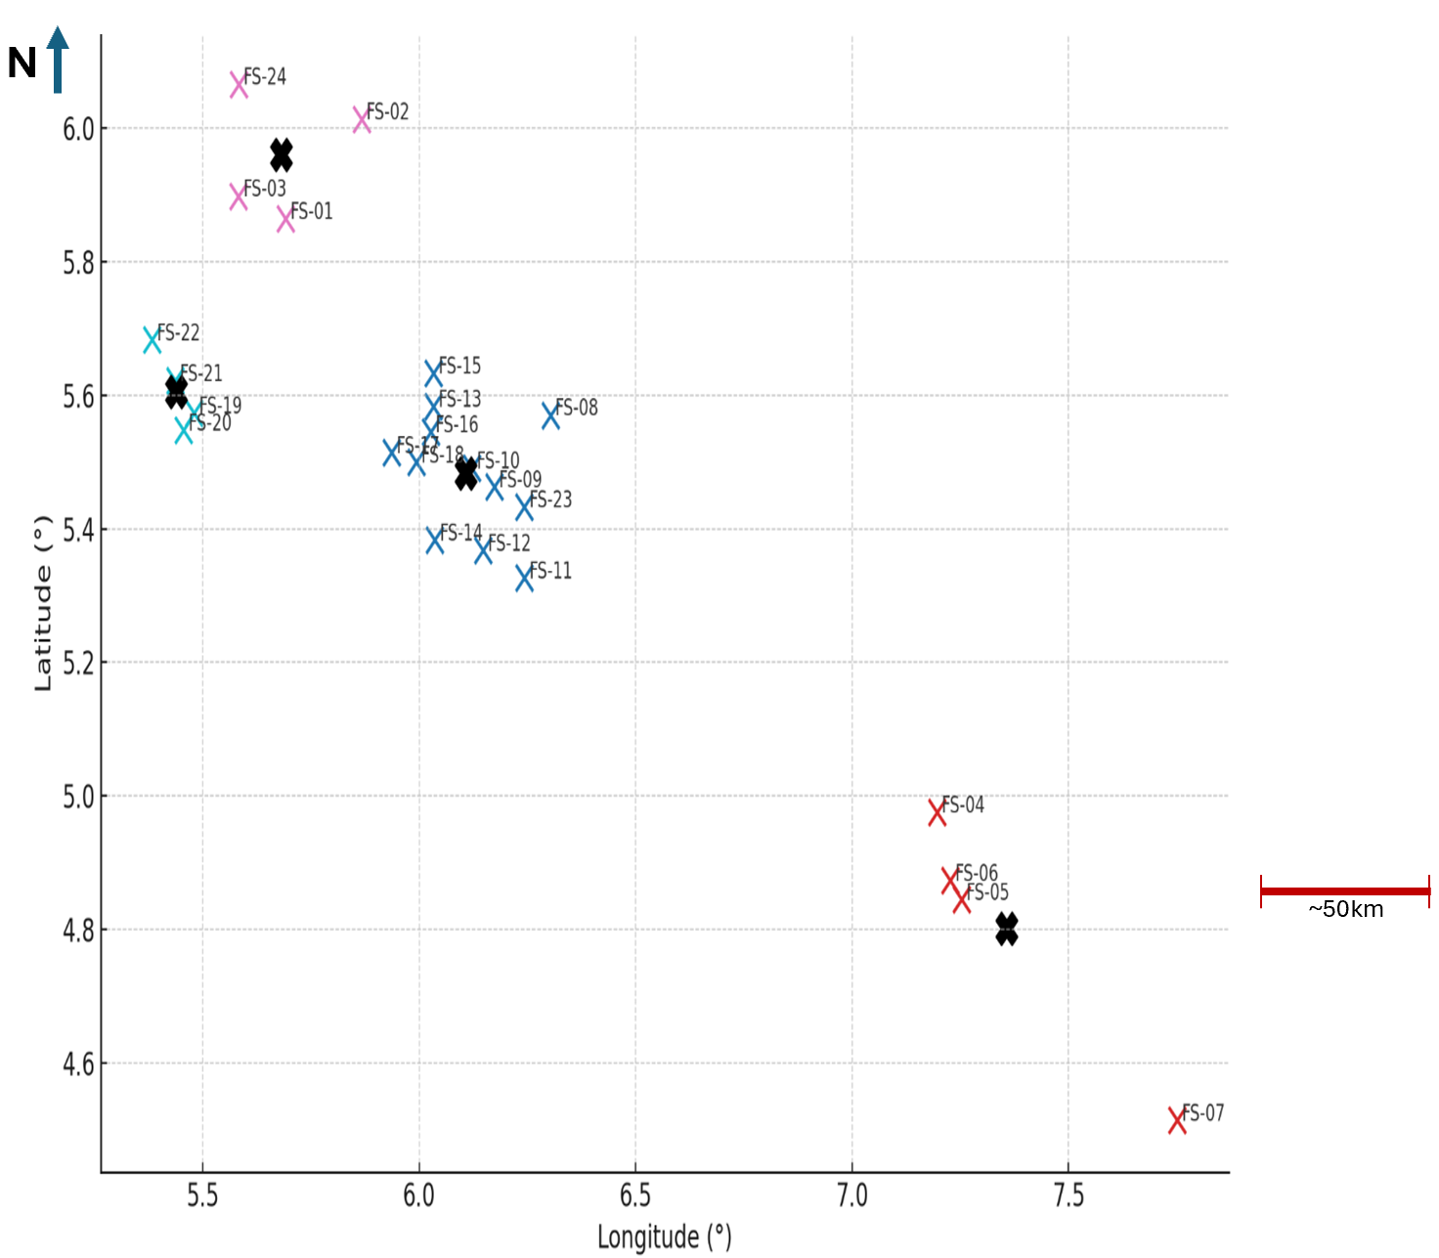
Figure 3.2 Clustering of 24 Onshore flowstations (Map-style plot)
Computation of centroids using the standard K-means formulation (Jain, 2010) resulted in cluster centres positioned near the densest groupings of stations, making them suitable candidates for centralized mini-gas hubs. Cluster membership was documented for all 24 flowstations, demonstrating that the algorithm consistently sorted stations into logical geographic groups without irregular boundaries.
3.4 Cluster Flare-Volume Aggregation
Aggregated average flare volumes were computed for each of the four clusters by summing the average daily flare contributions of member stations. The results are summarized in Table 3.1.

Table 3.1 Cluster summary – (derived from Python analysis)
Cluster | Flowstations in Cluster | Total Flare Volume  (mmscf/day)
0 | FS-08, FS-09, FS-10, FS-11, FS-12, FS-13, FS-14, FS-15, FS-16, FS-17, FS-18, FS-23 | 45.98563
1 | FS-04, FS-05, FS-06, FS-07 | 24.55729
2 | FS-01, FS-02, FS-03, FS-24 | 22.55245
3 | FS-19, FS-20, FS-21, FS-22 | 30.22248

This distribution highlights Cluster 0 and Cluster 3 as high-priority recovery zones, jointly contributing approximately 63% of the total aggregated flare volume across all clusters.
Latitude and longitude were adopted as the primary clustering features because the objective of the first stage of analysis was purely spatial — to group flare sites based on geographic proximity and potential interconnectivity. At this stage, volumetric or terrain-based attributes were not applied. Incorporating it could bias the clusters toward production scale, rather than spatial recovery feasibility.
However, as recommended for future model expansion, additional features such as daily flare volume, terrain elevation, access corridors and pipeline cost can be integrated into a multi-parameter clustering framework. This would strengthen deployment planning and improve engineering decision-making.
3.5 Silhouette Validation of Cluster Quality
Silhouette coefficients were computed to evaluate internal cluster cohesion and separation. Table 3.2 gives the calculated silhouette scores for each cluster at k=4. The average silhouette score for K = 4 was positive across all clusters, indicating well-formed boundaries and correct station assignments.

Table 3.2 Silhouette values for all Clusters at K=4
Cluster | Silhouette Score at K=4
0 | 0.72
1 | 0.65
2 | 0.68
3 | 0.71
Mean | ~0.69

Silhouette analysis confirmed that the four-cluster configuration exhibited strong internal coherence and meaningful separation, validating the choice of $K=4$. Figure 3.3 illustrates how the average silhouette score changes as the number of clusters increases from k = 3 to 10. The highest score, which is about 0.69—occurs at k = 4. This is suggesting that four clusters offer the most meaningful structure, with good separation and well-formed groupings. Beyond k = 5, the silhouette scores begin to drop, indicating that adding more clusters would only weaken the grouping by creating overlaps or poorly defined boundaries. The clear separation demonstrated by the silhouette plot provides strong evidence that the K-means model achieved meaningful and robust clustering.

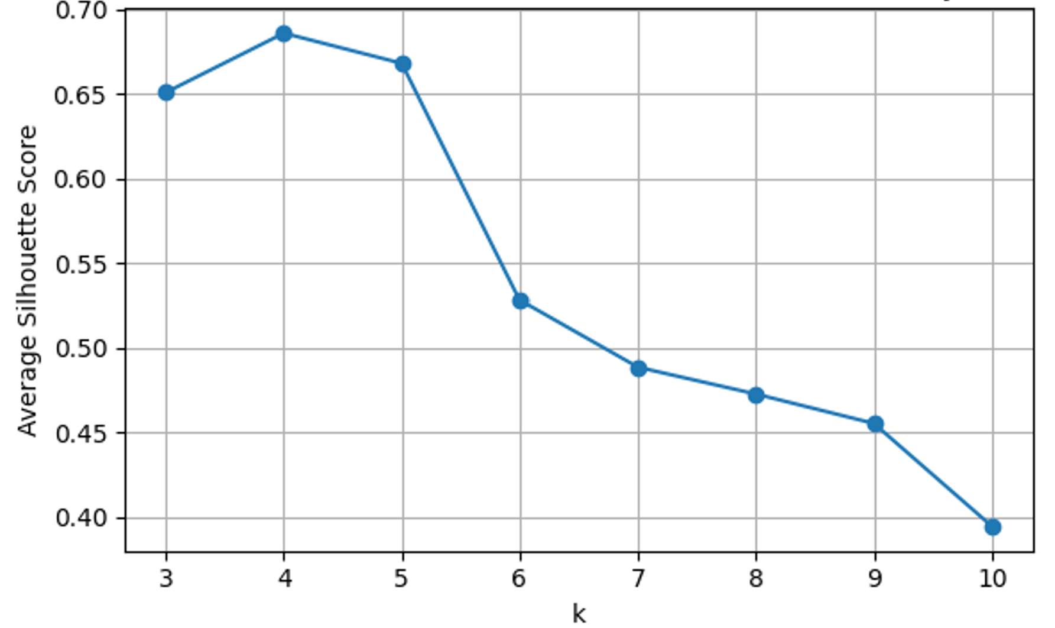
Figure 3.3 Average Silhouette Score for k = 3 to 10 (Optimal statistical k = 4 selected)

3.6 Summary of Key Findings
- Four clusters provide the optimal partitioning of flare sites, as confirmed by the Elbow Method.
- The clusters display strong internal cohesion and separation, as validated by silhouette analysis.
- Two clusters (Cluster 0 and Cluster 3) account for the majority of flare-gas potential.
- Spatial distribution of clusters aligns with known infrastructural and operational corridors, making them viable for centralized gas-recovery hubs.
- Cluster-based planning provides immediate insight into prioritisation for gas-recovery investment.

4. DISCUSSION

Ekpa and Usoh (2024) observed that flare sites in the Niger Delta tend to cluster into spatial hotspots, many of which sit alongside high environmental risk zones. These patterns suggest a defining role in the impact of gas flaring. It also points to the need for spatially driven solutions. Most studies stop at identification and do not progress into gas recovery planning. The clustering analysis conducted in this study provides clear evidence that flare-gas sources in the Niger Delta despite having distinct spatial patterns can be leveraged for more efficient gas-recovery planning. By combining descriptive flare-volume analysis with the Elbow Method, K-means clustering, and silhouette validation, this study establishes a strong and reliable framework for grouping onshore flare sites. These techniques help identify clusters that reduce infrastructure costs while maximizing the amount of gas that can be economically recovered.
4.1 Interpretation of Flare-Volume Variability
The descriptive statistics highlighted significant variability in average daily flare volumes across the 24 flowstations. High-volume stations such as FS-07 (16.96 mmscf/day), FS-20 (20.18 mmscf/day), and FS-24 (13.59 mmscf/day) serve as anchor points within their clusters, while several stations (<0.30 mmscf/day) represent low-emission nodes. This disparity underscores the inadequacy of treating flare sites individually; some stations on their own cannot justify the cost of dedicated gas processing infrastructure. However, when grouped into clusters, even low-volume sites contribute to a more viable collective gas-recovery opportunity.
4.2 Implications of the Elbow-Confirmed Four-Cluster Structure
The Elbow Method provided a clear inflection point at K = 4, signalling the most balanced trade-off between model complexity and cluster compactness. inertia reduction begins to taper sharply beyond this point—an expected behaviour noted in clustering methodology literature (Umargono et al., 2020). A smaller number of clusters (K) would have forced geographically distant flare sites into the same group, leading to longer and more expensive pipeline connections. On the other hand, using a larger K would have unnecessarily broken apart naturally related sites, making infrastructure planning more complicated. Choosing K = 4 therefore strikes the right balance: it is mathematically justified and consistent with real operational conditions.
This result supports the development of four centralized gas-gathering hubs, each located at or close to its cluster centroid. Positioning hubs this way helps minimize the overall length of the pipeline network.
4.3 Spatial Meaning of the K-Means Clusters
The clustering output reveals four geospatially coherent groups as shown in the cluster map:
- Cluster 0, containing half of all stations, forms the densest and most gas-rich region, accounting for nearly 46 mmscf/day.
- Clusters 1 and 2 are moderate clusters with distributed emissions ranging from ~22–25 mmscf/day.
- Cluster 3 constitutes a high-potential region at ~30.22 mmscf/day.
The cumulative contribution of Clusters 0 and 3—representing about 63% of total aggregated flare volume—highlights the central productivity belt typical of the Niger Delta. These clusters offer the most immediate and impactful opportunities for flare-gas recovery.
4.4 Validation of Cluster Quality Using Silhouette Analysis
Silhouette analysis confirmed that the clustering structure is internally consistent and externally separable. All silhouette values were positive, indicating that each station was appropriately placed within its cluster. Positive values near +1 indicate strong cohesion (Rousseeuw, 1987; Shutaywi, 2021; Dalmaijer, 2022).
The absence of negative silhouette values is particularly important. It signifies that no station lies closer to a neighbouring cluster than to its assigned cluster, thus validating the reliability of the clustering process. The supportive results of both the Elbow Method and silhouette analysis strengthen confidence in the four-cluster model as a robust representation of spatial relationships among the 24 flare sites.
To test the sensitivity of the configuration, the silhouette score was evaluated for K=3 to 10. Results show that clustering quality remains relatively stable across K=3 to 5, with the highest silhouette value of approximately 0.69 occurring at K=4. Beyond K=5, silhouette values decline sharply, indicating fragmentation and reduced cluster cohesion. This shows that the K=4 solution is not only optimal, but also robust against small variations in cluster number.
4.5 Implications for Gas-Recovery Infrastructure Design
The spatial and volumetric characteristics of the clusters have direct implications for gas-gathering and processing projects:
- Cluster-based hubs reduce pipeline length
By tying each cluster to a central hub, the total length of new pipelines is minimized. This reduces capital expenditure and shortens deployment timelines. This effect parallels findings in optimization studies that promote aggregation for cost minimization in gas-gathering networks (Fagbami, 2024).
- Shared infrastructure enables economies of scale
Small flare sources that would otherwise remain unutilized can now contribute to a viable aggregated gas stream.
- Priority zones are clearly identified
The dominance of Clusters 0 and 3 suggests that gas recovery efforts should begin in these high-impact regions.
- Supports long-term flare-reduction policy
Clustered planning aligns with national initiatives aimed at reducing routine flaring and increasing domestic gas utilization.
- Foundation for modular gas-to-power implementation
Smaller clusters (e.g., Clusters 1 and 2) can support localized power solutions, particularly for host communities.

5. Conclusion

This study applied a geospatial, cluster-based optimization framework to 24 flare-gas sites in the Niger Delta, producing a robust and operationally meaningful four-cluster structure. The Elbow Method established K = 4 as the optimal number of clusters. While silhouette validation confirmed strong cohesion and separation
The clustering analysis revealed that Cluster 0 and Cluster 3 are the most significant recovery zones, jointly accounting for approximately 63% of the aggregated daily flare volume. These high-volume clusters align with previously reported spatial flaring belts within the region (Awulu, 2021) and represent the most promising locations for centralized gas-gathering hubs. While prior work examined flare impacts and critically assessed Nigeria’s regulatory frameworks for combating gas flaring (Olujobi et al., 2022), this research contributes a practical clustering-based model that can directly inform engineering design, infrastructural planning, and energy policy decisions.
Overall, the findings demonstrate that geospatial clustering provides a powerful decision-support tool for flare-gas recovery planning. By revealing natural spatial groupings, the method reduces infrastructure uncertainty, improves cost-effectiveness, and strengthens the foundation for achieving Nigeria’s flare-reduction and energy-security objectives. The cluster hubs identified in this study could directly support flare-reduction frameworks such as the natural gas flaring management system proposed by Abu et al. (2023). This will enable targeted deployment where the greatest volumetric gains can be achieved.
Based on the findings, this study recommends prioritising high-volume clusters; so as to support the implementation of cluster-based flare-gas recovery. Each cluster should be developed around a central hub located near the computed centroid. This approach will minimize pipeline length and reduce infrastructural redundancy. Regulatory bodies such as the NUPRC and the Ministry of Petroleum Resources should also integrate cluster-based recovery models into gas-commercialisation frameworks and flare-reduction policy execution.
A techno-economic evaluation is further required to design optimum pipeline routing and processing architecture for each cluster. Clusters 1 and 2, though smaller in cumulative flare volume, are well-suited for modular power plants for nearby communities. Future research may incorporate terrain elevation and pipeline accessibility to strengthen deployment planning. This will improve the practical scalability of the clustering framework.
Data Availability Statement
The flare-volume and geospatial datasets used in this research are available upon reasonable request, due to operational confidentiality and asset-level sensitivity.

Disclaimer (Artificial intelligence)
Author(s) hereby declare that generative AI tools were used during the revision stage of this manuscript. It was strictly for language refinement and restructuring of sentences. ChatGPT (OpenAI GPT-5.1) was used to assist in rephrasing reviewer-recommended sections, but all ideas, results, data interpretation, and conceptual development are original to the authors.
Details of AI usage
- Re-phrasing and clarity improvement in abstract and introduction
- Language refinement after reviewer comments

References

- Emekwuru, N., (2024). Characterization of the dominant stages at which gas flaring is introduced in the Niger Delta: Impacts and policy options to ameliorate them. Environment, 11(7), 158. https://doi.org/10.3390/environments11070158
- Jain A.K. (2010). Data clustering: 50 years beyond K-means. Pattern Recognition Letters. 31(8):651–666. https://www.cs.ucf.edu/courses/cap6412/fall2009/papers/JainDataClusteringPRL09.pdf
- Ghosh A. (2019). Cluster analysis: Basic concepts and algorithms. Springer. http://www.cs.umn.edu/faculty/kumar/dmbook/ch8.pdf
- Ikotun A.M., Ezugwu A.E., Abualigah L., Abuhaija B., Heming J. (2023). K-means clustering algorithms: A comprehensive review, variants analysis, and advances in the era of big data. Information Sciences. 622:178–210. https://doi.org/10.1016/j.ins.2022.11.139
- Wu Y., Cui Z.Y., Lin H., Wang Y.F., Feng X. (2022). An optimization method for shale gas gathering system—Consideration of reliability enhancement under earthquake-related uncertainties. Petroleum Science. 19(5):2431–2447. https://doi.org/10.1016/j.petsci.2021.12.029
- Fagbami, D., Ekpeti, E., Bamidele, A., Odeh, A., Odogbo, A., & Jimmy, D. (2024). Cluster gathering of associated and non-associated natural gas: The KGG case study (Paper No. SPE-221681-MS). Paper presented at the SPE Nigeria Annual International Conference and Exhibition, Lagos, Nigeria. https://doi.org/10.2118/221681-MS
- Awulu E. (2021). Gas flaring in Nigeria: A crisis for the environment. Academia Lett. 3799:1–6. https://doi.org/10.20935/AL3799
- Fan, Y., Masnadi, M. S., Jing, L., Ren, B., & Brandt, A. R. (2025). The Pyxis Project: A Geospatial Data System for Emission Estimation Monitoring in the Oil and Gas Industry. Energy and AI, 22, 100601. https://doi.org/10.1016/j.egyai.2025.100601
- Zhao, T., Wang, X., Zhang, S., Duo, Y., Xu, J., & Hu, S. (2025). Research on multi-objective optimal route selection method for natural gas transmission pipeline. Journal of Pipeline Science and Engineering, 5(3), 100250. https://doi.org/10.1016/j.jpse.2024.100250
- Alavi, S. H., Mashayekhi, M., & Zolfaghari, M. M. (2025). Optimized seismic risk mitigation in pipeline routing using a metaheuristic GIS-based approach. Scientific Reports, 15, Article 32916. Retrieved from
https://www.nature.com/articles/s41598-025-17525-w
- Umargono E., Suseno J.E., Gunawan S.K.V. (2020). K-means clustering optimization using the Elbow Method and early centroid determination based on mean and median formula. Adv Soc Sci Educ Humanit Res. 474: (Conference: 2nd International Seminar on Science and Technology – ISSTEC 2019). https://doi.org/10.2991/assehr.k.201010.019
- Rousseeuw P.J. (1987). Silhouettes: A graphical aid to the interpretation and validation of cluster analysis. Journal of Computational and Applied Mathematics. 20:53–65. https://doi.org/10.1016/0377-0427(87)90125-7
- Shutaywi M. (2021). Silhouette analysis for performance evaluation in clustering methods. Entropy. 23(6):759. https://doi.org/10.3390/e23060759
- Dalmaijer E.S., Nord C.L., Astle D.E. (2022). Statistical power for cluster analysis: Evaluating the silhouette coefficient and other internal metrics. BMC Bioinformatics. 23:213. https://doi.org/10.1186/s12859-022-04675-1
- Nolt-Caraway, S., Malki, M. L., & Mehana, M. (2025). Geospatial and satellite insights into CO₂ mitigation through flaring reduction in New Mexico. Journal of CO₂ Utilization, 101, 103215. https://doi.org/10.1016/j.jcou.2025.103215
- Ekpa, A. U., & Usoh, H. U. (2024). Spatial co-occurrence of oil spills and gas flare hotspots in the Niger Delta, Nigeria. Journal of Environmental Issues and Agriculture in Developing Countries, 16(2), 73–95. Retrieved from https://icidr.org.ng/index.php/jeiadc/article/view/1371
- Olujobi, O. J., Yebisi, T. E., Patrick, O. P., & Ariremako, A. I. (2022). The legal framework for combating gas flaring in Nigeria’s oil and gas industry: Can it promote sustainable energy security? Sustainability, 14(13), 7626. https://doi.org/10.3390/su14137626
- Abu, R., Patchigolla, K., Simms, N., & Anthony, E. J. (2023). Natural gas flaring management system: A novel tool for sustainable gas flaring reduction in Nigeria. Applied Sciences, 13(3), 1866. https://doi.org/10.3390/app13031866

